# Country specific guideline for

# New Zealand

This guideline has been prepared by the Australian Government and Ministry for Primary Industries of New Zealand. It is intended to assist Australian importers of regulated timber products from New Zealand in understanding the regulatory framework in New Zealand in order for them to carry out their due diligence obligations under the Illegal Logging Prohibition Regulation 2012, which supports the Illegal Logging Prohibition Act 2012.

This guideline was co-endorsed by the Australian Government and Ministry for Primary Industries on 16 September 2019.

Contents

Contents 2

1. What is required under Australia’s illegal logging laws? 3

2. How to use the Country Specific Guideline (CSG) 3

3. Scope of the CSG for New Zealand 4

3.1. Timber harvested outside of New Zealand 4

4. Overview of forest management in New Zealand 5

4.1. Forest certification 5

4.2. Bans or limitations on harvest of specific species 6

5. Timber products exported from New Zealand 7

6. Laws and regulations governing forestry in New Zealand 7

6.1. Environmental legislation 7

6.2. Indigenous timber products 7

6.3. Harvesting in privately owned indigenous forests 8

6.4. Exporting indigenous timber products 8

6.5. Low risk of illegal harvesting 8

6.6. Corruption, bribery, governance and conflict 9

7. Identifying legal product from New Zealand 10

7.1. Considerations for importers 10

7.2. Traceability 10

7.3. Harvested wood levy statement 10

8. Who should I contact for further information? 11

Annex 1: Resource Consent 12

Annex 2: Intention to Export Indigenous Timber Form 13

Annex 3: Intention to Export Swamp Kauri Form 14

Annex 4: Load Delivery Docket 15

Annex 5: Harvested Wood Levy Statement 16

## 1. What is required under Australia’s illegal logging laws?

Australia’s *Illegal Logging Prohibition Regulation 2012* (the Regulation) prescribes due diligence for businesses importing ‘regulated timber products’[1] and for Australian processors of domestic raw logs. Under the Regulation, importers and processors have to undertake due diligence to minimise the risk of sourcing illegally logged timber.

Due diligence requirements for importers include the following steps:

**Step 1**: Establish and maintain a due diligence system.

**Step 2**: Gather information about the timber in the product that is being imported.

**Step 3**: Assess the risk (using one of the three methods outlined in the Regulation).

**Step 4**: Risk mitigation (if required).

**Step 5**: Keep records.

Further information about the Regulation and the due diligence requirements is available at the Australian Government Department of Agriculture, Water and the Environment website ([www.agriculture.gov.au/illegallogging](http://www.agriculture.gov.au/illegallogging)).

## 2 How to use the Country Specific Guideline (CSG)

This guideline is intended to assist an importer of regulated timber products from New Zealand to comply with the due diligence requirements of the Regulation.

An importer must gather information about the product in accordance with section 10 of the Regulation, this includes gathering information or evidence contained in this CSG.

Information or evidence listed in this guideline is not an exhaustive list of evidence or documentation required to satisfy due diligence requirements under the Regulation.

The information gathered by applying this guideline, along with any other information gathered in accordance with the Regulation, needs to be assessed in accordance with the processes outlined in section 12 of the Regulation (including considering any other information the importer knows, or ought reasonably to know, but is not contained in the CSG), to identify the risk that a regulated timber product is, is made from, or contains illegally logged timber.

All data included in this document is the most current as available at time of publishing.

## 3 Scope of the CSG for New Zealand

This CSG provides detailed information on the control of pathways for timber harvested and originating from within New Zealand and informs Australian importers of what is considered legal timber. It is only applicable for timber products with a New Zealand origin of harvest that are directly exported from New Zealand to Australia.

### 3.1 Timber harvested outside of New Zealand

There may be timber, forest products or products which contain timber, wholly or in-part, which was harvested in another country, before it was imported to New Zealand. These products are not in-scope of this CSG, however information contained in this document may assist importers in conducting due diligence through another available pathway.

Importers should contact their New Zealand exporter to gather further information about these products, as New Zealand’s regulatory framework does not cover timber products harvested overseas.

## 4 Overview of forest management in New Zealand

Timber or timber products that Australia imports from New Zealand may come from one of three sources:

* exotic forests, covering an estimated 1.71 million hectares as at 1 April 2017, provide 99.9 per cent of the annual harvested volume
* indigenous (natural) forests, consisting of 6.3 million hectares, provide less than 0.1 per cent of the annual harvested volume
* overseas timber products imported into New Zealand.

Exotic forests are comprised of species not native to New Zealand that are planted primarily for the purpose of being harvested. Radiata pine makes up 90 per cent of the exotic planted forest area, with Douglas fir (six per cent), eucalypts (one per cent) and other exotic species making up the remainder[2].

Indigenous forests are comprised of native species. Approximately 77 per cent of these forests are owned by the government and are protected as a part of the conservation estate. There are however, privately owned indigenous forests which may be harvested under strict regulations. Indigenous tree species which are commonly harvested include: rimu, miro, and matai (conifers), native beech (*Nothofagus* species), and tawa (hardwood).

### 4.1 Forest certification

Third party forest management certification and chain of custody schemes are voluntary in New Zealand. There are two main forest certification schemes operating in New Zealand:

### Forest Stewardship Council (FSC)

At August 2019, the forest areas with FSC certification[3] were:

* 1.25 million hectares of exotic planted forests, or approximately 70 per cent of the estate;
* 11,900 hectares of indigenous forest.

Most small forest owners choose not to certify their forests.

Approximately 260 suppliers, manufacturers and retailers of wood products have FSC chain of custody certification.

### Programme for the Endorsement of Forest Certification (PEFC)

At August 2019, 590,000 hectares of forest had PEFC forest management certification[4] covering 33 per cent of New Zealand’s plantation forest estate. These PEFC-certified areas also have FSC certification.

Seventy-three companies have PEFC chain of custody certification, some covering multiple sites.

### Bans or limitations on harvest of specific species

New Zealand is a party to the *Convention on International Trade in Endangered Species of Wild Fauna and Flora* (CITES). New Zealand bans and/or restricts the harvest or collection of flora species listed in accordance with the [CITES Appendices](https://www.cites.org/eng/app/appendices.php). All trade in CITES listed species (e.g. Korean pine) is strictly regulated and must be accompanied by the appropriate documentation where trade is permissible.

New Zealand has no indigenous timber tree species on its CITES list. The tree ferns listed (*Cyathea* species) are used domestically for ornamental and landscaping purposes[5].

## 5 Timber products exported from New Zealand

New Zealand is Australia’s second largest supplier of regulated timber products (by value). New Zealand’s exports to Australia span most of the regulated product categories, and were valued at AU$540 million in 2018-19. Wood products imported from New Zealand to Australia have typically undergone some processing.

## 6 Laws and regulations governing forestry in New Zealand

New Zealand has a robust regulatory framework and an operating environment that ensures a low risk of illegal logging in New Zealand forests. The regulatory framework is actively enforced, backed by a strong and independent judiciary, and a highly professional forestry industry. A range of laws which are not specific to the forestry sector also apply, including commercial and tax laws; labour, employment and safety laws; and the customs law.

### 6.1 Environmental legislation

New Zealand’s exotic forests, are regulated under the *Resource Management Act 1991 (RMA)*. The purpose of the Act is to promote sustainable management of natural and physical resources. The RMA and associated tools made under it are implemented by local government authorities,

The *National Environmental Standards for Plantation Forestry (NES-PF)* are regulations under the RMA. Under these regulations, forest owners can harvest forests and conduct associated activities, such as afforestation and earthworks, without a resource consent (as a permitted activity) if they meet certain conditions to manage potential effects on the environmental. Regional and district councils implement the NES-PF and are responsible for monitoring and enforcement of it.

If the conditions cannot be met, forest owners must obtain a resource consent (similar to a permit) from their local government body before carrying out the activity. Resource consents may include specific conditions on the activities, which must be complied with. An example of a resource consent certificate is provided in Annex 1.

New Zealand forest harvest practices are subject to oversight and scrutiny, both formally and through the actions of interested stakeholders within the community. The Ministry for Primary Industries, the Ministry for the Environment and other central government agencies work to ensure that forestry operations in exotic planted forests are environmentally sustainable, safe and legal under New Zealand law.

### 6.2 Indigenous timber products

Indigenous forests are comprised of native species. The majority of these forests are owned by the government and are protected as a part of the conservation estate under the *Conservation Act 1987*, *National Parks Act 1980*, and the *Reserves Act 1977*.

Harvesting of indigenous timber from privately owned indigenous forests and the export of indigenous timber are governed by the *Forests Act 1949*.

### 6.3 Harvesting in privately owned indigenous forests

Harvesting in privately owned indigenous forests must be done under a Sustainable Forest Management (SFM) Permit or Plan. Furthermore annual harvest plans must be submitted to MPI for harvesting under SFM Plans and Permits.

Permits and Plans are administered by the Ministry for Primary Industries. Currently registered Sustainable Forest Management Permits and Plans can be searched online at [www.teururakau.govt.nz/growing-and-harvesting/forestry/indigenous-forestry/harvesting-and-milling-indigenous-timber/](http://www.teururakau.govt.nz/growing-and-harvesting/forestry/indigenous-forestry/harvesting-and-milling-indigenous-timber/).

### 6.4 Exporting indigenous timber products

There is a ban on the export of indigenous timber in log or wood chip form. The export of indigenous timber is permitted in limited circumstances. Sawn timber of beech and rimu of specified dimensions sourced from a Sustainable Forest Management Plan or Permit, and sawn timber from stump and root material (usually kauri) sourced from non-indigenous forest land may be exported.

Exporters of unfinished indigenous forest timber are required to submit a notice of Intention to Export (ITE) form. The form requires exporters to identify the source of the timber, which is checked by the Ministry for Primary Industries. Prior to export, consignments must be presented to a Forestry Officer for inspection and approval.

A non-transferable single-use permit number is provided by the Ministry for Primary Industries on the completed approved Intention to export (ITE) form. The clearance (permit) number is required to clear the goods through the New Zealand Customs system. See Annex 2 and 3 for examples of the two types of Notice of Intention to Export Indigenous Timber.

There are no restrictions on the export of *finished or manufactured indigenous timber products* *or personal effects*, and no inspection or approval is required.

For more information on the regulatory framework for indigenous forests, and the processing and exporting of products from these forests, see [www.teururakau.govt.nz/growing-and-harvesting/forestry/indigenous-forestry/](http://www.teururakau.govt.nz/growing-and-harvesting/forestry/indigenous-forestry/).

### 6.5 Low risk of illegal harvesting

There is low risk in New Zealand of illegal harvesting, and many factors contribute to this.

New Zealand’s exotic forests were planted for the purpose of being harvested. These forests are primarily privately owned and operated, and companies have strong incentive to protect their property and assets. The exotic species used are low value compared to tropical hardwoods, and are unlikely to be the target of illegal trade. There are high levels of compliance by industry, including with voluntary industry codes of practice.

New Zealand has a strong regulatory framework which is actively enforced, and backed by a strong and independent judiciary. There is a strong and clear land tenure system, and there is an on ongoing legal process to address historical grievances and claims from Māori which has seen many claims settled formally with the Crown.

NEPCon rated the risk of illegality in New Zealand as 100/100 (lowest)[6]. Their risk assessment found: “Low risk of illegality”. It noted any breaches of applicable laws are temporary, unusual, limited in their impact, and effectively controlled by the relevant authorities. Further, they did not identify any specified risks, and therefore did not suggest any mitigation actions.

### 6.6 Corruption, bribery, governance and conflict

New Zealand is recognised internationally as having one of the lowest levels of corruption in the world. Transparency International ranked New Zealand as second in the world in its 2018 Corruption Perception Index (see [transparency.org](http://www.transparency.org/)).

Government officials are relatively well paid and do not need to rely on secondary sources of income from bribery. The New Zealand public and press expects a very high standard of conduct from all politicians, and there is no historical culture of informal payments or bribery in either the private or public sectors. There is a strong and active civil society, including non-government organisations (NGOs), local communities and interest groups.

The *Official Information Act 1982* and *Local Government Official Information and Meetings Act 1987* both set out to promote good governance and the enhancement of respect for the law by increasing the availability of official information. This enables more effective public participation in the making and administration of laws and policies, while also promoting the accountability of Ministers and officials.

New Zealand scores highly on all the World Bank Worldwide Governance Indicators. In 2017, New Zealand ranked number 1 on Control of Corruption indicator with a score of +2.24 (on a scale of -2.5 to +2.5, with +2.5 being the strongest governance). The indicators cover six dimensions of governance including voice and accountability, political stability and absence of violence, government effectiveness, regulatory quality, rule of law, and control of corruption (see [info.worldbank.org/governance/wgi/#reports](http://info.worldbank.org/governance/wgi/#reports)).

There is no armed conflict in New Zealand. For the years 2017 – 2019 New Zealand was rated as number 2 on Global Peace Index rankings by Institute for Economics and Peace based on 23 indicators (see [visionofhumanity.org/reports/](http://visionofhumanity.org/reports/)).

## 7 Identifying legal product from New Zealand

### 7.1 Considerations for importers

Things to consider for Australian importers when importing timber from New Zealand:

* Was the wood harvested in New Zealand? Was the product manufactured in New Zealand?
* Is the species what you would expect (e.g. exotic species from planted forests, indigenous species authorised under a Sustainable Forest Management Plan or Permit)?
* Do you know the exporter? Do you have an existing business relationship?
* Is there anything unusual about the product (e.g. low price, unusual volume)?

### 7.2 Traceability

All commercial deliveries of logs by truck or rail wagon are accompanied by load delivery dockets, which are the basis for the commercial invoicing or payment of all the parties involved. The same approach is used across the country, and provides a high level of traceability. There are inherent checks and balances because those being paid (suppliers and forest owners) or charged (customers) have strong incentives to ensure the information is correct.

Information on typical dockets includes: species and grade; forest owner/ forest; block/ compartment/ stand; harvesting, cartage and loading contractors with crew, truck and trailer codes; destination or customer; log count, gross weight, net weight. An example is provided in Annex 4, however each company has their own branded dockets which can have different formats.

Logs for export are individually barcoded on receipt into the port. The load delivery docket information is linked to the barcode. Therefore, a barcode on a log can be used to trace the log back to a supplier, and in most cases, the forest owner and forest. Some loads of very small piece size may be bundled and have one barcode.

### 7.3 Harvested wood levy statement

A mandatory industry good levy is charged on *all harvested wood material from plantation forests*.*[7]* This can be used to demonstrate that supply is from New Zealand forests that have been planted for the purpose of future harvesting.

The Forest Growers Levy Trust Inc. (the Trust) is the body mandated in regulation to collect the levy. The Trust contracts a third party, Levy Systems Limited, to administer the levy on behalf of the Trust.

Forest owners who pay the levy can provide a levy statement from Levy Systems Ltd that declares they are subject to the harvested wood levy. The harvested wood levy statement template is provided in Annex 5.

## 8 Who should I contact for further information?

|  |  |
| --- | --- |
| \\ACT001CL04FS05\RPIHome$\Riddy Cleo\Desktop\logo stacked April 2020.jpg | New Zealand Ministry for Primary Industries logo |
| **Australian Government**  Address: Department of Agriculture, Water and the Environment  GPO Box 858  Canberra ACT 2601  Australia  Phone: +61 2 6272 3933  Web: [www.agriculture.gov.au/illegal-logging](http://www.agriculture.gov.au/illegal-logging)  Email: [illegallogging@agriculture.gov.au](mailto:illegallogging@agriculture.gov.au) | **New Zealand Government**  Address: Ministry for Primary Industries  PO Box 2526  Wellington 6140  New Zealand  Phone: +64 4 894 0100  Web: [mpi.govt.nz/contact-us/](http://mpi.govt.nz/contact-us/)  Web:[teururakau.govt.nz/growing-and-harvesting/forestry/overview/preventing-illegal-logging/](http://mpi.govt.nz/growing-and-harvesting/forestry/overview/preventing-illegal-logging/) |

**Disclaimer**

While reasonable efforts have been made to ensure that the contents of this guideline and the associated quick reference guide are factually correct, the Commonwealth of Australia and Ministry for Primary Industries of New Zealand do not accept responsibility for the accuracy or completeness of the contents and expressly disclaims liability for any loss or damage, however caused, that may be occasioned directly or indirectly through the use of, or reliance on, the contents of this guideline or associated quick reference guide.

This guideline and its associated quick reference guide is made available on the understanding that the Commonwealth of Australia and the Ministry for Primary Industries are not providing professional advice. Before relying on this guideline or its associated quick reference guide, readers should obtain appropriate professional advice suitable to their particular circumstances.

Readers should also confirm that this is the most up-to-date available guideline by referring to the Department of Agriculture, Water and the Environment website.

Annex 1: Resource Consent

A sample Resource Consent form, issued by a local council. This example is ussed by the Gisborne District Council and the form is titled "Land Use Consent for Land Disturbance and/or Vegetation Clearance"

The Key ID Feature is a Consent Number, whichi reads "LV-2017-Consent Number-00".

Key feature: Consent number

EXAMPLE

Annex 2: Intention to Export Indigenous Timber Form

A sample blank Intention to Export Indigenous Timber (Form ITE1) issued by the New Zealand Ministry for Primary Industries. 

The Key ID Feature appears at the bottom of the page. A circle highlights the space for an Indigenous timber clearance number, or customs clearance number.

EXAMPLE

Key feature: Customs clearance number

Annex 3: Intention to Export Swamp Kauri Form

A sample blank Intention to Export Swamp Kauri (Form ITE2) issued by the New Zealand Ministry for Primary Industries. 

The Key ID Feature appears at the bottom of the page. A circle highlights the space for an Indigenous timber clearance number, or customs clearance number.

EXAMPLE

Key feature: Customs clearance number

Annex 4: Load Delivery Docket

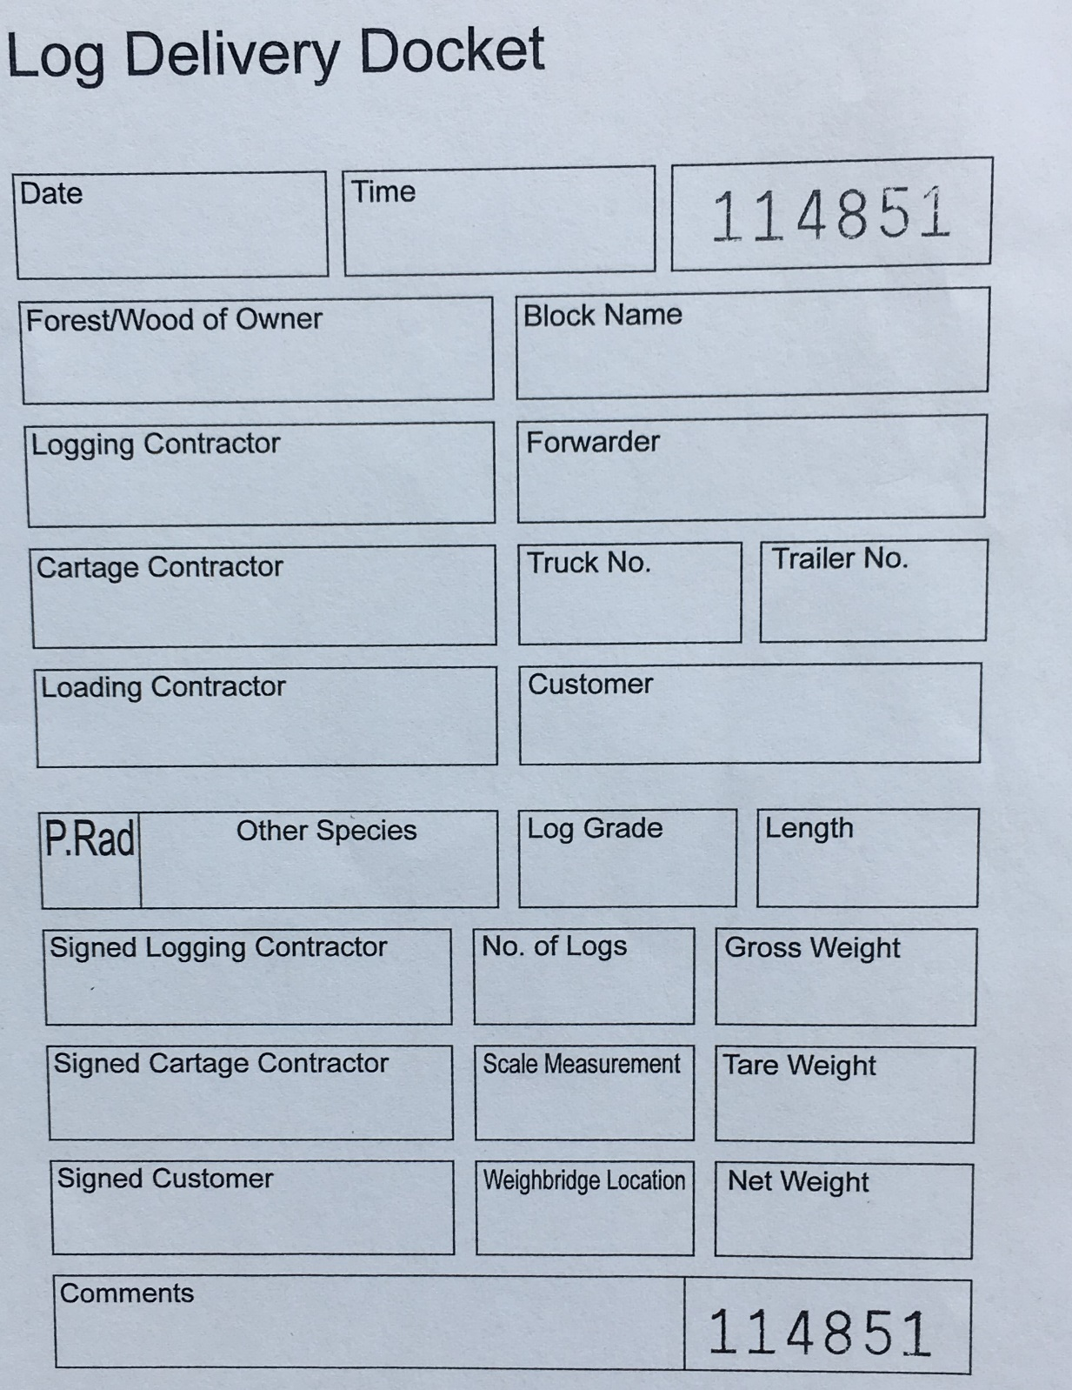

EXAMPLE

Key feature: Docket number

Annex 5: Harvested Wood Levy Statement

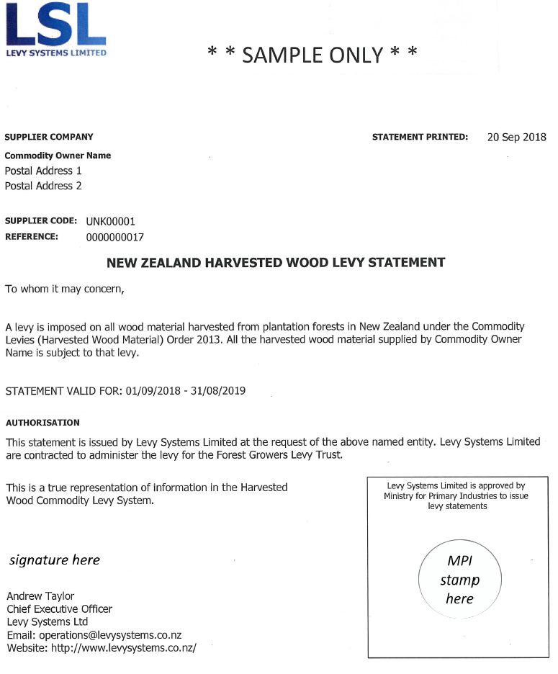

Key feature: government stamp

1. For the purposes of the *Illegal Logging Prohibition Act 2012* a ‘regulated timber product’ is a product listed in Schedule 1 to the Regulation.
2. Other exotic species include cypresses (*Cupressus macrocarpa*, *C. lusitanica*), other softwoods (pines, firs, larches, redwood, cedar), other eucalypt species, and other hardwoods (acacia, walnut, oak, poplar, willow, paulownia, birch, alder, elm).
3. Current FSC certificates are available at: <https://info.fsc.org/>
4. More information is available at <https://www.pefc.org/find-certified/certified-certificates/>
5. <http://www.doc.govt.nz/about-us/international-agreements/endangered-species/cites-species/nz-cites-listed-species/>
6. <https://www.nepcon.org/sourcinghub/timber/timber-new-zealand>. Extracted 20 August 2019.
7. Refer to the Commodity Levies Act 1990 and Commodity Levies (Harvested Wood Material) Order 2013.