Quick reference guide: identifying legal timber from New Zealand
This quick reference guide supports the Country Specific Guideline for New Zealand. These may be used by businesses importing regulated timber products from New Zealand to Australia to carry out their due diligence in accordance with the Illegal Logging Prohibition Act 2012 (the Act) and the Illegal Logging Prohibition Regulation 2012.

How does New Zealand manage the risk of illegality in its forests?
New Zealand operates a robust regulatory framework that ensures a negligible risk of illegal logging within New Zealand forests. This regulatory framework is backed up by a strong judiciary, and a highly professional forestry industry. Also, New Zealand consistently ranks as one of the least corrupt countries in the world.
Exotic planted forests are the source of 99.9 per cent of the annual harvested volume in New Zealand. These forests were planted for the purpose of being harvested. Ninety-six per cent of the area is privately owned, and owners have strong incentive to protect their forests assets and property. Seventy per cent of the area has Forest Stewardship Council certification. The exotic species used in New Zealand are low value compared to tropical hardwoods, and are unlikely to be the target of illegal trade.

What species and products I can expect to import from New Zealand?
Common species from exotic planted forests include radiata pine, Douglas fir, cypress and eucalyptus. There are exports to Australia spanning most of the product categories regulated under the Act.
Harvesting may be approved from privately owned indigenous forests under Sustainable Forest Management Permits or Plans authorised by the Ministry for Primary Industries under the Forests Act 1949. Harvesting from these forests is less than 0.1 per cent of the annual harvested volume. Common timber species include beech and rimu.

Factors to consider
Things for you to consider when importing timber from New Zealand:
- Was the product harvested in New Zealand?
- Is the species what you would expect (e.g. exotic species from planted forests, indigenous species authorised under a Sustainable Forest Management Plan or Permit)?
- Do you know the exporter? Do you have an existing business relationship?
- Is there anything unusual about the product (e.g. low price, unusual volume)?

There may be some products that contain timber which was harvested in a third country, before it was imported into New Zealand and then exported to Australia. In this case you should contact your New Zealand exporter to gather further information about this product as New Zealand’s regulatory framework does not cover timber products harvested overseas.

More information
For further information please refer to the Country Specific Guideline for New Zealand.

Examples of documents
An example of a resource consent granted by a local council is provided below. A resource consent is required where standard conditions that apply to a forestry activity under the Resource Management Act 1991 or the National Environmental Standards for Plantation Forestry cannot be met.
An example of an Intention to Export Form (ITE1) issued by Ministry for Primary Industries to authorise the export of unfinished indigenous forest products is provided below. An ITE1 form is not required to export finished indigenous forest products.
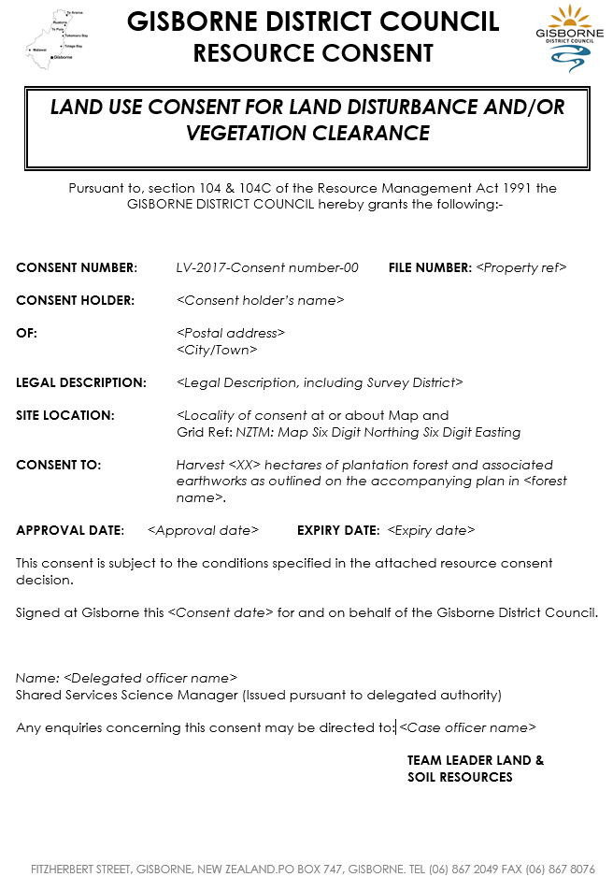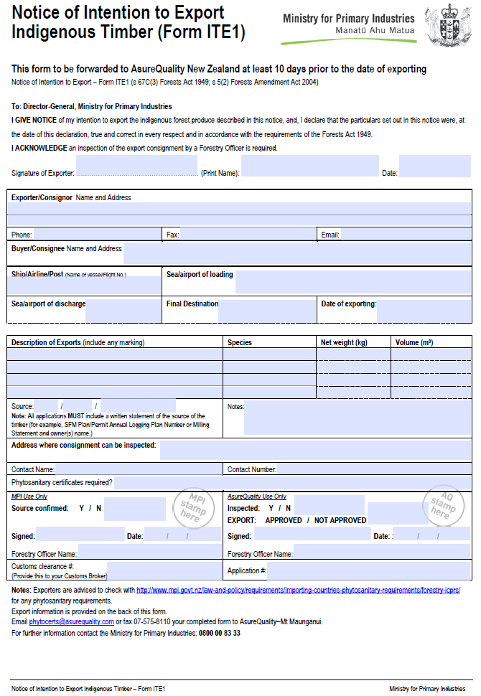
An example of a Harvested Wood Levy Statement issued by Levy Systems Ltd to companies subject to the mandatory industry levy charged on all harvested wood from plantation forests.

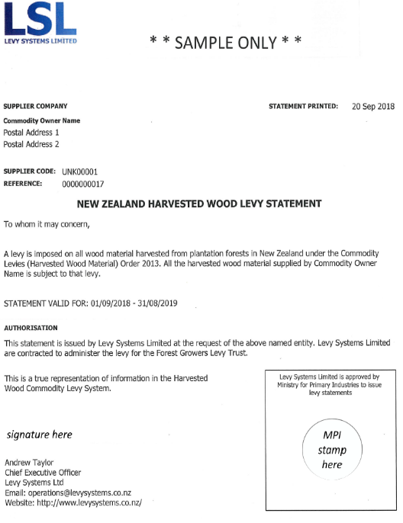

Who should I contact for further information?
Australian Government  Department of Agriculture, Water and the Environment  GPO Box 858, Canberra ACT 2601  Phone: +61 2 6272 3933  agriculture.gov.au/illegallogging  illegallogging@agriculture.gov.au | New Zealand Government  Ministry for Primary Industries  PO Box 2526  Wellington 6140  Phone: +64 4 894 0100  mpi.govt.nz/about-mpi/contact-us  mpi.govt.nz/forestry/forestry-in-nz/illegal-logging

