Bananas from the Philippines update

September 2026

Issue 6

This newsletter is to keep you updated on the assessment of alternative measures
for the importation of bananas from the Philippines.
For more information on the assessment, please visit our website: agriculture.gov.au/banana-Philippines.
In this issue
- Stage of the assessment
- ABARES project
- Draft report timeline
- Q&A: new webpage

You can read previous issues of the newsletter here.
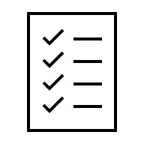

Stage of the assessment
We are currently at the 'assess biosecurity risk' stage of the assessment. There are several technical components that make up this stage as shown in the below diagram. We are continuing to progress these components.
In this and future newsletters, we will include a snapshot on the purpose of each technical component. Noting more information can be found in the issues paper.

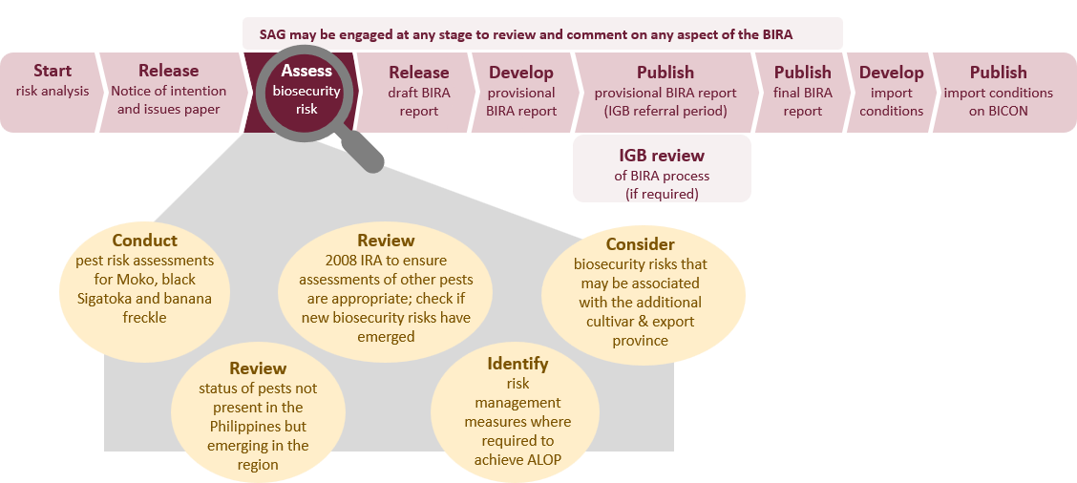
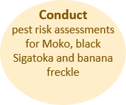
Conduct pest risk assessments for Moko, black Sigatoka and banana freckle – The focus of this component is conducting a comprehensive scientific assessment for the 3 main pathogens of concern. The objective of these pest risk assessments is to determine if the level of biosecurity risk posed by each pest/pathogen achieves Australia’s appropriate level of protection (ALOP), which is very low but not zero. If the risk does not achieve ALOP, we will then determine if there are any risk management measures that would reduce the biosecurity risk to meet Australia’s ALOP.
The risks posed by these pathogens will be assessed using our current methodology for pest risk analyses. This method is consistent with the International Standards for Phytosanitary Measures (ISPMs) that we adhere to as a member of the World Trade Organisation.


ABARES project
As we previously advised, the Australian Bureau of Agricultural and Resource Economics and Sciences (ABARES) are undertaking a project to examine the potential economic impacts key banana diseases could have if they were to become established in Australia. The diseases examined are Moko, black Sigatoka, banana freckle and Panama disease Tropical Race 4. This project is well under way and once complete, will inform the consequences part of the pest risk assessments.


Draft report timeline
We anticipate releasing the draft report in the first half of 2027, now likely around June, noting this timing is subject to change. We are considering all comments received on the issues paper and your feedback is helping to inform our draft report. The new release date of the draft report does not affect the BIRA timeline which must be completed within 30-months (noting the clock may be paused in specific circumstances).
We will release the draft report for a minimum 60-calendar day public consultation period. We will provide you with as much notice as possible ahead of the expected release date.
We will publish the proposed release date on our webpage and send a newsletter to notify you.


Questions and answers: new webpage
We remain committed to engaging with you throughout this assessment.
We will continue to publish responses to additional stakeholder questions asked at stakeholder engagement sessions on a dedicated ‘Questions and Answers’ webpage.
If you have a question on the assessment process you do not need to wait until the next engagement session. Email your question to plantstakeholders@aff.gov.au. We will continue to update the Q&A webpage throughout the process.

More information
- Webpage: agriculture.gov.au/banana-Philippines
- Register to receive regular updates: If you would like to receive regular updates on the bananas from the Philippines assessment, including this newsletter, please contact plantstakeholders@aff.gov.au
- Register to receive biosecurity advices: Subscribe to ‘Biosecurity Risk Analysis Plant’ via our online subscription service to receive Biosecurity Advices and other notifications relating to plant biosecurity policy: https://subscribe.agriculture.gov.au/subscribe
- To unsubscribe, please contact plantstakeholders@aff.gov.au

Acknowledgement of Country
We acknowledge the continuous connection of First Nations Traditional Owners and Custodians to the lands, seas and waters of Australia. We recognise their care for and cultivation of Country. We pay respect to Elders past and present, and recognise their knowledge and contribution to the productivity, innovation and sustainability of Australia’s agriculture, fisheries and forestry industries.
© Commonwealth of Australia 2026
Unless otherwise noted, copyright (and any other intellectual property rights) in this publication is owned by the Commonwealth of Australia (referred to as the Commonwealth).
All material in this publication is licensed under a Creative Commons Attribution 4.0 International Licence except content supplied by third parties, logos and the Commonwealth Coat of Arms.
The Australian Government acting through the Department of Agriculture, Fisheries and Forestry has exercised due care and skill in preparing and compiling the information and data in this publication. Notwithstanding, the Department of Agriculture, Fisheries and Forestry, its employees and advisers disclaim all liability, including liability for negligence and for any loss, damage, injury, expense or cost incurred by any person as a result of accessing, using or relying on any of the information or data in this publication to the maximum extent permitted by law.

