USER GUIDE

NEXDOC:
Obtaining an Export Declaration Number (EDN) through the Single Electronic Window (SEW) connection with the Integrated Cargo System (ICS)

__________________________________________________________________________________
In this document
This document contains the following topics.
Purpose of this document 2
How to ensure an Exporter ID is created for my products in the NEXDOC portal 2
Products tab 2
Exporter tab 5
Consignee tab 6
Transport tab 8
SEW tab 10
Contact the NEXDOC help desk. 11

Purpose of this document
The purpose of this document is to highlight the fields within the Request for Export (REX) application that must be populated to obtain an Export Declaration Number (EDN) via Single Electronic Window (SEW). These fields are provided to the Integrated Cargo System (ICS), via SEW, and return an EDN to the exporter.
With these fields populated, on lodging the REX you will receive a notification in your NEXDOC inbox confirming the ICS connection and your EDN.
The fields below need to be populated before lodging your REX.
Note: This guide will not outline how to lodge a REX. It will show the fields within the workflow that are necessary for an EDN.

How to ensure an Exporter ID is created for my products in the NEXDOC portal

Products tab
Step 1  In Section 2, when adding a product for export, you will need to ensure you have provided the AHECC and the Gross Weight.  Note: The appropriate AHECC codes will be visible in the AHECC drop down field. Simply select the available option. | 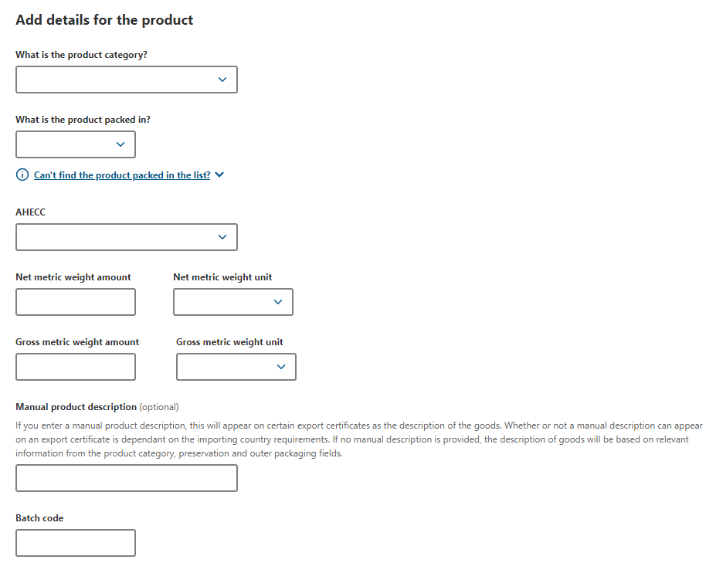
Step 2  Scroll down the Products and select the SEW tab. | 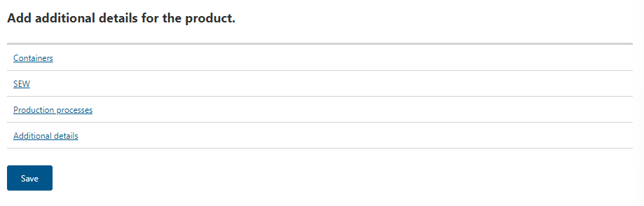
Step 3  Insert the Net Weight Amount, Net Weight Unit and FOB amount.  Select Save. | 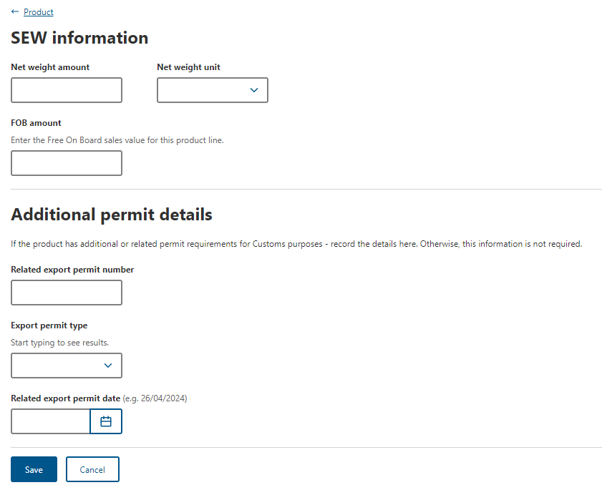
Step 4  Select the Additional Details tab. | 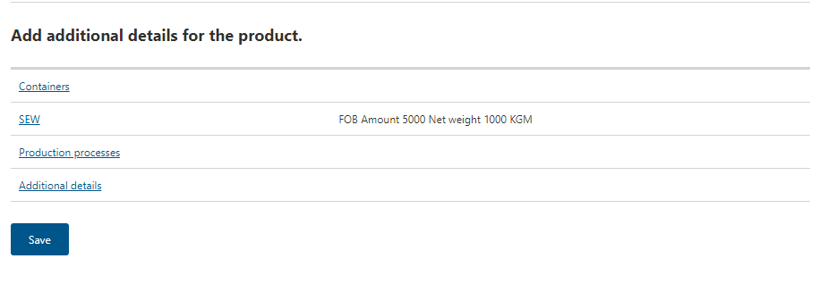
Step 5  Select the Product Source State drop down field and select the appropriate State or Territory.  Select Save. | 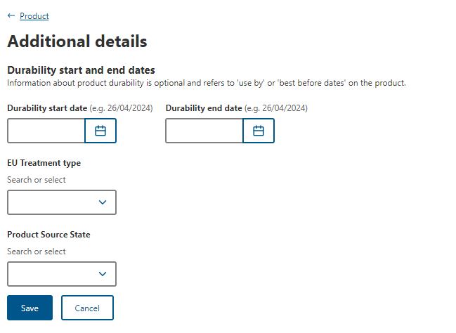
Step 6  Select Save. | 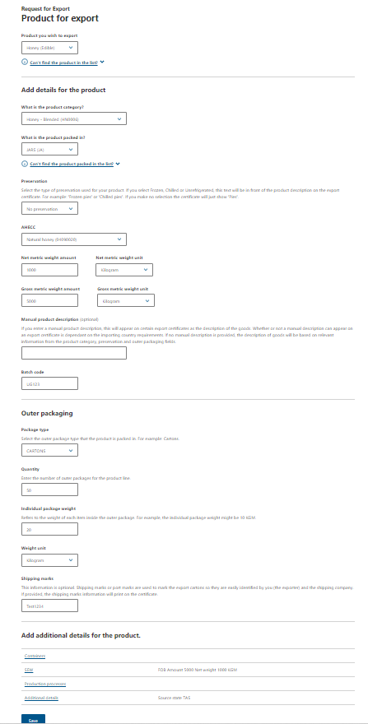

Exporter tab
Step 1  Select the Exporter tab. | 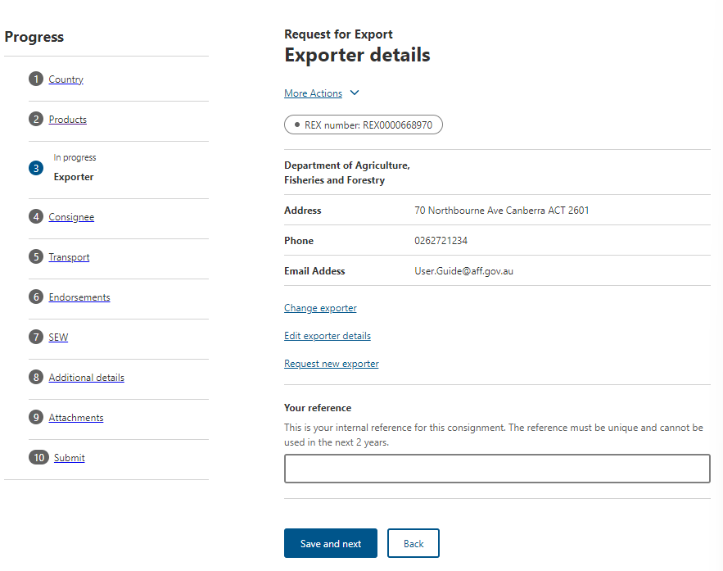
Step 2
Type your exporter reference in the Your reference field.

Select Save and next.

Consignee tab
Step 1  Select the Consignee tab | 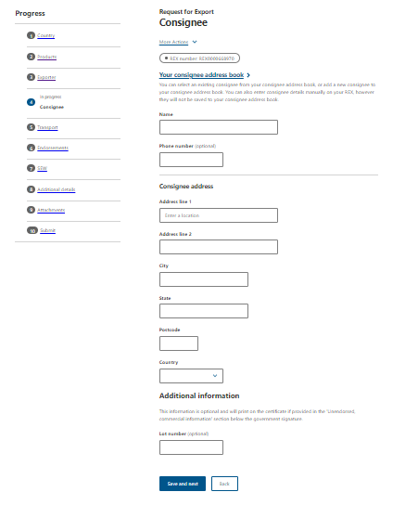
Step 2  Type the Consignee Name in the name field. | 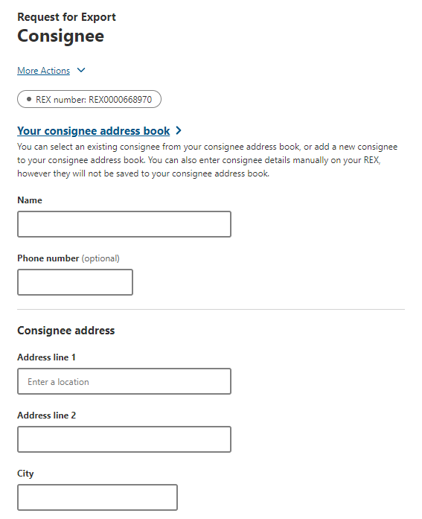
Step 3  Type the Consignee Address in the address field.  Select Save and next. | 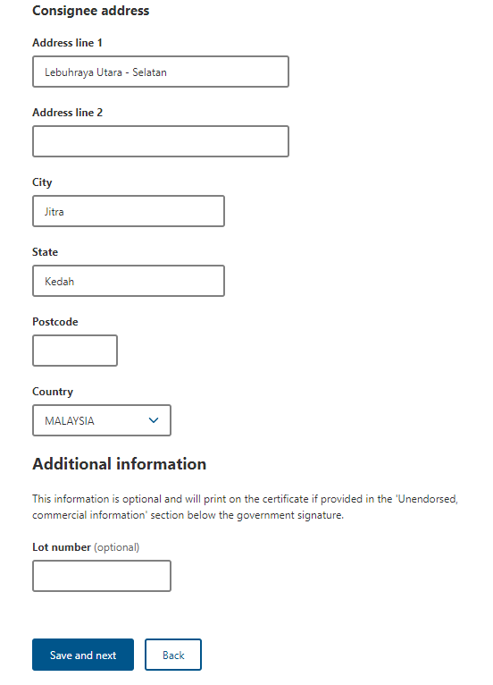

Transport tab
Step 1  Select the Transport tab | 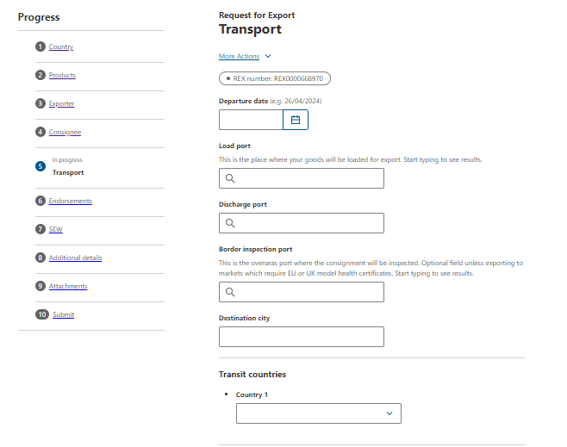
Step 2  Click on the Departure date field.  A pop-up calendar will appear.  Select a date from the calendar. | 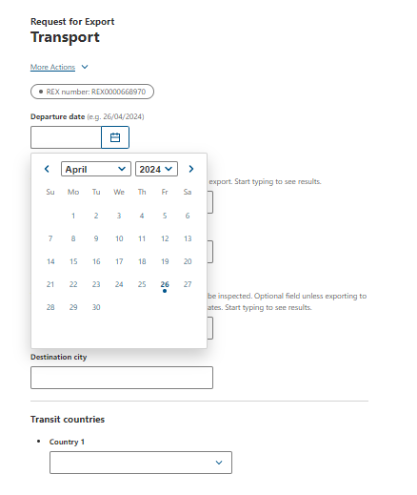
Step 3  Select the Load port field. Type the load port. | 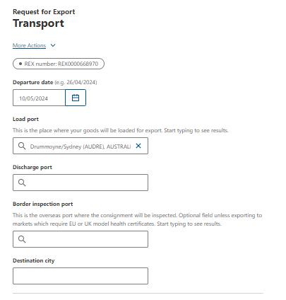
Step 4  Select the Discharge port field. Type the discharge port. | 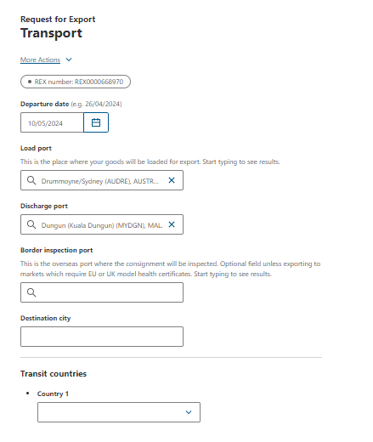

SEW tab
Step 1  Select the SEW tab | 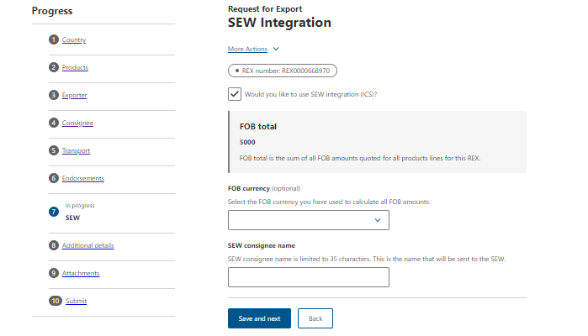
Step 2
Select the SEW integration box is ticked.

Step 3  Select the FOB currency.  Select Save and next. | 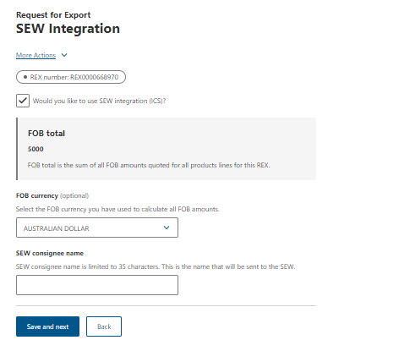
The above fields are required to be populated before lodging your REX.
Once lodged you will receive a notification in your NEXDOC inbox confirming the ICS connection and your EDN.
Please note, this notification can take 5-10 minutes to generate in your NEXDOC inbox.

Contact the NEXDOC help desk.
For more information or assistance, please contact NEXDOC@aff.gov.au

