Lodge a Request for Export (REX) to obtain the NX188B or NX188M certificate
The below guide shows how to lodge a Request for Export (REX) in NEXDOC for the NX188B or NX188M export certificates.
This guide assumes that you have already registered as an Other Goods exporter in NEXDOC.
- If you have not yet registered as an NEXDOC exporter, please refer to the Create a NEXDOC Exporter Account pdf or docx guide.
- If you are registered as a NEXDOC exporter, but need to add Other Goods to your exporter account, please refer to the Add or Remove Exporter to Exporter Account pdf or docx guide.

Log in to the Online Services Portal
Go to the Online Services Portal and click on the Login button. | 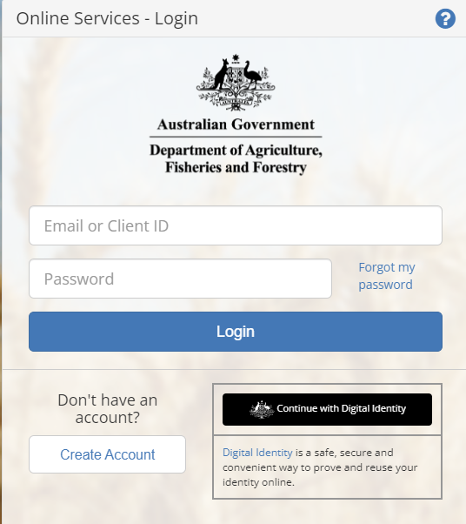

NEXDOC Portal Homepage
Click on the Lodge a Request for Export (REX) link. | 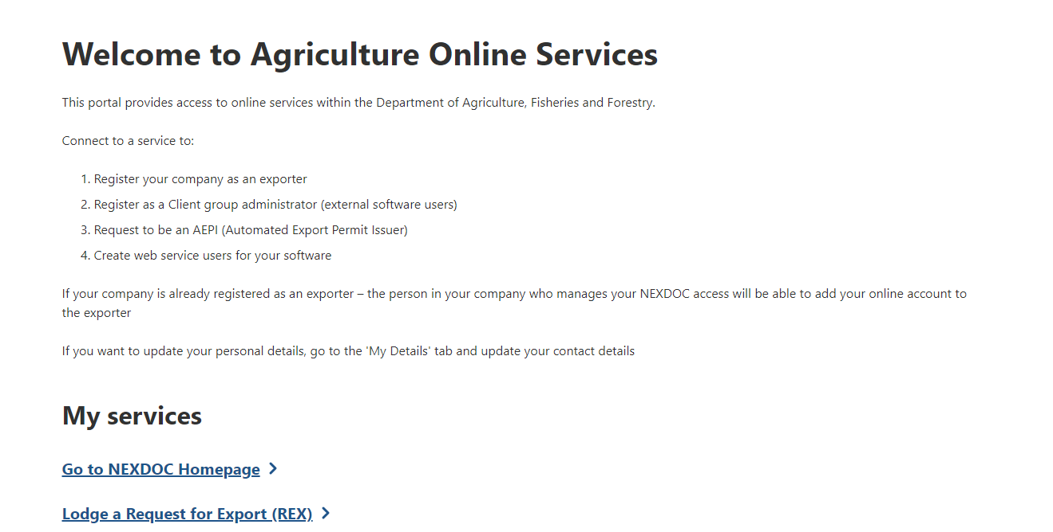

Start a new request for export (REX)
Step 1  Select Other Goods from the Commodity type of your export drop down menu | 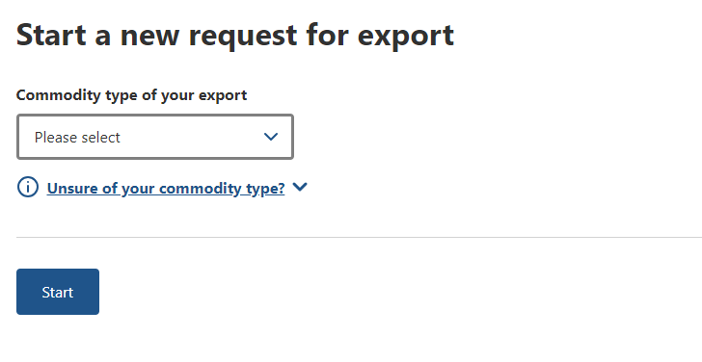
Step 2  Read the Other Goods product information now displaying.  If the product information does not apply to your goods, please check the Manual of Importing Country Requirements (Micor) or contact the department for advice.  If the product information applies to your goods, continue to Step 3. | 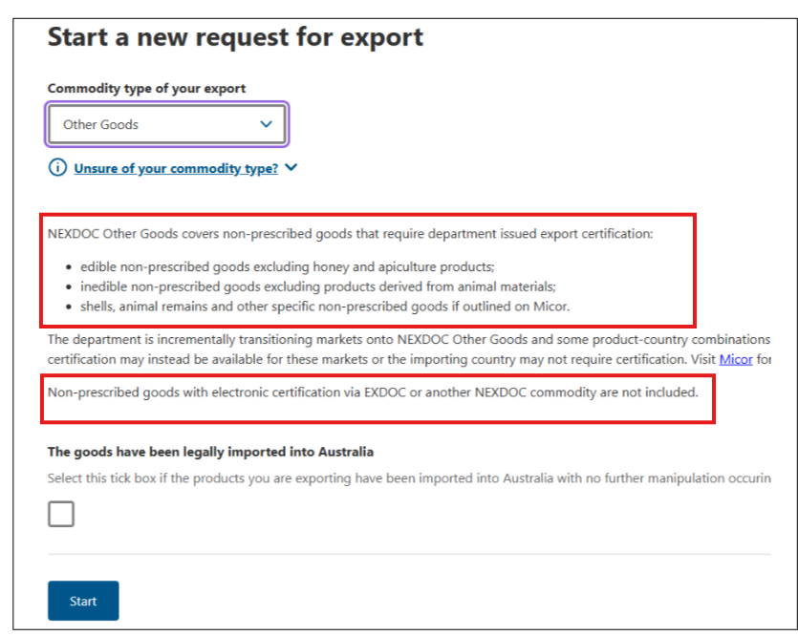
Step 3  If you are exporting imported goods:  - Select the checkbox.  - Refer to the OTHER GOODS – How to lodge a Request for Export (REX) for NX418 on the NEXDOC help page.  If you are exporting goods that have not been imported to Australia:  - Leave the checkbox blank.  - Click on the Start button. | 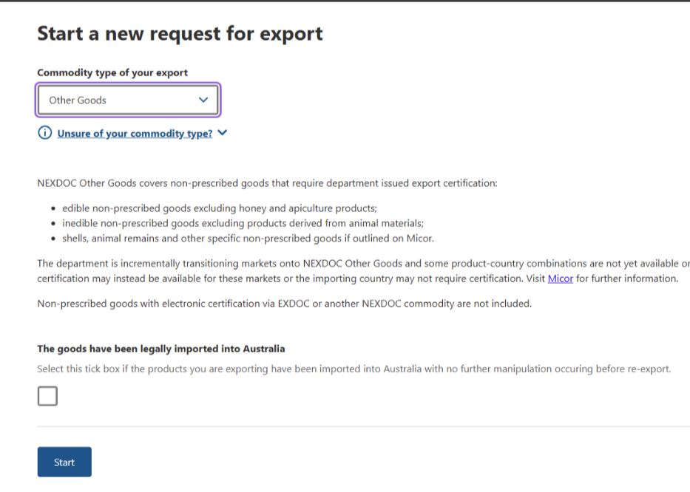

REX Section 1: Country
Select the destination country from the Country you wish to export to drop down menu.  Click on the Next  button. | 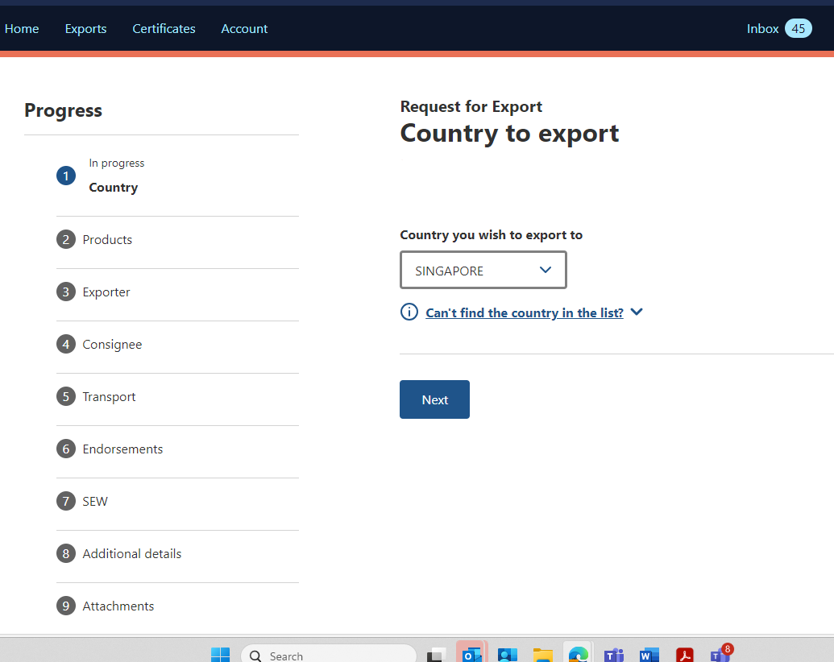

REX Section 2: Products
Step 1  In this step, you declare the number of product lines you have for export.  Note: The number of lines you have for export will affect the steps you need to follow.  If you have less than 20 lines:  - Select the Less than 20 lines radio button.  - Click on the Add a product to export link.  - Go to Step 4.  If you have 20 lines or more:  - Select the 20 or more product lines radio button.  - Go to Step 2. | 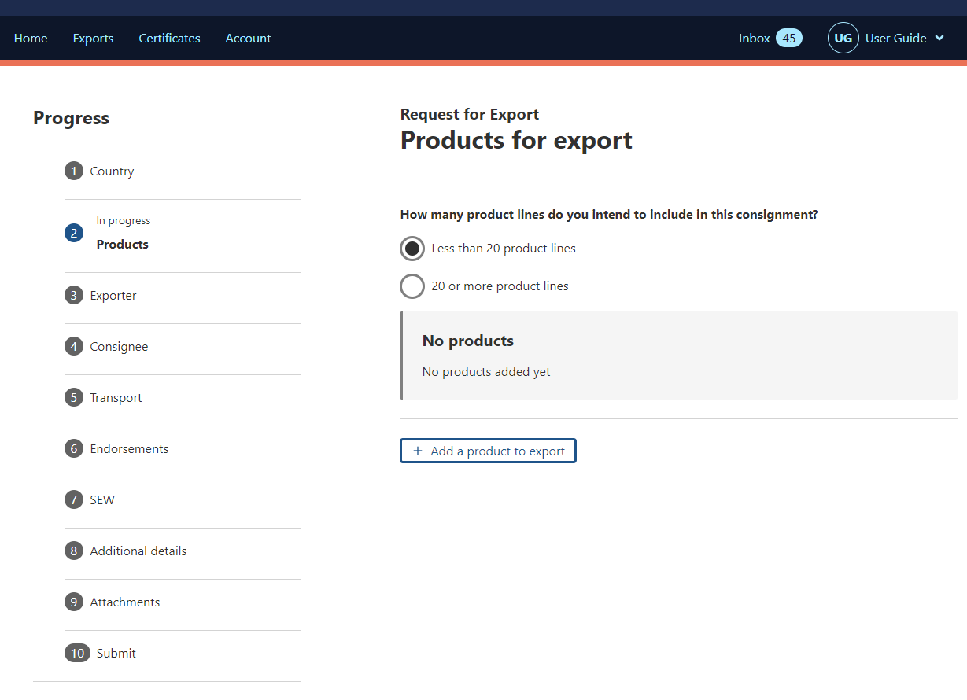
Step 2  There are two options for supplying the product details for a REX of 20 or more lines.  Option 1: Entering lines individually  This option involves more data entry but allows you to use the Single Electronic Window (SEW) connection to obtain your export declaration number (EDN).  To enter lines individually:  - Click on the Add a product to export link  - Go to Step 4.  Option 2: The packing list function  The packing list involves entering product information into a table, and you can paste data in from your own spreadsheet. If you use the packing list, you will not be able to use SEW to obtain your EDN.  To use the packing list option:  - Click on the Add multiple products using a packing list link  - Go to Step 3. | 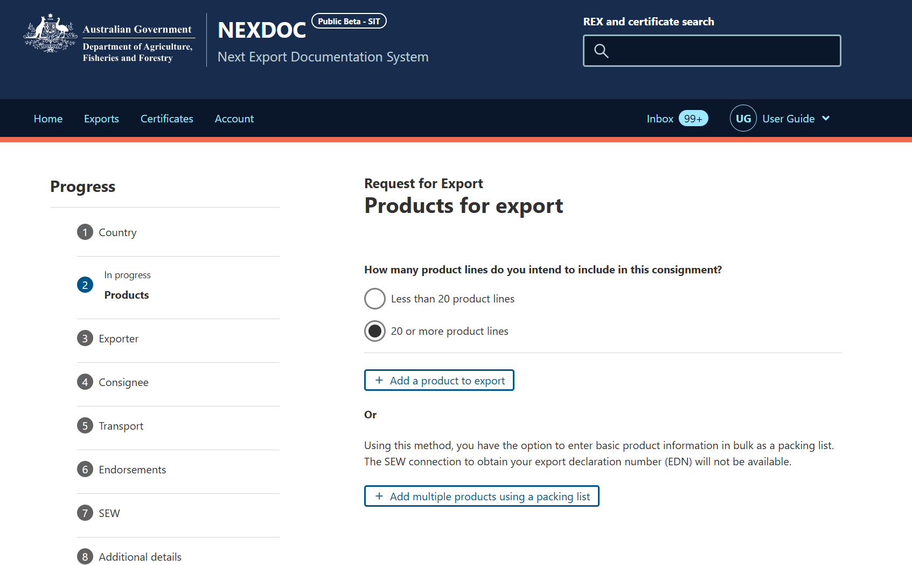
Step 3  Enter your packing list information into the table by either:  - Entering the information directly into the table  - Creating the packing list in your own spreadsheet software and then copying and pasting it into the table.  Once you have entered the information, click Save and next.  The system will return you to the Products for Export screen, where you have the option to view and edit the product list.  When your products are all entered correctly, proceed to REX Section 3: Exporter details | 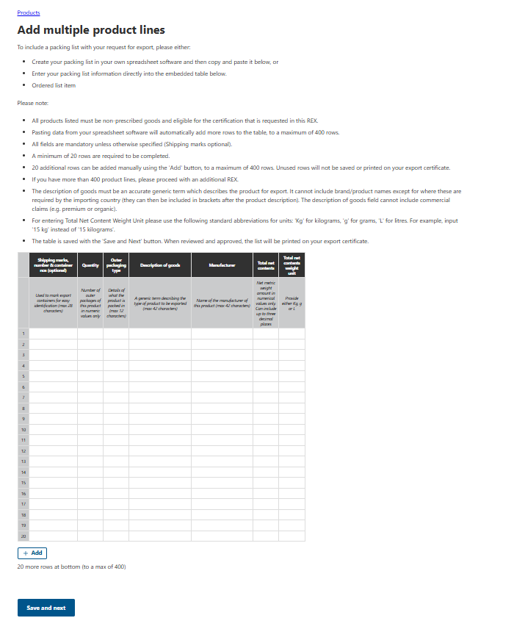
Step 4  Select the Product you wish to export drop down and choose the relevant product group type.  This is a mandatory field.  Note: There is information at the top of the screen on the different product groups within the Other Goods commodity. | 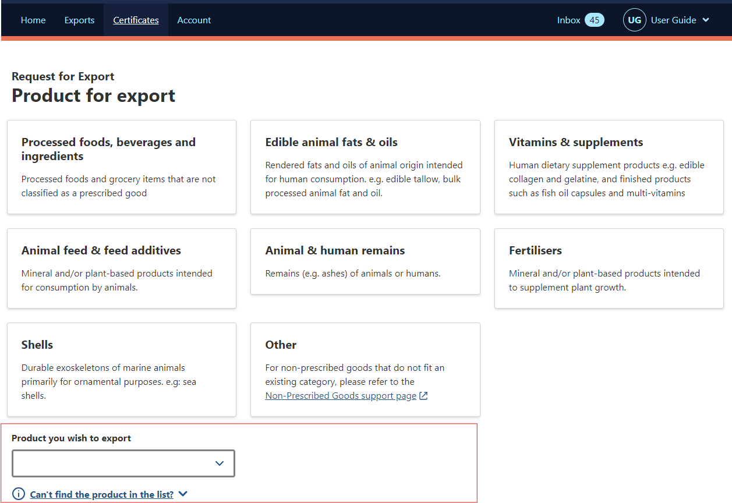
Step 5  Select a suitable option from the What is the product category? drop down menu.  Note: You can type in the box to narrow down the categories displayed.  This product category will appear on your export certificate as the Description of Goods.  This is a mandatory field. | 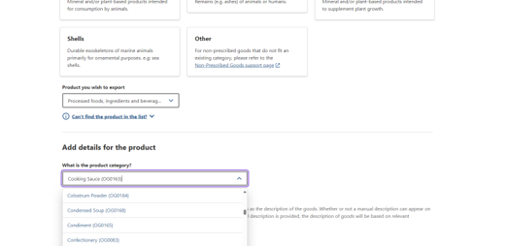
Step 6  If you wish to provide a more specific description of your product, you can use the optional Manual product description field.  If provided, the text in this field will appear on your export certificate as the Description of Goods.  This is an optional field and will override the product category description selected in step 5. | 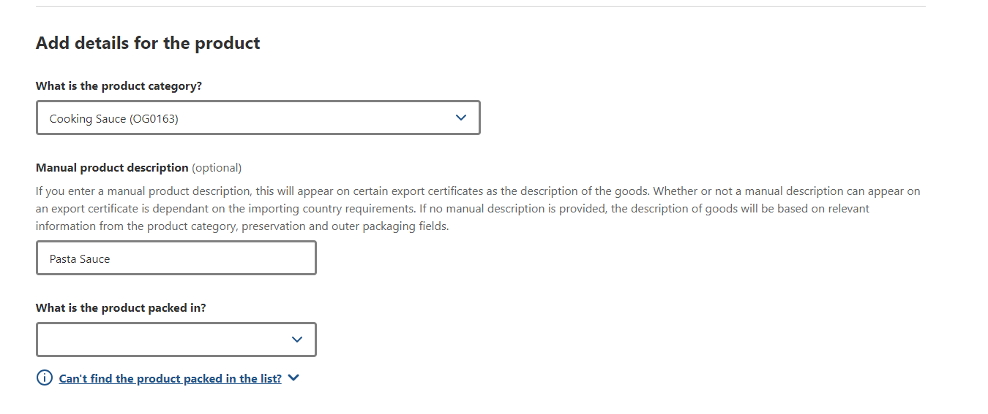
Step 7  Select a suitable option from the What is the product packed in? drop down field.  This is a mandatory field. | 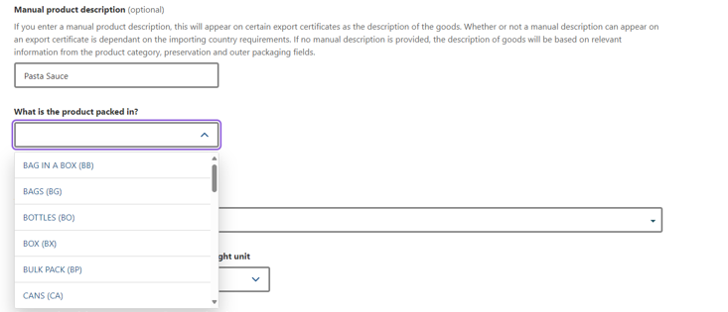
Step 8  Select the Preservation type for the product.  This is a mandatory field. | 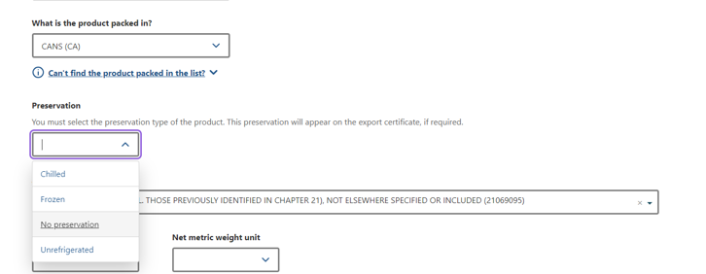
Step 9  Select the relevant AHECC code for the product.  This is an optional field but becomes mandatory if you are using the Single Electronic Window (SEW) connection to obtain an Export Declaration Number (EDN) via NEXDOC. | 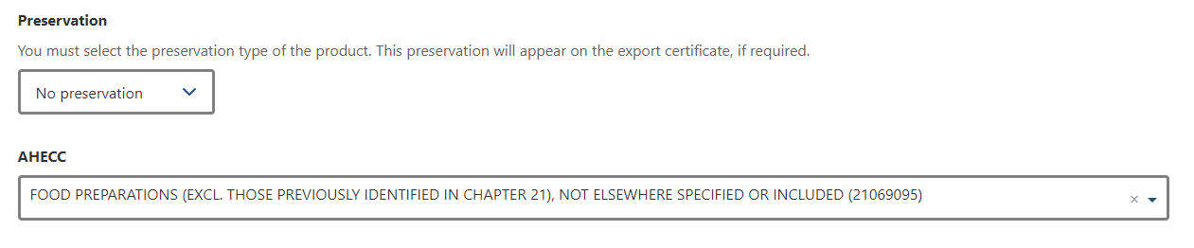
Step 10  Provide the Net metric weight amount and the Net metric weight unit.  These fields are mandatory.  The Gross metric weight amount and Gross metric weight unit are optional fields but become mandatory if you wish to use SEW to obtain your EDN.  All weight fields must equal more than zero. | 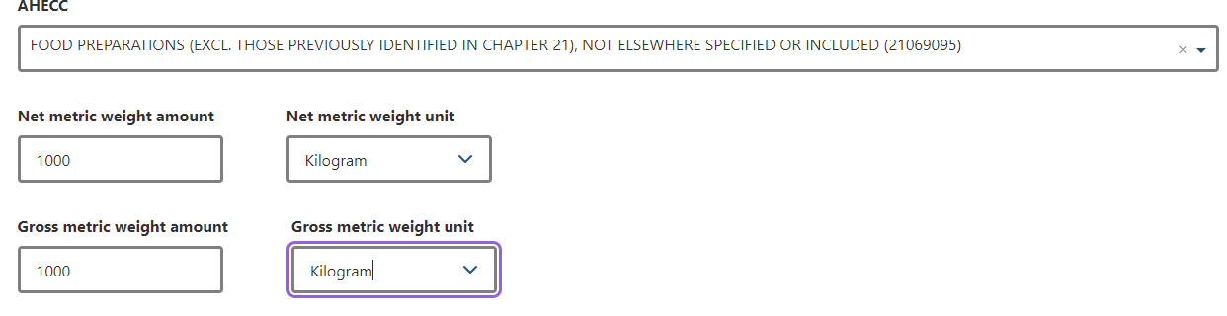
Step 11  Provide the Batch Code.  This field is optional and will appear on your certificate, if provided.  This field has a limit of 30 characters. | 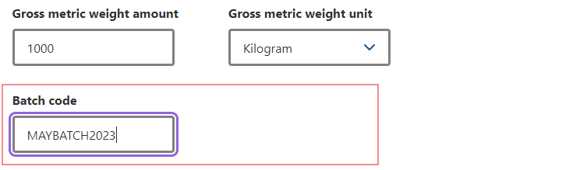
Step 12  Provide the Outer packaging details.  The Package type, Quantity, Individual package weight, and Weight unit are mandatory fields.  These details will appear alongside the Category type and Preservation type on the certificate unless you provide a Manual product description. | 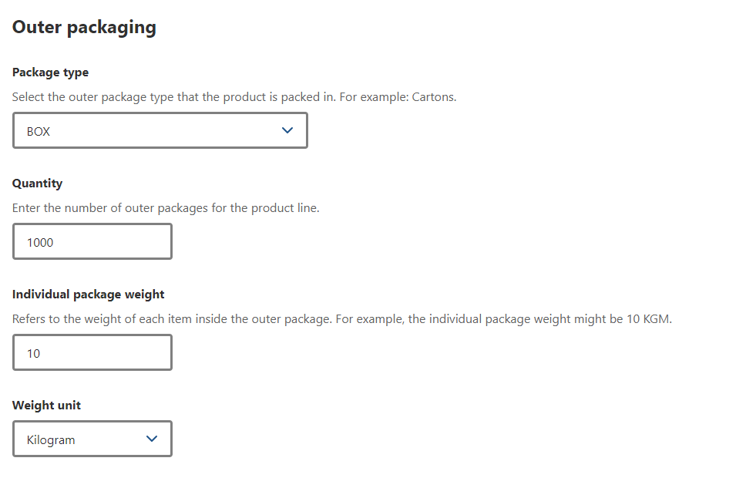
Step 13  Provide the Shipping marks.  This field is optional and has a limit of 30 characters. | 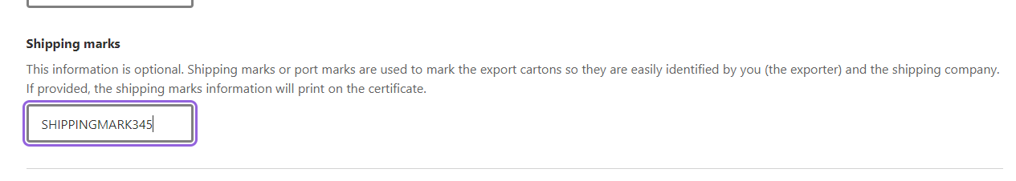
The below information relates to the Additional details of the product.

Details relating to Containers are optional.  SEW fields are optional. However, the Net weight amount, Net weight unit and FOB amount fields become mandatory if you are using SEW to obtain your EDN.  Details relating to the Production processes are mandatory.  Additional details are optional. In this tab, the Product Source State field becomes mandatory if you wish to use SEW and obtain your EDN. | 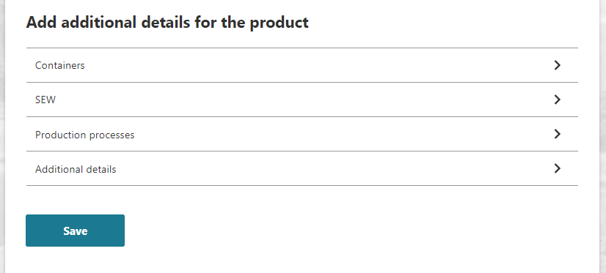  Mandatory if SEW is required.  Mandatory  Optional  Optional  Optional
Step 14  Scroll down to Add additional details for the product and  click on the Production processes link. | 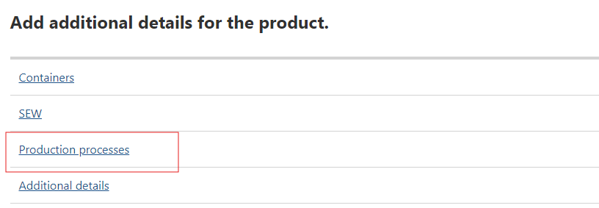
Step 15  Provide the free text Manufacturer name and enter the Manufacturer Address details.  These are the only mandatory field for markets requiring the NX188B or NX188M certificate.  All other fields are optional. | 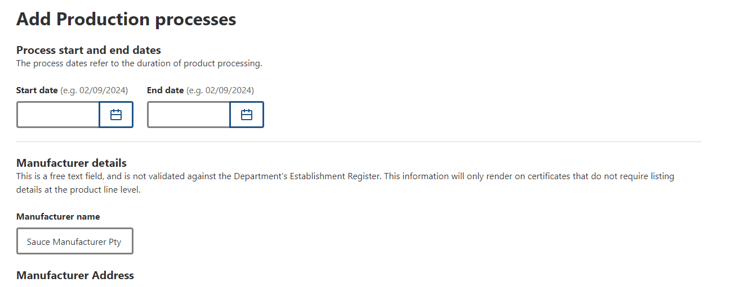
Step 16  Click the Product link to go back to the product screen | 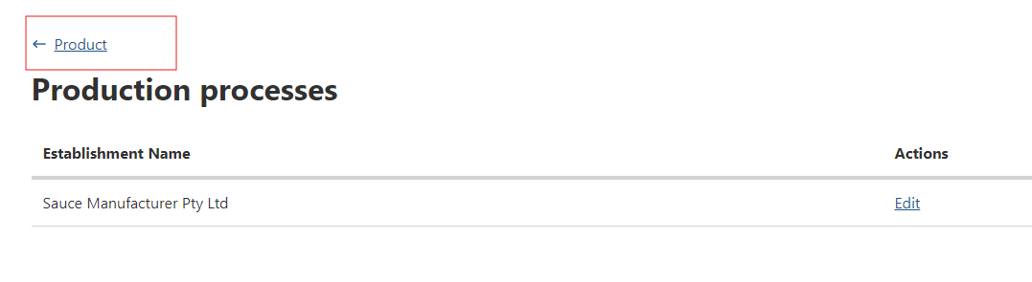
Step 17  You will return to the Product screen. | 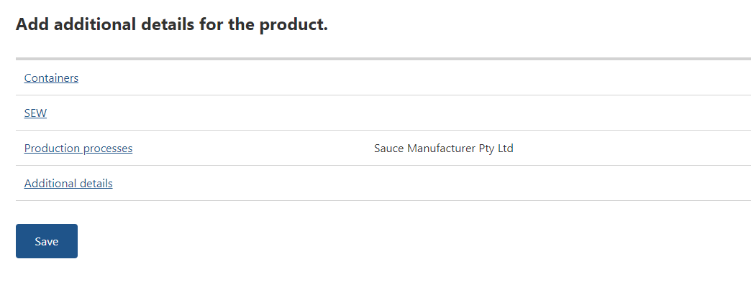
Step 18  Container details are optional.  Note: If you decide to provide container details for one product line, you must provide them against all product lines.  - If you wish to add container details, click on the Containers link.  - If you do not wish to add containers, go to Step 22. | 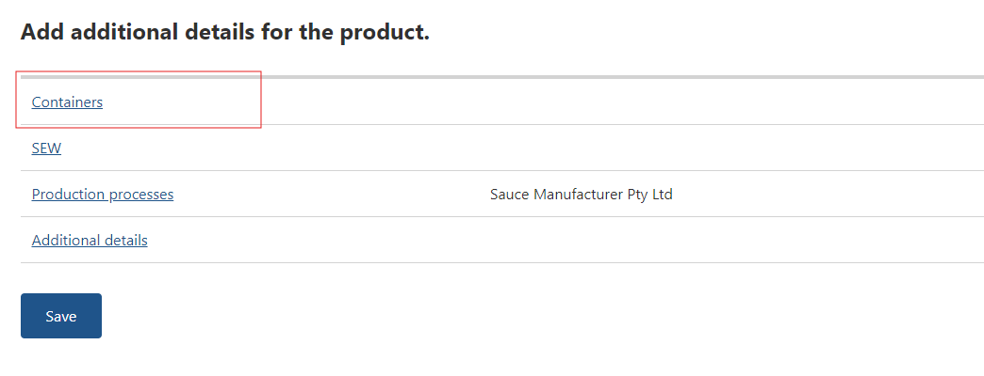
Step 19  Select the relevant type of freight container then select Add container.  If your container is:  - air freight, go to Step 20.  - sea freight, go to Step 21. | 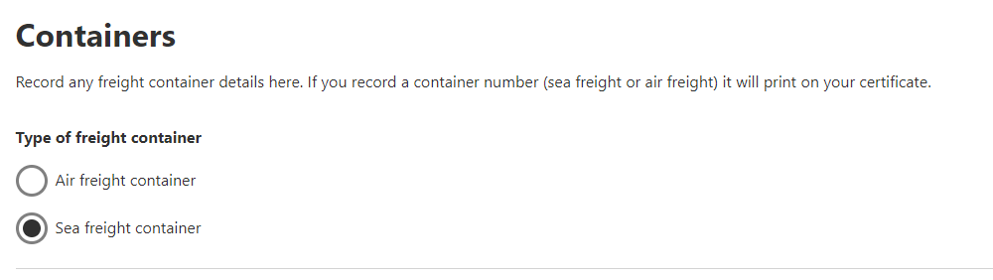
Step 20  Enter the air freight container number in the Container number field.  If seal numbers are available, select Add seal number and enter the Start and End seal numbers.  Select Add and go to Step 22.  Note: It is optional to provide air container number details. | 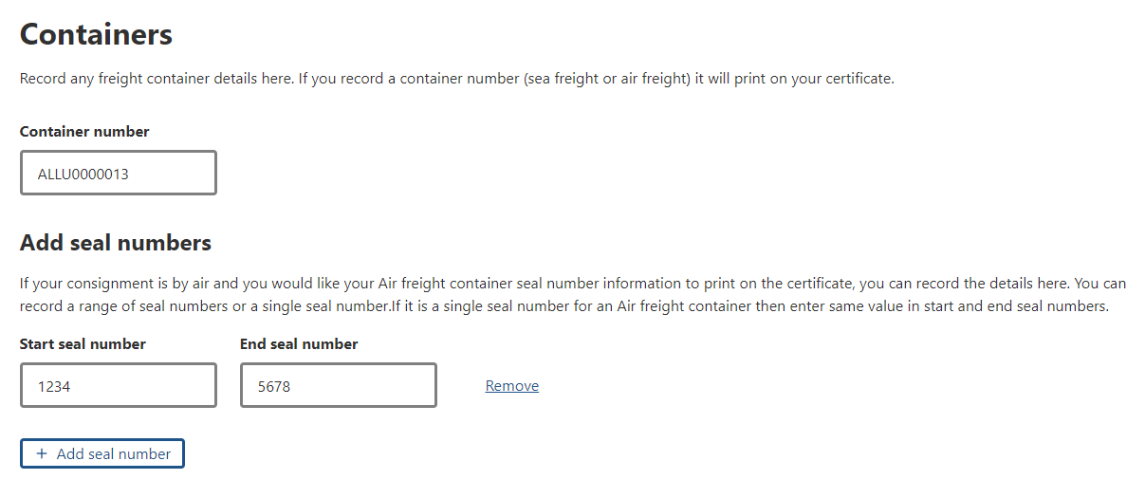
Step 21  Enter the sea freight container number in the Container number field.  Select Add seal number and provide the details.  Note: It is optional to provide sea container number details. | 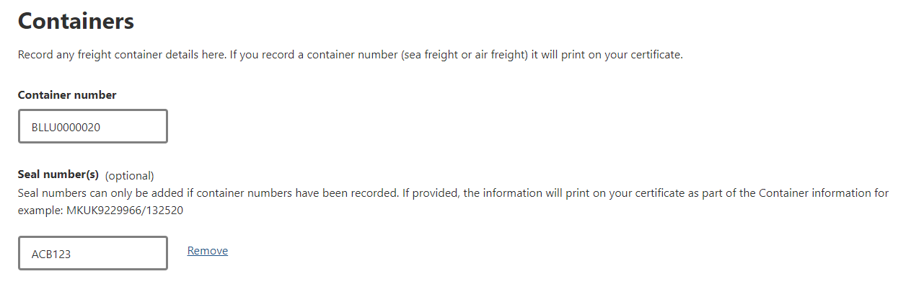
Step 22  SEW information is optional.  - If you wish to obtain your EDN through NEXDOC, select SEW.  - If you do not wish to obtain your EDN through NEXDOC, go to Step 24. | 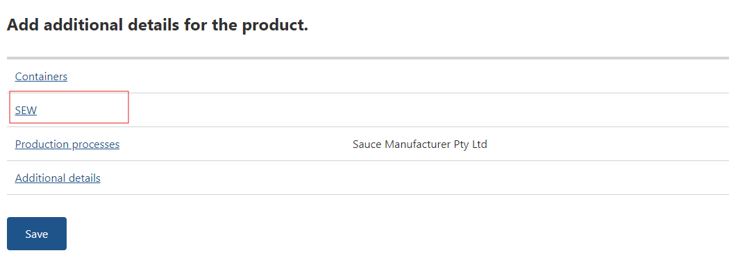
Step 23  To obtain your EDN through NEXDOC, you must provide the Net weight amount, Net weight unit and FOB amount.  Select Save. | 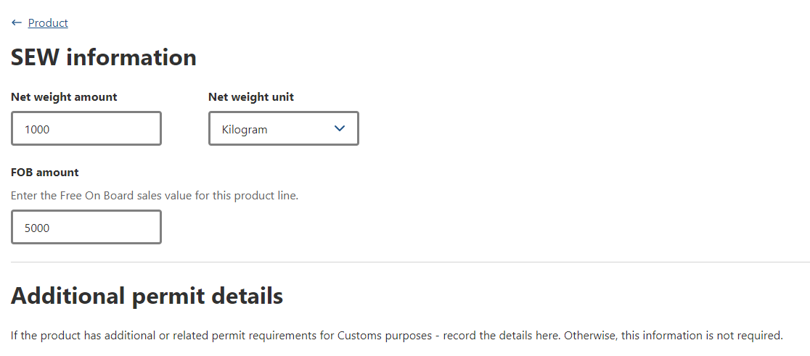
Step 24  Once you have provided all the necessary information, select Save. | 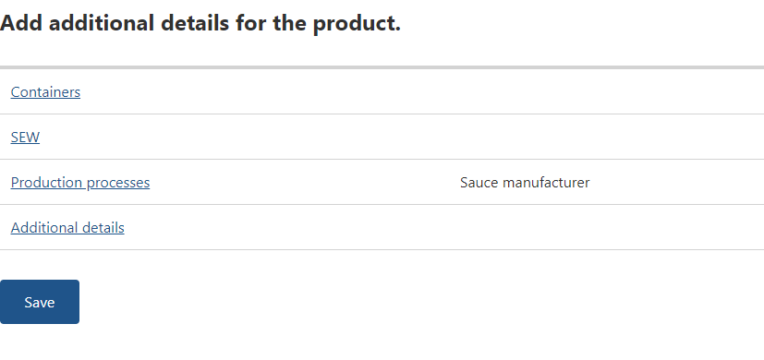
Step 25  You will return to the Products for export page.  If you need to add another product line, select either Add another product to export or Copy a product line.  If you copy an existing product line, NEXDOC will copy all base information and allow you to amend any unique information, such as the batch number.  Once you have all product line information saved, select Next. | 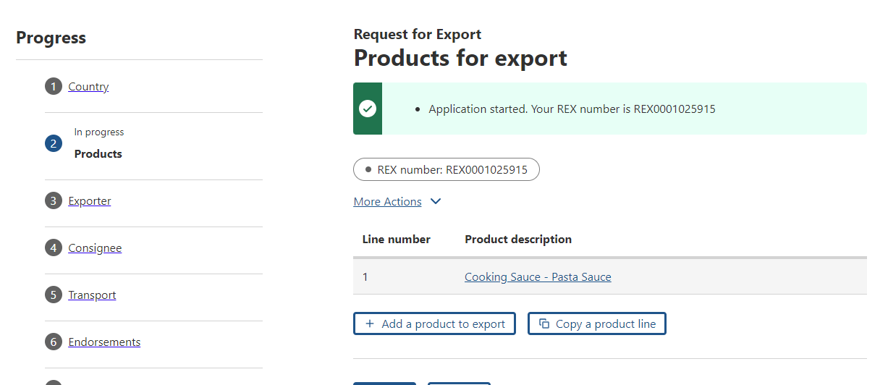

REX Section 3: Exporter Details
Exporter details are prepopulated from your NEXDOC exporter registration.  If you need to update these details, select Edit exporter details.  Provide your Exporter Reference.  This is a mandatory field and limited to 35 characters. This will assist you in identifying the REX. The exporter reference will also appear on your invoice.  Select Save and next. | 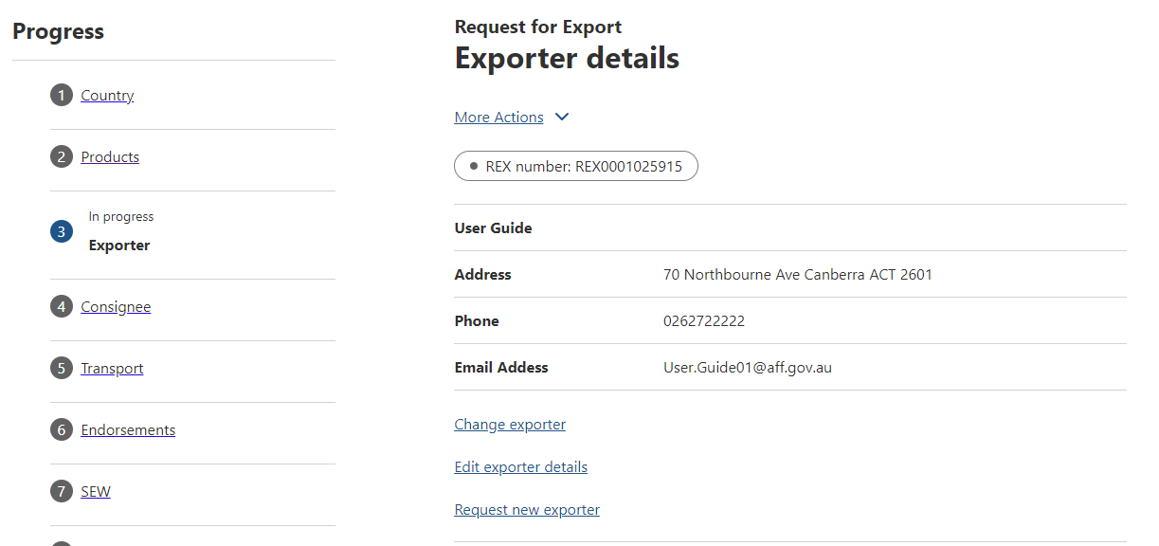

REX Section 4: Consignee Details
Step 1  Provide the consignee Name. This is a mandatory field.  Provide the consignee Phone number, if known.  This is an optional field.  Provide the Consignee address. This is a mandatory field.  Select Save and next.  Note: While you can enter consignee details manually per consignment, you can also add consignee details to the consignee address book for future use.  If you wish to add an address to the consignee address book, go to Step 2. | 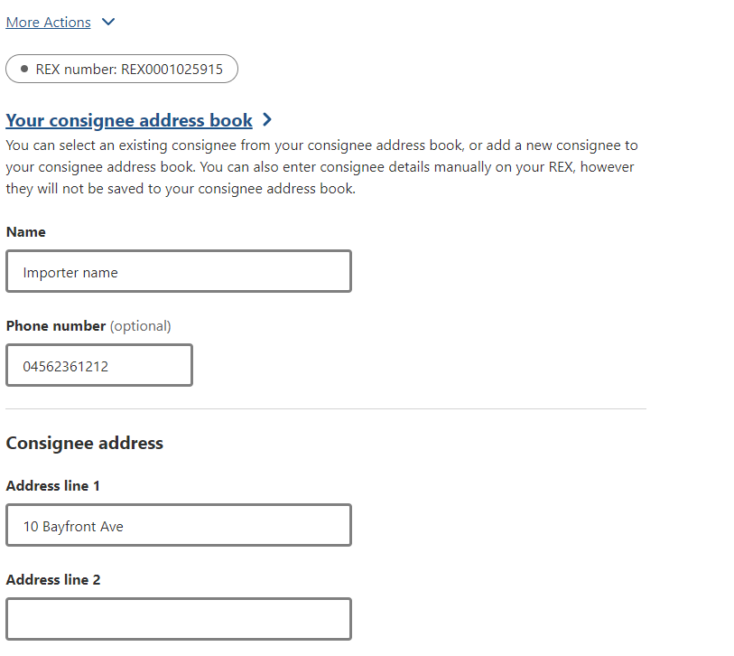
Step 2  To add a consignee, click the Your consignee address book link. | 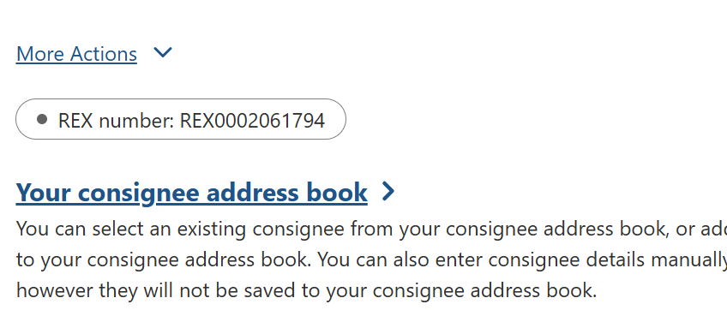
Step 3  Select Add consignee.  Enter all relevant details and select Save. | 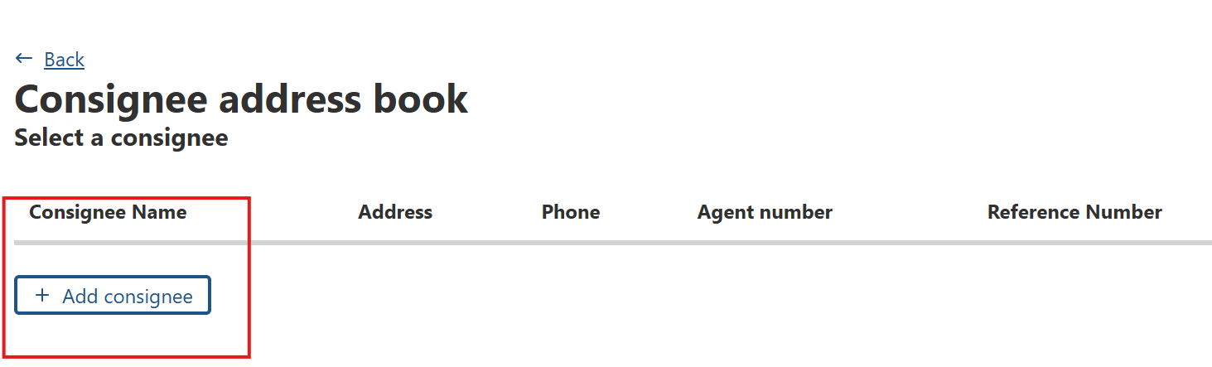

REX Section 5: Transport Details
Step 1  Enter the Departure date. This is a mandatory field.  Select the Load port. This is a mandatory field.  Select the Discharge port. This is a mandatory field.  The Border inspection port is an optional field  Provide the Destination city. This is a mandatory field. | 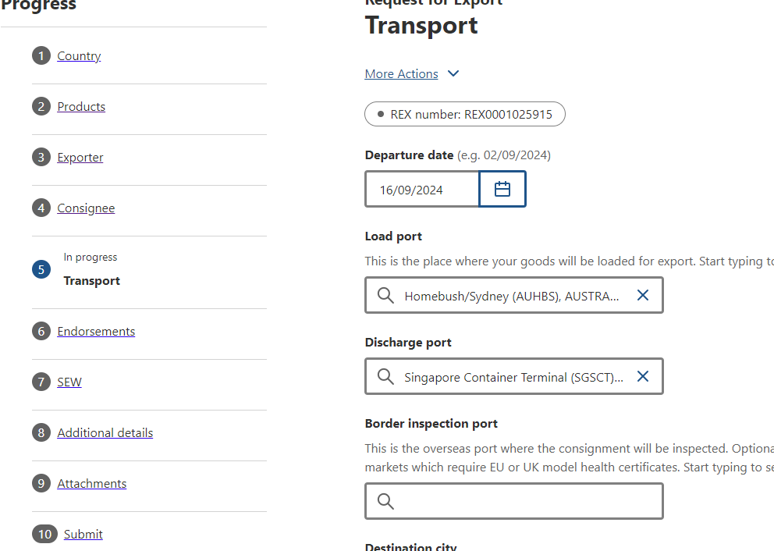
Step 2  Select the Transport mode. It is mandatory to select one of Sea, Air or Mail.  - If you select Mail, go to Step 4.  - If you select Air, go to Step 3.  - If you select Sea, provide the Vessel name and Voyage. These are mandatory fields. Then go to Step 4. | 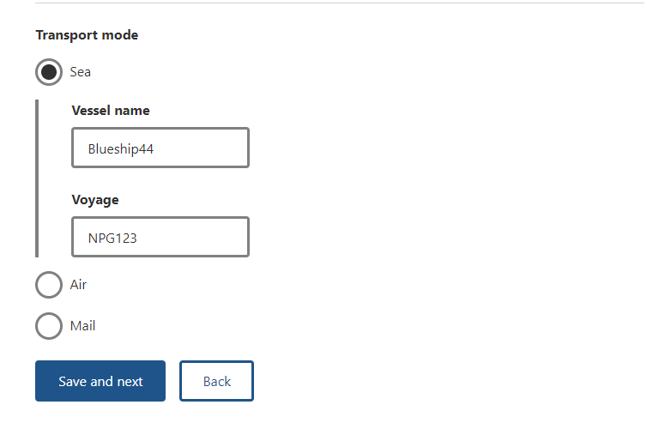
Step 3  If you select Air, you must provide the Flight Number. This is a mandatory field. | 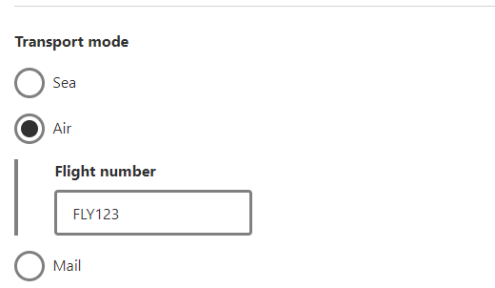
Step 4  Select Save and next. | 

REX Section 6: Templates and Endorsements
Step 1  NEXDOC will automatically allocate you an appropriate template and endorsement, if applicable.  It is your responsibility to check that the template and endorsement combination is appropriate for your market.  - If you would like to change the template and endorsement for a line, go to step 2.  - Otherwise, go to step 4 for information on free text endorsements. | 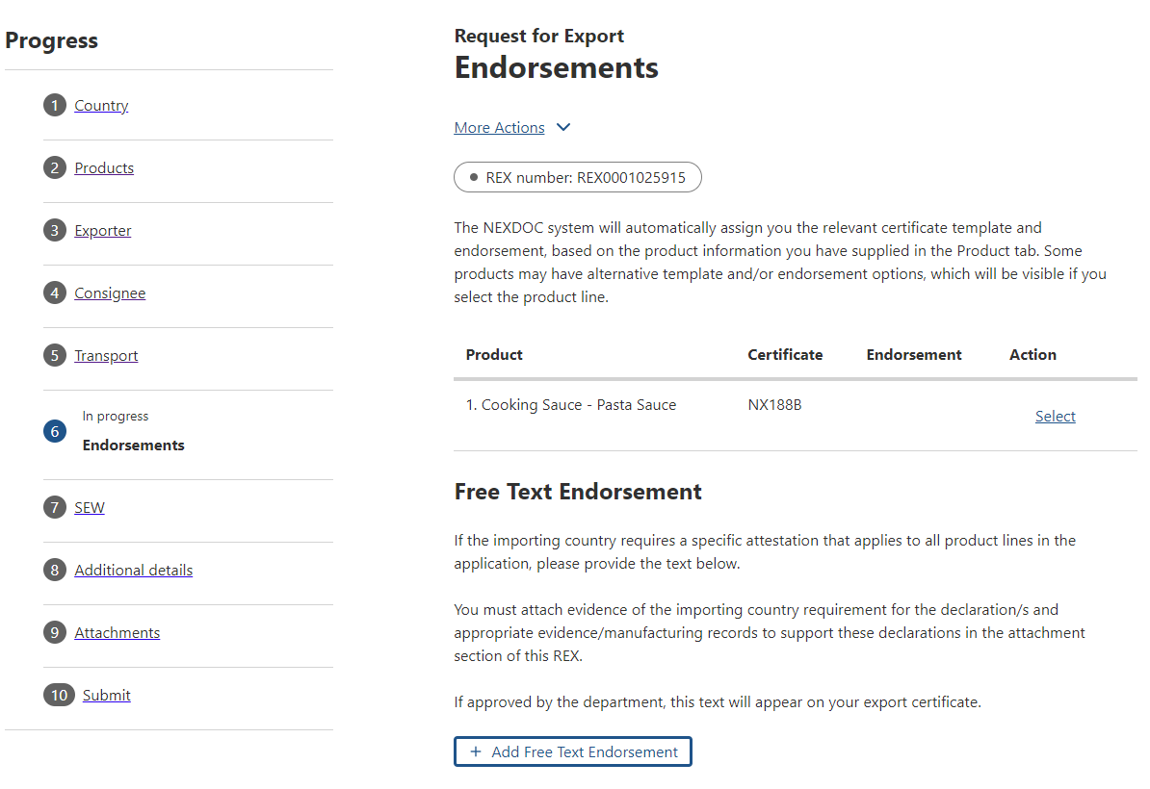
Step 2  If you would like to change the template and endorsement, click the Select link. | 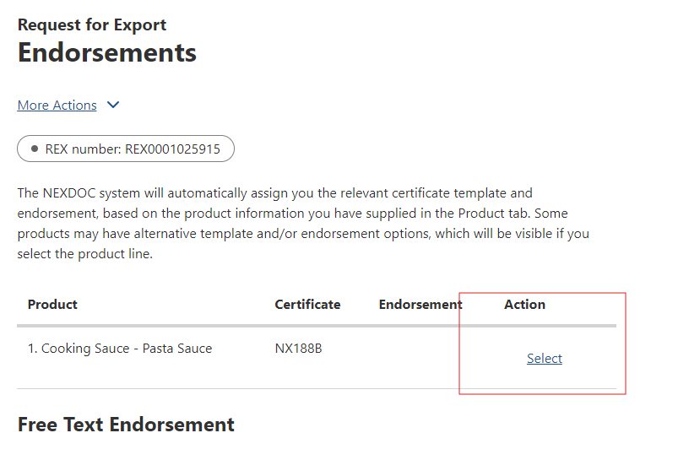
Step 3  Select Certificate Template drop-down and the Endorsement drop down to view available options.  If you have selected a change,  press Save. | 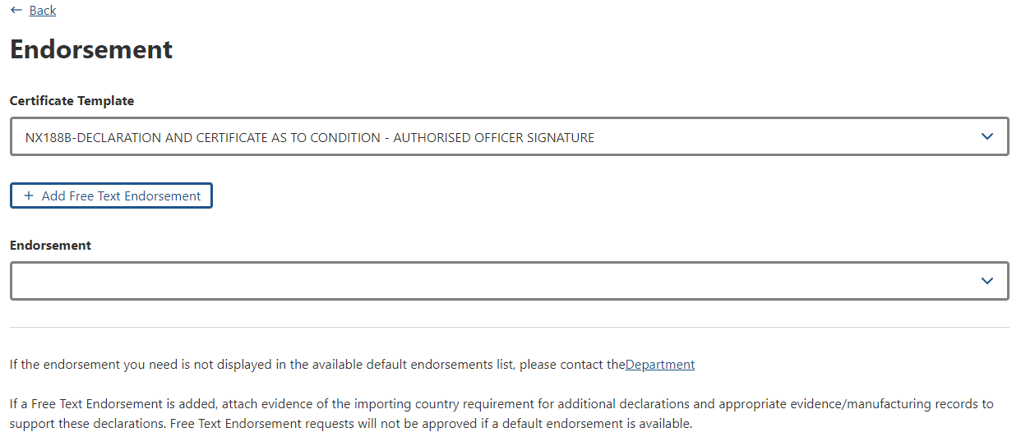
Step 4  NEXDOC will allocate negotiated and/or known endorsements. However, if you have evidence of the importing country requiring an endorsement not available in the system, you can provide this text via the Add Free Text Endorsement function.  This will generate a Free Text Endorsement request for the department to review and approve before it can appear on your export certificate.  If you wish to request a free text endorsement, go to Step 4. Otherwise, go to Step 6. | 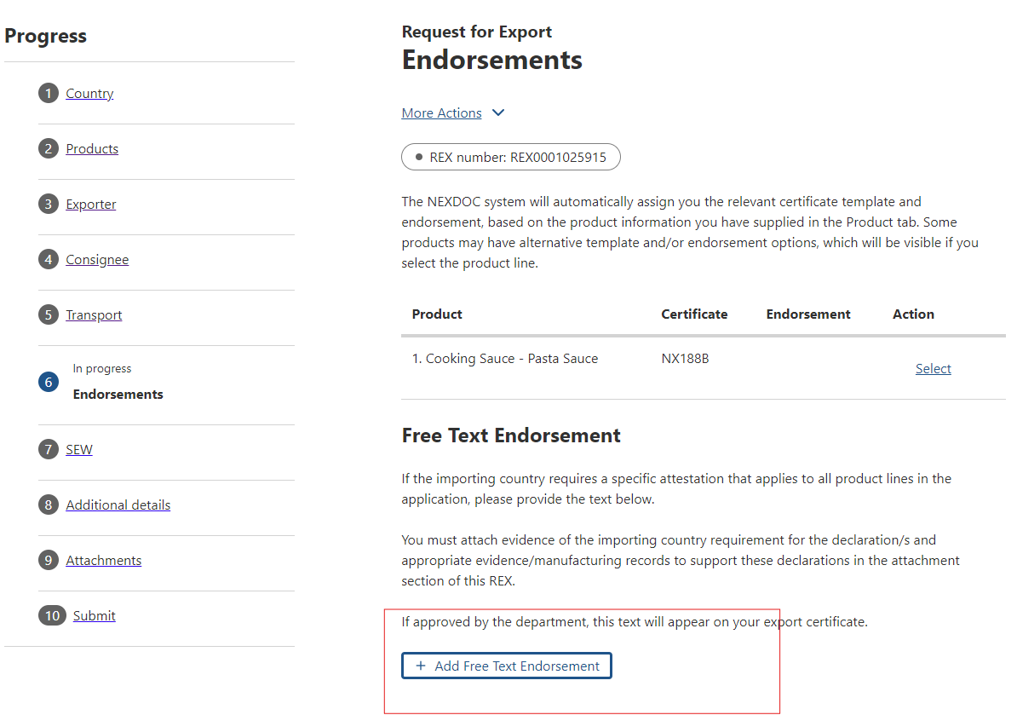
Step 5
Check that the free text endorsement you are requesting is applicable to all lines in your REX application.
Note: The free text endorsement applies to the whole REX, meaning only one certificate will generate with all products listed against this endorsement.
- If the free text endorsement applies, then click on Add Free Text Endorsement.
Note: If a free text endorsement is included in the REX, you must also attach evidence of the endorsement in the Attachments tab.

Step 6  Once you have confirmed the template and/or endorsement combination, select Next. | 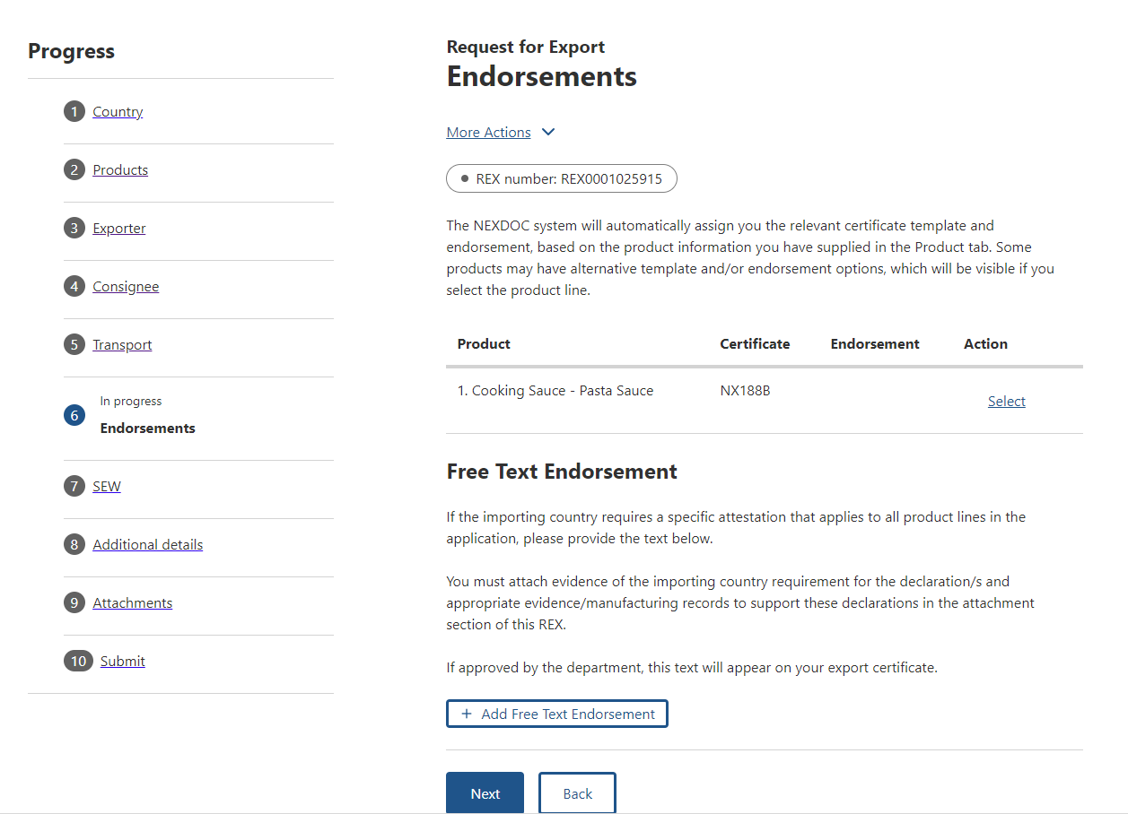

REX Section 7: Single Electronic Window (SEW)
Should you wish to use Single Electronic Window (SEW) integration to obtain your EDN (Export Declaration Number), you will need to complete the details on this screen.  Notes:  - You must have requested access to SEW in your exporter registration for this to be available.  - If you wish to use the SEW connection, you must have SEW details in each of your product lines.  - The FOB total is calculated from the information in the SEW tab of each product line.  - An EDN can only have a consignee name of 35 characters. If the consignee name you provided to appear in the certificate is greater than 35 characters, supply a shorter version here so that you can obtain an EDN.  - You cannot use SEW for requests for REXs that are using the packing list functionality. | 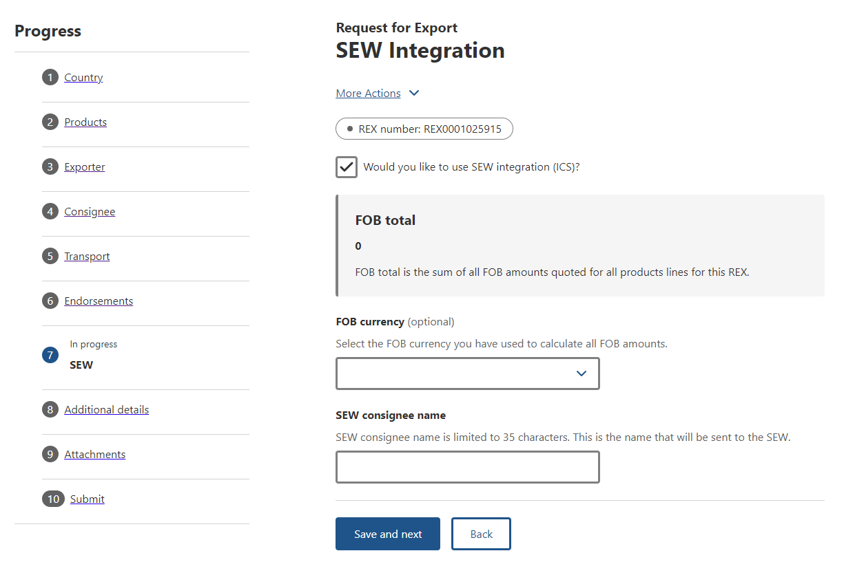

REX Section 8: Additional Details
Step 1  Select your Certificate print indicator value.  You must select Automatic or Hold.  This selection is mandatory.  Note:  If you select automatic, a print file will generate as soon as the certificate is ready to print. If you select hold, you can preview the certificate prior to finalising it.  Please refer to the NEXDOC Printing FAQ on the NEXDOC Help Page for further information regarding these options. | 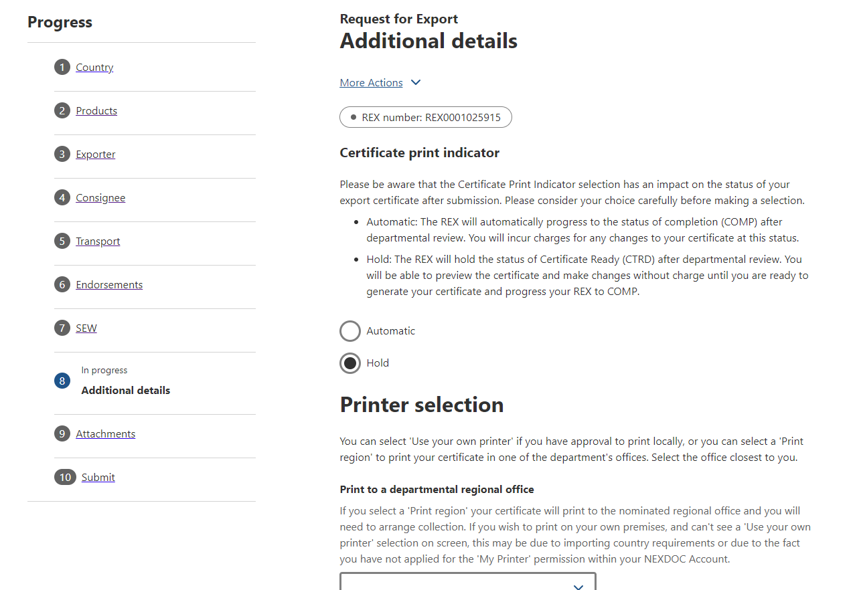
Step 2  Selecting the Use your own printer tick box will allow you to print your certificate remotely, rather than needing to collect it from a regional department office.  If you do not have the user your own printer option on screen, please request this permission via your registered NEXDOC exporter account. Refer to the Manage Your Details guide on the NEXDOC help page. | 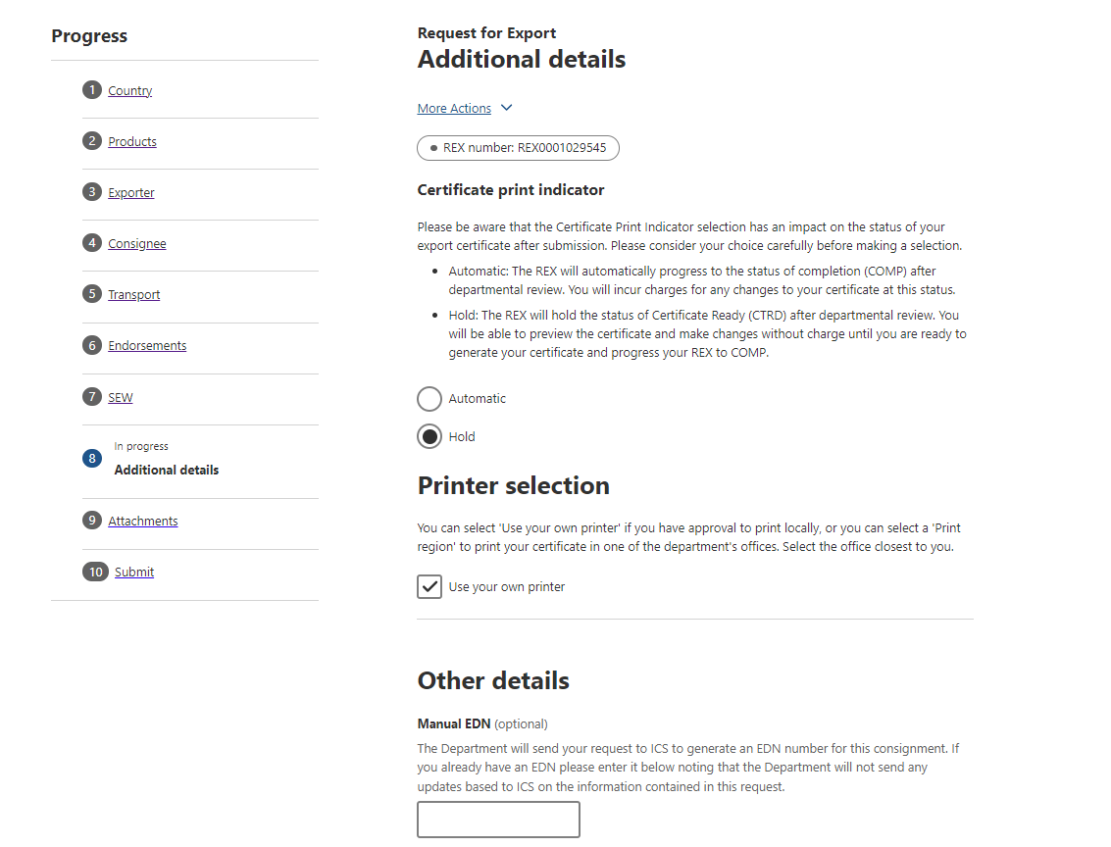
Step 3  If you do not wish to print remotely, you must select an available regional office in the Print to a departmental regional office field.  You will need to submit a collection list to the department’s Assessment Services (Exports) team to collect the certificate/s. If you do not have a copy of the collection list form, please email foodexports@aff.gov . | 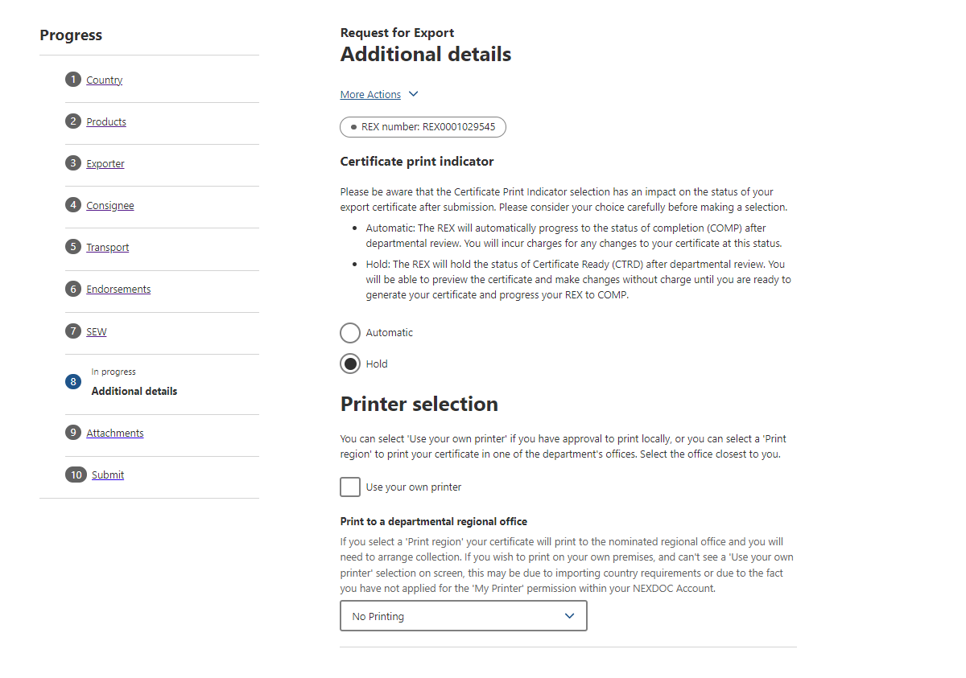
Step 4  If you wish to include your EDN (not obtained through the SEW) in the Request for Export (REX), then you can enter it in the Manual EDN field under Other details. This is not a mandatory field. | 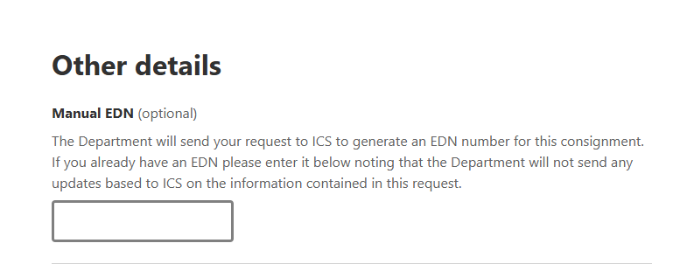
Step 5  Should you wish to save your import permit number and import permit date within your REX, select Add an import permit.  This is an optional feature and will appear on your certificate, if provided. | 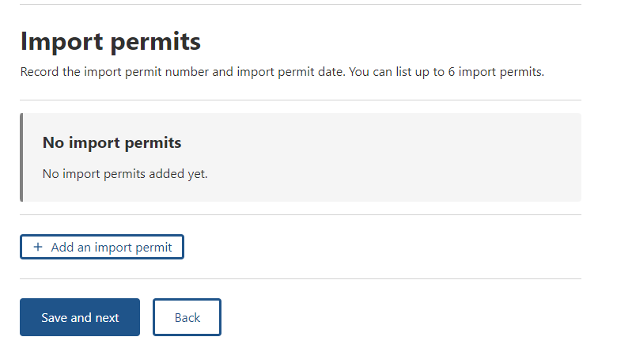
Step 6  Provide your Import permit number and Import permit date.  These are optional fields.  If provided, these details will appear on the export certificate. The import permit date must be in the past.  Select Save. | 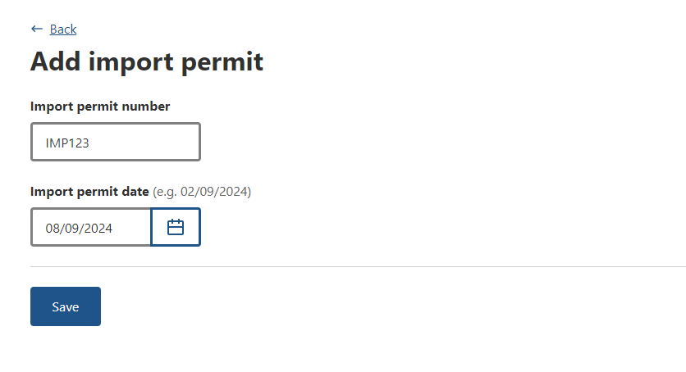
Step 7  Select Save and next. | 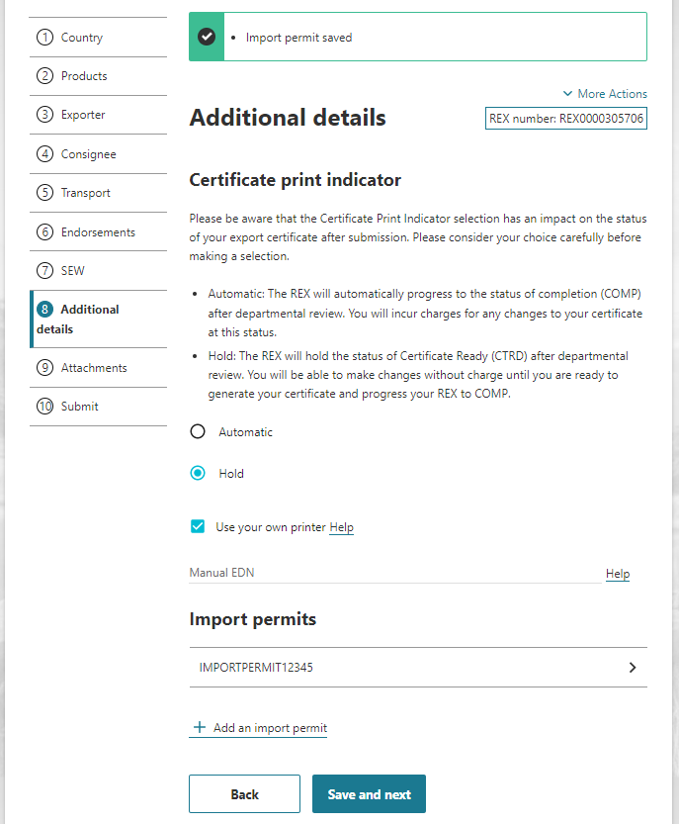

REX Section 9: Attachments
Step 1  The department assesses each certificate request against importing country requirements. Provide all relevant documentation to support your request. Relevant documentation may include, but is not limited to, import permits and manufacturers declarations.  Select Add attachment. | 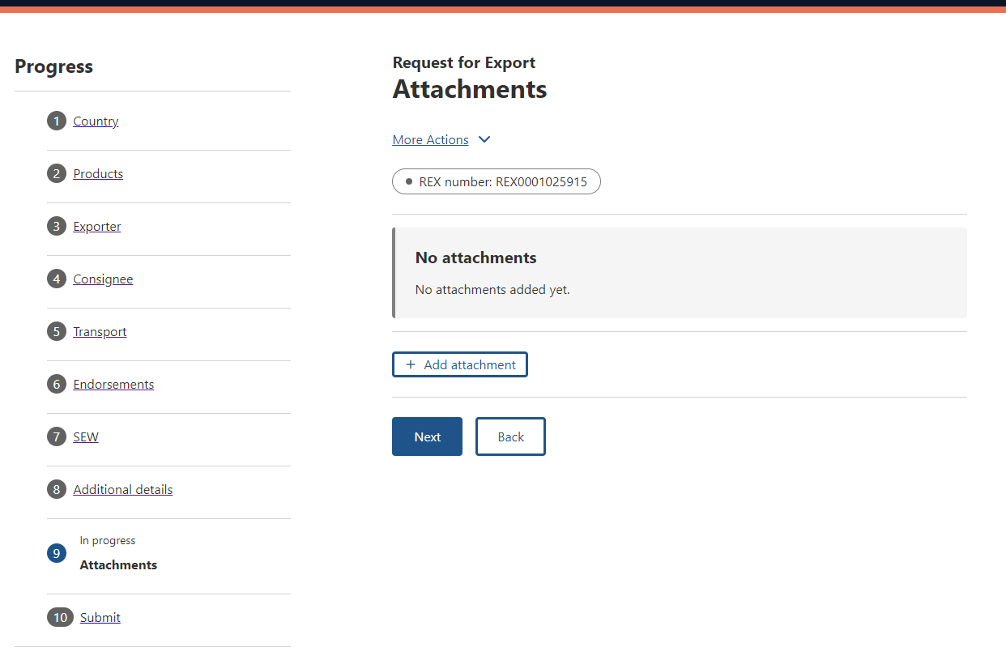
Step 2  Select the Document Type drop-down menu and select the type of attachment Supported file types include: jpg, tiff, gif, rtf, jfif, png, docx, tif, txt, pdf, xml, jpeg, doc, and jpe.  The Document Type field is mandatory if you are attaching a document.  Provide a Comment in relation to your attachment, if applicable.  The Comment field is optional.  Select Choose Files or drag and drop the file to attach.  Select Save. | 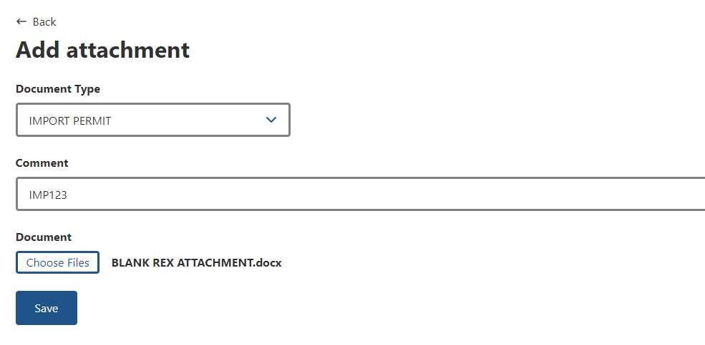
Step 3  Repeat Step 2 until you have attached all necessary documentation to support your application. You must attach all required documents so that the departmental officer has them available to review when assessing your REX.  Select Next. | 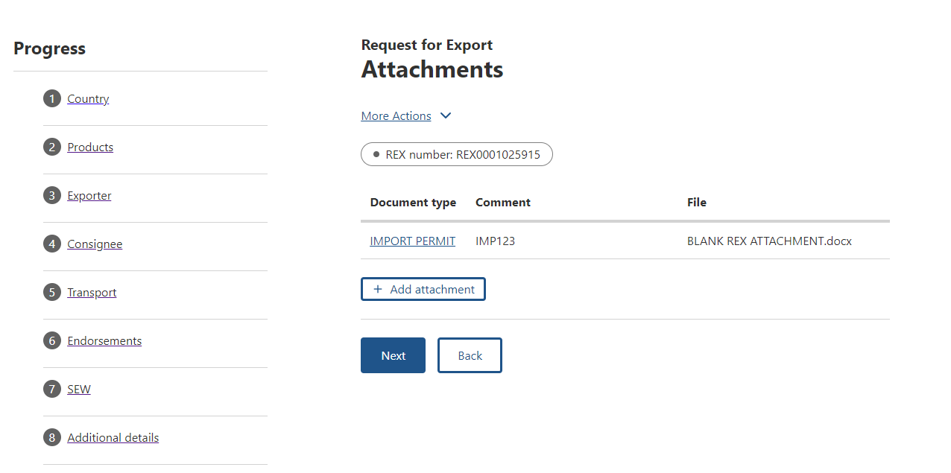

REX Section 10: Submit
Step 1  The Declaration will display. Please read this carefully.  If you wish to proceed with your lodgement, select I agree. | 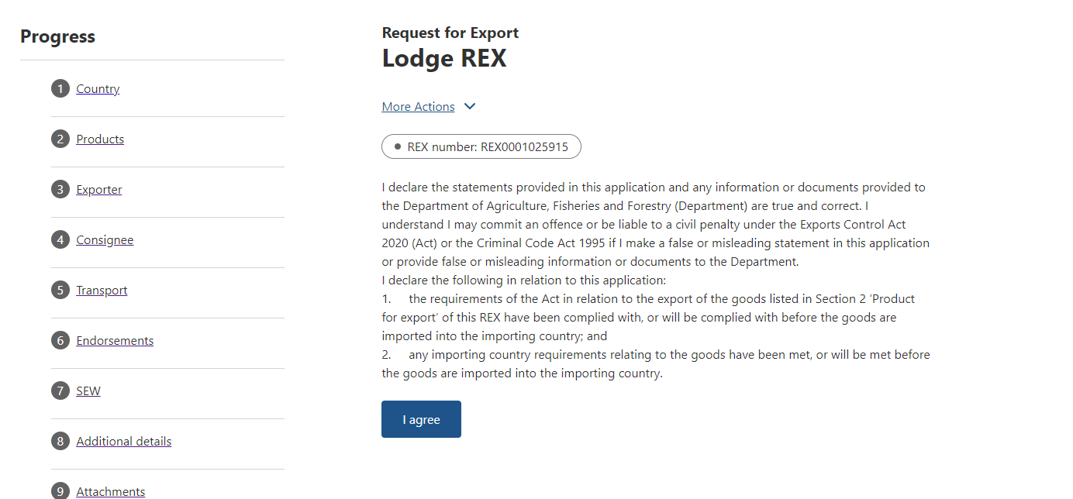
Step 2  The destination country and products will display. If there are no changes required, select Lodge REX. | 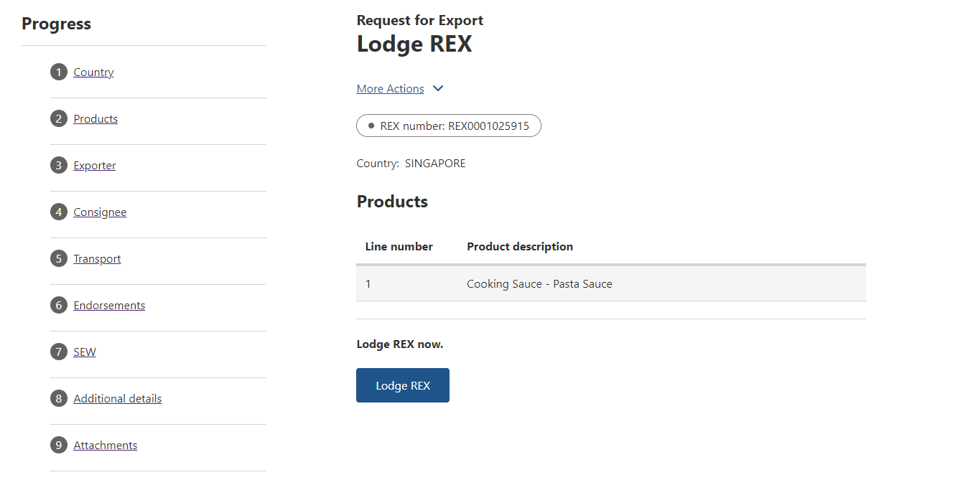
Step 3  A confirmation message will appear, alongside the Service ID associated with your application. Your REX is now awaiting assessment from a departmental officer.  You will receive a notification in the portal when the assessment is complete. | 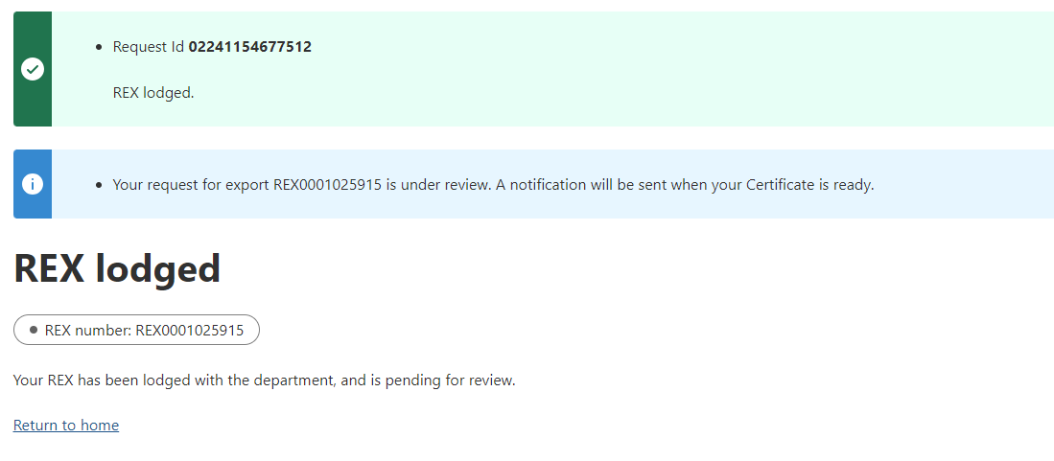
End

