NEXDOC Self-Triage Guide
Contents
Purpose of this document 1
Quick reference guide 2
Known issues and how to avoid them 3
Client Group mismatch 3
Entering invalid fields 4
Using the same client group in more than one software package 5
Forwarding with acceptance required/hold until status 6
Forwarding/Transferring a REX with a pending amendment task 6
Other issues and what to check 7
No Response Received 7
Authentication Failure 7
Certificate did not print 8
“OSB-*” 8
Unexpected error. Error reference:…. 8
Information to include with every DAFF support request 10
How to contact DAFF 10

Purpose of this document
This guide assists NEXDOC users in identifying whether an issue reported by an exporter is likely to be caused by:
- exporter data
- vendor software and the configuration of that software
- NEXDOC business rules or the NEXDOC platform.
By performing these checks, NEXDOC users can often resolve issues more quickly and provide higher quality information when assistance is required.

Quick reference guide
Issue | Likely Cause | Before Contacting DAFF
No response / Timeout | Client or vendor network issue | Check:  - Internet connectivity  - That you can navigate to online.agriculture.gov.au/nexdoc-ws-ext-proxy/RexSubmissionService?wsdl  - Server logs for errors
Authentication Failure | Token mismatch, wrong client group, wrong environment | Check:  - Client and client group tokens  - Client group configured in software is for the correct client group (not the “Exporter Client Group”)  - Username/Installation Token and password  - All tokens are for the correct exporter and the correct NEXDOC environment
CERTIFCATE DID NOT PRINT | Configuration issue with client group or certificate, wrong print option, or printer issue | Check:  - That the correct client group was used  - The certificate was not printed by another user within the client group  - The printer is configured and online  - The correct print option has been selected  - Client group and certificate are enabled for remote print
XML Validation Error / OSB-* | Invalid XML generated by vendor software | Check:  - Fields are filled in correctly  - No special characters in fields  - No missing data that is required for meat exports
Unexpected error. Error reference: XXXXX | Certificate print controls provided per certificate instead of per REX, possible NEXDOC issue | Check if certificate print controls are provided for each certificate. This is not currently supported. The certificate print controls need to be provided as one per REX only, not per certificate.
REX forwared or transferred does not arrive at destination | REX forwarded to Exporter Client Group or receiving party using Exporter Client Group, forward with acceptance used | Check:  - Forward with acceptance required was used  - REX was sent to “Exporter Client Group”
Message “REX with number xxx does not exist in repository” | REX forwarded to Exporter Client Group or Exporter Client Group is configured in software | Check:  - Software is not incorrectly configured with “Exporter Client Group Token”  - If REX was incorrectly forwarded to “Exporter Client Group”
message “The following fields cannot be amended…” | Invalid fields are stored on the REX and software receiving forward/transfer attempts to remove | If this message is encountered when the field in question is not visible in the REX, it was recorded incorrectly by the sender. Forward back to the sender and ask them to remove it and forward back. This works on some occasions. Sometimes the REX needs to be re-created.
REX is Forwarded while amendment is pending | Amendment task becomes corrupted and fails | Contact NEXDOC helpdesk. Helpdesk will need to clear the corrupted task. Then the recipient can forward back to the initiator who can apply for new amendment task.

Known issues and how to avoid them

Client Group mismatch
For software users, two client groups are created within NEXDOC. The “Exporter Client Group” is solely used in NEXDOC to manage exporter commodity registration and should not be used in software or forwarding/transferring .
Use of the incorrect client group in software and/or when forwarding/transferring ownership causes numerous issues including the receiver not receiving the REX, errors when loading the REX, lost notification messages, and printing issues.

How to avoid this
When configuring software and in forwards/transfers, always1 use the client group token associated with the administrator-created client group, never1 the “Exporter Client Group”.
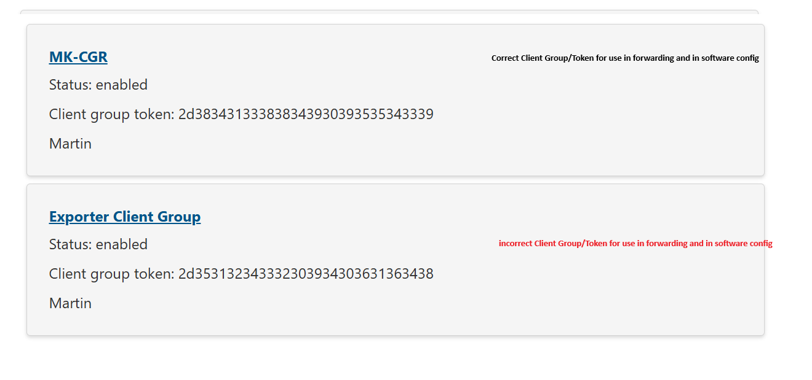

Symptoms of this problem
- Error: REX with number [xxxxx] does not exist in repository
- Client group never receives a transferred or forwarded REX
- Attempts to print the certificate fail.

What to do
- Make sure that your software has not been configured with the client group ID or client group token for the “Exporter Client Group”.
- If it has, correct the configuration to use the other client group ID and token and try again.
If you haven’t received a forward/transfer, make sure that you haven’t provided the Client Group ID of the “Exporter Client Group” to the initiator of the forward/transfer. If it was, ask the forwarder to withdraw the request and provide them with the correct client group ID.

Entering invalid fields
Some NEXDOC fields apply only to some commodities. We have discovered that some third party software allows fields to be captured that are not valid for the meat commodity. This causes issues when REXs are forwarded/transferred to software that doesn’t support these fields and therefore removes them.

How to avoid this
Do not enter information in any of the following fields if they appear in your software:
  - Preferred weight unit
  - Manufactured/Treated/Packaged/Labelled In Australia
  - Quota Exporter ID
  - Notify Party
  - Letter of Credit Information
  - Print location for individual certificate.

Symptoms of this problem
Error: The following fields cannot be amended [field name]

What to do
- Forward/transfer the REX back to the source and ask them to remove the field then forward/transfer back to you.
- If this does not resolve the issue, ask the initiator of the REX to withdraw the REX and start again without setting these fields.
- Inform your software provider.

Using the same client group in more than one software package
NEXDOC provides a notification service that tells users when something significant changes on the REX (e.g. REX forwarded or transferred, significant status changes, ICS interactions, pending approvals, approval outcomes, etc).
Notifications are sent to the client group associated with the REX. By default, each notification message is received by a software package once and is not sent again.
If an organisation is using the same client group in 2 or more software packages concurrently, the packages will compete for notifications on a REX being managed in another platform without intending to. This will result in notifications messages going missing and the software packages both behaving unpredictably.

How to avoid this
If you have:
- started to use a new package
- are using more than one concurrently
- are transitioning to a new software provider
before beginning to use a second package while another is still active:
- Login to the NEXDOC client portal as the client group administrator
- Create a new Client Group. Make a note of the Client Group Token and Client group ID issued by NEXDOC
- Add members to the new client group as required
- Add the new client group ID and client group token to the new software package.
- Make sure that forwards/transfers that you wish to see in the new package are sent to the new client group ID.

Symptoms of this problem
- Forwarded/Transferred REXs not appearing.
- Certificates not being printed automatically.
- Notification messages not arriving.

What to do
- Open the other platform being used and check if the REX, Certificate, or notification is visible there.
- Follow the “How to avoid this” steps above.

Forwarding with acceptance required/hold until status
NEXDOC allows REXs to be forwarded with acceptance being required by the receiver. This is new for meat with NEXDOC and is currently not behaving exactly as designed in some situations. Forwarding with acceptance required/hold until status sometimes results in the wrong notification behaviour.

How to avoid this
Avoid using acceptance required/hold until status for forwarding of meat REXs
Forward without acceptance required or hold until status set.

Symptoms of this problem
Recipient of forward does not receive REX/notification.

What to do
Recipient:
- Contact the NEXDOC helpdesk or forwarder
- Request the forward to be withdrawn and re-sent without acceptance required or hold until status.
Forwarder: withdraw forward. Re-forward without utilising the “acceptance required” or “hold until status” features.

Forwarding/Transferring a REX with a pending amendment task
Some software does not lock the REX when a pending amendment is in place. If the REX is forwarded or transferred while the amendment is pending, the amendment will fail because the client group assigned to the REX does not match that on the amendment task.

How to avoid this
Do not forward REXs with pending amendment tasks.

Symptoms of this problem
Amendment task becomes corrupted.
Amendment fails: There is a pending amendment task for this REX waiting for approval.

What to do
Forward recipient:
- Contact NEXDOC helpdesk
- Helpdesk will need to clear the corrupted task
- The recipient can then forward back to the initiator who can apply for new amendment task.

Other issues and what to check

No Response Received
Symptoms
- Application hangs
- Timeout
- Connection failure.
Check
- In a browser on the machine sending the NEXDOC message, try to reach online.agriculture.gov.au/nexdoc-ws-ext-proxy/RexSubmissionService?wsdl. If you can’t reach this page, the issue is likely to be a network issue on the client site.
- Internet connectivity – navigate to www.google.com or another reliable website
- NEXDOC request message was actually transmitted (check server outbound logs)
- Authentication – ensure the credentials being used are correct. check client group token, client token, and username/ws-installation token.
- TLS configuration.
Contact DAFF?
After confirming that no client connectivity issues are present.

Authentication Failure
Check
- Vendor Token
- Client and client Group Tokens
- Client group configured is for the correct client group (not the “Exporter Client Group”)
- Username/Installation Token and Password
- All tokens are for the correct exporter and the correct environment.
Contact DAFF?
After confirming credentials are correct.

Certificate did not print
Check
- The correct Client Group was used
- The certificate was not printed by another user within the client group
- The physical printer is online and is configured appropriately within vendor software
- The correct print option was selected within the certificate print controls in Lodge/Amend/Release to Print
- If you use more than one software package, check the others for the certificate. If it arrived in the wrong package the 2 packages are competing for notifications. See the “Using the same client group in more than one software package” section above.
- The client group is configured for my printer for the commodity in question.
- The certificate is enabled for remote printing.
Contact DAFF?
If the above are all correct.

“OSB-*”
Check
- Fields are filled in correctly
- no special characters in fields
- No missing data that is required for meat exports.
Contact DAFF?
Only after contacting the software vendor. Note that this issue is almost always caused by 3rd party software sending invalid messages due to mapping bugs within 3rd party software.

Unexpected error. Error reference:….
Check
- Printing preferences have been provided at the REX header level only, not per certificate.
Contact DAFF?
If the above is correct.

Information to include with every DAFF support request
Vendor
- Vendor name
- Software version
Transaction
Identify which of the following you had issues with:
- REX Submission: Order/Lodge/Amend/Withdraw REX
- REX Ownership: Forward/Transfer/Acknowledge
- Read/Load REX
- Certificates: Read (Print)/Replace Certificate
- Reference Data
- Request Assistance
Also provide
- REX Number (if available)
- Date/time when issue was encountered
Exporter
- Exporter ID
- Client Groups (for forwards and transfers please provide originating and target client groups)
- Client
Attachments
- System logs (if available)
- Request message (if available)
- Response message (if available)
- Screenshot
- Error Reference Number (if available)

How to contact DAFF
For all production issues, please contact the department via NEXDOC helpdesk:
NEXDOC Help: (02) 6272 4700 or email: NEXDOC@aff.gov.au
Food Exports: Phone 1800 900 090 or email foodexports@aff.gov.au

The exception to this rule is in cases where users have exclusively been using the Exporter Client Group and have been operating with this configuration for some time and without issues. If this is the case DO NOT switch to using the other client group as you will lose visibility of transactions conducted with the Exporter Client Group.

