*The National Halon Bank (NHB) is a Commonwealth owned facility operated by A‑Gas Australia Pty Ltd (A-Gas), under a Management Agreement with the Department of Agriculture, Water and the Environment (the Department). As described in the Australian Halon Management Strategy, the NHB was established to assist Australia meet its obligations under the Montreal Protocol on Substances that Deplete the Ozone Layer.*

*The Department has established an Environmental Management System (EMS) based on International Standard ISO 14001:2015 to guide the operation of the NHB. This Environmental Policy forms part of the requirements for the EMS.*

*The NHB is the only facility of its kind in the southern hemisphere. Through its operations, the Department is providing international leadership in the management of Ozone Depleting Substances and Synthetic Greenhouse Gases, predominantly halons, by providing services to customers in Australia and overseas.*

*The range of services provided by the NHB includes recovery, recycling, reclamation, storage, disposal and making halon available for essential use purposes (maritime, aviation & defence industries).*

*In order to maintain its operations to this standard, the NHB and A-Gas as its manager, have made the following environmental commitments for its operations at the NHB:*

1. *Controlling and minimising negative environmental impacts*
2. *Continual environmental improvement*
3. *Preventing and/or minimising pollution and emissions*
4. *Continual monitoring and evaluation of environmental performance*
5. *Complying with regulatory obligations, other environmental requirements, and compliance obligations*
6. *Setting and reviewing environmental objectives and targets through the use of Environmental Management Programs (EMPs)*
7. *Understanding the needs and expectations of interested parties*
8. *Assessing environmental risk and opportunities.*

*The NHB’s ISO 14001 certification is reviewed annually to ensure ongoing compliance. The NHB’s EMS was re-certified against ISO 14001:2015 for a further three years in 2019.*

*Communicating and implementing the environmental objectives of the NHB is paramount to achieving positive environmental outcomes. The NHB, through the Department and A-Gas, will achieve this by:*

* *Making this policy available to interested parties, including through publication on the Internet*
* *Communicating openly with all employees and other interested parties*
* *Making contractors aware of the EMS and their obligation to adhere to this system while operating at the NHB.*

*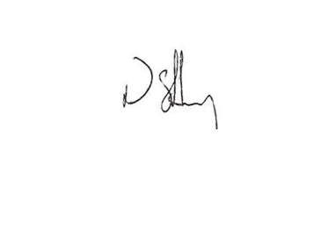*

*Nathan Sibley*

*Director, Air Quality Policy Section*

*Atmosphere and Reporting Branch*

*Environment Protection Division*