National Heritage List Logo

Branding Style Guide

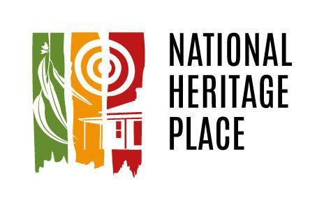

­­

January 2019

**CONTENTS**

INTRODUCTION 3

VISUAL REQUIREMENTS AND USE OF THE LOGO 4

Colour 4

Exclusion zone 5

Minimum size 5

Incorrect use 6

Original logo 6

Altered Colours 6

Altered Proportions and Rotations 7

Insufficient contrast 7

Logo users 7

Examples of use 7

Commercial use 8

Accessing the Logo 8

Co-branding 8

CERTIFICATION RULES FOR THE NATIONAL HERITAGE PLACE LOGO TRADE MARK 9

FURTHER INFORMATION – CONTACTING THE DEPARTMENT 13

# INTRODUCTION

Welcome to the National Heritage List Logo Branding Style Guide.

Our heritage is what makes our country special. It is the places and their stories that help explain who we are, how we arrived here as a nation, and what we wish to pass on to future generations. The National Heritage List showcases the places and their stories found to be of outstanding heritage value to Australia. It includes such significant buildings as the Sydney Opera House, places linked to important historic events such as the Wave Hill Walk-Off Route, and places exemplifying Australia’s diverse natural heritage such as the Australian Alps.

The National Heritage Place Logo (the **Logo**) provides a way to recognise the places in the National Heritage List. Its use will promote the recognition of our national heritage, and allow place owners and occupiers to highlight their part in our national story and the inclusion of their place in the National Heritage List.

Designed by Dreamtime PR it represents the list’s three heritage environments of natural, Indigenous and historic places. Adding the logo to information about your NHL place positions it as one of the best of Australia’s best heritage places.

The logo can be used on any promotional, educational or interpretative material you produce, e.g. websites, flyers, brochures, plaques, hardcopy or digital interpretative material, or multimedia installations. The use of the National Heritage place logo is option and does not have to be used in conjunction with Australian Government Branding.

The Logo must be used in accordance with:

* These Terms and Conditions, and
* The Certification Rules for the National Heritage Place Logo Trade Mark (the **Rules**)

The Terms and Conditions apply to any use of the Logo by an Approved User. For information on becoming an Approved User, please see the Rules.

If you are interested in using the logo please complete the National Heritage Place Logo Approved User application form provided on the internet page and return to Heritage@environment.gov.au on receipt of the application form the NHL Logo files will be sent to you.

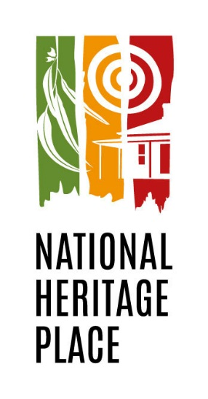

# VISUAL REQUIREMENTS AND USE OF THE LOGO

## Colour

The colour palette for the Logo consists of:

* Green: Pantone 370
* 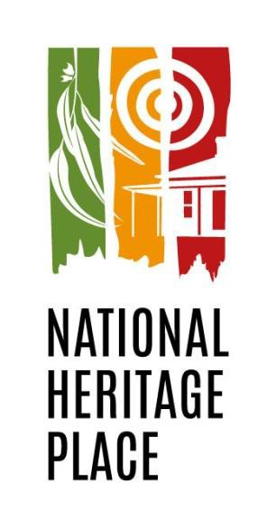Yellow: cyan 2, magenta 50, yellow 100, black 0
* Red: cyan 18, magenta 100, yellow 100, black 8 Examples of the colour Logo are shown below.



Vertical Horizontal

The Logo should be reproduced in colour where possible. When in colour, the Logo should be reproduced on a light or white coloured background. Reproduction of the colour Logo should, as far as possible, replicate the above colour palette.

The integrity of the Logo should not be compromised by a lack of contrast. For example, a light coloured Logo should not be used on a pastel or light coloured background, and a dark coloured Logo should not be used on a dark coloured background.

The Logo should never be placed over an image or heavily textured background.

Approval must be sought from the Department of the Environment and Energy (the **Department**) to reproduce the Logo in a colour that is inconsistent with the above specifications.

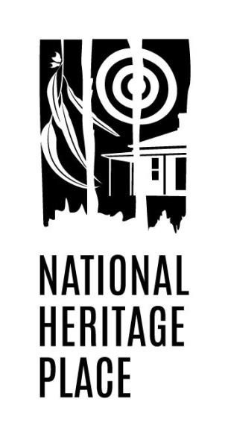When full colour is not possible, a monochrome version of the Logo can be used. Examples of the monochrome Logo are shown below.

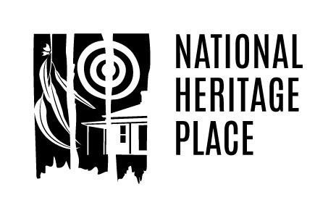

Vertical Horizontal

## Exclusion zone

To ensure maximum impact of the Logo and to maintain its integrity, the Logo must never be presented with other graphic elements. An exclusion zone must be maintained around the Logo to ensure it is clear of other images, text or graphics. The exclusion zone is defined as the height of the letter ‘N’ in the Logo. An example of the exclusion zone is shown below.

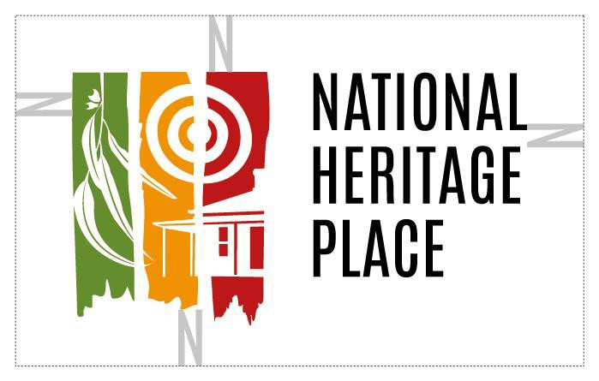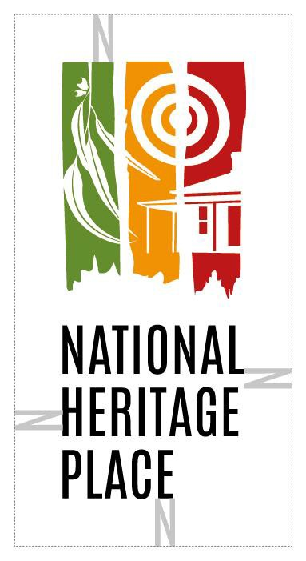

Vertical Horizontal

## Minimum size

The Logo should be no smaller than 12 mm, as shown below.

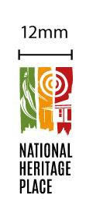 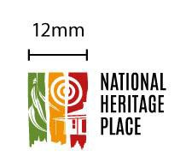

Vertical Horizontal

## Incorrect use

The integrity of the Logo must be maintained at all times. Only Logo image files supplied by the Department should be used to reproduce the Logo.

The Logo should not be extracted from any document (including this document). The Logo must not be reversed, manipulated or altered in any way other than size. Any alteration of the Logo’s size must ensure the Logo is scaled proportionately and in line with minimum size requirements.

The Logo proportions (height versus width) or the elements within the logo must not be altered. The number of colours, font and rotation of the National Heritage Place Logo must not be altered or skewed.

Examples of correct and incorrect use of the Logo are shown below

## Original logo

 

Vertical Horizontal

## Altered Colours

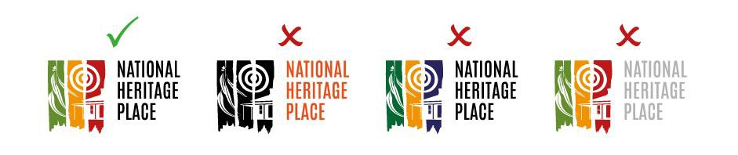

## Altered Proportions and Rotations

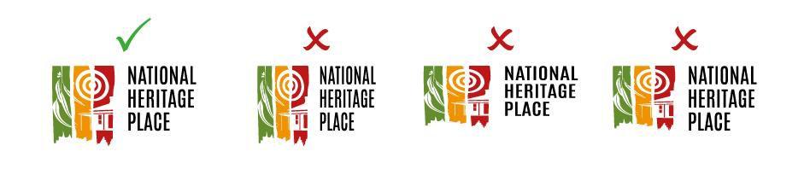

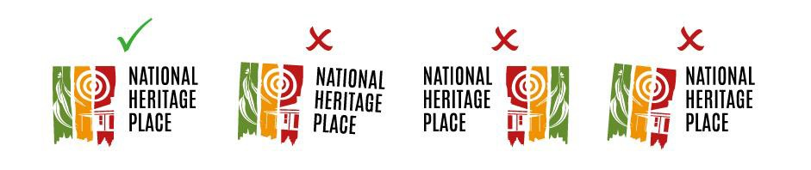

## Insufficient contrast

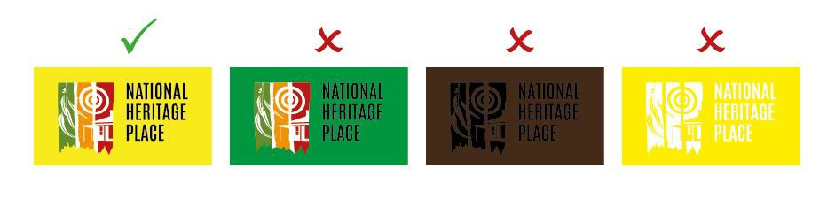

## Logo users

The following people and organisations are authorised to use the Logo:

* Approved Users (for information on becoming an Approved User, please see the Rules).
* The Department of the Environment and Energy and the Australian Heritage Council, for approved communication materials promoting the National Heritage List (e.g. media releases and publications about listed places).

## Examples of use

Examples of Logo use include:

* On plaques and signage at a National Heritage Place
* As a graphical element within print or digital media
* Within headers and footers on official stationery
* On official brochures produced about a National Heritage Place
* In media releases about a National Heritage Place

## Commercial use

Commercial use of the Logo (i.e. selling goods or services for profit) requires formal written approval from the Department. Approval will only be granted if the applicant can demonstrate the commercial use will promote the National Heritage values of the place (for the National Heritage values of a place, see section 324D of the *Environment Protection and Biodiversity Conservation Act 1999* and regulation 10.01A of the *Environment Protection and Biodiversity Conservation Regulation 2000*). Approved commercial use will be governed by a formal written agreement between the Approved User and the Department.

## Accessing the Logo

The Logo can be accessed by contacting the Heritage Branch of the Department. The Department will provide the Logo electronically to Approved Users in accordance with the Rules.

## Co-branding

A National Heritage Place that has its own logo or logos is encouraged to also use the Logo on publications and promotional material. The Logo must be placed immediately to the reader’s right of the relevant place’s own logo, separated by a single solid black line (see example below). The black line must be placed outside of the exclusion zone (see Exclusions Zones above).

 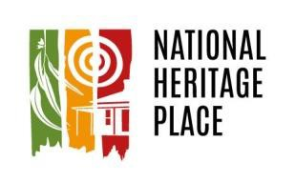

# CERTIFICATION RULES FOR THE NATIONAL HERITAGE PLACE LOGO TRADE MARK

**Definitions**

In these Rules:

**Department** means the Australian Government Department of the Environment and Energy.

**Certification Trade Mark** means the National Heritage Place “horizontal” Logo trade mark subject of Australian Trade Mark Application 1751277.

**National Heritage List** means the list maintained by the Australian Government Minister for the Environment and Energy under section 324C of the *Environment Protection and Biodiversity Conservation Act 1999* (EPBC Act).

**National Heritage Management Principles** means the management principles in Schedule 5B of the *Environment Protection and Biodiversity Conservation Regulations 2000.*

**National Heritage Place** means a place included in the National Heritage List by the Australian Government Minister for the Environment and Energy, in accordance with the EPBC Act.

**National Heritage Place Logo** means both the “horizontal” and “vertical” logo trade marks identified in the Terms and Conditions.

**Terms and Conditions** means the National Heritage Place Terms and Conditions for Logo Use set out in Appendix 1 to these Rules and intended to be read with these Rules**.**

**1. General**

1.1 The Certification Trade Mark provides public recognition that a place is a National Heritage Place or that a service/good (such as a publication, website or a publicity event) has been found to appropriately uphold and promote the Australian Government’s National Heritage List.

1.2 Beyond the public recognition referred to in clause 1.1, use of the Certification Trade Mark does not signify any endorsement by the Australian Government or the Department of the owner/occupier’s management or protection of the place, or of the service/good (such as a publication, website or a publicity event).

1.3 The Department may use or authorise use of the Certification Trade Mark to promote the National Heritage List and/or National Heritage Places including in media publications for the Australian Heritage Council and the Australian Government Minister for the Environment and Energy.

1.4 In order for a person or party to be approved by the Department to use the Certification Trade Mark, the proposed use must be consistent with the objectives outlined in clause 1.1.

1.5 Once approved to use the Certification Trade Mark in accordance with these Rules, the Department will grant an Approved User a royalty-free, non-exclusive, non-transferrable, revocable licence to use the Certification Trade Mark in Australia in accordance with the Terms and Conditions.

1.6 The licence referred to in clause 1.5 is conditional on:

(a) the person or party agreeing to use the Certification Trade Mark for lawful and approved purposes;

(b) the person or party agreeing to abide by the Terms and Conditions; and

(c) the person or party agreeing to comply with any directions given to it by the Department.

1.7 Any restriction in these Rules on the right to use the Certification Trade Mark (including any such restrictions in clauses 1, 2 and 6.3) will apply to the Certification Trade Mark and to any variation thereof including the “vertical” form of the National Heritage Place Logo.

**2. Requirements for use of the Certification Trade Mark**

2.1 Use of the Certification Trade Mark must be approved by the Department in accordance with these Rules. Approval for its use may be withdrawn in writing by the Department at any time in accordance with the procedures specified below.

2.2 Use of the Certification Trade Mark must relate to:

(a) a National Heritage Place or more than one National Heritage Places; or

(b) a specific geographical location within a National Heritage Place.

2.3 An Approved User is only permitted to use a version of the Certification Trade Mark which has been supplied to it from the Department and from no other source. For the avoidance of doubt, the Department does not permit use by any person of the Certification Trade Mark which has been obtained from another source.

2.4 The Certification Trade Mark must not be used in a manner deemed by the Department to be inappropriate, including without limiting the generality of this restriction, as follows:

(a) in a manner that contravenes the Terms and Conditions as amended from time to time;

(b) in a manner that infringes the Department’s intellectual property and other rights in the Certification Trade Mark;

(c) in a misleading or deceptive manner, or in any way which is illegal;

(d) in any way that is likely to damage the reputation of the National Heritage List or the Australian Government;

(e) used or modified in any way that is likely to damage the reputation of the Certification Trade Mark itself.

**3. Process to determine Approved Users of the Certification Trade Mark**

3.1 The Department will determine who is to be authorised to use the Certification Trade Mark (**Approved User**).

3.2 An Approved User may be:

(a) a body corporate; or

(b) an unincorporated body; or

(c) a body established by the Governor-General or by a Minister of State or the Commonwealth (including departments and agencies); or

(d) an incorporated company over which the Commonwealth exercises control; or

(e) a natural person who is an owner of a National Heritage Place.

3.3 Where the Approved User is a body (whether incorporated or not) and not a natural person, the name and contact details of a contact person for that body must be provided to the Department.

3.4 To seek authorisation to use the Certification Trade Mark, a party or person must apply to the branch of the Department responsible from time to time for administering the *Australian Heritage Council Act 2003* (the **Heritage Branch of the Department**).

**4. Approved Certifier to assess the proposed use of the Certification Trade Mark**

4.1 The Department will appoint an appropriate person as a delegate of the Australian Government Minister for the Environment and Energy (**Approved Certifier**) to assess applications for use of the Certification Trade Mark.

4.2 The Approved Certifier will be an officer within the Heritage Branch of the Department holding the classification of Executive Level 2 or higher.

4.3 The Approved Certifier will assess the application to determine if the proposed use:

(a) relates to the types of use set out in clause 2.2; and

(b) is in accordance with the National Heritage Management Principles, and

(c) has been agreed by the place owners, and, if it relates to a place where Indigenous people have a right or interest, then to those Indigenous people; and

(d) otherwise complies with the Terms and Conditions.

4.4 When assessing an application for use of the Certification Trade Mark, the Approved Certifier:

(a) must ensure that the application has been made in the correct form and otherwise complies with clauses 1.4 and 2 of these Rules; and

(b) may consult the Australian Heritage Council for advice; and

(c) may have regard to information or advice from any source;

(d) must respond to the applicant within a reasonable period from the date of the application time (such period to be determined at the discretion of the Department) advising the applicant whether or not the application has been approved or rejected.

4.4 If the Approved Certifier determines that an application to use the Certification Trade Mark should be rejected, the Approved Certifier must provide the unsuccessful applicant with written reasons for the determination.

4.5 An unsuccessful applicant who wishes to have the Approved Certifier’s determination reviewed may apply in writing for a review. Such review will be conducted by another officer of the Heritage Branch of the Department who holds the same classification as, or a higher classification than, the Approved Certifier who made the original determination and who had no involvement in making the original determination.

**5. Register of Approved Users**

5.1 The Approved Certifier will maintain a Register of Approved Users (**the Register**). The Register will include the date approved for use, contact details of the Approved User, the National Heritage Place in relation to which the Logo will be used, any conditions to which the Approved User is subject; and any sanction (other than a caution or termination) that has been imposed by the Department on the Approved User.

5.2 In accordance with the Department’s obligations under the *Privacy Act 1998,* information on the Register will be treated only for the purpose to which the information is relevant, and only for the purpose for which it was obtained, and not disclosed to another person unless an exemption is first obtained*.*

**6. Procedure for resolving a dispute**

**6.1 Dispute resolution**

6.1.1 Subject to clause 6.2, the parties agree not to commence any legal proceedings in respect of any dispute arising under these Rules which has not been resolved by informal discussion until the procedure provided by this clause 6 has been followed.

6.1.2 The parties agree that any dispute arising under these Rules, including disputes about whether a place meets the certification requirements as a National Heritage Place and other disputes concerning a determination by an Approved Certifier, will be dealt with as follows:

(a) the party claiming that there is a dispute will send the other a written notice setting out the nature of the dispute;

(b) the parties will try to resolve the dispute within a reasonable period of time (such period to be determined at the discretion of the Department) through direct negotiation, including by referring the matter to persons who have the authority to intervene and direct some form of resolution (such persons to include an officer of the Department, other than the Approved Certifier who made the original determination, who holds the classification of Executive Level 2 or higher);

(c) if the parties are unable to resolve the dispute under clause 6.1.2(b) within a reasonable period of time (such period to be determined at the discretion of the Department), either party may refer the matter to a mediator;

(d) if the parties cannot agree on a mediator, then the parties agree that a Delegate of the Minister can nominate the mediator;

(e) the mediator may decide the time and place for mediation;

(f) the parties must attend the mediation and try to resolve the dispute.

6.1.3 If within a reasonable period of time of notice of a dispute being given by either party under clause

6.2.1(a) (such period to be determined at the discretion of the Department):

(a) there is no resolution of the dispute;

(b) there is no agreement on submission of the dispute to mediation or some other form of alternative dispute resolution procedure; or

(c) there is a submission to mediation or some other form of alternative dispute resolution procedure, but there is no resolution within a reasonable period of time (as determined by the Department) following the submission, or within such further extended time as the parties may agree in writing before the expiration of that reasonable period of time,

then either party may commence legal proceedings.

**6.2 When clause 6.1 does not apply**

6.2.1 Despite the dispute resolution procedures in Clause 6.1, a party may seek urgent injunctive relief from an appropriate court, where failure to obtain such relief would be likely to cause irreparable damage to the party concerned.

6.2.2 Clause 6.1 also does not apply where:

(a) action is taken by the Department because of a breach or suspected breach of clause 2 of these Rules; or

(b) an authority of the Commonwealth, a State or Territory is investigating a breach or suspected breach of the law by any person whether that person be an Approved User or not.

**6.3 Obligation to cease use of the Certification Trade Mark**

6.3.1 If directed and notified in writing by the Department to do so, an Approved User or a person using the Certification Trade Mark who is not an Approved User must cease use of the Certification Trade Mark as specified in the Department's notice until the Department issues a further written notice to the person.

**7. Contact details for the Department**

7.1 Contact details for the Department are set out in the Terms and Conditions.

# FURTHER INFORMATION – CONTACTING THE DEPARTMENT

If you require further information about using the Logo, please contact the Department using the following contact information.

Email (preferred contact method): [heritage@environment.gov.au](mailto:heritage@environment.gov.au)

Phone: Community Information Unit on 1800 803 772

Post:

Heritage Branch

Department of the Environment and Energy

GPO Box 787

CANBERRA ACT 2601