## Consultation Paper: *HELP SHAPE THE NATIONAL LANDCARE PROGRAMME*

The Australian Government is investing more than $2 billion in managing our natural resources, enabling communities to take practical action to improve their local environment.

This consists of funding for the **National Landcare Programme**, including the 20 Million Trees Programme and a suite of other election commitments, as well as complementary initiatives such as the Green Army Programme, Reef 2050 Plan, Working on Country, the Land Sector Package, investments in the Great Barrier Reef Foundation, Carbon Farming Futures, the drought support package and work being undertaken by rural research and development corporations.

The purpose of this consultation paper is to provide a brief overview of the National Landcare Programme and to seek public input on the design and delivery of the regional stream of the programme.

## National Landcare Programme Consultation

### Community information sessions 4–15 August 2014

## Community information sessions on the National Landcare Programme are being held across the country in each state and territory from 4 August 2014 to 15 August 2014. Attendees will have an opportunity to talk to representatives from the Department of the Environment and Department of Agriculture.

### Online consultation survey 4–29 August 2014

## An online consultation survey is available for a four week period to seek your views on the design and delivery of the regional stream of the National Landcare Programme. The release of the survey coincides with the commencement of the community information sessions and is open from 4 August 2014 to 29 August 2014.

This consultation paper forms the basis of the online survey questions. If you would like to provide responses to the questions in this paper, please complete the online consultation survey available at [www.nrm.gov.au](http://www.nrm.gov.au)

# The National Landcare Programme

The National Landcare Programme (the programme) aims to build on the Landcare movement which is a community based approach that has played a major role in raising awareness, influencing farming and land management practices and delivering environmental outcomes across Australian landscapes.

The programme is a key component of the Clean Land pillar of the Australian Government’s Cleaner Environment Plan and will contribute to the Government’s commitment to support a vibrant, innovative and competitive agriculture sector.

Guiding principles for the new programme are that investment in managing our natural resources be **simple, local and long-term**.

* *Simple* - delivered through simplified guidelines and application processes, and reporting requirements.
* *Local* - deliver practical natural resource management outcomes with a focus on local and regional-scale activities and on maximising community participation in the delivery of natural resource management projects.
* *Long-term* - an on-going initiative that will continue significant investment in natural resource management priorities.

To ensure there is a local and regional ‘voice’ in the design and delivery of the programme, a **National Landcare Advisory Committee** will be established. The committee is to be comprised of expert members from the natural resource management community who will provide valuable input on matters such as investment priorities and community consultation and engagement. The Committee will provide advice to the Natural Heritage Ministerial Board, comprised of the Minister for the Environment and the Minister for Agriculture.

The new programme will involve local delivery through a **regional stream** and a **national stream**. It will support various activities that involve caring for the land, including soil conservation, management of erosion and salinity, sustainable farm practices, restoration of native habitats, revegetation, control of weeds and pests and the development of local natural resource management skills and knowledge.

The **regional stream** will be delivered through the 56 regional natural resource management organisations across the country with small, medium and large scale projects. These organisations will be tasked with maximising community, including landcare, participation in setting priorities and delivering projects with environmental and sustainable agricultural outcomes.

The **national stream** will deliver key election commitments including: the 20 Million Trees Programme; Coastal River Recovery Initiatives; the Cumberland Conservation Corridor; Whale and Dolphin Protection Plan; the Kimberley Cane Toads Clean Up; Weed and Pest Animal Biosecurity Incursion Management; and the Dandenong Ranges Programme.

The national stream will also include a one-off **small grants** round in 2014-15 to deliver small natural resource management projects through community participation and engagement.

## Australian Government’s natural resource management initiatives

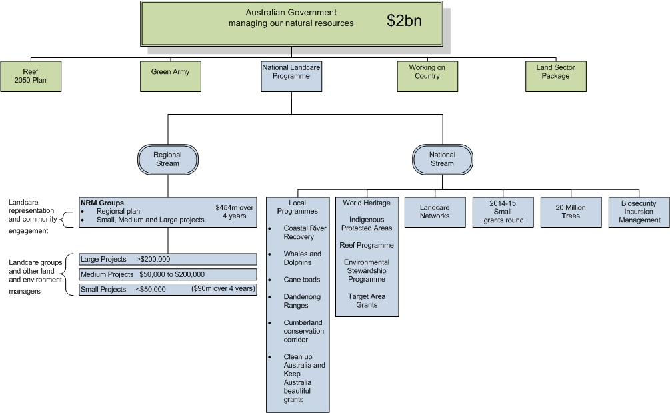

The programme will harness the expertise and enthusiasm of the natural resource management community, including landcare. By building the capacity of the natural resource management community to look after their local environments and the natural resource base, and support vibrant agricultural enterprises, we will strengthen regional communities and realise outcomes in the national interest. This approach delivers on the natural resource management community’s desire for a greater focus on local action and priorities.

The National Landcare Programme will deliver a reform agenda focused on:

* putting local natural resource management communities, including landcare, back at the centre of land management decision making and delivery;
* cutting red tape through simplified application and reporting systems; and
* maintaining critical natural resources and environmental infrastructure through the continued support for long-term investments and planning.

**Table 1**: The objectives of the National Landcare Programme

|  |  |
| --- | --- |
| **Strategic objectives** | **Strategic outcomes** |
| ***Strategic objective 1:*** *Communities are managing landscapes to sustain long-term economic and social benefits from their environment.* | *Maintain and improve ecosystem services through sustainable management of local and regional landscapes.* |
| ***Strategic objective 2:*** *Farmers and fishers are increasing their long term returns through better management of the natural resource base.* | *Increase in the number of farmers and fishers adopting practices that improve the quality of the natural resource base, and the area of land over which those practices are applied.* |
| ***Strategic objective 3:*** *Communities are involved in caring for their environment.* | *Increase engagement and participation of the community, including landcare, farmers and Indigenous people, in sustainable natural resource management.* |
| ***Strategic objective 4:*** *Communities are protecting species and natural assets.* | *Increase restoration and rehabilitation of the natural environment, including protecting and conserving nationally and internationally significant species, ecosystems, ecological communities, places and values.* |

NB: Strategic objectives are not weighted.

## National Landcare Programme: regional stream consultation paper

In addition to the information sessions mentioned above, we have prepared this paper to seek input from the community specifically on the design and delivery of the regional stream of the programme. We are particularly interested in your views about ensuring effective engagement with the landcare community, strong governance, and simplified reporting.

The regional stream will be designed to align with the three guiding principles of simple, local and long-term, specifically:

* simplified guidelines and application processes, and reporting requirements that are tailored to the scale and complexity of investment;
* a focus on decision making at the regional and local levels. Key to this will be regional natural resource management governance arrangements that support and encourage strong community engagement and participation in regional natural resource management planning and implementation; and
* multi-year funding agreements will continue to underpin regionally-based delivery and will be structured to support regional priority setting and flexibility in response to changing circumstances in the regions.

# Have your say...

The Government is seeking input to assist us to refine the design and delivery arrangements for the regional stream of the programme. Detailed below are five discussion topics followed by key questions on which the Australian Government is seeking input. Please consider these questions carefully as your responses will assist us to shape the regional stream of the National Landcare Programme. You can provide your input in response to these questions via the online consultation survey available at [www.nrm.gov.au](http://www.nrm.gov.au).

## 1. Partnering with the natural resource management community, including landcare

Regional natural resource management organisations, landcare, farming, Indigenous and other community and environment groups have for many years, often through partnerships, delivered local on-ground outcomes through small and medium scale natural resource management projects to improve their environment and the sustainability of agricultural landscapes.

With the addition of Oceanwatch and the Peel Harvey region, a total of 56 regional natural resource management organisations will be key delivery partners under the National Landcare Programme.

The Australian Government has made clear its intention to place landcare back at the centre of land management. The knowledge, skills and experience of the landcare community will be invaluable in planning and delivering local projects and it will be important that programme settings maximise opportunities to utilise this in projects.

In the context of the National Landcare Programme, ‘landcare’ includes state and national Landcare networks but also refers more broadly to community groups and individuals involved in natural resource management including local Landcare groups, farmers and farmer groups, Coastcare groups, ‘friends-of’ groups, Indigenous groups and many more.

The Australian Government has committed to support the important role of state and national Landcare networks. Supporting these networks to build on their good work to date could take the form of, for example:

* establishing and strengthening new collaborations between regional natural resource management organisations and landcare organisations;
* developing guidance and best practice materials for use by local landcare-type groups in building their capacity, including governance, to enhance their important local role; or
* supporting communication of local landcare priorities, including to potential project partners and to regional natural resource management organisations.

Under the regional stream of the National Landcare Programme it is expected that Indigenous people and organisations will continue to participate in the planning for and delivery of priority natural resource management activities. It will be important to maximise linkages between the programme and employment, education and training outcomes offered through the Green Army or other Australian Government programmes. It is expected that Indigenous people will be involved at an early stage of delivery design to ensure that activities are accessible, relevant and appropriate to Indigenous community groups. Engagement of Indigenous communities needs to reflect their responsibilities for managing land and sea country in each project and its location.

|  |
| --- |
| **Discussion questions**  *1a) What opportunities are there for greater partnerships within the natural resource management community, including landcare, and what is the best way to foster/encourage these partnerships?*  *1b) How could support for state and national Landcare networks best underpin the objectives of the programme and support the activity of all landcare-type groups?*  *1c) How can regional natural resource management organisations strengthen Landcare and community networks within and between regions?*  *1d) What opportunities are there for actively including Indigenous people in decision making and delivery of natural resource management?* |

### Facilitating Landcare

In addition to developing partnerships with landcare groups for on-ground project delivery, regional natural resource management organisations are also expected to support landcare and production groups to adopt sustainable farm and land management practices and to protect and restore Australia's natural environment through:

* the sharing of information;
* raising awareness of natural resource management priorities;
* strengthening landcare and community networks; and
* promoting the achievements and outcomes of landcare and the landcare ethic.

|  |
| --- |
| ***Discussion questions***  *1e) What methods work best for sharing information and lessons learned with others engaged in landcare?*  *1f) How can regional natural resource management organisations better promote the achievements and outcomes of landcare?* |

## 2. Community engagement in regional natural resource management planning and project delivery

Genuine community engagement, at all stages of regional natural resource management planning and delivery, will be a fundamental element of investment activity under the National Landcare Programme. Active, capable and informed communities are critical to achieving national objectives for a healthy environment and sustainable production landscapes. It is expected that regional natural resource management organisations will appropriately involve the broader natural resource management community, including Landcare and farmer groups, Indigenous people and individual landholders in delivery of the regional stream of the programme. In particular, the National Landcare Programme will focus on increasing participation by local natural resource management communities, including landcare, in:

* natural resource management planning and prioritisation;
* local natural resource management priorities' role in delivering national outcomes (e.g. threatened species and other matters of national environmental significance);
* natural resource management governance and decision making; and
* on-ground natural resource management through small and medium scale projects.

Regional natural resource management organisations will be expected to invest at least 20 per cent of their regional allocations in small projects, that directly engage the natural resource management community, including landcare.

It is expected that natural resource management investment decisions will be informed by regional natural resource management plans that have a strong scientific basis and community support. Regional natural resource management plans are an important tool for regional natural resource management organisations to work on together with their local communities, including landcare groups, to provide a strategic basis for investment under the National Landcare Programme.

Regional natural resource management organisations, together with their community, will identify the appropriate suite of activities to address the priorities identified in their regional natural resource management plans. Projects could include activities that better enable coordinated feral animal (including wild dogs) and weed control and, links to the Green Army where appropriate.

The Australian Government will establish appropriate guidelines and monitoring to ensure that regional natural resource management organisations meet the community’s expectations for enabling landcare, environment, Indigenous and other community groups and landholders to participate in activities that improve the health and sustainability of Australian agriculture and local environments.

The variability in the structure and capacity of state and territory Landcare networks, and in the governance and statutory arrangements for regional natural resource management organisations, may require tailored arrangements between Landcare representative organisations and regional natural resource management organisations to ensure effective engagement of the landcare community.

|  |
| --- |
| ***Discussion questions***  *2) What are the best mechanisms to achieve greater participation by the community, including landcare representation, in:*  *2a) regionally-based natural resource management planning?*  *2b) setting local and regional priorities and aligning them with national outcomes?*  *2c) decision making on natural resource management investments?*  *2d) delivery of National Landcare Programme projects?* |

## 3. Organisational performance expectations

The Australian Government understands that, to underpin the regional delivery focus of the National Landcare Programme, it is necessary for regional natural resource management organisations to effectively support the success of on-ground activities and meet the expectations of the community through transparent and strong governance processes.

The Australian Government has already put in place minimum governance standards to clearly articulate the Australian Government’s expectations regarding programme delivery. These governance standards will be incorporated into a set of performance expectations, with both project and organisational performance indicators, reflecting the specific delivery arrangements for the National Landcare Programme, particularly the importance of strong community engagement. The performance expectations will be clear and auditable and will be a key quality assurance and risk management tool for the programme.

|  |
| --- |
| ***Discussion questions***  *3a) What expectations should regional natural resource management organisations be required to meet in terms of community engagement and participation, including with Indigenous groups, landholders, landcare and other community groups, and local governments?*  *3b) How could the governance and community engagement performance of regional natural resource management organisations best be measured and communicated to their communities?*  *3c) What mechanisms or tools would be most effective in assisting regional natural resource management organisations to improve their organisational capacity where development needs are identified?* |

## 4. Simplified administrative processes

The Australian Government proposes simplified application processes focussed on a self-assessment by regional natural resource management organisations of their capability against three core areas (natural resource management investment planning, organisational governance and community engagement) with reference to the performance expectations referred to in section 3 above. The self-assessment is part of ensuring that regional NRM organisations delivering Australian Government investment operate effectively and transparently and involve their communities appropriately. It also aims to streamline application processes by focusing on an organisation’s capacity to identify, select and implement appropriate projects to meet the programme’s objectives, allowing flexibility for regional priority setting, instead of collecting detailed project-level information through the application process.

This self-assessment would allow regional natural resource management organisations to select appropriate ratings for their organisation against each capability, ranging from developing through to meeting all expected and advanced practices.

It is intended that a ‘developing’ rating would trigger a greater focus by the Australian Government, working with the regional natural resource management organisation, to ensure the organisation develops the required capabilities to meet all expected practices at a minimum.

To ensure accountability, this approach would be balanced by a series of rolling reviews. These reviews would involve Australian Government officers assessing regional natural resource management organisations against the performance expectations to ensure continuous improvement in organisational performance and engagement.

|  |
| --- |
| ***Discussion questions***  *4a) What are the opportunities and challenges of this approach?*  *4b) What type of performance measures would be most helpful to assist regional natural resource management organisations to identify where their performance needs to be improved, especially with respect to community engagement?*  *4c) What assessment methods would be most effective to clearly understand regional natural resource management organisations’ performance?* |

## 5. Simplified reporting of outcomes

A key element of the National Landcare Programme will be to clearly demonstrate, to both the community and government, the lasting outcomes from investment in natural resource management.

The success of our monitoring and reporting approach will rely on clear programme objectives that can be applied locally and regionally, while also painting a broader picture of what is being achieved nationally.

A simple, robust monitoring and reporting framework, based on standard performance indicators, will be used to show the outcomes we are achieving.

Project- and programme-level reporting combined should allow the local community to share and engage with the work being done under the National Landcare Programme. It is intended that this information will be readily accessible to communities Australia-wide, helping communities to tell their stories of our achievement and share lessons learned.

|  |
| --- |
| ***Discussion questions***  *5a) The Australian Government will take more of a ‘hands off’ role in relation to setting regional priorities and making decisions on projects. How can we make sure the programme is still accountable with respect to natural resource management outcomes and community participation?*  *5b) How can regions and the Australian Government best use simplified reporting to demonstrate the on-ground benefits of natural resource management investment to the broader public?* |

**HAVE YOUR SAY....**

To respond to the questions in this paper, please complete the online consultation survey at [www.nrm.gov.au](http://www.nrm.gov.au).