ABARES DAWR Left Aligned- TIF.tif

User guide for Land use of Australia 2010–11

Robert Smart

# Australian Bureau of Agricultural and Resource Economics and Sciences June 2016

# Summary

Land use information shows how we use the landscape and the extent and location of those land uses. Agricultural production is the main land use in Australia, dominated by grazing activities. Other land uses include nature conservation, forestry, water storage and urban development. Regular and consistent land use information is critical to inform, support and enable innovation and action in response to economic, social and environmental challenges.

The *Land use of Australia 2010–11* is the latest in a series of digital national land use maps at national scale. Agricultural land uses and their spatial distributions are based on the Australian Bureau of Statistics’ 2010–11 agricultural census data. The spatial distribution of the agricultural land uses is modelled and was determined using Advanced Very High Resolution Radiometer (AVHRR) satellite imagery with training data to make agricultural land use allocations. The non-agricultural land uses are drawn from existing digital maps covering seven themes: topographic features, catchment scale land use, protected areas, World Heritage Areas, tenure, forest type and vegetation condition.

The *Land use of Australia 2010–11* is supplied as a set of raster datasets (in Esri grid format) with geographical coordinates referred to the Geocentric Datum of Australia 1994 (GDA94) with a 0.01 degree pixel size. These comprise a set of floating point grids with pixel values between 0 and 1 and an integer grid. The floating point grids are continuous probability surfaces that describe the spatial distribution of each of the agricultural commodity groups mapped. The integer grid is a categorical summary land use map, which has a value attribute table (VAT) with columns defining input layers and an output layer. The output layer specifies land use in terms of the Australian Land Use and Management Classification Version 7 and is an approximation to a maximum likelihood map.

The *Land use of Australia* datasets are recognized as Foundation Spatial Data by the Australia New Zealand Land Information Council and as an Essential Statistical Asset for Australia by the Australian Bureau of Statistics. Common applications of the datasets are in strategic planning and continental modelling.

# Contents

Summary 1

Introduction 3

Construction methodology 5

Overview 5

Processing principles 6

Thematic layers 8

Spatial constraints 16

Refine inputs 21

Non-agricultural and simplified agricultural land use maps 22

Process agricultural census data 22

Allocate agricultural land uses 23

Assemble outputs 26

Input data provisions 28

Comparison with previous maps 30

Caveats 33

Expert review 35

Grid naming 37

Data dictionary 38

Categorical summary land use grid 38

Probability grids 50

Rationale for classification of land uses 51

Acknowledgements 54

References 55

# Introduction

The *Land use of Australia 2010*–*11* is a national scale land use map (NLUM) of Australia for the year 2010–11. It was constructed by the Australian Bureau of Agricultural and Resource Economics and Sciences (ABARES), a bureau within the Australian Government Department of Agriculture and Water Resources. The *Land use of Australia 2010*–*11* is a product of the Australian Collaborative Land Use and Management Program (ACLUMP). ACLUMP, coordinated by ABARES, is a collaborative cross-government approach producing land use mapping products for Australia underpinned by common technical standards (ABARES 2011). These datasets enable reporting of land use including change reporting and integrated assessments.

The *Land use of Australia 2010–11* is the latest in a series of digital national land use maps at national scale. Previous land use maps were the:

* *1996/97 Land use of Australia, Version 2 (the Version 2 NLUM)*—constructed by the Bureau of Rural Sciences (BRS) for the National Land and Water Resources Audit (NLWRA) (Stewart et al. 2001)
* *1992/93, 1993/94, 1996/97, 1998/99, 2000/01 and 2001/02 Land use of Australia, Version 3* (the Version 3 NLUM)*—*constructed by BRS for the Australian Greenhouse Office and the NLWRA (Smart et al. 2006)
* *Land use of Australia, Version 4, 2005–06* (the Version 4 NLUM)—constructed by ABARE–BRS for ACLUMP (ABARE–BRS 2010).

In the *Land use of Australia 2010*–*11* the types of agricultural land uses and their spatial distributions are based on 2010–11 agricultural census data collected by the Australian Bureau of Statistics (ABS). Two census datasets were used *Agricultural commodities, Australia, 2010*–*11* (ABS 2012a) and *Water use on Australian farms, 2010*–*11* (ABS 2012b). These provide areas for agricultural land uses within various collections of reporting areas that cover the whole of Australia. The smallest reporting areas for which 2010–11 agricultural census data are available are called statistical local areas (SLAs). The agricultural land in Australia is covered by approximately 700 SLAs. Since SLAs provide the best spatial resolution, the *Land use of Australia 2010*–*11* has been based on agricultural census data reported at SLA level. The spatial distribution of the agricultural land uses is modelled and has largely been determined using Advanced Very High Resolution Radiometer (AVHRR) satellite imagery with training data to make agricultural land use allocations to pixels of agricultural land subject to area constraints based on SLA level agricultural census data.

Non-agricultural land uses are drawn from existing digital maps covering seven themes: topographic features, catchment scale land use, protected areas, World Heritage Areas, tenure, forest type and vegetation condition. Time series data at relatively high temporal resolution are available for the protected areas, World Heritage Areas and forest type themes. Intensive land uses (which include the land uses found in built-up areas), plantation forestry and use of land for traditional indigenous purposes are sourced from the catchment scale land use data. The vegetation condition layer enabled grazing and other land uses to be split into native and non-native vegetation categories.

The *Land use of Australia 2010–11* is supplied as a set of raster datasets (in Esri grid format) with geographical coordinates referred to the Geocentric Datum of Australia 1994 (GDA94) with a 0.01 degree pixel size. These comprise a set of floating point grids with pixel values between 0 and 1 and an integer grid. The floating point grids are continuous probability surfaces that describe the spatial distribution, within the zone of non-forested agricultural land, of each of the agricultural commodity groups mapped. (The term ‘non-forested’ is used in this document to mean ‘no trees’ or ‘sparse trees’ up to a crown cover of 20 per cent.) The integer grid is a categorical summary land use map, which has a value attribute table (VAT) with columns defining input layers and an output layer.

The output layer specifies land use in terms of the Australian Land Use and Management Classification (ALUMC) Version 7 (<http://www.agriculture.gov.au/abares/aclump/land-use/alum-classification-version-7-may-2010>). The spatial distribution of agricultural commodity groups shown in the summary land use map within the zone of non-forested agricultural land is based on the probability surfaces and is an approximation to a maximum likelihood map.

Prospective users of the data should note that core metadata can be found in *Core metadata (ANZLIC Version2) for the Land use of Australia 2010–11* (ABARES 2016) and that the construction of this dataset (referred to as Version 5 NLUM) is similar to that of the Version 4 NLUM but that both differ significantly from the Version 3 NLUMs.

# Construction methodology

## Overview

Agricultural dryland and irrigated land uses were mapped within the zone of non-forested agricultural land using the algorithm SPREAD II (Smart et al. 2006). SPREAD II, like the SPREAD algorithm of Walker and Mallawaarachchi (1998), uses time series Normalised Difference Vegetation Index (NDVI) data with training data to spatially disaggregate agricultural census data, processing the census reporting areas one at a time. The SPREAD II methodology is statistically based using a Bayesian technique—a Markov Chain Monte Carlo (MCMC) algorithm. Training data were collected for the NLWRA, during the construction of the Version 2 NLUM, and relate to the four years 1996–97 to 1999–00 (Stewart et al. 2001).

To increase its discriminating power, SPREAD II can be run using not only the census based area constraints but also additional spatial constraints. Three spatial constraints were used, a horticulture constraint, a cultivation constraint and an irrigation constraint. Each spatial constraint relates to certain agricultural commodities and is a digital map identifying the pixels where those commodities are more likely to occur (the inside pixels) and where they are less likely to occur (the outside pixels). Thus, each spatial constraint controls how SPREAD II allocates the agricultural commodities to which the constraint relates.

For the *Land use of Australia 2010–11* (as for the Version 4 NLUM) a minor modification was made to the algorithm within SPREAD II that partitions the areas to be allocated between the ‘inside’ and ‘outside’ regions defined by each spatial constraint. For each spatial constraint, a default density is set for the commodities to which the spatial constraint relates. This setting gives the default density (calculated as a ratio of areas with value between 0 and 1) of the controlled commodities inside the spatial constraint. (For each constraint, the same defaults applied to all census reporting areas but the potential exists to set specific defaults for specific census reporting areas or groups of census reporting areas.) For example, the horticulture constraint is a digital map that identifies the pixels where horticulture is more likely to occur (the inside pixels) and where horticulture is less likely to occur (the outside pixels). The controlled commodities comprise all of the horticultural land uses to be mapped. Setting the default density to 90 per cent means that 90 per cent of the area inside the horticulture constraint should be occupied by horticultural land uses and only 10 per cent by non-horticultural land uses. The default setting is overridden with an alternative value calculated on the fly if the default proves to be inconsistent with the agricultural census based area constraints.

SPREAD II was used to map all agricultural land uses on non-forested agricultural land—irrigated and dryland. This contrasts with the methodology used in constructing the Version 4 NLUM, in which irrigation status was mapped outside SPREAD II. Additional grazing land was then mapped in woodland and open forest in SLAs where the total grazing area to be allocated could not be accommodated by non-forested agricultural land alone. The method used to map grazing land in forested agricultural land did not involve SPREAD II and, in this respect, the methodologies used in constructing the Version 4 NLUM and the Version 5 NLUM were similar.

The *Land use of Australia 2010–11* consists of a set of raster datasets (in Esri grid format) comprising continuous probability surfaces and a categorical summary land use map. The continuous probability surfaces describe the spatial distribution, within the zone of non-forested agricultural land, of each of the agricultural commodity groups mapped and are SPREAD II outputs. They are 23 in number. For a given pixel with a SPREAD II allocation, the sum of the pixel values for all of the probability grids is 1.

The categorical summary land use map is a grid with layers defined by VAT columns. There is an output land use layer, which is constructed from a series of input layers. Most of the input layers are based on existing digital maps showing themes such as protected areas and tenure, but two are newly constructed agricultural layers. The agricultural layers are categorical summary maps, one showing agricultural commodities and the other showing irrigation status; they embody the SPREAD II outputs for non-forested agricultural land and the outputs from mapping, outside SPREAD II, of grazing in forested agricultural land. SPREAD II makes agricultural land use grids in categorical summary form from its probability grid outputs using the following algorithm, applied to each census reporting area in turn:

1. Allocate land use of rarest commodity to the pixels with highest probability for the commodity until the agricultural census based area constraint is satisfied.
2. Allocate land use of next rarest commodity to the remaining pixels with highest probability for the commodity until the agricultural census based area constraint is satisfied.
3. Continue until all land uses allocated.

In the resulting summary agricultural land use grid, the area allocated is close to the census based area constraint, noting that the agricultural census estimates need to be modified to generate the area constraints. A land use with less than 110 hectares in a given census reporting area is treated by SPREAD II as though the area were zero (this being approximately the area of one pixel)—the probability surface for that land use is set to zero for all agricultural pixels in the census reporting area and there is no allocation in the census reporting area to that land use in the summary grid.

Figure 1 shows a summary of the methodology used in the construction of the *Land use of Australia 2010–11*.

## Processing principles

To convert input spatial datasets to raster format with the same pixel size and pixel alignment as the national land use datasets, two basic methodological principles were applied.

1. For categorical raster inputs: each output 0.01 degree pixel was assigned the input pixel value that represented the greatest area of the output pixel. This will be called principal type resampling.
2. For vector inputs: each output 0.01 degree pixel was assigned the input polygon attribute that represented the greatest area of the output pixel.

**Figure 1** Steps in the production of *Land use of Australia 2010–11*

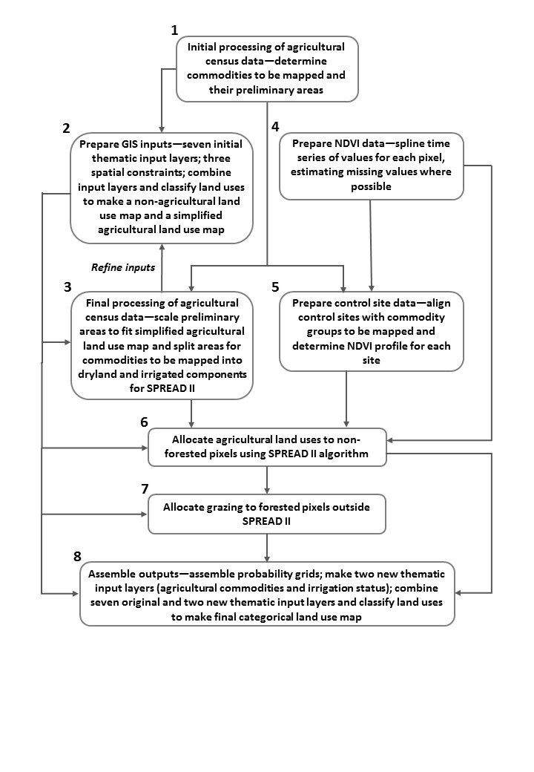

## Thematic layers

Seven thematic input layers were constructed in raster form with 0.01 degree pixel size and overlaid to determine the non-agricultural land uses and, by default, the spatial distribution of potentially agricultural land. The themes were topographic features, catchment scale land use, protected areas, World Heritage Areas, tenure, forest type and vegetation condition. This is part of step 2 in Figure 1.

Construction of these thematic input layers involved:

1. *Topographic features layer* (Map 1)—constructed from the 1:250 000 scale vector topographic dataset *GEODATA TOPO 250K series 3* (GA 2006). Polygon features representing built-up areas, mines, water bodies and watercourses were used. This layer is the same as in the Version 4 NLUM.
2. *Catchment scale land use layer*—constructed from catchment scale land use mapping (CLUM) data available as at January 2014 (ABARES 2014a). This was an unpublished national compilation that uses ALUMC Version 7 and was created by merging 50 metre pixel size data for Queensland released in January 2014 with a published 50 metre pixel size national compilation released in November 2012 (ABARES 2012a). The resulting 50 metre pixel size January 2014 national compilation was projected and resampled to match the pixel size and pixel alignment of the national land use dataset using the principal type resampling method. The currency of the November 2012 dataset ranges from 1997 to 2009. The January 2014 Queensland dataset has 2012 data for the Gold Coast and its hinterland, 2011 data for the Sunshine Coast and 1999 to 2009 data for the rest of the state. The November 2012 compilation had some small areas that had not been mapped as part of the ACLUMP catchment scale land use mapping program. These areas were filled using land use information from the *Mesh Blocks (2006) Digital Boundaries, Australia* dataset (ABS 2006) and their land use attributes were further updated from a number of sources. (The area of missing data was at most 0.30 per cent of the country and mainly confined to small areas around the capital cities Sydney, Melbourne, Adelaide, Darwin and Canberra.) Four errors involving incorrect classifications of land uses in outback South Australia were corrected:
   1. The Maralinga Defence Reserve in South Australia changed from ‘5.5.4 Defence facilities—urban’ to ‘1.3.1 Defence land—natural areas’
   2. A large region in the Coober Pedy district changed from ‘5.8.0 Mining’ to ‘2.1.0 Grazing native vegetation’
   3. A large region in the Marla district (a little east of Marla) changed from ‘5.8.0 Mining’ to ‘2.1.0 Grazing native vegetation’
   4. A large region in the Moomba district changed from ‘5.8.0 Mining’ to ‘1.1.7 Other conserved area’ and ‘2.1.0 Grazing native vegetation’.

**Map 1** Topographic features layer

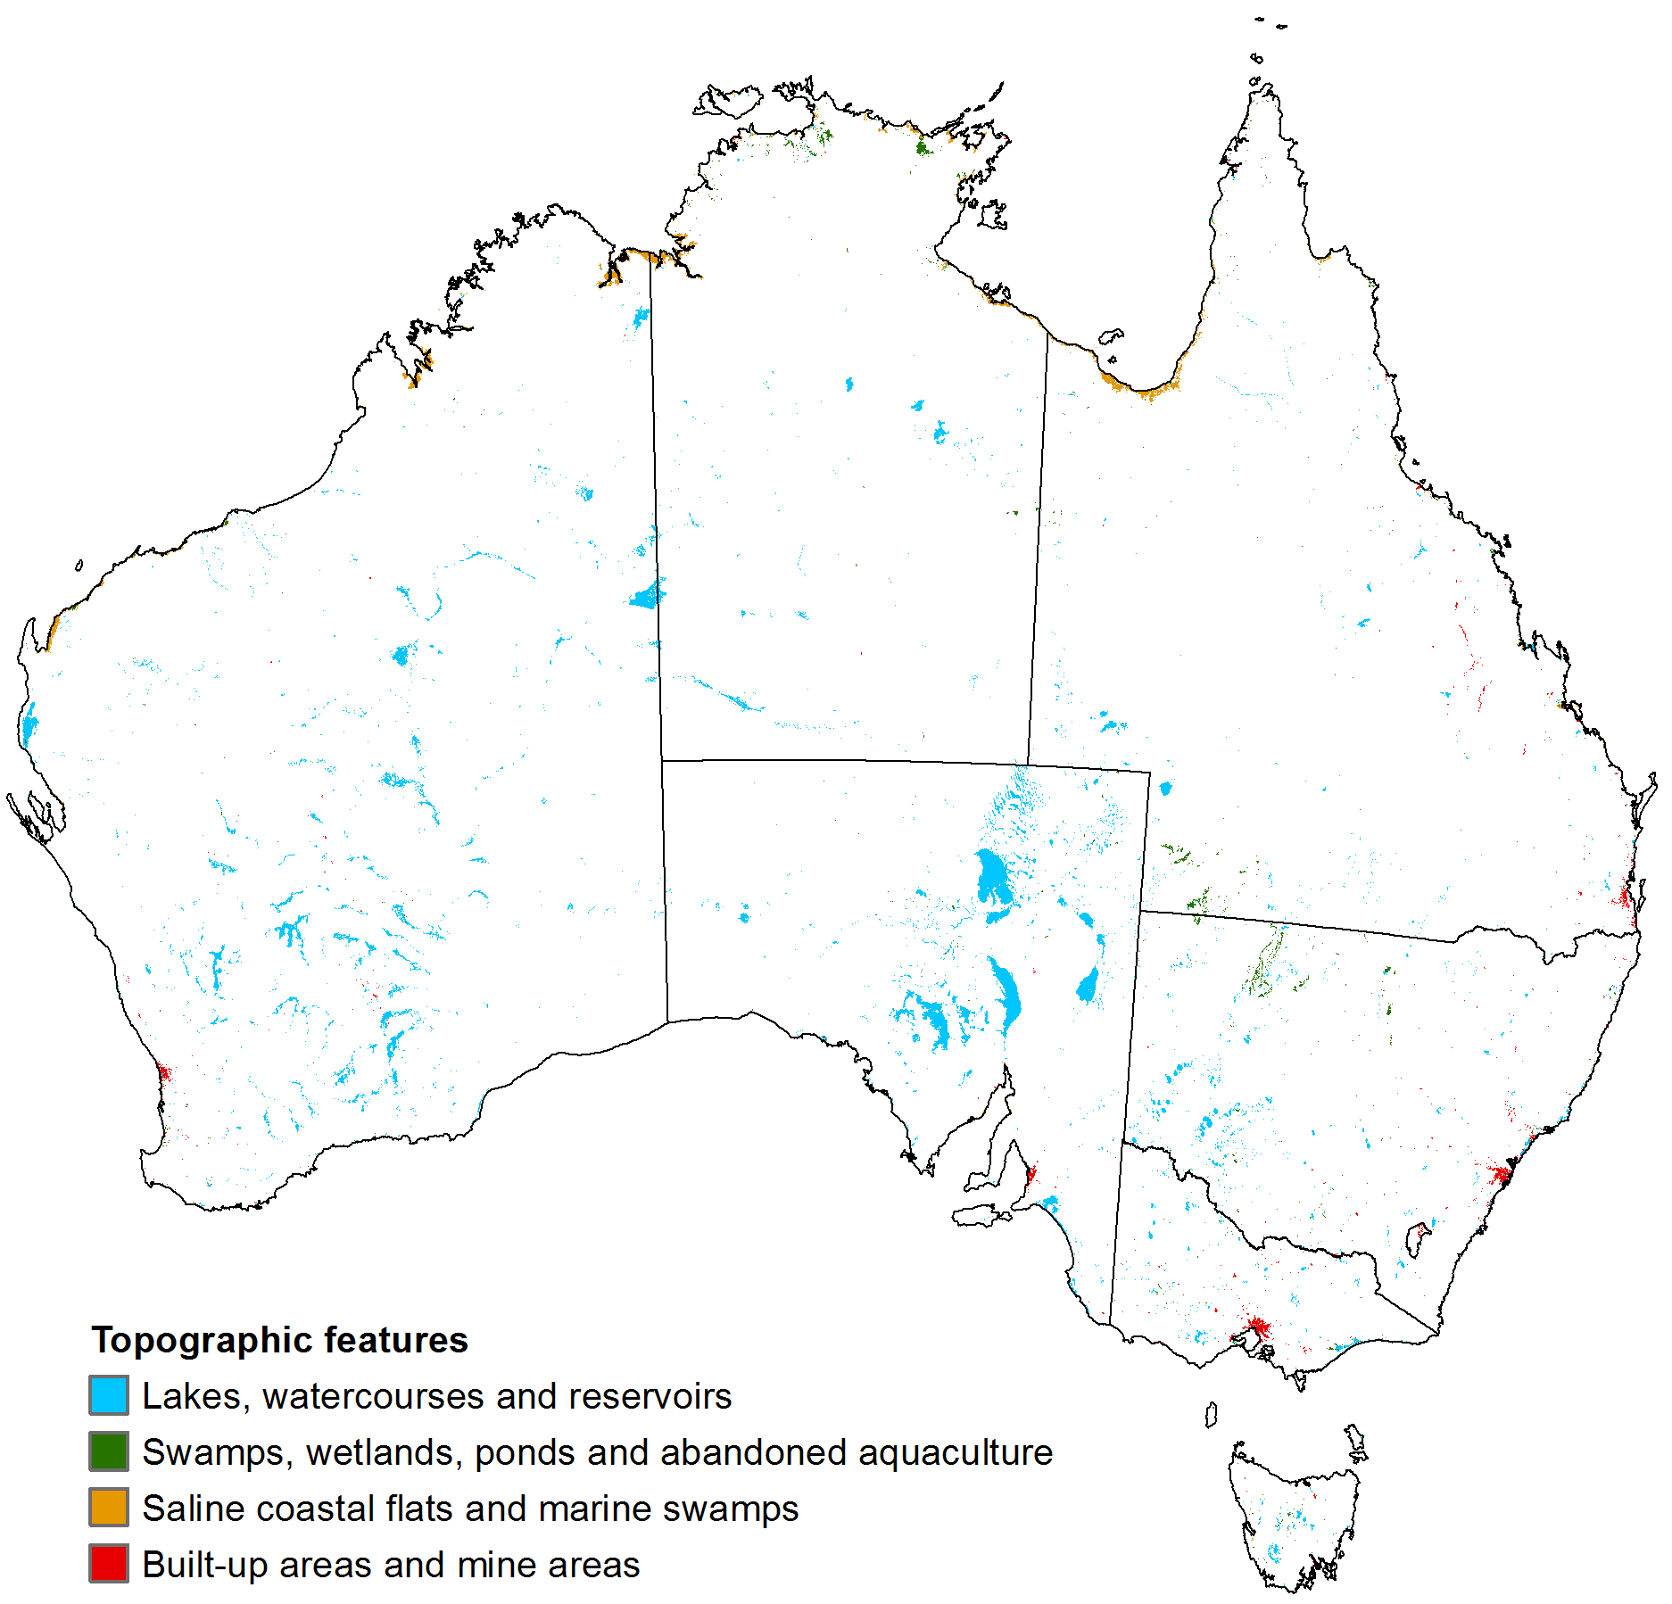

1. *Protected areas layer* (Map 2)—constructed to show International Union for Conservation of Nature (IUCN) protected areas. These were largely sourced from the *Collaborative Australian protected areas database – CAPAD 2010* (DSEWPaC 2012b), a 1:250 000 scale vector protected areas dataset with currency end date December 2011. Although the *Land use of Australia 2010–11* only shows land uses for onshore pixels, it was necessary to use both the marine protected areas data and the terrestrial protected areas data from *CAPAD 2010*, as some of the marine protected areas have onshore components. *CAPAD 2010* also contains protected areas that overlap each other—terrestrial protected areas overlapping other terrestrial protected areas, marine protected areas overlapping other marine protected areas and marine protected areas overlapping terrestrial protected areas. The terrestrial protected area polygons have two attributes that are used in the construction of the *Land use of Australia 2010–11*. One is called OVERLAP and the other, IUCN. The values for the attribute OVERLAP are 1 and 2. For each area represented by one or more terrestrial protected area polygons, value 1 identifies the polygon that carries the preferred IUCN category for the area; for each area represented by more than one terrestrial protected area polygon, value 2 identifies the polygons with the non-preferred IUCN category for the area. The values for the attribute, IUCN, are the IUCN categories for the polygons. Allowed values, with all but the last in order of decreasing level of protection, are ‘IA’, ‘IB’, ‘II’, ‘III’, ‘IV’, ‘V’, ‘VI’ and ‘NA’. Values ‘IA’ to ‘VI’ specify the IUCN category using the accepted abbreviations. Value ‘NA’ identifies protected area polygons that do not have an IUCN category. Marine protected area polygons do not have the attribute OVERLAP; they have only one attribute that is used in the construction of the Version 5 NLUM. It is called IUCN and its allowed values and their meanings are the same as for the IUCN attribute of the terrestrial protected area polygons. The attribute OVERLAP was used to identify the preferred IUCN category for overlaps involving terrestrial protected area polygons only; in such cases the IUCN category was taken from the overlapping polygon flagged with OVERLAP value 1; for all other overlaps, the preferred IUCN category was taken as that giving the highest level of protection among those ascribed to the marine polygons involved in the overlap and that ascribed to any terrestrial polygon also involved in the overlap flagged with OVERLAP value 1. In this way, a collection of protected area polygons, each having the preferred protected area category and none overlapping any other, was sourced from CAPAD 2010. This collection of polygons was converted to a 0.01 degree raster showing the preferred IUCN category according to CAPAD 2010 for all terrestrial pixels across the extent of the Version 5 NLUM.

Additional protected area polygons were sourced from *Indigenous protected areas (IPA)—declared* (DE 2014). This is a vector protected areas dataset with positional errors ranging from less than 1 metre to 500 metres with its most recent gazettal date in June 2014. Only polygons representing protected areas with gazettal dates prior to 1 April 2011 were used. All of these polygons have a level of protection attribute listing one or more IUCN categories. Where this list contained two or more IUCN categories, the IUCN category selected was that with the highest level of protection. In this way, a second collection of protected area polygons, each having a single protected area category with no overlapping areas, was sourced from the *Indigenous protected areas (IPA)—declared* dataset. This collection of polygons was converted to a 0.01 degree raster showing the preferred IUCN category according to the *Indigenous protected areas (IPA)—declared* datasetfor all terrestrial pixels across the extent of the Version 5 NLUM.

The final protected areas layer was made by combining the protected areas rasters derived from *CAPAD 2010* and the *Indigenous protected areas (IPA)—declared* dataset. Where a pixel had protected area status in both rasters but with different levels of protection, the higher level of protection was selected.

**Map 2** Protected areas layer

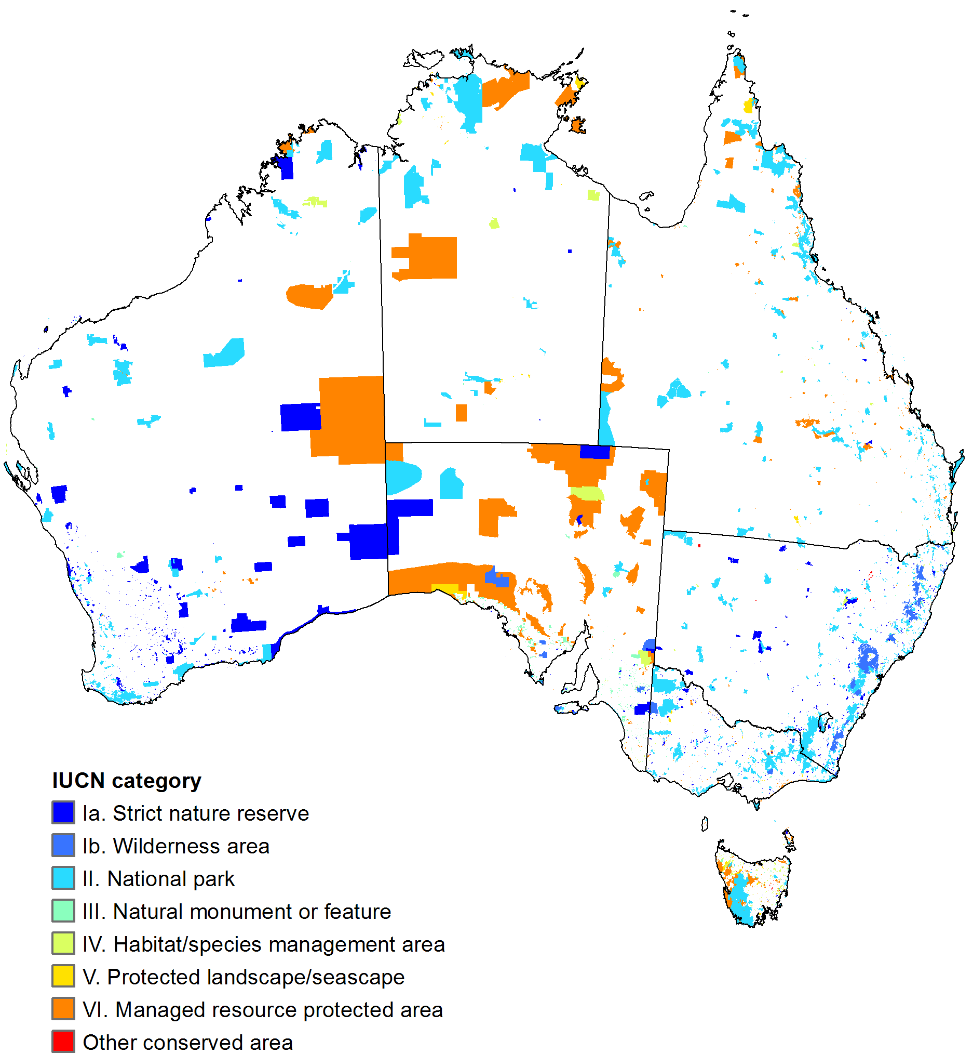

1. *World Heritage Areas layer* (Map 3)—constructed from *Australia, World Heritage Areas*, a 1:250 000 scale vector dataset with currency end date June 2011 (DSEWPaC 2012a). This layer flags, with value 1, all pixels within the extent of the Version 5 NLUM that represent a terrestrial World Heritage Area polygon in the *Australia, World Heritage Areas* dataset with the IUCN_MGT attribute specifying an assigned management level of one or more IUCN categories (with values such as ‘1a’ or ‘1a, 1b, 2’). All other pixels have value 0. Overlaps between World Heritage Area polygons occur in the source dataset. Where these overlaps were large enough to be of significance (in comparison with the 0.01 degree pixel size of the output World Heritage Areas layer), a management level was assigned when at least one of the polygons involved in the overlap had an assigned management level.

**Map 3** World Heritage Areas layer

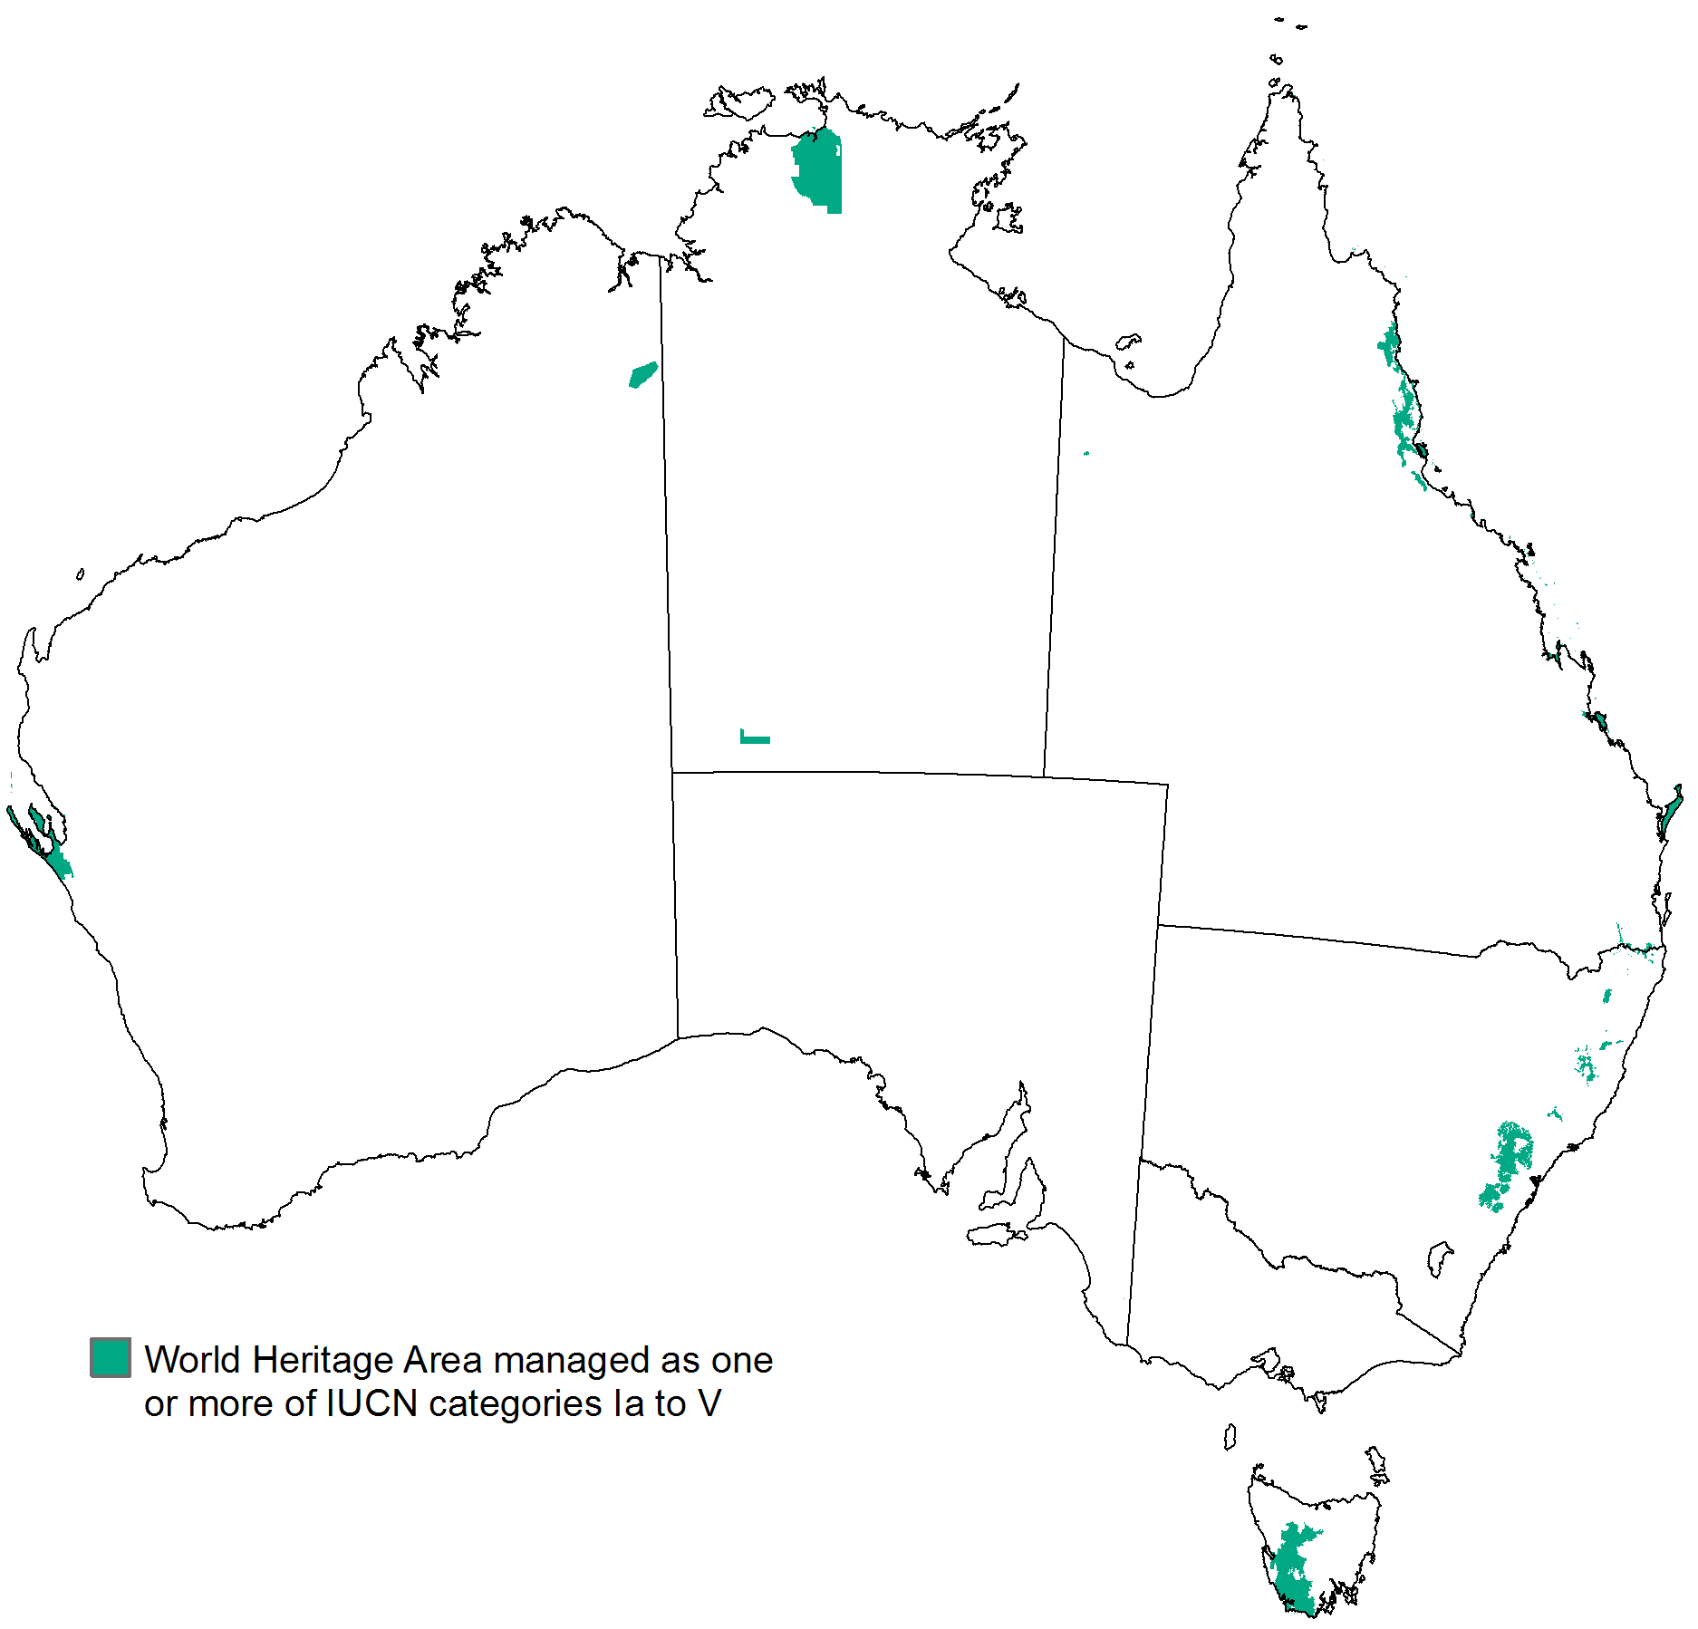

1. *Tenure layer* (Map 4)—an updated version of *Tenure of Australia's forests (2013)* (ABARES 2014c). The updates involved completing the layer in areas with unknown tenure, introducing Aboriginal land, defence and water production reserves, updating the tenure for the Ord River Irrigation Area (ORIA) and combining some tenure classes to simplify the tenure classification. Areas of missing tenure were completed using data from the tenure layer for the Version 4 NLUM. The Aboriginal land areas were taken from two sources, the CLUM dataset used to make the catchment scale land use layer (ABARES 2014a) and the *Western Australia Aboriginal lands trust estate as at May 2010* dataset (DAA 2011). Areas classified under ALUMC Version 7 as ‘1.2.5 Traditional indigenous uses’ were taken from the CLUM data and given the tenure classification ‘Aboriginal land—traditional indigenous uses’. Areas identified as General Purpose Leases in the DAA (2011) dataset, excluding areas classified as used for agriculture in the CLUM data and areas classified as nature conservation reserves in *Tenure of Australia's forests (2013)* were given the tenure classification ‘Aboriginal land—other non-agricultural’. Defence reserves were taken from *GEODATA TOPO 250K series 3* (GA 2006). Water production reserves were taken from the tenure layer for the Version 4 NLUM. The tenure for the ORIA was updated so that all areas used for sandalwood plantations or for agriculture are shown as private tenure.

**Map 4** Tenure layer

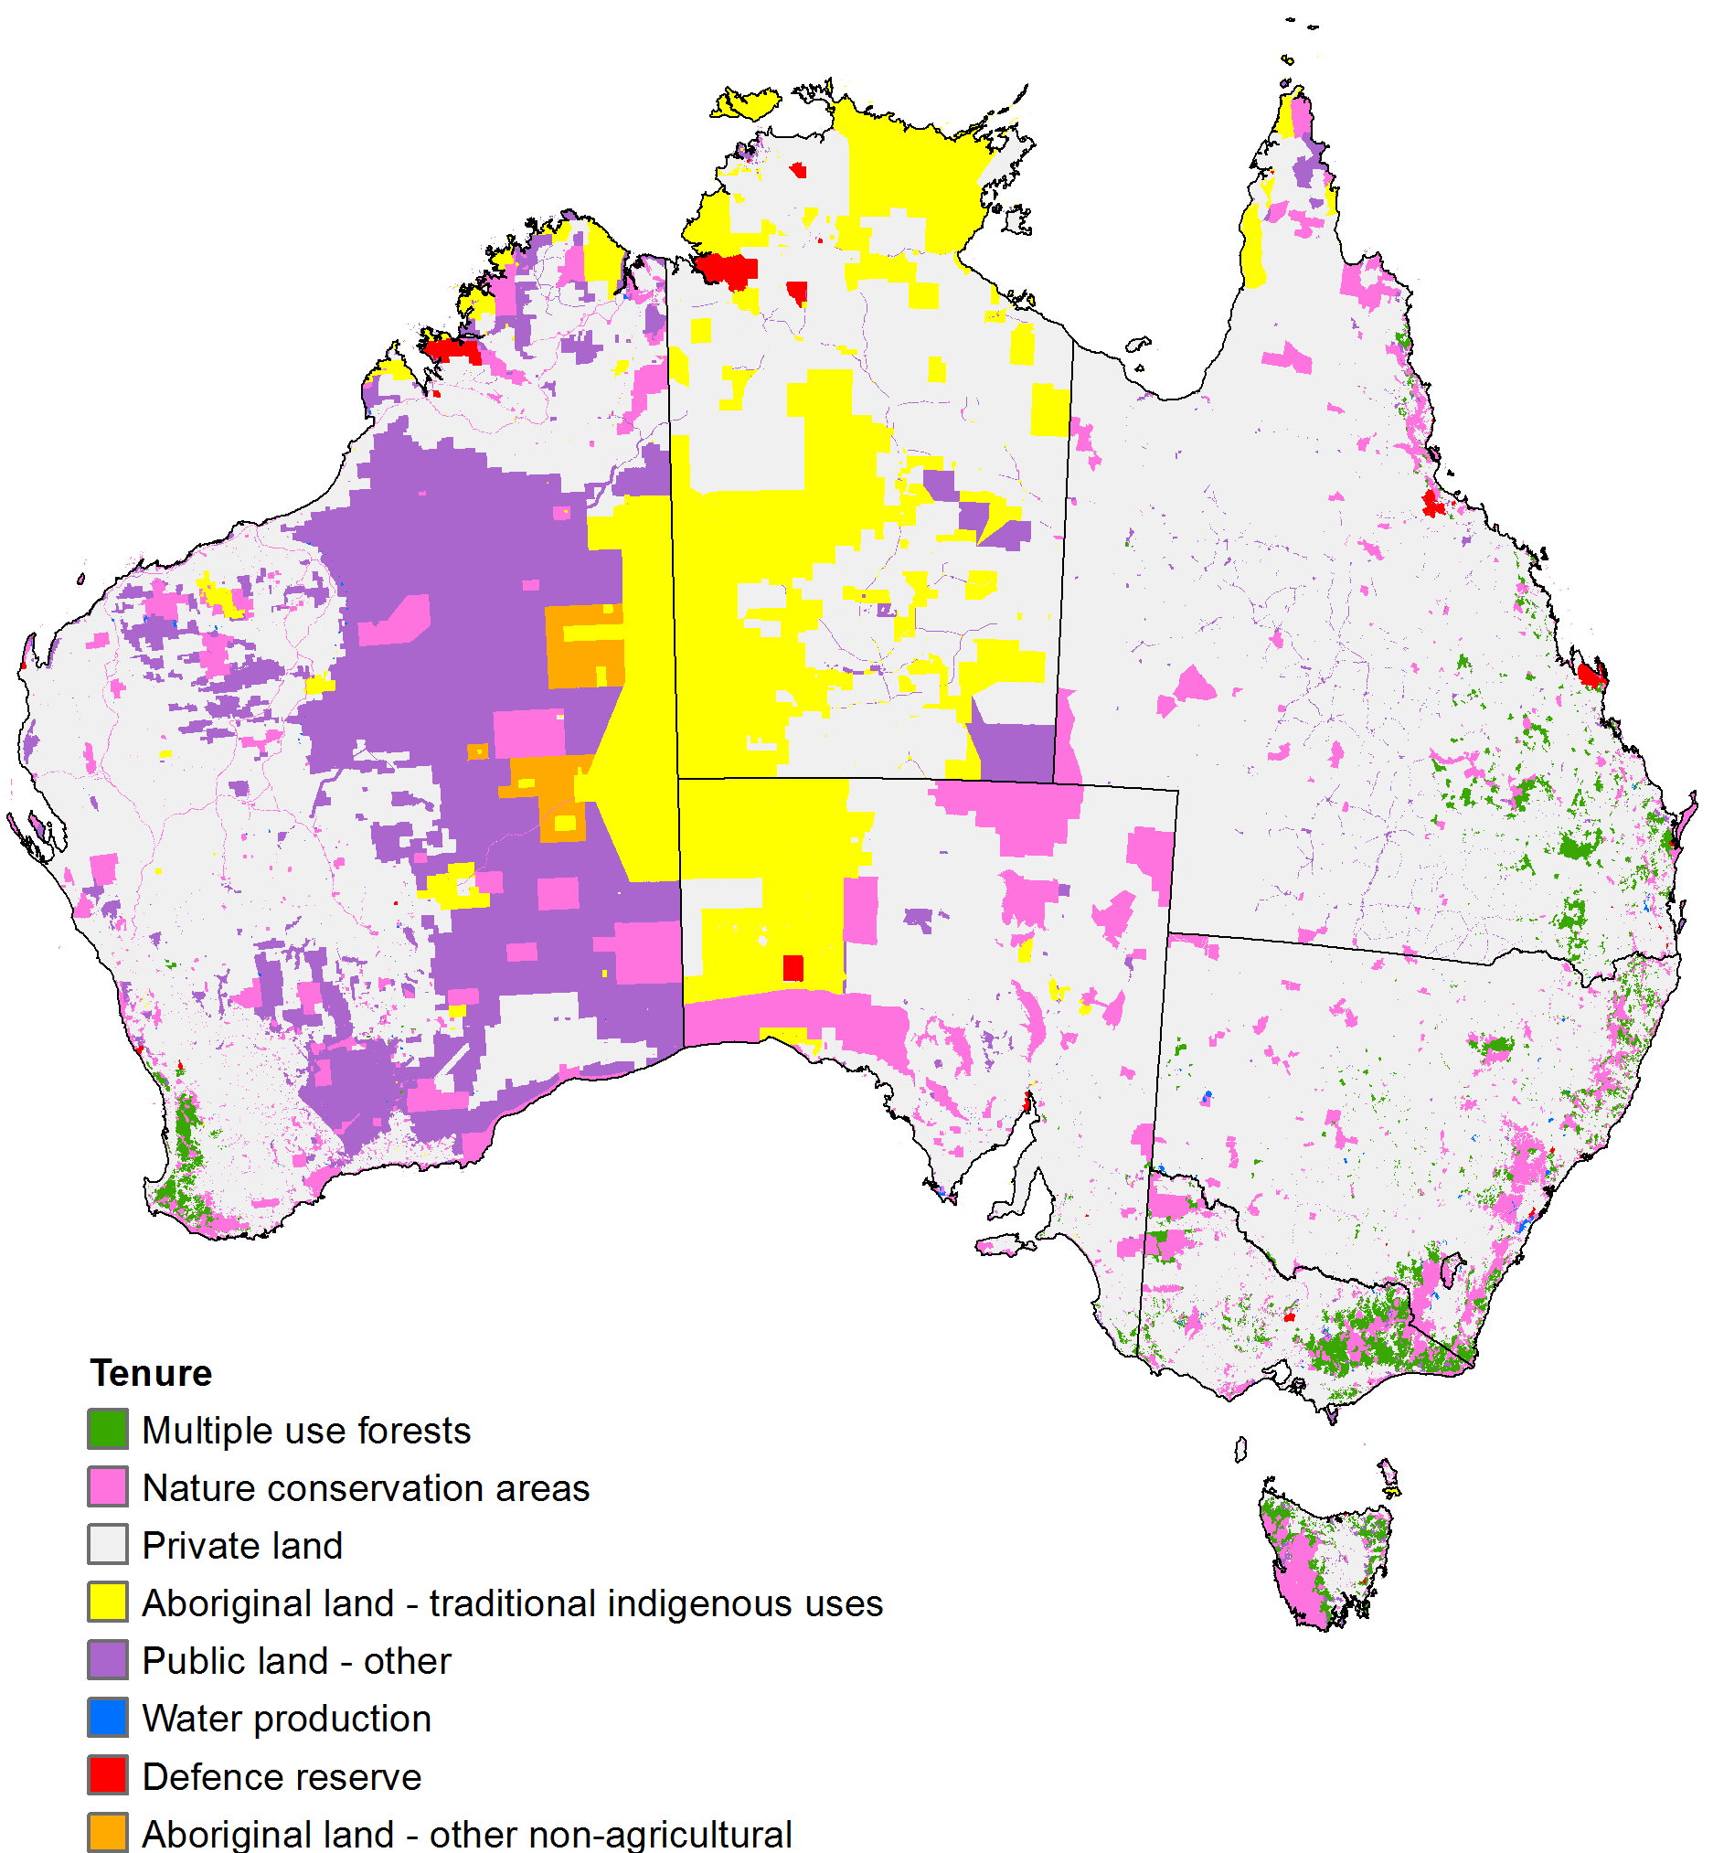

1. *Forest type layer* (Map 5)—constructed from the 100 metre raster dataset *Forests of Australia (2013)* (ABARES 2014b). This dataset defines forest as areas of trees with crown cover greater than 20 per cent and tree height greater than 2 metres. The forest type layer takes basic forest cover attributes from its source dataset. It categorises forest pixels as plantation forest, native forest (further broken down into closed forest with crown cover greater than 80 per cent, open forest with crown cover between 50 and 80 per cent and woodland with crown cover between 20 and 50 per cent) and non-forest (crown cover less than 20 per cent) or no data. Pixels representing forest of unknown type (and with unknown crown cover, if native forest) were assumed to represent native forest everywhere except in the ORIA and were assigned the crown cover of the nearest native forest pixels with known crown cover. Pixels representing forest of unknown type in the ORIA were assumed to represent irrigated plantation forest. A new forest type category was created for irrigated plantation forest with these pixels reclassified to the new category. For pixels representing plantation forest outside the ORIA, the irrigation status is unknown. The pixels already identified as plantation forest in the ORIA were also reclassified to irrigated plantation forest. The representation of plantation forest in the ORIA was further refined using information provided by the Department of Agriculture and Food, Western Australia (DAFWA) for the period 1 April 2010 to 31 March 2011. DAFWA indicated that the plantation forest in the ORIA during that period was irrigated sandalwood covering an area of 6,100 hectares and identified areas where it had been grown, some of which were additional to the areas of forest shown in *Forests of Australia (2013)*. The pixels representing these additional areas were reclassified as irrigated plantation forest bringing the total area of plantation forest shown by the forest type layer in the ORIA to 6,168.7 hectares.

**Map 5** Forest type layer

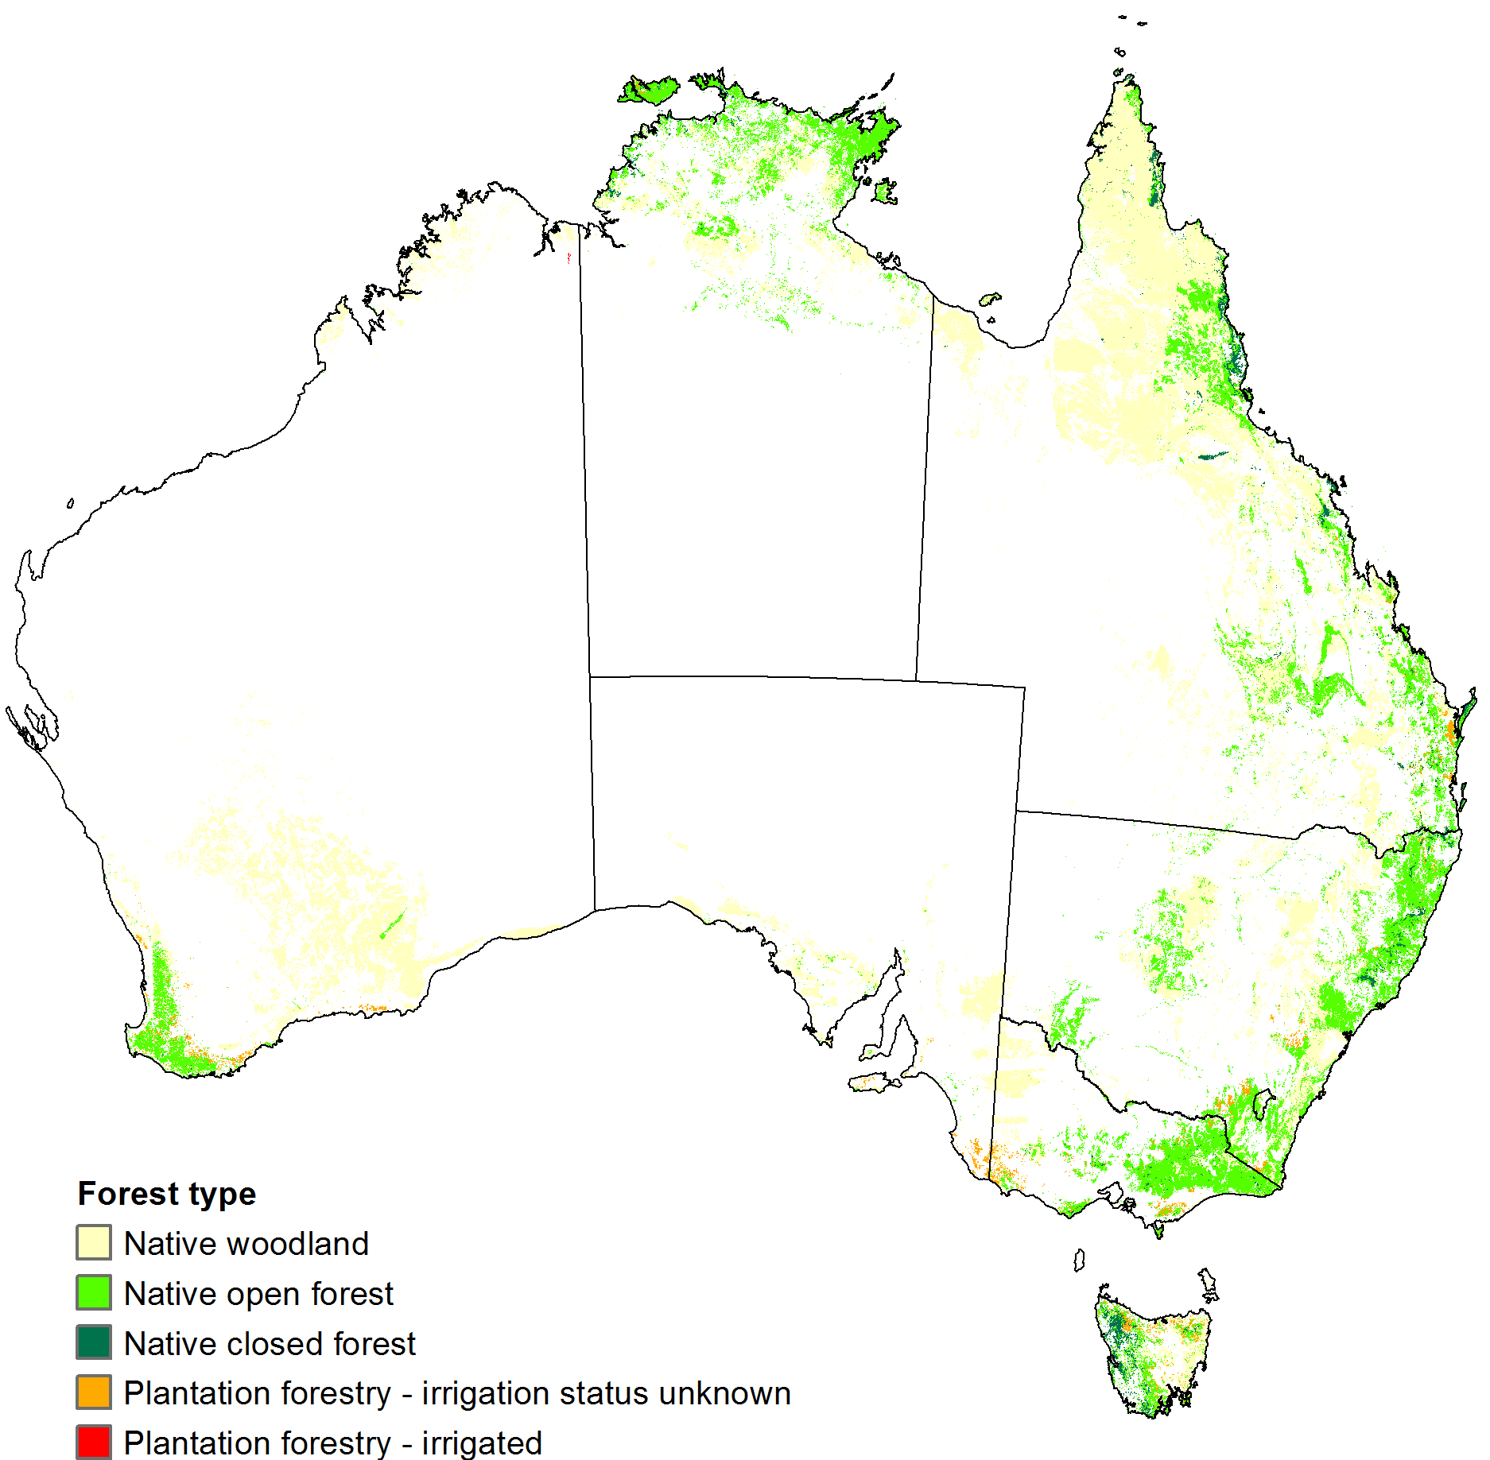

1. *Vegetation condition layer* (Map 6)—used to distinguish between native and modified vegetation. This improved the accuracy of classifying grazing land as either grazing of native vegetation (ALUMC Version 7 land use class ‘2.1.0 Grazing native vegetation’) or grazing of modified vegetation (ALUMC Version 7 land use classes ‘3.2.0 Grazing modified pastures’ and ‘4.2.0 Irrigated modified pastures’). It also enabled a more informed decision for classifying unused or little used land as having remnant native vegetation cover (ALUMC Version 7 land use class ‘1.3.3 Residual native cover’) or not (ALUMC Version 7 land use class ‘1.3.0 Other minimal use’). The vegetation condition layer provides a binary classification for each pixel as native or modified. The binary classification was derived from the CLUM data of the catchment scale land use layer with, in the main, all land uses (ALUMC Version 7) in primary classes ‘1 Conservation and Natural Environments’, ‘2 Production from Relatively Natural Environments’ and ‘6 Water’ classified as native and all land uses in primary classes ‘3 Production from Dryland Agriculture and Plantations’, ‘4 Production from Irrigated Agriculture and Plantations’ and ‘5 Intensive Uses’ classified as modified. Exceptions were:
   1. all pixels in the ORIA were classified as modified vegetation using boundaries representing the extent of the ORIA as provided by DAFWA
   2. for Queensland, the CLUM data were supplemented with additional information on vegetation assets, states and transitions (VAST) from the *VAST Map for Queensland* (DSITIA 2012) with native-exotic mosaics treated as modified vegetation
   3. for pixels in the CLUM data classed as ‘5.6 Utilities’ and ‘5.8 Mining’ the vegetation condition was determined as:
      1. modified if the unrefined cultivation constraint showed cultivated
      2. modified if (a) did not apply and the CLUM data showed a modified agricultural land use or a non-agricultural land use with predominantly modified agricultural land uses represented by the eight surrounding pixels
      3. native if (a) did not apply and the CLUM data layer showed a native agricultural land use or a non-agricultural land use with predominantly native agricultural land uses represented by the eight surrounding pixels
      4. native if none of the previous three cases (a, b and c) applied.

**Map 6** Vegetation condition layer

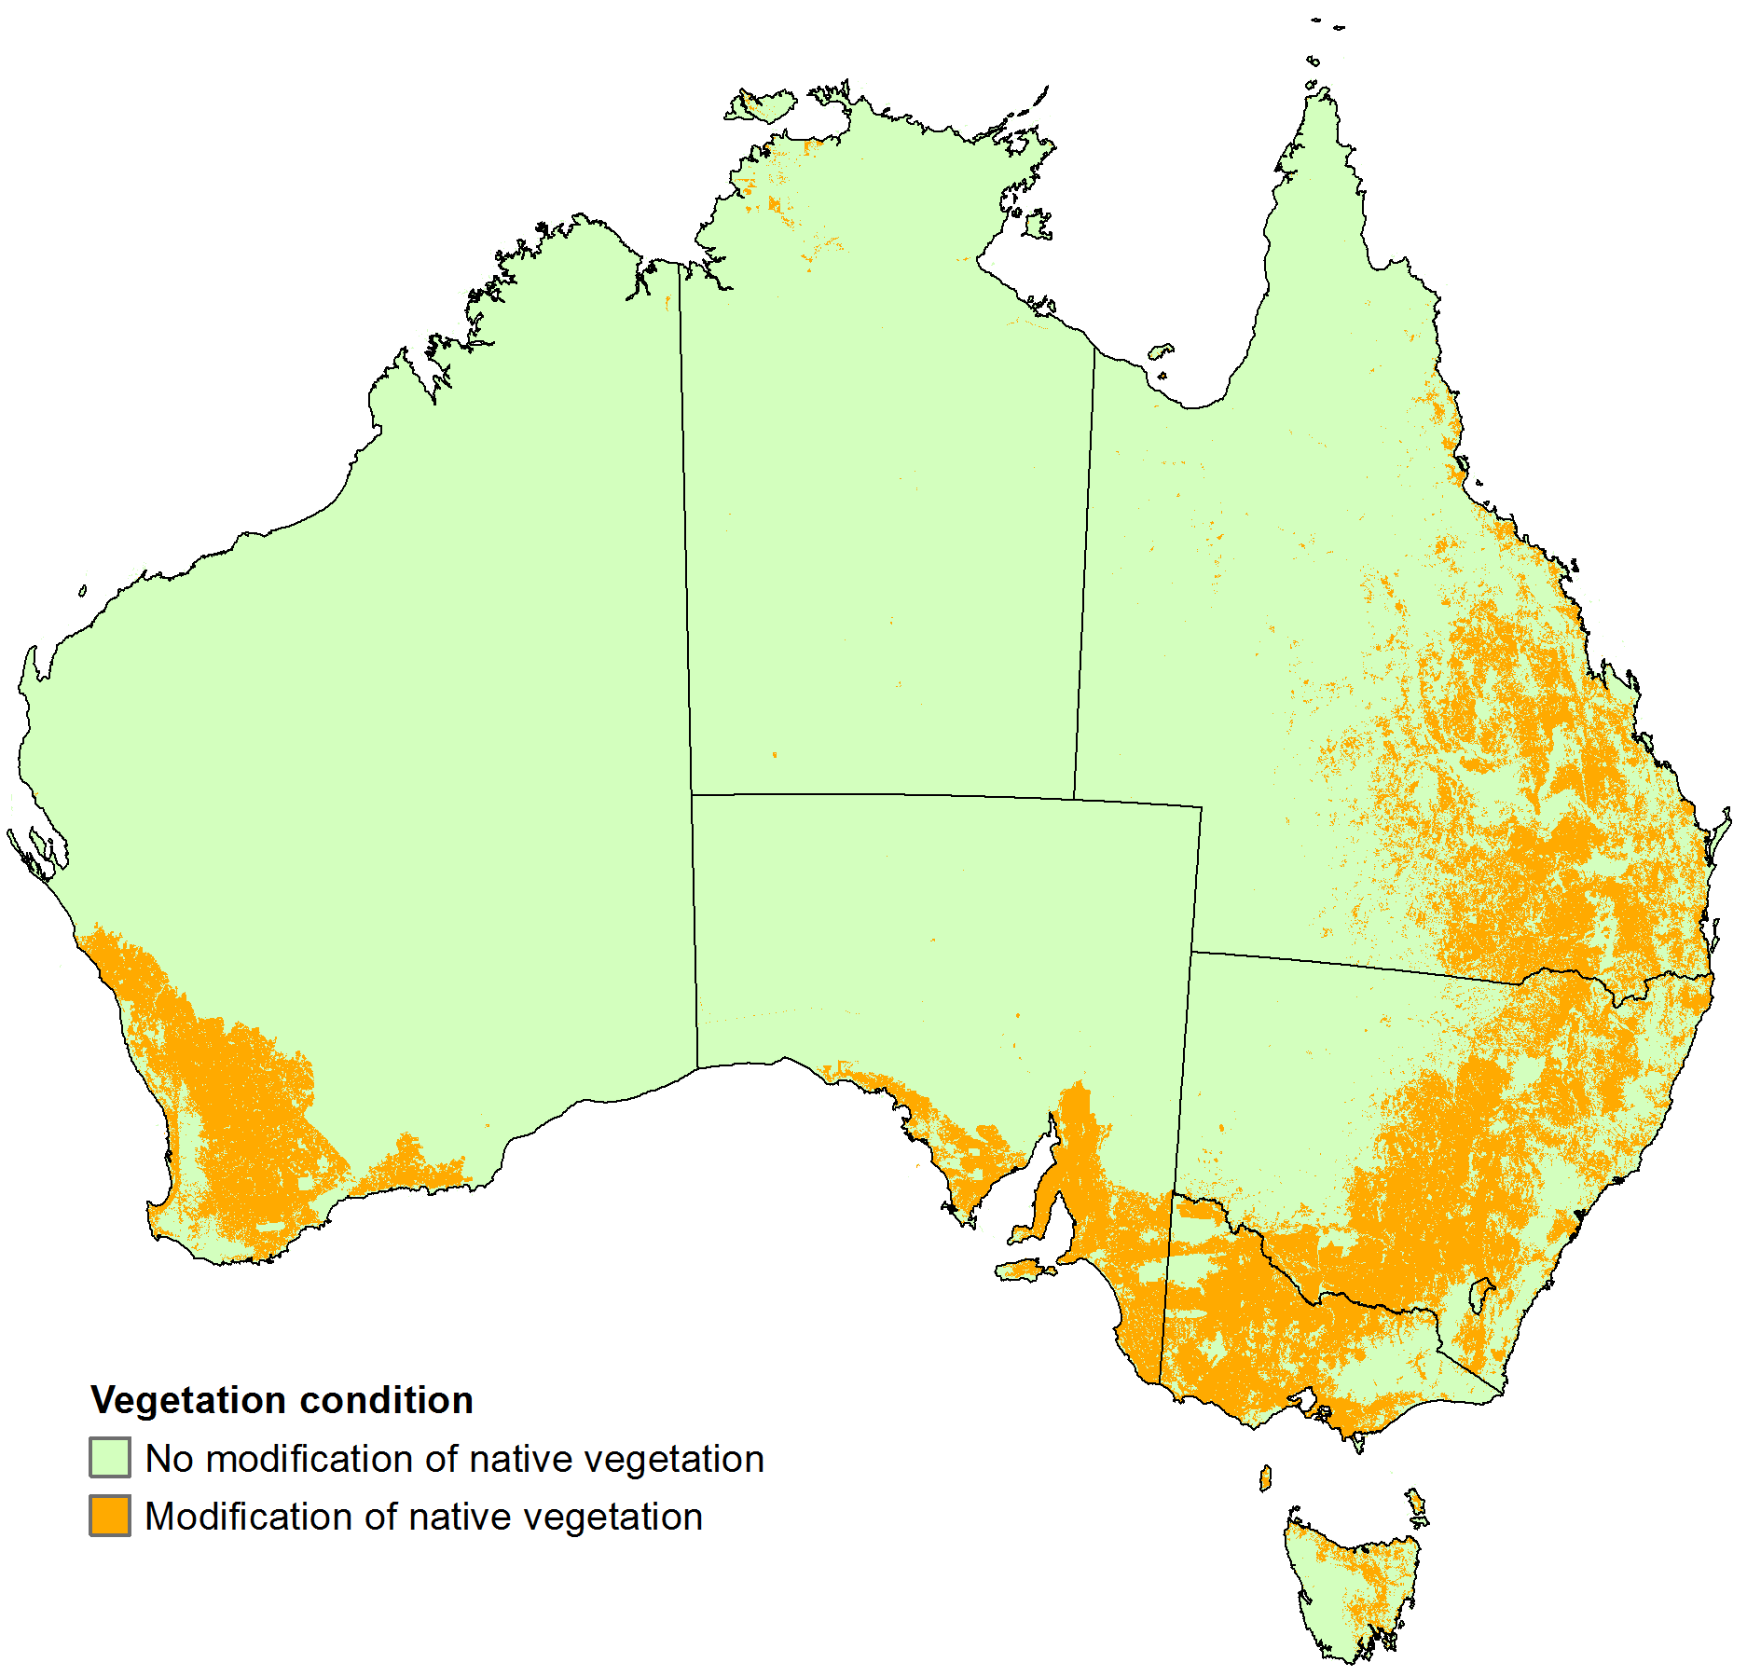

## Spatial constraints

The methods used in the construction of the three spatial constraints—horticulture, cultivation and irrigation—(part of step 2 in Figure 1) were:

1. *Horticulture spatial constraint* (Map 7)—identifies pixels representing horticulture, including vegetables, orchards, plantation fruit and grapes. The constraint was constructed using the following steps:
   1. Pixels representing horticulture were identified according to the national compilation of CLUM data used in the construction of the catchment scale land use layer.
   2. Additional horticulture pixels with currency 2000 to 2005 were identified using data from the collaborative project *Land Use Data Integration Case Study: the Lower Murray NAP Region* (Smith and Lesslie 2005).
   3. Additional horticulture pixels with currency c. 1995 were identified using data from a collaborative project on remote sensing of agricultural land cover change in Australia (Barson and Kitchen 1998; BRS 2000; and Barson et al. 2000).
   4. Additional horticulture pixels were identified using polygons representing orchards from *GEODATA TOPO 250K series 3* (GA 2006).
   5. All pixels flagged as horticulture in the SLA containing the ORIA but not within the ORIA (based on boundary data provided by DAFWA) were reclassified as non-horticultural. All pixels within the ORIA identified as sandalwood plantation were classified as non-horticultural.

**Map 7** Horticulture spatial constraint

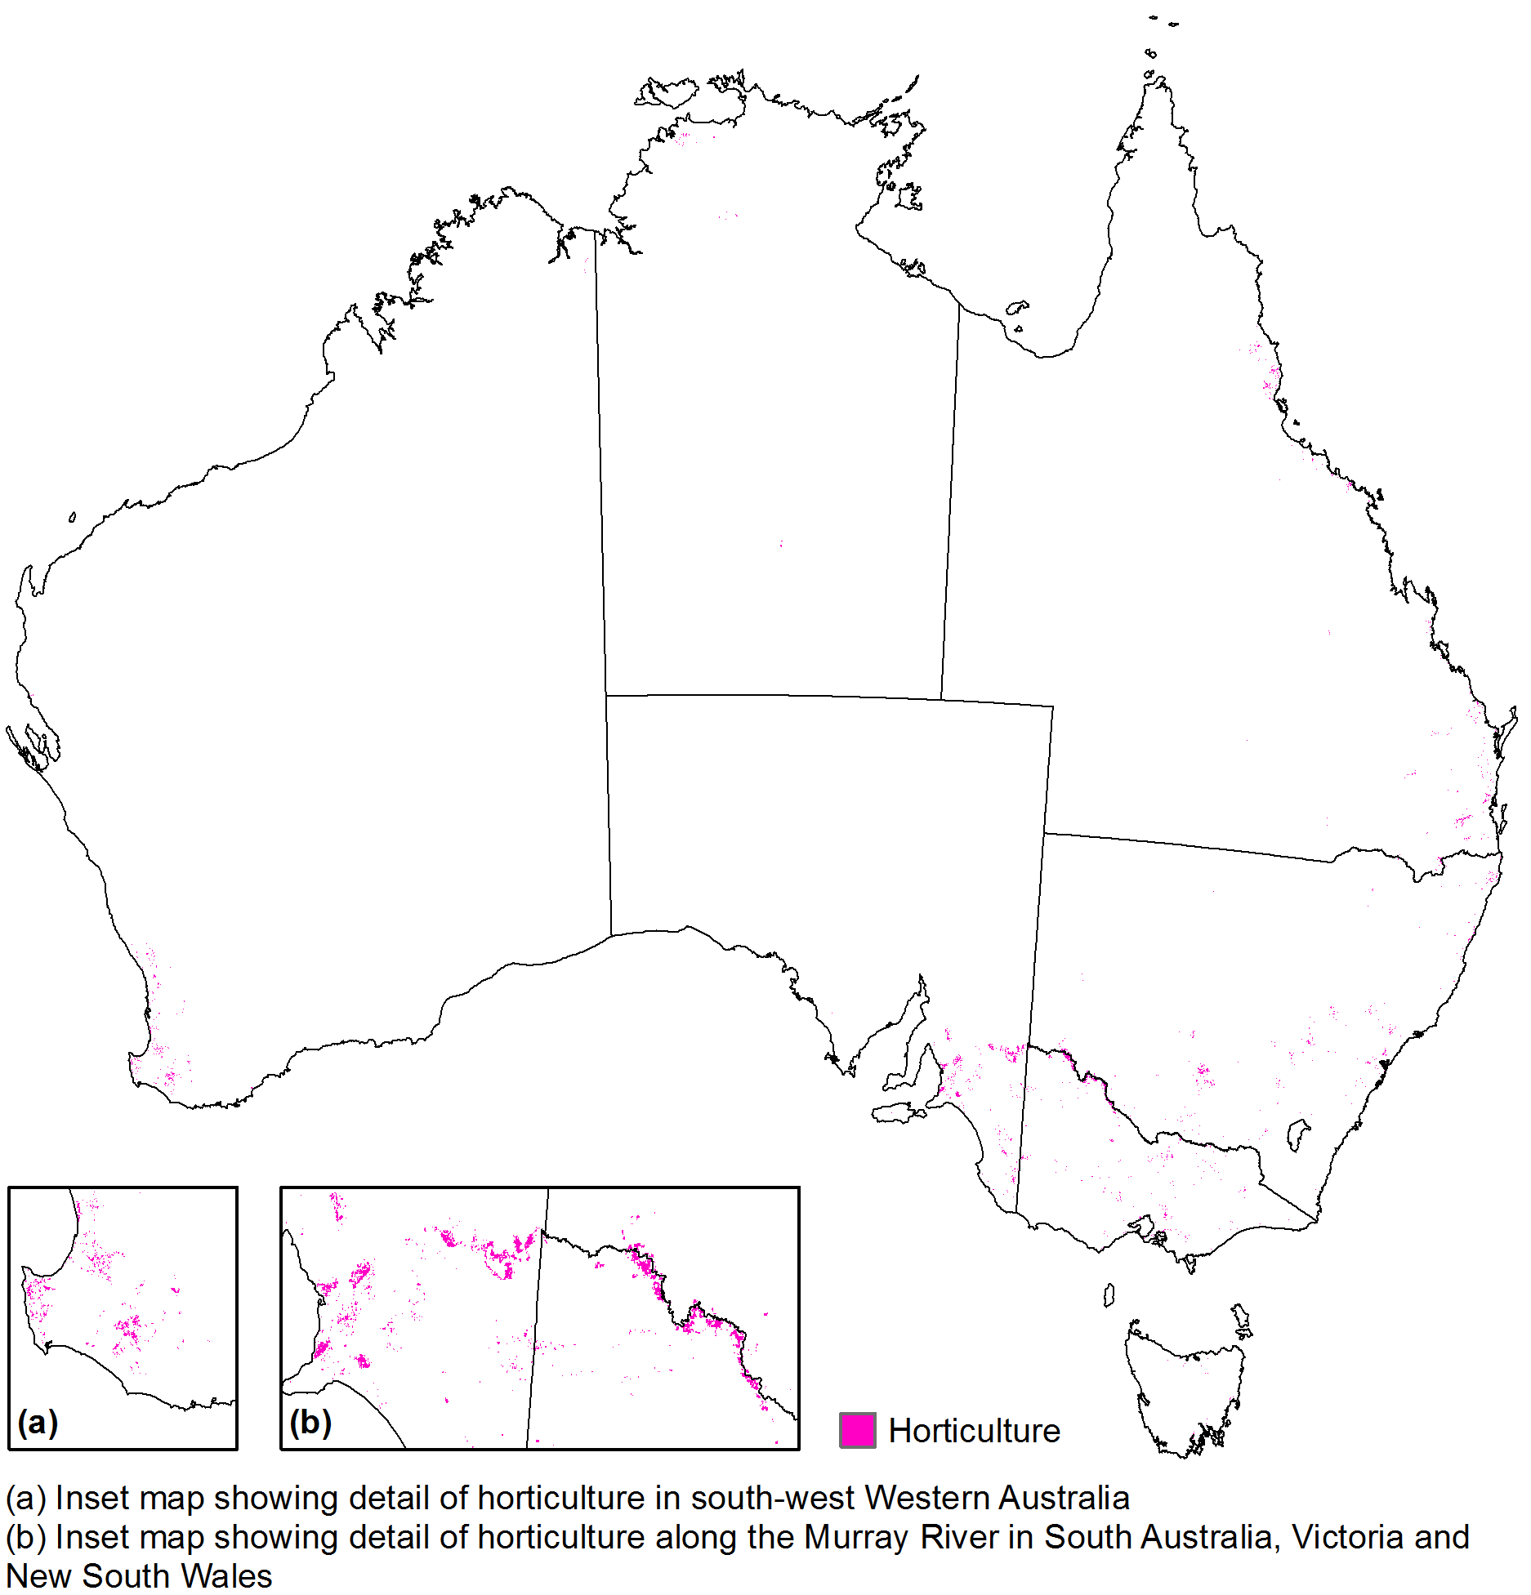

1. *Cultivation spatial constraint* (Map 8)—identifies pixels representing cultivated land, including sown pasture, grains, sugar cane, pastures and crops for hay, cotton, other non-cereal crops, vegetables and other horticulture but excluding grazing native vegetation, grazing native-exotic pasture mosaics, plantation forestry and agroforestry. The constraint was constructed using the following steps:
   1. The dataset *Native vegetation baseline 2004 version 1* (ABARES 2012b) was used to identify pixels representing cultivated land in all states and territories except Queensland. Cultivated land was taken to be the areas shown as modified vegetation where they coincide with potentially agricultural land.
   2. The unpublished *VAST map for Queensland* (DSITIA 2012) was used to identify pixels representing cultivated land in Queensland. Cultivated land was taken to be the areas shown as modified vegetation that coincide with potentially agricultural land except that native-exotic mosaic areas were classified as non-cultivated.
   3. All pixels in the SLA containing the ORIA flagged as cultivated were reclassified as non-cultivated if outside the ORIA (based on boundary data provided by DAFWA). All pixels within the ORIA identified as cropping or horticulture were classified as cultivated. All pixels within the ORIA identified as sandalwood plantation were classified as non-cultivated.

**Map 8** Cultivation spatial constraint

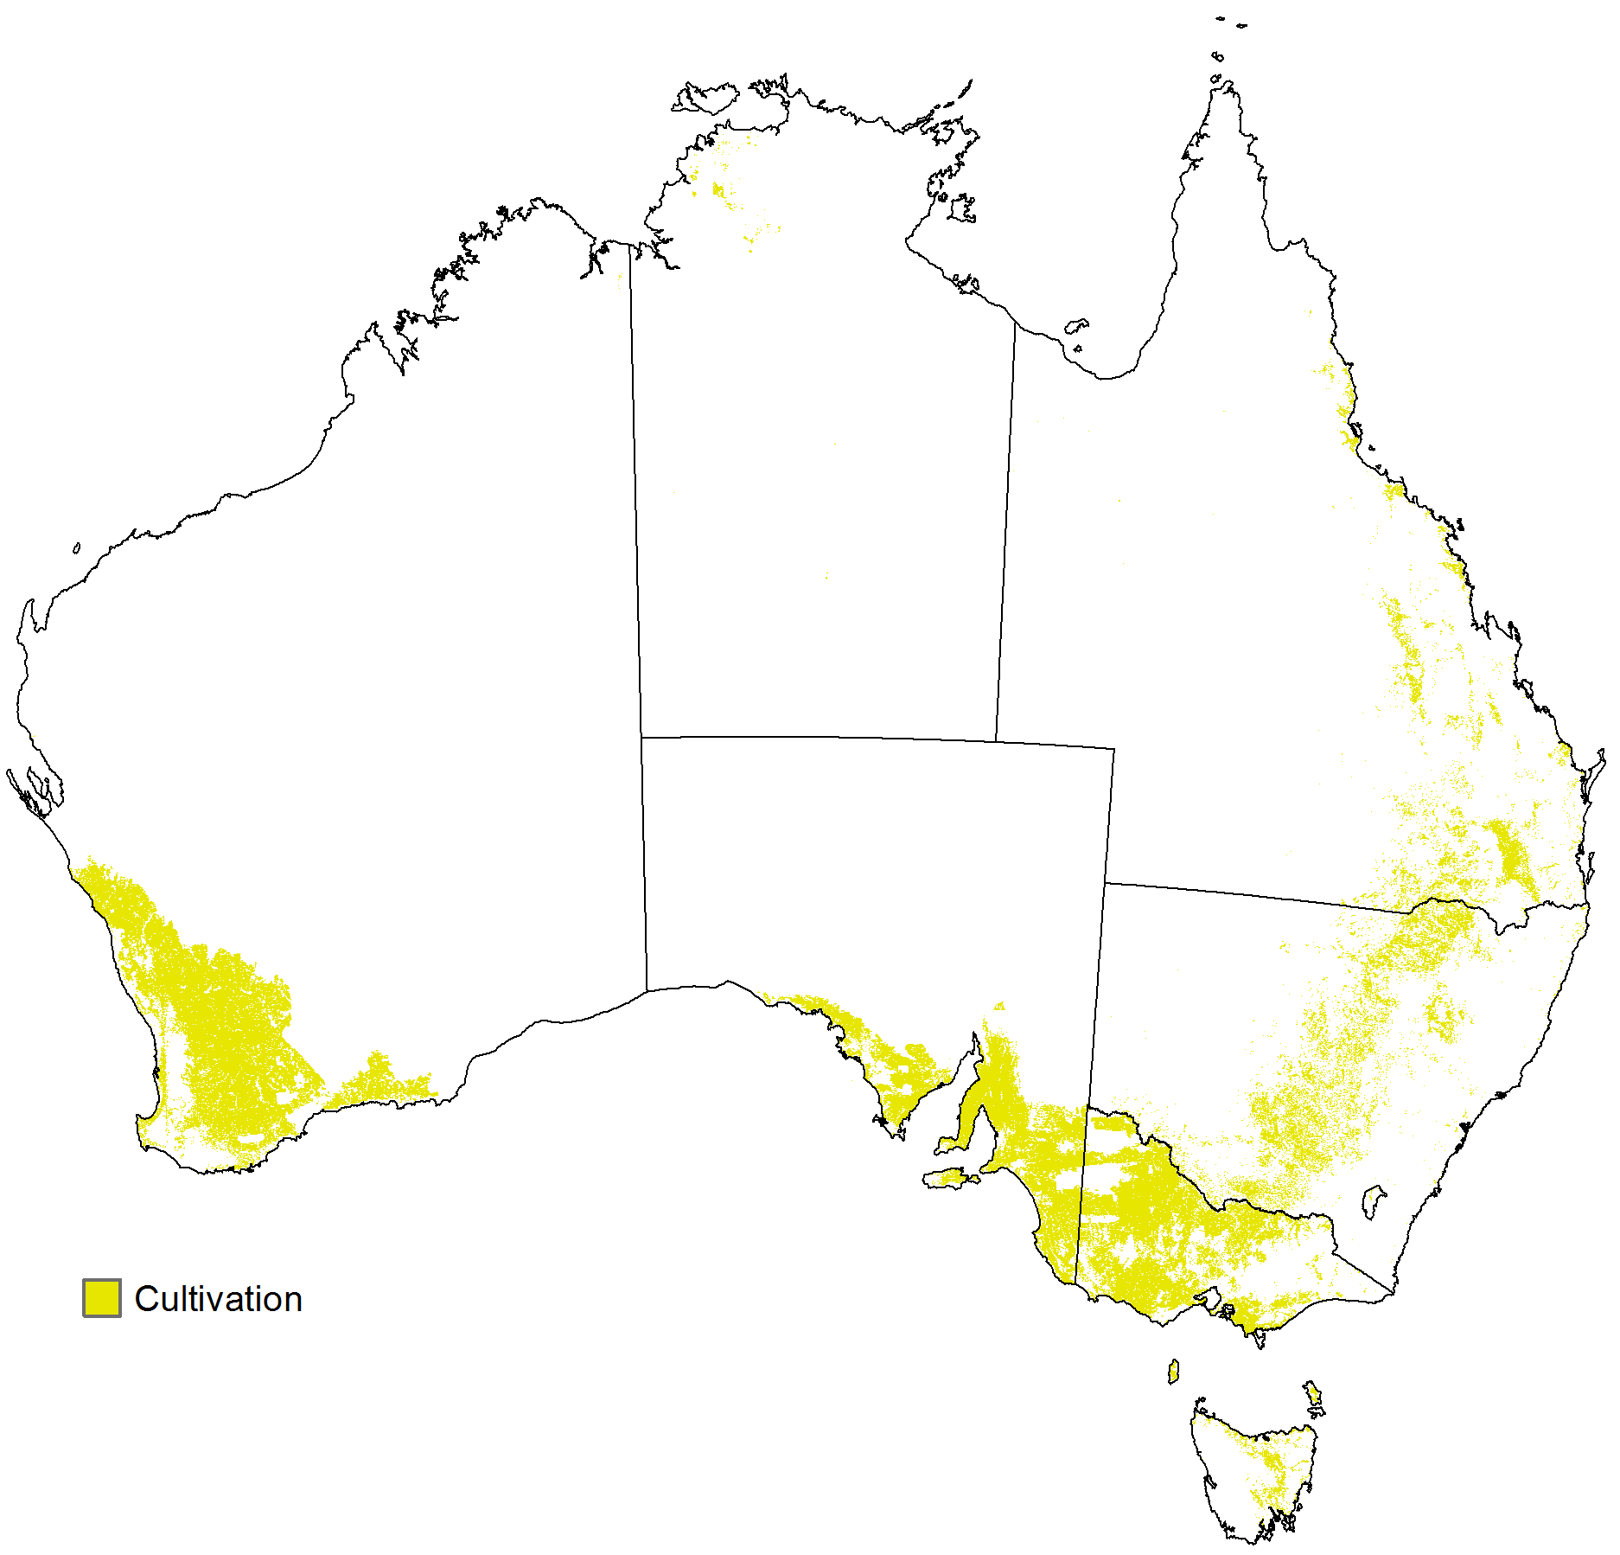

1. *Irrigation spatial constraint* (Map 9)—identifies pixels likely to have been irrigated in 2010–11. The constraint was constructed as follows:
   1. A preliminary irrigation mask was constructed as a 50 metre raster by extracting all pixels of irrigated agricultural land—irrigated grazing, cropping and horticulture but not irrigated plantation forestry—from CLUM data used to make the catchment scale land use layer (ABARES 2014a).
   2. NSW was updated with additional 50 metre pixels representing areas irrigated in 2010–11 using data from the New South Wales Government Office of Environment & Heritage.
   3. The wheat sheep belt in the south-west corner of Western Australia was updated to show areas irrigated in 2010–11 using data from DAFWA.
   4. A 0.01 degree irrigation density raster with the same coordinate system and pixel alignment as the Version 5 NLUM was then constructed. Each pixel in this irrigation density raster was assigned a value giving the proportion, by area, of the pixel that was occupied by irrigated land uses in 2010–11 according to the preliminary, 50 metre pixel size irrigation mask. The irrigation densities were expressed as percentages.
   5. For each state and territory, a minimum irrigation density threshold was determined that could be used to make the final irrigation spatial constraint with the same pixel size, coordinate system and pixel alignment as the Version 5 NLUM. Each density threshold specifies the minimum proportion irrigated for a 0.01 degree pixel to be classed as irrigated land. The density thresholds (rounded to multiples of 5 per cent) were chosen such that the resulting 0.01 degree irrigation mask gave irrigated land areas for each state and territory that were greater than or equal to (but otherwise as close as possible to) estimated irrigated land areas based on the 2010–11 agricultural census. The irrigated land areas for each state and territory could not be determined exactly until processing of the census data (including scaling to fit the mapped distribution of potentially agricultural land) had been completed (step 3 in Figure 1).
   6. The final 0.01 degree irrigation spatial constraint was made from the irrigation density raster using density thresholds established in step (v) except that for states and territories where the calculated density threshold exceeded 50 per cent, a density threshold of 50 per cent was used instead. The reasons for doing this were as follows:
      1. For states and territories with a calculated density threshold exceeding 50 per cent, using the ideal density threshold of 50 per cent would result in the area shown as irrigated being too large in comparison with the area of irrigated land uses to be allocated by SPREAD II; there would be a surplus of pixels identified as irrigated. In this case, constructing the spatial constraint using a density threshold of 50 per cent and requiring SPREAD II to cope with the surplus by finding a relatively small number of irrigated pixels in a larger but still relatively small number of target pixels was expected to lead to a good outcome. On the other hand, discarding the surplus by constructing the spatial constraint using the calculated density threshold would possibly lead to a poor outcome. Land uses shown as irrigated in CLUM data may have been inferred to be irrigated based on the presence of irrigation infrastructure though they may not actually have been irrigated in 2010–11. Discarding superfluous pixels based on the irrigation density according to CLUM data could result in some pixels being discarded that should have been retained.
      2. For states and territories with a calculated density threshold of 50 per cent or less, using the ideal density threshold of 50 per cent would result in the area shown as irrigated being too small in comparison with the area of irrigated land uses to be allocated by SPREAD II; there would be a shortfall of pixels identified as irrigated. In this case, making up the shortfall by constructing the spatial constraint using the calculated density threshold was expected to give a good outcome. For states and territories with a shortfall, it would be likely that all of the areas identified as irrigated in the CLUM data would have been irrigated in 2010–11 and the missing irrigated land uses would be likely to be close to those already identified. On the other hand, constructing the spatial constraint using a density threshold of 50 per cent and requiring SPREAD II to cope with the shortfall by finding a relatively small number of irrigated pixels in a much larger number of target pixels would probably lead to a poor outcome.
   7. After final processing of the agricultural census data (step 3 in Figure 1), the irrigation spatial constraint was remade using better estimates for the irrigated land areas for each state and territory. This entailed repeating many of the tasks involved in steps 2 and 3 in Figure 1 until the differences between the irrigated land areas in the irrigation spatial constraint and the new estimates derived from the agricultural census data were minimal and the irrigation density thresholds were all the same.

**Map 9** Irrigation spatial constraint

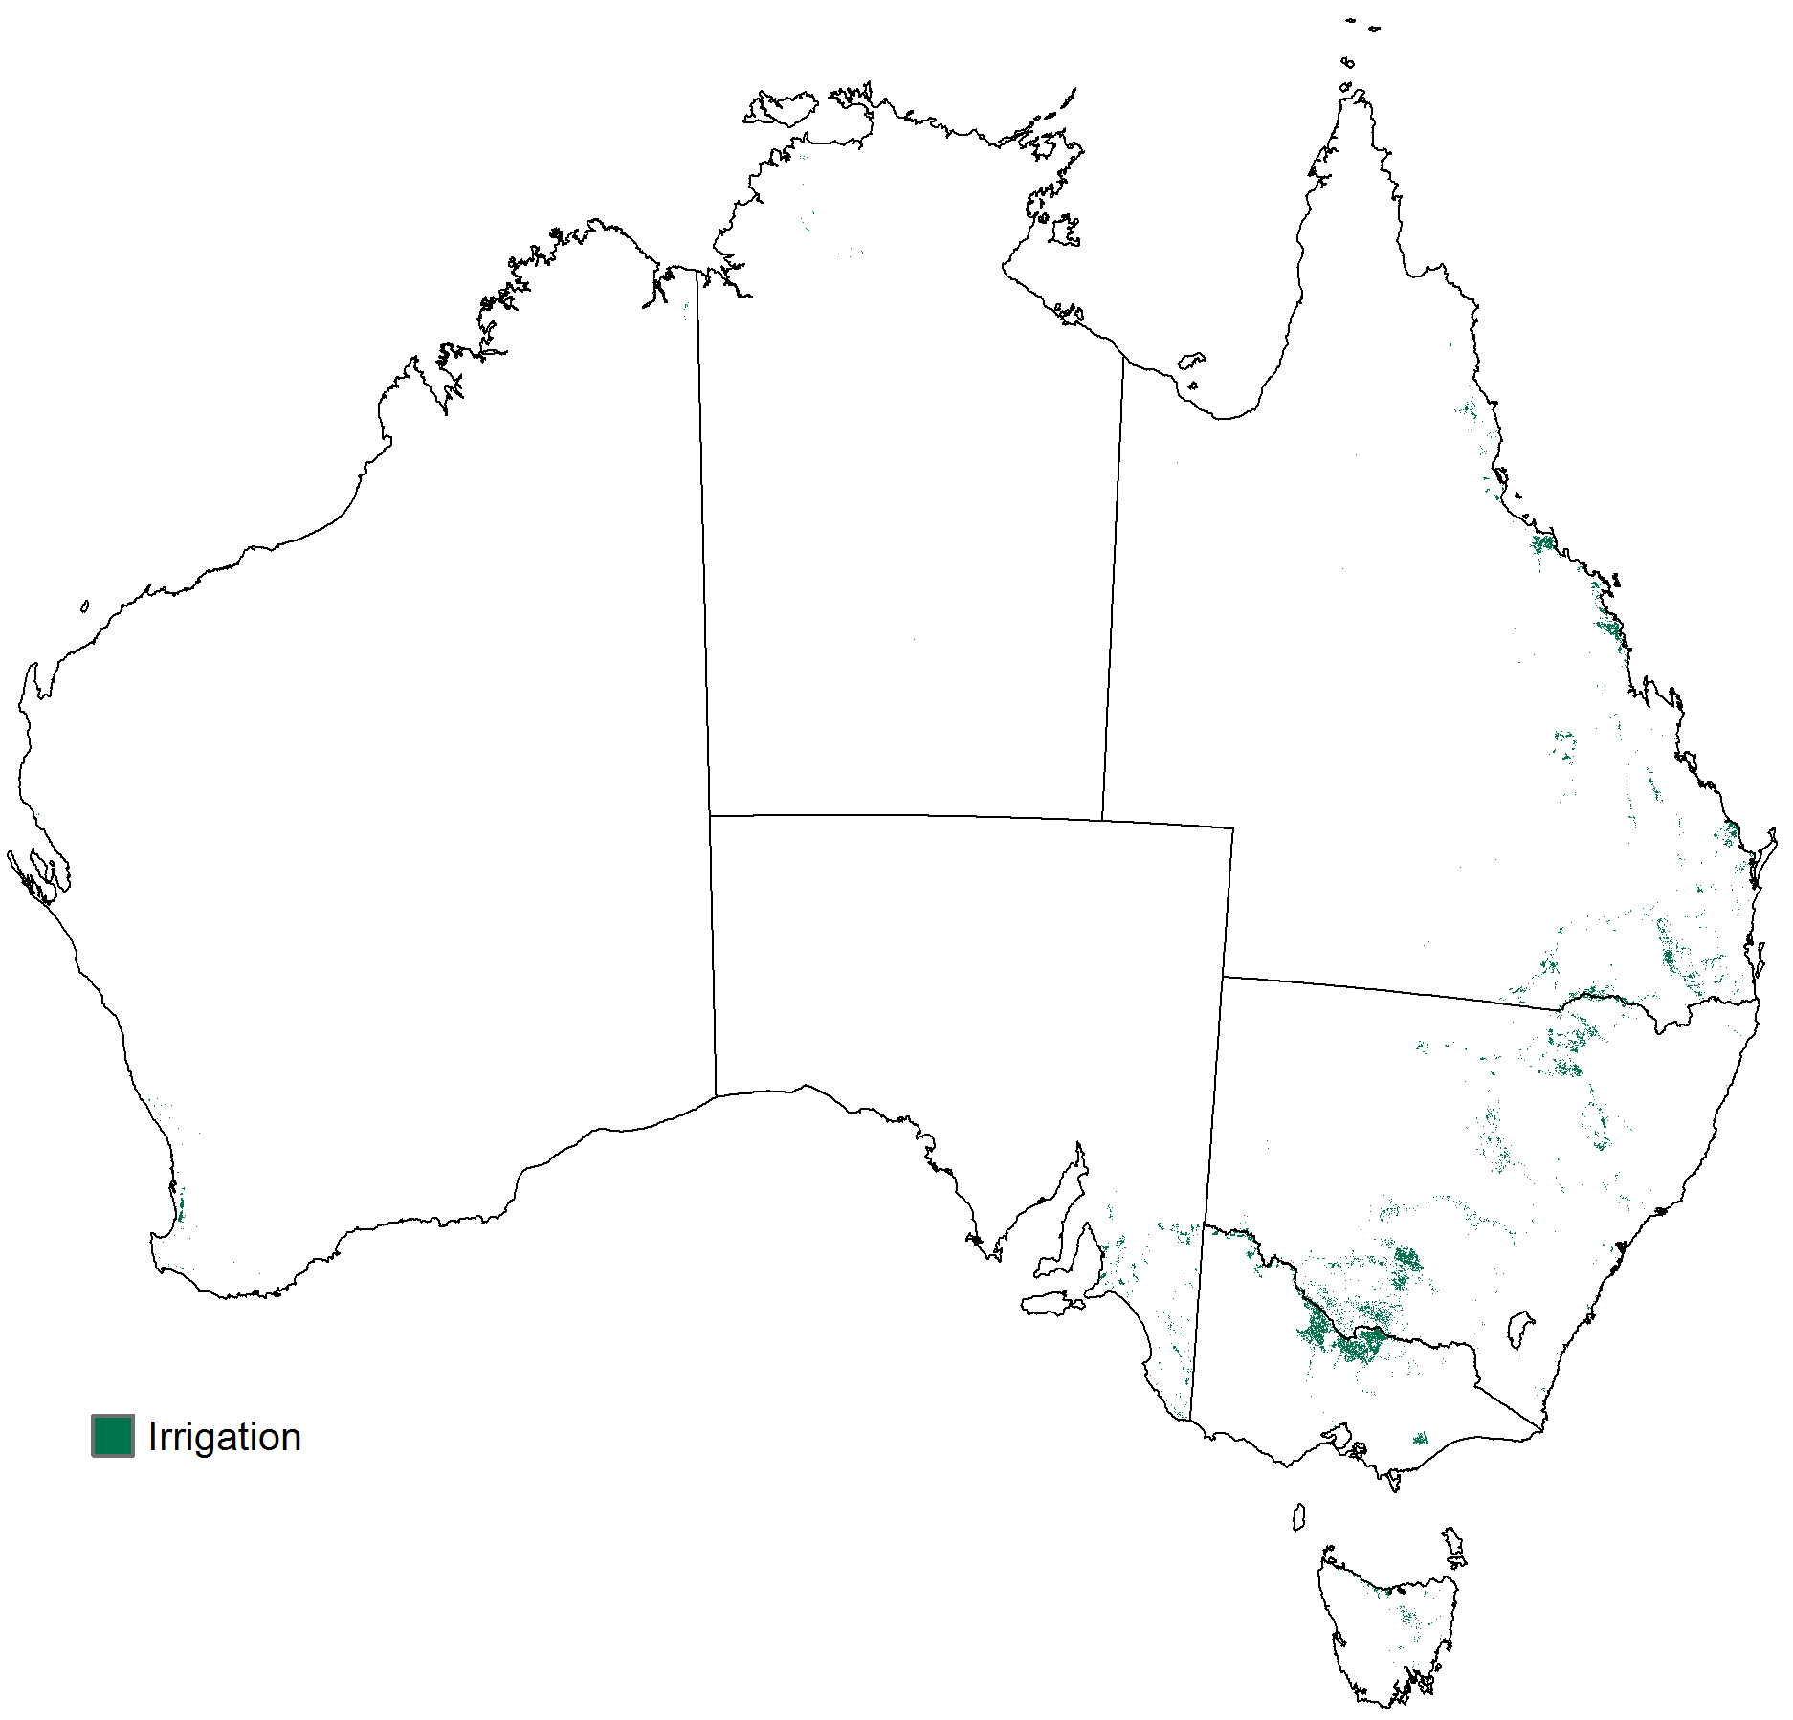

## Refine inputs

The three spatial constraints and the forest type and vegetation condition layers were refined to make them consistent with each other (included in step 2 of Figure 1). The following steps, based on an assumed order of reliability and additional assumptions about the mutual relationships between the five inputs, were used in making the refinements:

1. Irrigation and horticulture spatial constraints—these are based on the CLUM data used to make the catchment scale land use layer (ABARES 2014a) and are assumed to be the most reliable of these five inputs.
2. Forest type layer—this layer is based on the *Forests of Australia (2013)* dataset (ABARES 2014b), which is based on data from the states and territories and is assumed to be the next most reliable. It is assumed that irrigation and horticulture areas only occur in areas of non-forest and the forest type layer was modified to ensure consistency with this assumption.
3. Vegetation condition layer—this layer is based on the CLUM data used to make the catchment scale land use layer (ABARES 2014a) and the *VAST map for Queensland* dataset (DSITIA 2012). It is assumed that irrigation and horticulture areas only occur in areas of modified vegetation and that plantation forestry areas also only occur in areas of modified vegetation but that native forest areas must occur in areas of native vegetation. The vegetation condition layer was modified to ensure consistency with these assumptions.
4. Cultivation spatial constraint—this layer is based on the *Native vegetation baseline 2004 version 1* dataset (ABARES 2012b) and the *VAST map for Queensland* dataset (DSITIA 2012). It is assumed that irrigation and horticulture areas only occur in areas of cultivated land, that all forested areas only occur in areas of non-cultivated land and that unmodified vegetation areas only occur in non-cultivated land. The cultivation spatial constraint was modified to ensure consistency with these assumptions.

## Non-agricultural and simplified agricultural land use maps

The work described in this section is included in step 2 in Figure 1.

A non-agricultural land use map was made in the following way. The seven thematic input layers for determining the non-agricultural land uses were overlain and their attributes combined as separate columns in the VAT of the resulting raster. The various attribute combinations were classified as land uses using the ALUMC Version 7 with the aid of a macro. The land use assignments were stored in additional VAT columns, including primary, secondary and tertiary codes and descriptions from the ALUMC Version 7. The resulting non-agricultural land use map showed detailed non-agricultural land uses and also the distribution of potentially (unclassified) agricultural land. Potentially agricultural land is private land not used for intensive uses (such as urban residential) and not used for plantation forestry. This land is assumed to be partitioned into the various land uses reported in the agricultural census; some of these land uses are agricultural but some are not and include, for example, land set aside for conservation purposes, land used for farm infrastructure and water bodies.

A simplified agricultural land use map was made from the non-agricultural land use map. It showed potentially agricultural land further categorised according to its forest crown cover class. This enabled the determination for each SLA of the areas of potentially agricultural land in each forest crown cover class. This was necessary for the scaling of the agricultural census data, which is done in step 3 in Figure 1.

## Process agricultural census data

The work described in this section is included in steps 1 and 3 in Figure 1.

The agricultural census data were processed to generate suitable area constraint data: (i) adjustments for double cropping and for multiple cropping of vegetables, (ii) conversion of orchard tree numbers to areas, (iii) scaling of areas to fit the existing digital maps and (iv) disaggregation of irrigated areas for broad commodity groups into areas for the more specific commodity groups to be mapped. The processing undertaken for the Version 5 NLUM is similar to that described by Stewart et al. (2001).

An issue with the 2010–11 agricultural census data was that the ‘all cereals for all other purposes’ area estimates include cereals grazed or fed off and cereals cut for silage. It is also likely that many respondents included cereals cut for silage with the area reported as ‘cereal cut for hay’. It was necessary to estimate, for each SLA, a split of the sum of the areas reported as ‘all cereals for all other purposes’ and ‘cereals cut for hay’ into area of cereals grazed (or fed off), area of cereals cut for silage and area of cereals cut for hay. It is likely that the area reported as cereals grazed or fed off includes some cereal plantings that were later harvested for grain or seed or cut for hay or silage. This was ignored as the areas involved are assumed to be small. The split was estimated on the assumption that it should be in the same proportion as the areas irrigated for the three components. Where the total area irrigated for all three components was zero at SLA level, larger reporting regions were used—statistical divisions (SDs, of which about 60 cover all of Australia), states and territories or national. The resulting split was further modified to ensure that the areas of cereals grazed did not exceed the areas reported as ‘all cereals for all other purposes’ and the areas of cereals cut for hay did not exceed the areas reported as ‘cereals cut for hay’.

Another issue with the 2010–11 agricultural census data was that though the areas of ‘grazing on improved pastures’ and ‘grazing on other land’ were reported for each SLA, the area of grazing on sown pastures was not. This creates a difficulty for SPREAD II since improved pastures comprise sown pastures and native-exotic pasture mosaics but the satellite appearances of native-exotic pasture mosaics are much the same as those of native pastures. Improved pastures do not constitute a suitable map unit for allocation by SPREAD II. For SPREAD II, it was necessary to split grazing land into two map units distinguishable using satellite imagery— ‘grazing—sown pastures’ and ‘grazing—native or naturalised pasture or native-exotic pasture mosaic’ and to estimate the area of sown pasture in each SLA. The area of sown pasture was estimated as the area of non-forested, cultivated, potentially agricultural land (determined using the cultivation mask and the simplified agricultural land use map) minus the total area of other cultivated commodities (calculated from agricultural census data after processing and scaling). Where this gave a negative area, the area of grazing on sown pastures was taken to be zero. Where this gave an area that exceeded the area of grazing on improved pastures (calculated from agricultural census data after processing and scaling), the area of grazing on sown pastures was taken to be equal to the area of grazing on improved pastures. In the calculations, grazing of cereals was treated as grazing of sown pastures.

A third issue with the 2010–11 agricultural census data was that areas for newly planted agroforestry (seed sown or seedlings planted) were not reported. The 2005–06 agricultural census data enabled estimates to be made at state and territory level of the ratio of the area of newly planted agroforestry to the area of on-farm commercial forestry plantations; this ratio was used to calculate SLA level estimates of the area of newly planted agroforestry for 2010–11.

## Allocate agricultural land uses

The work described in this section is summarized in steps 4 to 7 in Figure 1.

The spatial distribution of specific agricultural land uses was modelled using area constraints based on the 2010–11 agricultural census data collected by the ABS and reported at SLA level using ASGC 2010 edition SLA boundaries (ABS 2010). Land uses on non-forested, potentially agricultural land were characterised using time series, monthly NDVI images. Each time series covered a 12 month period from 1 April to the following 31 March; the year mapped was 1 April 2010 to 31 March 2011. Discrimination between land uses was achieved using training data representing the four consecutive years from 1 April 1996 to 31 March 2000. The NDVI images were from AVHRR data (BOM 2013) and comprised five sets of monthly images covering the year to be mapped and each of the four consecutive years represented by the training data. Each set of monthly images was splined before use to further reduce the already small percentage of missing data (step 4 in Figure 1). The training data comprised a collection of ground control sites representing agricultural land uses at various locations within the above four year period collected by the National Land and Water Resources Audit (NLWRA) for the Version 2 NLUM (NLWRA 2001). The control sites were partitioned into groups aligning with the commodity groups to be mapped and the NDVI profile for each site was determined (step 5 in Figure 1).

The SLA boundaries were adjusted to align with ASGS 2011 mesh block boundaries (ABS 2011). The aim was to use commodity presence-absence data compiled by the ABS at mesh block level from the 2010–11 agricultural census data as spatial constraints but the data were not suitable for this purpose. The adjustments to the boundaries were negligible (the largest discrepancy was around 300 metres on the Nullarbor Plain) and in 0.01 degree cell size SLA code grids made from the boundaries, resulted in changes to the SLA code attribute for just 22 pixels.

The agricultural land uses, dryland and irrigated, were mapped in the zone of non-forested, potentially agricultural land using the SPREAD II algorithm (step 6 in Figure 1). The allocations were subject to the area constraints based on the agricultural census data (step 3 in Figure 1) and to the irrigation, horticulture and cultivation spatial constraints (step 2 in Figure 1). Since the number of land uses that can be mapped simultaneously by SPREAD II is 42 and the number of spatial constraints that can be used simultaneously with SPREAD II is two, the mapping of agricultural land uses was done using four runs of SPREAD II. The outputs of all four runs were combined.

In the first run, cultivated land uses were mapped using the irrigation and horticulture spatial constraints (with default densities set to 100 per cent) and with the pixels available for land use allocations restricted to pixels of cultivated land according to the cultivation spatial constraint. The run was limited to processing just those rural SLAs in which the total area of cultivated agricultural land uses to be allocated did not exceed the area of cultivated land.

In the second run, non-cultivated land uses were mapped using the irrigation and horticulture spatial constraints (with default densities set to 100 per cent) and with all pixels of non-forested, potentially agricultural land available for land use allocations except those to already allocated in the first run. The SLAs processed were the same as in the first run.

In the third run, non-cultivated land uses were mapped using the irrigation and horticulture spatial constraints (with default densities set to 100 per cent) and with the pixels available for land use allocations restricted to pixels of non-cultivated land according to the cultivation spatial constraint. The run was limited to processing all rural SLAs except those processed in the first and second runs. This ensured that the total area of non-cultivated agricultural land uses to be allocated did not exceed the area of non-cultivated, potentially agricultural land.

In the fourth run, cultivated land uses were mapped using the irrigation and horticulture spatial constraints (with default densities set to 100 per cent) and with all pixels of non-forested, potentially agricultural land available for land use allocations except those already allocated in the third run. The SLAs processed were the same as in the third run.

A special run was used to map the SLA ‘Unincorp. Far North’ which covers most of northern South Australia. This is the largest ASGC 2010 SLA in Australia based on total area and area of potentially agricultural land (almost all—99.99 per cent—native grazing). This SLA was processed in the third and fourth runs with unsatisfactory SPREAD II outputs. A successful allocation of the agricultural land uses in this SLA was achieved by:

1. allocating in a single run of SPREAD II the non-cultivated and cultivated agricultural land uses—as there were no pixels assigned as cultivated by the cultivation spatial constraint
2. dealing actively rather than passively with the land to be left unallocated by allocating it as an additional land use (‘unused rangelands’)—ground control sites were taken from non-forested, potentially agricultural land left unallocated in four nearby SLAs, two in the southern part of the Northern Territory and two in the south-west corner of Queensland.

The outputs from the four SPREAD II runs and the special SPREAD II run for the SLA ‘Unincorp. Far North’ were combined giving agricultural land use allocations in rural SLAs within non-forested, potentially agricultural land.

Additional grazing land allocations were then made to pixels in forested, potentially agricultural land, using a method not involving SPREAD II, until the total grazing area constraint calculated from the agricultural census data was satisfied (step 7 in Figure 1). Land uses were discriminated using crown cover and slope data. Allocations were to potentially agricultural land pixels with crown cover between 20 and 80 per cent (woodland and open forest), in SLAs where the total grazing area to be allocated could not be accommodated by non-forested, potentially agricultural land alone. The allocations were prioritised, first, by crown cover (pixels with lower crown cover class given higher priority) and, second, by slope (pixels with smallest slope values given highest priority). Crown cover data were from the forest type layer. Slope data were from *GEODATA 9 second DEM and D8: digital elevation model version 3 and flow direction grid* (GA 2008).

Mapping agroforestry presents some difficulties. Established agroforestry with trees 2 or more metres in height should be mapped as forest in the forest type layer. Area estimates for agroforestry with tree height less than 2 metre are not available in the 2010–11 agricultural census. Areas of newly planted agroforestry were estimated using the ratio of the area of newly planted agroforestry to the area of on-farm commercial forestry plantations from the 2005–06 agricultural census data. This enabled newly planted agroforestry to be mapped in the Version 5 NLUM as it had been in the earlier NLUM versions (though using less reliable area constraints). Agroforestry that has been planted for more than a year but with tree heights less than 2 metres would be expected to contribute to non-forested, potentially agricultural land left unallocated at the end of the SPREAD II runs. Such pixels are classified as ALUMC Version 7 land use classes ‘1.3.0 Other minimal use’ or ‘1.3.3 Residual native cover’ depending on whether the vegetation condition layer indicates modified or native vegetation. All agroforestry mapped in the Version 5 NLUM has been classified as dryland, since the agricultural census data have not included any area estimates for irrigated agroforestry.

As there are no ground control sites for berry fruit this commodity has not been mapped and there is no probability grid. The area of berry fruit is small. The largest area constraint for berry fruit from the 2010–11 agricultural census data (after scaling and other processing) is 1,757.8 hectares in the ‘Yarra Ranges (S)—Central’ SLA. According to the 2010–11 agricultural census there were only 10 SLAs with a berry fruit area constraint exceeding 120 hectares. In the construction of the Version 4 NLUM, berry fruit areas were all set to zero before the scaling of the agricultural census data. In the construction of the Version 5 map, berry fruit area constraints were calculated as for any other commodity but no berry fruit allocations were made. This means that in the construction of the Version 5 NLUM the berry fruit area constraint contributed to the area of potentially agricultural land that remained unallocated to any agricultural commodities at the end of the SPREAD II runs. Such pixels were classified as ALUMC Version 7 land use classes ‘1.3.0 Other minimal use’ or ‘1.3.3 Residual native cover’ depending on whether the vegetation condition layer indicates modified or native vegetation.

## Assemble outputs

The work described in this section is included in step 8 in Figure 1.

The final probability grids were assembled from the SPREAD II outputs (step 6 in Figure 1).

Two new thematic input layer grids—an agricultural commodities layer and an irrigation status layer—were constructed from the outputs of SPREAD II (step 6 in Figure 1) and the outputs of the grazing allocation process (step 7 in Figure 1). The final categorical summary land use grid was made by overlaying the nine thematic input layers (comprising the seven original input layers for determining the non-agricultural land uses and the two new, agricultural input layers) and combining their attributes as separate columns in the VAT of the resulting raster. The various attribute combinations were classified in land use terms (ALUMC Version 7) using a macro. The land use assignments were stored in a number of additional VAT columns, including columns storing primary, secondary and tertiary codes and descriptions from the ALUMC Version 7. The resulting final categorical summary land use grid shows both non-agricultural and agricultural land uses.

All spatial data processing described up to this point, used geographical coordinates referred to GDA94. The categorical summary land use grid with geographical coordinates referred to GDA94 is the definitive version. An alternative version of this grid with Albers conic equal-area coordinates referred to GDA94 was then made using the following steps:

1. The raster defined by the VAT column called *value* in the categorical summary land use map—the version with geographical coordinates, which will be called the source grid—was converted to vector format with each raster zone corresponding to a value of VAT column, *value*, in the source grid represented by a polygon storing that value as an attribute. The values of VAT column, *value*, which are unique identification numbers for the various combinations of values in all the other columns in the VAT of the source grid except *count*, are thus transferred to the polygons in the vector dataset.
2. The vector dataset was projected to Albers conic equal-area coordinates referred to GDA94. The attributes from the column, *value*, in the source grid were retained.
3. The vector dataset with Albers coordinates was converted to a grid with the same coordinates and 1000 metre pixel size—this will be called the derived grid; each 1000 metre pixel in the derived grid was assigned the attribute from VAT column, *value*, in the source grid that represented the greatest area of the pixel. At this point, the VAT of the derived grid had just two columns, the column, *value*, and another called *count*. The column, *count*, in the VAT of the derived grid, contained newly calculated values appropriate for the derived grid with its new coordinate system and pixel size.
4. The VAT of the source grid was joined to the VAT of the derived grid using a relational join, matching the values of columns, *value*, in each table. The column, *count*, the VAT of the derived grid, was retained while the column, *count*, in the VAT of the source grid was dropped.

This completes the description of the construction methodology for the *Land use of Australia 2010–11*.

# Input data provisions

The *Land use of Australia 2010*–*11* incorporates derivatives of data provided by various agencies under licence and is made publicly available subject to the following provisions:

1. The topographic features layer is derived with alterations of the *GEODATA TOPO 250K series 3* dataset, compiled by the Australian Government agency, Geoscience Australia, and released in June 2006. The *GEODATA TOPO 250K series 3* dataset is released under the Creative Commons Attribution 3.0 Australia Licence, <http://creativecommons.org/licenses/by/3.0/au/legalcode>. It is:  
   [Creative Commons Attribution Licence](http://creativecommons.org/licenses/by/3.0/)© Commonwealth of Australia (Geoscience Australia) 2006.
2. The protected areas layer is mainly based on the *Collaborative Australian Protected Areas Database – CAPAD 2010* dataset, compiled by the Australian Government Department of Sustainability, Environment, Water, Population and Communities (DSEWPaC), now the Australian Government Department of the Environment (DE) and is copyright, Commonwealth of Australia, 2012. The *Collaborative Australian Protected Areas Database – CAPAD 2010* dataset has been used in the *Land use of Australia 2010–11* with the permission of DE. DE has not evaluated the *Collaborative Australian Protected Areas Database – CAPAD 2010* dataset as altered and incorporated within the *Land use of Australia 2010–11* and therefore gives no warranty regarding the accuracy, completeness, currency or suitability for any particular purpose of this use and representation of their data.
3. The protected areas layer is also based, in part, on a derivative with alterations of the *Indigenous protected areas (IPA)—declared* dataset, compiled by DE with input from the Environment Branch, Indigenous Employment and Recognition Division, Department of the Prime Minister and Cabinet and the Environmental Resources Information Network, Department of the Environment and published in 2014. The *Indigenous protected areas (IPA)—declared* dataset is released under the Creative Commons Attribution 3.0 Australia Licence, <http://creativecommons.org/licenses/by/3.0/au/legalcode>. It is:  
   [Creative Commons Attribution Licence](http://creativecommons.org/licenses/by/3.0/)© Commonwealth of Australia (Department of the Environment and Department of the Prime Minister and Cabinet) 2014.
4. The World Heritage Areas layer is based on the *Australia, World Heritage Areas* dataset, compiled by DSEWPaC (now DE) and is copyright, Commonwealth of Australia, 2015. The *Australia, World Heritage Areas* dataset has been used in the *Land use of Australia 2010*–*11* with the permission of DE. DE has not evaluated the *Australia, World Heritage Areas* dataset as altered and incorporated within the *Land use of Australia 2010*–*11* and therefore gives no warranty regarding the accuracy, completeness, currency or suitability for any particular purpose of this use and representation of their data.
5. The tenure layer is mainly based on a derivative with alterations of the *Tenure of Australia's forests (2013)* dataset, derived and compiled by ABARES from data supplied by PSMA Australia Limited and Forests NSW and published in June 2014. The *Tenure of Australia's forests (2013)* dataset is released under the Creative Commons Attribution 3.0 Australia Licence, <http://creativecommons.org/licenses/by/3.0/au/legalcode>. It is:  
   [Creative Commons Attribution Licence](http://creativecommons.org/licenses/by/3.0/)© Commonwealth of Australia 2014.
6. The tenure layer is also based, in part, on a derivative with alterations of the *Western Australia Aboriginal Lands Trust Estate as at 14 March 2011* dataset, compiled by the Western Australian Government Department of Aboriginal Affairs (DAA) and is copyright, the state of Western Australia (Department of Aboriginal Affairs) 2011. The *Western Australia Aboriginal Lands Trust Estate as at 14 March 2011* dataset has been used in the *Land use of Australia 2010–11* with the permission of DAA. DAA has not evaluated the *Western Australia Aboriginal Lands Trust Estate as at 14 March 2011* dataset as altered and incorporated within the *Land use of Australia 2010*–*11* and therefore gives no warranty regarding the accuracy, completeness, currency or suitability for any particular purpose of this use and representation of their data.
7. The forest layer is mainly based on a derivative with alterations of the *Forests of Australia (2013)* dataset, derived and compiled by ABARES and published in June 2014. The *Forests of Australia (2013)* dataset is released under the Creative Commons Attribution 3.0 Australia Licence, <http://creativecommons.org/licenses/by/3.0/au/legalcode>. It is:  
   [Creative Commons Attribution Licence](http://creativecommons.org/licenses/by/3.0/)© Commonwealth of Australia 2014.
8. The vegetation condition layer is based, in part, on the *VAST map for Queensland* dataset, compiled by the Queensland Government Department of Science, Information Technology, Innovation and the Arts and completed in October 2012. The *VAST map for Queensland* dataset is released under the Creative Commons Attribution 3.0 Australia Licence, <http://creativecommons.org/licenses/by/3.0/au/legalcode>. It is:  
   [Creative Commons Attribution Licence](http://creativecommons.org/licenses/by/3.0/)© The State of Queensland (Department of Science, Information Technology, Innovation and the Arts) 2012.

# Comparison with previous maps

The *Land use of Australia 2010*–*11 (*Version 5 NLUM) is similar, in terms of its construction methodology, to the *Land use of Australia, Version 4, 2005–06* (Version 4 NLUM) (ABARE–BRS 2010). The main differences between the Version 5 NLUM and the Version 4 NLUM are:

1. *Land use classification*  
   In the Version 5 NLUM, land uses have been classified according to Version 7 of the ALUMC whereas the Version 4 NLUM was classified according to ALUMC Version 6; the Version 3 NLUMs were classified according to ALUMC Version 5; and the Version 2 NLUM was classified according to ALUMC Version 4. Tables for converting ALUMC Version 4 to Version 5 and Version 5 to Version 6 can be found in Appendices 5 and 6 of *Guidelines for land use mapping in Australia*, Edition 3 (BRS 2006). A table for converting ALUMC Version 6 to Version 7 can be found in Appendix 1 of *Guidelines for land use mapping in Australia*, Edition 4 (ABARES 2011).
2. *Mapping of irrigated land uses*  
   The Version 5 NLUM should have improved attribute accuracy in the mapping of agricultural land uses compared to the Version 4 NLUM. In the Version 5 NLUM, SPREAD II was used to map irrigated as well as dryland land uses requiring four runs of SPREAD II. In the Version 4 NLUM, SPREAD II was only used to map land uses that were unqualified as to irrigation status requiring only one run of SPREAD II, using cultivation and horticulture constraints. Irrigation status was then mapped outside SPREAD II, using an irrigation spatial constraint. In the 2010–11 agricultural census, the area irrigated data were reported at SLA level whereas in the 2005–06 agricultural census, the area irrigated data were reported at SD level—SDs are considerably larger than SLAs with one rural SD containing on average about 14 SLAs. The irrigation mask used to construct the Version 5 NLUM identified irrigated areas very precisely compared to the irrigation mask used to construct the Version 4 NLUM. In the Version 4 NLUM the benefit of the irrigation spatial constraint was only realised in SDs where SPREAD II had mapped the correct mix of commodities to the inside of the irrigation spatial constraint in the first place.
3. *Land left fallow between crops and land spelled between grazing*  
   In the 2005–06 and 2010–11 agricultural censuses, land left fallow between crops or spelled between grazing was dealt with by the land use questions but in different ways. In the 2005–06 agricultural census, respondents were asked to give area estimates for ‘land under fallow’. The areas reported were relatively large and were found to include both areas of land left fallow between crops and areas of land spelled between grazing. In the construction of the Version 4 NLUM measures were taken to deal with these large areas of fallow land and incorporate them into cropping and grazing lands. In the 2010–11 agricultural census questionnaire, respondents were asked to include ‘land left fallow between crops’ with land used for various crop types as ‘Land mainly used for crops’ and to include ‘land spelled between stock rotations’ with land used for grazing as ‘grazing on improved pastures’ or ‘grazing on other land’. The measures used in the construction of the Version 4 NLUM to deal with land left fallow or spelled were not needed in the construction of the Version 5 NLUM.
4. *Non-forested grazing*  
   In satellite imagery grazing of native or naturalised pasture and of native-exotic pasture mosaic appear similar but both appear different to grazing of sown pastures. Thus in the construction of the Version 5 NLUM (and Version 4 NLUM), SPREAD II was run using an estimated split of non-forested grazing into (i) grazing of native or naturalised pasture or of native-exotic pasture mosaic and (ii) grazing of sown pastures. In the 2010–11 agricultural census, area estimates for the area of grazing were split into a ‘grazing on improved pastures’ estimate and a ‘grazing on other land’ estimate whereas, in the 2005–06 agricultural census, grazing area estimates were only given for the total area of grazing. The estimated split made for the construction of the Version 5 NLUM should be a little more refined than in the construction of the Version 4 NLUM.
5. *Other minimal use and residual native cover*  
   In the Version 5 NLUM, as in the Version 4 NLUM, areas of crown land (other than defence reserves) not in protected areas and with no woody vegetation (that is the crown cover is less than 20 per cent or the height is less than 2 metres) are classified using ALUMC Version 7 either as ‘1.3.0 Other minimal use’ or ‘1.3.3 Residual native cover’. For the Version 5 dataset, the distinction was made using the vegetation condition layer; class 1.3.0 was used where the vegetation condition layer specified ‘modified’ and class 1.3.3 where the vegetation condition layer specified ‘native’. In Version 4 NLUM, the distinction was made using the forest type layer with class 1.3.0 used where the forest type layer specified ‘non-forest’ and class 1.3.3 where the forest type layer specified one of the three native forest categories (woodland, open forest or closed forest). In the Version 4 NLUM areas of residual native cover in non-forested areas were not identified. The method used in the Version 5 NLUM should greatly improve the attribute accuracy for these land uses.
6. *Agroforestry*  
   For the construction of the Version 4 NLUM, estimates of the areas of newly planted agroforestry were available directly from the agricultural census data. For the Version 5 NLUM estimates of the areas of newly planted agroforestry had to be estimated.
7. *Other non-cereal crops*  
   The SPREAD II map unit, ‘Other non-cereal crops’ comprises a mix of seasonal horticulture, perennial horticulture and cropping. In the Version 5 NLUM SLA-specific classifications at secondary or tertiary level of the ALUMC Version 7 classification were assigned to the SPREAD II map unit, ‘Other non-cereal crops’. In the Version 4 NLUM this map unit was classified as ‘3.0.0 Production from dryland agriculture and plantations’ or ‘4.0.0 Production from irrigated agriculture and plantations’, depending on whether irrigated or not (using Version 6 of the ALUMC). Reclassifying this map unit at the secondary or tertiary level of ALUMC enables more precise alignment of the Version 5 NLUM and its map products with CLUM data and map products.
8. *Vegetables*An additional step was used in calculating the area constraints for vegetables for Version 5 NLUM (compared to Version 4 NLUM). Preliminary vegetable area constraints were calculated by adding the area estimates for different vegetable types from the 2010–11 agricultural census and adjusting the totals for multiple cropping. The additional step involved refining the preliminary area constraints to obtain final area constraints. The refining process used the irrigated vegetable area estimates reported in the agricultural census to ensure that the final vegetable area constraint for each SLA was no less than the area of irrigated vegetables reported in the census. The final vegetable area constraint for each SLA was set to whichever was the greater of the irrigated area and the preliminary area constraint. This refining process was used in the construction of all published national scale land use maps prior to the Version 4 NLUM but was omitted in the construction of the Version 4 NLUM because the irrigated area estimates available from the 2005–06 agricultural census were reported at SD level.
9. *Alignment with CLUM data*  
   Minor changes were made to the structure of the VAT of the categorical summary land use map and to the columns in it that define the land use according to the ALUMC Version 7. These changes were made so that the Version 5 NLUM can be used more easily to make map products that align with CLUM data and map products. The columns that define the land use according to the ALUMC Version 7 have been moved to be adjacent to the *value* and *count* columns. Further, the columns that constitute the land use layer have been changed. The *lu_code* column has been renamed *lu_codev7n*. The *t-code* column has been renamed *lu_codev7*, placed next to the *lu_codev7n* column and fully populated so it no longer contains any empty strings. The *lu_desc*, *lu_desc2* and *lu_desc3* columns have been renamed *primary_v7*, *secondary_v7* and *tertiary_v7*, respectively, fully populated so they no longer contain any empty strings and their values now incorporate not only the ALUMC description but also have the ALUMC code prefixed to each description. They have been placed next to the *lu_codev7* column and their order in the table reversed. Two columns called *classes_18* and *c18_description* have been added to the land use layer next to the *primary_v7* column in the table to define a simple 18 class land use classification, giving a code and a description for it.
10. *Catchment scale land use layer*  
    The catchment scale land use layer was updated to represent all of Australia, not just the areas showing intensive uses and plantation forestry.
11. *Vegetation condition layer*  
    The Version 4 NLUM included a layer called the grazing split layer. This assisted in the classification of grazing land. In the Version 5 NLUM, this layer has been renamed the vegetation condition layer and assists in the classification of grazing land and land that is minimally used.

# Caveats

Users of the *Land use of Australia 2010*–*11* (Version 5 NLUM) should note the following caveats.

1. This dataset provides a nation-wide representation of major commodity types for mapping and display and for use as a spatial input to numerical models.
2. Finer resolution land use data are available for most of Australia and, when appropriate, should be used in preference to this dataset.
3. The land use dataset should be used at an appropriate scale (nominally 1:2 000 000). For the agricultural land uses, the categorical summary land use map cannot be expected to have high attribute accuracy on a pixel-by-pixel basis as each pixel is about 1 kilometre in size. If the dataset is compared with other national scale land use maps constructed by ABARES (or its predecessor agencies) using SPREAD or SPREAD II, the method used to construct the maps does not impose temporal stability and temporal changes observed in the land use allocations to individual pixels should not be used to infer real land use transitions.
4. Attribute accuracy is likely to be particularly low for pixels in the categorical summary land use map representing agricultural land used for more than one commodity group. This can occur where different commodity groups are close in space (strip cropping in particular and small scale planting in general) or in time (multiple cropping). Attribute accuracy is generally dependent on how distinct the commodity appears in the satellite image. The most distinct commodity categories are those based on SPREAD II map units that are phenologically homogeneous, for example, ‘cotton’ or ‘sugar cane’. The least distinct commodity categories are those based on SPREAD II map units that are phenologically inhomogeneous, for example, ‘other non-cereal crops’ or ‘plantation fruit’.
5. The ABS 2010–11 agricultural census data provide the commodity areas built into the categorical summary land use map: the area of each map unit in each SLA and the area irrigated for each map unit in each SLA. The ABS data were processed using various assumptions during construction of the dataset as discussed, using similar procedures to those described by Stewart et al. (2001). The unprocessed agricultural census data are estimates with relative standard errors, which, in some cases, are quite large. The dataset should, therefore, be used with appropriate caution.
6. It is difficult to classify grazing land in terms of the ALUMC guidelines without examining the pastures at first hand. The use of the vegetation condition layer should improve the results in this area but the classification of grazing land into ‘natural’ and ‘modified’ categories should still be used with caution.
7. In the categorical summary land use map, the assignment of land uses to potentially agricultural land pixels that did not receive a SPREAD II allocation was subject to simplifying assumptions—with such pixels having value zero in the *commodities* column in the VAT of the grid (refer to the *Data dictionary*).
8. In constructing the Version 3 NLUMs, the distribution of woody vegetation was modelled using datasets for the years 1992, 1995, 1998, 2000 and 2002 compiled by DSEWPaC (now DE) in 2004 for greenhouse gas accounting purposes. These datasets are an internally consistent time series of woody vegetation extent mapping providing a precise determination of change in extent. In constructing the Version 4 and 5 NLUMs, the nationally agreed forest extent data compiled from state and territory data by the National Forest Inventory (NFI) group within ABARES were used. These data include a wider range of forest types for the purpose of broader forest assessment and reporting. These methodological details may affect the distribution of some land uses and the outcomes of comparisons between the Version 4 or 5 NLUMs and any of the Version 3 NLUMs.
9. Non-perennial and perennial hydrographic features are not distinguished in the land use layer (though they are in the topographic features layer). In the land use layer some areas classified as ‘lake’, ‘river’ or ‘marsh/wetland’, the dominant land use might from time to time have been grazing.
10. The mapping of grazing of forested, potentially agricultural land (potentially agricultural land with woodland and open forest cover) was done outside SPREAD II. The attribute accuracy of the mapping is likely to be lower than that of the mapping of agricultural commodities across the zone of non-forested, potentially agricultural land done using SPREAD II.
11. Changes in IUCN categories shown in the protected areas layer between different versions of NLUM are not necessarily significant. Non-significant differences may exist in the source data as some states and territories do not have a formal system for assigning and using IUCN categories. Also different methodologies were used in the Version 4 and Version 5 NLUMs to construct the protected areas layer and to determine the preferred IUCN categories for areas where protected areas overlap. In the Version 4 NLUM only terrestrial protected areas were considered and the preferred IUCN category for each area where protected areas overlap was taken to be the highest level of protection. In the Version 5 NLUM marine protected areas and terrestrial protected areas were used. The preferred IUCN category for each area where protected areas overlap was determined using the OVERLAP attribute of CAPAD 2010 for terrestrial protected areas and then taking the highest level of protection from each of the other overlapping protected areas.
12. Users of the Version 5 NLUM should refer to the section *Expert review*.

# Expert review

The draft of the final dataset was reviewed by ACLUMP representatives, each concentrating on their own state. Some review was also undertaken by the Australian Bureau of Statistics and within ABARES. Issues were identified and steps were taken to remedy those considered serious. The steps taken included:

1. rebuilding the tenure layer
2. updating the protected areas, forest type and vegetation condition layers
3. updating the spatial constraints
4. changing the methodology used for mapping irrigation status.

Implementing these changes required a complete rebuild of the dataset.

The main issues identified and the steps taken to remedy them were:

1. *Incorrect spatial distribution of agricultural commodities, other minimal use or residual native cover within areas of potentially agricultural land*  
   This is likely to be a consequence of poor discrimination by SPREAD II, errors in spatial constraints or ineffective use of spatial constraints. The total areas for each land use within each ASGC 2010 SLA should be correct provided the input layers and agricultural census data (after scaling and adjustments for multiple cropping) are correct. In general these errors were not particularly serious which is fortunate as they are not easy to correct. However, the mapping of irrigated land uses in incorrect places did need to be addressed. These errors arose through ineffective use of the irrigation spatial constraint.
2. *Irrigated land uses mapped in incorrect places*In the draft dataset, irrigated and dryland agricultural commodities were mapped as combined entities by SPREAD II and irrigation status was then mapped outside SPREAD II using the irrigation spatial constraint. In SLAs where a significant proportion of irrigated commodities had been allocated by SPREAD II to pixels outside the irrigation spatial constraint, the effectiveness of the irrigation spatial constraint was reduced. This was most noticeable in SLAs where the commodities irrigated differed from those occupying the rest of the agricultural land in the SLA and where the total dryland and irrigated area for such commodities was small compared to the total area of agricultural commodities—for example, in SLAs where there is a small area of irrigated horticulture but the agricultural land largely comprises crop-pasture rotations or grazing of native vegetation. To correct this for the final version of the dataset SPREAD II was used to map dryland and irrigated agricultural commodities separately requiring four runs of SPREAD II.
3. *Incorrect areas of agricultural commodities in certain regions*  
   This is likely to be a consequence of errors in the input layers or in the agricultural census data (after scaling and adjustments for multiple cropping). Steps were taken to correct some of these errors by improving the inputs. For example, the mapping of sandalwood plantations and of agricultural commodities in the ORIA were improved by correcting plantation forestry in the ORIA in the forest type layer and by updating the area constraints for commodities produced in the SLA containing the ORIA.
4. *Difficulty mapping residual native cover*  
   Where residual native cover occurs on potentially agricultural land, correctly mapping it requires that allowance has been made for it in the commodity area constraints (based on the agricultural census data) and that SPREAD II does not allocate agricultural land uses to the pixels concerned. Residual native cover (whether it occurs on private land or public land) can only be classified to ALUMC Version 7 class ‘1.3.0 Other minimal use’ unless there is additional information that indicates the cover is native rather than modified. In previous versions of the national land use dataset the forest type layer has been used to identify the cover type. This means that residual native cover has only been identified when it is native forest. For the final version of the 2010–11 dataset, the vegetation condition layer was used to identify the cover type. This should mean that residual native cover has been identified whether or not it is forest.
5. *Difficulty mapping peri-urban areas and urban areas*Peri-urban areas are difficult to map. First, it is not easy to define the distinctions between urban and rural residential and between rural residential and farming that lend themselves to mapping using publicly available data. Second, peri-urban and urban areas tend to include a mix of land uses that often cannot be adequately represented at coarse scale. When constructing the Version 4 and Version 5 NLUMs, the mapping of intensive uses (which includes urban and peri-urban areas) was taken directly from CLUM data.
6. *Discrepancies between the draft dataset and CLUM data in the mapping of Aboriginal land used for traditional indigenous uses and of reserves, especially in northern Australia*To improve the attribute accuracy of the 2010–11 national land use dataset in the mapping of Aboriginal land used for traditional indigenous uses and of reserves, two steps were followed:

* The tenure layer was rebuilt to be more current.
* The protected areas layer was updated. The protected areas layer originally used in the 2010–11 national land use datasets was based on the '*Collaborative Australian protected areas database – CAPAD 2010*' dataset (DSEWPaC, 2012b). CAPAD 2010 has a currency end date of late 2010 and thus lacks a few reserves that were gazetted between late 2010 and 31 March 2011 (the currency end date for the Version 5 NLUM). The protected areas layer was updated by including in it all protected areas in the *Indigenous protected areas (IPA)—declared* dataset (DE, 2014) gazetted before 1 April 2011.

# Grid naming

The floating point probability grids have been named *p10v5xNN* where *p* indicates probability grid, *10* indicates the dataset currency (that is 2010–11), *v5* indicates the dataset version (that is Version 5), *x* is either *d* indicating dryland or *i* indicating irrigated and *NN* is a two digit integer code for the modelled land use with values ranging from 01 (that is 1) to 25, excluding 2 (grazing of forest, which is mapped outside SPREAD II) and 23 (berry fruit, for which there are no ground control sites). Table 13 lists the probability surfaces and indicates which land uses are represented by each.

The categorical summary land use map is available as two integer grids in the coordinate systems of geographical and Albers. The geographical coordinates are latitude and longitude referred to the horizontal coordinate datum GDA94. The Albers coordinates are Albers conic equal-area referred to the horizontal coordinate datum GDA94. Both grids have a VAT. The grids are called *lu10v5ug* and *lu10v5ua* where the prefix, *lu*, indicates categorical summary land use grid, *10* indicates the dataset currency (that is 2010–11), *v5* indicates the dataset version (that is Version 5), the second last letter, *u*, indicates unabridged (meaning that the VAT retains all columns used in construction) and the last letter indicates geographical coordinates or Albers coordinates (*g* or *a*, respectively). The two grids have the same structure. Each grid has layers defined by groups of columns in the VAT. The naming of the VAT columns and the way they are grouped into layers is described in the *Data dictionary*.

# Data dictionary

## Categorical summary land use grid

Table 1 shows the meanings and associated layers for the columns in the VAT of the categorical summary land use grid.

**Table 1** Categorical summary land use grid VAT columns

|  |  |  |
| --- | --- | --- |
| **Column** | **Meaning** | **Layer** |
| *value* | Pixel value—unique identification numbers for the combinations of values in the columns representing the nine thematic input layers (*topo_features*, *clum_data*, *prot_areas*, *wh_areas*, *tenure*, *forest_type*, *veg_condition*, *commodities* and *irrigation*) | Not applicable |
| *count* | Number of pixels with given value | ″ |
| *lu_codev7n* | Land use tertiary code (ALUMC V7) as three digit integer | Land use |
| *lu_codev7* | Land use tertiary code (ALUMC V7) as text string | ″ |
| *tertiary_v7* | Land use tertiary class description (ALUMC V7) | ″ |
| *secondary_v7* | Land use secondary class description (ALUMC V7) | ″ |
| *primary_v7* | Land use primary class description (ALUMC V7) | ″ |
| *classes_18* | Land use code for broad classes based on ALUMC V7 | ″ |
| *c18_description* | Description for code in column *classes_18* | ″ |
| *topo_features* | Topographic feature code | Topographic features |
| *topo_feat_desc* | Description for code in column *topo_features* | ″ |
| *clum_data* | Catchment scale land use code (ALUMC V7) | Catchment scale land use |
| *clum_data_desc* | Description for code in column *clum_data* | ″ |
| *prot_areas* | Protected areas code | Protected areas |
| *prot_areas_desc* | Description for code in column *prot_areas* | ″ |
| *wh_areas* | World Heritage Areas code | World Heritage Areas |
| *wh_areas_desc* | Description for code in column *wh_areas* | ″ |
| *tenure* | Tenure code | Tenure |
| *tenure_desc* | Description for code in column *tenure* | ″ |
| *forest_type* | Forest type code | Forest type |
| *forest_type_desc* | Description for code in column *forest_type* | ″ |
| *veg_condition* | Vegetation condition code: native or modified status | Vegetation condition |
| *veg_cond_desc* | Description for code in column *veg_condition* | ″ |
| *commodities* | Agricultural commodity code: output from SPREAD II and mapping of grazing outside SPREAD II | Agricultural commodities |
| *commodities_desc* | Description for code in column *commodities* | ″ |
| *irrigation* | Irrigation status code: output from SPREAD II | Irrigation status |
| *irrigation_desc* | Description for code in column *irrigation* | ″ |

**ALUMC V7** Australian Land Use and Management Classification Version 7 (May 2010).

The land use layer is defined by the columns *lu_codev7n, lu_codev7*, *tertiary_v7*, *secondary_v7*, *primary_v7, classes_18* and *c18_description*. The values of *lu_codev7n* and *primary_v7* and their meanings are surveyed in Table 2. The values of the column *lu_codev7n* are three digit integers indicating land use according to the ALUMC Version 7. The three digits indicate, in order from left to right, the primary, secondary and tertiary classification codes respectively. For example, *lu_codev7n* = 540 indicates secondary class ‘5.4.0 Residential and farm infrastructure’, while *lu_codev7n* = 542 indicates tertiary class ‘5.4.2 Rural residential with agriculture’. The values of the columns *primary_v7*, *secondary_v7* and *tertiary_v7* are the land use descriptions at the primary, secondary and tertiary level, respectively, of the ALUMC Version 7. The values of the column *lu_codev7* are the land use codes according to the ALUMC Version 7 in the published format; that is they are strings comprising the three digits making up the corresponding *lu_codev7n* value, in the same order, but separated by periods. The ALUMC Version 7 is described in detail at <http://www.agriculture.gov.au/abares/aclump/land-use/alum-classification-version-7-may-2010>.

**Table 2** Values and meanings of columns *lu_codev7n* and *primary_v7* of land use layer

|  |  |  |
| --- | --- | --- |
| ***lu_codev7n*** | ***primary_v7*** | **Meaning** |
| 0 | No data | No data |
| 100 to less than 200 | Conservation and natural environments | Land used primarily for conservation purposes, based on the maintenance of the essentially natural ecosystems present |
| 200 to less than 300 | Production from relatively natural environments | Land used primarily for primary production based on limited change to the native vegetation |
| 300 to less than 400 | Production from dryland agriculture and plantations | Land used mainly for primary production, based on dryland farming systems |
| 400 to less than 500 | Production from irrigated agriculture and plantations | Land used mostly for primary production, based on irrigated farming |
| 500 to less than 600 | Intensive uses | Land subject to extensive modification, generally in association with closer residential settlement, commercial or industrial uses |
| 600 to less than 700 | Water | Water features. Water is regarded as an essential aspect of the classification, but it is primarily a cover type. |

The values of the columns *classes_18* and *c18_description* and their meanings are listed in Table 3.

**Table 3** Values and meanings of columns *classes_18* and *c18_description* of land use layer

| ***classes_18*** | ***c18_description*** | **Meaning** |
| --- | --- | --- |
| 0 | No data | No data |
| 1 | Nature conservation (1.1) | Groups *lu_codev7n* values 110, 111, 112, 113, 114, 115, 116, 117 |
| 2 | Other protected areas including indigenous uses (1.2) | Groups *lu_codev7n* values 120, 122, 125 |
| 3 | Other minimal use (1.3) | Groups *lu_codev7n* values 130, 131, 133 |
| 4 | Grazing native vegetation (2.1) | Same as *lu_codev7n* value 210 |
| 5 | Production forestry (2.2) | Same as *lu_codev7n* value 220 |
| 6 | Plantation forestry (3.1, 4.1) | Groups *lu_codev7n* values 310, 311, 312, 313, 314, 410, 411, 412 |
| 7 | Grazing modified pastures (3.2) | Same as *lu_codev7n* value 320 |
| 8 | Dryland cropping (3.3) | Groups *lu_codev7n* values 330, 331, 332, 333, 334, 335, 336, 338 |
| 9 | Dryland horticulture (3.4, 3.5) | Groups *lu_codev7n* values 340, 341, 343, 346, 348, 349, 354 |
| 10 | Irrigated pastures (4.2) | Same as *lu_codev7n* value 420 |
| 11 | Irrigated cropping (4.3) | Groups *lu_codev7n* values 430, 431, 432, 433, 434, 435, 436, 438, 439 |
| 12 | Irrigated horticulture (4.4, 4.5) | Groups *lu_codev7n* values 440, 441, 443, 446, 448, 449, 454, 455 |
| 13 | Intensive animal and plant production (5.1, 5.2) | Groups *lu_codev7n* values 510, 511, 512, 520, 521, 522, 524, 525, 526, 527, 528, 529 |
| 14 | Rural residential and farm infrastructure (5.4.2, 5.4.3, 5.4.4, 5.4.5) | Groups *lu_codev7n* values 500, 542, 543, 545 |
| 15 | Urban intensive uses (5.3, 5.4, 5.4.1, 5.5, 5.6, 5.7) | Groups *lu_codev7n* values 530, 531, 532, 533, 534, 535, 536, 537, 540, 541, 550, 551, 552, 553, 554, 555, 560, 561, 562, 563, 564, 565, 570, 571, 572, 573, 574, 575 |
| 16 | Mining and waste (5.8, 5.9) | Groups *lu_codev7n* values 580, 581, 582, 583, 584, 590, 591, 592, 593, 595 |
| 17 | Water (6.0) | Groups *lu_codev7n* values 610, 611, 620, 623, 630, 631, 650, 651, 660, 661 |

The topographic features layer is defined by the VAT columns *topo_features* and *topo_feat_desc*. The values of these attributes and their meanings are listed in Table 4.

**Table 4** Values and meanings of columns representing the topographic features layer

| ***topo_features*** | ***topo_feat_desc*** | **Meaning** |
| --- | --- | --- |
| 0 | Not a topographic feature | Not classified as a topographic feature |
| 1 | Lake—perennial | A naturally occurring body of mainly static water surrounded by land; normally contains water for the whole year, except during unusually dry periods, in at least nine years out of ten |
| 2 | Lake—non-perennial | A naturally occurring body of mainly static water surrounded by land; contains water for several months of each year or only contains water intermittently |
| 3 | Watercourse—perennial | A natural channel along which water may flow from time to time; normally contains water for the whole year, except during unusually dry periods, in at least nine years out of ten |
| 4 | Watercourse—non-perennial | A natural channel along which water may flow from time to time; contains water for several months of each year or only contains water intermittently |
| 5 | Swamp | Land which is so saturated with water that it is not suitable for agricultural or pastoral use and presents a barrier to free passage |
| 6 | Marine swamp | That low lying part of the backshore area of tidal waters, usually immediately behind a saline coastal flat, which maintains a high salt water content, and is covered with characteristic thick grasses and reed growths |
| 7 | Saline coastal flat | That nearly level tract of land between mean high water and the line of the highest astronomical tide |
| 8 | Reservoir | A body of water collected and stored behind a constructed barrier for some specific use |
| 10 | Built-up area | An area where buildings are close together and have associated road and other infrastructure networks |
| 12 | Mine area | An excavation made by the removal of stone, gravel, clay or mineral from the ground for commercial or industrial purposes and tailings dumps from mining operations |
| 13 | Pond—aquaculture | Shallow beds, usually segmented by constructed walls, for the use of aquaculture |
| 14 | Pond—salt evaporator | A flat area, usually segmented, used for the commercial production of salt by evaporation |
| 15 * | Pond—effluent | Shallow beds, usually segmented by constructed walls, for the treatment of sewage or other wastes |
| 17 | Wetland—artificial | Artificially constructed wetlands |
| 18 | Abandoned aquaculture | Shallow beds, usually segmented by constructed walls, for the use of aquaculture—abandoned |

**\*** These features have largely been mapped as ‘5.9.1 Effluent pond’ but include other uses such as tailings dams and salt evaporators. 204 pixels in the categorical summary land use grid have these features.

The catchment scale land use layer is defined by the columns *clum_data* and *clum_data_desc*. Table 5 lists the values of these attributes. The values of the column *clum_data* are three digit integers indicating land use according to the ALUMC Version 7. The three digits indicate, in order from left to right, the primary, secondary and tertiary classification codes, respectively*.* Not all land uses in the ALUMC Version 7 are present. The ALUMC Version 7 is described in detail at <http://www.agriculture.gov.au/abares/aclump/land-use/alum-classification-version-7-may-2010>.

**Table 5** Values of columns representing the catchment scale land use layer

| ***clum_data*** | ***clum_data_desc*** |
| --- | --- |
| 0 | Offshore |
| 100 | 1.0.0 Conservation and natural environments |
| 110 | 1.1.0 Nature conservation |
| 111 | 1.1.1 Strict nature reserves |
| 112 | 1.1.2 Wilderness area |
| 113 | 1.1.3 National park |
| 114 | 1.1.4 Natural feature protection |
| 115 | 1.1.5 Habitat/species management area |
| 116 | 1.1.6 Protected landscape |
| 117 | 1.1.7 Other conserved area |
| 120 | 1.2.0 Managed resource protection |
| 122 | 1.2.2 Surface water supply |
| 123 | 1.2.3 Groundwater |
| 124 | 1.2.4 Landscape |
| 125 | 1.2.5 Traditional indigenous uses |
| 130 | 1.3.0 Other minimal use |
| 131 | 1.3.1 Defence land—natural areas |
| 132 | 1.3.2 Stock route |
| 133 | 1.3.3 Residual native cover |
| 134 | 1.3.4 Rehabilitation |
| 210 | 2.1.0 Grazing native vegetation |
| 220 | 2.2.0 Production forestry |
| 221 | 2.2.1 Wood production |
| 300 | 3.0.0 Production from dryland agriculture and plantations |
| 310 | 3.1.0 Plantation forestry |
| 311 | 3.1.1 Hardwood plantation |
| 312 | 3.1.2 Softwood plantation |
| 313 | 3.1.3 Other forest plantation |
| 314 | 3.1.4 Environmental forest plantation |
| 320 | 3.2.0 Grazing modified pastures |
| 321 | 3.2.1 Native/exotic pasture mosaic |
| 322 | 3.2.2 Woody fodder plants |
| 323 | 3.2.3 Pasture legumes |
| 324 | 3.2.4 Pasture legume/grass mixtures |
| 325 | 3.2.5 Sown grasses |

(Table continued next page)

(Table 5—continued)

| ***clum_data*** | ***clum_data_desc*** |
| --- | --- |
| 330 | 3.3.0 Cropping |
| 331 | 3.3.1 Cereals |
| 332 | 3.3.2 Beverage and spice crops |
| 333 | 3.3.3 Hay and silage |
| 334 | 3.3.4 Oil seeds |
| 335 | 3.3.5 Sugar |
| 336 | 3.3.6 Cotton |
| 338 | 3.3.8 Pulses |
| 340 | 3.4.0 Perennial horticulture |
| 341 | 3.4.1 Tree fruits |
| 342 | 3.4.2 Oleaginous fruits |
| 343 | 3.4.3 Tree nuts |
| 344 | 3.4.4 Vine fruits |
| 345 | 3.4.5 Shrub nuts, fruits and berries |
| 346 | 3.4.6 Perennial flowers and bulbs |
| 349 | 3.4.9 Grapes |
| 350 | 3.5.0 Seasonal horticulture |
| 351 | 3.5.1 Seasonal fruits |
| 354 | 3.5.4 Seasonal vegetables and herbs |
| 360 | 3.6.0 Land in transition |
| 361 | 3.6.1 Degraded land |
| 362 | 3.6.2 Abandoned land |
| 363 | 3.6.3 Land under rehabilitation |
| 364 | 3.6.4 No defined use |
| 365 | 3.6.5 Abandoned perennial horticulture |
| 400 | 4.0.0 Production from irrigated agriculture and plantations |
| 410 | 4.1.0 Irrigated plantation forestry |
| 411 | 4.1.1 Irrigated hardwood plantation |
| 412 | 4.1.2 Irrigated softwood plantation |
| 420 | 4.2.0 Grazing irrigated modified pastures |
| 421 | 4.2.1 Irrigated woody fodder plants |
| 422 | 4.2.2 Irrigated pasture legumes |
| 423 | 4.2.3 Irrigated legume/grass mixtures |
| 424 | 4.2.4 Irrigated sown grasses |
| 430 | 4.3.0 Irrigated cropping |
| 431 | 4.3.1 Irrigated cereals |
| 432 | 4.3.2 Irrigated beverage and spice crops |
| 433 | 4.3.3 Irrigated hay and silage |
| 434 | 4.3.4 Irrigated oil seeds |
| 435 | 4.3.5 Irrigated sugar |
| 436 | 4.3.6 Irrigated cotton |
| 437 | 4.3.7 Irrigated alkaloid poppies |
| 438 | 4.3.8 Irrigated pulses |
| 440 | 4.4.0 Irrigated perennial horticulture |
| 441 | 4.4.1 Irrigated tree fruits |
| 442 | 4.4.2 Irrigated oleaginous fruits |
| 443 | 4.4.3 Irrigated tree nuts |
| 444 | 4.4.4 Irrigated vine fruits |
| 445 | 4.4.5 Irrigated shrub nuts, fruits and berries |
| 446 | 4.4.6 Irrigated perennial flowers and bulbs |
| 447 | 4.4.7 Irrigated perennial vegetables and herbs |
| 448 | 4.4.8 Irrigated citrus |
| 449 | 4.4.9 Irrigated grapes |

(Table continued next page)

(Table 5—continued)

| ***clum_data*** | ***clum_data_desc*** |
| --- | --- |
| 450 | 4.5.0 Irrigated seasonal horticulture |
| 451 | 4.5.1 Irrigated seasonal fruits |
| 453 | 4.5.3 Irrigated seasonal flowers and bulbs |
| 454 | 4.5.4 Irrigated seasonal vegetables and herbs |
| 455 | 4.5.5 Irrigated turf farming |
| 460 | 4.6.0 Irrigated land in transition |
| 461 | 4.6.1 Degraded irrigated land |
| 464 | 4.6.4 No defined use (irrigation) |
| 500 | 5.0.0 Intensive uses |
| 510 | 5.1.0 Intensive horticulture |
| 511 | 5.1.1 Shadehouses |
| 512 | 5.1.2 Glasshouses |
| 520 | 5.2.0 Intensive animal husbandry |
| 521 | 5.2.1 Dairy sheds and yards |
| 522 | 5.2.2 Cattle feedlots |
| 524 | 5.2.4 Poultry farms |
| 525 | 5.2.5 Piggeries |
| 526 | 5.2.6 Aquaculture |
| 527 | 5.2.7 Horse studs |
| 528 | 5.2.8 Stockyards/saleyards |
| 530 | 5.3.0 Manufacturing and industrial |
| 531 | 5.3.1 General purpose factory |
| 532 | 5.3.2 Food processing factory |
| 533 | 5.3.3 Major industrial complex |
| 534 | 5.3.4 Bulk grain storage |
| 535 | 5.3.5 Abattoirs |
| 536 | 5.3.6 Oil refinery |
| 537 | 5.3.7 Sawmill |
| 540 | 5.4.0 Residential and farm infrastructure |
| 541 | 5.4.1 Urban residential |
| 542 | 5.4.2 Rural residential with agriculture |
| 543 | 5.4.3 Rural residential without agriculture |
| 545 | 5.4.5 Farm buildings/infrastructure |
| 550 | 5.5.0 Services |
| 551 | 5.5.1 Commercial services |
| 552 | 5.5.2 Public services |
| 553 | 5.5.3 Recreation and culture |
| 554 | 5.5.4 Defence facilities—urban |
| 555 | 5.5.5 Research facilities |
| 560 | 5.6.0 Utilities |
| 561 | 5.6.1 Fuel powered electricity generation |
| 562 | 5.6.2 Hydro electricity generation |
| 563 | 5.6.3 Wind farm electricity generation |
| 564 | 5.6.4 Electricity substations and transmission |
| 565 | 5.6.5 Gas treatment, storage and transmission |
| 570 | 5.7.0 Transport and communication |
| 571 | 5.7.1 Airports/aerodromes |
| 572 | 5.7.2 Roads |
| 573 | 5.7.3 Railways |
| 574 | 5.7.4 Ports and water transport |
| 575 | 5.7.5 Navigation and communication |

(Table continued next page)

(Table 5—continued)

| ***clum_data*** | ***clum_data_desc*** |
| --- | --- |
| 580 | 5.8.0 Mining |
| 581 | 5.8.1 Mines |
| 582 | 5.8.2 Quarries |
| 583 | 5.8.3 Tailings |
| 584 | 5.8.4 Extractive industry not in use |
| 590 | 5.9.0 Waste treatment and disposal |
| 591 | 5.9.1 Effluent pond |
| 592 | 5.9.2 Landfill |
| 593 | 5.9.3 Solid garbage |
| 595 | 5.9.5 Sewage/sewerage |
| 600 | 6.0.0 Water |
| 611 | 6.1.1 Lake—conservation |
| 612 | 6.1.2 Lake—production |
| 613 | 6.1.3 Lake—intensive use |
| 620 | 6.2.0 Reservoir/dam |
| 621 | 6.2.1 Reservoir |
| 622 | 6.2.2 Water storage—intensive use/farm dams |
| 623 | 6.2.3 Evaporation basin |
| 630 | 6.3.0 River |
| 631 | 6.3.1 River—conservation |
| 632 | 6.3.2 River—production |
| 633 | 6.3.3 River—intensive use |
| 640 | 6.4.0 Channel/aqueduct |
| 641 | 6.4.1 Supply channel/aqueduct |
| 650 | 6.5.0 Marsh/wetland |
| 651 | 6.5.1 Marsh/wetland—conservation |
| 652 | 6.5.2 Marsh/wetland—production |
| 654 | 6.5.4 Marsh/wetland—saline |
| 660 | 6.6.0 Estuary/coastal waters |
| 661 | 6.6.1 Estuary/coastal waters—conservation |
| 662 | 6.6.2 Estuary/coastal waters—production |
| 663 | 6.6.3 Estuary/coastal waters—intensive use |

The protected areas layer is defined by the columns *prot_areas* and *prot_areas_desc*. The values of these attributes and their meanings are listed in Table 6.

**Table 6** Values and meanings of columns representing the protected areas layer

| ***prot_areas*** | ***prot_areas_desc*** | **Meaning** |
| --- | --- | --- |
| 0 | Not a protected area | Not a protected area |
| 11 | Ia. Strict nature reserve | IUCN category Ia protected area: strict nature reserve; a protected area managed mainly for science |
| 12 | Ib. Wilderness area | IUCN category Ib protected area: wilderness area; a protected area managed mainly for wilderness protection |
| 20 | II. National park | IUCN category II protected area: national park; a protected area managed mainly for ecosystem conservation and recreation |
| 30 | III. Natural monument | IUCN category III protected area: natural monument; a protected area managed for conservation of specific natural features |
| 40 | IV. Habitat/species management area | IUCN category IV protected area: habitat/species management area; a protected area managed mainly for conservation through management intervention |
| 50 | V. Protected landscape/seascape | IUCN category V protected area: protected landscape/seascape; a protected area managed mainly for landscape/seascape conservation and recreation |
| 60 | VI. Managed resource protected areas | IUCN category VI protected area: managed resource protected area; a protected area managed mainly for the sustainable use of natural ecosystems |
| 70 | Other conserved area | Conserved areas with no IUCN category |

**IUCN** International Union for Conservation of Nature.

The World Heritage Areas layer is defined by the columns *wh_areas* and *wh_areas_desc*. The values of these attributes are listed in Table 7.

**Table 7** Values of columns representing the world heritage areas layer

| ***wh_areas*** | ***wh_areas_desc*** |
| --- | --- |
| 0 | IUCN management category unassigned or not a WHA |
| 1 | WHA managed as one or more of IUCN categories Ia to V |

**IUCN** International Union for the Conservation of Nature. **WHA** World Heritage Area.

The tenure layer is defined by the columns *tenure* and *tenure_desc*. The values of these attributes and their meanings are listed in Table 8.

**Table 8** Values and meanings of columns representing the tenure layer

| ***tenure*** | ***tenure_desc*** | **Meaning** |
| --- | --- | --- |
| 0 | Ocean, estuary with no tenure; no data | Ocean or estuary; also areas where the tenure is not known |
| 1 | Multiple use forests | Forestry areas on public land managed and controlled by state and territory forestry services in accordance with forestry acts and regulations; includes state forests and timber reserves |
| 4 | Nature conservation areas | National parks, nature reserves, state and territory recreation areas, conservation parks, environmental parks etc; crown land reserved for environmental conservation and recreational purposes; includes Aboriginal freehold land leased back to conservation authorities as national park and jointly controlled. The term 'crown land' means land not subject to freehold or leasehold title of any individual or incorporated group. |
| 6 | Private land | Land held under freehold (mainly privately owned land) or leasehold title (leased from the crown and regarded as ‘privately owned’ land). Excludes any private land classified under tenure codes 9 or 20. |
| 9 | Aboriginal land—traditional indigenous uses | Crown land reserved for Aboriginal or Torres Strait Islander people, under the control of state and territory government Aboriginal affairs authorities, or private land held, with special conditions attached, by Aboriginal or Torres Strait Islander communities; but, in either case, managed primarily for traditional indigenous purposes. |
| 10 | Public land—other | Crown land not included in any other category—includes crown land reserved for purposes such as mining and stock routes, used for utilities, used for scientific, research or educational institutions and vacant crown land that is not reserved for any purpose. |
| 11 | Water production | Crown land reserved to protect a water supply catchment or accommodate works associated with water supplies; includes privately or publicly owned land used for other purposes but subject to land use or access restrictions |
| 12 | Defence reserve | Crown land reserved for use by the armed forces |
| 20 | Aboriginal land—other non‑agricultural | Crown land reserved for Aboriginal or Torres Strait Islander people, under the control of state and territory government Aboriginal affairs authorities, or private land held, with special conditions attached, by Aboriginal or Torres Strait Islander communities; but, in either case, managed primarily for purposes other than traditional indigenous purposes and other than agriculture. |

*6. Forest type layer*

The forest type layer is defined by the columns *forest_type* and *forest_type_desc*. The values of these attributes and their meanings are listed in Table 9.

**Table 9** Values and meanings of columns representing the forest type layer

| ***forest_***  ***type*** | ***forest_type_desc*** | **Meaning** |
| --- | --- | --- |
| 0 | Non-forest or no data | Non-forest (crown cover between 0% and 20%) or no data |
| 2 | Native woodland | Native forest with crown cover between 20% and 50% |
| 3 | Native open forest | Native forest with crown cover between 50% and 80% |
| 4 | Native closed forest | Native forest with crown cover between 80% and 100% |
| 5 | Plantation forestry—irrigation status unknown | Plantation forest—irrigation status unknown |
| 6 | Plantation forestry—irrigated | Plantation forest—irrigated; this category is only used for the plantation forests in the ORIA, which are all sandalwood |

The vegetation condition layer is defined by the columns *veg_condition* and *veg_cond_desc*. The values of these attributes are listed in Table 10.

**Table 10** Values and meanings of columns representing the vegetation condition layer

|  |  |
| --- | --- |
| ***veg_condition*** | ***veg_cond_desc*** |
| 0 | Offshore |
| 1 | No modification of native vegetation |
| 2 | Modification of native vegetation |

The agricultural commodities layer is defined by the columns *commodities* and *commodities_desc*. The values of these attributes and their meanings are listed in Table 11. The table also shows how the mapped agricultural commodities were classified in terms of their cultivation and horticulture status for SPREAD II purposes. (SPREAD II preferentially allocated cultivated commodities to the ‘inside’ pixels as defined by the cultivation spatial constraint and horticultural commodities to the ‘inside’ pixels as defined by the horticulture spatial constraint.)

**Table 11** Values and meanings of columns representing the agricultural commodities layer and application of cultivation and horticulture spatial constraints by SPREAD II

| ***commodities*** | ***commodities_desc*** | **Meaning** | **Cultivation status** | **Horticulture status** |
| --- | --- | --- | --- | --- |
| –1 | Non-agricultural land or no data | Non-agricultural land or no data | na | na |
| 0 | Unallocated agricultural land | Unallocated agricultural land—occurs in SLAs in which the area of agricultural commodities to be allocated was less than the area of potentially agricultural land available | na | na |
| 1 | Grazing—native or naturalised pasture or native-exotic pasture mosaic | Grazing of native or naturalised pasture or native-exotic pasture mosaic | NC | NH |

(Table continued next page)

(Table 11—continued)

| ***commodities*** | ***commodities_desc*** | **Meaning** | **Cultivation status** | **Horticulture status** |
| --- | --- | --- | --- | --- |
| 2 | Grazing—largely of woodland and open forest | Grazing land mapped outside SPREAD II in potentially agricultural land covered by woodland or open forest | na | na |
| 3 | Grazing sown pastures | Grazing of sown pastures | C | NH |
| 4 | Agroforestry—newly planted | Agroforestry, newly planted (seed sown and seedlings planted) | NC | NH |
| 5 | Winter cereals | Winter cereals—includes wheat, oats, barley and triticale | C | NH |
| 6 | Summer cereals excluding rice | Summer cereals excluding rice—includes sorghum and maize | C | NH |
| 7 | Rice | Rice | C | NH |
| 8 | Winter legumes | Winter legumes—includes lupins, field peas, chick peas, vetches, lentils and faba beans | C | NH |
| 9 | Summer legumes | Summer legumes—includes soybeans, peanuts and mung beans | C | NH |
| 10 | Winter oilseeds | Winter oilseeds—includes canola | C | NH |
| 11 | Summer oilseeds | Summer oilseeds—includes sunflower, safflower and sesame | C | NH |
| 12 | Sugar cane | Sugar cane | C | NH |
| 13 | Pastures and crops for hay and silage | Pastures and crops for hay and silage | C | NH |
| 14 | Cotton | Cotton | C | NH |
| 16 | Vegetables | Vegetables—includes asparagus, French and runner beans, broccoli, capsicums (excluding chillies), carrots, cauliflowers, herbs, lettuces, melons, mushrooms, onions, green peas, potatoes, pumpkins (including butternut), sweet corn and tomatoes | C | H |
| 17 | Citrus | Citrus—includes oranges, grapefruit, lemons, limes and mandarins | C | H |
| 18 | Apples | Apples | C | H |
| 19 | Pears and other pome fruit | Pears and other pome fruit—includes pears and Nashi but excludes apples | C | H |
| 20 | Stone fruit excluding tropical | Stone fruit excluding tropical stone fruit—includes apricots, cherries, nectarines, olives, peaches, plums and prunes | C | H |
| 21 | Tropical stone fruit | Tropical stone fruit—includes avocados, carambola, custard apples, dates, jackfruit, guava, lychees, mangoes and rambutan | C | H |
| 22 | Nuts | Nuts—includes macadamia, almonds, pecans, pistachios and walnuts | C | H |

(Table continued next page)

(Table 11—continued)

| ***commodities*** | ***commodities_desc*** | **Meaning** | **Cultivation status** | **Horticulture status** |
| --- | --- | --- | --- | --- |
| 24 | Plantation fruit | Plantation fruit—includes bananas, kiwi fruit, pawpaws, passionfruit, pineapples | C | H |
| 25 | Grapes | Grapes | C | H |
| 30* | Other non-cereal crops—mainly cropping | Other non-cereal crops—mainly cropping; may include pastures for seed and non-cereal crops such as coffee, tea, aloe vera, broom millet, lab lab purpureus, fennel, popcorn, mustard, pyrethrum and peppermint | na | na |
| 32* | Other non-cereal crops—mainly coriander or hops | Other non-cereal crops—mainly coriander or hops | na | na |
| 46* | Other non-cereal crops—mainly nurseries, flowers or lavender | Other non-cereal crops—mainly nurseries, cut flowers or lavender as an essential oil | na | na |
| 55* | Other non-cereal crops—mainly irrigated turf farming | Other non-cereal crops—mainly irrigated turf farming | na | na |

**C** cultivated. **NC** not cultivated. **H** horticulture. **NH** not horticulture. **na** not applicable; not an agricultural commodity or mapped outside SPREAD II. **\*** These commodities are mapped outside SPREAD II based on allocations of unqualified ‘other non-cereal crops’ by SPREAD II made with cultivation status C and horticulture status NH.

The irrigation status layer is defined by the columns, *irrigation* and *irrigation_desc*. The values of these attributes and their meanings are listed in Table 12.

**Table 12** Values and meanings of columns representing the irrigation status layer

|  |  |  |
| --- | --- | --- |
| ***irrigation*** | ***irrigation_desc*** | **Meaning** |
| 0 | Dryland agriculture, not ag. or no data | Dryland agriculture, not an agricultural commodity or no data |
| 1 | Irrigated agriculture | Irrigated agriculture |

## Probability grids

A dryland and irrigated probability grid is produced for each agricultural commodity assigned by SPREAD II listed in Table 11 except that there is:

* No irrigated probability grid for agroforestry
* No dryland probability grid for rice.

In addition to these probability grids there are also dryland and irrigated probability grids for unqualified ‘other non-cereal crops’ (values 30, 32, 46 or 55 in the *commodities* column of the commodities layer—see Table 11). The total number of probability grids is 42. Their names and the commodities they represent are listed in Table 13. There are no probability grids for values 2, 30, 32, 46 and 55 in the *commodities* column of the commodities layer (see Table 11) since the commodities they represent were mapped outside SPREAD II.

Each probability grid has a pixel value between 0 and 1, for each pixel representing potentially agricultural land that received a SPREAD II allocation; this value gives the probability that the land use for the pixel concerned was the land use to which the probability surface relates. The sum of the probabilities from all of the probability grids for that pixel is 1. The probability grids have null values (‘NoData’) for all pixels that represent non-agricultural land or forested, potentially agricultural land and for some of the pixels that represent non-forested, potentially agricultural land that did not receive a SPREAD II allocation.

**Table 13** List of the probability grids showing the commodities represented by each

|  |  |  |  |
| --- | --- | --- | --- |
| **Commodity description** | **Value in *commodities* column of commodities layer** | **Probability grids for irrigated commodities** | **Probability grids for dryland commodities** |
| Grazing—native or naturalised pasture or native-exotic pasture mosaic | 1 | p10v5d01 | p10v5i01 |
| Grazing sown pastures | 3 | p10v5d03 | p10v5i03 |
| Agroforestry—newly planted | 4 | p10v5d04 | na |
| Winter cereals | 5 | p10v5d05 | p10v5i05 |
| Summer cereals excluding rice | 6 | p10v5d06 | p10v5i06 |
| Rice | 7 | na | p10v5i07 |
| Winter legumes | 8 | p10v5d08 | p10v5i08 |
| Summer legumes | 9 | p10v5d09 | p10v5i09 |
| Winter oilseeds | 10 | p10v5d10 | p10v5i10 |
| Summer oilseeds | 11 | p10v5d11 | p10v5i11 |
| Sugar cane | 12 | p10v5d12 | p10v5i12 |
| Pastures and crops for hay and silage | 13 | p10v5d13 | p10v5i13 |
| Cotton | 14 | p10v5d14 | p10v5i14 |
| Other non-cereal crops—unquallfied | 30, 32, 46 or 55 | p10v5d15 | p10v5i15 |
| Vegetables | 16 | p10v5d16 | p10v5i16 |
| Citrus | 17 | p10v5d17 | p10v5i17 |
| Apples | 18 | p10v5d18 | p10v5i18 |
| Pears and other pome fruit | 19 | p10v5d19 | p10v5i19 |
| Stone fruit excluding tropical | 20 | p10v5d20 | p10v5i20 |
| Tropical stone fruit | 21 | p10v5d21 | p10v5i21 |
| Nuts | 22 | p10v5d22 | p10v5i22 |
| Plantation fruit | 24 | p10v5d24 | p10v5i24 |
| Grapes | 25 | p10v5d25 | p10v5i25 |

**na** not applicable.

## Rationale for classification of land uses

The rationale for the classification of land uses in the categorical summary land use grid according to the ALUMC Version 7 is often not obvious. The following explanations are provided:

1. The procedure for assignment of land uses to potentially agricultural land pixels that received no SPREAD II allocation (value 0 in the *commodities* column of the VAT) was as follows:
   1. If the pixel had modified vegetation cover (value 2 in the *veg_condition* column of the VAT) ‘1.3.0 Other minimal use’ was assigned.
   2. Otherwise ‘1.3.3 Residual native cover’ was assigned.

Such pixels occurred in greatest numbers in SLAs for which the total area of agricultural commodities to be allocated was less than the area of potentially agricultural land. A small number of these pixels will have remained unallocated by SPREAD II because (i) berry fruit or agroforestry planted for more than a year but with tree heights under 2 metres could not be mapped and (ii) SPREAD II does not map any commodities with area constraint less than 110 ha.

1. The procedure for assignment of land uses to agricultural land pixels that received SPREAD II allocation ‘Grazing—native or naturalised pasture or native-exotic pasture mosaic’ (value 1 in the *commodities* column of the VAT), was as follows:
   1. If the pixel was irrigated (value 1 in the *irrigation* column of the VAT) ‘4.2.0 Irrigated modified pastures’ was assigned.
   2. If the pixel was not irrigated, the following steps were taken:
      1. If the pixel had modified vegetation cover (value 2 in the *veg_condition* column of the VAT) ‘3.2.0 Grazing modified pastures’ was assigned.
      2. Otherwise ‘2.1.0 Grazing native vegetation’ was assigned.
2. Agricultural land pixels that received the land use allocation ‘Grazing—largely of woodland and open forest’ (value 2 in the *commodities* column of the VAT) made outside SPREAD II were assigned ‘2.1.0 Grazing native vegetation’.
3. The procedure for assignment of land uses to agricultural land pixels that received SPREAD II allocation ‘Grazing sown pastures’ (value 3 in the *commodities* column of the VAT) was as follows:
   1. If the pixel was irrigated (value 1 in the *irrigation* column of the VAT) ‘4.2.0 Irrigated modified pastures’ was assigned.
   2. If the pixel was not irrigated ‘3.2.0 Grazing modified pastures’ was assigned.

The areas of grazing of cereals were able to be estimated from the agricultural census data and were included in the SPREAD II allocation ‘Grazing sown pastures’.

1. Agricultural land pixels that received SPREAD II allocation ‘Agroforestry—newly planted’ (value 4 in the *commodities* column of the VAT) were assigned to ‘3.1.0 Plantation forestry’. The pixels with this SPREAD II allocation were assumed to be all dryland.
2. The areas of crops for silage or green feed were estimated from the agricultural census data and were included in the SPREAD II allocation ‘Pastures and crops for hay and silage’ (value 13 in the *commodities* column of the VAT). Pixels with this SPREAD II allocation were assigned to ‘3.3.3 Hay and silage’ or ‘4.3.3 Irrigated hay and silage’.
3. The SPREAD II allocation ‘Other non-cereal crops’ (for which value 15 in the *commodities* column of the VAT was used temporarily during construction) is nationally heterogeneous. It includes representatives of land use categories 3.3.0, 3.4.0, 3.5.0, 4.3.0, 4.4.0 and 4.5.0 in the ALUMC Version 7. Since this SPREAD II allocation is much more homogeneous at SLA level it was possible to refine the initial allocations by replacing each instance of value 15 in the *commodities* column with codes for more specific land uses on an SLA-specific basis. The new codes introduced were 30 (‘Other non-cereal crops—mainly cropping’), 32 (‘Other non-cereal crops—mainly coriander or hops’), 46 (‘Other non-cereal crops—mainly nurseries, flowers or lavender’) and 55 (‘Other non-cereal crops—mainly irrigated turf farming’). Code 30 was assigned to ‘3.3.0 Cropping’ or ‘4.3.0 Irrigated cropping’, code 32 to ‘3.3.2 Beverage and spice crops’ or ‘4.3.2 Irrigated beverage and spice crops’, code 46 to ‘3.4.6 Perennial flowers and bulbs’ or ‘4.4.6 Irrigated perennial flowers and bulbs’ and code 55 to ‘4.5.5 Irrigated turf farming’.

The areas of pastures for seed, which are reported explicitly in the agricultural census data, were included in the SPREAD II allocation of unqualified ‘other non-cereal crops’ and, in the main, have been assigned value 30 in the *commodities* column of the commodities layer.

1. Agricultural land pixels that received SPREAD II allocation ‘Plantation fruit’ (value 24 in the *commodities* column of the VAT) were assigned to ‘3.4.0 Perennial horticulture’ or ‘4.4.0 Irrigated perennial horticulture’. This was done because ‘Plantation fruit’ includes representatives of categories 3.4.1, 3.4.4, 3.4.5, 4.4.1, 4.4.4 and 4.4.5 in the ALUMC Version 7.

# Acknowledgements

Many people contributed to the successful completion of the *Land use of Australia 2010–11*. Special mention is made of the following, who contributed data, information or expert opinion:

* Sarah Kiely of the Australian Bureau of Statistics, Hobart, and her staff, who provided data at short notice from the 2010–11 agricultural census
* Ian Grant of the Australian Government Bureau of Meteorology, Melbourne, who contributed information, expert opinion and AVHRR NDVI satellite image data
* Stuart Smith of the New South Wales Government Office of Environment and Heritage, who provided spatial data that enabled the mapping of irrigated land uses in New South Wales to be improved and who also provided expert opinion on the first draft of the mapping of New South Wales
* Peter Gardiner of the Western Australian Government Department of Agriculture and Food, who provided spatial data that enabled the mapping of irrigated land uses in Western Australia to be improved
* Noel Wilson of the Western Australian Government Department of Agriculture and Food, who provided spatial data, crop statistics and information that enabled the mapping of the ORIA and of the ‘Wyndham-East Kimberley (S)’ SLA to be improved
* all those who provided expert opinion on the first draft of the mapping, including: Elizabeth Morse-McNabb of the Victorian Government Department of Economic Development, Jobs, Transport and Resources; Craig Shephard of the Queensland Government Department of Science, Information Technology and Innovation; Matthew Miles of the South Australian Government Department of Environment, Water and Natural Resources; Heather Percy of the Western Australian Government Department of Agriculture and Food; John Bruce of the Western Australian Government Department of Agriculture and Food; Bronwyn Tilyard of the Tasmanian Government Department of Primary Industries, Parks, Water and Environment; Jenny Spencer of the Australian Bureau of Statistics, Hobart; and Tom Walter of the Australian Bureau of Statistics, Canberra.

The assistance of all of these people is gratefully acknowledged. Many others, including ABARES staff, also contributed in various ways, and their assistance is also gratefully acknowledged.

The Department of Agriculture and Water Resources is recognised for its financial support of the *Land use of Australia 2010–11*.

# References

ABARE–BRS 2010, *User guide and caveats for the land use of Australia, version 4, 2005*–*06*, Australian Bureau of Agricultural and Resource Economics – Bureau of Rural Sciences, Canberra, available at <http://data.daff.gov.au/anrdl/metadata_files/pa_luav4g9abl07811a00.xml>.

ABARES 2011, *Guidelines for land use mapping in Australia: principles, procedures and definitions*, edition 4, Australian Bureau of Agricultural and Resource Economics and Sciences, Canberra, available at <http://data.daff.gov.au/anrdl/metadata_files/pe_abares99001806.xml>.

—— 2012a, *Catchment scale Land use of Australia—update November 2012*, Australian Bureau of Agricultural and Resource Economics and Sciences, Canberra, available at <http://data.daff.gov.au/anrdl/metadata_files/pb_luausr9abll07620121211.xml>.

—— 2012b, *Native vegetation baseline 2004 version 1*, Australian Bureau of Agricultural and Resource Economics and Sciences, Canberra, available at <http://data.daff.gov.au/anrdl/metadata_files/pa_nvegbg9abll0042004_11a.xml>.

—— 2014a, *Catchment scale land use mapping for Australia—update January 2014*, unpublished dataset, Australian Bureau of Agricultural and Resource Economics and Sciences, Canberra.

—— 2014b, *Forests of Australia (2013)*, Australian Bureau of Agricultural and Resource Economics and Sciences, Canberra, available at <http://data.daff.gov.au/anrdl/metadata_files/pb_foa13g9abfs20140604_11a.xml>.

—— 2014c, *Tenure of Australia's forests (2013)*, Australian Bureau of Agricultural and Resource Economics and Sciences, Canberra, available at <http://data.daff.gov.au/anrdl/metadata_files/pb_fta13g9abfs20140604_11a.xml>.

—— forthcoming, *Core metadata (ANZLIC Version2) for the Land use of Australia 2010–11,* Australian Bureau of Agricultural and Resource Economics and Sciences, Canberra.

ABS 2006, *Mesh blocks (2006) digital boundaries, Australia*, cat. no. 1209.0.55.002, Australian Bureau of Statistics, Canberra, available at <http://www.abs.gov.au/ausstats/abs@.nsf/mf/1209.0.55.002/>, accessed 2006.

ABS 2010, *Australian Standard Geographical Classification (ASGC) Digital Boundaries (Intercensal), Australia,* cat. no. 1259.0.30.001, Australian Bureau of Statistics, Canberra, available at <http://www.abs.gov.au/AUSSTATS/abs@.nsf/DetailsPage/1259.0.30.001July%202010?OpenDocument>, accessed 2013.

ABS 2011, *Australian Statistical Geography Standard (ASGS) Volume 1—Main Structure and Greater Capital City Statistical Areas*, cat. no. 1270.0.55.001, Australian Bureau of Statistics, Canberra, available at <http://www.abs.gov.au/AUSSTATS/abs@.nsf/DetailsPage/1270.0.55.001July%202011?OpenDocument>, accessed 2011.

—— 2012a, *Agricultural commodities, Australia, 2010*–*11*, cat. no. 7121.0, Australian Bureau of Statistics, Canberra, available at <http://abs.gov.au/AUSSTATS/abs@.nsf/Lookup/7121.0Main+Features52010-11?OpenDocument>.

—— 2012b, *Water use on Australian farms, 2010*–*11*, cat. no. 4618.0, Australian Bureau of Statistics, Canberra, available at <http://abs.gov.au/AUSSTATS/abs@.nsf/Lookup/4618.0Main+Features12010-11?OpenDocument>.

Barson, M, Randall, L and Bordas, V 2000, *Land cover change in Australia*, Bureau of Rural Sciences, Canberra, available at <http://data.daff.gov.au/anrdl/metadata_files/pa_alccdr9ab__00411a10.xml>.

BOM 2013, *Normalized difference vegetation index (NDVI)—AVHRR, without atmospheric correction, Australia coverage*, Bureau of Meteorology, Canberra, copy of 1 km monthly data covering relevant years supplied 24 September 2013.

BRS 2000, *National agricultural land cover change dataset—land cover themes 1990*, Bureau of Rural Sciences, Canberra, available at <http://data.daff.gov.au/anrdl/metadata_files/pa_alccdr9ab__00411a09.xml>.

BRS 2006, *Guidelines for land use mapping in Australia: principles, procedures and definitions*, edition 3, Bureau of Rural Sciences, Canberra, available at <http://www.agriculture.gov.au/abares/publications/display?url=http://143.188.17.20/anrdl/DAFFService/display.php?fid=pd_aclump9abc_00711a08.xml>.

DAA 2011, *Western Australia Aboriginal lands trust estate as at 14 March 2011*, Western Australian Government Department of Aboriginal Affairs, East Perth, Western Australia.

DE 2014, *Indigenous protected areas (IPA)—declared*, Australian Government Department of the Environment, Canberra, available at <http://www.environment.gov.au/fed/>, accessed 6 April 2015.

DSEWPaC 2012a, *Australia, World Heritage Areas*, Australian Government Department of the Environment, Canberra, available at <http://www.environment.gov.au/fed/>, accessed 23 January 2013.

—— 2012b, *Collaborative Australian protected areas database – CAPAD 2010*, Australian Government Department of the Environment, Canberra, available at <http://www.environment.gov.au/fed/>, accessed 24 January 2013.

DSITIA 2012, *VAST map for Queensland*, 2 October 2012 compilation, unpublished dataset, Queensland Herbarium, Queensland Government Department of Science, Information Technology, Innovation and the Arts, Toowong, Queensland.

GA 2006, *GEODATA TOPO 250K series 3*, Geoscience Australia, Canberra, available at <http://www.ga.gov.au/metadata-gateway/metadata/record/64058/>.

—— 2008, *GEODATA 9 second DEM and D8: digital elevation model version 3 and flow direction grid 2008*, Geoscience Australia, Canberra, available at <http://www.ga.gov.au/metadata-gateway/metadata/record/gcat_66006/>.

Kitchen, M and Barson, M 1998, *Monitoring land cover change: specifications for the remote sensing of agricultural land cover change project 1990–1995*, Bureau of Rural Sciences, Canberra, available at <http://data.daff.gov.au/anrdl/metadata_files/pa_alccdr9ab__00411a11.xml>.

NLWRA, 2001, *Control site database for the 1996/97 Land use of Australia, version 2*, unpublished dataset, Australian Bureau of Agricultural and Resource Economics and Sciences, Canberra.

Smart, R, Knapp, S, Glover, J, Randall, L and Barry, S 2006, *Regional scale land use mapping of Australia: 1992/93, 1993/94, 1996/97, 1998/99, 2000/01 and 2001/02 maps, version 3*, unpublished report, Australian Bureau of Agricultural and Resource Economics and Sciences, Canberra.

Smith, J and Lesslie, R 2005, *Land use data integration case study: the Lower Murray NAP Region*, Australian Bureau of Agricultural and Resource Economics and Sciences, Canberra.

Stewart, JB, Smart, RV, Barry, SC and Veitch SM 2001, *1996/97 Land use of Australia: final report for project BRR5*, National Land and Water Resources Audit, Canberra, available at <http://www.agriculture.gov.au/abares/aclump/Documents/Web_LU%20of%20Australia%201996_97.pdf>.

Walker, PA and Mallawaarachchi, T 1998, ‘Disaggregating agricultural statistics using NOAA–AVHRR NDVI’, *Remote Sensing of Environment,* vol. 63, pp. 112–125, available at <http://www.sciencedirect.com/science/article/pii/S0034425797001302>.