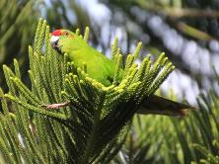

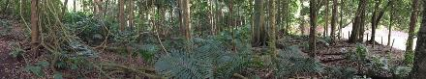

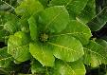 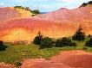

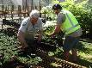

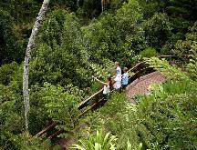 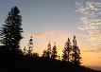 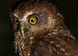

# Norfolk Island National Park and

**Norfolk Island Botanic Garden**

**Management Plan 2020**

ISBN: 978-0-9876152-6-8 (Print)

ISBN: 978-0-9876152-7-5 (Online)

***How to cite this document***

Director of National Parks (2020) *Norfolk Island National Park and Norfolk Island Botanic Garden Management Plan 2020*. Director of National Parks, Canberra.

This management plan has been prepared by the Director of National Parks and sets out how the park and botanic garden will be managed for the next 10 years.

© Director of National Parks 2020

This management plan is copyright. Apart from any use permitted under the *Copyright Act 1968*, no part may be reproduced by any process without prior written permission from the Director of National Parks.

Requests and inquiries concerning reproduction and rights can be addressed to: Director of National Parks

GPO Box 858

Canberra ACT 2601

E-location:<http://www.environment.gov.au/topics/national-parks/parks-australia/publications>

***Credits***

Photo credits:

Cover: Green parrot – Abi Smith Nursery – Mark Hallam

Phillip Island, Long Valley – Norfolk Island National Park Collection Visitors at the Botanic Garden – © Norfolk Island Tourism Morepork owl – © Lachlan L Hall

Pg. 7: Green parrot – Abi Smith

Pg. 13: White tern with chick – © Lachlan L Hall

Pg. 17: *Abutilon julianae* – Norfolk Island National Park Collection Pg. 41: Visitors at Captain Cook Lookout – © Norfolk Island Tourism

Pg. 49: Rangers at Phillip Island – Norfolk Island National Park Collection Other images – Parks Australia

Maps – Environmental Resources Information Network

Foreword

Norfolk Island National Park and Norfolk Island Botanic Garden protect over 650 hectares of the remote Territory of Norfolk Island. Set in the south-west Pacific Ocean, the

natural habitats and microclimates of the Territory provide refuge between tropical and temperate oceanic island environments and are home to unique assemblages of flora and fauna.

The park and botanic garden provide habitat and breeding areas for endemic species, migratory birds and large colonies of breeding seabirds. The park also protects remnant areas of subtropical rainforest that once covered much of the Island.

Management of the park and botanic garden is focused on the protection of existing native flora and fauna and habitat restoration through the control of invasive species, planting of native vegetation and implementation of erosion control measures.

The park and botanic garden provide educational, scientific, cultural and recreational opportunities for Norfolk Island residents and visitors as well as a valuable resource for the Norfolk Island tourism industry.

This management plan for Norfolk Island National Park and Norfolk Island Botanic Garden has been prepared under s.368 of the *Environment Protection and Biodiversity Conservation Act 1999* (EPBC Act).

James Larsen

A/g Director of National Parks

#### Acknowledgments

The Director of National Parks gratefully acknowledges the assistance and advice of members of the Norfolk Island National Park Advisory Committee and the individuals and organisations who contributed to the preparation of this management plan.

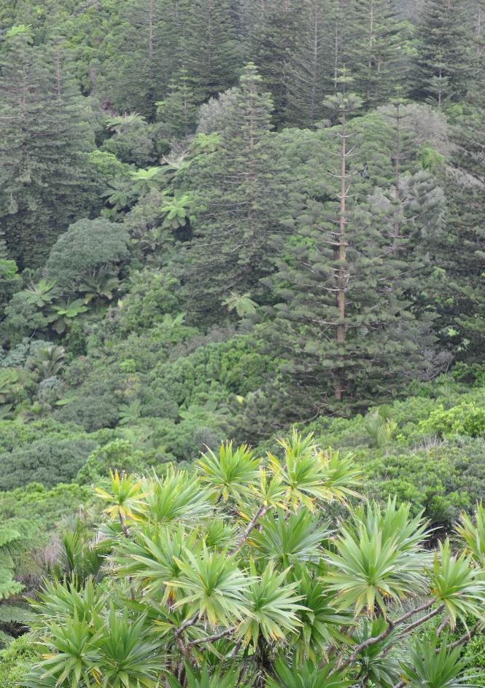

ii | Norfolk Island National Park and Norfolk Island Botanic Garden Management Plan 2020

Vision

Norfolk Island National Park and Norfolk Island Botanic Garden are recognised and appreciated for their natural, cultural and scientific values, as a refuge for native species and as an inspirational and rewarding experience for both visitors and the local community.

### Objectives

The objectives for management of the park and botanic garden are:

* To identify, conserve and protect the natural and cultural values of the park and botanic garden
* To offer world class natural and cultural experiences, that improve understanding of the values of the reserves and enhance the Norfolk Island regional economy
* To base management and decision-making on a foundation of best available information, sound policies and practices and contemporary management approaches.

The values of the park and botanic garden, as described in the statement of significance on page 4 of this plan, provide the basis and rationale for management of the reserves and underpin this plan’s objectives, prescriptions and actions.

The management prescriptions and actions in this plan contribute to achieving the objectives for the management of the park and botanic garden. These objectives support the purpose for which the reserves were declared and conservation of their natural and cultural values, ensuring they are managed consistently with their assigned International Union for the Conservation of Nature (IUCN) management categories.

### Contents

**Foreword** i

**Acknowledgments** i **Vision** iii **Objectives** iii

**A description of Norfolk Island National Park and**

**Norfolk Island Botanic Garden**

Territory of Norfolk Island 3 Norfolk Island National Park and Norfolk Island Botanic Garden 3 Statement of Significance 4 The values of the park and botanic garden 4

**Management Plan for Norfolk Island National Park and**

**Norfolk Island Botanic Garden**

1. **Introductory provisions**
   1. Short title 8
   2. Commencement and termination 8
   3. IUCN category and zoning 8

**Resilient places and ecosystems**

1. Natural and cultural heritage management
   1. Native plants and animals 12
   2. Cultural heritage management 15
   3. Botanic Garden and herbarium collection 16
   4. Research and monitoring 17
   5. Community use of natural resources 20
   6. Managing adverse impacts of plants, animals and pathogens 21
   7. Climate Change 26
   8. Landscapes, soils and water 27
   9. Landscape rehabilitation 29
   10. Forestry Area 30

**Tourism and use of the park and botanic garden**

1. Visitor and access management
   1. Visitor activities 36
   2. Visitor information, education and interpretation 38
   3. Commercial tourism and other commercial activities 39

**Effective business systems**

1. Effective business systems
   1. Assessment of proposals 44
   2. Roads and tracks 48
   3. Capital works and infrastructure 54
   4. Resource use in park operations 55
   5. Visitor safety and incident management 56
   6. Compliance and enforcement 59
   7. Neighbours, stakeholders and partnerships 60
   8. Activities not otherwise specified in this plan 62
   9. Management plan implementation and evaluation 63

Appendices

1. Interpretation (including acronyms) 64
2. Legislative context 66 Establishment of the National Park and Botanic Garden 66 Director of National Parks 66 EPBC Act 67 Norfolk Island legislation 69 Planning process 69 International agreements 71
3. EPBC Act listed species occurring in Norfolk Island National Park 73 and/or Norfolk Island Botanic Garden

Maps

1. Location of Norfolk Island National Park and Norfolk Island Botanic Garden 2
2. IUCN Categorisation of zones within the park and botanic garden 10
3. Forestry Area 33
4. Access to Norfolk Island National Park (Mount Pitt Section) 50
5. Access to Norfolk Island Botanic Garden 52
6. Access to Norfolk Island National Park (Phillip Island Section) 53

Tables

1. Decision-making process and impact assessment procedures 46
2. Environmental impact assessment matters and considerations 47

Bibliography 78

**Index** 80

A description of Norfolk Island National Park and Norfolk Island Botanic Garden | 1

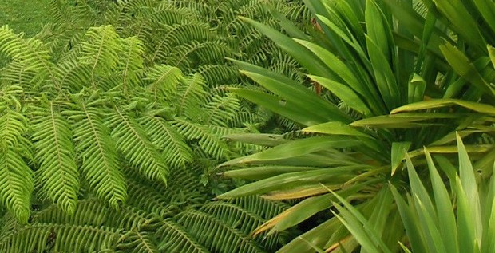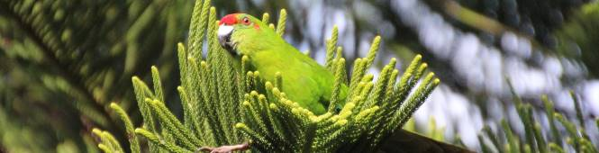

# A description of Norfolk Island National Park

**and Norfolk Island Botanic Garden**

##### Breathtaking scenery, dramatic landscapes and a unique diversity of plant and animal life

Map 1: Location of Norfolk Island National Park and

New Zealand

*TASMAN SEA*

Norfolk Island

Australia

New

Caledonia

Fiji

New Hebrides

*CORAL SEA*

**Norfolk Island Botanic Garden**

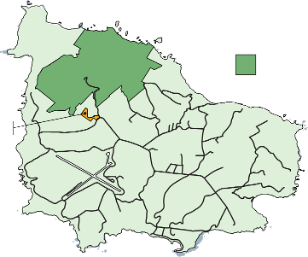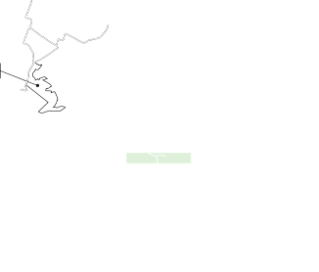

*Mount Pitt Section*

*Forestry Area*

*(within Mount Pitt Section)*

*Norfolk Island*

*National Park*

*Norfolk Island*

*Botanic Garden*

NORFOLK ISLAND

LOCALITY MAP

PHILLIP ISLAND

/

0 5

Kilometres

Territory of Norfolk Island

Norfolk Island is located in the South Pacific Ocean at latitude 29°02’ S and longitude 167° 57’ E. Norfolk Island covers an area of 3,455 hectares and is located approximately 1,700 kilometres from Sydney, Australia, and 1,100 kilometres from Auckland, New Zealand (Map 1).

The Territory of Norfolk Island includes Nepean and Phillip Islands—small, uninhabited islands that lie to the south of Norfolk Island—as well as several rocky islets along the island coastline. Norfolk Island has a permanent population of approximately 1,800 people.

Archaeological evidence suggests Norfolk Island was inhabited by Polynesians between the thirteenth and fifteenth centuries – it is unknown whether the Polynesian population moved on, or died out. Rediscovered by Captain Cook in 1774 and found to be uninhabited, Norfolk was settled by the British in 1788, just five weeks after the First Fleet’s arrival in Australia. The island operated as a colonial settlement between 1788 and 1814, utilising convict labour to harvest and mill Norfolk Island pines and harvest flax for the making of canvas. In 1825 a penal settlement was established, operating until 1855, when the last remaining convicts were removed.

In June 1856 the Island was settled by the Pitcairn Islanders, descendants of the mutineers of the HMS Bounty and their families. Pitcairn had become too small for their growing population and was no longer a suitable home. The Pitcairners established a permanent settlement on Norfolk Island and their descendants make up around one third of the Island’s current population.

Norfolk Island National Park and Norfolk Island Botanic Garden

Norfolk Island National Park covers 650 hectares in two sections. The Mount Pitt Section on Norfolk Island itself covers 460 hectares. The other section comprises 190 hectares of neighbouring Phillip Island. The Norfolk Island Botanic Garden covers 5.5 hectares and is located near the Mount Pitt Section of the park.

The Mount Pitt Section of the park and the botanic garden were first established by the *Norfolk Island National Park and Norfolk Island Botanic Garden Act 1984* when it came into force on 12 February 1985. These areas were subsequently declared a national park and botanic garden under the *National Parks and Wildlife Conservation Act 1975* by proclamation under that Act on 31 January 1986 following a request of the Norfolk Island Legislative Assembly. The Phillip Island Section of the park was proclaimed under the Commonwealth Act on 24 January 1996.

In July 2000 the *Environment Protection and Biodiversity Conservation Act 1999* (EPBC Act) came into force and replaced a number of Acts relevant to the management of the park and botanic garden. Since 16 July 2000, the park and the botanic garden have been managed under the EPBC Act.

#### Statement of Significance

Set in the south-west Pacific, Norfolk Island National Park and Norfolk Island Botanic Garden provide a link between tropical and temperate oceanic island environments. Norfolk’s remote location, coupled with Norfolk Island’s colonisation by plants and animals dispersed over vast distances of ocean, means the park and botanic garden have unique vegetation assemblages with many endemic species. The park contains historic sites and artefacts that illustrate the social development of the island and its people since early settlement. The park contains sites that support ongoing traditional and cultural practices undertaken by the local community.

###### The values of the park and botanic garden

Identification and recognition of the park and botanic garden’s values ensures a shared understanding about what is most important about the reserves, and the statement

of significance helps to focus management and planning. If the values are allowed to decline the park and botanic garden’s purpose and significance as protected areas would be jeopardised.

Natural values

The park and botanic garden protect most of the remaining areas of subtropical rainforest that originally covered Norfolk Island prior to settlement. This includes areas of remnant lower altitude rainforest that are characteristically dominated by vines.

The park and botanic garden provide principal, sole or partial habitat for listed threatened species, including four threatened species of forest-dwelling birds and two threatened species of seabird, five critically endangered snail species and 46 threatened plant species. The park also provides secure nesting habitat for at least 15 species of seabirds.

The park and the living collection in the botanic garden provide rich sources of horticultural, botanical and biological information about the native species of Norfolk Island.

Phillip Island, although long devoid of its original vegetation, is an important seabird nesting site and a refuge for several threatened species lost from Norfolk Island itself.

The gradual recovery of vegetation on Phillip Island, following the eradication of feral rabbits in 1986, is a unique example of nature’s capacity to restore balance to ecosystems under severe stress.

Heritage values

The park and botanic garden protect significant heritage sites associated with the defence of Norfolk Island during World War II, including the remains of a gun

emplacement and radar facility near the top of Mount Bates. Scattered throughout the park are less obvious relics of the military and colonial past, including additional gun emplacements, colonial brick clamps and other sites of heritage significance.

Phillip Island is a listed place on the Commonwealth Heritage List recognising that it provides a nesting habitat for seabirds, habitat for flora and fauna once considered to be extinct on nearby Norfolk Island and for its dramatic aesthetic landscape.

Social and economic values

In addition to being a significant place for the conservation of wildlife and other natural resources, Norfolk Island National Park and Norfolk Island Botanic Garden are places for public education, quiet enjoyment and recreation.

A significant proportion of Norfolk Island income is based on tourism. The majority of visitors to the island spend time within the park and botanic garden. Visitors seek

opportunities to walk through the forests of the park, to explore the botanic garden, to take in views of the landscape and seascapes from various vantage points in the park and botanic garden, and to surround themselves with nature.

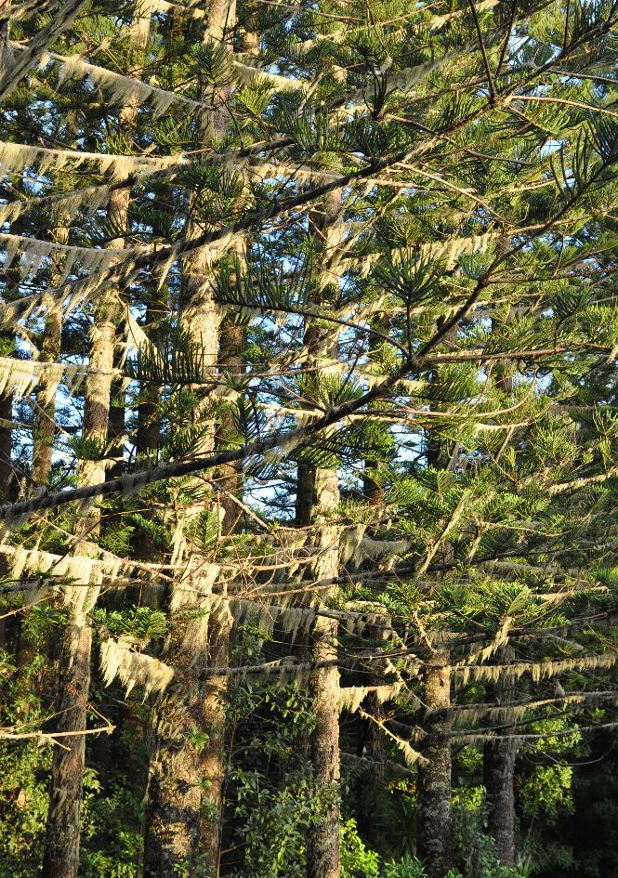

6 | Norfolk Island National Park and Norfolk Island Botanic Garden Management Plan 2020

Introductory provisions | 7

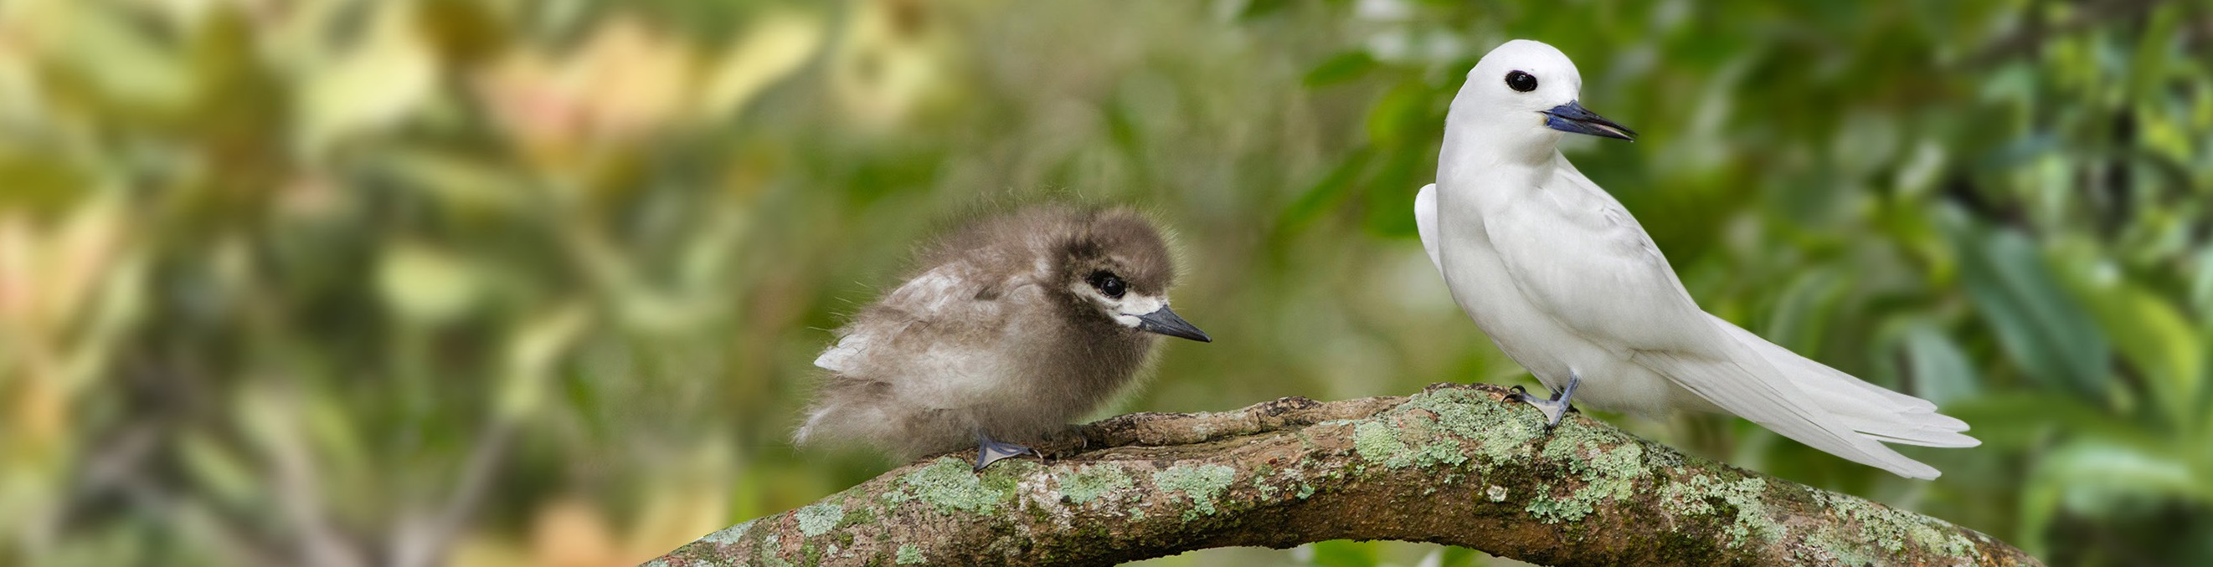

# Management plan for

**Norfolk Island National Park**

**and Norfolk Island Botanic Garden**

##### Conservation and appreciation of Norfolk Island’s natural and cultural heritage through the control of invasive species, provision of safe visitor access, and working with stakeholders and the community.

1. Introductory provisions

###### Short title

This management plan may be cited as the *Norfolk Island National Park and Norfolk Island Botanic Garden Management Plan 2020*.

###### Commencement and termination

This management plan will come into operation following approval by the Minister under

s.370 of the EPBC Act, on a date specified by the Minister or the day after it is registered under the *Legislation Act 2003*, whichever is later, and will cease to have effect ten years after commencement, unless revoked sooner by a new plan.

###### 1.3 IUCN category and zoning

1 **Our aim**

1. The park and botanic garden are managed in accordance with an IUCN protected area category and relevant management principles to protect their values while providing for

appropriate use

**Background**

Under s.367(1) of the EPBC Act, a management plan for a Commonwealth reserve must assign the reserve to an IUCN protected area category. A management plan can also divide a Commonwealth reserve into zones, but must assign each zone to an IUCN category which may differ from the overall category assigned to the reserve. The EPBC Regulations (Schedule 8) prescribe the management principles for each IUCN category.

The provisions of a management plan must not be inconsistent with the management principles for the IUCN category to which the reserve or zone of the reserve is assigned (s.367(3)).

The categories to which the park and botanic garden are assigned are guided by the purposes for which they were declared.

The purposes for which Norfolk Island National Park was declared as a Commonwealth reserve are:

* 1. the preservation of the area in its natural condition; and
  2. the encouragement and regulation of the appropriate use, appreciation and enjoyment of the area by the public.

The Norfolk Islands Botanic Gardens was declared for the purpose of increasing knowledge, appreciation and enjoyment of Australia’s plant heritage by establishing, as an integrated resource, a collection of living and herbarium specimens of Australian and related plants for study, interpretation, conservation and display.

The purposes for which the park was declared are consistent with the characteristics for IUCN protected area category II, national park. The purpose for which the botanic garden was declared is consistent with the characteristics for IUCN protected area category IV, habitat/species management area.

The park is divided by this plan into two zones—the Forestry Area to be managed as IUCN category VI, managed resource protected area, reflecting the purposes for which the area is used; and the balance of the Mount Pitt Section of the park and Phillip Island to be managed as IUCN category II, national park (see Map 2).

***Prescriptions***

* + 1. The park is assigned to IUCN category II, national park.
    2. The park is divided into two zones:
       1. the Forestry Area (Map 3), located within the Mount Pitt Section of the park, is assigned to IUCN category VI, managed resource protected area
       2. the balance of the Mount Pitt Section of the park and Phillip Island is assigned to IUCN category II, national park (Map 2).
    3. The botanic garden is assigned to IUCN protected area category IV, habitat/ species management area (Map 2).

1.3

***Actions***

* + 1. Manage the park and botanic garden in accordance with the Australian IUCN reserve management principles applicable to the relevant IUCN Categories assigned above, to protect their inherent natural and cultural values while providing for appropriate use.

Introductory provisions | 9

**Map 2: IUCN Categorisation of zones within the park and botanic garden**

1.3

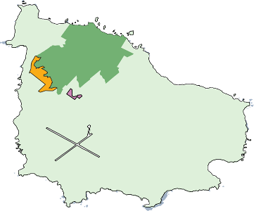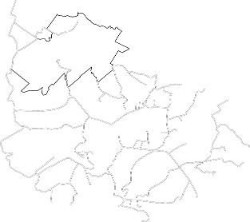

NORFOLK ISLAND

*IUCN Category II*

*National Park*

*IUCN Category IV*

*Habitat/Species Management Area*

*IUCN Category VI*

*Managed Resource Protected Area*

PHILLIP ISLAND

/

0

5

Kilometres

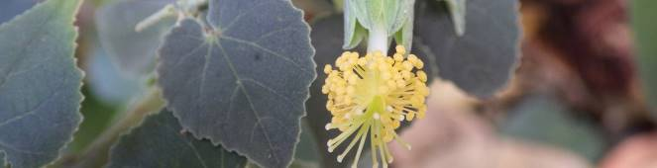

# Resilient places and ecosystems

##### Protecting and conserving the natural and cultural values of the park and botanic garden

*Objective:* • *To protect and conserve the natural and cultural*

*values of the park and botanic garden*

*Desired outcomes:* • *Natural and cultural values of the park and botanic*

*garden are protected and conserved Performance indicators:* • *Populations of threatened species are increasing*

* *Populations and extent of invasive species are reduced*
* *Ecosystem health is maintained or improved*
* *Historic sites in the park and botanic garden are protected and conserved*

Natural and cultural heritage management | 11

1. Natural and cultural heritage management

The Mount Pitt Section of the park consists of a small remnant (less than 10 per cent) of the subtropical rainforest which originally covered Norfolk Island.

The botanic garden contains a small remnant of the lowland subtropical hardwood forest dominated by vines, which once covered much of the island foothills. The small extent

of the remnants renders the natural heritage values of the park and botanic garden very sensitive to further disturbance. Introduced weeds, predators, competitors and pathogens are major threats to park and botanic garden values.

The botanic garden and park headquarters also support the living collection, herbarium collection and the visitor-focused Discovery Centre.

As a result of historic vegetation destruction by introduced animals there has been severe erosion on Phillip Island. Large areas remain bare, although significant areas of surviving native vegetation are spreading through some valleys. The introduced weed African olive (*Olea europaea*) remains a significant weed on Phillip Island requiring ongoing control. African Olive currently assists in soil stabilisation on areas of the island, therefore its control needs to be strategic.

The park and botanic garden are the refuge of many endemic species including

2 substantial proportions of many of the 15 flora species listed under the EPBC Act as

1. critically endangered.

The Forestry Area of the park contains stands of non-native trees as a result of efforts to develop timber production plantations as a local source of construction material on the island. These were established and managed many years before the proclamation of the park.

The significance of the park and botanic garden include both historic and cultural heritage values. The area which is now the Mount Pitt Section of the national park has been the site of a number of significant events in the human history of the island,

including its discovery and settlement by Europeans and its defence during World War II. The park contains a number of heritage artefacts relating to World War II.

###### 2.1 Native plants and animals

**Our aim**

Maintain or improve the distribution and abundance of species native to Norfolk Island, ensuring healthy ecosystems and the processes upon which they depend.

**Background**

Given the small size of the park and botanic garden and the distribution of many species beyond the park and botanic garden boundaries, achieving our aim depends on both on- and off-park actions. Therefore cooperation with the Norfolk Island Regional Council and the local community is vital.

Norfolk Island is home to a range of threatened species listed under Part 13 of the EPBC Act (see Appendix C). The Norfolk Island Region Threatened Species Recovery Plan identifies many of the priorities for species-directed management actions on and off the park.

In order to achieve the objectives of this management plan, the Director may need to impact upon native species, including species listed under Part 13 of the EPBC Act. Under ss.354 and 354A of the EPBC Act a person may not kill, injure, take, trade, keep or move a member of a native species except in accordance with a management plan. Unless specifically authorised by a management plan, the EPBC Regulations also prohibit taking animals and plants into the park or botanic garden, and cultivating plants in the park or botanic garden.

The protection of our native flora and fauna depends fundamentally on reducing or managing adverse impacts of plants, animals and pathogens including native species (see Section 2.6), rehabilitating natural ecosystems (see Section 2.9) and rigorous quarantine measures.

Actions taken in accordance with this plan in relation to members of species listed under Part 13 of the Act are exempt from prohibitions that would otherwise apply under

Part 13.

***Flora***

182 plant species are native to Norfolk Island. The park and the botanic garden are the refuge for 43 endemic species, including substantial proportions of the populations of many of the 15 plant species considered to be critically endangered under the EPBC Act.

Fauna

Of the 15 species and subspecies of birds endemic to Norfolk Island, only seven definitely remain.

There are techniques of nest maintenance, and predator and competitor control that have been successful in increasing Norfolk Island green parrot (*Cyanoramphus cookii*) and Norfolk Island morepork (*Ninox novaeseelandiae undulata*) numbers in the wild.

The two native mammals recorded on Norfolk Island—Gould’s wattled bat (*Chalinolobus gouldii*) and the eastern free-tail bat (*Mormopterus norfolkensis*)—are thought to be locally extinct.

Two native reptile species endemic to the Lord Howe and Norfolk Island groups—the Lord Howe Island (Norfolk Island) gecko (*Christinus guentheri*) and the Lord Howe Island (Norfolk Island) skink (*Oligosoma lichenigera*)—are thought to be extinct on Norfolk Island but are known to occur on Phillip Island.

The park and botanic garden have a rich diversity of terrestrial molluscs but it is thought that the introduction of rats and feral fowl (*Gallus gallus*) may have had a severe impact on this group of species. Five species of mollusc are listed as critically endangered under the EPBC Act.

2.1

**Issues**

* + A high proportion of the park and botanic garden species are listed threatened species under the EPBC Act.
  + The park and botanic garden provide habitat for listed threatened, migratory and marine species.
  + There is insufficient knowledge to enable the confident management of some species.
  + Monitoring trends of many species (both threatened and invasive) is challenging, particularly on Phillip Island where access is difficult.
  + The viability of some native species will depend upon actions taken inside and outside the park and botanic garden.

***Prescriptions***

* + 1. Priority will be given to activities that:
       1. improve the conservation status of listed threatened species.
       2. have systemic benefits for more than one species.
    2. The Director may take actions or authorise (whether by permit, contract, lease, letter or licence) actions by other persons concerning species, including species

2 listed under Part 13 of the EPBC Act, that are otherwise prohibited by the EPBC

1. Act or Regulations where they are necessary to implement this plan, or where

they are otherwise necessary for preserving or protecting the park and botanic garden, protecting or conserving biodiversity, or protecting persons or property in the park and botanic garden.

* + 1. Displays involving living animals will observe appropriate Australian standards for exhibited animals.
    2. Native plant material may be taken in and from the park and botanic garden in accordance with a permit or licence issued by the Director.

***Actions***

* + 1. Contribute to island-wide natural resource planning, multi-species recovery planning and associated implementation processes.
    2. Implement multi-species recovery plans, and relevant threat abatement plans for listed threatened species as they apply to the park and botanic garden.
    3. So far as practicable take other actions that may improve or maintain the conservation status of species native to Norfolk Island.
    4. Implement interventionist programs for EPBC Act listed species, such as captive breeding and species relocations, that have a long-term aim of improving their conservation status.
    5. Implement a species relocation program for the green parrot.
    6. Assess the feasibility of reintroducing species to Norfolk Island that have become extinct on the island, where suitable populations occur elsewhere.

See also Section 2.9 – Landscape rehabilitation, and 2.6 – Managing adverse impacts of plants, animals and pathogens.

###### Cultural heritage management

**Our aim**

Identify, protect, conserve and interpret to the public the cultural heritage values of the park and botanic garden.

**Background**

The park and botanic garden values include historic cultural heritage values. The area which is now the Mount Pitt Section of the park has been the site of a number of significant events in the human history of the island, including its discovery and settlement by Europeans and its defence during World War II. The park contains a number of heritage artefacts relating to World War II.

Phillip Island is a listed place on the Commonwealth Heritage List.

In accordance with the s.367 of the EPBC Act, where a Commonwealth reserve includes a Commonwealth Heritage place, a management plan for the reserve must not be inconsistent with the Commonwealth Heritage management principles prescribed by the EPBC Regulations (Schedule 7B).

**Issue**

Knowledge about the historical features of the park and botanic garden needs to be broadened.

***Prescriptions***

* + 1. Where the values of places in the park and botanic garden that are listed on the Commonwealth Heritage List include cultural heritage values, the places are to be managed in a manner consistent with relevant heritage management principles prescribed by the EPBC Regulations.
    2. As far as practicable, historic sites will be identified, conserved and their significance interpreted.

2.2

***Actions***

* + 1. Produce interpretive material and signage to support the historic and cultural heritage of the park and botanic garden.
    2. Consult with Norfolk Island historical and cultural agencies and experts, and other stakeholders in relation to the conservation and management of cultural values.

###### 2.3 Botanic garden and herbarium collection

**Our aims**

* + Establish and maintain a living and herbarium collection representative of Norfolk Island’s vascular flora with an emphasis on providing educational, interpretative and tourism experiences for visitors.
  + Contribute to the conservation of threatened plant species through the establishment and maintenance of healthy ex-situ plantings and seed collections.

**Background**

The botanic garden, which covers an area of 5.5 hectares and is adjacent to the park, is located on Mission Road near the Mount Pitt Road entrance to the park.

Under Section 3.1 – IUCN category and zoning, the botanic garden has been assigned IUCN protected area management category IV, habitat/species management area, to be managed in accordance with the management principles set down in Schedule 8 of the EPBC Regulations.

The botanic garden fulfils varied functions as set out in the aims. The living collection, display and the herbarium collection are valuable resources for the provision of horticultural and botanical information.

2 Its infrastructure, including the Discovery Centre, the living collection, and the walking

1. tracks, provide a comprehensive picture of the park and botanic garden for education, interpretation and tourism-related activities. A boardwalk provides wheelchair access to

the top of the botanic garden. The winding tracks and dense vegetation of the botanic garden provide an opportunity for visitors to experience the sensation of being in an ancient jungle.

**Issues**

* + Public paths and infrastructure needs to be monitored and maintained to ensure visitor safety.
  + The botanic garden’s infrastructure must continue to provide for education, interpretation and tourism-related activities.

***Prescriptions***

* + 1. The botanic garden will continue to place a strong focus on education, interpretation and tourism-related activities.
    2. As a priority, the remnant lowland subtropical hardwood forest will be maintained.
    3. The Director may take actions or authorise (whether by permit, contract, lease, letter or licence) actions by other persons concerning species, including species listed under Part 13 of the EPBC Act, that are otherwise prohibited by the EPBC Act or Regulations for the purpose of managing the botanic garden’s living collection and herbarium collection or where they are necessary to implement this plan.
    4. The living and herbarium collections will give priority to plants native to Norfolk Island with an emphasis on EPBC Act listed species.

***Actions***

* + 1. Maintain the living collection to high curatorial standards.
    2. Enhance the living and herbarium collections through the inclusion of threatened plants in ex situ conservation and preserved as herbarium specimens.
    3. Maintain the botanic garden’s infrastructure, including the Discovery Centre and associated displays, to reflect the focus on education, interpretation and tourism-related activities.
    4. Maintain the herbarium collection as a park resource and for public reference, forwarding duplicates of herbarium specimens to reputable scientific institutions.
    5. Make seeds, germplasm and/or vegetative material available to the National Seed Bank, the Millennium Seed Bank at the Royal Botanic Gardens, Kew, or similar collections.

###### 2.4 Research and monitoring

**Our aim**

Research and monitoring activities in the park and botanic garden contribute to improved conservation and management of park and botanic garden values.

**Background**

Research provides information about park and botanic garden values, visitor use and impact. Monitoring is an essential management tool for keeping track of changes to the environment and for measuring the success of management actions.

Research and monitoring assist the Director to make decisions about management of the park and botanic garden. This work may be carried out by staff or consultants engaged by the Director or undertaken in partnership with other government agencies, universities, non-government organisations and individuals.

In some cases, organisations and individuals carry out research and monitoring activities for their own purposes for either not-for-profit or commercial purposes.

***EPBC legislative provisions relevant to research and monitoring***

Under r.12.10 of the EPBC Regulations research may not be undertaken in the park unless it is provided for by, and carried out in accordance with, this plan, or is authorised by a permit. Research which involves taking, keeping, injuring, killing or moving native species, or is undertaken for commercial purposes, is prohibited by ss.354 and 354A of the Act except where undertaken in accordance with this plan.

Research which involves actions that affect members of species that are protected under Part 13 of the EPBC Act (i.e. listed threatened species, ecological communities, migratory species, marine species, or cetaceans) must also comply with the provisions of Part 13

of the Act unless done in accordance with this plan. Any research must also address the relevant EPBC Act requirements relating to listed heritage places including places on the Commonwealth Heritage List.

2.4

Research or other approved activities may involve accessing or taking biological resources of native species. Access to biological resources (also known as bioprospecting or biodiscovery) is the taking of biological resources of native species for research and development on any genetic resources, or biochemical compounds, comprising or contained in samples or specimens of these species.

Biological resources are defined by the EPBC Act (s.528) as including genetic resources, organisms, parts of organisms, populations and any other biotic component of an ecosystem with actual or potential use or value for humanity. Genetic resources are defined as any material of plant, animal, microbial or other origin that contains functional units of heredity and that has actual or potential value for humanity.

Part 8A of the EPBC Regulations (made under s.301 of the Act) controls access to biological resources in Commonwealth areas including the park and botanic garden. Access to biological resources is also covered by ss.354 and 354A of the EPBC Act if the resources are members of a native species and/or if access is for commercial purposes.

Key features of the EPBC Regulations on bioprospecting as they concern the park are as follows:

1. Any person who wants to access biological resources must obtain a permit from the Minister.

2 2. The “access provider” must agree to the taking of biological resources. The access

1. provider for the park and botanic garden is the Director of National Parks.
2. Where access is sought for commercial purposes or potential commercial purposes:
   1. The Director must give consent prior to the research being undertaken
   2. There must be a benefit-sharing agreement with the Director
   3. The benefit-sharing agreement must provide for reasonable benefit sharing arrangements
3. Where access is sought for non-commercial purposes:
   1. Written permission must be obtained from the Director
   2. A statutory declaration must be given to the Director declaring, among other things, that any biological resources taken are not intended to be used for commercial purposes, that a written report will be given to the Director on the results of any research into the biological resources, that samples will not be given to other people (other than voucher specimens to a specified research institution) without permission of the Director and that the person(s) given access will not carry, or allow others to carry out, commercial research or development unless a benefit-sharing arrangement is in place with the Director
   3. Public comment on the proposed access must be sought if the proposal is assessed as being likely to have more than negligible environmental impact.

**Issues**

* + Research and monitoring activities should provide information that contributes to effective management of the park and botanic garden.
  + Information needs to be clearly communicated to the park staff, considered in future management and made available to relevant stakeholders.
  + Effective methods for storing, sharing and retrieving data are required.

***Prescriptions***

* + 1. The Director and organisations and individuals having an agreement with, or permit from, the Director may carry out research and monitoring that involves actions covered by ss.354 and 354A and species listed under Part 13 of the EPBC Act.
    2. Organisations and individuals may carry out research and monitoring that involves actions covered by ss.354 and 354A and species listed under Part 13 of the EPBC Act:
       1. in collaboration with the Director under a written agreement with the Director; or
       2. in accordance with a permit issued by the Director.
    3. The Director may only authorise research and monitoring if the activity is consistent with this plan; will not, on balance, threaten the conservation status of a species or ecological community; and will not adversely impact upon park and botanic garden values. An additional consideration may be whether the research activity can reasonably be done outside the park and botanic garden.
    4. Persons carrying out research and monitoring under agreement with, or a permit from, the Director will be required to provide reports to the Director (including progress reports for longer-term research and monitoring).
    5. Research and monitoring that involves access to biological resources within the meaning of Part 8A of the EPBC Regulations must comply with those Regulations in addition to this Section 2.4 – Research and monitoring.

2.4

***Actions***

* + 1. Conduct, support and/or encourage research and monitoring that assists the conservation and management of the natural values of the park and botanic garden, particularly studies on:
       1. trends in the distribution, breeding and numbers of listed species.
       2. essential factors and procedures to support species translocations and ex-situ management
       3. seabird populations and breeding behaviour
       4. the reproductive biology of threatened Norfolk Island plants to assist in propagation
       5. the impact and control of threats
       6. potential impacts of chemicals and biological control agents considered for conservation and management purposes; and
       7. landscape change, soil chemistry, vegetation recovery and species distribution on Phillip Island.
    2. Develop and maintain systems for collecting, storing and retrieving research and monitoring data to improve accessibility and usability.
    3. Use research and monitoring to help prioritise and, as needed, adapt management actions.

###### Community use of natural resources

**Our aim**

Allow non-commercial harvesting of resources by the Norfolk Island community while ensuring the protection and conservation of the park and botanic garden’s natural values.

**Background**

Natural resources such as knots from the Norfolk Island Pine (*Araucaria heterophylla*) and the leaves of the Norfolk Island palm (*Rhopalostylis baueri*), ti (*Cordyline obtecta*), and flax (*Phormium tenax*) are used by the Norfolk Island community for craft, cultural and other purposes.

Fresh fruit is a limited and valued resource primarily available seasonally on the island. Island residents use the park as a source of fruit such as guava (*Psidium cattleianum cattleianum*) and lemon (*Citrus jambhiri*). There are no restrictions on people collecting guava or lemons from the park.

Historically, the eggs of the sooty tern (*Onychoprion fuscata*) have been harvested as a food resource from Phillip Island. This practice still continues during a declared harvest period. While the sooty tern is not endangered worldwide, the annual harvest may be

2 affecting the Phillip Island population. The sooty tern is a listed marine species under

.5

Part 13 of the EPBC Act and the collection of sooty tern eggs is prohibited under Part 13

unless an exemption under that Part applies.

Apart from the number of eggs taken, studies indicate that the effect of sooty tern egg harvesting on the overall population is linked to both the timing of the harvest and its duration. Since 1977, a set season for sooty tern egg harvesting has been implemented. The recent arrival and increase in numbers of Australasian Swamphen (*Porphyrio melanotus*–locally known as tarler birds) on Phillip Island has also impacted on the breeding of sooty terns on Phillip Island.

Under ss.354 and 354A of the EPBC Act, native species may only be taken in the park and botanic garden in accordance with this plan.

**Issues**

* + Community use of natural resources needs to be carried out in an environmentally sustainable way.
  + Community participation is necessary in determining appropriate use, and level of use, of traditional resources.

***Prescriptions***

* + 1. Non-commercial taking of guava and lemons from the park is allowed.
    2. Non-commercial taking of other non-native and native plant material may only be carried on in accordance with a permit or agreement issued by the Director.
    3. Sooty tern eggs must not be taken from the park or botanic garden, other than from Phillip Island:
       1. during an open season declared under legislation applicable to Norfolk

***Action***

Island and the collection of sooty tern eggs (currently the Birds Protection Act 1913 (NI)) following consultation with the Director, and then only from that part of Phillip Island specified in the declaration; or

* + - 1. during a period specified in a general approval issued by the Director, and in accordance with any conditions set out in that approval.
    1. Seek community participation to identify impacts on the occurrence and distribution of sooty terns in the park.

###### 2.6 Managing adverse impacts of plants, animals and pathogens

**Our aim**

Effective management of threats to the values of the park and botanic garden.

**Background**

Many plants and animals have been introduced to Norfolk Island by humans, including some native species within the meaning of the EPBC Act. Several introduced plant and animal species pose a major threat to the native species of Norfolk Island. In addition, native species may, on occasions, impact negatively on other native species and in extreme circumstances may require control action.

Some introduced predators on Norfolk Island, in particular rats and cats, have not become established on Phillip Island, allowing populations of some species that have become locally extinct on Norfolk Island to survive on Phillip Island. Examples include the Lord Howe Island (Norfolk Island) gecko (*Christinus guentheri*) and the Lord Howe Island (Norfolk Island) skink (*Oligosoma lichenigera*).

Biosecurity measures to prevent new weeds, predators, competitors and pathogens from entering Norfolk Island, or from crossing to Phillip Island, are critical to maintaining park and botanic garden values.

***Weeds and other problem plants***

In the Norfolk Island’s climate, weeds in the park and botanic garden are generally fast growing and require ongoing control. Without treatment, weed growth has the potential to significantly impact upon the natural values of the park and botanic garden through competition with native species, altering of microclimates in the park and botanic garden and changing vegetation structure.

The priority Norfolk Island invasive weed species are:

* + red guava (*Psidium cattleianum* var. *cattleianum*)
  + African olive (*Olea europaea africana*)
  + Hawaiian holly (*Schinus terebinthifolius*)
  + lantana (*Lantana camara*)
  + William Taylor (*Ageratina riparia*)
  + kikuyu (*Pennisetum clandestinum*)
  + wild tobacco (*Solanum mauritianum*)
  + Formosan lily (*Lilium formosanum*)

2.6

* + morning glory (*Ipomoea cairica* and *I. indica*)
  + Madeira vine (*Anredera cordifoliai*)
  + coral berry (*Rivina humilis*)

Weeds suppress or eliminate native plants and the animals that depend upon them.

They can alter habitat structure as well as the species composition of ecological communities. The impact of changes in vegetation and weed infestation on animals can include the loss of food resources and availability of nesting hollows.

Woody weeds (guava, African olive and Hawaiian holly) have dominated significant areas of the park for many years. They have been a priority for control in many areas of the park, with landscape rehabilitation required following removal.

Invasive vertebrates

Feral animals pose major threats to the native species of Norfolk Island. Major predators include the black rat (*Rattus rattus*), Polynesian rat (*Rattus exulans*), house cat (*Felis catus*) and feral fowl (*Gallus gallus*). They are a major threat to listed threatened species under the EPBC Act. None are present on Phillip Island.

The introduced Asian house gecko (*Hemidactylus frenatus*) has been recorded at three sites on Norfolk Island and is implicated in the decline of some native gecko species in

2 other parts of its range. The Asian House Gecko is currently absent from Phillip Island

.6 but has the potential to severely impact upon the island’s reptile population should it be introduced. Strong biosecurity measures are important between Norfolk Island and

Phillip Island to avoid accidental introduction of such threats.

**Predation by rodents**

Rodents eat birds, bird eggs, nestlings, reptiles, invertebrates (including land snails) and fruit, seeds and flowers. The Polynesian rat was probably introduced about 800 years ago by Polynesian explorers. The black rat was introduced later, possibly as late as 1943, and is considered to be the most destructive predator on Norfolk Island today. Park management has implemented an extensive rat control program since 1992. In March 2006 predation by exotic rats on Australian offshore islands of less than 1,000 square kilometres (100,000 hectares) was listed as a key threatening process under the EBPC Act.

**Predation by feral cats**

Feral cats (*Felis catus*) eat birds, nestlings and reptiles. They are a major threat to several listed species and many other native species. The Norfolk Island green parrot is listed in the *Threat abatement plan for predation by feral cats* (Environment Australia 1999) as one of the species for which feral cats are a known or suspected threat.

Cats are controlled through trapping and removal. National priorities for cat control are defined in the *Threat abatement plan for predation by feral cats*.

**Predation and competition by other introduced and native vertebrates**

The crimson rosella (*Platycerus elegans*), introduced to Norfolk Island and known locally as the red parrot, is a direct competitor of the endangered green parrot. It eats similar

foods, has similar nesting requirements and has also been known to break eggs and eject chicks from green parrot nests.

Feral fowl have increased their range and numbers on Norfolk Island. Anecdotal observations indicate that in the park and botanic garden feral fowl are changing the soil moisture regime through extensive disturbance of litter, reducing germination, disturbing seedling roots of rainforest plants, and reducing numbers of some invertebrates– including critically endangered land snails.

Native species may also impact adversely on one another from time to time or at particular locations. A population of Australasian swamphens (*Porphyrio melanotus*) have become established on Phillip Island during the life of the previous plan. The presence

of swamphens is impacting upon the breeding of seabirds as a result of the swamphens destroying and eating eggs and killing young chicks. Sooty terns (*Onychoprion fuscata*) in particular have been observed in fewer numbers on Phillip Island and appear to be increasing on Norfolk Island, possibly changing their nesting sites as a result of the emerging threat. The presence of sooty terns on Norfolk Island brings a new threat to the nesting birds–exposure to the threat of predation by feral cats and rats.

Invasive invertebrates

Close to 1,200 invertebrate taxa have been recorded on Norfolk Island, including 421 species which had not been recorded prior to 2014. It is not clear how many of these invertebrates are exotic or invasive and their potential impacts are also unknown.

A new arrival on Norfolk Island is the palm seed borer (*Coccotrypes dactyliperda*), an invasive 1.5–2.5 millimetre beetle that breeds in palm seeds, compromising plant reproduction. It could potentially impact on the island’s kentia palm industry, but the likely impacts on the island’s one indigenous palm species, Norfolk Island Palm

(*Rhopalostylis bauerii*) are unknown. Initial investigations indicate the beetle is found in the seeds of large numbers of Norfolk Island Palm seed.

The Argentine ant (*Linepithema humile*) has the potential to cause serious harm to Norfolk Island’s wildlife. Forming super-colonies, the Argentine Ant competitively displaces most other ant species which in turn compromises ecosystem processes such as soil aeration, nutrient cycling and seed dispersal. Additionally, ground nesting seabirds and rare species such as the green parrot and Norfolk robin (*Petroica multicolour*) are

at risk due to the ants’ aggression and need for protein. Other species such as the two indigenous reptiles would be at great risk if the Argentine ant spread to Phillip Island.

Colonies of European honey bee (*Apis mellifera*) frequently occupy tree hollows which might otherwise be used by nesting birds.

Pathogens

In general, pathogens of native plants and animals in the park and botanic garden are poorly known. Two pathogens are known to have had a significant impact on park and botanic garden values—psittacine circovirus disease (PCD), commonly known as ‘parrot beak and feather disease’, and the root rot fungus *Phellinus noxius*. These pathogens may occur naturally on Norfolk Island, as they do on mainland Australia, but dispersal of these threats on Norfolk Island is exacerbated by environmental factors.

2.6

PCD was listed as a key threatening process under the EPBC Act in 2001 and the *Threat abatement plan for beak and feather disease affecting endangered psittacine species* was released in 2005 (DEH 2005). The threat abatement plan identifies the Norfolk Island green parrot as being adversely affected by PCD. A recent study of 50 green parrots suggests that an estimated 8% of the population are affected by the disease.

The root rot fungus *Phellinus noxius* has been identified as being the principal pathogen causing dieback of Norfolk Island pine (*Araucaria heterophylla*). The fungus is a natural component of rainforests in many countries, but its impacts are exacerbated by low levels of soil phosphorous, highlighting the link between seabirds and the island’s ecosystem.

A serious fungal disease of plants in the Myrtaceae family, myrtle rust (*Puccinia psidii*) has recently arrived on Norfolk Island. Whilst there are no Myrtaceae plants indigenous to Norfolk Island, there are potential risks associated with a number of threatened plant species. The critically endangered kurrajong (*Wikstroemia australis*) is one species which is known to be particularly susceptible to disease and myrtle rust has previously been identified as a risk to this species. It is unclear as to whether the red guava, one of Norfolk Island’s principal weed species and a member of the Myrtaceae family, will be negatively affected by myrtle rust.

**Issues**

2.6

* Weeds, introduced predators, competitors and pathogens are major threats to park

and botanic garden values.

* + Management of these threats is resource intensive and costly.
  + Control of current and emerging threats needs to be managed across all of Norfolk Island to enable success within the park and botanic garden.
  + The recent introduction of a number of biosecurity risks, including the Argentine ant, Myrtle Rust and Palm Seed Borer to Norfolk Island raises concerns that current biosecurity arrangements may be insufficient to adequately protect park and botanic garden values.

***Prescriptions***

* + 1. The Director may take actions or authorise actions by other persons (by permit, licence, collaboration agreement or lease) concerning native species, including species listed under Part 13 of the EPBC Act, that are otherwise prohibited by the EPBC Act or Regulations where they are necessary to implement this plan, or where they are otherwise necessary to manage threatening processes in the park or botanic garden.
    2. The Director may use or authorise others (by permit, licence, collaboration agreement or lease) to use chemicals where necessary to implement this plan, or where they are otherwise necessary to manage threatening processes in the park or botanic garden, such as invasive species management. Persistent chemicals which may adversely affect the quality of surface water and/or water in aquifer recharge areas must not be used.
    3. Subject to risk assessments and other required regulatory approvals, the Director may introduce, or authorise others by permit to introduce non-native species into the park or botanic garden for conservation purposes, for example for use in the biological control of one or more invasive species.

***Actions***

* + 1. Implement an effective weed removal program, giving priority to those that pose the greatest threat to species listed as threatened under the EPBC Act (in the critically endangered, endangered and vulnerable categories).
    2. Take measures to mitigate the impacts of introduced predators, competitors and pathogens including:
       1. control and/or removal of rats and cats
       2. control and/or removal of other predators and dominant competitors including Australasian swamphens on Phillip Island and crimson rosellas in the Mount Pitt section of the park.
       3. rat-proofing bird breeding sites
       4. implementing biosecurity measures, such as boot scrub stations, at major visitor access points within the park or botanic garden
       5. monitoring species which may be susceptible to recently introduced pathogens and invertebrates.
    3. Monitor weed coverage, trends in the status of introduced predators, the impact of introduced competitors and the number of major incidents involving pathogens.
    4. Work with relevant government organisations, the local community and other stakeholders to ensure there is effective communication and advice provided on the identification and management of introduced competitors and pathogens, both at the time of identification and introduction to the island, and throughout the eradication/management process.
    5. Work with the Norfolk Island Community, government organisations and other stakeholders to develop island-wide programs for the management of threats including weeds, rats, cats and feral fowl.
    6. Any significant movement of soil or vegetative material (including mulch) in or out of the park or botanic garden will be inspected for Argentine Ants (*Linepithema humile*).
    7. Work with relevant stakeholders including the Department of Agriculture and Water Resources, visitors, tour operators and the local community, to improve biosecurity outcomes for Norfolk and Phillip Islands.
    8. Develop and implement a biosecurity plan for Phillip Island, including among other things, active management to prevent European honey bees colonising the island, and protections against phytophera incursion.
    9. Regularly monitor Phillip Island for invasive species, particularly the European honey bee, phytopthera, black rat, Polynesian rat, mouse, feral cat, Asian house gecko and Argentine Ant to enable quick response if an incursion is detected.

2.6

###### Climate change

**Our aim**

Climate change impacts on park and botanic garden values are better understood and management actions and planning are adapted to take account of the latest available information.

**Background**

In recent years global warming and its implications for climate change has emerged as a key issue for biodiversity and environmental management on a global scale. Climate change will amplify existing risks and create new risks for natural and human systems (IPCC 2014).

During the life of the previous management plan, methods used to project our changing climate have improved, with most predictions rated at high or very high confidence rating. While specific climatic conditions are not available for Norfolk Island due to its remoteness, indicative projections of anticipated direction and degree of change may be drawn from scenarios that apply to the New South Wales region.

The park and garden is likely to experience increased annual average temperatures with more hot days and warm spells. Decreases in winter rainfall events are forecast

2 (medium confidence) with increased intensity of extreme rainfall events. Mean sea

.7

level is projected to continue to rise (estimated 50 centimetres by 2070) and the height

of extreme sea-level events will also increase. A harsher fire-weather climate is also

anticipated.

While there is improved confidence as to the magnitude and timing of climate changes, the extent to which these changes may affect the natural, cultural and economic values of the park and botanic garden remains uncertain.

Certain aspects of the park and botanic garden may require adaptive management. For example, increased incidences of prolonged dry hot periods as a result of climate change may have disproportionately high adverse impacts on park and botanic garden values because of the soil’s poor moisture holding capacity.

An increased incidence of prolonged hot dry spells may increase the probability of wildfires in the park and botanic garden. While wildfires have not happened to date the flora would be very fire sensitive and would not recover from a hot wildfire. Changes to sea level and temperature may have a profound effect on seabird numbers as marine prey species either change behaviour or change in abundance.

**Issues**

* + Climate change impacts on the park and botanic garden are not known with enough certainty to mandate specific actions at the time of preparing this plan.
  + Adapting management actions to anticipate and respond to climate change impacts on park and botanic garden values will be important.

***Actions***

* + 1. Where feasible, adapt management priorities and programs in response to improved understanding of climate change impacts. This may include:
       1. Ecosystem and species management (see Section 2.6 – Managing adverse impacts of plants, animals and pathogens)
       2. Emergency response capacity, including wildfire management (see Section

4.5 – Visitor safety and incident management)

* + - 1. Infrastructure design, planning, development and maintenance (see Section

4.4 – Resource use in park operations)

* + - 1. Visitor management and safety (see Section 4.5 – Visitor safety and incident management).

###### Landscapes, soils and water

**Our aim**

Protection of the landscape, soil and water values of the park and botanic garden.

**Background**

***Landscapes***

Mount Pitt and Mount Bates, both in the park, are the highest peaks on Norfolk Island. Together with their extensive stands of Norfolk Island pine (*Araucaria heterophylla*), they form a dominant visual element of the Norfolk Island landscape.

Popular summit viewing areas provide panoramic views of much of the island, the surrounding sea, Nepean Island and Phillip Island. Views of the spectacular coastal scenery can be enjoyed from the Captain Cook Monument.

Viewing areas, in particular the summits of Mount Pitt and Mount Bates and the Captain Cook Monument area, are major assets for the tourism industry.

The degraded Phillip Island landscape is being rehabilitated to establish a cover of native vegetation.

***Soils***

Norfolk Island’s volcanic soils are nutrient rich, friable and porous. They do not hold moisture well, so native vegetation is susceptible to stress during long dry periods. Large amounts of soil have been lost from Phillip Island through erosion. Stabilisation of the soil is slowly increasing as vegetation recovers. Difficulties in accessing Phillip Island and the scale of the work necessary to manage recovering vegetation and control woody weeds provide ongoing challenges.

2.8

Water

Precipitation on Norfolk Island occurs mainly through rainfall with some fog-drip. The park and botanic garden are thought to be major recharge areas for Norfolk Island’s aquifers and hence for the community’s water supplies. The park and botanic garden are also catchments for surface run-off.

**Issues**

* + Maintaining landscape values while providing safe visitor access.
  + Managing erosion.
  + Maintaining water quality in aquifer recharge and surface run-off areas.

***Prescriptions***

* + 1. Actions taken under this plan must be taken in a manner that will minimise impact on park and botanic garden values including minimising soil erosion, controlling sediment and reducing the impact on aquifer recharge and surface water run-off.
    2. Persistent chemicals which may adversely affect the quality of surface water and/or water in aquifer recharge areas will not be used.

2 2.8.3 Mining operations are prohibited in the park and botanic garden.

1. 2.8.4 Excavation and relocation of soil, gravel and other earth materials may be

undertaken within the park and botanic garden for management purposes.

***Actions***

* + 1. Manage vegetation, including limited clearing, to maintain significant views.
    2. Maintain water collection and management works in the park and botanic garden to provide water for plant propagation and other management purposes.
    3. Monitor areas of the park and botanic garden that are susceptible to erosion, implement measures to minimise the occurrence of the soil loss and take action to rectify disturbed areas to ensure public safety, particularly during and following wet weather events. See also Section 4.2 – Roads and tracks.

###### Landscape rehabilitation

**Our aims**

* + Areas of the park and botanic garden revegetated with appropriate native plants to enhance biodiversity health.
  + The Mount Pitt section of the park is managed to return, as close as possible, to its condition prior to the arrival of Europeans on Norfolk Island.
  + The Phillip Island section of the park is managed to return its condition, in parts, to that prior to the arrival of Europeans on Norfolk Island. Parts of the island will need to be managed to ensure suitable habitat for seabirds that have come to depend on bare areas of Phillip Island.

**Background**

The park and botanic garden have been subject to a long history of disturbance which has caused disruption to ecological processes, species extinctions and major reductions in the extent and quality of ecosystems.

Much vegetation in the park and botanic garden has either been destroyed completely by introduced herbivores or has been displaced by weeds. Some specific ecological processes have been severely damaged or destroyed by past actions.

For example, the removal of over 100,000 breeding providence petrels (*Pterodroma solandri*) over 100 years ago had a major impact on the nutrient status of the park. The introduction of pigs, goats and rabbits to Phillip Island from 1793 onwards commenced a devastating loss of vegetation that bound together the fragile soil, denuding the island and resulting in two centuries of substantial and irreversible erosion.

The extent of the historical damage means that it is not feasible to aim to restore the park and botanic garden to the precise state which existed prior to the beginning of either Polynesian or European impacts. For example, it is not practical to recover the extinct species or to reclaim the huge amounts of soil and nutrients lost to sea from Phillip Island.

However, progress can be made towards significant improvements in the state of the remaining ecosystems, the status of species, preventing the further destruction of remaining ecological processes, and re-establishing native vegetation in areas that have been totally denuded of vegetation or overrun by weeds.

**Issues**

* + Some areas of the park and botanic garden are either completely denuded of vegetation or very heavily infested with weeds.
  + Areas cleared of weeds and areas prone to erosion require actions to prevent further erosion and to aid revegetation.
  + Some native species have adapted to disturbed habitats.

2.9

***Actions***

* + 1. On a priority basis, revegetate denuded areas and areas cleared of weeds with native vegetation.
    2. Undertake rehabilitation activities on Phillip Island to reduce invasive weeds, control erosion and enhance biodiversity.
    3. Maintain native plant nurseries on Norfolk Island and Phillip Island to support landscape rehabilitation activities and to support conservation and recovery of EPBC listed threatened plants.
    4. Collect seed and actively cultivate native plants to provide for landscape rehabilitation activities in the park and garden.
    5. Take species-focused actions to promote recovery of listed plant species.
    6. Develop and implement a rehabilitation plan for the plantation areas of the park that occurred within the Forestry Area under the previous management plan that now fall within the area of the park managed under IUCN Category II.

###### Forestry Area

**Our aims**

2.10

* Provide an area for sustainable timber production for the benefit of the Norfolk Island

community.

* + Reduce the extent of eucalypt plantation within the park, replacing it with native timber plantations or native forest.
  + Ensure eucalypt forests are managed in a way that does not lead to a significant increase in fire risk in the park.
  + Maintain and/or enhance native biodiversity.
  + Allow for compatible park visitor use.

**Background**

The Forestry Area was originally cleared for banana plantations during the 1930s but after the collapse of the banana industry it developed into a series of dense thickets of weeds, mainly African olive. The area was included in the then Mount Pitt Reserve as an area reserved for forestry purposes in 1955 and was later declared a public reserve under the *Norfolk Island Commons and Public Reserves Ordinance 1936* (NI). Some

sections adjacent to the western boundary of the Forestry Area were cleared of olive and eucalypt plantations were established.

The boundary of the Forestry Area, as defined in the first management plan for the park (1984), was based on an assessment of the extent of heavily weed-infested forest

using aerial photography. The boundary was surveyed and marked on the ground during 1992–93.

The primary purpose of the Forestry Area is to produce native species timber for the Norfolk Island community through forestry operations. Under the previous management

plan, forestry operations were to be carried on by the Norfolk Island Parks and Forestry Service or an outsourced operator (a forestry operator working on behalf of the Norfolk Island Government).

In 1994 areas of remnant native vegetation in the Forestry Area were surveyed and recommended for preservation due to their high nature conservation values (Davidson, Anderson and Evans 1994). The previous management plans provided that these areas were not to be cleared and weed management be undertaken in and around them by the forestry operator. The area was again mapped in 2010 to determine the vegetation types within the Forestry Area and to consider appropriate future management and use.

An investigation into the viability of forestry operations was commissioned 2012 by an independent forestry expert. It found that the Forestry Area had little economic value for the island and should be rehabilitated to provide increased opportunities for community recreation and tourism. In this plan, the boundary of the Forestry Area has been adjusted to:

* + Continue to provide a sufficiently large timber resource of eucalypts and pines to meet the needs of the Norfolk Island community while reducing management and maintenance costs to the forestry operator.
  + Allow for increased recreational and tourism use of the area.
  + Allow for the return of areas with remnant native vegetation and high conservation value to native forest.

Map 3 shows the revised boundary of the Forestry Zone.

The conduct of forestry operations is subject to ss.354 and 354A of the EPBC Act and may only be carried on in accordance with this plan.

**Issues**

* + Forestry practices need to be undertaken safely and sustainably.
  + Appropriate use should be made of the Forestry Area by park visitors, in a manner that does not have a significant impact on forestry operations.
  + The mature eucalypt plantations in the Forestry Area increase the risk of wildfire on Norfolk Island.
  + Eucalypt plantations now provide habitat to several endemic species on Norfolk Island, including the Norfolk Island green parrot, the Norfolk Island morepork owl, the Norfolk robin and other species including migratory seabirds.

***Prescriptions***

* + 1. The Director may issue a permit, contract, licence or other agreement for the harvesting of timber and land management for prescribed sections of the Forestry Area of the park, provided that the operations are conducted:
       1. for the benefit of the Norfolk Island community

2.10

* + - 1. in accordance with the written authorisation and conditions issued by the

Director

* + - 1. subject to prohibitions, restrictions or determinations made by the Director under the EPBC Regulations
      2. at the cost of the forestry operator
      3. ensuring that all work, health and safety issues are adequately addressed (including WHS plans, risk management and incident reporting) and public liability and insurance requirements are met
    1. Proposals for forestry operations will be subject to assessment in accordance with Section 4.1 – Assessment of proposals.
    2. An authorised forestry operator will be the owner of all felled timber and other products obtained from the conduct of its forestry operations.
    3. Areas subject to active forestry operations will be closed to public access to ensure public safety.
    4. Permits may be issued for the small-scale harvest and collection of timber from the forestry area for local use.
    5. Only native species may be planted in the Forestry Area.

2 2.10.7 Fire-breaks and forest fuel reduction in the Forestry Area will be used to reduce

.10

the likelihood of wildfire in the plantations.

* + 1. Park visitors, commercial tour operators and other members of the public may conduct recreational and other activities in the Forestry Area of the park subject to 2.10.4 and in accordance with Section 3. A permit or licence issued by the Director is required for any commercial operations undertaken in the Forestry Area.

***Actions***

* + 1. In consultation with the Norfolk Island Regional Council and other relevant stakeholders, undertake a review of the Forestry Area to determine its future use and rehabilitation requirements.

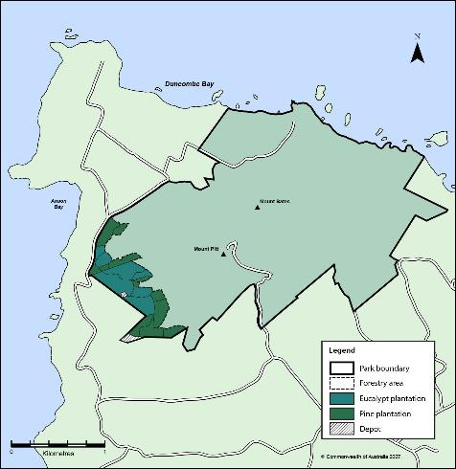**Map 3: Forestry area**

2.10

34 | Norfolk Island National Park and Norfolk Island Botanic Garden Management Plan 2020

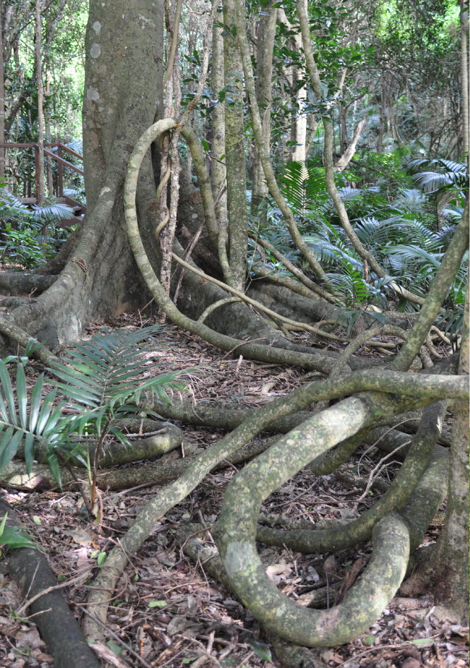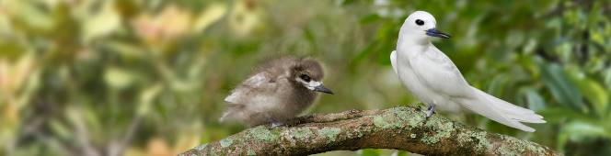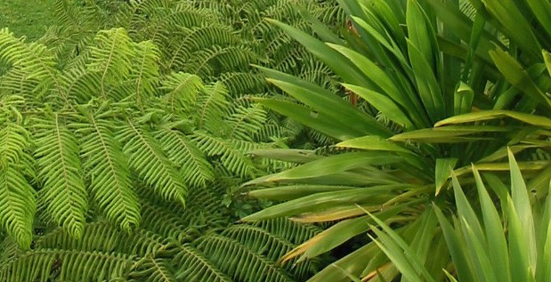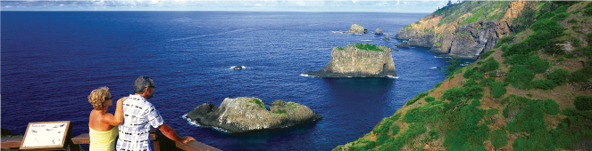

# Tourism and use of the

**park and botanic garden**

##### Offering world class natural and cultural experiences

*Objective:* • *To offer world class natural and cultural experiences,*

*that improve understanding of the values of the reserves and enhance the Norfolk Island regional economy*

*Desired outcomes:* • *Visitors enjoy, appreciate and understand the values*

*of the park and botanic garden*

*Performance indicators:* • *Level of satisfaction expressed in feedback from park*

*and botanic garden visitors*

* + - * *Level of support for protecting the natural values of the park and botanic garden*

Tourism and use of the park and botanic garden | 35

1. Tourism and use of the park

and botanic garden

Norfolk Island National Park and Norfolk Island Botanic Garden are places for public education, enjoyment and recreation and also significant places for the conservation of wildlife and other natural resources. The challenge is to provide visitor access and facilities that ensure visitor safety, without compromising the values of the park and botanic garden.

###### Visitor activities

**Our aims**

* Visitors enjoy and appreciate the experience of visiting the park and botanic garden.
* Visitor use of the park and botanic garden is managed in ways that do not impact upon park and botanic garden values.

**Background**

The types of recreational opportunities appropriate to the Mount Pitt Section of the park are very different from those for Phillip Island and the botanic garden. Furthermore,

the range of recreational experiences sought by Norfolk Island residents is often very different from those sought by visitors to Norfolk Island.

Touring by vehicle, walking, horse riding and cycling are popular leisure activities in the Mount Pitt section of the park. The multi-purpose use of roads and walking tracks has safety implications and requires careful management. Visitors are advised to wear sensible footwear and to take water and food supplies on the longer walks. In extreme

3 wet weather tracks may become slippery and extreme caution is advised. Dog walking

1. is not allowed in the Botanic Gardens nor Phillip Island sections of the park. The Mount

Pitt section of the park (see Maps 1 and 4) is the only part of the park exempt from the general prohibition on dog-walking.

Access to Phillip Island is by boat and from the boat landing place, people ascend a cliff using fixed ropes and a ladder system.

The main uses of the Phillip Island section of the park by Norfolk Island residents and visitors are fishing, camping, birdwatching and general recreation. All activities on Phillip Island have associated risks concerning access, weather and surface conditions, and rescue capacity should an accident occur. Visitors to Phillip Island are advised to ensure that they have adequate clothing and supplies, and are advised that they should only attempt to visit the island accompanied by a professional permitted guide or an experienced Norfolk Island resident.

The park boundary extends to the high water mark where it meets the coastline. The shore and marine waters below the high water mark fall within the Norfolk Marine Park, also managed by the Director of National Parks as part of the Temperate East Commonwealth Marine Reserves Network. There may be opportunities during the life of the plan for activities to occur that incorporate use of the both the park and the marine reserve, such as scuba diving and snorkelling tours or establishment of visitor infrastructure in the park that support activities undertaken in the marine reserve.

**Issue**

Striking a balance between providing opportunities for the appropriate use, appreciation and enjoyment of the park and botanic garden by a diversity of visitors, whilst protecting the natural and cultural values and public safety.

***Prescriptions***

* + 1. Visitor activities and use will be managed to protect park and botanic garden values, maximise visitor safety and enhance visitor experience.
    2. The Director may prohibit or restrict activities that present a risk to public safety or may prohibit or restrict access to areas of the park and botanic garden where it is considered necessary to do so to protect the values of the those areas, biodiversity or heritage in these areas, use by other persons, or in the interests of public safety.
    3. To enhance biosecurity visitors must not take animals, plants or seeds to Phillip Island.
    4. Dog-walking is allowed in the Mount Pitt section of the park provided that dogs are kept on a leash at all times to ensure the protection of vulnerable wildlife.
    5. Horse riding and mountain bike riding is allowed on public access roads and tracks in the Mount Pitt section of the park (see Map 4). The Director may restrict access to certain tracks and sections of the park for horse riding or mountain bike riding to protect track surfaces and park values, or improve safety for walkers. Any such restrictions will be clearly identified through appropriate signage.
    6. Public gatherings of more than 15 persons may be carried out in the park or botanic garden in accordance with a permit or licence issued by the Director.
    7. Climbing in the park is allowed where required to negotiate part of the designated track system of the park or where associated with a research activity conducted in accordance with a permit or licence.
    8. Permits for activities prohibited by r.12.26 of the EPBC Regulations (adventurous activities) will not be issued unless the Director is satisfied that the activity

will not adversely impact upon the park or botanic garden, is consistent with appropriate appreciation and enjoyment, will not interfere with other park or botanic garden users, does not present an unreasonable risk to public and staff safety, and the proponent has sufficient safety and rescue capacity available.

* + 1. Remotely piloted aircraft may be operate in the park or botanic garden for recreational purposes in accordance with a permit issued by the Director, which may only be issued if the proposed operation will not create a hazard to another aircraft, person or property.

Note: Operation of remotely piloted aircraft in connection with scientific research, commercial tourism or commercial film or photography activities may be carried out in accordance with an authorisation issued by the Director for that activity under this management plan.

3.1

* + 1. As the park and botanic garden is within 5.5 kilometres of an airfield, remotely piloted aircraft must not be operated:
       1. on the approach and departure path, or
       2. within the aircraft movement area, or
       3. in a manner that creates a hazard to aircraft that may be using those areas.
    2. Permits may be issued for the scattering of ashes or installation of plaques in the park and botanic garden.
    3. Firearms and other equipment and devices covered by r.12.18 of the EPBC Regulations must not be brought into, or used in, the park or botanic garden except in accordance with a permit issued by the Director. Permits will only be issued in exceptional circumstances.

***Actions***

* + 1. Tourists who wish to visit Phillip Island will be encouraged to seek the assistance of, and be accompanied by, a permitted tour operator with knowledge of Phillip Island access and conditions.
    2. Work in partnership with the local community and relevant organisations to identify opportunities to increase the quality, type and number of nature-based visitor experiences in the park and botanic garden.

###### 3.2 Visitor information, education and interpretation

**Our aim**

3 Inform visitors and the community about park and botanic garden values and their

1. ongoing protection and conservation.

**Background**

Well-prepared information about park and botanic garden values and management can add to the quality of the visitor experience and is likely to benefit protection of the area. Visitors are able to obtain information about the park and botanic garden from:

* + pre-visit tourism industry information
  + website and social media
  + brochures and publications
  + interpretive and regulatory signage
  + commercial tour operators.

Information is available on Norfolk Island from Park Headquarters and from the tourism information centre in Burnt Pine. The botanic garden is home to the Discovery Centre which provides information on activities within the park and botanic garden as well as significant detail about the environmental history and values of the park and botanic garden and Norfolk Island as a whole.

The botanic garden is a hub for teaching people about the natural history of Norfolk Island, including examples of its flora within the living collection. Education and interpretive services are critical to visitors’ ability to get the most from their visit to the botanic garden. Plant labels clearly identify species within the botanic garden.

**Issue**

Appropriate information about an area’s values and management can add to the quality of a visitor’s experience and is likely to benefit protection of the area.

***Actions***

* + 1. All signage and interpretive material for walking tracks shall include advice on location, direction, degree of difficulty, likely time to traverse, and any relevant safety issues.
    2. Review and maintain high quality interpretive information for visitors, commercial operators, guides and other stakeholders on the values of the park and botanic garden and relevant safety and biosecurity issues through brochures, signage, plant labelling in the botanic gardens, media articles and briefings.
    3. Undertake regular visitor surveys during the life of this plan to measure visitor satisfaction and appreciation of park values, working with relevant stakeholders to determine visitation rates.

###### Commercial tourism and other commercial activities

**Our aim**

* + Ensure that commercial activities in the park and botanic garden promote park and botanic garden values and enhance visitor experience without compromising management actions or the cultural and natural values of the park and botanic garden.

**Background**

Parts of the park and botanic garden are managed to provide opportunities for public recreation and enjoyment. This creates opportunities for local tourism businesses to provide products and services to visitors to the park and botanic garden.

Commercial activities which may take place within the Mount Pitt section of the park include tours by bus, mountain bikes, horse riding and walking as well as photography and events management. Commercial operators may also be authorised to operate guided walking tours on Phillip Island.

During the life of the plan it may be appropriate to consider and grant leases, subleases and licences of land or premises for other purposes e.g. to new and emerging business enterprises or to utility providers (for areas of land containing cables and pipes for electricity, gas, water or communication services). Section 358(2) of the EPBC Act allows the Director to grant a lease, sublease, or licence relating to land in the park or botanic garden provided it is in accordance with a management plan.

3.3

Sections 354 and 354A of the EPBC Act require that commercial tourism and other commercial activities may only be carried on in accordance with this plan.

Regulation 12.36 of the EPBC Regulations deems commercial activities carried out in airspace up to 3,000 metres above sea level over a Commonwealth reserve to be carried out in the reserve, and prohibits such activities.

**Issues**

* + There is a need to enable appropriate commercial tourism opportunities that present the unique characteristics of the park and botanic garden without adversely impacting upon park and botanic garden values.
  + Commercial tour activities must be conducted in a manner that ensures visitor safety.
  + Management of commercial use of park and botanic garden resources requires resources and monitoring.

***Prescriptions***

* + 1. Commercial tourism and other commercial activities may be carried on in accordance with a permit or licence issued by the Director.
    2. Permits and licences will not be issued unless the Director is satisfied that the activity:
       1. will not adversely impact upon the values of the park or botanic garden
       2. promotes an understanding and appreciation of the park and botanic garden’s natural and cultural heritage
       3. will not interfere with other park and botanic garden users; and

3.3

* + - 1. does not present an unreasonable risk to public safety

and the operator:

* + - 1. has sufficient public liability insurance for the duration of the licence/permit
      2. observes workplace health and safety standards and laws; and
      3. has sufficient first aid qualifications and rescue capacity available.
    1. Tour operators applying for a permit or a licence valid for three or more years must be accredited under a Tourism Accreditation Australia Limited (TAAL) program. At the time of preparing this plan, the following accreditation programs met the Director of National Parks requirements under TAAL:
       1. Ecotourism EcoCertification Program (Ecotourism Australia)
       2. Advanced EcoCertification Program (Ecotourism Australia)
       3. Nature Tourism EcoCertification Program (Ecotourism Australia)
       4. Respecting Our Culture (Ecotourism Australia)
       5. ATAP (Australian Tourism Accreditation Program).
    2. Subject to assessment under Section 3.6, the Director may grant leases and licences relating to land in the park and botanic garden including, but not restricted to, leases or licences for exclusive-use commercial activities.
    3. Leases and licences will:
       1. clearly define the area covered by the sublease or licence
       2. include provisions for minimising impacts on park and botanic garden values
       3. include environmental protection measures including, where necessary, waste management
       4. provide for cost-recovery and, if relevant, appropriate financial terms.
    4. Commercial scenic flights may be carried on over the park and botanic garden subject to Australian Civil Aviation Standards.
    5. Commercial operation of a remotely piloted aircraft within or above the park and botanic garden requires a permit or licence issued by the Director and must comply with relevant Civil Aviation Safety Authority requirements at all times.
    6. Appropriate risk assessments must be undertaken by the operator prior to the commercial operation of remotely piloted aircraft in or above the park and botanic garden.

***Actions***

* + 1. Investigate opportunities for new commercial operations in the park and botanic garden, including opportunities for commercial partnerships.
    2. Work with the managers of the Norfolk Island Commonwealth Marine Reserve to investigate opportunities for visitor experiences and activities that combine access and use of both terrestrial and marine reserves.
    3. Establish and periodically review fees for park and botanic garden use, use of facilities, exclusive use of areas of the park and botanic garden, provision of services, and lease/licence fees, ensuring that the fees determined reflect current market rates and contribute to the cost of delivery.
    4. Monitor commercial operations for compliance with permit conditions and respond accordingly.
    5. Consult with the Norfolk Island National Park Advisory Committee (NINPAC) as appropriate in relation to applications to conduct commercial activities of interest to the community.

3.3

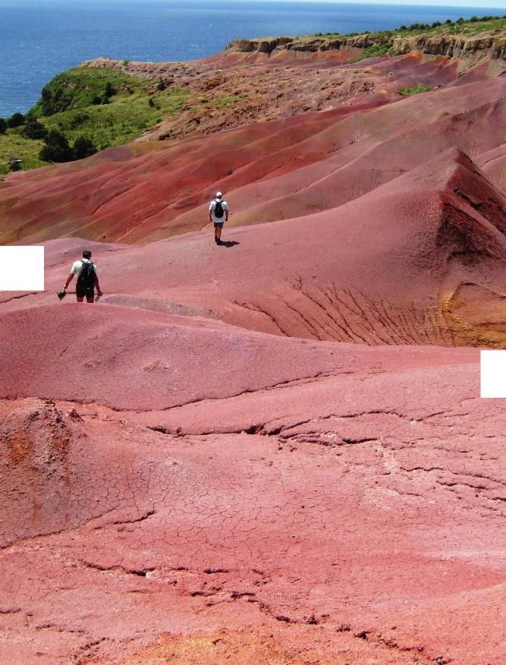

_,,,... ---

*_ ..':!*

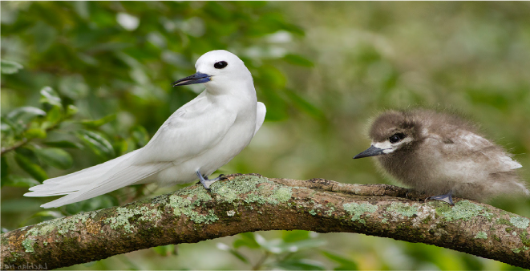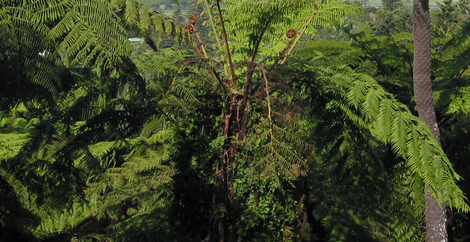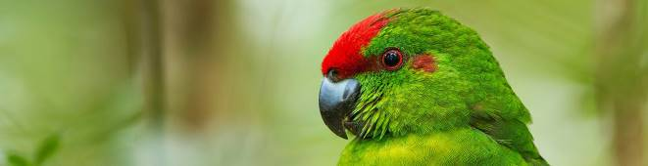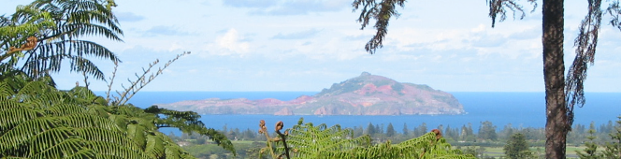

# Effective business systems

##### Efficient and effective business practices and systems

*Objective:* • *To base management and decision-making on a foundation*

*of best available information, sound policies and practices, contemporary management approaches.*

*Desired outcomes:* • *Impacts of proposed activities are minimised through use of*

*impact assessment procedures prior to approval.*

* *Capital works and infrastructure are appropriate to the site and maintained to safe standards*
* *Incidents are minimised in the park and botanic garden through responsible risk assessment and identification of hazards.*

*Performance indicators:* • *Number of proposals assessed for their potential impact*

*upon park values.*

* *Visitor satisfaction with park and garden facilities*
* *Number and severity of incidents in the park are minimised*

Effective business systems | 43

1. Effective business systems

Management of the park and botanic garden needs to be done in ways to minimise impacts on values and in accordance with relevant legislation. Park staff need to be sufficiently trained to respond to incidents and to carry out law enforcement activities. It is important that new proposals for the park and botanic garden are properly assessed to make sure they do not have unacceptable impacts on values and other issues

like visitor safety and enjoyment. It is also important that park and botanic garden management activities are monitored regularly to know whether they are succeeding. Financial management of the park and botanic garden must be within the accountability rules and limits of the Chief Executive Instructions issued by the Director under the (Commonwealth) *Public Governance Performance and Accountability Act 2013* (PGPA Act).

###### Assessment of proposals

**Our aim**

The potential or likely impacts of proposed actions on park and botanic garden values are properly considered before such actions are approved.

**Background**

Activities proposed to be undertaken in the park or botanic garden by the Director and external stakeholders must be assessed for their potential impacts on the park and botanic garden values before a decision can be made on whether the activity should go ahead.

Some activities proposed to be undertaken in the park or botanic garden may be ‘controlled actions’ (see Appendix B, Legislative context) and may also require assessment and approval by the Minister under the EPBC Act because they are likely to have a significant impact on a matter of national environmental significance (such as nationally listed threatened species) or the environment generally in Commonwealth

4 land. The EPBC Act defines the ‘environment’ as including:

1. (a) ecosystems and their constituent parts, including people and communities;
2. natural and physical resources;
3. the qualities and characteristics of locations, places and areas;
4. heritage values of places; and
5. the social, economic and cultural aspects of a thing mentioned in paragraph (a), (b)

or (c).

Proposed actions that do not trigger the EPBC Act assessment and approval provisions may still have impacts that require assessment before a decision can be made on whether the action should go ahead. Proposed actions of a routine nature that are authorised by or under prescriptions and actions in this plan generally do not require impact assessment.

The Director makes decisions on whether or not to approve proposals using the park and botanic garden’s environmental impact assessment process. In doing so the Director seeks the advice of the Norfolk Island National Park Advisory Committee (NINPAC).

**Issues**

* + If not properly assessed and managed, proposed actions may cause significant damage to park and botanic garden values.
  + Assessment of proposals may require significant resources.
  + Assessment of proposals needs to take account of NINPAC’s advice and any submissions or representations by other stakeholders.

***Prescriptions***

* + 1. The potential impacts of proposed actions in the park and botanic garden will be considered and, where necessary, assessed in accordance with Table 1, the assessment matters and considerations outlined in Table 2 and the following prescriptions and actions.
    2. Assessment of proposed activities that are not controlled actions under the EPBC Act may be carried out by park staff, proponents of the proposed activity, or independent experts.
    3. Subject to the EPBC Act, the Director may recover from proponents the costs associated with administering, assessing, managing and monitoring of proposals in the park and botanic garden and/or work with proponents to facilitate contributions from approved commercial activities to support the conservation of park and botanic garden values.

***Actions***

* + 1. Develop and review impact assessment procedures as needed for the park and botanic garden, in accordance with Tables 1 and 2.

4.1

|  |  |  |
| --- | --- | --- |
| **Category** | **Example** | **Decision-making process and impact assessment requirements** |
| Category 1 | | |
| Actions considered likely to have no impact, or no more than a negligible impact, on the natural or cultural values of the park or botanic gardens. | Minor works to maintain, repair, replace or improve existing infrastructure in its present form and footprint.  Existing routine operations to implement prescriptions and actions in this management plan, e.g. weed and feral animal control.  Issuing permits or licences for regular activities in accordance with this plan  e.g. land-based tours, research. | No assessment required  Process accords with management plan prescriptions and actions.  Consultation occurs with interested stakeholders.  Minimal impact work practices must be used when carrying out actions  Decision is made by the Director or appropriate delegate. |
| Category 2 | | |
| Actions considered likely to have more than a negligible impact, but not a significant impact, on the natural or cultural values of the park or botanic gardens. | Major new operations to implement prescriptions in this management plan.  Minor new works and infrastructure to implement prescriptions in this management plan.  Moderate capital works e.g. new infrastructure, or moderate expansion or upgrade of existing infrastructure beyond its current footprint.  Rehabilitation of heavily eroded sites.  Major/long-term changes to existing visitor access arrangements.  New types of commercial activities.  Note: The examples listed above may be Category 3 actions if they are likely to have significant impacts on park values (for example, because of the location, character or extent of the proposed action). | Process accords with management plan prescriptions and actions.  Relevant stakeholders are informed and consulted.  Assessment of management activities prepared by park staff.  The Director will determine whether the assessment of other proposals can be prepared by the proponent or must be prepared by an independent expert  engaged by the proponent at its own cost  Assessment to take into account the matters and considerations set out in Table 2.  Based on the assessment, if the Director determines that the action is likely to have a significant impact on park values the action must be assessed as a Category 3 action  Decision is made by the Director or appropriate delegate. |
| Category 3 | | |
| Actions considered likely to have a significant impact on the natural or cultural values of the park or botanic gardens. | Major capital works e.g. new major infrastructure or major expansion of existing infrastructure.  Note: The examples listed above are deemed to be Category 3 actions. Other actions likely to have significant impacts on park values will also be Category 3 actions. | Assessment by independent expert taking into account the matters and considerations set out in Table 2.  The action must also be referred by the proponent for consideration as a ‘controlled action’ under the EPBC Act.  If, following referral under the EPBC Act, the Minister determines the action is not a  ‘controlled action’, or issues a ‘not controlled action if undertaken in a particular manner’ decision, or approves the action (including subject to conditions), the Director will consider whether additional conditions  are required to be imposed on the action in order to protect park values (prior to approval of the action being given by the Director, as the prescriptions and actions of this management plan may require) |

4.1

**Table 1:Decision-making process and impact assessment procedures**

**Table 2:Environmental impact assessment matters and considerations**

|  |  |
| --- | --- |
| Matters for assessment | Considerations include, but not limited to |
| ***1. Environmental context*** |  |
| (a) What are the components or features of the environment in the area where the action will take place? | * Species and ecological communities in the site, park-wide and regional context * Matters of national environmental significance * Cultural and heritage features * Socio-economic values * Tourism, recreational values, and impact on visitor experience * Aesthetic and landscape values * Scientific reference areas |
| (b) Which components or features of the environment are likely to be impacted? | * Short and long-term impacts on- and off-site |
| (c) Is the environment which is likely to be impacted, or are elements of it, sensitive or vulnerable to impacts? | * Cumulative impacts from a range of activities across the park and botanic garden on the environment or its elements |
| (d) What is the history, current use and condition of the environment which is likely to be impacted? | * Comparison with condition of similar sites elsewhere in the park and botanic garden |
| ***2. Potential impacts*** |  |
| (a) What are the components of the action? | * Include associated infrastructure and stages |
| (b) What are the predicted adverse impacts associated with the action including indirect consequences? | * Include indirect and off-site impacts |
| (c) How severe are the potential impacts? | * Consider scale, intensity, timing, duration and   frequency |
| (d) What is the extent of uncertainty about potential impacts? |  |
| ***3. Impact avoidance and mitigation*** |  |
| (a) Will any measures to avoid or mitigate impacts ensure, with a high degree of certainty, that impacts are not significant? | * Include whether any alternative sites for proposal have been considered |
| ***4. Significance of impacts*** |  |
| (a) Considering all the matters above, is the action likely to have a significant impact on the environment? | * If yes, the proponent must refer the action for Ministerial consideration under the EPBC Act as set out in Table 1 |

.1

4

* 1. Roads and tracks

**Our aim**

Park and botanic garden roads and tracks are provided and maintained in a manner that fulfils the reasonable requirements of Norfolk Island residents and visitors whilst protecting park and botanic garden values.

**Background**

***Vehicle access roads and tracks***

Visitors to the botanic garden have only pedestrian access.

The road to Mount Pitt and Captain Cook Lookout are sealed while access to Palm Glen is by unsealed road. Dirt roads are currently graded and resurfaced to maintain them at a standard suitable for two-wheel-drive vehicles in dry weather. During wet weather, some roads may be closed to avoid accidents and to prevent damage to the road surfaces.

Roads in the park are required to provide safe carriageway for a range of purposes including walking, riding, and driving motor cars, buses, and heavy maintenance equipment.

***Walking tracks***

There are a number of signposted walking tracks in the Mount Pitt Section of the park (Map 4).

Grades vary from easy to steep and distances vary from 200 metres to five kilometres return. Tracks may be slippery when wet. Walks are signposted at the start of each walk and at junctions of major tracks. There are also a number of signposted walking tracks in the botanic garden (Map 5).

Tracks are required to provide safe passage for a range of all-weather uses normally including walking, horse riding, mountain bike riding, maintenance, and rescue.

4.2

The sparse vegetation on Phillip Island provides easy access to the flatter parts of the

island. Walking off designated tracks can hamper habitat rehabilitation efforts (Map 6).

The EPBC Regulations (r.12.41 to 12.44) prohibit use of vehicles other than on designated access roads, tracks and parking areas, and allow the Director to control the use of vehicles (or classes of vehicles) on public access roads and tracks, including setting speed limits.

The EPBC Regulations (r.12.55) prohibit walking or riding off designated vehicle access roads and tracks, or designated walking tracks.

The Director may prohibit or restrict access to all or part of a Commonwealth reserve (r.12.23).

**Issues**

* + Some sections of track may become slippery and difficult to negotiate during extreme weather.
  + There are many steep and rugged parts of the park and botanic garden inaccessible for people with disabilities. There are some sections of track at Mount Pitt, Captain Cook

Lookout, Palm Glen and the botanic garden where ramps and grades provide limited access to assisted wheelchairs.

* + Most roads and tracks need to cater for multiple uses.
  + Phillip Island has specific safety issues.

***Prescriptions***

* + 1. Commercial tour operators may be permitted or licenced to conduct four- wheel-drive tours on vehicle access roads and vehicle access tracks in the Forestry Area that are not designated for public use. Four-wheel-drive tours may only be undertaken during suitable weather conditions, when tracks are considered to be capable of sustaining vehicle use, and where the activity does not result in accelerated erosion or structural damage to the roads and tracks in use.
    2. Commercial tour operators who require access to Phillip Island must:
       1. provide safety management plans and standard operating procedures for tour operations on Phillip Island to the satisfaction of the Director of National Parks
       2. have sufficient public liability insurance for the duration of their licence or permit
       3. observe workplace health and safety standards; and
       4. have sufficient first aid qualifications and rescue capacity available.

See also Prescription 3.3.3.

* + 1. Access to Phillip Island by Norfolk Island residents and accompanied visitors is allowed, with restrictions possible for the purposes of protecting flora and fauna or for public safety.
    2. The Director may prohibit or restrict use of vehicle access roads and vehicle access tracks, including by a class of vehicles specified by size or weight. Such closures will be indicated by appropriate signage at a point or points where a vehicle would ordinarily enter the road or track.

Actions

* + 1. Public vehicle access roads, vehicle access tracks and tracks for walking and riding will be maintained to a safe standard.
    2. Where practicable, disabled access will be incorporated into the planning and design of tracks for walking or riding.
    3. Undertake a visitor access risk assessment for Phillip Island and implement recommendations where appropriate.
    4. Provide, develop and maintain an appropriate network of roads, tracks, lookouts and other visitor infrastructure, appropriate to the nature, size and uniqueness of the park and botanic garden.
    5. Maintain signage in the park and botanic garden designating vehicle access roads, vehicle access tracks and tracks for walking and riding.

4.2

* + 1. Review signage for tracks for walking and riding in the park, providing advice on location, direction, degree of difficulty, likely time to traverse and any relevant safety issues.
    2. Monitor the condition of vehicle access tracks and tracks for walking and riding that are subject to saturation and erosion, particularly during and following wet weather events.
    3. Review and upgrade tracks, stairways and boardwalks within the botanic garden towards improving access throughout the site.
    4. Maintain and/or upgrade tracks for walking and riding in the park and botanic garden to a reasonable and safe standard, with steps and handrails provided where considered necessary.

Map 4: Access to Norfolk Island National Park (Mount Pitt section)

4.2



1000

500

0

250

500

**NORFOLK ISLAND NATIONAL PARK**

Walking tracks in the Mount Pitt Section of the park

|  |  |  |
| --- | --- | --- |
| SUMMIT TRACK  An easy walk | 500m  Journey along the ridge top from the peak of Mount Pitt to the peak of Mount Bates, the highest points on the island. Venture through tea-tree forest and stately Norfolk pines.  Catch spectacular panoramic views over Norfolk and the coast |  | RED STONE LINK TRACK  A moderate to difficult walk, some steep sections | 700m  Use this track between Bird Rock Track and Bridle Track to avoid the steep climb out from the  Bird Rock lookout. You’ll pass through beautiful forests of Norfolk pine and rainforest. From October to March the air is full of white terns, black noddies and red-tailed tropic birds. |
| PALM GLEN TRACK  An easy walk | 290m  Take this link walk from the Palm Glen Circuit Track to connect with the Red Road Track.  This is your chance to see beautiful stands of native Norfolk palm mixed in with giant tree ferns. You may also spot the large and very old specimen of a tree exclusive to Norfolk, the bastard oak. |  | MCLACHLANS LANE  A moderate walk | 650m  Start this walk from the Red Road entrance to the park and follow the path to the ‘dry waterfall’.  Look closely and you will see McLachlan’s old house site among the Norfolk pine and white oak forest. At the end of the track you will discover a lush valley with a waterfall that flows after good rain. |
| BRIDLE TRACK  An easy to moderate walk, some steep sections | 1.7km  Take the Bridle Track from below the grassy slope at Captain Cook Monument to the intersection at Red Road Track. Meander up and around the edge of the coastline through coastal vegetation, Norfolk Island pines and white oaks. Enjoy spectacular views of the coastline and islets. |  | BIRD ROCK TRACK  A moderate to difficult, steep walk | 760m  Bird Rock Track heads down from the Bridle Track towards Bird Rock. Travel through pine forest to  a spectacular view from the cliff top overlooking Bird Rock. The return walk up Bird Rock Track from Bird Rock lookout is the most challenging in the park, because of its consistent uphill slope. |
| OLD MOUNTAIN TRACK  A moderate, steep walk | 540m  Enter at the Mount Pitt Road entrance and walk along the track up Mount Pitt. As a reward for your efforts, savour the expansive views from the top looking south over Norfolk to Phillip Island. The Old Mountain track was the main access to Mount Pitt prior to World War II. You can still see the remnants of a gun emplacement on this track. |  | PALM GLEN CIRCUIT TRACK  An easy to moderate walk | 910m  Start and finish this walk from the Palm Glen picnic area. Enjoy the lush greenery as you take the path through one of Norfolk Island’s spectacular rainforest gullies. See marvellous  tree ferns and dense stands of Norfolk palms—a palm tree found nowhere else in the world.  Experience a magnificent panoramic view over the southern parts of Norfolk Island and out to Phillip Island. |
| RED ROAD TRACK  A moderate walk | 1.7km  Take this walk from the Red Road car park towards the top of Mount Bates. Experience the grandeur of some magnificent stands of Norfolk pine, one of the island’s best known symbols. Catch glimpses into the steep valleys on either side filled with palms and ferns. This is a good place to see birdlife—maybe even the Norfolk Island green parrot. |  | MOUNT BATES TRACK  An easy walk | 620m  Begin this track at Mount Pitt Road to walk up Mount Bates. The wide grassy track skirts the top edge of the ridge through palm forests with amazing island views to the south-east. You will be rewarded for your climb with breathtaking views over the north-west of the island.  Excavations at the top are relics of a WWII radar  station. |

.2

4

**Map 5: Access to Norfolk Island Botanic Garden**

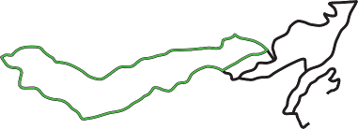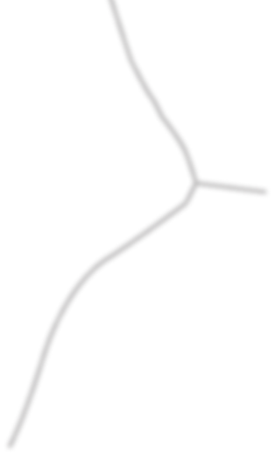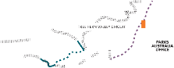

garden trail

information display area toilets

public parking

rainforest gully circuit

samsons circuit stairways

garden trail

**DISCOVERY CENTRE**

rainforest gully circuit

samsons circuit

.2

4

|  |
| --- |
| GARDEN TRAIL  An easy walk suitable for wheelchairs and strollers | 90m  Learn about many of Norfolk Island’s unique plants on this short walk featuring a sample of the plants found throughout the park. |
| THE BOARDWALK  An easy walk suitable for wheelchairs and strollers | 170m  Stroll through shady forests and open woodlands and get an elevated boardwalk perspective with views down the gully sides. Witness Norfolk’s spectacular sunsets from the viewing platform near the Mt Pitt end of the track. |
| TREE FERN VALLEY CIRCUIT  A moderate walk with a few flights of stairs | 370m  Start and finish this walk from the Palm Glen picnic area. Enjoy the lush greenery as you take the path through one of Norfolk Island’s spectacular rainforest gullies. See marvellous tree ferns and dense stands of Norfolk palms—a palm tree found nowhere else in the world. Experience a magnificent panoramic view over the southern parts of Norfolk Island and out to Phillip Island. |
| RAINFOREST GULLY CIRCUIT  A moderate walk with some stairs and steep sections | 600m  Experience Norfolk’s rainforest wonders like the giant vines and the cool, lush surroundings of the valley as you wander this rainforest gully track. |
| SAMSONS CIRCUIT  A moderate walk with stairs | 120m  Catch great views of valleys of tree ferns and observe the plant Samson’s sinew and introduced vines while walking through an area of disturbed forest where light has opened up the rainforest. |

4.2

**Map 6: Access to Norfolk Island National Park (Phillip Island Section)**

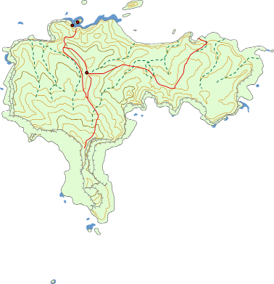

Walking track High cliff Valley

Contour line (index 100m) Contour line (standard)

Rock ledge

1,000

500

Metres

0

.

Whales Hump

*Garnet Point*

*Dar Tomato Bay*

*SPIN BAY*

*Juvenile Point*

Parks Australia Hut

*East End*

*Point*

*West End*

*Point*

*Dar Moo-oo* Sail Rock

*Bay*

Fishing Hut

Site

*Bay*

*Cow* Landing

Red Stone

White Stone

Outside Dar Stool

*Dar Stool Inlet*

**PHILLIP ISLAND**

Hard Balli Stone

4.3 Capital works and infrastructure

**Our aim**

Capital works and infrastructure are appropriate, safe, functional and cost effective to construct and maintain, and are developed and maintained in a manner that protects park and botanic garden values.

**Background**

Capital works and infrastructure in the park and botanic garden include visitor access facilities (such as public roads, tracks, boardwalks and bridges), management facilities (such as access roads and tracks, radio repeaters, storage sheds, workshops and Park Headquarters) and visitor facilities (such as the Discovery Centre, viewing decks, seats, picnic facilities, landing areas, fixed ropes on steep sections of tracks, signs, public toilets and day use areas).

Additionally some public utilities are sited in, or go through, the park and botanic garden.

Other facilities are located at the depot in the Forestry Area. These include storage sheds, nursery facilities, chemical storage and associated equipment.

Phillip Island is largely devoid of artificial structures with the exception of the Parks Australia hut, a private encampment, tracks and climbing ropes. The Fishing Club’s hut is sited on a small islet adjacent to Phillip Island and is used and maintained as accommodation for overnight fishing trips or in emergencies where return to Norfolk

Island may not be possible (e.g. due to weather conditions). The islet is not part of the national park.

Under ss.354 and 354A of the EPBC Act the Director and other persons can only excavate, erect a building or other structure, or carry out works in the park and botanic garden in accordance with this plan.

**Issues**

* + The management challenge is to strike a balance between providing opportunities for

4 the appropriate use, appreciation and enjoyment of the park and botanic garden by

1. visitors, protecting park and botanic garden values, and allowing the construction of infrastructure necessary for approved activities.
   * Management programs and maintenance schedules require safe and appropriate access to work sites, and need to be undertaken in a cost effective manner.
   * Capital works are governed by rules and regulations regarding correct procurement and accounting processes.

***Prescriptions***

* + 1. The Director may carry out works in the park and botanic garden, including carrying out an excavation, erect a building or other structure, or carry out other works otherwise prohibited under ss.354(1) and 354A(3) of the EPBC Act.
    2. Third parties may carry out an excavation, erect a building or other structure, or carry out works in the park or botanic garden in accordance with a permit, lease, sublease, or licence granted by the Director.
    3. Capital works and infrastructure, and alterations, renovations or significant repairs to existing capital works and infrastructure must comply with all relevant laws, standards and codes of practice.
    4. As far as practicable, new capital works and infrastructure must use existing roads and tracks or other disturbed sites.
    5. Third parties who undertake capital works and infrastructure development and other works must meet the cost of any rehabilitation required as a result of the works.
    6. Timber, including preservative treated timber, may be brought into the park and botanic garden and used for construction purposes.
    7. Landscaping materials including road fill, sand, rocks and organic material may be brought into the park and botanic garden subject to prior assessment of potential environmental impacts including potential to introduce new non-native or invasive species or pathogens.

***Actions***

* + 1. Construct and maintain capital works and infrastructure to reasonable and safe standards (including any relevant Australian Standards).
    2. Ensure that all construction and maintenance planning and works are undertaken in a way which minimises the impact on park and botanic garden values.
    3. Where practicable, disabled access will be incorporated into the planning and design of new capital works and infrastructure.
    4. Maintain facilities on Phillip Island to support management activities including regeneration of native vegetation, research and maintenance.
    5. Maintain an effective communications capacity appropriate to the operational and emergency rescue needs of the park and botanic garden.

###### Resource use in park operations

**Our aim**

Financial and environmental best practice governs the use and management of resources.

**Background**

The Director supports financial and environmental best practice principles in regard to the use of resources and management of waste products in the park and botanic garden.

These principles are consistent with good governance and with the need for conserving the natural and cultural values of the park and botanic garden.

**Issue**

Financial accountability is a critical component of proper resource management.

***Actions***

* + 1. Where practicable all management activities will aim to reduce or minimise the use of energy or materials.

4.4

* + 1. Maintain and acquit proper financial records in accordance with the PGPA Act and other financial governance legislation and policies of the Commonwealth.
    2. Develop cost effective strategies and technologies (such as energy reduction and alternative energy sources) for reducing the park and botanic garden’s output of greenhouse gases.
    3. Promote best practice environmental work practices and activities in the park and botanic garden.
    4. Seek alternative sources of funding and other resources for management activities through sponsorships, donations, bequests and partnerships.

###### 4.5 Visitor safety and incident management

**Our aim**

* + Visitors to the park and botanic garden have a safe and rewarding experience.
  + Incidents and emergencies in the park and botanic garden are responded to promptly, effectively and safely.

**Background**

Normal enjoyment of the park and botanic garden may involve some risk. Injury can occur on slippery or ocean-swept rocks, wet boardwalks, bridges or tracks. Overhanging trees or branches can pose dangers, as can activities such as driving vehicles, riding

and walking, especially for elderly or unfit users of the park and botanic garden. Some viewing and walking areas of the park are close to precipitous cliffs.

A range of measures are adopted in the park and botanic garden to reduce risks to visitors, including:

* + maintaining roads, tracks and visitor facilities in a safe condition
  + providing educational materials and signs for visitors and tour operators on safety and safe behaviour

4 • working with other agencies in emergency operations

1. • maintaining an integrated lock system which enables emergency vehicles to gain

access to all management tracks within the park and botanic garden

* + documenting, investigating and reporting incidents.

The Phillip Island component of the park is isolated and potentially dangerous. In wet conditions the surfaces become slippery and treacherous. The difficulties of landing boats mean that access to Phillip Island can generally only be accomplished in calm seas. People can be stranded on Phillip Island for several days waiting for seas to abate enough to return to Norfolk Island. The Fishing Club hut provides emergency shelter. Currently, access to Phillip Island is gained by fixed ropes and ladders. The lack of soil structure has rendered some areas of the island unstable and there are numerous cliffs and gullies.

The Director works with relevant agencies to ensure there is adequate rescue capacity in place.

All visitor safety incidents are reported, recorded and reviewed regularly. Using this information the Director has compiled a Risk Watch List for the park and botanic garden that identifies and rates a range of risks, including risks to visitor safety, and specifies risk management measures that are carried out as required. The list is reviewed and updated regularly.

The Director may also prohibit or restrict entry to areas of the park and botanic garden under the EPBC Regulations (r.12.23), including where it is necessary for safety reasons.

The Director has the function under the EPBC Act of administering, managing and controlling the park and botanic garden. Also, the Director has a duty of care for employees and visitors, and a duty under the *Work Health and Safety Act 2011* to take reasonably practicable steps to protect employees and visitors from risks to their health and safety.

Police do not have a statutory role in relation to incidents of the type referred to in this Section unless an incident is a disaster or emergency, requiring counter disaster measures. However, police forces are generally responsible for marine search and rescue operations for persons or ships in waters within the limits of ports of a state/territory and in respect of pleasure craft and fishing vessels; provision and coordination of land searches for missing civil aircraft; and overall coordination of searches for hikers and land vehicles. In complex rescues the Police Officer-in-Charge controls the incident in liaison with representatives from each agency involved, including Parks Australia, fire and rescue and emergency services. The Police Officer-in-Charge has powers to draw on available resources, wherever they are and whoever controls them.

**Issues**

* + The operation of Commonwealth reserves can involve exposure of a range of risks to visitors, staff and contractors.
  + Public interest in adventure tourism increases the potential for incidents, especially on Phillip Island.
  + Park staff are called upon from time to time to respond to emergencies in and outside the park and botanic garden, as part of the Norfolk Island community emergency response arrangements.
  + There is a need for appropriate numbers of properly trained and resourced personnel to provide an effective incident response system.

***Prescriptions***

* + 1. An incident response and management capacity will be maintained within the park and botanic garden.
    2. The Director may prohibit or restrict activities that present a risk to public safety or may prohibit or restrict access to areas of the park and botanic garden where it is considered necessary to do so to protect the values of the park and botanic garden, biodiversity or heritage in the park and botanic garden, use by other persons, or in the interests of public safety.

4.5

* + 1. Fire bans may be declared in the park and botanic garden under r.12.30 of the EPBC Regulations during periods of high fire risk.
    2. Subject to legal requirements, the Director may seek reimbursement or contributions for the cost of responding to incidents, in particular search and rescue operations.

***Actions***

* + 1. Cooperate with relevant emergency services agencies and volunteer organisations to ensure that emergency response plans are in place and effective, with clearly defined roles and response procedures.
    2. Regularly assess and review risks in the park and botanic garden, including visitor sites, workplace and facility inspections, and implement appropriate management and risk reduction measures as necessary.
    3. Provide staff with regular training in first aid to ensure their qualifications remain current.
    4. Store and maintain first aid equipment, emergency water and food supplies at the Parks Australia hut on Phillip Island.
    5. Ensure that relevant staff receive and maintain training appropriate for participating in island-wide emergency response activities.
    6. Ensure the Director’s staff, contractors and visitors are able to communicate with Norfolk Island while on Phillip Island.
    7. Review and implement incident management procedures for managing potential incidents that may affect people’s safety, property and the environment in the park and botanic garden, ensuring that the procedures:
       1. are consistent with island-wide emergency response procedures
       2. outline the roles and responsibilities of the Director, other agencies and volunteer groups
       3. identify training, record keeping, debriefing, reporting and counselling

4 requirements.

1. (d) use results from previous exercises, the Director’s Workplace Health and Safety Policies and contemporary approaches to improve responses.

###### Compliance and enforcement

**Our aim**

There is maximum compliance with relevant legislation by users of the park and botanic garden as a result of effective education and enforcement programs.

**Background**

Compliance with relevant legislation is important for the protection of park and botanic garden values, and for people’s safety.

Staff may be appointed by the Minister under the EPBC Act as rangers or wardens, and exercise the powers and functions conferred on them by the Act and the Regulations. In addition, all members of the Australian Federal Police and special members of the Australian Border Force are *ex officio* wardens; and officers or employees of other Australian, state or territory government agencies may be appointed by the Minister as rangers or wardens. The Australian Government requires that investigating officers be trained to standards prescribed in the Commonwealth Fraud Control Guidelines.

Park staff not appointed as wardens and rangers cannot exercise these powers but can encourage compliance with legislation through education to raise public awareness of appropriate behaviour.

Norfolk Island laws apply in the park and botanic garden to the extent they can operate concurrently with the EPBC Act and Regulations and this plan.

**Issues**

* + Effective compliance and enforcement requires appropriate resources and training, and a strategic approach based on risk management principles.
  + Exercise of enforcement powers by park staff must comply with Australian Government policies, standards and guidelines.
  + Establishing and maintaining working relationships with other relevant compliance agencies can improve management of compliance issues that are of shared concern.

***Actions***

* + 1. Undertake compliance and enforcement activities in accordance with the EPBC Act and Regulations.
    2. Provide ongoing compliance and law enforcement training for staff appointed, or likely to be appointed, as rangers and wardens.
    3. Provide permit holders, licence holders and other stakeholders with appropriate information on compliance and enforcement risks, strategies and associated issues.
    4. Liaise and, where appropriate, work with relevant local and Australian Government agencies and organisations to address compliance and enforcement issues.

4.6

###### Neighbours, stakeholders and partnerships

**Our aim**

Develop and maintain cooperative relations and partnerships with the Norfolk Island community, government agencies, neighbours and stakeholders in a manner that focuses on promoting the most effective management of these areas and botanic garden and achieving common management aims.

**Background**

The park is integral to nature conservation on Norfolk Island, containing significant tourist attractions and sites and species which are important to the residents of Norfolk Island for recreation and traditional uses. Therefore there are many people and organisations with a strong interest in the management of the park and botanic garden. It is important to have good working relations with these people and organisations for the effective management of the park and botanic garden.

Due to the size and location of the park and botanic garden relative to Norfolk Island, conservation of the park and botanic garden and their values depends on the joint commitment of all groups to work in partnership to ensure effective conservation and management outcomes.

On request, Parks Australia provides advice and assistance to the Norfolk Island Administrator, the Norfolk Island Regional Council, and the public on conservation, wildlife management and environmental issues.

Parks Australia supports relevant activities undertaken by local non-government organisations, assists at the local school with talks, tree plantings and environmental references and works cooperatively with the local community to encourage appropriate environmental behaviour. Regular articles in the local paper educate and encourage a broader community focus on environmental issues, particularly those which impact on the park and botanic garden values.

***Norfolk Island National Park Advisory Committee (NINPAC)***

4.7

NINPAC advises the Director on the effective implementation of the management plan

and on other matters relevant to the park and botanic garden. NINPAC members are

appointed by the Director.

NINPAC membership is reviewed by the Director every three years. A representative of the Norfolk Island Regional Council also sits on NINPAC.

The chair is elected by NINPAC and the Park Manager acts as committee secretary. At the time of preparing this plan NINPAC’s functions are to:

* + provide advice towards the development, implementation and revision of management plans for Norfolk Island National Park and Norfolk Island Botanic Garden
  + monitor the management of Norfolk Island National Park and Norfolk Island Botanic Garden
  + identify and recommend conservation priorities for Norfolk Island National Park and Norfolk Island Botanic Garden
  + make recommendations on work programs required to implement the management plan
  + provide a forum for members of the Norfolk Island community to raise issues relevant to the management of Norfolk Island National Park and Norfolk Island Botanic Garden.

**Issue**

Developing and maintaining relationships and partnerships with neighbours and stakeholders can increase support for park and botanic garden values, help to manage issues of common interest and optimise use of available resources.

***Actions***

* + 1. Productive and effective working relationships will be maintained with the community and other stakeholders.
    2. Norfolk Island National Park Advisory Committee (NINPAC) will function as the primary liaison mechanism with the local community for significant issues relating to the park and botanic garden management.
    3. Convene a minimum of two NINPAC meetings each calendar year to discuss management of the park and botanic garden and issues of concern to the community.
    4. During the life of the plan, review the terms of reference for NINPAC.
    5. Investigate opportunities to improve avenues of communication between NINPAC and the community to ensure that the community’s views are fairly represented at committee meetings and relevant outcomes of meetings are made known.
    6. Work with relevant local and Australian Government agencies and organisations to promote the park and botanic garden as important visitor destinations.
    7. Share information with the community and other stakeholders in relation to park, botanic garden and island-wide conservation issues and other issues of mutual interest. This may include:
       1. establishing or participating in additional consultative and advisory groups or forums
       2. establishing or participating in awareness raising and information sharing forums; and
       3. consulting the community and other stakeholders in relation to specific issues.
    8. Work with relevant stakeholders and organisations to develop partnerships and whole-of-government approaches for implementing this plan and addressing island-wide conservation issues and other issues of mutual interest.
    9. Implement strategies to increase community and stakeholder involvement in contributing to the management of the park and botanic garden, including developing and supporting appropriate volunteer activities.

4.7

###### 4.8 Activities not otherwise specified in this plan

**Our aim**

The Director is able to respond to new issues and proposals consistent with this plan and the EPBC Act and Regulations.

**Measuring how well we are meeting our aim**

Extent to which new issues are dealt with effectively and consistent with the principles and policies set out in this plan

**Background**

This plan sets out how the park and botanic garden will be managed for a period of ten years. During that time, circumstances may arise or proposals be brought forward for actions which are not known or anticipated at the time this plan is being prepared and which will require the Director to take actions that are not covered by specific prescriptions and actions in this plan.

As noted in Appendix B, Legislative context, under ss.354 and 354A of the EPBC Act certain types of actions can only be taken if they are authorised by this plan (including acts in relation to native species, works, and actions for commercial purposes). Actions affecting members of species protected under Part 13 of the Act may be taken in accordance with this plan.

Section 358(2) of the EPBC Act allows the Director to grant a lease, sublease, or licence relating to land in the park and botanic garden provided it is in accordance with a management plan.

The Director is required by the Act (s.362) to exercise the Director’s powers e.g. to issue permits and to perform the Director’s functions so as to give effect to the plan.

**Issue**

This plan needs to enable appropriate actions to be taken and authorised that are not

4 specified by other prescriptions and actions in the plan because they are not foreseen at

1. the time of writing this plan.

***Prescriptions***

* + 1. The Director may take actions that are not covered by specific prescriptions and actions in this plan, including actions covered by ss.354 and 354A of the EPBC Act.
    2. The Director may authorise (whether by permit, contract, lease or licence) actions by other persons that are not covered by specific prescriptions and actions in this plan, including actions covered by ss.354 and 354A of the EPBC Act or the EPBC Regulations.
    3. The Director may grant leases, subleases and licences relating to land in the park and botanic garden.
    4. Except in cases of emergency, the impact assessment processes prescribed in Section 4.1 of this plan apply to actions under this Section.

###### Management plan implementation and evaluation

**Our aim**

Manage the park and botanic garden in an effective and efficient manner and in accordance with obligations under this plan at law, and relevant Commonwealth and departmental policies.

**Background**

It is the responsibility of the Director under s.514B of the EPBC Act to administer, control, protect, conserve and manage biodiversity in Commonwealth reserves. Funds for the management of the park and botanic garden are allocated from the Australian National Parks Fund under the EPBC Act. The principal sources of the fund’s money are prescribed by s.514S of the EPBC Act. Under s.356A of the EPBC Act the Director may collect charges for activities undertaken in Commonwealth reserves, subject to the approval of the Minister. As a corporate Commonwealth entity for the purposes of the PGPA Act, the Director is also subject to the requirements of that Act and the policies and rules made under it, as well as other relevant legislative requirements and government policies.

**Issues**

* + To effectively and responsibly implement this plan, work policies, procedures and programs must be consistent with the plan and with relevant government policies.
  + Near this plan’s expiry date, there should be a review of how successfully the plan has been implemented.

***Actions***

* + 1. Priorities for implementation of the actions in this plan will be determined by the need to protect and promote park and botanic garden values, ensure visitor and staff safety, and ensure cost effectiveness.
    2. The findings of research and monitoring and contemporary approaches to natural resource management will be used to adapt the implementation of management activities.
    3. Develop an implementation schedule for this plan and, based on the schedule, develop and implement annual priorities and work/operational plans.
    4. Reviews of park management activities and performance will be provided through the Director’s Annual Report or where otherwise required by the Director.
    5. Undertake a formal review of this management plan at the commencement of the eighth year of the plan that:
       1. considers each management prescription and action and whether or not it was successfully implemented
       2. evaluates the performance of each prescription and action
       3. determines the cause of any prescription and/or action that was not implemented, or which failed to achieve the desired outcome; and
       4. provides recommendations for adapting future management, contributing towards the development of the next management plan for the park.

4.9

Appendix A

###### Interpretation (including acronyms)

In this plan:

**Australian Government** means the Government of the Commonwealth of Australia

**Bonn Convention** means the Convention on the Conservation of Migratory Species of Wild Animals (Bonn Convention)

**Botanic Garden** means the Norfolk Island Botanic Garden

**CAMBA** means the Agreement between the Government of Australia and the Government of the People’s Republic of China for the Protection of Migratory Birds and their Environment

**Commonwealth reserve** means a reserve established under Division 4 of Part 15 of the EPBC Act

**Department** means the Department of the Environment and Energy or such other department or agency that succeeds to the functions of the Department

**Department of Agriculture and Water Resources** means the Australian Government department responsible for biosecurity in Australia

**Director** means the Director of National Parks continuing as a corporation under s.514A of the EPBC Act, and includes Parks Australia and any person to whom the Director has delegated powers and functions under the EPBC Act in relation to Norfolk Island National Park and/or Norfolk Island Botanic Garden

**EPBC Act** means the *Environment Protection and Biodiversity Conservation Act 1999*, including Regulations under the Act, and includes reference to any Act amending, repealing or replacing the EPBC Act

**EPBC Regulations** means the Environment Protection and Biodiversity Conservation

4 Regulations 2000 and includes reference to any Regulations amending, repealing or

1. replacing the EPBC Regulations

**Forestry operations** means operations or activities connected with, or incidental to, planting, maintenance and harvesting of trees or other plants

**Forestry operator** means an appropriately qualified individual or organisation authorised to undertake forestry operations in accordance with Prescription 2.10.1 of this management plan.

**IUCN** means the International Union for Conservation of Nature

**JAMBA** means the Agreement between the Government of Australia and the Government of Japan for the Protection of Migratory Birds and Birds in Danger of Extinction and their Environment

**Management plan** or **plan** means this management plan for the park and botanic garden, unless otherwise stated

**Management principles** means the Australian IUCN reserve management principles set out in Schedule 8 of the EPBC Regulations

**Minister** means the Minister administering the EPBC Act

**NINPAC** means the Norfolk Island National Park Advisory Committee

**Norfolk Island Botanic Garden** means the area declared as a reserve by that name under the NPWC Act and continued under the EPBC Act by the *Environmental Reform (Consequential Provisions) Act 1999*

**Norfolk Island National Park** means the areas declared as a national park by that name under the NPWC Act and continued under the EPBC Act by the *Environmental Reform (Consequential Provisions) Act 1999*

**NPWC Act** means the *National Parks and Wildlife Conservation Act 1975* and the Regulations under that Act

**Park** or **National Park** means Norfolk Island National Park

**Parks Australia** means that part of the Department that assists the Director in performing the Director’s functions under the EPBC Act

**Parks Australia** staff means staff who are employees of the Department assigned to assist the Director of National Parks

**PGPA Act** means the *Public Governance, Performance and Accountability Act 2013*, including Rules under the Act, and includes reference to any Act amending, repealing or replacing the PGPA Act.

**Remotely piloted aircraft** means aircraft that are remotely piloted by a person on the ground including unmanned aerial vehicles (UAVs), also known as recreational drones.

**ROKAMBA** means the Agreement between the Government of Australia and the Government of the Republic of Korea for the Protection of Migratory Birds and their Environment

**Territory** means the Territory of Norfolk Island

Appendix A – Interpretation (including acronyms) | 65

## Appendix B

#### Legislative context

Establishment of the National Park and Botanic Garden

The Mt Pitt section of the park and the Botanic Garden were established when the *Norfolk Island National Park and Norfolk Island Botanic Garden Act 1984* (Norfolk Island) came into effect on 12 February 1985. Prior to this, both Mt Pitt Reserve and Phillip Island had been public reserves declared under the Commons and Public Reserves Ordinance 1936 (Norfolk Island). The Mt Pitt section of the Park and the Botanic Garden were subsequently also proclaimed under the *National Parks and Wildlife Conservation Act 1975* (Commonwealth) (NPWC Act) on 31 January 1986 following a request of the Norfolk Island Legislative Assembly.

The Phillip Island section of the park was proclaimed under the NPWC Act on 24 January 1996. The NPWC Act was replaced by the *Environment Protection and Biodiversity Conservation Act 1999* (EPBC Act) in July 2000. The park and the botanic garden continue as Commonwealth reserves under the EPBC Act pursuant to the *Environmental Reform (Consequential Provisions) Act 1999*, which deems the park to have been declared for the following purposes:

* + the preservation of the area in its natural condition
  + the encouragement and regulation of the appropriate use, appreciation and enjoyment of the area by the public

and deems the botanic garden to have been declared for the purpose of:

* + increasing knowledge, appreciation and enjoyment of Australia’s plant heritage by establishing, as an integrated resource, a collection of living and herbarium

specimens of Australian and related plants for study, interpretation, conservation and display.

The Director of National Parks is responsible for the management of Norfolk Island National Park and Norfolk Island Botanic Garden.

Director of National Parks

The Director is a corporation-sole under the EPBC Act (s.514A) and a corporate Commonwealth entity for the purposes of the *Public Governance, Performance and Accountability Act 2013*. The corporation is constituted by the person appointed by the Governor-General to the office that is also called the Director of National Parks (s.514F of the EPBC Act).

The functions of the Director (s.514B) include the administration, management and control of the park and botanic garden. The Director generally has power to do all things necessary or convenient for performing the Director’s functions (s.514C). The Director has a number of specified powers under the EPBC Act and EPBC Regulations, including the power to prohibit or control some activities and to issue permits or enter into licences for activities that are otherwise prohibited. The Director performs functions and exercises powers in accordance with this management plan.

EPBC Act

*Objects of the EPBC Act*

The objects of the EPBC Act as set out in Part 1 are:

1. to provide for the protection of the environment, especially those aspects of the environment that are matters of national environmental significance
2. to promote ecologically sustainable development through the conservation and ecologically sustainable use of natural resources
3. to promote the conservation of biodiversity
4. to provide for the protection and conservation of heritage
5. to promote a co-operative approach to the protection and management of the environment involving governments, the community, land-holders and indigenous peoples
6. to assist in the co-operative implementation of Australia’s international environmental responsibilities
7. to recognise the role of indigenous people in the conservation and ecologically sustainable use of Australia’s biodiversity; and
8. to promote the use of indigenous people’s knowledge of biodiversity with the involvement of, and in cooperation with, the owners of the knowledge.

*Control of actions in Commonwealth reserves*

The EPBC Act (ss.354 and 354A) prohibits certain actions being taken in Commonwealth reserves except in accordance with a management plan. These actions are:

* + kill, injure, take, trade, keep or move a member of a native species; or
  + damage heritage; or
  + carry on an excavation; or
  + erect a building or other structure; or
  + carry out works; or
  + take an action for commercial purposes.

The EPBC Act (ss.355 and 355A) also prohibits mining operations being taken in Commonwealth reserves except in accordance with a management plan.

The EPBC Regulations control, or allow the Director to control, a range of activities in Commonwealth reserves, such as camping, use of vehicles and vessels, littering, commercial activities and research. The Director applies the Regulations subject to

and in accordance with the EPBC Act and management plans. The Regulations do not apply to the Director or to wardens or rangers appointed under the EPBC Act. Activities that are prohibited or restricted by the EPBC Regulations may be carried on if they are authorised by a permit issued by the Director, if they are carried on in accordance with a management plan, or if another exception prescribed by r.12.06(1) of the Regulations applies.

*Wildlife protection*

The EPBC Act also contains provisions (Part 13) that prohibit and regulate actions in relation to listed threatened species and ecological communities, listed migratory

species, cetaceans (whales and dolphins) and listed marine species. Appendices B, C and D to this plan list species that occur in the park and botanic garden that are listed threatened species, listed migratory species and listed marine species under the EPBC Act.

Actions taken in accordance with a Commonwealth reserve management plan that is in operation under the EPBC Act are exempt from Part 13.

*Penalties*

Civil and criminal penalties may be imposed for breaches of the EPBC Act.

*Heritage protection*

At the time of preparing this plan the Mount Pitt Section of the National Park is an ‘indicative place’ for possible inclusion in the Commonwealth Heritage List under the Act. Phillip Island is listed on the Commonwealth Heritage List.

The EPBC Act Commonwealth Heritage protection provisions (ss.341A to 341ZH) relevantly provide:

* + for the establishment and maintenance of a Commonwealth Heritage List, criteria and values for inclusion of places in the list and management principles for places that are included in the list
  + that Commonwealth agencies must not take an action that is likely to have an adverse impact on the heritage values of a place included in the Commonwealth Heritage

List unless there is no feasible and prudent alternative to taking the action, and all measures that can reasonably be taken to mitigate the impact of the action on those values are taken; and

* + that Commonwealth agencies that own or control places must:
  1. prepare a written heritage strategy for managing those places to protect and conserve their Commonwealth Heritage values, addressing any matters required by the EPBC Regulations, and consistent with the Commonwealth Heritage management principles; and
  2. identify Commonwealth Heritage values for each place, and produce a register that sets out the Commonwealth Heritage values (if any) for each place (and do so within the time frame set out in their heritage strategies).

*Environmental impact assessment*

Actions that are likely to have a significant impact on matters of ‘national environmental significance’ are subject to the referral, assessment and approval provisions of Chapters 2 to 4 of the EPBC Act (irrespective of where the action is taken).

At the time of preparing this plan, the matters of national environmental significance identified in the EPBC Act are:

* + World Heritage properties
  + National Heritage places
  + Wetlands of international importance
  + Listed threatened species and communities
  + Listed migratory species
  + Protection of the environment from nuclear actions
  + Marine Environment
  + Great Barrier Reef Marine Park
  + Protection of water

The referral, assessment and approval provisions also apply to actions on Commonwealth land that are likely to have a significant impact on the environment and actions

taken outside Commonwealth land that are likely to have a significant impact on the environment on Commonwealth land. The park and botanic garden are Commonwealth land for the purposes of the EPBC Act.

Responsibility for compliance with the assessment and approval provisions of the EPBC Act lies with persons taking relevant ‘controlled’ actions. A person proposing to take an action that the person thinks may be or is a controlled action should refer the proposal to the Minister for the Minister’s decision whether or not the action is a controlled action. The Director of National Parks may also refer proposed actions to the Minister.

Norfolk Island legislation

The park and botanic garden are also established under the *Norfolk Island National Park and Norfolk Island Botanic Garden Act 1984* (NI), which operates subject to the EPBC Act. For the purposes of this Act, one or more persons may be appointed by the responsible Minister as Officers. In the past, the park manager has been appointed as an Officer, with the designation of Park Superintendent.

Planning process

*Management plans*

Section 366 of the EPBC Act requires the Director to prepare management plans for the park and the botanic garden. When prepared, a plan is given to the Minister for approval. A management plan is a ‘legislative instrument’ for the purposes of the *Legislation Act 2003* and must be registered under that Act. Following registration the plan is tabled in each House of the Commonwealth Parliament and may be disallowed by either House on a motion moved within 15 sitting days of the House after tabling.

A management plan for a Commonwealth reserve has effect for ten years, subject to being revoked or amended earlier by another management plan for the reserve.

*Purpose, content and matters to be taken into account in a management plan*

The purpose of this management plan is to describe the philosophy and direction of management for the park and botanic garden for the next ten years in accordance with the EPBC Act. The plan enables management to proceed in an orderly way; it helps reconcile competing interests and identifies priorities for the allocation of available resources.

Under s.367(1) of the EPBC Act, a management plan for a Commonwealth reserve (in this case, the park and the botanic garden) must provide for the protection and conservation of the reserve. In particular, each plan must:

1. assign the reserve to an IUCN protected area category (whether or not a proclamation has assigned the reserve or a zone of the reserve to that IUCN category)
2. state how the reserve, or each zone of the reserve, is to be managed
3. state how the natural features of the reserve, or of each zone of the reserve, are to be protected and conserved
4. if the Director holds land or seabed included in the reserve under lease—be consistent with the Director’s obligations under the lease
5. specify any limitation or prohibition on the exercise of a power, or performance of a function, under the EPBC Act in or in relation to the reserve
6. specify any mining operation, major excavation or other works that may be carried on in the reserve, and the conditions under which it may be carried on
7. specify any other operation or activity that may be carried on in the reserve
8. indicate generally the activities that are to be prohibited or regulated in the reserve, and the means of prohibiting or regulating them
9. indicate how the plan takes account of Australia’s obligations under each agreement with one or more other countries that is relevant to the reserve (including the World Heritage Convention and the Ramsar Convention, if appropriate)
10. if the reserve includes a National Heritage place:
    1. not be inconsistent with the National Heritage management principles; and
    2. address the matters prescribed by regulations made for the purposes of paragraph 324S(4)(a); and
11. if the reserve includes a Commonwealth Heritage place:
    1. not be inconsistent with the Commonwealth Heritage management principles; and
    2. address the matters prescribed by regulations made for the purposes of paragraph 341S(4)(a).

In preparing a management plan the EPBC Act (s.368) also requires account to be taken of various matters. In respect to the park and botanic garden these matters include:

* + the regulation of the use of the park and botanic garden for the purposes for which they were declared
  + the protection of the special features of the park and botanic garden, including objects and sites of biological, historical, palaeontological, archaeological, geological and geographical interest
  + the protection, conservation and management of biodiversity and heritage within the park and the botanic garden
  + the protection of the park and botanic garden against damage
  + Australia’s obligations under agreements between Australia and one or more other countries relevant to the protection and conservation of biodiversity and heritage.

International agreements

This management plan must take account of Australia’s obligations under relevant international agreements. The following agreements are relevant to the park and botanic garden and are taken into account in this management plan.

**CAMBA**

CAMBA provides for China and Australia to cooperate in the protection of migratory birds listed in the annex to the agreement and their environment, and requires each country to take appropriate measures to preserve and enhance the environment of migratory birds. Twenty-six species listed under this agreement occur in the park and botanic garden.

**JAMBA**

JAMBA provides for Japan and Australia to cooperate in taking measures for the management and protection of migratory birds, birds in danger of extinction, and the management and protection of their environments, and requires each country to take appropriate measures to preserve and enhance the environment of birds protected under the provisions of the agreement. Thirty-two species listed under this agreement occur in the park and botanic garden.

**ROKAMBA**

ROKAMBA provides for the Republic of Korea and Australia to cooperate in taking measures for the management and protection of migratory birds and their habitat by providing a forum for the exchange of information, support for training activities and collaboration on migratory bird research and monitoring activities. Twenty-six species listed under this agreement occur in the park and botanic garden.

**Bonn Convention**

The Convention on the Conservation of Migratory Species of Wild Animals (Bonn Convention) aims to conserve terrestrial, marine and avian migratory species throughout their range. Parties to this convention work together to conserve migratory species and their habitats. Twenty species listed under this convention occur in the park and botanic garden.

Species that are listed under the above agreements and conventions are listed species under Part 13 of the EPBC Act. Appendix C to this management plan describes listed migratory species found in the park and botanic garden.

**Convention on Biological Diversity**

The Convention’s objectives are:

* + the conservation of the world’s biological diversity
  + to promote the sustainable use of the components of biological diversity
  + to provide for the fair and equitable sharing of benefits from the utilisation of genetic resources, including providing appropriate access to genetic resources and the appropriate transfer of relevant technologies taking into account all rights over those resources and technologies, and by appropriate funding (UNEP 1994).

Appendix B – Legislative context | 71

The EPBC Act is the primary legislative instrument for implementing the Convention on Biological Diversity in Australia.

**Nagoya Protocol**

In October 2010 the Conference of Parties to the Convention on Biological Diversity adopted the Nagoya Protocol on Access to Genetic Resources and the Fair and Equitable Sharing of Benefits Arising from their Utilization. Australia signed the protocol in January 2012, and is committed to its full implementation and ratification.

The protocol establishes an internationally recognised framework for access to genetic resources and associated traditional knowledge for research activities and sharing the benefits from their use. Access to biological resources in Commonwealth areas such as the park and botanic garden is regulated under the EPBC Act and EPBC Regulations (see also Section 2.4 – Research and monitoring).

## Appendix C

###### EPBC Act listed species occurring in Norfolk Island National Park and/or Norfolk Island Botanic Garden

**Birds**

|  |  |  |  |
| --- | --- | --- | --- |
| **Scientific name** | **Common name** | **Threat Status** | **Marine CAMBA JAMBA ROKAMBA**  **Bonn** |
| *Alopecoenas norfolkensis* | Norfolk ground dove | EX |  |
| *Anous minutus* | black noddy |  | ✓ |
| *Anous stolidus* | brown noddy |  | ✓ ✓ ✓ |
| *Aplonis fusca fusca* | Tasman starling | EX |  |
| *Ardea alba* | great egret |  | ✓ ✓ ✓ |
| *Ardenna carneipes* | flesh-footed shearwater |  | ✓ ✓ ✓ |
| *Ardenna pacifica* | wedge-tailed shearwater |  | ✓ ✓ |
| *Arenaria interpres* | ruddy turnstone |  | ✓ ✓ ✓ ✓ |
| *Bubulcus coromandus* | eastern cattle egret |  | ✓ ✓ ✓ |
| *Charadrius bicinctus* | double-banded plover |  | ✓ |
| *Chrysococcyx lucidus* | shining bronze-cuckoo |  | ✓ |
| *Circus approximans* | swamp harrier |  | ✓ |
| *Cyanoramphus cookii* | Norfolk parakeet,  Norfolk Island green parrot | EN | ✓ |
| *Falco cenchroides* | nankeen kestrel |  | ✓ |
| *Fregetta grallaria grallaria* | white-bellied storm-petrel | VU | ✓ |
| *Fregata minor* | great frigatebird |  | ✓ ✓ ✓ |
| *Gygis alba* | white tern |  | ✓ |

EX

New Zealand pigeon

(Norfolk Island race)

*Hemiphaga novaeseelandiae*

*spadicea*

*Hirunda neoxena* welcome swallow ✓

EX

long-tailed triller (Norfolk Island

race)

*Lalage leucopyga leucopyga*

*Limosa lapponica* bar-tailed godwit ✓ ✓ ✓ ✓

*Morus serrator* Australasian gannet ✓

|  |  |  |  |
| --- | --- | --- | --- |
| **Scientific name** | **Common name** | **Threat Status** | **Marine CAMBA JAMBA ROKAMBA**  **Bonn** |
| *Nestor productus* | Norfolk kaka | EX |  |
| *Ninox novaeseelandiae undulata* | Norfolk Island morepork (boobook | EN |  |
|  | owl), southern morepork (boo- |  | ✓ ✓ |
|  | book) (Norfolk Island) |  |  |
| *Numenius phaeopus* | whimbrel |  | ✓ ✓ ✓ ✓ |
| *Onychoprion fuscatus* | sooty tern |  | ✓ |
| *Pachycephala pectoralis xanthoprocta* | golden whistler (Norfolk Island) | VU |  |
| *Petroica multicolor* | Norfolk robin | VU |  |
| *Phaethon rubricauda* | red-tailed tropicbird |  | ✓ |
| *Pluvialis fulva* | Pacific golden plover |  | ✓ ✓ ✓ ✓ ✓ |
| *Porphyrio melanotus* | Australasian swamphen |  | ✓ |
| *Procelsterna albivitta* | grey noddy |  | ✓ |
| *Pterodroma cervicalis* | white-necked petrel |  | ✓ |
| *Pterodroma neglecta neglecta* | kermadec petrel (western) | VU |  |
| *Pterodroma nigripennis* | black-winged petrel |  | ✓ |
| *Pterodroma solandri* | providence petrel |  | ✓ ✓ |
| *Puffinus assimilis* | little shearwater |  | ✓ |
| *Sula dactylatra* | masked booby |  | ✓ ✓ ✓ |
| *Todiramphus sanctus* | sacred kingfisher |  | ✓ |
| *Tringa incana* | wandering tattler |  | ✓ ✓ ✓ |

*Turdus poliocephalus poliocephalus*

island thrush (Norfolk Island race),

grey-headed blackbird EX

*Urodynamis taitensis* Pacific long-tailed cuckoo ✓

*Zosterops albogularis* white-chested white-eye EX ✓

**Reptiles**

|  |  |  |
| --- | --- | --- |
| **Scientific name** | **Common name** | **Threat Status** |
| *Christinus guentheri* | Lord Howe Island gecko | VU |
| *Oligosoma lichenigera* | (Norfolk Island gecko) | VU |

**Plants**

|  |  |  |
| --- | --- | --- |
| **Scientific name** | **Common name** | **Threat Status** |
| *Abutilon julianae* | Norfolk Island abutilon | CE |
| *Achyranthes arborescens* | Chaff tree, soft-wood | CE |
| *Achyranthes margaretarum* | Phillip Island chaff-tree | CE |
| *Blechnum norfolkianum* | Norfolk Island water-fern | EN |
| *Boehmeria australis* var. *australis* | nettle tree | CE |
| *Calystegia affinis* | a creeper | CE |
| *Clematis dubia* | clematis | CE |
| *Coprosma baueri* | coastal coprosma | EN |
| *Coprosma pilosa* | mountain coprosma | EN |
| *Cordyline obtecta* | ti | VU |
| *Crepidomanes endlicherianum* | middle filmy fern | EN |
| *Dysoxylum bijugum* | sharkwood | VU |
| *Elatostema montanum* | mountain procris | CE |
| *Elymus multiflorus* var. *kingianus* | Phillip Island wheatgrass | CE |
| *Euphorbia norfolkiana* | Norfolk Island euphorbia | CE |
| *Euphorbia obliqua* | a herb | VU |
| *Hibiscus insularis* | Phillip Island hibiscus | CE |
| *Hypolepis dicksonioides* | downy ground-fern, brake fern | VU |
| *Ileostylus micranthus* | mistletoe | VU |
| *Lastreopsis calantha* | shield-fern | EN |
| *Marattia salicina* | king fern | EN |
| *Melicope littoralis* | shade tree | VU |
| *Melicytus latifolius* | melicytus | CE |
| *Melicytus ramiflorus* subsp. *oblongifolius* | whiteywood | VU |
| *Meryta angustifolia* | meryta | VU |
| *Meryta latifolia* | broad-leaved meryta | CE |
| *Muehlenbeckia australis* | shrubby creeper | EN |
| *Myoporum obscurum* | popwood | CE |
| *Myrsine ralstoniae* | beech | VU |
| *Pennantia endlicheri* | pennantia | EN |
| *Phreatia limenophylax* | Norfolk Island phreatia | CE |

|  |  |  |
| --- | --- | --- |
| **Scientific name** | **Common name** | **Threat Status** |
| *Phreatia paleata* | an orchid | EN |
| *Pittosporum bracteolatum* | oleander | VU |
| *Pouteria costata* | bastard ironwood | EN |
| *Pteris kingiana* | king’s brakefern | EN |
| *Pteris zahlbruckneriana* | netted brakefern | EN |
| *Senecio australis* | yellow daisy | VU |
| *Senecio evansianus* | a daisy | EN |
| *Senecio hooglandii* | yellow daisy | VU |
| *Streblus pendulinus* | siah’s backbone | EN |
| *Taeniophyllum muelleri* | minute orchid, ribbon-root orchid | VU |
| *Thelychiton brachypus* | Norfolk Island orchid | EN |
| *Tmesipteris norfolkensis* | hanging fork-fern | VU |
| *Ungeria floribunda* | bastard oak | VU |
| *Wikstroemia australis* | kurrajong | CE |
| *Zehneria baueriana* | native cucumber | EN |

**Snails**

|  |  |  |
| --- | --- | --- |
| **Scientific name** | **Common name** | **Threat Status** |
| *Advena campbellii* | Campbell’s helicarionid land snail | CE |
| *Mathewsoconcha grayi* ms | Gray’s helicarionid land snail | CE |
| *Mathewsoconcha phillipii* | Phillip Island helicarionid land snail | CE |
| *Mathewsoconcha suteri* | a helicarionid land snail | CE |
| *Quintalia stoddartii* | Stoddart’s helicarionid land snail | CE |

Note: This list may be amended during the life of this plan as new information becomes available.

**Key**

**CAMBA** Listed under the Agreement between the Government of Australia and the Government of the People’s Republic of China for the Protection of Migratory Birds and their Environment

**JAMBA** Listed under the Agreement between the Government of Australia and the Government of Japan for the Protection of Migratory Birds and Birds in Danger of Extinction and their Environment

**ROKAMBA** Listed under the Agreement between the Government of Australia and the Government of the Republic of Korea for the Protection of Migratory Birds

**Bonn** Listed under the Convention on the Conservation of Migratory Species of Wild Animals

**Threat Status** Threatened species status under the EPBC Act:

**CE** Listed under the EPBC Act as critically endangered

**EN** Listed under the EPBC Act as endangered **VU** Listed under the EPBC Act as vulnerable **EX** Listed under the EPBC Act as extinct

**Marine** Listed as a marine species under the EPBC Act

Bibliography and further reading

Agriculture and Resource Management Council of Australia and New Zealand, Australian and New Zealand Environment and Conservation Council, & Forestry Ministers (1999) *National weeds strategy: a strategic approach to weed problems of national significance*, rev. ed., Commonwealth of Australia, Canberra.

Anderson, JG (1990) *Supplementary weed control program for Norfolk Island National Park*, Report to ANCA, Norfolk Island. Anderson, JG & Cochrane, K (1995) *Assessment of population numbers of Norfolk’s threatened plants (Norfolk Island National*

*Park)*, Report to ANCA, Norfolk Island.

Anderson, JG (1997) *Establishing a weed control strategy for the preservation and protection of the endangered plants of Norfolk Island*, Report to ANCA, Norfolk Island.

Australian Biological Resources Study (1994) *Flora of Australia, Volume 49, Oceanic islands 1*, ABRS, Canberra.

Australian National Parks and Wildlife Service (1982) *Draft plan of management: Mount Pitt Reserve and Norfolk Island Botanic Garden*, ANPWS, Canberra.

Australian National Parks and Wildlife Service (1984) *Plan of management: Norfolk Island National Park and Norfolk Island Botanic Garden*, ANPWS, Canberra.

Australian National Parks and Wildlife Service (1989) *Phillip Island revised draft plan of management*, ANPWS, Canberra. Australian Nature Conservation Agency (1995) *Phillip Island resource assessment*, unpublished ANCA report, Canberra.

Bell, BD (1990) *The status and management of the White-breasted White-eye and other birds on Norfolk Island*, unpublished report to the ANPWS.

Benson, ML (1980) ‘*Dieback of Norfolk Island pine in its natural environment*’, Australian Forestry, Vol. 43, no. 4: pp. 245–252. Benson, ML (1985) *Forest working plan for Norfolk Island*, Forestry and Timber Bureau, Canberra.

Benson, ML (1992) *Report on the forest working plan for Norfolk Island*, unpublished report to the Norfolk Island Government.

Butler, G (1990) *Propagation manual produced for the ANPWS and forestry section of Norfolk Island*, unpublished report to the ANPWS.

Christian, M L (2005) *Norfolk Island… the birds*, Green Eyes Publications, Kingston, Norfolk Island.

Cogger, HG, Cameron, EE, Sadlier, RA (1979) *The terrestrial reptiles of islands in the Norfolk Island complex*. Unpublished report to the Australian National Parks and Wildlife Service, Canberra.

Cogger, HG, Cameron, EE, Sadlier, RA, & P Eggler (1993) *The action plan for Australian reptiles*, ANCA, Canberra.

Cogger, HG (2004) *Draft recovery plan for the threatened lizards Chritinus guentheri and Oligosoma lichenigera on Norfolk and Lord Howe Islands*. Unpublished draft report to the Department of the Environment and Heritage, Canberra.

Cogger, HG, Muir, G, & Shea, G (2005) *A survey of the terrestrial reptiles of Norfolk Island March 2005*, unpublished report to the Department of the Environment and Heritage, Canberra.

Commonwealth of Australia (1997) *Norfolk Island weed control manual* (ed. P Ziesing) Environment Australia, Norfolk Island. Crouchley, D (1989) *Norfolk Island Green Parrot consultancy report*, unpublished report to the ANPWS, Canberra.

Davidson, PM, Anderson, J, & O Evans (1994) *Native vegetation within the forestry zone of the Norfolk Island National Park*, unpublished report to the ANCA, Norfolk Island.

Department of the Environment and Heritage (2005) *Threat abatement plan for beak and feather disease affecting endangered psittacine species*, DEH, Canberra.

Director of National Parks (2008) *Norfolk Island National Park and Norfolk Island Botanic Garden Management Plan 2008–2018*, Parks Australia, Canberra

Director of National Parks (2010) *Norfolk Island Region Threatened Species Recovery Plan*. Department of the Environment, Water, Heritage and the Arts, Canberra.

Edgecombe, J (1991) *Norfolk Island—South Pacific: island of history and many delights*, J Edgecombe, Thornleigh, NSW. Environment Australia (1999) *Threat abatement plan for predation by feral cats*, Environment Australia, Canberra.

Evans, O (1987) *Rat index line trapping*, unpublished report to the ANPWS, Norfolk Island.

Forshaw, JM (1976) *Nature conservation on Norfolk Island*, Report of visit 25–29 July 1976, unpublished report to the ANPWS, Canberra.

Forshaw, JM (1981) *Australian parrots*, 2nd ed., Lansdowne Press, Melbourne.

Fullagar, P (1978a) *Report on the rabbits on Phillip Island*, Norfolk Island, CSIRO, Canberra.

Fullagar, P (1978b) *Norfolk Island birds*, unpublished report released at RAOU Congress, Norfolk Island. Garnett, S (1992) *The action plan for Australian birds*, ANPWS, Canberra.

Gilmour, P & C Helman (1989) *The vegetation of Norfolk Island National Park*, unpublished report to the ANPWS, Canberra. Griffith University (1994) *Norfolk Island National Park visitor survey*, unpublished report to the ANCA, Canberra.

Gutteridge, Haskins & Davey Pty Ltd. (1994) *Asset management report*, unpublished report to the ANCA, Canberra.

Hart, R (1994) *Assessment of plant practices and equipment for propagation of Norfolk Island native plants*, unpublished report to the ANCA, Norfolk Island.

Invasive Species Council and Island Conservation (2017) *Norfolk Island: Protecting an Ocean Jewel. Recommendations for stronger biosecurity for the Norfolk Island group*. Invasive Species Council and Island Conservation. Fairfield, Victoria, Australia.

Iredale, T (1945) *The land mollusca of Norfolk Island*, Australian Zoology 11: pp. 46–71.

Jurd, G (ed.) (1989) *Norfolk Island environment book: a teachers handbook*, ANPWS, Canberra.

Lane, BA, Bezuijen, MR, Greenwood, D, Carr, GW & Ward, R (1998) *Recovery plan for Norfolk Island Parrot* (Cyanoramphus novaezelandiae cookii), Ecology Australia, Fairfield (Vic).

Major, R (1989) *Reproductive output and recruitment of the Norfolk Island Scarlet Robin* (Petroica multicolor multicolor), unpublished report to the ANPWS, RAOU, Melbourne.

Mills, K. (2007). *The Flora of Norfolk Island. 1. The Indigenous Flora*. The Author, Jamberoo (NSW). Mills, K. (2007). *The Flora of Norfolk Island. 2. Epiphytes and Mistletoes*. The Author, Jamberoo (NSW). Mills, K. (2007). *The Flora of Norfolk Island. 3. The Coastal Species*. The Author, Jamberoo, (NSW).

Mills, K. (2007). *The Flora of Norfolk Island. 4. The Naturalised Species*. The Author, Jamberoo, (NSW).

Naumann, ID (1990) *The aculeate wasps and bees (Hymenoptera) of Norfolk and Phillip Islands*, Australian Entomological Magazine, Vol. 17, no. 1: pp. 17–28.

Olsen, PD (1986) *Status and conservation of the Norfolk Island Boobook Owl Ninox novaeseelandiae undulata*, unpublished report to the ANPWS.

Parks Australia (2000) *Norfolk Island National Park and Norfolk Island Botanic Garden plans of management*, Parks Australia, Canberra.

Parks Australia (2007) *Norfolk Island National Park and Norfolk Island Botanic Garden Draft Management Plan 2007*, Parks Australia, Canberra.

Rooke, I (1985) *Survey of the Norfolk Island Boobook Owl and White-breasted White-eye*, unpublished report to the ANPWS, RAOU, Melbourne.

Schodde, R, Fullagar, P & Hermes, N (1983) *A review of Norfolk Island birds: past and present*, ANPWS Special Publication No. 8, ANPWS, Canberra.

Stevenson, P, Yorkston, H, & Greenwood, D (1995) *Norfolk Island Green Parrot recovery program 1995–96 draft interim plan*, unpublished ANCA report.

Strahan, R (ed.) (1983) *The Australian Museum complete book of Australian mammals*, Angus and Robertson, Sydney. Sykes, WR & Atkinson, IAE (1988) *Rare and endangered plants of Norfolk Island*, Botany Division, DSlR, New Zealand. Taylor, RH (1985) *Status, habits and conservation of Cyanoramphus parakeets in the New Zealand region*, lCBP Technical

Publication No 3, ed. Moors: pp. 195–211, Cambridge.

Tierney, J.W. (1989) *Report on Investigation into Kurrajong (Wikstroemia australis) Decline and Phellinus noxius Root Rot Control on Norfolk Island*, ANPWS

#### Index

###### A

acronyms and abbreviations, 64–5 actions

adverse impacts of plants, animals and pathogens, 25 Botanic Garden and herbarium collection, 17 business systems, 45–7

assessment of proposals, 45–7 capital works and infrastructure, 55 climate change, 27

commercial tourism and activities, 41 community use of natural resources, 21 compliance and enforcement, 59 cultural heritage management, 15 Forestry Area, 32

herbarium collection, 17 implementation and evaluation, 63 invasive and introduced species, 25 IUCN categories and zoning, 9 landscape rehabilitation, 30 landscapes, soil and water, 28 native plants and animals, 14 natural heritage management, 14

neighbours, stakeholders and partnerships, 61 Norfolk Island Botanic Garden, 17

research and monitoring, 19

resource use in park operations, 55–6 roads and tracks, 49–50

threatened native species, 14 visitor activities, 38

visitor information, education and interpretation, 39 visitor safety and incident management, 58

activities not covered by plan, 62 activities, proposals for, 44–7 African olive, 12, 21–2, 30 agreements

benefit-sharing, 18

international, 71–2

research and monitoring, 18 aircraft, 37–8, 41

alternative energy use, 56

animals

introduced and invasive, 12–14, 21–5, 29

listed threatened species, 13–14, 73–6

native, 4, 12–14, 13

predatory, 12, 13, 21–3

recovery and threat abatement plans, 14 relocation and captive breeding, 14 research and monitoring, 17–18

species relocation, 14

aquifers, 28

Argentine ant, 23, 25

Asian house gecko, 22, 25

assessment procedures, 45–7

Australasian swamphen, 20, 23 Australian Border Force, 59 Australian Federal Police, 59

###### B

bats, 13

beak and feather disease *see*

psittacine circovirus disease beetles, introduced, 23

bibliography, 78–9

biodiscovery, 18

biological resources, access to, 18 biosecurity, 37

birds, 4, 13

egg harvesting, 20–1 introduced and invasive, 20

listed threatened species, 13, 73–4

native, 13

species relocation, 14 boardwalks *see* roads and tracks

botanic garden *see* Norfolk Island Botanic Garden Burnt Pine, 38

business systems, 44–63

###### C

capital works and infrastructure, 54–5

*see also* roads and tracks captive breeding, 14

cats, 21, 22, 25

chemical use, 19, 24, 28

climate change, 26–7

climbing, 37

commercial activities, 39–41 assessment of proposals, 44–7 permits, leases and licences, 40–1 *see also* tourism

Commonwealth Heritage List, 4, 68

communication activities, 60–1 community consultation and liaison, 60–1 compliance and enforcement, 59–60 controlled actions, 44, 67, 69

coral berry, 21

crimson rosella, 22–3

cultural heritage management, 15

###### D

decision-making process, 44–7

definitions, 64–65

Director of National Parks, 66 disabled access, 55

disaster management, 57

Discovery Centre, 12, 16–17, 38, 54

dogs, 36–37

###### E

eastern free-tail bat, 13 education activities, 16, 38–9

emergency management, 56–8 energy, alternative sources of, 56

*Environment Protection and Biodiversity Conservation*

*Act 1999*, 3, 66, 67–9

environmental impact assessments, 47, 68–9

erosion, 12, 27–8, 49–50

eucalypts, 30–1 European honey bee, 23

European settlement, 3, 12

###### F

facilities, 54

fauna *see* animals; birds; reptiles fees and charges, 41

feral animals *see* animals feral fowl, 22–3

financial management, 44, 55–6

firearms, 38

fires, 26–7, 58

first aid, 40, 49, 58

flax plants, 20

Forestry Area, 12, 30–2 IUCN category of, 9 map showing, 2

forestry operations, 30–2

Formosan lily, 21

four-wheel drive tours, 49 fruit, native, 20

funding, 55–6, 63

fungal diseases, 23–4

further reading, 78–9

###### G

geckos, 22, 25

genetic resources, 18

global warming, 26–7

glossary, 64–5

Gould’s wattled bat, 13 greenhouse gas emissions, 56 guava, native, 20

guava, red, 21–2

###### H

Hawaiian holly, 21–2

herbarium collection, 12, 16–17

historical sites and artefacts, 4, 15

horse riding, 36, 37, 39, 49

###### I

impact assessment procedures, 46, 47 incident management and reporting, 56–8

information, education and interpretation, 15, 38–9 infrastructure *see* capital works and infrastructure insurance, commercial public liability, 32, 40, 49

international agreements, 71–2 International Union for the Conservation of

Nature (IUCN), iii categories and zoning, 8–9

interpretive materials and signage, 15, 38–9 invasive species *see* animals

invertebrates, introduced, 23 issues

activities not covered by management plan, 62 adverse impacts of plants, animals and pathogens, 24 assessment of proposals, 45

Botanic Garden and herbarium collection, 16 business systems, 45

capital works and infrastructure, 54 climate change, 26

commercial tourism and activities, 40 community use of natural resources, 20 compliance and enforcement, 59

cultural heritage management, 15 Forestry Area, 31

herbarium collection, 16 implementation and evaluation, 63 invasive and introduced species, 24 landscape rehabilitation, 29 landscapes, soil and water, 28 native plants and animals, 14 natural heritage management, 14

neighbours, stakeholders and partnerships, 61 Norfolk Island Botanic Garden, 16

research and monitoring, 18–19 resource use in park operations, 55 roads and tracks, 48–9

threatened native species, 14 visitor activities, 37

visitor information, education and interpretation, 39 visitor safety and incident management, 57

###### K

kikuyu, 21

kurrajong, 24

###### L

landscapes, 27–8

rehabilitation, 29–30

landscaping materials, 55

lantana, 21

leases *see* permits, leases and licences legislative context, 3, 66–72

lemons, native, 20

licences *see* permits, leases and licences

listed threatened species, 4, 13–14, 67–8, 73–6 research and monitoring, 17–19

threats to, 21–5

living collection, 12, 16–17

Lord Howe Island (Norfolk Island) gecko, 13, 21 Lord Howe Island (Norfolk Island) skink, 13, 21

###### M

Madeira vine, 21

mammals, native, 13 Management Plan

activities not covered by, 62 commencement and termination, 8 implementation and evaluation, 63 interpretation, 64–5

planning process, 69–70 vision and objectives, iii

maps

access to Norfolk Island Botanic Garden, 52 access to Norfolk Island National Park

(Mount Pitt Section), 50

access to Norfolk Island National Park (Phillip Island Section), 50–3

IUCN categorisation of zones, 10

location of National Park and Botanic Garden, 2 Norfolk Island National Park, 33

walking tracks, 50–2

marine species, 13, 17

memorial plaques, 38

migratory species, 14, 17, 31

molluscs, native, 13

monitoring *see* research and monitoring morning glory, 21

Mount Pitt Section, 3, 12 commercial activities in, 39–41 IUCN category of, 9

landscape rehabilitation, 29

map showing, 2

mountain bike riding, 37, 39, 48

myrtle rust, 24

###### N

*National Parks and Wildlife Conservation Act 1975*, 3 National Seed Bank, 17

native species *see* animals; plants natural heritage management, 12–33 natural resource use, community, 20–1

neighbours *see* stakeholders and partnerships Norfolk Island, 3

legislation, 69

Norfolk Island Botanic Garden, 3, 12, 16–17 heritage and natural values, 4

IUCN category and zoning, 8–9 map showing, 2

social and economic values, 5

vision and management objectives, iii

Norfolk Island Commonwealth Marine Reserve, 41 Norfolk Island green parrot, 13, 14, 22–3

Norfolk Island morepork, 13 Norfolk Island National Park, 3

heritage and natural values, 4 IUCN category and zoning, 8–9 map showing, 2

social and economic values, 5

vision and management objectives, iii

Norfolk Island National Park Advisory Committee, 41, 60–1

*Norfolk Island National Park and Norfolk Island Botanic Garden Act 1984*, 3

Norfolk Island palm, 20 Norfolk Island pine, 20, 24

Norfolk Island Regional Council, 12 Norfolk robin, 23

###### P

palm seed borer, 23 Parks Australia, 60

partnerships *see* stakeholders and partnerships pathogens, introduced, 12, 23–4

pathways *see* roads and tracks penalties, 68

permits, leases and licences, 40–1 adventurous activities, 37

capital works and infrastructure, 54 commercial tourism, 39–41, 49 compliance and enforcement, 59 firearms, 38

forestry operations, 32

introduction of non-native species, 25 public gatherings, 37

remotely piloted aircraft, 37 research and monitoring, 19

scattering of ashes and installation of plaques, 38 persistent chemicals, 28

Phillip Island, 3

erosion, 12

heritage and natural values, 4 introduced species, 12, 20, 22–3, 29–30 IUCN category of, 9

landscape rehabilitation, 29, 30

tourism and activities, 36–8, 39

visitor safety, 49, 56–7

plant nurseries, 30 plants

critically endangered, 12, 13

introduced and invasive, 12, 21–5

listed threatened species, 13–14, 75–6

native, 4, 12–14, 13, 16, 20

recovery and threat abatement plans, 14 research and monitoring, 17–18

species relocation, 14

*see also* timber production plantations predators *see* animals

prescriptions

activities not covered by management plan, 62–3 adverse impacts of plants, animals and pathogens,

24–5

assessment of proposals, 45

Botanic Garden and herbarium collection, 16–17 business systems, 45

capital works and infrastructure, 54–5 commercial tourism and activities, 40–1 community use of natural resources, 20–21 cultural heritage management, 15

Forestry Area, 31–32

herbarium collection, 16

invasive and introduced species, 24–5 IUCN categories and zoning, 9 landscapes, soil and water, 28

native plants and animals, 14 natural heritage management, 14 Norfolk Island Botanic Garden, 16 research and monitoring, 19 roads and tracks, 49–50 threatened native species, 14 visitor activities, 37–8

visitor safety and incident management, 57–8 proposals for activities, 44–7

providence petrels, 29

psittacine circovirus disease, 23–4

###### R

rainfall, 26–7, 28

rainforest, 4, 12

rangers, 59

rats *see* rodents, introduced recreation activities, 36–41, 48–53

remnant vegetation, 12

remotely piloted aircraft, 37–8, 41

reptiles, 13, 21

listed threatened species, 74 research and monitoring, 17–19 resources

community use, 20–1

use in park operations, 55–6 risk management, 56–8

roads and tracks, 16, 48–53

rodents, introduced, 13, 21, 22, 25 root rot fungus, 23–4

###### S

scenic flights, 41

seabirds, 4, 23

search and rescue, 57, 58

seed banks, 17

signage *see* interpretive materials and signage skinks, 13, 21

snails, 4

listed threatened species, 76 soils, 27–8

sooty terns, 20, 23

staff training, 58, 59

stakeholders and partnerships, 12, 15, 41, 60–1 Statement of Significance, 4

surveys, 30, 31, 39

###### T

threat abatement plans, 14

threatened species *see* listed threatened species Threatened Species Recovery Plan, 13

timber production plantations, 12 tourism, 5, 16–17, 36–41

commercial, 39–41

licences and permits, 37, 39–41, 49

visitor safety and incident management, 56–8

U

unforseen activities, 62

###### V

vegetation *see* plants vehicle access, 48–53

visitors, 5, 36–41, 48–9

with disability, 16, 48–9, 55

information, education and interpretation, 15, 38–9 safety and incident management, 56–8

volunteering, 61

###### W

walking tours, 39

walking tracks *see* roads and tracks wardens, 59

waste products, 41, 55–6

water, 27–8

weeds, introduced, 12, 21–2, 30–2

removal, 25

wild tobacco, 21

wildfires, 26–7

William Taylor plant, 21 World War II sites, 4, 12

###### Z

zones, IUCN, 8–9