# Northern connectivity event update 1

In mid-April, the release of water from dams commenced to support native fish in rivers of the northern Murray-Darling Basin. This water is currently flowing down the Gwydir and Macintyre river systems towards the Barwon-Darling River. Monitoring of fish and habitat is underway. This important event will be shared with riverside communities.

## Background

The objectives of the northern connectivity are providing longitudinal connectivity and freshening / replenishing drought refuge for instream life, particularly native fish. There are five listed native fish species in the northern Basin, and some other fish species are not found in the southern Basin.

The recent unregulated flow event in the Darling River peaked at Bourke at nearly 1,800 ML/day. It takes quite a large volume of water to re-start the Darling between Bourke and Wilcannia with dry sections of river bed, and to top up water holes. Very little or none of that flow will flow through to Wilcannia. However, the recent unregulated flow event provides a great foundation for the northern connectivity event (by re-filling some waterholes).

## Flows

The northern connectivity event commenced on 17 April 2018. Held environmental water releases continue from Glenlyon Dam (Border Rivers), and Copeton Dam (Gwydir River). The current delivery plan includes a total expected delivery of around 25 GL comprised of about 5 GL from the Border Rivers and 20 GL from the Gwydir, including 7 GL of held environmental water from NSW Office of Environment and Heritage. Orders of Commonwealth and NSW environmental water from the Gwydir (Mehi River and Carole / Gil Gil Creeks) are targeting 1,000 ML/d in total for around 20 days at end of system; Border River flows targeting 400 ML/d for 10 days at Mungindi.

The flows in the Mehi River at Moree started to rise on Sunday 22 April, and the first of the flow is to arrive in the Macintyre at Boggabilla in coming days.

The flows will merge at Collarenebri in the Barwon from early May, and it is expected that the flow will reach Bourke by mid to late May (about 500 - 700 ML/d for about 2 weeks) if current estimates and Wilcannia by early June (about 200 - 400 ML/d for about 2 weeks).

In addition to tracking the flow via stream gauges and on-ground activities to generate hydrographs, several NSW and Commonwealth agencies will use satellite imagery to assist in monitoring the progress of the flow. Imagery from mid-April to mid-June will be analysed covering the Barwon-Darling, Gwydir and Border Rivers from the release points of the dams to past Wilcannia.

## Ecological monitoring

Initial samples of fish have been collected and a number of fish have been tagged to track their movement in response to the flows. Monitoring in the coming week will include habitat and water quality monitoring downstream of Wilcannia (representing ‘before event’ samples, as a baseline to assess the impact of environmental flows). Findings to date include that golden perch have been detected on the Barwon near Walgett, which is a good indication of new recruits following the high flows in 2016. Additionally, fish downstream of Wilcannia are looking noticeably stressed, with some covered in lernaea (a parasitic crustacean).

## Engagement events

There continues to be significant community interest in the event, and we at the CEWO with NSW look forward to sharing it, both from communities within the Basin, and beyond. Ongoing and planned engagement includes:

* On-ground engagement including CEWO Local Engagement Officers and hopefully NSW agency representatives at some. Possible community events: Brewarrina ~23 May; Bourke ~30 or 31 May; Wilcannia ~early June. Possibly also at Mungindi, Moree
* Social media – CEWH twitter feed with photos.
* Multiple media releases are attached: joint CEWO / NSW Office of Environment and Heritage ; NSW Department of Industry; WaterNSW .
* A factsheet is attached.

## Media releases

# CEWO and OEH joint media release

# Connecting the Northern Rivers

**Commonwealth Environmental Water Office**  
**NSW Office of Environment and Heritage**

JOINT MEDIA RELEASE  
16 April 2018

It’s been a dry start to the year in the northern Murray-Darling Basin with much of the Barwon-Darling river system under significant stress.

In a joint effort by the Commonwealth and NSW Government, water for the environment will be released into the northern rivers from mid-April, specifically to connect river systems across the Northern Basin.

“This is one of the first opportunities we’ve had to manage such a large scale connection – from the top end of the Northern Basin through the Barwon-Darling and down to Wilcannia with the possibility of reaching the Menindee Lakes,” said Commonwealth Environmental Water Holder, Jody Swirepik.

“Water for the environment is needed to maintain connection of northern rivers and the Barwon-Darling. Although our purpose is to improve river health, we do hope it will also relieve some of the pressure the community has been feeling.”

Assistant Minister for the Environment Melissa Price welcomed the decision to use environmental water in the northern basin. "It will provide benefits to both the environment and communities," she said.

Minister Price also welcomed the strong co-operation between the Australian Government and New South Wales to organise this event.

In January a number of river reaches in the Barwon-Darling River downstream of Brewarrina stopped flowing. The watering event will capitalise on more recent flows making their way down the Barwon-Darling system which provides an excellent foundation for enhancing in-stream ecological outcomes.

“We now have a chance to improve conditions for the inland river systems across northern NSW, and particularly to help our native fish like the iconic Murray cod and silver perch,” said Tim Hosking of the NSW Office of Environment and Heritage.

“Managed water for the environment will add to the runoff that recently entered the Barwon and Darling Rivers, and will aim to connect rivers, improve water quality, and provide habitat and food sources for native fish populations. It will also help to build up their resilience for longer-term survival when the system becomes dry again.”

Monitoring that is underway may help to understand the effects on native fish when river flows stop, and how fish communities respond once rivers start flowing again.

Ms Swirepik said the water delivery would not have been possible without the support of the NSW Government ensuring the environmental flows would be protected to pass along the system.

“I’d also like to acknowledge the goodwill and collaboration of many agencies in NSW, as well as the support of local councils and irrigator groups who have an interest in making this complex watering event work,” Ms Swirepik said.

“We look forward to sharing the outcomes of this event with the community.”

The connectivity event is planned to cover a distance in excess of 2,000 km as releases from a number of northern rivers converge in the Barwon-Darling River. It is anticipated that environmental flows will reach Bourke by early May, and Wilcannia by late May.

|  |
| --- |
| Department of Industry media releaseNSW agrees to protect environmental water **Media release** | 16 April 2018  The NSW Government has today announced that it will work with the Commonwealth Environmental Water Holder (CEWH) to facilitate a 23,800 ML release of environmental water into the Barwon-Darling River system.  Minister for Regional Water, Niall Blair said Commonwealth and NSW environmental water reserves will be released to enhance river flows in northern NSW and support native habitats along the river system.  “We know how important the Barwon and Darling rivers are to our most remote communities and this event will refresh those rivers after a long period of hot and dry weather,” Mr Blair said.  “There is widespread support for the release of this environmental water and today highlights the willing co-operation through all levels of Government and the Northern Basin community.”  Today’s announcement follows the NSW Government’s water reform consultation that included a discussion paper on environmental flow management. This event comes at just the right time and will be used as a pilot to inform reforms for environmental water management. An interagency working group has been established to manage the event, which will be overseen by the NSW Natural Resources Access Regulator.  Mr Blair said today highlights the difference between the NSW Liberals & Nationals Government and the newly-formed Labor/Greens regional water alliance.  “We don’t just talk. We listen to our regional communities, we get their feedback and most importantly, we get on with the job, as we look for the best ways to manage water now and into the future,” Mr Blair said.  “The current Labor and Greens water spokesmen prefer to run ill-informed scare campaigns during periods of drought, but then run away from any plans or policy.  “While we are busy identifying solutions, all Labor and the Greens do is create political stunts designed to list all the problems but offer no practical, funded solutions. Our communities deserve better.” |
| WaterNSW media releaseMajor environmental flow to benefit Barwon-Darling **17 April 2018**  **WaterNSW will begin delivering a major environmental release on behalf of the NSW Office of Environment and Heritage (OEH) and the Commonwealth Environmental Water Holder (CEWH) into the Barwon-Darling system that could extend from Mungindi as far as the Menindee lakes.**  Water deliveries that will ultimately total in excess of 23,000 megalitres will commence this week from Copeton Dam on the Gwydir River and Glenlyon Dam on the Border Rivers in Queensland.  As a large release from regulated tributaries into the Barwon-Darling, the operation is a first and WaterNSW and the CEWH will closely monitor its success via the rivers’ gauging network and with on-ground personnel.  The environmental water will be protected from extraction. The only extractions permitted from the other water currently in the river during the flow event will be extractions for stock and domestic supply and town water.  If significant rainfall should occur during the watering event, WaterNSW will assess the inflow volumes and advise licensed water holders as to what access they have to those flows. Event forecast and customer access arrangement will be published on the WaterNSW website.  The pump restrictions implemented on 1 April applying to A, B and C water access licence holders downstream from Boorooma (midway between Walgett and Brewarrina) to Lake Wetherell at the top of the Menindee lakes system remain in place.  Executive Manager, System Operations Adrian Langdon said WaterNSW and the CEWH are working with customers to ensure their obligations and entitlements are clear.  “We are working hard with customers and stakeholders to ensure that both the environmental water is protected and that in the unlikely event of rainfall, other users’ rights to pump additional inflows are not affected.  This is the win-win we are all trying to achieve.”  “WaterNSW has committed additional resources to ensure the objectives of this environmental flow are fully realised.  We are also taking the opportunity to have our in-field team work together during the environmental flow event with new Natural Resource Access Regulator (NRAR) staff to kick-off what needs to be a very collaborative relationship between our agencies.”  Read [Information on pumping regulations in the Barwon-Darling](https://www.waternsw.com.au/supply/regional-nsw/barwon-darling).  Contact: Tony Webber. Phone: 0428 613 478 |

## Fact sheet

# Connecting the Northern Rivers - factsheet

2018

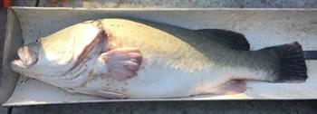

*A stressed Murray cod from a waterhole in the Darling River presents with red lesions on its body (early April 2018). Image NSW DPI Fisheries.*

In January 2018, over 1,000 km of the Barwon-Darling River downstream of Brewarrina ceased to flow. This happens from time to time. As a result, the water quality deteriorates in stagnant waterholes, and the instream life is put under significant stress.

Some rainfall in Queensland has been flowing into the Barwon-Darling throughout March 2018. A modest amount of water has partly replenished some of the drought refuge waterholes in the Barwon-Darling and some northern tributaries, but these flows have been not enough to complete the task or provide much connectivity between waterholes.

In response, between April and June 2018, Commonwealth and NSW water for the environment will be delivered to build on these natural inflows and provide for connectivity across multiple river systems to protect and support native fish.

Between 25 and 30 GL of environmental water will be used mainly from the Gwydir Valley and Border Rivers catchments.

Connecting the northern rivers will support at least five important native fish species, including threatened species such as silver perch and iconic Murray cod.

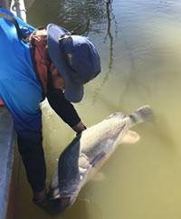

*Murray cod being released after monitoring. Image NSW DPI Fisheries*

It will help by providing better food sources and opportunities to disperse and either improve water quality in their stretch of the river or giving them the chance to find better habitat in neighbouring waterholes.

This flow event will help preserve these species for future generations of Australians.

It is a complex task to coordinate an environmental flow over 2,000 km of river, including the northern tributaries and the full length of the Barwon-Darling River to the Menindee Lakes.

NSW has provided significant support for this flow event including providing environmental water, technical advice, river information, and protecting the water so that it stays in the river channel to benefit the environment.

Extensive monitoring of flows, habitat condition, and fish response will be undertaken. The learnings will be shared with the community, and inform future use of water for the environment. This is an opportunity for the community to work with government to gain a better understanding of the river and the environment.

Communities in the north of the Basin from Goondiwindi and Moree to Bourke and onto Wilcannia can expect a healthier river as a result of flow events such as this.

As a result of the Basin Plan, we are able to help the river system to recover, bit by bit, through actions such as this.

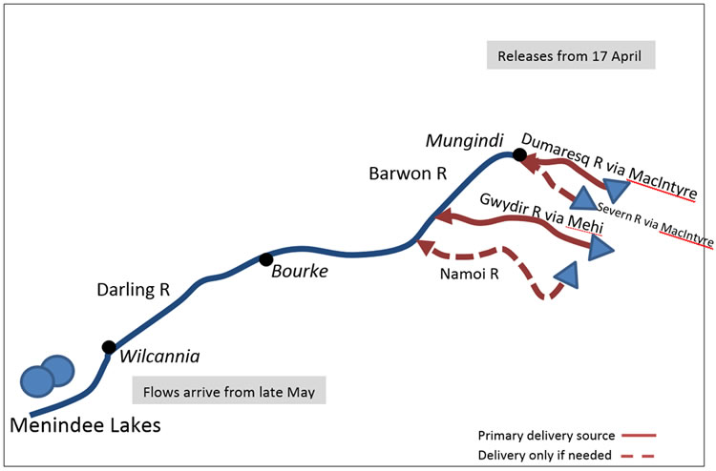

*This map shows the storages that water for the environment will be delivered from and when flows are expected to arrive at Wilcannia. Up to 23.8GL of Commonwealth environmental water and 7.2GL of NSW Government environmental water has been made available to connect the northern rivers.*

## For more information

Visit [www.environment.gov.au/water/cewo](http://www.environment.gov.au/water/cewo)  
Email [ewater@environment.gov.au](mailto:ewater@environment.gov.au)