# Northern connectivity event update 2

In mid-April, the release of water from dams commenced to support native fish in rivers of the northern Murray-Darling Basin. At present, this water is flowing down the Gwydir and Macintyre river systems towards the Barwon-Darling River. Monitoring of fish and habitat is underway. This important event will be shared with riverside communities.

## Event update

Between 17 April and 2 May 2018, the movement of the flow in the northern connectivity event is shown below.

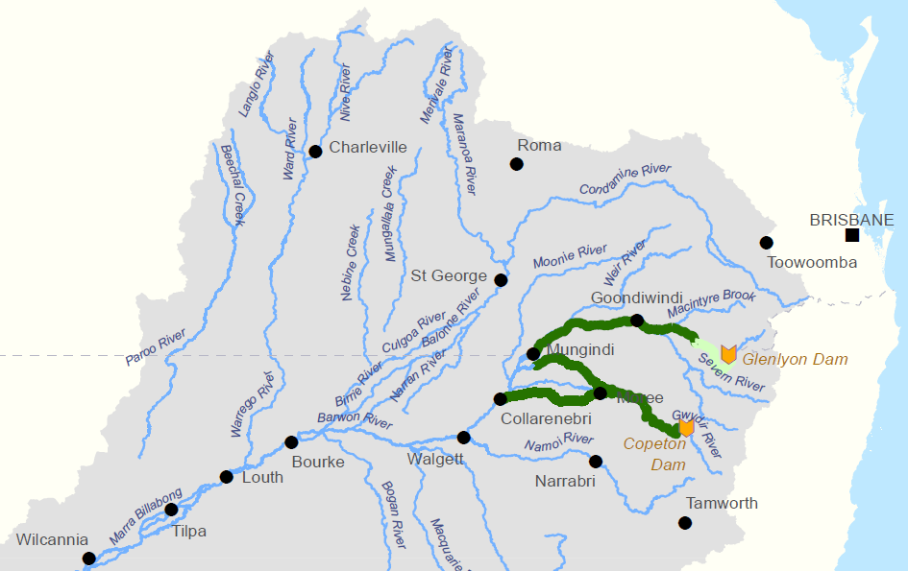

|  |  |
| --- | --- |
| cid:image002.png@01D3E300.64CB8140 |  |

1

Flows from the Mehi River in the Gwydir system are just reaching Collarenebri on the Barwon River. The river started flowing there again yesterday morning (3 May), and the flow is over 500 ML/day this morning (4 May). Flows from the Border Rivers will soon reach Mungindi.

The below shows how the water quality in Collarenebri weir pool improved over the last few days when the river re-started flowing. Flows will rise further in coming days.

#### Collarenebri Weir – flow improves water quality

|  |  |
| --- | --- |
|  |  |
| Before  1 May | After  4 May |

2

## Flows and satellite images – northern connectivity event

Satellite images of the Gwydir showing increased coverage of the river bed by flow are below.

This increased in-stream inundation would have washed some nutrients into the river, assisting with productivity and food sources for fish and other aquatic life.

|  |  |
| --- | --- |
| 18 April 2018  cid:image003.jpg@01D3E300.64CB8140 | The images to the left provide a comparison of a 2 km reach of the Gwydir River upstream of Pallamallawa.  Comparing the extent of the river channel inundated before the flow (18 April) and after the flow (25 April).  The flows just upstream of the reach (at Gravesend) and just downstream of the reach (at Pallamallawa) are shown below. This graph confirms that the flow arrived between when the satellite images were taken.  cid:image004.png@01D3E300.64CB8140 |
| cid:image005.jpg@01D3E300.64CB8140  25 April 2018 |

3

## Flows and satellite images – flow before the northern connectivity event

An unregulated flow originated from the Moonie and Culgoa rivers in February and March 2018. It was protected by NSW for water supply along the Barwon-Darling.

This unregulated flow event has re-filled some waterholes and reconnected some of the refuge pools. It now provides a great foundation for the northern connectivity event.

The satellite imagery below shows a section of the Darling River approximately 30 km upstream from Wilcannia (river channel length). There was little flow remaining there (see images below). The Wilcannia weir pool has started to gradually rise over the last few days.

The northern connectivity event is on its way, and is expected to reach the river bend below by late May, and Wilcannia weir soon after.

|  |  |
| --- | --- |
| 24 April 2018 | The satellite imagery to the left shows a section of the Darling River approximately 30 km upstream from Wilcannia (river channel length).  There is not much difference as the flow event has nearly stopped there. The area below the curve (which is the volume passing a point) is decreasing. The difference horizontally between peaks in the flow reflects travel time (longer than usual as waterholes have had to re-fill). |
| 28 April 2018 |
| 4 |  |

## Ecological monitoring

### Fish

NSW DPI Fisheries have been engaged to monitori fish condition before and after the event, and movement during the event.

|  |  |
| --- | --- |
| cid:image012.jpg@01D3E302.18231B30 | NSW DPI Fisheries electrofishing on the Darling River near Louth to capture fish for radio-tagging. |
| cid:image013.jpg@01D3E302.18231B30 | A golden perch following surgery with an acoustic tag.  This fish has been returned to the river, and may move between habitats when the northern connectivity event arrives. |

5

### Habitat

In addition to monitoring of fish condition and movement, monitoring of refuge habitat and water quality are also occurring, with teams from Eco Logical Australia currently out gathering ‘baseline’ data in the Darling River, ahead of the northern connectivity event arriving in coming weeks. This information collected before the flow will be used to assess the response to the forthcoming environmental water delivery.

In-stream bug sampling is also being undertaken to assess the level of food available for native fish – and it will be interesting to see how the bug community responds to environmental flows. Water quality sampling is also underway (see photo below).

The data collected will be used in analysis in coming months, and shared with the community.

|  |  |
| --- | --- |
|  | Eco Logical Australia deploying water quality data loggers on the Darling. |

6

## Media release

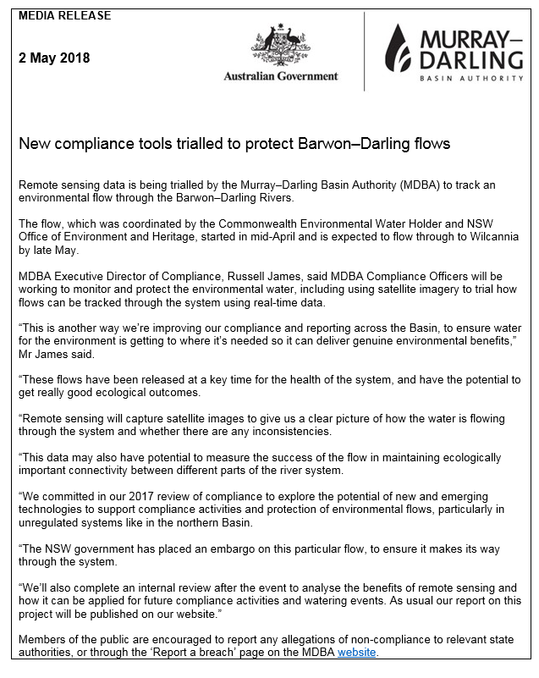

## Engagement events

Engagement activities to share information on northern rivers are being planned for Walgett (15 May), Collarenebri (16 May), and Mungindi (17 May). Activities in Brewarrina, Bourke, Wilcannia, Goondiwindi and Moree will also occur in coming weeks. NSW agencies will also share information on many of these occasions.

## Contacts

**Local Engagement Officers:**

**Neal Foster**  
 0437 141 495

**Jason Wilson**  
 0418 210 389

**CEWO media line**  
[media@environment.gov.au](mailto:media@environment.gov.au)   
 02 6275 9880

**CEWO**[ewater@environment.gov.au](mailto:ewater@environment.gov.au)

Sources of images

1 – The Department of the Environment and Energy

2 – Commonwealth Environmental Water Office

3 –The Murray-Darling Basin Authority, using raw Sentinel 2 satellite images, which have a resolution of 10m2 and cover the whole Basin every few days. The image is enhanced to highlight the presence of water.

4 – NSW OEH, using raw Planet Lab satellite images, which have a resolution of 3m2.

5 – NSW DPI Fisheries

6 – Eco Logical Australia