# Northern connectivity event update 3

In mid-April, the release of water from dams commenced to support native fish in rivers of the northern Murray-Darling Basin. At present, this water is flowing from the Gwydir and Macintyre river systems and along the Barwon-Darling River to Walgett. Monitoring of fish and habitat is underway. This important event will be shared with riverside communities.

### Allocated water

This is a key time to improve the health of the rivers and connect the rivers, making the most of recent flows in March and April through the Barwon­­–Darling system. The flows will improve water quality and support native fish species like the iconic Murray cod and silver perch—helping to build up their resilience for longer-term survival when the system becomes dry again.

The Commonwealth Environmental Water Holder has allocated up to 23.8 GL of Commonwealth environmental water for the northern rivers connectivity event. The NSW Office of Environment and Heritage has also committed up to 7.2 GL of NSW environmental water. The Murray–Darling Basin Authority is trialling remote sensing data to track an environmental flow through the Barwon–Darling Rivers.

### Results from the watering event

A map showing northern connectivity event flows is below.

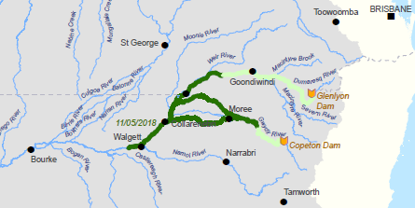

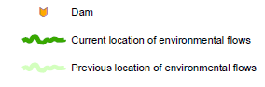[[1]](#endnote-1)

The northern connectivity event flows from the Border Rivers and the Gwydir system converged late last week at Collarenebri on the Barwon River, where the flow was over 1,200 ML/day. The flows reached Walgett on Tuesday, and is now passing over the weir at over 700 ML/day (below). The front of the flow is expected to reach Brewarrina during next week, and Bourke during the following week.

| Weir at Collarenebri, Barwon River, before and after the watering event | |
| --- | --- |
|  |  |
| Before: 7 May 2018 | After: 11 May 2018 |

[[2]](#endnote-2)

### Flows at downstream gauges [[3]](#endnote-3)

The flows at downstream gauges in the Macintyre (Mungindi) and Gwydir system (Mehi, Gil Gil) are shown below, with the resulting flow in the Barwon River at Collarenebri, and further downstream, at Dangar Bridge near Walgett. At this stage, around 18.3 GL of water from Commonwealth and NSW environmental water is being delivered from the Gwydir system, and around 4.3 GL of Commonwealth environmental water is being delivered from the Border Rivers (22.6 GL in total). Under current conditions, this is believed to be adequate to provide good connectivity.

|  |  |
| --- | --- |
|  |  |
| If the northern connectivity event was not underway, the flows in the Barwon River at Collarenebri and Walgett today would be zero or near zero. The flow at Brewarrina is around 20 ML/day at present. Satellite tracking The connection between northern rivers can be seen using satellites. The flow from the Mehi into the Barwon started on about 3 May. The water colour in the Barwon downstream of the junction with the Mehi was light brown before the Mehi water arrived (left image, on 28 April) and changed on the second image (right image, on 3 May) see the river beside the white asterisk. | |

| Connection between the Mehi and the Barwon rivers | |
| --- | --- |
|  |  |
| 28 April 2018 | 3 May 2018 |

[[4]](#endnote-4)

The flow provides a signal for native fish from the Barwon to migrate upstream into the Mehi River, as occurred when there was connection between the Barwon and the Macquarie rivers in autumn 2017 in the ‘Macquarie connection flow’, which used 27.6 GL of Commonwealth environmental water.

As the flow arrived, algal blooms in the Collarenebri weir pool were broken down. Using satellite technology, algal blooms (bright green on the top image) can be seen from space. When the flow arrived, the algal blooms were dispersed. On the ground photos looking downstream of Collarenebri Bridge are also below. The location of the bridge is indicated by the yellow asterisk.

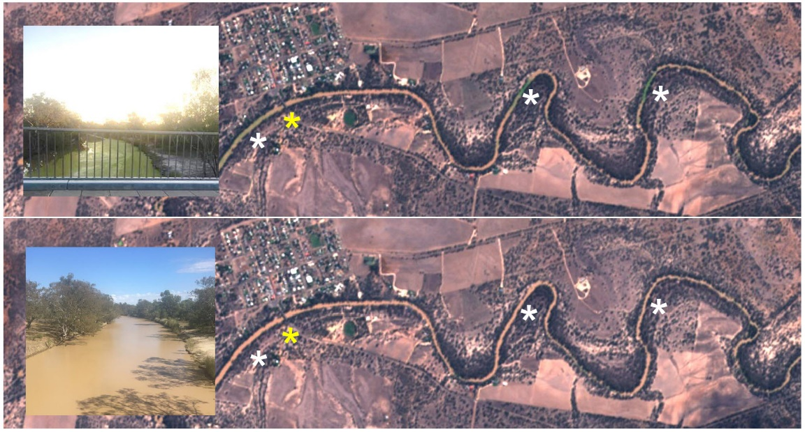[[5]](#endnote-5)

Further downstream, at Wilcannia, as a result of the flows protected for town water supplies that is preceding the northern connectivity event, the cease-to-flow event was broken this week. The flow peaked at about 40 ML/day. This was the first flow since late January. In the 46 years of flow record at Wilcannia gauge since 1972, the five longest cease-to-flow events have occurred in the last decade, including the event that just ended. Satellite imagery of before the flow (on 2 May) and following the start of the flow (on 7 May) are below – in-stream bars are inundated in the latter.

| Wilcannia, before and after the watering event | |
| --- | --- |
|  |  |
| 2 May 2018 | After: 7 May 2018  In-stream bars inundated following flow |

[[6]](#endnote-6)

## Ecological monitoring

The purpose of the northern connectivity event is to provide longitudinal connectivity and improved food sources, habitat, and opportunities to move and disperse for native fish. The Basin-wide environmental watering strategy and annual environmental watering priorities highlight the ecological importance of connectivity.

Flow and ecological monitoring of the northern connectivity event is underway. Habitat condition monitoring includes assessment of water quality, as well as sampling for microinvertebrates and macroinvertebrates.

### Bugs

Microinvertebrates are expected to be very responsive to increased flows and greater inundation of bank sediments where eggs can hatch. Some microinvertebrates, such as seed shrimps and rotifers (shown), are important food sources at the bottom of the food chain for macroinvertebrates, and small fish.

|  |  |
| --- | --- |
| 20180430_120325  7 | H:\Documents\Seed shrimp - Eco Logical.PNG |
|  |

### Fish

Fish sampling in late April / early May in the Dumaresq and Macintyre has shown many Murray cod recruits (that is, fish less than one year old), as well as some freshwater catfish recruits, and a number of olive perchlet. All of these species are listed as being of international, national or state conservation significance. (Freshwater catfish recruits have also been found in the Mehi in the last year, and specific flows were provided earlier in the year to assist that population). While the scientific data analysis is ongoing, initial thoughts are that the timing of the northern connectivity event will support the growth and survival of these recruits. It is particularly important that an adequate number of juvenile fish grow through to be adults, to help restore native fish populations over time.

|  |  |
| --- | --- |
|  |  |
| Murray cod - young of the year, and one year old, as well as golden perch recruits, ca[ptured and released as part of recent sampling 8 | Olive perchlet - a small rare species |

### Timing

Timing of the northern connectivity event has been carefully considered to reduce any risk of fish kills due to low oxygen. There is some risk that shallow flows in the heat of summer could potentially mix layered pools and inundate organic matter from hot, dry river beds, resulting in very low dissolved oxygen levels. This can be magnified by hot daytime temperatures.

To reduce this risk, the northern connectivity event was timed for the flows reached the Darling by late May and early June when the temperature was less. High temperatures in western NSW persisted throughout summer and have extended into autumn. April was relatively hot in the north-west (below). For the next week the maximum (air) temperatures at Bourke are forecast to be below 25oC for the first time in many months.

## Looking ahead

The CEWO will continue to provide updates on the Northern connectivity watering event. Check back in to find out about:

* movement of fish in the northern Basin and fishways
* tracking movement of golden perch on the Darling River near Tilpa
* events at Walgett, Collarenebri and Mungindi.

Visit the CEWO website for more information on other plans in place to protect and restore internationally and nationally significant places in the northern Basin. This includes Ramsar wetlands in the Gwydir and Macquarie catchments, and populations of rare fish in the Namoi and Border Rivers catchment.

## Engagement events

Come, learn and share about the environmental flow that is currently making its way through over 2,000km of some of the greatest rivers in the Murray–Darling Basin.

### Sharing information on northern rivers

* Walgett – 15 May
* Collarenebri – 16 May
* Mungindi – 17 May

### Bourke event

* **Where**: Bourke Wharf
* **When**: Thursday 31 May, 9am-12pm
* **Contact**: Neal Foster, 0437 141 495

Activities in Wilcannia, Goondiwindi and Moree will occur in the coming weeks.

## Contacts

**Local Engagement Officers:**

|  |  |
| --- | --- |
| **Neal Foster**  0437 141 495  **CEWO media line** [media@environment.gov.au](mailto:media@environment.gov.au)   02 6275 9880 | **Jason Wilson**  0418 210 389  **CEWO** [ewater@environment.gov.au](mailto:ewater@environment.gov.au) |

1. Source of images:

   Department of the Environment and Energy [↑](#endnote-ref-1)
2. Commonwealth Environmental Water Holder [↑](#endnote-ref-2)
3. Gauge data, plotted by MDBA [↑](#endnote-ref-3)
4. The images to above were provided by the Murray-Darling Basin Authority, using Sentinel 2 satellite images, which have a resolution of 10m2 and cover the whole Basin every few days. [↑](#endnote-ref-4)
5. The satellite images to above were provided by the Murray-Darling Basin Authority, using Sentinel 2 satellite images, which have a resolution of 10m2. Photo source: CEWO. [↑](#endnote-ref-5)
6. The above satellite images were provided by OEH, using raw Planet Lab satellite images, which have a resolution of 3m2.

   7 Eco Logical Australia

   8 NSW DPI Fisheries [↑](#endnote-ref-6)