**Northern connectivity event update 4**

The purpose of the northern connectivity event is to benefit native fish along rivers in the northern Murray-Darling Basin by improving longitudinal connectivity, and therefore providing improved food sources, and opportunities to move and disperse to better habitats.

The Commonwealth Environmental Water Holder has allocated up to 23.8 GL of Commonwealth environmental water for the northern rivers connectivity event. The NSW Office of Environment and Heritage has also committed up to 7.2 GL of NSW environmental water. The Murray–Darling Basin Authority is trialling remote sensing data to track an environmental flow through the Barwon–Darling Rivers. Flow is moving from A to B on the map below, between mid-April and late June.

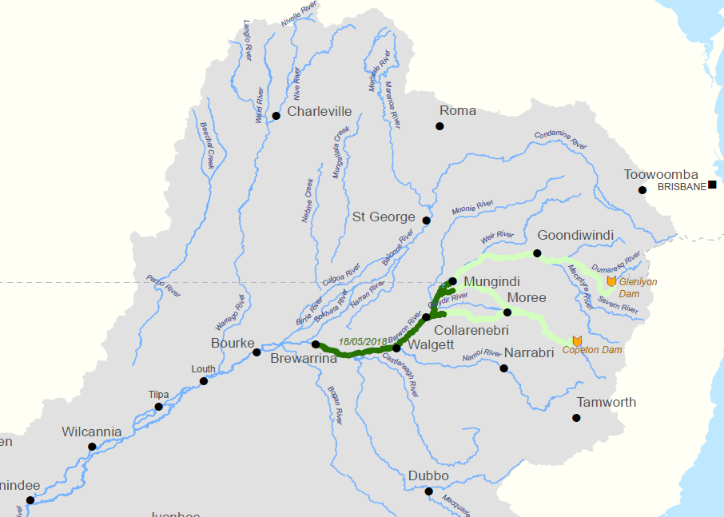1

B

A

## Progress of the flows

|  |  |
| --- | --- |
| The movement of the northern connectivity event over the last month is shown. Releases of Commonwealth and NSW environmental water from Glenlyon Dam and Copeton Dam commenced on 17 April, and have now ended.  Last week the flow peak in the Barwon River at Collarenebri and Walgett reached 1,200 ML/day.  The flow is just reaching Brewarrina. It will reach the historic port of Bourke on the Darling River in the coming week, and then onto Wilcannia via Louth and Tilpa by mid-late June (total journey - over 2,000 km of river).  Northern connectivity event flows are now receding in tributaries of the Barwon-Darling.    cid:image002.png@01D3E300.64CB8140 |  |
|  |
|  |
|  |

The northern channel in the Gwydir system shown on the preceding maps is the Carole - Gil Gil Creek system. Most of the northern connectivity event has passed through the Carole Creek, and flows are also starting to recede in the Gil Gil Creek, as the flows pass into the Barwon River.

| Receding flows in the Gwydir Catchment on 17 May | |
| --- | --- |
|  |  |
| Carole Creek at Wal Murray bridge  2 | Gil Gil Creek at Wemalah |

As the flow moves downstream, the peak will decrease due to seepage, evaporation, attenuation, and filling of waterholes when needed. Attenuation is when the flow gradually spreads along the river channel. Due to this spreading of the flow, some of the releases for the northern connectivity event will persist as very low flows for weeks after the main flow event has passed. Downstream of Brewarrina, waterholes have been filled to Wilcannia as a result of a recent flow that was protected by NSW for town water supplies.

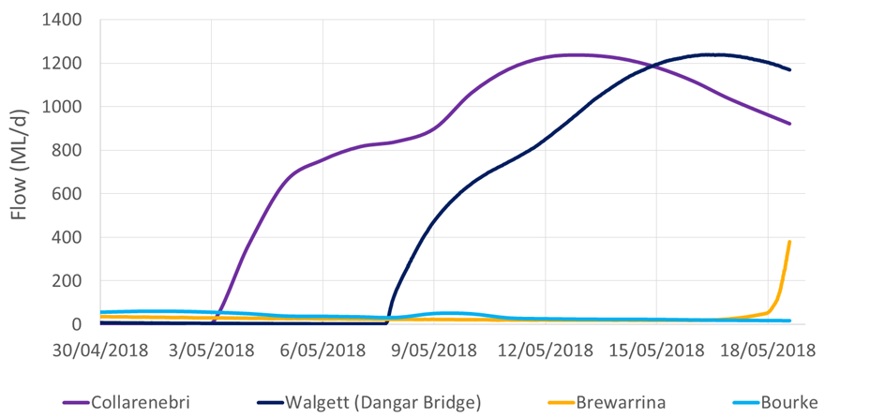3

**Downstream of Wilcannia, the cease-to-flow event persists**

The cease-to-flow event persists in the reach of the Darling River downstream of Wilcannia. The greater coverage of the river bed by water at Wilcannia shows that the recent flow protected for town water supplies did make it this far downstream. However, this flow has not reached much further downstream. The northern connectivity event, currently in the Barwon, will build on this unregulated event, and is expected to replenish the waterholes to the Menindee Lakes.

| The Darling River at Wilcannia | |
| --- | --- |
| Sentinel-2 image on 2018-05-04.jpg_Wilco  \*  \*  Wilcannia | Sentinel-2 image on 2018-05-09.jpg_Wilco  \*  \*  Wilcannia |
| 4 May | 9 May |

4

## Fish monitoring and health downstream of Wilcannia

The northern connectivity event includes fish monitoring and assessment of habitat condition. This will complement other monitoring projects that are underway: Commonwealth Long-Term Intervention monitoring in the Gwydir catchment and in the Warrego and Darling rivers near Toorale; fish monitoring and habitat assessment in the Border Rivers; as well as other state based monitoring activities across the northern Basin. Fish monitoring is a focus of this update.

In mid-April, NSW DPI Fisheries monitored fish at nine sites between Bourke and Menindee shown by the black squares below. Three sites were downstream of Wilcannia: Moorabin; Billilla and Viewmont Windmill. The latter was connected to the Menindee Lakes.

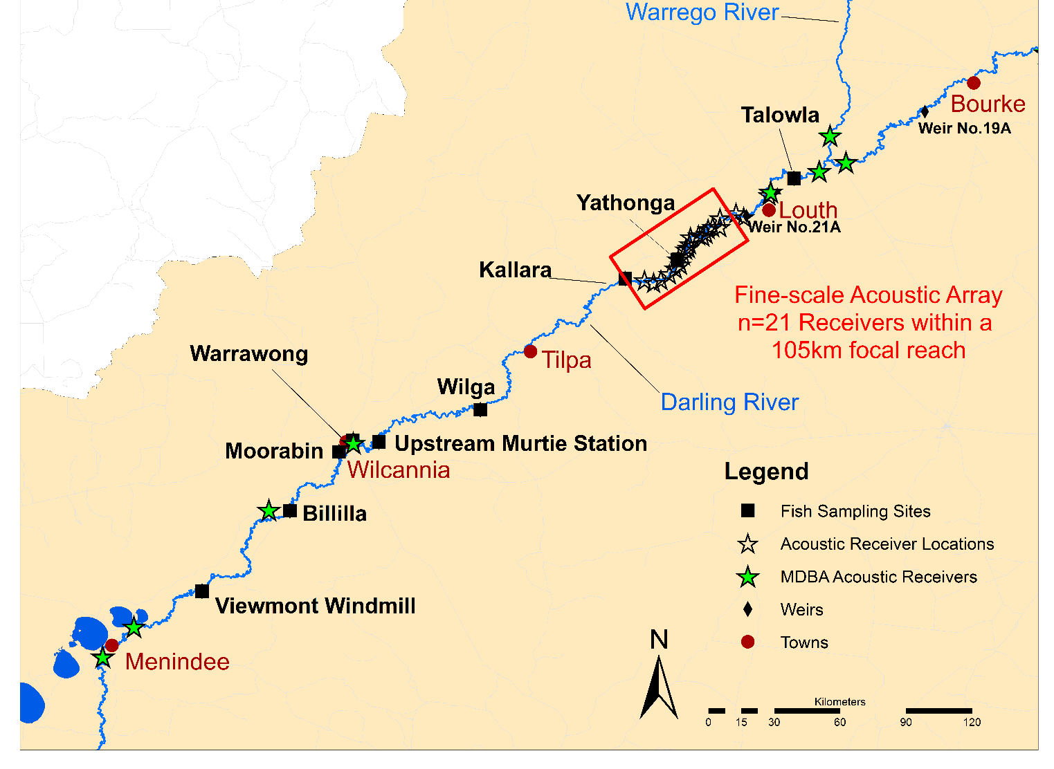5

The April fish monitoring involved electrofishing and bait traps to cover the whole fish community, including larger fish and smaller fish. As part of the April sampling, a fine-scale acoustic array was set up between Louth and Tilpa (shown above in the red box), and radio-tags surgically inserted into 48 golden perch. The acoustic tags have a battery life of up to three years so movement responses to future flow events can be tracked for years to come. Given recent stresses on these fish from the cease-to-flow event, they may be more inclined to disperse and seek new habitat despite the water temperature cooling off in recent weeks. The array and tagged fish will help detect fish movement responses during future fish monitoring. There will be further fish monitoring in the same nine sites after the northern connectivity flow event has moved through. The scientific analysis will be complete and released by the end of the year.

Preliminary results on fish condition have been kindly provided by NSW DPI Fisheries. The fish sampling to date suggests a high diversity of fish species at the nine sites, but low numbers, consistent with the Darling fish population being in moderate condition but having a good platform for recovery. There is potential to re-colonise other sections of the northern Basin, and management activities will be important.

The preliminary results also showed that fish were stressed where the river had ceased-to-flow. The proportion of fish with health conditions was highest at the two sites immediately downstream of Wilcannia (Moorabin and Billilla) where the river had ceased-to-flow for longest, and algae levels remain high. Around a third of the fish sampled at the Moorabin site had a health condition. The most commonly recorded health conditions were skin abnormalities with raised or discoloured scales, and the presence of parasites on fish such as anchor worm. These are signs of fish in stress, and more common in fish living in rivers that have ceased-to-flow conditions.

|  |  |  |
| --- | --- | --- |
|  |  |  |
| Fish monitoring at Moorabin on the Darling River: showing golden perch and Murray cod with health conditions. All of the native fish were safely released. 6 | | |

The healthy native fish captured in the sampling included several large Murray cod, an endangered silver perch, and a year old golden perch was caught at Billilla. The significance of the latter ‘cohort’ is discussed later in this update. These native fish were gently released, as was the Murray cod shown below. Introduced fish were also captured at the nine sites along the Darling including goldfish (below) and carp, but not returned to the river.

|  |  |
| --- | --- |
|  |  |
| G:\Environment\Environmental Water\CEWH\Photos\2018\Northern Connectivity Event - B-D\April  2018 DPI Fisheries - Fish Monitoring Pre-event\Billilia_100418_Golden Perch 150mm.JPG |

7

The flow in the northern connectivity event is on track and expected to pass Wilcannia from mid-June, persisting for at least a fortnight. This flow event will contribute to greater connectivity, and fish being healthier and living in healthier habitats. However, recovery of stressed native fish is expected to take some time, and multiple unregulated events with a range of flows.

## Fish movement through the northern Basin

The northern connectivity event is providing native fish with opportunities to move and disperse, including between waterholes in the Macintyre, Mehi, Gil Gil and Barwon, subject to any in-stream barriers such as weirs. The flow event is just reaching Brewarrina, which is particularly significant with respect to fish movement for two reasons – which will be explained after a little background on fish movement in the northern Basin.

Flows in the northern Basin are highly variable, with native fish adapted to be versatile and responsive to flow events. The movement responses of native fish to flows, and the triggers for this, vary between native fish species, with fish such as Murray cod moving 10s – 100s of kilometres, while fish like golden perch may move 100s – 1,000s of kilometres. In fact, the longest distance recorded for a native freshwater fish in the Basin is a remarkable golden perch that was tagged near Berri (South Australia) and re-captured at Mungindi (on the Queensland / NSW Border). This fish moved over 2,300 km at around 10 km/day during the high flow years of 1974 and 1975, when weirs along the river were overtopped or ‘drowned out’. About a sixth of the fish tagged and re-captured in that study had moved more than 500 km, including two other fish moved to tributaries of the Darling in Queensland. This suggests some native fish have a strong tendency to migrate and that the Barwon-Darling is an important north-south artery of native fish movement – like the Newell Highway for native fish!

One reason that native fish, particularly species such as golden perch and silver perch may migrate upstream is to counter the downstream drift of eggs and larvae to nursery habitats. This passive floating downstream may be over considerable distances, with upstream migration by fish later in life needed to replenish populations. For example, during the wet spring of 2016 that produced good flows in waterways of the northern Basin, there was a widespread spawning of golden perch in the Barwon River and tributaries. Many of the resulting larvae drifted as far downstream as the Menindee Lakes, with current thinking indicating that floodplain habitat such as these lakes and other smaller off-channel wetlands provide a valuable nursery habitat, where the juvenile fish can grow. From there, golden perch move and disperse when connecting flows allow: some may travel south to the River Murray; while others return north towards the Barwon-Darling and its tributaries. Some of the fish spawned in 2016, now around a year old, are currently in the Darling working their way upstream. One of these young golden perch was picked up in the monitoring at Billilla (shown previously).

Weirs serve important community functions, but impede fish movement along the Barwon-Darling, and are blockages in the main north-south artery for fish movement. Weirs can: interrupt upstream migrations to replenish populations (including in tributaries); reduce access to preferred habitat and food resources; and reduce genetic flow between fragmented fish communities. Weirs can also disrupt downstream movement including fish larvae drift through the creation of still water environments. This is particularly an issue for small short-lived native fish species whose populations can become fragmented, and can become locally extinct within a few years. Additionally, the concentration of fish downstream of weirs can make them vulnerable to fishing, including by birds. On the flip side, weirs enlarge waterholes and can enhance drought refuges for fish.

Fish ladders or ‘fishways’ were constructed decades ago on some weirs along the Darling and the Murray with the aim of supporting fish movements. The fishways were developed based on overseas designs for athletic leaping adult salmon. As most native species do not leap and cannot swim as fast as adult salmon, these fishways are largely ineffective in the Murray-Darling. An example of a largely ineffective fish ladder at Collarenebri Weir is shown below. Encouragingly, there have been major advances in the design of fishways for native fish in the last 25 years, and recently the ‘sea to Hume’ fishway program was completed along the River Murray using new effective designs, and a new fishway was constructed at Brewarrina.

|  |  |  |
| --- | --- | --- |
| Collarenebri Weir and fishway on 17 May, Note the steepness of the fishway, and the turbulence within. 1,000 ML/day. 8 |  |  |

## Two important fish related structures at Brewarrina

Brewarrina is a particularly significant location when thinking about the movement of native fish for two reasons: the ancient fish traps; and a new fishway.

The Brewarrina fish traps are of high cultural significance, particularly to the Ngemba people, who have used and maintained them for thousands of years and refer to the site as *Ngunnhu*. The traps are listed on national and NSW heritage lists. The fish traps reflect the understanding of the movement of fish by the Ngemba people. Fish moving upstream were herded into progressively smaller pens formed from river rocks. The fish were then trapped.

|  |  |
| --- | --- |
| G:\Environment\Environmental Water\CEWH\Photos\2017\20171124-28 - Barwon-Darling-NSloane\DSF_9331_Brewarrina_Fish_Traps_NSloane.JPG | G:\Environment\Environmental Water\CEWH\Photos\2018-19 Planning documents\Barwon-Darling\IMG_0212 - Barwon- Brewarrina Fishway CEWO.jpg |
| Brewarrina fish traps | Brewarrina fishway |

9

Of the 14 major weirs along the main stem of the Barwon-Darling system from the Macintyre junction to upstream of Menindee Lakes, only the Brewarrina Weir contains an effective fishway. The fishway provides fish with areas of low water speed to rest, so that they can then dart through faster flows to the next resting pool. Note that the flow is gentler and less turbulent than the fishway at Collarenebri (albeit it at a lower flow of 20 ML/day).

Some of these 14 major weirs along the Barwon-Darling drown out at lower flows than others providing for fish passage. For example, the Mungindi Weir drowns out at around 2,500 ML/day, the Walgett Weir drowns out at 14,000 ML/day, and the Bourke Weir drowns out at about 10,000 ML/day. The majority of these major weirs require flows generally greater than 7,500 ML/day to provide fish passage. The Collarenebri Weir drowns out at around 18,000 ML/day – and the northern connectivity event peaked at just over 1,200 ML/day at Collarenebri, illustrating that drowning out weirs to provide fish passage using held environmental water without fishways is not practical. Other solutions are needed. Using improved and effective designs, fish passage could be restored at the 14 major weirs on the Barwon-Darling, providing significant connectivity to nearly 4,000 km of waterway and creating a vital pathway between the northern and southern Basin, linking up local, regional and perhaps Basin-wide fish populations.

With our colleagues from NSW, we at the CEWO are looking forward to sharing the results of the fish monitoring with communities.

## Engagement events

There have been three engagement events this week: at Walgett, Collarenebri and Mungindi. Students from Collarenebri Central School attended. NSW has been well represented at these engagement events.

|  |  |
| --- | --- |
| For example, Grant Barnes from the new NSW Natural Resource Access Regulator attended the Walgett engagement event. Shown in the photograph to the right are Grant (centre) with Mark Taylor (CEWO - right), and Rory Treweeke from the MDBA’s Basin Consultative Committee (left). NRAR has had field officers along the Barwon during this flow event. | 10 |

## Looking ahead

|  |  |
| --- | --- |
| An important upcoming community event to share the event is at Bourke on 31 May. There will be attendees from local, NSW and Commonwealth government bodies, as well as representatives of community groups and local schools. | Bourke Poster |

## Contacts

**Local Engagement Officers:**

**Neal Foster**  
 0437 141 495

**Jason Wilson**  
 0418 210 389

**CEWO media line**  
[media@environment.gov.au](mailto:media@environment.gov.au)   
 02 6275 9880

**CEWO**[ewater@environment.gov.au](mailto:ewater@environment.gov.au)

Source of images:

1 – Department of the Environment and Energy. 2, 8, 9,10 – Commonwealth Environmental Water Office. 3 – Murray-Darling Basin Authority, using gauged data. 4- Murray-Darling Basin Authority, using data from Sentinel satellites. 5,6,7 – NSW Department of Primary industries, Fisheries.