# Northern connectivity event update 5

Release of water from dams to support native fish in rivers of the northern Murray-Darling Basin started in mid-April. This water has now flowed from the Gwydir and Macintyre rivers into the Barwon-Darling, and is now between Collarenebri and Bourke. Monitoring of fish and habitat is underway. The watering event is being shared with riverside communities.

## Event update

The flow from the northern connectivity event reached 1,000 ML/day in the Barwon River at Brewarrina on 22 May, and remains at about that level. This is the first time in over a year that flow of around 1,000 ML/day has persisted for more than a day there. The current flow at Brewarrina Weir is shown below – note the inundation of in-channel vegetation downstream of the weir, which is providing organic material and habitat, and the rock ramp fishway on the bottom right of the image, which allows fish to move past the weir and disperse upstream and downstream. 1

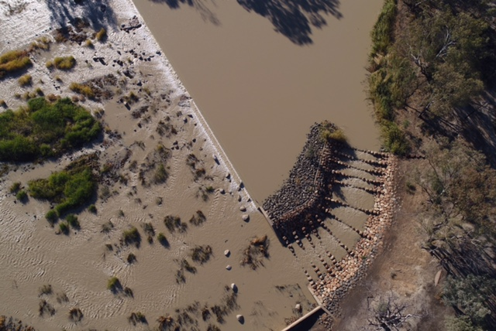1

Flow

Recent images from around Brewarrina and the weir are shown below. The weir is indicated by a white asterisk on the satellite images. There was a significant change in water colour as the connectivity flow arrived, as a result of river bed inundation and the capture of sediment and organic material into the flow, to fuel productivity.

|  |  |  |
| --- | --- | --- |
| \* | Brewarrina (from satellite)  ←16 May, before  21 May, after→ | \* |
| G:\Environment\Environmental Water\CEWH\Photos\2018-19 Planning documents\Barwon-Darling\IMG_0212 - Barwon- Brewarrina Fishway CEWO.jpg | Brewarrina fishway  ← 8 May – before, 20 ML/day  23 May – after, 1,000 ML/day→ |  |

2,3

Interestingly, the depth of flow in the Brewarrina fishway (above) has changed little as the flow increased. The fishway would function well at either flow, as well as at higher flows.

Snapshots of the flows from earlier in the week (23 May) and today (25 May) are below. The flows upstream in the northern rivers were low (for example, less than 30 ML/day at Mungindi; 60 ML/day or less at Pallamallawa on the Gwydir). The flows downstream in the Darling River at Bourke were very low on Wednesday (14 ML/day), and now have increased to over 500 ML/day, and are expected to rise further in coming days. It is easy to identify the location of the flow in the northern connectivity event as it moves along the system.

\*

|  |  |
| --- | --- |
| Flows on 23 May – low flow at Bourke | Flows on 25 May – Bourke flow rising |
|  | \* |

4

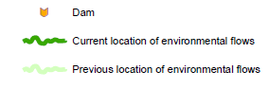The movement of the northern connectivity event since 17 April is shown below.

|  |
| --- |
| 17 April  17 April |
| 28 April |
| 2 May |
| 18 May  11 May |
|  |
| 25 May |

5

The flow event has benefited over 1,000 km of river channel habitat so far, supporting native fish. Currently, there are higher flows in the river channel between Collarenebri to Bourke, a river distance of about 500 km.

The flows from 30 April until now at downstream gauges of the Macintyre (Mungindi) and Gwydir system (Mehi, Gil Gil) and in the Barwon are shown below. The flow event has passed from the Macintyre and Mehi systems into the Barwon River, and much of it will flow past the Culgoa junction and into the Darling River over the next fortnight.

|  |  |
| --- | --- |
| cid:image004.png@01D3F40D.4BC9E0B0 |  |

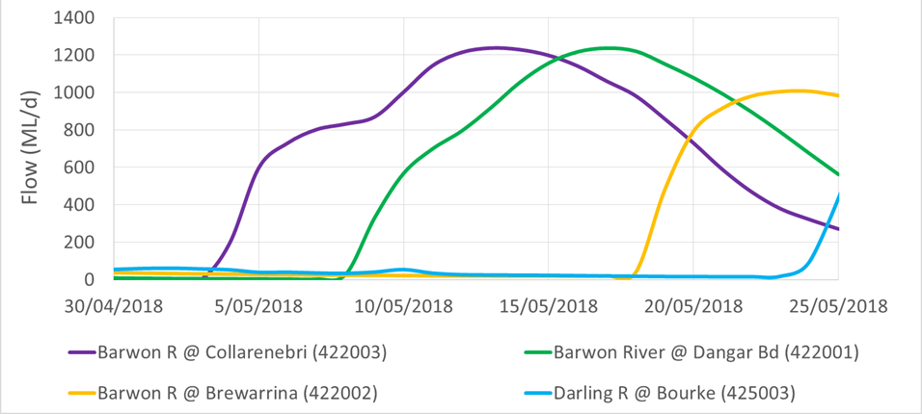6

Flows have started increasing at Bourke from mid-week, had reached 532 ML/day earlier this morning and 615 ML/day by this afternoon. Higher flows are expected in coming days.

|  |  |  |
| --- | --- | --- |
| C:\Users\A21906\AppData\Local\Microsoft\Windows\Temporary Internet Files\Content.Word\DSCF2199.jpg | Bourke Weir  ← 23 May, before  25 May, flow increasing → |  |

7

## Ecological monitoring

### Fish

Further fish monitoring results from the northern connectivity event have been kindly provided by NSW DPI Fisheries, and are shared below.

The most common native fish species found in the April survey was bony bream.  Bony bream and spangled perch have been consistently the most abundant species (based on catch effort) during past fish surveys of the northern Basin over the last decade. Carp gudgeon, a small native fish species, were the most abundant species sampled at the Viewmont Windmill site (which was connected to the Menindee Lakes). Carp, an introduced species, had the largest biomass by far, except at the Billilla site, where several large native Murray cod were sampled.

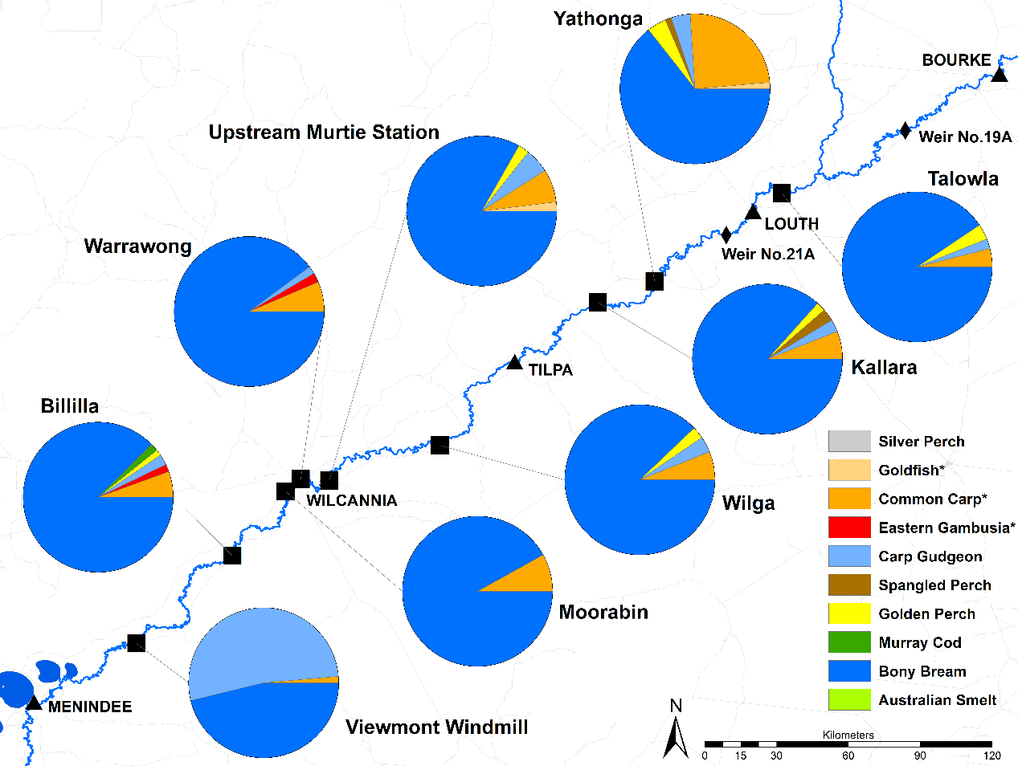8

Abundance of fish

Photographed below are two bony bream sampled at Wilga between Tilpa and Wilcannia, showing different age classes.

Bony bream are a fragile species and relatively vulnerable to low water temperatures, which can make the species more susceptible to parasites and fungi. Bony bream are also vulnerable to when rivers stop flowing, with fish kills being observed in northern rivers in the past. However, populations of bony bream can bounce back quickly, as individuals have been known to produce over 800,000 eggs.

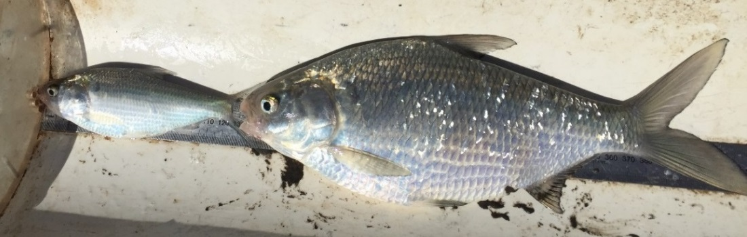Bony bream, 9

Across northern Australia (including the Gulf country), spangled perch, shown below, are the most abundant fish. Young of the year spangled perch and bony bream were sampled last week in Gil Gil Creek (Gwydir valley) as part of NSW Basin Plan Environmental Objective Monitoring. Northern connectivity flows that moved through the system recently would be helping these young fish to survive in the connected tributary.

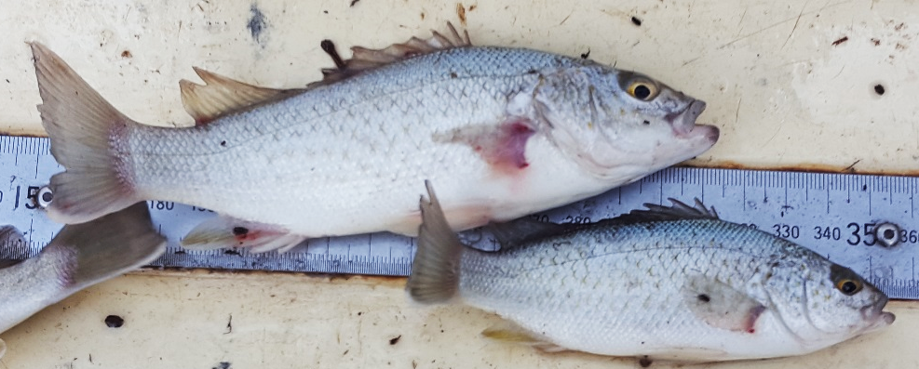Spangled perch, 10

Whilst bony bream and spangled perch are perhaps little known and seldom sought or caught by anglers these days, they are very important for anglers (as well as to the ecosystem generally). They are important food sources for the aquatic apex predators of the northern Basin: Murray cod and golden perch. This is shown on the food web for the north that follows later in this update.

Spangled perch and bony bream are examples of species benefiting from the northern connectivity event.

In short, the purpose of the northern connectivity event is to support native fish by providing longitudinal connectivity. A life cycle of native fish is shown below. As indicated by red asterisks, flows as part of the northern connectivity event are assisting with: improving water quality; improving food supplies; assisting fish to access better habitat (and possibly to disperse and re-colonise), and improving survival prospects. This would apply to the young of the year (juvenile) bony bream and spangled perch sampled in the Gil Gil Creek last week.

For adult fish, the flows and associated improved food would assist in improving fish condition and therefore their ‘pre-spawning fitness’, should suitable spawning conditions occur in the coming spring and summer.

11

\*

\*

\*

\*

## Food web of northern rivers

A food web for native species in the northern rivers in the Murray-Darling Basin is shown below.

The northern connectivity event includes sampling of: nutrients, organic matter; microinvertebrates (requiring a microscope to observe); macroinvertebrates; and fish of all sizes.

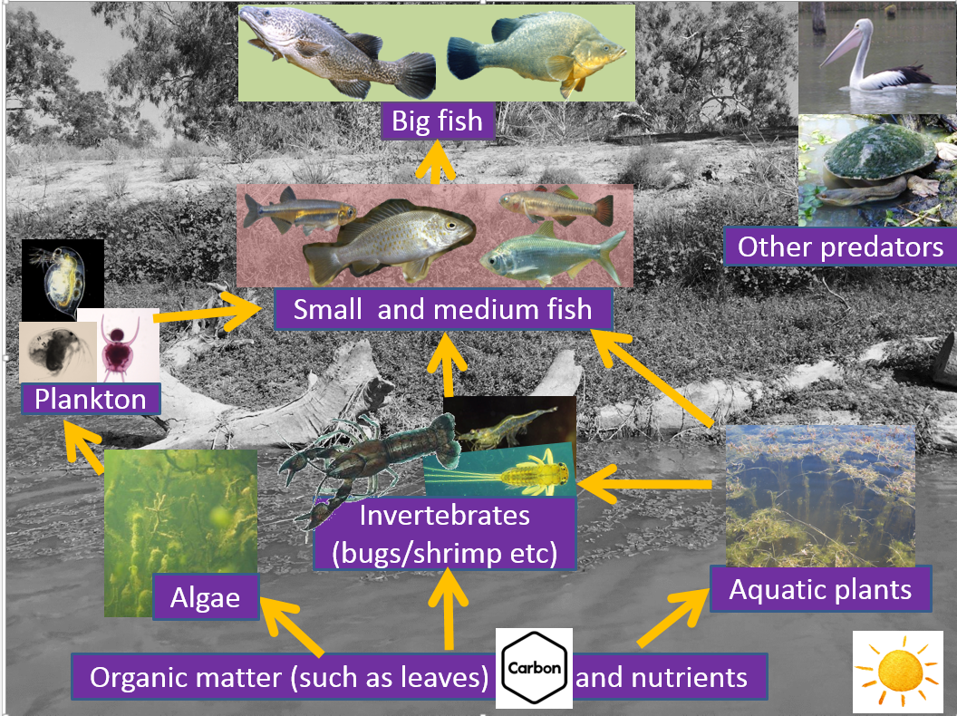12

Referring back to the fish abundance data from the April survey, and thinking about the above food web, an interesting finding emerges. Bony bream were the most abundant species, and are in the middle of the food-web. Generally smaller species in a food web would be expected to be present in greater numbers than larger species. However, many of the smaller native fish species in the northern Basin such as carp gudgeon and Australian smelt have been recorded in relatively low numbers, or in the case of Darling River hardyhead, olive perchlet and purple spotted gudgeon, are very rare and have conservation listings.

Some possible reasons for this low abundance of small species may include the relatively short lifespan these species have and vulnerability to extreme conditions in the river system, which means they need regular spawning and recruitment for a sustainable population; some of the threatened species spend parts of their lives on floodplains or in wetlands along northern rivers that now receive water less often than in the past; the preferred habitat of aquatic plants has been impacted in most systems, and; they may be heavily impacted by carp through predation, competition, and impacts on habitat. There are multiple factors that can affect populations, including flows as well as in-stream barriers, discussed in the update 4 on this flow event.

## Engagement events

Engagement is an important part of the northern connectivity event. Last week, there were engagement events at Walgett, Collarenebri, and Mungindi. In total, there were around 60 attendees including about 30 adults and about 30 schoolchildren, many from local Aboriginal communities along the Barwon River. They were interested in the flow event, what environmental water managers ‘do’, carp, and how the water in the river is shared. Commonwealth and NSW agency representatives enjoyed sharing information with them.

|  |  |  |
| --- | --- | --- |
| Yesterday, there was a community event at Brewarrina. There were around 25-30 community attendees. This was a great opportunity for  Brewarrina Shire Mayor Phil O’Connor and CEWO Local Engagement Officer Neal Foster (right) to catch up and discuss the environmental and social benefits of the northern connectivity event. Those who attended the information session commented that they considered the northern connectivity event as a wonderful use of environmental water for the Barwon-Darling and marvelled that the water had travelled so far from it source at Copeton and Glenlyon dams. Environmental needs in multiple catchments are considered when deciding on watering actions. | 13 | |
| Bourke Poster | | We are looking forward to the engagement event that will be held in Bourke in the coming week. Feedback from this will be provided in the next update. |

## Looking ahead

Flows: expected to arrive in Wilcannia in around mid-June.

Engagement events: Bourke – Bourke Wharf, Thursday 31 May, from 9 am. Wilcannia, Moree and Goondiwindi - timing to be advised.

Habitat condition assessment: June and July / August.

Fish monitoring: August/September sampling, including download of movement data.

Final evaluation: December.

## Contacts

**Local Engagement Officers:**

|  |  |
| --- | --- |
| **Neal Foster**  [neal.foster@environment.gov.au](mailto:neal.foster@environment.gov.au)   0437 141 495 | **Jason Wilson**  [jason.wilson@environment.gov.au](mailto:jason.wilson@environment.gov.au)   0418 210 389 |
| Neal assisting NSW DPI Fisheries to stock silver perch in the Namoi River, for conservation purposes | cid:1626559451c33ee02211  Jason discussing opportunities for sharing information on river health with Aaron Hinch at Collarenebri Central School |

14,15

|  |  |
| --- | --- |
| **CEWO media line** [media@environment.gov.au](mailto:media@environment.gov.au)   02 6275 9880 | **CEWO** [ewater@environment.gov.au](mailto:ewater@environment.gov.au) |

## Acknowledgements

Thank you to those who shared the previous updates on the northern connectivity event: including those from the environmental, floodplain, irrigation, and local government sectors.

Thank you also to the NSW and Commonwealth agencies that have worked together with us at the CEWO to help make this flow event happen, and contributed information for this report. This includes the NSW Office of Environment and Heritage (who manage NSW environmental water and provided up to 7.2 GL for this watering event); the NSW Department of Primary Industries, Fisheries; the NSW Department of Industry, Water, WaterNSW; the Murray-Darling Basin Authority; the NSW Natural Resource Access Regulator; and the Queensland Department of Natural Resources, Mines and Energy. Thank you also to local councils in the area for support, particularly Bourke Shire Council and Brewarrina Shire Council.

Source of images:

1 – Drone image kindly provided by Paul Harmon

2 - The images were provided by the Murray-Darling Basin Authority, using Sentinel 2 satellite images, which have a resolution of 10m2 and cover the whole Basin every few days.

3 – Commonwealth Environmental Water Office

4 – NSW Department of Primary Industries, <http://realtimedata.water.nsw.gov.au/water.stm>

5 - Department of the Environment and Energy

6 - Gauge data, plotted by the MDBA

7 – Bourke Shire Council

8 to10 - NSW Department of Primary Industries, Fisheries

11 - MDBA, 2014 courtesy of Arthur Rylah Institute.

12 – Developed in conjunction with NSW Department of Primary Industries, Fisheries

13 to 15 – Commonwealth Environmental Water Office