# Northern connectivity event update 6

A release of water from dams in the northern Murray-Darling Basin started in mid-April. On 1 June, the flow is in the Barwon-Darling River between Walgett and Tilpa, with the flow peak at Louth. The purpose of the northern connectivity event is to support native fish and aquatic life in the Border Rivers, Gwydir and Barwon-Darling systems. The relationship between communities and the mid-Darling River is a focus of this update. In the last week, there was a community celebration of the flow event alongside the historic wharf at Bourke.

## Engagement events

Sharing the northern connectivity event with the community is very important. In mid-May there were engagement events at Walgett, Collarenebri, Mungindi and Brewarrina. In total, around 85 - 90 community members attended.

In the past week, the focus of engagement activities was Bourke. These activities were to share information with the local Councils, school children, interested townspeople, irrigators, and some relaxed tourists. A community function was held at Bourke on Thursday. Following a gracious welcome to country, Bourke Mayor Barry Holman spoke1.

|  |  |
| --- | --- |
|  |  |

Councillor Hollman described the northern connectivity event as “*an excellent example of intergovernmental collaboration and cooperation which has resulted in significant environmental, economic and social benefits for all those along the river system and Bourke Shire Council is very pleased to provide support to such a beneficial initiative”*. Councillor Hollman also acknowledged the support of the New South Wales Minister for Regional Water and Primary Industry the Honourable Niall Blair MP.

The Commonwealth Environmental Water Holder, Jody Swirepik, spoke of the environmental significance of the flow event, the importance of collaboration in making the event happen, and the pleasure of sharing the flow event with the community. Peter Christie, from the Office of Environment and Heritage, acknowledged the support for the event ‘up river’, including in the Gwydir catchment, and of the benefits for the riverine system broadly including water rats and turtles. Graeme White, from the NSW Natural Resource Access Regulator, spoke of the welcome that field compliance officers were receiving from irrigators, and progress being made towards having more ‘boots on the ground’ in compliance activities. Sam Davis from NSW Department of Primary Industries Fisheries shared interesting information on some life cycles of native fish in the Darling, and the fish monitoring that has been done and will be ongoing as part of the northern connectivity event. Officers from WaterNSW and the MDBA, who are assisting with managing and tracking the event, were also in Bourke to talk with the community, Councils and other agencies.

|  |  |
| --- | --- |
|  |  |
| Peter Christie (NSW Office of Environment and Heritage) and Mark Taylor (CEWO) 2 | Historic Bourke wharf with visitors 3 |

50-60 people from the regional community participated in the events at Bourke. Thank you to those from our partner organisations who supported the event, and to those who attended and shared their thoughts. There was strong support for the northern connectivity event, and interest in its scale (watering over 2,000 km of river habitat, flows taking more than two months to move along the system to the Menindee Lakes).

## Flows

More than six weeks have passed since the first releases of water were made in the northern connectivity event. These releases were made from Glenlyon and Copeton dams, in the Border Rivers and Gwydir catchments respectively. The flow is now in the Barwon-Darling River between Walgett and Tilpa. The front of the northern connectivity event reached Louth on the Darling River last Monday, and is now peaking there at around 800 ML/day. The front of the flow will reach Tilpa early in the coming week, and many in Wilcannia are awaiting its arrival in the week after.

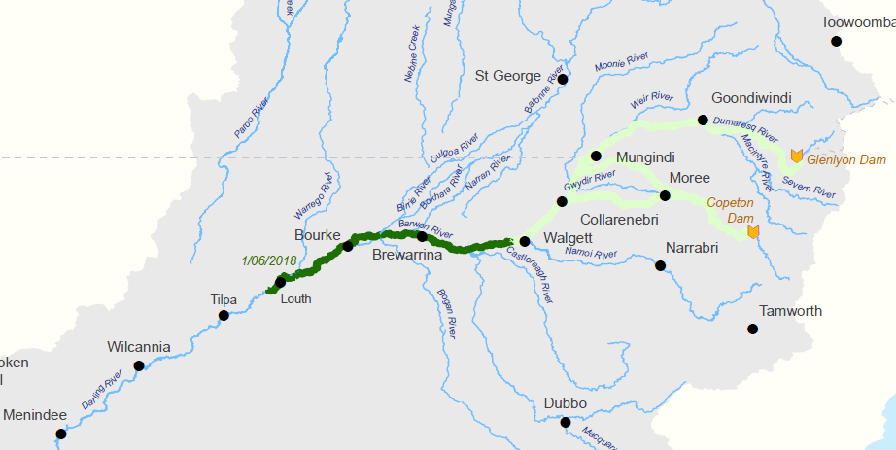4

17 April

17 April

11 May

1 June

The flow at Bourke peaked at nearly 900 ML/day, and remains at over 700 ML/day.

|  |  |
| --- | --- |
| The Bourke Weir on 23 May, before the flow arrived ↓  C:\Users\A21906\AppData\Local\Microsoft\Windows\Temporary Internet Files\Content.Word\DSCF2199.jpg    ↑ The Bourke Weir on 25 May, after the flow arrived.  5,6 |  |
| ↑ Grant Barnes (the Chief Executive Officer of the Natural Resources Access Regulator) and Jody Swirepik (the Commonwealth Environmental Water Holder) at Bourke Weir on 29 May. |

Further upstream of the main flow, a month after the flows arrived at Collarenebri and peaked at 1,200 ML/day, the flow is now 80 ML/day and receding gradually (red line below). The flow in the Barwon River at Collarenebri during this month is entirely due to the northern connectivity event. The below shows the movement of the flow through the system – the peak is holding up well given the distances involved (nearly 1,000 river km from Collarenebri to Louth).

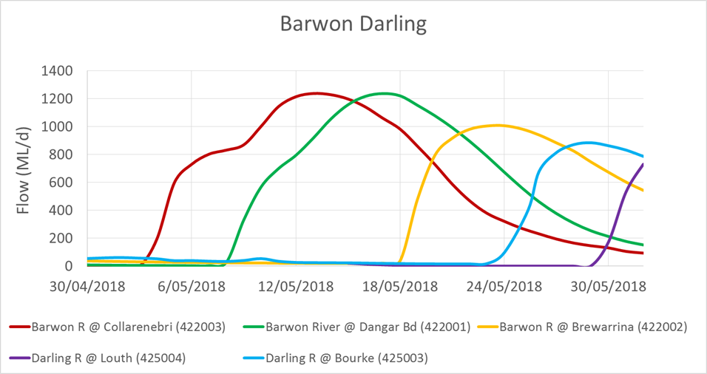7

Looking ahead of the flow event, the current flow (on 1 June) at Tilpa is 2 ML/day, and at Wilcannia is 7 ML/day. Communities along the mid-Darling are keeping a keen eye on the flow, and are looking forward to flow along this very stressed part of the Darling in the near future. In particular, there is a stretch of river between Wilcannia and the Menindee Lakes where there has not been a flow since mid-January, and an amber blue-green algae alert remains there.

## Current social aspects, with links to the Darling

As background to the northern connectivity event, the Barwon-Darling River from Brewarrina to the Menindee Lakes ceased to flow in January 2018. Red and amber alerts for blue-green algae occurred along much of the Barwon-Darling, restricting the use and enjoyment of the river for recreation, and increasing water treatment needed. Several locals spoke about how flows in the river are reflected in the mood of riverside communities at engagement events held in recent weeks. For example, an Aboriginal Client Service Specialist, working in the Local Courts system in Wilcannia has observed: “*When the [Darling] river is down, the crime rate is high. Most families spend weekends on the river – fishing, swimming and on boats. When there is no water in the river, they’re stuck in town, there is nowhere to go. And the river was absolutely full, kids were swimming in the river, people were fishing, the spirit was just really high”.8* The Darling at Wilcannia has been in a ‘cease to flow’ state for about four years out of the last twenty.

In February 2018, four Shire Councils along the Darling (based in Walgett, Brewarrina, Bourke and Wilcannia) issued a press release in February that said “*All councils agree that with the cessation of flow in most of the Barwon-Darling the situation is quite dire and with the hot weather forecast to continue in the short term there is every likelihood there will be an increased instance of blue-green algae detected”.*

In April 2018, after considering the environmental merits, the Commonwealth Environmental Water Holder, Jody Swirepik and NSW Office of Environment and Heritage agreed to provide water for the environment. When announcing the northern connectivity event, Jody said “*Water for the environment is needed to maintain connection of northern rivers and the Barwon-Darling. Although our purpose is to improve river health, we do hope it will also relieve some of the pressure the community has been feeling.*” The Shire Councils welcomed these environmental flows. The arrival of the flow event and cooler temperatures has resulted in a decline of algal levels along much of the river, and a more positive mood in riverside communities.

|  |  |
| --- | --- |
|  | The flows improved fishing opportunities along the river. This golden perch (yellowbelly) was caught when the flow event was passing through Walgett on the Barwon River, which broke a cease to flow event there.  9 |

## Some Darling River history: people and fish

The Darling River is historic and iconic. 183 years ago to the day, Thomas Mitchell wrote the following about fish in the Darling in his journal (on 1st June 1835):

|  |
| --- |
| *The water being beautifully transparent, the bottom was visible at great depths, showing large fishes in shoals, floating like birds in mid-air*. 10 |

That’s one of the earliest written accounts of fish in the Barwon-Darling. Of course, Aboriginal communities lived along the Darling for tens of thousands of years before Mitchell’s exploration. Appropriately, in this Reconciliation Week, respects were paid to Aboriginal elders, past, present and emerging at the riverside celebration of the northern connectivity event in Bourke on Thursday. The *Kurnu-Baakandji* *(*people of the river) lived along the riverbanks of the *Baaka* (Darling) and hunted fish that they knew as *kunball* (golden perch), *barntu* (Murray cod), and *nhaamba* (bony bream), as well as other prey such as *kungkulu* (yabbies) and turtles.

The relationship between the *Kurnu-Baakandji,* the *Baaka* and its fish is described in an interpretative display along the Darling at Toorale National Park, from which the below quote is drawn11.

|  |
| --- |
| *Kurnu-Baakandji people have deep connection to the Darling River, which they call Baaka. Its waters provided an abundant source of food. Many different fishing techniques and tools were used depending on the conditions of the Darling. Spears and a variety of fibre nets, traps and wooden structures were used extensively for fishing. Nets were also used to ensnare wildfowl and yabbies.*  *Stone walled fisheries were created to catch larger numbers of migrating fish. These were built by hand in the bed of the river using closely packed rocks to trap fish as the water level changed. Fish would swim into the stone constructions, only to be captured as the waters subsided, or caught in traps with nets or spears. The traps were utilised daily by local people and when there was a substantial rise in the river, plentiful numbers of fish would be trapped. Most of these fish traps were completely or partially destroyed to allow the passage of paddle steamers plying the river from the 1800s.* |

River transport is also an important part of the more recent heritage of the Darling. The photo below was taken at Hells Gate, near the Toorale National Park, between Bourke and Louth on Wednesday near the peak of the northern connectivity event there (around 800 ML/day). Hells Gate (pictured below) was a site where the Baakandjicaught fish but was later blasted to improve the safety of river transport.

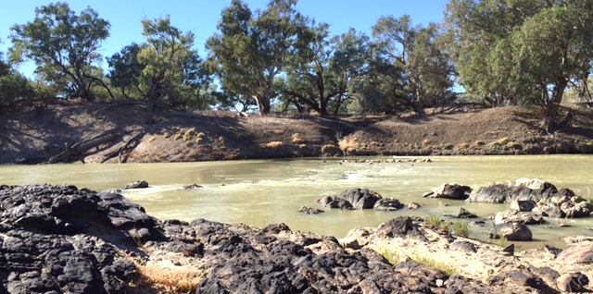12

Trips by paddle steamers along the Darling were often treacherous, as the channel was full of obstructions such as snags and rock bars. De-snagging of the Darling River was seen as the single most important task to river navigation13, and was undertaken along much of the Darling. De-snagging however reduced habitat for the river ecosystem, and for species such as Murray cod, which are renowned for having a home snag. A few sunken paddle steamers and barges provide some fish habitat these days, and there has been work done by NSW agencies and local recreational fishing groups to re-snag sections of the river.

Another reason that the Darling was challenging for river transport was the variability of flows. The Darling has one of the most variable flow regimes in the world. The variability of flows in the Darling was captured by Henry Lawson in 'The Song of the Darling River' (provided in the attachment to this update). Lawson used phrases like ‘*watering the barren land 10 leagues wide'*, and wanting *'no blistering barge aground’14*. This variability in flows provided difficulties for river traffic. In dry times, some paddle steamers became stranded in the channel of the Darling River. In flood times, sections of some bridges (including the North Bourke Bridge) could be raised to allow paddle steamers to pass, but some paddle steamers became stranded on the floodplain if they tried to cut off bends and take a short cut.

|  |  |
| --- | --- |
|  | To allow paddle steamers to pass during periods of higher flows, the North Bourke Bridge has a middle span that could be lifted by a system of pulleys. 15 |

Further Darling River history is provided in an attachment to this update.

Whilst the era of river transport along the Darling has passed, the paddle steamer Jandra provides a great way for current generations to experience the river and some of its rich history, during hour long cruises on the Bourke Weir pool.

|  |  |
| --- | --- |
|  |  |

16, 17

## The northern connectivity event: looking ahead

Next update: around 15 June 2018.

Flows: expected to arrive in Wilcannia in around mid-June.

Upcoming engagement events: Wilcannia (in conjunction with the Central Darling Shire), Moree and Goondiwindi - timing to be advised.

Habitat condition assessment: June and July / August.

Fish monitoring: August/September sampling, including download of movement data.

Final evaluation: December.

## Acknowledgements

A particular thank you to Bourke Shire Council for hosting activities this week. Also to those community and agency representatives who attended and participated at the function in Bourke.

## Contacts

**Local Engagement Officers:**

|  |  |
| --- | --- |
| **Neal Foster**  [neal.foster@environment.gov.au](mailto:neal.foster@environment.gov.au)   0437 141 495 | 18 |
| **Jason Wilson**  [jason.wilson@environment.gov.au](mailto:jason.wilson@environment.gov.au)   0418 210 389 |
| **CEWO media line** [media@environment.gov.au](mailto:media@environment.gov.au)   02 6275 9880 |
| **CEWO** [ewater@environment.gov.au](mailto:ewater@environment.gov.au) |

Preceding updates can be found at: <http://www.environment.gov.au/water/cewo/northern-rivers>

## Attachment – A little more Darling River history, and poetry

The use of paddle steamers on the Darling for transporting produce such as wool extended from the late 1850s until the early 1930s, a period of about 70 years. It was an era where river maps were kept on scrolls, river bends had names, and the rivers had many hazards. The original Bourke court house had the distinction of being Australia’s first inland maritime court.

|  |  |
| --- | --- |
| cid:image002.png@01D3E5E4.B7A19300 | During the late 1860s Bourke was known as a travel hub with a port and the Cobb & Co service. The trade on the river reached its peak between 1870 and 1880. By 1885 the railway had arrived and by the time that weirs were constructed along the river freight by rain and later by road transport had replaced the river trade. 19 |

|  |  |
| --- | --- |
| The photo of the paddle steamer Nile near Bourke illustrates the challenges of navigation along the Darling. One paddle steamer, the ‘Jane Eliza’, took more than three years to travel from Morgan to reach Bourke during a dry period.20 | cid:image003.png@01D3E5E4.B7A19300 |

|  |
| --- |
| ***'The Song of the Darling River' – Henry Lawson***  *The skies**are brass and the plains are bare, Death and ruin are everywhere— And all that is left of the last year’s flood Is a sickly stream on the grey-black mud; The salt-springs bubble and the quagmires quiver, And—this is the dirge of the Darling River:*  *‘I rise in the drought from the Queensland rain, ‘I fill my branches again and again; ‘I hold my billabongs back in vain, ‘For my life and my peoples the South Seas drain; ‘And the land grows old and the people never ‘Will see the worth of the Darling River.*  *‘I drown dry gullies and lave bare hills, ‘I turn drought-ruts into rippling rills— ‘I form fair island and glades all green ‘Till every bend is a sylvan scene. ‘I have watered the barren land ten leagues wide! ‘But in vain I have tried, ah! in vain I have tried ‘To show the sign of the Great All Giver, ‘The Word to a people: O! lock your river.*  *‘I want no blistering barge aground, ‘But racing steamers the seasons round; ‘I want fair homes on my lonely ways, ‘A people’s love and a people’s praise— ‘And rosy children to dive and swim— ‘And fair girls’ feet in my rippling brim; ‘And cool, green forests and gardens ever’— Oh, this is the hymn of the Darling River.*  *The sky is brass and the scrub-lands glare, Death and ruin are everywhere; Thrown high to bleach, or deep in the mud The bones lie buried by last year’s flood, And the Demons dance from the Never Never To laugh at the rise of the Darling River.* |

Sources:

1, 3, 9, 12, 14, 15, 17, 18 – Commonwealth Environmental Water Office

2, 6 – Ian Cole, Western Herald

4 – The Department of the Environment and Energy

5 – Bourke Shire Council

7 – Murray-Darling Basin Authority, using gauged data

8 - <https://www.mdba.gov.au/sites/default/files/pubs/MDB-Compliance-Review-Final-Report.pdf>

10 – Talking fish, <https://www.dpi.nsw.gov.au/fishing/habitat/publications/pubs/talking-fish-in-the-murray-darling-basin>

11 – Quote from the Toorale National Park, NSW National Parks

13 - <https://discoveringthedarling.com.au/early-settlement/paddle-steamers/>

14 - The Song Of The Darling River, by Henry Lawson, from book: [Verses Popular And Humorous](https://www.poetrylibrary.edu.au/poems-book/verses-popular-and-humorous-0022000), first published 1899. <https://www.poetrylibrary.edu.au/poets/lawson-henry/the-song-of-the-darling-river-0022021>

16 - <http://www.bourke.nsw.gov.au/tourism/pv-jandra>

19 - <https://maas.museum/event/ecologic/resources/changing-landscapes/transport/discharging-wool-at-bourke-river-transport-linked-with-rail/>

20 - <https://commons.m.wikimedia.org/wiki/File:Photographic_postcard_showing_the_paddle_steamer_NILE_on_Darling_River_Bed,_Bourke_(8282892046).jpg>