# Northern connectivity event update 7

A release of water from dams in the northern Murray-Darling Basin started in mid-April. On 15 June, the flow is in the Darling River between Bourke and Menindee, with the flow peak approaching Wilcannia. The northern connectivity event is refreshing waterholes and providing longitudinal connectivity to support native fish and aquatic life over 2,000 km of river.

## Progress of the flow

The northern connectivity event has been underway since mid-April. Just before the first dam releases were made on 17 April, residents of the Tilpa and Wilcannia areas played cricket in the Darling River bed at old Trevallyn station near Tilpa (below). The game was featured on Landline on ABC TV.

By early June the cricket pitch was under water due to a small unregulated flow event that was followed by the northern connectivity event. (Play has been suspended!)

|  |  |
| --- | --- |
| cid:D8E8F6A5-A718-48BE-9F5F-D2EB24FD428F |  |
| Near Tilpa, mid-April 2018  Before | Same location, 13 June 2018  After the flow event passed |

1

The releases of water in the northern connectivity event were made from Glenlyon and Copeton dams, near the Queensland / NSW border, commencing 17 April.

|  |  |
| --- | --- |
|  |  |

Releases from Glenlyon Dam, 18 April 2

On Tuesday, after eight weeks in transit, the front of the northern connectivity event reached Wilcannia in south western NSW, near Broken Hill.

|  |  |
| --- | --- |
| H:\Wilcannia Weir - 4 May.jpg |  |
| Wilcannia Weir  Before – 4 May | Wilcannia Weir  After - 13 June 2016 3 |

The flow has travelled over 1,700 river kilometres so far, travelling almost across NSW and substantially south along the west of the state. The progress of the flow is shown on the following page4. This update has a focus on the Darling between Bourke and Wilcannia.

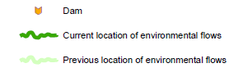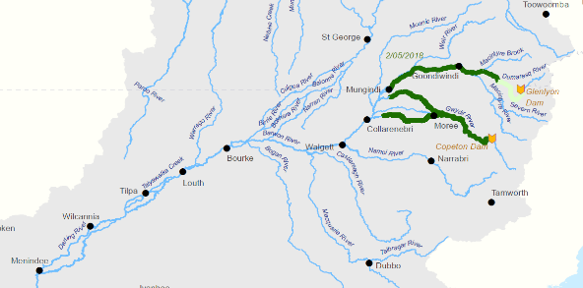

2 May – the releases made from two storages near the Qld / NSW border are progressing down the Border Rivers and Gwdyir system (via Mehi River, Gil Gil Creek)

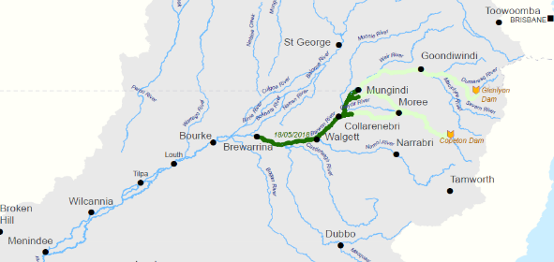

18 May – flows now in the Barwon River

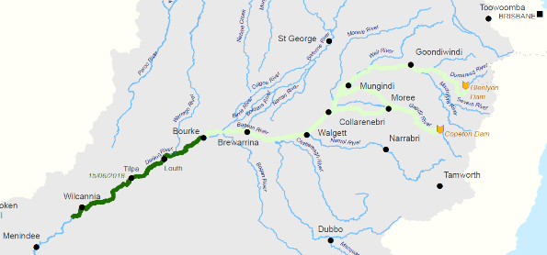

15 June – flows now in the Darling River

## Flow peaks along the Barwon-Darling

As shown below, the peak flows recorded at gauges along the Barwon-Darling are gradually reducing as the northern connectivity event meanders downstream. This is due to the natural processes of attenuation (spreading of the flow along the channel that results in a reduced peak), seepage and evaporation.

During the northern connectivity event, the gauged peak flow in the Barwon-Darling river at: Collarenebri and Walgett was 1,200 ML/day; Brewarrina was 1,000 ML/day; Bourke was 900 ML/day; Louth was 850 ML/day; and Tilpa was 650 ML/day (below).

|  |
| --- |
| cid:image001.png@01D403F0.B6F87E805 |

The flow in the Darling River at Wilcannia (green line above) has reached 494 ML/day this morning, up from 1 ML/day on last Monday, and is expected to peak between 500 - 525 ML/day. 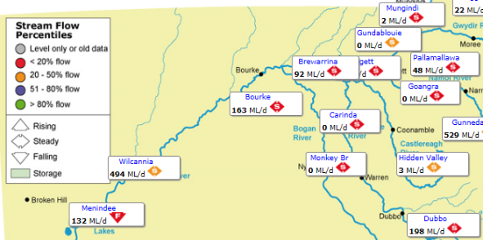6

\*

## Volume and destination

As the weeks roll past and the flow meanders downstream, the volume of water recorded at each flow gauge is reducing gradually. Of the 23 GL delivered from the Border Rivers and Gwydir systems into the Barwon-Darling, about half of it (11.8 GL) has passed Bourke. About a quarter of the original volume (5-6 GL) is expected to pass Wilcannia, and about 1-2 GL is expected to pass into the Menindee Lakes, which is about 5-10% of the original volume that passed Collarenebri. This was expected from the natural seepage and is not as a result of any significant pumping (see ‘significance of antecedent flows’ for more of a discussion on these system ‘losses’).

To put this inflow volume in context of the Menindee Lakes System, it is less than 0.1% of the total capacity of the storage, and considerably less than the annual evaporation and seepage from the lakes. Any inflows from the northern connectivity event are expected to be contained in the Darling River channel upstream ​of the ​Menindee Lakes ​Main Weir, in ​Lake Wetherell. ​ Lake Wetherell contains some deep waterholes  ​which serve​ ​as important refuges for native ​animals and plants​. ​Fish data from the ‘Viewmont Windmill’ site in the update of 25 May is a sample of the fish community in Lake Wetherell: with a lot of carp gudgeon (a small native fish) recorded.

The storage of additional inflows in Lake Wetherell may slightly extend (by a matter of days) the capacity to maintain small operational releases to the Lower Darling River downstream of the Menindee Lakes.

For any future northern flow events generated using held environmental water, consideration may be given to earmarking flows from these flow events generated using held environmental water in northern systems for downstream environmental use – but that’s a longer term policy matter.

## Flow targets and ecological basis

In general, responses of river ecosystems to flows depend on multiple factors including: peak flow; duration of the flow; water temperature / season; water quality; habitat; and the sequence of flow events. Also, the duration that a river is not flowing can significantly affect river health.

One of the main flow targets for the northern connectivity event was to maintain the flow within the upstream river channels, including the Mehi River. This was achieved. The other main flow targets for the northern connectivity event were to:

1. achieve a flow of over 500 ML/day at Bourke for around 14 days; and
2. achieve a flow of over 150 ML/day (but preferably over 350 ML/day) at Wilcannia for at least 10 days.

These targets were informed by best available science, including a report by Associated Professor Fran Sheldon which is available on the CEWO website7. These targets were designed as a low flow to replenish waterhole refuge habitat, provide longitudinal connectivity, transfer nutrients and improve water quality for native animals, plants, as well as water users7. The environmental benefits from longitudinal connectivity have been discussed in previous updates, and are summarised in an attachment.

The flow target at Bourke was achieved. We are increasingly confident that the targeted flow and duration at Wilcannia will also be achieved. We’ll know this time next week! The flow will soon reach a section of the Darling River just downstream of Wilcannia that has not flowed for around 150 days. Monitoring being undertaken in this reach of the river will improve our understanding of the flow targets that are required to replenish waterholes so they can provide refuge habitat for native fish during dry periods.

Several weeks after the northern connectivity event has passed through, flows return to very low levels. Flows in the Barwon River at Mungindi are low (around 2 ML/day), and blue-green algae have been recorded. In-channel flow pulses are critical for suppressing algal blooms. The northern connectivity event is expected to have delayed and lessened blooms such as these, but they will return in the future. Cooler temperatures in coming months usually result in reduced algal growth.

## Flows at Wilcannia

As discussed in the update of 1 June, river transport along the Darling was very important between the late 1850s and early 1930s. A paddle steamer and barge laden with wool near Wilcannia in about 1905 is shown below8.

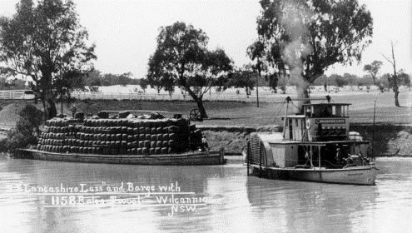

Near Wilcannia, c. 1905

River transport was risky on the variable flows in the Darling. The Darling River is one of the most variable rivers in the world. In the 74 years since 1944, the flows in the two wettest years (1950 and 1956) at Bourke are reported to be almost equal the flow in the driest 50 years9. The Darling did cease-to-flow, but usually for short durations, prior to water resource development.

The recorded flows since 1972 at Wilcannia are shown in the figure below. The pink vertical lines highlight when the river ceased to flow at Wilcannia. In total, the river has ceased to flow more often in the last two decades than in the previous decades. The Darling has ceased-to-flow at Wilcannia in total for about four years out of the last twenty. There are multiple possible explanations including: drought; climate change; and upstream diversions in the Barwon-Darling and further upstream.

10

Wilcannia is a town of considerable social disadvantage11. The average life expectancy of Aboriginal men born in Wilcannia is 37 years, and for women it is 41 years11, while the median age overall is 28 years12. Those in riverside communities that were born in the 1960s and 1970s would have personal experience of a flowing river for nearly all of the time through their teens and twenties, and a more frequently stopping and less healthy river since.

There is a social and ecological need to reduce the number and duration of cease-to-flow periods to help improve the health of the Darling River. The Murray-Darling Basin Authority has recommended limiting no and very low flow periods from exceeding 120-150 days at Wilcannia (as well as 60-80 days at Bourke) especially in spring and summer13. The experience and science from the northern connectivity event will help improve the understanding of cease-to-flow events, and how ecosystems respond.

There is a reach of the Darling between Wilcannia and the Menindee Lakes that has not had a flow since January (approaching the 150 days limit) which will soon benefit from the flows in the northern connectivity event.

|  |  |
| --- | --- |
| A community celebration of the flows is being organised by the Wilcannia community for the coming Tuesday. This important function will including dancing and art, and opportunities for future community leaders.  It is being organised by the local community.  Towns like Wilcannia are happier places when the river is flowing. | 14 |

## Significance of antecedent conditions in the Darling on flows

Two flow events have flowed through the Barwon-Darling since February:

* An unregulated flow event that originated from flow out of the Moonie and Culgoa rivers in February / March 2018 and flowed down the Darling between mid-March and late April on a largely dry river bed; and
* The northern connectivity event, which is currently flowing down the Darling, on a bed that had been wetted by the preceding unregulated flow event.

Both flow events were protected by NSW by temporary restrictions – or ‘embargos’ to take. The first event was protected for town water supplies. The northern connectivity event was protected for environmental outcomes. These events provide an opportunity to compare the flows between Bourke and Wilcannia (approximately 590 km of the Darling) when there is no pumping for irrigation, and the significance of antecedent conditions.

The flows for each event for Bourke, Tilpa and Wilcannia are shown below, with the earlier unregulated flow event shown as a hatched line.

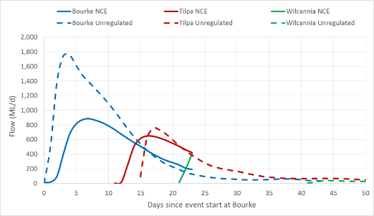15

So that the flow events can be easily compared the horizontal axis is the number of days since the flow started to rise in the Darling River at Bourke. For the northern connectivity event (solid lines), the lines end after 22 days, because the flows started rising at Bourke about 22 days ago in late May.

Some key points from the comparison are:

* **Peak flow**: the peak flow at Bourke in the unregulated event was about twice that of the northern connectivity event. By Tilpa, the flow peaks were about the same for the two flow events. At Wilcannia, the peak of the northern connectivity event will exceed that of the unregulated event by at least 450 ML/day.
* **Volume**: The volume that passed Bourke: in the unregulated flow event was about 20.5 GL; and in the northern connectivity event has been 11.8 GL. However, by Tilpa, the area under each curve (or volume) is looking similar. The volume passing Wilcannia will probably be around 5 GL greater for the northern connectivity event than the unregulated flow.
* **Travel time**: the head of the flow in the northern connectivity event took about 21 days to move from Wilcannia to Bourke, compared to 41 days for the unregulated event. Travel times can be significant longer when the river channel is dry and the flow is low because each waterhole needs to be filled up before the flow can move onto the next waterhole.

So, the volumetric changes or ‘losses’ in the unregulated event were much higher than the northern connectivity event (around 20 GL compared to around 5 GL between Bourke and Wilcannia). The natural losses in the unregulated flow event seem to be quite extreme. A question is whether similar sized flow events in the past under dry conditions have resulted in similar flows at Wilcannia. A similar event to the 2018 unregulated event was found in the gauged record, from 2007. As shown below, The 2007 event and the 2018 event both resulted in minimal or no flows at Wilcannia despite peaking at over 1,600 ML/day at Bourke. That suggests a ‘loss’ of around 20 GL in this reach is not unprecedented when ‘re-starting’ the river after a dry period.

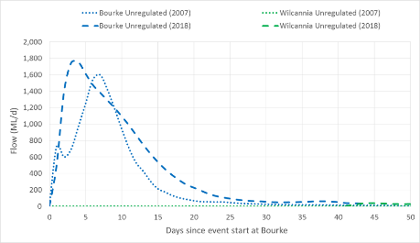16

## Initial learnings on the rules to protect water for the environment

It is important to learn and share as much as we can from opportunity provided by the northern connectivity event. For example, agencies with new responsibilities in compliance such as the Natural Resources Access Regulator in NSW and the Murray-Darling Basin Authority have been learning using the event as a timely case study. The final evaluation of the flow event, incorporating all of the post event scientific monitoring, will be completed in late 2018. Initial learnings are provided below. The next update, scheduled for mid-July, will be a preliminary evaluation of the northern connectivity event.

The northern connectivity event was broadly supported by irrigation groups, and this support has been important and appreciated. This includes supporting the use of entitlements in upstream storages to get whole of northern system outcomes, and general support for the protection of this water for the environment from pumping. Irrigation groups voluntarily offered not to pump the northern connectivity event as a significant gesture of goodwill.

The amount of water that irrigators on the Barwon-Darling can and do take from flow events from time to time depends on factors including: the rules of take for their licences; water allocation account volumes; the size of their pumps and storages; and opportunities to take. At present, most private storages are dry or largely dry, and there have been few opportunities for take in the last 18 months.

Under the current Barwon-Darling water sharing rules, flows from tributaries to the Barwon-Darling (such as from the Border Rivers or Gwydir system) are available for extraction if they exceed commence-to-pump levels (depending on each users water allocation account volumes). This is true whether the water was acquired for the environment or not. Under Barwon-Darling water sharing plan rules:

* the B Class commence-to-pump thresholds in the sections between Mungindi and Walgett are between 230 – 500 ML/day; and
* the A class commence-to-pump thresholds near Bourke are around 350 ML/day.

There is a significant volume of entitlement issued for B Class licences mentioned above. The flows in the northern connectivity event were well (i.e. hundreds of ML/day) above the B Class commence-to-pump thresholds between Mungindi and Walgett, and also above the A Class commence-to-pump thresholds near Bourke.

If the embargo approved by NSW was not in place, and irrigators chose to take what they are entitled to, there could have been enough pumping to reduce the flow at Bourke to 350 ML/day, or even less if the upstream B Class licensees with low commence-to-pump thresholds had significant take. Given that the difference in peak flow in the northern connectivity event between Bourke (900 ML/day peak) and Wilcannia (around 500 ML/day peak) is likely to exceed 400 ML/day, then it is likely that the flow would have not made it Wilcannia under current water sharing rules if the temporary restriction was not in place.

Another feature of water sharing arrangements is that water take throughout the Murray-Darling Basin is currently limited by the Cap on diversions (and, in the future, the Sustainable Diversion Limits under the Basin Plan). But it is important to understand that the Cap on diversions is based on long term averages – it does not protect particular flow events. The volume expected to pass Wilcannia is estimated to be around 6 GL. 6 GL is about 3% of the long term average Cap in the Barwon-Darling – so this is not volumetrically significant on a long term basis, but the timing can be absolutely critical, as long and frequent cease-to-flow spells can be detrimental to the environment and communities.

The use of averages can be a bit problematic when it comes to highly variable systems such as the Barwon-Darling. The Barwon-Darling Water Sharing Plan includes a comment17 that approximately 94% of the long-term average annual flow in the Barwon-Darling water source is committed for the environment. One might interpret that, with such a high proportion of flows going to the environment on average, it is inevitable that the river is healthy. However, the 94% average figure is something of a furphy, and seem to be heavily dominated by a few big floods in the 1950s. As shown on the chart with pink vertical lines, there can be extended periods with few flow events, particularly at Wilcannia. There are at least five fish species in the northern Basin that are listed as vulnerable or endangered, and the Darling fish community is also listed as being endangered under NSW legislation. Flow events and longitudinal connectivity are vitally important for the river ecosystem. For example, native fish species in the northern Basin with short life cycles and strong preferences or needs to access habitats such as wetlands during those life cycles are particularly vulnerable. It seems that the more variable the flow regime in a river system, the more important that appropriate rules are in place to protect enough flow events for river health. (There are other factors that also affect the health of fish community, such as barriers to fish movement and the effects of carp).

Long story short, an initial learning from the northern connectivity event is that the current rules permit extraction from small events that could result in a cease-to-flow event around Wilcannia if enough upstream irrigators opted to take up their legal rights to pump from small flow events. So protection in some form is important. Another learning is that if the northern connectivity event was with antecedent conditions of a ‘dry’ river bed, then the chance of the flow making it to Wilcannia would be much further reduced.

So – flow events and longitudinal connectivity are important for river ecosystem. The bigger, fuller picture is that some flow events can be critical for irrigation (particularly the last waterings of cotton in February, to finish off crops). Flow events are also important for riverside communities and the rise in community spirit as the northern connectivity event has arrived has been palpable.

So some flow events are more critical (for social, economic, environmental reasons) than others. Resolving how to share these events, including those created or enhanced from water recovered under the Basin Plan, through time is an important step towards a healthy working Basin.

These above initial learnings regarding the protection of ecologically significantly flow events can be considered the Barwon-Darling Stakeholder Advisory Panel, and in the ‘better management of environmental water’ under the NSW Water Reform Action Plan, when developing enduring solutions.

## Salinity in the Darling

Natural saline groundwater in-flows are a well-known feature of the Barwon-Darling River. (Henry Lawson referred to bubbling ‘salt springs’ *in the Song of the Darling River,* provided in the 1 June update)*.*

The salt interception scheme downstream of Bourke plays an important role in helping reduce salt loads into the river improving water quality for native plants, animals and downstream water users.

In-channel pulses also play an important role in flushing salts from the river system. Saline groundwater in-flows into waterholes contribute to increased salinity in these important refuge habitats during cease-to-flow periods, particularly around Weir 19A just downstream of Bourke. The electrical conductivity of water provides a measure of how salty it is – drinking water is typically less than 800 μS/cm – sea water is 50,000 μS/cm. Levels more than 1,000 μS/cm can cause problems for irrigating some crops and can also damage aquatic ecosystems.18 Saline groundwater inflows during cease-to-flows contribute to declining water quality by increasing salinity levels. Increases in salinity can also lead to clay particles flocculating out of the water column, improving water clarity but possibly stimulating algal blooms.

|  |  |
| --- | --- |
| The recent cease-to-flow experienced in the Barwon-Darling earlier this year resulted in the electrical conductivity at Weir 19A (shown right) increasing to more than 11,000 μS/cm. As shown on the following charts, the unregulated flow, which passed through the site in early April 2018 helped to flush salt downstream. The subsequent northern connectivity event, which passed through the site in early June maintained lower salinity levels at the site. | G:\Environment\Environmental Water\CEWH\Photos\2018\20180319-23 - Barwon-Darling-Neal Foster\IMG_3629 - Darling at Weir 19a.jpg  Weir 19A, just downstream of Bourke 19 |

Flow and salinity at weir 19A on the Darling, between Bourke and Louth.

|  |
| --- |
| Unregulated event  Northern connectivity event |
| Reduced salinity with dilution in northern connectivity event  Reduced salinity with dilution in unregulated event  Increase in salinity due to saline groundwater inflows and water then evaporating leaving the salt |

20

The northern connectivity event is an example of how in-channel flow pulses can help to suppress algal growth while the flow is occurring. The image on the left below was taken at Louth on 21 May 2018. This image illustrates how clay particles can flocculate out of the water column during cease to flow periods with increasing salinity. These conditions allow light to penetrate further into the water column increasing the chance of an algal bloom, particularly during warmer months. The image on the right was taken on 5 June 2018 during the northern connectivity event.

|  |  |
| --- | --- |
| C:\Users\A21906\AppData\Local\Microsoft\Windows\Temporary Internet Files\Content.Word\Louth image on 2018-05-21.jpg  \* | C:\Users\A21906\AppData\Local\Microsoft\Windows\Temporary Internet Files\Content.Word\Louth image on 2018-06-05.jpg  \* |
| Louth. Before - 21 May 2018 | Louth. After – 5 June 2018 19 |

## Water quality monitoring

|  |  |
| --- | --- |
| Targeted monitoring is being undertaken as part of the northern connectivity event. This will improve our understanding of how waterholes function as refuge, including how the quality of this habitat changes in response to low flow pulses and with subsequent drying. Water quality and waterbug (micro and macroinvertebrates) sampling is occurring at 10 sites along the Barwon-Darling River from Mungindi to Wilcannia. Each site was sampled in late April, before the northern connectivity event reached the Barwon, once again in after the front of the flow, and again in late July, to track the longer lasting influences of the flow on water quality and waterbug communities. This sampling combined with fish monitoring will provide important insights into how refuge habitat functions in the Barwon- Darling. | 21 |

## The northern connectivity event: looking ahead

Final update: around 16 July 2018, including a preliminary evaluation of the northern connectivity event (including a return to focussing more upstream on the Border Rivers and the Gwydir).

Upcoming engagement events: Wilcannia (Central Darling Shire are organising a function on 19 June, referred to previously). Moree and Goondiwindi - timing to be advised, likely to be in July or August.

Habitat condition assessment: June and July / August.

Fish monitoring: August/September sampling, including download of movement data.

Final evaluation: December 2018.

## Your feedback

Please let us know what you think about these updates: what you have liked about them, and what you think could be improved. This will form part of our evaluation of the event. Please send your thoughts to: [ewater@environment.gov.au](mailto:ewater@environment.gov.au). Please include ‘northern connectivity event feedback’ in the subject line.

## Acknowledgements

Thank you to those who shared the previous updates on the northern connectivity event: including those from the environmental, floodplain, irrigation, and local government sectors.

Thank you also to the NSW and Commonwealth agencies that have worked together with us at the CEWO to help make this flow event happen, and contributed information for this report. This includes the NSW Office of Environment and Heritage (who also contributed NSW environmental water to the event); the NSW Department of Primary Industries, Fisheries; the NSW Department of Industry, Water, WaterNSW, the Murray-Darling Basin Authority, and the NSW Natural Resources Access Regulator. Thank you also to local councils along the Barwon-Darling for support.

In particular, the CEWO would like to acknowledge the practicality, fairness, and professionalism of Craig Cahill, river operator from WaterNSW.

## And then what’s next…..

Beyond the northern connectivity event, environmental water advisory groups and environmental managers are discussing plans to water internationally significant (Ramsar) wetlands in the coming year, particularly the Macquarie Marshes and the Gwydir Wetlands. Whilst we collectively had hoped that nature would provide unregulated flows to water these wetlands in 2017 and 2018 to date, but alas, it didn’t happen. And so, this is likely to be a year when we need to draw on environmental water reserves and water areas of wetlands to preserve wetlands habitat for the future. Plans for use of environmental water will be shared in the near future.

## Contacts

**Local Engagement Officers:**

|  |  |
| --- | --- |
| **Neal Foster**  [neal.foster@environment.gov.au](mailto:neal.foster@environment.gov.au)   0437 141 495 | 18 |
| **Jason Wilson**  [jason.wilson@environment.gov.au](mailto:jason.wilson@environment.gov.au)   0418 210 389 |
| **CEWO media line** [media@environment.gov.au](mailto:media@environment.gov.au)   02 6275 9880 |
| **CEWO** [ewater@environment.gov.au](mailto:ewater@environment.gov.au) |

Preceding updates can be found at: <http://www.environment.gov.au/water/cewo/northern-rivers>

## Attachment – On longitudinal connectivity

“**Longitudinal**” connectivity, is the connectivity of water **along** a stream and between streams. To do this we need to maintain enough flow to prevent them from stopping or “**ceasing-to-flow**”. Longitudinal connectivity provides an aquatic pathway along which animals can move upstream and downstream, and seeds and tiny animals can disperse downstream using the energy of the flow.

Longitudinal connectivity along the length of a river or between river catchments can be critical for aquatic species that occupy a range of habitats over vast areas. For example, golden perch migrate long distances along rivers to spawn in faster flowing water. River flows aid in dispersal of their eggs and larvae during which time they continue to grow, before making their way back upstream later in life to start the cycle again. Without longitudinal connectivity, movement in either direction can be compromised. In fact we now know that golden perch populations in the Murray River are heavily dependent on fish that originated in the Darling River – often right up in the Barwon-Darling system. Therefore, longitudinal connectivity from the northern to southern Murray-Darling Basin is necessary to ensure the ongoing viability of golden perch stocks in the Murray River.

Historically, some Australian rivers regularly stopped flowing, or even dried out over long sections. The Darling River did occasionally stop flowing although it usually only lasted for a few days or weeks, and generally occurred in cooler seasons. In response to flow variability in rivers, our native animals and plants evolved specialised movement or breeding strategies over millions of years to enable survival in particular river systems. Humans have altered the way many rivers in the Murray-Darling Basin flow by building big dams and weirs, and by extracting water for towns or irrigation. Many of the structures we have built to control or regulate river flow also act as physical barriers, preventing or modifying not only the downstream transport of nutrients, food, eggs and plant seeds; but also the upstream movements many animals like fish must undertake to ensure survival or the recovery of populations.

In a cease to flow event a river contracts to still pools, often isolated from one another, and wetlands are disconnected from river channels. Under these conditions, available food and habitat can start to decline – it can become harder to find food, or even to hide from larger predators. The number of animals living in a pool (the “carrying capacity”) can be limited by space or resources.

It’s because connectivity is so important to aquatic animals and plants that water managers aim to maintain or resume connectivity, by making releases from storage dams. 22

Sources:

1 With thanks to Justin and Julie McClure, Tilpa

2. SunWater

3, 10, 19, 20 Commonwealth Environmental Water Office

4 Department of the Environment and Energy

5, 15, 16 Murray-Darling Basin Authority

6 Department of Primary Industries, Office of Water: <http://realtimedata.water.nsw.gov.au/water.stm>

7 Characterising the effects of changes in the ‘low flow hydrology’ of the Barwon-Darling River: <http://www.environment.gov.au/water/cewo/publications/characterising-eco-effects-changes-barwon-darling-2017>

8 Paddle steamer Lancashire Lass pulling a barge with 1158 bales of wool at Wilcannia, NSW, c. 1905. Photo by G. Young, courtesy of State Library of NSW.<https://maas.museum/inside-the-collection/2013/09/16/paddle-steamers-one-of-australias-inland-pioneering-transport-systems/>

9 Remember the ’56 flood? How much water flows to the environment in the Barwon Darling system? <http://apo.org.au/node/124366>

11 The Murray–Darling Basin Water Compliance Review, Murray-Darling Basin Authority and Independent Panel: <https://www.mdba.gov.au/sites/default/files/pubs/MDB-Compliance-Review-Final-Report.pdf>

12 Census QuickStats, Australian Bureau of Statistics: [www.censusdata.abs.gov.au/census\_services/getproduct/census/2011/quickstat/UCL121121](http://www.censusdata.abs.gov.au/census_services/getproduct/census/2011/quickstat/UCL121121)

13 Barwon–Darling ecological needs and hydrology, Murray Darling Basin Authority <https://www.mdba.gov.au/sites/default/files/pubs/ecological-needs-low-flows-barwon-darling.pdf>

14 Darling River Dance organised by the Wilcannia Drop in Centre

17 Water Sharing Plan for the Barwon-Darling Unregulated and Alluvial Water Sources: <http://www.legislation.nsw.gov.au/viewtop/inforce/subordleg+488+2012+cd+0+N/>

18 Salinity, Department of Industry website: <http://www.water.nsw.gov.au/water-management/water-quality/salinity>

21 Eco Logical

22 Based on input provided by NSW Department of Primary Industries, Fisheries