Northern Fish Flow

Community Information Drop-In Sessions

**Contacts:**

CEWO Local Engagement Officers Jason Wilson on 0418 210 389 or Jane Humphries at [jane.humphries@environment.gov.au](mailto:jane.humphries@environment.gov.au)

NSW OEH local officer David Preston on 0476 837 489 [David.Preston@environment.nsw.gov.au](mailto:David.Preston@environment.nsw.gov.au)

Sunset at Boobera Lagoon

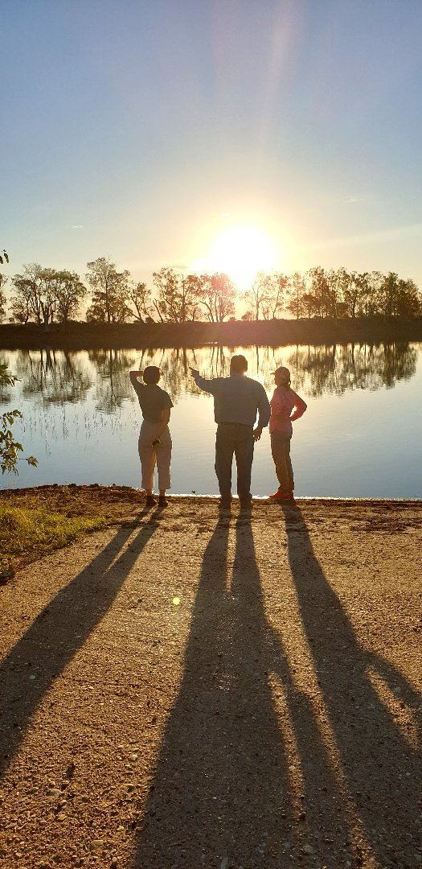

To help native fish survive the drought, the Commonwealth Environmental Water Office and NSW Office of Environment and Heritage are releasing water for the environment into the Dumaresq, Macintyre, Mehi and Barwon Rivers from April to June 2019.

Want to know more? Come along to the next community information drop-in sessions at Walgett or Brewarrina.

Sessions have already been held in Texas, Goondiwindi, Toomelah, Boggabilla, Mungindi, Boomi and Moree in May.

**Walgett: 6 June 10am-12pm**

Sporting Club, [Fox St and Monkella St, Walgett](https://www.google.com/maps/place/Walgett+Sporting+Club/@-30.0168045,148.1184296,17z/data=!3m1!4b1!4m5!3m4!1s0x6ba813e87c035283:0xf0609b573febd00!8m2!3d-30.0168045!4d148.1184296)

**Brewarrina: 13 June 10am – 12pm**

Weir Park, Doyle St, Brewarrina