|  |  |
| --- | --- |
|  | C:\Users\a23713\AppData\Local\Microsoft\Windows\Temporary Internet Files\Content.Outlook\CV4XR1IS\waratah-nsw-government-reverse-top-page-png-logo.png |

# Northern Fish Flow - Update 3

The Northern Fish Flow has reached the Barwon River, and waterholes there are being replenished for the first time in nearly a year. This flow is helping native fish and animals survive. The flow will continue past Walgett, to the Macquarie–Barwon junction and hopefully beyond.

|  |  |  |  |
| --- | --- | --- | --- |
| OBJECTIVES OF THE NORTHERN FISH FLOW | | | |
|  | Help native fish and animals survive the drought. |  | Improve water quality, connect the rivers, and improve habitat for native fish and animals. Improve social, cultural and economic outcomes for river communities. |

|  |  |
| --- | --- |
| SUMMARY | |
| Much has happened in the last three weeks. The flows from the Macintyre River have reached the Barwon River at Mungindi. The flows from the Mehi River have just reached the Barwon River at Collarenebri. Each flow has travelled around 400 river km following release from a dam. There have been eight community drop-in sessions in Queensland and NSW to share the Northern Fish Flow with locals, including local schools and the Aboriginal community at Toomelah. Discussions with locals including irrigators and townspeople have provided a diverse range of thoughts. Compliance officers have had their ‘boots on the ground’, and used ‘eyes in the sky’ from satellites, to keep track of the flow. Monitoring of fish and water quality has continued. We have also captured some great photos of the flow as it makes its way along the dry riverbeds.  *And …. at the end of a day of local engagement at Mungindi, there was time to enjoy the sunset at the Boobera Lagoon.* | | Resized_20190515_164650  1 | |

|  |  |
| --- | --- |
| PROGRESS OF THE NORTHERN FISH FLOW | |
| By Friday 24 May the flow had travelled down the Macintyre and Mehi rivers to the Barwon. | |
| Releases from Glenlyon Dam finished early last week. The tail of the flow is now heading down the Dumaresq River towards Boggabilla. Releases from Copeton Dam will continue at the current rate for around another week. |  |

2

|  |  |
| --- | --- |
| Flows at gauges along the Border Rivers are shown below. There is a natural reduction in peak | |
| and volume of the flow (the area under each curve) because of ‘losses’, particularly seepage when the landscape is so dry. Some of the water released from Glenlyon Dam was additional to the environmental flow, and drawn from the accounts of others for their purposes,  Flow (ML/day) | | cid:image001.png@01D51236.80206BC0  3 | |

including irrigation. In very dry times, water orders are often delivered together.

On the Gwydir River, not far downstream of Copeton Dam, the difference in the river before and after the Northern Fish Flow is shown below.

4

Near Copeton Dam, during flow - May **2019**

|  |  |
| --- | --- |
| Near Copeton Dam, before flow - April 2019 |  |

Further downstream, the flow is passing from the Gwydir into the Mehi River at Tareelaroi Weir. The flow along the Mehi River at Collarenebri started to arrive by Tuesday afternoon. (Post note – by Monday 27 May enough water had had made it to the Barwon River for the Collarenebri weir pool to start to rise).

Mehi R at Collarenebri – Tuesday morning…

5

|  |  |
| --- | --- |
| C:\Users\A21906\AppData\Local\Microsoft\Windows\Temporary Internet Files\Content.Word\IMG_1611.jpeg | C:\Users\A21906\AppData\Local\Microsoft\Windows\Temporary Internet Files\Content.Word\FullSizeRender.jpeg  ..…and Tuesday afternoon |

When the flow arrives, even though it looks like a modest trickle to start with, it is met with considerable excitement by local communities. Vanessa Hickey, a Traditional Owner from Walgett, is looking forward to the arrival of the flow.

*This water coming down is going to mean a lot to our community here in Walgett. We've got two beautiful rivers, I never thought I'd see the day we could touch the bottom of the Barwon and the Namoi. These places are very special to us Aboriginal people, our ancestors walked here for thousands and thousands of years. They lived off these river banks. With the environmental flow coming down, this is going to pipe my community up. We're going to be out here fishing a lot. I could see our river bends with a lot of families on the weekend just all sharing stories, coming out having a good old fish*.

|  |  |
| --- | --- |
|  |  |

The progress of the flow can be followed using satellite images with a moisture index filter. The below images are of the Mehi River near Ballin Boora. The land is bright orange because of the extremely low moisture levels at present. The above image is before the flow passed through in late April, the lower image is after the flow had passed. The continuous royal blue in the channel in mid-May indicates that the head of the flow had moved past this point.

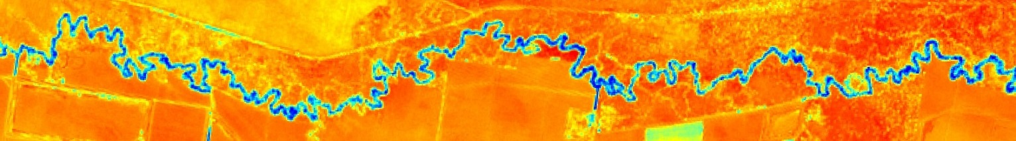

13 April

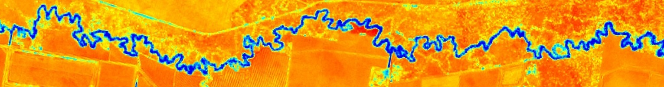

6

18 May

Ahead of the flow, the Barwon River awaits, with dry bed interspersed with stagnant pools.

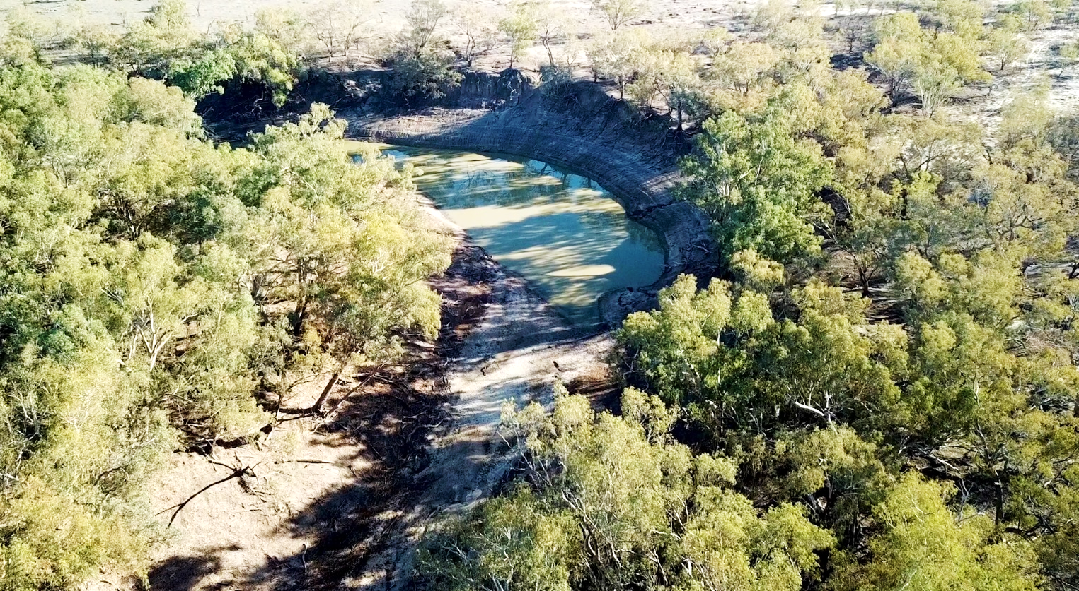

7

Further downstream of the Northern Fish Flow, over recent weeks, it has been good to see flows from the Warrego Rivers into the Darling River, in addition to some flow from the Culgoa. The flows in the Darling River at Louth and Tilpa are below – from current gauged data.

Flow from the Warrego persists

First peak mainly from local rainfall between Bourke and Louth

|  |  |
| --- | --- |
| The first peak at Louth originated from local rainfall just downstream of Bourke. Then water from higher in the Warrego catchment arrived at Louth from about a week later. The flow in the Darling includes about 8 GL of Commonwealth water | **Louth**  8  **Tilpa**  Flow (ML/day) |

for the environment from Toorale / Warrego unregulated licences. The flow from the Warrego to the Darling peaked last weekend and remains over 600 ML/day.

Despite the very hot summer and dry condition of the Darling River bed, the volume of flow passing Louth could exceed the flow in April 2018 that broke an extended cease-to-flow event and reached Wilcannia. We hope that the current flow will also reach Wilcannia.

|  |
| --- |
| SHARING THE NORTHERN FISH FLOW WITH THE COMMUNITY |

As part of the Northern Fish Flow, there have been eight community drop-in sessions held so far. These have been held in Texas, Boggabilla, Goondiwindi, Mungindi, Moree, Boomi, Collarenebri, and Toomelah station. Toomelah Station was formerly Toomelah Aboriginal Mission, and is near the junction of the Dumaresq and Macintyre rivers. Topics discussed at each drop-in session included: the progress of the flow; how much water has been released from the dams; how much water remains in storage for critical human water needs; and the compliance activities associated with the flow event.

9

|  |  |
| --- | --- |
| At Texas, there was discussion about where the water goes in dry times. In some years, groundwater contributes water to the river, in years like this, there is a lot of seepage from rivers. There was particular interest in the amount of water remaining in Glenlyon Dam. | **Z:\Photos\2019\20190514 - Jason Wilson, NFF engagement, Bonshaw\Engagement at Texas.jpeg** |
| At Toomelah Station, there was discussion of how the flows in the Dumaresq and Macintyre are managed. Some of the comments were – “*I got family down the Barwon River, hope this water helps it out*” and “*this is great, send it down*”. | C:\Users\A21906\AppData\Local\Microsoft\Windows\Temporary Internet Files\Content.Word\IMG_0370.jpg |

At Mungindi and Boomi, local schools were well represented.

Thank you to those who could come along for these community drop-in sessions. There will also be community drop-in sessions held at: Walgett on 6 June 2019 from 10 am to 12 pm at the Sporting Club, and at Brewarrina on 13 June from 10 am to 12 pm at Weir Park.

|  |
| --- |
| MONITORING OF THE NORTHERN FISH FLOW |

The Northern Fish Flow will increase the chances of fish survival by improving water quality, habitat, food sources, and providing some opportunity to escape from isolated waterholes. Results from the Northern Connectivity Event which was at a similar time last year, show how native fish such as golden perch (yellowbelly, or ‘dhagaay’ in the local Gomileroi language)

|  |  |
| --- | --- |
| can move and disperse when there is a suitable flow. The Northern Connectivity Event reached Louth and Tilpa in June 2018. Awaiting the flow were 48 golden perch which had transmitters attached in April 2018. During that flow, several of these fish moved over 5 kilometres in a single day. Over the flow event of around a month, most fish moved tens of kilometres. Some moved upstream to weirs which blocked their progress. Based on these findings from the | 10  This indicates fish movement  Northern connectivity event |

Northern Connectivity Event, it is likely some fish may move during the Northern Fish Flow. Queensland research using acoustically-tagged fish in the Condamine-Balonne has also shown that golden perch can move during low and medium flows following periods of no flow. There are arrays of sensors in both the Barwon and the Mehi rivers from which data will be downloaded in coming months to look for fish movement.

Ongoing monitoring of dissolved oxygen along the Barwon will also continue. We expect the dissolved oxygen will improve quickly following the arrival of the Northern Fish Flow, and look forward to sharing initial results from Collarenebri weir pool in a future update. These results will be used alongside the results from several years of the monitoring of fish populations and health by NSW DPI Fisheries as part of the implementation of the Basin Plan.

|  |  |
| --- | --- |
| **Z:\Photos\2019\2019 - Mark Southwell - Assorted\Mark @Bourke_Pic ME.JPG**  11 | 12 |
| THE TEAM EFFORT BEHIND THE NORTHERN FISH FLOW | |

In addition to those that are out and about engaging and monitoring directly with communities, there is a diverse team in the background supporting the Northern Fish Flow.

15

14

13

|  |  |
| --- | --- |
| **Z:\Photos\2019\20190319 - Mark Southwell - Gwydir ECAOAC\DSC_0049.JPG**  Gwydir EWAG | The Gwydir Environmental Water Advisory Group provided advice on possible use of water for the environment in the Northern Fish Flow. NSW (OEH) and Commonwealth (CEWO) environmental water managers then considered community, scientific and river operations advice, and placed water orders. River operators (WaterNSW) are now delivering water orders, and keeping an eye on the flow as it moves downstream. |
| C:\Users\A21906\AppData\Local\Microsoft\Windows\Temporary Internet Files\Content.Word\IMG_0747.jpg  Environmental water managers | C:\Users\A21906\AppData\Local\Microsoft\Windows\Temporary Internet Files\Content.Word\Ken Gee.jpg  River operators |
| 16  NSW compliance officers | Compliance activities are taking place both along the river (NRAR and Qld), and remotely using satellite images (MDBA). **IMG_0730**  17  MDBA officers analysing satellite images |
| Social media is used to share news of the Northern Fish Flow – including tweets, and a YouTube video by the Gwydir Valley Irrigators.    18  18  Many have kindly passed on these updates to their network. Thank you. | cid:image001.jpg@01D50C8F.32F2D790  19  Irrigators sharing news |

The next update on the Northern Fish Flow is scheduled for early June. By then, the flow will be approaching Walgett, and will have broken a cease-to-flow of about 10 months on the Barwon River between Collarenebri and Walgett. The Northern Fish Flow benefits other native animals than fish. The timing of the Northern Fish Flow coincides with the celebration of World Turtle Day (yesterday).

|  |  |  |  |
| --- | --- | --- | --- |
| CONTACTS | | | |
| **CEWO Local Engagement Officer: Jason Wilson**  0418 210 389  jason.wilson@environment.gov.au  C:\Users\A21906\AppData\Local\Microsoft\Windows\Temporary Internet Files\Content.Word\IMG_1641.jpg  20 | **NSW OEH Senior Wetlands & Rivers Conservation Officer: Daryl Albertson**  0407 071 985  daryl.albertson@environment.nsw.gov.au  Government agencies are working together on the Northern Fish Flow, and were well represented at the Collarenebri community drop-in session on Wednesday. OEH was represented by David Preston and Jane Humphries (left). The MDBA was represented by Annabelle Guest (centre). CEWO staff present were Glen Sturesteps (foreground) and Jason Wilson (right).  Jane Humphries joins the CEWO from OEH on Monday (27 May). Jane is looking forward to continuing to engage with communities in the northern Basin on environmental water, particularly in the Border Rivers, Gwydir and Namoi catchments. |

|  |
| --- |
| FURTHER INFORMATION |

**NSW OEH website**

<http://www.environment.nsw.gov.au/topics/water/water-for-the-environment/about-water-for-the-environment>

<https://www.environment.nsw.gov.au/news/water-for-native-fish-mehi-river-flow>

**CEWO website**

<https://www.environment.gov.au/water/cewo>, Follow us on Twitter @thecewh

<http://www.environment.gov.au/water/cewo/catchment/northern-fish-flow-2019>

**Gwydir Valley Irrigators video**

<https://twitter.com/GwydirValley/status/1118626100236574720>

Credits for images

1 – Commonwealth Environmental Water Office (CEWO) – by Richard Mintern.

2 – Department of Energy and the Environment (DoEE).

3 – Murray-Darling Basin Authority (MDBA) – using gauged data from NSW water gauging network.

4 – WaterNSW.

5 - CEWO – by Jason Wilson.

6 – MDBA – using Sentinel 2 satellite images with a filter to highlight moisture. These images have a resolution of 10 m2 and cover the whole Murray-Darling Basin every few days.

7 – DoEE – drone image of the Barwon River near Walgett, by Huw Graham-Matheson.

8 – CEWO – using gauged data from NSW water gauging network.

9 – CEWO.

10 – NSW DPI Fisheries, data of fish movement from an acoustic array.

11 – EcoLogical Australia, of Mark Southwell.

12 – NSW DPI Fisheries. Photo in in the Lower Gwydir, May 2019. By John St Vincent-Welsh of Leo Cameron.

13 – NSW Office of Environment and Heritage. Of the Gwydir Environmental Water Advisory Group (or Gwydir ECAOAC).

14 - CEWO – of Michael Peat.

15 – DoEE - of Ken Gee (WaterNSW) by Huw Graham-Matheson.

16 - NSW Natural Resource Access Regulator.

17 – CEWO – of David Weldrake and Nathan Clough (MDBA)

18 – NSW Natural Resource Access Regulator

19 – Gwydir Valley Irrigators Association (image by and of Zara Lowein).

20 – CEWO (by Glen Sturesteps)