|  |  |
| --- | --- |
|  | C:\Users\a23713\AppData\Local\Microsoft\Windows\Temporary Internet Files\Content.Outlook\CV4XR1IS\waratah-nsw-government-reverse-top-page-png-logo.png |

# Northern Fish Flow – Wrap-up

The Northern Fish Flow commenced from reservoirs in the Dumaresq and Gwydir rivers four months ago. The flow is ceasing just downstream of the Culgoa junction having refreshed around 1,500 km of river habitat.

|  |
| --- |
| ACHIEVEMENTS OF THE NORTHERN FISH FLOW |

The northern Murray-Darling Basin is experiencing severe drought. The Northern Fish Flow improved water quality, connected the rivers and helped native fish survive along 1,500 km of the river system. Large sections of river were connected by the flow. Waterhole refuges now contain more water, which means that they will persist longer. This is expected to keep more fish and animals alive in the lead-up to the summer period when rainfall typically occurs in the northern Basin.

The flow improved food sources for fish by washing organic material from the dry river bed down the river system. Monitoring has shown that the flow has improved oxygen content in waterholes which will be important refuges in coming months.

The Northern Fish Flow provided relief to communities who had not seen parts of the rivers flow for nearly a year in places, such as Walgett. Many people visited the river to see the flow. These people included Aboriginal leaders who have spoken about the cultural, community and personal benefit of seeing water back in the river. Many riverside landholders were able to take some water for basic landholder rights, which helped to sustain their stock for better (and wetter) times. NSW and Queensland protected the flow from take for irrigation purposes.

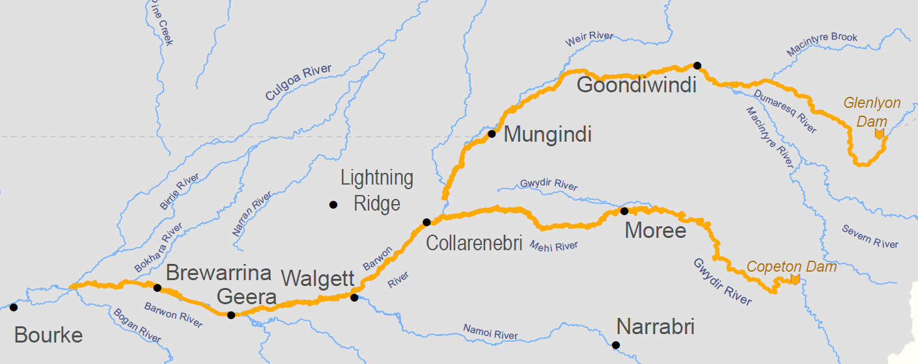

1

|  |
| --- |
| THE PASSAGE OF THE NORTHERN FISH FLOW |

The Northern Fish Flow occurred along the Mehi and Macintyre rivers and into the Barwon River. The flow from the Mehi River passed about 300 river km further downstream than expected and reached just upstream of Bourke weir pool. The flow from the Macintyre stopped about 5 km short than expected upstream of Collarenebri – as the losses en route were particularly high.

|  |  |
| --- | --- |
| It was exciting to see the flow moving down the Mehi River.  The flow reached Collarenebri Weir. Images below of before and after the arrival of the flow (21 and 28 May 2019) |  |
| cid:image001.png@01D55F38.C2383B10 | cid:image002.png@01D55F38.C2383B10  2 |

The flow replenished poor and fragmented habitat. Near Calmundi Weir, between Collarenebri and Walgett, there was a small fish death event in March before the flow arrived (left). The healthier habitat in the waterhole after the flow passed is shown to the right.

|  |  |
| --- | --- |
| 3 | 4 |

|  |  |
| --- | --- |
| Brewarrina Weir on 10 July, looking from downstream. Flow was overtopping the weir, and passing down the fishway on the right. | Just downstream of Brewarrina Weir these hungry pelicans were looking to capture fish. |
| 5 | G:\Environment\Environmental Water\CEWH\Photos\2019\201905 - Mark Southwell - Assorted\CEWO B-D WQ site photos July 2019\Pelicans_bre weir2.JPG  6 |

|  |
| --- |
| ENGAGING WITH COMMUNITIES |

The Northern Fish Flow was planned with support from NSW and Queensland government agencies, local councils, irrigators and landholders along the rivers.

During the flow, over 70 community members, including school children, attended information drop-in sessions held at Texas, Goondiwindi, Toomelah, Boggabilla, Mungindi, Boomi, Moree, Collarenebri, Walgett and Brewarrina.

|  |  |
| --- | --- |
| One of the best attended, and most energetic, drop-in sessions was held at Boomi on 17 May, when the local primary school dropped in. | 7 |

People were interested to understand how the Northern Fish Flow was delivered and asked questions about the timing, the quantity of the flow, and the flow rates. A number of communities along the Barwon to Brewarrina and along the Mehi expressed excitement at having their weir pools topped by the Northern Fish Flow for the first time in many months. Local landholders and councillors talked about the critical role that water for the environment plays in linking up rivers, particularly during drought. It’s important to get this feedback as we have the job of managing water for the environment on behalf of the community to produce the best environmental benefit.

Minister for the Environment, the Hon Susan Ley MP also visited the northern Basin during the Northern Fish Flow in June. The Minister saw first-hand how water recovered for the environment under the Murray Darling-Basin Plan is managed in the Northern Basin and met with local river communities. The Minister talked with local councils, landholders and Aboriginal communities from Bourke to Brewarrina and Moree.

|  |  |
| --- | --- |
| Minister Ley heard from Gomeroi Nation representatives about how important healthy rivers are to the wellbeing of their communities and their ideas about how to involve young Aboriginal people in caring for the rivers.  Jody Swirepik (Commonwealth Environmental Water Holder), Vivian Duncan, Minister Ley, and Liz Taylor | G:\Environment\Environmental Water\CEWH\Photos\2019\201906-07 - Jane Humphries - June and July various\Photos_2019_June-July_JaneH\Moree - Ministers  visit 18 June 2019\20190618_122939.jpg  8 |

The Northern Fish Flow travelled through the traditional lands of many Aboriginal nations, supporting important environmental, social and cultural values. Aboriginal community members who attended the drop-in sessions expressed a deep connection to the rivers and a strong support for environmental flows. Vanessa Hickey, a Traditional Owner from Walgett stated *“With the environmental flow coming down, this is going to pipe my community up. We're going to be out here fishing a lot”.*

The support and interest in the Northern Fish Flow highlights how important water for the environment is for communities in the Basin. We will continue to improve how we engage with local communities on future use of water for the environment.

|  |
| --- |
| MONITORING |

During the Northern Fish Flow, there was monitoring of water quality, flows and fish response.

The monitoring of water quality in refuge pools was mainly undertaken along the Barwon River. Samples of dissolved oxygen were collected before, during and after the Northern Fish Flow. If the dissolved oxygen fell below 4 mg/L then fish become stressed and may die. Prior to the Northern Fish Flow, dissolved oxygen concentrations at the Collarenebri Weir pool were found to be below 4 mg/L in places. Dissolved oxygen readings show that concentrations increased when the Northern Fish Flow passed as expected. Water quality data has been downloaded and is being compiled into a final report.

|  |  |  |
| --- | --- | --- |
| A pleasant day of monitoring – downloading dissolved oxygen data from Brewarrina weir pool | 9 | |
| The response of food sources in the river can be rapid. These are shrimp picked up in monitoring recently in the Warrego catchment. The response of shrimp in the rivers benefiting from the Northern Fish Flow is expected to be similar. | | C:\Users\A21906\AppData\Local\Microsoft\Windows\Temporary Internet Files\Content.Word\Fairy and shield shrimp 2019.png |

Monitoring of flows was also important because we continue to learn about the amount of water needed to re-start rivers once they dry back to isolated weir pools spread between reaches of dry river bed. There have been two comparable ‘connection’ flow events between the Mehi, Macintyre and Barwon rivers: the Northern Fish Flow on a ‘dry’ river bed in 2019 and the Northern Connectivity Event into a connected Barwon River in 2018. Whilst the shape of the flow ‘hydrographs’ (below) was a bit different, the volumes where similar when measured at Collarenebri (between 15 and 20 GL). The key learnings from comparing these flow events are provided below.

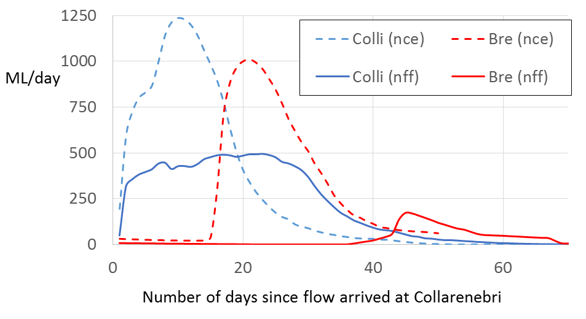

Northern Fish Flow at: Collarenebri (blue) and Brewarrina (red)

Northern Connectivity Event at: Collarenebri (blue) and Brewarrina (red)

11

For the Northern Fish Flow, on a dry river bed, the volume of water that passed Collarenebri was about 15.4 GL, of which about 15% passed Brewarrina. The ‘loss’ (mainly seepage) was about 5 GL per 100 river kilometres. For the Northern Connectivity Event, where waterholes were full prior to the flow, the volume of water that passed Collarenebri was about 19.9 GL, of which about 80% passed Brewarrina. About a fifth of the water per 100 km of river was used when there was a connected river bed compared to when the river bed was dry.

The travel time from Collarenebri to Brewarrina for the Northern Fish Flow was about six weeks, or three times longer than it took for the Northern Connectivity Event. That meant that the community drop in sessions preceded the arrival of the Northern Fish Flow at Boomi, Mungindi, Collarenebri, Walgett and Brewarrina. We’ll know better next time!

Part of the reasons for the differences could be due to the shape of the hydrograph – we aimed for a ‘gentle’ pulse in the Northern Fish Flow so that conditions in waterholes were not changed too quickly.

|  |  |
| --- | --- |
| The flows were also observed from the sky using satellites. These images show the Barwon River near Walgett filling in June, and then the water persisting into August. | \\UPVVIRTCLUS01FS\Users$\A24500\Profile\Downloads\Sentinel-2 L1C image on 2019-06-07 (1).jpg  **7 June 2019** – before the flow |
| \\UPVVIRTCLUS01FS\Users$\A24500\Profile\Downloads\Sentinel-2 L1C image on 2019-06-17 (1).jpg  **17 June 2019** – after flow has passed | \\UPVVIRTCLUS01FS\Users$\A24500\Profile\Downloads\Sentinel-2 L1C image on 2019-08-01.jpg  **1 August 2019** – water persisting  12 |

There was also monitoring of fish movement and migration undertaken during the Northern Fish Flows. This monitoring has occurred in long stretches of the Mehi River and the Barwon River using acoustic arrays. Fish species involved are freshwater catfish, Murray cod, and golden perch – gaygay, guduu, and dhagaay respectively in the Gomeroi language. NSW fisheries officers will download data in coming months and report, which will be shared on the CEWO website. There was movement of fish observed in the Northern Connectivity Event, and movement is expected this time around as well.

No fish death events were observed after the Northern Fish Flow had moved past. However, unless it rains, there is considerable risk to native fish in the coming months throughout the Basin. If it were not for the Northern Fish Flow, more fish death events may have already occurred in the northern rivers.

|  |
| --- |
| THANK YOU |

Commonwealth and New South Wales environmental water managers would like to thank the community that participated in the Northern Fish Flow, including those who attended the community drop in sessions, even when the flow was still on its way! We acknowledge the important advice from the Gwydir Environmental Water Advisory Group during the planning of the flow.

We appreciate the work of those who distributed information about the Northern Fish Flow, including those in the irrigation industry, recreational fishers, local government, the Aboriginal community, and Local Land Services. We would also like to thank agencies in NSW and Queensland that provided support to the event in areas such as compliance, river operations, and community engagement.

|  |  |  |  |
| --- | --- | --- | --- |
| CONTACTS | | | |
| **CEWO Local Engagement Officer: Jason Wilson** (Walgett)  0418 210 389  jason.wilson@environment.gov.au  **CEWO Local Engagement Officer: Jane Humphries** (Moree)  0437 141 495  jane.humphries@environment.gov.au  **NSW DPIE Senior Wetlands & Rivers Conservation Officer: Daryl Albertson**  0407 071 985  daryl.albertson@environment.nsw.gov.au | Resized_20190515_164650image1.jpeg  Jason pointing out features of Boobera lagoon  Jane (right) with Sally Dickinson (MDBA)  13  14 |

|  |
| --- |
| FURTHER INFORMATION |

**NSW DPIE websites**

<http://www.environment.nsw.gov.au/topics/water/water-for-the-environment/about-water-for-the-environment>

https://www.environment.nsw.gov.au/news/water-for-native-fish-mehi-river-flow

**CEWO websites**

<https://www.industry.nsw.gov.au/water/environmental-water-hub>

<https://www.environment.gov.au/water/cewo>, Follow us on Twitter @thecewh

<http://www.environment.gov.au/water/cewo/catchment/northern-fish-flow-2019>

A report from the monitoring of dissolved oxygen will be available from the CEWO website in coming months.

**Credits for images**

1, 2, 4, 5, 7, 8, 11 – Commonwealth Department of the Environment and Energy (DoEE). 3 – NSW Department of Planning, Industry and Environment (Fisheries). 6,9,10 – Eco Logical. 11 - DoEE using gauged data from NSW water gauging network. 12 – DoEE using Sentinel 2 satellite images. These images have a resolution of 10 m2 and cover the whole Murray-Darling Basin every few days. 14 – Murray-Darling Basin Authority.