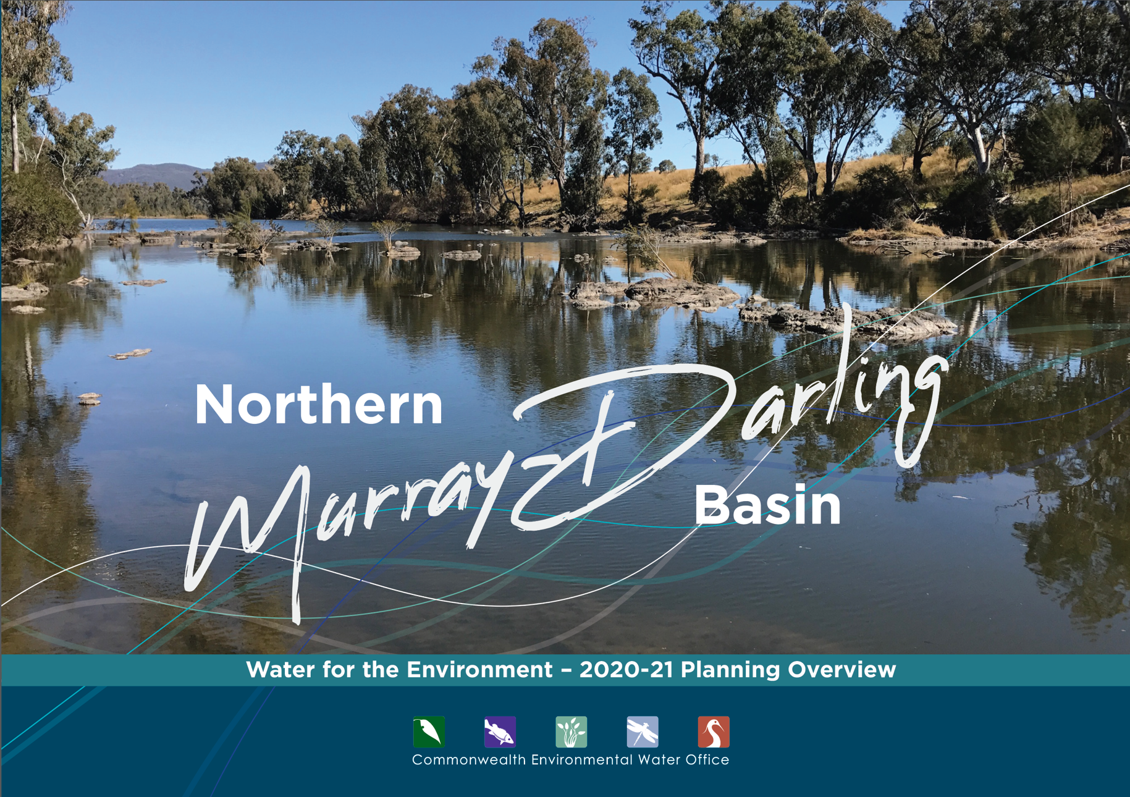

## A message from the Commonwealth Environmental Water Holder

Our planning for 2020–21 reflects the very dry conditions of the last three years. While the rainfall outlook for winter and early spring looks optimistic, storages are low and our carryover is the lowest in a decade.

Careful planning is critical to squeezing the most for the environment out of every drop of water available.

Without further major rainfall, our water use in the northern Basin will be limited to topping up refuges for native fish and possibly small flows to internationally important wetlands such as the Macquarie Marshes, Gwydir Wetlands and Narran Lakes.

I’m delighted this year’s planning includes formal input from the Northern Basin Aboriginal Nations on First Nations’ environmental objectives. This is a significant step and complements the work we do locally with First Nations people.

We work closely with many people and organisations to plan our water use. We are grateful for their contributions and look forward to working together in the coming year to deliver water to keep our rivers flowing and healthy.  
  
Jody Swirepik  
Commonwealth Environmental Water Holder

## Healthy rivers, healthy communities

Many rivers of the Murray-Darling Basin have been changed to provide water for towns, industry and food production.

This has interrupted the natural flow of water that plants and animals need to survive. With natural runoff from rainfall now captured in dams or extracted for human use, the pattern of flow in rivers needs to be actively managed to keep them healthy.

The Commonwealth Environmental Water Office delivers water for the environment when native plants and animals need it most. This is critical to keeping rivers healthy, so they continue to sustain healthy communities.

Water availability can change dramatically in the northern Basin. This changes how we use water for the environment and is why we need to carefully plan our potential watering options every year.

In the wettest years, we look to improve river system health and help fish and wildlife build up numbers. In the driest years we maintain system health and reduce environmental damage.

Our first priority in most years is to support internationally important wetlands and increase the connection of northern rivers with the Barwon-Darling River.

To view our Water Management Plan 2020-21, or an overview of planning in the Southern Murray-Darling Basin, visit **environment.gov.au/water/cewo**

Our Local Engagement Officers are based in Moree and Walgett.

For more information contact:

• Moree, NSW - Jane Humphries, 0437 141 495

• Walgett, NSW - Jason Wilson, 0418 210 389

## Working with First Nations

The Commonwealth Environmental Water Office pays respect to the Traditional Owners and First Nations of the Murray-Darling Basin.

We acknowledge their enduring cultural, social, environmental, spiritual and economic connection to the rivers, wetlands and floodplains of the Basin. We are committed to continuously improving how we work with First Nations across the Basin to manage water for the environment.

## Northern Murray-Darling Basin

## Planning our use of water for the environment in 2020-21

Each year, planning the best use of Commonwealth water begins long before the water   
starts flowing.

We work with local water managers, scientists, First Nations peoples, river operators and landholders to prioritise critical sites and carefully plan where water for the environment will be delivered in the year ahead. Their advice ensures our water use is backed by science and meets local needs.

We prepare a Water Management Plan which considers

• forecast water availability for the coming year

• seasonal rainfall outlook

• health of river and wetland plants and animals.

What we aim to achieve - when, where and how our water is delivered - depends on how much water is allocated to our entitlements by state governments. Every year is different.

We plan water use scenarios for a range of weather conditions (from dry to wet) so we can adapt to whatever seasonal conditions eventuate.

Forecast water available in 2020-21*

|  |  |  |
| --- | --- | --- |
|  | Carryover from previous year | Forecast allocations to Commonwealth entitlements |
| **Macquarie** | **23GL** | **92GL** |
| **Namoi** | **1GL** | **5GL** |
| **Gwydir** | **12GL** | **33GL** |
| **Border Rivers** | **2GL** | **9GL** |

* For regulated systems only. Volumes based on Bureau of Meteorology forecasts for wetter than average conditions July to September 2020-21.

### We plan water use scenarios for very dry through to very wet conditions and adapt to whatever season eventuates.

Rivers in the northern Basin can switch from being dry to in flood within days or weeks. In times of drought, rivers can shrink back to small pools or dry up completely. Water for the environment is used to help connect river habitats and reconnect rivers to important wetlands. This is critical for fish and other animals to find food and shelter, escape predators and migrate to breed.

## What we aim to achieve with water for the environment in 2020-21

### A) Barwon-Darling River

Increase connection between habitats along the river. Protect refuges and native fish populations.

### A) Warrego River

Increase connection between the Warrego River and Darling River. Maintain health of the Warrego floodplain.

### B) Condamine-Balonne

Continue to support the recovery of the Narran Lakes Ramsar site following drought. Increase connection between habitats.

### C) Macquarie River Valley

Support recovery of Macquarie Marshes Ramsar site following drought and fire. Support native fish to breed and disperse.

### D) Namoi River Valley

Protect drought refuges and support native fish. Increase connection between habitats.

### E) Gwydir River Valley

Maintain drought refuges for native fish. Support Gwydir Wetlands (including Ramsar site) following drought and fire.

### F) Border Rivers

Protect drought refuges for native fish. Increase connection between habitats.

