

Environment Protection and Biodiversity Conservation Act 1999 referral guidelines for the endangered northern quoll, Dasyurus hallucatus

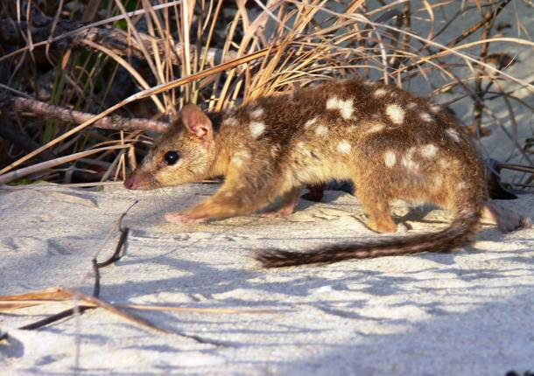

EPBC Act policy statement 3.25

© Commonwealth of Australia 2011
This work is copyright. You may download, display, print and reproduce this material in unaltered form only (retaining this notice) for your personal, non-commercial use or use within your organisation. Apart from any use as permitted under the Copyright Act 1968, all other rights are reserved. Requests and inquiries concerning reproduction and rights should be addressed to Commonwealth Copyright Administration, Attorney General’s Department, Robert Garran Offices, National Circuit, Barton ACT 2600 or posted at www.ag.gov.au/cca.

Disclaimer
The contents of this document have been compiled using a range of source materials and is valid as at February 2011. The Australian Government is not liable for any loss or damage that may be occasioned directly or indirectly through the use of reliance on the contents of the document.

Front page photograph: Northern quoll, Dasyurus hallucatus, photo taken by Craig Ward provided in the National Recovery Plan for the northern quoll.
Important notice
Please note that these guidelines are general in nature only and do not remove your obligation to consider whether you need to make a referral to the federal environment minister under the Environment Protection and Biodiversity Conservation Act 1999 (EPBC Act). While these guidelines provide information to help you decide whether to refer your action, the possible impacts of your proposal will depend on the particular circumstances of the action. These circumstances may include issues such as the precise location, mitigation measures and indirect impacts. These guidelines do not provide guidance on requirements under state and local government laws. Information on Queensland (QLD), Northern Territory (NT) or Western Australia (WA) and local government council laws can be obtained from the QLD Department of Environment and Management Resources, NT Department of Natural Resources, Environment, The Arts and Sport, WA Department of the Environment and Conservation and local councils in or near the proposed project area.

How to use these guidelines
These guidelines are intended to assist you in determining whether your action needs to be referred to the Australian Government Department of Sustainability, Environment, Water, Population and Communities (the department). These guidelines should be read in conjunction with the EPBC Act Policy Statement 1.1 Significant Impact Guidelines – Matters of National Environmental Significance.

These guidelines apply to the northern quoll, Dasyurus hallucatus, anywhere it may occur in Australia. The northern quoll is listed as an endangered species under the EPBC Act. Listed threatened species and ecological communities are matters of national environmental significance under the EPBC Act. If you plan to undertake an action that has, will have or is likely to have a significant impact on the northern quoll you must refer the proposal to the minister before commencing. The minister will then decide, within 20 business days, whether assessment is required under the EPBC Act. The potential significance of each action is judged on a case-by-case basis. Substantial penalties apply for undertaking an action, to which the EPBC Act applies, without approval (civil penalties up to $5.5 million or criminal penalties including up to seven years imprisonment). More information on referral, assessment and compliance is available at www.environment.gov.au/epbc/.

The decision tree in Figure 1 and the rest of these guidelines are designed to assist you in determining whether your proposed action needs to be referred. You may also refer your proposed action if you are uncertain about the need to refer, or if you think the proposal would not have significant impacts on matters of national environmental significance, but would like legal certainty.

Possible exceptions to the need to refer
Certain actions are exempt from the requirement of assessment and approval under the EPBC Act. These include lawful continuations of land use that started before 16 July 2000, or actions that were legally authorised before 16 July 2000. There are a number of criteria that must be satisfied to rely on any such exemptions. More information on exemptions under the EPBC Act is available at www.environment.gov.au/epbc/publications/exemptions.html
Figure 1: Decision making

YES
NO

YES or UNSURE

YES
NO
Have you surveyed for northern quoll using the recommended methods (see Section 4)?
NO
or
UNSURE
REFERRAL RECOMMENDED
High risk of resulting in significant impact**
Assume your project will impact on the northern quoll (see Section 5)
NO

Could your action impact on the northern quoll (see Section 5)?
Is your impact mitigation best practice so that it may reduce the significance of your impacts on northern quoll (see Section 6)?
Could the impacts of your action affect habitat for the northern quoll (see Section 3)?
REFERRAL MAY NOT BE REQUIRED*

Low risk that your action will result in a significant impact on northern quoll (see Section 7)**
Uncertainty whether your action will result in a significant impact on northern quoll (see Section 7)***
High risk that your action will result in a significant impact on northern quoll (see Section 7)**
REFERRAL RECOMMENDED
OR CONTACT THE DEPARTMENT
REFERRAL RECOMMENDED

Could the impacts of your action occur within the modelled distribution of the northern quoll (see section 2)?
YES or UNSURE
REFERRAL MAY NOT BE REQUIRED*
Low risk of resulting in significant impact**
YES or UNSURE
NO

REFERRAL MAY NOT BE REQUIRED*
Low risk of resulting in significant impact**
Could your action require a referral to the federal environment minister for significant impacts on northern quoll (see Section 7)?
REFERRAL MAY NOT BE REQUIRED*
Low risk of resulting in significant impact**

*Although it would appear a referral may not be required, you may still refer your proposed action if unsure, or if you think the proposal would not have significant impacts on matters of national environmental significance, but would like legal certainty. An example may be when other matters of national environmental significance, in addition to northern quoll, are potentially affected.
** Risk is the chance of something happening that will have a [significant] impact on objectives [e.g. protecting matters of national environmental significance] (adapted from Australian / New Zealand Risk Management Standard 4360: 2004).
*** If you are uncertain about the need to refer then you may also contact the Department to discuss your action by emailing epbc.referrals@environment.gov.au
1. What is known about the northern quoll?

Northern quolls are small, nocturnal, carnivorous marsupials and are the smallest of all Australian quolls. Northern quolls are sedentary with a moderately large home range with female home ranges known to average 35 ha and male home ranges covering 100 ha or more during the breeding season. Northern quolls reproduce once per year and have on average seven young, however they have a short lifespan with most females usually only surviving one breeding season. The intense physical effort of male quolls (roving during the breeding season) appears to cause the physiological decline of most males and their subsequent die off at one year of age. This unique life history can exacerbate the effects of population decline and habitat loss, and make population recovery very slow.

The northern quoll was listed as endangered under the EPBC Act in 2005 owing to a substantial reduction in numbers across its range. This decline has been gradual over the last 50 years with a number of threats either directly or in combination with each other thought be contributing. Threats include mortality caused by poisoning from cane toads, inappropriate fire regimes (and predation by introduced animals after fire) and the removal, degradation and fragmentation of habitat as a result of development actions and pastoralism. It must be recognised that in many areas, immediately following colonisation by cane toads, the decline in northern quolls was precipitous.

Relevant background information on the biology and ecology of northern quoll is provided in the department’s Species Profile and Threats (SPRAT) database.

2. Could the impacts of your action occur within the modelled distribution of northern quoll?

The northern quoll is restricted to five regional populations across Queensland, the Northern Territory and Western Australia, both on the mainland and some offshore islands. In Queensland, the species occurs from the south east to the gulf of Carpentaria. In the Northern Territory it occurs in the Top End and in Western Australia it occurs in the Pilbara and Kimberley regions. The northern quoll occurs both on the mainland and some offshore islands (refer to maps 1-5). In Western Australia, island populations include the Adolphus, Augustus, Bigge, Boongaree, Capstan, Storr, Dolphin, Hidden, Koolan, Purrungku, Uwins and Wollaston Islands (see Map 5). In the Northern Territory, northern quoll populations occur on Astell, Channel, Groote Eylandt, Inglis, Low, Marchinbar, Northeast, Pobassoo and Vanderlin islands as well as on two unnamed islands near Groote Eylandt (see Map 5).

The distribution maps presented in this document are based on the best available information at the time of publication and remain a static product. For the most up-to-date report of whether northern quoll may occur in your project area, always use the Protected Matters Search Tool.
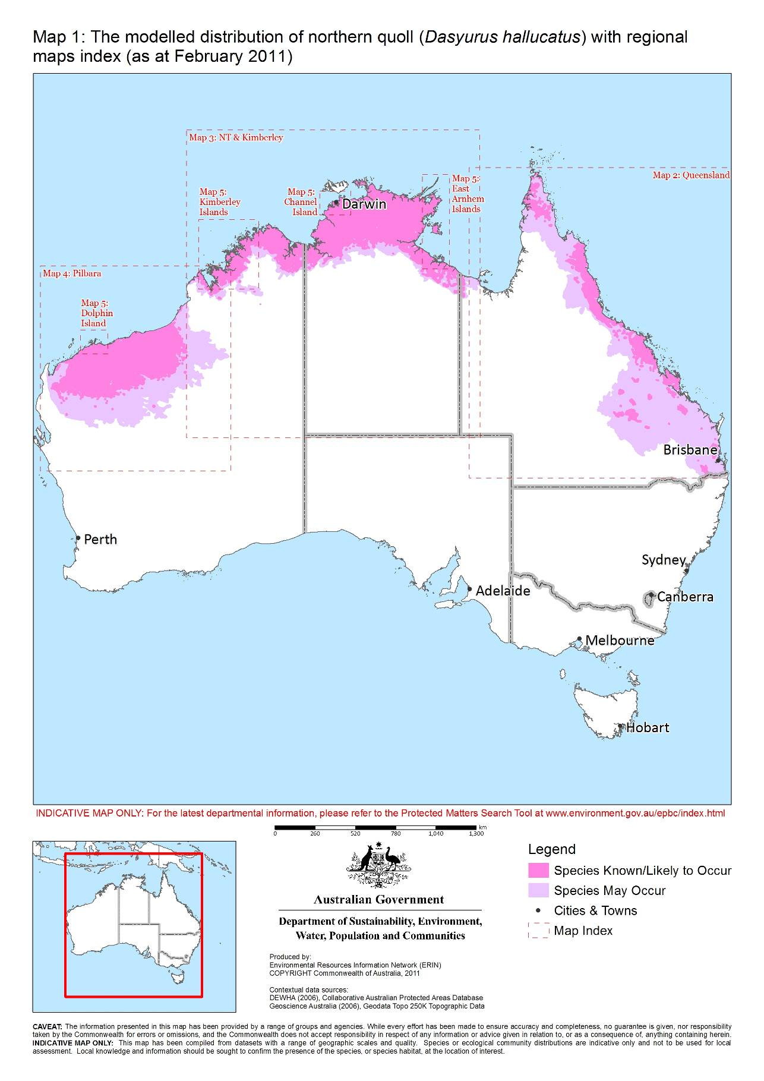
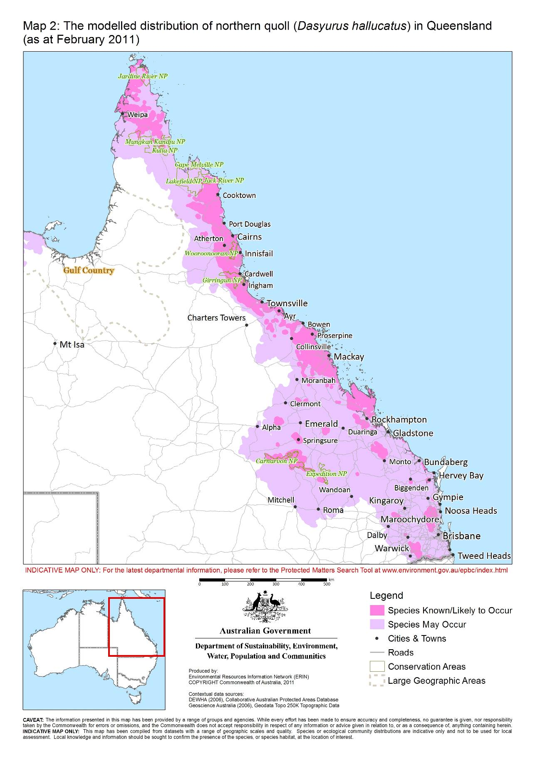

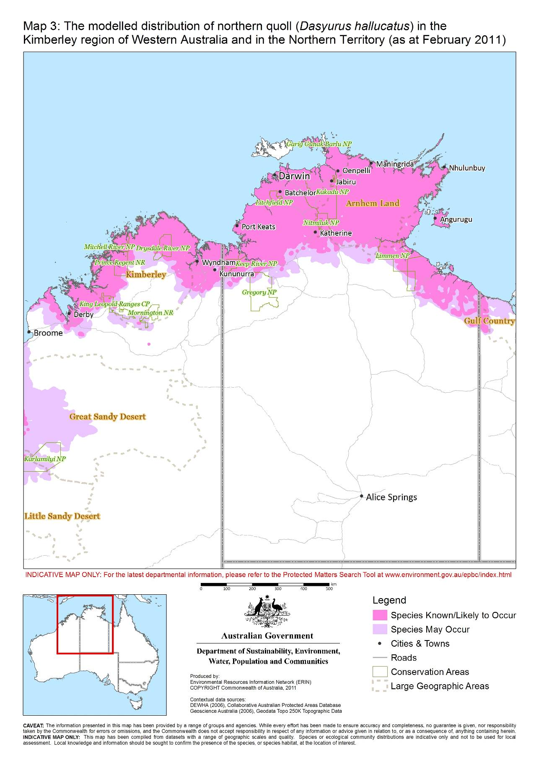

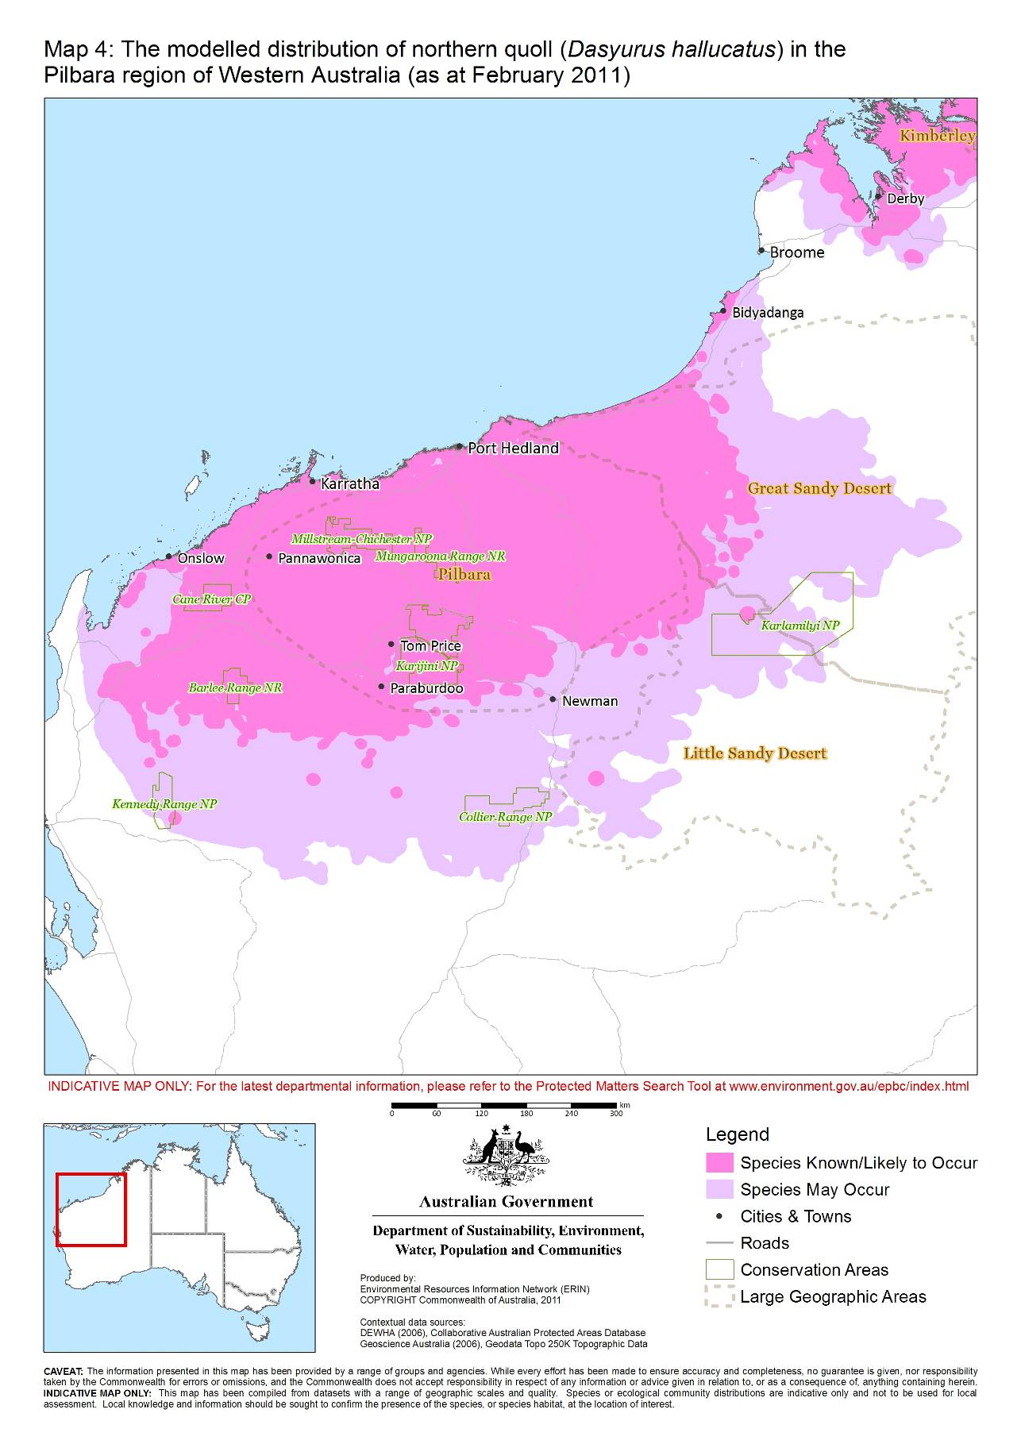

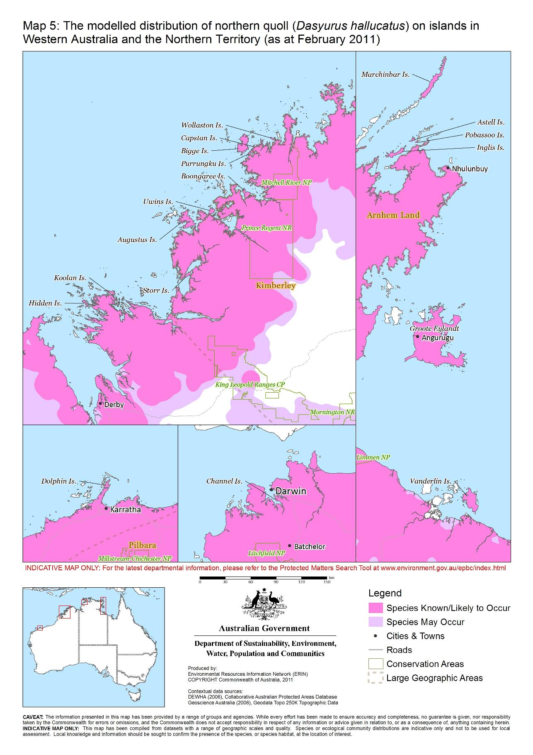
3. Could the impacts of your action affect habitat for the northern quoll?

The northern quoll occupies a variety of habitats across its current range including rocky areas, eucalypt forest and woodlands, rainforests, sandy lowlands and beaches, shrublands, grasslands and deserts. Habitat usually requires some form of rocky area or structurally diverse woodland or forest for denning / shelter purposes with surrounding vegetated habitats used for foraging and dispersal. This denning / shelter habitat is important for the species for the purposes of breeding, refuge from fire and / or predation and long term viability of the species.

Little is understood about the characteristics of foraging or dispersal habitat for the northern quoll. However, on current knowledge, foraging or dispersal habitat is recognised to be any land comprising predominately native vegetation in the immediate area (within 2 km) of denning / shelter habitat, quoll records or land comprising predominately native vegetation that is connected to denning / shelter habitat within the species range.

Where denning / shelter habitat occurs within the modelled distribution of the species (refer to maps 1-5), it is considered habitat critical to the survival of the species. Habitat critical to the survival of the northern quoll occurs in three forms across the species range which includes:

- Rocky habitats such as ranges, escarpments, mesas, ranges, gorges, breakaways, boulder fields, major drainage lines or treed creek lines
- Structurally diverse woodland or forest areas containing large diameter trees, termite mounds or hollow logs
- Off shore islands where the northern quoll is known to exist

Further information on northern quoll habitat and habitat critical to the survival of the species is provided in the department’s Species Profile and Threats (SPRAT) database.

4. Have you surveyed for northern quoll using the recommended methods?

A guide to conducting surveys for northern quoll in areas of suitable habitat is outlined below. Surveys should:

- be conducted by a suitably qualified person with demonstrated skill in mammal surveys
- maximise the chance of detecting the species
- account for uncertainty and error (such as false presences and absences).

Surveys for the northern quoll can have different objectives and therefore require different guidelines and experimental design. However for the purposes of referral and assessment under the EPBC Act it is recommended that surveys for northern quoll involve an initial reconnaissance survey which aims to identify the need for further investigations through a targeted survey. Where it is not possible to conduct surveys in this manner, failure to detect northern quoll should not be considered indicative of its absence.

Reconnaissance survey

A reconnaissance survey can be conducted at any time of the year but should be undertaken in the early planning stages of the project. The reconnaissance survey should assess the suitability of habitat for northern quolls, both for denning / shelter and dispersal and foraging purposes. Suitable habitat should be mapped during this survey and habitat areas calculated. Data collected should describe the habitat quality including information on vegetation, microhabitat, fire history, presence of introduced predators, grazing history and landscape condition. A reconnaissance survey may choose to consider the presence or potential presence of the northern quoll by using non-invasive techniques such as active searching for scats and latrine sites, motion sensitive cameras, hair tubes or spotlighting where appropriate.

Targeted survey

A targeted survey is recommended for any proposal occurring within the modelled distribution of the species (see Figures 1-5) where the reconnaissance survey identifies the presence of quolls and / or habitat critical to the survival of northern quoll.

The objective of the targeted survey should be to determine the relative abundance and distribution of northern quolls likely to be impacted by the proposed development. The survey protocol should be designed so that the total population of northern quolls in the impact area can be calculated. A targeted survey should be undertaken pre development and during the months of May, June, July or August (primarily to avoid any disturbance during the reproductive period) and involve a trapping program using preferably wire cage traps or large size Elliot traps.

As a minimum, a targeted survey should consider the following:

- Carefully configure the trapping program to address project impact and non-impact zones so that results are adequate to inform monitoring programs and project siting options.
- Trapping should be concentrated in habitat critical to the survival with some consideration of non-rocky foraging and dispersal habitats.
- In Western Australia traps should be set for seven consecutive nights, unless two or more individuals are caught twice, in which case the traps should be closed after four nights of trapping.
- In the Northern Territory and Queensland, traps should be set for a minimum of three nights with the aim of sampling as many sites possible over the three nights
- Where large Elliott traps are the primary trapping technique, a minimum of four cage traps should be used per trap configuration.
- To be considered effective, traps should be baited with sardines or a bolus mix of oats and peanut butter with honey being optional. Chicken wings and diced bacon are also optional.
- Traps should be rebaited at least every second day (baits should be fresh), cleared within 2-3 hours of sunrise and have adequate shade cover during the day. Consideration should be given to closing traps during the day to eliminate by-catch and potential heat stress issues.
- In Western Australia, tissue samples (ear clippings) should be collected from all individuals captured and analysed with the aim of increasing genetic knowledge of the northern quoll in Western Australia (ethics clearance is required for this procedure). Tissue samples should be sent to the Western Australian Museum with the following details: Weight, sex, pes (left hindfoot measurement), tail diameter / circumference, crown reproductive condition, presence/absence of bite marks and parasites, locality (GPS coordinate in lat and long), collectors name and date.
- Targeted surveys may be supplemented by one of several non-invasive survey techniques such as latrine searches in habitat critical to the survival, use of motion sensitive cameras and / or hair tubes. These methods should however not be relied upon to demonstrate northern quolls are not present in an area.

Targeted survey effort

- Trapping effort for a targeted survey should be determined by the formula y = 50x^{0.5}, where y is the number of trap-nights and x is the area of potential northern quoll habitat in hectares.
- Trapping effort is calculated as the number of traps by the number of nights of trapping (e.g. trap-nights).
- For linear habitat critical to the survival of the species (e.g. gorges, major drainage lines, breakaways less than 100 m wide), 1 trap per 100 linear metres is recommended.

Those wishing to demonstrate the absence of northern quolls in an area, or who are planning trapping programs over large areas of northern quoll habitat (>15 000 ha), should contact the department to discuss survey design and effort. Please send an email to speciespolicy@environment.gov.au.

5. Could your action impact on the northern quoll?

Potential impacts on the northern quoll should be considered when determining whether to refer your action. You should consider referring your action if there is a real chance or possibility that it will have a significant impact on northern quoll. The self-assessment criteria used to judge significant impacts in the significant impact guidelines 1.1 refers to impacts on a population of the species. Your action may significantly impact on a population if your action is likely to:

- lead to a long-term decrease in the size of a population
- fragment an existing population into two or more populations
- disrupt the breeding cycle of a population

A population of northern quoll is presumed to occur in any area with recent evidence of a single northern quoll. Evidence of a northern quoll is considered recent if it is post 1980 and may include, but not limited to, a database record, scat, latrine site, hair sample, remote camera detection or a trapped or sighted animal by a qualified practioner.

In addition, consideration of impacts must be given to the species as a whole. Your action may significantly impact on the species if your action is likely to:

- adversely affect habitat critical to the survival of a species
- reduce the area of occupancy of the species
- modify, destroy, remove, isolate or decrease the availability or quality of habitat to the extent that the species is likely to decline
- result in invasive species that are harmful to a endangered species becoming established in the endangered species’ habitat
- introduce disease that may cause the species to decline, or
- interfere with the recovery of the species.

Section 7 provides guidance for when one or more of these criteria may trigger the need to refer your action.

6. Is your impact mitigation best practice so that it may reduce the significance of your impacts?

Mitigation has the principle aim of avoiding significant impacts and should be applied in a hierarchical order:
1. Avoid impacts – preserve populations and habitat to avoid further loss.
2. Mitigate impacts – prevent habitat degradation and retain habitat function.
3. Monitor effectiveness of mitigation – ensure mitigation is effective and feeds back into an adaptive management plan.

Table 1 outlines the main threats to northern quoll, their impacts and mitigation. It is not intended to be exhaustive or prescriptive.

Table 1: Primary threats, impacts and mitigation

Threats and key impacts | Mitigation
Habitat clearing  - Direct mortality  - Displacement | - Relocate the project  - Design the project to avoid and protect habitat critical to the survival of the species  - Reconfigure the project to remove threatening processes  - Retain movement corridors and put in place natural buffers  - Rehabilitate disturbed habitats  - Maintain habitat to reduce edge effects and monitor  - Avoid activities such as rock blasting or heavy machinery operation between May and November (quoll breeding).  - Educate mine site personnel about northern quoll ecology on site
Introduction of invasive species  E.g. cane toads, gamba grass.  - Direct mortality  - Habitat degradation  - Competition  - Increased fire risk  - Habitat displacement | - Implement quarantine protocols  - Install a staging facility for the storage and inspection of equipment/goods. The staging facility should be surrounded by a toad-proof barrier/fence (including no gaps under doors), and should include shelter sites for toads that can be easily and regularly inspected. For island developments, the staging facility should be on the mainland (e.g. Broome, Derby, Wyndham, Darwin, Gove and Borroloola) and be located at the wharf from where goods are shipped out to the site.  - Prescribe and apply a holding period (at least 48 hours) before equipment is used on-site or shipped to site, to allow time for toads/pests to emerge.  - Install a wash down facility. The wash down facility should comprise high pressure water or steam devices. Cane toad traps should be installed surrounding the wash down and staging facilities (see http://www.frogwatch.org.au for more information on cane toad traps).  - Develop and facilitate educational programs for staff and contractors about quarantine protocols and associated risks involved with invasive species.  - Implement a no fill policy for the life of the project e.g. no introduction of material from off site such as soil or vegetation.  - Control (and where possible) eradicate weeds with a high priority for habitat-modifying weeds.  - Remove and spray high priority weeds e.g. gamba grass (Andropogon gayanus).  - Manage fuel loads of weeds to reduce risk of high fire intensity.
Pastoralism  - Habitat degradation  - Inappropriate fire regimes | - Maintain current site conditions e.g. disturbance regimes, grazing, and vegetation structure.  - Retain and manage grazing regimes to avoid high fuel levels and high intensity dry season fires (as some of the most persistent populations of northern quolls in Queensland are in areas that are grazed, often heavily).
Traffic  - Direct mortality  - Habitat fragmentation | - Retain quoll movement corridors.  - Control and manage traffic levels to minimise fragmentation and mortality.  - Educate project staff.  - Ensure no entry into conservation areas with signage (except for necessary environmental management and monitoring).  - Avoid and enforce unauthorised off track driving with signage and penalties.  - Reduce and enforce speed limits in the vicinity of quoll habitat with signage and penalties.  - Fence underpasses where appropriate to funnel movement to safer areas.  - Report and record road kills
Inappropriate fire regimes  - Increased predation risk  - Loss of denning habitat | - Manage fires to reduce incidence, extent and severity to levels appropriate to retain or restore optimal northern quoll habitat.In QLD, storm-burning (lighting fires after the first wet season rains) is the suggested burning regime for northern quoll. Such a regime aims to reduce the risk of high fuel accumulation and homogeneity. Storm burning significantly reduces the risk of extensive dry season wildfire which can result in local population extinctions of northern quoll.  - Construct fire control lines to facilitate movement to control fire fronts.  - Educate and train staff about equipment and procedures to act on unexpected fire events.
Feral animals  e.g. Feral cats and pigs, wild dogs and cattle  - Direct predation  - Habitat degradation  - Competition  - Disease e.g. Toxoplasmosis | - Control feral animal abundance such as feral cats, pigs and wild dog.  - Eradicate feral animals through localised live trapping, shooting and baiting. Consideration should be given to limit the likelihood of baiting mortality to quolls.  - Implement and enforce a no cat and no dog policy for developments with accommodation facilities  - Educate and train staff and public in any no cat and dog policy and ensure signage is displayed.  - Remove any harbourage sites such as tips and dump sites  - Modify existing habitat to make it less suitable for cats e.g. reduce fragmentation by rehabilitating tracks and clearings and making it more structurally complex with shelter and escape sites.

7. Could your action require a referral to the federal environment minister for significant impacts on the northern quoll?

As the person proposing the action it is your responsibility to decide whether or not to refer your action. If you believe your action is at high risk of having a significant impact on a population of northern quoll or the species as a whole you should refer the action to the federal environment minister. If you are uncertain whether your action will have a significant impact on the northern quoll you may also refer your action or contact the department. Table 2 provides general guidance on what, in the department’s view, may be at high and low risk of requiring a referral to the department as well as providing some guidance on uncertainty.

Table 2: Referral guidelines
High risk of significant impacts: referral recommended
- Actions which remove known habitat critical to the survival of the species
- Actions which remove known foraging and dispersal habitat in toad invaded areas
- Actions which remove > 5 ha of known foraging and dispersal habitat in areas not yet invaded by cane toads
- Actions which remove >10 ha of potential habitat critical to the survival of the species
- Actions which remove >200 ha of potential foraging and dispersal habitat.
Uncertainty: referral recommended
- Actions which restrict northern quoll dispersal by creating barriers between populations
- Actions which may increase traffic volumes increasing the risk of mortality and population fragmentation
- Actions which may introduce cane toads to areas which are not yet exposed to cane toads
- Actions which have inappropriate quarantine measures in place for movements between offshore islands
- Actions which may increase the risk of late dry season high intensity fires to the area
- Actions which may alter habitat structure through the introduction of invasive species.
Low risk of significant impacts: referral may not be required but you may refer for legal certainty
- Actions in which impacts occur outside the modelled distribution of the northern quoll
- Actions which avoid habitat removal in accordance with the guidance on habitat removal above, adopt and implement best practice mitigation and have a management plan in place to monitor northern quoll populations.

8. How can I manage northern quolls on site?

To manage northern quolls in your study area and ensure the mitigation put in place is effective, populations should be actively monitored. Monitoring should be undertaken in a similar nature to a targeted survey (section 4) but with the following considerations:

- Monitoring sites should be established in denning / shelter habitat types outside of direct impact zones, within impact zones and in rehabilitated areas (original impact areas).
- Control sites should be established in similar habitat type which occurs outside of any impact areas.
- Monitoring should seek to monitor all representative habitat types.
- Monitoring should involve the mark and recapture of individuals e.g. using numbered tags, tattoos, or ear notching (ethics clearance is required for this procedure).
- Survey effort should be similar to that used during the targeted survey in both the impact and control sites.
- Pre impact baseline survey data should be collected
- Post construction monitoring should take place annually for the first two years and then once every three years after that for the life of the project.
- Wherever possible, monitoring programs should be designed to provide evidence of the effectiveness of any management actions undertaken to mitigate impacts or aimed to enhance habitat quality.
- In Western Australia, monitoring programs should employ methodologies used in the regional monitoring program undertaken by the Department of the Environment and Conservation.
- All monitoring protocols and data should be made available, preferably on the companies website.

9. Where can you get more information?

The SPRAT profile for this species provides the biological and ecological context for survey guidelines, significant mitigation measures and referral guidance. It can be accessed at www.environment.gov.au/cgi-bin/sprat/public/sprat.pl.

Other EPBC Act policy statements are available to help you understand the EPBC Act and your obligations. They are available from the department’s website at www.environment.gov.au/epbc/guidelines-policies.html or by contacting the community information unit by email: ciu@environment.gov.au or by phone: 1800 803 772. The department can provide assistance in ensuring your action complies with the EPBC Act, especially when contacted early in the planning process.

The Protected Matters Search Tool can provide a good starting point for determining the likelihood of having matters of national environmental significance in your area. State and territory government agencies may also hold relevant information including habitat and species distribution information.

When considering whether or not your action will have a significant impact on northern quoll, it is relevant to consider all adverse impacts from the action, including direct, indirect and offsite impacts such as downstream or downwind impacts, upstream impacts and facilitated impacts (impacts that result from further actions, which are made possible or facilitated by the action).
In Western Australia, both a reconnaissance and targeted survey should conform with a level 1 assessment and level 2 survey described in the Environment Protection Authority (EPA) Position Statement 3, Guidance Statement 56, and EPA and Department of Environment and Conservation (DEC) Technical Guide - Terrestrial Vertebrate Fauna Surveys for Environmental Impact Assessment. In NT and QLD there are no specific survey protocols, any surveys for northern quolls should conform to this policy.
Known habitat critical to the survival of the species is habitat critical to the survival of the species where northern quoll is recorded on site during surveys, or where no surveys were conducted in suitable habitat.
Potential habitat critical to the survival of the species is habitat critical to the survival of the species occurring within the modelled known / likely distribution of the northern quoll.

