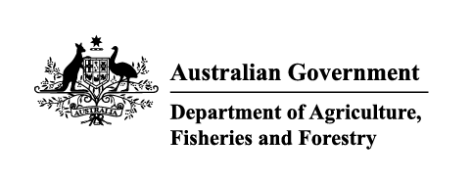

Instrument revoking a holding order under section 15(2) of the Imported Food Control Act 1992
The listed holding orders, having satisfied the circumstances under which the orders will be revoked, are revoked under section 15(2) of the Imported Food Control Act 1992 (the Act).
The circumstances being that the Secretary or delegate is satisfied that the basis for the order no longer applies.
Holding order number | Date revoked
18551 | 02/11/2025
18548 | 02/11/2025
18506 | 02/11/2025
16156 | 02/11/2025
16617 | 02/11/2025
13770 | 02/11/2025
15454 | 02/11/2025
18765 | 02/11/2025
18764 | 02/11/2025
18724 | 02/11/2025
17025 | 02/11/2025
18178 | 02/11/2025
18682 | 02/11/2025
18761 | 02/11/2025
18741 | 02/11/2025
18766 | 02/11/2025
18767 | 02/11/2025
18769 | 02/11/2025
18715 | 02/11/2025
18145 | 02/11/2025
18717 | 02/11/2025
18754 | 02/11/2025
18737 | 02/11/2025
18716 | 02/11/2025
18745 | 02/11/2025
18650 | 02/11/2025
18714 | 02/11/2025
18721 | 02/11/2025
18725 | 02/11/2025
18712 | 02/11/2025
18713 | 02/11/2025
18720 | 02/11/2025
18753 | 02/11/2025
18738 | 02/11/2025
18774 | 02/11/2025
18776 | 02/11/2025
18777 | 02/11/2025
18778 | 02/11/2025
18783 | 02/11/2025
20020 | 06/11/2025
19172 | 11/11/2025
18726 | 11/11/2025
20052 | 11/11/2025
18701 | 13/11/2025
18702 | 13/11/2025
19740 | 13/11/2025
18743 | 28/11/2025
19813 | 28/11/2025
18690 | 28/11/2025
19254 | 28/11/2025
19144 | 28/11/2025
Delegate position number | Date
190001 | 8/12/2025
Delegate of the secretary for the purposes of section 15(2) of the Act.

