How to register an account on the National Stewardship Trading Platform

- Head to agsteward.com.au and click register in the top right corner of the page.
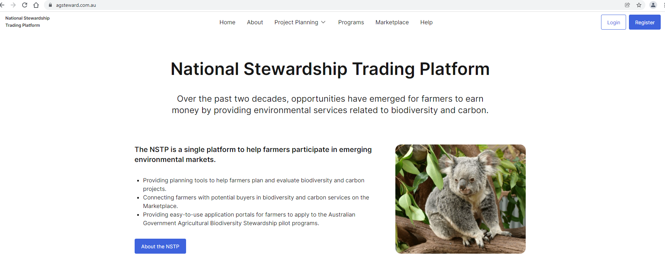

- A pop up box will appear. Enter your email address and click send verification notification code. An email with a code will be sent to your email address. This step authenticates users of the platform. Please use an email address you check regularly as it will be linked to your account and used for any correspondence relating to your listings or projects.
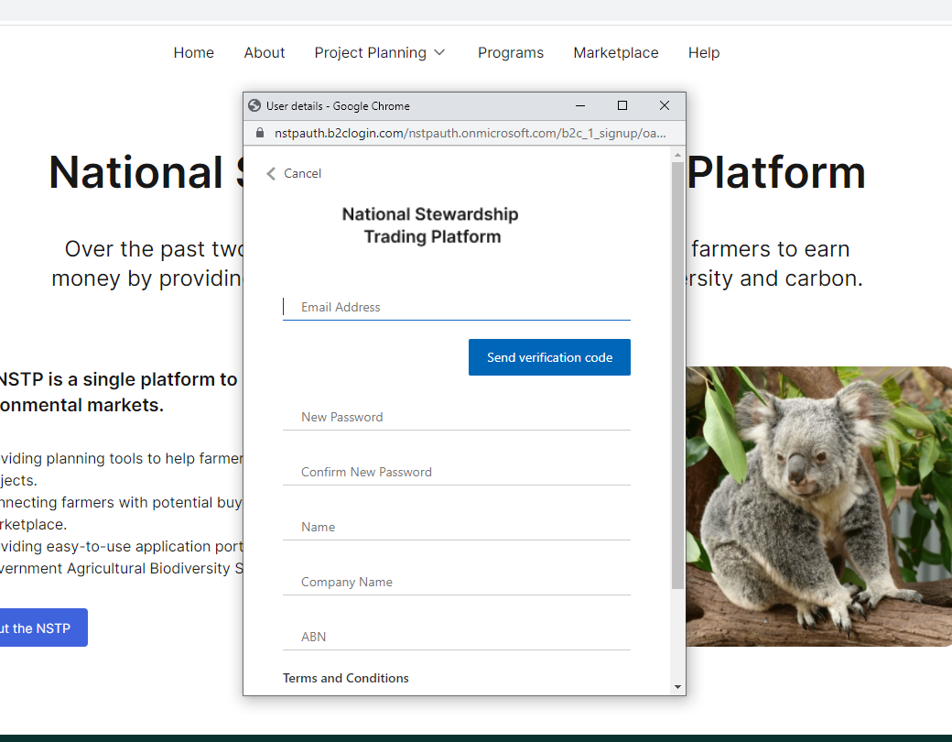
The email you receive will look like this.
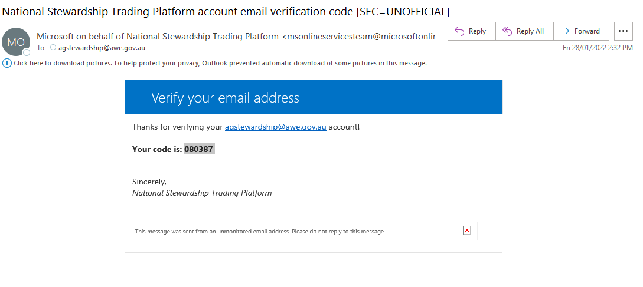

- Enter the verification code and click verify code.
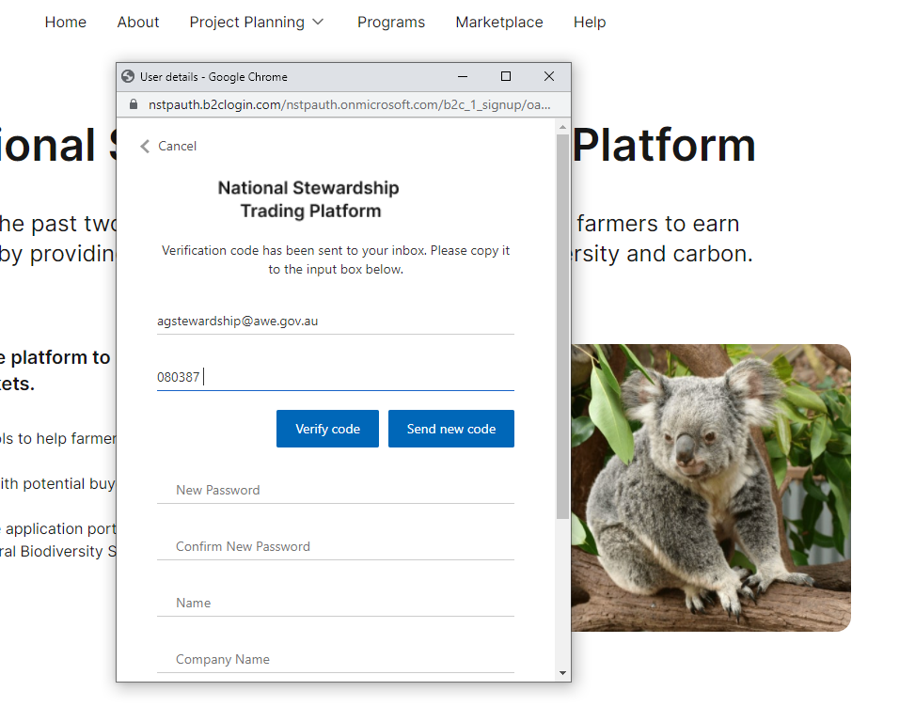

- Once verified proceed to enter a password, your name, company and your ABN. You require a current ABN to register an account. Your password must have at least 3 of the following:
- a lowercase letter
- an uppercase letter
- a digit
- a symbol
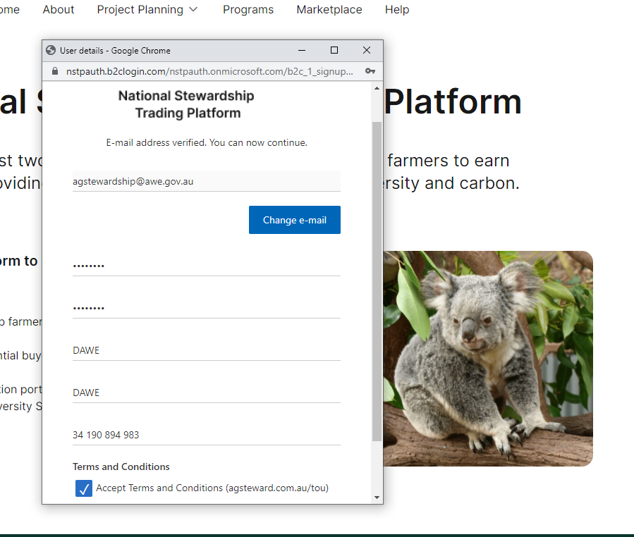

- Read site terms of use found at agsteward.com.au/terms-of-use. Before listing on the platform you must understand the rules and your responsibilities as a listing owner.

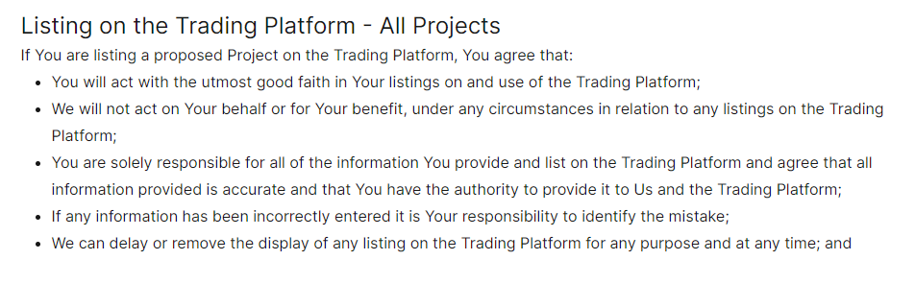

- You are now registered and can log back in at any time. You will see your details in the top right of the page when logged in. As a registered user you can create buy or sell listings on the marketplace, contact other users about their listings and create and save projects using the planning tool.
