NEW SOUTH WALES
COMMERCIAL KANGAROO HARVEST MANAGEMENT PLAN

2017 – 2021

© Copyright Office of Environment and Heritage on behalf of State of NSW
The Office of Environment and Heritage and the State of NSW are pleased to allow this material to be reproduced in whole or in part for educational and non-commercial use, provided the meaning is unchanged and its source, publisher and authorship are acknowledged.
Published by:
Office of Environment and Heritage
Department of Planning and Environment (NSW)
59-61 Goulburn Street, Sydney, NSW 2000
PO Box A290, Sydney South, NSW 1232
Phone: 9995 5000 (switchboard)
Phone: 131 555 (environment information and publications requests)
Phone: 1300 361 967 (national parks, climate change and energy efficiency information, and publications requests)
Fax: 9995 5999
TTY: 9211 4723
Email: info@environment.nsw.gov.au
Website: www.environment.nsw.gov.au

Citation This document should be cited as:
Office of Environment and Heritage (NSW) 2017, New South Wales Commercial Kangaroo Harvest Management Plan 2017–2021, Office of Environment and Heritage, Department of Planning and Environment (NSW), Sydney.

ISBN 978-1-76039-142-3
OEH2015/0705

Table of Contents
Definitions iii
1. Introduction 1
2 Legislative framework 1
3. Biology, ecology and conservation of kangaroos 3
3.1 Red kangaroo 5
3.2 Eastern grey kangaroo 5
3.3 Western grey kangaroo 6
3.4 Common wallaroo 6
4. Assessment of activities and environmental impacts 7
4.1 Target taxa and conservation status 7
4.2 Environmental Impact Assessment of activities covered by this Plan 7
4.3 Assessment of threats and impacts of commercial harvest 8
4.4 Assessment of impact to population numbers and other species 10
4.5 Certain indigenous rights not affected 10
5. Controls to manage, mitigate and monitor commercial harvest 12
5.1 Animal welfare and assessment of welfare impacts 12
5.2 Ecological sustainability 13
5.3 Restriction of harvest area (no-harvest sanctuaries) 14
5.4 Employing the precautionary principle 14
5.5 Compliance and regulation 14
5.6 Monitoring and reporting 15
5.7 Raising community awareness 15
6. Monitoring and reporting 20
References 21
Appendix 1 – Setting and applying harvest thresholds 24
List of figures
Figure 1: NSW kangaroo management zones for allocation and monitoring of quota per species. 3
Figure 2: Distribution of eastern grey kangaroo, wallaroo, red kangaroo, and western grey kangaroo 4
Figure 3: Fluctuation in absolute NSW kangaroo populations between 1975 and 2015. 8
Figure 4: Histogram of a theoretical population of kangaroos. 25
Figure 5: A theoretical distribution after z-score transformation. 25
Figure 6: Example of setting harvest thresholds for red kangaroos in Zone 2. 25
Figure 7: 10,000 simulations for a population fluctuating over 20 years. 27
Figure 8: Simulated population as described for Figure 7 28
List of Tables
Table 1: Conservation status of the kangaroo species across relevant endangered species lists. 7
Table 2: Threats and issues pertinent to the conservation status of kangaroos. 9
Table 3: Potential impacts of the commercial harvest on other species, habitats and ecosystems. 11
Table 4: Methods used by OEH to comply with the RSPCA Australia sustainable use model. 12
Table 5: Actions and indicators for achieving the plan’s objectives 16

Definitions
Definitions
Carcass | The entire body (including the skin) of the kangaroo, excluding the head and viscera.
Chiller premises | A refrigerated facility used for the temporary storage of kangaroo carcasses until collection and transport to a processing works.
Commercial operators | Kangaroo carcass processors, chiller premises operators and harvesters.
Harvester | A person registered with and authorised by the NSW Office of Environment and Heritage (OEH) to harvest kangaroos for commercial purposes.
Kangaroo | The kangaroo species that can be utilised in accordance with this management plan: the red kangaroo (Macropus rufus), western grey kangaroo (M. fuliginosus), eastern grey kangaroo (M. giganteus) and wallaroo (M. robustus robustus).
Landholder | The owner or occupier of specified lands.
National Code of Practice for the Humane Shooting of Kangaroos and Wallabies for Commercial Purposes | The National set of standards endorsed by the Natural Resource Management Ministerial Council in 2008 to ensure the minimum of pain is inflicted to kangaroos and wallabies being harvested. This code is enforced by all state governments managing commercial kangaroo harvesting programs.

1. Introduction
The purpose of this plan is to provide a management framework for the commercial harvest of kangaroos in NSW. In Australia, the export of kangaroo products requires Commonwealth Government approval under the Environment Protection and Biodiversity Conservation Act 1999 (EPBC Act). To satisfy requirements of the EPBC Act, the primary objectives of this plan are:
- to ensure kangaroo populations in NSW remain ecologically sustainable; and
- to ensure the methods of harvesting kangaroos for commercial use are humane.
The plan applies to the commercial harvesting of red kangaroo (Macropus rufus), western grey kangaroo (M. fuliginosus), eastern grey kangaroo (M. giganteus), and common wallaroo (M. robustus robustus) within NSW. Where the term kangaroo is used throughout this document, it refers to all of the aforementioned macropod species and the wallaroo subspecies.
Kangaroos are protected in NSW under the National Parks and Wildlife Act 1974 (NPW Act). The use of kangaroos is regulated under the NPW Act and the National Parks and Wildlife Regulation 2009 (NPW Regulation). OEH administers the commercial kangaroo harvest in accordance with the NPW Act and NPW Regulation. Activities in this plan are consistent with the International Union for Conservation of Nature (IUCN) recommendation 18.24, which provides that ‘the ethical, wise and sustainable use of some wildlife can provide an alternative or supplementary means of productive land use, and can be consistent with and encourage conservation, where such use is in accordance with the appropriate safeguards’ (IUCN 1990).
This plan only relates to the commercial harvest of kangaroos on privately owned land within NSW. This plan does not provide a framework for the management of kangaroos within protected areas, and this plan does not regulate non-commercial culling of kangaroos in NSW for damage mitigation purposes. This plan is current for a maximum of five years.
This plan prohibits the taking of kangaroos for their skin only. The OEH will implement this plan, and is committed to engaging with the community and industry to ensure the objectives of the plan are met. With the approval of the Commonwealth Minister for the Environment and Energy this management plan is current for a maximum five-year period from 01 January 2017 to 31 December 2021.

2. Legislative framework
Commonwealth Environment Protection and Biodiversity Conservation Act 1999 (EPBC Act) and Regulations
The EPBC Act requires the development and approval of wildlife trade management plans in order for permits to be issued for the commercial export of wildlife products. Export of wildlife products must meet the following objectives (Part 13A):
- to ensure compliance with the Convention on International Trade in Endangered Species of Wild Fauna and Flora (CITES) and the Biodiversity Convention;
- to protect wildlife that may be adversely affected by trade;
- to promote the conservation of biodiversity in Australia and other countries;
- to ensure that any commercial utilisation of Australian native wildlife for the purposes of export is managed in an ecologically sustainable way;
- to promote humane treatment of wildlife;
- to ensure ethical conduct during any research associated with the utilisation of wildlife; and
- to ensure the precautionary principle is taken into account in making decisions relating to the utilisation of wildlife.
The EPBC Act states that the Commonwealth Minister responsible for the environment may approve a wildlife trade management plan for a maximum of five years. The EPBC Act specifies that such approval must be given only if the Minister is satisfied that:
- the plan is consistent with the objects of Part 13A of the EPBC Act (above);
- an assessment of the environmental impacts of the activities in the plan has been undertaken;
- the plan includes management controls directed towards ensuring the impacts of the activities covered by the plan are ecologically sustainable;
- the activities in the plan are not detrimental to the species to which the plan relates or any relevant ecosystem; and
- the plan includes measures to mitigate, monitor and respond to the environmental impacts of the activity covered by the plan.
In deciding whether to declare a plan, the Minister must also have regard to whether:
- legislation relating to the protection, conservation or management of the species to which the plan relates is in force in the State or Territory concerned;
- the legislation applies throughout the State or Territory concerned; and
- in the opinion of the Minister, the legislation is effective.
In deciding whether to declare a plan, the Minister must be satisfied that if an animal is killed, it is done in a way that is generally accepted to minimise pain and suffering. Animal welfare standards for the commercial harvesting of kangaroos are detailed in the National Code of Practice for the Humane Shooting of Kangaroos and Wallabies for Commercial Purposes. All kangaroos must be taken in accordance with this Code or any subsequent relevant nationally-endorsed codes that replace that document.
NSW National Parks and Wildlife Act 1974 (NPW Act) and Regulations
The NPW Act and the NPW Regulation make provisions for licensing of a range of activities relating to the commercial harvesting of kangaroos in NSW.
Kangaroos can be taken only in accordance with this management plan under a licence issued by OEH. Licences may be issued under Part 9 of the NPW Act to land owners (s121), harvesters (s123), fauna dealers (s124), skin dealers (s125), and for importing or exporting kangaroos or kangaroo products (s126) to or from NSW. OEH have the authority to attach conditions and restrictions to these licences under section 133 of the NPW Act. Tags are issued as a condition of licences, in accordance with the NPW Regulation Part 6, Division 1 (s53).
Commercial harvesting of kangaroos in NSW is restricted to the kangaroo management zones illustrated in Figure 1, which also shows where each species is permitted to be harvested. Within the life of this plan new kangaroo management zones may be opened to meet market demand, on the basis of kangaroo population surveys and criteria in the EPBC Act. In the event of changes to biodiversity legislation in NSW, it may be necessary to write a new plan for public exhibition, consistent with EPBC Act requirements.

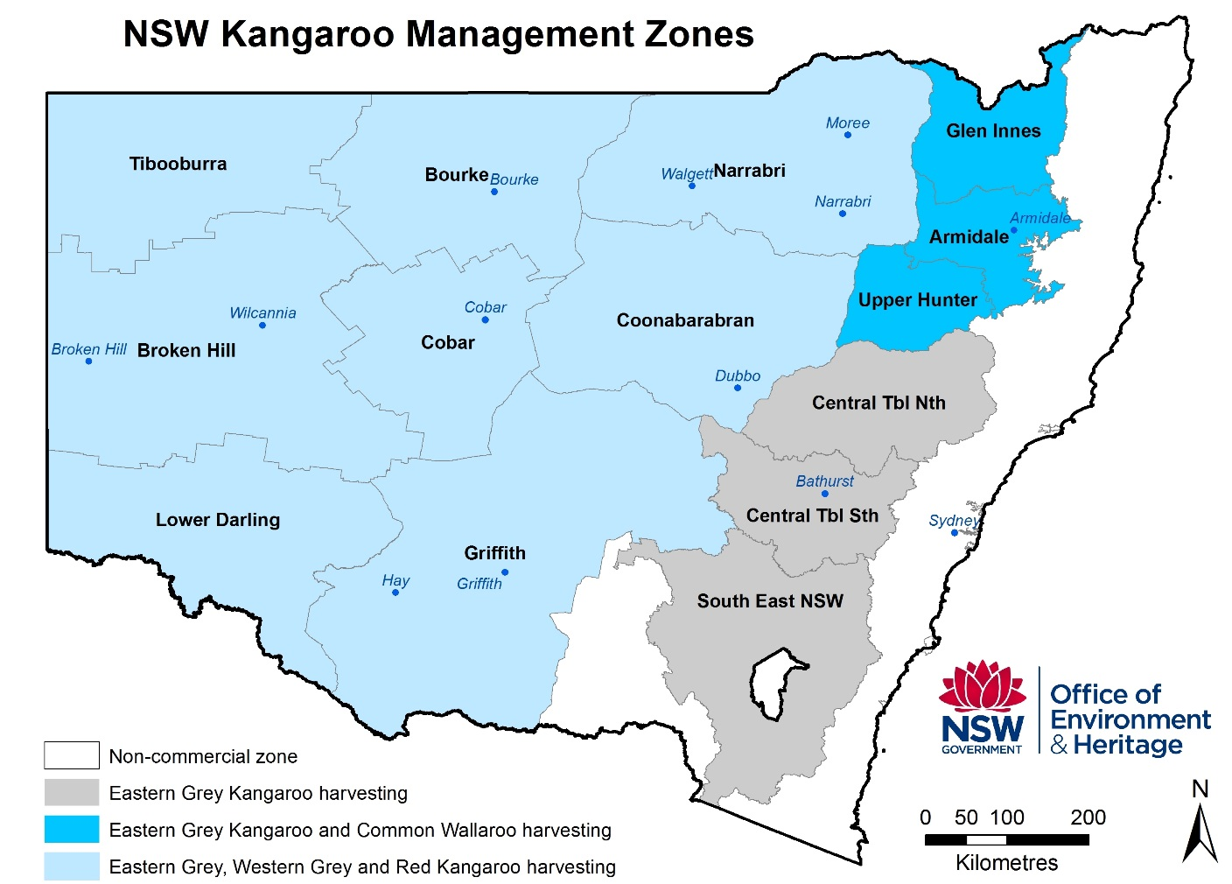
Figure 1: NSW kangaroo management zones for allocation and monitoring of quota per species.

3. Biology, ecology and conservation of kangaroos
The biology, ecology, conservation status, threats and issues relating to the conservation and harvesting of kangaroos have been comprehensively documented (Caughley et al. 1987, Dawson 1995, and Hacker and McLeod 2003).The four kangaroo species available for commercial harvesting in NSW are abundant over a broad area of Australia and NSW (Figure 2). The red kangaroo, western grey kangaroo and eastern grey kangaroo comprise approximately 97 per cent of the commercial harvest in NSW, and are particularly common over pastoral areas of western NSW. The common wallaroo is the most widely distributed macropod species across Australia.
The provision of permanent watering points for livestock is believed to be the main reason kangaroos are more likely to be limited by food than water (Newsome 1965a, Oliver 1986, Hacker and McLeod 2003). Kangaroos are robust animals and populations respond directly to climatic variation (Caughley et al. 1987). Population monitoring by OEH shows populations in NSW decline during dry climatic conditions and increase in wet climatic conditions. Dry conditions appear to have caused a population decline from approximately 15.5 million kangaroos in 2002 to approximately 5.5 million kangaroos in 2005. The population then increased in size and density, over the course of eight years, to approximately 15.3 million kangaroos by 2013 and more than approximately 16 million by 2015.

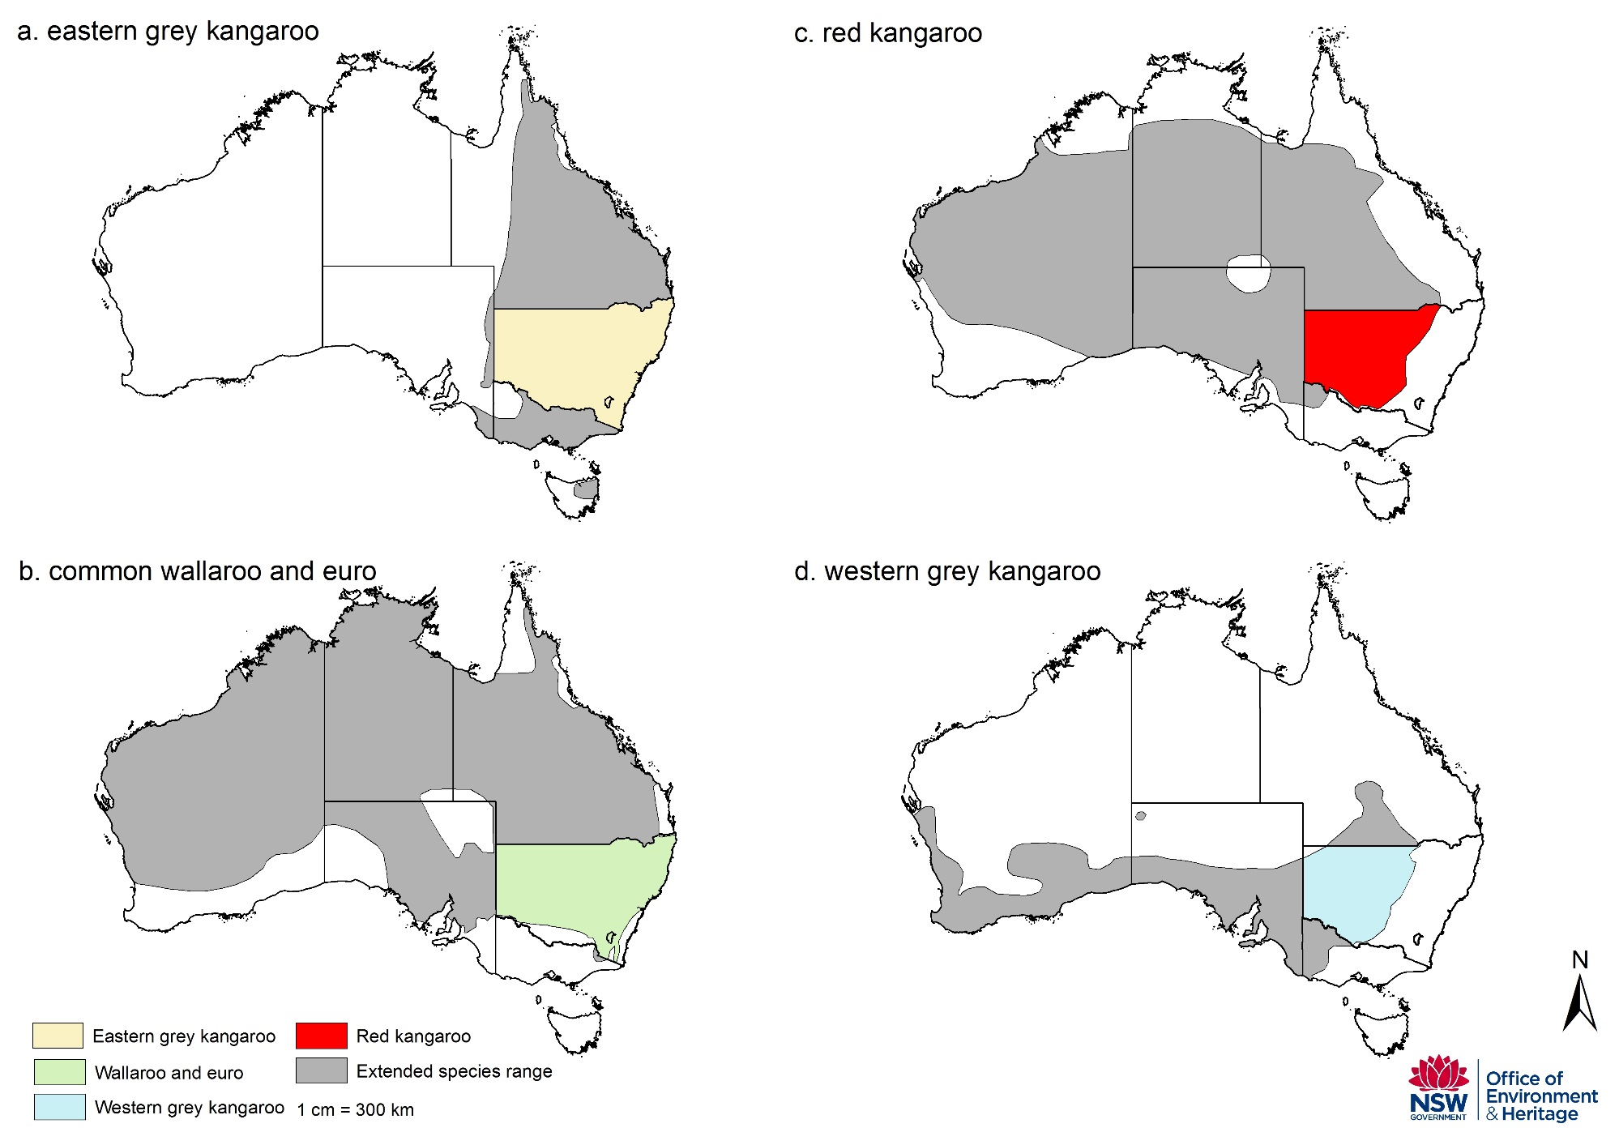

Figure 2: Distribution of eastern grey kangaroo Macropus giganteus (a.), wallaroo M. robustus ssp. (b.), red kangaroo M. rufus (c.), and western grey kangaroo M. fuliginosus (d.)

3.1 Red kangaroo (Macropus rufus)
Red kangaroo is distributed over much of dry, inland Australia and is the only species exclusively restricted to the arid zone (Tyndale-Biscoe 2005). This distribution reflects the interaction between mean annual precipitation and mean annual temperature (Caughley et al. 1987). Red kangaroo occupies a wide range of habitats including mulga and mallee scrub, scrublands, woodlands, grasslands and desert (Caughley 1964; Russell 1974; Johnson & Bayliss 1981; Low et al. 1981; Short et al. 1983; Strahan 1995). Strahan (1995) and Russell (1974), however, described a preference of this species for open plains habitat. The red kangaroo is herbivorous and has a preference for green herbage including grasses and dicotyledonous plants (Griffiths & Barker 1966; Chippendale 1968; Storr 1968; Bailey et al. 1971; Ellis 1976).
The reproductive biology of red kangaroo has been thoroughly studied (Frith & Sharman 1964; Newsome 1964a, b, 1965b; Sharman 1964; Sharman & Pilton 1964). Females are fertile throughout the year, although periods of extreme drought may lead to suppression of the oestrus cycle, which is correlated with body condition (Moss & Croft 1999). Females can come into breeding condition almost immediately after drought-breaking rains.
Red kangaroo is a gregarious species (Kirkpatrick 1967) and although relatively large groups may sometimes form, these groups are unstable in their composition (Croft 1980). Several studies have examined the movement patterns of red kangaroo (Frith 1964; Bailey 1971; Denny 1980; Croft 1980; Priddel 1987). These studies indicated the majority of the population is relatively sedentary. Individual home ranges have been found to overlap. In western NSW, Croft (1991) found that red kangaroos had weekly home ranges of 259 to 560 hectares.
The annual OEH aerial population surveys provide a means of assessing population dynamics and the response of macropod populations to environmental conditions, particularly rainfall. Caughley et al. (1984) found that, at average annual rainfall red kangaroos increase 35 per cent per annum in the east and 30 per cent per annum in the west. When rainfall is below average, kangaroo numbers decline. The dingo is the main predator of red kangaroos (Caughley et al. 1980) where dingoes and red kangaroos co-exist.

3.2 Eastern grey kangaroo (Macropus giganteus)
Eastern grey kangaroo is distributed across eastern Australia from northern Queensland to Tasmania between the inland plains and the coast (Russell 1974; Strahan 1995). The distribution corresponds with areas where rainfall either has little seasonal trend or where rainfall in summer exceeds rainfall in winter (Caughley et al. 1987). Eastern grey kangaroos are common and occupies a range of habitats including woodland, scrublands, open forest, and semi-arid mallee and mulga scrubs (Caughley 1964; Calaby 1966; Bell 1973; Russell 1974; McCann 1975; Taylor 1980; Hill 1981; Strahan 1995; Southwell 1987).
It is likely that the development of the pastoral industry has led to an increase in the abundance of this species (Poole, in Strahan 1995). Population densities of eastern grey kangaroos may be increasing in the rangelands, due partly to the increase in watering points for sheep and cattle (Tyndale-Biscoe 2005) and pasture availability.
The eastern grey kangaroo prefers grasses such as spinifex (Triodia mitchelli). Breeding occurs throughout the year but there is a peak of births in summer (Kirkpatrick 1965, 1967; Poole 1975; Kirsch & Poole 1972).
The social behaviour of eastern grey kangaroo reflects their seasonal breeding and preference for woodland habitat. Eastern grey kangaroos are gregarious (Southwell 1984a), forming groups that are unstable in their composition (Southwell 1984b).
Compared with red kangaroos, eastern grey kangaroos show more tendency to return to previously occupied parts of their range (high site fidelity), and the species occupies well-defined, overlapping home ranges (Jarman and Taylor 1983; Jarman & Southwell 1986). Both sexes are relatively sedentary but genetic analyses showed there was only weak genetic structuring of populations (Zenger et al. 2003). This indicates there can be high levels of dispersal at both a local (<50 kilometres) and regional (50–230 kilometres) scale.
Populations have been found to have a maximum rate of increase of 35 per cent per annum where rainfall was above average, and a rate of increase of 25 per cent per annum at average rainfall. Populations declined only when rainfall was well below average (Caughley et al. 1984).
Eastern grey kangaroos are subject to predation by the dingo (Robertshaw & Harden 1985; Purcell 2010a,b). Removal of dingoes from areas inhabited by eastern grey kangaroo has increased the effect of eastern grey kangaroos on those ecosystems (Colman et al 2014).

3.3 Western grey kangaroo (Macropus fuliginosus)
The western grey kangaroo distribution extends from Western Australia across the south of the continent, northwards through western NSW and into a small area of southern central Queensland. This distribution corresponds to areas of seasonal winter rainfall (Caughley et al. 1987). Where the range of western grey kangaroos overlaps with eastern grey kangaroos, the latter are more abundant..
Western grey kangaroos feed mainly on grasses (Coulson and Norbury 1988) and shift to forbs and shrubs as pasture biomass declines (Norbury 1987). Western grey kangaroos also show higher site fidelity than red kangaroos and occupy relatively small home ranges that overlap extensively (Priddel 1987, Priddel et al. 1988a, b).
Western grey kangaroos do not exhibit embryonic diapause (Poole, in Strahan 1995).

3.4 Common wallaroo (Macropus robustus)
The wallaroo has the widest distribution of the larger macropod species. It occurs across the entire mainland continent and is absent only from the extreme northern and southern portions of Australia (Russell 1974; Strahan 1995). Despite their relative abundance, wallaroos are infrequently seen because of their association with mountains and rocky hill country (Dawson 1995). Two wallaroo subspecies are found in NSW – the common wallaroo (M. robustus robustus), and the euro, or inland wallaroo (M. robustus erubescens) the geographic area of demarcation and the genetic characterisation are speculative (Clancy and Croft 2008). Populations of euros are not surveyed for commercial harvesting due to topography of the area they inhabit, and any reports of increasing population size are anecdotal. To permit harvesting of euros, populations will need to be surveyed to establish precise and accurate monitoring methods and population estimates.
The common wallaroo is found on the eastern and western slopes of the Great Dividing Range and the euro is found in the drier areas of the state (Dawson 1995). Under this plan, only the common wallaroo populations in the Northern Tablelands zones are surveyed and have set quotas for harvesting.
The wallaroo occupies a wide range of habitats but prefers areas with steep escarpments, rocky hills and stony rises (Calaby 1966; Kirkpatrick 1968; Russell 1974; McCann 1975; Strahan 1995; Taylor 1985). Newsome (1975) considers the alteration of vegetation communities to sub-climax spinifex by the grazing of sheep in north-west Western Australia has enabled wallaroos to inhabit previously unoccupied valley areas.
In the NSW tablelands, wallaroos have a diet consisting primarily of grasses (Ealey and Main 1967, Storr 1968, Ellis 1976, Squires 1982, Taylor 1983b). In the arid Pilbara region of Western Australia, the wallaroo was found to prefer spinifex (Ealey & Main 1967).

Wallaroos are opportunistic breeders. Under normal conditions females can breed continuously, giving birth to a single young every eight to nine months (Sadlier 1965, Ealey 1963, Kirkpatrick 1968, Poole and Merchant 1987). If drought persists for more than six months, wallaroos stop breeding until the drought breaks (Tyndale-Biscoe 2005).
The wallaroo is less gregarious than the other large macropod species (Kirkpatrick 1968, Croft 1981, Taylor 1982). Social groups remained relatively stable throughout each day, but group size and composition varied between days (Croft 1981). It is relatively sedentary, occupying small home ranges that overlap broadly with those of other individuals (Ealey 1967, Croft 1981, Jarman and Taylor 1983). Home ranges remain stable from year to year.

4. Assessment of activities and environmental impacts
Section 303FO of the EPBC Act 1999 provides a list of details required for environmental assessment to determine impacts of the wildlife trade operations. These include species status, threats to habitat, and impact of the activities.

4.1 Target taxa and conservation status
This plan relates to four large and abundant kangaroo species. The animals are protected as native species and declared common throughout their ranges. No commercially harvested kangaroo species in NSW is listed as threatened or endangered under State or Commonwealth legislation, nor in international listings (Table 1).
Table 1: Conservation status of the kangaroo species across relevant endangered species lists.
Species |  | NSW legislation | Commonwealth | IUCN red list§ | CITES
Red | status | protected | - | least concern | -
Red | trend | common | - | stable | -
Eastern | status | protected | - | least concern | -
Eastern | trend | common | - | stable | -
Western | status | protected | - | least concern | -
Western | trend | common | - | increasing | -
Wallaroo | status | protected | - | least concern | -
Wallaroo | trend | common | - | stable | -
§The IUCN Red List of Threatened Species. Version 2015.2. <www.iucnredlist.org>. Downloaded on 19 August 2015.
Convention on International Trade in Endangered Species of Wild Fauna and Flora 2015 The CITES Appendices, Appendices I, II and III Valid from 5 February 2015. Available: https://www.cites.org/eng/app/appendices.php Accessed: 19 August 2015

4.2 Environmental Impact Assessment of activities covered by this Plan
In the context of commercial kangaroo harvesting in NSW, OEH monitors:
- population
- issues relating to the population biology, conservation and harvesting of kangaroos
- impacts of harvesting on kangaroos, as well as other species, habitats and ecosystems

Assessment of impact from harvest combined with environmental factors
Kangaroo population fluctuation and effects of harvesting are assessed using robust methods of population monitoring. A full description of methods for surveying populations are available on the OEH website.
The Kangaroo populations are strongly influenced by environmental conditions. Figure 3 shows kangaroo population fluctuations in relation to quotas and the number of kangaroos harvested. The kangaroo harvest has a negligible impact on kangaroo population dynamics (Hacker and McLeod 2003). After 40 years of commercial harvesting in NSW, kangaroos remain common, and populations remain ecologically sustainable.

7-Sample blocks I 200m strip count I 100m strip count
Survey method>
Figure 3: Fluctuation in absolute NSW kangaroos populations between 1975 and 2015. The graph shows temporal variation of kangaroo populations in relation to wet and dry periods during commercial harvest activities. The pattern of a slower population recovery, following sudden decline of kangaroo populations, is similar throughout the period. Kangaroo populations have not been effected by the rate of harvest, under the method used to set a quota. Survey methods to estimate population size have varied over time from monitoring seven sample blocks (striped line), to 200-metre (black line) and 100-metre strip transects (dotted line).

4.3 Assessment of threats and impacts of commercial harvest
In the context of commercial kangaroo harvesting in NSW, threats to the conservation of harvested kangaroo species are limited (see Table 2). Management for conservation and for commercial harvesting of kangaroos is well understood. With more than 40 years of commercial kangaroo harvesting in NSW, ecologically sustainable populations of harvested kangaroo species have been maintained across their range, and the ranges of the eastern grey and western grey kangaroo species have been expanding. Commercial harvesting is not considered to have an adverse impact on the genetic integrity or conservation status of kangaroos in NSW.

Table 2: Threats and issues pertinent to the conservation status of kangaroos.
Threats | Comments | Selected References*
Drought | Rainfall affects plant productivity and water availability. It is the single most important factor affecting kangaroo populations. Dry climatic conditions can greatly reduce kangaroo numbers. Kangaroos, however, are well adapted to a dynamic environment and populations have recovered after drought-driven population declines. Therefore drought is not considered a threat to the conservation status of kangaroos amidst commercial harvesting with conservative quotas. | Caughley et al. 1985; Robertson 1986; Bayliss 1987; Cairns & Grigg 1993;; McCarthy 1996; Cairns et al. 2000; Pople 2003; Dawson et al. 2007; Underhill et al. 2007; Fensham & Fairfax 2008; Pople et al. 2010;
Disease | A range of parasites and pathogens affect kangaroo populations, including cystic hydatid disease, Cryptospiridium sp., Ovine Johnes Disease, Toxoplasmosis and Herpes. Effects on individual kangaroos range from little impact to severe clinical disease and mortality. Epidemics have caused significant short-term reductions in population size and density in particular areas. Diseases are not considered important agents of mortality in kangaroos at the population level. | Kirkpatrick 1985; Caughley 1987a; Speare et al. 1989; Gilroy et al. 1999; Pople & Grigg 1999; Power et al. 2005; Banks et al. 2006; Barnes et al. 2007; Ryan et al. 2008; Smith et al. 2008; Garnick et al. 2009; Parameswaran et al. 2009; Power et al. 2009; Cleland et al. 2010; Banazis et al. 2010
Flood | Flooding has been found to affect the short-term distribution and abundance of kangaroos. Flooding is not considered a threat to the conservation status of kangaroos. Flooding has been associated with occasional localised or widespread viral diseases that may cause populations to decline. | Clancy et al. 1990; Choquenot 1991; Hale 2004
Habitat loss and modification | The three largest species of kangaroos have benefited from habitat modification. Population size has generally increased and distribution of species has increased in area, due principally to pasture availability. Conversely, kangaroo populations have generally declined where there is intensive agriculture, urbanisation or extensive clearing. Despite more than 200 years of heavy exploitation and clearing of the land, the larger kangaroos have maintained or increased in abundance. Habitat loss and modification are not considered threats to the conservation status of kangaroos. | Short & Grigg 1982; Calaby & Grigg 1989; Dawson et al. 2004; Pople et al. 2010;
Climate change | Impacts on kangaroos from climate change are not well documented. Effects on individuals include changes to forage composition, seasonal events, fecundity, survival and behaviour, while effects on populations include changing species abundance, distribution, and genetics. | Ritchie & Bolitho 2008; Dunlop & Brown 2008; Jonzen et al. 2010
Harvesting – general | In more than 40 years of managed commercial harvesting activities, populations of the harvested kangaroo species have been maintained across their natural range. Furthermore, the distribution of eastern and western grey kangaroos have expanded. Harvesting is not considered a threat to the conservation status of kangaroos. | Cairns & Coombs 1992; Calaby & Grigg 1989; Dawson et al. 2004; Grigg & Pople 2001; Pople et al. 2007; Viggers & Hearn 2005
Harvesting  – genetic impacts | Kangaroo populations are panmictic, meaning genetic diversity is high, no genetic traits will be lost from selective or non-selective harvesting, and phenotypic traits will not be affected. Population harvesting, especially non-random or selective harvesting, has the potential to alter the genetic structure and genetic diversity of certain species dependent on intensity and selectivity. None of the theoretical, empirical or modelled evidence of kangaroo genetic population structure in NSW indicates kangaroos will be affected by population harvesting. | Clegg et al. 1998; Hacker & McLeod 2003; Hacker et al. 2003, 2004; Hale 2001, 2004; Tenhumberg et al. 2002, 2004; Zenger et al. 2003; Allendorf et al. 2008; Neaves et al. 2009, 2010; Mysterud 2011
Predation | In some circumstances dingoes (Canis lupus dingo) have been shown to limit kangaroo populations, and there is increasing evidence for this species having a regulatory effect. Other predators such as foxes (Vulpes vulpes) and wedge-tailed eagle (Aquila audax) do not appear to exert much influence on the harvested species of kangaroo. Predation is not considered a threat to the conservation status of kangaroos. | Caughley et al. 1980; Corbett & Newsome 1987; Thompson 1992; Banks et al. 2000; Pople & Page 2001; Letnic & Koch 2010; Fillios et al. 2010; Purcell 2010a,b

4.4 Assessment of impact to population numbers and other species
Landscape changes since European settlement have favoured kangaroos and distributions of individual species have increased. Commercial harvest is not considered a threat to population numbers due to the relatively small size of the harvest and the ability to limit or stop the harvest if required (Hacker and McLeod 2003).
OEH undertakes monitoring of kangaroo population numbers, setting of quotas and identification of thresholds to ensure the harvest is ecologically sustainable (see Appendix 1). Kangaroo populations are monitored using scientifically robust and peer reviewed methods of aerial wildlife population surveying (Barker 2008; Cairns et al. 2008; Fewster & Pople 2008; Fleming and Tracey 2008; Hone 2008; Laake et al. 2008; Pople 2008). Size and density of kangaroo populations are surveyed annually or triennially as appropriate to the survey method (Payne 2008). A full description of methods for surveying populations is available on the OEH kangaroo management web page.
Maximum harvest quotas are set at 15 per cent of the population for grey kangaroo and common wallaroos, and 17 per cent of the population for red kangaroos (Hacker et al. 2004; McLeod et al. 2004). OEH manages the commercial harvest of kangaroos using a proportional harvesting strategy (see Appendix 1), with quotas set annually based on population monitoring. This strategy has been well studied and is considered to be an effective approach to managing a fluctuating population (Caughley 1987; Engen, Lande et al. 1997; McLeod and Pople 1998). The tagging system (licensees are required to affix a tag to every carcass harvested) enables OEH to track the harvest against the quota.
Thresholds used by OEH are reference points for minimum population densities to manage the harvest if the quotas are being approached or met and are described in further detail at Appendix 1. Where populations have declined below certain population estimates, harvesting of that particular species will be reduced (for instance, if the normal quota is 15 per cent then it may be reduced to 10 per cent). Thresholds were used to manage eastern grey kangaroo populations on the edge of their normal range in 2014. In substantial population declines, quotas can be suspended until the population increases to determined densities.
Minimum carcass weights are prescribed in licences to ensure that the harvest does not impact on population dynamics. Average carcass weights are monitored monthly to detect any change in population health through observation of a sudden drop in carcass weights. This is also used as a trigger to suspend harvest in the affected area so that an assessment of population health can be made. Apart from the non-commercial zone, refuges and areas of no commercial harvest exist within public land including national parks, state forests and crown land across the state. Therefore, impacts of commercial harvesting on landscapes, ecosystems and individual species of flora and fauna were reviewed and identified to be minimal or low risk (Table 3).

4.5 Certain indigenous rights not affected
While the EPBC Act allows for commercial utilisation of native wildlife in accordance with the objectives of Part 13A, it is not intended to prevent indigenous persons from carrying out traditional use of wildlife. To avoid doubt, nothing in this plan prevents an indigenous person from continuing in accordance with law the traditional use of an area for:
- hunting (except for the purposes of sale); or
- food gathering (except for the purposes of sale); or
- ceremonial or religious purposes.

Table 3: Potential impacts of the commercial harvest on other species, habitats and ecosystems.
Potential Impacts | Comments | Selected References*
Reduction in soil quality and land stability | There is no evidence to demonstrate a reduction in soil quality or land stability as a consequence of the commercial kangaroo harvest as harvesters generally operate on already-formed tracks. Moreover, kangaroo harvest off cuts have been shown to contribute to soil nutrient retention and cycling, thereby improving soil quality. | Wilson & Read 2003
Detrimental effects on water bodies, watercourses, wetlands and natural drainage systems | There is no evidence that suggests the commercial kangaroo harvest will have detrimental effects on water bodies, watercourses, wetlands and natural drainage systems.
Vegetation clearing or modification | No vegetation is likely to be cleared or modified as a consequence of the commercial harvest. The commercial harvest may however provide indirect benefits to vegetation by potentially contributing to an integrated approach to reducing total grazing pressure or facilitating the retention of vegetation by private landholders. | Grigg 1988, 1995; Fisher et al. 2004;
Detrimental effects on threatened flora species, populations, or their habitats | There is no evidence that the commercial kangaroo harvest has a detrimental effect on threatened flora species, populations or their habitats.
Endangering, displacing or disturbing native fauna, or creating a barrier to their movement | There is no evidence to demonstrate that native fauna are endangered, displaced or disturbed as a consequence of the commercial kangaroo harvest. The commercial harvest is, moreover, unlikely to create a barrier to the movement of native fauna. Kangaroo harvest off cuts are however utilised by birds of prey thereby benefiting these species. | Read & Wilson 2004
Detrimental effects on threatened fauna species, populations, or their habitats | There is no evidence that the commercial kangaroo harvest has a detrimental effect on threatened fauna species, populations, or their habitats. There may be indirect effects on threatened fauna species and/or populations as a consequence of the commercial kangaroo harvest, however such effects are not likely to be significant (see section on introduced predators below).
Detrimental impacts on ecological communities of conservation significance | Ecological communities of conservation significance are unlikely to be impacted by the commercial kangaroo harvest.
Positive effects on introduced predators | Kangaroo harvest off cuts may be utilised by scavengers, including native and introduced predators. Carcasses may sustain populations of these scavengers. Scavengers also may prey upon threatened or endangered flora and fauna. Harvesters only operate on private land and many landholders participate in predator control programs. These control programs are limited to wildlife which may impact on agricultural productivity and do not address possible effects of, for instance, Australian ravens (Corvus ssp) on both common and threatened small mammals, reptiles and birds. Presently harvest off cuts are widely and randomly dispersed across the landscape. It is unlikely that the commercial kangaroo harvest will have more significant effects on threatened flora and fauna than would roadkill carcasses. | Saunders et al. 1995; Kay et al. 2000; Read & Wilson 2004
Positive effects on introduced herbivores | No research has been completed to show kangaroos outcompete introduced herbivores, including feral goats (Capra hircus), domesticated livestock and rabbits (Oryctolagus cuniculus) for resources.

5. Controls to manage, mitigate and monitor commercial harvest
OEH has established Memorandums of Understanding (MoU) with state and Commonwealth government departments to increase our capacity to ensure humane harvesting practices are implemented. The MoU with the Commonwealth Department of Agriculture and Water Resources Meat Exports Branch authorises them to report non-head shot kangaroos found in processing works. The MoU with NSW Department of Primary Industries Food Authority authorises them to report non–compliance events observed inside chiller premises during their inspections. In addition, OEH can report hygiene breaches to NSW Food Authority and regulates compliance with this framework in accordance with the Compliance Policy. The following controls provide a framework for managing humane harvesting standards and sustainable kangaroo population management in NSW.

5.1 Animal welfare and assessment of welfare impacts
All harvesters licenced through the Kangaroo Management Program are required to comply with the National Code of Practice for the Humane Shooting of Kangaroos and Wallabies for Commercial Purposes. Licenced harvesters are required to be accredited shooters and undergo competency testing every five years with the NSW Firearms Safety Training and Awareness Council. This testing ensures kangaroo harvesters can shoot humanely consistent with the National Code of Practice. Animals which are head-shot during a ground shooting activity is relatively humane based on the premise that there is virtually no welfare impact prior to death and the mode of death being instant when undertaken by a competent shooter in accordance with best practice (Sharp & Saunders 2011).
RSPCA Australia recently developed six steps to protect animal welfare under a sustainable use model (Jones in press). This model is a useful tool to aid decision making and assess animal welfare. To establish and maintain a social licence to operate wildlife harvesting operations, the operators need to show use of wildlife is justified, effective and humane. The six steps proposed by RSPCA Australia include Intention, Standards, Competency, Auditing, Incentives and Transparency. This management plan meets these steps using the methods described in Table 4.
Table 4: Methods used by OEH to comply with the RSPCA Australia Sustainable Use model.
Steps to Maintain Sustainable Use | OEH Methods
1. Intention  Commitment to animal welfare | Harvester accuracy tests, inter-government MoU and field audits
2. Standards  Best practice humane methods | Following National Code of Practice species specific allocation of quota via tags and properties for tracing carcasses. Only kangaroos which weigh >14kg are permitted to be harvested.
3. Competency  Operators are capable | Food authority training, accuracy tests
4. Auditing  Verify compliance of operators | Harvester returns, field audits, inter-government MoU
5. Incentives  Provide financial compensation | Compliance with regulations to avoid fines
6. Transparency  Open to public scrutiny | KMP information available on public webpage

In addition to adopting the RSPCA Australia Sustainable Use model, OEH is also implementing an education program to engage with industry professionals and to ensure compliance.
Male-only harvesting
The RSPCA Australia (2002) originally suggested male-only harvesting as a method to avoid cruelty to pouch young by stopping the harvesting of female kangaroos which was subsequently adopted by the industry.
Genetic evidence indicates however, that kangaroos are panmictic (Hale 2004), meaning there is so much genetic diversity that it would be highly unlikely, or even impossible, that male only harvesting will affect the National population. There is opportunity to research sex ratios and effect of harvesting but spatio-temperol variation would be difficult to quantify over time, habitat and environmental conditions.

5.2 Ecological sustainability
Kangaroo populations are monitored using best practice survey methods for the terrain (Payne 2008). Monitoring is undertaken for each species and for each management zone. Population monitoring data are used as the basis for setting quotas and monitoring population health.
The harvest of all four kangaroo species is monitored regularly throughout their range to identify threats and to enable early identification of abnormal population trends. Diseased animals can be traced to their origin through the tagging system and observations are investigated. The harvest can be regulated using methods including limiting or stopping the harvest if triggers are met (see Appendix 1).
In setting the quotas and analysing trends, OEH uses accepted population thresholds for each species. Quotas are set annually. The quota report is submitted to the Commonwealth Department of the Environment and Energy by 30 November and published on the OEH kangaroo management web page. The population counts determine the quota for the following calendar year, commencing on 1 January. Quotas are set per species and per zone (Figure 1). Quotas are set only when the kangaroo population trends are within the normal range. If there is any concern about kangaroo population trends the quota can be reduced or suspended.

Special quota

Special kangaroo harvest quotas will be set in accordance with the provisions of the New South Wales Commercial Kangaroo Harvest Management Plan 2017 – 2021.
A special quota for commercial kangaroo management zones will be set annually at a maximum of five percent of the population estimate of each kangaroo species in any one zone, and a maximum of 1.5 percent of the population of each species across all zones.
The sole purpose of special quota allocations is to provide for commercial utilisation of kangaroos that would be shot and left in the field under the normal non-commercial licensing system. The special quota will therefore minimise the number of kangaroos shot under non-commercial licences. The special quota can only be considered for release when the commercial quota for a particular kangaroo management zone has been fully issued, and will not be allocated in zones where the commercial harvest is reduced or suspended due to low populations.
The use of special quota will depend on one or more of the following:
- A commercial quota was set at the usual proportion for that species in that zone (i.e. Not reduced or suspended due to low populations)
- climatic trends and local conditions – for example, rainfall in the lowest five percent of historical records over the previous twelve months
- Western Lands de-stocking orders
- kangaroo population trends.
OEH will make the decision whether to make the special quota available at any particular time following consultation with the Kangaroo Management Advisory Panel and consideration of these factors.
Special quota allocations and the use of the special quota will be reported to the Commonwealth in the Quota Report and Annual Report.

5.3 Restriction of harvest area (no-harvest sanctuaries)
Restrictions on harvest areas are implemented through licence conditions. Kangaroos are permitted to be harvested only in kangaroo harvest management zones. Harvesting kangaroos from public lands is not permitted. The no-harvest areas are, by default, areas of sanctuary habitat for kangaroos. The zone based system has proven to be an effective and sustainable management tool for the kangaroo populations in NSW. Managing quota through a zone based system also assists to maintain the population threshold system to conserve kangaroos when population densities fall below identified thresholds (Appendix 1).

5.4 Employing the precautionary principle
Quotas, thresholds and targets are supported by the scientific literature (see Appendix 1) and are set conservatively to ensure populations will not be affected by harvesting rates. Population trends are monitored annually. Data are analysed to identify potentially adverse trends. Adverse, concerning or unexplained trends are investigated and acted upon with the aim of conserving kangaroo populations.

5.5 Compliance and regulation
To effectively regulate the NSW commercial kangaroo harvest, OEH implements a range of programs to promote voluntary compliance, and to identify and respond to non-compliance (see Table 5 for details). Compliance covers all of the activities which help support adherence to the law. This includes statutory mechanisms such as licences with conditions, engaging with industry and community to help prevent non-compliance, targeted auditing informed by intelligence, investigating reports of possible non-compliance, and taking appropriate enforcement action when non-compliance is detected.
OEH escalates its compliance response according to the seriousness of the non-compliance, and the culpability of the offender. OEH measures the performance of its compliance function so that it can continually improve its effectiveness, and identify emerging compliance issues. This approach enables OEH to accurately evaluate the overall effectiveness of the commercial kangaroo harvest management program, and to detect and respond to emerging risks.
OEH has established an MoU with the Commonwealth Department of Agriculture and Water Resources Meat Exports Branch and the NSW Department of Primary Industries Food Authority. Both of these departments inspect kangaroo carcasses either before being exported or in chiller premises respectively. Both report to OEH if they identify non-compliance events. OEH also receives non-compliance reports through NSW Enviroline and from other industry professionals. Reports received are prioritised for response using the OEH Regional Operations Compliance Risk Assessment Framework.
Compliance targets may vary and are based on risk assessments. On an annual basis OEH will inspect every chiller premises once per year, processing plants three times per year and conduct two field audits of licenced harvesters per year.
Before a harvester can be licenced to harvest kangaroos, they must provide OEH with certified copies of their firearms licence, firearms safety training and awareness accuracy test, game meat handling and hygiene certification and registration with Food Authority NSW.

5.6 Monitoring and reporting
Annual reports will be prepared to demonstrate compliance with this plan and to provide observations of the population from the OEH monitoring program. The annual report will report against the performance indicators provided in Table 1 to demonstrate the effectiveness of the management actions in meeting the objectives of this plan. Annual reports will be submitted by 31 March each year.
Quota reports will be prepared annually, to provide population estimates and quotas for each of the species in each management zone, and submitted to the Commonwealth Department of the Environment and Energy by 30 November each year. The reports will be published on the OEH kangaroo management website.

5.7 Raising community awareness
The Kangaroo Management Advisory Panel (KMAP) is established to provide information and engage with key stakeholders.
The following documents are published on the OEH website for each year/period:
- NSW Commercial Kangaroo Harvest Management Plan
- Annual Report – NSW Commercial Kangaroo Harvest Management Plan
- NSW Commercial Kangaroo Harvest Management Plan – Quota Report
- NSW Handbook for Kangaroo Harvesters.

Table 5: Actions and indicators for achieving the plan’s objectives.
Management action | Method | Performance indicators
Objective 1: To ensure animals are harvested or euthenised using humane methods
Implement the National Code of Practice for the Humane Shooting of Kangaroos and Wallabies for commercial purposes across all harvesting activity | Monitor requirements including:  - Firearms licence  - Accreditation under National code of practice  - Competency in firearms accuracy  - Self-reporting of non-compliance  - Risk-based approach to auditing compliance | 1a. 100% of licence holders have met shooter competency standards  1b. Reports received from chiller operators weekly  1c. Results of weekly reports assessed for any non- compliances  1d. Compliance response taken for identified non-compliances proportionate to the risk to program objectives
Reports through the Memorandum of Understanding with the Commonwealth Department of Agriculture and Water Resources Meat Exports Branch | Department inspects kangaroo carcasses before being exported. | 2. OEH reports non-compliance events annually and applies risk assessment to reported breaches. OEH monitors reports and responds consistent with its compliance framework
Reports through Memorandum of Understanding with NSW Department of Primary Industries Food Authority | Department inspects kangaroo carcasses in chiller premises while performing routine chiller inspections | 3. OEH reports non-compliance events annually and applies risk assessment to reported breaches and reports breaches to the NSW food authority
Non-compliance reports received through NSW Enviroline | Breaches reported to OEH are prioritised and assessed using risk management tool | 4. OEH reports non-compliance events annually and applies risk assessment to reported breaches
Self-reporting from industry professionals. | Apply risk assessment methods | 5. Reports received are prioritised using the OEH Regional Operations Compliance Risk Assessment Framework and investigated
Inspect each chiller premises once per year | Routine inspections consistent with OEH safety protocol | 6. Inspections and breaches reported annually
Inspect every processing plant three times per year | Routine inspections consistent with OEH safety protocol | 7. Inspections and breaches reported annually

Conduct two field audits of licenced harvesters per year | Routine inspections consistent with OEH safety protocol | 8. Inspections and breaches reported annually
Objective 2: To ensure that the commercial harvest is ecologically sustainable
Population monitoring | - Annual aerial surveys | 9. 100% of surveys conducted by November 30 (annually or triennially as relevant)
Quota set each year as a percentage of kangaroo population | - Quota percentage set for each species and calculated for each management zone based on population estimates | 10. Quotas commence at 1 January each year, and harvest does not exceed allocations as stated in Quota Reports
Restriction of harvest area (no-harvest sanctuaries) | - Harvesting is permitted only on private land | 11. 100% harvest returns specify the private land where the kangaroo was harvested
Risk assessment of species through harvest data | - Analysis of kangaroo data from harvesters (weight, sex, number) per zone | 12a. All required data captured  12b. All data analysed  12c. Kangaroo populations statistics are compared against thresholds to measure whether kangaroo populations are within normal range  12d. Action taken, including possible suspension of harvest, if population statistics show trends below thresholds
Maintenance of population within thresholds | - Tags allocated in accordance with quotas only  - Quarterly returns to monitor actual take against quota numbers | 13. Actual take and tag allocations are kept within quota allocations
Regular review and adaptive program management. | - Aspects of the harvest including population size, population trends, species health, and harvester compliance are reviewed annually against performance indicators  - Relevant data are required to be submitted from harvesters and chiller operators  - Data is analysed and compared against performance indicators  - The harvest program is adjusted annually in accordance with population monitoring  - The Kangaroo Management Plan is reviewed and re-submitted for assessment by the Commonwealth and public comment before approval by the Minister for the Environment and Energy at least 12 months before its expiry | 14a. 100% of harvester returns is received each quarter  14b. Annual report prepared and submitted to the Commonwealth Department of the Environment, and published on the OEH kangaroo management web page by 31 March each year  14c. The Commercial Kangaroo Harvest Management Plan is reviewed in 2021 or as required, including in the event of legislative change
Triggers to suspend the harvest if population declines, or if population health is declining. | - Reducing or ceasing the harvest as needed to maintain population sustainability and/or health (managed through the tag allocation system). | 15. All relevant quotas suspended if populations are below thresholds
Implementation of a risk based compliance program.  Audit of compliance program undertaken periodically to ensure confidence in the program. | - OEH will implement proactive compliance, including analysing data and intelligence to apply a risk-based approach to compliance  - OEH will assess reports of non-compliance and take a compliance response to confirmed non-compliances that is commensurate with the level of risk of the non-compliance  - OEH audit team to periodically audit higher risk aspects of the program  - Self-reporting of non-compliance is a licence condition for harvesters and chillers | 16a. All allegations of non-compliance assessed for risk to program objectives, and investigated as required  16b. All self-reports of non-compliance assessed for risk to program objectives and investigated as required  16c. At least one audit program undertaken in the period covered by this plan
Special kangaroo harvest quotas are set | - Utilised in accordance with the provisions of the New South Wales Commercial Kangaroo Harvest Management Plan 2017 – 2021 (p17). | 17. If special quota is utilised it will be reported in the annual report and quota reports
OEH Commitment: Engage with community and industry stakeholders to ensure the objectives of this plan are met
Proactive engagement with community and industry stakeholders | - Engage a KMAP, with members representing the range of stakeholder interests, to be appointed by the Chief Executive of OEH  - Engage with KMAP on the preparation of the annual report and quota report, and other items as required | 18. KMAP meetings at least twice per year
Provide regular up-to-date information on OEH website | - Maintain active role in web-based and manual delivery of information. | 19. Annual report and quota report uploaded to OEH kangaroo management web page, and other relevant documents accessible as required.

6. Monitoring and reporting
A review of the NSW Commercial Kangaroo Harvest Management Plan 2017 – 2021 will commence no later than 12 months prior to the expiry of this plan. The review will be conducted by OEH Kangaroo Management Team and seek to identify areas where wildlife trade management plans can be improved. The current plan will be evaluated against its performance measures annually. The results of this review will be presented to the Commonwealth and placed on the OEH kangaroo management web page.

References
Barker, R. (2008) Theory and application of mark–recapture and related techniques to aerial surveys of wildlife. Wildlife Research 35, 268–274.
Calaby JH and Grigg GC (1989) ‘Changes in macropodid communities and populations in the past 200 years, and the future’, in G Grigg, P Jarman and I Hume (eds), Kangaroos, wallabies and rat-kangaroos, Surrey Beatty & Sons, Sydney, pp. 813-820.
Caughley G, N Shepherd and J Short (1987) Kangaroos: their ecology and management in the sheep rangelands of Australia, Cambridge University Press, Cambridge
Caughley G (1987a) ‘Ecological relationships’, in G Caughley, N Shepherd and J Short (eds), Kangaroos: their ecology and management in the sheep rangelands of Australia, Cambridge University Press, Cambridge, pp. 159-187.
Caughley G, Grigg GC and Smith L (1985) ‘The effect of drought on kangaroo populations’, Journal of Wildlife Management 49, 679-685.
Caughley G, Grigg GC, Caughley J and Hill GJE (1980) Does dingo predation control the densities of kangaroos and emus?, Australian Wildlife Research 7, 1-12.
Convention on International Trade in Endangered Species of Wild Fauna and Flora 2015 The CITES Appendices, Appendices I, II and III Valid from 5 February 2015. Available: https://www.cites.org/eng/app/appendices.php Accessed: 19 August 2015
Croft DB (1981) Social behaviour of the euro, Macropus robustus, in the Australian arid zone, Australian Wildlife Research 8:13-49.
Croft DB (1991) Home range of the red kangaroo Macropus rufus, Journal of Arid Environments 20:83-98.Dawson, TJ (1995) Kangaroos: biology of the largest marsupials University of New South Wales Press ltd, Sydney
Dawson TJ, McTavish KJ and Ellis BA (2004) ‘Diets and foraging behaviour of red and eastern grey kangaroos in arid shrub land: is feeding behaviour involved in the range expansion of the eastern grey kangaroo into the arid zone?’ Australian Mammalogy 26, 169–178.
Dawson TJ, Blaney CE, McCarron HCK and Maloney SK (2007) Dehydration, with and without heat, in kangaroos from mesic and arid habitats: different thermal responses including varying patterns in heterothermy in the field and laboratory. Journal of Comparative Physiology B Biochemical Systemic and Environmental Physiology 177, 797‐807.
Deroba JJ & Bence JR (2008) A review of harvest policies: Understanding relative performance of control rules. Fisheries Research 94:210-223.
Engen S, Lande R & Saether B-E (1997) Harvesting strategies for fluctuating populations based on uncertain population estimates. Journal of Theoretical Biology 186:201-212.
Fewster, R.M., and Pople, A.R. (2008) A comparison of mark–recapture distance-sampling methods applied to aerial surveys of eastern grey kangaroos. Wildlife Research 35, 320–330.
Fleming, P.J.S., and Tracey, J.P. (2008) Some human, aircraft and animal factors affecting aerial surveys: how to enumerate animals from the air. Wildlife Research 35, 258–267.
Grigg G (1982) ‘Roo harvesting. Are kangaroos really under threat?’ Australian Natural History 21, 123-127.
Grigg G (1995) ‘Kangaroo harvesting for conservation of rangelands, kangaroos and graziers’, in GC Grigg, PT Hale and D Lunney (eds), Conservation through sustainable use of wildlife, Centre for Conservation Biology, The University of Queensland, Brisbane, pp. 161-165.
Grigg GC and Pople AR (2001) ‘Sustainable use and pest control: kangaroos, a case study’, in JD Reynolds, G Mace and KH Redford (eds), Conservation of exploited species, Cambridge University Press, Melbourne.
Hacker R and McLeod S (2003) Living with kangaroos: a guide to kangaroos and their management in the Murray-Darling Basin, New South Wales Department of Agriculture, Orange.
Hacker R, McLeod S, Druhan J, Tenhumberg B and Pradhan U (2004) Kangaroo management options in the Murray-Darling Basin, report to Murray-Darling Basin Commission, Canberra.
Hacker RB, McLeod SR and Druhan J (2003) Evaluating alternative management strategies for kangaroos in the Murray-Darling Basin, final report to the Murray-Darling Basin Commission, Canberra.
Hale PT (2001) Kangaroo genetics: impacts of harvesting Online: (http://www.environment.nsw.gov.au/resources/nature/genetics.pdf) Office of Environment and Heritage. Accessed: 30 September 2015
Hale PT (2004) Genetic effects of kangaroo harvesting, Australian Mammalogy 26, 75–86.
Hone, J. (2008) On bias, precision and accuracy in wildlife aerial surveys. Wildlife Research 35, 253–257.
The IUCN Red List of Threatened Species. Version 2015.2. Online: www.iucnredlist.org Accessed: 19 August 2015.
Jarman PJ and Denny MJS (1976) ‘Red kangaroos and land use along the New South Wales, Queensland and South Australian borders’, in PJ Jarman (ed), Agriculture, forestry and wildlife: conflict or coexistence?, University of New England, Armidale, pp. 56-67.
Jones B In press How can the welfare of wildlife be protected under a sustainable use model? In: Anonymous Proceedings of the Conservation of wildlife through sustainable use conference 2016 Brisbane, Queensland
Jonzen N, Pople T, Knape J and Skold M (2010) Stochastic demography and population dynamics in
the red kangaroo Macropus rufus. Journal of Animal Ecology 79, 109‐116.
Kay B, Gifford E, Perry R and van der Ven R (2000) ‘Trapping efficiency for foxes (Vulpes vulpes) in central New South Wales: age and sex biases and the effects of reduced fox abundance’, Wildlife Research 27, 547-552.
Kirkpatrick TH (1985) ‘Biology for management’, in HJ Lavery (ed), The kangaroo keepers, University of Queensland Press, St Lucia, pp. 135-160.
Laake, J., Dawson, M.J., and Hone, J. (2008) Visibility bias in aerial survey: mark–recapture, line-transect or both?. Wildlife Research 35, 299–309.
Lande R, Engen S & Saether B-E (1995) Optimal harvesting of fluctuating populations with a risk of extinction. American Naturalist 145:728-745.
Lande R, Saether B-E & Engen S (1997) Threshold harvesting for sustainability of fluctuating resources. Ecology 78:1341-1350.
McLeod SR, Hacker RB and Druhan JP, 2004. Managing the commercial harvest of kangaroos in the Murray-Darling Basin. Australian Mammalogy 26: 9-22.
Neaves LE, Zenger KR, Prince RIT, Eldridge MDB and Cooper DW (2009) ‘Landscape discontinuities influence gene flow and genetic structure in a large, agile Australian mammal, Macropus fuliginosus. Molecular Ecology 18, 3363-3378.
Milner-Gulland EJ, Shea K, Possingham H, Coulson T and Wilcox C (2001) Competing harvesting strategies in a simulated population under uncertainty. Animal Conservation 4: 157-167.
Neaves LE, Zenger KR, Cooper DW and Eldridge MDB (2010) Molecular detection of hybridization between sympatric kangaroo species in south‐eastern Australia. Heredity 104, 502‐512.
NSW Scientific Committee (2012) Guidelines for interpreting listing criteria for species, populations and ecological communities under the NSW Threatened Species Conservation Act NSW Scientific Committee Listing guidelines version 1.3
Payne, N 2008 Population monitoring methods for the NSW kangaroo management program Department of Environment and Climate Change NSW, Hurstville
Pople AR (2003) Harvest management of kangaroos during drought, Online: http://www.environment.nsw.gov.au/resources/parks/NSWNPWSDroughtHarvestmanagementColour.pdf Report to the New South Wales National Parks and Wildlife Service. Accessed: 30 September 2015
Pople A (2003) 'Harvest management of kangaroos during drought.' Unpublished report to New South Wales National Parks and Wildlife Service, Dubbo, NSW.
Pople, A.R. (2008) Frequency and precision of aerial surveys for kangaroo management. Wildlife Research 35, 340–348.
Pople AR, Grigg GC, Phinn SR, Menke N, McAlpine C, Possingham HP (2010) ‘Reassessing spatial and temporal dynamics of kangaroo populations’ in Macropods: the Biology of Kangaroos, Wallabies and Rat-kangaroos. (Eds G Coulson and MDB Eldridge) pp. 197-210. (Melbourne: CSIRO Publishing)
Pople AR, Phinn SR, Menke N, Grigg GC, Possingham HP and McAlpine C (2007) Spatial patterns of kangaroo density across the South Australian pastoral zone over 26 years: aggregation during drought and suggestions of long distance movement. Journal of Applied Ecology 44, 1068‐1079
Pople AR and Page M (2001) Management of artificial watering points on National Parks in western Queensland, report for the Queensland National Parks and Wildlife Service.
Pople T and Grigg G (1999) Commercial harvesting of kangaroos in Australia, Online: http://www.environment.gov.au/biodiversity/trade-use/wild-harvest/kangaroo/harvesting/index.html Department of the Environment and Heritage Accessed: 20 September 2015.
Purcell BV (2010) Dingo CSIRO Publishing Collingwood.
Purcell BV (2010) A novel observation of dingoes (Canis lupus dingo) attacking a swimming eastern grey kangaroo (Macropus giganteus). Australian Mammalogy 32, 201-204, doi.org/10.1071/AM10001
Read JL, and Wilson D (2004) ‘Scavengers and detritivores of kangaroo harvest off cuts in arid Australia’, Wildlife Research 31, 51-56.
RSPCA Australia (2002) A Survey of the Extent of Compliance with the Requirements of the Code of Practice for the Humane Shooting of Kangaroos
Online: https://www.environment.gov.au/biodiversity/wildlife-trade/publications/kangaroo-shooting-code-compliance/contents Report to Environment Australia Accessed: 1 November 2016.
Saunders G, Coman B, Kinnear J and Braysher M (1995) Managing vertebrate pests: foxes, Bureau of Resource Sciences, Canberra.
Short J and Grigg GC (1982) ‘The abundance of kangaroos in suboptimal habitats: wheat, intensive pastoral and mallee’, Australian Wildlife Research 9, 221-228.
Smith JA, Wellehan JFX, Jr., Pogranichniy RM, Childress AL, Landolfi JA and Terio KA (2008)
Identification and isolation of a novel herpesvirus in a captive mob of eastern grey kangaroos (Macropus giganteus). Veterinary Microbiology 129, 236‐245.
Speare R, Donovan JA, Thomas AD and Speare PJ (1989) ‘Disease of free-ranging Macropodoidea’, in G Grigg, P Jarman and I Hume (eds), Kangaroos, wallabies and rat-kangaroos, Surrey Beatty & Sons, Sydney, pp. 705-734.
Tenhumberg B, Tyre AJ, Pople AP and Possingham HP (2002) Evolutionary responses to selective harvesting in a stochastic environment, report to Murray-Darling Basin Commission, Canberra.
Tenhumberg B, Tyre AJ, Pople AP and Possingham HP (2004) ‘Do harvest refuges buffer kangaroos against evolutionary responses to selective harvesting?’, Ecology 85, 2003–2017.
Thompson PC (1992) ‘The behavioural ecology of dingoes in north-western Australia. III. Hunting and feeding behaviour, and diet’, Wildlife Research 19, 531-541.
Wilson D and Read JL (2003) ‘Kangaroo harvesters: fertilising the rangelands’, The Rangeland Journal 25, 47-55.
Zenger KR, Eldridge MDB and Cooper DW (2003) ‘Intraspecific variation, sex-biased dispersal and phylogeography of the eastern grey kangaroo (Macropus giganteus). Heredity 91, 153-162.

Appendix 1 – Setting and applying harvest thresholds
SR McLeod and AR Pople

Setting thresholds for proportional threshold harvest strategies
When populations fluctuate widely, harvest strategies that track changes in population size have been found to reduce the likelihood of overharvest (Lander et. al. 1995). A proportional harvest strategy is currently used to set quotas for the commercial harvest of kangaroos in Australia (Pople & Grigg 1999). This harvest strategy tracks fluctuations in population abundance and adjusts quotas accordingly, and has been found to have a low risk of overharvest (Engen et. al. 1997). Proportional threshold harvesting is a modification of proportional harvesting and sets a threshold in population abundance, below which the proportion of the population that can be harvested is reduced eventually to zero. Harvest thresholds thus lower the risk of over harvesting by reducing harvest mortality at times of low population size.
Harvest strategies that use thresholds will not necessarily result in substantially lower yields. Research on proportional threshold harvesting (Lande et. al. 1997) indicated that average yield may even be increased if thresholds are set optimally. However, a drawback of threshold harvesting is that it may increase variance in annual yield since there may be some years when no harvesting is allowed if the population remains below the lowest threshold. Nevertheless, proportional threshold harvesting has been shown to be superior, in terms of reducing depletion and extinction while maintaining yield, to other harvesting strategies including proportional harvesting.
Threshold abundance levels can be set in a number of ways. Using a time series of abundance data, the threshold can be set at the minimum observed abundance (Deroba & Bence 2008). A potential disadvantage of this method is that the time series needs to be sufficiently long to be representative of the conditions (environmental and anthropogenic) that influence a population’s abundance, and so establish a reliable threshold. For example, if a rare event caused abundance to fall to a historically low level that is unlikely to occur again, the threshold might be set too low. Furthermore, if abundance falls below the threshold, which can happen even in the absence of harvesting, should the threshold be adjusted to the new low abundance or not? The somewhat arbitrary nature of the threshold can make management actions unclear when abundance falls below the threshold.
Alternatively, the threshold can be based on statistical properties of a time series of the population’s abundance. For example, a time series of abundance estimates can be plotted as a histogram (Figure 4). In this example, the distribution of abundance follows an approximately lognormal distribution with a mean of 15.2 kangaroos per square kilometre and a standard deviation of 5.8 kangaroos per square kilometre. In the long term, kangaroo density is expected to follow a lognormal distribution. This distribution can also be represented using z-scores. The z-score transformation quantifies the variables in terms of standard deviations from the mean. The z-score transformation also standardises the variables so that the mean of the distribution is zero and the standard deviation is one. The area under the curve between two z-scores represents the probability that an element of the distribution is the specified number of standard deviations from the mean (Figure 5). In terms of setting harvesting thresholds, a threshold set at a z-score of -1.5 would represent the lowest 6.7 per cent of the distribution, while a z-score of two represents the lowest 2.3 per cent of the distribution.
The advantage of this method of setting the threshold over a more arbitrary method is that the threshold is unlikely to be biased by a single low abundance. Additionally, as more survey data are added to the time series of abundance for a population, the estimates of the population’s mean and standard deviation become more robust.
Applying this method of setting thresholds to red kangaroos in harvest zone 2 (Figure 6) indicates an initial threshold of 7.8 red kangaroos per square kilometre and a lower threshold of 6.4 red kangaroos per square kilometre. If the annual aerial survey indicates that the population of red kangaroos is below 7.8 kangaroos per square kilometre, the annual quota is reduced from 17 to 10 per cent of the estimated population size. If the survey indicates that the population abundance of red kangaroos is below 6.4 kangaroos per square kilometre, then all harvesting in the zone will cease until at least the next survey when the annual harvest quota is reappraised. Thus, thresholds allow the population to fluctuate within its normal range in abundance, but prevent harvest mortality from depleting the population when it is at low abundance.
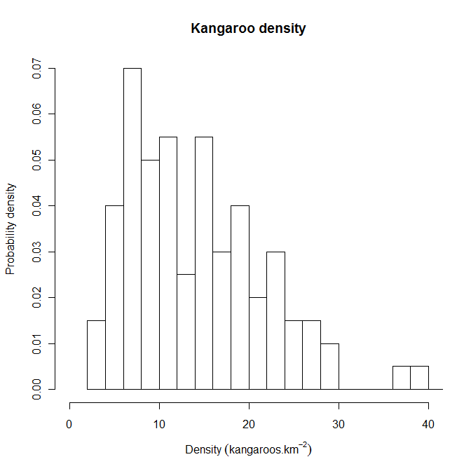
Figure 4: Histogram of a theoretical population of kangaroos.
Density is estimated by aerial survey and the frequency of estimated densities is converted to probability densities. The distribution of kangaroo densities is approximately lognormal.

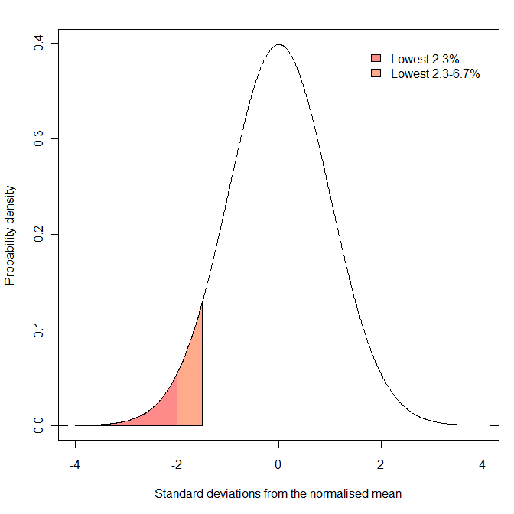
Figure 5: A theoretical distribution after z-score transformation. The mean of the distribution is zero and the standard deviation is one. Areas under the distribution represent probabilities. The orange shaded region represents the probability that a sample is between 1.5 and two standard deviations below the mean (and represents 4.4 per cent of the area). The red shaded region represents the probability that a sample is more than two standard deviations below the mean (and represents 2.3 per cent of the area).

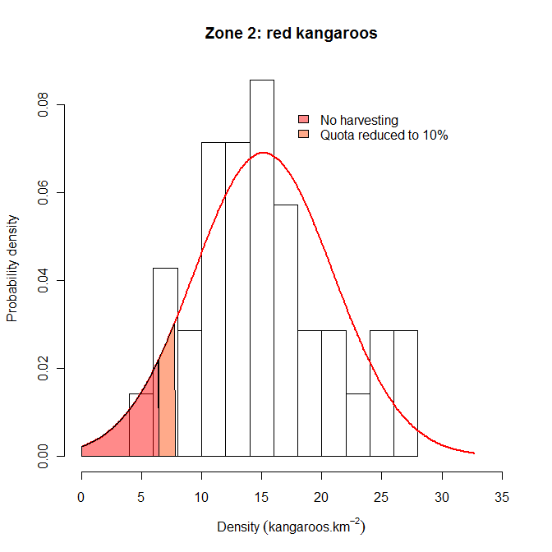
Figure 6: Example of setting harvest thresholds for red kangaroos in Zone 2. The red line represents a normal probability distribution of the observed data with a mean of 15.2 kangaroos per square kilometre and a standard deviation of 5.8 kangaroos per square kilometre. The upper range of the orange region (7.8 kangaroos per square kilometre) represents the threshold within which harvest rate is reduced from 17 per cent to 10 percent. This lower rate is maintained unless density falls below 6.4 kangaroos per square kilometre, at which point harvesting ceases (red region). The thresholds were calculated after log transforming the data.

The following section shows how model simulations can be used to examine the relative effects of different thresholds applied to harvesting a theoretical population of red kangaroos.

Reducing the risk of overharvesting: an example using red kangaroos
The recommended strategy to minimise the risk of overharvest is to reduce harvest rate as density declines, with changes in harvest rate triggered at predetermined density thresholds. Appropriate thresholds can be considered by harvesting a simulated population of kangaroos (e.g. Milner-Gulland et al. 2001). An appropriate population model for red kangaroos was developed by Caughley (1987) and various forms of the model have continued to be used for assessing strategies for managing the kangaroo harvest (e.g. Hacker et al. 2004; Pople 2003, 2008).
Briefly, changes in kangaroo numbers are modelled as a function of pasture biomass which, in turn, is determined by recent rainfall, past pasture biomass and the density of kangaroos (and livestock) consuming the pasture. Harvesting obviously reduces kangaroo numbers, but the reduced density results in higher pasture biomass and therefore higher rates of increase of kangaroos. This improvement in environmental conditions for a population, which without harvesting has no long-term trend, is a basic requirement for the sustainability of a harvest. The population can be simulated 10,000 times over a 20 year period. Each run is different as, every three months, rainfall is drawn from a probability distribution using the average and standard deviation for rainfall in western NSW and thus reflects the uncertain food supply in this arid environment. Population size is also estimated with uncertainty by aerial surveys, and so this too was drawn from a probability distribution using the average and standard deviation associated with aerial surveys (Pople 2008). The population was harvested at an annual rate of 15 per cent or less if it was below a particular threshold.
Extinction is highly unlikely for this simulated population unless there is some combination of low numbers, catastrophic weather and unsustainable harvesting (i.e. much greater than 15 per cent). A more useful measure of threshold performance is the probability of the population dropping to a relatively low density. This can be calculated as the proportion of the 10,000 simulation runs where the population falls below particular densities. Thresholds can be expressed in terms of standard deviations (SDs) below long-term average density for a kangaroo management zone. That way, the aim of the threshold harvest strategy is to keep the harvested population above historically low density.
The effect of reducing harvest rate at varying SDs below the long-term average density for the simulated kangaroo population is shown in Figure 7. Reducing the threshold not surprisingly reduces the probability of very low density, but the decline in probability from no threshold (15 per cent harvest) to no harvest is smooth. There is therefore no obvious optimum with the choice being somewhat arbitrary. Notably, even an unharvested population has some chance of declining to very low density.
Other factors that could be considered in setting thresholds is the time spent below some relatively low density (e.g. Figure 8), and the long-term average and variability in harvest offtake (including years with zero offtake) (Pople 2003). For these simulations, average harvest offtake was similar among the thresholds shown in Figures 7 and 8, but variability in the annual harvest increased slightly as the threshold was reduced.

Figure 7: 10,000 simulations for a population fluctuating over 20 years. Standard deviation (over time) was calculated from a lognormal distribution. Mean population size was about eight kangaroos per square kilometre. Density was about four kangaroos per square kilometre at two standard deviations below the mean.

Figure 8: Simulated population as described for Figure 7. Density was about two kangaroos per square kilometre at 4.5 standard deviations below the mean.

Website http://www.environment.nsw.gov.au/wildlifemanagement/KMPPopulationEstimatesWest.htm on 31 October 2016
http://www.environment.nsw.gov.au/wildlifemanagement/KangarooManagementProgram.htm

