1. ***Title and introduction***

**Application for a Wildlife Trade Operation (WTO): Barramundi (*Lates calcarifer*) and associated by-product species, Northern Territory Barramundi Fishery**

Barramundi (*Lates calcarifer*) and are presently taken commercially in the Northern Territory (NT) by licenced commercial fishers in the NT Barramundi Fishery (the fishery). The list of by-product species includes King Threadfin (Polydactylus macrochir), Black Jewfish (Protonibea diacanthu), Blacktip Sharks (Carcharhinus *Carcharhinus limbatus, tilstoni and sorrah*), Blue Threadfin (Eleutheronema tetradactylum) Queenfish (*Scomberoides commersonnianus*), Tripletail (*Lobotes surinamensis*), Scale Croaker (*Nibea squamosa)* and Barred Javelin (*Pomadasys Kaakan*).

1. ***Statement of general goal/aims***

The WTO is necessary to allow commercial fishers to export their product from what is already a government managed commercial fishery.

1. ***Harvest Details***
   1. *The fishery[1]*

The take of the species covered in this report is regulated by the NT Department of Industry, Tourism and Trade (DITT). The commercial fishery extends 3 nautical miles (nm) from the low water mark of the mainland NT coast, and 3 nm from islands off the NT. Commercial species are gill netted with the final product being whole fish or fillets for human consumption. The fishery boundary is shown in Figure 1, with the extent of the historical catches in the fishery is shown in Figure 2.

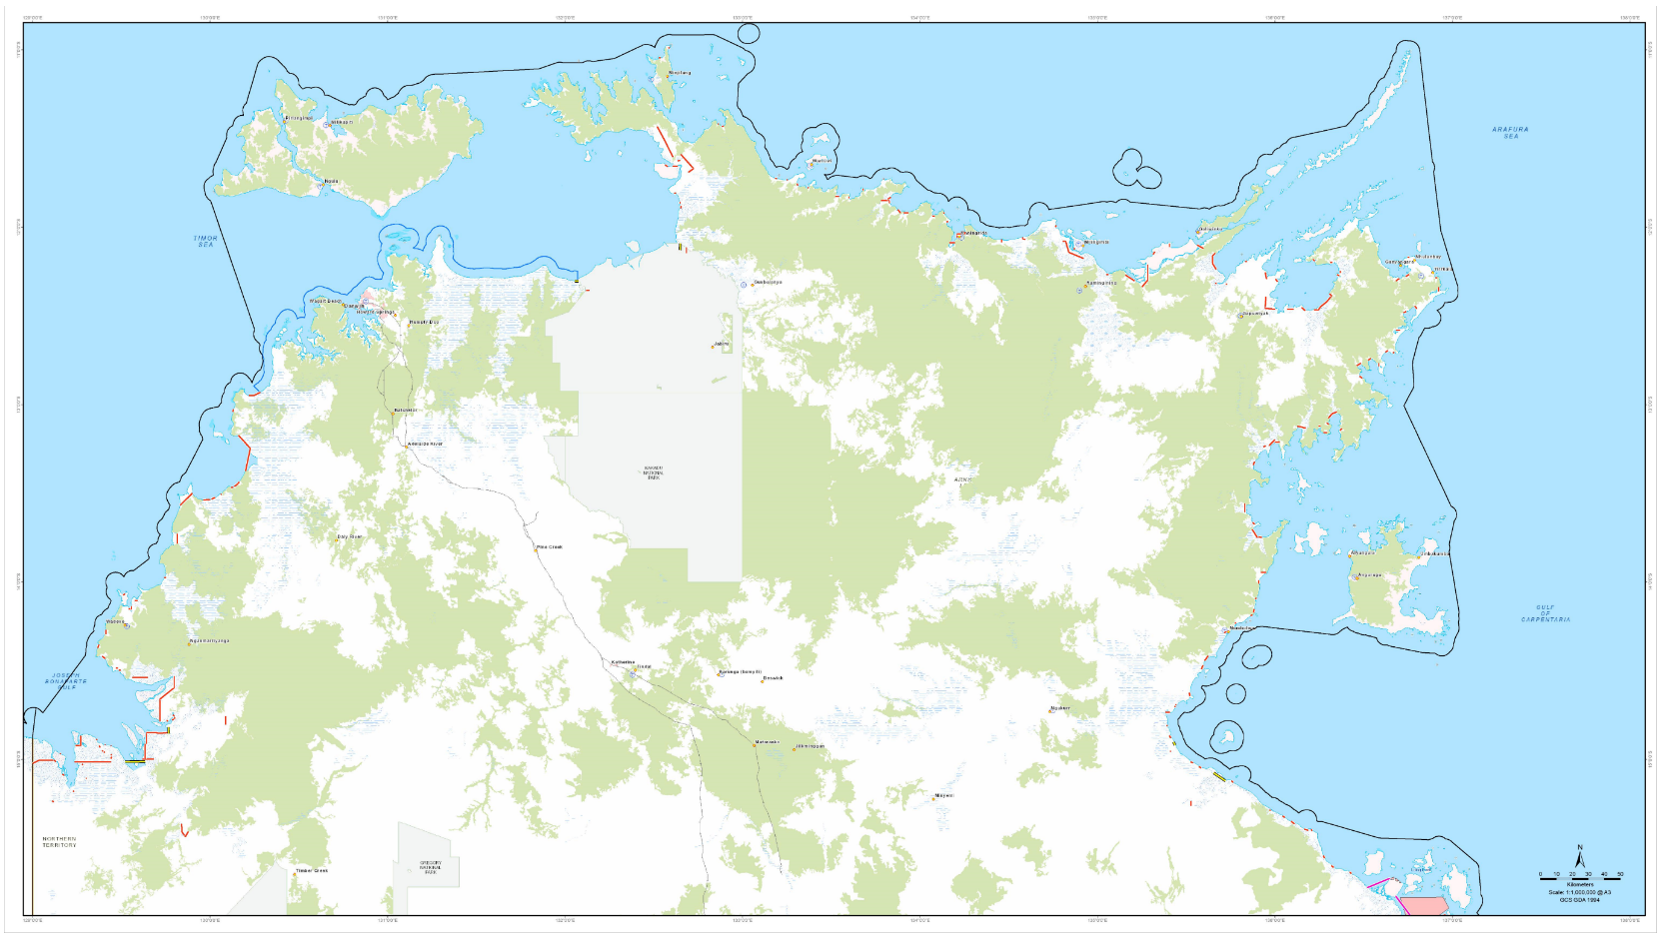

Figure 1: NT Barramundi Fishery boundary.

*Source: Wild Barra Fisheries Pty Ltd*

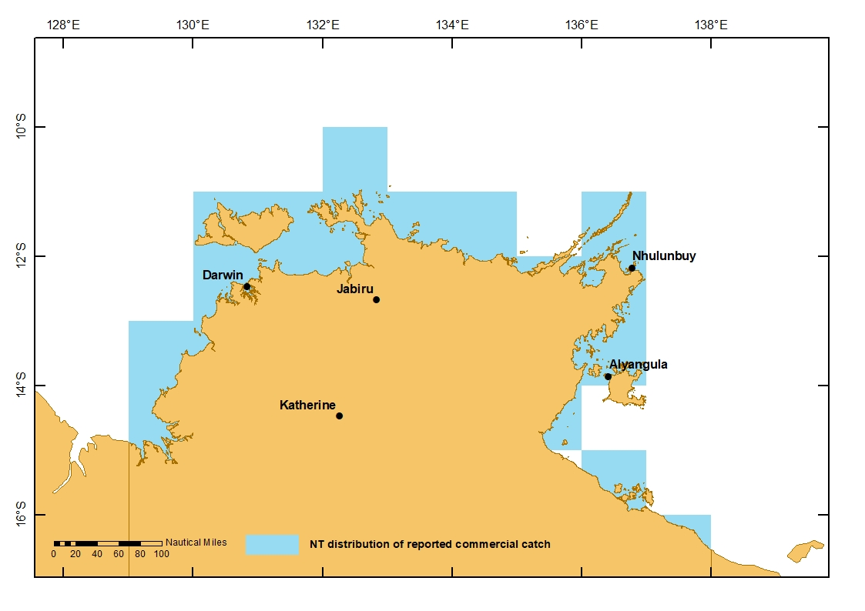

Figure 2: Extent of commercial barramundi take, NT Barramundi Fishery.

*Source: NT Government*

The fishery is also accessed by recreational, fishing tourism operators, and Aboriginal communities of the NT. Total historical catch by all fishing sectors is shown in Figure 3 below.

Figure 3: Historical catch by all sectors, NT Barramundi Fishery.

*Source: NT Government*

1. ***Impact of harvest on the taxa and the relevant ecosystem***

*Provide details of the likely impact of the harvest on the species and the ecosystem. Include impacts due to the size of harvest, harvest methodology and where relevant how the harvest site is accessed by the harvester. In estimating the likely impact it is necessary to consider the species’ biology, its role in the ecosystem and in some cases its susceptibility to pathogens introduced during the harvest operation.*

*Provide reasons why you believe there is or isn’t any impact. Clearly state if the information provided is based on personal observations and include references for sources quoted.*

Barramundi taken commercially in the fishery must have an overall length greater than 55 cm for whole fish, and 39 cm for fish without heads. Catch per unit effort (CPUE) levels for barramundi are 20% above the long-term average (1983–2016) and CPUE increased in 2017. Results from tag and recapture programs indicate the combined take by all sectors is less than 8% of biomass, a figure unlikely to cause recruitment impairment.

By-product (fish species taken which can be sold) in the fishery includes include King Threadfin (Polydactylus macrochir), Black Jewfish (Protonibea diacanthu), Blacktip Sharks (Carcharhinus *Carcharhinus limbatus, tilstoni and sorrah*), Blue Threadfin (Eleutheronema tetradactylum) Queenfish (*Scomberoides commersonnianus*), Tripletail (*Lobotes surinamensis*), Scale Croaker (*Nibea squamosa)* and Barred Javelin (*Pomadasys Kaakan*).

* 1. NT Barramundi Fishery Ecological Risk Assessment

The NT Fisheries Division conducts Ecological Risk Assessments (ERAs) periodically to assess the impacts of a fishery’s activity on all different components of the marine environment in which they operate. The ERA process assesses not only contemporary risks of harvesting activities on species by all sectors in a fishery, but also the broader impacts of the activities on the environment (general ecosystem). Outcomes of risk assessments are used to inform ecosystem-based fisheries management harvest strategies and to prioritise departmental monitoring, research and management activities (DITT 2020).

In 2020/21, DITT conducted an ERA on the Barramundi Fishery though a technical workshop attended by an independent panel of scientific and management experts and then circulated to external stakeholders for consideration. The ERA identified and assessed a total of 49 risks (see Table 1). The majority of these risks were assessed as low (30), eight as moderate, five as high and six as severe (DITT 2021). These identified risk ratings will be addressed through the development of a contemporary management framework. Please refer to the NT Barramundi Fishery ERA 2021 for detailed information.

Table 1 Summary of risks assessed in the Barramundi Fishery ERA

|  |  |  |  |
| --- | --- | --- | --- |
| Issue assessed | | | Risk rating |
| **RETAINED SPECIES** | | | |
| Primary Species | Barramundi | | Moderate |
| King Threadfin | | Moderate |
| Byproduct species | Black Jewfish | | Low |
| Queenfish | | Low |
| Blue Threadfin | | Low |
| Tripletail | | Low |
| Barred Javelin | | Low |
| Scale Croker | | Low |
| Catfishes | | Low |
| Sharks (Blacktip Sharks, Bull Sharks, Pigeye Sharks, Graceful Sharks and Milk Sharks) | | Low |
| **NON RETAINED SPECIES** | | | |
| Species of Concern | Scalloped Hammerhead | | Low |
| Winghead Shark | | Moderate |
| Great Hammerhead | | Low |
| Bycatch | Blue Threadfin | | Low |
| Barred Javelin | | Low |
| Queenfish | | Low |
| Sharks (Blacktip Sharks, Bull Sharks, Pigeye Sharks, Graceful Sharks and Milk Sharks) | | Low |
| Catfishes | | Low |
| Threatened, Endangered and Protected Species | Bottlenose Dolphin | | Severe |
| Humpback Dolphin | | Severe |
| Snubfin Dolphin | | Severe |
| Dugong | | High |
| Dwarf Sawfish | | Severe |
| Green Sawfish | | High |
| Largetooth Sawfish | | High |
| Narrow Sawfish | | High |
| River Sharks (Glyphis spp.) | | Severe |
| Saltwater Crocodile | | Moderate |
| Leatherback Turtle | | Severe |
| Green Turtle | | High |
| Olive-Ridley Turtle | | Moderate |
| Flatback Turtle | | Moderate |
| Hawksbill Turtle | | Moderate |
| Loggerhead Turtle | | Moderate |
| Incidental Interaction | Sea birds | | Low |
| Boat Strike (Dugong, Turtles, Crocodiles, Cetaceans) | | Low |
| **GENERAL ECOSYSTEM EFFECTS** | | | |
| Impacts on trophic structure | Removal of organisms | Primary species | Low |
| Bait collection | Low |
| Ghost fishing | Low |
| Addition of biological material | Discards | Low |
| Bait | Low |
| Fish stocking | Low |
| Habitat disturbance | Fishing gear | | Low |
| Anchoring | | Low |
| Lost gear | | Low |
| Broader environment | Air quality | | Low |
| Greenhouse gas | | Low |
| Rubbish | | Low |
| Oil discharge | | Low |

1. **Monitoring and assessment**

Commercial fishers are required to operate at all times a vessel monitoring system (VMS) and complete mandatory catch logbooks, which also include TEPS reporting. Figures 4, 5, 6 and 7 show the total commercial catch, Catch per unit of effort (CPUE) by the commercial sector for Barramundi and King Threadfin from 1983 to 2020.

Figure 4: Total commercial catch (t) of Barramundi from 1983 to 2020

Source: NT Government

Figure 5: NT Commercial Barramundi Fishing Effort (hmnd) and CPUE of Barramundi from 1983 to 2020.

Source: NT Government

Figure 6: Total Commercial Catch (t) of King Threadfin from 1983 to 2020.

Source: NT Government

Figure 7: Commercial Fishing Effort (hmnd) and catch rates (CPUE; kg/hmnd) of King Threadfin from 1983 to 2020.

Source: NT Government

CPUE levels for barramundi are 20% above the long-term average (1983–2016) and CPUE increased in 2017. Results from tag and recapture programs indicate the combined take by all sectors is less than 8% of biomass, a figure unlikely to cause recruitment impairment.

Effort in the fishery is at near record low levels and the CPUE for king threadfin has been trending upwards.

* 1. By-product

By-product species such as Black Jewfish, Queenfish and a variety of sharks (mainly blacktip sharks) are also caught by the commercial fishery. To limit the take of these species, voyage limits have been imposed on the commercial Barramundi Fishery that include 6 kg of fillets for Golden Snapper, 80 kg of fillets for Black Jewfish and 500 kg of Shark. Figure 8 provides an overview of the byproduct in the Barramundi Fishery for the last 5 years (2016 – 2020).

Figure 8. Commercial Barramundi Fishery Bycatch from 2016 to 2020.

Table 2 below shows fishery dependent reporting data for TEPs in the commercial Barramundi Fishery for the last 5 years (2016 to 2020).

|  |  |  |  |  |  |  |  |  |  |  |
| --- | --- | --- | --- | --- | --- | --- | --- | --- | --- | --- |
| Year | 2016 | | 2017 | | 2018 | | 2019 | | 2020 | |
| Species/Status on release | **Alive** | **Dead** | **Alive** | **Dead** | **Alive** | **Dead** | **Alive** | **Dead** | **Alive** | **Dead** |
| **Bottlenose Dolphin** | 0 | 0 | 0 | 0 | 0 | 0 | 0 | 8 | 0 | 0 |
| **Dugong** | 0 | 0 | 5 | 4 | 2 | 0 | 0 | 1 | 0 | 0 |
| **Dwarf Sawfish** | 24 | 0 | 170 | 0 | 296 | 54 | 510 | 67 | 166 | 31 |
| **Green Sawfish** | 26 | 0 | 7 | 0 | 56 | 6 | 297 | 75 | 87 | 31 |
| **Largetooth Sawfish** | 9 | 0 | 0 | 0 | 71 | 7 | 22 | 12 | 27 | 4 |
| **Narrow Sawfish** | 1 | 0 | 64 | 0 | 25 | 2 | 249 | 15 | 1305 | 136 |
| **Saltwater Crocodile** | 118 | 61 | 111 | 52 | 52 | 42 | 105 | 29 | 100 | 14 |
| **Freshwater Crocodile** | 0 | 0 | 0 | 0 | 0 | 0 | 0 | 0 | 32 | 3 |
| **Marine Turtle** | 0 | 0 | 10 | 0 | 0 | 0 | 0 | 0 | 0 | 0 |
| **Speartooth Shark** | 0 | 0 | 0 | 0 | 0 | 0 | 124 | 63 | 23 | 12 |
| **Northern River Shark** | 0 | 0 | 0 | 0 | 0 | 0 | 0 | 0 | 59 | 9 |
| **Great Hammerhead** | 0 | 0 | 0 | 0 | 0 | 0 | 0 | 0 | 10 | 8 |
| **Scalloped Hammerhead** | 0 | 0 | 0 | 0 | 0 | 0 | 0 | 0 | 104 | 1 |

Table 2: Fishery dependent reporting data for TEPS in the Commercial Barramundi Fishery.

Source: NT Fisheries

It is believed the increase in interactions reported is as a result of better record keeping by the fishing industry (Pers. Comm., DITT).

There is limited data for fishery independent observer coverage with sparse coverage since 2017. Length by weight data collection for barramundi, and the retention of barramundi heads for otolith analysis has begun in the fishery in 2021 (Pers. Comm., Geoff Diver). The commercial sector is also moving to electronic logbooks which allows for better recording of TEPS interactions with the inclusion of position data, and time and date data. Table 3 shows the output of an electronic logbook in the fishery.

Table 3: Output of an electronic logbook in the fishery.

Fishery independent data collection is expected to increase through 2021 and beyond with a new entrant into the fishery giving DITT access to three vessels (Pers. Comm., Geoff Diver).

The same company has also commenced a Crew Member Observer Programme (CMOP) with crew having been trained in the collection of length by weight data collection for barramundi, the retention of barramundi heads for otolith analysis, and species identification for sawfish, river sharks, and hammerhead sharks.

There are plans for independent research into various aspects of interaction and survivability into the bycatch river shark and sawfish species listed above (Pers. Comm., Peter Kyne, Charles Darwin University).

In addition, the NT Seafood Council (NTSC) has received funding from the Fisheries Research and Development Corporation (FRDC) for a project to synthesis industry knowledge of sawfish spatial and temporal distribution, and techniques to avoid interaction with fishing gear. This project is due to commence in July 2021 (Pers. Comm., Katherine Winchester).

* 1. *Has there been a resource assessment of distribution and abundance (for example, population survey) for the harvest area? If yes, provide details.*

An assessment of Barramundi and King Threadfin stocks are conducted annually through the *Status of Key NT Fish Stocks Report* (<https://industry.nt.gov.au/projects-and-initiatives/fisheries/fisheries-research>) and bi-annually with the National Status of Australian Fish Stocks Report (<https://fish.gov.au/jurisdiction/northern-territory>).

The most recent assessment of Barramundi in the NT was conducted in 2020 to align with the *National Status of Australian Fish Stocks Report*.

The last *Status of Key NT Fish Stocks Report* covers data up until 2017. The report notes difficulties deriving stock separation for barramundi in the NT due to data constraints. Instead, the NT government bases its assessment on the Daly and Mary Rivers as these are the most heavily fished river catchments and therefore the areas in which it is assumed the highest levels of exploitation occur.

DPIR attribute recent declines in commercial catch and commercial around 2017 to poor wet seasons since 2013. However, they note that current CPUE levels are 20% higher than the 1983 to 2016 long term average. Recaptures from tagging indicate the annual harvest rate for all sectors is below 8% which is unlikely to impair recruitment. The NT government have given the fishery the status of “sustainable”.

* 1. *Will there be independent supervision of the harvesting? If so, provide details (for example, State/Territory control) and how this will be achieved.*

Compliance for the fishery is managed by DITT in accordance with the *Fisheries Act 1988*, the *Fisheries Regulations 1992*, and the *Barramundi Fishery Management Plan 1998*. Commercial fishers are required to carry VMS and to complete mandatory catch logbooks which include the reporting for TEPS.

DITT will also be increasing their independent observer coverage as reported previously in this report.

* 1. *Outline the methods to be employed to monitor the harvesting of the specimens to identify whether the species or other species in the ecosystem are affected by the harvesting.*

See Section 5.2.

* 1. *Describe any other biological and environmental monitoring proposed for the harvesting area.*

See Section 5.2.

The major licence holder in the fishery has committed to assist DITT with the research and observer programs, as well as offering assistance with the independent research of sawfish and river sharks.

1. ***Management strategies***
   1. *How will you respond to population changes if/when detected?*

The fishery is subject to a range of management measures including:

* Legislation and Regulation;
* A management plan;
* Limited entry;
* The allocation of units of fishing effort;
* Spatial and temporal management measures;
* Specification of fishing gear specifications including the labelling of gear;
* Fish size limits;
* A soon the be developed harvest strategy.

These are discussed below.

Principal Legislation and Regulation for the fishery are the *Fisheries Act 1988* and the *Barramundi Fishery Management Plan 1998*. Other NT Legislation which affect the fishery include *NT Sacred Sites Act 1998, Land Rights (Northern Territory) Act 1976, Aboriginal Land Act 1976, Environmental Protection Act 2019*. The fishery is also subject to the commonwealth *EPBC Act 1999,* and the *National Parks and Wildlife Conservation Act 1975.*

There are 14 licences in the fishery. The unit of fishing for the fishery is 100 metres of monofilament gillnet with a cap of 10 units per licence. The current licence and unit configurations in the fishery are:

* 8 x 10 Unit
* 3 x 5 Unit
* 1 x 2 Unit
* 1 x 3 Unit
* 1 x 8 Unit

The fishery is closed from 1 October each year until 31 January the following year.

There are a number of closure lines in the fishery. These are shown in Schedule 5 of the *Barramundi Fishery Management Plan 1998*. There are also management lines which regulate different net mesh sizes. These are referred to a “7 inch lines” and are shown in Schedule 6 of the *Barramundi Fishery Management Plan 1998.* The gillnet must not have a mesh size less than 150 mm in the open sea, and 175 mm when fishing between a closure line and a “7 inch line”. *The Barramundi Fishery Management Plan 1998* also contains dugong protection zones*.*

All commercial fishing vessels must carry a vessel monitoring system (VMS).

Fishing in Aboriginal sacred sites is only allowed through a successful application to the Aboriginal Areas Protection Authority (AAPA) which is assessed through the *Sacred Sites Act 1998*.

Planning for additional regulatory measures includes The establishment of a Management Advisory Committee (MAC) with representatives from (but not limited to) government, the commercial sector, recreational and charter sector, the Indigenous sector, environment groups. These sectors were represented in the ERA process. It is also anticipated the fishery will have a harvest strategy developed.

The measures, along with the existing management structure will ensure that impacts to fish stocks and the broader ecosystem will be detected and there will be agreed management responses which can then be enacted.

1. ***Compliance***

Compliance for the fishery is managed by the NT DITT in accordance with the *Fisheries Act 1988* and the *Barramundi Fishery Management Plan 1998*. Operational compliance is carried out by the Water Police section of the NT Police Service on behalf of DITT.

1. ***Reports***

*Periodic reports (at least annually: requirements will be specified in the declaration approving the operation) must be provided to the Department on implementation of the proposal. These reports may be made available to the public.*

The NT government periodically releases a *Northern Territory Fish Stocks Report* on the status of key fish stocks in their jurisdiction. The last report covers data up until 2017. The barramundi fishery is reported under the headings:

* Stock status overview;
* Stock structure;
* Stock status;
* Biology;
* Distribution;
* Catch history;
* Management and catch table for all fishing sectors.

These reports are public documents.

1. ***Background information***

*Include background information on the biology of the species relevant to its management and history of the harvest/industry. Please include references.*

* 1. *Biology*

Barramundi occur in tropical and sub-tropical waters in the Indo-Pacific region inhabiting rivers and creeks which are accessible from the sea. The fish have a complex and spatially variable life history (Russell 2014).

The key aspects of the life history of barramundi are:

* Longevity: barramundi are relatively long lived, with specimens of 20 years old recorded from the Gulf of Carpentaria and 35 years old recorded from the Queensland east coast.
* Protandry: most barramundi mature first as males (at two to five years), with females derived from sexually mature males at five to seven years of age (Moore 1979; Davis 1982).
* Seasonal spawning: barramundi spawn during spring and summer, with the timing and duration of the spawning dependent on water temperature, and lunar and tidal cycles.
* Non-obligatory catadromy, that is, movement between salt and freshwater: although spawned in salt water, barramundi can use numerous habitats, from fully marine to fully freshwater, during their life cycle. Supra-littoral coastal swamps act as nursery areas for juvenile barramundi. Where access permits, a variable proportion of juvenile barramundi will swim upstream to freshwater habitats, while the remainder stay in estuarine habitats. The duration and locality (i.e., distance upstream) of freshwater residency is variable between individuals, rivers and years (Halliday et al. 2012).
* Environmental influences: The influence of rainfall and river flow on barramundi catches has been noted for several decades (Dunstan 1959; Williams 2002; Gribble et al. 2005). Rainfall and seasonal flooding of rivers affect the relative recruitment of young-of-the-year barramundi (Staunton-Smith et al. 2004; Halliday et al. 2012). River-flow also affects barramundi growth rates (Sawynok 1998; Robins et al. 2006). Additionally, seasonal flooding allows the downstream movement of freshwater residents, thereby influencing the overall fish age-structure and length-structure of harvested barramundi, as well as changing the catchability of fish and the absolute tonnage of the commercial catch.

Several aspects of the biology of the fish are explicitly addressed in the management of the fishery. These include (among others):

* Seasonal closures for spawning;
* Size limits of fish taken;
* Gillnet mesh size considerations;
* Closure lines along rivers.

King Threadfin (*Polydactylus macrochir*) are the largest of the seven species of threadfin found in Australian waters. Both juveniles and adults complete their life cycles in sandy and muddy beach habitats in nearshore, shallow waters (Pember et al. 2005). This species normally grows to between 500 mm and 900 mm in length, although there have been many cases of individuals growing to over 1300 mm in length. King Threadfin range in weight from 1 kg to 15 kg, with the average being 3.5 kg. In Western Australia, they attain lengths of 322 at the end of their first year, 520 in their second year and 945 mm in their fifth year (Pember et al. 2005). King Threadfin have a protracted spawning period of 6 months, with spawning peaking from September to December.

Like Barramundi, King Threadfin are protandrous hermaphrodites (i.e. mature first as a male before later changing to females). King Threadfin typically reach sexual maturity as males during their first year of life when their length are *ca* 230 mm. King Threadfin typically change from male to female at *ca* 810 mm when they are *ca* 4 years old (Pember et al. 2005).

Details for incidental commercial by-product species have not been included

1. ***References***

Davis (1982) Maturity and sexuality in Barramundi, Lates calcarifer (Bloch), in the Northern Territory and south-eastern Gulf of Carpentaria. Journal: Australian Journal of Marine and Freshwater Research Volume: 33 Issue: 3

Department of Industry, Tourism and Trade, (2021). NT Barramundi Fisgery Ecological Risk Assessment.

Department of Primary Industry and Resources, (2019). Status of key Northern Territory fish stocks report 2017: Fishery report no. 121

Dunstan, D.J. (1959). The barramundi Lates calcarifer (Bloch) in Queensland waters. Division of Fisheries and Oceanography Technical Paper. 22 pp.

Gribble, N., Welch, D., Garrett, R., Higgs, J. and Whybird, O. (2005). Draft 1981 - 2004 Assessment of the barramundi fishery in Queensland. Department of Primary Industries and Fisheries, Queensland, Cairns. 62 pp.

Halliday, I., Saunders, T., Sellin, M.J., Allsop, Q.A., Robins, J.B., McLennan, M. and Kurnoth, P. (2012). Flow impacts on estuarine finfish fisheries of the Gulf of Carpentaria. Final Report for FRDC Project No. 2007/002. Queensland Department of Agriculture, Fisheries and Forestry, Brisbane. 76 pp.

Moore, R. (1979). Natural sex inversion in the giant perch (Lates calcarifer). Australian Journal Marine and Freshwater Research 30, 808-813.

Northern Territory Government (2019). Status of Key Northern Territory Fish Stocks Report 2017. Northern Territory Government Department of Primary Industry and Resources. Fishery Report No. 121.

Pember, M. B., Newman, S. J., Hesp, S. A., Young, G. C., Skepper, C. L., Hall, N. G. and Potter, I. C. (2005). Biological parameters for managing the fisheries for Blue and King Threadfin Salmons, Estuary Rockcod, Malabar Grouper and Mangrove Jack in northwestern Australia. Final Report to the Fisheries Research and Development Corporation, Project 2002/003. Centre for Fish and Fisheries Research Murdoch University Murdoch, Western Australia, Australia. 177pp. Queensland Government (2019). Stock assessment of the barramundi (Lates calcarifer) fishery in Queensland, Australia. Department of Agriculture and Fisheries.

Robins, J., Mayer, D.G., Staunton-Smith, J., Halliday, I., Sawynok, B. and Sellin, M.J. (2006). Variable growth rates of the tropical estuarine fish barramundi Lates calcarifer (Bloch) under different freshwater flow conditions. Journal of Fish Biology 69, 379-391.

Sawynok, B. (1998). Fitzroy River: effects of freshwater flows on fish: impact on barramundi recruitment, movement and growth. Infofish Services National Fishcare Project Report 97/003753, Rockhampton. 59 pp.

Staunton-Smith, J., Robins, J.B., Mayer, D.G., Sellin, M.J. and Halliday, I. (2004). Does the quantity and timing of fresh water flowing into a dry tropical estuary affect year-class strength of barramundi (Lates calcarifer)? Marine and Freshwater Research 55, 787-797.

Williams, L.E. (2002). Queensland's fisheries resources. Current condition and recent trends: 1988-2000. Queensland Department of Primary Industries, Brisbane. 180 pp.

1. Specific management measures in this section are taken from the *Barramundi Fishery Management Plan 1998*.