Description paper for Areas for Further Assessment in the North-west Marine Region
This document provides a broad overview of the seven Areas for Further Assessment identified for the development of a Commonwealth Marine Reserves Network in the North-west Marine Region. Comprehensive information about the Commonwealth marine environment of the North-west can be found at http://www.environment.gov.au/coasts/mbp/north-west/index.html.
The shapefiles and metadata for the Areas for Further Assessment can be obtained by emailing NW_Marine_Plan@environment.gov.au
What progress has been made in marine bioregional planning in the North-west?
The Marine Bioregional Planning Program started in 2006. It is a three step process and will result in the development of marine bioregional plans under national environmental law for all Commonwealth waters. It will also establish networks of Commonwealth Marine Reserves which will contribute to the National Representative System of Marine Protected Areas. All governments in Australia have a shared and international commitment to establish a national representative system by the year 2012.
Planning in the North-west Marine Region commenced in July 2006 and the bioregional profile for the region (stage one) was released in November 2008. The profile describes the geomorphology, oceanography and ecology of the region, and identifies its conservation values. The profile also provides information about the human activities currently taking place in the region and explains how new Marine Protected Areas (MPAs) will be identified.
In December 2008 stakeholder forums were held in Perth and Broome to outline the contents of the profile and the intent to develop the draft plan (stage two) that includes a proposed network of MPAs. Work to identify and design a marine reserve network has so far been undertaken within government.
Recently, the Department of the Environment, Water, Heritage and the Arts (DEWHA) has completed the first stage of the network design and is preparing to gather further information from government and non-government stakeholders on specific Areas for Further Assessment.
What are Areas for Further Assessment?
Areas for Further Assessment are large areas that encompass representative examples of the range of biodiversity and ecosystems within the North-west Marine Region. Reserves that include the key characteristics of these areas should meet the goals and principles for the establishment of the regional networks.
Areas for Further Assessment are NOT proposed reserves.
The assessment process that DEWHA is undertaking on the Areas for Further Assessment aims to ensure that proposed marine reserves in the North-west Marine Region will achieve robust conservation outcomes while minimising socio-economic costs associated with their establishment. Based upon an understanding of the distribution of values (socio-economic and conservation), reserve boundaries and zones will be designed and a draft Network Proposal will be included in the draft North-west Marine Bioregional Plan. This is due for completion in early 2010. The release will be followed by a statutory period of public consultation. Public comments will inform finalisation of the Marine Bioregional Plan (stage three), following which the process of declaration will commence. The declaration process has its own statutory consultation requirements.

Figure 1. Areas for Further Assessment for the development of a Commonwealth Marine Reserves Network in the North-west Marine Region
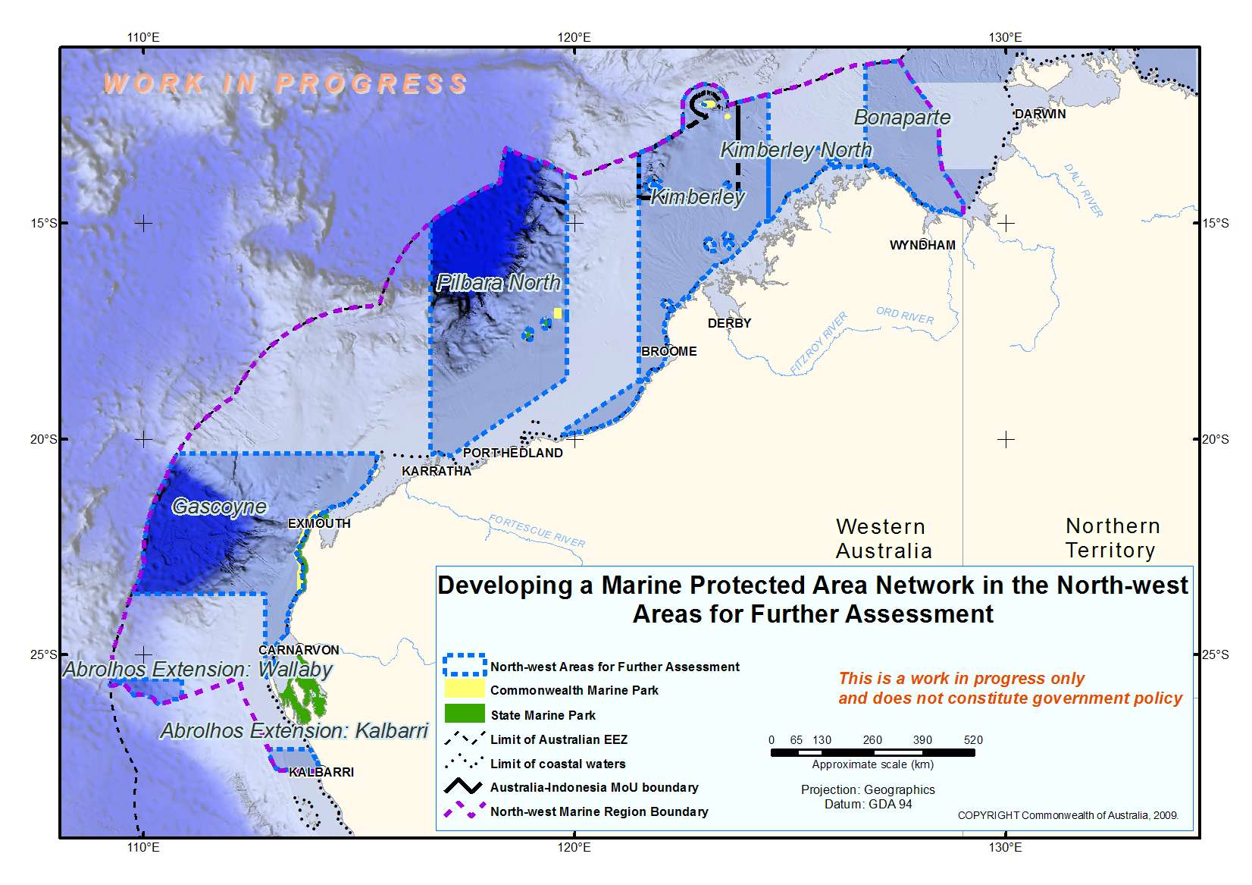
How were Areas for Further Assessment identified?
Areas for Further Assessment in the North-west Marine Region were identified through the application of the goals and principles for the establishment of Marine Reserves in Commonwealth waters and the use of available scientific data and informed by internationally recognised approaches to reserve design. The goals and principles can be viewed at:
http://www.environment.gov.au/coasts/mbp/publications/general/goals-nrsmpa.html
What measures other than Marine Reserves may be included in the North-west Marine Bioregional Plan?
In addition to the establishment of regional marine reserves networks, the marine bioregional planning process will lead the preparation of a marine bioregional plan under the Section 176 of the national environment law (the Environment Protection and Biodiversity Conservation Act 1999). As this law requires the Minister to have regard to a plan in making any decision of relevance to an area for which a plan is in place, the primary role of a plan is to support decision-making and to provide an integrated framework for all Commonwealth conservation measures and initiatives within a marine region. Measures associated with marine bioregional plans will include administrative guidance about matters of national environmental significance occurring in the region. The plans will also outline key considerations that will inform referral and approval decisions as well as strategic assessment decisions for export and Commonwealth-managed fisheries.

How can stakeholders and the public input into the process?
Non-government stakeholders in the North-west include representatives of the following sectors: commercial fishing, aquaculture, recreational fishing ,oil and gas exploration and production, carbon sequestration, shipping and ports, indigenous groups and conservation organisations.
Stakeholder consultation on the new MPAs will comprise of three main stages:
1. Targeted meetings of key stakeholders in the region will be held between late September and mid October, to gather input and views in relation to the Areas for Further Assessment. This input will inform the development of a Draft Proposal for a Commonwealth Marine Reserves Network.
2. A period of statutory consultation (minimum 60 days) will commence following the release of the Draft North-west Marine Bioregional Plan, which will include the Draft Proposal for a Commonwealth Marine Reserves Network, including proposed zoning arrangements. This will occur during the first half of 2010.
3. Additional statutory consultation (minimum 60 days) will occur during the process of proclamation of the Commonwealth Marine Reserves as required under the national environment law. This will happen in late 2010 / early 2011.

Where can I get more information?
More information is available at http://www.environment.gov.au/coasts/mbp/index.html.
Or email the department at: NW_Marine_Plan@environment.gov.au.

AREAS FOR FURTHER ASSESSMENT IN THE NORTH-WEST MARINE REGION

1. ABROLHOS EXTENSION: KALBARRI Area for Further Assessment
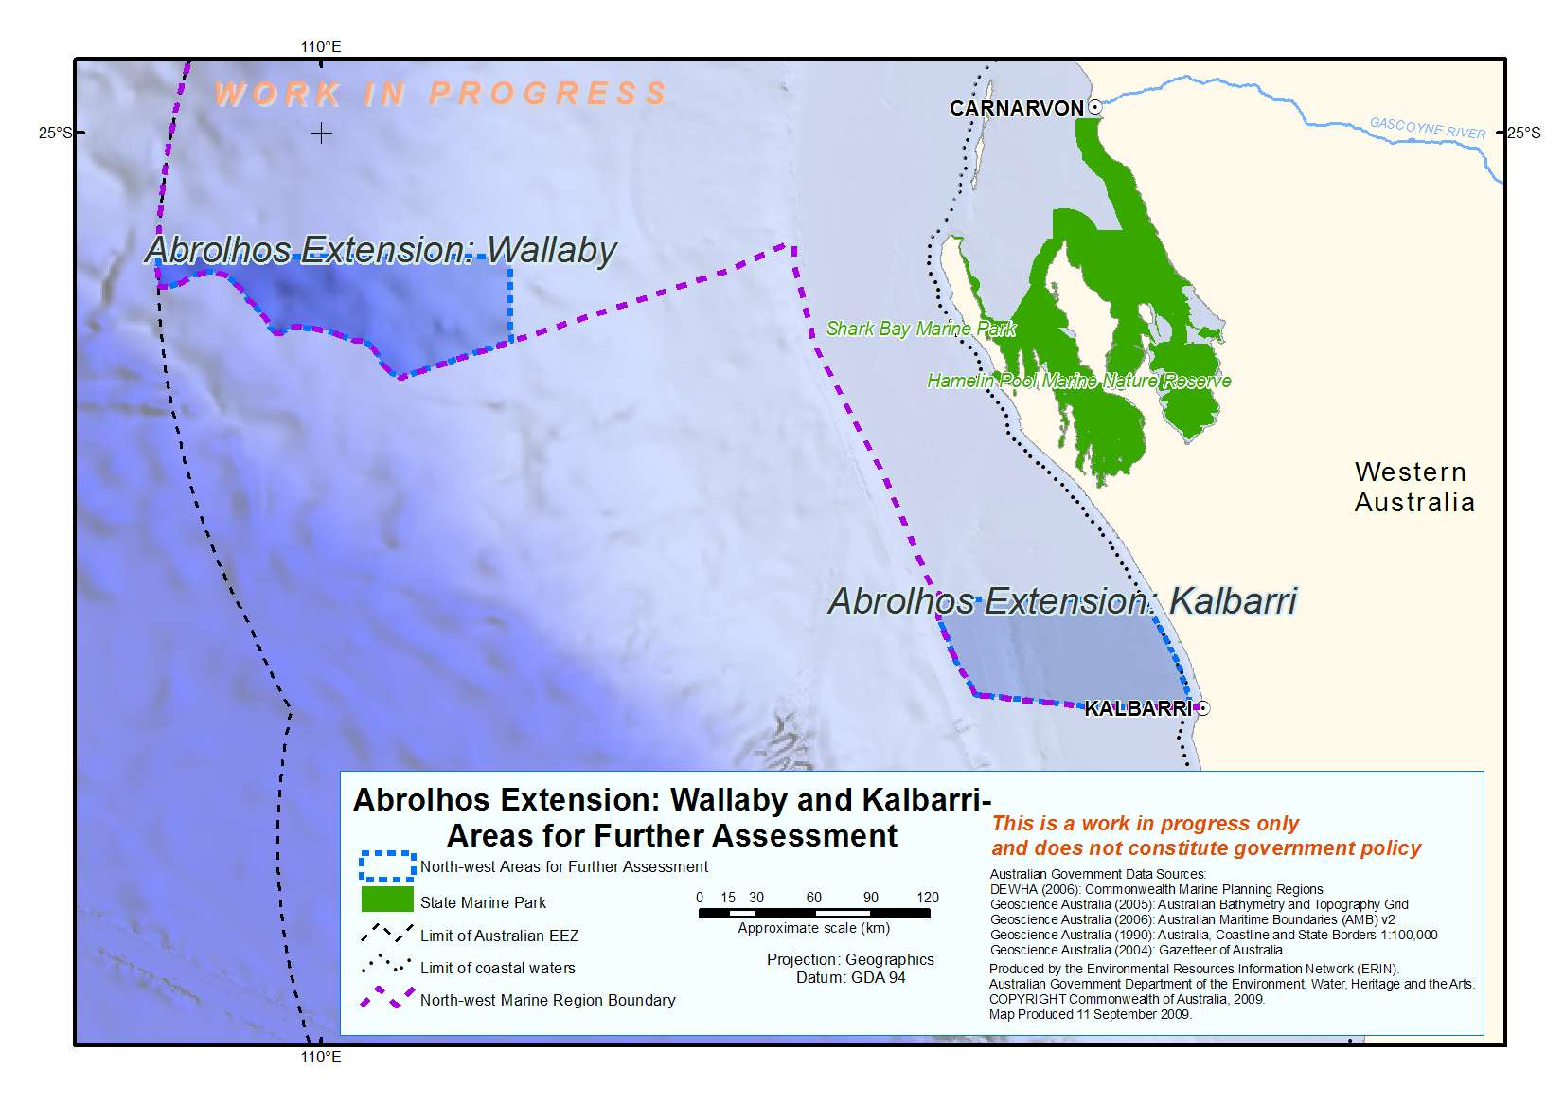
This Area is an extension into the North-west Marine Region of the ‘Abrolhos’ Area for Further Assessment in the South-west Marine Region. It covers 5830 km² of ocean north-west of Kalbarri and includes ecosystems from the Central Western Shelf Province provincial bioregion and the Zuytdorp meso-scale bioregion. This Area covers depths ranging from 20 to 300 metres and includes areas of shelf, slope, banks/shoals and deeps/holes/valleys.

Proposed conservation objectives for reserve(s) established within the Abrolhos Extension: Kalbarri Area for Further Assessment:
- To protect ecologically adequate examples of the benthic/demersal habitats and communities of the Central Western Shelf Province provincial bioregion and Zuytdorp meso-scale bioregion.
- To protect an important foraging area for pelagic dolphin species.
- To increase the representation in marine reserves of key seafloor features (banks and shoals, deeps/holes/valleys, shelf and slope) and associated biodiversity. The banks and shoals in this Area are of particular note as they occur at latitudes significantly further south of other occurrences of these features elsewhere in the North-west Marine Region.
- To maintain connectivity between biological and ecological processes in State and Commonwealth waters.

2. ABROLHOS EXTENSION: WALLABY Area for Further Assessment
This Area is an extension into the North-west Marine Region of the ‘Abrolhos’ Area for Further Assessment in the South-west Marine Region (see Figure above). It covers 6306 km² of ocean west of Denham at the edge of Australia’s EEZ. It includes ecosystems of the Central Western Transition provincial bioregion. The Area covers depths of over 3000 metres and includes areas of continental rise, abyss and part of the Wallaby Saddle, the only known seafloor feature of this type in the North-west Marine Region. The Wallaby Saddle is thought to be an area of upwelling supporting aggregations of small pelagic fish and associated predators, and may support aggregations of sperm whales. The demersal fish communities associated with the slope in this Area have a high level of endemism and species diversity.

Proposed conservation objectives for reserve(s) established within the Abrolhos Extension: Wallaby Area for Further Assessment:
- To protect ecologically adequate examples of benthic habitat communities of the Central Western Transition provincial bioregion.
- To protect biodiversity associated with the Wallaby Saddle, a unique seafloor feature in the North-west Marine Region.
- To protect biodiversity associated with slope habitats in this Area.

3. GASCOYNE Area for Further Assessment
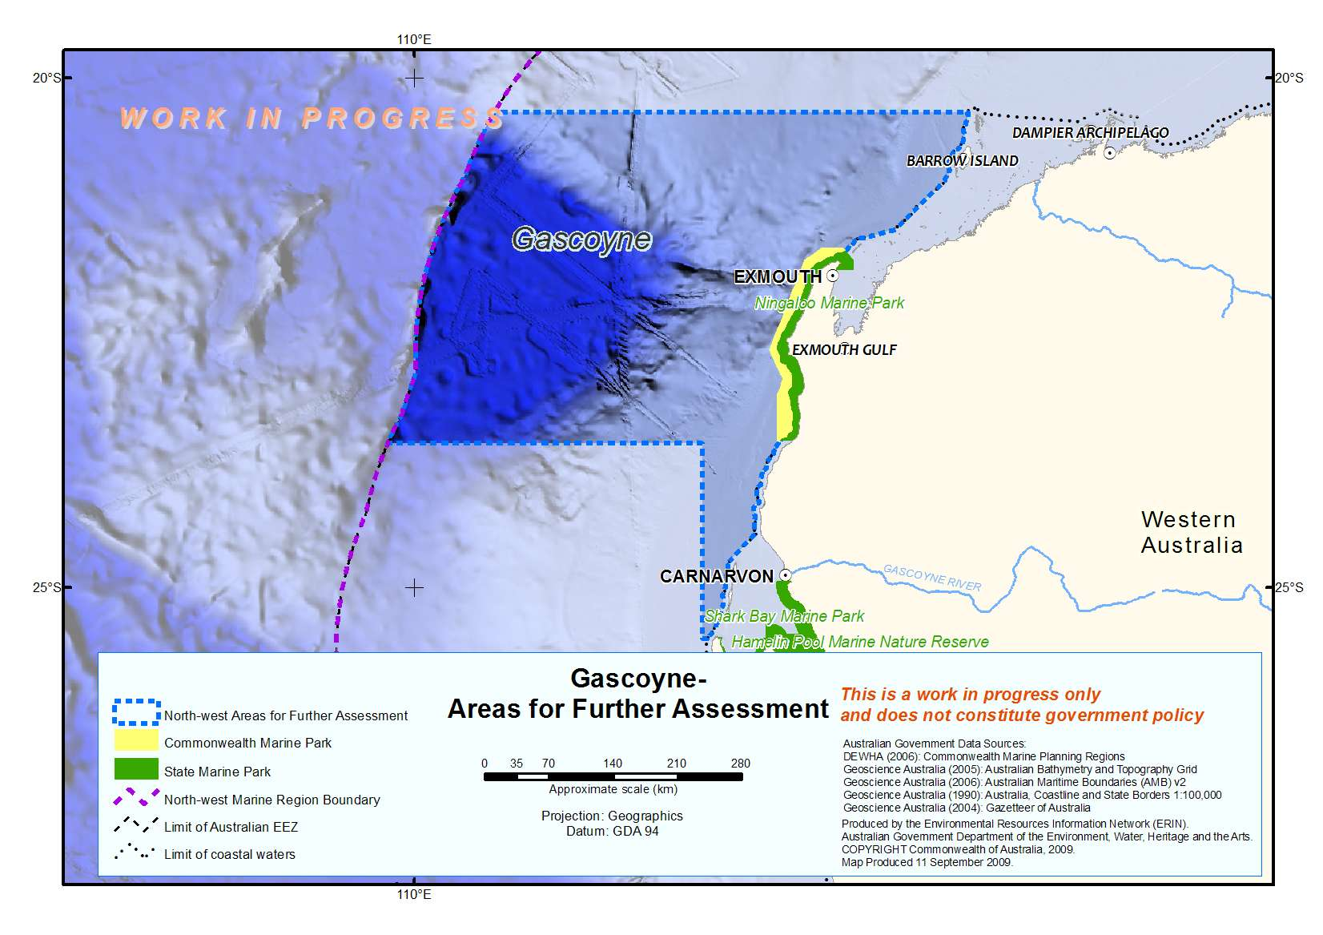
The Gascoyne Area for Further Assessment covers 161 071 km² of ocean, extending from south of Carnavon to north of Onslow and out to the limit of Australia’s EEZ. It includes ecosystems of five provincial bioregions and three meso-scale bioregions: the Central Western Shelf Province, the Central Western Shelf Transition, the Central Western Transition, the Northwest Province and the Northwest Shelf Province provincial bioregions, and the Pilbara Offshore, Ningaloo and Zuytdorp meso-scale bioregions. The Area incorporates the existing Ningaloo Marine Park (Commonwealth Waters) and is adjacent to the Shark Bay World Heritage Area. The Area is also adjacent to a number of existing Western Australian Government Marine Reserves in State waters: Ningaloo Marine Park (State Waters), Montebello Islands Marine Park, Barrow Island Marine Park, Barrow Island Marine Management Area and Muiron Islands Marine Park. This Area includes important seafloor features such as the Exmouth Plateau, the Montebello Trough and the Cape Range and Cloates canyon systems which are areas of high biological productivity which support the diversity of Ningaloo Reef. The demersal fish communities associated with the slope in this Area also have a high level of endemism and species diversity.

Proposed conservation objectives for reserve(s) established within the Gascoyne Area for Further Assessment:
- To protect ecologically adequate examples of the benthic/demersal habitats and communities of the Northwest Province and Central Western Shelf Transition provincial bioregions and the Ningaloo meso-scale bioregion. These bioregions are not included elsewhere in the Areas for Further Assessment.
- To protect ecologically adequate examples of pelagic habitats and communities of the Central Western Shelf Transition, the Central Western Province and the Northwest Province, including those environments associated with enhanced productivity and species aggregations:
- Exmouth Plateau
- the Cloates and Cape Range canyon systems
- To extend the continuity of protection of the Cape Range-Ningaloo system to the offshore canyons and deep sea environments.
- To enhance protection of Ningaloo Reef and the habitats that support it.
- To enhance protection for nationally protected species including whale sharks, humpback whales, pelagic dolphins and marine turtles.
- To protect biodiversity associated with slope habitats in this Area.

- PILBARA NORTH Area for Further Assessment
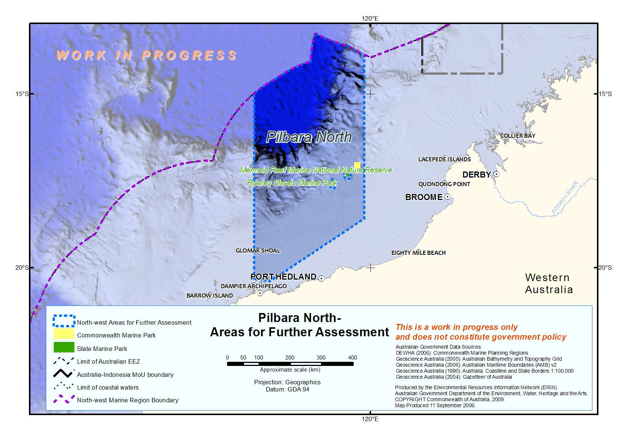
The Pilbara North Area for Further Assessment covers 208 088 km² of ocean offshore from the port of Dampier through to north of Port Hedland and out to the edge of Australia’s EEZ. The Area includes ecosystems from the Northwest Shelf Province, the Northwest Transition and the Timor Province provincial bioregions and the Pilbara Offshore and North West Shelf meso-scale bioregions. The Area includes depths ranging from 20 metres to over 3000 metres. The Area incorporates the existing Mermaid Reef Marine National Nature Reserve and is adjacent to the Western Australian Rowley Shoals Marine Park and the proposed Dampier Archipelago Marine Park. There is one historic shipwreck in the Area, the Lively, which was wrecked on Mermaid Reef in 1818.

Proposed conservation objectives for reserve(s) established within the Pilbara North Area for Further Assessment:

- To protect ecologically adequate examples of the benthic/demersal habitats and communities of the Northwest Shelf Province, the Northwest Transition and the Timor Province provincial bioregions and the Pilbara Offshore and North West Shelf meso-scale bioregions.
- To protect ecologically adequate examples of pelagic habitats and communities, in particular those environments associated with enhanced productivity and species aggregations:
- The Glomar Shoals
- Canyons between the Argo Abyssal Plain and Scott Plateau
- The ancient coastline

- To enhance protection of the Rowley Shoals and the processes that underpin the importance of these areas and the species that rely on them including sharks and dolphins.
- To contribute to the long-term protection of areas adjacent to critical nesting sites for flatback, green and hawksbill turtles.
5. KIMBERLEY Area for Further Assessment
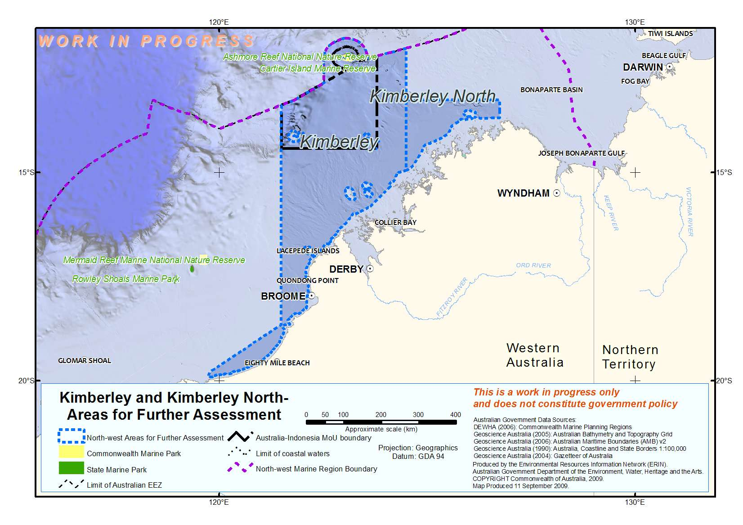
The greater part of the Kimberley Area for Further Assessment extends from Cape Bossut to north of Camden Sound and out to the limit of Australia’s EEZ, covering waters adjacent to the western third of the Kimberley including waters adjacent to the Dampier Peninsula. The Area also extends south along the coast to Cape Keraudren incorporating an area adjacent to Eighty Mile Beach. The Area covers 140 485 km² of ocean ranging in depth from 20 metres to over 2000 metres. The Area encompasses ecological examples of the Northwest Shelf Province, the Northwest Shelf Transition and the Timor Province provincial bioregions and the Canning, Kimberley, Oceanic Shoals, North West Shelf and Eighty Mile Beach meso-scale bioregions. The demersal fish communities associated with the slope in this Area also have a high level of endemism and species diversity. There are two existing Commonwealth Marine Reserves in the Area, Ashmore Reef National Nature Reserve and Cartier Island Marine Reserve. The Area is adjacent to Eighty Mile Beach and Roebuck Bay which are Ramsar Wetlands of International Significance, as well as the Eighty Mile Beach Marine Reserve Study Area proposed by the Western Australian Government, and the State-managed Browse Island Nature Reserve and Lacepedes Islands Nature Reserve. The Area incorporates the Australian-Indonesian Memorandum of Understanding Box (MoU Box), which includes Ashmore Reef, Cartier Island, and Scott and Seringapatam Reefs. There is one historic shipwreck in the Area, the Ann Millicent, which was wrecked on Cartier Island in 1888.

Proposed conservation objectives for reserve(s) established within the Kimberley Area for Further Assessment:
- To protect ecologically adequate examples of the benthic/demersal habitats and communities of the Northwest Shelf Province, the Northwest Shelf Transition and the Timor Province provincial bioregions and the Pilbara Offshore, North West Shelf and Eighty Mile Beach meso-scale bioregions.
- To enhance protection of the benthic, demersal and pelagic ecosystems associated with Ashmore Reef and Cartier Island
- To enhance protection of waters adjacent to Eighty Mile Beach and Roebuck Bay.
- To protect waters adjacent to humpback breeding grounds on the Kimberley Coast.
- To enhance protection for the genetically distinct Scott Reef population of green turtles.
- To protect ecologically adequate examples of pelagic habitats and communities, in particular those environments associated with enhanced productivity and species aggregations:
- Scott and Seringapatam reefs
- Quondong Point
- The ancient coastline
- To protect biodiversity associated with slope habitats in this Area.

6. KIMBERLEY NORTH Area for Further Assessment
The Kimberley North Area for Further Assessment covers 20 893 km² of ocean offshore from north of Camden Sound to Cape Talbot and extends from the coastal water limit out to 13.25 degrees of latitude (see Figure above). The Area encompasses ecological examples of the Northwest Shelf Province and the Northwest Shelf Transition provincial bioregions and the North West Shelf, Kimberley and Oceanic Shoals meso-scale bioregions. The Area is entirely on the shelf and is relatively shallow with depths ranging from less than 40 metres to 150 metres.

Proposed conservation objectives for reserve(s) established within the Kimberley North Area for Further Assessment
- To protect ecologically adequate examples of benthic/demersal habitat and communities of the Northwest Shelf Province and Northwest Shelf Transition provincial bioregions and the North West Shelf, Kimberley and Oceanic Shoals meso-scale bioregions.
- To increase the representation in marine reserves of key seafloor features (banks and shoals, deeps/holes/valleys, terrace and plateau) and associated biodiversity.
- To increase protection for important areas for pelagic dolphins, humpback whales and sawfish.
- To protect the Holothuria banks and reefs which are believed to be an important area for marine turtles.

7. BONAPARTE Area for Further Assessment
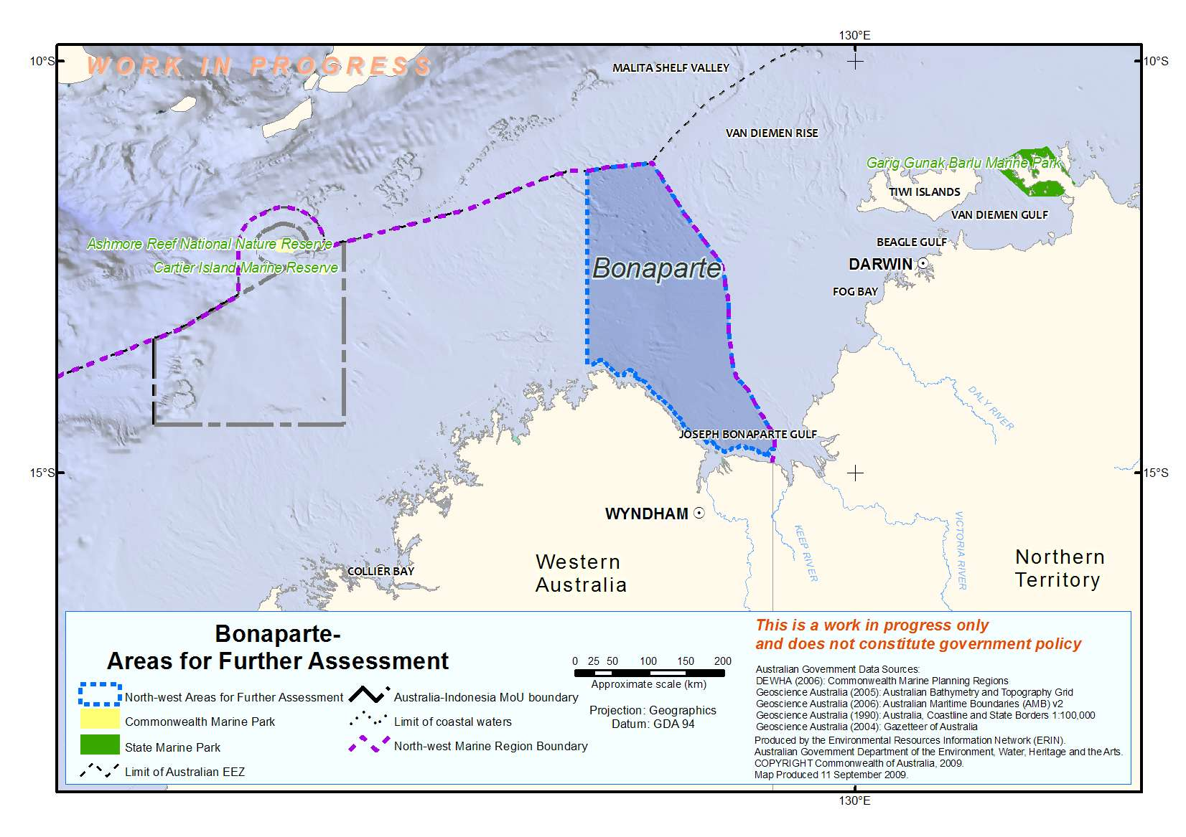
The Bonaparte Area for Further Assessment covers 55 670 km² of ocean offshore from Cape Talbot through to the Western Australia/Northern Territory border. It incorporates the Joseph Bonaparte Gulf and extends out to the edge of Australia’s EEZ. The Area encompasses ecological examples of the Northwest Shelf Transition provincial bioregion and the Cambridge-Bonaparte, Bonaparte Gulf, Kimberley and Oceanic Shoals meso-scale bioreigons. The majority of the area is relatively shallow ranging in depth from less than 20 metres to 150 metres. The Area is adjacent to the North Marine Region and the Northwest Shelf Transition bioregion is shared between the two Regions.

Proposed conservation objectives for reserve(s) established within the Bonaparte Area for Further Assessment
- To protect ecologically adequate examples of the benthic/demersal habitats and communities of the Northwest Shelf Transition provincial bioregion and the Cambridge-Bonaparte, Bonaparte Gulf, Kimberley and Oceanic Shoals meso-scale bioregions.
- To protect ecologically adequate examples of pelagic habitats and communities, in particular those environments associated with enhanced productivity and species aggregations:
- Carbonate banks and pinnacles and associated biodiversity in the Joseph Bonaparte Gulf.
- To protect important foraging areas for loggerhead, green, olive ridley and flatback turtles
- To increase representation in marine reserves of tidal sandwaves and sandbanks, the only occurrence of this feature in the North-west Marine Region.

