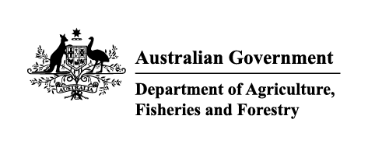

Instrument revoking a holding order under section 15(2) of the Imported Food Control Act 1992
The listed holding orders, having satisfied the circumstances under which the orders will be revoked, are revoked under section 15(2) of the Imported Food Control Act 1992 (the Act).
The circumstances being that the Secretary or delegate is satisfied that the basis for the order no longer applies.
Holding order number | Date revoked
19902 | 01/10/2025
19908 | 01/10/2025
19661 | 03/10/2025
18641 | 06/10/2025
14418 | 06/10/2025
18635 | 06/10/2025
18637 | 06/10/2025
17932 | 06/10/2025
18638 | 06/10/2025
16202 | 06/10/2025
18449 | 06/10/2025
18629 | 06/10/2025
16651 | 06/10/2025
18678 | 06/10/2025
18639 | 06/10/2025
18695 | 06/10/2025
18224 | 06/10/2025
18634 | 06/10/2025
18673 | 06/10/2025
18674 | 06/10/2025
18675 | 06/10/2025
18012 | 06/10/2025
18669 | 06/10/2025
ABDUL KA | 06/10/2025
18653 | 06/10/2025
14510 | 06/10/2025
17788 | 06/10/2025
16332 | 06/10/2025
18676 | 06/10/2025
18651 | 06/10/2025
18703 | 06/10/2025
18654 | 06/10/2025
18353 | 06/10/2025
18632 | 06/10/2025
18630 | 06/10/2025
18582 | 06/10/2025
18666 | 06/10/2025
18667 | 06/10/2025
18665 | 06/10/2025
18658 | 06/10/2025
18636 | 06/10/2025
18631 | 06/10/2025
18662 | 06/10/2025
18696 | 06/10/2025
18697 | 06/10/2025
18672 | 06/10/2025
19309 | 07/10/2025
16623 | 07/10/2025
19717 | 07/10/2025
19566 | 07/10/2025
19456 | 07/10/2025
18457 | 07/10/2025
19568 | 14/10/2025
19928 | 14/10/2025
19066 | 20/10/2025
19066 | 20/10/2025
19595 | 22/10/2025
18250 | 22/10/2025
19032 | 22/10/2025
19630 | 22/10/2025
19880 | 22/10/2025
19863 | 22/10/2025
19741 | 22/10/2025
19936 | 29/10/2025
19917 | 29/10/2025
Delegate position number | Date
100091 | 3/11/2025
Delegate of the secretary for the purposes of section 15(2) of the Act.

