

Department of Sustainability, Environment
Water, Population and Communities

A comprehensive baseline analysis of
Occupational Health & Safety (OHS)
statistics specific to the e-waste recycling industry
within Australia, including collection, storage, handling,
transport and treatment/processing

Project Conducted by:-
David Caple, Director
David Caple & Associates Pty Ltd
PO Box 2135
Ivanhoe East
Victoria 3079
david@caple.com.au
www.davidcaple.com.au

March 2011

Executive Summary

This project was commissioned by the Department of Sustainability, Environment, Water, Population and Communities (DSEWPaC) to provide baseline data on the Occupational Health and Safety (OHS) risks associated with the e-waste recycling industry in Australia. This has involved visits to six workplaces and processing survey data from seven companies involved in this sector in Australia.

It also has involved consultation with 15 companies in total and two groups of Auditors who have visited Australian workplaces generally on behalf of the Original Equipment Manufacturers (OEMs).

The base line data that has been developed from 2007- 08 to 2010 -11 (Year to Date) indicates that:

- 50% of injuries are cuts and lacerations primarily to hands and forearms during the disassembling process.
- 30% are sprains and strains – associated with the manual handling tasks and repetitive arm work in the disassembly process.
- 10% are bruising – mainly involved in the manual handling of the TVs and computers from the storage and disassembly processes.

All of the companies interviewed and visited were accredited with ISO 9001 and ISO 140001 as part of their requirements to undertake e-waste recycling activities. These companies also had elements of AS4801 in place relating to OHS management systems.

Basically, the attention to documentation of generic OHS systems was considered contemporary with most other medium sized employers working in the manufacturing sector in Australia.

The major gap that emerged during this review was the potential lack of education and awareness of employers and workers about scientifically based methodologies for environmental monitoring of the list of chemicals that are handled by the workers during the recycling processes.

It was observed that there is some knowledge of potential health effects, for example, handling of lead which is resulting in medical health checks of blood for workers in this sector. It was noted however that there is potentially a high turnover in this sector, particularly of casual workers, where such monitoring is difficult to maintain on an ongoing basis.

Further, there is little evidence of monitoring of the other chemicals that are involved in Cathode Ray Tube (CRT) and television recycling, nor an understanding of what the Threshold Limit Values (TLV) that would be relevant for this type of work.

Most sites indicated that the level of risk to all of these chemicals was extremely low. This was based on their anecdotal experience and dependence on the mechanical ventilation systems and the wearing of personal protective equipment by their workers. However, there was no evidence that this expectation had been based on quantitative data arising from valid testing undertaken by qualified Occupational Hygienists.

It is therefore concluded that the major systemic risk through significant increases in e-waste volume processing may relate to the long term health effects from exposure to the range of chemical outlined in the draft interim industry standard.

The work methods used across this sector would be deemed to be rather basic from a process design perspective.

The majority of the products are manually handled multiple times. There is a dependence on team lifting for removing large and awkward objects such as televisions from stillages and containers in the re-processing area.

If the volumes were to increase significantly, a program would need to be developed on how to better utilise mechanical handling equipment and more sophisticated systems of work to increase productivity and reduce the manual handling risks to the workers.

The storage of e-waste in car parks and external areas introduces potential for chemicals to be washed into storm water drains with the potential health effects on others.

The congestion observed within the workplaces increases the probability of serious incidents between pedestrians and forklifts sharing the same walkways and work areas. The OHS legislation relating to forklift safety will need to be referred to and included within the industry guidance.

Within Australia, OHS is legislated by state and territory governments for all workplaces within their jurisdiction. They provide an extensive range of Guidance materials, as well as Regulations and Codes of Practice. It will be the responsibility for the employers working within this sector to ensure that they comply with their duty of care requirements as outlined in their respective OHS legislation. They will need to be able to provide evidence that due diligence has been followed in the design and operation of their respective workplaces. It is therefore recommended that DSEWPaC works closely with Safe Work Australia to ensure that the linkages between the proposed Australian and New Zealand (ANZ) Standard with the OHS legislation are made during the drafting stages.

Recommendations

- Baseline health exposures to each of the chemicals listed in the draft interim industry standard should be developed and protocols for environmental monitoring of each chemical should be developed in consultation with Certified Occupational Hygienists.
- Baseline measurements for each of the chemicals should be required for each accredited e-waste processing site.
- Monitoring of these chemicals should be ongoing in accordance with OHS legislation requirements.
- Future data collection of OHS Incidents and Workers Compensation Claims should be standardized against hours worked or tonnage produced.
- Consultation with Safe Work Australia should determine if a Workplace Industry Code (WIC) could be developed for the e-waste sector to enable national monitoring of OHS performance with the State OHS Regulators.
- A project to identify and document safe work processes for common tasks in e-waste processing should provide practical examples of risk controls into the proposed ANZ Standard.
- The setting of OHS requirements for the e-waste industry should be based around the existing OHS legislation. This includes existing OHS Regulations and Codes of Practice. These should be monitored through Safe Work Australia and the State OHS Regulators. Existing Regulations and Codes on OHS hazards such as noise, chemical storage and handling or manual handling should be integrated into the ANZ Standard. This will ensure employers have one OHS set of requirements.

- An education and OHS awareness program should be developed for employers. This should cover the range of OHS risks, measurement techniques and risk assessment methods, together with examples of engineering risk controls that are consistent with the OHS legislation.
- Further research and guidance is required on the safe handling of toner.
- Guidance information is required on the selection, use and maintenance of Personal Protective Equipment including gloves, forearm guards and masks.
- Forklift and pedestrian safety should be discussed with the industry as an OHS risk that requires engineering controls to separate their respective travel areas.
- An integrated system using stillages is required for the collection, storage and transportation processes to eliminate multiple handling of the products with the associated OHS risks. These stillages should have fold down sides to assist in manual handling of the objects.
- Mechanical aids need to be identified to move the large televisions and to eliminate the need for team lifting with the associated manual handling risks.
- The potential for electrical safety risks from the storage and handling of batteries and capacitors should be included as part of the OHS risks together with guidance on practicable risk controls.
- Guidance is required on the prevention of slips, trips and falls in the workplaces particularly relating to the procedures used for the product storage and handling.

February 2011

Introduction

In November 2009, the Environment Protection and Heritage Council (EPHC) released the National Waste Policy: Less waste, more resources. The policy has a strong focus on taking responsibility, through product stewardship, for the environmental, health and safety footprints of manufactured goods during and at end of life. A key priority will be for the Australian Government to introduce national product stewardship legislation.

The first products to be regulated under this legislation will be televisions, computers and computer peripherals. The National Television and Computer Product Stewardship Scheme (the Scheme) will be implemented from 2011, with a national roll out taking five years.

The National Television and Computer Product Stewardship Scheme Implementation Working Group (IWG) is a joint government and industry working group which has been established to develop and implement the operational arrangements of the Scheme. The IWG includes representatives from the Australian and state governments, the Australian Information Industry Association (AIIA) and Product Stewardship Australia (PSA).

The IWG has identified injury or loss of life to service providers collecting, storing, handling, transporting and treating television and computer waste as a severe risk in relation to the operation of the Scheme. To mitigate this risk, Standards Australia is developing an Australian and New Zealand (ANZ) Standard for the collection, storage, handling, transport and treatment of e-waste. As the ANZ Standard may take up to two years to complete, AIIA and PSA are developing an interim industry standard titled “Collection, Transport and Recycling of End-of-Life (EOL) Televisions and Computers” (November, 2010).

Whilst these standards will assist with the appropriate collection, storage, handling, transport and treatment of waste arising from the Scheme and will aim to prevent injury and loss of life through using appropriate processes, there are currently no e-waste specific Occupational Health and Safety (OHS) statistics available that will enable the Scheme to assess how successful the standards are at reducing OHS related incidents or to determine what some of the specific issues or concerns may be. Safe Work Australia has advised the Department of Sustainability, Environment, Water, Population and Communities (DSEWPaC) that the closest available match for OHS statistics for the e-waste recycling industry is the ‘waste disposal services’ category. This category includes garbage collection and disposal, industrial waste collection, rubbish dump and tip operation and sanitary disposal services. Whilst e-waste recycling is a component of this group, Safe Work Australia is unable to separate this information from the other listed activities and therefore these statistics are too broad to assess the performance of Scheme’s risk management activities. There may be further capacity to obtain additional data from state and territory health or industry departments and DSEWPaC will assist in this area by asking for additional jurisdictional support on behalf of the successful provider.

DSEWPaC is working with industry stakeholders to develop governance and risk management in relation to the processing of e-waste within Australia. Specifically, this project looks at the processing of televisions, computers, and computer peripherals.

One component to this governance review in consultation with the industry is the development of an ANZ Standard.

The interim industry standard being developed by AIIA and PSA for their contractual purposes provides general guidance on the life cycle processes involved in the collection, transportation, storage and recycling of end-of-life televisions and computer products.

Appendix 1 of the draft interim industry standard provides guidance on the environmentally sound recycling of electronics. Details of “substances of concern” are provided for:

- Circuit boards
- Batteries
- Cathode ray tubes
- Leaded plasma display glass, and other leaded glass
- Lamps, bulbs and switches
- Insulated wire
- Plastics

Consistent with the Stockholm Convention on Persistent Organic Pollutants (POP), ratified by Australia on 20 May 2004, has an obligation to eliminate or reduce the release of POPs into the environment. In 2004, the first 12 POPs were listed. A further nine new chemicals were listed in August 2010. These will be amended to the Annexes of the Convention.

The main chemicals that have been identified in the draft interim industry standard of concern to the health of the workers in the e-waste sector include:

- Lead
- Cadmium
- Phosphor
- Silica dust
- Beryllium
- Mercury
- Bromine
- PCBs
- Antimony

In accordance with Occupational Health & Safety (OHS) legislation in Australia, once potential hazards to health and safety of the workers is identified, a risk management based process needs to be followed to assess the level of risk and implement risk controls. As outlined in the draft interim industry standard, the Waste Hierarchy must be followed.

This requires the employer to:

- Eliminate the hazard. If this is not reasonably practicable, then they should,
- Substitute the hazard with a lesser risk, or
- Isolate the hazard, or
- Use engineering controls, or
- Use administrative controls, or
- Use personnel protective equipment (PPE).

It is expected that the risk assessments that are undertaken within each of the work places should follow this hierarchy in a sequential process to provide the highest level of risk reduction to the workers within the workplace.

This project provided an opportunity to identify which OHS hazards are present within the OHS incident data and WorkCover claims from a sample of employers currently working in the e-waste industry in Australia. This provides the development of baseline data on the OHS experience of this industry sector and to inform the technical committee of the ANZ Standard.

Project Methodology

- A list of companies involved in the e-waste industry sector was provided by DSEWPaC during January 2011. Caple and Associates subsequently identified additional companies thanks to the interest and cooperation from the industry stakeholders.
In total, 15 companies participated in the contribution to the baseline data and the consultation processes. This included data from all of the major e-waste processors who are responsible for recycling over 80% of the waste. Three of these companies who provided input into the project outcomes had multiple workplaces in Australia. Their data in the survey from each company was provided in an aggregated form from all the sites under the nominated manager’s control.

No data has been provided from local Councils and data has been included from one Social Enterprise.
- A survey tool was developed in consultation with DSEWPaC to seek OHS data from those companies who are involved in the e-waste sector. A copy of this survey is provided in Appendix 2 of the report.
- Site visits were made to six e-waste processing facilities to observe the systems of work and to consult with the company management about OHS processes and systems. This included two workplaces in Sydney and four located in Melbourne.
- Telephone conferences were held with two independent auditing companies who primarily work with the major manufacturers of computer systems. These manufacturers are referred to as Original Electronic Manufacturers (OEM) within the sector.
As a requirement for the e-waste participants to handling their products, the OEMs also conduct audits to ensure that their expected environmental standards are maintained. This includes the physical environment to minimise wastage and product contamination, as well as the work environment from an OHS perspective. The OEMs are the major manufacturers of televisions and computers at a global level.
- Confidentiality agreements were signed with companies involved in this report. This enabled them to contribute data and examples of policies and OHS systems for consideration.
In respect for these confidentiality agreements, participating companies have not been identified nor their specific data in this report.
- During the course of the project the National Alliance of Charitable Recyclers Association (NACRO) was consulted. This enabled an overview of the issues that are currently under discussion at a political level associated with the future planning for e-waste processing in Australia, and the potential role of charitable associations. This particularly related to the collection of e-waste from the community.
Members of NACRO also provided additional contacts to broaden the base of the OHS consultation process for this project.

Project Outcomes

1. E-Waste Processing Overview

It was evident through the consultation process that there are different stakeholders involved in the life cycle of the e-waste processing industry. The key processes involved are:

- Collection
- Transporting
- Storage
- Dismantling and extraction of e-waste components for further down stream processing

The majority of the larger processing sites were also involved in refurbishing and on-selling items of computer technologies. Whilst this is undertaken generally in a secured area of the recycling factory, the OHS issues associated with refurbishment were outside the scope of this project.

A flow chart outlining the key steps of this end to end industry has been summarised in Appendix 3 of this report.

2. Survey Results

The collection of baseline data was undertaken from companies willing to share their OHS data to develop a baseline of experience for OHS incidents, injuries and illness.

The key findings in establishing this baseline data are provided below.

This data has been found by aggregating the survey feedback provided from seven e-waste processing sites within Australia.

It is noted that this would not constitute a statistical sample large enough to make any definitive findings. However, they should be taken as indicative of the experience in OHS to date.

2.1 Number of years the site has been processing e-waste.

It was found that five of the seven sites have been processing e-waste for five years or less.

There were two sites that have been processing it more than 15 years.

2.2 E-Waste services provided.

Figure 1 shows the number of sites who were involved with each of the main service delivery areas of e-waste who participated in this survey.

Figure 1: Services provided by the 7 sites who responded to the survey

It is evident that the majority of companies provide all of the key services involved in the e-waste sector. Not all sites are involved in refurbishment of computers. The larger sites tended to contract out the transporting of the e-waste. It seems that the e-waste is collected from four different collection sources.

These include:

- Local government involved in scheduled collection days
- Charitable associations
- Major retailers
- Corporate clients particularly involved in leased computer technologies

2.3 Total number of OHS incidents

In aggregating the data from this survey, the total number of incidents reported for the seven respondent sites are summarised in Figure 2.

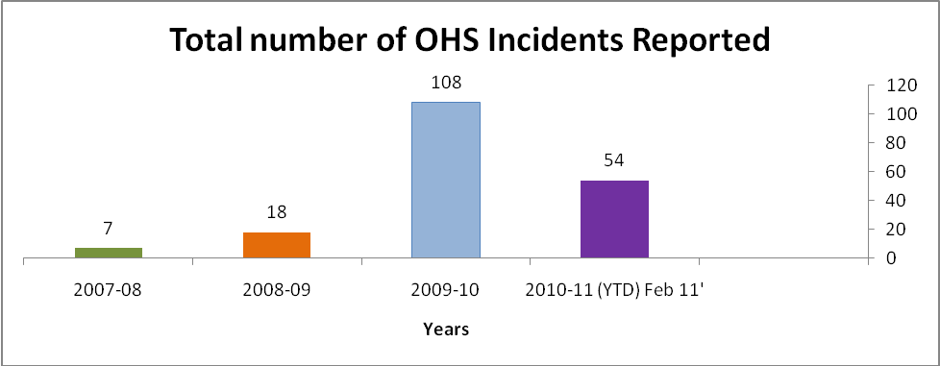
Figure 2: Number of OHS Incidents reported per year

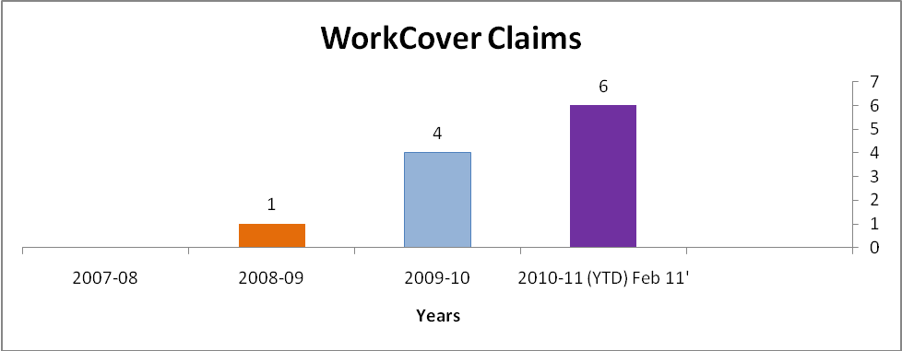
Figure 3: Number of Workers Compensation Claims per year

It is evident that the reported number of incidents is increasing each year. Also there has been an increase in the number of Workers Compensation Claims. These incidents have been reported from all sites surveyed with no site having any higher proportion of incidents per number of employees as others. As a general finding there were around 5 incidents reported for every 10 employees. It is noted that one of the largest sites was not able to provide incident data for 2010–11. This site accounted for 63% of all the incidents reported in 2009-10.

It is noted that these incidents would generally be reported at a site level and a proportion of these may end up with the submission of a Workers Compensation Claim.

The Workers Compensation Claims reported came from 3 of the 7 sites in the survey. The other 4 sites reported that no Workers Compensation Claims had been submitted.

Although there are an increasing number of OHS incidents being reported, the number of Workers Compensation Claims are still quite low as seen in Figure 3. This would imply that the majority of the incidents have been minor and the worker was able to return to work without requiring a Workers Compensation Claim to be submitted.

2.4 Yearly tonnage of e-waste

In reviewing the data provided in the surveys, there appears to be two clusters of companies. These are:

- Small e-waste processing sites – these sites are processing between 200 tonne and 1,000 tonne of e-waste per year.
- Large processing sites – these are producing in excess of 1,000 tonnes of e-waste per year.

All sites have been increasing in their production on a year to year basis. Since 2007 all sites surveyed have doubled their production output with a range from 430 tonnes per year up to more than 5,000 tonnes per year per company.

When combining all the tonnage processed per year since 2007-08 the data is summarised in Figure 4.

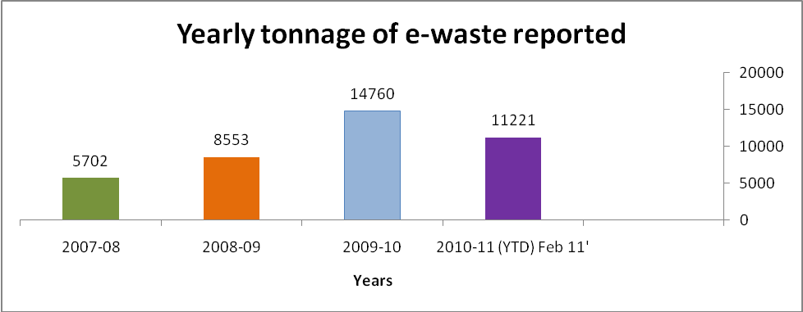
Figure 4: Total Tonnage of e-waste producted from the companies involved with this survey.

It is interesting to note that there appears to be a correlation between the numbers of incidents reported with the yearly tonnage of e-waste.

This number of incidents has not been standardised per hours worked or per employee as this data was not available for all companies. However, where data was available both variables have increased over the last three years.

Hence, from a risk management perspective, with increasing exposure to the processing tasks, there is an associated increase in the number of OHS incidents that are occurring.

2.5 Injury type

In aggregating the data provided by the seven participating sites, the following data on injury types was provided.

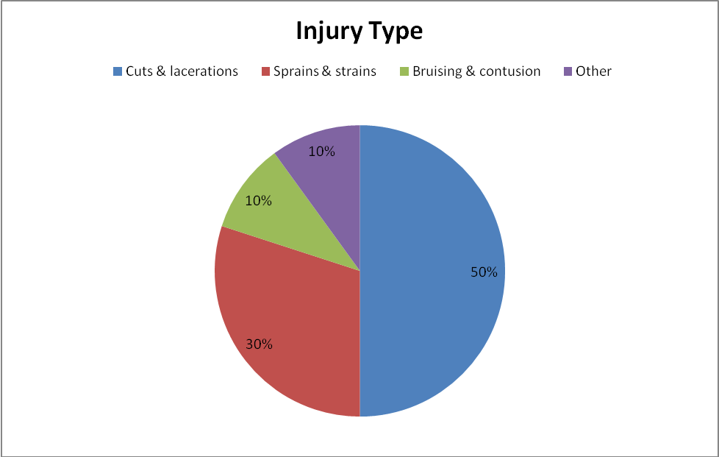
Figure 5: Breakdown of injuries reported from e-waste workers

‘Other’, includes:
- Slips, trips, falls
- Psychological (Stress / bullying incident)
- Chemical exposure
- Electrical
- Pedestrian forklift incident

It was evident that there is some variation from site to site in relation to these injury types. However, this aggregated data is deemed to be representative of this sector as a whole. It seems that around 80% of reported injuries are from cuts and lacerations, or manual handling sprains and strains.

In reviewing this data on a year to year basis there is a consistent trend that cuts and lacerations, and sprains and strains together constitute around 80% of incidents each year. There does not appear to be another type of injury emerging in the data with any statistical growth.

The majority of the sites had 10 to 25 employees involved in e-waste processing each year. In 2010 the sites ranged from 11 to 64 employees in e-waste processing. The largest sites had more incidents than the smaller sites per year but all averaged around 5 incidents per 10 employees per year. In relation to Workers Compensation Claims the majority reported in the survey were from the medium sized workplaces with 20 – 40 employees.

2.6 Categories of OHS incidents, illness and injury

The survey requested that all of the data be separated into three categories.

These were:

- Trauma – injuries associated with a particular incident e.g. cuts, trip, collision.
- Chronic – overuse injury, repetitive work, stress.
- Systemic Exposure – hearing loss, respiratory dust, dermatitis or chemical exposure.

The following table summarises the allocation under these categories that were provided by the respondents.

Category | Percentage of total injuries reported
Trauma injuries | 75%-100%
Chronic | 0%-25%
Systemic exposure | 0%-10%

Table One: Allocation of injury type to traumatic, chronic or systemic illness or injury.

This data would indicate that the majority of the OHS incidents and injuries that are being reported by the e-waste sector are either trauma incidents, such as cuts or lacerations and sprain and strain, or musculoskeletal injuries associated with manual handling and repetitive work. This survey would indicate that collectively, these account for around 80% of all OHS incidents and injuries reported by these e-waste companies.

3. Employee Health Checks

3.1 Pre-employment health checks

There were two companies that require a pre-employment medical to be undertaken of all potential employees.

The major focus was on the general health of employees and some specific medical tests relating to their physical capabilities to undertake the proposed work duties. These include items such as cardiovascular fitness, range of movements, grip strength, as well as blood pressure and heart rate readings.

One site indicated that it tests for lead levels in whole blood as part of their pre-employment check.

The remaining four sites do not have a pre-employment medical check currently in place.

3.2 Annual or bi-annual health checks

It was found that four of the seven sites do annual or bi-annual health checks on their employees. The most frequently measured tests were:

- Blood test for lead
- Hearing test
- Random drug and alcohol tests
- General health and fitness tests
- Vision tests

One site also tests for cadmium level for workers in the CRT dismantling area.

The remaining three sites do not have annual or bi-annual health checks.

4. Work Environment Monitoring

There were two sites that do some environmental monitoring. Both of these sites test the environmental noise levels. One also tests for air quality.

None of the other five sites have a systematic process of work environment monitoring.

5. OHS Operating Procedures

All seven sites provided examples of documented OHS procedures relating to work methods in the e-waste recycling tasks.

Some of the more sophisticated procedures were incorporating photographs and simple work instructions to provide a “step by step” approach to how these tasks should be safely undertaken.

During site visits, an observation was made on operating procedures close to some of the dismantling work benches. These operating procedures were also provided in the training and induction manuals.

These procedures also included details of personal protective equipment (PPE) to be worn. Again, photographs were used in some of these procedures to show which PPE is available and how it is correctly fitted.

Observations of work practices during the site visit would indicate that the employees were mostly following their site’s determined safe work practice. However, the understanding of what is “safe” varied between sites. When employees were observed undertaking the same tasks at different sites they also undertook a wide range of work methods. For example, the selection of PPE gloves and forearm protection varied greatly from none being worn to multiple layers of PPE. Each site indicated they had done their own research and determined that their system was safe. This reflected a lack of exposure by some managers to safer work methods that are used at other companies undertaking the same tasks.

6. OHS Policies Relating to E-Waste Management

All of the companies that were surveyed and visited have introduced their own OHS management systems. These contain a range of policies and procedures to enable them to obtain compliance with key International Standards and Australian Standards.

All of the sites had accreditation for:

- ISO 9001 – 2008 “Quality management systems”
- ISO14001 – 2004 “Environmental management systems”

In the specific area of OHS, the sites were developing their OHS systems based on AS4801 – 2001 “OHS Management Systems”.

The companies were also seeking equivalent ISO Standards relating to OHS risks in the ISO18000 series. These relate to “Information technology — Radio frequency identification for item management”.

In consultation with the auditing teams, it was indicted that their expectations would be that companies involved in the recycling of e-waste materials should be accredited to all of these Standards as a baseline to ensure safe systems of work.

It was noted that offshore processing is undertaken for the high value e-waste components. These are separated during the recycling process and sent in containers to Singapore and other regional processing centres that have the machinery to extract the valuable materials. This project did not have the scope to assess the OHS processes or risks associated with these offshore companies.

7. Staff Turnover

It was commented, particularly amongst the smaller processing sites, that they have a small permanent pool of employees who undertake the majority of their reprocessing work on a daily basis. However, these sites also have a pool of casual workers that they utilise either directly, or through labour hire companies during peak periods of processing work requirements.

It was commented during informal discussions that there is a relatively high turnover of staff performing the manual labour tasks in this sector. Consequently, this may be a confounding factor in determining any long term systemic impacts from working particularly with the chemical exposures for those individuals who stay in the industry for short periods of time.

It was noted that the majority of workplaces were not only processing computer and television e-waste, but a range of other products were also part of their work requirements. The other industries that are undertaken within the same workplaces appear to be dependent on the history of the particular company prior to them going into the e-waste sector.

Examples of these other industries included:

- Reprocessing of batteries and electrical conductors.
- Reprocessing and refurbishment of wire products for the retail industry.
- Reprocessing of mobile telephones and other electrical and battery operated consumer products.

Hence, the exposure to risks from a holistic perspective would need to be assessed within the context of the other systems of work present within these workplaces.

Discussion

This analysis of baseline OHS data from the e-waste industry sector indicates a number of key findings.

These include:

- Whilst the draft interim industry standard clearly outlines a range of risks associated with chemical exposures particularly during the dismantling and reprocessing activities, there is little sophistication evident within the companies to accurately monitor the work environment to assess worker exposure to these chemicals.
There would appear to be a need within the proposed ANZ Standard on e-waste to identify the importance of an Occupational Hygienist, or similar persons with appropriate technical understanding of sampling methodologies and analytical methods to undertake or oversee the environmental monitoring programs.
For example, consultation with auditors of the e-waste sector indicate that even when some environmental monitoring has been undertaken, it has not been sampled during activities and in locations where individual workers may potentially be exposed.
- Once the methodologies and risk controls expected for these potential health risks from chemicals has been determined by the ANZ Standard, an education program will be required across this industry sector focussing on the senior management and supervisor level.
It was observed that there is currently a wide variation in the knowledge and expectation in relation to risks associated with chemical exposures.
- A second phase of the education requirement will be with workers within the sector to be included in their induction training and integrated into the agendas of OHS consultative committees. This will ensure that the results of the environmental monitoring undertaken within their workplace are tabled within a consultative environment, to ensure that both employer and workers receive and understand the results that are presented.
- There is a wide range of engineering controls that need to be evaluated to eliminate or reduce the risk of injury and illness within this sector.
For example, whilst cuts and lacerations were the majority of OHS incidents that were reported, there was no consistent knowledge or supply of gloves and forearm protectors with the companies who were visited as part of this project.
It would appear that each company had made their own investigations as to appropriate PPE and had found different products that they deemed to be most suitable for this task. However, it was observed that there was a wide variety of product being used with variable protection given to the worker’s hands, wrists, and forearms.
Guidance should be provided to the industry on the most suitable items of PPE particularly to minimise exposure to cuts and lacerations of the hands, wrists and forearms.
- The exposure to dusts and chemicals also requires more information provided to the industry on appropriate suppression methods and personal protective equipment. For example, the masks that were worn at one site for protection from silica dust and lead appeared to be the basic medical masks that are provided in the health sector.

There is concern that these types of masks may be inappropriate and ineffective for the particulate type that is relevant to the e-waste processing chemicals.
Further guidance is required to the industry on the methods of dust suppression and PPE relevant for these chemicals.
- It was observed that each site who are handling CRT monitors from either televisions or computers are generally stacking these on pallets and transporting them to specialist processing factories. A visit to these factories to observe how items are subsequently processed was not able to be made, but it is understood that strict protocols are in place.
However, an observation was made at sites where the glass in CRTs was broken during the transportation, storage, or reprocessing activities. There did not appear to be any rigid protocols as to how the workers should minimise their exposure to the phosphor, lead, and silica dust associated with sweeping up or handling these items.
The ANZ Standard will need to include the requirement of specialist processing facilities that are either totally enclosed, or with a positive air flow to ensure that such exposures are eliminated. Preferred supply format for e-waste collections should also be specified (e.g. palletised, crushed, de-pressurised, wrapped, etc). Safe methods for accidental exposure resulting from broken glass from these CRTs during other stages of the collection, transportation or storage processes should also be covered.
- Due to the high volume of e-waste which is collecting at most of the sites visited, stillages and containers of product are now sitting in car parks and outside storage areas. This exposes the e-waste to external weather conditions with the potential that chemicals and environmental dust contaminated by some of these items could be washing into the storm water drainage system around these factories.
The risk associated with the storage of large quantities of these items will need to be included in the ANZ Standard to ensure that safe storage systems are specified.
- The transportation receptacles that are used for e-waste were observed to introduce a range of OHS risks. These included:

  - When the collection agency delivers the e-waste to the factory, forklifts were observed to tip the loose components from the collection agency’s bins into the company owned processing bins. This resulted in a range of dust, fallen and damaged product, potential chemical exposure, as well as breakages of glass during this tipping and transfer process.
  - The manual handling risks, particularly in moving large computer monitors and television sets were clearly evident from the 30 cubic metre storage bins and solid sided stillages and pellecons.
Information on better stillages preferred by the e-waste industry was provided. These have the ability to open on the side to minimise the manual handling risks and appear to be similar to those used in the automotive industry for the delivery of component parts. The ANZ Standard should identify the hazards associated with the collection bins and provide recommendations of those stillages and pellecons that minimise the potential for manual handling risks both for the collecting agencies as well as the processing facilities.

- The major manual handling risks appear to be associated in the e-waste dismantling area from:
  - Individuals or team lifting of large and awkward shaped televisions from the stillages onto the work bench.
There were no mechanical aids that were observed in any of the factories that eliminate or provide mechanical assistance for these current manual handling tasks.
There may be an opportunity for the industry to work with materials handling companies to identify if there are suitable mechanical aids for this purpose.
  - Repetitive use of powered tools was a fundamental part of the disassembly process on the work benches.
A variety of hand held powered tools were observed during the site visits. These included:

- Air powered In line screwdrivers. These are generally suspended above the work bench and the operator grips the long cylinder shaped tool and directs the screw tip to the screws to be removed.
- Battery operated pistol shaped screwdrivers
- A range of manually operated screwdrivers

The ANZ Standard should identify the relative benefits and risks associated with the different tools that are used for the repetitious disassembly tasks. This would enable an informed decision as to which would be the appropriate tools for use in the disassembly processes.

- The potential for electrical safety incidents is clearly evident within many of the workplaces visited. The primary source of electrical discharge that could cause severe injury to the workers were from:

- Batteries that are removed from machinery. Some batteries that hold charge that are removed from machinery during the dismantling process.
- Capacitors that are still holding charge that are removed from the older style televisions in particular.

The ANZ Standard will need to contain examples of the electrical safety risks, together with reference to other Standards that provide guidance on the safe handling of batteries to minimise electrical risks to the workers.

- Incidents between forklifts and pedestrians within the often congested work places will become a greater risk if more employees and forklifts are sharing the same work areas.
The OHS regulators in Australia require specific forklift management plans to be in place within workplaces to ideally eliminate those areas where the pedestrians can walk and where the forklifts are operating. There was one site visited during this review that has implemented such a forklift management plan. However, none of the other sites appear to have planned the layout of their factory to meet this OHS requirement.
The ANZ Standard will need to identify forklift and pedestrian safety risks as an area for OHS compliance with the relevant OHS Codes of Practice and Guidelines provided by the OHS Regulators.

- The layout and housekeeping of the work areas would appear to be a primary risk for the slip, trip and fall incidents that were recorded in the data. Items were observed stored within congested areas resulting in the potential to trip over electrical cords or components that were lying around the floor area.
For example, where the powered hand tools were being used, it was observed that many of the small screws from the computers being dismantled were across the work benches and on the surrounding floor area. These add to the potential for slip, trip and fall incidents.
When large containers of stored e-waste are delivered to the site, it was noted that they were often up-ended and a large volume of e-waste was lying on the factory floor. This increases the potential for walkways to be encroached with the resultant and slip, trip and fall risks.
The ANZ Standard will need to identify the risks associated with slips, trips and falls, together with simple guidance on housekeeping methods to minimise the exposure and probability.
- The incidents of damaged toner cartridges were observed during site visits. This results in a potential additional chemical related hazard for the workers handling these products.
Exposure to toner was identified by the Auditors as one of the major health risks for workers in this sector. This was not a hazard that had been identified for health measurement to be taken to determine the exposure limits. It was also not an issue that had safe work procedures consistently available. Further research should be undertaken to determine how toner should be safely monitored, handled and processed.
The ANZ Standard should identify this hazard together with appropriate work practices that should be implemented to minimise the potential health risks to the worker.

Conclusion

This review indicates the majority of the e-waste processing companies are accredited for ISO compliance for environmental and quality management systems. Consequently, they have developed comprehensive OHS related policies and procedures to minimise the risk of illness and injury within their workplaces.

The data indicates that the majority of incidents and injuries that have occurred primarily relate to cuts and lacerations particularly to the hands and arms as well as sprains and strains from the manual handling tasks. To date, there has been little evidence of health effects from systemic exposure to the many chemicals associated with this industry.

A range of recommendations have been provided within this report for the consideration of the committee involved in writing the proposed ANZ Standard in a section relating to OHS.
This will build on the technical information provided in the draft interim industry standard. It will also provide a broader basis of risks that have been identified and the requirement for basic guidance to be developed for this sector on OHS prevention initiatives.
It is also evident that an education program will need to be undertaken to increase awareness of the potential long term health effects associated with the chemical exposures based on the experience that was reported by the auditors who have been involved in visiting many of the same sites in Australia that were included in this review.

Appendix 1: Companies consulted with regarding this project

Appendix 2: Survey

Appendix 3: Flow Chart

Appendix 1: Companies consulted with regarding this project

Company | Type | Sites | Contact details
CRT Recycling Australia | Recycler | Gepps Cross, SA (TIC dismantle and send here for VIC) | Michelle Morton
MRI | Recycler | Campbellfield, VIC | Will Le Messurier
PGM Refiners | Recycler | Narre Warren, VIC | Sam Miller
Sims Recycling Solutions | Recycler | Villawood, NSW | Graham Muir  Kumar Radhakrishnan  Neil Reid
Sims Recycling Solutions | Recycler | Oakleigh South, VIC | Brandon Truong
SITA Environment Solutions | Recycler |  | Joanna McNamara
Tes-Amm Australia | Recycler | Villawood, NSW | Alvin Piadasa
TIC Group | Recycler | Braybrook, VIC | Kane Siegel
Veolia Environmental Services | Recycler |  | Tony Cade  Peter Shmigel
Salvation Army | Charitable Recycler | Noble Park, VIC | Kerryn Caulfield
National Alliance of Charitable  Recyclers Association | Charitable Recycler |  | Kerryn Caulfield
InfoActiv | Reverse Logistics |  | Helen Jarman
Apple | Brand running take-back events |  | Vicki Hawthorne
AIIA – Byteback Trial | Collection |  | Josh Millen
Renewable Recyclers | Social Enterprise | 5/13 Ralph Black Drive, North Wollongong | Alison Perizi  Program Manager
Work Ventures | Social Enterprise | Sydney | Scott Millington
Aurus | Auditors | International – based in San Antonio, USA | Sharon Small  Bob Balutowski

Appendix 2: Survey
1st February 2011

E-Waste OHS Review – Company data sheet

Company Name
Company Location
Contact Person
Email
Phone
Date
Years processing e-waste | ...........................years

- E-Waste Service

Please tick those e – waste services provided by your company.
Tick ✓if appropriate.
Collection of e-waste
Transporting e- waste
Storage of e- waste
Refurbishment of e- waste products
Recycling e- waste components
Note; If you company does multiple services could you separate your responses in Questions 2 – 5 for each of these services?

- OHS Incidents / Injury experience

We would appreciate if you could collect data from the last 3 financial years, as well as the current year to date. We only need data relating to e- waste activities and not unrelated incidents / claims.

Data Type | 2007-2008 | 2008-2009 | 2009-2010 | 2010-2011 (YTD)
Number of OHS incidents reported
Number of injury claims
Number of employees engaged in e-waste
Total hours worked by e-waste employees
Yearly tonnage of e- waste
- Injury types

Date Type | 2007-2008 | 2008-2009 | 2009-2010 | 2010-2011 (YTD)
Percentage of injuries relating to body types
- Cuts and lacerations
- Sprain and strain (musculoskeletal)
- Slips, trips and falls
- Psychological / mental injury
- Chemical exposure
- Noise
- Bruising / contusion
- Pedestrian / forklift
- Other (specify)

- Briefly explain the types of OHS incidents / injuries as percentages under the following three categories.

Category | Percentage of injuries reported
Trauma – injuries associated with a particular incident e.g. cuts, trip, collision.
Chronic – e.g. overuse injury, repetitive work, stress
Systemic exposure e.g. hearing loss, respiratory e.g. dust, dermatitis, chemical exposure

- Does your company conduct employee health checks?
- Pre-employment checks – briefly describe what health conditions are checked.
____________________________________________________________________________________________________________________________________________________
____________________________________________________________________________________________________________________________________________________

- Annual or biannual checks – briefly describe what health conditions are checked on an ongoing basis including the frequency of checking e.g. hearing, lead, respiratory, fitness.
____________________________________________________________________________________________________________________________________________________
____________________________________________________________________________________________________________________________________________________

- Does your site undertake work environment monitoring?

If so, please circle if it is for noise, dust, chemical, thermal comfort or other.
How often is this monitoring undertaken?

- Does your company have OHS operating procedures? e.g. use of particular machines, wearing of PPE (personal protective equipment), handling of heavy or awkward objects, handling of glass, dust suppression, etc.

If so, would you be agreeable to email some examples? – david@caple.com.au

- Do you have any particular OHS Policies relating to e-waste? E.g. Risk Management Policy, Employee Training, Forklift Safety, Handling of Dangerous Goods and Hazardous Substances.

If so, would you be agreeable to email some examples? – david@caple.com.au

- Does your company have an OHS Management System? If so, provide examples of OHS prevention related initiatives. E.g. workplace inspections, OHS training, safe behaviour observations, risk assessment, or OHS consultation meetings. Can you detail the sort of systems you have and / or email us with examples david@caple.com.au
_____________________________________________________________________________________________________________________________________________________________________________________________________________________________________________
_____________________________________________________________________________________________________________________________________________________________________________________________________________________________________________

We would appreciate your feedback by the 16th of February, 2011.

Feel free to call me for further clarifications if required.

Many thanks,


Prof. David C Caple
Director
David Caple & Associates Pty Ltd
Office – (03) 9499 9011
Mobile – 0419 339 268

Appendix 3: Flow Chart of E-Waste Industry Sector

Landfill
Councils

NACRO
Consumers

Collection Points
Manufacturers
Retailers

Corporate

Pallets
Transport
Stillages
Containers / skips

Warehousing
Double stacked pallets / stillages
Forklift / pedestrian safety

Bins
Processing
Rubbish
Bags
Containers
Customers

Refurbish
Products
Recycle
Components

Batteries
TV
Computers
Toners
Printers/faxes/scanners

Fluoro tubes
Specialist recycling
Tubes
Gas

Metals
High value
e.g. circuit boards, CPU units
- Lead
Glass
- Cadmium coating
Plastics
- Phosphor
Offshore processing
No ferrous
Ferrous

Hazardous
Non Hazardous
Plastics

Steel

Aluminium
Copper
Not Recycle
Recycle

