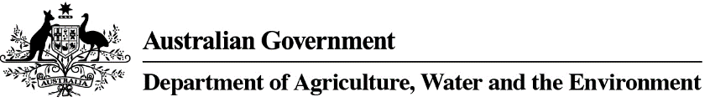
OK TO FORWARD REQUEST Email to PEQservices@awe.gov.au
AWB Number
No. of Cages / Weight
Origin
Destination
Number/Type of Animal
Import Permit No.
Flight Details
Arrival DATE/TIME into MEL (not ex DXB)
Note: Our written approval granting uplift of your animal to the airline is NOT confirmation the Veterinary Health certificate has been assessed and deemed compliant. Document assessments will be completed upon arrival of your animal into the Post Entry Quarantine facility.

