

REFERENCE

# Plant Exports Management System (PEMS) Authorised officer user guide – Onshore Cold Treatment Calibration Records

**In this document**

This document contains the following topics.

Purpose of this document 2

Initiating an onshore calibration record 2

OSCT Calibration page 5

Recording the calibration details 6

Recording the calibration readings 7

Recording the Pre-cooling temperatures 8

Recording the Pulp temperatures 10

Submitting the OSCT calibration record 12

Joining the re-calibration 13

Join the re-calibration record 13

Re-calibration 15

Re-Calibration page 16

Record the Re-Calibration Readings 17

Record the Re-Calibration details 18

Record the Loading details 19

Completing and submitting the calibration record 21

Document information 23

Version history 23

## Purpose of this document

This reference outlines how to use PEMS to record Onshore Cold Treatment Calibration record.

**Note:** An overview of PEMS and general functions can be found in the Reference: *Plant Exports Management System (PEMS) Authorised Officer User Guide – Overview and general functions*.

## Initiating an onshore calibration record

To initiate an onshore calibration record, click the **Home1** PEMS menu tab and then click the **OSCT Calibration2** button.

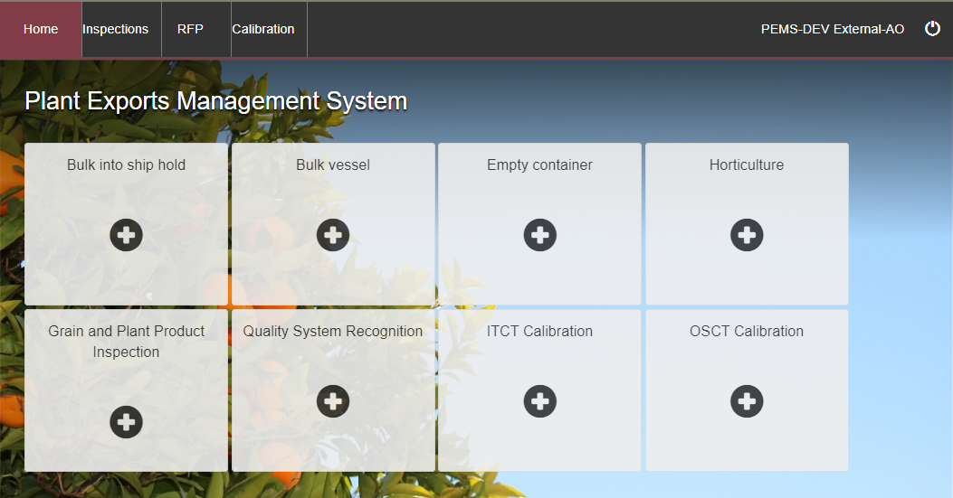

**2**

**1**

The *Create Calibration* window will display.

If known, enter the **RFP number1**. The RFP number should be seven digits long. If an RFP number is entered it will prepopulate the Establishment number and name, the country and the commodities listed on the RFP with the information from EXDOC.

**!** If the OSCT calibration is to take place at an establishment that is different to where the goods were inspected and packed, the establishment number for this location can be updated in this screen.

Where an RFP number is not provided, then you can enter the following details to the record:

**Establishment number2**. The establishment number should be three to four digits long and click **Search3**. The Establishment Name will update.

Destination **Country4**.

**Coolroom number5**

**Commodity6** and select **Add7**. The commodity will appear below. This step will need to be repeated if there are multiple commodities.

Click **Create8**.

**8**

**5**

**4**

**6**

**7**

**3**

**2**

**1**

PEMS will populate the OSCT Calibration page. The calibration record will remain **Active1** until the record is withdrawn, submitted, or cancelled.

**1**

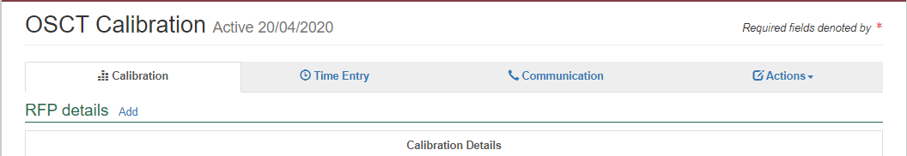

**!** While the calibration record is active, the date provided on the calibration record is the date the calibration record was initiated.

#### OSCT Calibration page

The *OSCT Calibration* page displays the following sections:

* **RFP details1 –** The RFP details will be blank. You will need to add the RFP number manually when the RFP number has been created, and the rest of the details in this field will populate automatically.
* **Calibration details2 –** allows you to state if fumigation treatment has taken place, the calibration date and time, the coolroom number, and the commodity, packages and type.
* **Pulp Temperature3 –** allows you to record the temperature of the fruit.
* **Calibration Readings4** **–** allows you to record the sensor readings and the air inlet and outlet probes.
* **Pre-cooling teperatures5** **–** allows you to record the pre-cooling temperatures of the fruit/vegetable prior to it going into the cool room.
* **Comments6** **–** allows you to record general comments regarding the calibration. See Section 3.8 Adding comments to a record in the PEMS AO User Guide – Overview and General Functions.

Step-by-step instruction on how to record or change data on this page is provided below.

**6**

**5**

**1**

**2**

**3**

**4**

#### Adding a commodity

To add a commodity to the Calibration details, click **Add Commodity1**.

**1**

Enter the **commodity1**, click **Add2** and then click **Save3**.

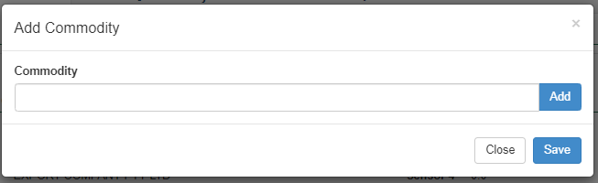

#### Recording the calibration details

To edit or record the Calibration details, click **Change1**.

**1**

If the country is China, a tick box will need to be selected on **Has the commodity been fumigated as part of a combination fumigation + cold treatment?1.**

Enter the **Coolroom number2**. The number must match exactly including any spaces or special characters as PEMS will validate this information.

Enter the **Treatment Schedule °C3** and the **Treatment Duration Days4**.

Enter the **Calibration Date5** and the **Calibration Time6**.

To record the Packages and Type, select the **Commodity7** from the drop-down. Enter the **Number of Packages8** and select **Type9** from the drop-down list. Click **Add10**. Repeat steps for multiple commodities and pack types.

Once complete, select **Save11**.

**11**

**10**

**9**

**8**

**7**

**6**

**5**

**4**

**3**

**2**

**1**

#### Recording the calibration readings

To record the readings under sensor 1, 2, 3, 4 and Air inlet and outlet probe, click **Open1**.

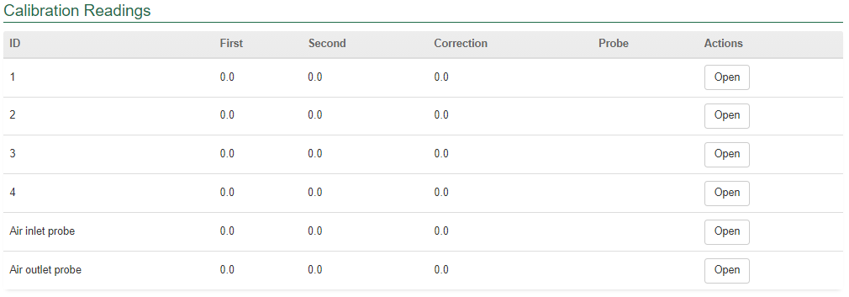

The *Reading for Sensor 1* window will display.

**Sensor ID1** will be displayed by default.

Record the **First** and **Second Reading2**, if applicable, enter the third reading.

The **Correction factor3** will be auto calculated by PEMS.

Click **Previous** and **Next4** to navigate between the Sensors.

Click **Close5** to exit the Sensor window at any time and return to the Calibration page.

Click **Save6** to record the readings.

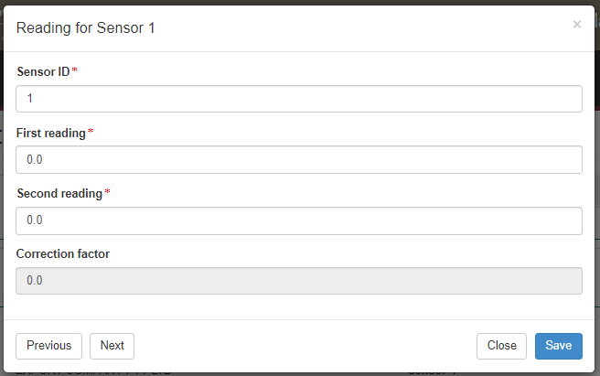

**4**

**1**

**6**

**5**

**3**

**2**

The *Calibration Readings* page will display the updated sensor readings.

**!** An Add Probe button will appear if the destination country is New Zealand, USA or Philippines.

! The first, second and third (if applicable) reading for every individual sensor must be identical.

**!** PEMS will accept reading between -0.0 to 0.3 degrees Celsius.

**!** For Indonesia, a reading for sensor 1 is mandatory.

**!** For USA, a first, second and third reading for each sensor is required.

**!** For Japan, probe placement image against every sensor can be viewed under probe.

**!** For the Philippines, PEMS will accept a reading of 0.0.

! The add probe button will only appear for countries where this may be required.

#### Recording the Pre-cooling temperatures

To record pre-cooling temperatures, click **Change1**.

**1**



The *Pre-cooling Temperatures* window will display.

You can enter multiple comma-separated lists of readings under **Temperatures1** and click **Update2** to automatically populate **boxes 1–223**. For example, 0.1, 0.1, 0.2.

Click **Clear4** if you wish to remove the readings.

You can also record readings directly into the **boxes 1–223**.

Click **Close5** to exit the pre-cooling temperatures window at any time and return to the Calibration page.

Click **Save6** to record the readings.

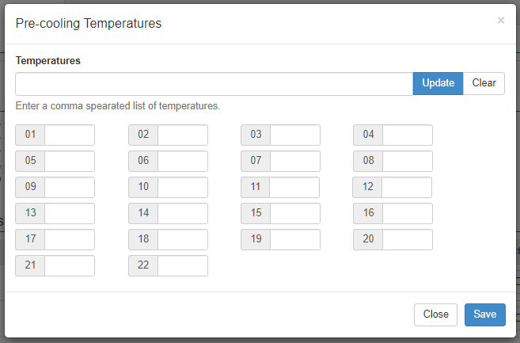

**6**

**5**

**4**

**3**

**2**

**1**

The calibration page will display the updated **Pre-cooling temperatures1**.

**1**

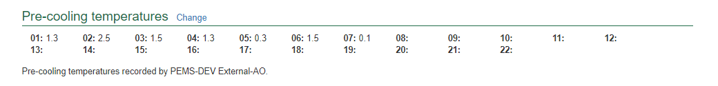

**!** Pre-cooling temperatures are mandatory for Japan, Korea and Vietnam.

**!** A minimum of five pre-cooling temperatures is mandatory.

**!** PEMS will display a warning message if pre-cooling temperatures are above 3.0 and less than 4.0 degrees Celsius.

**!** PEMS will not record pre-cooling temperatures greater than 4.0 degrees Celsius to meet with importing country requirements.

**!** Pre-cooling temperatures arenot mandatory for some countries, such as China.

#### Recording the Pulp temperatures

To record Pulp temperatures, click **Change1**.

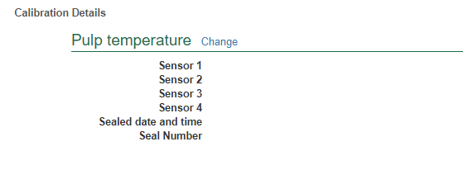

**1**

The *Pulp Temperatures* window will display.

Tick the box to confirm the **probes placed as per Importing Country’s requirements1.**

Enter the **Pulp temperature** for **Sensor 1, 2, 3 and 42**.

Seal the cool room and enter the **Seal number, Sealed date** and **Sealed time3.**

Click **Save4** to record the readings.

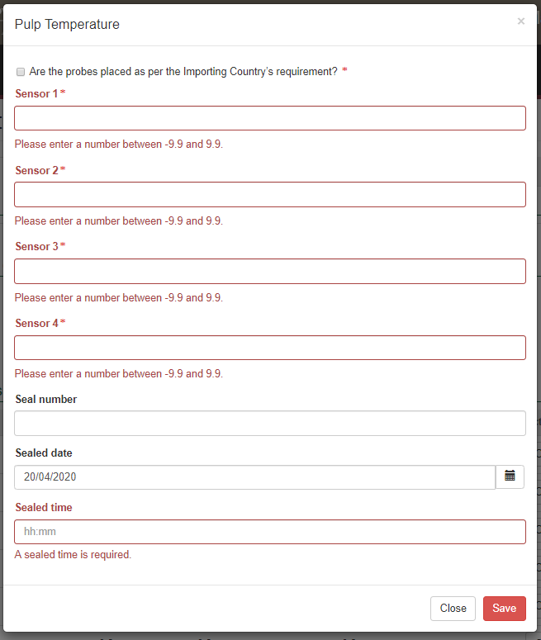

**4**

**3**

**1**

**2**

## Submitting the OSCT calibration record

The OSCT calibration record can only be submitted after:

* all calibration results and data are recorded appropriately
* a **Time Entry1** is provided for all AOs who recorded calibration results
* if applicable, attachments and correspondence relating to the calibration are recorded under the **Communications2** tab.

Details on the **Time Entry1** and **Communications2** tabs can be found in Section 3: General PEMS functions in the PEMS AO User Guide – Overview and General Functions.

When you are ready to submit the calibration record, click the **Actions3**tab, then click **Submit4**.

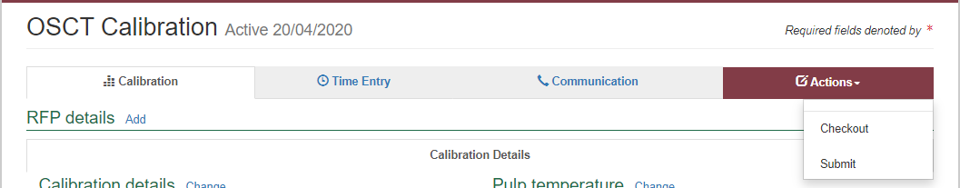

**4**

**3**

**2**

**1**

A pop-up window will ask you to confirm that you want to submit the calibration. Click **Ok1.**

**1**

## Joining the re-calibration

Calibration of the cool room occurs twice, once prior to the cold treatment, and once post the cold treatment after the minimum required time period. The second calibration is called the re-calibration.

On completion of the onshore cold treatment an Authorised Officer will join the existing calibration record to record the re-calibration details.

#### Join the re-calibration record

To join the recalibration, from the home page click on **Calibration1**.

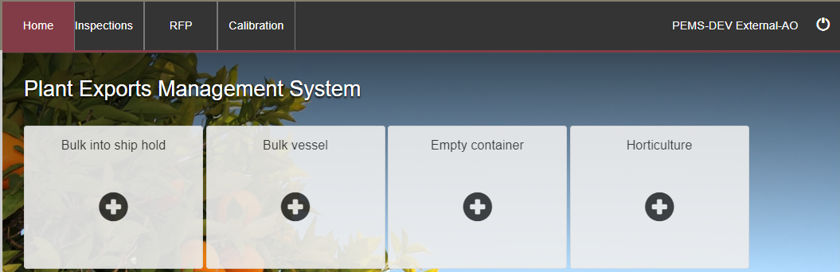

**1**

The *Search Calibrations* page opens. Click on **Advanced Search1**.

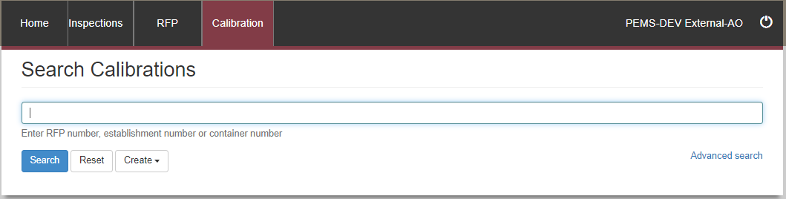

**1**

The *Advanced Search* page opens.

Enter the **Est. number1**.

For **Calibration Type2**, select OSCT from the drop-down box.

For the **Status3** select Calibrated from the drop-down.

Click **Search4**.

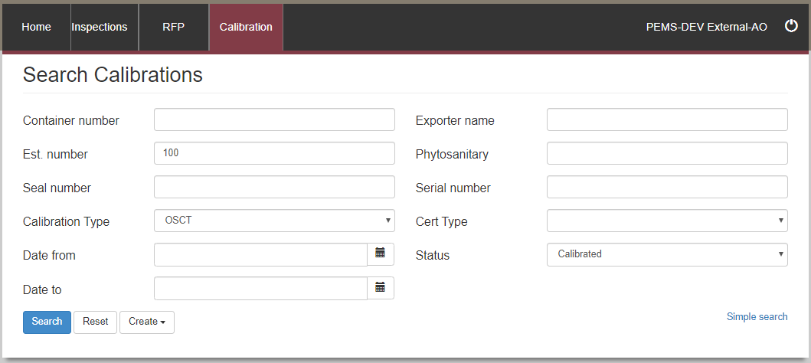

**3**

**2**

**4**

**1**

From the *Search Results*, locate the Calibrated record and click on **Join1**.

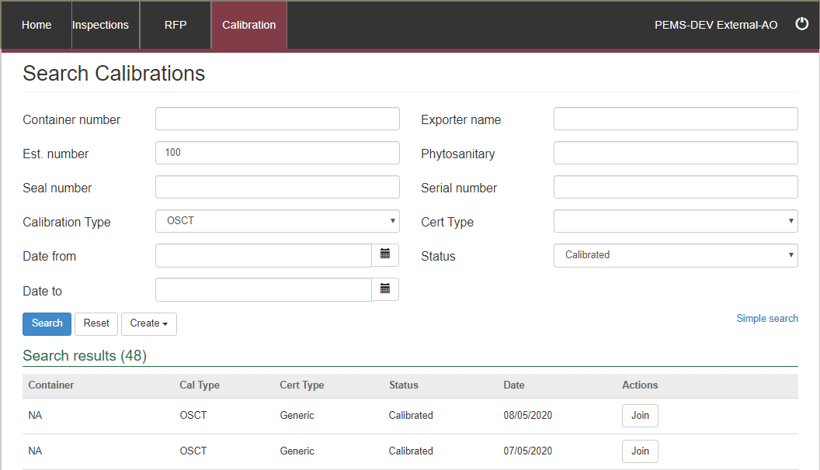

**1**

The *Join Calibration* window opens.

To join the calibration, you need to enter the **Seal number1**.

Enter the **Treatment start date** and **Treatment start time2**. The treatment start time must be later than the Calibration End Time provided for the relevant calibration.

Enter the **Treatment end date** and the **Treatment End time3**.

Then click **Join4**.

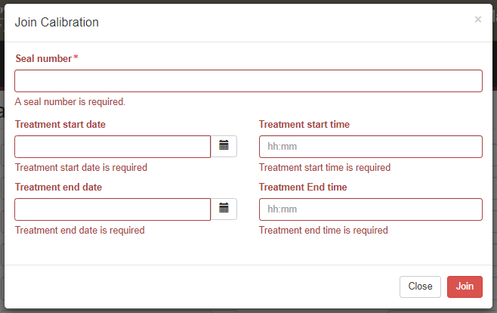

**4**

**3**

**2**

**1**

The system will validate the treatment duration and, providing this information meets the minimum time required, it will automatically open the original calibration record.

If the information provided is not valid an error will be shown.

## Re-calibration

Click on the **Re-Calibration Details1** tab.

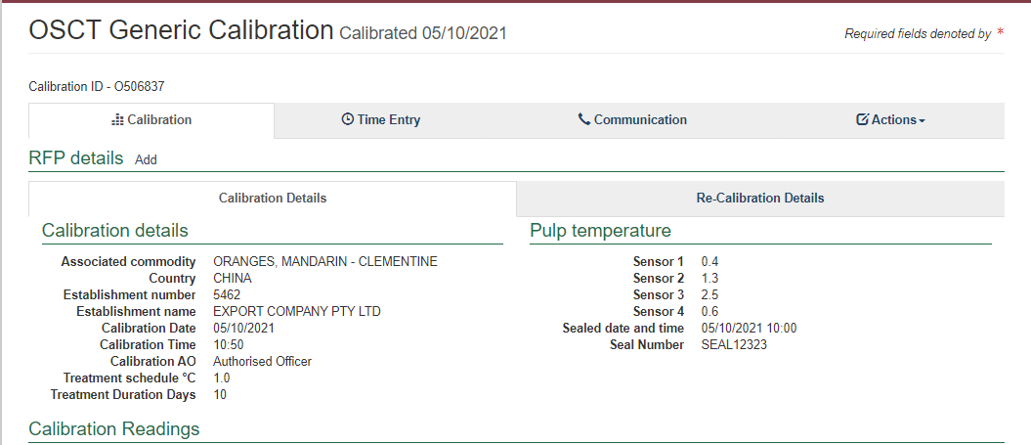

**1**

#### Re-Calibration page

The *OSCT Calibration* page displays the following sections:

* **RFP details1 –** The RFP details will be blank. You will need to add the RFP number when the RFP number has been created, and the rest of the details in this field will populate automatically.
* **Re-Calibration details2 –** allows you to record the recalibration date and time and the result.
* **Loading details3 –**Is only applicable if the commodity is to be exported by sea freight.
* **Re-Calibration Readings4** **–**records the sensor readings and the air inlet and outlet probes.
* **Comments5** **–** allows you to record general comments regarding the calibration. For more information see Section 3.8 Adding comments to a record in the PEMS AO User Guide – Overview and General Functions.

Step-by-step instruction on how to record or change data on this page is provided below.

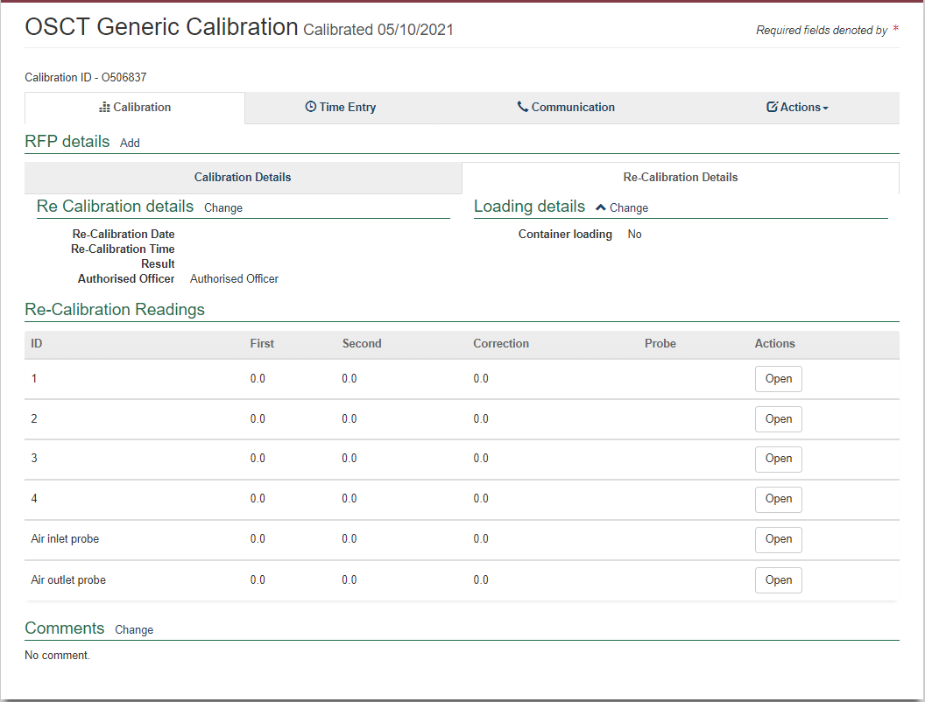

**3**

**5**

**4**

**2**

**1**

#### Record the Re-Calibration Readings

To record the readings under sensor 1, 2, 3, 4 and Air Inlet and Outlet probe, click **Open1**.

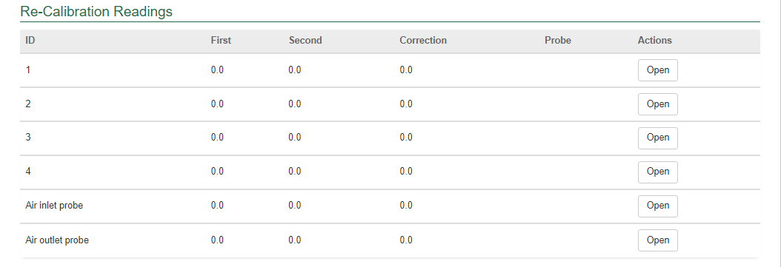

**1**

The *Reading for Sensor 1* window will display.

**Sensor ID1** will be displayed by default.

Record the **First** and **Second reading2** and, if applicable, the third reading. The **Correction factor3** will be auto calculated by PEMS.

Click **Previous** and **Next4** to navigate between the Sensors.

Click **Close5** to exit the *Sensor window* at any time and return to the Calibration page.

Click **Save6** to record the readings.

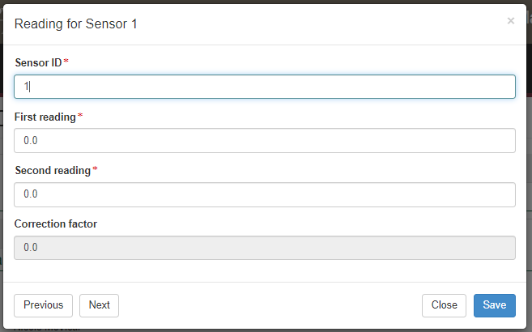

**3**

**!** For the Philippines the readings must be within +/- 0.3 of the original reading.

**!** A third reading is required for the USA.

**4**

**6**

**5**

**1**

**2**

#### Record the Re-Calibration details

To record the re-calibration details, click **Change1**.

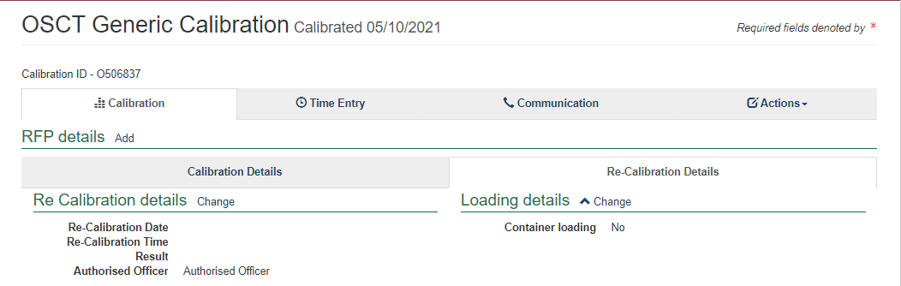

**1**

The *Re-Calibration Details* window opens.

From the drop-down box, select a **Result1**. Enter the **Re-calibration date** and **time2**.

If applicable, enter **Comments3**, then select **Save4**.

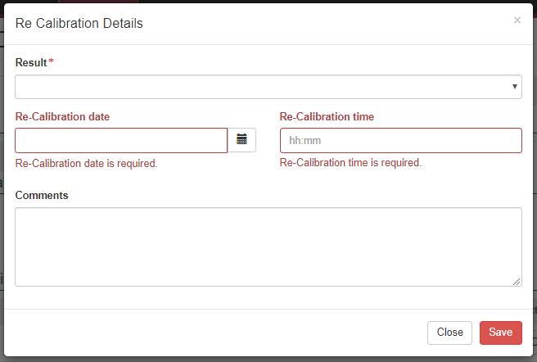

**4**

**3**

**1**

**2**

#### Record the Loading details

This section is only applicable if the commodity is being exported via sea freight. To record the loading details, select **Change1**.



**1**

The *Loading Details* window opens.

Select the relevant answer to *Does the importing country require supervision of loading?*

If the answer is **No1**, Select **Save2**.

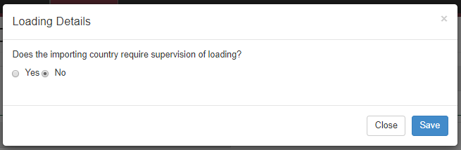

**1**

**2**

If selected **Yes1**, enter the **Container number2**.

Decide if the **Container Approval3** isYes or No**.**

Enter the **Seal number4**.

Click **Save5**.

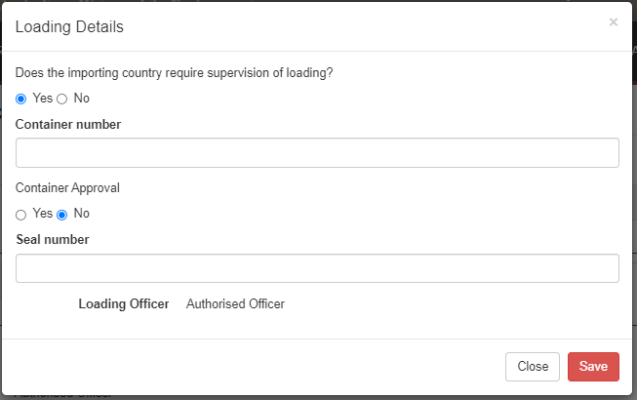

**3**

**4**

**5**

**2**

**1**

#### Completing and submitting the calibration record

The OSCT record can only be submitted after:

* the re-calibration results and data are recorded appropriately
* a **Time Entry1** is provided for all AOs who recorded OSCT calibration results
* OSCT Data Logs need to be attached and any other attachments and correspondence relating to the calibration are recorded under the **Communications2** tab.

Details on the **Time Entry1** and **Communications2** tabs can be found in Section 3: General PEMS calibration functions the PEMS AO User Guide – Overview and General Functions.

When you are ready to submit the OSCT re-calibration record, click the **Actions3**tab, then click **Submit4**.

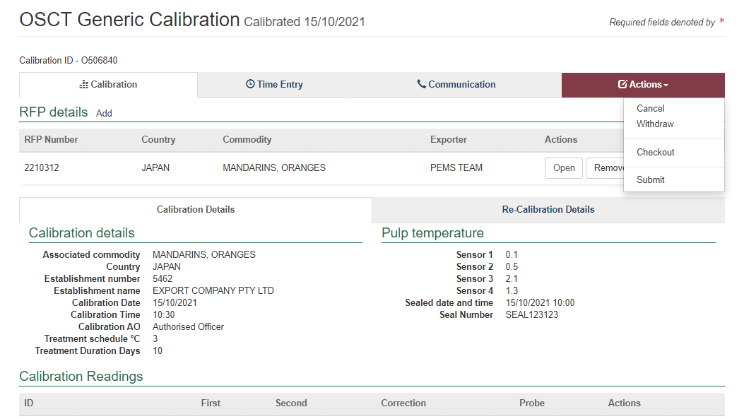

**4**

**3**

**2**

**1**

If Loading details have been entered, the *OSCT Calibration* window will display.

* Confirm that the container meets all three requirements displayed as **checkboxes1**.
* Select if you want to **email the exporter/EDI user on the submission of the inspection2**. When selecting this option, the OSCT calibration submit confirmation box will expand.
* Enter the **email address3**, this can be multiple email addresses each separated by a comma.
* Enter in any **Comments4** that are to be included in the email.
* Click **Submit5**.

**5**

**2**

**4**

**3**

**1**

#### Download OSCT report

You can download the OSCT record report after a calibration record is submitted in PEMS.

To download the calibration report, click the **Actions1** tab and then select **Download Report2.**

**2**

**1**

A PDF document will be downloaded onto your device (next two screen shots).

Once the document is opened, it will display the relevant OSCT record.

**Related material**

The following related material is available on the department’s website:

* Manual of Importing Country Requirements ([Micor](http://micor.agriculture.gov.au/Plants/Pages/Documents.aspx)).
* [Micor Plants](https://micor.agriculture.gov.au/Plants/Pages/default.aspx) (importing country requirements, protocols and work plans)
* [Protocols, work plans](http://micor.agriculture.gov.au/Plants/Pages/Documents.aspx)
* [Plant Export Operations Manual](http://www.agriculture.gov.au/export/controlled-goods/plants-plant-products/plantexportsmanual)
* Reference: *Plant Export Management System (PEMS) Authorised officer user guide*
  + *Empty container inspections*
  + *Grain and Plant Product inspections*
  + *Horticulture inspections*
  + *Bulk vessel inspections*
  + *Bulk into ship hold inspections*
  + *Quality systems recognition inspection*
  + *In-transit cold treatment calibration records*
* The following related material is available on the department’s [Learnhub](https://learnhub.ssc.gov.au/login/):
* Plant Export Management System (PEMS) video tutorials

**Contact information**

* Authorised Officer Hotline: 1800 851 305
* Authorised Officer Program: PlantExportTraining@awe.gov.au
* PEMS Administration: [PEMS@awe.gov.au](mailto:PEMS@awe.gov.au)

## Document information

The following table contains administrative metadata.

| Instructional Material Library document ID | Instructional material owner |
| --- | --- |
| IMLS-9-7593 | Director, [Section] |

## Version history

The following table details the published date and amendment details for this document.

| Version | Date | Amendment details |
| --- | --- | --- |
| 1.0 | 08/07/2016 | New user guide. |
| 1.1 | 12/07/2016 | Minor variations for accuracy and clarity. |
| 2.0 | 30/09/2016 | * Complete document restructure. * Addition of sections on: * Logging into PEMS * Calibration records * Calibration search. |
| 2.1 | 16/12/2016 | * Minor variations for accuracy and clarity * Removal of Appendix F – Calibrations and loading * Removal of Section 2.3 – Calibration search |
| 3.0 | 09/10/2018 | AO user guide updated with PEMS v2.1 enhancements. |
| 4.0 | 23/05/2019 | AO user guide updated with PEMS v3.1 and v3.2 enhancements. |
| 5.0 | 4/11/2019 | Updated with PEMS v.3.3 and 3.4 enhancements. |
| 6.0 | 3/06/2020 | Updated with PEMS 3.5 enhancements. |
| 7.0 | 28/08/2020 | * Removal of appendices from Plant Exports Management System (PEMS) Authorised Officer user guide to make each its own user guide. * Update to OSCT calibration records. |
| 8 | 28/03/2021 | Updated for commencement of the *Export Control Act 2020* and associated Plant Rules. |
| 9 | 11/11/2021 | Updated to include Horticulture Export Program team feedback |
| 10 | 4/04/2022 | Update for PEMS April 2022 release. |