**Final report**

**28/07/2020**

**Opportunities to increase organic waste recovery**

‘Organic waste’ is a very broad term. Technically it could apply to anything that has once grown or lived and organic waste needs to be clearly defined for the scope of this analysis.

In the most recent [National Waste Report 2018](https://www.environment.gov.au/protection/waste-resource-recovery/national-waste-reports/national-waste-report-2018) (NWR 2018) the material category ‘organics’ referred to the ‘core waste types’ of food, garden organics and timber. Core organics excluded paper, cardboard, textiles, rubber and leather, and hazardous organics, because these wastes are typically managed separately to core organic wastes. This report focuses on the same ‘core organic’ waste types (food, garden and timber). Paper, cardboard, textiles, rubber and leather, biosolids and hazardous organics as well as organics generated by agriculture and fisheries industries are not included in this analysis.

The Department of Agriculture, Water and the Environment (DAWE) engaged Randell Environmental Consulting (REC) to complete analysis of the *Opportunities to increase organic waste recovery* (the project).

This concise report includes analysis of:

* current organics recovery rates (including recycling and energy recovery) from the municipal solid waste (MSW), commercial and industrial (C&I), and construction and demolition (C&D) waste streams
* the new national waste policy targets and what they would mean for organics generation and recovery if successfully implemented
* an overview of the opportunities for improved recovery and potential future recovery rates based on what has been achieved internationally and what could be considered best practice.

The 2019 *National Waste Policy Action Plan* will drive the implementation of Australia’s *National Waste Policy 2018*. It includes the following key waste management targets that are relevant for organics:

* Target 2 – reduce total waste generated in Australia by 10% per person by 2030
* Target 3 – 80% average resource recovery rate from all waste streams following the waste hierarchy by 2030
* Target 4 – significantly increase the use of recycled content by governments and industry
* Target 6 – halve the amount of organic waste sent to landfill for disposal by 2030.

An assessment by Blue Environment in 2018 projected national waste generation increasing to 70.7 Mt by 2030 and the total recovery reaching 50.2 Mt (“business as usual” scenario). This equates to an estimated recovery rate of 71% or 9 % (or 6.4 Mt tonnes) below the 80% overall recovery rate target in the *National Waste Policy Action Plan*. This report estimates what share of this projected 6.4 Mt shortfall an increase in core organic wastes recovery could contribute.

Over the 10-year period from 2007 to 2017, Australia’s organic waste generation was around 14-15 Mt and the recovery rate (via recycling or an energy from waste facility) increased, from around 40% (5.6 Mt) to 62% (8.8 Mt) per annum. In 2017, the recycling rate (e.g. composting) was 52% and the rate of recovery via energy from waste facilities was 10%.

In 2017, organics waste generation was mostly from the MSW (52%) and the C&I (42%) streams, with timber waste (mostly) from the C&D stream making up the remaining 6%. In 2017, the recovery rates were 37% for MSW, 62% for C&I, and 42% for C&D. This highlights that the greatest opportunities for increasing recovery are likely to be in the MSW stream as it has the highest tonnage and the lowest recovery rate.

MSW organics recovery rates in many countries in the European Union (UN) are 70% or more (in stark contrast with Australia’s MSW organics recovery rate of 37% in 2017). For example, Italy and the United Kingdom have achieved recovery rates for MSW organics of 70% through source segregation of food and garden organics and processing via a combination of composting (for garden and some food) and anerobic digestion (AD) (for food wastes).

With a **food waste** recovery rate (across MSW and C&I streams) of just 13%, in 2017, and generation of over 4 Mt there remains a significant opportunity to improve organics recovery by increasing the rate of food waste recovery in Australia. In 2017, food organics made-up **70%** of the organic waste sent to landfill (3.8 Mt of 5.4 Mt).

The *National Waste Policy Action Plan* Target 6 (to halve the amount of all organic waste sent to landfill) aims to recover 2.7 Mt of additional organics from landfill by the year 2030. If all of the 3.8 Mt of food waste organics (only) were removed from landfill, the *National Waste Policy Action Plan* Target 6 would be met and exceeded

If Australia were to recover food waste at the same rate as the EU (70%), an additional 2.5 Mt of food waste would be recovered, above 2017 recovery tonnages. This would almost meet the *National Waste Policy Action Plan* Target 6 (half organics to landfill). It would also result in an overall organics recovery rate of 79% and almost meet Target 3 (80% average resource recovery rate) for the organics stream, further illustrating the need to focus on food waste.

To achieve the higher food waste recovery rate would require a major increase in energy recovery from food organics via AD and/or major increases in food waste composting. It would also require a national increase in the implementation of FOGO collections from households and food organics (FO) collections from businesses.

In 2017, the tonnages of **C&I food waste** recovery (225,000 tonnes) represented 42% of the total food waste recovery of around 540,000 tonnes. However, C&I food waste only made up 27% of the total food waste generation in 2017, illustrating that C&I food waste recovery is significantly better than food waste recovery from the MSW stream. However, with a recovery rate of 19%, in 2017, and generation of over 1 Mt there remains a significant opportunity to improve organics recovery by increasing the rate of C&I food waste recovery. The expansion of segregated FO only collection services in the hospitality and food manufacturing industries presents a significant opportunity to increase food waste recovery.

In 2017, the tonnages of **garden organics** waste recovery of 3 Mt represent 34% of the total organics recovery of around 8.8 Mt. With a recovery rate of almost 70% in 2017, the garden organics recovery rate is far higher than food organics, which reflects the large number of households with a dedicated garden waste bin and a well-developed composting industry around Australia. There remains some opportunity to improve garden organics recovery, however, increases will likely be modest compared to food waste.

**Timber wastes** such as fence palings, structural timbers and processed timber such as medium density fibreboard (MDF) can provide a valuable, high calorific value, waste stream for refuse derived fuels (RDFs). Since 2007, there has been little improvement in the amount of timber waste sent to energy from waste facilities. With an energy recovery rate of just 3%, in 2017, and around 1.2 Mt of timber waste being sent to landfill there may be significant opportunities to improve organics recovery by increasing the rate of timber waste sent to energy from waste facilities (not anerobic digestion facilities). Energy from waste facilities that are using post-consumer waste timber as a fuel source would need to have appropriate emissions control systems in place, due to potential contaminants present in processed, painted and treated waste timbers.

The Australian composting industry currently depends heavily on the urban amenity market (domestic and local government use of compost in gardens and public use areas). The urban amenity market has limited scope for development and is an inefficient off-take market to shift large bulk tonnages of recycled organics (due to the large amounts of packaging, logistics, handling, storage, etc.). Internationally, composting markets often include a very large portion (80%+) of agriculture and horticulture market off-take. This market accounted for only around 10% of the Victorian market in 2013. The EU success in developing major compost and AD digestate off-take markets in agriculture and forestry provide an example of the potential for these markets that require significant development in Australia. Part of the EU success has been wide spread source segregation of organics which has enabled the generation of higher quality end products with less risk of contamination (than organics recovered from the residual or mixed waste bin).

If Australia could increase food waste recovery to 70% (as has been achieved in some countries in the EU) by 2030 this would result in an additional 2.5 Mt of recovered organics. This would contribute 39% of the 6.4 Mt shortfall in recovery projected by Blue Environment. If half of the timber wastes currently being landfilled were processed into fuel for energy recovery, this would result in around another 0.6 Mt of recovery and result in a 48% contribution to the projected recovery shortfall.

Opportunities to increase organics recovery

Client

Department of Agriculture, Water and the Environment (DAWE)

Client Contact

Paul Starr

Paul.Starr@awe.gov.au

Author

Paul Randell

Project Number: PREC115

Report Disclaimer

This report has been prepared for DAWE in accordance with the terms and conditions of appointment dated 13/03/2020. Randell Environmental Consulting Pty Ltd (ABN 38 326 653 151) cannot accept any responsibility for any use of or reliance on the contents of this report by any third party.

Randell Environmental Consulting Pty Ltd

ABN 38 326 653 151

Castlemaine Victoria 3451

Paul@randellenvironmental.com.au

Phone 0429 501 717

Contents

1 Introduction 3

1.1 Scope 3

1.2 National waste policy 2018 and targets for organics 4

1.3 COAG *National Waste Policy Action Plan* 4

2 Current organics waste generation and recovery rates 5

3 Current Australian recycled organics markets 12

4 International organics recovery rates and Australian opportunities 13

4.1 United Kingdom 13

4.2 Italy 16

4.3 Germany 17

5 Conclusions 19

6 References 21

# Introduction

The Department of Agriculture, Water and the Environment (DAWE) engaged Randell Environmental Consulting (REC) to complete analysis of the *Opportunities to increase organics recovery* (the project).

This concise report includes analysis of:

* current organics recovery rates (including recycling and energy recovery) from the municipal solid waste (MSW), commercial and industrial (C&I), and construction and demolition (C&D) waste streams
* the new national waste policy targets and what they would mean for organics generation and recovery if successfully implemented
* an overview of the opportunities for improved recovery and potential future recovery rates based on what has been achieved internationally and what could be considered best practice.

The report is based on desktop literature review. Consultation with stakeholders was beyond the project scope.

## Scope

‘Organic waste’ is a very broad term. Technically it could apply to anything that has once grown or lived and organic waste needs to be clearly defined for the scope of the project analysis.

In the most recent [National waste report 2018](https://www.environment.gov.au/protection/waste-resource-recovery/national-waste-reports/national-waste-report-2018) (NWR 2018) the material category ‘organics’ referred to the ‘core waste types’[1] of food, garden organics and timber. It excluded paper, cardboard, textiles, rubber and leather, and hazardous organics, because these wastes are typically managed separately to other core organic wastes.

DAWE are currently preparing the next national waste report, being delivered by Blue Environment Pty Ltd (BE). REC has consulted BE regarding the scope of organics being reported in the next NWR. At the time of writing, BE planned to report against a slightly amended definition of organics to include the following wastes: food, domestic garden, C&I food and other (including timber waste). The project analysis focuses on the same scope of organics waste, i.e. food, domestic garden, C&I food, timber and other.

The project analysis does not cover paper, cardboard, textiles, rubber and leather, biosolids and hazardous organics as well as organics generated by agriculture and fisheries industries. It is recommended that further analysis at the ‘total organics’ scope be considered.

The project analysis is focused on Australia’s current organics recovery rate and analysis of rates achieved internationally to identify the ‘size’ of the opportunities in Australia. The analysis is focused on the tonnage recovery outcomes and does not delve into detailed analysis of ‘how’ each country has achieved organics recovery. There are a wide range of policy interventions and infrastructure options for organics recovery in place globally and it is beyond the project scope to provide detailed analysis what policy or infrastructure options would be most appropriate in the Australian context.   
Opportunities for Australia are discussed in broad terms only, commensurate with the project scope and budget.

## National waste policy 2018 and targets for organics

The 2018 *National Waste Policy* provides the national waste management policy direction until 2030.

The policy includes five principles for waste management with the aim of supporting a circular economy, included below.

1. Avoid waste:
   1. Prioritise waste avoidance, encourage efficient use, reuse and repair
   2. Design products so waste is minimised, they are made to last and we can more easily recover materials.
2. Improve resource recovery:
   1. Improve material collection systems and processes for recycling
   2. Improve the quality of recycled material we produce.
3. Increase use of recycled material and build demand and markets for recycled products.
4. Better manage material flows to benefit human health, the environment and the economy.
5. Improve information to support innovation, guide investment and enable informed consumer decisions.

## COAG *National Waste Policy Action Plan*

On the 9th November 2019 Environment ministers agreed to a new *National Waste Policy Action Plan* that will drive the implementation of Australia’s *National Waste Policy 2018*.

It includes the following key waste management targets that are relevant for organics:

* Target 2 – reduce total waste generated in Australia by 10% per person by 2030
* Target 3 – 80% average resource recovery rate from all waste streams following the waste hierarchy by 2030
* Target 4 – significantly increase the use of recycled content by governments and industry
* Target 6 – halve the amount of organic waste sent to landfill for disposal by 2030.

The Commonwealth agreed to a leading role in implementing the action plan and will report progress at the next meeting of ministers.

An assessment by Blue Environment in 2018 projected national waste generation increasing to   
70.7 Mt by 2030 and the total recovery reaching 50.2 Mt (“business as usual” scenario). This equates to an estimated recovery rate of 71% or 9 % (or 6.4 Mt tonnes) below the 80% overall recovery rate target in the *National Waste Policy Action Plan*. This report estimates what share of this projected   
6.4 Mt shortfall an increase in organics recovery could contribute.

This report focuses on the potential of increases in organics recovery to meet the Targets 3 and 6 of the action plan. The opportunities for avoidance of organics waste (in particular food waste) to contribute to Target 2 are not included in the analysis (i.e. this analysis focuses on recovery not avoidance).

# Current organics waste generation and recovery rates

The publishing of the NWR 2018, included a [National Waste Database](https://www.environment.gov.au/protection/waste-resource-recovery/national-waste-reports/national-waste-report-2018) and data from 2007 to 2017. The database is the source of the data analysed in this section.

Figure 1 details Australia’s organic wastegeneration and management from 2007 to 2017. Over the 10-year period Australia’s organic waste generation was around 14-15 Mt and the recovery rate (via recycling or an energy from waste facility[2]) increased, from around 40% (5.6 Mt) to 62% (8.8 Mt) per annum. In 2017, the recycling rate (e.g. composting) was 52% and the rate of recovery via energy from waste facilities was 10%. **Note:** since 2017 there has been some development in MSW organics recovery. In particular, the amount of combined food and garden organics (FOGO) waste collections from households in Australia have increased. The 2020 recovery rates for MSW organics are likely to be slightly higher than in 2017.

Figure 1 Australian organic waste generation and management (2007 to 2017)

Figure 2 details Australia’s organics waste generation by generating stream (MSW, C&I and C&D)from 2007 to 2017. In 2017, organics waste generation was mostly from the MSW (52%) and C&I (42%) streams with timber waste (mostly) from the C&D stream making up the remaining 6%.

Figure 2 Australian organics waste generation by stream (2007 to 2017)

Figure 3 details Australia’s organics waste generation and management by generating stream (MSW, C&I and C&D)from 2007 to 2017. In 2017, the recovery rates were 37% for MSW, 62% for C&I, and 42% for C&D. This highlights that the greatest opportunities for increasing recovery are likely to be in the MSW stream as it has the highest tonnage and the lowest recovery rate.

Figure 3 Australian organics waste generation by stream (a) MSW, (b) C&I and (c) C&D (2007 to 2017)

**(a)**

**(c)**

**(b)**

The analysis that follows ‘drills down’ into organic waste material types generation and management from 2007 to 2017.

Figure 4 details Australia’s **food waste** generation and management from 2007 to 2017.

Figure 4 Australian food waste generation and management (2007 to 2017)

Over the 10-year period Australia’s food waste generation fell from around 4.8 Mt to around 4.3 Mt and the rate of recovery increased, from just 1% to 13% per annum. In 2017, the recycling rate (e.g. composting) was 11% and the rate of recovery via energy from waste facilities was 2%.

Whilst there appears to have been some improvements in reducing food waste generation since 2007 (noting population increased over this period) there was no significant improvement in food waste recovery rates between 2015 and 2017.

With a recovery rate of just 13%, in 2017, and generation of over 4 Mt there remains a significant opportunity to improve organics recovery by increasing the rate of food waste recovery.

**Potential opportunity:**

Based on 2017 tonnages, the *National Waste Policy Action Plan* Target 6 (to halve the amount of all organic waste sent to landfill) aims to recover 2.7 Mt of additional organics from landfill in the year 2030.

Figure 1 and Figure 4 show that, in 2017, food organics made-up **70%** of the organic waste sent to landfill (3.8 Mt of 5.4 Mt).

If food waste organics (only) were removed from landfill, the *National Waste Policy Action Plan* Target 6 (to halve the amount of all organic waste sent to landfill by 2030) would be met and exceeded.

Figure 5 details Australia’s **C&I food** waste generation and management from 2007 to 2017.

Figure 5 Australian C&I food waste generation and management (2007 to 2017)

C&I food waste is generated by the hospitality and food manufacturing industries. Over the 10-year period Australia’s C&I food waste generation fell from around 1.6 Mt to around 1.1 Mt and the rate of recovery increased, from just 1% to 19% per annum. In 2017, the recycling rate (e.g. composting) was 15% and the rate of recovery via energy from waste facilities was 4%.

Whilst there appears to have been some improvements in reducing C&I food waste generation since 2007 (noting population increased over this period) there was no significant improvement in food waste recovery rates between 2015 and 2017.

In 2017, the tonnages of C&I food waste recovery (225,000 tonnes) represented 42% of the total food waste recovery of around 540,000 tonnes (see Figure 2). However, C&I food waste only made up 27% of the total food waste generation in 2017, illustrating that C&I food waste recovery is significantly better than food waste recovery from the MSW stream. However, with a recovery rate of 19%, in 2017, and generation of over 1 Mt there remains a significant opportunity to improve organics recovery by increasing the rate of C&I food waste recovery. The expansion of segregated food organics (FO) only collection services in the hospitality and food manufacturing industries presents a significant opportunity to increase food waste recovery.

Figure 6 details Australia’s **garden organics** wastegeneration and management from 2007 to 2017.

Figure 6 Australian garden organics waste generation and management (2007 to 2017)

Over the 10-year period Australia’s garden organics waste generation increased significantly from around 2.5 Mt to around 4.4 Mt and the rate of recovery increased from around 34% to 69% per annum. In 2017, almost all garden organics recovery was via recycling (e.g. composting) with recovery via energy from waste facilities falling to just 40,000 tonnes (<1%) from a high of 140,000 tonnes in 2011.

The significant increase of around 75% in garden organics generation over the 10-year period could be due to increased reporting and/or due to increases in the provision of garden waste bins, resulting in increased collections and reported generation.

In 2017, the tonnages of garden organics waste recovery of 3 Mt represent 34% of the total organics recovery of around 8.8 Mt. With a recovery rate of almost 70% in 2017, the garden organics recovery rate is far higher than food organics, which reflects the large number of households with a dedicated garden waste bin and a well-developed composting industry around Australia. There remains some opportunity to improve garden organics recovery, however, increases will likely be modest compared to food waste.

Figure 7 details Australia’s **timber** waste generation and management from 2007 to 2017.

Figure 7 Australian timber waste generation and management (2007 to 2017)

Timber wastes are generated mostly by the construction and demolition industries and refers to wastes such as fence palings, structural timbers and processed timber such as medium density fibreboard (MDF) that is widely used in cabinet making. Waste timber is often processed, painted and/or treated with chemicals to preserve the timber and prevent termite attack. Timber waste does not include the waste generated by the forestry and saw milling industries – it refers to post consumer timber waste.

Over the 10-year period Australia’s timber waste generation increased slightly from around 2.2 Mt to around 2.4 Mt and the rate of recovery also increased from around 32% to 46% per annum. In 2017, the recycling rate (e.g. mulching or similar) was 43% and the rate of recovery via energy from waste facilities was 3%.

Whilst there have been improvements in timber waste recycling rates, the uses for recycled timbers are often of limited value. For example, shredded timber wastes are often used as hard-stand areas at landfills. In addition, waste timber and can also present contamination and emissions risks from processed, treated and painted timbers.

There has been little improvement in the amount of timber waste sent to energy from waste facilities. Timber waste can provide a valuable, high calorific value, waste stream for refuse derived fuels (RDFs). With an energy recovery rate of just 3%, in 2017, and around 1.2 Mt of timber waste being sent to landfill there may be significant opportunities to improve organics recovery by increasing the rate of timber waste sent to energy from waste facilities (not anerobic digestion facilities). These facilities could be in Australia or overseas. Energy from waste facilities that are using post-consumer waste timber as a fuel source would need to have appropriate emissions control systems in place, due to potential contaminants present in processed, painted and treated waste timbers.

Figure 8 details Australia’s **other organics** waste generation and management from 2007 to 2017.

Figure 8 Australian other organics waste generation and management (2007 to 2017)

Over the 10-year period Australia’s other organics waste generation increased significantly from around 0.5 Mt to around 1.7 Mt and the rate of recovery increased from around 29% to 80% per annum. In 2017, all other organics recovery was via recycling (e.g. composting, mulching, etc.) with no recovery via energy from waste facilities reported.

The large increase of around 220% in other organics generation over the 10-year period is likely due to increased reporting. What each jurisdiction in Australia includes in ‘other organics’ varies and is often not detailed. It is likely that in 2015 significant additional ‘other’ material types were included in reporting, causing a sudden increase in the recycling tonnages.

Due to the lack of information regarding the wastes that are included in ‘other organics’, and the 2017 recovery rate already being at 80%, there is little value in analysing opportunities for additional recovery from the ‘other organics’ tonnages. The project analysis will focus on organics opportunities where the waste type is more clearly defined and the tonnage opportunities are greater (i.e. food, timber and garden).

# Current Australian recycled organics markets

Sustainability Victoria 2013 provided a detailed analysis of the recycled organics market in Victoria. While the Australian market will vary to an extent, the Victorian analysis provides insight into the current markets for recycled organics from composting facilities in Australia.

Figure 9 provides a summary of Victoria’s recycled organics supply, products, and uses (off-take markets). The Victorian composting industry currently depends heavily on the urban amenity market (domestic and local government use of compost in gardens and public use areas) and this is understood to be the case across much of Australia. The urban amenity market has limited scope for development and is an inefficient off-take market to shift large tonnages of recycled organics (due to the large amounts of packaging, logistics, handling, storage, etc.).

Section 4, provides examples of international composting markets that often include a very large portion (80%+) of agriculture and horticulture market off-take. This market accounted for only around 10% of the Victorian market in 2013.

Currently the agriculture and horticulture off-take market for compost in Australia needs targeted market development. Currently there is a low demand and price point for recycled organics in the agriculture and horticulture market. This contributes to urban amenity providing the largest current market share, currently.

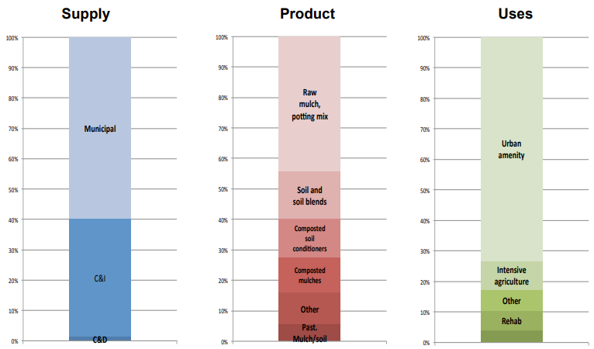Figure 9 Victorian recycled organics supply chain and end markets summary (SV 2013)

In October 2018 the NSW EPA revoked the general and specific *Resource Recovery Orders and Resource Recovery Exemptions* for the application of Mixed Waste Organic Outputs (MWOO) to land due to risks associated with chemical and physical contaminants. Part of realising opportunities for organic wastes will need to involve the development of organics source segregation collection infrastructure (rather than targeting organics in mixed waste collections).

# International organics recovery rates and Australian opportunities

This section provides a review of organics recovery rates internationally to develop a benchmark for rates that could be achieved in Australia in future. As noted above this section has a focus on food organics as these wastes have the highest tonnages and low recovery rates, currently. There is also a focus on the MSW stream as it is Australia’s largest organics waste stream with the lowest recovery rate. MSW organics are also, by far, the most widely reported organics stream, globally, enabling a more complete international comparison of opportunities.

[ISWA 2020](https://www.iswa.org/uploads/media/Report_1_Global_Assessment_of_Municipal_Organic_Waste_Compressed_v2.pdf) provides a good and current overview of MSW organics collection systems around the world and is a key reference for this section.

Analysis of organics recovery in the UK, Italy and Germany are provided below as these countries have significantly higher organics recovery than Australia.

## United Kingdom

Historically, the UK’s organics recovery has been driven by their *EU-Landfill Directive (1999/31/EC)[3]* response that was to reduce biodegradable waste landfilled to 35% of 1995 levels by 2020.

Since leaving the EU, England and Scotland rely solely on landfill levies to reduce landfilling of MSW organics. Northern Ireland and Wales have a landfill allowances scheme (LAS) in place which requires waste disposal authorities to limit the amount of MSW organics that they send to landfill.

Northern Ireland also has in place the *Food Waste Regulations (Northern Ireland) (2015)*, which requires the separate collection and subsequent treatment of food waste and prohibits its disposal to sewer. The *Waste (Scotland) Regulations (2012)* also require local authorities to offer a food waste recycling service in non-rural areas and places a ban on MSW organics going to landfill by 2021. The *Waste (Wales) Measure (2010)* sets out requirements that every Welsh local authority must meet an annual recycling target (70% by 2025).

WRAP (the Waste & Resources Action Programme) also have several, UK wide, food focused programs:

* *Courtauld Commitment* – that aims to improve resource efficiency and reduce food waste
* *Hospitality and Food Service Agreement* – that aims to improve food waste recovery from these sectors
* *‘Love Food Hate Waste’* campaign – a community engagement and information campaign to reduce food waste generation and improve recovery.

WRAP 2020 estimated annual food waste arisings in UK households, hospitality and food service (HaFS), food manufacture, retail and wholesale sectors in 2018 at around 9.5 million tonnes.

Figure 10 includes the food waste generating sectors (WRAP 2020 page 2). Households (or MSW) generated 70% of the UK food waste and the remaining 30% of food waste was the C&I stream.

Figure 10 UK food waste generation by sector 2018 (millions of tonnes)

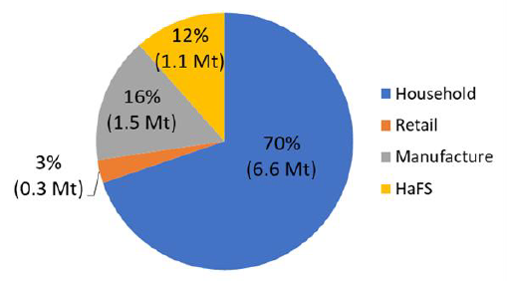

WRAP 2020, page 3, also details the management of food waste in the UK in 2018. Figure 11 includes the WRAP 2020 summary and it shows that of the 9.5 Mt of food waste generated: 1.9 Mt (20%) was recycled by composting or anerobic digestion; 4.4 Mt (46%) was sent to energy recovery or ‘landspreading’[4] and 3.2 Mt (34%) was sent to landfill.

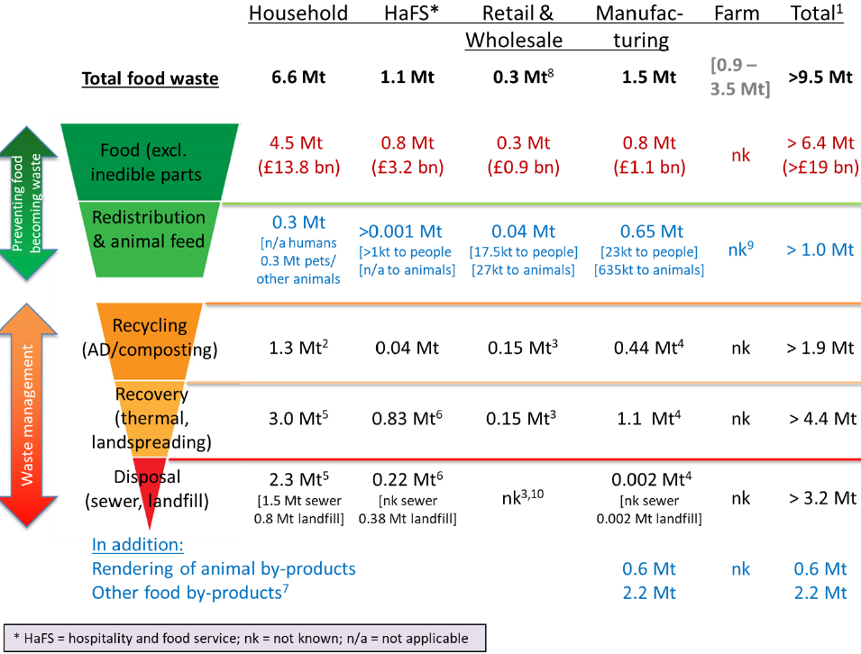Figure 11 UK food waste management summary in 2018

The UK has very well-established organics collection and processing infrastructure.

Regarding organics collection, according to WRAP’s statistics [website](https://laportal.wrap.org.uk/Statistics.aspx), in 2016/2017:

* almost 96% of all households in the UK were connected to a separate collection scheme for garden organics waste
* about 38% of all households were connected to a separate kerbside collection for food waste
* and another 19% were connected to commingled collection of both food and garden waste (FOGO).

Regarding organics processing, ISWA 2020 explains:

* 362 composting facilities and 259 anerobic digestion (AD) plants were operating in 2012
* 162 of the operating AD plants in the UK, were processing primary production wastes directly from farms
* for AD plants (both urban and agricultural) the largest volume of feedstock recycled was postconsumer food waste (35%) followed by crops (26%).

ECN 2017 (b) provides a summary of the market distribution for recycled organics, from composting facilities, in 2012, and in included below. Agriculture and horticulture markets dominated at around 80% of the composting off-take market.

Figure 12 UK recycled organics market distribution 2012 (ECN 2017 b)

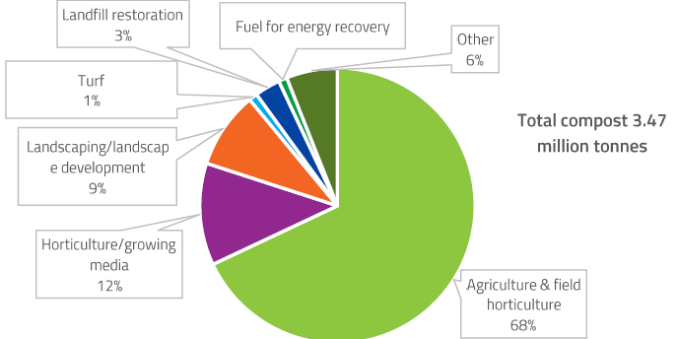

ECN 2017 b also notes that in 2014 over 4.5 Mt of digestate was produced from AD facilities and that over 2.4 Mt of digestate (54%) was certified at 42 AD facilities for land application and this would have been applied to agricultural land.

## Italy

According to ISWA 2020, in 2016, Italy generated around 30 Mt of MSW of which around 8 Mt was organic wastes. Around 6 Mt or 72% of MSW organics generation was recovered of which around   
4 Mt was food organics.

The Italian *Waste Framework Law (DL 152/2006),* 2006, requires single municipalities to collect separately and recycle a minimum of 65% of all MSW. This has driven separate collection of organic waste, in particular food waste. Compost that is generated from source separated organics has been deemed a product in Italy for about 20 years. Digestate from AD facilities, however, is considered a waste and needs to be composted before use as a soil conditioner or organic fertiliser.

Italy has a network of around 330 composting and AD facilities to process segregated MSW organics. Around half of Italy’s 4 Mt of food recovery was processed by composting facilities with the other half processed by AD facilities. Almost all of Italy’s garden organics were processed by composting facilities.[5]

Italy’s 2016 recovery rate for MSW organics of 70% is consistent with the UK recovery rate for organics and is in stark contrast with Australia’s MSW organics recovery rate of 37% in 2017. Like the UK, Italy has achieved high rates of MSW organics recovery through source segregation of food and garden organics and processing via a combination of composting (for garden and some food) and AD (for food wastes).

**Potential opportunity:**

If Australia were to recover food waste at the same rate as the UK and Italy (70%), an additional   
2.5 Mt of food waste would be recovered, above 2017 recovery tonnages.

This would almost meet the *National Waste Policy Action Plan* Target 6 (half organics to landfill).

It would also result in an overall organics recovery rate of 79% and almost meet Target 3 (80% average resource recovery rate) for the organics stream, further illustrating the need to focus on food waste.

To achieve the UK and Italian food waste recovery rate would require a major increase in energy recovery from food organics via AD and/or major increases in food waste composting. It would also require a national program for the implementation of FOGO collections from households and possibly from businesses.

## Germany

EEA 2013 explains that in the early 2000’s Germany implemented strong responses to the *EU-Landfill Directive (1999/31/EC)* that included the following:

* a maximum of 5 % carbon content in waste direct landfilled
* no biodegradable waste to landfills by 2006
* mandatory separate collection of organics implemented in 2015.

ISWA 2020 details Germany’s amount of organic waste (‘biowaste’) recovery compared to other countries across the EU. In 2016, Germany recovered 113 kg/capita of organic waste. That is significantly higher than the EU average of 78 kg/capita, reflecting the large variance in organics recovery that has been achieved across the EU with differing implementation of the *EU-Landfill Directive (1999/31/EC)*.

Figure 13 includes a chart from EEA 2013. It illustrates Germany’s rate of landfilling of biodegradable wastes (all organic wastes) and the *EU-Landfill Directive (1999/31/EC)* targets for the progressive reduction of biodegradable waste landfilling from levels landfilled in 1995. The chart illustrates that since 2006 Germany have effectively not sent untreated organic waste to landfill.

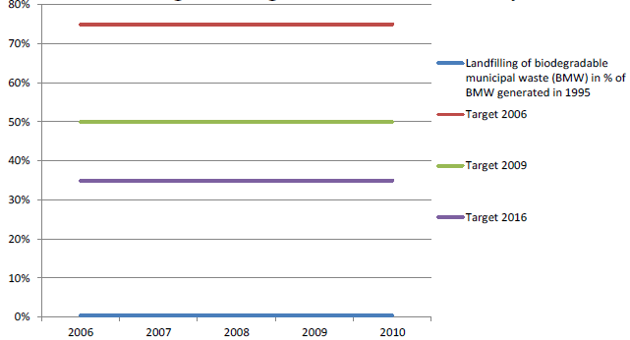Figure 13 Germany’s landfilling of biodegradable waste and EU landfill directive targets

BMU 2018 explains that in 2015, Germany processed around 7.4 Mt of organics at 868 composting facilities, and 6.5 Mt of organics at 1,392 AD facilities (including combined digestion and composting facilities). The organics were processed into 4 Mt of compost and 4 Mt of AD digestate for use in various sectors as fertilisers or soil additives.

Figure 14 includes BMU 2018’s analysis of the off-take markets for composting and AD processes. Of particular note is the 62% of compost being used in the agriculture and forestry industries and that almost all AD digestate is used in agriculture and forestry.

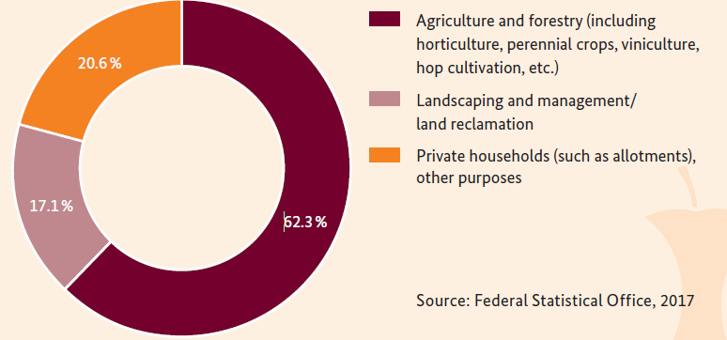Figure 14 Germany’s use of (a) composting and (b) AD off-take markets 2015 (BMU 2018)

**(a)**

**(b)**

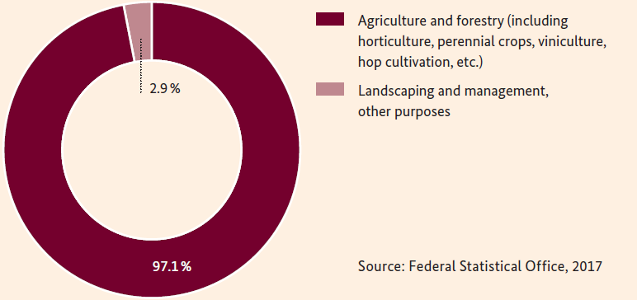

Historically, Germany has also processed a lot of residual waste bin MSW wastes by mechanical biological treatment (MBT) plants, that remove and/or treat the organics, as well as energy from waste facilities.

Germany has been able achieve almost complete recovery of collected organics via a combination of:

* landfill bans and source segregation of food and garden organics
* implementing a large network of composting, AD, MBT and energy from waste infrastructure
* developing strong off-take markets in agriculture and forestry for both compost and AD digestate.

**Potential opportunity:**

The UK and German success in developing major compost and AD digestate off-take markets in agriculture and forestry provide an example of the potential for these markets that require significant development in Australia.

# 

# Conclusions

Over the 10-year period from 2007 to 2017, Australia’s organic waste generation was around 14-15 Mt and the recovery rate (via recycling or an energy from waste facility) increased, from around 40% (5.6 Mt) to 62% (8.8 Mt) per annum. In 2017, the recycling rate (e.g. composting) was 52% and the rate of recovery via energy from waste facilities was 10%.

In 2017, organics waste generation was mostly from the MSW (52%) and the C&I (42%) streams, with timber waste (mostly) from the C&D stream making up the remaining 6%. In 2017, the recovery rates were 37% for MSW, 62% for C&I, and 42% for C&D. This highlights that the greatest opportunities for increasing recovery are likely to be in the MSW stream as it has the highest tonnage and the lowest recovery rate.

MSW organics recovery rates in many countries in the European Union (UN) are 70% or more (in stark contrast with Australia’s MSW organics recovery rate of 37% in 2017). For example, Italy and the United Kingdom have achieved recovery rates for MSW organics of 70% through source segregation of food and garden organics and processing via a combination of composting (for garden and some food) and anerobic digestion (AD) (for food wastes).

With a **food waste** recovery rate (across MSW and C&I streams) of just 13%, in 2017, and generation of over 4 Mt there remains a significant opportunity to improve organics recovery by increasing the rate of food waste recovery in Australia. In 2017, food organics made-up **70%** of the organic waste sent to landfill (3.8 Mt of 5.4 Mt).

The *National Waste Policy Action Plan* Target 6 (to halve the amount of all organic waste sent to landfill) aims to recover 2.7 Mt of additional organics from landfill by the year 2030. If all of the 3.8 Mt of food waste organics (only) were removed from landfill, the *National Waste Policy Action Plan* Target 6 would be met and exceeded

If Australia were to recover food waste at the same rate as the EU (70%), an additional 2.5 Mt of food waste would be recovered, above 2017 recovery tonnages. This would almost meet the *National Waste Policy Action Plan* Target 6 (half organics to landfill). It would also result in an overall organics recovery rate of 79% and almost meet Target 3 (80% average resource recovery rate) for the organics stream, further illustrating the need to focus on food waste.

To achieve the higher food waste recovery rate would require a major increase in energy recovery from food organics via AD and/or major increases in food waste composting. It would also require a national increase in the implementation of FOGO collections from households and food organics (FO) collections from businesses.

In 2017, the tonnages of **C&I food waste** recovery (225,000 tonnes) represented 42% of the total food waste recovery of around 540,000 tonnes. However, C&I food waste only made up 27% of the total food waste generation in 2017, illustrating that C&I food waste recovery is significantly better than food waste recovery from the MSW stream. However, with a recovery rate of 19%, in 2017, and generation of over 1 Mt there remains a significant opportunity to improve organics recovery by increasing the rate of C&I food waste recovery. The expansion of segregated FO only collection services in the hospitality and food manufacturing industries presents a significant opportunity to increase food waste recovery.

In 2017, the tonnages of **garden organics** waste recovery of 3 Mt represent 34% of the total organics recovery of around 8.8 Mt. With a recovery rate of almost 70% in 2017, the garden organics recovery rate is far higher than food organics, which reflects the large number of households with a dedicated garden waste bin and a well-developed composting industry around Australia. There remains some opportunity to improve garden organics recovery, however, increases will likely be modest compared to food waste.

**Timber wastes** such as fence palings, structural timbers and processed timber such as medium density fibreboard (MDF) can provide a valuable, high calorific value, waste stream for refuse derived fuels (RDFs). Since 2007, there has been little improvement in the amount of timber waste sent to energy from waste facilities. With an energy recovery rate of just 3%, in 2017, and around 1.2 Mt of timber waste being sent to landfill there may be significant opportunities to improve organics recovery by increasing the rate of timber waste sent to energy from waste facilities (not anerobic digestion facilities). Energy from waste facilities that are using post-consumer waste timber as a fuel source would need to have appropriate emissions control systems in place, due to potential contaminants present in processed, painted and treated waste timbers.

The Australian composting industry currently depends heavily on the urban amenity market (domestic and local government use of compost in gardens and public use areas). The urban amenity market has limited scope for development and is an inefficient off-take market to shift large bulk tonnages of recycled organics (due to the large amounts of packaging, logistics, handling, storage, etc.). Internationally, composting markets often include a very large portion (80%+) of agriculture and horticulture market off-take. This market accounted for only around 10% of the Victorian market in 2013. The EU success in developing major compost and AD digestate off-take markets in agriculture and forestry provide an example of the potential for these markets that require significant development in Australia. Part of the EU success has been wide spread source segregation of organics which has enabled the generation of higher quality end products with less risk of contamination (than organics recovered from the residual or mixed waste bin).

If Australia could increase food waste recovery to 70% (as has been achieved in some countries in the EU) by 2030 this would result in an additional 2.5 Mt of recovered organics. This would contribute 39% of the 6.4 Mt shortfall in recovery projected by Blue Environment. If half of the timber wastes currently being landfilled were processed into fuel for energy recovery, this would result in around another 0.6 Mt of recovery and result in a 48% contribution to the projected recovery shortfall.

# References

Department of Agriculture, Water and the Environment (DAWE), [*2018 National waste report database*](https://www.environment.gov.au/protection/waste-resource-recovery/national-waste-reports/national-waste-report-2018)

Environment Agency 2013, [*How to comply with your landspreading permit*](https://assets.publishing.service.gov.uk/government/uploads/system/uploads/attachment_data/file/290130/LIT_5492_40c081.pdf)

European Compost Network (ECN), 2017 (a), [*2017 ECN Country report Germany*](https://www.compostnetwork.info/download/country-report-germany/)

European Compost Network (ECN), 2017 (b), [*2017 ECN Country report United Kingdom*](https://www.compostnetwork.info/download/country-report-germany/)

European Compost Network (ECN), 2019, [*2019 ECN Country report Italy*](https://www.compostnetwork.info/download/country-report-germany/)

European Environment Agency (EEA), 2013 [*Municipal waste management in Germany*](https://www.eea.europa.eu/ds_resolveuid/OFV2PWDS36#:~:text=There%20is%20no%20national%20waste%20management%20planning%20in%20Germany.&text=For%20waste%20generated%20by%20households,these%20are%20districts%20and%20towns).)

Eurostat online [database](https://ec.europa.eu/eurostat/databrowser/view/t2020_rt120/default/table?lang=en)

German Federal Ministry for the Environment, Nature Conservation and Nuclear Safety (BMU), 2018 [*Waste Management in Germany 2018 Facts, data, diagrams*](https://www.bmu.de/fileadmin/Daten_BMU/Pools/Broschueren/abfallwirtschaft_2018_en_bf.pdf)

International Solid Waste Association (ISWA) 2020 [*Global Assessment of Municipal Organic Waste Production and Recycling*](https://www.iswa.org/uploads/media/Report_1_Global_Assessment_of_Municipal_Organic_Waste_Compressed_v2.pdf)

Sustainability Victoria, 2013, [*Recycled Organics Market Analysis, Sustainability Victoria 2013*](https://www.sustainability.vic.gov.au/About-Us/Publications/Recycled-Organics-Market-Analysis)

WRAP 2020, [*Food surplus and waste in the UK – key facts Updated January 2020*](https://wrap.org.uk/sites/files/wrap/Food_%20surplus_and_waste_in_the_UK_key_facts_Jan_2020.pdf)

1. NWR 2018 defied core waste as: waste generally managed by the waste and resource recovery sector, comprising solid non-hazardous waste and hazardous waste including liquids, and generated in the municipal, construction and demolition, and commercial and industrial sectors generally excluding primary production and including biosolids.
2. This excludes energy recovery from the capture and combustion of methane generated when organics are sent to landfill.
3. EU-Landfill Directive (1999/31/EC) mandated that EU Member States reduce the amount of biodegradable municipal waste that they landfill to 35% of 1995 levels by 2016 (for some countries by 2020).
4. Environment Agency 2013 defines landspreading as *the application of waste to land, any method of applying waste to the surface of the soil or directly within the body of the soil* (rooting zone). Landspreading is subject to permit and management conditions and must be beneficial to the land.
5. AD facilities are well suited for processing segregated food wastes and are typically not well suited to processing garden organics.