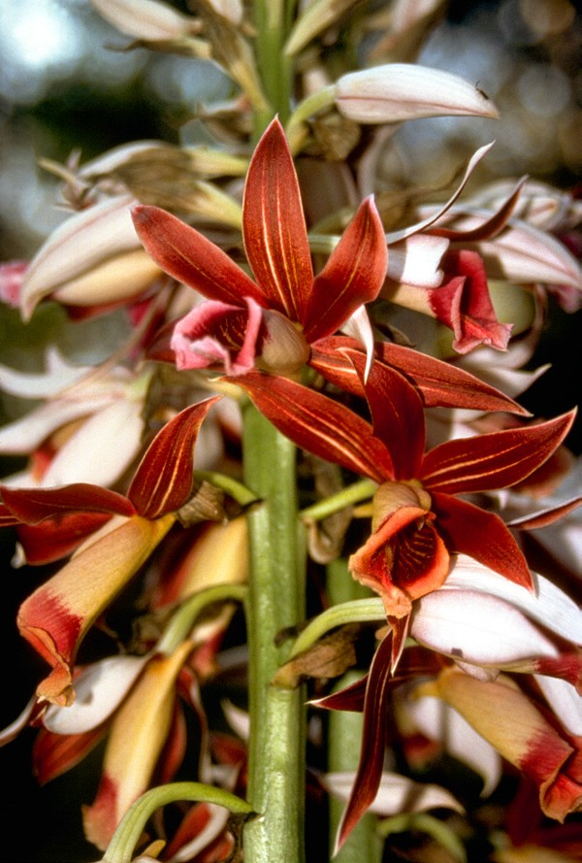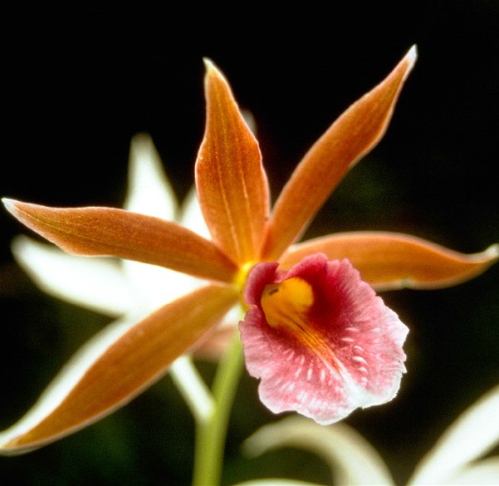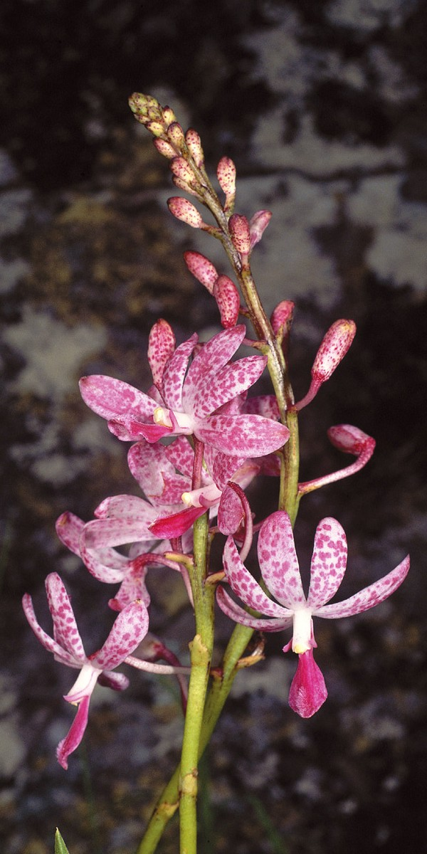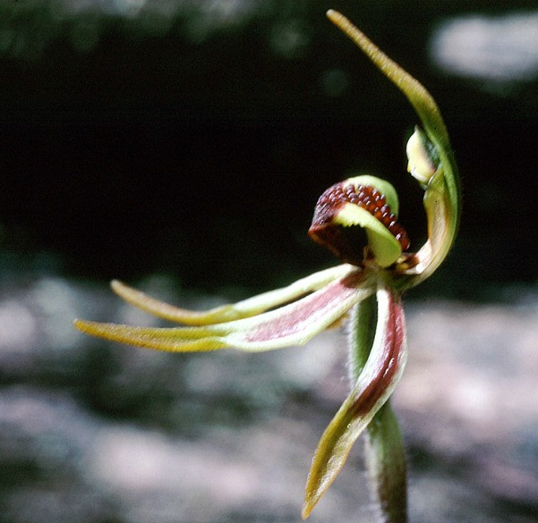

Are you planning to move orchids into or out of Australia?

Live orchid plants coming into or leaving Australia must be accompanied by an Australian wildlife trade permit.

Permit rules apply, unless the live orchid plants meet **permit exemption criteria** listed on the back of this card.

This means you need to get a wildlife trade permit before you move your orchids—whether you intend to carry the orchids with you or you plan to send them by post or freight.

Without a permit, you may be breaking the law. You could be liable for significant penalties including seizure of the orchids and fines.

Apply for a wildlife trade permit from the Department of the Environment and Energy at:

[**www.environment.gov.au/biodiversity/wildlife-trade**](http://www.environment.gov.au/biodiversity/wildlife-trade)

**Permit exemption criteria**

Under Australian law, Australian wildlife trade permits are **not** required for the following:

* Orchid seeds, spores and pollen
* Orchid seedling or tissue cultures/flasks
* Cut flowers of artificially-propagated orchids
* Artificially-propagated hybrids of *Cymbidium*, *Dendrobium*, *Phalaenopsis* and *Vanda* species

**if they meet all of the following criteria**:

**environment**.gov.au

* ‘Container’ includes cartons, boxes, crates or individual shelves of CC-Containers (Container Centralen or Danish Trolley).

|  |  |
| --- | --- |
| All specimens must:  ✓ be recognisable as artificially propagated  ✓ be healthy with no signs of damage  ✓ look uniform in size and shape.  When shipped in a flowering state:  ✓ each plant must have at least one fully open flower | ✓ plants must be professionally processed for retail sale—i.e. labelled with printed labels or packaging indicating the name of the hybrid and the country of final processing.  **When shipped in a non-flowering state:**  ✓ each container* must have 20 or more plants of the same hybrid type (e.g. V. Kru Chon ‘Dark Knight’)  ✓ each shipment must include an invoice or other document that clearly states the number of plants of each hybrid in the shipment. |
|  |  |

All permit applications are processed as quickly as possible. The timeframe for assessing permit applications varies based on the volume of applications received. Please allow up to **40 business days** for your permit application to be processed.