# Oversized tyres presentation and treatment guide

Biosecurity Operations Division

Version 1.0

© Commonwealth of Australia 2025

**Ownership of intellectual property rights**

Unless otherwise noted, copyright (and any other intellectual property rights) in this publication is owned by the Commonwealth of Australia (referred to as the Commonwealth).

**Creative Commons licence**

All material in this publication is licensed under a [Creative Commons Attribution 4.0 International Licence](https://creativecommons.org/licenses/by/4.0/legalcode) except content supplied by third parties, logos and the Commonwealth Coat of Arms.



**Cataloguing data**

This publication (and any material sourced from it) should be attributed as: DAFF 2025, *Oversized tyres presentation and treatment guide*, Department of Agriculture, Fisheries and Forestry, Canberra, CC BY 4.0.

Department of Agriculture, Fisheries and Forestry

GPO Box 858 Canberra ACT 2601

Telephone 1800 900 090

Web [agriculture.gov.au](https://www.agriculture.gov.au/)

**Disclaimer**

The Australian Government acting through the Department of Agriculture, Fisheries and Forestry has exercised due care and skill in preparing and compiling the information and data in this publication. Notwithstanding, the Department of Agriculture, Fisheries and Forestry, its employees and advisers disclaim all liability, including liability for negligence and for any loss, damage, injury, expense or cost incurred by any person as a result of accessing, using or relying on any of the information or data in this publication to the maximum extent permitted by law.

**Acknowledgement of Country**

We acknowledge the continuous connection of First Nations Traditional Owners and Custodians to the lands, seas and waters of Australia. We recognise their care for and cultivation of Country. We pay respect to Elders past and present, and recognise their knowledge and contribution to the productivity, innovation and sustainability of Australia’s agriculture, fisheries and forestry industries.

Contents

Introduction 1

Purpose 2

Biosecurity risks 3

Presentation methods 4

Outcomes 4

Potential hazards 4

Presentation options 4

Presentation method using chocks only 5

Presentation methods using infrastructure 7

Treatment 9

Treatment of goods 9

Treatment that may damage goods 9

Treatment information 9

Export information 11

More information 11

Version history 11

****Tables****

Table 1 Examples of biosecurity risks on imported goods 3

Table 2 Hot water treatment steps 9

**Figures**

Figure 1 Tyre presentation using chocks – tread direction 6

Figure 2 Tyre presentation using chocks – minimum spacing 6

Figure 3 Tyre presentation using chocks – groups of 6 7

Figure 4 Tyre presentation using chocks and steel bracing 7

Figure 5 Tyre presentation using chocks, straps and flat rack 8

Figure 6 Tyre presentation using single file in pre-made frame 8

Figure 7 Tyre presentation using inspection stand 8

## Introduction

One of the Department of Agriculture, Fisheries and Forestry’s primary roles is to address biosecurity threats to Australia’s primary production sectors, the environment and human health, while also supporting tourism and trade.

To do this, the department provides import and export inspection and certification to help retain Australia’s highly favourable animal, plant and human health status and wide access to overseas export markets.

The department also manages biosecurity controls at our borders to minimise the risk of exotic pests and diseases entering the country.

Imported goods may be subject to targeted or random inspection by biosecurity officers who are trained to look for biosecurity risks on imported goods. In most cases, import conditions relating to imported goods that pose a specific and identifiable biosecurity risk are stipulated in the department’s [Biosecurity Import Conditions system](https://www.agriculture.gov.au/biosecurity-trade/import/online-services/bicon) (BICON).

To prepare for inspection, industry must effectively present oversize tyres using approved methods where all safety concerns are addressed, and inspections can be carried out safely.

Presentation methods are a guide only. Third-party premises should conduct their own risk assessments and ensure reasonable controls are put in place to ensure the safety of all staff working in proximity to oversize tyres. Biosecurity officers can request evidence from the industry representative that the methods used to safely secure and present oversize tyres for inspection have been risk assessed. Biosecurity officers reserve the right to remove themselves from any situations they deem unsafe.

The application of more than one treatment type may be necessary to mitigate multiple biosecurity risks. All expenses for any treatment, supervision of treatment and/or reinspection (if required) are borne by the importer.

## Purpose

This guide has been created with the intention of informing industry on the correct presentation and safe treatment methods for oversize tyre biosecurity inspections.

This guide provides department approved oversize tyre presentation methods for importers, brokers, import agents and external stakeholders involved in the importing industry.

The treatment information applies only to biosecurity risks detected at the initial inspection as biosecurity risks that may occur:

* on the surfaces of imported goods
* as non-commodity-based risks associated with imported goods
* in packaging not associated with the imported goods but used to facilitate safe transport.

## Biosecurity risks

Table 1 describes examples of biosecurity risks that may be detected on oversize tyres, non-commodity items and packaging.

Table 1 Examples of biosecurity risks on imported goods

| Item | Examples |
| --- | --- |
| Live animals – vertebrates | frogs, geckos, birds, rodents, reptiles |
| Animal material | hair, fur, skin, faeces, shell, blood, and fluids, feathers, honey, flesh, bone, horn |
| Animal material – evidence | feathers, fur, faeces |
| Plants – live | plants, weeds, sprouted seeds, propagatable material |
| Plant material – reproductive | pollen, spores, flowers, fruit, vegetables |
| Plant material – seeds | seeds, pods |
| Plant material – fresh | fresh leaves, gum, stems, pods, roots, flowers |
| Plant material – dry | dried leaves, branches, roots, straw, wood |
| Plant material – bark | bark |
| Invertebrates – timber pests | borers, wasps, termites, ants, larvae, eggs, beetles |
| Invertebrates – flying pests | flies, moths, bees, wasps |
| Invertebrates – fresh produce pests | beetles, thrips, larvae, mites, flies, caterpillars |
| Invertebrates – stored product pests | beetles, larvae, eggs, casings |
| Other invertebrates of concern – terrestrial | flatworms, nematodes, earthworms |
| Other invertebrates of concern – aquatic | sponges, jellyfish, starfish, barnacles, algae |
| Invertebrates seeking refuge – hitchhikers | ants, bees, wasps, moths, spiders, grasshoppers, butterflies |
| Invertebrates – evidence | wasps nests, mud nests, wings, shells, casing, frass |
| Snails and slugs | snails, slugs |
| Snails and slugs – evidence | shells, eggs, trail marks |
| Plant pathogens | fungi, lichen, bacteria, viruses, moulds, protozoa, phytoplasmas |
| Soil | dirt, mud, clay, sand |
| Water | pools of water, water in receptacles, articles used with water |
| Water – evidence | water marks |

## Presentation methods

### Outcomes

Oversize tyres must be presented by industry for inspection in a manner that must meet these 3 outcomes:

1. A biosecurity officer must have the ability to inspect all internal and external surfaces safely.
2. A biosecurity officer must have the ability to collect water samples if required.
3. A biosecurity officer or a third-party treatment provider must have the ability to apply biosecurity measures to address biosecurity risks.

### Potential hazards

Tyres stacked in an upright position have the potential to pose a serious hazard.

During inspection operations, improper presentation may cause either the unit being handled (or an adjacent one) to become unstable.

The result of this can be tyres falling into each other, creating an irreversible chain of events which can lead to the collapse of the entire stack, either onto the ground, people in the area, or onto the machine handling them.

The size and weight of these large tyres requires they be handled by specific equipment.

Inspection will not proceed if the biosecurity officer or industry representative identify these hazards:

* incorrect chocking, and/or identification of unsafe chocks
* straps not used in the correct manufacturer specified manner
* mobile plant operating within the sign posted area
* high winds (+40 knots)
* any other situation that may cause the situation to become unsafe to continue.

### Presentation options

At inspection, industry should present oversize tyres using only departmental approved methods. Presentation methods are to follow these departmental-approved processes.

Should biosecurity officers believe the process has not been followed at any time before or during the inspection, they can refuse to inspect until rectified.

Current departmental approved presentation methods include:

* presentation methods using chocks only
* presentation methods using infrastructure

### Presentation method using chocks only

The use of chocks is one method that can be utilised to support the tyres from underneath. Chocking the tyres correctly allows the tyres to be inspected with the hazard minimised to an acceptable level.

If using a presentation method that uses chocks:

* There must be 4 chocks per tyre or 6 chocks per pair as a minimum standard.
* Chocks must be placed on the outer edge of the tread pattern and wedged into the tyre for maximum support.
* Chocks must be commercially made, Australian industry standard that are rated specifically for the dimensions of the tyre.
* Chocks used must be free of damage such as cracks, splits and rotting.
* All straps holding tyres together must be
  + free from damage
  + attached only by the corresponding ratchet for that strap (not knotted together)
  + industry standard
  + attached in such a way that the tyres cannot move.

Figure 1, Figure 2 and Figure 3 show the department-approved methods for presenting oversize tyres for inspection using chocks only. If you would like to propose an alternative presentation method that is not depicted in the approved methods, email [SeaCargoPolicy@aff.gov.au](mailto:SeaCargoPolicy@aff.gov.au) for consultation.

#### Method 1

Place tyres free standing in pairs with tread facing out, chocked at the bottom (Figure 1).

Ensure there is a minimum of 1 metre of space between each pair of tyres for access (Figure 2).

Presentation groups of 6 tyres will have 3 chocks at each end and 2 between touching pairs (Figure 3).

Figure 1 Tyre presentation using chocks – tread direction

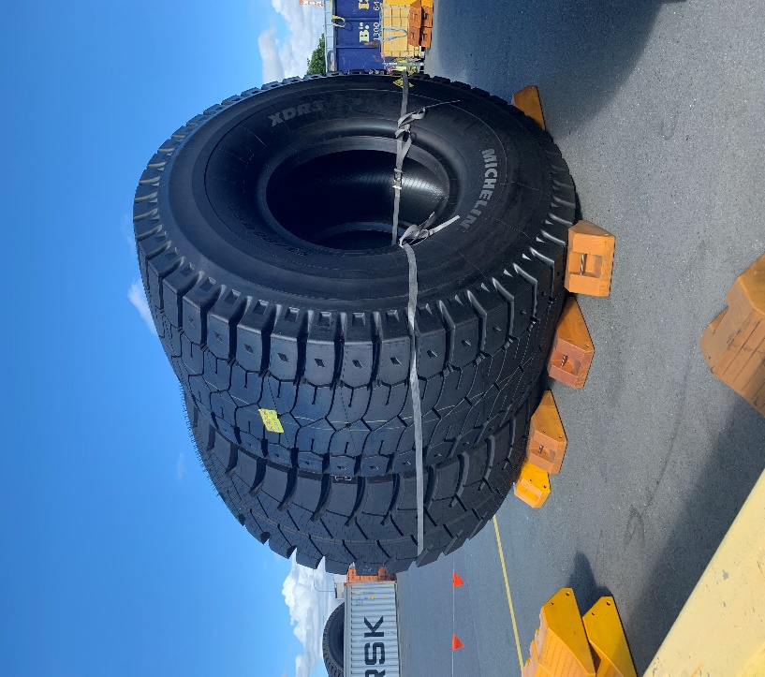

Figure 2 Tyre presentation using chocks – minimum spacing

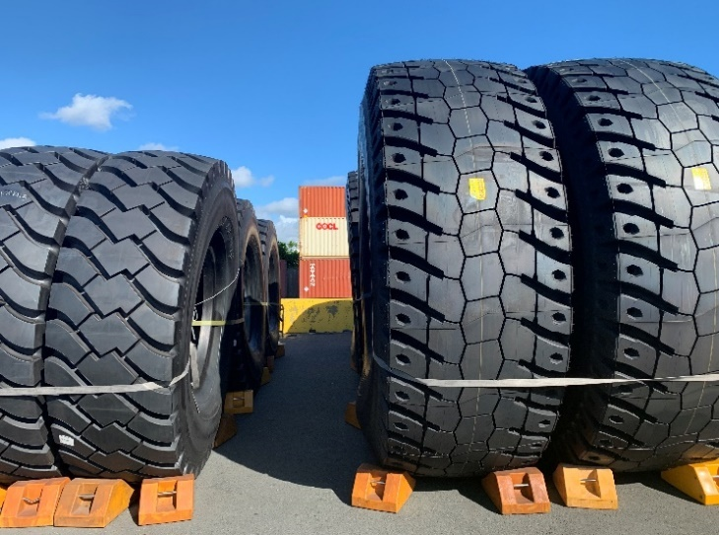

1 metre min

Figure 3 Tyre presentation using chocks – groups of 6

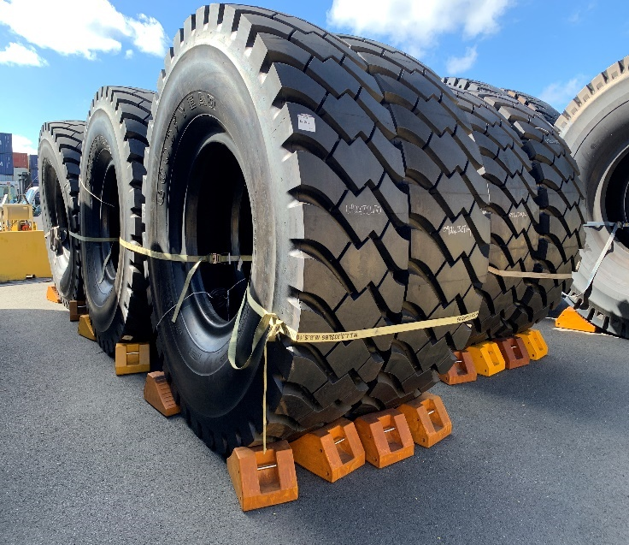

Presentation groups of 6

Min 2 chocks in between

Min 3 chocks on end

### Presentation methods using infrastructure

This procedure outlines the steps required to safely present oversize tyres for inspection using various types of infrastructure.

#### Method 2

Multiple tyres lined up in pairs and chocked within a perimeter of steel bracing (Figure 4).

Figure 4 Tyre presentation using chocks and steel bracing

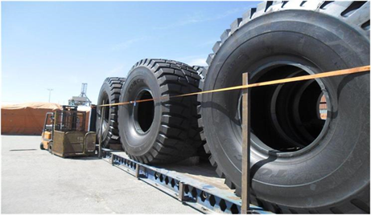

#### Method 3

Multiple tyres lined up and chocked and strapped together in pairs on a flat rack (Figure 5).

Figure 5 Tyre presentation using chocks, straps and flat rack

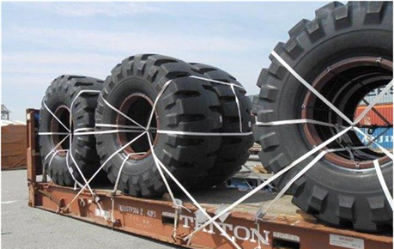

#### Method 4

Multiple tyres lined up in single file in a pre-made frame (Figure 6).

Figure 6 Tyre presentation using single file in pre-made frame

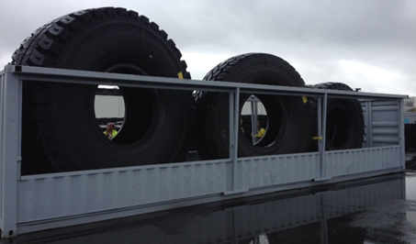

#### Method 5

Single tyre chocked against a purpose-built inspection stand (Figure 7).

Figure 7 Tyre presentation using inspection stand

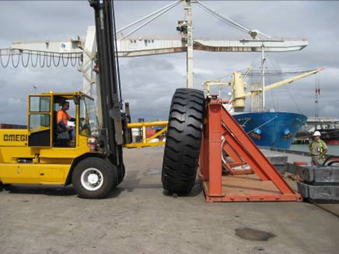

## Treatment

### Treatment of goods

Where a biosecurity officer suspects, on reasonable grounds, that the level of biosecurity risk associated with the goods that are subject to biosecurity control is of an unacceptable level, the officer may require biosecurity measures to be taken in relation to the goods. These biosecurity measures allow a biosecurity officer to manage biosecurity risks to an acceptable level.

Biosecurity officers have the power to require that goods be treated in a specific manner.

### Treatment that may damage goods

The Biosecurity Act 2015 outlines the requirements for notifying the person in charge of goods where a biosecurity officer suspects on reasonable grounds that the treatment required is likely to damage the goods.

If the biosecurity officer suspects on reasonable grounds that the goods pose a high level of biosecurity risk and need to be treated as soon as practicable, the officer will direct industry to carry out the specified treatment without having to notify the person in charge.

### Treatment information

#### Hot water treatment

* A biosecurity officer may direct industry to treat the affected areas with hot water.
* The equipment used to perform the hot water treatment must be able to deliver hot water under pressure, ensuring that the water temperature exceeds 70 degrees Celsius (70°C) at the substrate surface.
* The unit must be mobile or be able to be taken to the area where the tyres are unpacked and presented for inspection.
* Equipment used to verify water temperature must be able to be calibrated according to manufacturer’s specifications.
* The following table describes the steps industry must follow when a hot water treatment is applied to new oversize tyres.

Table 2 Hot water treatment steps

| Step | Action |
| --- | --- |
| 1. | Treat contamination sites and surrounding areas with hot water, ensuring that the water temperature exceeds at least 70°C at the substrate surface. |
| 2. | There is no need for the tyres to be moved to a designated wash pad for treatment. They can be treated in an area that is located within the AA site as long as the surface is impervious and adequate WHS requirements are in place (e.g. appropriate signage, restrictions on vehicular movement) |
| 3. | Measure the distance between the end of the nozzle and the point where the temperature falls below 70°C and recorded in the operating instructions for equipment use.  The actual process of using a thermometer to verify the temperature of the water will be performed by the third-party provider performing the treatment. |
| 4. | Verify the water temperature prior to the commencement of every treatment.  This is to ensure the water is at the required temperature to ensure effective treatment.  Verification of the water temperature used for treatment can be requested by the biosecurity officer at any time throughout the process. |

#### Residual insecticide surface spray

A biosecurity officer may direct industry to treat the affected areas with residual insecticide surface spray.

Use products containing synthetic pyrethroids that are registered for the residual treatment of surfaces against insects in a domestic or workplace environment. Typically, these products contain one or more compounds such as deltamethrin, beta-cyfluthrin, bifenthrin tetramethrin, cypermethrin and other ‘thrin’ relatives. Products containing a combination neonicotinoid and pyrethroid are also suitable.

For any standing water, a qualified pesticide operator must be used to apply appropriate insecticide products registered for this purpose.

The residual surface sprays need to be applied to the dry surface immediately above and around the water line until beads form and run off.

#### Safety directions

This safety information is for industry to understand the potential risks of insecticide treatment that may get applied to oversize tyres during inspection.

Insecticides:

* are harmful if swallowed
* may cause temporary facial numbness if in contact with facial skin
* will irritate the eyes and skin.

Please ensure that you consult with the relevant safety data sheets for further information.

## Export information

Goods with biosecurity risks that cannot be treated or destroyed by an approved method must be exported from Australia.

Goods destined for export must be separated and contained prior to export.

Export from Australia must take place within stated timeframes.

## More information

For more information about the presentation and treatment of oversize tyres options, email [SeaCargoPolicy@aff.gov.au](mailto:SeaCargoPolicy@aff.gov.au).

Phone: 1800 900 090

Email: [SeaCargoPolicy@aff.gov.au](mailto:SeaCargoPolicy@aff.gov.au)

## Version history

| Version | Date published | Reason for issue or amendment | Section |
| --- | --- | --- | --- |
| 1.0 | March 2025 | Guide created for industry | Sea Cargo Policy |