|  |
| --- |
| oceans and atmosphere |
| Australian and Global Emissions of Ozone Depleting Substances  B. L. Dunse, N. Derek, P. J. Fraser, P. B. Krummel and L. P. Steele  June 2019  Report prepared for the Australian Government Department of the Environment and Energy |

|  |
| --- |
|  |

CSIRO Oceans and Atmosphere

Citation

Dunse, B. L., N. Derek, P. J. Fraser, P. B. Krummel and L. P. Steele, Australian and Global Emissions of Ozone Depleting Substances, Report prepared for the Australian Government Department of the Environment and Energy*,* CSIRO Oceans and Atmosphere, Climate Science Centre, Aspendale, Australia, iv, 37 pp., 2019

Copyright and disclaimer

© 2018 CSIRO To the extent permitted by law, all rights are reserved and no part of this publication covered by copyright may be reproduced or copied in any form or by any means except with the written permission of CSIRO.

Important disclaimer

CSIRO advises that the information contained in this publication comprises general statements based on scientific research. The reader is advised and needs to be aware that such information may be incomplete or unable to be used in any specific situation. No reliance or actions must therefore be made on that information without seeking prior expert professional, scientific and technical advice. To the extent permitted by law, CSIRO (including its employees and consultants) excludes all liability to any person for any consequences, including but not limited to all losses, damages, costs, expenses and any other compensation, arising directly or indirectly from using this publication (in part or in whole) and any information or material contained in it.

Contents

Figures ii

Tables iii

Acknowledgments iv

1 Introduction 1

2 Measurements of synthetic and natural ODSs at Cape Grim, Tasmania 2

2.1 CFCs 6

2.2 HCFCs 7

2.3 Other Chlorocarbons ODSs 8

2.4 Halons 9

2.5 Other organobromine species 9

2.6 Total chlorine and bromine: impact on stratospheric ozone 9

2.7 Global radiative forcing from ODSs, HFCs and other SGGs 10

3 Global emissions of ODSs 11

4 Australian ODS imports and banks 13

5 Estimated Australian ODS emissions from Cape Grim data 16

5.1 CFCs 20

5.2 HCFCs 21

5.3 Halons 22

5.4 Methyl bromide 23

5.5 Carbon tetrachloride and methyl chloroform (Montreal Protocol chlorocarbons) 24

5.6 Other chlorocarbons 25

5.7 GWP-weighted ODS emissions 25

5.8 Total ODS emissions 25

Summary 28

References 30

Figures

**Figure 1.** Cape Grim *in situ* and Air Archive observations of CFCs, HCFCs, halons, carbon tetrachloride, methyl chloroform, methyl chloride, dichloromethane, chloroform, TCE, PCE, methyl bromide, dibromomethaneand bromoform (1978 – 2018) showing baseline monthly mean data (Medusa - dark green; ADS - purple; ECD – dark blue; Archive data – orange) and total data (Medusa - light green; ADS – pink; ECD – light blue) obtained from the GC-MS-Medusa, GC-MS-ADS and GC-ECD instruments at Cape Grim and Aspendale. The CFC-112, -112a, -113a, -216ba, -216ca and HCFC-133a data are from UEA and Empa measurements on the Cape Grim Air Archive (see text above and CSIRO unpublished data). 5

**Figure 2.** Global concentrations of CFC-11, CFC-12 and CFC-113 (ppt) and WMO A1 scenarios (dashed lines; Harris and Wuebbles, 2014; Carpenter and Daniel, 2018). 6

**Figure 3.** Global concentrations of HCFC-22, HCFC-141b and HCFC-142b (ppt) and WMO A1 scenarios (dashed lines; Harris and Wuebbles, 2014; Carpenter and Daniel, 2018). 8

**Figure 4.** Total chlorine from CFCs, HCFCs, carbon tetrachloride: CCl4, methyl chloroform: CH3CCl3 and other chlorine-containing ODSs (Table 1) as measured at Cape Grim. 9

**Figure 5.** Total bromine from methyl bromide: CH3Br, halons and other bromine-containing ODSs (dibromomethane - CH2Br2 and bromoform - CHBr3) as measured at Cape Grim (Table 1). 10

**Figure 6.** Total column ozone (DU) changes at Halley Station, Antarctica (76oS), and Melbourne, Australia (38oS) and Equivalent Effective Stratospheric Chlorine (EESC, ppb) changes at polar and mid-latitudes. The Melbourne ozone data are 11-year running means to minimize impacts of solar variability. 10

**Figure 7.** Global abundance (ppb, left) and radiative forcing (W/m2, right) of synthetic greenhouse gases (SGGs: HFCs, HCFCs, CFCs, others). 11

**Figure 8.** Global annual emissions (M tonnes) of ODSs (CFCs, chlorinated solvents (methyl chloroform: CH3CCl3, carbon tetrachloride: CCl4), methyl chloride, dichloromethane, chloroform, halons, methyl bromide: CH3Br, HCFCs) derived from global AGAGE data by inverse modelling using the 12-box AGAGE global transport model, by forward modelling using a 2-D atmospheric chemistry-transport model and by Bayesian inverse modelling using the FLEXPART dispersion model. For methyl bromide, pre-1998 emissions are scaled from global atmospheric concentrations. 12

**Figure 9**. Global emissions (ODP tonnes) of the Montreal Protocol ODSs and global equivalent chlorine (ppt), both derived from AGAGE data (Fraser *et al*., 2014a; Rigby *et al*., 2014 and subsequent updates) using the 12-box AGAGE model. For methyl bromide, pre-1998 emissions are scaled to post-1998 from global atmospheric concentrations, 1978-2018. 13

**Figure 10.** Australian imports (tonnes) of ODSs (CFCs, HCFCs, halons, MC: CH3CCl3, MB: CH3Br – total left, MB: CH3Br – nQPS right) (A. Gabriel, AWE, private communication, 2019). The 2012-2018 data are from the OLaRS data base, 2010 and earlier are pre-OLaRS data, and 2011 is a mixture of OLaRS and pre-OlaRS data. 14

**Figure 11**. Australian HCFC-22 and HCFC-123 banks and HCFC-22 bank emissions (Brodribb and McCann, 2013, 2014, 2015a). Dashed line is from Brodribb and McCann, 2018: burgundy= banks, black=bank emissions. 14

**Figure 12.** Annual average (3-yr running means) Australian emissions of CFCs, methyl bromide, HCFCs, halons and chlorocarbons (methyl chloroform, carbon tetrachloride, chloroform, dichloromethane, trichloroethylene, perchloroethylene) from Cape Grim AGAGE data, using ISC techniques (orange: GC-ECD data; blue: GC-MS data). methyl bromide emissions are for SE Australia. Australian emissions are scaled from SE Australian emissions on a population basis; halon emissions are adjusted to account for SE Australian Halon Bank emissions. NAME emissions are show in light blue. HCFC-22 emissions from the refrigerant bank are show in red (Brodribb and McCann, 2015a). 17

**Figure 13.** Declining Australian CFC, HCFC, halon and carbon tetrachloride emissions (k tonnes). 20

**Figure 14.** Total Australian HCFC-22 emissions (k tonnes) from Cape Grim data and HCFC-22 bank emissions as functions of the HCFC-22 bank (k tonnes; Brodribb and McCann, 2015a). The dashed line is a linear regression: slope = 0.13 tonne/tonne banked. 21

**Figure 15**. Possible HCFC-22 emissions from non-equipment bank sources such as landfills. 21

**Figure 16.** Australian methyl bromide emissions (3-year average) calculated from Australian methyl bromide import data and the modified UNEP emissions model (UNEP, 2018). 24

**Figure 17.** SE Australian methyl bromide emissions calculated (see text for details) by ISC from Cape Grim *in situ* AGAGE methyl bromide data (blue) and from a modified UNEP (2018) emissions model (orange, 3-year average) based on Australian methyl bromide imports and the SE Australian methyl bromide consumption for timber/grain exports and strawberry runner production. 24

**Figure 18.** Australian carbon tetrachloride emissions calculated from Cape Grim *in situ* AGAGE data by ISC and inverse modelling (NAME). 25

**Figure 19.** Total Australian ODS emissions; without other chlorocarbons (Section 5.6, left) and with other chlorocarbons (right). 26

**Figure 20.** Australian emissions (GWP-weighted: M tonnes CO2-e) of ODSs (Montreal Protocol species: CFCs, HCFC, halons, methyl bromide, methyl chloroform, carbon tetrachloride) and the GHGs reported to UNFCCC (carbon dioxide, methane, nitrous oxide, Kyoto Protocol synthetics: HFC, PFCs and sulfur hexafluoride), including and excluding GHG emissions due to land-use/land-use change and forestry (LULUCF). 27

**Figure 21.** Global (since 1978) and Australian (since 1995) CFC, HCFC and HFC emissions (M tonne CO2-e). 27

Tables

**Table 1.** Southern Hemisphere concentrations (2017, 2018) and growth rates (2017-2018) for CFCs, HCFCs, halons, carbon tetrachloride, methyl chloroform, methyl chloride, dichloromethane, chloroform, trichloroethylene, perchloroethylene, methyl bromide, dibromomethane and bromoform measured *in situ* at Cape Grim, Tasmania and/or in the Cape Grim Air Archive (references: see text above and CSIRO unpublished data). 4

**Table 2.** Australian imports (bulk and pre-charged equipment, tonnes) of ODSs (CFCs, HCFCs, MC: CH3CCl3, halons, MB: CH3Br) 1992-2018; 2012-2018 data are from the OLaRS data base, 2010 and earlier are pre-OLaRS data, and 2011 is a mixture of OLaRS and pre-OlaRS data (A. Gabriel, DAWE, private communications, 2014-2016). The only significant carbon tetrachloride (CCl4) imports were ~0.5 tonnes in 1995/1996 (not listed). ODS imports less than 0.1 tonne are not listed, but included in total ODS. Methyl bromide imports are listed as for QPS and non-QPS uses. Small quantities of methyl bromide imports are exported (do not influence Australian emissions); significant quantities HCFC-123 imports are exported or used as feedstock (do not influence Australian emissions) – for example 10 tonnes exported and 3 tonnes used for feedstock in 2014, ~1 tonne exported 2015). 15

**Table 3.** Annual average (3-yr running means, i.e. 2014 = average of 2013, 2014, 2015) Australian emissions (metric tonnes unless otherwise stated) of ODSs (CFCs, HCFCs, halons, MB and chlorocarbons) from Cape Grim AGAGE data, using ISC techniques. Australian emissions are scaled from SE Australian emissions on a population basis; Australian halon emissions are from SE Australian emissions adjusted for the impact of emissions from the National Halon Bank in Melbourne; Australian methyl bromide emissions are from a DPI-modified UNEP model of methyl bromide emissions based on QPS and non-QPS methyl bromide consumption (see text). GWPs (to calculate CO2-e emissions) are from Forster and Ramaswamy (2007); ODPs (to calculate ODP-weighted emissions) are from Montzka and Reimann (2011); assumed GWPs for trichloroethylene (0.67) and perchloroethylene (0.53). Pre-1999 emissions of CFC-114, -115, HCFCs, halons and dichloromethane (shown in red) are assumed equal to 1999 emissions; pre-2005 emissions of perchloroethylene (shown in red) are assumed equal to 2005 emissions. 18

Acknowledgments

The authors would like to thank the Cape Grim staff for the maintenance and operation of the AGAGE (Advanced Global Atmospheric Gases Experiment) instruments at Cape Grim and for the collection of the Cape Grim Air Archive; Dr D. Ivy (MIT USA), Dr B. R. Miller (SIO USA and NOAA USA), Dr D. E. Oram (UEA UK), Dr M. K. Vollmer (Empa, Switzerland) and the late Mr L. W. Porter (BoM) for gas chromatography-mass spectrometry analyses of the Cape Grim Air Archive; Dr A. Manning (UKMO) for ozone depleting substances (ODS) emissions calculations (NAME-InTEM); Dr M. Rigby (U. Bristol UK) for global ODS emissions calculations (AGAGE 12-box model); Dr I. Porter (DPI Victoria) for methyl bromide emissions information; Ms. A. Gabriel (Department of the Environment and Energy) for ODS import and emission data; CSIRO, BoM, NASA/MIT, Department of the Environment and Energy and RRA (Refrigerant Reclaim Australia) for funding in support of the Cape Grim AGAGE program.

# Introduction

Chlorofluorocarbons (CFCs), hydrochlorofluorocarbons (HCFCs), halons, carbon tetrachloride (CTC: CCl4), methyl chloroform (MC: CH3CCl3) and methyl bromide (MB: CH3Br) are all ozone depleting substances (ODSs), whose production and consumption, and resulting emissions, have been significantly reduced by national actions to comply with the Montreal Protocol. However, significant, persistent ODS emissions remain (Montzka *et al*., 2018; Engel and Rigby, 2018; Rigby *et al*., 2019), particularly CFC-11 from East Asia. If this current increase in globally significant CFC-11 emissions were to continue, it could delay recovery of mid-latitude and Antarctic ozone depletion by about 7 and 20 years respectively. Avoiding these increased CFC-11 emissions could have a larger positive impact on stratospheric ozone than any other policy option considered in the latest assessment of stratospheric ozone depletion, including destruction of the CFC bank (Carpenter, Daniel et al. 2018).

Methyl chloride (CH3Cl), dichloromethane (CH2Cl2), chloroform (CHCl3), trichloroethylene (TCE: CHClCl2), perchloroethylene (PCE: CCl2CCl2), dibromomethane (CH2Br2), bromoform (CHBr3) and methyl iodide (CH3I) are not listed as ODSs in a Montreal Protocol context, because methyl chloride, chloroform, dibromomethane, bromoform and methyl iodide are predominantly natural in origin, and dichloromethane, trichloroethyleneand perchloroethylene,although largely anthropogenic in origin, have relatively short atmospheric lifetimes (<0.5 yr, Montzka and Reimann, 2011) and therefore relatively low Ozone Depleting Potentials (ODPs). They are considered in this report in the context of their potential contribution to Equivalent Effective Stratospheric Chlorine (EESC), the ultimate driver of stratospheric ozone depletion (Bekki and Bodeker, 2011; Montzka and Reimann, 2011; Carpenter and Reimann, 2014; Fraser *et al*., 2014a; Engel and Rigby, 2018).

The most dramatic demonstration of the environmental impact of EESC is the annual appearance of the Antarctic ozone hole (AOH; Klekociuk *et al*., 2015 and earlier papers). In a companion report (Krummel *et al*., 2019 and earlier reports) we review the development and decline of the 2018 AOH, and review its metrics in light of the ongoing decline of EESC in the atmosphere. The overall ranking of the 2018 AOH is quantified in that report. In addition, ODS emissions play an important role globally in contributing to radiative forcing by greenhouse gases (GHGs), and reductions in ODSs have helped reduce the human contribution to climate change over the past 30 years (Forster and Ramaswamy, 2007; Myhre and Schindell, 2013; Carpenter and Reimann, 2014).

CFCs, halons, carbon tetrachloride and methyl chloroform are no longer imported into Australia in any significant quantities; however small amounts can still be used for essential purposes. Nevertheless, long-term atmospheric observations at Cape Grim, Tasmania, show that there are measurable past and current emissions of these chemicals from the Melbourne-Port Phillip-SE Australian region, and presumably from all the major Australian urban regions (Dunse *et al*., 2005; Fraser *et al*., 2014b). Previous research (Fraser *et al*., 2013; 2014b) suggested that the emissions are likely from ‘banks’ of these species, in the form of old ODS-containing equipment and materials still in use (for example refrigerators, aerosol cans, fire extinguishers, foam plastics) or from leaking landfills, containing the aggregated emissions from buried ODS-containing equipment and materials. ODS emissions are not regulated as part of the Montreal Protocol. However, ODS emissions in Australia are controlled directly by actions taken by the Australian government to control ODS production and consumption under the Montreal Protocol and by additional measures to reduce emissions – for example banning the emissions of ODSs unless permitted by regulation in the main end-use sectors: air conditioning, refrigeration and fire protection. In addition, mitigation of Australian emissions of these species is supported by government and industry initiatives in capture of used ODS substances, followed by their recycling or destruction.

HCFCs, methyl bromide, dichloromethane, trichloroethylene and perchloroethylene are imported into Australia and used in maintaining existing HCFC-containing refrigeration and air conditioning equipment, for quarantine and pre-shipment (QPS) uses of methyl bromide, such as grain fumigation immediately prior to international export, one exempted non-QPS use of methyl bromide (for growing strawberry runners), fire protection, and for solvent use (dichloromethane, trichloroethylene, perchloroethylene). HCFC and non-QPS methyl bromide consumptions are controlled by Australia’s commitments under the Montreal Protocol and are declining, whereas QPS-uses of methyl bromide are not subject to phase-out under the Montreal Protocol and consequently methyl bromide emissions from QPS-use have the potential to increase. Methyl bromide use for fumigation of grain prior to transport within Australia is declining, where phosphine (PH3) and sulfuryl fluoride (SO2F2) are seen as suitable, but not universal, alternative or replacement chemicals. There are no controls over the use of dichloromethane, trichloroethylene, perchloroethylene from climate change or ozone depletion perspectives, but emissions of these chlorinated solvents are regulated in Australia due to their hazardous nature (toxicity) as volatile organic compounds (VOCs; EPA 1998).

# Measurements of synthetic and natural ODSs at Cape Grim, Tasmania

The concentrations of synthetic (CFCs, HCFCs, halons, carbon tetrachloride, methyl chloroform, dichloromethane, trichloroethylene, perchloroethylene, methyl bromide-partially) and natural (methyl chloride, chloroform, methyl bromide-partially, dibromomethane, bromoform, methyl iodide) ODSs have been measured in the background (baseline) Southern Hemisphere atmosphere on air samples at or from Cape Grim, Tasmania. Measurements have been made on baseline air in the Cape Grim Air Archive (1978-2017) at CSIRO (Aspendale), at the Scripps Institution for Oceanography (SIO, USA), at the University of East Anglia (UEA, UK) and at Eidgenössische Materialprüfungs und Forschungsanstalt (Empa, Switzerland). Other flask air samples from Cape Grim and over SE Australia have been analysed at CSIRO, the Oregon Graduate Center (OGC, USA), SIO, the National Oceanographic and Atmospheric Administration (NOAA, USA), UEA, and the National Institute for Environmental Research (NIES, Japan). The synthetic and natural ODSs have been measured by CSIRO *in situ* in the atmosphere (baseline and non-baseline) at Cape Grim, Tasmania, since 1976 (CFC-11, carbon tetrachloride, methyl chloroform), since 1978 (CFC-12, chloroform), since the early 1980s (CFC-113), since the late-1990s (CFC-114, CFC-115, several HCFCs, halons), since the mid-2000s (several more HCFCs, methyl chloride, dichloromethane, trichloroethylene, perchloroethylene, methyl bromide) and more recently dibromomethane and bromoform.

CFC-114 has been measured *in situ* at Cape Grim (since 1998) and in the Cape Grim Air Archive (1978-2015) on UEA GC-MS and AGAGE ADS/Medusa GC-MS instruments (Oram, 1999; Krummel *et al*., 2014; Vollmer *et al*., 2018, and earlier reports). ‘CFC-114’ measured on the AGAGE instruments is actually an unresolved mixture of CFC-114 (CClF2CClF2) and CFC-114a (CCl2FCF3), whereas the UEA GC-MS instrumentation can separate these two species, resulting in data for each species. Based on the early work of Oram (1999), in the international assessments of ozone depletion science (Carpenter and Reimann, 2014 and earlier assessments), it was assumed that AGAGE ‘CFC-114’ is approximately 90% CFC-114 and 10% CFC-114a, constant in time, likely reflecting a common source. Further work at UEA analysing the Archive shows that the CFC-114a: CFC-114 ratio is actually lower (currently 6%), and varies with time, suggesting, in part, separate sources for these CFCs, in particular in east Asia (Laube *et al*., 2016).

Examples of new ODSs that have been measured recently in the Cape Grim Air Archive and/or *in situ* at Cape Grim, for which estimates of global abundances and some emissions have been made, include 37Cl-CFC-11 (CCl237ClF), 37Cl-CFC-12 (CCl37ClF2), CFC-112 (CCl2FCCl2F), CFC-112a (CClF2CCl3), CFC-113a (CCl3CF3), 37Cl-CFC-113 (CCl37ClFCClF2), CFC-114a (CCl2FCF3), CFC-133a (CCl3CF3), CFC-216ba (CClF2CClFCF3), CFC-216ca (CClF2CF2CClF2), HCFC-31 (CH2ClF), HCFC-133a (CH3CClF2) and HCFC-225ca (CHCl2CF2CF3) (Kloss *et al*., 2014; Laube *et al*., 2014; Vollmer *et al*., 2015; Schoenenberger *et al*., 2015; Adcock *et al*., 2018; Engel and Rigby, 2018; CSIRO unpublished data). Other new ODSs recently measured at Cape Grim include HCFC-21 (CHCl2F, commencing 2015), HCFC-132b (CHCl2CHF2, commencing 2015) and HCFC-1233zd (or HFO-1233zd: CHClCHCF3, commencing 2014). Provisionally-calibrated data are available for HCFC-132b (Table 1).

These data are used, in conjunction with similar data collected from other Northern and Southern Hemispheric sites, to estimate both global and regional concentration trends, atmospheric lifetimes and emissions for these species, which have been reported in the peer-reviewed scientific literature:

CFCs Fraser *et al*., 1977, 1983, 1996, 2016, 2018; Fraser and Pearman, 1978a,b; Hyson *et al*., 1980; Rasmussen and Khalil, 1979; Rasmussen *et al*., 1982; Cunnold *et al*., 1983; 1986, 1994, 1997; Oram, 1999; Fraser, 2000; Prinn *et al*., 2000, 2018; Sturrock *et al*., 2002; Dunse *et al*., 2005; Laube *et al.*, 2013, 2014, 2016; Rigby *et al*., 2013, 2014; Kloss *et al*., 2014; Allin *et al*., 2015; Meinshausen *et al*., 2017; Adcock *et al*., 2018; Montzka *et al*., 2018; Vollmer *et al*., 2018; Engel and Rigby, 2018; Reimann *et al*., 2018

HCFCs Rasmussen *et al*., 1980, 1982; Montzka *et al*., 1994; Oram *et al*., 1995; Miller, 1998; Miller *et al*., 1998, 2010; Oram, 1999; Prinn *et al*., 2000, 2018; Sturrock *et al*., 2002; O’Doherty *et al*., 2004; Greally *et al*., 2007; Stohl *et al*., 2009; Saikawa *et al*., 2012; Laube *et al.*, 2013, 2014; Kloss *et al*., 2014; Rigby *et al*., 2014, 2017; Vollmer *et al*., 2015; Schoenenberger *et al*., 2015; Chirkov *et al*., 2016; Fraser *et al*., 2016; Liang *et al*., 2017; Meinshausen *et al*., 2017; Simmonds *et al*., 2017, 2018; Engel and Rigby, 2018; Reimann *et al*., 2018; Li *et al*., 2019

halons Butler *et al*., 1994; Fraser and Prather, 1999; Fraser *et al*., 1999; Oram, 1999; Fraser, 2000; Sturrock *et al*., 2002; Newland *et al*., 2013; Vollmer *et al*., 2016; Meinshausen *et al*., 2017; Engel and Rigby, 2018; Reimann *et al*., 2018

CTC Fraser and Pearman, 1978a; Rasmussen *et al*., 1982; Simmonds *et al*., 1988, 1998; Prinn *et al*., 2000, 2018; Sturrock *et al*., 2002; Dunse *et al*., 2005; Xiao, 2008; Xiao *et al*., 2010a; Laube *et al.*, 2013; Fraser *et al*., 2014b, 2016, 2018; Rigby *et al*., 2014; Chipperfield *et al*., 2016; Liang *et al*., 2016; Meinshausen *et al*., 2017; Lunt *et al*., 2018; Engel and Rigby, 2018; Reimann *et al*., 2018

MC Fraser and Pearman, 1978a; Rasmussen *et al*., 1982; Fraser *et al*., 1986, 2016, 2018; Prinn *et al*., 1987, 1992, 1995, 2000, 2001, 2005, 2018; Oram, 1999; Sturrock *et al*., 2002; Dunse *et al*., 2005; Laube *et al.*, 2013; Rigby *et al*., 2013, 2014, 2017; Patra *et al*., 2014; McNorton *et al*., 2016; Liang *et al*., 2017; Meinshausen *et al*., 2017; Engel and Rigby, 2018; Reimann *et al*., 2018

CH3Cl Rasmussen *et al*., 1982; Prinn *et al*., 2000; Cox, 2001; Cox *et al*., 2003a, 2004; Simmonds *et al*., 2004; Trudinger *et al*., 2004; Xiao, 2008; Xiao *et al*., 2010b; Meinshausen *et al*., 2017; Engel and Rigby, 2018

CH2Cl2 Cox *et al*., 2000, 2003a,b; Cox, 2001; Trudinger *et al*., 2004; Simmonds *et al*., 2006; Xiao, 2008; Meinshausen *et al*., 2017; Hossaini *et al*., 2017; Oram *et al*., 2017

CHCl3 Rasmussen *et al*., 1982; Prinn *et al*., 2000; O’Doherty *et al*., 2001; Cox, 2001; Cox *et al*., 2003b, 2004; Trudinger *et al*., 2004; Xiao, 2008; Hossaini *et al*., 2015; Meinshausen *et al*., 2017; Fang *et al*., 2018

TCE Simmonds *et al*., 2006

PCE Rasmussen *et al*., 1982; Simmonds *et al*., 2006

MB Cox, 2001; Sturrock *et al*., 2002, 2003a,b; Cox *et al*., 2004; Simmonds *et al*., 2004; Trudinger *et al*., 2004; Porter *et al*., 2006, 2009, 2010; Meinshausen *et al*., 2017: Engel and Rigby, 2018; Reimann *et al*., 2018

CH2Br2 Yokouchi *et al*., 2005

CHBr3 Yokouchi *et al*., 2005

CH3I Cox, 2001; Cohan *et al*., 2003; Cox *et al*., 2004

The abundances and trends of CFCs, HCFCs, halons, carbon tetrachloride, methyl chloroform, methyl bromide, methyl chloride, dichloromethane, chloroform, trichloroethylene, perchloroethylene, dibromomethane and bromoform in the global background atmosphere, as measured at Cape Grim, Tasmania, or in the Cape Grim air archive, are shown in Table 1 (2017-2018) and Figure 1 (1978-2018).

**Table 1.** Southern Hemisphere concentrations (2017, 2018) and growth rates (2017-2018) for CFCs, HCFCs, halons, carbon tetrachloride, methyl chloroform, methyl chloride, dichloromethane, chloroform, trichloroethylene, perchloroethylene, methyl bromide, dibromomethane and bromoform measured *in situ* at Cape Grim, Tasmania and/or in the Cape Grim Air Archive (references: see text above and CSIRO unpublished data).

|  |  |  |  |  |  |  |  |  |  |  |  |
| --- | --- | --- | --- | --- | --- | --- | --- | --- | --- | --- | --- |
| Species | Formula | Concentration | | Growth | | Species | Formula | Concentration | | Growth | |
|  |  | 2017 | 2018 | ppt/yr | %/yr |  |  | 2017 | 2018 | ppt/yr | %/yr |
| **CFCs** |  |  |  |  |  | **Halons** |  |  |  |  |  |
| CFC-11 | CCl3F | 226.4 | 225.6 | -0.8 | -0.37 | H-1202 | CBr2F2 | 0.02c | 0.02c | 0.0 | 0.0 |
| CFC-12 | CCl2F2 | 510.6 | 507.7 | -2.9 | -0.57 | H-1211 | CBrClF2 | 3.4 | 3.4 | -0.08 | -2.4 |
| CFC-13 | CClF3 | 3.2 | 3.2 | 0.04 | 1.28 | H-1301 | CBrF3 | 3.3 | 3.3 | 0.002 | 0.06 |
| CFC-112 | CCl2FCCl2F | 0.52 | 0.52 | 0.00 | 0.11 | H-2402 | CBrF2CBrF2 | 0.4 | 0.4 | -0.006 | -1.5 |
| CFC-112a | CClF2CCl3 | 0.06 | 0.06 | 0.00 | -1.7 | **total halons** |  | 7.2 | 7.1 | -0.09 | -1.2 |
| CFC-113 | CCl2FCClF2 | 70.9 | 70.3 | -0.59 | -0.84 | **total halon (Cl)** |  | 3.4 | 3.4 | -0.08 | -2.4 |
| CFC-113a | CCl3CF3 | 0.55 | 0.58 | 0.02 | 4.1 | **total halon (Br)** |  | 7.6 | 7.5 | -0.09 | -1.2 |
| CFC-114a | CClF2CClF2 | 16.2 | 16.3 | 0.03 | 0.16 | **Other ODSs** |  |  |  |  |  |
| CFC-114a | CCl2FCF3 | 1.1 | 2.1 | 1.00 | 62.5 | carbon tetrachloride | CCl4 | 78.1 | 77.3 | -0.76 | -1.0 |
| CFC-115 | CClF2CF3 | 8.5 | 8.6 | 0.05 | 0.64 | methyl chloroform | CH3CCl3 | 2.2 | 1.9 | -0.31 | -15.0 |
| CFC-216ba | CF2ClCFClCF3 | 0.034 | 0.033 | 0.00 | -2.2 | methyl chloride | CH3Cl | 532.3 | 530.4 | -1.8 | -0.3 |
| CFC-216ca | CF2ClCF2CF2Cl | 0.020 | 0.020 | 0.00 | -1.1 | dichloromethane | CH2Cl2 | 15.8 | 17.0 | 1.2 | 7.4 |
| **total CFCs** |  | 838.1 | 834.9 | -3.2 | -0.38 | Chloroform | CHCl3 | 5.9 | 6.0 | 0.09 | 1.5 |
| **total CFC (Cl)** |  | 1963.5 | 1955.6 | -7.8 | -0.40 | TCE | CHClCCl2 | 0.021 | 0.019 | -0.003 | -13.3 |
| **HCFCs** |  |  |  |  |  | PCE | CCl2CCl2 | 0.36 | 0.36 | 0.002 | 0.5 |
| HCFC-22 | CHClF2 | 231.2 | 234.8 | 3.6 | 1.5 | **total other Cl-ODSs** |  | 634.7 | 633.1 | -1.6 | -0.3 |
| HCFC-31 d | CH2ClCF3 |  |  |  |  | **total other Cl-ODSs (Cl)** |  | 902.1 | 899.0 | -3.1 | -0.3 |
| HCFC-124 | CHClFCF3 | 1.0 | 0.9 | -0.06 | -6.0 | methyl bromide | CH3Br | 6.1 | 6.0 | -0.07 | -1.1 |
| HCFC-132b | C2H2Cl2F2 | 0.09 | 0.10 | 0.01 | 10.6 | dibromomethane | CH2Br2 | 1.1 | 1.1 | -0.009 | -0.86 |
| HCFC-133a | CH2ClCF3 | 0.42 | 0.44 | 0.01 | 3.2 | Bromoform | CHBr3 | 1.8 | 1.6 | -0.21 | -12.8 |
| HCFC-141b | CH3CCl2F | 23.5 | 23.4 | -0.15 | -0.65 | **total other Br-ODSs** |  | 8.9 | 8.6 | -0.29 | -3.3 |
| HCFC-142b | CH3CClF2 | 21.9 | 21.9 | 0.04 | 0.19 | **total other Br-ODSs (Br)** |  | 13.6 | 12.8 | -0.73 | -5.5 |
| HCFC-225ca | CF3CF2CHCl2 | 0.005 | 0.001 | 0.00 | -129 | **total Cl** |  | 3170.8 | 3163.0 | -7.78 | -0.25 |
| **total HCFCs** |  | 278.1 | 281.6 | 3.4 | 1.2 | **total Br** |  | 21.2 | 20.4 | -0.82 | -3.9 |
| **total HCFC (Cl)** |  | 301.8 | 305.0 | 3.3 | 1.1 |  |  |  |  |  |  |

a AGAGE ‘CFC-114’ = CFC-114+CFC-114ab from 2012 concentration and growth ratec from 2014 concentration and growth rate dmeasured in 2015 only

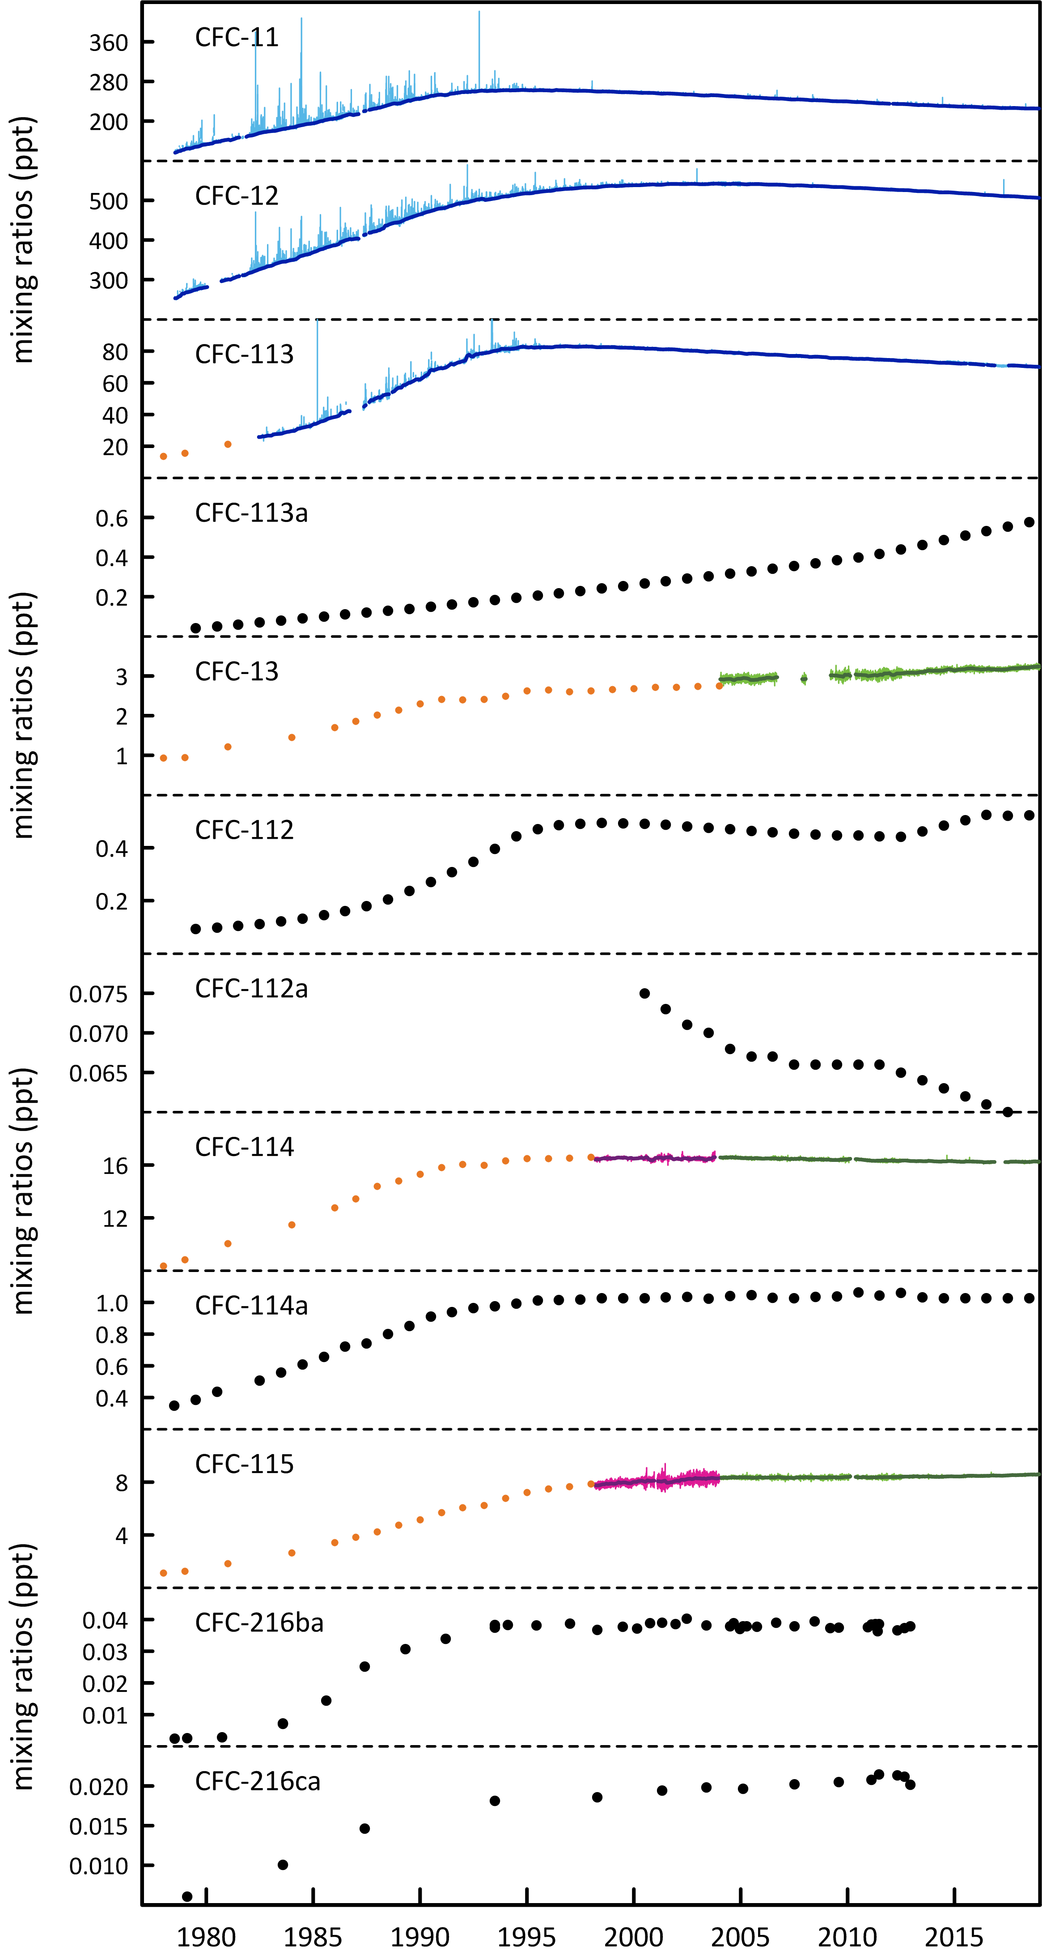

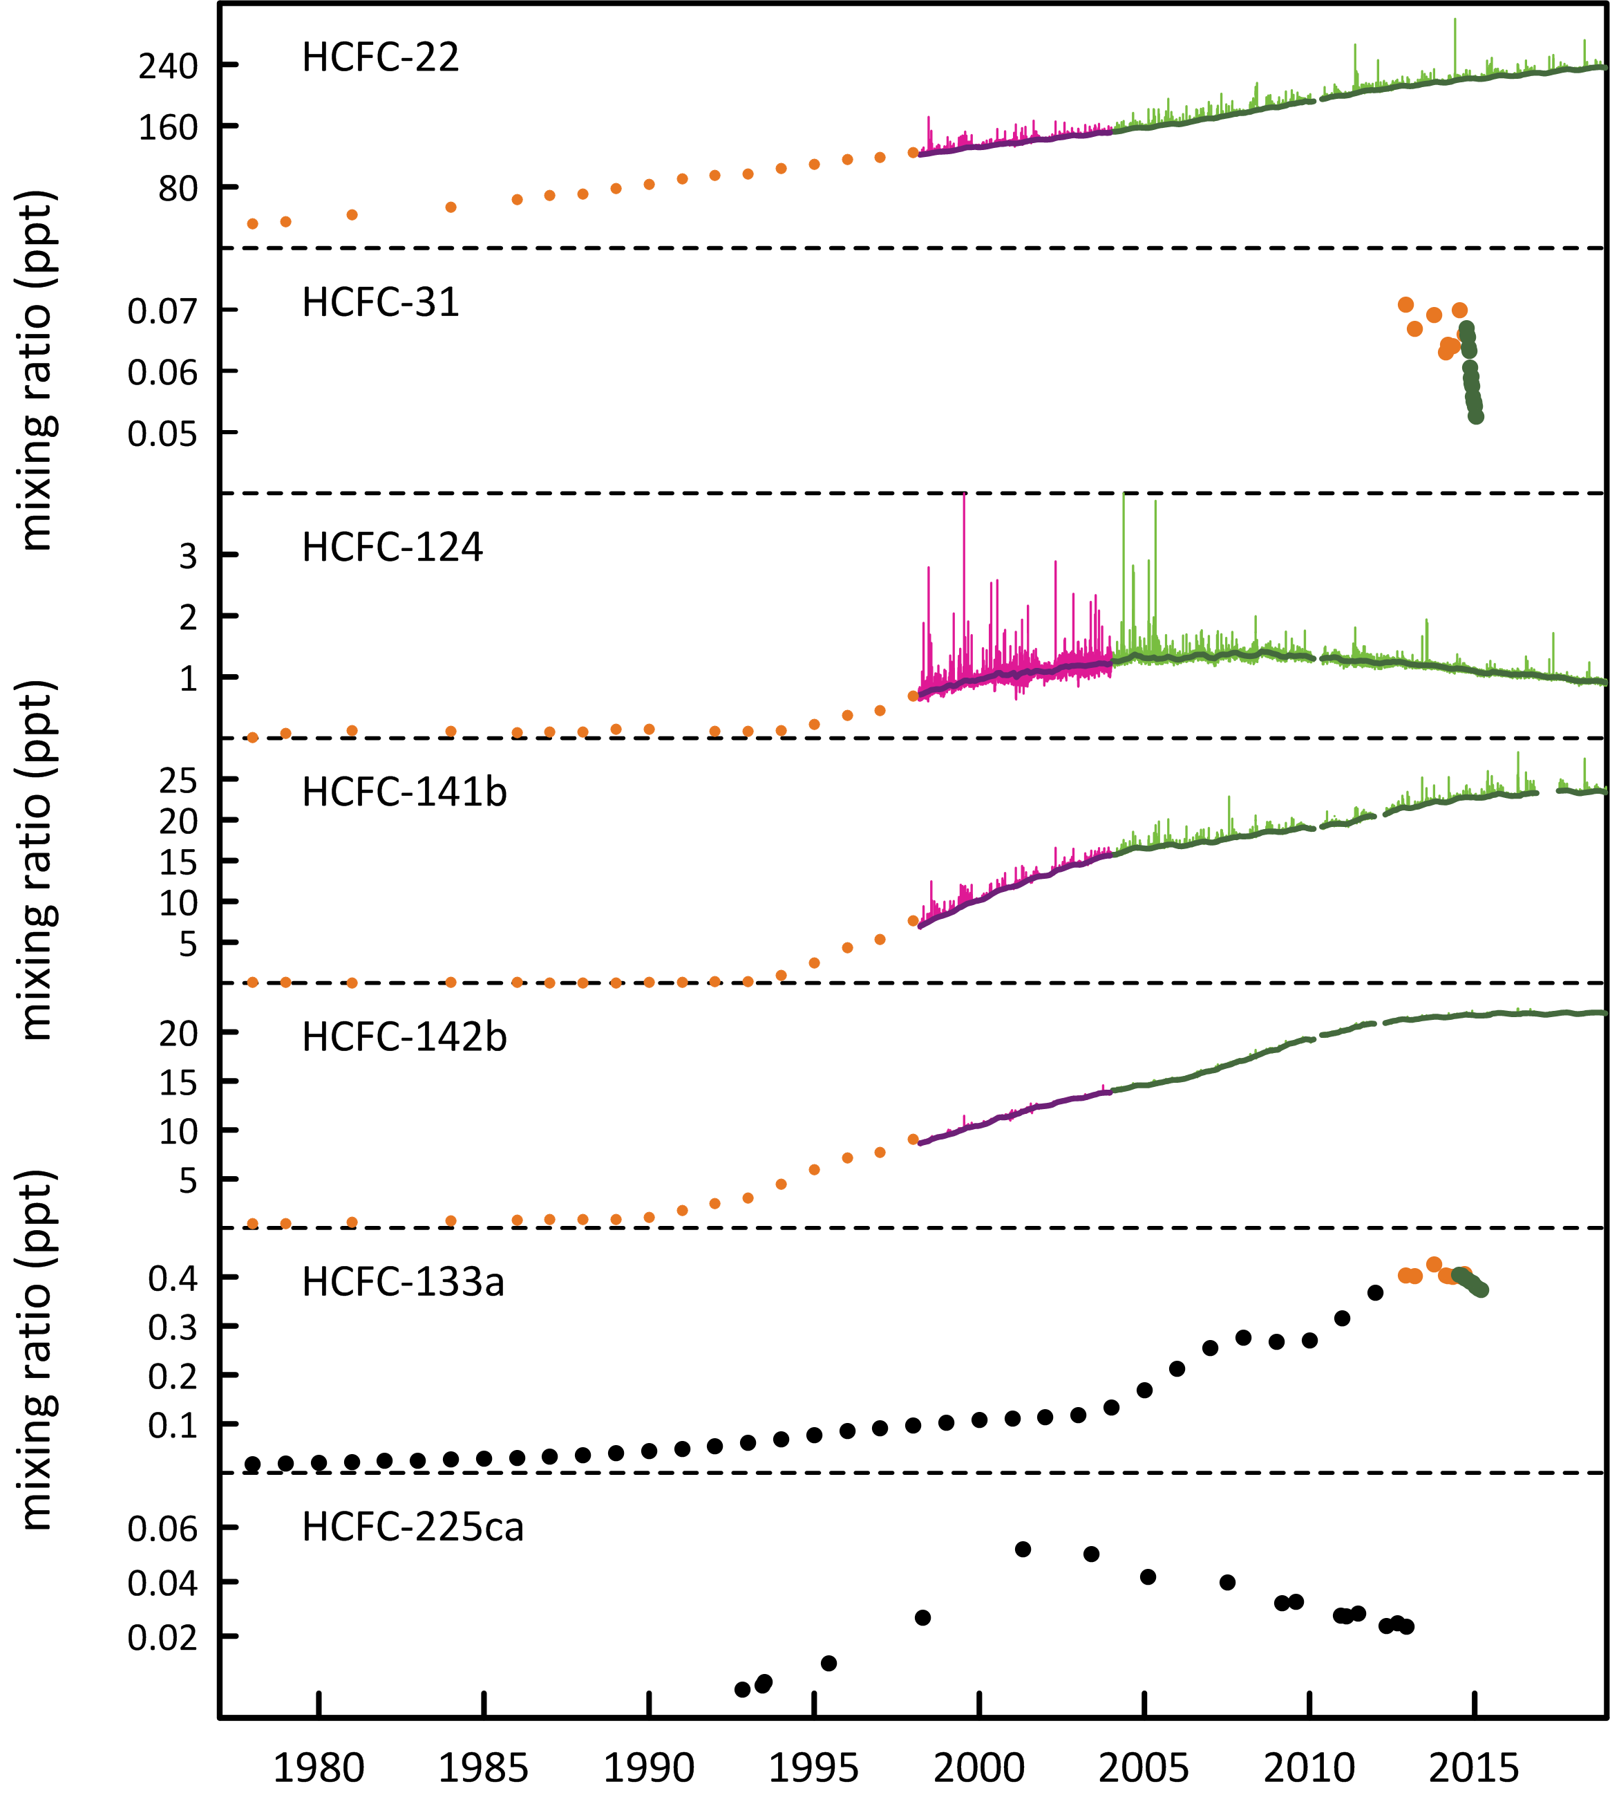

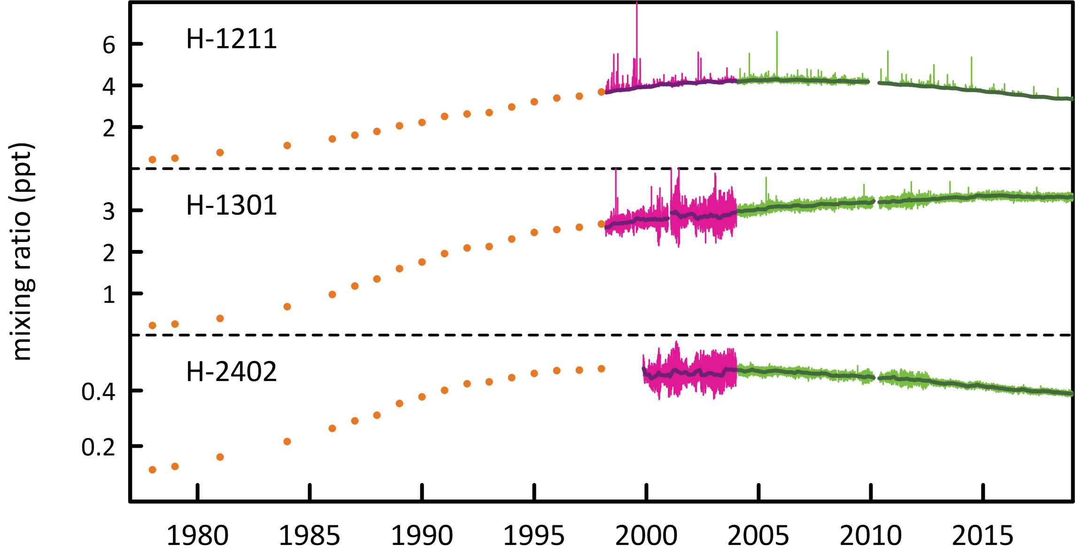

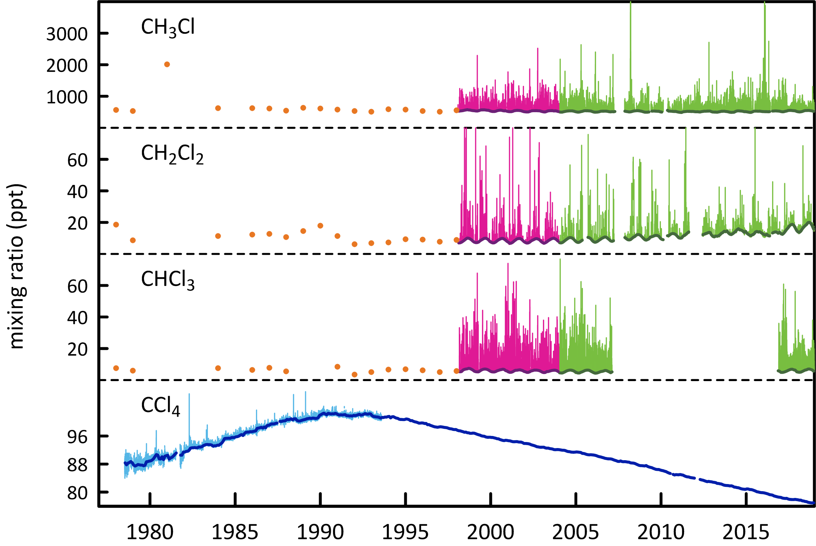

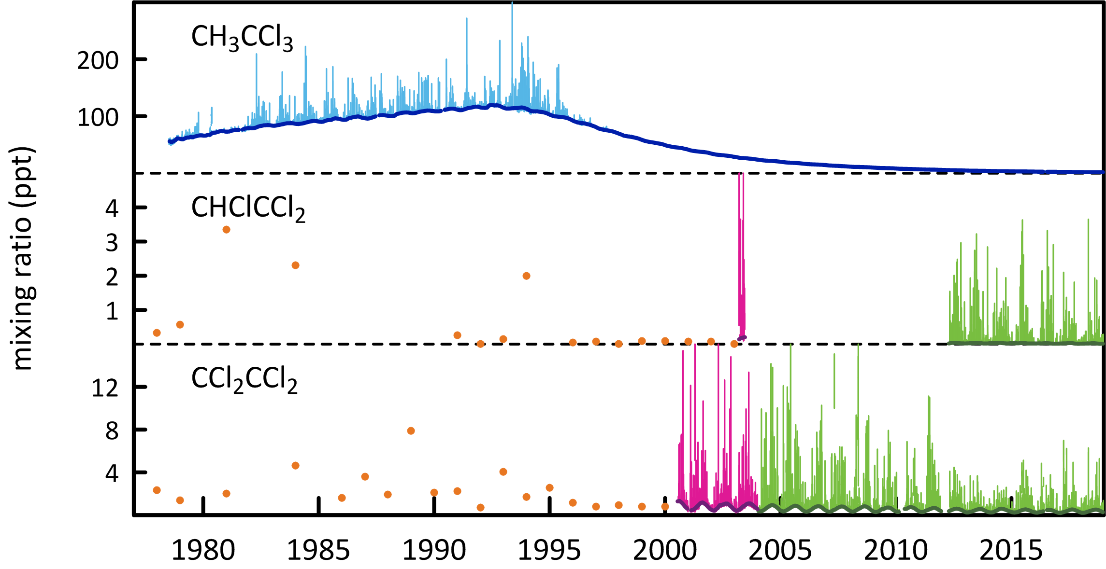

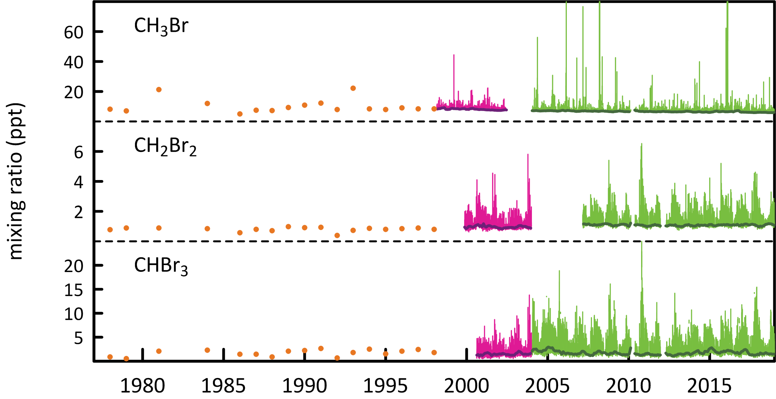

**Figure 1.** Cape Grim *in situ* and Air Archive observations of CFCs, HCFCs, halons, carbon tetrachloride, methyl chloroform, methyl chloride, dichloromethane, chloroform, TCE, PCE, methyl bromide, dibromomethaneand bromoform (1978 – 2018) showing baseline monthly mean data (Medusa - dark green; ADS - purple; ECD – dark blue; Archive data – orange) and total data (Medusa - light green; ADS – pink; ECD – light blue) obtained from the GC-MS-Medusa, GC-MS-ADS and GC-ECD instruments at Cape Grim and Aspendale. The CFC-112, -112a, -113a, -216ba, -216ca and HCFC-133a data are from UEA and Empa measurements on the Cape Grim Air Archive (see text above and CSIRO unpublished data).

## 

## CFCs

CFC-11 and CFC-12 are the dominant CFCs in the atmosphere, constituting 88% of all CFCs in 2018. CFC-113, CFC-114 and CFC-115 constitute 11% of CFCs, the remaining minor CFCs about 1%. The CFCs account for 62% of chlorine from all ODSs in the background atmosphere.

As a result of measures undertaken within the Montreal Protocol framework, the majority of the CFCs (CFC-11, CFC-12, CFC-112a and CFC-113) measured in the atmosphere in 2018 at Cape Grim have stopped growing or are in decline, the exceptions being CFC-112, CFC‐13, CFC-113a, CFC-114 and CFC‐115, which are growing slowly. Total CFCs measured in the atmosphere are declining by 0.5% per year due to declining emissions (see below); chlorine from CFCs in the atmosphere decreased by 9.3 ppt (2017-2018, 0.5%) slightly less than the decline in 2016-2017.

The summed concentration of the minor CFCs (CFC-112, CFC-112a, CFC-113a, CFC-216ba and CFC-216ca; Kloss *et al.*, 2014, Laube *et al.*, 2014) in 2017 is likely only ~1 ppt, while the total CFCs in the background atmosphere sum to 835 ppt in 2018. The summed growth of these minor CFCs in the atmosphere is 0.02 ppt/yr. These low abundance CFCs are thought to be used as chemical feedstocks, or produced as by-products, with some fugitive emissions, or used as specialised solvents (Kloss *et al.*, 2014, Laube *et al.*, 2014).

Global concentrations of the major CFCs (CFC-11, CFC-12, CFC-113) are all in decline (Figure 2). However, the rate of decline of global CFC-11 concentrations has slowed down from -1.67 ppt/yr (2012-2013) to -0.9 ppt/yr (2017-2018). This slow down in the decline of CFC-11 has been attributed to east Asian, specifically east China, emissions from new, likely illegal production of CFC-11 (Montzka *et al*., 2018; Rigby *et al*., 2019). The rate of decline for CFC-12 has increased slightly from, -2.79 ppt/yr (2012-2013) to -3.0 ppt/yr (2017-2018). The growth rate for CFC-113 has decreased slightly from -0.59 ppt/yr (2012-2013) to -0.55 ppt/yr (2017-2018).

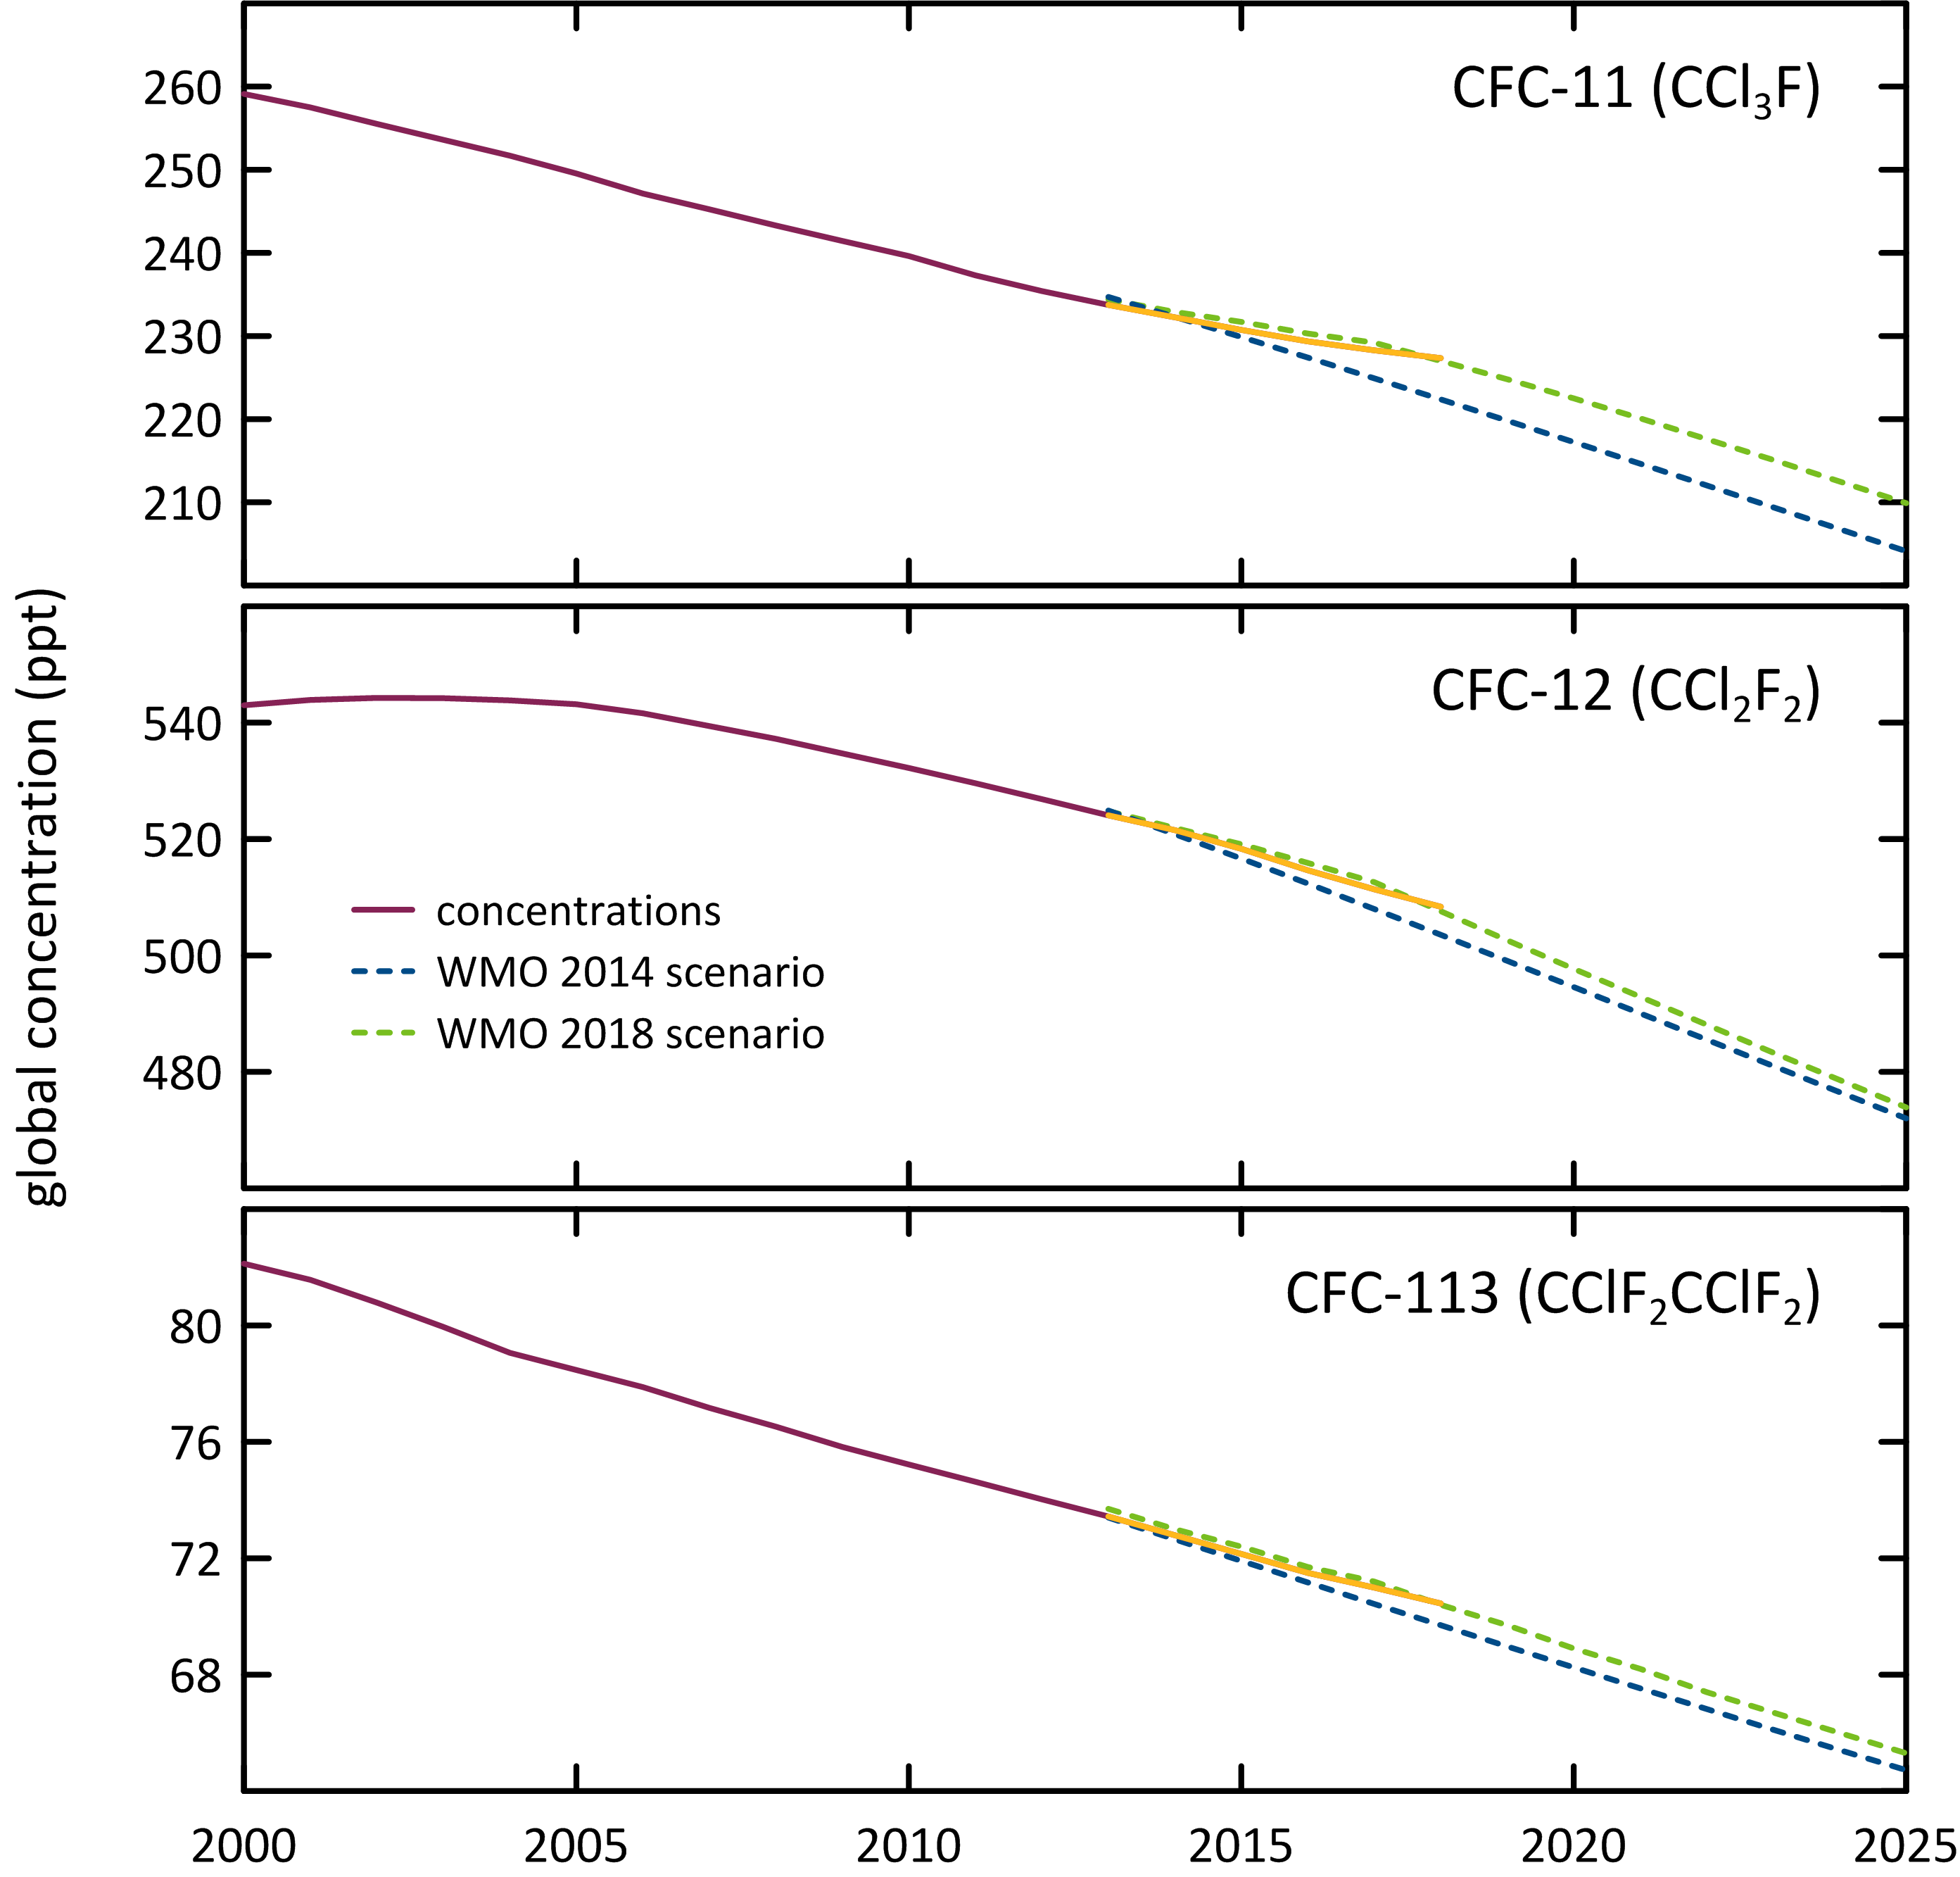

**Figure 2.** Global concentrations of CFC-11, CFC-12 and CFC-113 (ppt) and WMO A1 scenarios (dashed lines; Harris and Wuebbles, 2014; Carpenter and Daniel, 2018).

## HCFCs

The major HCFCs measured in the atmosphere in 2018 at Cape Grim are HCFC-22, HCFC-141b and HCFC-142b. HCFC-22 is currently growing at 1.5% per year. The growth rate for HCFC-22 has been declining since around 2010. HCFC-142b is currently growing at 0.19% per year and its growth rate has also been declining since 2010. HCFC-141b is declining by 0.65% per year. The dominant HCFC is HCFC-22 (234.8 ppt in 2018), 83% of the abundance and 99% of the growth of all HCFCs. HCFC-141b and HCFC-142b constitute 16% of HCFCs, the remaining minor HCFCs close to 1%. The growth rate of total HCFCs is slowing down. Total HCFCs increased by 3.4 ppt or 1.2% per year (2017-2018) compared to 1.5% per year (2016-2017). Chlorine in the atmosphere from HCFCs (305 ppt in 2018, 9.6% of total chlorine from all ODSs) increased by 3.3 ppt (1.1%, 2017-2018), the only ODS sector showing an increase in chlorine (apart from dichloromethane and chloroform, see below).

HCFC-31 was identified in the Cape Grim Air Archive (Laube *et al*., 2014; Schoenenberger *et al*., 2015; Vollmer *et al*., 2015) in 2015. The background concentration of HCFC-31 is low (0.06 ppt in 2015). HCFC-133a was also identified in the Cape Grim Air Archive and is now measured routinely at Cape Grim, with a background concentration of 0.44 ppt in 2018). There are no clearly identified sources of these HCFCs, but it is possible they are emitted to the atmosphere from an inadvertent by-product emission (Laube *et al*., 2014; Schoenenberger *et al*., 2015; Vollmer *et al*., 2015). It has been suggested that there may have been a change in the industrial processes that result in their release to the atmosphere (Schoenenberger *et al*., 2015; Vollmer *et al*., 2015).

Measurements of HCFC-132b commenced at Cape Grim in July 2014. The 2018 annual mean HCFC-132b concentration was 0.10 ppt, increasing by 10.6%/yr (2017-2018). HCFC-123 (CHCl2CF3) was measured *in situ* at Cape Grim from 1998 to 2004 on the GC-MS-ADS instrument (Krummel *et al*., 2006). The 2004 annual mean was 0.064 ppt increasing by 0.003 ppt per year. At this rate of increase, current HCFC-123 concentrations at Cape Grim would be less than 0.1 ppt. HCFC‑123 is not measured on the current GC-MS-Medusa instrument at Cape Grim.

Global concentrations of the most abundant HCFC, HCFC-22, continue to grow in the atmosphere (Figure 3), however the rate of increase has declined every year since 2008. The growth rate for HCFC-22 has slowed down from 8.62 ppt/yr (2007-2008) to 2.97 ppt/yr (2017-2018). The growth rate for HCFC-141b decreased from 1.08 ppt/yr (2011-2012) to 0.16 ppt/yr (2017-2018) and concentrations appear to have begun a decline. This will be reviewed in the next report in this series. The growth rate for HCFC-142b has also declined substantially from 1.17 ppt/yr (2006-2007) to -0.007 ppt/yr (2017-2018) and concentrations for HCFC-142b also appear to have begun a decline. This will also need to be reviewed in the next report in this series. The concentrations of all three HCFCs deviate from the WMO 2014 A1 scenario (Figure 3) and are much lower than the A1 scenario from around 2013 onwards. This scenario assumed that after 2012, all Article 5 countries would continue producing HCFCs at the maximum level allowed under the Montreal Protocol (Engel and Rigby, 2018). All three HCFCs track well with the more recent WMO 2018 scenarios (Figure 3).

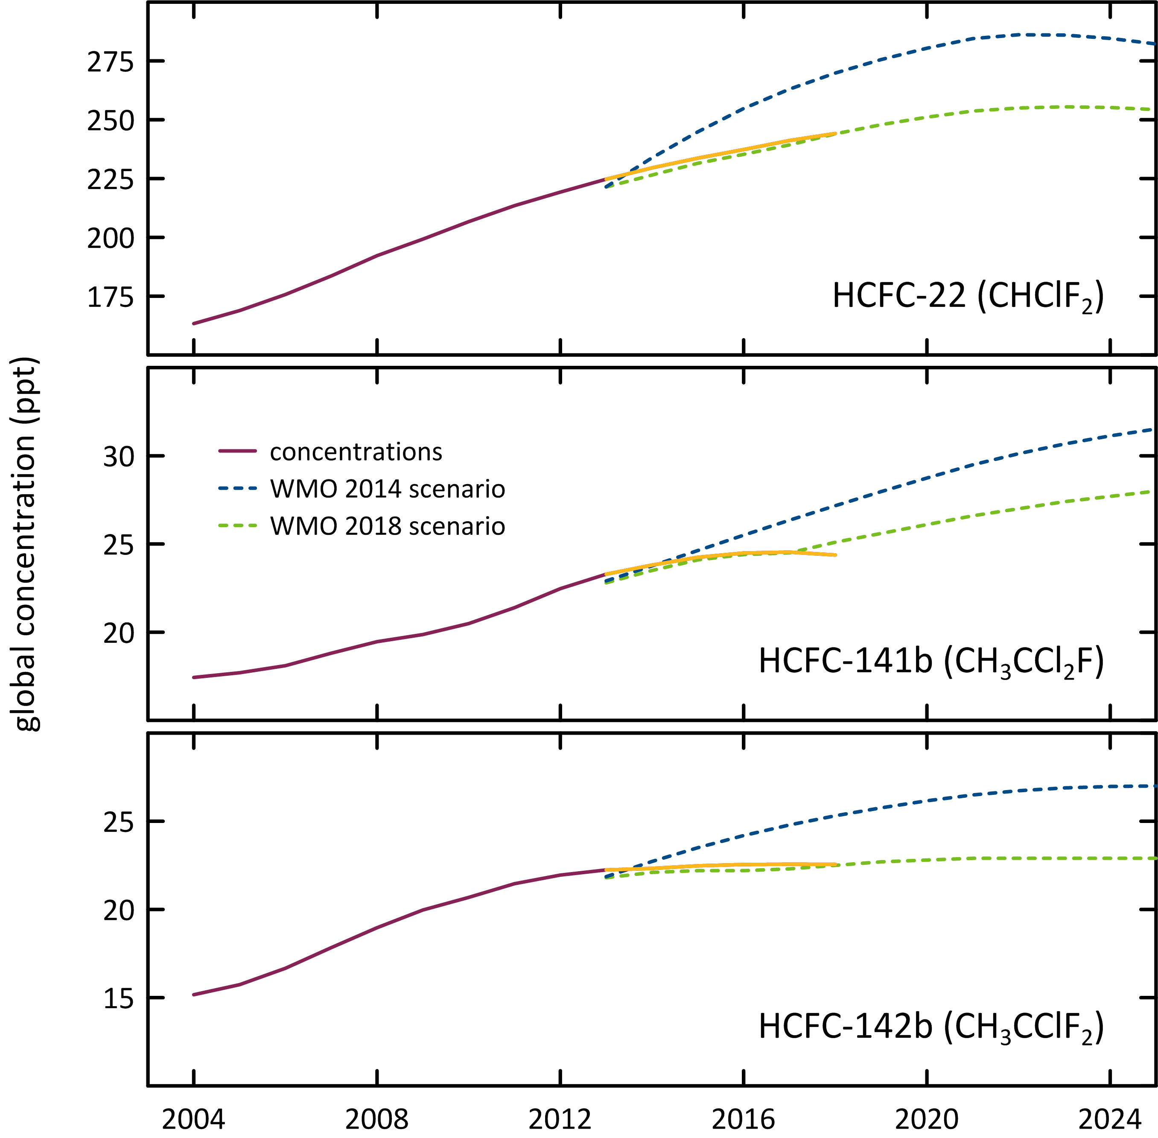

**Figure 3.** Global concentrations of HCFC-22, HCFC-141b and HCFC-142b (ppt) and WMO A1 scenarios (dashed lines; Harris and Wuebbles, 2014; Carpenter and Daniel, 2018).

## Other Chlorocarbons ODSs

The most abundant chlorocarbon in the background atmosphere is the largely naturally-occurring methyl chloride (CH3Cl, 530.4 ppt, 2018), accounting for 84% of all chlorocarbons and 59% of chlorine from chlorocarbons. The next most abundant chlorocarbon is anthropogenic carbon tetrachloride (77.3 ppt, 2018), accounting for 35% of chlorine from chlorocarbons. The remaining minor chlorocarbons, including methyl chloroform, contribute 6% of chlorocarbon chlorine. The chlorocarbons account for 28% of total chlorine from all ODSs in the background atmosphere.

Carbon tetrachloride, methyl chloroform, methyl chloride and trichloroethylene measured at Cape Grim showed decreasing concentrations in 2018 compared to 2017, whereas dichloromethane, chloroform, and perchloroethylene all showed increasing concentrations. The largest decrease in the chlorocarbons was 0.31 ppt (15%) for methyl chloroform and the largest increase in the chlorocarbons was 1.2 ppt (7.4%) for dichloromethane. Significant inter-annual variability is expected for naturally-emitted methyl chloride and chloroform, which have oceanic and biomass burning sources. Total chlorine from chlorocarbons decreased by 3.1 ppt (0.3%).

The dichloromethane growth rate has decreased substantially since the last report (3.0 ppt/yr, 20%/yr; 2016-2017), down to (1.2 ppt/yr, 7.4%/yr 2017-2018). Two recent papers (Hossaini *et al*., 2017 and Oram *et al*., 2017) have shown that globally dichloromethane is increasing rapidly in the atmosphere. However, the recent Ozone Assessment (Engel and Rigby, 2018 ) showed recent (2015 to 2016) global growth rates have declined and are small compared to previous years. Engel and Rigby, 2018 concluded that currently it can’t be determined whether the recent decrease in growth rate reflects a stabilization of emissions or reflects the large atmospheric variability.

The rate of decline of methyl chloroform is consistent with its relatively short atmospheric lifetime and near-zero global emissions, whereas the rate of decline of carbon tetrachloride in the atmosphere suggests there are remaining, significant carbon tetrachloride sources outside the control of the Montreal Protocol (Fraser *et al*., 2014; Liang *et al*., 2016).

## Halons

H-1211 is the most abundant halon in the background atmosphere (3.4 ppt, 2018), followed by H-1301 (3.3 ppt) and H-2402 (0.4 ppt). H-1211 and H-2402 are in decline in the atmosphere (-0.08 ppt/yr and -0.006 ppt/yr respectively, 2017-2018). H-1301 growth rates were reported as being negative in the previous report (-0.01 ppt/yr; 2016-2017), have now increased to 0.002 ppt/yr 2017-2018. Overall halons are in decline by 1.2% per year (compared to 1.7%/yr 2016-2017), a larger rate of decline (in percentage terms) compared to the CFCs. Bromine in the atmosphere from halons decreased by 0.09 ppt/yr (1.2%), which equates to about a 5 ppt/yr decline in equivalent chlorine. This is a significant decline – chlorine from CFCs is declining currently by 7.8 ppt/yr. The decline in bromine from halons is a significant driver of likely ozone recovery (see Krummel *et al*., 2016).

## Other organobromine species

Methyl bromide is the most abundant (6.0 ppt) organobromine ODS in the background atmosphere in 2018, followed by H-1211 (3.4 ppt), H-1301 (3.3 ppt), bromoform (1.6 ppt) and dibromomethane (1.1 ppt).

Methyl Bromide showed a small decrease (0.07 ppt/yr 2017-2018) compared to the previous years decrease (0.6 ppt/yr 2016-2017) in the background atmosphere. There is an overall long-term decrease in methyl bromide in the atmosphere since about 2000, which briefly halted in 2012-2013 and 2014-2015. Because there are significant natural emissions of methyl bromide, year-to-year variability in the rate of decline or growth is expected.

Natural bromoform showed a decrease (0.21 ppt/yr) and natural dibromomethane also showed a small decrease (0.009 ppt/yr) in 2017-2018. Overall bromine from all non-halon ODSs decreased by 0.73 ppt/yr (2017-2018), a 5.5%/yr decrease, largely due to the decrease in bromine from bromoform and methyl bromide. This is the third year in a row that background levels of bromoform have decreased. In 2014-2015, bromoform was at its highest concentration for the last decade. Significant inter-annual variability is expected for naturally emitted dibromomethane and bromoform, which have oceanic sources. Long-term trends (decadal) have not been found for these species (Carpenter and Reimann, 2014).

## Total chlorine and bromine: impact on stratospheric ozone

Total chlorine from ODSs (Figure 4) decreased from 3171 ppt in 2017 to 3163 ppt in 2018, a decrease of 7.8 ppt (0.25%). This total is also 10% lower than its peak value in 1994. Total chlorine from chlorocarbons decreased by 3.1 ppt (0.3%). The overall decline in chlorine from CFCs was 7.8 ppt (2017-2018) and HCFC chlorine increased by 3.3 ppt.

|  |  |
| --- | --- |
| Figure 4 shows total chlorine from chlorine-containing ozone depleting substances from 1980 to 2018 as measured at Cape Grim. It shows an increase in total chlorine until 1995 and then a gradual decrease. | **Figure 4.** Total chlorine from CFCs, HCFCs, carbon tetrachloride: CCl4, methyl chloroform: CH3CCl3 and other chlorine-containing ODSs (Table 1) as measured at Cape Grim. |

Total bromine from organobromine ODSs (Figure 5) was 20.4 ppt (2018) - 36% from halons, 29% from methyl bromide, 24% bromoform and 11% dibromomethane. Bromine from all ODSs decreased by 0.82 ppt (2017-2018, 3.9%), due to -0.09 ppt/yr from the halons and -0.73 ppt/yr from the non-halon ODSs. The variability in total bromine compared to total chlorine is due to the relatively larger natural (therefore variable) contributions to bromine compared to chlorine.

|  |  |
| --- | --- |
| Figure 5 is a graph showing total bromine from bromine containing ozone depleting substances from 1980 to 2018 as measured at Cape Grim. It shows an increase in total bromine until around 2000 and then a gradual decrease. | **Figure 5.** Total bromine from methyl bromide: CH3Br, halons and other bromine-containing ODSs (dibromomethane - CH2Br2 and bromoform - CHBr3) as measured at Cape Grim (Table 1). |

The impact of total chlorine and bromine from ODSs on stratospheric ozone at polar and mid-latitudes is discussed in detail in the companion Report on the 2018 Antarctic Ozone Hole (Krummel *et al*., 2019). Figure 6 shows the strong correlation between ozone depletion over Antarctica (Halley Station) and at mid-latitudes in the Southern Hemisphere (Melbourne). In both regions there is a strong indication of the onset of significant ozone recovery.

o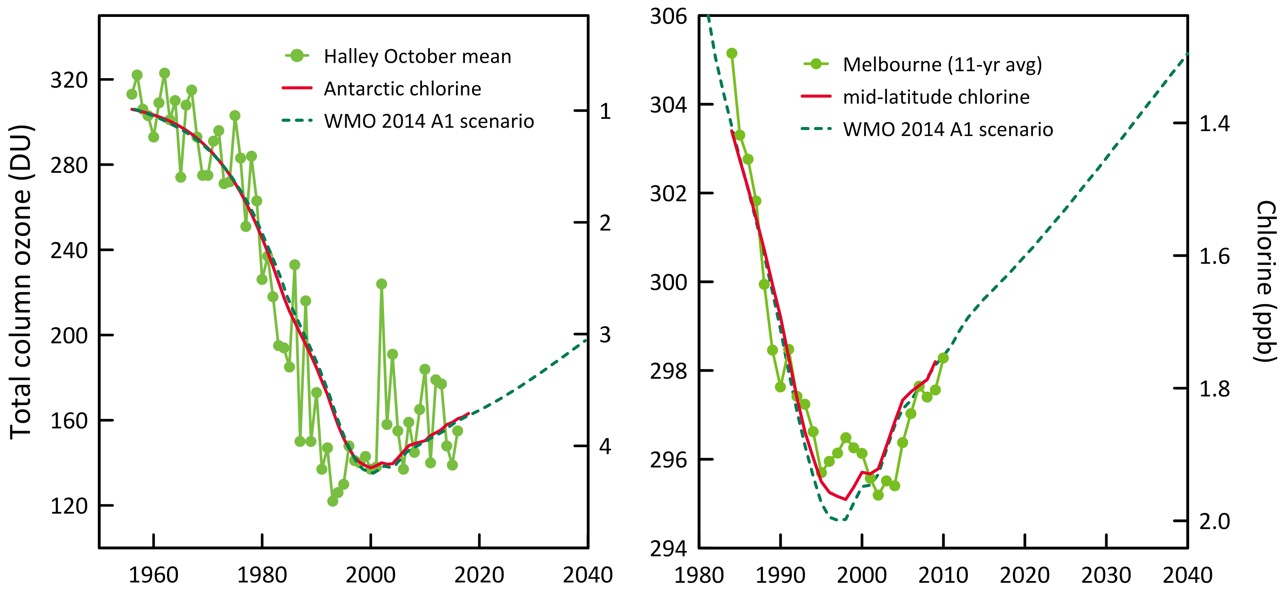

**Figure 6.** Total column ozone (DU) changes at Halley Station, Antarctica (76oS), and Melbourne, Australia (38oS) and Equivalent Effective Stratospheric Chlorine (EESC, ppb) changes at polar and mid-latitudes. The Melbourne ozone data are 11-year running means to minimize impacts of solar variability.

## Global radiative forcing from ODSs, HFCs and other SGGs

ODSs and other synthetic greenhouse gases (SGGs, for example hydrofluorocarbons – HFCs) make a significant contribution to global radiative forcing (Figure 7). SGGs are the second most important driver of climate change after carbon dioxide since the 1950s. Radiative forcing from total SGGs almost stopped growing in the background atmosphere in the 1990s, due to the overall success of the Montreal Protocol, but recommenced growing in the 2000s due to growing global emissions of HFCs and growing emissions of HCFCs and lately CFCs in the developing world. Montreal Protocol HCFC controls will impact these emissions from the developing world (35% reduction by 2020). Global HFC emissions should also commence to be restrained now that the Kigali Amendment to the Montreal Protocol has entered into force (1st January 2019). The Kigali Amendment mandates a phase-down schedule for HFC production and consumption. Hopefully this will lead to another ‘plateau’ in radiative forcing from SGGs in the next 5-10 years.

Total radiative forcing due to SGGs is increasing by 0.5%/yr (2017-2018). Radiative forcing from CFCs contributes 67% of total SGG radiative forcing but is in decline by 0.5%/yr (2017-2018). HCFCs currently contribute 16% of SGG radiative forcing and the HCFC contribution is increasing by 1%/yr (2017-2018). The remaining ODSs (halons, chlorocarbons) currently contribute 4% of SGG radiative forcing but is in decline by 1.3%/yr (2017-2018).

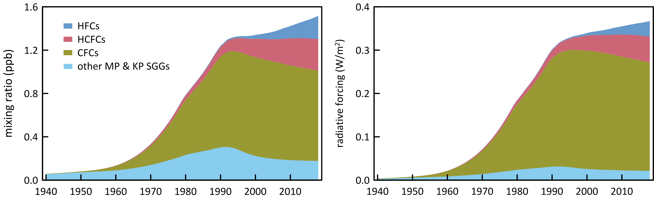

**Figure 7.** Global abundance (ppb, left) and radiative forcing (W/m2, right) of synthetic greenhouse gases (SGGs: HFCs, HCFCs, CFCs, others).

# Global emissions of ODSs

Background ODS observations at Cape Grim and from other AGAGE stations in the Northern and Southern Hemispheres have been used to calculate global ODS emissions up to 2017 (the data for 2017 is preliminary and may change with future updates) (Figure 8; Rigby *et al*., 2014 and updates; Vollmer *et al*., 2015). These emissions are derived using the AGAGE 12-box global model of atmospheric chemistry and transport (Rigby *et al*., 2013) and a Bayesian inverse method based on Rigby *et al*. (2011, 2013). ODS emissions have been calculated for recently identified ODSs in the Cape Grim Air Archive using forward modelling in a 2-D atmospheric chemistry-transport model (Laube *et al*., 2014; Kloss *et al*., 2014) and Bayesian inverse modelling based using the FLEXPART dispersion model (Laube *et al*., 2014; Kloss *et al*., 2014; Rigby *et al*., 2014 and updates; Schoenenberger *et al*., 2015; Vollmer *et al*., 2015).

Total global CFC emissions are declining, dominated (90%) by emissions of CFC-11 and CFC-12, currently about 106 k tonnes/yr (2015-2017) (Rigby *et al*., 2014 and updates). Since the peak emissions of CFCs in the late 1980s (1128 k tonnes, 1987), overall CFC emissions have declined by 8%/yr, attesting to the success of the Montreal Protocol controls on CFC production and consumption. Two recent papers, Montzka *et al*., 2018 and Rigby *et al*., 2019, found an unexpected increase in global emissions of CFC-11. The conclusions from both studies suggest that the increase is probably not related to existing banks of CFC-11 but rather new production and uses in east Asia, predominantly east China. Global CFC-11 emissions from Rigby *et al*., 2019 75 k tonnes/yr (2014-2017) represent a rise of 11 ktonnes/yr above the 2008-2012 period.

Global emissions of CFC-12 have declined substantially since its peak in the 1980s, and emissions continue to decline. Since the peak emissions of CFC-12 in the late 1980s (513 k tonnes, 1988), CFC-12 emissions have declined by 94% (10%/yr). Current global CFC-12 emissions are about 34 ktonnes/yr (2015-2017) (Rigby *et al*., 2014 and updates).

The emissions of the other CFCs (CFC-113, -114, -115), including the minor CFCs, increased from a total of 11.1 k tonnes in 2016 to 11.9 k tonnes in 2017. All of the increase is due to emissions of CFC-113 and CFC-115.

Global carbon tetrachloride emissions average around 35 k tonnes/yr from 2015-2017 (Engel and Rigby, 2018). Long-term, global carbon tetrachloride emissions have declined slowly from a peak of around 120 k tonnes/yr in the late 1970s, declining to 50 k tonnes/yr by 2005, a long-term decline of about 3%/yr. Since 2005 global carbon tetrachloride emissions have fluctuated between increases and decreases but overall have declined steadily by about 1-2 k tonne per year (3%/yr) until 2017. The decline in global carbon tetrachloride emissions is not as rapid as anticipated under the Montreal Protocol (Montzka and Reimann, 2011; Carpenter and Reimann, 2014; Lunt *et al*., 2018). A partial explanation may be that global emissions of carbon tetrachloride from land-fills and chlor-alkali plants may be significant, and not yet accounted for, in global budgets (Fraser *et al*., 2014; Hu *et al*., 2016, Liang *et al*., 2016).

|  |  |
| --- | --- |
| Figure 8 has five graphs showing the global annual emissions of ozone depleting substances from 1980 and 2018 in mega tonnes.  The trend in emissions decreases for all ozone depleting substances except for hydrochlorofluorocarbons. | **Figure 8.** Global annual emissions (M tonnes) of ODSs (CFCs, chlorinated solvents (methyl chloroform: CH3CCl3, carbon tetrachloride: CCl4), methyl chloride, dichloromethane, chloroform, halons, methyl bromide: CH3Br, HCFCs) derived from global AGAGE data by inverse modelling using the 12-box AGAGE global transport model, by forward modelling using a 2-D atmospheric chemistry-transport model and by Bayesian inverse modelling using the FLEXPART dispersion model. For methyl bromide, pre-1998 emissions are scaled from global atmospheric concentrations. |

Global methyl chloroform emissions peaked in 1990 at 669 k tonnes. Emissions have declined almost every year since, with a small increase in 2008 (8.1 k tonnes) then declining significantly to 2.3 k tonnes in 2017. Over the past 5 years (2013-2017) global emissions have averaged 2.2 k tonnes/yr. The long term decline in methyl chloroform emissions is in excess of 20%/yr, which is about what is expected for an ODS with low (~zero) emissions and an atmospheric lifetime of about 5 years.

Global HCFC emissions peaked in 2010 (488 k tonnes) and have since declined (6%) to 460 k tonnes in 2017, a decline of about 1%/yr. The decline in emissions since 2010 is encouraging in relation to the overall long-term decline in ODSs that will bring about, possibly hasten, ozone layer recovery. Throughout the period from the late-1970s to 2010, total HCFC emissions increased by about 4%/yr. HCFC-22 emissions peaked in 2010 at 386 k tonnes declining (0.7%/yr) to 372 k tonnes in 2017; HCFC-141b: 68 k tonnes (2012) to 58 k tonnes (4%/yr, 2017); HCFC-142b: 39 k tonnes (2008) to 24.5 k tonnes (6%/yr, 2017). Declining HCFC emissions cause the observed slowing of the recent HCFC concentration growth rates in the atmosphere (see Section 2.2). HCFC concentrations appear to have peaked and have started to decline.

Data on halon emissions are now available back to the 1970s, based on AGAGE *in situ* and Cape Grim Air Archive data (Vollmer *et al*., 2016). Total global halon emissions continue to decline (6.9 k tonnes in 2012, 4.9 k tonnes in 2017), dominated (~70%) by halon-1211 emissions, which declined by 1.2 k tonnes over the same period. Peak total halon emissions (18 k tonnes) occurred in 1990 and have declined to 4.9 k tonnes in 2017 (~5%/yr; H-1211: 4.5%/yr, H-1301: 5.5%/yr, H-2402: 6%/yr).

Global methyl bromide emissions have been estimated from AGAGE data, including Cape Grim (Rigby *et al*., 2014) and these have only been updated to 2016. The emission estimates start in 2000 (196 k tonnes), declining steadily to 141 k tonnes in 2016, a long-term decline of about 1.5% per year. Methyl bromide emissions from 2013-2016 are fairly steady, ranging from 137-141 ktonnes suggesting the long-term decline in methyl bromide emissions may have levelled off in line with developing country phase-out in 2015.

The total ODS global emissions for the Montreal Protocol ODSs (CFCs, HCFCs, halons, methyl chloroform, carbon tetrachloride and methyl bromide) in ODP tonnes are shown in Figure 9, together with the global atmospheric concentration data for these species expressed as equivalent chlorine. The combined global emissions of the Montreal Protocol ODSs peaked at 1460 k tonnes in the late 1980s, declining, thanks to the Montreal Protocol restrictions on ODS production and consumption, at 10% per year from 1990 to 2000 and then 3% per year from 2000 to 2017, to reach 290 tonnes in 2017. Note the significant contribution of methyl bromide to global emissions in, for example, 2016 (~30%), most (96% in Australia in 2016, see below) of which is from QPS consumption (not controlled by the Montreal Protocol). At peak ODS emissions in the late 1980s, methyl bromide contributed only 7%.

The total global concentrations of ODSs, expressed as equivalent chlorine (Figure 9), peaked later in the mid-1990s at 4135 ppt (4.14 ppb) declining slowly (24 ppt per year) to 3.6 ppb by 2017, resulting largely from the long (50-100+ years) lifetimes for carbon tetrachloride and CFCs in the atmosphere.

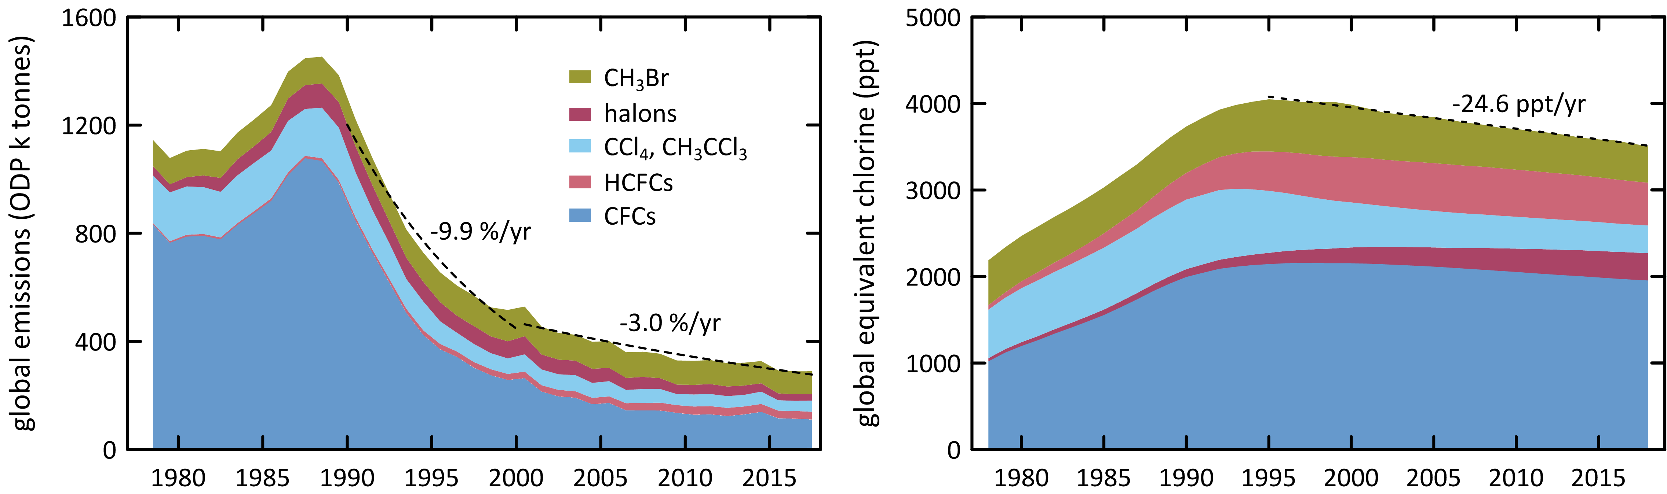

**Figure 9**. Global emissions (ODP tonnes) of the Montreal Protocol ODSs and global equivalent chlorine (ppt), both derived from AGAGE data (Fraser *et al*., 2014a; Rigby *et al*., 2014 and subsequent updates) using the 12-box AGAGE model. For methyl bromide, pre-1998 emissions are scaled to post-1998 from global atmospheric concentrations, 1978-2018.

# Australian ODS imports and banks

Data on Australian imports of ODSs are reported to the Australian Government (Department of Agriculture, Water and the Environment - DAWE) under licensing arrangements in the *Ozone Protection and Synthetic Greenhouse Gas Management Act, 1989*, with the requirement being established under the Act in 1989. Australian imports are documented in the DAWE *Ozone Licensing and Reporting System* (OLaRS: A. Gabriel, AWE, private communications, 2014-2017), which was introduced during 2011, replacing previous import data recording systems. OLaRS details imports of bulk and pre-charged refrigeration and air conditioning equipment containing HCFCs (individual HCFCs or HCFC blends) and other bulk ODSs (in particular carbon tetrachloride and methyl bromide).

For 2012 – 2018 (January – December) imports are reported entirely via the OLaRS protocol. Methyl bromide data were reported separately up until 2015, but are now incorporated into OLaRS. For 2008-2010, the ODS imports are reported using the pre-OLaRS protocol. Imports of ODSs are shown in Table 2 and Figure 10.

There is an overall decline in Australian ODS imports from over 15,000 tonnes in 1991 to 790 tonnes in 2018, a long-term decline of about 250 tonnes per year since 1995. ODS imports in 2018 decreased by 157 tonnes from the previous year to 790 tonnes, due to methyl bromide imports reducing from 915 tonnes (2017) to 742 tonnes (2018), for all applications.

In 1991, CFCs were the major ODS imports (7,144 tonnes), but they declined rapidly to 371 tonnes by 1996, an overall decline of about 50% per year as a result of the phase-out by the Montreal Protocol, except for a few essential uses. By 2003 CFC imports were virtually zero. Methyl chloroform (MC) was the second largest ODS import in 1991 (4,700 tonnes) but imports ceased by 1996. HCFCs imports nearly doubled between 1991 (2,400 tonnes) and 1998 (4,200 tonnes); since 1998 there has been a long term decline in HCFC imports, falling to 45 tonnes per year from 2016-2018. Australia has reached its second last step in its HCFC phase out, with an annual import limit for HCFCs of 45 tonnes from 2016 to 2029 (DoEE, 2016)

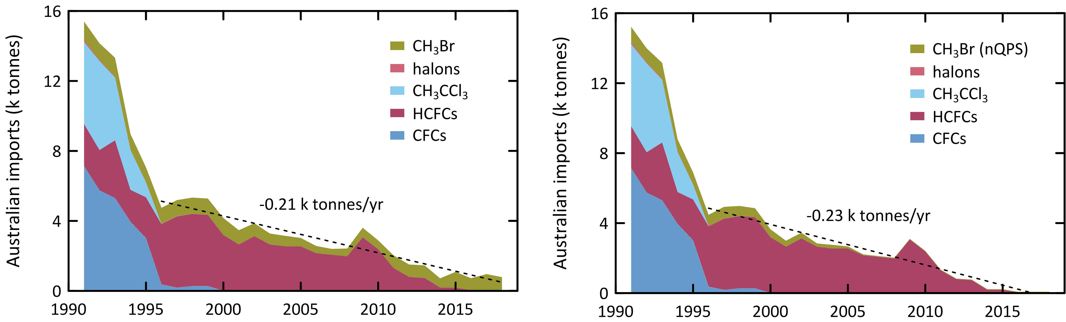

**Figure 10.** Australian imports (tonnes) of ODSs (CFCs, HCFCs, halons, MC: CH3CCl3, MB: CH3Br – total left, MB: CH3Br – nQPS right) (A. Gabriel, AWE, private communication, 2019). The 2012-2018 data are from the OLaRS data base, 2010 and earlier are pre-OLaRS data, and 2011 is a mixture of OLaRS and pre-OlaRS data.

Methyl bromide (MB) imports were just over 1,000 tonnes per year in the early 1990s, falling to about 350 tonnes in 2007, a long-term decline of 8% per year, due in part to declining non-QPS methyl bromide use and also a decline in QPS use (possibly due to reduced grain production as a result of the severe drought in SE Australia) (Note: MB values used here are imports – exports). After 2007, methyl bromide imports increased and by 2011 had reached over 720 tonnes, twice as large as the 2007 imports. Since 2011, imports have declined again to 519 tonnes in 2014, rising to 915 tonnes in 2017, the highest methyl bromide imports since 2000. Methyl bromide imports in 2018 dropped to 742 tonnes. The increase in methyl bromide imports since 2007 has been driven by an increase in QPS use of methyl bromide. Variations in QPS demand for methyl bromide in Australia will likely follow overall grain and wood products production trends, trading partner requirements and the use of methyl bromide alternatives (for example phosphine and sulfuryl fluoride). Grain production increased from about 20 M tonnes at the height of the recent drought (2006/2007) to 62 M tonnes in 2016/2017 and 42 M tonnes in 2017/2018 (ABARES, 2018a, ABARES, 2018b). Imports of methyl bromide for non-QPS use fell to 30-35 tonnes by the mid-2000s and have stayed at around 30 tonnes to 2018.

The Australian CFC bank (in operational refrigeration/air conditioning equipment) is now estimated to be less than 450 tonnes. The Australian HCFC-22 bank has been estimated at 13450 tonnes in 2007 with a projected decline to 2858 tonnes in 2018 (Brodribb and McCann, 2013). A more recent estimate (Brodribb and McCann, 2018) estimates the Australian HCFC-22 Bank at 5584 tonnes for 2018. The only other significant ODS bank in operational equipment is HCFC-123, with a bank of 2320 tonnes in 2003 with a projected decline to 311 tonnes in 2018 (Figure 11; Brodribb and McCann, 2013), this has now been updated to 198 tonnes in 2018 (Brodribb and McCann, 2018). The updated bank and bank emissions from Brodribb and McCann, 2018 are included in Figure 11 (dashed lines: burgundy=banks, black=bank emissions).

Australian HCFC-22 and HCFC-123 emissions have been estimated using refrigerant bank data and specific emission factors for refrigeration/air conditioning equipment (Figure 11; Brodribb and McCann, 2015a, 2018). HCFC-22 emissions have declined from 1320 tonnes in 2003 to 180 tonnes in 2018 (Brodribb and McCann, 2013). The emissions have been updated in Brodribb and McCann, 2018 and report Australian emissions of HFCF-22 for 2018 of 323 tonnes and HCFC-123 emissions of about 4 tonnes.

|  |  |
| --- | --- |
| Figure 11 is a graph showing Australia's bank of hydrochlorofluorocarbons from 2004 to 2018 in kilo tonnes.  It shows a decrease over time. | **Figure 11**. Australian HCFC-22 and HCFC-123 banks and HCFC-22 bank emissions (Brodribb and McCann, 2013, 2014, 2015a). Dashed line is from Brodribb and McCann, 2018: burgundy= banks, black=bank emissions. |

**Table 2.** Australian imports (bulk and pre-charged equipment, tonnes) of ODSs (CFCs, HCFCs, MC: CH3CCl3, halons, MB: CH3Br) 1992-2018; 2012-2018 data are from the OLaRS data base, 2010 and earlier are pre-OLaRS data, and 2011 is a mixture of OLaRS and pre-OlaRS data (A. Gabriel, DAWE, private communications, 2014-2016). The only significant carbon tetrachloride (CCl4) imports were ~0.5 tonnes in 1995/1996 (not listed). ODS imports less than 0.1 tonne are not listed, but included in total ODS. Methyl bromide imports are listed as for QPS and non-QPS uses. Small quantities of methyl bromide imports are exported (do not influence Australian emissions); significant quantities HCFC-123 imports are exported or used as feedstock (do not influence Australian emissions) – for example 10 tonnes exported and 3 tonnes used for feedstock in 2014, ~1 tonne exported 2015).

|  |  |  |  |  |  |  |  |  |  |  |  |  |  |  |  |  |  |  |  |  |  |  |  |  |  |  |  |  |
| --- | --- | --- | --- | --- | --- | --- | --- | --- | --- | --- | --- | --- | --- | --- | --- | --- | --- | --- | --- | --- | --- | --- | --- | --- | --- | --- | --- | --- |
|  | 1991 | 1992 | 1993 | 1994 | 1995 | 1996 | 1997 | 1998 | 1999 | 2000 | 2001 | 2002 | 2003 | 2004 | 2005 | 2006 | 2007 | 2008 | 2009 | 2010 | 2011 | 2012 | 2013 | 2014 | 2015 | 2016 | 2017 | 2018 |
| CFC-11 | 1759 | 1786 | 1443 | 927 | 498 | 69 | 52 | 90 | 90 |  |  |  | 1 |  |  |  |  |  |  |  |  |  |  |  |  |  |  |  |
| CFC-12 | 4049 | 3054 | 3205 | 2784 | 2229 | 181 | 129 | 182 | 182 | 8 | 8 | 8 |  |  |  |  |  |  |  |  |  |  |  |  | 0.0 |  | 0.0 |  |
| CFC-113 | 999 | 808 | 485 | 168 | 236 | 118 | 0.1 | 0.1 | 0.1 |  |  |  |  |  |  |  |  |  |  |  |  |  |  |  |  |  |  |  |
| CFC-114 | 6 | 19 | 6 | 11 | 7 | 3 | 3 | 3 | 3 | 1.4 | 1.4 | 1.5 |  |  |  |  |  |  |  |  |  |  |  |  |  |  |  |  |
| CFC-115 | 331 | 84 | 172 | 64 | 46 |  |  |  |  |  |  |  |  |  |  |  |  |  |  |  |  |  | 0.0 |  |  |  |  |  |
| **Total CFCs** | **7144** | **5751** | **5311** | **3954** | **3016** | **371** | **184** | **275** | **275** | **9** | **9** | **10** | **1** |  |  |  |  |  |  |  |  |  | **0.0** |  | **0.0** |  | **0.0** |  |
| HCFC-22 | 2402 | 2252 | 2940 | 1328 | 1663 | 2626 | 3056 | 2900 | 2955 | 2160 | 2228 | 2557 | 2054 | 2053 | 1979 | 1843 | 1808 | 1773 | 1878 | 1224 | 1280 | 758 | 714 | 181 | 181 | 45 | 42 | 45 |
| HCFC-123 |  | 17 | 60 | 67 | 74 | 59 | 52 | 72 | 76 | 20 | 7 | 34 | 11 | 31 | 28 | 15 | 18 | 21 | 48 | 26 | 8 | 20 | 14 | 4 | 9 |  |  |  |
| HCFC-124 |  |  | 8 | 2 | 49 | 93 | 195 | 189 | 140 | 56 | 60 | 46 | 64 | 43 | 29 | 15 | 18 | 20 | 13 | 32 | 5 | 4 | 4 | 0.5 | 1 |  |  |  |
| HCFC-141b |  | 30 | 269 | 411 | 522 | 579 | 639 | 827 | 813 | 892 | 301 | 446 | 473 | 396 | 428 | 241 | 198 | 155 | 76 | 49 | 3 |  | 1 |  |  |  |  |  |
| HCFC-142b |  | 3 | 23 | 14 | 29 | 89 | 130 | 141 | 87 | 59 | 52 | 40 | 54 | 27 | 84 | 40 | 26 | 12 | 8 | 5 | 3 | 2 | 2 | 0.3 |  |  |  |  |
| HCFC-225ca |  |  | 1.2 | 1 | 0.9 | 0.8 | 0.7 | 0.6 | 0.4 | 0.3 | 0.6 | 0.2 | 0.2 | 0.4 | 0.7 | 0.3 | 0.4 | 0.4 | 0.5 | 0.3 | 0.4 | 0.5 | 0.4 | 0.3 | 0.3 | 0.3 |  |  |
| **Total HCFCs** | **2402** | **2302** | **3301** | **1823** | **2338** | **3448** | **4071** | **4129** | **4071** | **3187** | **2648** | **3123** | **2656** | **2551** | **2548** | **2156** | **2068** | **1981** | **2023** | **1336** | **1300** | **784** | **734** | **186** | **192** | **46** | **42** | **45** |
| **CH3CCl3** | **4680** | **5086** | **3586** | **2273** | **846** | 0.1 | 0.1 | 0.1 | 0.1 |  |  |  |  |  |  |  |  |  |  |  |  |  |  |  |  |  |  |  |
| H-1211 | 111 | 14 |  |  |  |  |  |  |  |  |  |  |  |  |  |  |  |  |  |  |  |  | 0.1 | 0.4 |  |  | 1 | 0.3 |
| H-1301 | 11 | 39 |  |  |  |  |  |  | 1 |  |  |  |  |  |  |  |  |  |  |  |  |  | 1 | 3 |  |  | 1 | 2.0 |
| **Total halon** | **122** | **53** |  |  |  |  |  |  | **1** |  |  |  |  |  |  |  |  |  |  |  |  |  | **1** | **3** |  |  | **2** | **2** |
| MB-nQPS | 876 | 799 | 921 | 704 | 664 | 631 | 660 | 569 | 507 | 452 | 335 | 323 | 183 | 207 | 119 | 55 | 46 | 41 | 33 | 34 | 33 | 33 | 32 | 30 | 30 | 28 | 30 | 30 |
| MB-QPS | 172 | 160 | 166 | 172 | 168 | 276 | 259 | 352 | 425 | 516 | 475 | 415 | 441 | 390 | 358 | 355 | 288 | 401 | 509 | 472 | 689 | 676 | 618 | 489 | 864 | 653 | 885 | 713 |
| **Total MB** | **1048** | **959** | **1087** | **876** | **832** | **907** | **919** | **921** | **932** | **968** | **810** | **738** | **624** | **597** | **477** | **410** | **334** | **442** | **543** | **506** | **722** | **709** | **719** | **519** | **894** | **681** | **915** | **742** |
| **Total ODSs** | **15396** | **14151** | **13285** | **8926** | **7032** | **4726** | **5174** | **5325** | **5279** | **4164** | **3467** | **3870** | **3281** | **3148** | **3025** | **2566** | **2402** | **2423** | **3610** | **2886** | **2022** | **1493** | **1455** | **708** | **1086** | **727** | **947** | **790** |

# 

# Estimated Australian ODS emissions from Cape Grim data

Estimates of emissions of CFCs, HCFCs, methyl chloroform, carbon tetrachloride, halons and methyl bromide from the Melbourne/Port Phillip region (Dunse *et al*., 2001, 2005; Dunse 2002; Greally *et al*., 2007; Fraser *et al*., 2012, 2013, 2014b), have been made utilising *in situ* measurements from the Cape Grim Baseline Air Pollution Station in Tasmania and an interspecies correlation (ISC) technique with co-incident carbon monoxide (CO) measurements.

The original ISC emission estimates were based on an average CO emissions from the Melbourne/Port Phillip region (600 k tonnes/yr) which were assumed to have been relatively constant during 2004-2009 (EPA, 1998). In Fraser *et al*. (2012), revised estimates of the Port Phillip region CO emissions were used (Delaney and Marshall, 2011) with 2002 emissions estimated at 605 k tonnes and 2006 emissions at 645 k tonnes. Carbon monoxide emissions were assumed constant after 2006 for the Port Phillip region. There has been a further revision of CO emissions from the Port Phillip region (S. Walsh, Victorian EPA, unpublished data, 2013). The 2006 Port Phillip CO emissions are now estimated to have been significantly higher at 796 k tonnes, with the increase in emissions compared to earlier estimates due to increased emissions from vehicles and reduced emissions from wood heaters. In this Report, the time-dependence of the Port Phillip CO emissions is estimated from the episodes of Port Phillip CO pollution observed at Cape Grim. Using the revised data on CO emissions, Port Phillip ODS emissions have been calculated, for 1994-2017, using Cape Grim *in situ* data and ISC, obtained from the GC-ECD and GC-MS instruments at Cape Grim, and scaled to Australian emissions, where appropriate, on a population basis (using a population-based scale factor of 5.4). NOAA air mass back trajectory analyses (Draxler and Hess, 1997) are used to ensure that the pollution events at Cape Grim used to derive Port Phillip emissions are imbedded in air masses that only pass over the Port Phillip region and do not include other possible carbon monoxide source regions, in particular the Latrobe Valley.

South East (SE) Australian ODS emissions can be calculated from Cape Grim data using the NAME model. NAME (Numerical Atmospheric dispersion Modelling Environment) is a Lagrangian particle dispersion model (O’Doherty *et al*., 2009; Manning *et al*., 2003, 2011) driven by 3-dimensional wind fields from numerical weather predictions models. NAME has a horizontal resolution (grid boxes 40 km x 40 km) and a minimum boundary layer height of 100 m. NAME operates in a backward mode, so, for example, it identifies, within a 3 hour period at Cape Grim, which grid boxes in a prescribed domain impact on Cape Grim over the previous 12 days. NAME releases 33000 particles at Cape Grim over a 3 hr period and the resultant 12 day integrated concentrations in each of the domain boxes are calculated. Operating NAME in the backward mode is numerically very efficient and is a very close approximation to the forward running mode, which is what is used to identify emission sources impacting on Cape Grim. In the inverse calculation, NAME identifies pollution episode data at Cape Grim, and starts with randomly-generated emission maps and searches for the emission map that leads to a modelled pollution time series that most accurately mimics the observations. The inversion method assumes that baseline air enters the inversion domain regardless of direction i.e. it assumes that sources outside the specified domain do not impact significantly on Cape Grim. One of the major advantages of the NAME method, especially when using Cape Grim data, is that it does not require a prior estimate of emissions. Other inversion methods used to estimate regional emissions using Cape Grim data often derive emissions that are not significantly different to the prior estimates.

The NAME model ‘sees’ emissions from Victoria/Tasmania or Victoria/Tasmania/New South Wales (depending on the domain used in the model) and are presented as 3-yr running averages of emissions (i.e. 2008 annual emissions are derived from 2007-2009 data). The Australian emissions are calculated from NAME Victorian/Tasmanian or Victorian/Tasmanian/NSW emissions using population based scale factors of 3.7 and 1.7 respectively, when appropriate, and are shown in Figure 12.

Australian halon emissions are derived from SE Australian emissions (ISC), assuming 6-8 % of SE Australian emissions are from the National Halon Bank located in Melbourne (see below; in Fraser *et al*., 2013, 10% emission were assumed). The SE Australian (non-Halon Bank) halon emissions are scaled to Australian emissions based on population.

Australian methyl bromide emissions (QPS) are scaled from SE Australian emissions (ISC), less non-QPS SE Australian emissions derived from non-QPS imports and a non-QPS emission factor applicable to methyl bromide use in Australia (100% of Australian non-QPS methyl bromide is assumed to originate in SE Australia); the QPS scaling factor is based on the assumption that 35% of Australian QPS methyl bromide originating from SE Australia grain export ports (35% of Australia’s grain exports originate from SE Australian ports). Australian methyl bromide emissions (QPS plus non-QPS) are the sum of Australian methyl bromide emissions (QPS) plus SE Australian methyl bromide emissions (non-QPS).

Australian HCFC-22 emissions have been estimated using an emissions model based on HCFC-22 imports, and estimates of the HCFC-22 bank as refrigerants and refrigerant leakage rates from the bank (Figure 11; Brodribb and McCann, 2015a).

The Australian emissions of ODSs - CFCs, HCFCs, halons, MB, Montreal Protocol chlorocarbons (methyl chloroform, carbon tetrachloride) other chlorocarbons (dichloromethane, chloroform, trichloroethylene, perchloroethylene) - are presented as 3-year running averages (1995-2017: Table 3, Figure 12).

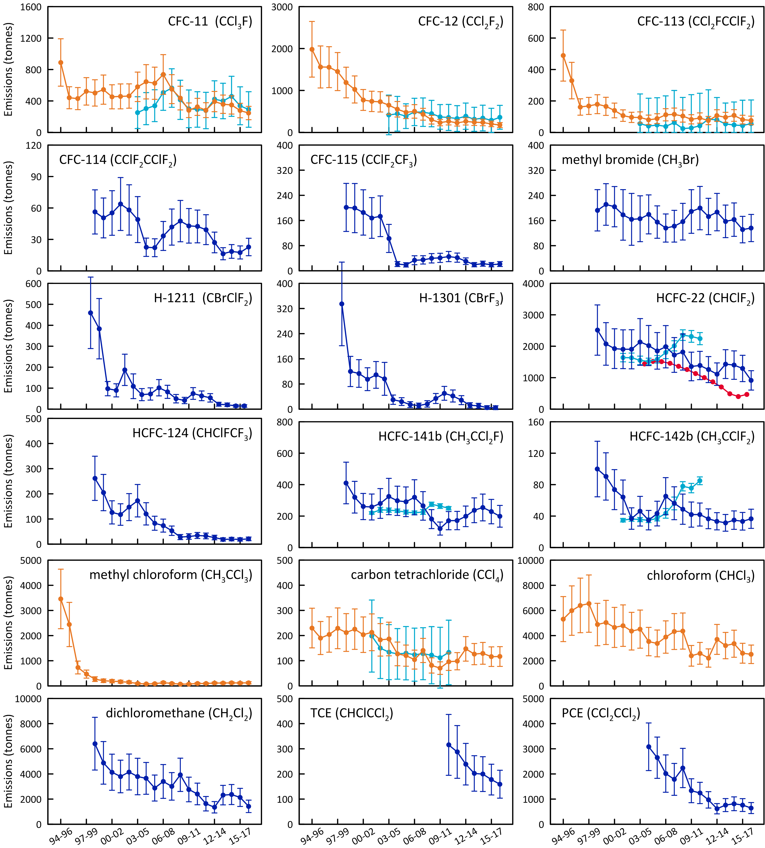

**Figure 12.** Annual average (3-yr running means) Australian emissions of CFCs, methyl bromide, HCFCs, halons and chlorocarbons (methyl chloroform, carbon tetrachloride, chloroform, dichloromethane, trichloroethylene, perchloroethylene) from Cape Grim AGAGE data, using ISC techniques (orange: GC-ECD data; blue: GC-MS data). methyl bromide emissions are for SE Australia. Australian emissions are scaled from SE Australian emissions on a population basis; halon emissions are adjusted to account for SE Australian Halon Bank emissions. NAME emissions are show in light blue. HCFC-22 emissions from the refrigerant bank are show in red (Brodribb and McCann, 2015a).

**Table 3.** Annual average (3-yr running means, i.e. 2014 = average of 2013, 2014, 2015) Australian emissions (metric tonnes unless otherwise stated) of ODSs (CFCs, HCFCs, halons, MB and chlorocarbons) from Cape Grim AGAGE data, using ISC techniques. Australian emissions are scaled from SE Australian emissions on a population basis; Australian halon emissions are from SE Australian emissions adjusted for the impact of emissions from the National Halon Bank in Melbourne; Australian methyl bromide emissions are from a DPI-modified UNEP model of methyl bromide emissions based on QPS and non-QPS methyl bromide consumption (see text). GWPs (to calculate CO2-e emissions) are from Forster and Ramaswamy (2007); ODPs (to calculate ODP-weighted emissions) are from Montzka and Reimann (2011); assumed GWPs for trichloroethylene (0.67) and perchloroethylene (0.53). Pre-1999 emissions of CFC-114, -115, HCFCs, halons and dichloromethane (shown in red) are assumed equal to 1999 emissions; pre-2005 emissions of perchloroethylene (shown in red) are assumed equal to 2005 emissions.

| Refrigerant | 1995 | 1996 | 1997 | 1998 | 1999 | 2000 | 2001 | 2002 | 2003 | 2004 | 2005 | 2006 | 2007 | 2008 | 2008 | 2010 | 2011 | 2012 | 2013 | 2014 | 2015 | 2016 | 2017 |
| --- | --- | --- | --- | --- | --- | --- | --- | --- | --- | --- | --- | --- | --- | --- | --- | --- | --- | --- | --- | --- | --- | --- | --- |
| **CFCs** |  |  |  |  |  |  |  |  |  |  |  |  |  |  |  |  |  |  |  |  |  |  |  |
| CFC-11 | 890 | 441 | 430 | 522 | 502 | 544 | 453 | 458 | 462 | 579 | 644 | 625 | 736 | 550 | 436 | 281 | 324 | 283 | 392 | 358 | 349 | 278 | 246 |
| CFC-12 | 1982 | 1561 | 1556 | 1451 | 1190 | 1023 | 774 | 740 | 728 | 650 | 551 | 479 | 500 | 434 | 302 | 233 | 264 | 226 | 262 | 243 | 236 | 202 | 175 |
| CFC-113 | 489 | 329 | 162 | 168 | 179 | 166 | 139 | 107 | 95 | 95 | 80 | 87 | 112 | 114 | 104 | 83 | 91 | 75 | 107 | 96 | 108 | 81 | 76 |
| CFC-114 | 56 | 56 | 56 | 56 | 56 | 50 | 55 | 64 | 58 | 49 | 23 | 22 | 33 | 42 | 47 | 43 | 42 | 39 | 27 | 16 | 19 | 18 | 23 |
| CFC-115 | 202 | 202 | 202 | 202 | 202 | 199 | 186 | 168 | 173 | 103 | 21 | 19 | 33 | 35 | 40 | 41 | 45 | 42 | 30 | 19 | 23 | 19 | 21 |
| Total | 3618 | 2589 | 2406 | 2399 | 2129 | 1983 | 1606 | 1536 | 1518 | 1476 | 1319 | 1233 | 1415 | 1175 | 929 | 682 | 767 | 665 | 818 | 732 | 734 | 598 | 541 |
| ODP tonnes | 3440 | 2443 | 2293 | 2285 | 2012 | 1870 | 1504 | 1448 | 1429 | 1416 | 1295 | 1208 | 1379 | 1138 | 892 | 649 | 731 | 633 | 785 | 705 | 703 | 574 | 518 |
| M tonnes CO2-e | 30.9 | 23.2 | 22.0 | 21.4 | 18.5 | 16.7 | 13.4 | 12.8 | 12.6 | 11.7 | 9.9 | 9.1 | 10.2 | 8.7 | 6.8 | 5.1 | 5.7 | 5.0 | 5.9 | 5.2 | 5.2 | 4.3 | 3.9 |
| **HCFCs** |  |  |  |  |  |  |  |  |  |  |  |  |  |  |  |  |  |  |  |  |  |  |  |
| HCFC-22 | 2514 | 2514 | 2514 | 2514 | 2514 | 2073 | 1924 | 1904 | 1903 | 2136 | 2022 | 1853 | 1984 | 1723 | 1817 | 1357 | 1388 | 1258 | 1112 | 1431 | 1400 | 1293 | 914 |
| HCFC-124 | 262 | 262 | 262 | 262 | 262 | 205 | 126 | 118 | 147 | 173 | 120 | 83 | 74 | 53 | 28 | 30 | 34 | 33 | 26 | 19 | 20 | 19 | 21 |
| HCFC-142b | 100 | 100 | 100 | 100 | 100 | 90 | 74 | 64 | 37 | 46 | 35 | 43 | 65 | 56 | 49 | 42 | 42 | 37 | 33 | 31 | 35 | 33 | 37 |
| HCFC-141b | 411 | 411 | 411 | 411 | 411 | 320 | 261 | 258 | 280 | 324 | 297 | 291 | 319 | 265 | 181 | 121 | 171 | 171 | 198 | 237 | 255 | 228 | 199 |
| Total | 3286 | 3286 | 3286 | 3286 | 3286 | 2689 | 2384 | 2344 | 2367 | 2679 | 2474 | 2270 | 2442 | 2097 | 2075 | 1550 | 1635 | 1498 | 1370 | 1718 | 1710 | 1573 | 1170 |
| ODP tonnes | 196 | 196 | 196 | 196 | 196 | 160 | 142 | 140 | 141 | 160 | 149 | 139 | 150 | 129 | 124 | 91 | 99 | 91 | 86 | 107 | 108 | 99 | 75 |
| M tonnes CO2-e | 5.2 | 5.2 | 5.2 | 5.2 | 5.2 | 4.3 | 3.9 | 3.9 | 3.8 | 4.3 | 4.0 | 3.7 | 4.0 | 3.5 | 3.5 | 2.7 | 2.8 | 2.5 | 2.2 | 2.8 | 2.8 | 2.6 | 1.9 |
| **Halons** |  |  |  |  |  |  |  |  |  |  |  |  |  |  |  |  |  |  |  |  |  |  |  |
| H-1211 | 459 | 459 | 459 | 459 | 459 | 384 | 98 | 90 | 187 | 109 | 69 | 72 | 102 | 82 | 50 | 41 | 75 | 63 | 54 | 23 | 21 | 15 | 15 |
| H-1301 | 335 | 335 | 335 | 335 | 335 | 120 | 113 | 95 | 109 | 96 | 30 | 24 | 14 | 11 | 17 | 34 | 50 | 42 | 28 | 12 | 10 | 5 | 4 |
| Total | 794 | 794 | 794 | 794 | 794 | 503 | 211 | 185 | 296 | 205 | 99 | 96 | 116 | 94 | 66 | 75 | 125 | 105 | 82 | 36 | 31 | 20 | 19 |
| ODP tonnes | 4724 | 4724 | 4724 | 4724 | 4724 | 2348 | 1426 | 1220 | 1650 | 1290 | 507 | 457 | 449 | 361 | 314 | 461 | 726 | 607 | 446 | 192 | 167 | 95 | 89 |
| M tonnes CO2-e | 2.9 | 2.9 | 2.9 | 2.9 | 2.9 | 1.3 | 0.91 | 0.77 | 0.99 | 0.81 | 0.30 | 0.26 | 0.23 | 0.19 | 0.18 | 0.29 | 0.44 | 0.37 | 0.27 | 0.11 | 0.10 | 0.05 | 0.05 |
|  |  |  |  |  |  |  |  |  |  |  |  |  |  |  |  |  |  |  |  |  |  |  |  |
| **methyl bromide (MB)** |  |  |  |  |  |  |  |  |  |  |  |  |  |  |  |  |  |  |  |  |  |  |  |
| Total | 519 | 552 | 588 | 609 | 615 | 609 | 576 | 511 | 467 | 416 | 370 | 314 | 314 | 351 | 397 | 474 | 521 | 563 | 518 | 573 | 585 | 696 | 645 |
| ODP tonnes | 311 | 331 | 353 | 365 | 369 | 366 | 345 | 307 | 280 | 249 | 222 | 188 | 188 | 211 | 238 | 284 | 312 | 338 | 311 | 344 | 351 | 417 | 387 |
| k tonnes CO2-e | 2.6 | 2.8 | 2.9 | 3.0 | 3.1 | 3.0 | 2.9 | 2.6 | 2.3 | 2.1 | 1.8 | 1.6 | 1.6 | 1.8 | 2.0 | 2.4 | 2.6 | 2.8 | 2.6 | 2.9 | 2.9 | 3.5 | 3.2 |
| **chlorocarbons (MP)** |  |  |  |  |  |  |  |  |  |  |  |  |  |  |  |  |  |  |  |  |  |  |  |
| carbon tetrachloride (CT) | 230 | 190 | 204 | 229 | 212 | 225 | 203 | 213 | 183 | 186 | 127 | 120 | 104 | 141 | 81 | 70 | 96 | 98 | 147 | 126 | 129 | 116 | 117 |
| methyl chloroform (MC) | 3458 | 2442 | 732 | 470 | 269 | 204 | 189 | 168 | 144 | 96 | 75 | 87 | 131 | 97 | 70 | 74 | 97 | 94 | 114 | 113 | 122 | 115 | 125 |
| Total | 3688 | 2632 | 936 | 698 | 481 | 430 | 392 | 381 | 327 | 282 | 202 | 207 | 236 | 238 | 151 | 144 | 193 | 192 | 261 | 239 | 252 | 231 | 241 |
| ODP tonnes | 599 | 453 | 298 | 299 | 260 | 268 | 243 | 251 | 216 | 214 | 147 | 141 | 128 | 164 | 96 | 85 | 115 | 117 | 173 | 150 | 154 | 139 | 141 |
| M tonnes CO2-e | 0.92 | 0.70 | 0.47 | 0.48 | 0.42 | 0.44 | 0.39 | 0.41 | 0.35 | 0.35 | 0.24 | 0.23 | 0.21 | 0.27 | 0.16 | 0.14 | 0.19 | 0.19 | 0.28 | 0.24 | 0.25 | 0.23 | 0.23 |
| **Montreal Protocol (MP) ODSs** | | | | |  |  |  |  |  |  |  |  |  |  |  |  |  |  |  |  |  |  |
| MP ODSs (k tonnes) | 12 | 9.9 | 8.0 | 7.8 | 7.3 | 6.2 | 5.2 | 5.0 | 5.0 | 5.1 | 4.5 | 4.1 | 4.5 | 4.0 | 3.6 | 2.9 | 3.2 | 3.0 | 3.0 | 3.3 | 3.3 | 3.1 | 2.6 |
| ODP (k tonnes) | 9.3 | 8.1 | 7.9 | 7.9 | 7.6 | 5.0 | 3.7 | 3.4 | 3.7 | 3.3 | 2.3 | 2.1 | 2.3 | 2.0 | 1.7 | 1.6 | 2.0 | 1.8 | 1.8 | 1.5 | 1.5 | 1.3 | 1.2 |
| M tonnes CO2-e | 40 | 32 | 31 | 30 | 27 | 23 | 19 | 18 | 18 | 17 | 15 | 13 | 15 | 13 | 11 | 8.2 | 9.1 | 8.0 | 8.7 | 8.4 | 8.4 | 6.9 | 6.4 |
| **other chlorocarbons** |  |  |  |  |  |  |  |  |  |  |  |  |  |  |  |  |  |  |  |  |  |  |  |
| Dichloromethane | 6406 | 6406 | 6406 | 6406 | 6406 | 4881 | 4137 | 3798 | 4154 | 3794 | 3648 | 2879 | 3401 | 3011 | 3930 | 2764 | 2408 | 1632 | 1351 | 2316 | 2361 | 2133 | 1423 |
| Chloroform | 5312 | 5989 | 6400 | 6544 | 4881 | 5045 | 4651 | 4792 | 4352 | 4515 | 3525 | 3377 | 3887 | 4324 | 4361 | 2394 | 2590 | 2217 | 3698 | 3206 | 3356 | 2598 | 2514 |
| PCE | 3081 | 3081 | 3081 | 3081 | 3081 | 3081 | 3081 | 3081 | 3081 | 3081 | 3081 | 2646 | 2015 | 1784 | 2237 | 1333 | 1243 | 969 | 617 | 762 | 814 | 763 | 644 |
| TCE |  |  |  |  |  |  |  |  |  |  |  |  |  |  |  |  | 315 | 287 | 239 | 202 | 199 | 177 | 159 |
| total (k tonnes) | 15 | 15 | 16 | 16 | 14 | 13 | 12 | 12 | 12 | 11 | 10 | 8.9 | 9.3 | 9.1 | 11 | 6.5 | 6.6 | 5.1 | 5.9 | 6.5 | 6.7 | 5.7 | 4.8 |
| ODP tonnes | 125 | 132 | 135 | 137 | 122 | 109 | 99 | 97 | 97 | 95 | 85 | 74 | 79 | 78 | 89 | 55 | 53 | 41 | 50 | 55 | 57 | 48 | 40 |
| M tonnes CO2-e | 0.25 | 0.27 | 0.28 | 0.29 | 0.24 | 0.23 | 0.21 | 0.21 | 0.20 | 0.21 | 0.17 | 0.16 | 0.17 | 0.18 | 0.19 | 0.11 | 0.12 | 0.09 | 0.13 | 0.13 | 0.13 | 0.11 | 0.10 |
| all ODSs |  |  |  |  |  |  |  |  |  |  |  |  |  |  |  |  |  |  |  |  |  |  |  |
| all ODS (k tonnes) | 27 | 25 | 24 | 24 | 22 | 19 | 17 | 17 | 17 | 16 | 15 | 13 | 14 | 13 | 14 | 9.4 | 9.8 | 8.1 | 9.0 | 10 | 10 | 8.7 | 7.3 |
| ODP k tonnes | 9.4 | 8.3 | 8.0 | 8.0 | 7.7 | 5.1 | 3.8 | 3.5 | 3.8 | 3.4 | 2.4 | 2.2 | 2.4 | 2.1 | 1.8 | 1.6 | 2.0 | 1.8 | 1.8 | 1.5 | 1.5 | 1.3 | 1.3 |
| M tonnes CO2-e | 40 | 32 | 31 | 30 | 27 | 23 | 19 | 18 | 18 | 17 | 15 | 13 | 15 | 13 | 11 | 8.3 | 9.2 | 8.1 | 8.8 | 8.6 | 8.5 | 7.0 | 6.5 |

## CFCs

CFC-11 emissions have averaged about 460 tonnes from 1996 to 2017 (Table 3, Figure 12). CFC-11 emissions increased from 2003 (462 tonnes) to 2007 (736 tonnes) - the cause of this increase is unclear. Since 2007 CFC-11 emissions have declined to about 314 tonnes per year (2010-2017), an encouraging 53% lower than average 2004-2009 emissions (600 tonnes per year). CFC-11 emissions have been steadily declining for the past 4 years and reached 246 tonnes in 2017. It appears the long-term decline in emissions has resumed after being stalled for several years (2009-2013). Australian CFC-11 emissions have been estimated by inverse modelling (NAME/InTEM, Figure 12) for the period 2004-2017. The overall agreement with ISC estimates is 22%, ISC higher. This agreement improves to 7% from 2008-2017, ISC lower.

CFC-12 emissions have declined steadily since 1995 (1982 tonnes) to 233 tonnes by 2010, a long-term decline of 15% per year. CFC-12 emissions were 175 tonnes in 2017 and have averaged 230 tonnes from 2010-2017, 47% lower than average 2004-2009 emissions (486 tonnes per year). As with CFC-11 above, CFC-12 emissions have also been steadily declining for the last 4 years, suggesting the long-term decline has resumed after being stalled for several years (2009-2013). Australian CFC-12 emissions from NAME/InTEM (Figure 12) have been compared with ISC estimates for the period 2004-2017, with an overall agreement of 14%, ISC lower.

CFC-113 emissions declined rapidly from 489 tonnes in 1995 to under 100 tonnes in the early 2000s, averaging close to 100 tonnes per year from 2002 to 2017. CFC-113 emissions in 2017 were 76 tonnes. CFC-113 emissions are quite variable and do not show a clear trend. Australian CFC-113 emissions from NAME/InTEM (Figure 12) have been compared with ISC estimates for the period 2004-2017, with ISC roughly double NAME/InTEM estimates from 2004-2011, with the overall agreement improving to 20% from 2012-2017, ISC higher.

Total Australian CFC (and HCFC, halon and carbon tetrachloride) emissions are shown in Figure 13. The overall decline in CFC emissions from 1995 (nearly 3400 tonnes) to 2017 (525 tonnes) is about 7.7% per year. ODP weighted CFC emissions have fallen from 3440 tonnes in 1995 to 545 tonnes in 2017 (declining by about 8% per year). Australian ODP-weighted CFC emissions in 2017 (545 tonnes) were 0.5% of global ODP-weighted CFC emissions. Australian ODP-weighted CFC emissions (545 tonnes) are currently (2017) about 45% of Australia’s Montreal Protocol ODS (ODP-weighted) emissions (1200 tonnes).

CFC emissions are presumed to be from CFC-containing appliances/materials (refrigeration/ac equipment, foams, aerosol cans), either existing or buried (land-fills). If the current total emissions (~5 tonnes per year) continue to decline at ~7.7%/yr, it will take about 21 years for Australian CFC emissions to drop below 100 tonnes/yr.

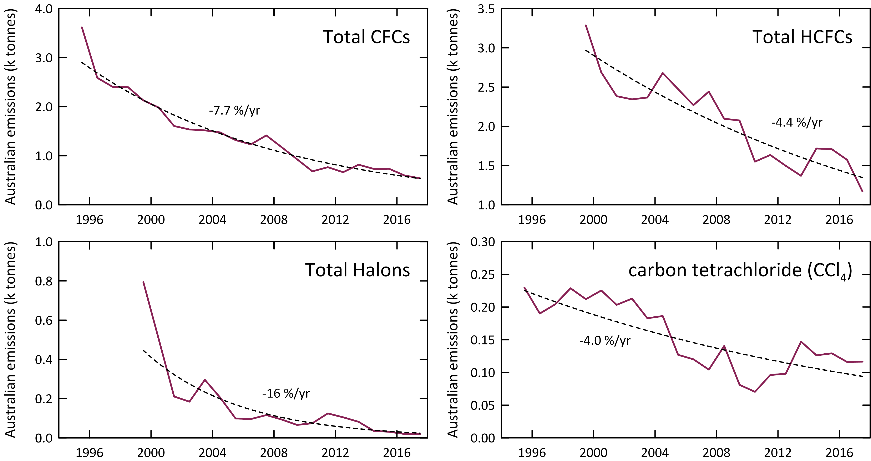

**Figure 13.** Declining Australian CFC, HCFC, halon and carbon tetrachloride emissions (k tonnes).

## HCFCs

Total Australian HCFC-22 emissions have been estimated from Cape Grim data using ISC and NAME methods. Australian HCFC-22 emissions from operational and end-of-life refrigeration/air conditioning equipment has been estimated from an emissions model based on imports/consumption data for HCFC-22, estimates of the resultant HCFC-22 bank in the operational and retired equipment bank and assumptions about emission rates from the bank (Brodribb and McCann, 2015a, 2018).

There has been an overall decline in Australian HCFC-22 emissions estimated by ISC from about 2500 tonnes in 1999 to around 900 tonnes in 2017 (5% per year over this period) (Table 3, Figure 12). HCFC-22 emissions declined rapidly from 2136 tonnes in 2004 to 1112 tonnes in 2013 (7% per year), and then increased again in 2014 and 2015 to 1431 and 1400 tonnes respectively, declining again in 2017 to 914 tonnes.

Australian HCFC-22 emissions have been estimated by inverse modelling (NAME, Figure 12) for the period 2002-2011. The overall agreement with ISC estimates is good (better than 99%), with average NAME emissions being lower than ISC emissions pre-2007 and higher post-2007 (Figure 12).

The Australian HCFC-22 bank in operational refrigeration/air conditioning equipment peaked at 13450 tonnes in 2007 with a projected decline to 2858 tonnes in 2018 (Brodribb and McCann, 2013). Over the same period emissions from the bank have fallen from 1450 tonnes in 2007 to 180 tonnes in 2018. As mentioned in section 4, a recent update (Brodribb and McCann, 2018) estimates the Australian HCFC-22 Bank at 5584 tonnes for 2018 and Australian emissions of HCFC-22 for 2018 of 323 tonnes. Some of the additional HCFC-22 emissions implied from the Cape Grim data could be from refrigeration/ac equipment and other HCFC-22-containing products (e.g. plastic foams, aerosol cans) in landfills.

Total HCFC-22 emissions from Cape Grim data and as projected leakage from the HCFC-22 bank are shown in Figure 14 as a function of the HCFC-22 bank. An assumed linear relationship between emissions and bank size, implies a bank emission factor from operational refrigeration equipment of 13%/yr. The difference between total HCFC-22 emissions and bank HCFC-22 emissions could be emissions from landfills (Figure 15) or other minor uses such as from foam, fire protection or aerosols. These emissions are relatively constant over the period 2002-2012 (approx. 500 tonnes) increasing to about 900 tonnes (2014-2016) and dropping to 670 tonnes in 2017.

|  |  |
| --- | --- |
| Figure 14 is a graph of total Australian HCFC 22 emissions as a function of HCFC 22 bank emissions. It shows that as the bank decreases, total HCFC emissions also decrease slightly. | **Figure 14.** Total Australian HCFC-22 emissions (k tonnes) from Cape Grim data and HCFC-22 bank emissions as functions of the HCFC-22 bank (k tonnes; Brodribb and McCann, 2015a). The dashed line is a linear regression: slope = 0.13 tonne/tonne banked. |
| Figure 15 is a graph of Australian emissions of hydrochlorofluorocarbon 22 from 2002 to 2017. It suggests that emissions might be coming from non equipment sources such as landfills. | **Figure 15**. Possible HCFC-22 emissions from non-equipment bank sources such as landfills. |

HCFC-124 emissions have declined steadily from 262 tonnes in 1999 to 21 tonnes in 2017 (a decline of over 15% per year). Emissions levelled off from 2009-2013, staying steady at about 30 tonnes per year, then averaging about 20 tonnes per year from 2014-2017.

HCFC-141b emissions have fluctuated over the period 1999-2017, falling from over 400 tonnes in 1999 to 260-320 tonnes in 2001-2007, falling again to 120 tonnes in 2010, then rising every year since to 255 tonnes in 2015, dropping again to 199 tonnes in 2017. Australian HCFC-141b emissions have been estimated by inverse modelling (NAME,Figure 12) for the period 2002-2011. The overall agreement with ISC estimates is good, with average NAME emissions being 6% lower than ISC emissions.

HCFC-142b emissions have also fluctuated over the period 1999-2017, falling from 100 tonnes in 1999 to 35 tonnes in 2005, rising to 65 tonnes in 2007, then declining for most of the following years to 37 tonnes in 2017. Australian HCFC-141b emissions have been estimated by inverse modelling (NAME, Figure 12) for the period 2002-2011. The overall agreement with ISC estimates is good, with average NAME emissions being 4% lower than ISC emissions (similar to the HCFC-141b comparison).

Total HCFC emissions have fallen by about 64% from 3,286 tonnes in 1999 to 1,170 tonnes in 2017, an overall decline of about 6% per year. ODP-weighted HCFC emissions have fallen from 196 tonnes in 1999 to about 100 tonnes per year, 2010-2017, 6% of Australia’s Montreal Protocol ODS (ODP-weighted) emissions in 2017 (1200 tonnes). GWP-weighted HCFC emissions have fallen from 5.2 M tonnes CO2-e in 1999 to 1.9 M tonnes CO2-e in 2017, an overall decline of 63%.

Australian HCFC emissions are likely from a combination of service and malfunction leaks from existing refrigeration/ac equipment, from other minor uses and from land-fills. Australian HCFC emissions in 2017 (1170 tonnes) were 0.25% of global HCFC emissions (460 k tonnes) on a metric tonne basis.

## Halons

The origin of Australian halon emissions is uncertain, but they could be coming from remaining building fire-fighting systems (if they exist), from the Australian Halon Bank (a facility to destroy or reprocess recyclyed halons located in Melbourne) and exempted halon based aircraft firefighting suppression systems. It may not be appropriate to directly scale the SE Australian halon emissions (as determined from Cape Grim data) to Australian emissions on a simple population basis. This is because the Melbourne/Port Philip region contains an additional likely halon source compared to other Australian regions, the National Halon Bank. The Bank collected about 5 tonnes of halon in 2014, with a collection/processing loss rate of less than 2% (0.01 tonne) and has stored a total of about 550 tonnes of halons by 2013 (140 tonnes H-1211, 410 tonnes H-1301) (E. Nigido, A-Gas (Australia) Pty. Ltd., personal communications, May 2014 and August 2015). Assuming that typical leaks from the storage of halons are less than 1% (Nigido 2015; we have assumed 0.5%), then halon emissions from the Halon Bank could be 3-4 tonnes/year. This is a small component (perhaps 6-8%) of SE Australian halon emissions. The Australian halon emissions shown in Table 3 are the sum of Halon Bank emissions and Australian non-Halon Bank emissions. The SE Australian non-Halon Bank emissions are obtained from SE Australian Halon emissions (from Cape Grim data) by subtracting the Halon Bank emissions. Australian non-Halon Bank emissions equal SE Australian non-Halon Bank emissions scaled by population.

It is assumed that the Halon Bank started to accumulate, process and store halons in 1993 and that the halon bank has grown linearly for both halons to reach current banked levels of 130 tonnes (H-1211) and 490 tonnes (H-1301), accumulation rates of approximately 5 and 20 tonnes per year.

Australian halon emissions fell from nearly 800 tonnes in 1999 to 200-300 tonnes in 2001-2004 and then to 67-125 tonnes in 2005-2011, before declining each following year to reach an all time low of 19 tonnes in 2017 (Figures 12, 13), an overall decline of about 23% per year. Approximately 60%-79% of Australian halon emissions over the period 2012-2017 are H-1211, 21%-40% H-1301. The increase in halon emissions seen in 2011, has not been maintained and emissions have declined each year since. SE Australian halon emissions are likely to show significant inter-annual variability.

Australian H-1211 emissions in 2017 were 15 tonnes, 0.4% of global emissions (3400 tonnes) and Australian H-1301 emissions in 2017 were 4 tonnes, 0.3% of global emissions (1200 tonnes). The Australian H-1211/H-1301 emissions ratio in 2017 was 3.8, compared to the global emissions ratio of 2.8.

## Methyl bromide

Methyl bromide (MB) is used in Australia as a fumigant for cereals, such as wheat, for cottonseed and timber logs prior to export, biosecurity treatment of of imported goods and also as a soil sterilant during the production of strawberry runners. The former uses are QPS, which are exempted from Montreal Protocol controls, and the latter use is non-QPS (n-QPS), which is restricted by the Montreal Protocol and for which Australia has to apply for a Critical Use Exemption (CUE) under the Montreal Protocol on an annual basis.

Today, methyl bromide is imported into Australia predominantly for QPS use. Two-thirds of QPS methyl bromide use in Australia is for timber-log and wood-chip fumigation (80% export, 20% import). The major timber-log fumigation sites are Eden (60%, NSW), Geelong/Portland (40%, Vic) (personal communication, Mebrom Pty. Ltd., 2014). One-third of QPS methyl bromide use in Australia is for grain fumigation, largely export. Grain exported from SE Australian grain terminals account for about 20% of Australia’s grain exports (National Transport Commission, 2008; GrainCorp, 2012). Australia’s current non-QPS methyl bromide use occurs at Toolangi, NE of Melbourne, for growing strawberry runners. It is also occasionally used in small amounts as a feedstock in chemical reactions to create other chemicals.

A UNEP model of methyl bromide emissions suggests that 80-90 % of methyl bromide QPS use escapes to the atmosphere (UNEP, 2018). The UNEP methyl bromide emissions model may not be suitable for Australian methyl bromide consumption. It has been suggested (I. Porter, DPI Victoria, private communication) that close to 95% of QPS and about 50% of non-QPS methyl bromide are emitted to the atmosphere under Australian conditions, resulting in emissions of 600±30 tonnes in 2011-2015 (6% of global QPS plus non-QPS emissions, 9.9 k tonnes in 2012; Carpenter and Reimann, 2014). Note that neither model takes into account some recapture of methyl bromide which appears anecdotally, to be increasing to meet local OH&S requirements.

The results from the modified UNEP model of Australian methyl bromide emissions are shown in Figure 16. SE Australian methyl bromide emissions from this model (assuming the speciation of SE Australian methyl bromide emissions from timber, grain exports and strawberry runner production discussed above) are compared to SE Australian emissions calculated from Cape Grim data by ISC in Figure 17 (also Figure 12). It is also worth noting that using imports in any given year as a basis for estimating emissions may bring in unrealistic year-to-year variability in calculated emissions as the amount of methyl bromide used in any year can be sourced from both imports and stock-in-hand. However, long term growth in methyl bromide stock is unlikely – in order to diminish the impact of short-term impacts of methyl bromide stock changes, 3-year average emissions from the model are also shown in Figure 17.

The emissions from the model and those derived from atmospheric data for SE Australia show reasonable overall agreement (within 7%, model higher) over the period 2002-2017. Prior to 2004, the model methyl bromide emissions were 30-40% higher than methyl bromide emissions derived from Cape Grim observations. The QPS and non-QPS emission factors in the model are assumed to be time-invariant. Lower emission factors before 2004 would help explain this difference; 2004 is also the time of a methyl bromide instrument change at Cape Grim. Both these factors are being investigated for possible impacts on pre-2004 emission data from Cape Grim observations. The emissions calculated from atmospheric data are consistent with the model emissions for SE Australia and it can be assumed that the model emissions for Australia are close to actual emissions.

Australian methyl bromide emissions based on the emissions model peaked at about 600 tonnes per year in 1999-2000, falling to 300 tonnes per year in 2006-2007, due in part to declining non-QPS methyl bromide use and also a decline in QPS use (possibly due to reduced grain production as a result of the severe drought in SE Australia), increasing again to 645 tonnes in 2017, due to increased QPS methyl bromide use (Figure 16). The 387 ODP tonnes of methyl bromide in 2017 are about 32% of Australia’s total ODS emissions in ODP tonnes.

Victorian methyl bromide consumption data for 2014 have been obtained from Mebrom Pty. Ltd. (K. Bartolo, private communication, 2014). Victorian methyl bromide consumption in 2014 was 170 tonnes, 125 tonnes in Melbourne (grain, wood products)/Toolangi (non-QPS), 35 tonnes in Portland (grain/wood) and 10 tonnes in Geelong (grain/timber). The methyl bromide consumption is similar to the emissions from Melbourne/Victoria calculated from Cape Grim data (160±60 tonnes in 2014). These data would imply that most of the methyl bromide consumed is emitted to the atmosphere.

|  |  |
| --- | --- |
| Figure 16 is a graph of Australian methyl bromide emissions from 1992 to 2016 showing an increase in quarantine and pre shipment uses of methyl bromide. | Figure 17 is a graph of south east Australian methyl bromide emissions from 1998 to 2018 based on imports of methyl bromide and uses. It compares two models of emissions, which have some points of intersection. |
| **Figure 16.** Australian methyl bromide emissions (3-year average) calculated from Australian methyl bromide import data and the modified UNEP emissions model (UNEP, 2018). | **Figure 17.** SE Australian methyl bromide emissions calculated (see text for details) by ISC from Cape Grim *in situ* AGAGE methyl bromide data (blue) and from a modified UNEP (2018) emissions model (orange, 3-year average) based on Australian methyl bromide imports and the SE Australian methyl bromide consumption for timber/grain exports and strawberry runner production. |

## Carbon tetrachloride and methyl chloroform (Montreal Protocol chlorocarbons)

Carbon tetrachloride (CTC) emissions are calculated from Cape Grim *in situ* GC-ECD data (reliable carbon tetrachloride data are not collected on the Cape Grim GC-MS Medusa instrument). The GC-ECD carbon tetrachloride data have been reprocessed for use with the recalculated Port Phillip CO emissions. The latest available estimates of Australian carbon tetrachloride emissions by ISC and NAME are shown in Figure 18.

Carbon tetrachloride emissions estimated by ISC were 230 tonnes in 1995, declining to below 100 tonnes per year for 2009-2012, before rising again to about 147 tonnes in 2013, declining again to 117 tonnes by 2017. Carbon tetrachloride emissions estimated using the NAME model were 198 tonnes in 2002, declining by 5% per year to 133 tonnes in 2011. Over the same period carbon tetrachloride emissions estimated by ISC fell by 8% per year. Overall ISC and NAME estimates of carbon tetrachloride emissions obtained from Cape Grim data agree to within 6% over this period, NAME higher.

The ISC and NAME estimates of Australian carbon tetrachloride emissions have been published in the peer-reviewed literature and used to identify possible ‘missing’ carbon tetrachloride sources on a global scale (Fraser *et al*., 2014b). These findings have been incorporated into the *Scientific Assessment of Ozone Depletion: 2014* and 2018 (Carpenter and Reimann, 2014; Engel and Rigby, 2018) and the recent *SPARC Report on the Mystery of Carbon Tetrachloride* (Liang *et al*., 2016). The Cape Grim data have been essential in identifying emissions of carbon tetrachloride not associated with carbon tetrachloride production and use. The carbon tetrachloride sources seen in the Cape Grim data are possibly from landfills and/or chlor-alkali production. The Cape Grim data have encouraged new initiatives around the world in estimating these previously unaccounted-for emissions. The SPARC Report now estimates global carbon tetrachloride ‘bottom-up’ emissions of 25 k tonnes per year, whereas atmospheric data indicate emissions of 30-40 k tonnes per year. The gap between these emission estimates has closed to 5-15 k tonnes, significantly less than the 54 k tonne ‘gap’ reported in the 2014 international scientific assessment of ozone depletion (Carpenter and Reimann, 2014).

Australian methyl chloroform emissions declined from about 3,500 tonnes in 1995 to 100 tonnes by 2004. Methyl chloroform emissions stabilised at about 100 tonnes per year from 2004-2012. In 2013-2017 Australian methyl chloroform emissions averaged about 118 tonnes per year, 4-8% of global emissions (1400-3100 tonnes) in 2013-2017. In 2017 Australian methyl chloroform emissions were 125 tonnes.

The combined carbon tetrachloride/methyl chloroform emissions totalled 600 ODP tonnes in 1995, declining to about 85 tonnes in 2010, an overall decline of about 12% per year. The combined carbon tetrachloride/methyl chloroform emissions rose to 173 ODP tonnes in 2013. In 2014-2017 Australian methyl chloroform/carbon tetrachloride emissions averaged around 146 ODP tonnes and were about 12% of total Australian ODS emissions.

|  |  |
| --- | --- |
| Figure 18 is a graph of Australian carbon tetrachloride emissions calculated from Cape Grim data from 1996 to 2018. It shows a gradual decrease in emissions from two different models. | **Figure 18.** Australian carbon tetrachloride emissions calculated from Cape Grim *in situ* AGAGE data by ISC and inverse modelling (NAME). |

## Other chlorocarbons

Dichloromethane (CH2Cl2), chloroform (CHCl3), CHClCCl2 (trichloroethylene) and CCl2CCl2 (perchloroethylene) are short-lived ODSs whose production and consumption are not controlled by the Montreal Protocol. Significant emissions of all these ODSs are seen in the Cape Grim data (Figure 1). Australian dichloromethane emissions were about 6400 tonnes in 1999 declining by 10% per year to about 1400 tonnes in 2013, rising to 2361 tonnes in 2015, declining again to 1423 tonnes in 2017.

Australian chloroform emissions were over 5,300 tonnes in 1995 declining overall by 4% per year to about 2,217 tonnes in 2012, rising to over 3000 tonnes per year for the next 3 years and then declining to 2514 tonnes in 2017. There are natural emissions of chloroform from soil and it is possible that the chloroform emissions calculated from Cape Grim data contain natural emissions which are difficult to quantify.

Australian perchloroethylene emissions were over 3,000 tonnes in 2004 declining by about 13% per year to about 617 tonnes in 2013, increasing again 2014-2016, then declining to 644 tonnes in 2017. Trichloroethylene emissions were about 316 tonnes in 2011 falling by 12% per year to 159 tonnes in 2017.

Total emissions for these short-lived ODSs (not including trichloroethylene) were 11k tonnes (95 ODP tonnes) in 2004, falling by 7% per year to 4.7 k tonnes (40 ODP tonnes) in 2017. The ODP-weighted emissions of these short-lived ODSs were about 3% of total ODS emissions (ODP weighted).

## GWP-weighted ODS emissions

The overall decline in GWP-weighted CFC emissions from 1995 (31 M tonnes CO2-e) to 2017 (3.9 M tonnes CO2-e) is 10% per year. Australian GWP-weighted CFC emissions in 2017 (3.9 M tonnes CO2-e) were 0.7 % of Australia’s total GHG emissions (535 M tonnes CO2-e, including land use change, 2017). CFC emissions are not included in Australia’s national GHG emissions, as CFCs have been phased-out under the Montreal Protocol and are therefore not subject to separate controls under the Kyoto Protocol and subsequent agreements. Nevertheless, the 27 M tonnes CO2-e decline in GWP-weighted CFC emissions since 1995 is significant compared to other changes in Australian GHG emissions over the same period. Australian emissions of GHGs (CO2, CH4, N2O, HFCs, PFCs, SF6 including land use change), as reported to UNFCCC, have increased by a net 52 M tonnes CO2-e from 1995 to 2017.

HCFC emissions, like CFC emission, are not included in Australia’s national GHG emissions (535 M tonnes CO2-e in 2017) as HCFCs are being phased-out under the Montreal Protocol and are therefore not subject to separate controls under the Kyoto Protocol and subsequent agreements. The overall decline in GWP-weighted HCFC emissions from 1999 (5.2 M tonnes CO2-e) to 2017 (1.9 M tonnes CO2-e) is 6% per year; CO2-e weighted HCFC emissions in 2017 are 0.4% of Australia’s reported net GHG emissions.

The CO2-e weighted emissions of other ODSs (halons, methyl bromide, chlorocarbons, other chlorocarbons) totalled 0.38 M tonnes in 2017, around 0.07% of Australia’s reported net GHG emissions.

## Total ODS emissions

Total Australian ODS emissions (CFCs, HCFCs, halons, methyl bromide, carbon tetrachloride, methyl chloroform, ODP- and GWP-weighted), with and without ‘other chlorocarbons’ (see above) are shown in Figure 19. From 1995 the emissions are based on Cape Grim GC-ECD data for the major CFCs (CFC-11, -12, -113), methyl chloroform and carbon tetrachloride. From 1999 the emissions for all species are calculated from Cape Grim GC-ECD and GC-MS data, except for perchloroethylene whose GC-MS observations commenced in 2004 (1995 to 2003 perchloroethylene emissions are assumed equal to 2005 emissions) and trichloroethylene whose GC-MS observations commenced in 2011. In previous reports trichloroethylene observations were reported back to 2005, but these earlier trichloroethylene data have now been assessed as unreliable.

For the minor CFCs, HCFCs and halons it is assumed that annual emissions from 1995-1999 equal 1999 emissions. This could lead to a significant underestimate of emissions during this period (the ISC method is limited to the period when well-calibrated CO data were measured at Cape Grim - 1994 onwards). Methodologies are being investigated to extend ODS emissions estimates prior to 1994 – these will be evaluated in a future report.

The other chlorocarbons (dichloromethane, chloroform, perchloroethylene, trichloroethylene) make a very significant contribution to total Australian ODS emissions. Since 2011, 60%-70% of ODS emissions are from these other chlorocarbons. However, they only make small contributions to ODP (2%-3%) or GWP (1%-2%) weighted emissions (or ozone depletion and climate change), because of their low ODPs and GWPs.

ODP-weighted ODS emissions fell by about 9% per year from 9.4 k tonnes in 1995 to 1.3 k tonnes in 2017. The largest decline is due to the halons, falling from emissions of 4.7 k tonnes (ODP) in 1999 to 0.09 k tonnes (ODP) in 2017, a fall of 4.6 k tonnes compared to a fall of 1.5 k tonnes (ODP) in CFC emissions and 0.09 k tonnes ODP in HCFC emissions over the same period.

GWP weighted ODS emissions fell by about 9% per year from 40 M tonnes CO2-e in 1995 to 6.5 M tonnes CO2-e in 2017. As discussed above the fall due to CFCs alone is 27 M tonnes CO2-e, more than 80% of the overall decline in GWP-weighted ODS emissions.

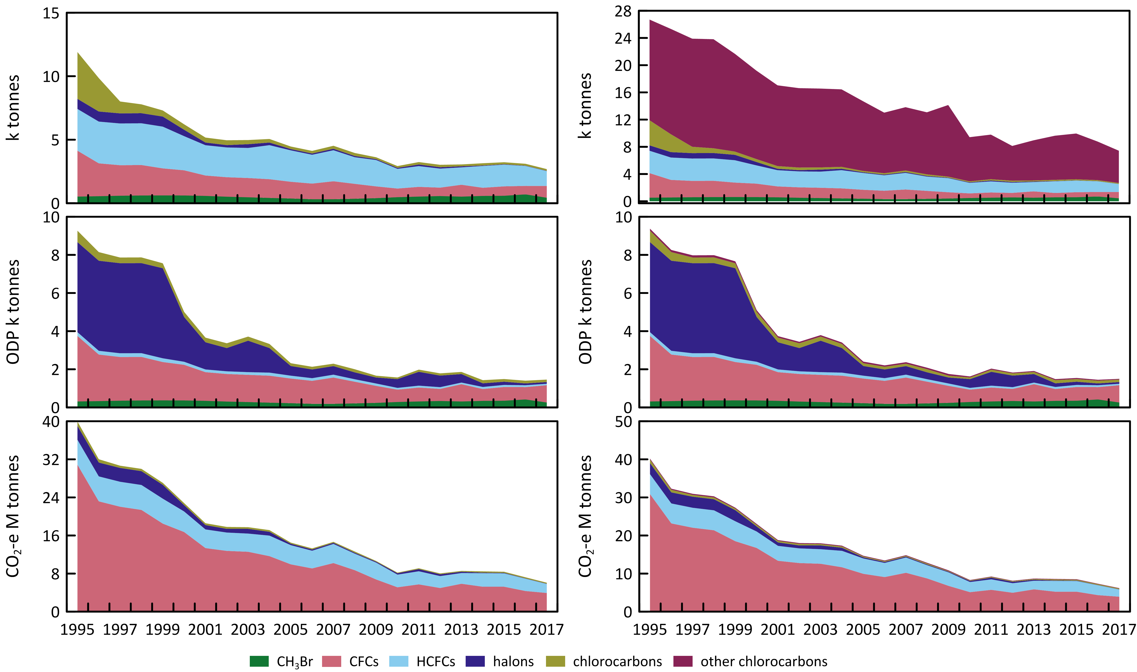

**Figure 19.** Total Australian ODS emissions; without other chlorocarbons (Section 5.6, left) and with other chlorocarbons (right).

The significance of the decline of GWP-weighted ODS emissions compared to GWP-weighted emissions of the GHGs reported to UNFCCC (CO2, CH4, N2O, HFCs, PFCs, SF6) are shown in Figure 20. The 33.5 M tonnes CO2-e decline in GWP-weighted ODS emissions since 1995 is significant compared to other changes in Australian GHG emissions over the same period: as discussed above, Australian emissions of GHGs (carbon dioxide, methane, nitrous oxide, HFCs, PFCs, NF3 and SF6, including land use change emissions), as reported to UNFCCC, increased by a net 52 M tonnes CO2-e from 1995 to 2017.

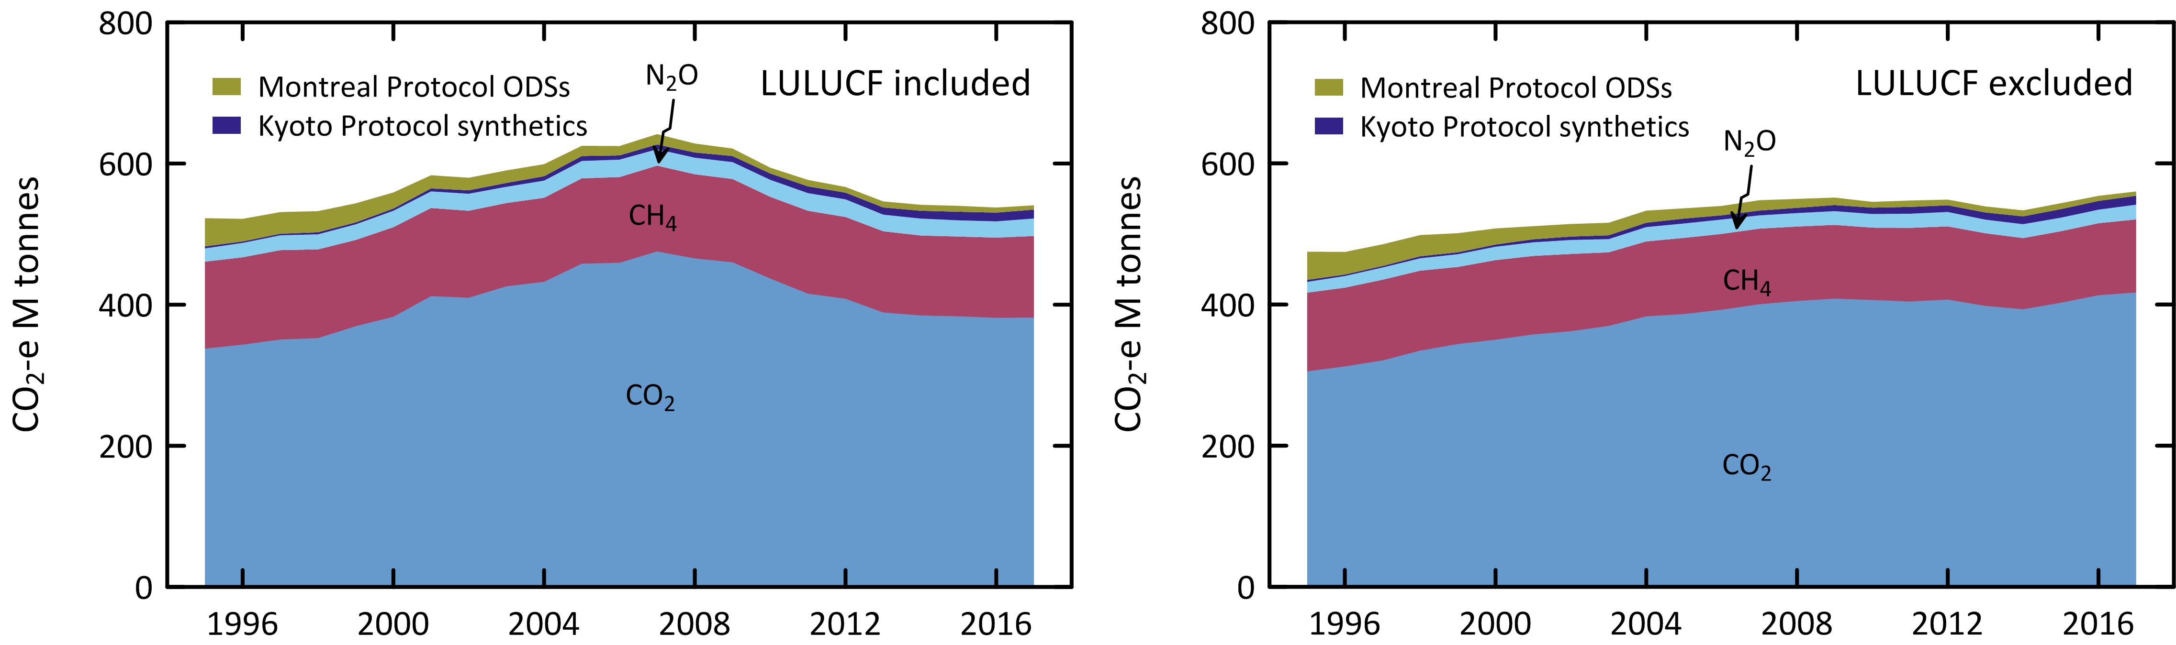

**Figure 20.** Australian emissions (GWP-weighted: M tonnes CO2-e) of ODSs (Montreal Protocol species: CFCs, HCFC, halons, methyl bromide, methyl chloroform, carbon tetrachloride) and the GHGs reported to UNFCCC (carbon dioxide, methane, nitrous oxide, Kyoto Protocol synthetics: HFC, PFCs and sulfur hexafluoride), including and excluding GHG emissions due to land-use/land-use change and forestry (LULUCF).

**Figure 21** shows a comparison of global and Australian CFC, HCFC and HFC emissions in M tonnes CO2-e from atmospheric abundance data. There has been about a 73% decline in global CFC, HCFC and HFC emissions since their peak (9400 M tonnes CO2-e) in the late 1980s and about a 37% decline since 1995. There has been a corresponding 71% decline in Australian CFC, HCFC and HFC emissions since 1995 (41 M tonnes CO2-e). Australian ODS emissions are typically about 0.5% to 1% of global emissions. In 2017, global CFC, HCFC and HFC emissions are similar in their climate impact (30%, 31%, 39%), whereas in Australia HFC emissions have become dominant (51%) with CFCs at 33% and HCFCs at 16%. The decline in Australian CFC, HCFC and HFC emissions stalled in 2012 at about 15 M tonnes CO2-e, declining to 11.7 M tonnes CO2-e in 2017. Global CFC, HCFC and HFC emissions have been about 2400-2600 M tonnes CO2-e since 2004.

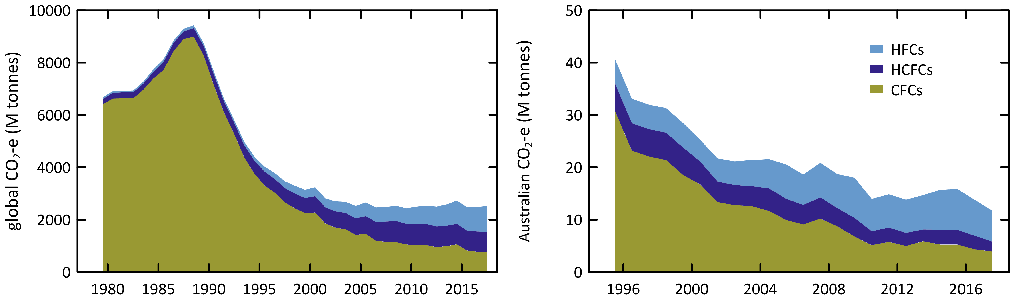

**Figure 21.** Global (since 1978) and Australian (since 1995) CFC, HCFC and HFC emissions (M tonne CO2-e).

Summary

* CSIRO and collaborating laboratories measure the abundances and trends of thirty four (34) ODSs at Cape Grim, comprising twelve CFCs, eight HCFCs, four halons, seven chlorocarbons and three bromocarbons. Cape Grim has the most comprehensive list of measured ODSs anywhere in the world.
* As a result of measures undertaken within the Montreal Protocol framework, the majority of the CFCs (CFC-11, CFC-12, CFC-112a and CFC-113) measured in the atmosphere in 2018 at Cape Grim have stopped growing or are in decline, the exceptions being CFC-112, CFC‐13, CFC-113a, CFC-114 and CFC‐115, which are growing slowly. Total CFCs in the background atmosphere declined by 0.5% (2017-2018), as did chlorine from CFCs.
* The atmospheric abundance of two of the major HCFCs (HCFC-22 and HCFC-142b) measured in the atmosphere at Cape Grim are currently (2017-2018) growing at 1.5% and 0.19% per year respectively. HCFC-141b is declining by 0.65% per year. The growth rate of total HCFCs is slowing down. Total HCFCs increased by 3.4 ppt or 1.2% per year (2017-2018). Chlorine in the atmosphere from HCFCs (305 ppt in 2018, 9.6% of total chlorine from all ODSs) increased by 3.3 ppt (1.1%, 2017-2018), the only ODS sector showing an increase in chlorine (apart from chloroform and dichloromethane).
* The chlorocarbons account for 28% of total chlorine from all ODSs in the background atmosphere. Carbon tetrachloride, methyl chloroform, methyl chloride and trichloroethylene measured at Cape Grim showed decreasing concentrations in 2018 compared to 2017, whereas dichloromethane, chloroform, and perchloroethylene all showed increasing concentrations. The largest decrease in the chlorocarbons was 0.31 ppt (15%) for methyl chloroform and the largest increase in the chlorocarbons was 1.2 ppt (7.4%) for dichloromethane. Total chlorine from chlorocarbons decreased by 3.1 ppt (0.3%).
* H-1211 and H-2402 are in decline in the atmosphere (-0.08 ppt/yr and -0.006 ppt/yr respectively, 2017-2018). H-1301 growth rates were reported as being negative in the previous report (-0.01 ppt/yr; 2016-2017), have now increased to 0.002 ppt/yr 2017-2018. Overall halons are in decline by 1.2% per year (compared to 1.7%/yr 2016-2017), a larger rate of decline (in percentage terms) compared to the CFCs.). Overall bromine from halons is in decline by 1.2% per year (0.09 ppt/yr).
* Methyl bromide showed a small decrease (0.07 ppt/yr 2017-2018) compared to the previous years decrease (0.6 ppt/yr 2016-2017) in the background atmosphere. There is an overall long-term decrease in methyl bromide in the atmosphere since about 2000, which briefly halted in 2012-2013 and 2014-2015.
* Total chlorine from all ODSs decreased by 0.25% (7.8 ppt, 2017-2018). This total is 10% lower than its peak value in 1994.
* Total bromine from all ODSs decreased 3.9% (0.82 ppt, 2017-2018)
* Global CFC-11 emissions averaged 75 k tonne per year from 2014-2017, an increase of 11 k tonne per year compared to the 2008-2012 period (Rigby *et al*., 2019).
* Since the peak emissions of CFC-12 in the late 1980s (513 k tonnes, 1988), CFC-12 emissions have declined by 94% (10%/yr). Current global CFC-12 emissions are about 34 k tonnes/yr (2015-2017) (Rigby *et al*., 2014 and updates).
* Global emissions of the other CFCs (CFC-113, -114, -115), including the minor CFCs, increased from a total of 11.1 k tonnes in 2016 to 11.9 k tonnes in 2017. All of the increase is due to emissions of CFC-113 and CFC-115.
* Global carbon tetrachloride emissions average around 35 k tonnes/yr from 2015-2017. Long-term, global carbon tetrachloride emissions have declined slowly from a peak of around 120 k tonnes/yr in the late 1970s, declining to 50 k tonnes/yr by 2005, a long-term decline of about 3%/yr. Since 2005 global carbon tetrachloride emissions have fluctuated between increases and decreases but overall have declined steadily by about 1-2 k tonne per year (3%/yr) until 2017. The decline in global carbon tetrachloride emissions is not as rapid as anticipated under the Montreal Protocol.
* Global methyl bromide emissions estimates start in 2000 (196 k tonnes), declining steadily to 149 k tonnes in 2016, a long-term decline of about 1.5% per year. Methyl bromide emissions from 2013-2016 are fairly steady, ranging from 147-151 k tonnes suggesting the long-term decline in methyl bromide emissions may have levelled off in line with developing country phase-out in 2015.
* Australian imports of ODSs (in tonnes) decreased by 34% from 2017 to 2018, due to methyl bromide imports for QPS applications decreasing from 915 tonnes (2017) to 742 tonnes (2018).
* Australian CFC emissions, based on Cape Grim data, have decreased by 10% from 2016 (598 tonnes) to 2017 (541 tonnes), 7.7% per year since 1995. Australian ODP-weighted CFC emissions in 2017 (518 tonnes) were 0.5% of global ODP-weighted CFC emissions. Australian ODP-weighted CFC emissions (518 tonnes) are currently (2017) about 45% of Australia’s total ODS (ODP-weighted) emissions (1200 tonnes).
* Total HCFC emissions have fallen by about 64% from 3,286 tonnes in 1999 to 1,170 tonnes in 2017, an overall decline of about 6% per year. ODP-weighted HCFC emissions have fallen from 196 tonnes in 1999 to about 100 tonnes per year, 2010-2017, 6% of Australia’s total ODS (ODP-weighted) emissions in 2017 (1200 tonnes). GWP-weighted HCFC emissions have fallen from 5.2 M tonnes CO2-e in 1999 to 1.9 M tonnes CO2-e in 2017, an overall decline of 63%.
* Australian halon emissions fell from nearly 800 tonnes in 1999 to 200-300 tonnes in 2001-2004 and then to 67-125 tonnes in 2005-2011, before declining each following year to reach an all time low of 19 tonnes in 2017, an overall decline of about 23% per year. Approximately 60%-79% of Australian halon emissions over the period 2012-2017 are H-1211, 21%-40% H-1301.
* Australian methyl bromide emissions based on imports and an emissions model peaked at about 600 tonnes per year in 1999-2000, falling to 300 tonnes per year in 2006-2007, due in part to declining non-QPS methyl bromide use, and also a decline in QPS use (possibly due to reduced grain production as a result of the severe drought in SE Australia), increasing again to 645 tonnes in 2017, due to increased QPS methyl bromide use. The 387 ODP tonnes of methyl bromide in 2017 are about 32% of Australia’s total ODS emissions in ODP tonnes. The emissions from the model and those derived from atmospheric data for SE Australia show reasonable overall agreement (within 7%, model higher) over the period 2002-2017.
* Australian carbon tetrachloride emissions estimated from Cape Grim data were 230 tonnes in 1995, declining to below 100 tonnes per year for 2009-2010, before rising again to about 147 tonnes in 2013, declining again to 117 tonnes by 2017. The carbon tetrachloride sources seen in the Cape Grim data are likely from landfills and/or chlor-alkali production, in the absence of any other explanation.
* GWP weighted ODS emissions fell by about 9% per year from 40 M tonnes CO2-e in 1995 to 6.2 M tonnes CO2-e in 2017. The fall due to CFCs alone is 27 M tonnes CO2-e, 80% of the overall decline in GWP-weighted ODS emissions. The 27 M tonnes CO2-e decline in GWP-weighted CFC emissions since 1995 is significant compared to other changes in Australian GHG emissions over the same period.
* In Australia (as elsewhere) the Montreal Protocol has been very effective in controlling the consumption, and therefore the emissions, of ODSs that cause stratospheric ozone depletion to the extent that ozone recovery is being detected over the Antarctic.

References

ABARES, *Australian Crop Report*, Australian Bureau of Agricultural and Resource Economics and Sciences, No. 185, 24 pp., February 2018a.

ABARES, *Australian Crop Report*, Australian Bureau of Agricultural and Resource Economics and Sciences, No. 188, 26 pp., December 2018b.

Adcock, K., C. E. Reeves, L. J. Gooch, E. L. Elvidge, P. J. Fraser, R. Langenfelds, C. A. M. Brenninkmeijer, J.-L. Wang, C.-F. Ou-Yang, T. Röckmann, S. O’Doherty, W. T. Sturges, D. E. Oram, M. J. Ashfold, N. M. Hanif and J. C. Laube, CFC-113a (CF3CCl3) in the atmosphere: an update of distributions, trends, emissions and potential source, *Atmos. Chem. Phys.*, 18, 4737-4751, doi.org/10.5194/acp-18-4737-2018.

Allin, S. J., J. C. Laube, E. Witrant, J. Kaiser, E. McKenna, P. Dennis, R. Mulvaney, E. Capron, P. Martinerie, T. Röckmann, T. Blunier, J. Schwander, P. J. Fraser, R. L. Langenfelds and W. T. Sturges, Chlorine isotope composition in chlorofluorocarbons CFC-11, CFC-12 and CFC-113 in firn, stratospheric and tropospheric air, *Atmos. Chem. Phys.,* 15, 3867-6877, doi:10.5194/acp-15-6867-2015, 2015.

Bekki, S. and G. Bodeker, Coordinating Lead Authors, Future Ozone and Its Impact on Surface UV, Chapter 3 in *Scientific Assessment of Ozone Depletion: 2010*, WMO Global Ozone Research and Monitoring Project – Report No. 52, 3.1-3.60, 2011.

Brodribb, P. and M. McCann*, Cold Hard Facts 2: a study of the refrigeration and air conditioning industry in Australia*, Expert Group and Thinkwell Australia, Canberra, ACT, Australia, 134 pp., 2013.

Brodribb, P. and M. McCann*, A study into HFC consumption in Australia*, Expert Group, Canberra, ACT, Australia, 129 pp., 2014.

Brodribb, P. and M. McCann, *Assessment of environmental impacts from the Ozone Protection and Synthetic Greenhouse Gas Management Act 1989*, Expert Group, Canberra, ACT, Australia, for the DoE, April 2015a.

Brodribb, P. and M. McCann, Environmental impacts of refrigerant gas in end-of- life vehicles in Australia, Expert Group, Canberra, ACT, Australia, for the DoE, March 2015b.

Brodribb, P. and M. McCann*, Cold Hard Facts 3: a study of the refrigeration and air conditioning industry in Australia*, Expert Group and Thinkwell Australia, Canberra, ACT, Australia, 202 pp., 2018.

Butler, J., J. W. Elkins, B. R. Hall, S. A. Montzka, S. Cummings, P. J. Fraser and L. W. Porter, Recent trends in the global atmospheric mixing ratios of Halon-1301 and Halon-1211 in *Baseline Atmospheric Program Australia 1991*, A. Dick and J. Gras (eds.), Department of the Environment, Sport and Territories, Bureau of Meteorology and CSIRO Division of Atmospheric Research, 29-32, 1994.

Carpenter, L. J. and J. S. Daniel, Lead Authors, Scenarios and Information for Policy Makers, Chapter 6 in *Scientific Assessment of Ozone Depletion: 2018*, Global Ozone Research and Monitoring Project – Report No. 58, 588 pp., Geneva, Switzerland, 2018.

Carpenter, L. and S. Reimann, Lead Authors, Update on Ozone-Depleting Substances (ODSs) and Other Gases of Interest to the Montreal Protocol, Chapter 1 in *Scientific Assessment of Ozone Depletion: 2014*, Global Ozone Research and Monitoring Project – Report No. 55, 416 pp., Geneva, Switzerland, 2014.

Chipperfield, M., Q. Liang, M. Rigby, R. Hossaini, S. Montzka, S. Dhomse, W. Feng, R. Prinn, R. Weiss, C. Harth, P. Salameh, J. Muhle, S. O'Doherty, D. Young, P. Simmonds, P. Krummel, P. Fraser, L. Steele, J. Happell, R. Rhew, J. Butler, S. Yvon-Lewis, B. Hall, D. Nance, F. Moore, B. Miller, J. Elkins, J. Harrison, E. Atlas & E. Mahieu, Model sensitivity studies of the decrease in atmospheric carbon tetrachloride, *Atmos. Chem. Phys.,* 16, 15741–15754, 2016, doi:10.5194/acp-16-15741-2016.

Chirkov, M., G. P. Stiller, A. Laeng, S. Kellmann, T. von Clarmann, C. D. Boone, J. W. Elkins, A. Engel, N. Glatthor, U. Grabowski, C. M. Harth, M. Kiefer, F. Kolonjari, P. B. Krummel, C. R. Lunder, B. R. Miller, S. A. Montzka, J. Mühle, S. O’Doherty, J. Orphal, R. G. Prinn, G. Toon, M. K. Vollmer, K. A. Walker, R. F. Weiss, A. Wiegele and D. Young, Global HCFC-22 measurements with MIPAS: retrieval, validation, climatologies and trends, *Atmos. Chem. Phys*., 16, 3345–3368, doi:10.5194/acp-16-3345-2016, 2016.

[Cohan, D. S., G. A. Sturrock, A. P. Biazar and P. J. Fraser, Atmospheric methyl iodide at Cape Grim, Tasmania, from AGAGE observations, *J. Atmos. Chem.*, 44 (2), 131-150, doi: 10.1023/A:1022481516151, 2003.](https://ejournal.csiro.au/cgi-bin/sciserv.pl?collection=journals&journal=01677764&issue=v44i0002&article=131_amiacgtfao%20)

Cox, M., P. J. Hurley, P. J. Fraser and W. Physick, Investigation of Melbourne region pollution events using Cape Grim data, a regional transport model (TAPM) and the EPA Victoria carbon monoxide inventory, *Clean Air*, 34(1), 35-40, 2000.

Cox, M. L., A regional study of the natural and anthropogenic sinks of the major halomethanes, *PhD thesis*, School of Mathematical Sciences, Monash University, Clayton, Victoria, Australia, 2001.

Cox, M. L., G. A. Sturrock, P. J. Fraser, S. T. Siems, P. B. Krummel and S. O'Doherty, Regional sources of methyl chloride, chloroform and dichloromethane identified from AGAGE observations at Cape Grim, Tasmania, 1998-2000, *J. Atmos. Chem,* 45(1), 79-99, doi: 10.1023/A:1024022320985, 2003a.

Cox, M. L., S. T. Siems, P. J. Fraser, P. J. Hurley and G. A. Sturrock, TAPM modelling studies of AGAGE dichloromethane observations at Cape Grim in *Baseline Atmospheric Program Australia 1999-2000*, N. Tindale, N. Derek and P. J. Fraser (eds.), Melbourne: Bureau of Meteorology and CSIRO Atmospheric Research, 25-30, 2003b.

[Cox, M. L., P. J. Fraser, G. A. Sturrock, S. T. Siems and L. W. Porter, Terrestrial sources and sinks of halomethanes near Cape Grim, Tasmania, *Atmos. Environ.*, 38(23), 3839-3852, doi:10.1016/j.atmosenv.2004.03.050, 2004.](https://ejournal.csiro.au/cgi-bin/sciserv.pl?collection=journals&journal=13522310&issue=v38i0023&article=3839_tsasohncgt%20)

Cunnold, D. M., R. G. Prinn, R. A. Rasmussen, P. G. Simmonds, F. N. Alyea, C. A. Cardelino, A. J. Crawford, P. J. Fraserand R. D. Rosen, The Atmospheric Lifetime Experiment, 2: Lifetime methodology and application to three years of CFCl3 data, *J. Geophys. Res.,* 88(C13), 8379-8400, doi:10.1029/JC088iC13p08379, 1983.

Cunnold, D. M., R. G. Prinn, R. A. Rasmussen, P. G. Simmonds, F. N. Alyea, C. A. Cardelino, A. J. Crawford, P. J. Fraserand R. D. Rosen, Atmospheric lifetime and annual release estimates for CFCl3 and CF2Cl2 from 5 years of ALE data, *J. Geophys. Res.,* 91(D10), 10797-10817, doi:10.1029/JD091iD10p10797, 1986.

Cunnold, D. M., P. J. Fraser, R. F. Weiss, R. G. Prinn, P. G. Simmonds, B. R. Miller, F. N. Alyea and A. J. Crawford, Global trends and annual releases of CCl3F and CCl2F2 estimated from ALE/GAGE and other measurements from July 1978 to June 1991, *J. Geophys. Res.,* 99(D1), 1107-1126, doi:10.1029/93JD02715, 1994.

Cunnold, D. M., R. F. Weiss, R. G. Prinn, D. Hartley, P. G. Simmonds, P. J. Fraser, B. R. Miller, F. N. Alyea and L. W. Porter, GAGE/AGAGE measurements indicating reductions in global emissions of CCl3F and CCl2F2 in 1992-1994, *J. Geophys. Res.,* 102(D1), 1259-1269, doi:10.1029/96JD02973, 1997.

Delaney, W. and A. Marshall, Victorian air emissions inventory for 2006, Proceedings, *20th International Clean Air and Environment Conference*, 30 July – 2 August, 2011, CASANZ, Auckland, NZ., 2011.

DoEE, Australia’s progress towards meeting its commitments under the Montreal Protocol on Substances that Deplete the Ozone Layer - 2015 report, Department of the Environment and Energy, 9 pp., 2016

Dunse, B. L., L. P. Steele, P. J. Fraser and S. R. Wilson, An analysis of Melbourne pollution episodes observed at Cape Grim from 1995-1998 in *Baseline Atmospheric Program (Australia) 1997-98*, N. Tindale, R. Francey, and N. Derek (eds.), Bureau of Meteorology and CSIRO Atmospheric Research, Melbourne, Australia, 34-42, 2001.

Dunse, B. L., Investigation of urban emissions of trace gases by use of atmospheric measurements and a high-resolution atmospheric transport model, *PhD thesis*, Wollongong University, Wollongong, NSW, Australia, 2002.

Dunse, B. L., L. P. Steele, S. R. Wilson, P. J. Fraser and P. B. Krummel, Trace gas emissions from Melbourne Australia, based on AGAGE observations at Cape Grim, Tasmania, 1995-2000, *Atmos. Environ.*, 39, 6334-6344, doi:10.1016/j.atmosenv.2005.07.014 , 2005.

Draxler, R. and D. Hess, Description of the HYSPLIT_4 Modeling 389 System, NOAA Technical Memorandum ERL ARL-224, 24 pp., NOAA, 1997.

Engel, A. and M. Rigby (Lead Authors), J.B. Burkholder, R.P. Fernandez, L. Froidevaux, B.D. Hall, R. Hossaini, T. Saito, M.K. Vollmer, and B. Yao, Update on Ozone-Depleting Substances (ODSs) and Other Gases of Interest to the Montreal Protocol, Chapter 1 in Scientific Assessment of Ozone Depletion: 2018, Global Ozone Research and Monitoring Project – Report No. 58, World Meteorological Organization, Geneva, Switzerland, 2018.

EPA, Air Emissions Inventory: Port Phillip Region, *EPA Publication 632*, 48 pp., 1998.

Fang, X., S. Park, T. Saito, S. Li, M. Rigby, P. Yu, R. W. Portmann, R. Tunnicliffe, A. L. Ganesan, Y. Yokouchi, R. Weiss, P. Krummel, P. Fraser, J. Mühle, C. Harth, P. Salameh, S. O’Doherty, D. Young, M. Lunt, A. Gressent and R. G. Prinn, [A growing threat to the ozone layer](https://www.google.com/url?sa=t&rct=j&q=&esrc=s&source=web&cd=10&cad=rja&uact=8&ved=0ahUKEwj9nuDdqeTUAhUp9IMKHY73CjgQFghYMAk&url=http%3A%2F%2Fwww.atmos-chem-phys-discuss.net%2Facp-2017-497%2Facp-2017-497.pdf&usg=AFQjCNGJxYWXGORmpnqY-IxWQI1foIjmZw) due to rapid increase in chloroform emissions in China, *Nature Geoscience*, doi.org/10.1038/s41561-018-0278-2, 2018.

Forster, P. and V. Ramaswamy, Coordinating Lead Authors, Changes in Atmospheric Constituents and in Radiative Forcing, Chapter 2 in: *Climate Change 2007: The Physical Basis. Contribution of Working Group I to the Fourth Assessment Report of the Intergovernmental Panel on Climate Change*, Solomon, S., D. Qin, M. Manning, Z. Chen, M. Marquis, K. Averyt, M. Togor and H. Miller (eds.), Cambridge University Press, Cambridge, UK and New York, NY, USA, 129-234, April 2007.

Fraser, P. J., B. L. Sawford and P. C. Manins, CCl3F (Freon-11) as an indicator of transport processes in an urban atmosphere: a case study in Melbourne, *Atmos. Environ*., 11(11), 1025-1028, doi:10.1016/0004-6981(77)90231-1, 1977.

Fraser, P. J. and G. I. Pearman, Atmospheric halocarbons in the southern hemisphere, *Atmos. Environ.,* 12(4), 839-844, doi:10.1016/0004-6981(78)90021-5, 1978a.

Fraser, P. J. and G. I. Pearman, The fluorocarbon-ozone theory – II. Tropospheric lifetimes - an estimate of the tropospheric lifetime of CCl3F, *Atmos. Environ.,* 12(8), 1807-1808, doi:10.1016/0004-6981(78)90332-3, 1978b.

Fraser, P. J.,P. Hyson, I. G. Enting and G. I. Pearman, Global distribution and southern hemispheric trends of atmospheric CCl3F, *Nature,* 302(5910), 692-695, doi:10.1038/302692a0, 1983.

Fraser, P. J., P. Hyson, R. A. Rasmussen, A. J. Crawford and M. A. K. Khalil, Methane, carbon monoxide and methyl chloroform in the southern hemisphere, *J. Atmos. Chem.*, 4(1), 3-42, doi:10.1007/BF00053771, 1986.

Fraser, P. J., D. M. Cunnold, F. N. Alyea, R. F. Weiss, R. G. Prinn, P. G. Simmonds, B. R. Miller and R. L. Langenfelds, Lifetime and emission estimates of 1,1,2-trichlorotrifluorethane (CFC-113) from daily global background observations June 1982-June 1994, *J. Geophys. Res.,* 101(D7), 12585-12599, doi:10.1029/96JD00574, 1996.

Fraser, P. J. and M. J. Prather, Uncertain road to ozone recovery, *Nature,* 398(6729), 663-664, doi:10.1038/19418, 1999.

Fraser, P. J., D. E. Oram, C. E. Reeves, S. A. Penkett and A. McCulloch, Southern Hemisphere halon trends (1978-1998) and global halon emissions, *J. Geophys. Res.,* 104(D13), 15985-15999, doi:10.1029/1999JD900113, 1999.

[Fraser, P. J., Will illegal trade in CFCs and halons threaten ozone layer recovery? *Atmos. Environ.*, 34(18), 3038-3039, doi:10.1016/S1352-2310(00)00094-7, 2000.](https://ejournal.csiro.au/cgi-bin/sciserv.pl?collection=journals&journal=13522310&issue=v34i0018&article=3038_witicahtolr%20)

Fraser, P. J., L. P. Steele, P. B. Krummel, C. E. Allison, S. A. Coram, B. L. Dunse and M. K. Vollmer, DSEWPaC Research Projects 2011/2012, Final Report October 2012, 14 pp., 2012.

Fraser, P. J., B. L. Dunse, P. B. Krummel, L. P. Steele and N. Derek, SGGs and Stratospheric Ozone, DSEWPaC Projects 2012-2013, Report prepared for Department of Sustainability, Environment, Water, Populations and Communities, CSIRO Marine and Atmospheric Research, September 2013, 30 pp, 2013.

Fraser, P. J, P. B. Krummel, L. P. Steele, C. M. Trudinger, D. M. Etheridge, S. O'Doherty, P. G. Simmonds, B. R. Miller, J. Mühle, R. F. Weiss, D. E. Oram, R. G. Prinn and R. H. J. Wang, Equivalent effective stratospheric chlorine from Cape Grim Air Archive, Antarctic firn and AGAGE global measurements of ozone depleting substances, *Baseline Atmospheric Program (Australia) 2009-2010*, N. Derek, P. B. Krummel and S. Cleland (eds.), Australian Bureau of Meteorology and CSIRO Marine and Atmospheric Research, Melbourne, Australia, 17-23, 2014a.

Fraser, P. J., B. L. Dunse, A. J. Manning, S. Walsh, R. H. J. Wang, P. B. Krummel, L. P. Steele, L. W. Porter, C. E. Allison. S. O’Doherty, P. G. Simmonds, J. Mühle and R. G. Prinn, Australian carbon tetrachloride (CCl4) emissions in a global context, *Environ. Chem*., 11, 77-88, doi:10.1071/EN13171, 2014b.

Fraser, P., B. Dunse, P. Krummel, P. Steele and N. Derek, *Australian and Global ODS Emissions*, Final Report to Department of the Environment, CSIRO Oceans and Atmosphere Flagship, July 2015.

Fraser, P. J., L. P. Steele, G. I. Pearman, S. Coram, N. Derek, R. L. Langenfelds and P. B. Krummel, Non-carbon dioxide greenhouse gases at Cape Grim: a 40 year odyssey, *Baseline Atmospheric Program (Australia) History and Recollections, 40th Anniversary Special Edition,* Derek, N., P. B. Krummel and S. J. Cleland (eds.), Bureau of Meteorology/CSIRO Oceans and Atmosphere, ISSN 0155-6959, 45-76, 2016.

Fraser, P. J., G. I. Pearman and N. Derek, CSIRO non-carbon dioxide greenhouse gas research. Part 1: 1975-1990, *Historical Records of Australian Science*, 28, 1-13, [doi.10.1071/HR1701](https://doi.10.1071/HR17014)6, 2018.

Greally, B. R., A. J. Manning, S. Reimann, A. McCulloch, J. Huang, B. L. Dunse, P. G. Simmonds, R. G. Prinn, P. J. Fraser, D. M. Cunnold, S. O’Doherty, L. W. Porter, K. Stemmler, M. K. Volmer, C. R. Lunder, N. Schmidbauer, O. Hermansen, J. Arduini, P. K. Salameh, P. B. Krummel, R. H. J. Wang, D. Folini, R. F. Weiss, M. Maione, G. Nickless, F. Stordal and R. G. Derwent, Observations of 1,1-difluoroethane (HFC-152a) at AGAGE and SOGE monitoring stations in 1994-2004 and derived global and regional emission estimates, *J. Geophys. Res*., 112, D06308, doi:10.1029/2006JD007527, 2007.

Harris, N. and D. Wuebbles, Lead Authors, Scenarios and Information for Policy Makers, Chapter 5 in *Scientific Assessment of Ozone Depletion: 2014*, Global Ozone Research and Monitoring Project – Report No. 55, 416 pp., Geneva, Switzerland, 2014.

Hossaini, R., M. P. Chipperfield, A. Saiz-Lopez, J. J. Harrison, R. von Glasow, R. Sommariva, E. Atlas, M. Navarro, S. A. Montzka, W. Feng, S. Dhomse, C. Harth, J. Mühle, C. Lunder, S. O’Doherty, D. Young, S. Reimann, M. K. Vollmer, P. B. Krummel and P. F. Bernath, Growth in stratospheric chlorine from short-lived chemicals not controlled by the Montreal Protocol, *Geophys. Res. Lett.*, 42, 4573-4580, doi:10.1002/2015GL063783, 2015.

Hossaini, R., M. P. Chipperfield, S. A. Monztka, A. A. Leeson, S. S. Dhomse and J. A. Pyle, The increasing threat to stratospheric ozone from dichloromethane, *Nature Communications*, 8:15962, doi:10.1038/ncomms15962, 27 June 2017.

Hu, L., S. A. Montzka, B. R. Miller, A. E. Andrews, J. B. Miller, S. J. Lehman, C. Sweeney, S. M. Miller, K. Thoning, C. Siso, E. L. Atlas, D. R. Blake, J. de Gouw, J. B. Gillman, G. Dutton, J. W. Elkins, B. Hall, H. Chen, M. L. Fischer, M. E. Mountain, T. Nehrkorn, S. C. Biraud, F. L. Moore and P. Tans, Continued emissions of carbon tetrachloride from the U.S. nearly two decades after its phase-out for dispersive uses, *Proc. Nat. Acad. Sci*., 113, 2880-2885, doi:10.1073/pnas.1522284113, 2016.

Hyson, P., P. J. Fraserand G. I. Pearman, A two-dimensional transport simulation model for trace atmospheric constituents, *J. Geophys. Res.,* 85(C8), 4443-4456, doi:10.1029/JC085iC08p04443, 1980.

Klekociuk, A. R., P. B. Krummel, M. B. Tully, H. P. Gies,S. P. Alexander, P. J. Fraser, S. I. Henderson, J. Javorniczky, J. D. Shanklin, R. Schofield and K. A. Stone, The Antarctic Ozone Hole during 2013, *Aust. Meteorol. Oceanog. J.*, 65, 247-265, 2015.

Kloss, C., M. J. Newland, D. E. Oram, P. J. Fraser, C. A. M. Brenninkmeijer, T. Röckmann and J. C. Laube, Atmospheric abundances, trends and emissions of CFC-216ba, CFC-216ca and HCFC-225ca, *Atmosphere, Special Issue: Ozone Depletion and Climate Change*, 5(2), 420-434, doi:10.3390/atmos5020420, 2014.

Krummel., P. B., L. W. Porter, P. J. Fraser, B. L. Dunse and N. Derek, HCFCs, HFCs, halons, minor CFCs, PCE and halomethanes: the AGAGE *in situ* GC-MS-ADS program at Cape Grim, 1998-2004, *Baseline Atmospheric Program (Australia) 2005-2006*, J. Cainey, N. Derek and P. B. Krummel (eds.), Australian Bureau of Meteorology and CSIRO Marine and Atmospheric Research, Melbourne, Australia, 65-73, 2006.

Krummel, P. B., P. J. Fraser, L. P. Steele, N. Derek, C. Rickard, J. Ward, N. T. Somerville, S. J. Cleland, B. L. Dunse, R. L. Langenfelds, S. B. Baly and M. Leist, The AGAGE *in situ* program for non-CO2 greenhouse gases at Cape Grim, 2009-2010, *Baseline Atmospheric Program (Australia) 2009-2010*, N. Derek P. B. Krummel and S. Cleland (eds.), Australian Bureau of Meteorology and CSIRO Marine and Atmospheric Research, Melbourne, Australia, 55-70, 2014.

Krummel, P. B., P. J. Fraser and N. Derek, *The 2016 Antarctic Ozone Hole and Ozone Science Summary: Final Report*, Australian Government Department of the Environment and Energy, CSIRO Oceans and Atmosphere Climate Science Centre, Australia, v, 29 pp., June 2017.

Krummel, P. B., P. J. Fraser and N. Derek, *The 2017 Antarctic Ozone Hole and Ozone Science Summary: Final Report*, Australian Government Department of the Environment and Energy, CSIRO Oceans and Atmosphere Climate Science Centre, Australia, v, 29 pp., June 2018.

Krummel, P. B., P. J. Fraser and N. Derek, *The 2018 Antarctic Ozone Hole and Ozone Science Summary: Final Report*, Australian Government Department of the Environment and Energy, CSIRO Oceans and Atmosphere Climate Science Centre, Australia, v, 29 pp., May 2019.

Laube, J. C., A. Kiel, H. Bönisch, E. Engel, M. Newland, T. Röckmann , C. M. Volk, W. T. Sturges, P. J. Fraser and D. Oram, Supplementary information to ‘Observation-based assessment of stratospheric fractional release, lifetimes and Ozone Depletion Potentials of ten important trace gases’, *Atmos. Chem. Phys.*, 13, 2779-2791, doi:10.5194/acp-13-2779-2013, 2013.

Laube, J. C., M. J. Newland, C. Hogan, C. A. M. Brenninkmeijer, P. J. Fraser, P. Martinerie, D. E. Oram, C. E. Reeves, T. Röckmann, J. Schwander, E. Witrant and W. T. Sturges, Newly detected ozone depleting substances in the atmosphere, *Nature Geoscience*, 7, 266-269, doi:10.1038/ngeo2109, 2014

Laube, J. C., N. M. Hanif, P. Martinerie, E. Gallacher, P. J. Fraser, R. L. Langenfelds, C. A. M. Brenninkmeijer, J. Schwander, E. Witrant, J.-L. Wang, C.-F. Ou-Yang, L. J. Gooch, C. E. Reeves, W. T. Sturges and D. E. Oram Tropospheric observations of CFC-114 and CFC-114a with a focus on long-term trends and emissions, *Atmos. Chem. Phys*. *Discuss*., doi:10.5194/acp-2016-610, 2016.

Li, P. , J. Mühle , S. A. Montzka, D. E. Oram, B. R. Miller, R. F. Weiss , P. J. Fraser and T. Tanhua, Atmospheric histories, growth rates and solubilities in seawater and other natural waters of the potential transient tracers HCFC-22, HCFC-141b, HCFC-142b, HFC-134a, HFC-125, HFC-23, PFC-14 and PFC-116, *Ocean Sci.*, 15, 33-60, 2019, doi.org/105194/os-15-33-2019, 2019.

Liang, Q., P. Newman, S. Reiman, H. Ahmadzai, R. Block, J. Burkholder, J. Butler, A. Chatterjee, M. Chipperfield, J. Daniel, N. Derek, E. Fleming, P. J. Fraser, F. Graziosi, B. R. Hall, J. Hannigan, J. Hu, L. Hu, K. Kucks, D. Kinnison, L. Kuijpers, M. Kurylo, O. Lezeaux, F. Lupo, E. Mahieu, M. Maione, A. McCulloch, M. Odabasi, K. Ohnishi, S. Park, R. Rhew, M. Rigby, D. Sherry, I. Simpson, H. Singh, P. Suntharalingam, F. Tummon, I. Tellaetxe, T. Clarmann, R. F. Weiss, B. Yao, S. Tvon-Lewis and L. Zhou, *SPARC Report on the Mystery of Carbon Tetrachloride*, SPARC Report No. 7, WCRP-13/2016, 51 pp., 2016.

Liang, Q., M. P. Chipperfield, E. L. Fleming, N. L. Abraham, P. Braesicke, J. B. Burkholder, J. S. Daniel, S. Dhomse, P. J. Fraser, S. C. Hardiman, C. H. Jackman, D. E. Kinnison, P. B. Krummel, S. A. Montzka, O. Morgenstern, A. McCulloch, J. Mühle. P. A. Newman, V. L. Orkin, G. Pitari, R. G. Prinn, M. Rigby, E. Rozanov, A. Stenke, F. Tummon, G. J. M. Velders, D. Visioni and R. F. Weiss, Deriving global OH abundance and atmospheric lifetimes for long-lived gases: a search for CH3CCl3 alternatives, *J. Geophys. Res*. *– Atmos*., 122, 11914*–*11933, doi:10.1002/2017JD026926, 2017.

Manning, A. J. , D. B. Ryall, R. G. Derwent, P. G. Simmonds and S. O’Doherty, Estimating European ozone depleting and greenhouse gases using observations and a modelling attribution technique, *J. Geophys. Res*., 108, 4405, doi:10.1029/2002JD002312, 2003.

Manning, A. J., S. O’Doherty, A. R. Jones, P. G. Simmonds and R. G. Derwent, Estimating UK methane and nitrous oxide emissions from 1990 to 2007 using an inversion modeling approach, *J. Geophys. Res*., 116(D2): D02305, doi:10.1029/2010JD004763, 2011.

McNorton, J., M. P. Chipperfield, M. Gloor, C. J. Wilson, W. Feng, G. D. Hayman, M. Rigby, P. B. Krummel, S. O’Doherty, R. G. Prinn, R. F. Weiss, D. Young, E. Dlugokencky and S. A. Montzka, Role of OH variability in the stalling of the global atmospheric CH4 growth rate from 1999 to 2006, *Atmos. Chem. Phys.*, 16, 7943-7956, doi:10.5194/acp-16-7943-2016, 2016.

Meinshausen, M., E. Vogel, A. Nauels, K. Lorbacher, N. Meinshausen, D. Etheridge, P. Fraser S. Montzka, P. Rayner, C. Trudinger, P. Krummel, U. Beyerle, P. Canadell, J. Daniel, I. Enting, R. Law, C. Lunder, S. O'Doherty, R. Prinn, S. Reimann, M. Rubino, G. Velders, M. Vollmer, R. Wang and R. Weiss, Historical greenhouse gas concentrations for climate modelling (CMIP6), *Geoscientific Model Development*, 10, 2015-2116, doi:10.5194/gmd-10-2087-2017, 2017.

Miller, B. R., Abundances and trends of atmospheric chlorofluoromethane and bromomethane, *PhD thesis*, University of California at San Diego, La Jolla, California, USA, 149 pp, 1998.

Miller, B. R., J. Huang, R. F. Weiss, R. G. Prinn and P. J. Fraser, Atmospheric trend and lifetime of chlorodifluoromethane (HCFC-22) and the global tropospheric OH concentration, *J. Geophys. Res.,* 103(D11), 13237-13248, doi:10.1029/98JD00771, 1998.

Miller, B. R., M. Rigby, L. J. M. Kuijpers, P. B. Krummel, L. P. Steele, M. Leist, P. J. Fraser, A. McCulloch, C. M. Harth, P. K. Salameh, J. Mühle, R. F. Weiss, R. G. Prinn, R. H. J. Wang, S. O’Doherty, B. R. Greally and P. G. Simmonds, hfc-23 (CHF3) emission trend response to HCFC-22(CHClF2) production and recent HFC-23 emission abatement measures, *Atmos. Chem. Phys.*, 10, 7875-7890, doi:10.5194/acp-10-7875-2010, 2010.

Montzka, S. A., M. R. Nowick, R. C. Myers, J. W. Elkins, J. H. Butler, S. O. Cummings, P. J. Fraserand L. W. Porter, NOAA-CMDL chlorodifluoromethane (HCFC-22) observations at Cape Grim, in *Baseline Atmospheric Program Australia* 1991, A. Dick and J. Gras (eds.), Melbourne: Department of the Environment, Sport and Territories, Bureau of Meteorology and CSIRO Division of Atmospheric Research, 25-28, 1994.

Montzka, S. A. and S. Reimann, Coordinating Lead Authors, Ozone-Depleting Substances (ODSs) and Related Chemicals, Chapter 1 in *Scientific Assessment of Ozone Depletion: 2010*, WMO Global Ozone Research and Monitoring Project – Report No. 52, 1.1-1.108, 2011.

Montzka, S. A., Dutton, G. S., Yu, P., Ray, E., Portmann, R. W., Daniel, J. S., Kuijpers, L., K., Hall, B.D., Mondeel, D., Siso, C., Nance, J.D., Rigby, M., Manning, A.J., Hu, L., Moore, F., Miller, B.R. and Elkins, J. W., An unexpected and persistent increase in global emissions of ozone-depleting CFC-11. *Nature, 557*(7705), 413-417. doi:10.1038/s41586-018-0106-2, 2018.

Myhre, G. and D. Schindell, Anthropogenic and Natural Radiative Forcing, Chapter 8 in Climate Change 2013 – The Physical Science Basis, Working Group I Contribution to the Fifth Assessment Report of the Intergovernmental Panel on Climate Change, IPCC (ed.), Cambridge University Press, Cambridge, UK and New York, NY, USA, 8.1-8.139, 2014.

National Transport Commission, Grain Supply Chain Pilot Study, Stage One Final Report, prepared by Strategic Design and Development, Epping, NSW, for the National Transport Commission, 62 pp., 2008.

Newland, M. J., C. E. Reeves, D. E. Oram, J. C. Laube, W. T. Sturges, C. Hogan, P. Begley and P. J. Fraser, Southern hemispheric halon trends and global halon emissions, 1978-2011, *Atmos. Chem. Phys.,* 13, 5551-5565, doi:10.5194/acp-13-5551-2013, 2013.

[O'Doherty, S., P. G. Simmonds, D. M. Cunnold, R. H. J. Wang, G. A. Sturrock, P. J. Fraser, D. Ryall, R. Derwent, R. F. Weiss, P. K. Salameh, B. R. Miller and R. G. Prinn, *In situ* chloroform measurements at Advanced Global Atmospheric Gases Experiment atmospheric research stations from 1994 to 1998, *J. Geophys. Res.*, 106(D17), 20429-20444, doi:10.1029/2000JD900792, 2001.](http://www.agu.org/journals/jd/jd0117/2000JD900792/pdf/2000JD900792.pdf%20)

O'Doherty, S., D. M. Cunnold, A. Manning, B. R. Miller, R. H. J. Wang, P. B. Krummel, P. J. Fraser, P. G. Simmonds, A. McCulloch, R. F. Weiss, P. K. Salameh, L. W. Porter, R. G. Prinn, J. Huang, G. Sturrock, D. Ryall, R. Derwent and S. A. Montzka, Rapid growth of hydrofluorocarbon 134a and hydrochlorofluorocarbons 141b, 142b, and 22 from Advanced Global Atmospheric Gases Experiment (AGAGE) observations at Cape Grim, Tasmania, and Mace Head, Ireland, *J. Geophys. Res.*, 109(D6), doi:10.1029/2003JD004277, 2004.

O’Doherty, S., D. M. Cunnold, B. R. Miller, J. Mühle, A. McCulloch, P. G. Simmonds, A. J. Manning, S. Reimann, M. Vollmer, B. Greally, R. G. Prinn, P. J. Fraser, L. P. Steele, P. B. Krummel, B. L. Dunse, L. W. Porter, C. Lunder, N. Schmidbauer, O. Hermansen, P. K. Salameh, C. M. Harth, R. H. J. Wang and R. F. Weiss, Global and regional emissions of HFC-125 (CHF2CF3) from *in situ* and air archive observations at AGAGE and SOGE observatories, *J. Geophys. Res.*, 114(D23), D23304, doi:10.1029/2009JD012184, 2009.

Oram, D. E., C. E. Reeves, S. A. Penkett and P. J. Fraser, Measurements of HCFC-142b and HCFC-141b in the Cape Grim air archive: 1978-1993, *Geophys. Res. Letts.,* 22(20), 2741-2744, doi:10.1029/95GL02849, 1995.

Oram, D. E., Trends in long-lived anthropogenic halocarbons in the Southern Hemisphere and model calculations of global emissions, *PhD thesis*, University of East Anglia, Norwich, UK, 1999.

Oram, D. E., M. J. Ashfold, J. C. Laube, L. J. Gooch, S. Humphrey, W. T. Sturges, E. Leedham-Elvidge, G. L. Foster, N. R. P. Harris, M. Iqbal Mead, A. A. Samah, S. M. Phang, C.-F. Ou-Yang, N.-H. Lin, J.-L. Wang, A. K. Baker, C. A. M. Brenninkmeijer and D. Sherry, A growing threat to the ozone layer from short-lived anthropogenic chlorocarbons, *Atmos. Chem. Phys*., 17, 1-31, doi.org/10.5194/acp-17-1-2017, September 2017.

Patra, P. K., M. C. Krol, S. A. Montzka, T. Arnold, E. L. Atlas, B. R. Lintner, B. B. Stephens, B. Xiang, J. W. Elkins, P. J. Fraser, A. Ghosh, E. J. Hintsa, D. F. Hurst, K. Ishijima, P. B. Krummel, B. R. Miller, K. Miyazaki, F. L. Moore, J. Mühle, S. O’Doherty, R. G. Prinn, L. P. Steele, M. Takigawa, H. J. Wang, R. F. Weiss, S. C. Wofsy and D. Young, Inter-hemispheric gradient of hydroxyl in the troposphere, *Nature*, 513, 219-223, doi:10.1038/nature13721, 2014.

Porter, I., S. W. Mattner, J. Banks and P. J. Fraser,Impact of global methyl bromide phase-out on the sustainability of strawberry industries, *Acta Horticulturae*, 708, 179-185, 2006.

Porter, I., J. Banks, S. Mattner and P. J. Fraser, Global phase-out of methyl bromide under the Montreal Protocol: implications for bioprotection, biosecurity and the ozone layer, in *Plant Pathology in the 21st Century: Recent Developments in Management of Plant Diseases*, 1, 293-309, Springer-Verlag Berlin, doi:10.1007/978-1-4020-8804-9_21, 2009.

Porter, I., M. Pizano, M. Besri and P. J. Fraser, Progress in the global phase-out of methyl bromide and the relative effectiveness of soil disinfestations strategies, *Acta Horticulturae*, 883, 59-66, 2010.

Prinn, R., D. Cunnold, R. Rasmussen, P. Simmonds, F. Alyea, A. Crawford, P. Fraser and R. Rosen, Atmospheric trends in methylchloroform and global average for the hydroxyl radical, *Science,* 238(4829), 945-950, doi: 10.1126/science.238.4829.945, 1987.

Prinn, R., D. Cunnold, P. Simmonds, F. Alyea, R. Boldi, A. Crawford, P. Fraser, D. Gutzler, D. Hartley, P. Rosen and R. Rasmussen, Global average concentration and trend for hydroxyl radicals deduced from ALE/GAGE trichloroethane (methyl chloroform) data for 1978-1990, *J. Geophys. Res.*, 97(D2), 2445-2461, doi: 10.1029/91JD02755, 1992.

Prinn, R. G., R. F. Weiss, B. R. Miller, J. Huang, F. N. Alyea, D. M. Cunnold, P. J. Fraser, D. Hartley and P. G. Simmonds, Atmospheric trends and lifetime CH3CCl3 and global OH concentrations, *Science,* 269(5221), 187-192, doi:10.1126/science.269.5221.187, 1995.

[Prinn, R. G., R. F. Weiss, P. J. Fraser, P. G. Simmonds, D. M. Cunnold, F. N. Alyea, S. O'Doherty, P. K. Salameh, B. R. Miller, J. Huang, R. H. J. Wang, D. Hartley, C. M. Harth, L. P. Steele, G. Sturrock, P. Midgley and A. McCulloch, A history of chemically and radiatively important gases in air deduced from ALE/GAGE/AGAGE, *J. Geophys. Res.,*105(D14), 17751-17792, doi:10.1029/2000JD900141, 2000.](http://www.agu.org/journals/jd/jd0014/2000JD900141/0.html%20)

[Prinn, R. G., J. Huang, R. F. Weiss, D. M. Cunnold, P. J. Fraser, P. G. Simmonds, A. McCulloch, C. M. Harth, P. K. Salameh, S. O'Doherty, R. H. J. Wang, L. W. Porter and B. R. Miller, Evidence of substantial variations of atmospheric hydroxyl radicals in the past two decades, *Science*, 292(5523), 1882-1888, doi:10.1126/science.1058673, 2001.](http://www.sciencemag.org/cgi/content/abstract/292/5523/1882%20)

Prinn, R. G., J. Huang, R. F. Weiss, D. M. Cunnold, P. J. Fraser, P. G. Simmonds, A. McCulloch, C. M. Harth, S. Reimann, P. K. Salameh, S. O’Doherty, R. H. J. Wang, L. W. Porter, B. R. Miller and P. B. Krummel, Evidence for variability of atmospheric hydroxyl radicals over the past quarter century, *Geophys. Res. Letts.*, 32(7): L07809, doi:10.1029/2004GL022228, 2005.

Rasmussen, R. A. and M. A. K. Khalil, Atmospheric Halocarbons: Measurements and analyses of selected trace gases, *Proceedings of the NATO Advanced Study Institute on Atmospheric Ozone*, Aikin, A. C. (ed.), Aldeia das Acoteias, Algarve, Portugal, 1-13 October 1979, US Department of Transportation, Washington, D. C., USA, 209-231, 1979.

Rasmussen, R. A., M. A. K. Khalil, S. A. Penkett and N. J. D. Prosser, CHClF2 (F-22) in the Earth’s atmosphere, *Geophys. Res. Lett*., 7 (10), 809-812, DOI:10.1029/GL007i010p00809, 1980.

Rasmussen, R., M. A. K. Khalil, A. J. Crawford and P. J. Fraser, Natural and anthropogenic trace gases in the southern hemisphere, *Geophys. Res. Lett.,* 9(6), 704-707, doi:10.1029/GL009i006p00704, 1982.

Reimann, S., J. W. Elkins, P. J. Fraser, B. D. Hall, M. J. Kurylo, E. Mahieu, S. A. Montzka, R. G. Prinn, M. Rigby, P. G. Simmonds and R. F. Weiss, Observing the atmospheric evolution of ozone-depleting substances, *Comptes Rendus Geoscience*, doi:10.1016/j.crte.2018.08.008, 2018.

Rigby, M., A. Ganesan and R. G. Prinn, Deriving emissions time series from sparse atmospheric mole fractions, *J.* *Geophys. Res.*, 116, D08306, doi:10.1029/2010JD01540, 2011.

Rigby, M., R. G. Prinn, S. O'Doherty, S. A. Montzka, A. McCulloch, C. M. Harth, J. Mühle, P. K. Salameh, R. F. Weiss, D. Young, P. G. Simmonds, B. R. Hall, G. Dutton, D. Nance, D. Mondeel, J. W. Elkins, P. B. Krummel, L. P. Steele and P. J. Fraser, Re-evaluation of the lifetimes of the major CFCs and CH3CCl3 using atmospheric trends, Re-evaluation of the lifetimes of the major CFCs and CH3CCl3 using atmospheric trends, *Atmos. Chem. Phys*., 13, 1-11, doi:10.5194/acp-13-2691-2013, 2013.

Rigby, M., R. G. Prinn, S. O’Doherty, B. R. Miller, D. Ivy, J. Mühle, C. M. Harth, P. K. Salameh, T. Arnold, R. F. Weiss, P. B. Krummel, L. P. Steele, P. J. Fraser, D. Young and P. G. Simmonds, Recent and future trends in synthetic greenhouse gas radiative forcing, *Geophys. Res. Lett.*, 41, 2623-2630, doi:10.1002/2013GL059099, 2014.

Rigby, M., S. Montzka, R. Prinn, J. White, D. Young, S. O’Doherty, M. Lunt, A. Ganeson, A. Manning, P. Simmonds, P. Salameh, C. Harth, J. Muhle, R. Weiss, P. Fraser, P. Steele, P. Krummel, A. McCulloch and S. Park, Role of atmospheric oxidation in recent methane growth, *PNAS*, 114 (21), 5373-5377, doi:10.1073/pnas.1616426114, 2017.

Rigby, M., S. Park, T. Saito, L. M. Western, A. L. Redington, X. Fang, S. Henne, A.J. Manning, R. G. Prinn, G. S. Dutton, P. J. Fraser, A. L. Ganesan, B. D. Hall, C. M. Harth, J. Kim, K.-R. Kim, P. B. Krummel, T. Lee, S. Li, Q. Liang, M. F. Lunt, S .A. Montzka, J. Muhle, S. O’Doherty, M.-K. Park, S. Reimann, P. K. Salameh, P. Simmonds, R. L. Tunnicliffe, R. F. Weiss, Y. Yokouchi and D. Young, An increase in CFC-11 emissions from China inferred from atmospheric observations, *Nature*, 569, 546-550, doi.org/10.1038/s41586-019-1193-4, 2019.

Saikawa, E., M. Rigby, R. G. Prinn, S. A. Montzka, B. R. Miller, L. J. M. Kuijpers, P. J. Fraser, M. K. Vollmer, T. Saito, Y. Yokouchi, C. M. Harth, J. Mühle, R. F. Weiss, P. K. Salameh, J. Kim, S. Li, S. Park, K.-R. Kim, D. Young, S. O’Doherty, P. G. Simmonds, A. McCulloch, P. B. Krummel, L. P. Steele, C. Lunder, O. Hermansen, M. Maione, J. Arduini, B. Yao, L. X. Zhou, R. H. J. Wang, J. W. Elkins and B. R. Hall, Global and regional emissions estimates for HCFC-22, *Atmos. Chem. Phys.*, 12, 10033-10050, doi:10.5194/acp-12-10033-2012, 2012.

Schoenenberger, F., M. K. Vollmer, M. Rigby, M. Hill, P. J. Fraser, P. B. Krummel, R. L. Langenfelds, T. S. Rhee, T. Peter and S. Reimann, First observations, trends and emissions of HCFC-31 (CH2ClF) in the global atmosphere, *Geophys. Res. Lett*., 42, 7817-7824, 2015, doi:10.1002/2015GL064709, 2015.

Simmonds, P. G., D. M. Cunnold, F. N. Alyea, C. A. Cardelino, A. J. Crawford, R. G. Prinn, P. J. Fraser**,** R. A. Rasmussen and R. D. Rosen, Carbon tetrachloride lifetimes and emissions determined from daily global measurements during 1978-1985, *J. Atmos. Chem.*, 7(1), 35-58, doi:10.1007/BF00048253, 1988.

Simmonds, P. G., D. M. Cunnold, R. F. Weiss, R. G. Prinn, P. J. Fraser, A.McCulloch, F. N. Alyea and S. O'Doherty, Global trends and emission estimates of CCl4 from *in situ* background observations from July 1978 to June 1996, *J. Geophys. Res.,* 103(D13), 16017-16027, doi:10.1029/98JD01022, 1998.

[Simmonds, P. G., R. G. Derwent, A. J. Manning, P. J. Fraser, P. B. Krummel, S. O'Doherty, R. G. Prinn, D. M. Cunnold, B. R. Miller, R. H. J. Wang, D. B. Ryall, L. W. Porter, R. F. Weiss and P. K. Salameh, AGAGE observations of methyl bromide and methyl chloride at Mace Head, Ireland, and Cape Grim, Tasmania, 1998-2001, *J. Atmos. Chem.*, 47(3), 243-269, doi:10.1023/B:JOCH.0000021136.52340.9c, 2004.](https://ejournal.csiro.au/cgi-bin/sciserv.pl?collection=journals&journal=01677764&issue=v47i0003&article=243_aoombaiacgt1%20)

Simmonds, P. G., A. J. Manning, D. M. Cunnold, A. McCulloch, S. O’Doherty, R. G. Derwent, P. B. Krummel, P. J. Fraser, B. Dunse, L. W. Porter R. H. J. Wang, B. R. Greally, B. R. Miller P. K. Salameh, R. F. Weiss and R. G. Prinn, Global trends, seasonal cycles, and European emissions of dichloromethane, trichloroethene and tetrachloroethene from AGAGE observations at Mace Head Ireland and Cape Grim, Tasmania, *J. Geophys. Res*., 111(D18), D18304, doi:10.1029/2006JD007082, 2006.

Simmonds, P. G., M. Rigby, A. McCulloch, D. Young, J. Mühle,R. F. Weiss,P. K. Salameh, C.M. Harth, P. B. Krummel, P. J. Fraser, L. P. Steele, A.J. Manning, R.H.J. Wang, R. G. Prinn and S. O’Doherty, Changing trends and emissions of hydrochlorofluorocarbons and their hydrofluorocarbon replacements, *Atmos. Chem. Phys.*, 17, 4641-4655, doi:10.519/acp-17-4641-2017, 2017.

Simmonds, P. G., M. Rigby, A. McCulloch, M. K. Vollmer, S. Henne, J. Mühle, B. R. Miller,S. O’Doherty, A.J. Manning, P. B. Krummel, P. J. Fraser, D. Young, R. F. Weiss, P. K. Salameh, C.M. Harth, S. Reimann, C. M. Trudinger, L. P. Steele, R.H.J. Wang, D. Ivy, R. G. Prinn, B. Mitrevski and D. M. Etheridge, Recent increases in the growth rate and emissions of HFC-23 (CHF3) and the link to HCFC-22 (CHClF2) production, *Atmos. Chem. Phys*., 18, 4153–4169, doi.org/10.5194/acp-18-4153-2018, 2018.

Stohl, A., P. Seibert, J. Arduini, S. Eckhardt, P. J. Fraser, B. R. Greally, C. Lunder, M. Miaone, J. Mühle, S. O’Doherty, R. G. Prinn S. Reimann, T. Saito, N. Schmidbauer, P. G. Simmonds, M. K. Vollmer, R. F. Weiss and Y. Yokouchi, An analytical inversion method for determining regional and global emissions of greenhouse gases: sensitivity studies and application to halocarbons, *Atmos. Chem. Phys.*, 9, 1597-1620, doi:10.5194/acp-9-1597-2009, 2009.

[Sturrock, G. A., D. M. Etheridge, C. M. Trudinger, P. J. Fraser and A. M. Smith, Atmospheric histories of halocarbons from analysis of Antarctic firn air: major Montreal Protocol species, *J. Geophys. Res.*, 107 (D24): 4765, doi:10.1029/2002JD002548, 2002.](http://www.agu.org/pubs/crossref/2002/2002JD002548.shtml%20)

Sturrock, G. A., C. R. Parr, C. E. Reeves, S. A. Penkett, P. J. Fraser and N. W. Tindale, Methyl bromide saturations in surface seawater off Cape Grim, *Baseline Atmospheric Program Australia 1999-2000*, N. W.Tindale, N. Derek and P. J. Fraser (eds.), Melbourne, Bureau of Meteorology and CSIRO Atmospheric Research, 85-86, 2003a.

Sturrock, G. A., C. E. Reeves, S. A. Penkett, C. R. Parr, A. McMinn, G. Corno, N. W. Tindale and P. J. Fraser, Saturation levels of methyl bromide in the coastal waters off Tasmania, *Glob. Biogeochem. Cyc.*, 17 (4), 1101, doi:10.1029/2002GB002024, 2003b.

[Trudinger, C. M., D. M. Etheridge, G. A. Sturrock, P. J. Fraser, P. B. Krummel and A. McCulloch, Atmospheric histories of halocarbons from analysis of Antarctic firn air: methyl bromide, methyl chloride, chloroform and dichloromethane, *J. Geophys.* *Res.*, 109 (D22), 22310, doi:10.1029/2004JD004932, 2004.](http://www.agu.org/pubs/crossref/2004/2004JD004932.shtml%20)

Vollmer, M. K., M. Rigby, J. C. Laube, S. Henne, T. S. Rhee, L. J. Gooch, A. Wenger, D. Young, L. P. Steele, R. L. Langenfelds, C. A. M. Brenninkmeijer, J.-L. Wang, C.-F. Ou-Yang, S. A. Wyss, M. Hill, D. E. Oram, P. B. Krummel, F. Schoenenberger, C. Zellweger, P. J. Fraser, W. T. Sturges, S. O’Doherty and S. Reimann, Abrupt reversal of HCFC-133a (CF3CH2Cl) in the atmosphere, *Geophys. Res. Lett*., 42, 8702-8710, doi:10.1002/2015GL065846, 2015.

Vollmer, M. K., J. Mühle, C. M. Trudinger, M. Rigby, S. A. Montzka, C. M. Harth, B. R. Miller, S. Henne, P. B. Krummel, B. D. Hall, D. Young, J. Kim, J. Arduini, A. Wenger, B. Yao, S. Reimann, S. O’Doherty, M. Maione, D. M. Etheridge, S. Li, D. P. Verdonik, S. Park, G. Dutton, L. P. Steele, C. R. Lunder, T. S. Rhee, O. Hermansen, N. Schmidbauer, R. H. J. Wang, M. Hill, P. K. Salameh, R. L. Langenfelds, L. Zhou, T. Blunier, J. Schwander, J. W. Elkins, J. H. Butler, P. G. Simmonds, R. F. Weiss, R. G. Prinn and P. J. Fraser, Atmospheric histories and global emissions of the halons H-1211(CBrClF2), H-1301 (CBrF3), and H-2402 (CBrF2CBrF2), *J. Geophys. Res*., 121, 3663-3686, doi:10.1002/2015JD024488, 2016.

Vollmer, M. K., D. Young, C. M. Trudinger, J. Muhle, S. Henne, M. Rigby, S. Park, S. Li, M. Guillevic, B. Mitrevski, C. M. Harth, B. R. Miller, S. Reimann, B. Yao, L. P. Steele, S. A. Wyss, C. R. Lunder, J. Arduini, A. McCulloch, S. Wu, T. S. Rhee, R. H. J. Wang, P. K. Salameh, O. Hermansen, M. Hill, R. L. Langenfelds, D. Ivy, S. O'Doherty, P. B. Krummel, M. Maione, D. M. Etheridge, L. X. Zhou, P. J. Fraser, R. G. Prinn, R. F. Weiss and P. G. Simmonds (2018). Atmospheric histories and emissions of chlorofluorocarbons CFC-13 (CClF3), ƩCFC-114 (C2Cl2F4), and CFC-115 (C2ClF5). *Atmos. Chem. and Phys, 18*(2), 979-1002. doi:10.5194/acp-18-979-2018.

Xiao, X., Optimal estimation of the surface fluxes of chloromethanes using a 3-D global atmospheric transport model, *PhD thesis*, Massachusetts Institute of Technology, 2008.

Xiao,X., R. G. Prinn,P. J. Fraser, R. F. Weiss, P. G. Simmonds,S. O’Doherty, B. R. Miller,P. K. Salameh,C. M. Harth,P. B. Krummel, A. Golombek, L. W. Porter, J. H. Butler, J. W. Elkins, G. S. Dutton, B. D. Hall, L. P. Steele, R. H. J. Wang and D. M. Cunnold, Atmospheric three-dimensional inverse modeling of regional industrial emissions and global oceanic uptake of carbon tetrachloride, *Atmos. Chem. Phys.*, 10, 10421-10434, doi:10.5194/acp-10-10421-2010, 2010a.

Xiao,X., R. G. Prinn,P. J. Fraser,P. G. Simmonds,R. F. Weiss, S. O’Doherty, B. R. Miller,P. K. Salameh,C. M. Harth,P. B. Krummel, L. W. Porter, J. Mühle, B. R. Greally,D. M. Cunnold,R. H. J. Wang,S. A. Montzka,J. W. Elkins, G. S. Dutton, T. M. Thompson, J. H. Butler, B. D. Hall,S. Reimann. M. K. Vollmer, F. Stordal, C. Lunder, M. Maione, J. Arduini and Y. Yokouchi, Optimal estimation of the surface fluxes of methyl chloride using a 3-D global chemical transport model, *Atmos. Chem. Phys.*, 10, 5515-5533, doi:10.5194/acp-10-5515-2010, 2010b.

Yokouchi, Y., F. Hasebe, M. Fujiwara, H. Takashima, M. Shiotani, N. Nishi, Y. Kanaya, S. Hashimoto, S., P. J. Fraser, D. Toom-Sauntry, H. Mukai and Y. Nojiri, Correlations and emission ratios among bromoform, dibromochloromethane, and dibromomethane in the atmosphere. *J. Geophys. Res.*, 110 (D23), 23309, doi:10.1029/2005JD006303, 2005.

|  |  |  |
| --- | --- | --- |
|  | | |
| CONTACT US  t 1300 363 400  +61 3 9545 2176  e enquiries@csiro.au  w www.csiro.au  Your CSIRO  Australia is founding its future on science and innovation. Its national science agency, CSIRO, is a powerhouse of ideas, technologies and skills for building prosperity, growth, health and sustainability. It serves governments, industries, business and communities across the nation. |  | For further information  Oceans and Atmosphere  Paul Fraser  t +61 3 9239 4526  e paul.fraser@csiro.au  w www.csiro.au/en/Research/OandA  Paul Krummel  t +61 3 9239 4568  e paul.krummel@csiro.au  w www.csiro.au/en/Research/OandA |