# Australian and Global Emissions of Ozone Depleting Substances

Australia’s National  
Science Agency

Bronwyn L. Dunse, Nada Derek, Paul J. Fraser,   
Paul B. Krummel and L. Paul Steele

CSIRO Oceans and Atmosphere, Climate Science Centre

June 2020

Report prepared for the   
Australian Government   
Department of Agriculture,   
Water and the Environment

**CSIRO Oceans and Atmosphere, Climate Science Centre**

**Citation**

Dunse, BL, Derek, N, PJ, Fraser, Krummel, PB & Steele, LP 2020. Australian and Global Emissions of Ozone Depleting Substances, Report prepared for the Australian Government Department of Agriculture, Water and the Environment, CSIRO Oceans and Atmosphere, Climate Science Centre, Melbourne, Australia, viii, 58 p.

**Copyright**

© Commonwealth Scientific and Industrial Research Organisation 2020. To the extent permitted by law, all rights are reserved, and no part of this publication covered by copyright may be reproduced or copied in any form or by any means except with the written permission of CSIRO.

**Important disclaimer**

CSIRO advises that the information contained in this publication comprises general statements based on scientific research. The reader is advised, and needs to be aware, that such information may be incomplete or unable to be used in any specific situation. No reliance or actions must therefore be made on that information without seeking prior expert professional, scientific and technical advice. To the extent permitted by law, CSIRO (including its employees and consultants) excludes all liability to any person for any consequences, including but not limited to all losses, damages, costs, expenses and any other compensation, arising directly or indirectly from using this publication (in part or in whole) and any information or material contained in it.

CSIRO is committed to providing web accessible content wherever possible. If you are having difficulties with accessing this document please contact [csiroenquiries@csiro.au](mailto:csiroenquiries@csiro.au).

**Acknowledgments**

The authors would like to thank the Cape Grim staff for the maintenance and operation of the AGAGE (Advanced Global Atmospheric Gases Experiment) instruments at Cape Grim and for the collection of the Cape Grim Air Archive; Dr D Ivy (MIT USA), Dr BR Miller (SIO USA and NOAA USA), Dr DE Oram (UEA UK), Dr MK Vollmer (Empa, Switzerland) and the late Mr LW Porter (BoM) for gas chromatography-mass spectrometry analyses of the Cape Grim Air Archive; Dr AJ Manning and Dr A Redington (UKMO) for ozone depleting substances (ODS) emissions calculations (NAME-InTEM); Dr M, Rigby (U. Bristol UK) for global ODS emissions calculations (AGAGE 12-box model); Dr IJ Porter (DPI Victoria) for methyl bromide emissions information; Ms A Gabriel (Department of Agriculture, Water and the Environment) for ODS import and emission data; CSIRO, BoM, NASA/MIT, Department of Agriculture, Water and the Environment and RRA (Refrigerant Reclaim Australia) for funding in support of the Cape Grim AGAGE program.

Contents

Executive summary v

Introduction 9

1 Measurements of synthetic and natural ODSs at Cape Grim, Tasmania 11

1.1 CFCs 15

1.2 HCFCs 16

1.3 Other Chlorocarbons ODSs 17

1.4 Halons 18

1.5 Other organobromine species 18

1.6 Total chlorine and bromine: impact on stratospheric ozone 19

1.7 Global radiative forcing from ODSs, HFCs and other SGGs 20

2 Australian ODS imports and banks 22

3 Estimated Australian and Global ODS emissions 26

3.1 CFCs 32

3.2 HCFCs 33

3.3 Halons 35

3.4 Methyl bromide 36

3.5 Carbon tetrachloride and methyl chloroform (Montreal Protocol chlorocarbons) 38

3.6 Chlorocarbons not controlled by the Montreal Protocol 39

3.7 Australian GWP-weighted ODS emissions 40

3.8 Total ODS emissions 40

Appendix A 44

A.1 Cape Grim *in situ* and air archive measurements 44

A.2 NAME/InTEM 44

A.3 Carbon Monoxide Emissions 45

References 46

Figures

Figure 1. Cape Grim *in situ* and Air Archive observations of CFCs, HCFCs, halons, carbon tetrachloride, methyl chloroform, methyl chloride, dichloromethane, chloroform, TCE, PCE, methyl bromide, dibromomethaneand bromoform (1978 – 2019) showing baseline monthly mean data (Medusa - dark green; ADS - purple; ECD – dark blue; Archive data – orange) and total data (Medusa - light green; ADS – pink; ECD – light blue) obtained from the GC-MS-Medusa, GC-MS-ADS and GC-ECD instruments at Cape Grim and Aspendale. The CFC-112, -112a, -113a, -216ba, -216ca and HCFC-133a data are from UEA and Empa measurements on the Cape Grim Air Archive. 14

Figure 2. Global concentrations of CFC-11, CFC-12 and CFC-113 (ppt) and WMO A1 scenarios (dashed lines; Harris & Wuebbles, 2014; Carpenter & Daniel, 2018). 15

Figure 3. Global concentrations of HCFC-22, HCFC-141b and HCFC-142b (ppt) and WMO A1 scenarios (dashed lines; Harris & Wuebbles, 2014; Carpenter & Daniel 2018). 17

Figure 4. Total chlorine from CFCs, HCFCs, carbon tetrachloride: CCl4, methyl chloroform: CH3CCl3 and other chlorine-containing ODSs (Table 1) as measured at Cape Grim. 19

Figure 5. Total bromine from methyl bromide: CH3Br, halons and other bromine-containing ODSs (dibromomethane: CH2Br2 and bromoform: CHBr3) as measured at Cape Grim (Table 1). 19

Figure 6. Total column ozone (DU) changes at Halley Station, Antarctica (76°S; left), and Melbourne, Australia (38°S; right) and Equivalent Effective Stratospheric Chlorine (EESC, ppb) changes at polar and mid-latitudes. The Melbourne ozone data are 11-year running means to minimise impacts of solar variability. 20

Figure 7. Global abundance (ppb, left) and radiative forcing (W/m2, right) of synthetic greenhouse gases (SGGs: HFCs, HCFCs, CFCs, others). 21

Figure 8. Australian imports (tonnes) of ODSs (CFCs, HCFCs, halons, MC: CH3CCl3, MB: CH3Br) (A. Gabriel, DAWE, private communication, 2019). 22

Figure 9. Australian HCFC-22 and HCFC-123 banks and HCFC-22 bank emissions (Brodribb & McCann 2013, 2014, 2015). Dashed line is from Brodribb & McCann (2018): blue= banks, red=bank emissions. 23

Figure 10. Annual average (3-year running means) Australian emissions of CFCs, methyl bromide, HCFCs, halons and chlorocarbons (methyl chloroform, carbon tetrachloride, chloroform, dichloromethane, trichloroethylene, perchloroethylene) from Cape Grim AGAGE data, using ISC techniques (orange: GC-ECD data; green: GC-MS data). methyl bromide emissions are for SE Australia. Australian emissions are scaled from SE Australian emissions on a population basis; halon emissions are adjusted to account for SE Australian Halon Bank emissions. InTEM emissions are show in light blue. HCFC-22 emissions from the refrigerant bank are show in red (Brodribb & McCann 2015). 27

Figure 11. Global annual emissions (M tonnes) of ODSs (CFCs, chlorinated solvents (methyl chloroform: CH3CCl3, carbon tetrachloride: CCl4), methyl chloride, dichloromethane, chloroform, halons, methyl bromide: CH3Br, HCFCs) derived from global AGAGE data by inverse modelling using the 12-box AGAGE global transport model, by forward modelling using a 2-D atmospheric chemistry-transport model and by Bayesian inverse modelling using the FLEXPART dispersion model. For methyl bromide, pre-1998 emissions are scaled from global atmospheric concentrations. 29

Figure 12. Declining Australian CFC, HCFC, halon and carbon tetrachloride emissions (k tonnes). 33

Figure 13. Total Australian HCFC-22 emissions (k tonnes) from Cape Grim data and HCFC-22 bank emissions as functions of the HCFC-22 bank (k tonnes; Brodribb & McCann 2015). The dashed line is a linear regression: slope = 0.13 tonne/tonne banked. 34

Figure 14. Possible HCFC-22 emissions from non-equipment bank sources such as landfills. 34

Figure 15. Australian methyl bromide emissions (3-year average) calculated from Australian methyl bromide import data and the modified UNEP emissions model (UNEP 2019. 37

Figure 16. SE Australian methyl bromide emissions calculated by ISC from Cape Grim *in situ* AGAGE methyl bromide data (blue) and from a modified UNEP (2018) emissions model (orange, 3-year average) based on Australian methyl bromide imports and the SE Australian methyl bromide consumption for timber/grain exports and strawberry runner production. 37

Figure 17. Australian carbon tetrachloride emissions calculated from Cape Grim *in situ* AGAGE data by ISC and inverse modelling (InTEM). 38

Figure 18. Total Australian ODS emissions; without other chlorocarbons (Section 5.6, left) and with other chlorocarbons (right). 41

Figure 19. Australian emissions (GWP-weighted: M tonnes CO2-e) of ODSs (Montreal Protocol species: CFCs, HCFC, halons, methyl bromide, methyl chloroform, carbon tetrachloride) and the GHGs reported to UNFCCC (carbon dioxide, methane, nitrous oxide, Kyoto Protocol synthetics: HFC, PFCs and sulfur hexafluoride), including GHG emissions due to land-use/land-use change and forestry (LULUCF). 42

Figure 20. Global (since 1978) and Australian (since 1995) CFC, HCFC and HFC emissions (M tonne CO2-e). 42

Figure 21. Global emissions (ODP tonnes) of the Montreal Protocol ODSs and global equivalent chlorine (ppt), both derived from AGAGE data (Fraser *et al*. 2014a; Rigby *et al*. 2014 and subsequent updates) using the 12-box AGAGE model. For methyl bromide, pre-1998 emissions are scaled to post-1998 from global atmospheric concentrations, 1978-2018. 43

Tables

Table 1. Southern Hemisphere concentrations (2018, 2019) and growth rates (2018–2019) for CFCs, HCFCs, halons, carbon tetrachloride, methyl chloroform, methyl chloride, dichloromethane, chloroform, trichloroethylene, perchloroethylene, methyl bromide, dibromomethane and bromoform measured *in situ* at Cape Grim, Tasmania and/or in the Cape Grim Air Archive (CSIRO unpublished data). 13

Table 2. Australian imports (bulk and pre-charged equipment, tonnes) of ODSs (CFCs, HCFCs, MC: CH3CCl3, halons, MB: CH3Br) 1991-2019; 2012-2019 data are from the OLaRS data base, 2010 and earlier are pre-OLaRS data, and 2011 is a mixture of OLaRS and pre-OlaRS data (A. Gabriel, DAWE private communications, 2014-2019). The only significant carbon tetrachloride (CCl4) imports were ~0.5 tonnes in 1995/1996 (not listed). ODS imports less than 0.1 tonne are not listed but included in total ODS, Methyl bromide imports are listed as for QPS and non-QPS uses. Small quantities of methyl bromide imports are exported (do not influence Australian emissions); significant quantities HCFC-123 imports are exported or used as feedstock (do not influence Australian emissions) – for example 10 tonnes exported and 3 tonnes used for feedstock in 2014, ~1 tonne exported 2015). 24

Table 3. Annual average (3-yr running means, i.e. 2014 = average of 2013, 2014, 2015) Australian emissions (metric tonnes unless otherwise stated) of ODSs (CFCs, HCFCs, halons, MB and chlorocarbons) from Cape Grim AGAGE data, using ISC techniques. Australian emissions are scaled from SE Australian emissions on a population basis; Australian halon emissions are from SE Australian emissions adjusted for the impact of emissions from the National Halon Bank in Melbourne; Australian methyl bromide emissions are from a DPI-modified UNEP model of methyl bromide emissions based on QPS and non-QPS methyl bromide consumption (see text). GWPs (to calculate CO2-e emissions) are from Forster & Ramaswamy (2007); ODPs (to calculate ODP-weighted emissions) are from Montzka & Reimann (2011); assumed GWPs for trichloroethylene (0.67) and perchloroethylene (0.53). Pre-1999 emissions of CFC-114, -115, HCFCs, halons and dichloromethane (shown in red) are assumed equal to 1999 emissions; pre-2005 emissions of perchloroethylene (shown in red) are assumed equal to 2005 emissions. Every second year is shown up until 2010 and then every year is shown. 30

## Executive summary

* CSIRO and collaborating laboratories measure the abundances and trends of thirty-four (34) ozone depleting substances (ODSs) at Cape Grim, comprising twelve chlorofluorocarbons (CFC-11, -12, -13, -112, -112a -113, -113a, -114, -114a, -115, -216ba, -216ca), eight hydrochlorofluorocarbons (HCFC-22, -31d, -124, -132b, -133a, ‑141b, -142b, -225ca) four halons (-1201, -1202, -1301, -2402) , seven chlorocarbons (CH3Cl, CH2Cl2, CHCl3, CCl4, CH3CCl3, CHClCCl2, CCl2CCl2) and three bromocarbons (CH3Br, CHBr3, CH2Br2). Cape Grim has the most comprehensive list of measured ODSs anywhere in the world.
* In Australia (as elsewhere) the Montreal Protocol has been very effective in controlling the consumption, and therefore the emissions, of ODSs that cause stratospheric ozone depletion to the extent that ozone recovery is being detected over the Antarctic.
* Total chlorine from all ODSs decreased by 0.62% (20 ppt, 2018-2019). This total is 10% lower than its peak value in 1994.
* Total bromine from all ODSs decreased 2.4% (0.48 ppt, 2018-2019). This total is 16% lower than its peak value in 1998 and 2005. The variability in total bromine compared to total chlorine is relatively large due to natural contributions.
* As a result of measures undertaken within the Montreal Protocol framework, the majority of the CFCs (CFC-11, CFC-12, CFC‐13, CFC-112a and CFC-113) measured in the atmosphere in 2019 at Cape Grim have stopped growing or are in decline, the exceptions being CFC-112, CFC-113a, CFC-114 and CFC‐115, which are growing slowly. Total CFCs measured in the background atmosphere declined by 0.7% and chlorine from CFCs in the atmosphere decreased by 0.6% (2018-2019).
* The atmospheric abundance of HCFC-22 measured in the atmosphere at Cape Grim is currently (2018-2019) growing at 1%. HCFC-141b and HCFC-142b are declining by 0.59% and 0.41% per year respectively. The growth rate of total HCFCs is slowing down. Total HCFCs increased by 2.1 ppt or 0.7% per year (2018-2019). Chlorine in the atmosphere from HCFCs (307 ppt in 2019, 9.8% of total chlorine from all ODSs) increased by 1.9 ppt (0.6%, 2018-2019), the only ODS sector showing an increase in chlorine.
* Carbon tetrachloride and methyl chloroform are chlorocarbons controlled by the Montreal Protocol. Carbon tetrachloride and methyl chloroform measured at Cape Grim showed decreasing concentrations in 2019 compared to 2018. The largest decrease in the chlorocarbons was 0.28 ppt (16%) for methyl chloroform.
* Methyl chloride, dichloromethane, perchloroethylene and trichloroethylene are chlorocarbons not controlled by the Montreal Protocol. Methyl chloride, dichloromethane and perchloroethylene measured at Cape Grim showed decreasing concentrations in 2019 compared to 2018, whereas trichloroethylene showed increasing concentrations. Total chlorine from chlorocarbons decreased by 9.1 ppt (1%).
* Halons H-1211 and H-2402 are in decline in the atmosphere (-0.09 ppt/yr and -0.008 ppt/yr respectively, 2018-2019). H-1301 growth rates have increased slightly from (0.002 ppt/yr; 2017-2018) to 0.009 ppt/yr 2018-2019. Overall halons are in decline by 1.3% per year (compared to 1.2%/yr 2017-2018), a larger rate of decline (in percentage terms) compared to the CFCs. Bromine in the atmosphere from halons decreased by 0.1 ppt/yr (1.3%).
* Methyl Bromide showed a small decrease (0.18 ppt/yr 2018-2019) in the background atmosphere. There is an overall long-term decrease in methyl bromide in the atmosphere since about 2000, which briefly halted in 2012-2013 and 2014-2015.
* Global ODS emissions have been calculated using background ODS observations at Cape Grim and from other AGAGE stations in the Northern and Southern Hemispheres up to 2018. These emissions are derived using the AGAGE 12-box global model of atmospheric chemistry and transport (Rigby *et al*., 2013) and a Bayesian inverse method based on Rigby *et al*. (2011, 2013).
* Global CFC-11 emissions averaged about 78 k tonnes/yr (2016-2018), an increase of 14 k tonne per year compared to the 2008-2012 period. Global CFC-11 emissions decreased slightly from 80 k tonnes in 2017 to 76 k tonnes in 2018.
* Since the peak emissions of global CFC-12 in the late 1980s (513 k tonnes, 1988), CFC-12 emissions have declined by 92% (7%/yr). Current global CFC-12 emissions are about 42 k tonnes/yr (2016-2018).
* Global emissions of the other CFCs (CFC-113, -114, -115), including the minor CFCs, decreased from a total of 13.3 k tonnes in 2017 to 12.5 k tonnes in 2018. All of the decrease is due to a decline in emissions of CFC-113 and CFC-115.
* Global carbon tetrachloride emissions average around 41 k tonnes/yr from 2016-2018. Long-term, global carbon tetrachloride emissions have declined slowly from a peak of around 120 k tonnes/yr in the late 1970s. The decline in global carbon tetrachloride emissions is not as rapid as modelled under the Montreal Protocol.
* Global methyl bromide emissions decline from 182 k tonnes in 1999 to 126 k tonnes in 2018, a decline of about 1.3%/yr. Methyl bromide emissions drop from 132 k tonnes in 2015 to 126 k tonnes in 2018 reflecting in part the developing country phase-out of non-QPS uses in 2015.
* Australian emissions of CFCs, HCFCs, methyl chloroform, carbon tetrachloride, halons and methyl bromide have been detected in the Cape Grim data. The emissions have been quantified using two techniques, interspecies correlation (ISC), and inverse modelling using the UK Meteorological Office transport model NAME (Numerical Atmospheric Dispersion Modelling Environment) coupled to the inversion model InTEM (Inversion Technique for Emission Modelling).
* Australian CFC emissions, based on Cape Grim data, have decreased by 26% from 2017 (538 tonnes) to 2018 (397 tonnes), but long term decreases have been around 8% per year since 1995 (emissions are presented as 3-year running averages of emissions (i.e. 2018 annual emissions are derived from 2017-2019 data). Australian ODP-weighted CFC emissions in 2018 (380 tonnes) were 0.3% of global ODP-weighted CFC emissions. Australian ODP-weighted CFC emissions in 2018 were about 38% of Australia’s total ODS (ODP-weighted) emissions of around 1000 tonnes.
* Total Australian HCFC emissions have fallen by about 64% from 3,286 tonnes in 1999 to 614 tonnes in 2018, an overall decline of about 6% per year. ODP-weighted HCFC emissions have fallen from 196 tonnes in 1999 to 42 tonnes in 2018, 4% of Australia’s total ODS (ODP-weighted) emissions in 2018 (1000 tonnes). GWP-weighted HCFC emissions have fallen from 5.2 million tonnes (M tonnes) CO2-e in 1999 to 0.9 M tonnes CO2-e in 2018, an overall decline of 83%.
* Australian halon emissions fell from nearly 800 tonnes in 1999 to 6 tonnes in 2018, an overall decline of about 17% per year. The majority of Australian halon emissions over the period 2012-2018 are H-1211.
* Australian methyl bromide emissions based on imports and an emissions model peaked at about 600 tonnes per year in 1999-2000, falling to 300 tonnes per year in 2006-2007, due in part to declining non-QPS methyl bromide use, and also a decline in QPS use (possibly due to reduced grain production as a result of the severe drought in SE Australia), increasing again to 686 tonnes in 2018, due to increased QPS methyl bromide use resulting from grain harvests recovering, trade patterns and trade partner requirements. The 412 ODP tonnes of methyl bromide emitted in 2018 are about 41% of Australia’s total ODS emissions in ODP tonnes.
* Carbon tetrachloride emissions estimated by ISC were 227 tonnes in 1995, declining to 82 tonnes by 2018. The carbon tetrachloride sources seen in the Cape Grim data are likely from landfills and/or chlor-alkali production.
* Total Australian GWP weighted emissions of ODS controlled by the Montreal Protocol fell by about 7% per year from 43 M tonnes CO2-e in 1995 to 8 M tonnes CO2-e in 2018. The fall due to CFCs alone is 28 M tonnes CO2-e, 80% of the overall decline in GWP-weighted ODS emissions. The 28 M tonnes CO2-e decline in GWP-weighted CFC emissions since 1995 is significant compared to other changes in Australian GHG emissions over the same period.
* Total Australian ODP weighted emissions of ODS controlled by the Montreal Protocol fell by about 9% per year from 9.4 k tonnes in 1995 to 1.0 k tonnes in 2018. The largest decline is due to the halons, falling from emissions of 4.7 k tonnes (ODP) in 1999 to 0.02 k tonnes (ODP) in 2018, a fall of 4.68 k tonnes compared to a fall of 1.6 k tonnes (ODP) in CFC emissions and 0.15 k tonnes ODP in HCFC emissions over the same period.

This page was left blank intentionally

## Introduction

Chlorofluorocarbons (CFCs), hydrochlorofluorocarbons (HCFCs), halons, carbon tetrachloride (CTC: CCl4), methyl chloroform (MC: CH3CCl3) and methyl bromide (MB: CH3Br) are all ozone depleting substances (ODSs), whose production and consumption, and resulting emissions, have been significantly reduced by national actions to comply with the Montreal Protocol. However, significant, persistent ODS emissions remain (Montzka *et al*. 2018; Engel & Rigby 2018; Rigby *et al*. 2019), particularly CFC-11 from East Asia. If this current increase in globally significant CFC-11 emissions were to continue, it could delay recovery of mid-latitude and Antarctic ozone depletion by about 7 and 20 years respectively. Avoiding these increased CFC-11 emissions could have a larger positive effect on stratospheric ozone than any other policy option considered in the latest assessment of stratospheric ozone depletion, including destruction of the CFC bank (Carpenter & Daniel 2018).

Methyl chloride (CH3Cl), dichloromethane (CH2Cl2), chloroform (CHCl3), trichloroethylene (TCE: CHClCl2), perchloroethylene (PCE: CCl2CCl2), dibromomethane (CH2Br2), bromoform (CHBr3) and methyl iodide (CH3I) are not listed as ODSs in a Montreal Protocol context. Methyl chloride, chloroform, dibromomethane, bromoform and methyl iodide are predominantly natural in origin, and dichloromethane, trichloroethyleneand perchloroethylene,although largely anthropogenic in origin, have relatively short atmospheric lifetimes (<0.5 yr, Montzka & Reimann 2011) and therefore relatively low Ozone Depleting Potentials (ODPs). They are considered in this report in the context of their potential contribution to Equivalent Effective Stratospheric Chlorine (EESC), the ultimate driver of stratospheric ozone depletion (Bekki & Bodeker 2011; Montzka & Reimann 2011; Carpenter & Reimann 2014; Fraser *et al*. 2014a; Engel & Rigby 2018).

The most dramatic demonstration of the environmental effect of EESC is the annual appearance of the Antarctic ozone hole (AOH; Klekociuk *et al*. 2015 and earlier papers) in the southern hemisphere spring. In a companion report (Krummel *et al*. 2020 and earlier reports) we review the development and decline of the 2019 AOH and review its metrics in light of the ongoing decline of EESC in the atmosphere. The overall ranking of the 2019 AOH is quantified in that report. In addition, ODS emissions play an important role globally in contributing to radiative forcing as many of them are also greenhouse gases (GHGs), and reductions in ODSs have helped reduce the human contribution to climate change over the past 30 years (Forster & Ramaswamy 2007; Myhre & Shindell 2014; Carpenter & Reimann 2014).

CFCs, halons, carbon tetrachloride and methyl chloroform are no longer imported into Australia in any significant quantities; however small amounts can still be used for essential purposes. Nevertheless, long-term atmospheric observations at Cape Grim, Tasmania, show that there are measurable past and current emissions of these chemicals from the Melbourne-Port Phillip-SE Australian region, and presumably from all the major Australian urban regions (Dunse *et al*. 2005; Fraser *et al*. 2014b). Previous research (Fraser *et al*. 2013; 2014b) suggested that the emissions are likely from ‘banks’ of these species, in the form of old ODS-containing equipment and materials still in use (for example refrigerators, aerosol cans, fire extinguishers, foam plastics) or from leaking landfills. ODS emissions are not controlled by the Montreal Protocol. However, ODS emissions in Australia are controlled by the Australian government as it controls ODS production and consumption under the Montreal Protocol and by additional measures to reduce emissions – for example banning the emissions of ODSs unless permitted by regulation in the main end-use sectors: air conditioning, refrigeration and fire protection. In addition, mitigation of Australian emissions of these species is supported by government and industry initiatives in the capture of used ODS substances, followed by their recycling or destruction.

HCFCs and methyl bromide, are imported into Australia and used in maintaining existing HCFC-containing refrigeration and air conditioning equipment, for quarantine and pre-shipment (QPS) uses of methyl bromide, one exempted non-QPS use of methyl bromide (for growing strawberry runners) and fire protection. HCFC and non-QPS methyl bromide consumption is controlled by Australia’s commitments under the Montreal Protocol and are declining, whereas QPS-uses of methyl bromide are not subject to phase-out under the Montreal Protocol and consequently methyl bromide emissions from QPS-use vary from year to year. Methyl bromide use for fumigation of grain prior to transport within Australia is declining, where phosphine (PH3) and sulfuryl fluoride (SO2F2) are seen as suitable, but not universal, alternative or replacement chemicals.

Dichloromethane, trichloroethylene and trichloroethylene are imported into Australia and are mainly used as industrial solvents. There are no controls over the use of dichloromethane, trichloroethylene, perchloroethylene from climate change or ozone depletion perspectives, but emissions of these chlorinated solvents are regulated in Australia due to their hazardous nature (toxicity) as volatile organic compounds (VOCs; EPA 1998).

## Measurements of synthetic and natural ODSs at Cape Grim, Tasmania

The concentrations of synthetic (CFCs, HCFCs, halons, carbon tetrachloride, methyl chloroform, dichloromethane, trichloroethylene, perchloroethylene, methyl bromide-partially) and natural (methyl chloride, chloroform, methyl bromide-partially, dibromomethane, bromoform, methyl iodide) ODSs have been measured in the background (baseline) Southern Hemisphere atmosphere on air samples captured at Cape Grim, Tasmania. For more detail on the Cape Grim *in situ* and air archive measurements see Appendix A.

The synthetic and natural ODSs have been measured by CSIRO at Cape Grim since:

* 1976 (CFC-11, carbon tetrachloride, methyl chloroform)
* 1978 (CFC-12, chloroform)
* early 1980s (CFC-113)
* late-1990s (CFC-114, CFC-115, several HCFCs, halons)
* mid-2000s (several more HCFCs, methyl chloride, dichloromethane, trichloroethylene, perchloroethylene, methyl bromide) and more recently dibromomethane and bromoform.

Examples of new ODSs that have been measured recently in the Cape Grim Air Archive and/or *in situ* at Cape Grim, for which estimates of global abundances and some emissions have been made, include 37Cl-CFC-11 (CCl237ClF), 37Cl-CFC-12 (CCl37ClF2), CFC-112 (CCl2FCCl2F), CFC-112a (CClF2CCl3), CFC-113a (CCl3CF3), 37Cl-CFC-113 (CCl37ClFCClF2), CFC-114a (CCl2FCF3), CFC-133a (CCl3CF3), CFC-216ba (CClF2CClFCF3), CFC-216ca (CClF2CF2CClF2), HCFC-31 (CH2ClF), HCFC-133a (CH3CClF2) and HCFC-225ca (CHCl2CF2CF3) (Kloss *et al*. 2014; Laube *et al*. 2014; Vollmer *et al*. 2015; Schoenenberger *et al*. 2015; Adcock *et al*. 2018; Engel & Rigby 2018; CSIRO unpublished data). Other new ODSs recently measured at Cape Grim include HCFC-21 (CHCl2F, commencing 2015), HCFC-132b (CHCl2CHF2, commencing 2015) and HCFC-1233zd (or HFO-1233zd: CHClCHCF3, commencing 2014). Provisionally calibrated data are available for HCFC-132b (Table 1).

These data are used, in conjunction with similar data collected from other Northern and Southern Hemispheric sites, to estimate both global and regional concentration trends, atmospheric lifetimes and emissions for these species, which have been reported in the peer-reviewed scientific literature:

CFCs Fraser *et al*. 1977, 1983, 1996, 2016, 2018; Fraser & Pearman 1978a,b; Hyson *et al*. 1980; Rasmussen & Khalil 1979; Rasmussen *et al*. 1982; Cunnold *et al*. 1983; 1986, 1994, 1997; Oram 1999; Fraser 2000; Prinn *et al*. 2000, 2018; Sturrock *et al*. 2002; Dunse *et al*. 2005; Laube *et al.* 2013, 2014, 2016; Rigby *et al*. 2013, 2014; Kloss *et al*. 2014; Allin *et al*. 2015; Meinshausen *et al*. 2017; Adcock *et al*. 2018; Montzka *et al*. 2018; Vollmer *et al*. 2018; Engel & Rigby 2018; Reimann *et al*. 2018

HCFCs Rasmussen *et al*. 1980, 1982; Montzka *et al*, 1994; Oram *et al*. 1995; Miller 1998; Miller *et al*. 1998, 2010; Oram 1999; Prinn *et al*. 2000, 2018; Sturrock *et al*. 2002; O’Doherty *et al*. 2004; Greally *et al*. 2007; Stohl *et al*. 2009; Saikawa *et al*. 2012; Laube *et al.* 2013, 2014; Kloss *et al*. 2014; Rigby *et al*. 2014, 2017; Vollmer *et al*. 2015; Schoenenberger *et al*. 2015; Chirkov *et al*. 2016; Fraser *et al*. 2016; Liang *et al*. 2017; Meinshausen *et al*. 2017; Simmonds *et al*. 2017, 2018; Engel & Rigby 2018; Reimann *et al*. 2018; Li *et al*. 2019

halons Butler *et al*. 1994; Fraser & Prather 1999; Fraser *et al*. 1999; Oram 1999; Fraser 2000; Sturrock *et al*. 2002; Newland *et al*. 2013; Vollmer *et al*. 2016; Meinshausen *et al*. 2017; Engel & Rigby 2018; Reimann *et al*. 2018

CTC Fraser & Pearman 1978a; Rasmussen *et al*. 1982; Simmonds *et al*. 1988, 1998; Prinn *et al*. 2000, 2018; Sturrock *et al*. 2002; Dunse *et al*. 2005; Xiao 2008; Xiao *et al*. 2010a; Laube *et al.* 2013; Fraser *et al*. 2014b, 2016, 2018; Rigby *et al*. 2014; Chipperfield *et al*. 2016; Liang *et al*. 2016; Meinshausen *et al*. 2017; Lunt *et al*. 2018; Engel & Rigby 2018; Reimann *et al*. 2018

MC Fraser & Pearman 1978a; Rasmussen *et al*. 1982; Fraser *et al*. 1986, 2016, 2018; Prinn *et al*. 1987, 1992, 1995, 2000, 2001, 2005, 2018; Oram 1999; Sturrock *et al*. 2002; Dunse *et al*. 2005; Laube *et al.* 2013; Rigby *et al*. 2013, 2014, 2017; Patra *et al*. 2014; McNorton *et al*. 2016; Liang *et al*. 2017; Meinshausen *et al*. 2017; Engel & Rigby 2018; Reimann *et al*. 2018

CH3Cl Rasmussen *et al*. 1982; Prinn *et al*. 2000; Cox 2001; Cox *et al*. 2003a, 2004; Simmonds *et al*. 2004; Trudinger *et al*. 2004; Xiao 2008; Xiao *et al*. 2010b; Meinshausen *et al*. 2017; Engel & Rigby 2018

CH2Cl2 Cox *et al*. 2000, 2003a,b; Cox 2001; Trudinger *et al*. 2004; Simmonds *et al*. 2006; Xiao 2008; Meinshausen *et al*. 2017; Hossaini *et al*. 2017; Oram *et al*. 2017

CHCl3 Rasmussen *et al*. 1982; Prinn *et al*. 2000; O’Doherty *et al*. 2001; Cox 2001; Cox *et al*. 2003b, 2004; Trudinger *et al*. 2004; Xiao 2008; Hossaini *et al*. 2015; Meinshausen *et al*. 2017; Fang *et al*. 2019

TCE Simmonds *et al*. 2006

PCE Rasmussen *et al*. 1982; Simmonds *et al*. 2006

MB Cox 2001; Sturrock *et al*. 2002, 2003a,b; Cox *et al*. 2004; Simmonds *et al*. 2004; Trudinger *et al*. 2004; Porter *et al*. 2006, 2009, 2010; Meinshausen *et al*. 2017: Engel & Rigby 2018; Reimann *et al*. 2018

CH2Br2 Yokouchi *et al*. 2005

CHBr3 Yokouchi *et al*. 2005

CH3I Cox 2001; Cohan *et al*. 2003; Cox *et al*. 2004

The abundances and trends of CFCs, HCFCs, halons, carbon tetrachloride, methyl chloroform, methyl bromide, methyl chloride, dichloromethane, chloroform, trichloroethylene, perchloroethylene, dibromomethane and bromoform in the global background atmosphere, as measured at Cape Grim, Tasmania, or in the Cape Grim air archive, are shown in Table 1 (2018-2019) and Figure 1 (1978-2019).

Table 1. Southern Hemisphere concentrations (2018, 2019) and growth rates (2018–2019) for CFCs, HCFCs, halons, carbon tetrachloride, methyl chloroform, methyl chloride, dichloromethane, chloroform, trichloroethylene, perchloroethylene, methyl bromide, dibromomethane and bromoform measured *in situ* at Cape Grim, Tasmania and/or in the Cape Grim Air Archive (CSIRO unpublished data).

|  |  |  |  |  |  |  |  |  |  |  |  |
| --- | --- | --- | --- | --- | --- | --- | --- | --- | --- | --- | --- |
| Species | Formula | Concentration | | Growth | | Species | Formula | Concentration | | Growth | |
|  |  | 2018 | 2019 | ppt/yr | %/yr |  |  | 2018 | 2019 | ppt/yr | %/yr |
| CFC-11 | CCl3F | 225.6 | 224.3 | -1.3 | -0.59 | H-1202 | CBr2F2 | 0.02c | 0.02c | 0.00 | 0.0 |
| CFC-12 | CCl2F2 | 507.8 | 503.9 | -3.9 | -0.77 | H-1211 | CBrClF2 | 3.4 | 3.3 | -0.09 | -2.7 |
| CFC-13 | CClF3 | 3.2 | 2.3 | -0.87 | -31.43 | H-1301 | CBrF3 | 3.3 | 3.3 | 0.009 | 0.28 |
| CFC-112 | CCl2FCCl2F | 0.53 | 0.53 | 0.00 | 0.52 | H-2402 | CBrF2CBrF2 | 0.4 | 0.4 | -0.008 | -2.1 |
| CFC-112a | CClF2CCl3 | 0.06 | 0.06 | 0.00 | -1.7 | **total halons** |  | **7.1** | **7.0** | **-0.09** | **-1.3** |
| CFC-113 | CCl2FCClF2 | 70.4 | 69.8 | -0.63 | -0.89 | **total halon (Cl)** |  | **3.4** | **3.3** | **-0.09** | **-2.7** |
| CFC-113a | CCl3CF3 | 0.58b | 0.60b | 0.02 | 3.9 | **total halon (Br)** |  | **7.5** | **7.4** | **-0.10** | **-1.3** |
| CFC-114a | CClF2CClF2 | 16.3 | 16.3 | 0.01 | 0.06 | **Other ODSs** |  |  |  |  |  |
| CFC-114a | CCl2FCF3 | 1.1 | 2.1 | 1.00 | 62.5 | carbon tetrachloride | CCl4 | 77.4 | 76.4 | -0.96 | -1.2 |
| CFC-115 | CClF2CF3 | 8.6 | 8.6 | 0.06 | 0.68 | methyl chloroform | CH3CCl3 | 1.9 | 1.6 | -0.28 | -15.8 |
| CFC-216ba | CF2ClCFClCF3 | 0.033 | 0.032 | 0.00 | -2.3 | methyl chloride | CH3Cl | 531.1 | 527.2 | -3.9 | -0.7 |
| CFC-216ca | CF2ClCF2CF2Cl | 0.020 | 0.019 | 0.00 | -1.1 | dichloromethane | CH2Cl2 | 17.1 | 17.0 | 0.0 | -0.1 |
| **total CFCs** |  | **834.2** | **828.6** | **-5.6** | **-0.68** | chloroform | CHCl3 | 6.0 | 5.9 | -0.13 | -2.3 |
| **total CFC (Cl)** |  | **1954.3** | **1942.0** | **-12.4** | **-0.63** | TCE | CHClCCl2 | 0.018 | 0.019 | 0.001 | 4.0 |
| HCFC-22 | CHClF2 | 234.7 | 237.1 | 2.3 | 1.0 | PCE | CCl2CCl2 | 0.36 | 0.35 | -0.015 | -4.1 |
| HCFC-31d | CH2ClCF3 |  |  |  |  | **total other Cl-ODSs** |  | **633.8** | **628.5** | **-5.3** | **-0.8** |
| HCFC-124 | CHClFCF3 | 0.9 | 0.9 | -0.06 | -6.1 | **total other Cl-ODSs (Cl)** |  | **899.9** | **890.9** | **-9.1** | **-1.0** |
| HCFC-132b | C2H2Cl2F2 | 0.10 | 0.10 | 0.01 | 6.8 | methyl bromide | CH3Br | 6.0 | 5.8 | -0.18 | -3.1 |
| HCFC-133a | CH2ClCF3 | 0.44 | 0.44 | 0.00 | -0.4 | dibromomethane | CH2Br2 | 1.1 | 1.1 | 0.020 | 1.81 |
| HCFC-141b | CH3CCl2F | 23.4 | 23.3 | -0.14 | -0.59 | bromoform | CHBr3 | 1.6 | 1.5 | -0.08 | -5.4 |
| HCFC-142b | CH3CClF2 | 21.9 | 21.8 | -0.09 | -0.41 | **total other Br-ODSs** |  | **8.7** | **8.4** | **-0.24** | **-2.9** |
| HCFC-225ca | CF3CF2CHCl2 | 0.001 | -0.003 | 0.00 | 447.1 | **total other Br-ODSs (Br)** |  | **12.9** | **12.5** | **-0.39** | **-3.0** |
| **total HCFCs** |  | **281.5** | **283.6** | **2.1** | **0.7** | **total Cl** |  | **3162.6** | **3143.0** | **-19.59** | **-0.62** |
| **total HCFC (Cl)** |  | **305.0** | **306.9** | **1.9** | **0.6** | **total Br** |  | **20.4** | **19.9** | **-0.48** | **-2.4** |

a AGAGE ‘CFC-114’ = CFC-114+CFC-114a b from 2012 concentration and growth rate c from 2014 concentration and growth rate d measured in 2015 only

Figure 1. Cape Grim *in situ* and Air Archive observations of CFCs, HCFCs, halons, carbon tetrachloride, methyl chloroform, methyl chloride, dichloromethane, chloroform, TCE, PCE, methyl bromide, dibromomethaneand bromoform (1978 – 2019) showing baseline monthly mean data (Medusa - dark green; ADS - purple; ECD – dark blue; Archive data – orange) and total data (Medusa - light green; ADS – pink; ECD – light blue) obtained from the GC-MS-Medusa, GC-MS-ADS and GC-ECD instruments at Cape Grim and Aspendale. The CFC-112, -112a, -113a, -216ba, -216ca and HCFC-133a data are from UEA and Empa measurements on the Cape Grim Air Archive.

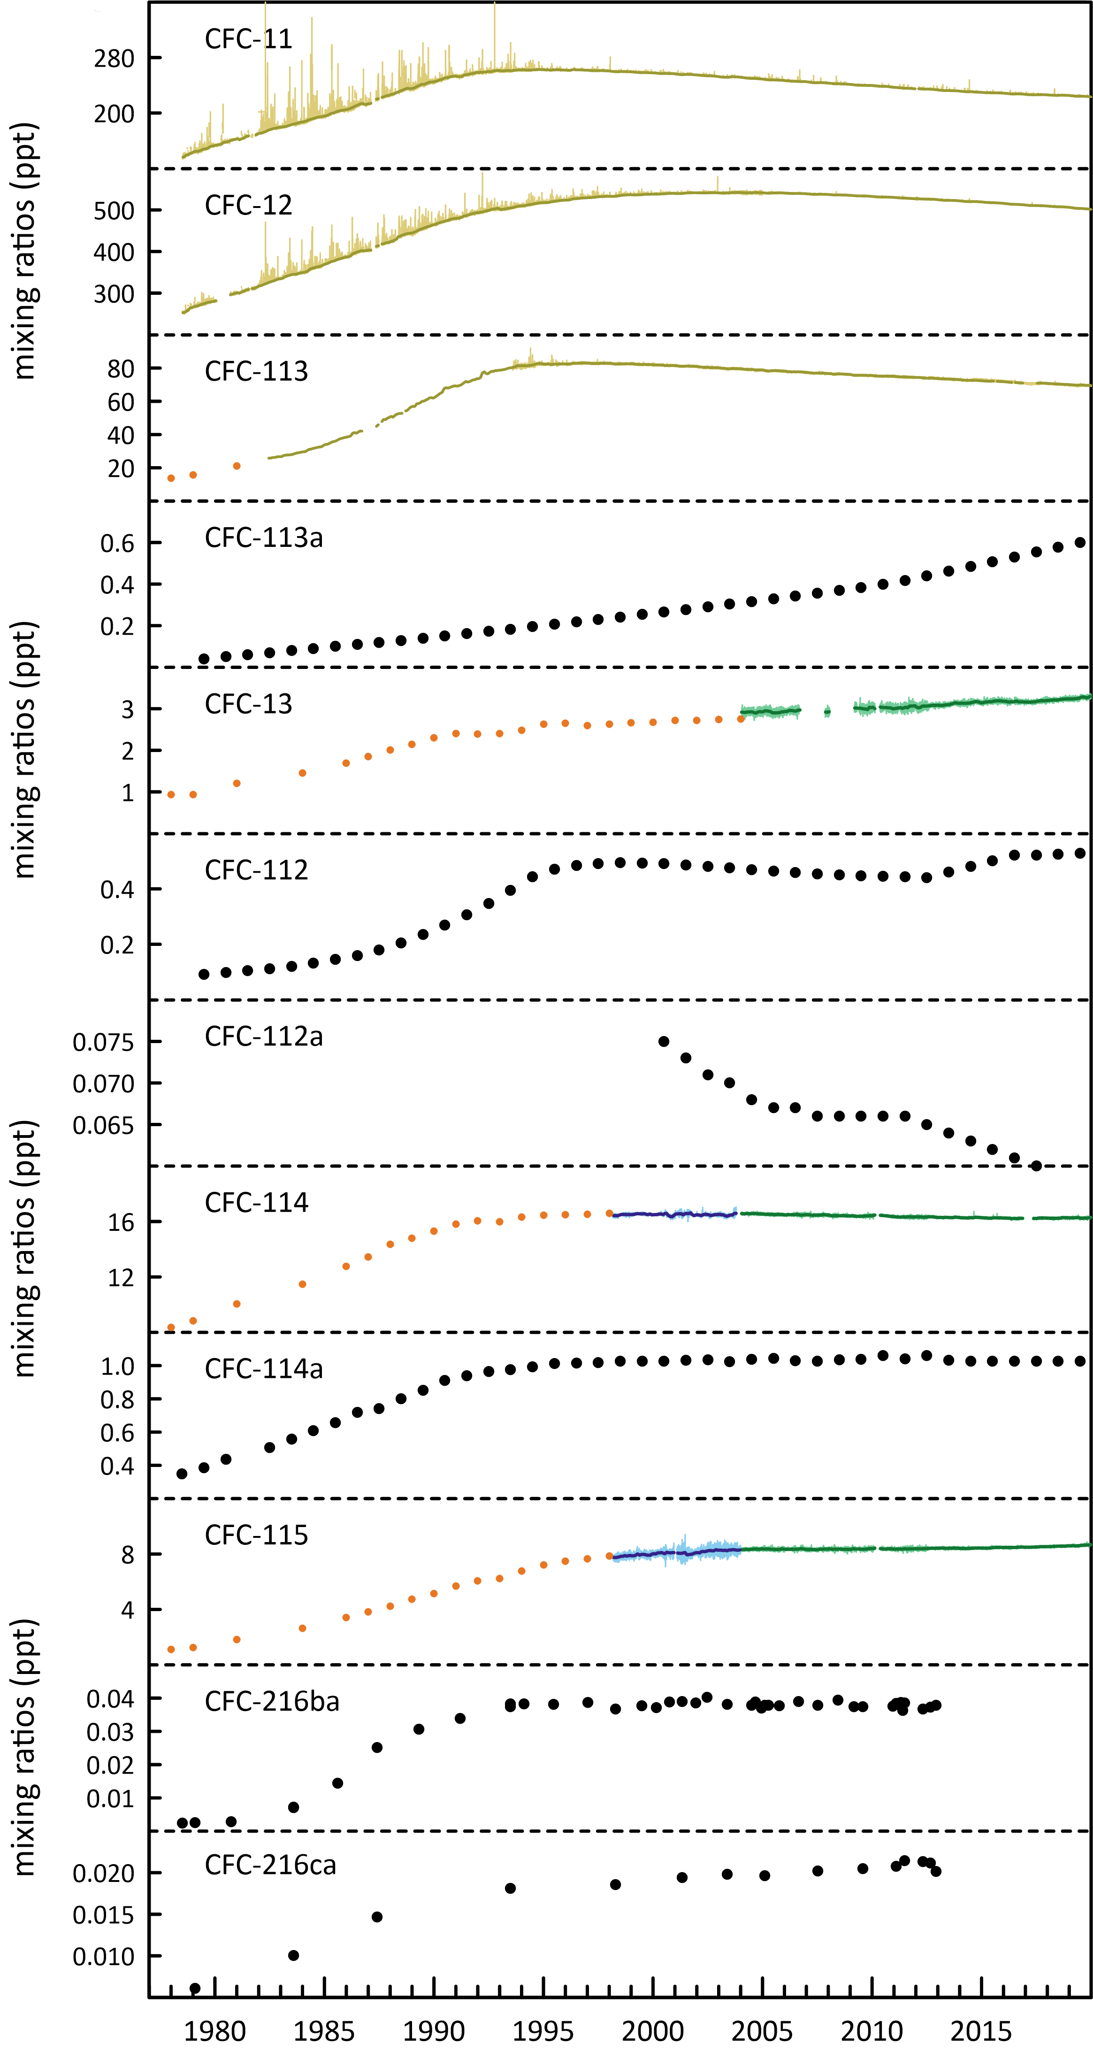

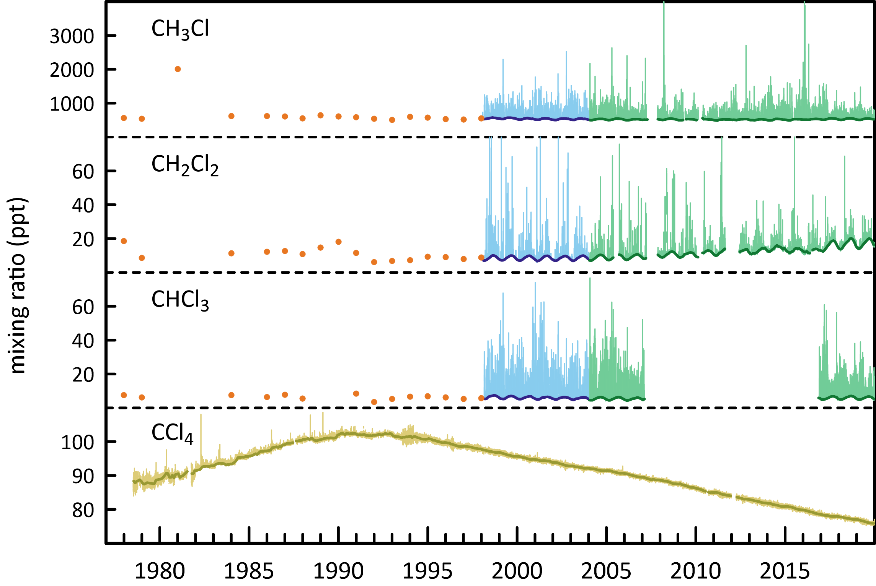

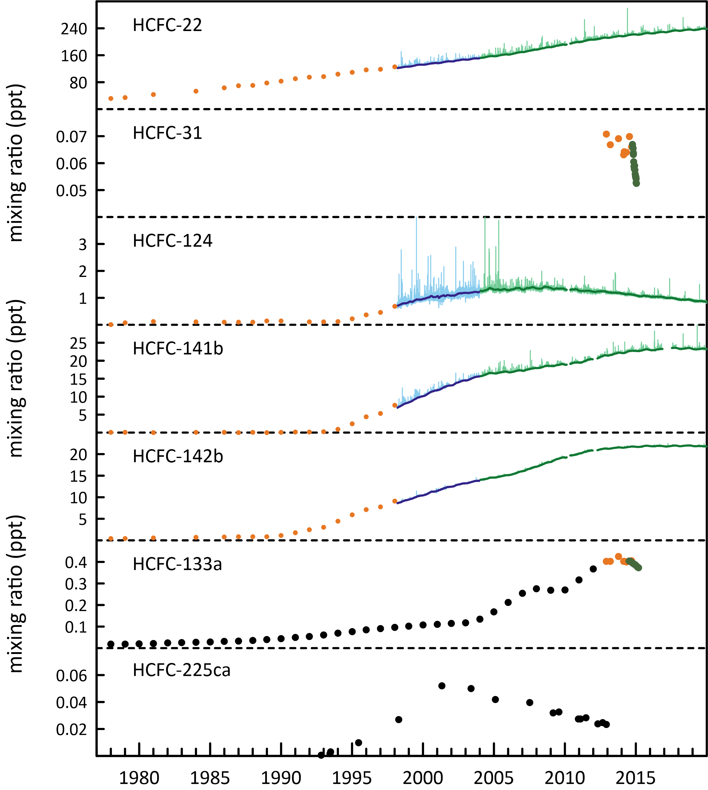

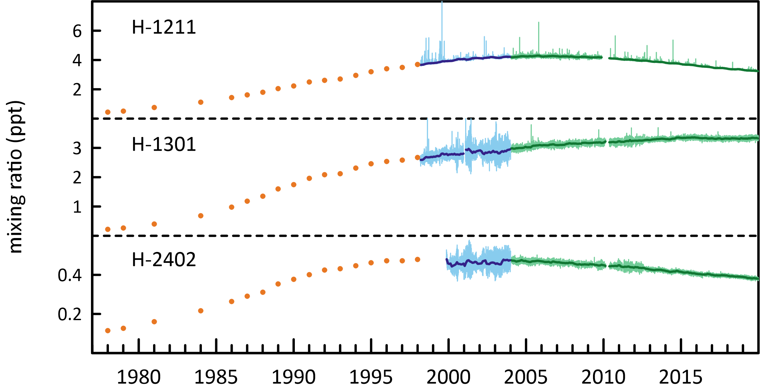

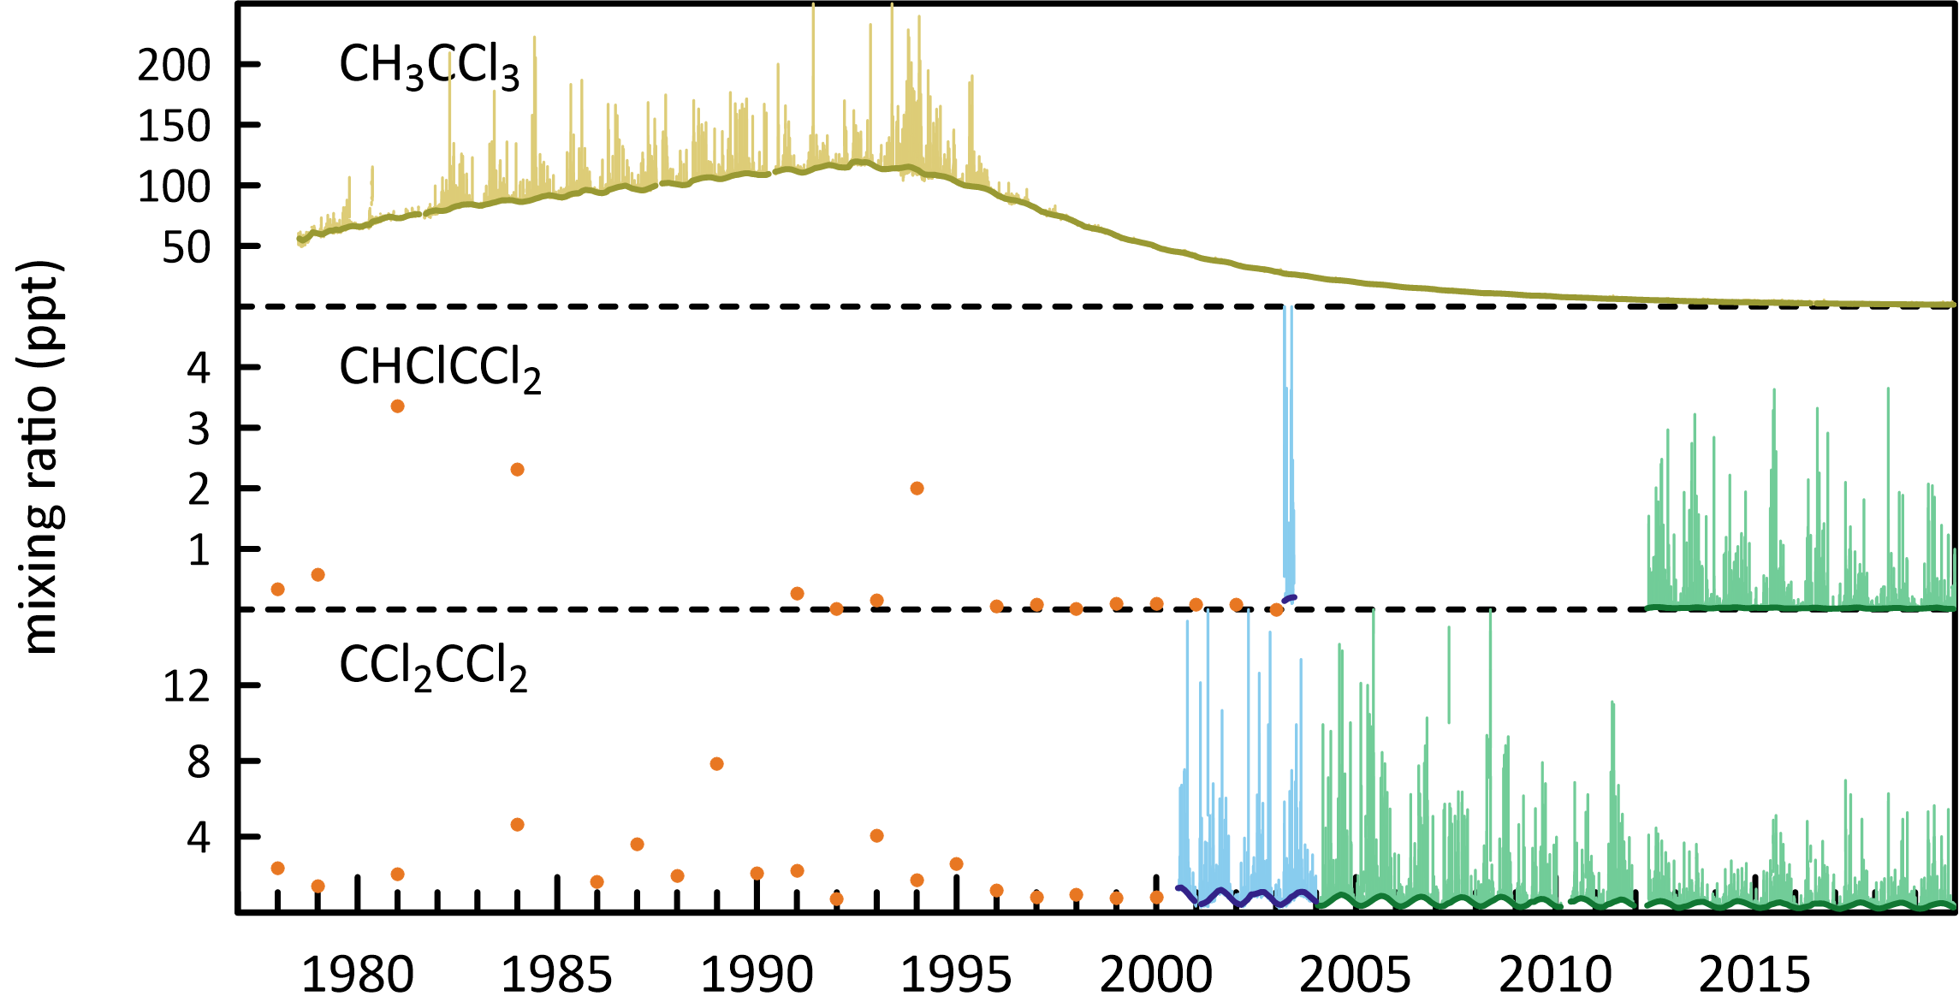

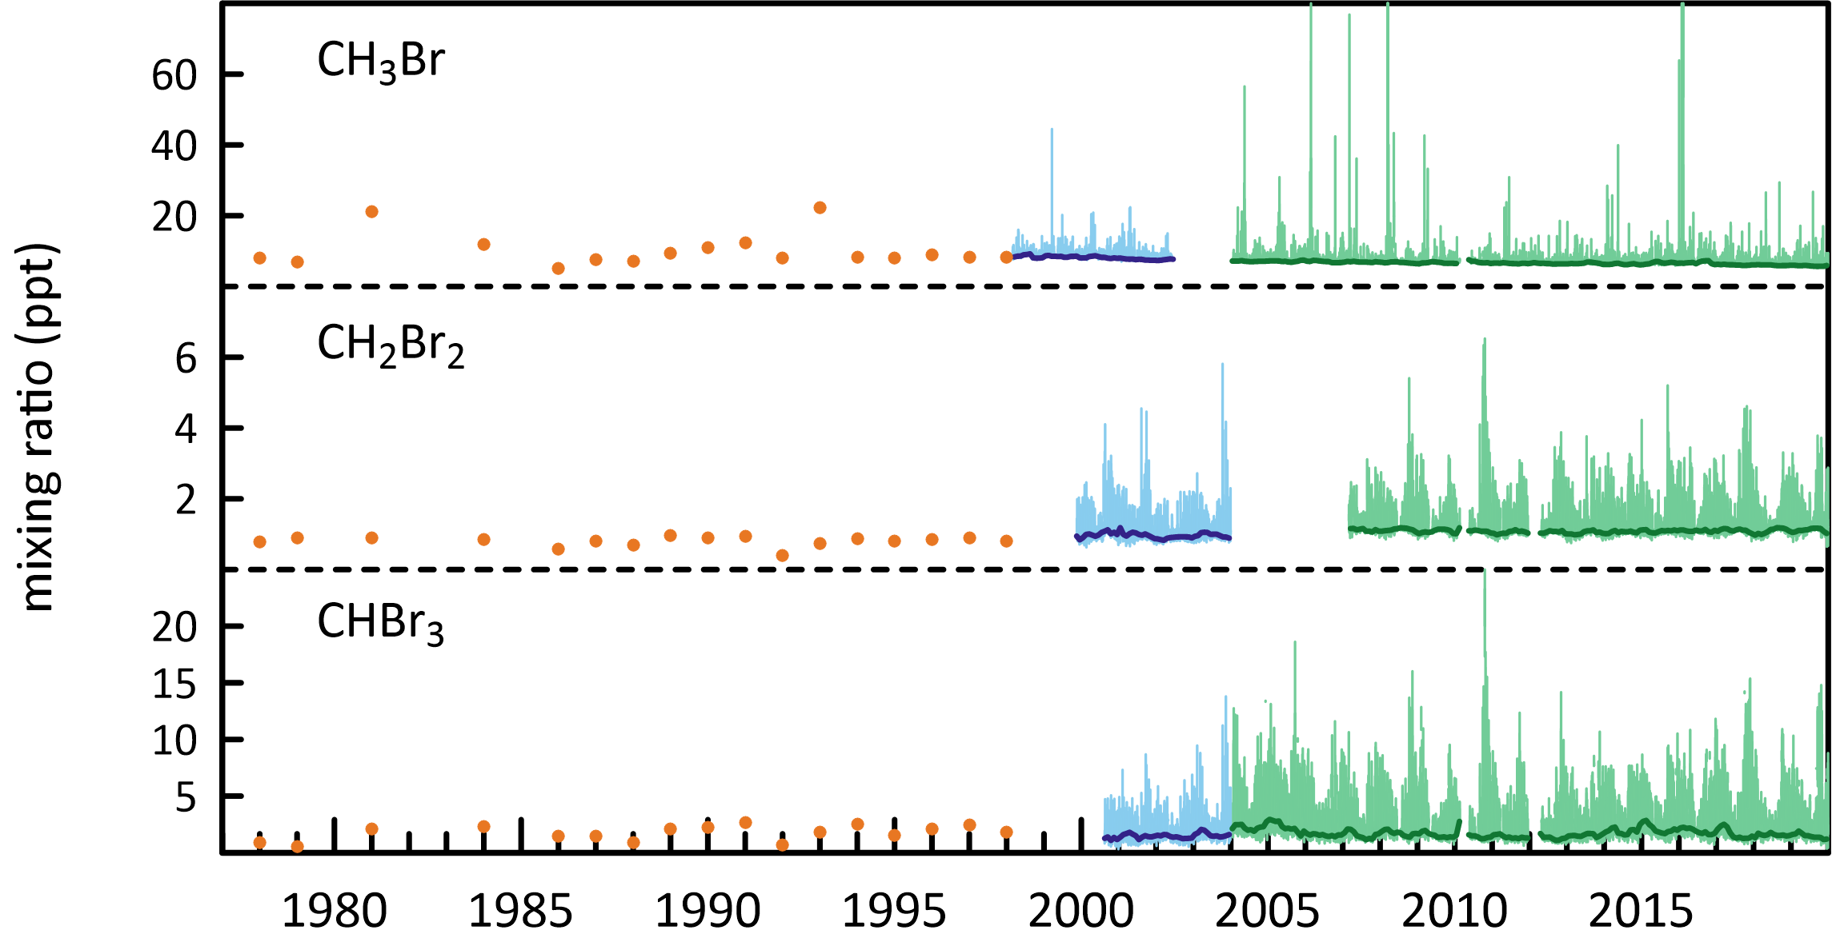

### CFCs

CFC-11 and CFC-12 are the dominant CFCs in the atmosphere, constituting 88% of all CFCs in 2019. CFC-113, CFC-114 and CFC-115 constitute 11% of CFCs, the remaining minor CFCs about 1%. The CFCs account for 62% of chlorine from all ODSs in the background atmosphere.

As a result of measures undertaken within the Montreal Protocol framework, the majority of the CFCs (CFC-11, CFC-12, CFC‐13, CFC-112a and CFC-113) measured in the atmosphere in 2019 at Cape Grim have stopped growing or are in decline, the exceptions being CFC-112, CFC-113a, CFC-114 and CFC‐115, which are growing slowly. Total CFCs measured in the atmosphere are declining by 0.7% per year due to declining emissions; chlorine from CFCs in the atmosphere decreased by 12.4 ppt (2018-2019, 0.6%) slightly more than the decline in 2017-2018.

The summed concentration of the minor CFCs (CFC-112, CFC-112a, CFC-113a, CFC-216ba and CFC-216ca; Kloss *et al.* 2014, Laube *et al.* 2014) in 2019 is 1.2 ppt, while the total CFCs in the background atmosphere sum to 829 ppt in 2019. The summed growth of these minor CFCs in the atmosphere is 0.02 ppt/yr. These low abundance CFCs are thought to be used as chemical feedstocks, or produced as by-products, with some fugitive emissions, or used as specialised solvents (Kloss *et al.* 2014, Laube *et al.* 2014).

Global concentrations of the major CFCs (CFC-11, CFC-12, CFC-113) are all in decline (Figure 2). However, the rate of decline of global CFC-11 concentrations slowed down from -1.67 ppt/yr (2012-2013) to -0.9 ppt/yr (2017-2018). This slow-down in the decline of CFC-11 has been attributed to new likely illegal production of CFC-11 and subsequent emissions from east Asia, around 50 % of which is attributed to China (Montzka *et al*. 2018; Rigby *et al*. 2019). This slow-down in the decline of CFC-11 in the atmosphere appears to be short lived with the rate of decline for 2018-2019 increasing to -1.4 ppt/yr. The rate of decline for CFC-12 has increased from, -2.79 ppt/yr (2012-2013) to -3.7 ppt/yr (2018-2019). The growth rate for CFC-113 has decreased slightly from -0.59 ppt/yr (2012-2013) to -0.55 ppt/yr (2018-2019).

Figure 2. Global concentrations of CFC-11, CFC-12 and CFC-113 (ppt) and WMO A1 scenarios (dashed lines; Harris & Wuebbles, 2014; Carpenter & Daniel, 2018).

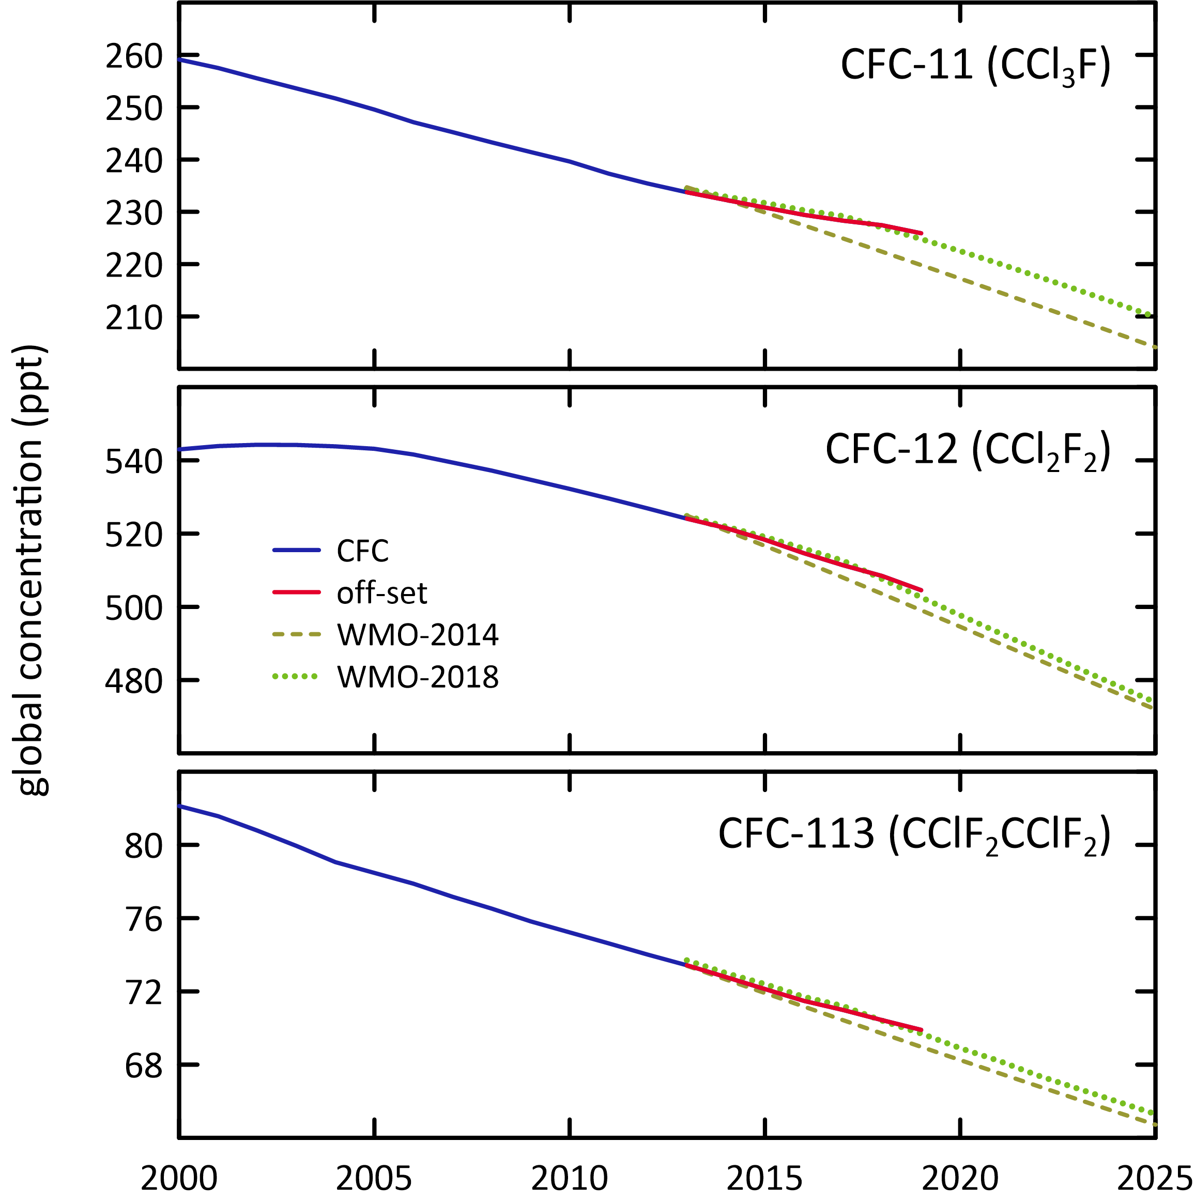

### HCFCs

The major HCFCs measured in the atmosphere in 2019 at Cape Grim are HCFC-22, HCFC-141b and HCFC-142b. HCFC-22 is currently growing at 1% per year, however the growth rate for HCFC-22 has been declining since around 2010. HCFC-142b is currently declining by 0.41% per year and its growth rate has also been declining since 2010. HCFC-141b is declining by 0.59% per year. The dominant HCFC is HCFC-22 (237.1 ppt in 2019), constituting 84% of the abundance and 99% of the growth of all HCFCs. HCFC-141b and HCFC-142b constitute 16% of HCFCs, the remaining minor HCFCs close to 1%. The growth rate of total HCFCs is slowing down. Total HCFCs increased by 2.1 ppt or 0.7% per year (2018-2019) compared to 1.2% per year (2017-2018). Chlorine in the atmosphere from HCFCs (307 ppt in 2019, 9.8% of total chlorine from all ODSs) increased by 1.9 ppt (0.6%, 2018-2019), the only ODS sector showing an increase in chlorine.

HCFC-31 was identified in the Cape Grim Air Archive (Laube *et al*. 2014; Schoenenberger *et al*. 2015; Vollmer *et al*. 2015) in 2015. The background concentration of HCFC-31 is low (0.06 ppt in 2015). HCFC-133a was also identified in the Cape Grim Air Archive and is now measured routinely at Cape Grim, with a background concentration of 0.44 ppt in 2019). There are no clearly identified sources of these HCFCs, but it is possible they are emitted to the atmosphere from an inadvertent by-product emission (Laube *et al*. 2014; Schoenenberger *et al*. 2015; Vollmer *et al*., 2015). It has been suggested that there may have been a change in industrial processes that result in their release to the atmosphere (Schoenenberger *et al*. 2015; Vollmer *et al*. 2015). Measurements of HCFC-132b commenced at Cape Grim in July 2014. The 2019 annual mean HCFC-132b concentration was 0.10 ppt, increasing by 6.8%/yr (2018-2019).

Global concentrations of the most abundant HCFC, HCFC-22, continue to grow in the atmosphere (Figure 3), however the rate of increase has declined almost every year since 2008. The growth rate for HCFC-22 has slowed down from 8.63 ppt/yr (2007-2008) to 2.4 ppt/yr (2018-2019). The growth rate for HCFC-141b decreased from 1.08 ppt/yr (2011-2012) to -0.04 ppt/yr (2018-2019) and concentrations have shown a decline for the second year in a row. The growth rate for HCFC-142b has also declined substantially from 1.17 ppt/yr (2006-2007) to -0.06 ppt/yr (2018-2019) and concentrations for HCFC-142b also appear to have begun a decline. The concentrations of all three HCFCs deviate from the WMO 2014 A1 scenario (Figure 3) and are much lower than the A1 scenario from around 2013 onwards. This scenario assumed that after 2012, all Article 5 countries would continue producing HCFCs at the maximum level allowed under the Montreal Protocol (Engel & Rigby, 2018). All three HCFCs track well with the more recent WMO 2018 scenarios (Figure 3).

The chlorocarbons account for 28% of total chlorine from all ODSs in the background atmosphere. The most abundant chlorocarbon in the background atmosphere is the largely naturally occurring methyl chloride (CH3Cl, 527.2 ppt, 2019), accounting for 84% of all chlorocarbons and 59% of chlorine from chlorocarbons. The next most abundant chlorocarbon is anthropogenic carbon tetrachloride (76.4 ppt, 2019), accounting for 35% of chlorine from chlorocarbons. The remaining minor chlorocarbons, including methyl chloroform, contribute 6% of chlorocarbon chlorine.

Carbon tetrachloride, methyl chloroform, methyl chloride, dichloromethane and perchloroethylene measured at Cape Grim showed decreasing concentrations in 2019 compared to 2018, whereas trichloroethylene showed increasing concentrations. The largest decrease in the chlorocarbons was 0.28 ppt (16%) for methyl chloroform. Significant inter-annual variability is expected for naturally emitted methyl chloride and chloroform, which have oceanic and biomass burning sources. Total chlorine from chlorocarbons decreased by 9.1 ppt (1%).

The dichloromethane growth rate has decreased substantially in the last few years (3.0 ppt/yr, 20%/yr; 2016-2017), down to (1.2 ppt/yr, 7.4%/yr 2017-2018) and for the current year the growth rate is now negative (-0.01 ppt/yr; 2018-2019). Two recent papers (Hossaini *et al*. 2017 and Oram *et al*. 2017) have shown that globally dichloromethane is increasing rapidly in the atmosphere. However, the recent Ozone Assessment (Engel & Rigby 2018) showed recent (2015 to 2016) global growth rates have declined and are small compared to previous years. Engel & Rigby (2018) concluded that currently it can’t be determined whether the recent decrease in growth rate reflects a stabilization of emissions or reflects the large atmospheric variability.

The rate of decline of methyl chloroform is consistent with its relatively short atmospheric lifetime and near-zero global emissions, whereas the rate of decline of carbon tetrachloride in the atmosphere suggests there are remaining, significant carbon tetrachloride sources outside the control of the Montreal Protocol (Engel & Rigby 2018).

Figure 3. Global concentrations of HCFC-22, HCFC-141b and HCFC-142b (ppt) and WMO A1 scenarios (dashed lines; Harris & Wuebbles, 2014; Carpenter & Daniel 2018).

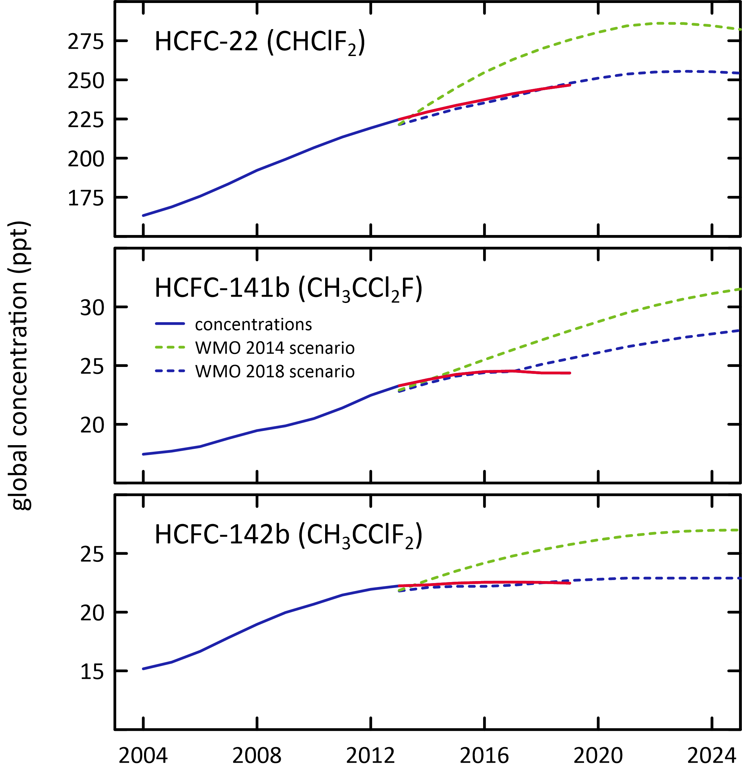

### Other Chlorocarbons ODSs

The chlorocarbons account for 28% of total chlorine from all ODSs in the background atmosphere. The most abundant chlorocarbon in the background atmosphere is the largely naturally occurring methyl chloride (CH3Cl, 527.2 ppt, 2019), accounting for 84% of all chlorocarbons and 59% of chlorine from chlorocarbons. The next most abundant chlorocarbon is anthropogenic carbon tetrachloride (76.4 ppt, 2019), accounting for 35% of chlorine from chlorocarbons. The remaining minor chlorocarbons, including methyl chloroform, contribute 6% of chlorocarbon chlorine.

Carbon tetrachloride, methyl chloroform, methyl chloride, dichloromethane and perchloroethylene measured at Cape Grim showed decreasing concentrations in 2019 compared to 2018, whereas trichloroethylene showed increasing concentrations. The largest decrease in the chlorocarbons was 0.28 ppt (16%) for methyl chloroform. Significant inter-annual variability is expected for naturally emitted methyl chloride and chloroform, which have oceanic and biomass burning sources. Total chlorine from chlorocarbons decreased by 9.1 ppt (1%).

The dichloromethane growth rate has decreased substantially in the last few years (3.0 ppt/yr, 20%/yr; 2016-2017), down to (1.2 ppt/yr, 7.4%/yr 2017-2018) and for the current year the growth rate is now negative (-0.01 ppt/yr; 2018-2019). Two recent papers (Hossaini *et al*. 2017 and Oram *et al*. 2017) have shown that globally dichloromethane is increasing rapidly in the atmosphere. However, the recent Ozone Assessment (Engel and Rigby 2018) showed recent (2015 to 2016) global growth rates have declined and are small compared to previous years. Engel and Rigby, 2018 concluded that currently it can’t be determined whether the recent decrease in growth rate reflects a stabilization of emissions or reflects the large atmospheric variability.

The rate of decline of methyl chloroform is consistent with its relatively short atmospheric lifetime and near-zero global emissions, whereas the rate of decline of carbon tetrachloride in the atmosphere suggests there are remaining, significant carbon tetrachloride sources outside the control of the Montreal Protocol (Engel and Rigby 2018).

### Halons

H-1211 and H-1301 are the most abundant halons in the background atmosphere (3.3 ppt, 2019), followed by H-2402 (0.4 ppt). H-1211 and H-2402 are in decline in the atmosphere (-0.09 ppt/yr and -0.008 ppt/yr respectively, 2018-2019). H-1301 growth rates have increased slightly from (0.002 ppt/yr; 2017-2018) to 0.009 ppt/yr 2018-2019. Overall halons are in decline by 1.3% per year (compared to 1.2%/yr 2017-2018), a larger rate of decline (in percentage terms) compared to the CFCs. Bromine in the atmosphere from halons decreased by 0.1 ppt/yr (1.3%). The decline in bromine from halons is a significant driver of likely ozone recovery (see Krummel *et al*. 2019).

### Other organobromine species

Methyl bromide is the most abundant (5.8 ppt) organobromine ODS in the background atmosphere in 2019, followed by H-1211 (3.3 ppt), H-1301 (3.3 ppt), bromoform (1.5 ppt) and dibromomethane (1.1 ppt).

Methyl Bromide showed a small decrease (0.18 ppt/yr 2018-2019) in the background atmosphere. There is an overall long-term decrease in methyl bromide in the atmosphere since about 2000, which briefly halted in 2012-2013 and 2014-2015. Because there are significant natural emissions of methyl bromide, year-to-year variability in the rate of decline or growth is expected.

Natural bromoform showed a decrease (0.08 ppt/yr) and natural dibromomethane showed a small increase (0.02 ppt/yr) in 2018-2019. Overall bromine from all non-halon ODSs decreased by 0.39 ppt/yr (2018-2019), a 3%/yr decrease, largely due to the decrease in bromine from bromoform and methyl bromide. This is the fourth year in a row that background levels of bromoform have decreased. In 2014-2015, bromoform was at its highest concentration for the last decade. Significant inter-annual variability is expected for naturally emitted dibromomethane and bromoform, which have oceanic sources. Long-term trends (decadal) have not been found for these species (Carpenter & Reimann 2014).

### Total chlorine and bromine: impact on stratospheric ozone

Total chlorine from ODSs (Figure 4) decreased from 3163 ppt in 2018 to 3143 ppt in 2019, a decrease of 20 ppt (0.62%). This total is also 10% lower than its peak value in 1994. Total chlorine from chlorocarbons decreased by 9.1 ppt (1%). The overall decline in chlorine from CFCs was 12.4 ppt (2018-2019) and HCFC chlorine increased by 1.9 ppt.

Total bromine from organobromine ODSs (Figure 5) was 19.9 ppt (2019) - 37% from halons, 29% from methyl bromide, 23% bromoform and 11% dibromomethane. Bromine from all ODSs decreased by 0.48 ppt (2018-2019, 2.4%), due to -0.1 ppt/yr from the halons and -0.39 ppt/yr from the non-halon ODSs. The variability in total bromine compared to total chlorine is due to the relatively larger natural (therefore variable) contributions to bromine compared to chlorine.

Figure 4. Total chlorine from CFCs, HCFCs, carbon tetrachloride: CCl4, methyl chloroform: CH3CCl3 and other chlorine-containing ODSs (Table 1) as measured at Cape Grim.

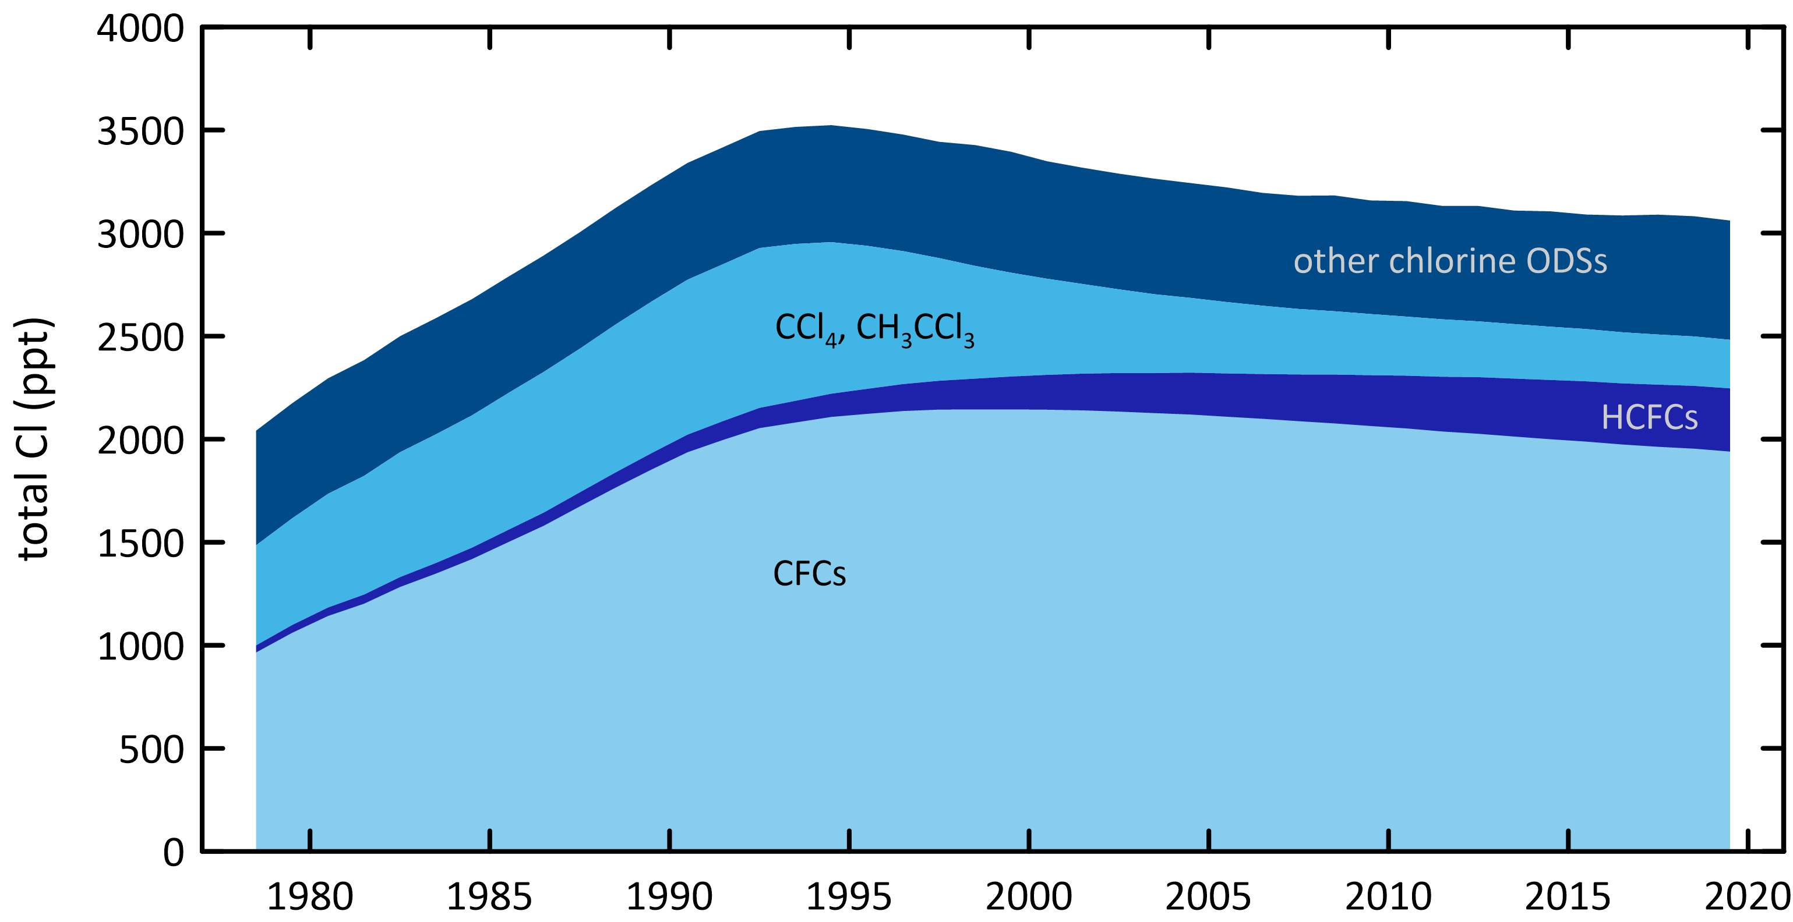

Figure 5. Total bromine from methyl bromide: CH3Br, halons and other bromine-containing ODSs (dibromomethane: CH2Br2 and bromoform: CHBr3) as measured at Cape Grim (Table 1).

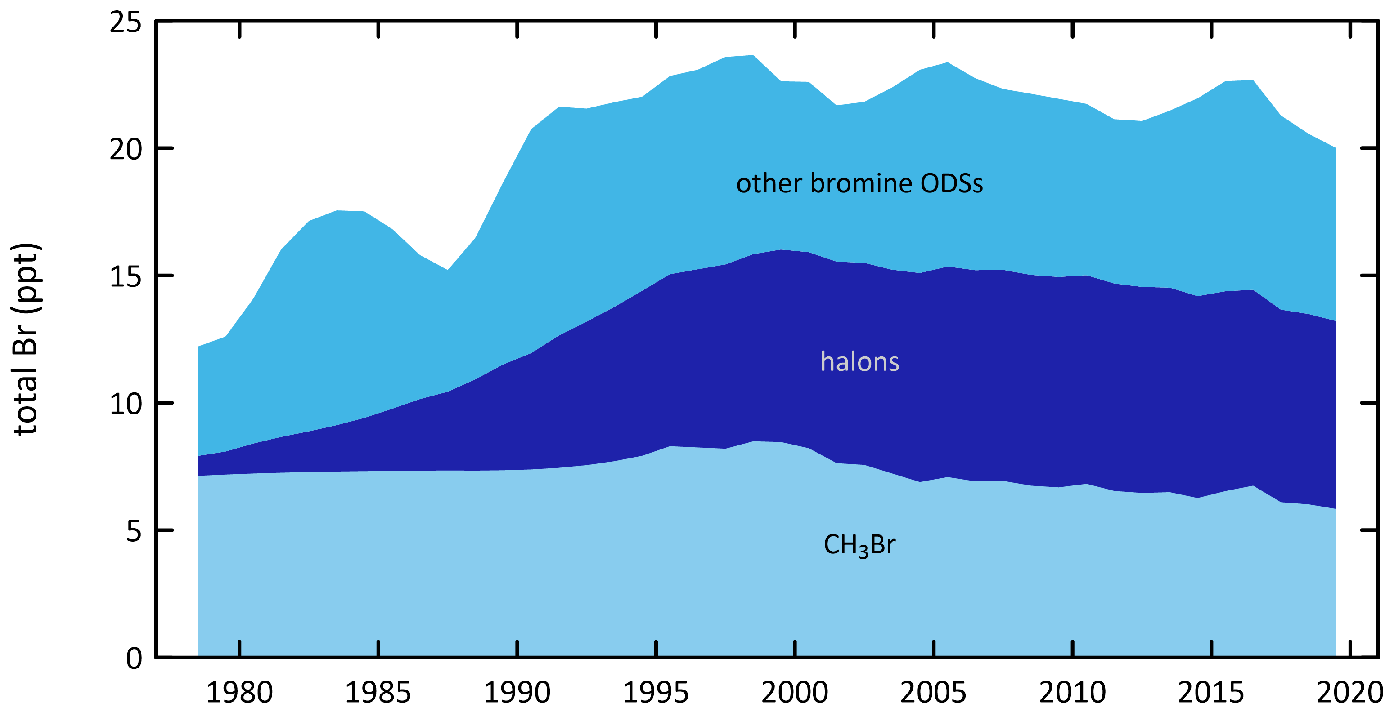

The impact of total chlorine and bromine from ODSs on stratospheric ozone at polar and mid-latitudes is discussed in detail in the companion Report on the 2019 Antarctic Ozone Hole (Krummel *et al*., 2020). Figure 6 shows the strong correlation between ozone depletion over Antarctica (Halley Station) and at mid-latitudes in the Southern Hemisphere (Melbourne). In both regions there is a strong indication of the onset of significant ozone recovery.

Figure 6. Total column ozone (DU) changes at Halley Station, Antarctica (76°S; left), and Melbourne, Australia (38°S; right) and Equivalent Effective Stratospheric Chlorine (EESC, ppb) changes at polar and mid-latitudes. The Melbourne ozone data are 11-year running means to minimise impacts of solar variability.

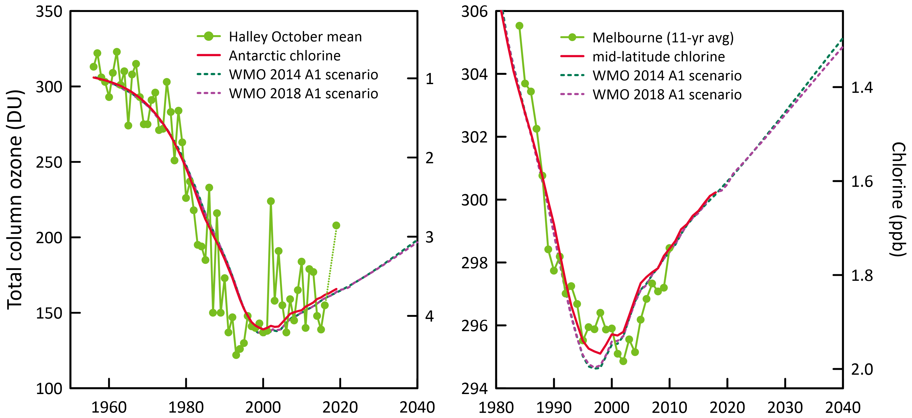

### Global radiative forcing from ODSs, HFCs and other SGGs

ODSs and other synthetic greenhouse gases (SGGs, for example hydrofluorocarbons – HFCs) make a significant contribution to global radiative forcing (Figure 7). Radiative forcing from total SGGs almost stopped growing in the background atmosphere in the 1990s, due to the overall success of the Montreal Protocol, but recommenced growing in the 2000s due to growing global emissions of HFCs and growing emissions of HCFCs from developing countries prior to their phase-out commencing. Montreal Protocol HCFC phase-out controls will affect these emissions from the developing world with the next phase-out target being 35% reduction by 2020. Global HFC emissions should also start being restrained now that the Kigali Amendment to the Montreal Protocol has entered into force (1st January 2019). The Kigali Amendment mandates a phase-down schedule for HFC production and consumption. Hopefully this will lead to another ‘plateau’ in radiative forcing from SGGs in the next 5-10 years. Unreported and unexpected emissions of CFC-11 in East Asia after the phase-out date of 2010 have also contributed to increased radiative forcing.

Total radiative forcing due to ODSs and other SGGs is increasing by 0.3%/yr (2018-2019). Radiative forcing from CFCs contributes 67% of total SGG radiative forcing but is in decline by 0.7%/yr (2018-2019). HCFCs currently contribute 16% of SGG radiative forcing and the HCFC contribution is increasing by 1%/yr (2018-2019). The remaining ODSs (halons, chlorocarbons) currently contribute 4% of SGG radiative forcing but is in decline by 3%/yr (2018-2019).

Figure 7. Global abundance (ppb, left) and radiative forcing (W/m2, right) of synthetic greenhouse gases (SGGs: HFCs, HCFCs, CFCs, others).

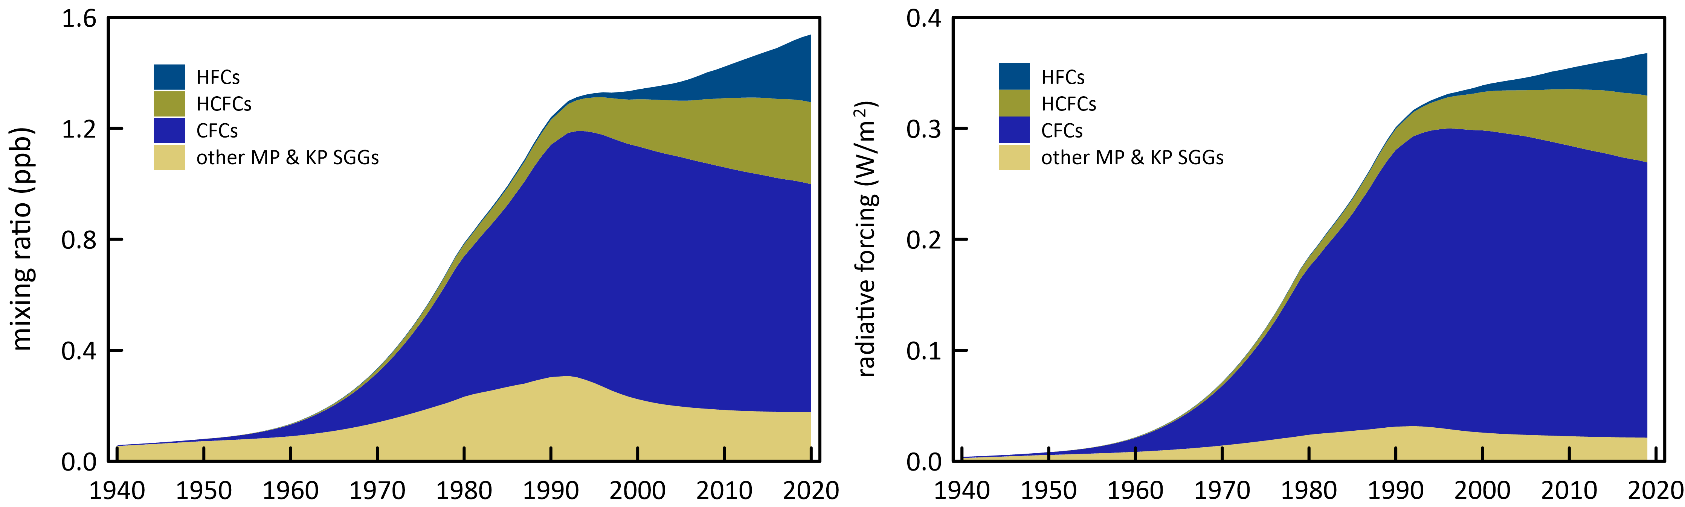

## Australian ODS imports and banks

Data on Australian imports of ODSs are reported to the Australian Government (Department of Agriculture, Water and the Environment - DAWE) under licensing arrangements in the *Ozone Protection and Synthetic Greenhouse Gas Management Act, 1989*, with the requirement being established under the Act in 1989. Australian imports are documented in the DAWE *Ozone Licensing and Reporting System* (OLaRS: A. Gabriel, AWE, private communications, 2014-2019), which was introduced during 2011, replacing previous import data recording systems. OLaRS details imports of bulk and pre-charged refrigeration and air conditioning equipment containing HCFCs (individual HCFCs or HCFC blends) and other bulk ODSs (in particular, carbon tetrachloride and methyl bromide). Imports of ODSs are shown in Table 2 and Figure 8.

There is an overall decline in Australian ODS imports from over 15,000 tonnes in 1991 to 870 tonnes in 2019, a long-term decline of about 250 tonnes per year since 1995. ODS imports in 2019 increased by 90 tonnes from the previous year to 870 tonnes, due to methyl bromide imports increasing from 742 tonnes (2018) to 823 tonnes (2019), for quarantine and pre-shipment applications.

In 1991, CFCs were the major ODS imports (7,144 tonnes), but they declined rapidly to 371 tonnes by 1996, an overall decline of about 50% per year as a result of the phase-out by the Montreal Protocol, except for a few essential uses. By 2003 CFC imports were virtually zero. Methyl chloroform (MC) was the second largest ODS import in 1991 (4,700 tonnes) but imports ceased by 1996. HCFCs import nearly doubled between 1991 (2,400 tonnes) and 1998 (4,200 tonnes); since 1998 there has been a long-term decline in HCFC imports, falling to 45 tonnes per year from 2016-2019. Australia has reached its second last step in its HCFC phase out, with an annual import limit for HCFCs of around 45 tonnes of HCFC-22 from 2016 to 2029 (DoEE 2016).

Figure 8. Australian imports (tonnes) of ODSs (CFCs, HCFCs, halons, MC: CH3CCl3, MB: CH3Br) (A. Gabriel, DAWE, private communication, 2019).

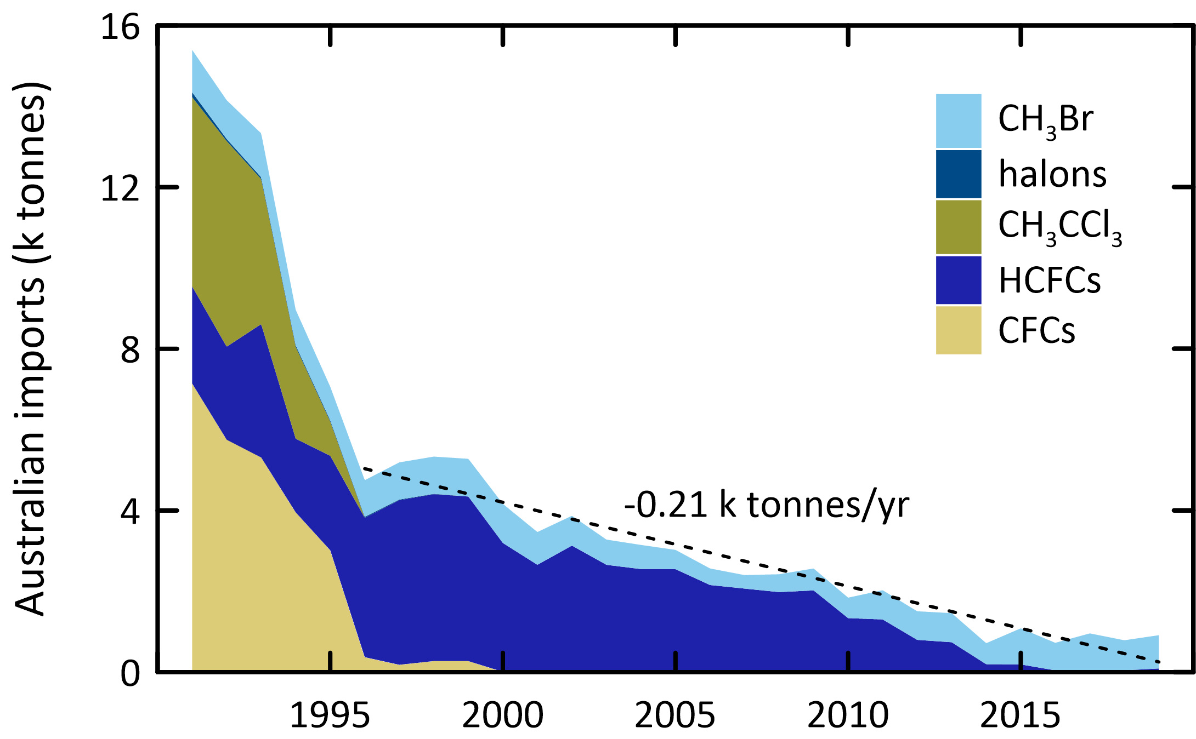

Methyl bromide (MB) imports were just over 1,000 tonnes per year in the early 1990s, falling to about 350 tonnes in 2007, a long-term decline of 8% per year, driven by the reduction in non-QPS use of methyl bromide, drought, trade patterns and trading partner requirements (Note: MB values used here are imports minus exports). After 2007, methyl bromide imports increased and since 2011, imports have remained high, ranging from 519 to 915 tonnes per year. Methyl bromide imports in 2019 were 823 tonnes. The increase in methyl bromide imports since 2007 has been driven by an increase in QPS use of methyl bromide. Variations in QPS demand for methyl bromide in Australia will likely follow overall grain and wood products production trends, trading partner requirements and the use of methyl bromide alternatives (for example phosphine and sulfuryl fluoride). Grain production increased from about 20 M tonnes at the height of the recent drought (2006/2007) to 42 M tonnes in 2017/2018 (ABARES 2018a, ABARES 2018b). Imports of methyl bromide for non-QPS use fell to 30-35 tonnes by the mid-2000s and is now around 29 tonnes per year.

The current Australian CFC banks have been estimated at, CFC-11: 5,000-16,000 tonnes, CFC-12: 2,000-7,000 tonnes and CFC-113: 500-2,000 tonnes (Fraser *et al*. 2020). The Australian HCFC-22 bank was estimated at 13,450 tonnes in 2007 with a projected decline (Brodribb & McCann 2018) to 4,464 tonnes in 2019. The only other significant ODS bank in operational equipment is HCFC-123, with a bank of 2,320 tonnes in 2003 with a projected decline to 190 tonnes in 2019 (Brodribb & McCann 2018). The updated bank and bank emissions from Brodribb & McCann (2018) are included in Figure 9 (dashed lines: blue=banks, red=bank emissions).

Australian HCFC-22 and HCFC-123 emissions have been estimated using refrigerant bank data and specific emission factors for refrigeration/air conditioning equipment (Figure 9; Brodribb & McCann 2015, 2018). HCFC-22 emissions have been estimated to have declined from around 1,320 tonnes in 2003 to 261 tonnes in 2019. HCFC-123 emissions in 2019 were estimated at about 4 tonnes (Brodribb & McCann 2018).

Figure 9. Australian HCFC-22 and HCFC-123 banks and HCFC-22 bank emissions (Brodribb & McCann 2013, 2014, 2015). Dashed line is from Brodribb & McCann (2018): blue= banks, red=bank emissions.

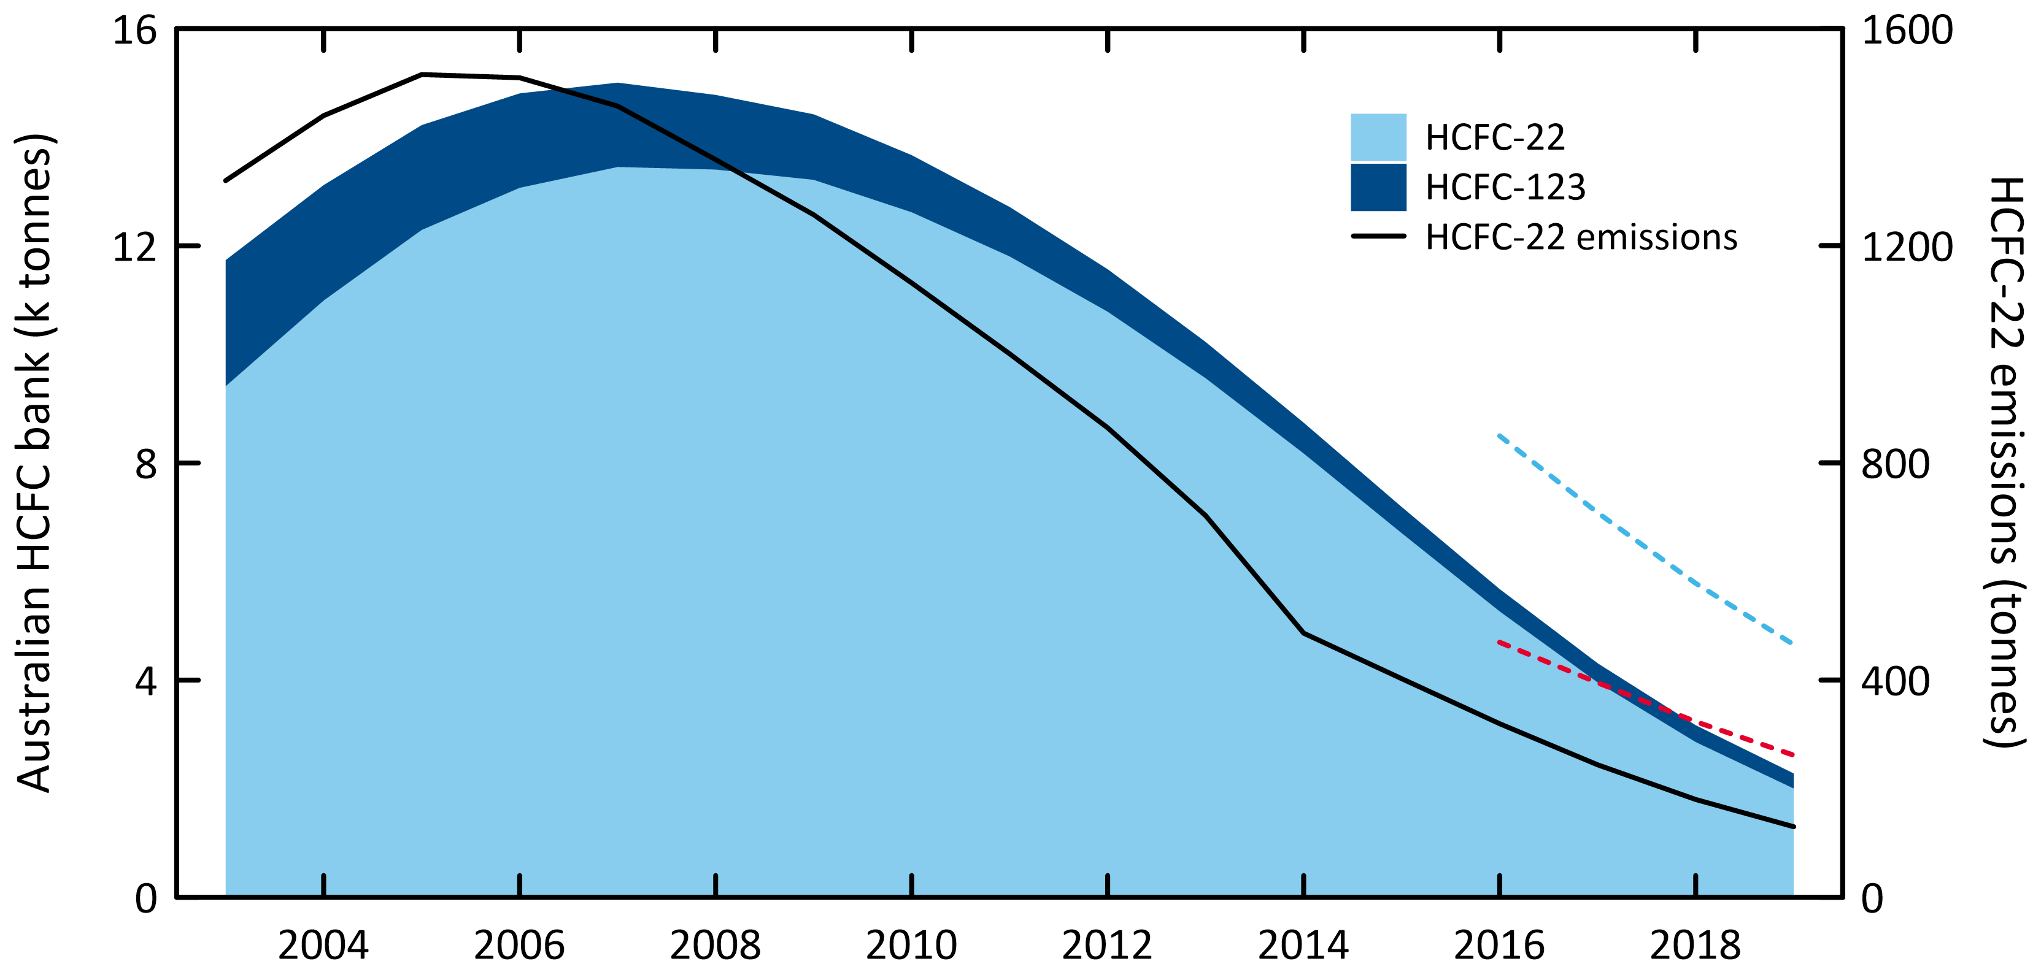

Table 2. Australian imports (bulk and pre-charged equipment, tonnes) of ODSs (CFCs, HCFCs, MC: CH3CCl3, halons, MB: CH3Br) 1991-2019; 2012-2019 data are from the OLaRS data base, 2010 and earlier are pre-OLaRS data, and 2011 is a mixture of OLaRS and pre-OlaRS data (A. Gabriel, DAWE private communications, 2014-2019). The only significant carbon tetrachloride (CCl4) imports were ~0.5 tonnes in 1995/1996 (not listed). ODS imports less than 0.1 tonne are not listed but included in total ODS, Methyl bromide imports are listed as for QPS and non-QPS uses. Small quantities of methyl bromide imports are exported (do not influence Australian emissions); significant quantities HCFC-123 imports are exported or used as feedstock (do not influence Australian emissions) – for example 10 tonnes exported and 3 tonnes used for feedstock in 2014, ~1 tonne exported 2015).

|  |  |  |  |  |  |  |  |  |  |  |  |  |  |  |  |  |  |  |  |  |  |
| --- | --- | --- | --- | --- | --- | --- | --- | --- | --- | --- | --- | --- | --- | --- | --- | --- | --- | --- | --- | --- | --- |
|  | CFCs | | | | | Total CFCs | HCFCs | | | | | | Total HCFCs |  | Halons | | Total Halons | CH3Br imports | | | Total ODSs |
|  | -11 | -12 | -113 | -114 | -115 | -22 | -123 | -124 | -141b | -142b | -225ca | CH3CCl3 | -1211 | -1301 | n-QPS | QPS | Total |
| 1991 | 1759 | 4049 | 999 | 6 | 331 | 7144 | 2402 |  |  |  |  |  | 2402 | 4680 | 111 | 11 | 122 | 876 | 172 | 1048 | 15396 |
| 1992 | 1786 | 3054 | 808 | 19 | 84 | 5751 | 2252 | 17 |  | 30 | 3 |  | 2302 | 5086 | 14 | 39 | 53 | 799 | 160 | 959 | 14151 |
| 1993 | 1443 | 3205 | 485 | 6 | 172 | 5311 | 2940 | 60 | 8 | 269 | 23 | 1 | 3301 | 3586 |  |  |  | 921 | 166 | 1087 | 13285 |
| 1994 | 927 | 2784 | 168 | 11 | 64 | 3954 | 1328 | 67 | 2 | 411 | 14 | 1 | 1823 | 2273 |  |  |  | 704 | 172 | 876 | 8926 |
| 1995 | 498 | 2229 | 236 | 7 | 46 | 3016 | 1663 | 74 | 49 | 522 | 29 | 0.9 | 2338 | 846 |  |  |  | 664 | 168 | 832 | 7032 |
| 1996 | 69 | 181 | 118 | 3 |  | 371 | 2626 | 59 | 93 | 579 | 89 | 0.8 | 3448 | 0.1 |  |  |  | 631 | 276 | 907 | 4726 |
| 1997 | 52 | 129 | 0.1 | 3 |  | 184 | 3056 | 52 | 195 | 639 | 130 | 0.7 | 4071 | 0.1 |  |  |  | 660 | 259 | 919 | 5174 |
| 1998 | 90 | 182 | 0.1 | 3 |  | 275 | 2900 | 72 | 189 | 827 | 141 | 0.6 | 4129 | 0.1 |  |  |  | 569 | 352 | 921 | 5325 |
| 1999 | 90 | 182 | 0.1 | 3 |  | 275 | 2955 | 76 | 140 | 813 | 87 | 0.4 | 4071 | 0.1 |  | 1 |  | 507 | 425 | 932 | 5279 |
| 2000 |  | 8 |  | 1 |  | 9 | 2160 | 20 | 56 | 892 | 59 | 0.3 | 3187 |  |  |  |  | 452 | 516 | 968 | 4164 |
| 2001 |  | 8 |  | 1 |  | 9 | 2228 | 7 | 60 | 301 | 52 | 0.6 | 2648 |  |  |  |  | 335 | 475 | 810 | 3467 |
| 2002 |  | 8 |  | 1 |  | 10 | 2557 | 34 | 46 | 446 | 40 | 0.2 | 3123 |  |  |  |  | 323 | 415 | 738 | 3870 |
| 2003 | 1 |  |  |  |  | 1 | 2054 | 11 | 64 | 473 | 54 | 0.2 | 2656 |  |  |  |  | 183 | 441 | 624 | 3281 |
| 2004 |  |  |  |  |  |  | 2053 | 31 | 43 | 396 | 27 | 0.4 | 2551 |  |  |  |  | 207 | 390 | 597 | 3148 |
| 2005 |  |  |  |  |  |  | 1979 | 28 | 29 | 428 | 84 | 0.7 | 2548 |  |  |  |  | 119 | 358 | 477 | 3025 |
| 2006 |  |  |  |  |  |  | 1843 | 15 | 15 | 241 | 40 | 0.3 | 2156 |  |  |  |  | 55 | 355 | 410 | 2566 |
| 2007 |  |  |  |  |  |  | 1808 | 18 | 18 | 198 | 26 | 0.4 | 2068 |  |  |  |  | 46 | 288 | 334 | 2402 |
| 2008 |  |  |  |  |  |  | 1773 | 21 | 20 | 155 | 12 | 0.4 | 1981 |  |  |  |  | 41 | 401 | 442 | 2423 |
| 2009 |  |  |  |  |  |  | 1878 | 48 | 13 | 76 | 8 | 0.5 | 2023 |  |  |  |  | 33 | 509 | 543 | 2566 |
| 2010 |  |  |  |  |  |  | 1224 | 26 | 32 | 49 | 5 | 0.3 | 1336 |  |  |  |  | 34 | 472 | 506 | 1842 |
| 2011 |  |  |  |  |  |  | 1280 | 8 | 5 | 3 | 3 | 0.4 | 1300 |  |  |  |  | 33 | 689 | 722 | 2022 |
| 2012 |  |  |  |  |  |  | 758 | 20 | 4 |  | 2 | 0.5 | 784 |  |  |  |  | 33 | 676 | 709 | 1493 |
| 2013 |  |  |  | 0.0 | 0.0 | 0.0 | 714 | 14 | 4 |  | 2 | 0.4 | 734 |  | 0.1 | 1 | 1 | 32 | 618 | 650 | 1386 |
| 2014 |  |  |  |  |  |  | 181 | 4 | 0.5 |  | 0.3 | 0.3 | 186 |  | 0.4 | 3 | 3 | 30 | 489 | 519 | 708 |
| 2015 |  | 0.0 |  |  |  | 0.0 | 181 | 9 | 1 |  |  | 0.3 | 192 |  |  |  |  | 30 | 864 | 894 | 1086 |
| 2016 |  |  |  |  |  |  | 45 |  |  |  |  | 0.3 | 46 |  |  |  |  | 28 | 653 | 681 | 727 |
| 2017 |  | 0.0 |  |  |  | 0.0 | 42 |  |  |  |  |  | 42 |  | 1 | 0.8 | 2 | 30 | 885 | 915 | 960 |
| 2018 |  |  |  |  |  |  | 45 |  |  |  |  |  | 45 |  | 0.3 | 2 | 2 | 30 | 713 | 742 | 790 |
| 2019 |  |  |  |  |  |  | 46 |  |  |  |  |  | 46 |  | 0.5 | 1 | 2 |  |  | 823 | 870 |

# 

## Estimated Australian and Global ODS emissions

Estimates of emissions of CFCs, HCFCs, methyl chloroform, carbon tetrachloride, halons and methyl bromide from the Melbourne/Port Phillip region (Dunse *et al*. 2001, 2005; Dunse 2002; Greally *et al*. 2007; Fraser *et al*. 2012, 2013, 2014b), have been made utilising *in situ* measurements from the Cape Grim Baseline Air Pollution Station in Tasmania and an interspecies correlation (ISC) technique with co-incident carbon monoxide (CO) measurements and an independent estimate of carbon monoxide emissions. For more information on the carbon monoxide emissions see Appendix A.

Port Phillip ODS emissions have been calculated, for 1994-2018, using Cape Grim *in situ* data and ISC, obtained from the GC-ECD and GC-MS instruments at Cape Grim, and scaled to Australian emissions, where appropriate, on a population basis (using a population-based scale factor of 5.4). NOAA air mass back trajectory analyses (Draxler & Hess 1997) are used to ensure that the pollution events at Cape Grim used to derive Port Phillip emissions are imbedded in air masses that only pass over the Port Phillip region and do not include other possible carbon monoxide source regions, in particular the Latrobe Valley.

South East (SE) ODS emissions can be calculated from Cape Grim data using the NAME (Numerical Atmospheric dispersion Modelling Environment) particle dispersion model coupled to the InTEM (Inversion Technique for Emission Modelling) inversion model (O’Doherty *et al*. 2009; Manning *et al*. 2003, 2011; Redington & Manning 2018). NAME is a Lagrangian particle dispersion model driven by 3-dimensional wind fields from numerical weather predictions models. For a more detailed description of the NAME/InTEM model see Appendix A.

The current InTEM model domain used to derive emissions (VextT) incorporates all of Victoria and Tasmania as well as southern and south western New South Wales and eastern South Australia. The inversion results from this domain are referred to as InTEM in this report. Previous inversions have used a domain incorporating all of Victoria, Tasmania and New South Wales. These older inversions are referred to as NAME in this report. Emissions are presented as 3-year running averages of emissions (i.e. 2008 annual emissions are derived from 2007-2009 data). The Australian emissions are calculated from InTEM (VextT) using a population based scale factor of 2.6, and are shown in Figure 10.

Australian halon emissions are derived from SE Australian emissions (ISC), assuming 6-8 % of SE Australian emissions are from the National Halon Bank located in Melbourne (see section 3.3). The SE Australian (non-Halon Bank) halon emissions are scaled to Australian emissions based on population.

To estimate Australian methyl bromide emissions (QPS) we begin with the SE Australian methyl bromide emissions estimated using the ISC method and then subtract the non-QPS SE Australian emissions. Australian emissions are obtained by scaling this result using a scaling factor (35%) that is based on the proportion of Australia’s grain exports originating from SE Australian ports.

Figure 10. Annual average (3-year running means) Australian emissions of CFCs, methyl bromide, HCFCs, halons and chlorocarbons (methyl chloroform, carbon tetrachloride, chloroform, dichloromethane, trichloroethylene, perchloroethylene) from Cape Grim AGAGE data, using ISC techniques (orange: GC-ECD data; green: GC-MS data). methyl bromide emissions are for SE Australia. Australian emissions are scaled from SE Australian emissions on a population basis; halon emissions are adjusted to account for SE Australian Halon Bank emissions. InTEM emissions are show in light blue. HCFC-22 emissions from the refrigerant bank are show in red (Brodribb & McCann 2015).

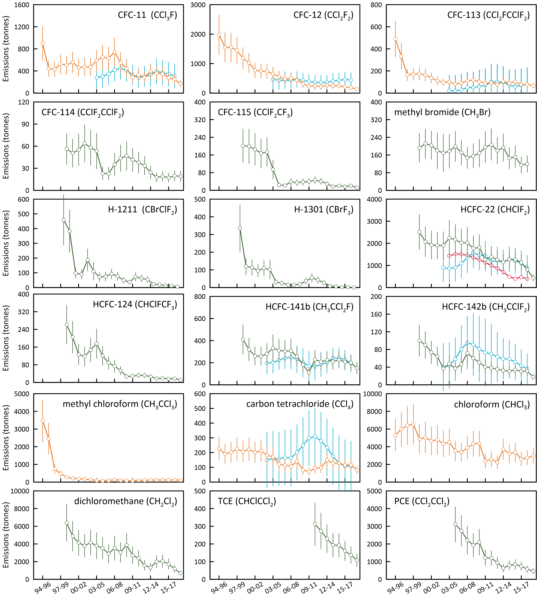

Australian HCFC-22 emissions have been estimated using an emissions model based on HCFC-22 imports, and estimates of the HCFC-22 bank as refrigerants and refrigerant leakage rates from the bank (Figure 9; Brodribb & McCann 2015).

The Australian emissions of ODSs - CFCs, HCFCs, halons, MB, Montreal Protocol chlorocarbons (methyl chloroform, carbon tetrachloride) other chlorocarbons (dichloromethane, chloroform, trichloroethylene, perchloroethylene) - are presented as 3-year running averages (1995-2018: Table 3, Figure 10).

Global ODS emissions have been calculated using background ODS observations at Cape Grim and from other AGAGE stations in the Northern and Southern Hemispheres up to 2018 (Figure 11; Rigby *et al*. 2014 and updates; Vollmer *et al*. 2015). These emissions are derived using the AGAGE 12-box global model of atmospheric chemistry and transport (Rigby *et al*. 2013) and a Bayesian inverse method based on Rigby *et al*. (2011, 2013). ODS emissions have been calculated for recently identified ODSs in the Cape Grim Air Archive using forward modelling in a 2-D atmospheric chemistry-transport model (Laube *et al*. 2014; Kloss *et al*. 2014) and Bayesian inverse modelling based using the FLEXPART dispersion model (Laube *et al*. 2014; Kloss *et al*. 2014; Rigby *et al*. 2014 and updates; Schoenenberger *et al*. 2015; Vollmer *et al*. 2015).

Figure 11. Global annual emissions (M tonnes) of ODSs (CFCs, chlorinated solvents (methyl chloroform: CH3CCl3, carbon tetrachloride: CCl4), methyl chloride, dichloromethane, chloroform, halons, methyl bromide: CH3Br, HCFCs) derived from global AGAGE data by inverse modelling using the 12-box AGAGE global transport model, by forward modelling using a 2-D atmospheric chemistry-transport model and by Bayesian inverse modelling using the FLEXPART dispersion model. For methyl bromide, pre-1998 emissions are scaled from global atmospheric concentrations.

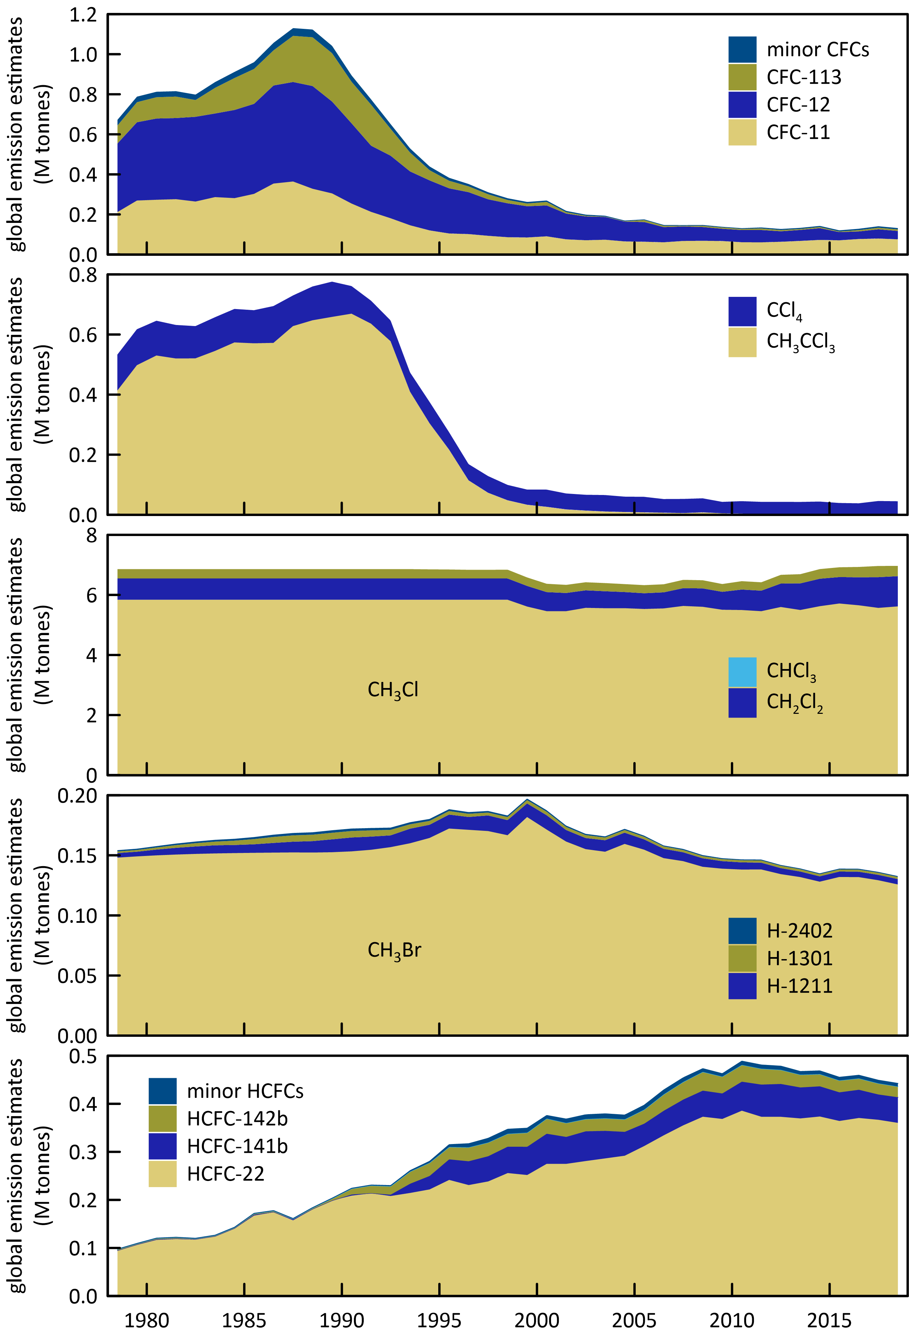

Table 3. Annual average (3-yr running means, i.e. 2014 = average of 2013, 2014, 2015) Australian emissions (metric tonnes unless otherwise stated) of ODSs (CFCs, HCFCs, halons, MB and chlorocarbons) from Cape Grim AGAGE data, using ISC techniques. Australian emissions are scaled from SE Australian emissions on a population basis; Australian halon emissions are from SE Australian emissions adjusted for the impact of emissions from the National Halon Bank in Melbourne; Australian methyl bromide emissions are from a DPI-modified UNEP model of methyl bromide emissions based on QPS and non-QPS methyl bromide consumption (see text). GWPs (to calculate CO2-e emissions) are from Forster & Ramaswamy (2007); ODPs (to calculate ODP-weighted emissions) are from Montzka & Reimann (2011); assumed GWPs for trichloroethylene (0.67) and perchloroethylene (0.53). Pre-1999 emissions of CFC-114, -115, HCFCs, halons and dichloromethane (shown in red) are assumed equal to 1999 emissions; pre-2005 emissions of perchloroethylene (shown in red) are assumed equal to 2005 emissions. Every second year is shown up until 2010 and then every year is shown.

|  |  |  |  |  |  |  |  |  |  |  |  |  |  |  |  |  |
| --- | --- | --- | --- | --- | --- | --- | --- | --- | --- | --- | --- | --- | --- | --- | --- | --- |
| Refrigerant | 1996 | 1998 | 2000 | 2002 | 2004 | 2006 | 2008 | 2010 | 2011 | 2012 | 2013 | 2014 | 2015 | 2016 | 2017 | 2018 |
| CFCs |  |  |  |  |  |  |  |  |  |  |  |  |  |  |  |  |
| CFC-11 | 443 | 525 | 557 | 475 | 588 | 630 | 550 | 284 | 325 | 283 | 391 | 357 | 347 | 275 | 248 | 167 |
| CFC-12 | 1555 | 1446 | 1023 | 747 | 656 | 474 | 439 | 228 | 254 | 219 | 262 | 250 | 245 | 210 | 183 | 141 |
| CFC-113 | 333 | 169 | 163 | 110 | 100 | 91 | 117 | 88 | 136 | 110 | 83 | 65 | 65 | 56 | 67 | 56 |
| CFC-114 | 56 | 56 | 50 | 64 | 53 | 23 | 44 | 42 | 38 | 34 | 24 | 18 | 19 | 17 | 20 | 19 |
| CFC-115 | 202 | 202 | 199 | 168 | 94 | 22 | 35 | 40 | 46 | 41 | 30 | 17 | 21 | 18 | 21 | 13 |
| total | 2588 | 2397 | 1993 | 1563 | 1492 | 1240 | 1184 | 682 | 798 | 687 | 790 | 706 | 697 | 575 | 538 | 397 |
| ODP tonnes | 2441 | 2283 | 1881 | 1474 | 1434 | 1213 | 1147 | 648 | 753 | 648 | 762 | 687 | 676 | 557 | 516 | 380 |
| M tonnes CO2-e | 23.1 | 21.3 | 16.8 | 12.9 | 11.8 | 9.1 | 8.8 | 5.1 | 5.9 | 5.0 | 5.7 | 5.1 | 5.1 | 4.2 | 3.9 | 3.0 |
| HCFCs |  |  |  |  |  |  |  |  |  |  |  |  |  |  |  |  |
| HCFC-22 | 2514 | 2514 | 2073 | 1904 | 2246 | 2024 | 1772 | 1264 | 1397 | 1258 | 1149 | 1279 | 1266 | 1131 | 810 | 434 |
| HCFC-124 | 262 | 262 | 205 | 118 | 176 | 89 | 54 | 28 | 32 | 32 | 27 | 18 | 19 | 16 | 18 | 12 |
| HCFC-142b | 100 | 100 | 90 | 64 | 48 | 47 | 60 | 41 | 39 | 35 | 32 | 31 | 34 | 31 | 31 | 18 |
| HCFC-141b | 411 | 411 | 320 | 258 | 332 | 304 | 257 | 111 | 228 | 208 | 224 | 210 | 226 | 206 | 200 | 151 |
| total | 3286 | 3286 | 2689 | 2344 | 2802 | 2464 | 2143 | 1444 | 1696 | 1533 | 1432 | 1537 | 1545 | 1385 | 1059 | 614 |
| ODP tonnes | 196 | 196 | 160 | 140 | 167 | 150 | 131 | 85 | 105 | 95 | 91 | 96 | 97 | 87 | 69 | 42 |
| M tonnes CO2-e | 5.2 | 5.2 | 4.3 | 3.9 | 4.5 | 4.0 | 3.6 | 2.5 | 2.8 | 2.5 | 2.3 | 2.5 | 2.5 | 2.3 | 1.7 | 0.9 |
| Halons |  |  |  |  |  |  |  |  |  |  |  |  |  |  |  |  |
| H-1211 | 459 | 459 | 384 | 90 | 111 | 76 | 77 | 37 | 73 | 62 | 55 | 23 | 21 | 14 | 13 | 6 |
| H-1301 | 335 | 335 | 120 | 95 | 101 | 25 | 15 | 37 | 55 | 43 | 27 | 9 | 7 | 2 | 2 | 0.07 |
| total | 794 | 794 | 503 | 185 | 212 | 101 | 92 | 74 | 129 | 105 | 83 | 32 | 28 | 16 | 15 | 6 |
| ODP tonnes | 4724 | 4724 | 2348 | 1220 | 1346 | 478 | 382 | 481 | 771 | 617 | 440 | 157 | 131 | 60 | 62 | 20 |
| M tonnes CO2-e | 2.9 | 2.9 | 1.3 | 0.77 | 0.84 | 0.27 | 0.20 | 0.30 | 0.48 | 0.38 | 0.26 | 0.09 | 0.07 | 0.03 | 0.03 | 0.01 |
| CH3Br | 523 | 579 | 608 | 510 | 416 | 314 | 351 | 474 | 521 | 563 | 509 | 565 | 576 | 687 | 645 | 686 |
| ODP tonnes | 314 | 348 | 365 | 306 | 249 | 188 | 211 | 284 | 312 | 338 | 305 | 339 | 346 | 412 | 387 | 412 |
| k tonnes CO2-e | 2.6 | 2.9 | 3.0 | 2.6 | 2.1 | 1.6 | 1.8 | 2.4 | 2.6 | 2.8 | 2.5 | 2.8 | 2.9 | 3.4 | 3.2 | 3.4 |
| Chlorocarbons (MP) |  |  |  |  |  |  |  |  |  |  |  |  |  |  |  |  |
| CCl4 | 190 | 223 | 222 | 212 | 172 | 114 | 141 | 70 | 95 | 97 | 149 | 127 | 128 | 115 | 118 | 82 |
| CH3CCl3 | 2457 | 474 | 203 | 165 | 92 | 87 | 99 | 77 | 105 | 100 | 117 | 111 | 122 | 115 | 123 | 109 |
| total | 2647 | 697 | 425 | 376 | 264 | 201 | 241 | 147 | 200 | 197 | 265 | 239 | 250 | 230 | 241 | 190 |
| ODP tonnes | 455 | 293 | 264 | 249 | 199 | 134 | 165 | 85 | 115 | 117 | 175 | 151 | 153 | 138 | 142 | 101 |
| M tonnes CO2-e | 0.70 | 0.47 | 0.43 | 0.41 | 0.32 | 0.22 | 0.27 | 0.14 | 0.19 | 0.19 | 0.28 | 0.25 | 0.25 | 0.22 | 0.23 | 0.16 |
| MP ODSs (k tonnes) | 9.8 | 7.8 | 6.2 | 5.0 | 5.2 | 4.3 | 4.0 | 2.8 | 3.3 | 3.1 | 3.1 | 3.1 | 3.1 | 2.9 | 2.5 | 1.9 |
| ODP (k tonnes) | 8.1 | 7.8 | 5.0 | 3.4 | 3.4 | 2.2 | 2.0 | 1.6 | 2.1 | 1.8 | 1.8 | 1.4 | 1.4 | 1.3 | 1.2 | 1.0 |
| M tonnes CO2-e | 35 | 33 | 26 | 21 | 20 | 15 | 15 | 10 | 12 | 11 | 11 | 11 | 11 | 10 | 9.1 | 7.5 |
| other chlorocarbons |  |  |  |  |  |  |  |  |  |  |  |  |  |  |  |  |
| dichloromethane | 6406 | 6406 | 4881 | 3798 | 3797 | 2896 | 3053 | 2708 | 2381 | 1580 | 1347 | 2001 | 2051 | 1725 | 1180 | 689 |
| chloroform | 5990 | 6546 | 5046 | 4791 | 4515 | 3377 | 4323 | 2393 | 2590 | 2217 | 3698 | 3206 | 3357 | 2598 | 2748 | 2957 |
| PCE | 3112 | 3112 | 3112 | 3112 | 3112 | 2745 | 1931 | 1223 | 1197 | 942 | 635 | 791 | 842 | 732 | 578 | 457 |
| TCE |  |  |  |  |  |  |  |  | 312 | 274 | 230 | 194 | 192 | 160 | 137 | 108 |
| total (k tonnes) | 16 | 16 | 13 | 12 | 11 | 9.0 | 9.3 | 6.3 | 6.5 | 5.0 | 5.9 | 6.2 | 6.4 | 5.2 | 4.6 | 4.2 |
| ODP tonnes | 132 | 137 | 110 | 98 | 95 | 74 | 79 | 54 | 53 | 40 | 50 | 52 | 54 | 44 | 39 | 36 |
| M tonnes CO2-e | 0.27 | 0.29 | 0.23 | 0.21 | 0.21 | 0.16 | 0.18 | 0.11 | 0.11 | 0.09 | 0.13 | 0.12 | 0.13 | 0.10 | 0.10 | 0.10 |
| all ODSs |  |  |  |  |  |  |  |  |  |  |  |  |  |  |  |  |
| all ODSs (k tonnes) | 25 | 24 | 19 | 17 | 17 | 13 | 13 | 9 | 10 | 8 | 9 | 9 | 10 | 8 | 7 | 6 |
| ODP (k tonnes) | 8.3 | 8.0 | 5.1 | 3.5 | 3.5 | 2.2 | 2.1 | 1.6 | 2.1 | 1.9 | 1.8 | 1.5 | 1.5 | 1.3 | 1.2 | 1.0 |
| M tonnes CO2-e | 35 | 33 | 26 | 21 | 20 | 15 | 15 | 10 | 12 | 11 | 11 | 11 | 11 | 10 | 9.2 | 7.6 |

### CFCs

#### Australian emissions

Australian CFC-11 emissions have averaged about 440 tonnes from 1996 to 2018 (Table 3, Figure 10). CFC-11 emissions increased from 2002 (475 tonnes) to 2007 (744 tonnes) - the cause of this increase is unclear. Since 2007 CFC-11 emissions have declined to about 300 tonnes per year (2010-2018), an encouraging 50% lower than average 2004-2009 emissions (600 tonnes per year). Australian CFC-11 emissions have been steadily declining for the past 5 years and reached 167 tonnes in 2018. Australian CFC-11 emissions have been estimated by inverse modelling (InTEM, Figure 10) for the period 2004-2017. The overall agreement with ISC estimates is 22%, ISC higher. This agreement improves to 0.3% from 2008-2017, ISC lower.

Australian CFC-12 emissions have declined steadily since 1995 (1,981 tonnes) to 141 tonnes in 2018 and have averaged 220 tonnes from 2010-2018, 55% lower than average 2004-2009 emissions (490 tonnes per year). As with CFC-11 above, CFC-12 emissions have also been steadily declining for the last 5 years after being stalled during the 2009-2013 period. Australian CFC-12 emissions from InTEM (Figure 10) have been compared with ISC estimates for the period 2004-2017, with an overall agreement of 20%, ISC lower.

Australian CFC-113 emissions declined rapidly from 488 tonnes in 1995 to under 100 tonnes in the early 2000s, averaging close to 100 tonnes per year from 2002 to 2018. CFC-113 emissions in 2018 were 56 tonnes. CFC-113 emissions are quite variable and do not show a clear trend. Australian CFC-113 emissions from InTEM (Figure 10) have been compared with ISC estimates for the period 2004-2017, with ISC 36% higher than InTEM estimates, with the overall agreement improving to 8% from 2012-2017, ISC lower.

Total Australian CFC (and HCFC, halon and carbon tetrachloride) emissions are shown in Figure 12. The overall decline in CFC emissions from 1995 (3,627 tonnes) to 2018 (397 tonnes) is about 8% per year. ODP weighted CFC emissions have fallen from 3448 tonnes in 1995 to 380 tonnes in 2018. Australian ODP-weighted CFC emissions in 2018 (380 tonnes) were 0.3% of global ODP-weighted CFC emissions. Australian ODP-weighted CFC emissions are currently (2018) about 38% of Australia’s total ODS (ODP-weighted) emissions (1000 tonnes).

CFC emissions are presumed to be from CFC-containing appliances/materials (refrigeration/ac equipment, foams, aerosol cans), either existing or buried (landfills). If the current total emissions (~400 tonnes per year) continue to decline at ~8%/yr, it will take about 16 years for Australian CFC emissions to drop below 100 tonnes/yr.

#### Global emissions

Total global CFC emissions are declining, dominated (90%) by emissions of CFC-11 and CFC-12, currently about 120 k tonnes/yr (2016-2018) (Rigby *et al*., 2014 and updates). Since the peak emissions of CFCs in the late 1980s (1108 k tonnes, 1987), overall CFC emissions have declined by 7%/yr, attesting to the success of the Montreal Protocol controls on CFC production and consumption. Two recent papers, Montzka *et al*. (2018) and Rigby *et al*. (2019), found an unexpected increase in global emissions of CFC-11. The conclusions from both studies suggest that the increase is probably not related to existing banks of CFC-11 but rather new production and uses in east Asia, around 50% of which has been attributed to east China. Global CFC-11 emissions averaged about 78 k tonnes/yr (2016-2018), an increase of 14 k tonne per year compared to the 2008-2012 period (Rigby *et al*. 2019 and updates). Global CFC-11 emissions decreased slightly from 80 k tonnes in 2017 to 76 k tonnes in 2018.

Global emissions of CFC-12 have declined substantially since its peak in the 1980s, and emissions continue to decline. Since the peak emissions of CFC-12 in the late 1980s (513 k tonnes, 1988), CFC-12 emissions have declined by 92% (7%/yr). Current global CFC-12 emissions are about 42 k tonnes/yr (2016-2018) (Rigby *et al*. 2014 and updates).

The global emissions of the other CFCs (CFC-113, -114, -115), including the minor CFCs, decreased from a total of 13.3 k tonnes in 2017 to 12.5 k tonnes in 2018. All the decrease is due to a decline in emissions of CFC-113 and CFC-115.

Figure 12. Declining Australian CFC, HCFC, halon and carbon tetrachloride emissions (k tonnes).

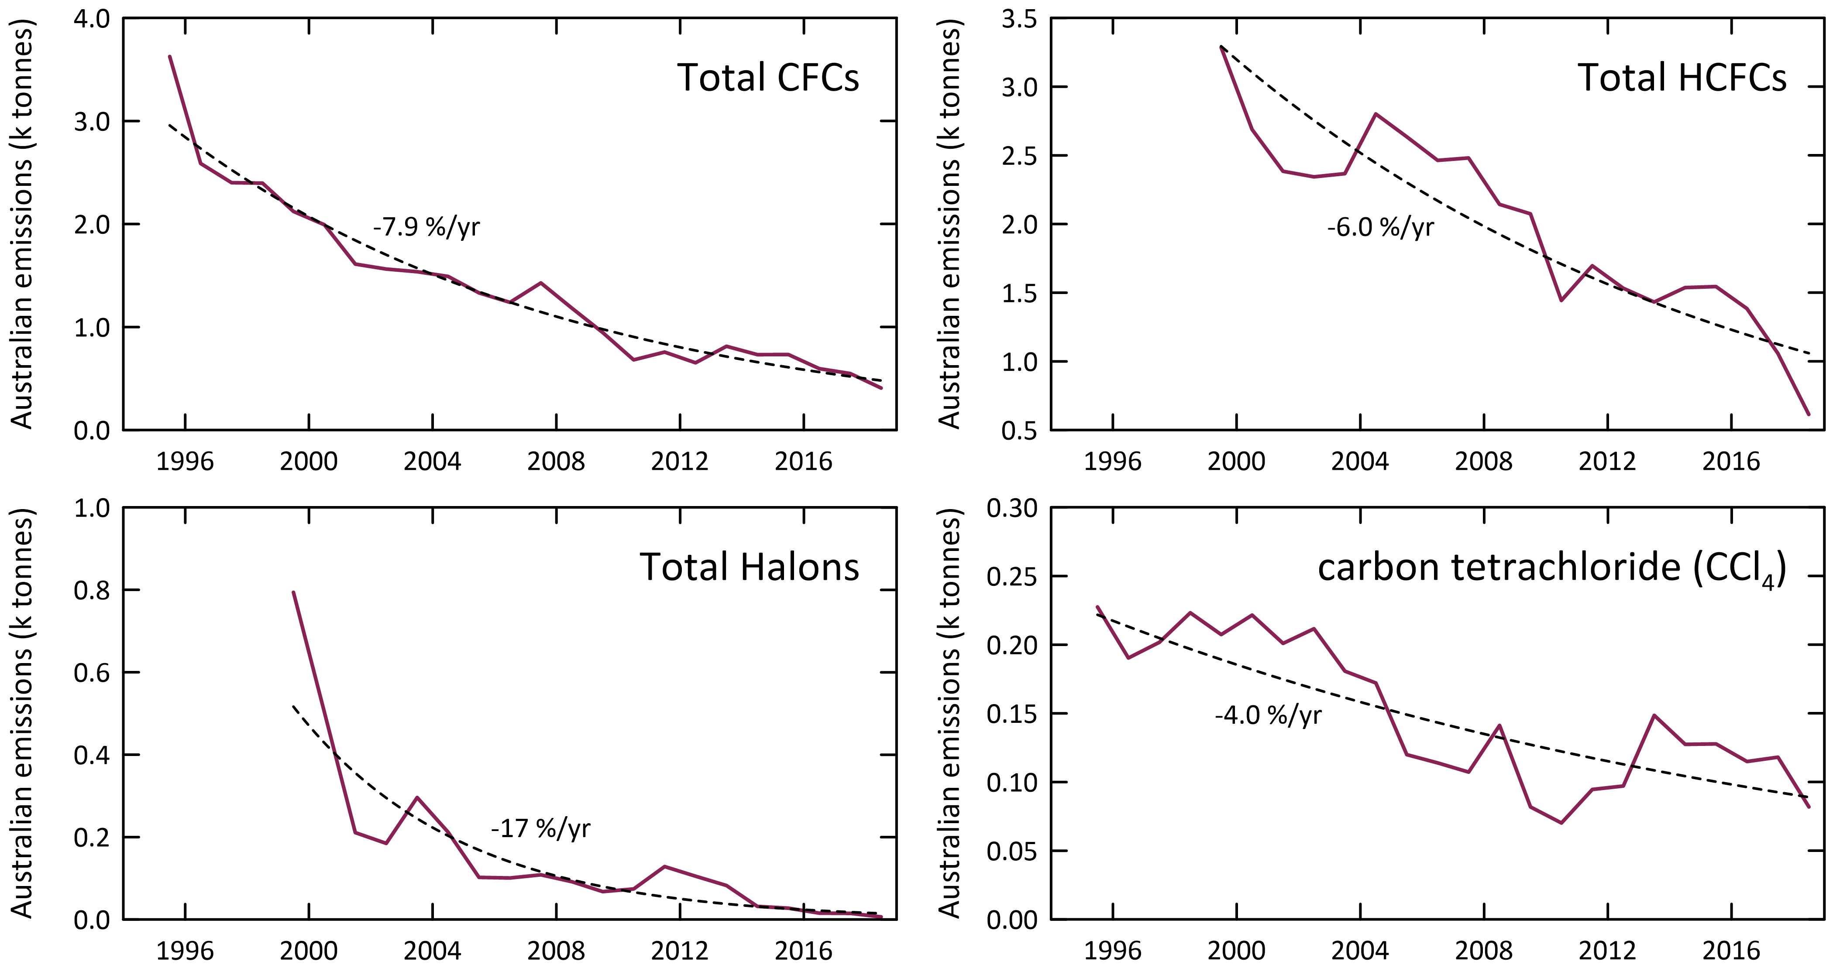

### HCFCs

#### Australian emissions

Total Australian HCFC-22 emissions have been estimated from Cape Grim data using ISC and InTEM methods. Australian HCFC-22 emissions from operational and end-of-life refrigeration/air conditioning equipment has been estimated from an emissions model based on imports/consumption data for HCFC-22, estimates of the resultant HCFC-22 bank in the operational and retired equipment bank and assumptions about emission rates from the bank (Brodribb & McCann 2015, 2018).

There has been an overall decline in Australian HCFC-22 emissions estimated by ISC from about 2,500 tonnes in 1999 to 434 tonnes in 2018 (9% per year over this period) (Table 3, Figure 10). HCFC-22 emissions declined rapidly from 2,246 tonnes in 2004 to 1,149 tonnes in 2013 (7% per year). The decline in HCFC-22 emissions briefly stalled in 2014 and 2015 but emissions have declined for the last 5 years, falling to a low of 434 tonnes in 2018.

Australian HCFC-22 emissions have been estimated by inverse modelling (InTEM, Figure 10) for the period 2004-2017. The overall agreement with ISC estimates is 25%, ISC higher. This agreement improves to 5% from 2008-2017, ISC higher.

The Australian HCFC-22 bank in operational refrigeration/air conditioning equipment peaked at 13,450 tonnes in 2007 (Brodribb & McCann 2013). As mentioned in section 4, a recent update (Brodribb & McCann 2018) estimates the Australian HCFC-22 Bank at 5,584 tonnes in 2018 and Australian emissions of HCFC-22 in 2018 of 323 tonnes.

Total HCFC-22 emissions from Cape Grim data and as projected leakage from the HCFC-22 bank are shown in Figure 13 as a function of the HCFC-22 bank. An assumed linear relationship between emissions and bank size, implies a bank emission factor from operational refrigeration equipment of 13%/yr. The difference between total HCFC-22 emissions and bank HCFC-22 emissions could be emissions from landfills (Figure 14) or other minor uses such as from foam, fire protection or aerosols.

Figure 13. Total Australian HCFC-22 emissions (k tonnes) from Cape Grim data and HCFC-22 bank emissions as functions of the HCFC-22 bank (k tonnes; Brodribb & McCann 2015). The dashed line is a linear regression: slope = 0.13 tonne/tonne banked.

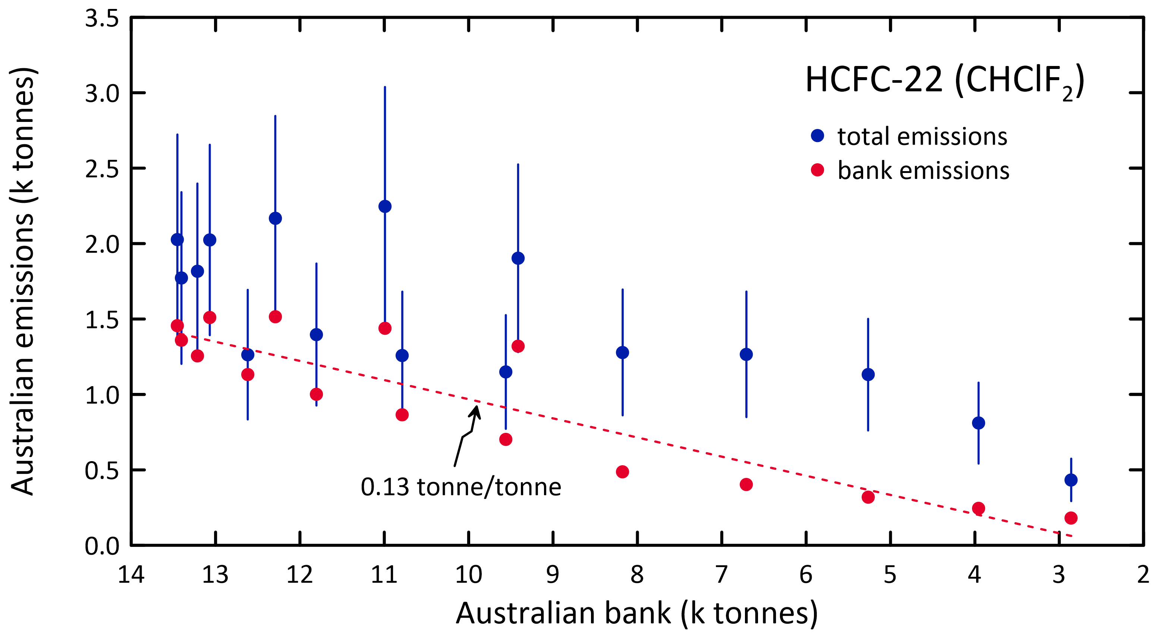

Figure 14. Possible HCFC-22 emissions from non-equipment bank sources such as landfills.

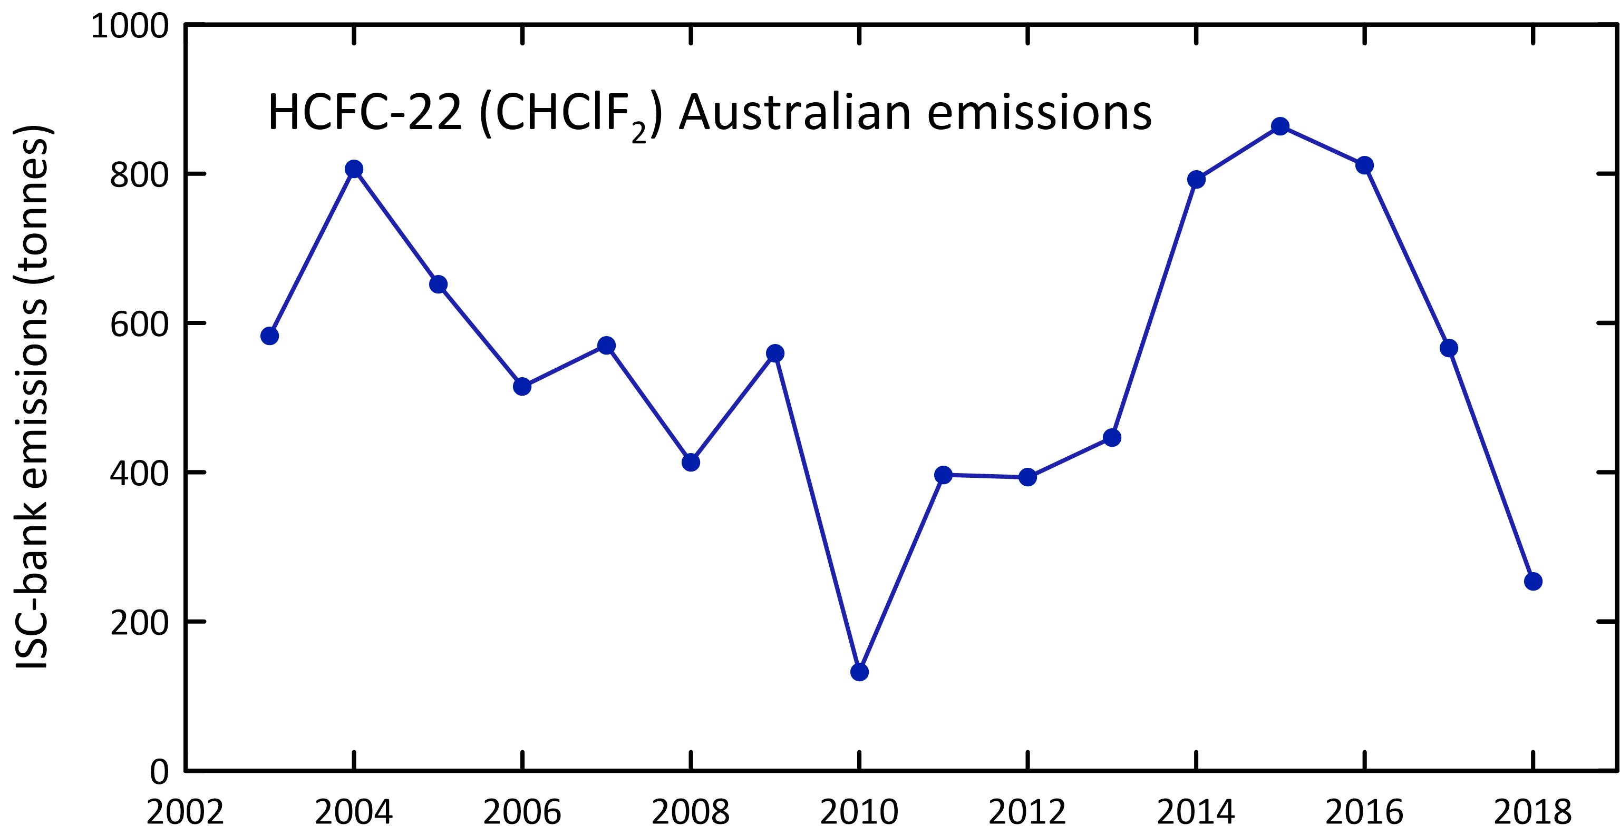

HCFC-124 emissions have declined steadily from 262 tonnes in 1999 to 12 tonnes in 2018 (a decline of around 15% per year). Emissions levelled off from 2009-2013 and then dropped each year from 2014 to 2018.

HCFC-141b emissions have fluctuated over the period 1999-2018, falling from over 400 tonnes in 1999 to around 151 tonnes in 2018, with some falls and increases in the intervening period. Australian HCFC-141b emissions have been estimated by inverse modelling (InTEM, Figure 10) for the period 2004-2017. The overall agreement with ISC estimates is good, with average InTEM emissions being 10% lower than ISC emissions.

HCFC-142b emissions have also fluctuated over the period 1999-2017, falling from 100 tonnes in 1999 to 18 tonnes in 2018 with an increase estimated in 2007 before a steady decline to 2018. Australian HCFC-142b emissions have been estimated by inverse modelling (InTEM, Figure 10) for the period 2004-2017. The overall agreement with ISC estimates is 46% with average InTEM emissions being higher than ISC emissions.

Total HCFC emissions have fallen by about 64% from 3,286 tonnes in 1999 to 614 tonnes in 2018, an overall decline of about 6% per year. ODP-weighted HCFC emissions have fallen from 196 tonnes in 1999 to 42 tonnes in 2018, 4% of Australia’s total ODS (ODP-weighted) emissions in 2018 (1000 tonnes). GWP-weighted HCFC emissions have fallen from 5.2 M tonnes CO2-e in 1999 to 0.9 M tonnes CO2-e in 2018, an overall decline of 83%.

Australian HCFC emissions are likely from a combination of service and malfunction leaks from existing refrigeration/ac equipment, from other minor uses and from landfills. Australian HCFC emissions in 2018 (614 tonnes) were 0.14% of global HCFC emissions (441 k tonnes) on a metric tonne basis.

#### Global emissions

Global HCFC emissions peaked in 2010 (488 k tonnes) and have since declined (9%) to 441 k tonnes in 2018, a decline of about 1%/yr. The decline in emissions since 2010 is encouraging in relation to the overall long-term decline in ODSs that will bring about ozone layer recovery. Throughout the period from the late-1970s to 2010, total HCFC emissions increased by about 4%/yr. Declining HCFC emissions cause the observed slowing of the recent HCFC concentration growth rates in the atmosphere (see section 2.2).

HCFC-22 emissions (the most commonly used HCFC) peaked in 2010 at 386 k tonnes declining (0.9%/yr) to 360 k tonnes in 2018; HCFC-141b: 68 k tonnes (2012) to 53 k tonnes (4%/yr, 2018); HCFC-142b: 39 k tonnes (2008) to 22 k tonnes (6%/yr, 2018).

### Halons

#### Australian emissions

The origin of current Australian halon emissions is uncertain, but they could be coming from remaining building fire-fighting systems, from the Australian Halon Bank (a facility to destroy or store and reprocess recycled halons located in Melbourne) and exempted halon based aircraft firefighting suppression systems. It may not be appropriate to directly scale the SE Australian halon emissions (as determined from Cape Grim data) to Australian emissions on a simple population basis. This is because the National Halon bank is located in the Melbourne/Port Philip region. The Bank has a collection/processing loss rate of less than 2% (0.01 tonne) and had stored a total of about 550 tonnes of halons by 2013 (140 tonnes H-1211, 410 tonnes H-1301) (E. Nigido, A-Gas (Australia) Pty. Ltd., personal communications, May 2014 and August 2015). Assuming that typical leaks from the storage of halons are less than 1% (Nigido personal communication; we have assumed 0.5%), then halon emissions from the Halon Bank could be 2-3 tonnes/year. This is a small component (perhaps 6-8%) of SE Australian halon emissions. The Australian halon emissions shown in Table 3 are the sum of estimated Halon Bank emissions and Australian non-Halon Bank emissions. The SE Australian non-Halon Bank emissions are obtained from SE Australian Halon emissions (from Cape Grim data) by subtracting the Halon Bank emissions. Australian non-Halon Bank emissions equal SE Australian non-Halon Bank emissions scaled by population.

It is assumed that the Halon Bank started to accumulate, process and store halons in 1993 and that the halon bank has grown linearly for both halons to reach current (2018) banked levels of 138 tonnes (H-1211) and 508 tonnes (H-1301), accumulation rates of approximately 5 and 20 tonnes per year.

Australian halon emissions fell from nearly 800 tonnes in 1999 to 6 tonnes in 2018 (Figure 10, Figure 12), an overall decline of about 17% per year. The majority of Australian halon emissions over the period 2012-2018 are H-1211. SE Australian halon emissions are likely to show significant inter-annual variability.

Australian H-1211 emissions in 2018 were 6 tonnes, 0.2% of global emissions (3,400 tonnes) and Australian H-1301 emissions in 2018 were 0.07 tonnes, 0.005% of global emissions (1,300 tonnes).

#### Global emissions

Data on global halon emissions are now available back to the 1970s, based on AGAGE *in situ* and Cape Grim Air Archive data (Vollmer *et al*. 2016). Total global halon emissions continue to decline (6.9 k tonnes in 2012, 5.1 k tonnes in 2018), dominated (~70%) by halon-1211 emissions, which declined by 1.2 k tonnes over the same period. Peak total halon emissions (18 k tonnes) occurred in 1990 and have declined to 5.1 k tonnes in 2018.

### Methyl bromide

#### Australian emissions

Methyl bromide (MB) is used in Australia mainly as a fumigant for cereals, such as wheat, for cottonseed and timber logs prior to export and biosecurity treatment of imported goods. These are QPS uses, which are exempted from phase-out under the Montreal Protocol. Methyl bromide is also used as a soil sterilant during the production of strawberry runners, this being a non-QPS use which is restricted by the Montreal Protocol and for which Australia has to apply for a Critical Use Exemption (CUE) under the Montreal Protocol on an annual basis.

For many years now, methyl bromide has been imported into Australia predominantly for QPS uses. Two-thirds of QPS methyl bromide use in Australia is for timber-log and wood-chip fumigation (80% export, 20% import). The major timber-log fumigation sites are Eden (60%, NSW), Geelong/Portland (40%, Vic) (personal communication, Mebrom Pty. Ltd., 2014). One-third of QPS methyl bromide use in Australia is for grain fumigation, largely export. Grain exported from SE Australian grain terminals account for about 20% of Australia’s grain exports (National Transport Commission 2008; ABARES 2018a). Australia’s current non-QPS methyl bromide use occurs at Toolangi, NE of Melbourne, for growing strawberry runners. It is also occasionally used in small amounts as a feedstock in chemical reactions to create other chemicals.

A UNEP model of methyl bromide emissions suggests that 80-90 % of methyl bromide QPS use escapes to the atmosphere (UNEP 2019). The results from the UNEP model of Australian methyl bromide emissions are shown in Figure 15. SE Australian methyl bromide emissions from this model (assuming the speciation of SE Australian methyl bromide emissions from timber, grain exports and strawberry runner production discussed above) are compared to SE Australian emissions calculated from Cape Grim data by ISC in Figure 16 (also Figure 10). It is also worth noting that using imports in any given year as a basis for estimating emissions may bring in unrealistic year-to-year variability in calculated emissions as the amount of methyl bromide used in any year can be sourced from both imports and stock-in-hand. However, long term growth in methyl bromide stock is unlikely – in order to diminish the impact of short-term impacts of methyl bromide stock changes, 3-year average emissions from the model are also shown in Figure 16.

Figure 15. Australian methyl bromide emissions (3-year average) calculated from Australian methyl bromide import data and the modified UNEP emissions model (UNEP 2019.

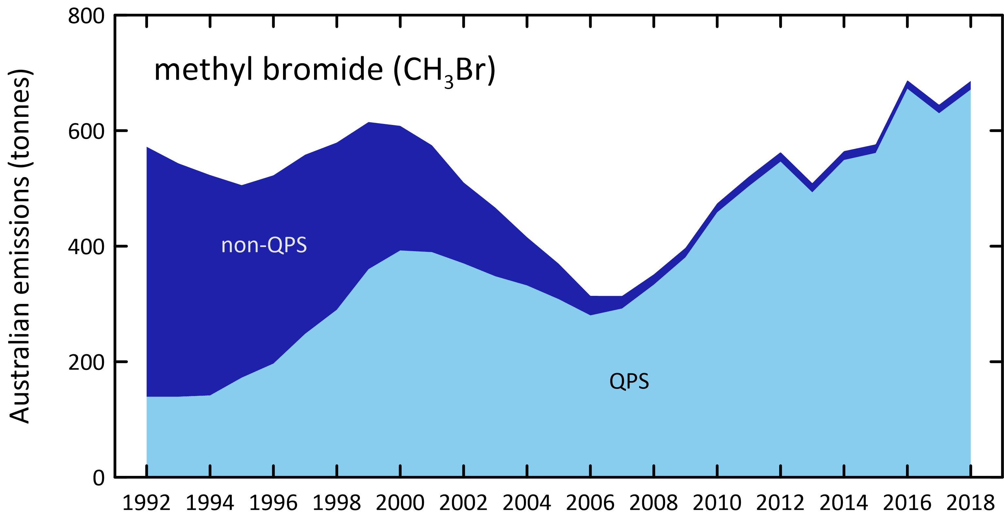

Figure 16. SE Australian methyl bromide emissions calculated by ISC from Cape Grim *in situ* AGAGE methyl bromide data (blue) and from a modified UNEP (2018) emissions model (orange, 3-year average) based on Australian methyl bromide imports and the SE Australian methyl bromide consumption for timber/grain exports and strawberry runner production.

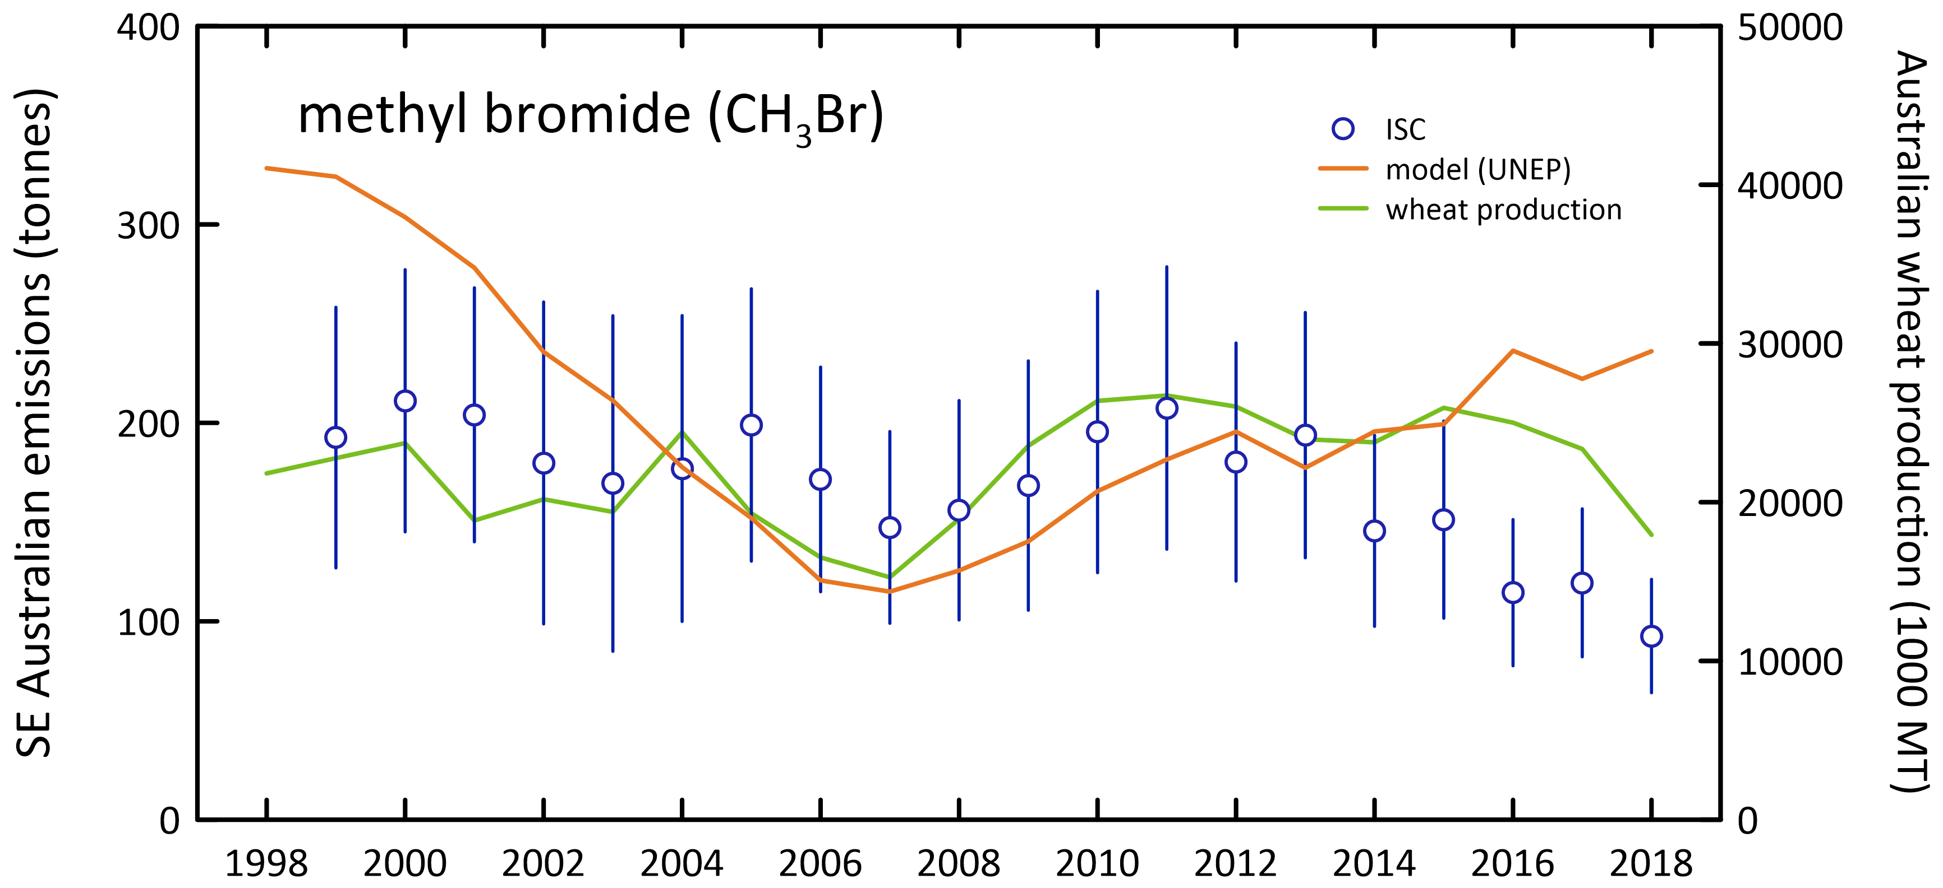

The emissions from the model and those derived from atmospheric data for SE Australia show reasonable overall agreement (within 7%, model higher) over the period 2002-2017. The emissions calculated from atmospheric data are consistent with the model emissions for SE Australia and it can be assumed that the model emissions for Australia are close to actual emissions.

Australian methyl bromide emissions based on the emissions model peaked at about 600 tonnes per year in 1999-2000, falling to 300 tonnes per year in 2006-2007, due in part to declining non-QPS methyl bromide use and also a decline in QPS use (possibly due to reduced grain production as a result of the severe drought in SE Australia), increasing again to 686 tonnes in 2018, due to increased QPS methyl bromide use resulting from grain harvests recovering, trade patterns and trade partner requirements (Figure 15). The 412 ODP tonnes of methyl bromide emitted in 2018 are about 41% of Australia’s total ODS emissions in ODP tonnes.

#### Global emissions

Global methyl bromide emissions have been estimated from AGAGE data, including Cape Grim (Rigby *et al*. 2014 and updates). Global methyl bromide emissions decline from 182 k tonnes in 1999 to 126 k tonnes in 2018, a decline of about 1.3%/yr. Methyl bromide emissions drop from 132 k tonnes in 2015 to 126 k tonnes in 2018 reflecting in part the developing country phase-out of non-QPS uses in 2015.

### Carbon tetrachloride and methyl chloroform (Montreal Protocol chlorocarbons)

#### Australian emissions

Carbon tetrachloride (CTC) emissions are calculated from Cape Grim *in situ* GC-ECD data. This data has been reprocessed for use with the recalculated Port Phillip CO emissions. The latest available estimates of Australian carbon tetrachloride emissions by ISC and InTEM are shown in Figure 17.

Figure 17. Australian carbon tetrachloride emissions calculated from Cape Grim *in situ* AGAGE data by ISC and inverse modelling (InTEM).

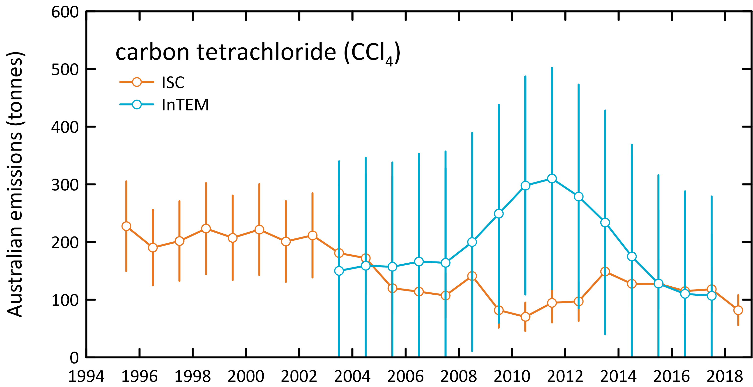

Carbon tetrachloride emissions estimated by ISC were 227 tonnes in 1995, declining to 82 tonnes by 2018. Carbon tetrachloride emissions estimated using the InTEM model were 159 tonnes in 2004, declining by 3% per year to 107 tonnes in 2017. Over the same period carbon tetrachloride emissions estimated by ISC fell by 5% per year. The overall agreement between ISC and InTEM estimates of carbon tetrachloride emissions obtained from Cape Grim data is 50%, with InTEM higher.

The ISC and InTEM estimates of Australian carbon tetrachloride emissions have been published in the peer-reviewed literature and used to identify possible ‘missing’ carbon tetrachloride sources on a global scale (Fraser *et al*. 2014b). These findings have been incorporated into the *Scientific Assessment of Ozone Depletion: 2014* and 2018 (Carpenter & Reimann 2014; Engel & Rigby 2018) and the recent *SPARC Report on the Mystery of Carbon Tetrachloride* (Liang *et al*. 2016).

Australian methyl chloroform emissions declined from about 3,500 tonnes in 1995 to 100 tonnes in 2004. Methyl chloroform emissions then stabilised at about 100 tonnes until 2012. In 2013-2018 Australian methyl chloroform emissions averaged about 116 tonnes per year, 4-9% of global emissions (1,300-3,200 tonnes). In 2018 Australian methyl chloroform emissions were estimated at 109 tonnes.

#### Global emissions

Long-term, global carbon tetrachloride emissions have declined slowly from a peak of around 120 k tonnes/yr in the late 1970s, declining to 50 k tonnes/yr by 2005, a long-term decline of about 3%/yr. Since 2005 global carbon tetrachloride emissions have fluctuated between increases and decreases but overall have declined steadily by about 1-2 k tonne per year (1.2%/yr) until 2018 when emissions were estimated at 43 k tonnes/yr. The decline in global carbon tetrachloride emissions is not as rapid as anticipated under the Montreal Protocol (Montzka & Reimann 2011; Carpenter & Reimann 2014; Lunt *et al*. 2018). A partial explanation may be that global emissions of carbon tetrachloride from landfills and chlor-alkali plants may be significant, and not yet accounted for, in global budgets (Fraser *et al*. 2014; Hu *et al*. 2016, Liang *et al*. 2016).

Global methyl chloroform emissions peaked in 1990 at 669 k tonnes. Emissions have declined almost every year since and are estimated at 1.9 k tonnes in 2018. Over the past 5 years (2014-2018) global emissions have averaged 2.1 k tonnes/yr. The long-term decline in methyl chloroform emissions is in excess of 20%/yr, which is expected for an ODS with low (~zero) emissions and an atmospheric lifetime of about 5 years.

### Chlorocarbons not controlled by the Montreal Protocol

Dichloromethane (CH2Cl2), chloroform (CHCl3), trichloroethylene (CHClCCl2) and perchloroethylene (CCl2CCl2) are short-lived ODSs whose production and consumption are not controlled by the Montreal Protocol. Significant emissions of all these ODSs are seen in the Cape Grim data (Figure 1).

* Australian dichloromethane emissions were about 6400 tonnes in 1999 declining by 10% per year to about 1400 tonnes in 2013 and after a rise in 2015, declined to a low of 689 tonnes in 2018.
* Australian chloroform emissions were over 5,300 tonnes in 1995 declining overall by 4% per year to about 2,217 tonnes in 2012, and after a rise for 3 years, is now averaging around 2,700 tonnes/yr in 2016-2018. There are natural emissions of chloroform from soil and it is possible that the chloroform emissions calculated from Cape Grim data contain natural emissions which are difficult to quantify.
* Australian perchloroethylene emissions were over 3,000 tonnes in 2004 declining to 457 tonnes in 2018.
* Trichloroethylene emissions were about 312 tonnes in 2011 falling by 14% per year to 108 tonnes in 2018.

Total emissions for these short-lived ODSs (not including trichloroethylene, as reliable measurements weren’t obtained until 2011) were 11k tonnes (95 ODP tonnes) in 2004, falling by 7% per year to 4.2 k tonnes (36 ODP tonnes; including trichloroethylene) in 2018. The ODP-weighted emissions of these short-lived ODSs were about 0.6% of total Australian ODS emissions (ODP weighted).

### Australian GWP-weighted ODS emissions

The overall decline in Australian GWP-weighted CFC emissions from 1995 (31 M tonnes CO2-e) to 2018 (3 M tonnes CO2-e) is 10% per year. 2018 emissions (3 M tonnes CO2-e) were 0.7 % of Australia’s total GHG emissions (537 M tonnes CO2-e, including land use change, 2018). CFC emissions are not included in Australia’s national GHG emissions inventory, as CFCs have been phased-out under the Montreal Protocol and are therefore not subject to separate controls under the Kyoto Protocol and subsequent agreements. Nevertheless, the 28 M tonnes CO2-e decline in GWP-weighted CFC emissions since 1995 is significant compared to other changes in Australian GHG emissions over the same period. Australian emissions of GHGs (CO2, CH4, N2O, HFCs, PFCs, SF6 including land use change), as reported to UNFCCC, have increased by a net 39 M tonnes CO2-e from 1995 to 2018.

HCFC emissions, like CFC emissions, are not included in Australia’s national GHG emissions (537 M tonnes CO2-e in 2018) as HCFCs are also being phased-out under the Montreal Protocol. The overall decline in GWP-weighted HCFC emissions from 1999 (5.2 M tonnes CO2-e) to 2018 (0.9 M tonnes CO2-e) is 9% per year; CO2-e weighted HCFC emissions in 2018 are 0.2% of Australia’s reported net GHG emissions.

The CO2-e weighted emissions of other ODSs (halons, methyl bromide, chlorocarbons, other chlorocarbons) totalled 0.27 M tonnes in 2018, around 0.05% of Australia’s reported net GHG emissions.

### Total ODS emissions

Total Australian ODS emissions (CFCs, HCFCs, halons, methyl bromide, carbon tetrachloride, methyl chloroform, both ODP- and GWP-weighted), with and without non-Montreal Protocol chlorocarbon are shown in Figure 18. From 1995-1998, emissions are based on Cape Grim GC-ECD data for the major CFCs (CFC-11, -12, -113), methyl chloroform and carbon tetrachloride. From 1999 the emissions for all species are calculated from Cape Grim GC-ECD and GC-MS data, except for perchloroethylene whose GC-MS observations commenced in 2004 (1995 to 2003 perchloroethylene emissions are assumed equal to 2005 emissions) and trichloroethylene whose GC-MS observations commenced in 2011. In previous reports, trichloroethylene observations were reported back to 2005, but these earlier trichloroethylene data have now been assessed as unreliable.

For the minor CFCs, HCFCs and halons it is assumed that annual emissions from 1995-1999 equal 1999 emissions. This could lead to a significant underestimate of emissions during this period (the ISC method is limited to the period when well-calibrated CO data were measured at Cape Grim – 1994 onwards). Methodologies are being investigated to extend ODS emissions estimates prior to 1994 – these will be evaluated in a future report.

The non-Montreal Protocol chlorocarbons (dichloromethane, chloroform, perchloroethylene, trichloroethylene) make a significant contribution to total Australian ODS emissions. Since 2011, 65%-70% of ODS emissions are from these other chlorocarbons, as emissions of Montreal Protocol chlorocarbons have reduced. However, they only make small contributions to ODP (2%-4%) or GWP (1%-2%) weighted emissions (or ozone depletion and climate change), because of their low ODPs and GWPs.

ODP-weighted ODS emissions fell by about 9% per year from 9.4 k tonnes in 1995 to 1.0 k tonnes in 2018. The largest decline is due to the halons, falling from emissions of 4.7 k tonnes (ODP) in 1999 to 0.02 k tonnes (ODP) in 2018, a fall of 4.68 k tonnes compared to a fall of 1.6 k tonnes (ODP) in CFC emissions and 0.15 k tonnes ODP in HCFC emissions over the same period.

GWP-weighted ODS emissions fell by about 7% per year from 43 M tonnes CO2-e in 1995 to 8 M tonnes CO2-e in 2018. As discussed previously the fall due to CFCs alone is 28 M tonnes CO2-e, 80% of the overall decline in GWP-weighted ODS emissions.

Figure 18. Total Australian ODS emissions; without other chlorocarbons (Section 5.6, left) and with other chlorocarbons (right).

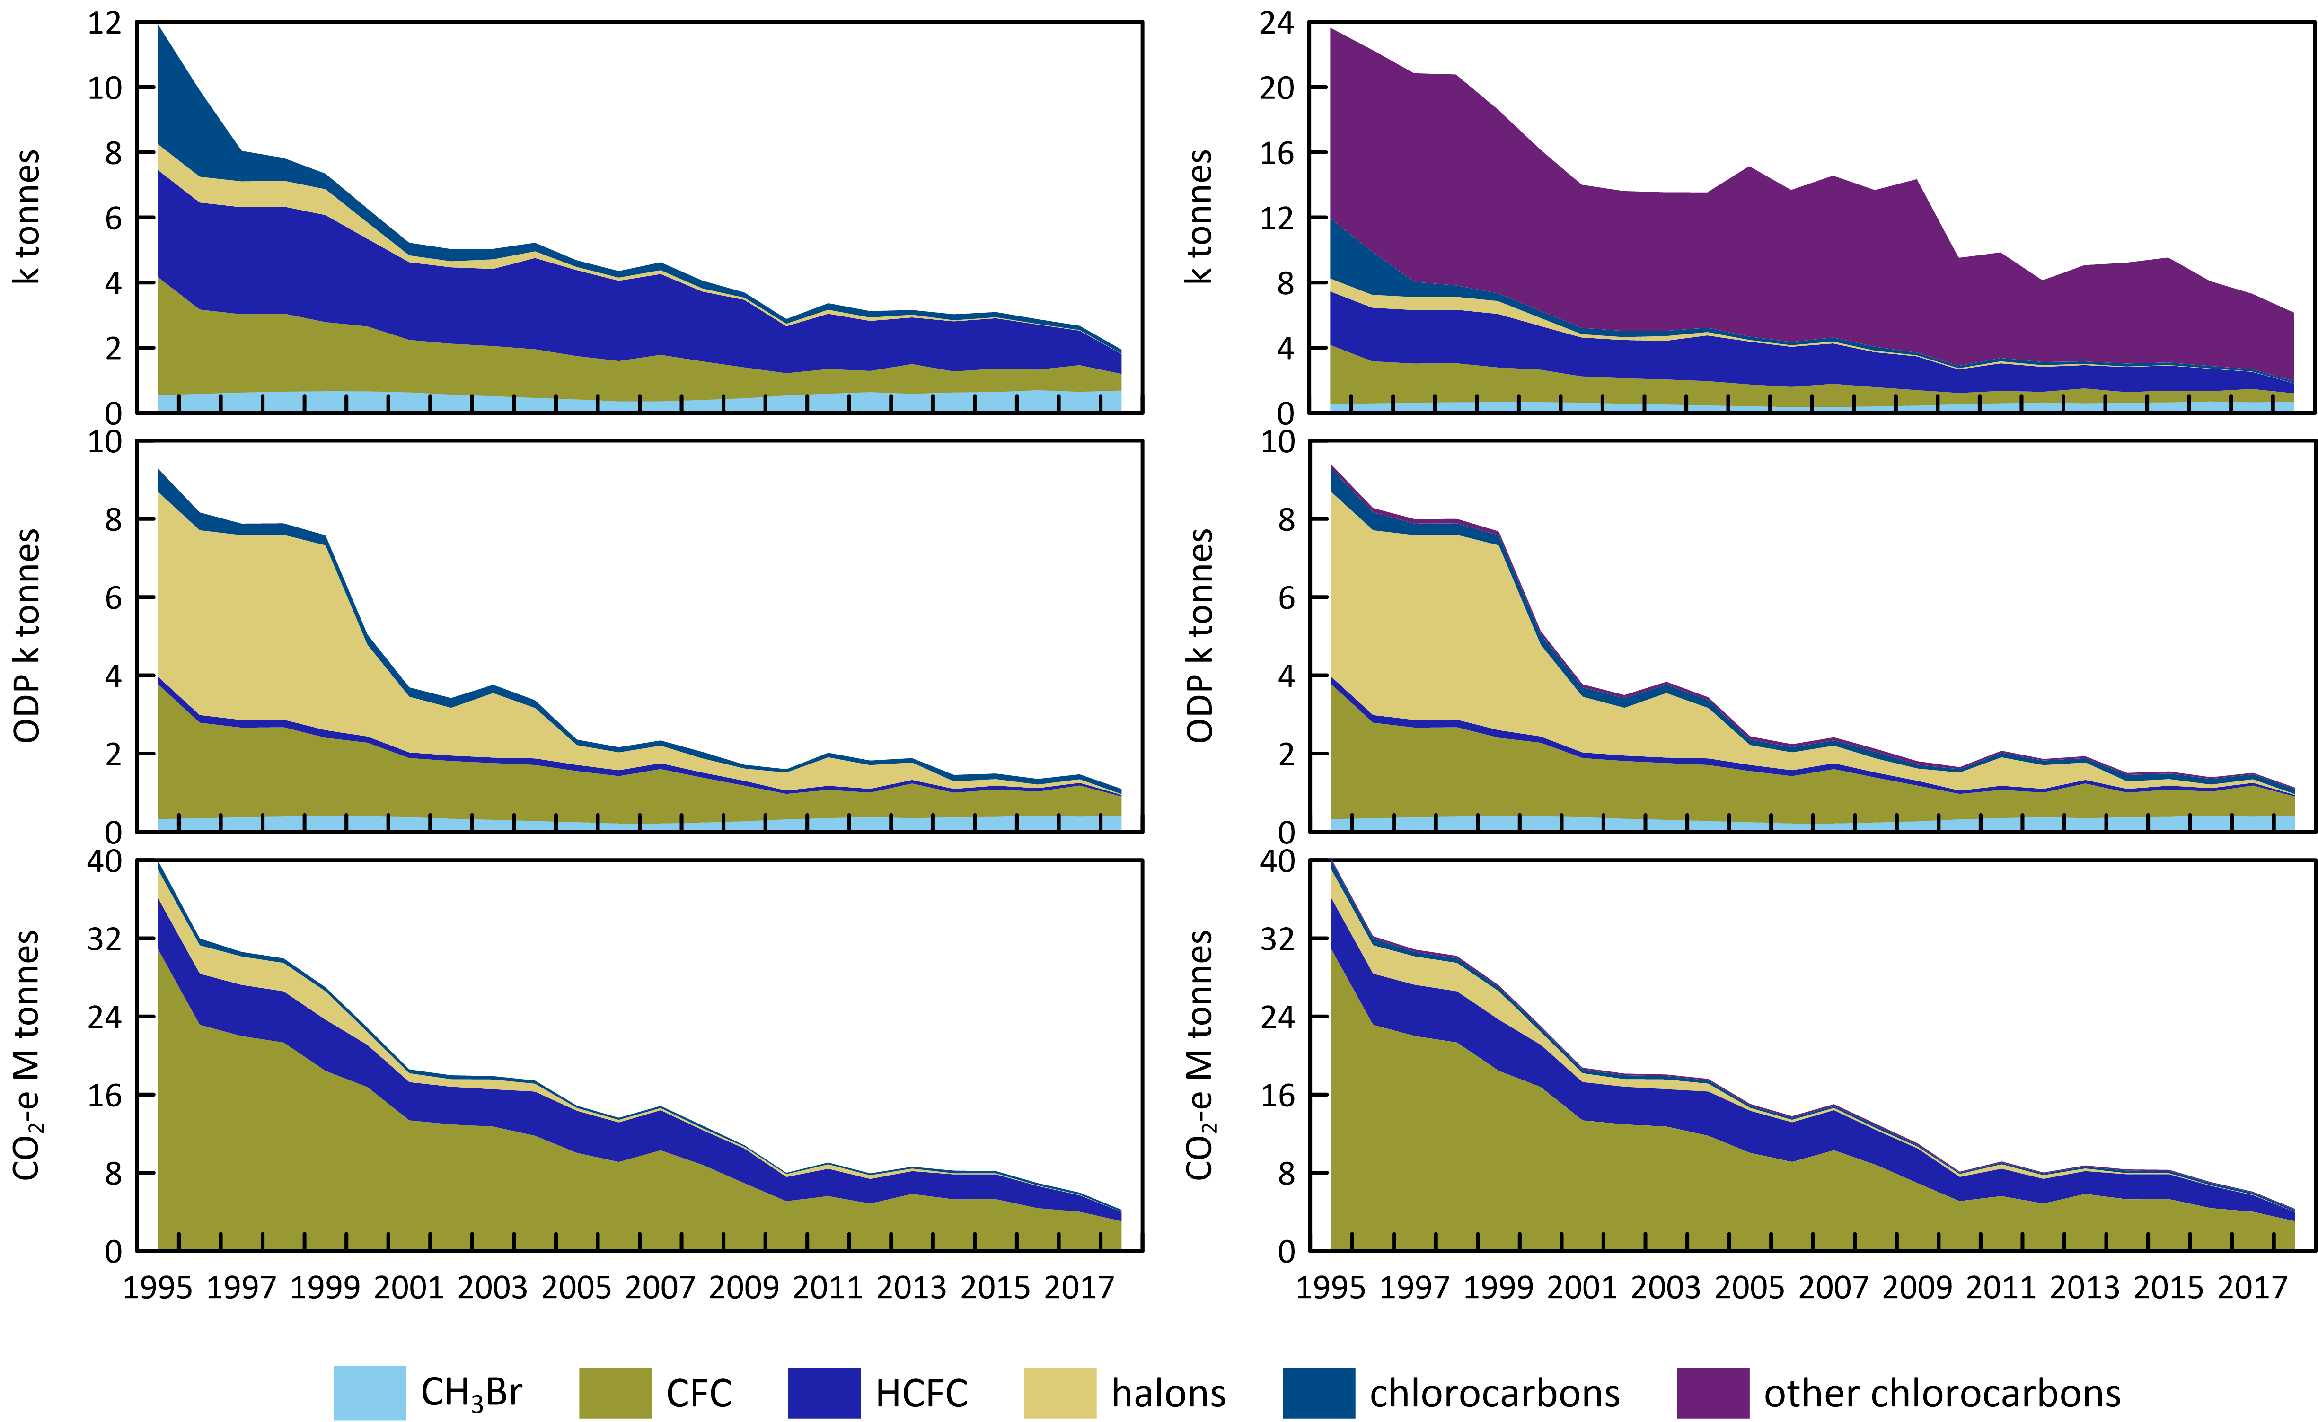

The significance of the decline of GWP-weighted ODS emissions compared to GWP-weighted emissions of the GHGs reported to UNFCCC (CO2, CH4, N2O, HFCs, PFCs, SF6) is shown in Figure 19. The 35 M tonnes CO2-e decline in GWP-weighted ODS emissions since 1995 is significant compared to other changes in Australian GHG emissions over the same period: as discussed previously, Australian emissions of GHGs (carbon dioxide, methane, nitrous oxide, HFCs, PFCs, NF3 and SF6, including land use change emissions), as reported to UNFCCC, increased by a net 39 M tonnes CO2-e from 1995 to 2018.

Figure 19. Australian emissions (GWP-weighted: M tonnes CO2-e) of ODSs (Montreal Protocol species: CFCs, HCFC, halons, methyl bromide, methyl chloroform, carbon tetrachloride) and the GHGs reported to UNFCCC (carbon dioxide, methane, nitrous oxide, Kyoto Protocol synthetics: HFC, PFCs and sulfur hexafluoride), including GHG emissions due to land-use/land-use change and forestry (LULUCF).

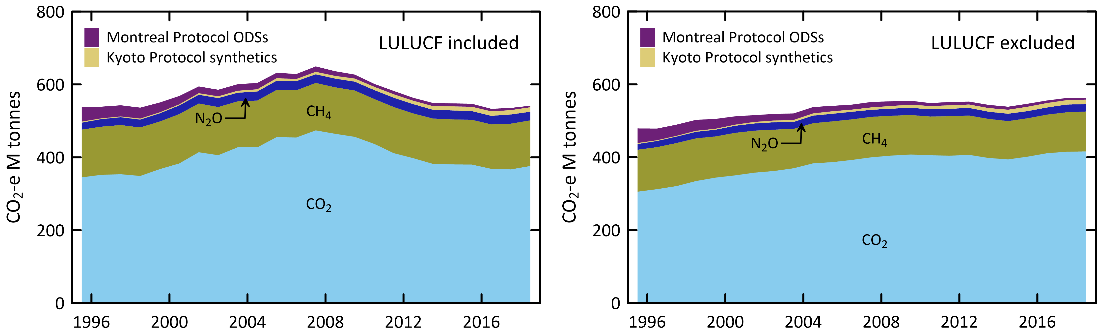

Figure 20 shows a comparison of global and Australian CFC, HCFC and HFC emissions in M tonnes CO2-e from atmospheric abundance data. There has been about a 71% decline in global CFC, HCFC and HFC emissions since their peak (9400 M tonnes CO2-e) in the late 1980s and about a 33% decline since 1995. There has been a corresponding 71% decline in Australian CFC, HCFC and HFC emissions since 1995 (41 M tonnes CO2-e). Australian ODS emissions are typically about 0.5% to 1% of global emissions. In 2018, global CFC, HCFC and HFC emissions are similar in their climate impact (33%, 27%, 39%), whereas in Australia HFC emissions have become dominant (55%) with CFCs at 35% and HCFCs at 10%. Global CFC, HCFC and HFC emissions have been about 2400-2700 M tonnes CO2-e since 2004.

Figure 20. Global (since 1978) and Australian (since 1995) CFC, HCFC and HFC emissions (M tonne CO2-e).

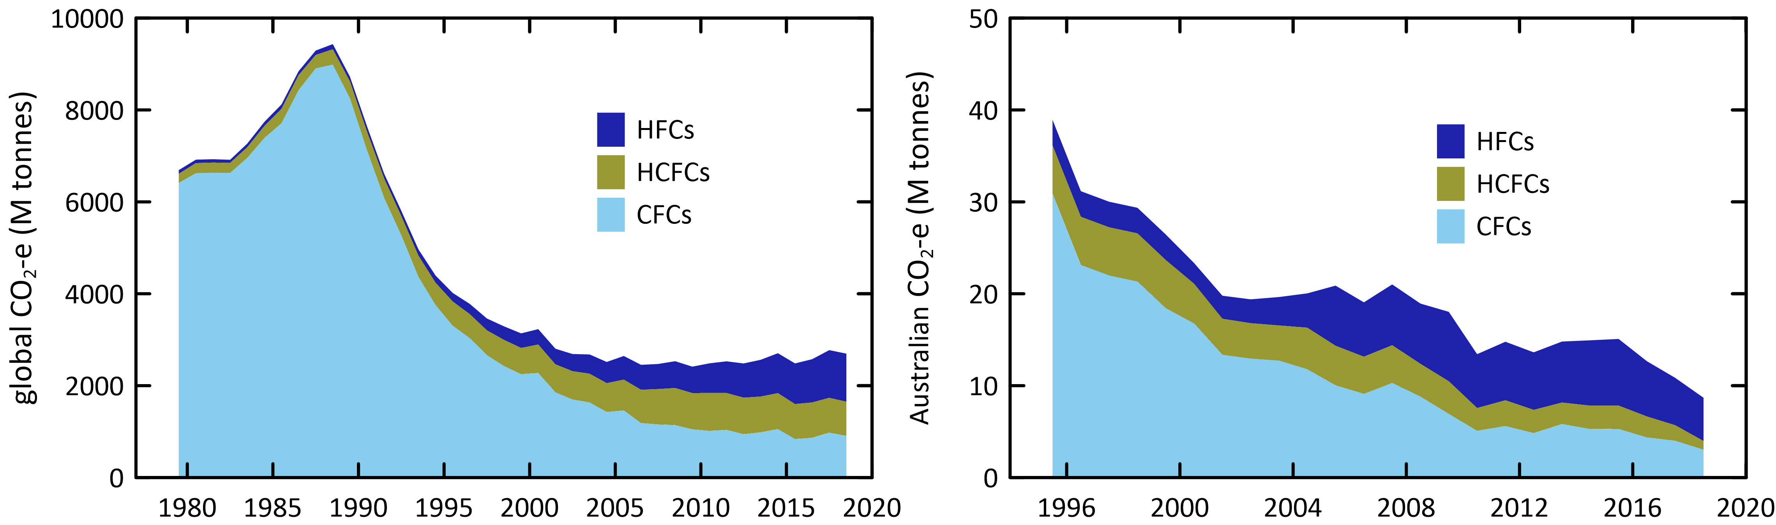

The total ODS global emissions for the Montreal Protocol ODSs (CFCs, HCFCs, halons, methyl chloroform, carbon tetrachloride and methyl bromide) in ODP tonnes are shown in Figure 21, together with the global atmospheric concentration data for these species expressed as equivalent chlorine. The combined global emissions of the Montreal Protocol ODSs peaked at 1,446 k tonnes in the late 1980s, declining at 10% per year from 1990 to 2000 and then 2.6% per year from 2000 to 2018, to reach 304 tonnes in 2018.

The total global concentrations of ODSs, expressed as equivalent chlorine (Figure 21), peaked later in the mid-1990s at 4.05 ppb, declining slowly (24 ppt per year) to 3.5 ppb by 2018, this slow decline resulting largely from the long (50-100+ years) lifetimes for carbon tetrachloride and CFCs in the atmosphere.

Figure 21. Global emissions (ODP tonnes) of the Montreal Protocol ODSs and global equivalent chlorine (ppt), both derived from AGAGE data (Fraser *et al*. 2014a; Rigby *et al*. 2014 and subsequent updates) using the 12-box AGAGE model. For methyl bromide, pre-1998 emissions are scaled to post-1998 from global atmospheric concentrations, 1978-2018.

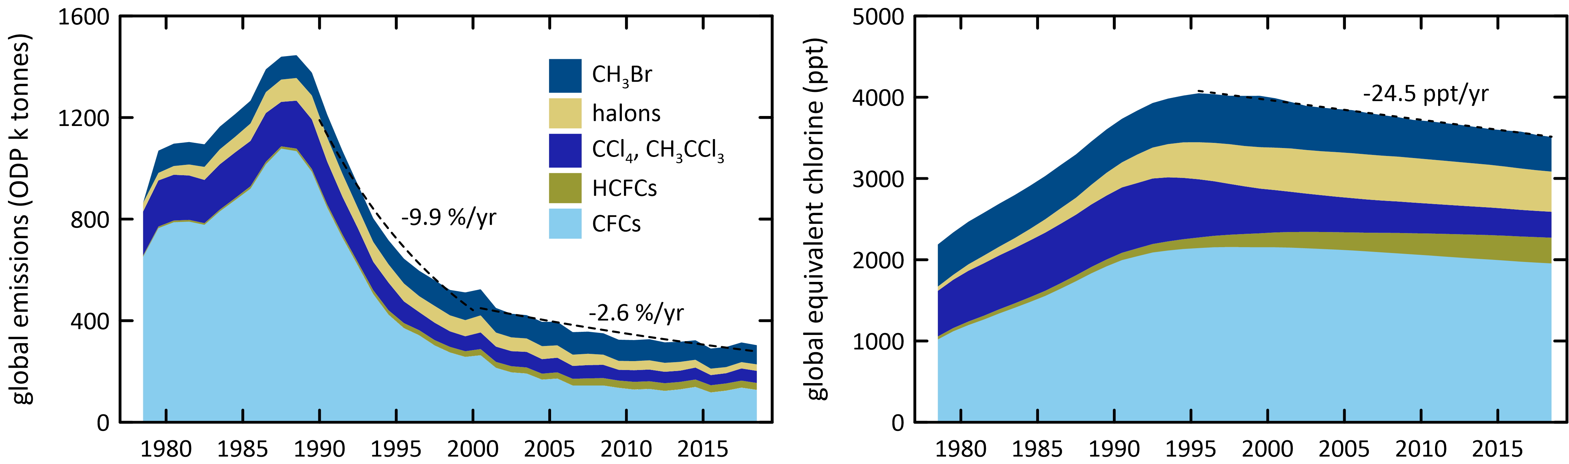

## Appendix A

### A.1 Cape Grim *in situ* and air archive measurements

Measurements have been made on baseline air in the Cape Grim Air Archive (1978-2017) at CSIRO (Aspendale), at the Scripps Institution for Oceanography (SIO, USA), at the University of East Anglia (UEA, UK) and at Eidgenössische Materialprüfungs und Forschungsanstalt (Empa, Switzerland). Other flask air samples from Cape Grim and over SE Australia have been analysed at CSIRO, the Oregon Graduate Center (OGC, USA), SIO, the National Oceanographic and Atmospheric Administration (NOAA, USA), UEA, and the National Institute for Environmental Research (NIES, Japan).

CFC-114 has been measured *in situ* at Cape Grim (since 1998) and in the Cape Grim Air Archive (1978-2015) on UEA GC-MS and AGAGE ADS/Medusa GC-MS instruments (Oram 1999; Krummel *et al*. 2014; Vollmer *et al*. 2018). ‘CFC-114’ measured on the AGAGE instruments is actually an unresolved mixture of CFC-114 (CClF2CClF2) and CFC-114a (CCl2FCF3), whereas the UEA GC-MS instrumentation can separate these two species, resulting in data for each species. Based on the early work of Oram (1999), in the international assessments of ozone depletion science (Carpenter & Reimann 2014 and earlier assessments), it was assumed that AGAGE ‘CFC-114’ is approximately 90% CFC-114 and 10% CFC-114a, constant in time, likely reflecting a common source. Further work at UEA analysing the Archive shows that the CFC-114a: CFC-114 ratio is actually lower (currently 6%), and varies with time, suggesting, in part, separate sources for these CFCs, in particular in east Asia (Laube *et al*. 2016).

### A.2 NAME/InTEM

NAME (Numerical Atmospheric Dispersion Modelling Environment) is a Lagrangian particle dispersion model. NAME has a horizontal resolution (grid boxes 40 km x 40 km) and a minimum boundary layer height of 100 m. NAME operates in a backward mode, so, for example, it identifies, within a 3 hour period at Cape Grim, which grid boxes in a prescribed domain impact on Cape Grim over the previous 12 days. NAME releases 33000 particles at Cape Grim over a 3-hour period and the resultant 12-day integrated concentrations in each of the domain boxes are calculated. Operating NAME in the backward mode is numerically very efficient and is a very close approximation to the forward running mode, which is what is used to identify emission sources impacting on Cape Grim. In the inverse calculation, InTEM (Inversion Technique for Emission Modelling) identifies pollution episode data at Cape Grim and starts with randomly generated emission maps and searches for the emission map that leads to a modelled pollution time series that most accurately mimics the observations. The inversion method assumes that baseline air enters the inversion domain regardless of direction i.e. it assumes that sources outside the specified domain do not impact significantly on Cape Grim. One of the major advantages of this method, especially when using Cape Grim data, is that it does not require a prior estimate of emissions. Other inversion methods used to estimate regional emissions using Cape Grim data often derive emissions that are not significantly different to the prior estimates. For the current InTEM inversions (VextT), emissions were scaled from a domain that includes Victoria and Tasmania as well as southern and south western New South Wales and eastern South Australia. Emissions referred to as NAME in the report use a different domain that incorporates all of Victoria, Tasmania and New South Wales.

### A.3 Carbon Monoxide Emissions

The original ISC emission estimates were based on average CO emissions from the Melbourne/Port Phillip region (600 k tonnes/yr) which were assumed to have been relatively constant during 2004-2009 (EPA 1998). In Fraser *et al*. (2012), revised estimates of the Port Phillip region CO emissions were used (Delaney & Marshall 2011) with 2002 emissions estimated at 605 k tonnes and 2006 emissions at 645 k tonnes. Carbon monoxide emissions were assumed constant after 2006 for the Port Phillip region. There has been a further revision of CO emissions from the Port Phillip region (S, Walsh, Victorian EPA, unpublished data, 2013). The 2006 Port Phillip CO emissions are now estimated to have been significantly higher at 796 k tonnes, with the increase in emissions compared to earlier estimates due to increased emissions from vehicles and reduced emissions from wood heaters. In this report, the time-dependence of the Port Phillip CO emissions is estimated from the episodes of Port Phillip CO pollution observed at Cape Grim.

## References

ABARES 2018a. *[Australian Crop Report: February 2018 – Report No. 185](https://daff.ent.sirsidynix.net.au/client/en_AU/ABARES/search/results?qu=Australian+Crop+Report+2018&h=1)*. Australian Bureau of Agricultural and Resource Economics and Sciences, Canberra.

ABARES 2018b. [*Australian Crop Report: December 2018 – Report No. 188*](https://daff.ent.sirsidynix.net.au/client/en_AU/ABARES/search/results?qu=Australian+Crop+Report+2018&h=1)*.*, Australian Bureau of Agricultural and Resource Economics and Sciences, Canberra.

Adcock, K, Reeves, CE, Gooch, LJ, Elvidge, EL, Fraser, PJ, Langenfelds, R, Brenninkmeijer, CAM, Wang, J-L, Ou-Yang, C-F, Röckmann, T, O’Doherty, S, Sturges, WT, Oram, DE, Ashfold, MJ, Hanif, NM & Laube, JC 2018. ‘[CFC-113a (CF3CCl3) in the atmosphere: an update of distributions, trends, emissions and potential source](https://doi.org/10.5194/acp-18-4737-2018)’. *Atmos. Chem. Phys*. 18, pp. 4737-4751.

Allin, SJ, Laube, JC, Witrant, E, Kaiser, J, McKenna, E, Dennis, P, Mulvaney, R, Capron, E, Martinerie, P, Röckmann, T, Blunier, T, Schwander, J, Fraser, PJ, Langenfelds, RL & Sturges, WT 2015. ‘[Chlorine isotope composition in chlorofluorocarbons CFC-11, CFC-12 and CFC-113 in firn, stratospheric and tropospheric air](https://doi.org/10.5194/acp-15-6867-2015)’. *Atmos. Chem. Phys*. 15, pp. 3867-6877.

Bekki, S, & Bodeker, GE (Coordinating Lead Authors), Bais, AF, Butchart, N, Eyring, V, Fahey, DW, Kinnison, DE, Langematz, U, Mayer, B, Portmann, RW & Rozanov, E 2011. ‘Future Ozone and Its Impact on Surface UV’. Chapter 3 in [*Scientific Assessment of Ozone Depletion: 2010*](https://csl.noaa.gov/assessments/ozone/), WMO Global Ozone Research and Monitoring Project – Report No. 52, pp. 3.1-3.60.

Brodribb, P & McCann*,* M 2013. [Cold Hard Facts 2: a study of the refrigeration and air conditioning industry in Australia](https://www.environment.gov.au/protection/ozone/publications), Expert Group and Thinkwell Australia, Canberra, ACT, Australia, 134 pp.

Brodribb, P & McCann*,* M 2014. [A study into HFC consumption in Australia](https://www.environment.gov.au/protection/ozone/publications), Expert Group, Canberra, ACT, Australia, 129 pp.

Brodribb, P & McCann, M 2015. [Assessment of environmental impacts from the Ozone Protection and Synthetic Greenhouse Gas Management Act 1989](https://www.environment.gov.au/protection/ozone/legislation), Expert Group, Canberra, ACT, Australia, for the DoE.

Brodribb, P & McCann, M 2018.[Cold Hard Facts 3: a study of the refrigeration and air conditioning industry in Australia](https://www.environment.gov.au/protection/ozone/publications), Expert Group and Thinkwell Australia, Canberra, ACT, Australia, 202 pp.

Butler, J, Elkins, JW, Hall, BR, Montzka, SA, Cummings, S, Fraser, PJ & Porter, LW 1994. ‘Recent trends in the global atmospheric mixing ratios of Halon-1301 and Halon-1211’. In *Baseline Atmospheric Program Australia 1991*, Dick, A & Gras, J (eds.), pp. 29-32. Department of the Environment, Sport and Territories, Bureau of Meteorology and CSIRO Division of Atmospheric Research.

Carpenter, LJ & Daniel, JS (Lead Authors) 2018. ‘Scenarios and Information for Policy Makers’. Chapter 6 in [*Scientific Assessment of Ozone Depletion: 2018*](https://csl.noaa.gov/assessments/ozone/), Global Ozone Research and Monitoring Project – Report No. 58, pp. 1.1-1.87, WMO: Geneva, Switzerland.

Carpenter, LJ & Reimann S, (Lead Authors) 2014. ‘Update on Ozone-Depleting Substances (ODSs) and Other Gases of Interest to the Montreal Protocol’. Chapter 1 in [*Scientific Assessment of Ozone Depletion: 2014*](https://csl.noaa.gov/assessments/ozone/), Global Ozone Research and Monitoring Project – Report No. 55, pp. 1.1-1.101, WMO: Geneva, Switzerland.

Chipperfield, M, Liang, Q, Rigby, M, Hossaini, R, Montzka, S, Dhomse, S, Feng, W, Prinn, R, Weiss, R, Harth, C, Salameh, P, Mühle, J, O'Doherty, S, Young, D, Simmonds, P, Krummel, P, Fraser, P, Steele, L, Happell, J, Rhew, R, Butler, J, Yvon-Lewis, S, Hall, B, Nance, D, Moore, F, Miller, B, Elkins, J, Harrison, J, Atlas, E & Mahieu, E 2016. ‘[Model sensitivity studies of the decrease in atmospheric carbon tetrachloride](https://doi.org/10.5194/acp-16-15741-2016)’. *Atmos. Chem. Phys*.16, pp. 15741-15754.

Chirkov, M, Stiller, GP, Laeng, A, Kellmann, S, von Clarmann, T, Boone, CD, Elkins, JW, Engel, A, Glatthor, N, Grabowski, U, Harth, CM, Kiefer, M, Kolonjari, F, Krummel, PB, Lunder, CR, Miller, BR, Montzka, SA, Mühle, J, O’Doherty, S, Orphal, J, Prinn, RG, Toon, G, Vollmer, MK, Walker, KA, Weiss, RF, Wiegele, A & Young, D 2016. ‘[Global HCFC-22 measurements with MIPAS: retrieval, validation, climatologies and trends](https://doi.org/10.5194/acp-16-3345-2016)’. *Atmos. Chem. Phys*. 16, pp. 3345-3368.

Cohan, DS, Sturrock, GA, Biazar, AP & Fraser, PJ 2003. ‘[Atmospheric methyl iodide at Cape Grim, Tasmania, from AGAGE observations](https://doi.org/10.1023/A:1022481516151)’. *J. Atmos. Chem.* 44(2), pp. 131-150’.

Cox, M, Hurley, Fraser, PJ, PJ & Physick, W 2000. ‘[Investigation of Melbourne region pollution events using Cape Grim data, a regional transport model (TAPM) and the EPA Victoria carbon monoxide inventory](https://search.informit.org/doi/10.3316/INFORMIT.418169383181534)’. *Clean Air* 34(1), pp. 35-40.

Cox, ML, 2001. ‘A regional study of the natural and anthropogenic sinks of the major halomethanes’. *PhD thesis*, School of Mathematical Sciences, Monash University, Clayton, Victoria, Australia.

Cox, ML, Sturrock, GA, Fraser, PJ, Siems, ST, Krummel, PB & O'Doherty, S 2003a. ‘[Regional sources of methyl chloride, chloroform and dichloromethane identified from AGAGE observations at Cape Grim, Tasmania, 1998-2000](https://doi.org/10.1023/A:1024022320985.)’. *J. Atmos. Chem*. 45(1), pp. 79-99.

Cox, ML, Siems, ST, Fraser, PJ, Hurley, PJ & Sturrock, GA 2003b. ‘TAPM modelling studies of AGAGE dichloromethane observations at Cape Grim’. In *Baseline Atmospheric Program Australia 1999-2000*, Tindale, NW, Derek, N & Fraser, PJ (eds.), pp. 25-30. Bureau of Meteorology and CSIRO Atmospheric Research, Melbourne.

Cox, ML, Fraser, PJ, Sturrock, GA, Siems, ST, & Porter, LW 2004. ‘[Terrestrial sources and sinks of halomethanes near Cape Grim, Tasmania](https://doi.org/10.1016/j.atmosenv.2004.03.050)’. *Atmos. Environ*. 38(23), pp. 3839-3852.

Cunnold, DM, Prinn, RG, Rasmussen, RA, Simmonds, PG, Alyea, FN, Cardelino, CA, Crawford, AJ, Fraser, PJ & Rosen, RD 1983. ‘[The Atmospheric Lifetime Experiment: 3. Lifetime methodology and application to three years of CFCl3 data](https://doi.org/10.1029/JC088iC13p08379)’. *J. Geophys. Res*. 88(C13), pp. 8379-8400.

Cunnold, DM, Prinn, RG, Rasmussen, RA, Simmonds, PG, Alyea, FN, Cardelino, CA, Crawford, AJ, Fraser, PJ & Rosen, RD 1986. ‘[Atmospheric lifetime and annual release estimates for CFCl3 and CF2Cl2 from 5 years of ALE data](https://doi.org/10.1029/JD091iD10p10797)’. *J. Geophys. Res.,* 91(D10), pp. 10797-10817.

Cunnold, DM, Fraser, PJ, Weiss, RF, Prinn, RG, Simmonds, PG, Miller, BR, Alyea, FN & Crawford, AJ 1994. ‘[Global trends and annual releases of CCl3F and CCl2F2 estimated from ALE/GAGE and other measurements from July 1978 to June 1991](https://doi.org/10.1029/93JD02715)’. *J. Geophys. Res*. 99(D1), pp. 1107-1126.

Cunnold, DM, Weiss, RF, Prinn, RG, Hartley, D, Simmonds, PG, Fraser, PJ, Miller, BR, Alyea, FN & Porter, LW 1997. ‘[GAGE/AGAGE measurements indicating reductions in global emissions of CCl3F and CCl2F2 in 1992-1994](https://doi.org/10.1029/96JD02973)’. *J. Geophys. Res.,* 102(D1), pp. 1259-1269.

Delaney, W & Marshall, A 2011. ‘Victorian air emissions inventory for 2006’. In Proceedings, *20th International Clean Air and Environment Conference*, 30 July – 2 August 2011, CASANZ, Auckland, NZ.

DoEE 2016. [Australia’s progress towards meeting its commitments under the Montreal Protocol on Substances that Deplete the Ozone Layer - 2015 Report](https://www.environment.gov.au/protection/ozone/publications), Department of the Environment and Energy, Canberra, 9 pp.

Draxler, RR & Hess, GD 1997. ‘[Description of the HYSPLIT_4 Modeling System (pdf 389 kb)](https://www.arl.noaa.gov/documents/reports/arl-224.pdf)’. NOAA Technical Memorandum ERL ARL-224, 31 p., NOAA, Colorado, USA.

Dunse, BL, Steele, LP, Fraser, PJ & Wilson, SR 2001. ‘An analysis of Melbourne pollution episodes observed at Cape Grim from 1995-1998’. In *Baseline Atmospheric Program (Australia) 1997-98*, Tindale, NW, Derek, N & Francey, RJ (eds.), pp. 34-42. Bureau of Meteorology and CSIRO Atmospheric Research, Melbourne, Australia

Dunse, BL 2002. ‘[Investigation of urban emissions of trace gases by use of atmospheric measurements and a high-resolution atmospheric transport model](https://ro.uow.edu.au/theses/1159/)’. *PhD thesis*, University of Wollongong, Wollongong, NSW, Australia.

Dunse, BL, Steele, LP, Wilson, SR, Fraser, PJ & Krummel, PB 2005. ‘[Trace gas emissions from Melbourne, Australia, based on AGAGE observations at Cape Grim, Tasmania](https://doi.org/10.1016/j.atmosenv.2005.07.014), 1995-2000’. *Atmos. Environ*. 39(34), pp. 6334-6344.

Engel, A & Rigby M (Lead Authors) 2018. ‘Update on Ozone-Depleting Substances (ODSs) and Other Gases of Interest to the Montreal Protocol’, Chapter 1 in [*Scientific Assessment of Ozone Depletion: 2018*](https://csl.noaa.gov/assessments/ozone/), Global Ozone Research and Monitoring Project – Report No. 58, pp. 1.1-1.87, WMO: Geneva, Switzerland.

EPA 1998. Air Emissions Inventory: Port Phillip Region, *EPA Publication 632*, 48 pp.

Fang, X, Park, S, Saito, T, Tunnicliffe, R, Ganesan, AL, Rigby, M, Li, S, Yokouchi, Y, Fraser, PJ, Harth, CM, Krummel, PB, Mühle, J, O’Doherty, S, Salameh, PK, Simmonds, PG, Weiss, RF, Young, D, Lunt, MF, Manning, AJ, Gressent, A & Prinn, RG 2019. ‘[Rapid increase in ozone-depleting chloroform emissions from China](https://doi.org/10.1038/s41561-018-0278-2)’. *Nature Geosci*. 12, pp. 89-93.

Forster, P & Ramaswamy, V (Coordinating Lead Authors) 2007. ‘Changes in Atmospheric Constituents and in Radiative Forcing’. Chapter 2 in: [*Climate Change 2007: The Physical Basis*](https://www.ipcc.ch/report/ar4/wg1/)*. Contribution of Working Group I to the Fourth Assessment Report of the Intergovernmental Panel on Climate Change*, Solomon, S, Qin, D, Manning, M, Chen, Z, Marquis, M, Averyt, K, Togor, M & Miller, H (eds.), Cambridge University Press, Cambridge, UK and New York, NY, USA, pp. 129-234.

Fraser, PJ, Sawford, BL & Manins, PC 1977. ‘[CCl3F (Freon-11) as an indicator of transport processes in an urban atmosphere: a case study in Melbourne](https://doi.org/10.1016/0004-6981(77)90231-1)’. *Atmos. Environ*. 11(11), pp. 1025-1028.

Fraser, PJ & Pearman, GI 1978a. ‘[Atmospheric halocarbons in the southern hemisphere](https://doi.org/10.1016/0004-6981(78)90021-5)’. *Atmos. Environ*. 12(4), pp. 839-844.

Fraser, PJ & Pearman, GI 1978b. ‘[The fluorocarbon-ozone theory – II. Tropospheric lifetimes - an estimate of the tropospheric lifetime of CCl3F](https://doi.org/10.1016/0004-6981(78)90332-3)’. *Atmos. Environ.* 12(8), pp. 1807-1808.

Fraser, PJ,Hyson, P, Enting, IG & Pearman, GI 1983. ‘[Global distribution and southern hemispheric trends of atmospheric CCl3F](https://doi.org/10.1038/302692a0)’. *Nature* 302, pp. 692-695.

Fraser, PJ, Hyson, P, Rasmussen, RA, Crawford, AJ & Khalil, MAK 1986. ‘[Methane, carbon monoxide and methyl chloroform in the southern hemisphere](https://doi.org/10.1007/BF00053771)’. *J. Atmos. Chem.*, 4 pp. 3-42.

Fraser, PJ, Cunnold, DM, Alyea, FN, Weiss, RF, Prinn, RG, Simmonds, PG, Miller, BR & Langenfelds, RL 1996. ‘[Lifetime and emission estimates of 1,1,2-trichlorotrifluorethane (CFC-113) from daily global background observations June 1982-June 1994](https://doi.org/10.1029/96JD00574)’. *J. Geophys. Res*, 101(D7), pp. 12585-12599.

Fraser, PJ & Prather, MJ 1999. ‘[Uncertain road to ozone recovery](https://doi.org/10.1038/19418)’. *Nature* 398(6729), pp. 663-664.

Fraser, PJ, Oram, DE, Reeves, CE, Penkett, SA & McCulloch, A 1999. ‘[Southern Hemispheric halon trends (1978-1998) and global halon emissions](https://doi.org/10.1029/1999JD900113)’. *J. Geophys. Res*. 104(D13), pp. 15985-15999.

Fraser, PJ 2000. ‘[Will illegal trade in CFCs and halons threaten ozone layer recovery](https://doi.org/10.1016/S1352-2310(00)00094-7)?’ *Atmos. Environ*. 34(18), pp. 3038-3039.

Fraser, PJ, Steele, LP, Krummel, PB, Allison, CE, Coram, SA, Dunse, BL & Vollmer, MK 2012. DSEWPaC Research Projects 2011/2012, Australian emissions of ODSs and SGGs, Final Report October 2012, 14 pp.

Fraser, PJ, Dunse, BL, Krummel, PB, Steele, LP & Derek, N 2013. ‘[Australian atmospheric measurements and emissions estimates of ozone depleting substances and synthetic greenhouse gases’ (pdf 3.48 mb)](https://www.environment.gov.au/system/files/resources/b8436f38-c581-4fec-bc9f-999b2bd3ec90/files/australian-ods-sgg-emissions.pdf), DoE Projects 2012-2013, Report prepared for Department of Sustainability, Environment, Water, Populations and Communities, CSIRO Marine and Atmospheric Research, Melbourne, Australia, iv, 42 p.

Fraser, PJ, Krummel, PB, Steele, LP, Trudinger, CM, Etheridge, DM, O'Doherty, S, Simmonds, PG, Miller, BR, Mühle, J, Weiss, RF, Oram, DE, Prinn, RG & Wang, RHJ 2014a. Equivalent effective stratospheric chlorine from Cape Grim Air Archive, Antarctic firn and AGAGE global measurements of ozone depleting substances, *Baseline Atmospheric Program (Australia) 2009-2010*, N. Derek, PB, Krummel and Cleland, S (eds.), pp. 17-23. Australian Bureau of Meteorology and CSIRO Marine and Atmospheric Research, Melbourne, Australia.

Fraser, PJ, Dunse, BL, Manning, AJ, Walsh, S, Wang, RHJ, Krummel, PB, Steele, LP, Porter,LW, Allison, CE, O’Doherty, S, Simmonds, PG, Mühle, J & Prinn, RG 2014b. ‘[Australian carbon tetrachloride emissions in a global context](https://doi.org/10.1071/EN13171)’. *Environ. Chem*. 11(1), pp. 77-88.

Fraser, P, Dunse, B, Krummel, P, Steele, P & Derek, N 2015. [Australian and Global ODS Emissions](https://www.environment.gov.au/protection/ozone/publications), Report prepared for the Department of the Environment, CSIRO Oceans and Atmosphere Flagship, Melbourne, Australia, iii, 29 p.

Fraser, PJ, Steele, LP, Pearman, GI, Coram, S, Derek, N, Langenfelds, RL & Krummel, PB 2016. ‘Non-carbon dioxide greenhouse gases at Cape Grim: a 40 year odyssey’. In *Baseline Atmospheric Program (Australia) History and Recollections, 40th Anniversary Special Edition,* Derek, N, Krummel, PB & Cleland, SJ (eds.), pp. 45-76. Bureau of Meteorology, CSIRO Oceans and Atmosphere, Melbourne, Australia.

Fraser, PJ, Pearman, GI & Derek, N 2018. ‘[CSIRO non-carbon dioxide greenhouse gas research. Part 1: 1975-1990](https://doi.org/10.1071/HR17016)’. *Historical Records of Australian Science* 28, pp. 1-13.

Fraser, PJ, Dunse, BL, Krummel, PB, Steele, LP, Derek, N, Mitrevski, B, Allison, CE, Loh, Z, Manning, AJ, Redington, A & Rigby, M 2020. ‘[Australian chlorofluorocarbon (CFC) emissions: 1960-2017](https://doi.org/10.1071/EN19322)’. *Environ. Chem*. 17, pp. 525-544.

Greally, BR, Manning, AJ, Reimann, S, McCulloch, A, Huang, J, Dunse, BL, Simmonds, PG, Prinn, RG, Fraser, PJ, Cunnold, DM, O'Doherty, S, Porter, LW, Stemmler, K, Vollmer, MK, Lunder, CR, Schmidbauer, N, Hermansen, O, Arduini, J, Salameh, PK, Krummel, PB, Wang, RHJ, Folini, D, Weiss, RF, Maione, M, Nickless, G, Stordal, F & Derwent, RG 2007. ‘[Observations of 1,1-difluoroethane (HFC-152a) at AGAGE and SOGE monitoring stations in 1994-2004 and derived global and regional emission estimates](https://doi.org/10.1029/2006JD007527)’. *J. Geophys. Res*. 112, D06308.

Harris, NRP & Wuebbles, DJ (Lead Authors) 2014. ‘Scenarios, Information, and Options for Policy Makers’. Chapter 5 in [*Scientific Assessment of Ozone Depletion: 2014*](https://csl.noaa.gov/assessments/ozone/), Global Ozone and Monitoring Project – Report No. 55, pp. 5.1-5.58, WMO, Geneva, Switzerland.

Hossaini, R, Chipperfield, MP, Saiz-Lopez, A, Harrison, JJ, von Glasow, R, Sommariva, R, Atlas,E, Navarro, M, Montzka, SA, Feng, W, Dhomse, S, Harth, C, Mühle, J, Lunder, C, O’Doherty, S, Young, D, Reimann, S, Vollmer, MK, Krummel, PB & Bernath, PF 2015. ‘[Growth in stratospheric chlorine from short-lived chemicals not controlled by the Montreal Protocol](https://doi.org/10.1002/2015GL063783)’. *Geophys. Res. Lett*. 42(11), pp. 4573-4580. doi:10.1002/2015GL063783

Hossaini, R, Chipperfield, MP, Monztka, SA, Leeson, AA, Dhomse, SS & Pyle, JA 2017. ‘[The increasing threat to stratospheric ozone from dichloromethane](https://doi.org/10.1038/ncomms15962)’. *Nature Comms*. 8, 15962.

Hu, L, Montzka, SA, Miller, BR, Andrews, AE, Miller, JB, Lehman, SJ, Sweeney, C, Miller, SM, Thoning, K, Siso, C, Atlas, EL, Blake, DR, de Gouw, J, Gillman, JB, Dutton, G, Elkins, JW, Hall, B, Chen, H, Fischer, ML, Mountain, ME, Nehrkorn, T, Biraud, SC, Moore, FL & Tans, P 2016. ‘[Continued emissions of carbon tetrachloride from the U.S, nearly two decades after its phase-out for dispersive uses](https://doi.org/10.1073/pnas.1522284113)’. *Proc. Nat. Acad. Sci*. 113(11), pp. 2880-2885.

Hyson, P, Fraser, PJ &, Pearman, GI 1980. ‘[A two-dimensional transport simulation model for trace atmospheric constituents](https://doi.org/10.1029/JC085iC08p04443)’. *J. Geophys. Res*. 85(C8), pp. 4443-4456.

Klekociuk, AR, Krummel, PB, Tully, MB, Gies,HP, Alexander, SP, Fraser, PJ, Henderson, SI, Javorniczky, J, Shanklin, JD, Schofield, R & Stone, KA 2015. ‘[The Antarctic Ozone Hole during 2013 (pdf 2.36 mb)](http://www.bom.gov.au/jshess/docs/2015/klekociuk.pdf)’. *Aust. Meteorol. Oceanog. J*. 65(2), pp. 247-265.

Kloss, C, Newland, MJ, Oram, DE, Fraser, PJ, Brenninkmeijer, CAM, Röckmann, T & Laube, JC 2014. ‘[Atmospheric abundances, trends and emissions of CFC-216ba, CFC-216ca and HCFC-225ca](https://doi.org/10.3390/atmos5020420)’. *Atmosphere* 5(2), pp. 420-434.

Krummel., PB, LW, Porter, Fraser, PJ, BL, Dunse & Derek, N 2006. ‘HCFCs, HFCs, halons, minor CFCs, PCE and halomethanes: the AGAGE *in situ* GC-MS-ADS program at Cape Grim, 1998-2004’. In *Baseline Atmospheric Program (Australia) 2005-2006*, Cainey, J, Derek, N & Krummel, PB (eds.) pp. 65-73. Australian Bureau of Meteorology and CSIRO Marine and Atmospheric Research, Melbourne, Australia.

Krummel, PB, Fraser, PJ, Steele, LP, Derek, N, Rickard, C, Ward, J, Somerville, NT, Cleland, SJ, Dunse, BL, Langenfelds, RL, Baly, SB & Leist, M 2014. ‘The AGAGE *in situ* program for non-CO2 greenhouse gases at Cape Grim, 2009-2010’. In *Baseline Atmospheric Program (Australia) 2009-2010*, Derek, N, Krummel, PB & Cleland, SJ (eds.) pp. 55-70. Australian Bureau of Meteorology and CSIRO Marine and Atmospheric Research, Melbourne, Australia.

Krummel, PB, Fraser PJ, & Derek, N 2017. [*The 2016 Antarctic Ozone Hole and Ozone Science Summary: Final Report*](https://www.environment.gov.au/protection/ozone/publications/antarctic-ozone-hole-summary-reports), Australian Government Department of the Environment and Energy, CSIRO Oceans and Atmosphere Climate Science Centre, Australia, v, 29 pp.

Krummel, PB, Fraser PJ, & Derek, N 2018. [*The 2017 Antarctic Ozone Hole and Ozone Science Summary: Final Report*](https://www.environment.gov.au/protection/ozone/publications/antarctic-ozone-hole-summary-reports), Australian Government Department of the Environment and Energy, CSIRO Oceans and Atmosphere Climate Science Centre, Australia, v, 29 pp.

Krummel, PB, Fraser PJ, & Derek, N 2019. [*The 2018 Antarctic Ozone Hole and Ozone Science Summary: Final Report*](https://www.environment.gov.au/protection/ozone/publications/antarctic-ozone-hole-summary-reports), Australian Government Department of the Environment and Energy, CSIRO Oceans and Atmosphere Climate Science Centre, Australia, v, 29 pp.

Krummel, PB, Fraser PJ, & Derek, N 2020. [*The 2019 Antarctic Ozone Hole and Ozone Science Summary: Final Report*](https://www.environment.gov.au/protection/ozone/publications/antarctic-ozone-hole-summary-reports), Australian Government Department of the Environment and Energy, CSIRO Oceans and Atmosphere Climate Science Centre, Australia, v, 28 pp.

Laube, JC, Kiel, A, Bönisch, H, Engel, E, Newland, M, Röckmann, T, Volk, CM, Sturges, WT, Fraser, PJ & Oram, D 2013. Supplementary information to ‘[Observation-based assessment of stratospheric fractional release, lifetimes and ozone depletion potentials of ten important trace gases](https://acp.copernicus.org/articles/13/2779/2013/)’. *Atmos. Chem. Phys*. 13, pp. 2779-2791.

Laube, JC, Newland, MJ, Hogan, C, Brenninkmeijer, CAM, Fraser, PJ, Martinerie, P, Oram,DE, Reeves, CE, Röckmann, T, Schwander, J, Witrant, E & Sturges, WT 2014. ‘[Newly detected ozone depleting substances in the atmosphere](https://doi.org/10.1038/ngeo2109)’. *Nature Geosci*. 7, pp. 266-269.

Laube, JC, Hanif, NM, Martinerie, P, Gallacher, E, Fraser, PJ, Langenfelds, RL, Brenninkmeijer, CAM, Schwander, J, Witrant, E, Wang, J-L, Ou-Yang, C-F, Gooch, LJ, Reeves, CE, Sturges, WT & Oram, DE 2016. ‘[Tropospheric observations of CFC-114 and CFC-114a with a focus on long-term trends and emissions](https://doi.org/10.5194/acp-16-15347-2016)’. *Atmos. Chem. Phys*. 16, pp. 15347-15358.

Li, P, Mühle, J, Montzka, SA, Oram, DE, Miller, BR, Weiss, RF, Fraser, PJ & Tanhua, T 2019. ‘[Atmospheric histories, growth rates and solubilities in seawater and other natural waters of the potential transient tracers HCFC-22, HCFC-141b, HCFC-142b, HFC-134a, HFC-125, HFC-23, PFC-14 and PFC-116](https://doi.org/10.5194/os-15-33-2019)’. *Ocean Sci.* 15, pp. 33-60.

Liang, Q, Newman, P & Reiman, S (eds.) 2016. [*SPARC Report on the Mystery of Carbon Tetrachloride*](https://www.sparc-climate.org/publications/sparc-reports/sparc-report-no-7/), SPARC Report No. 7, WCRP-13/2016, xii, 52 p.

Liang, Q, Chipperfield, MP, Flemimg, EL, Abraham, NL, Braesicke, P, Burkholder, JB, Daniel, JS, Dhmosa, S, Fraser, PJ, Hardiman, SC, Jackman, CH, Kinnison, DE, Krummel, PB, Montzka, SA, Morgenstern, O, McCulloch, A, Mühle, J, Newman, PA, Orkin, VL, Pitari, G, Prinn, RG, Rigby, M, Razanov, E, Stenke, A, Tummon, F, Velders, GJM, Visioni, D & Weiss, RF 2017. ‘[Deriving global OH abundance and atmospheric lifetimes for long-lived gases: a search for CH3CCl3 alternatives](https://doi.org/10.1002/2017JD026926)’. *J. Geophys. Res.* 122, pp. 11914-11933.

Lunt, M. F., Park, S., Li, S., Henne, S., Manning, A. J., Ganesan, A. L., Simpson, I. J., Blake, D. R., Liang, Q., O'Doherty, S., Harth, C. M., Muhle, J., Salameh, P. K., Weiss, R. F., Krummel, P. B., Fraser, P. J., Prinn, R. G., Reimann, S. & Rigby, M. 2018. [Continued Emissions of the Ozone-Depleting Substance Carbon Tetrachloride From Eastern Asia](https://agupubs.onlinelibrary.wiley.com/doi/10.1029/2018GL079500). *Geophysical Research Letters,* 45**,** 11423-11430.

Manning, AJ, Ryall, DB Derwent, , RG, Simmonds, PG & O'Doherty, S 2003. ‘[Estimating European od ozone depleting and greenhouse gases using observations and a modelling back-attribution technique](https://doi.org/10.1029/2002JD002312)’. *J.* *Geophys. Res*. 108(D14), 4405, 2003

Manning, AJ, O'Doherty, S, Jones, AR, Simmonds, PG & Derwent, RG 2011. ‘[Estimating UK methane and nitrous oxide emissions from 1990 to 2007 using an inversion modeling approach](https://doi.org/10.1029/2010JD014763)’. *J. Geophys. Res*. 116, D02305, 2011.

McNorton, J, Chipperfield, MP, Gloor, M, Wilson, C, Feng, W, Hayman, GD, Rigby, M, Krummel, PB, O’Doherty, S, Prinn, RG, Weiss, RF, Young, D, Dlugokencky, E & Montzka, SA 2016. ‘[Role of OH variability in the stalling of the global atmospheric CH4 growth rate from 1999 to 2006](https://doi.org/10.5194/acp-16-7943-2016)’. *Atmos. Chem. Phys*. 16, pp. 7943-7956.

Meinshausen, M, Vogel, E, Nauels, A, Lorbacher, K, Meinshausen, N, Etheridge, D, Fraser, P, Montzka, S, Rayner, P, Trudinger, C, Krummel, P, Beyerle, U, Canadell, P, Daniel, J, Enting, I, Law, R, Lunder, C, O'Doherty, S, Prinn, R, Reimann, S, Rubino, M, Velders, G, Vollmer, M, Wang, R & Weiss, R 2017. ‘[Historical greenhouse gas concentrations for climate modelling (CMIP6)](https://doi.org/10.5194/gmd-10-2057-2017)’, *Geosci. Model Dev.*, 10(5), 2015-2116.

Miller, BR 1998. ‘Abundances and trends of atmospheric chlorofluoromethane and bromomethane’. *PhD thesis*, University of California at San Diego, La Jolla, California, USA, 149 p.

Miller, BR, Huang, J, Weiss, RF, Prinn, RG & Fraser, PJ 1998. ‘[Atmospheric trend and lifetime of chlorodifluoromethane (HCFC-22) and the global tropospheric OH concentration](https://doi.org/10.1029/98JD00771)’, *J. Geophys. Res.,* 103(D11), pp. 13237-13248.

Miller, BR, Rigby, M, Kuijpers, LJM, Krummel, PB, Steele, LP, Leist, M, Fraser, PJ, McCulloch, A, Harth, C, Salameh, P, Mühle, J, Weiss, RF, Prinn, RG, Wang, RHJ, O'Doherty, S, Greally, BR & Simmonds, PG 2010. ‘[HFC-23 (CHF3) emission trend response to HCFC-22 (CHClF2) production and recent HFC-23 emissions abatement measures](https://doi.org/10.5194/acp-10-7875-2010)’. *Atmos. Chem. Phys.*, 10(16), pp. 7875-7890.

Montzka, SA, M, R. Nowick, R. C. Myers, JW, Elkins, JH, Butler, S, O. Cummings, Fraser, PJ & Porter, LW 1994. ‘NOAA-CMDL chlorodifluoromethane (HCFC-22) observations at Cape Grim’, in *Baseline Atmospheric Program Australia* 1991, Dick, A & Gras, J (eds.) pp. 25-28. Department of the Environment, Sport and Territories, Bureau of Meteorology and CSIRO Division of Atmospheric Research, Melbourne.

Montzka, SA & Reimann, S (Coordinating Lead Authors), 2011. ‘Ozone-Depleting Substances (ODSs) and Related Chemicals’. Chapter 1 in [*Scientific Assessment of Ozone Depletion: 2010*](https://csl.noaa.gov/assessments/ozone/), WMO Global Ozone Research and Monitoring Project – Report No. 52, pp. 1.1-1.108, WMO: Geneva, Switzerland.

Montzka, SA, Dutton, GS, Yu, P, Ray, E, Portmann, RW, Daniel, JS, Kuijpers, LK, Hall, BD, Mondeel, D, Siso, C, Nance, JD, Rigby, M, Manning, AJ, Hu, L, Moore, F, Miller, BR & Elkins, JW 2018. ‘[An unexpected and persistent increase in global emissions of ozone-depleting CFC-11](https://doi.org/10.1038/s41586-018-0106-2)’. *Nature* 557(7705), pp. 413-417.

Myhre, G & Shindell, D (Lead autors), 2014. ‘Anthropogenic and Natural Radiative Forcing’, Chapter 8 in [*Climate Change 2013 – The Physical Science Basis*](https://www.ipcc.ch/report/ar5/wg1/), Working Group I Contribution to the Fifth Assessment Report of the Intergovernmental Panel on Climate Change, Stocker, TF, Qin, D, Plattner, G-K, Tignor, M, Allen, SK, Boschung, J, Nauels, A, Xia, Y, Bex, V & Midgley, P (eds.), Cambridge University Press, Cambridge, UK and New York, NY, USA, pp. 659-740.

National Transport Commission 2008. Grain Supply Chain Pilot Study, Stage One Final Report, prepared by Strategic Design and Development, Epping, NSW, for the National Transport Commission, 62 pp.,

Newland, MJ, Reeves, CE, Oram, DE, Laube, JC, Sturges, WT, Hogan, C, Begley, P & Fraser PJ 2013. ‘[Southern hemispheric halon trends and global halon emissions, 1978-2011](https://doi.org/10.5194/acp-13-5551-2013)’. *Atmos. Chem. Phys*. 13, pp. 5551-5565.

O'Doherty, S, Simmonds, PG, Cunnold, DM, Wang, HJ, Sturrock, GA, Fraser, PJ, Ryall, D, Derwent, R, Weiss, RF, Salameh, P, Miller, BR & Prinn, RG 2001. ‘[*In situ* chloroform measurements at Advanced Global Atmospheric Gases Experiment atmospheric research stations from 1994 to 1998](https://doi.org/10.1029/2000JD900792)’. *J. Geophys. Res.*, 106(D17), 20429-20444

O'Doherty, S, Cunnold, DM, Manning, A, Miller, BR, Wang, RHJ, Krummel, PB, Fraser, PJ, Simmonds, PG, McCulloch, A, Weiss, RF, Salameh, P, Porter, LW, Prinn, RG, Huang, J, Sturrock, G, Ryall, D, Derwent, RG & Montzka, SA 2004. ‘[Rapid growth of hydrofluorocarbon 134a and hydrochlorofluorocarbons 141b, 142b, and 22 from Advanced Global Atmospheric Gases Experiment (AGAGE) observations at Cape Grim, Tasmania, and Mace Head, Ireland](https://doi.org/10.1029/2003JD004277)’. *J.* *Geophys. Res*., 109, D06310.

O'Doherty, S, Cunnold, DM, Miller, BR, Mühle, J, McCulloch, A, Simmonds, PG, Manning, AJ, Reimann, S, Vollmer, MK, Greally, BR, Prinn, RG, Fraser, PJ, Steele, LP, Krummel, PB, Dunse, BL, Porter, LW, Lunder, CR, Schmidbauer, N, Hermansen, O, Salameh, PK, Harth, CM, Wang, RHJ & Weiss, RF 2009. ‘[Global and regional emissions of HFC-125 (CHF2CF3) from *in situ* and air archive observations at AGAGE and SOGE observatories](https://doi.org/10.1029/2009JD012184.)’. *J.* *Geophys. Res*. 114, D23304.

Oram, DE, Reeves, CE, Penkett, SA & Fraser, PJ 1995. ‘[Measurements of HCFC-142b and HCFC-141b in the Cape Grim air archive: 1978-1993](https://doi.org/10.1029/95GL02849)’. *Geophys. Res. Lett*. 22(20), pp. 2741-2744.

Oram, DE 1999. ‘Trends in long-lived anthropogenic halocarbons in the Southern Hemisphere and model calculations of global emissions’. *PhD thesis*, University of East Anglia, Norwich, UK.

Oram, DE, Ashfold, MJ, Laube, JC, Gooch, LJ, Humphrey, S, Sturges, WT, Leedham-Elvidge, E, Forster, GL, Harris, NRP, Iqbal Mead, M, Samah, AA, Phang, SM, Ou-Yang, C-F, Lin, N-H, Wang, J-L, Baker, AK, Brenninkmeijer, CAM & Sherry, D 2017. ‘[A growing threat to the ozone layer from short-lived anthropogenic chlorocarbons](https://doi.org/10.5194/acp-17-11929-2017)’. *Atmos. Chem. Phys*., 17, pp. 11929-11941.

Patra, PK, Krol, MC, Montzka, SA, Arnold, T, Atlas, EL, Lintner, BR, Stephens, BB, Xiang, B, Elkins, JW, Fraser, PJ, Ghosh, A, Hintsa, EJ, Hurst, DF, Ishijima, K, Krummel, PB, Miller, BR, Miyazaki, K, Moore, FL, Mühle, J, O’Doherty, S, Prinn, RG, Steele, LP, Takigawa, M, Wang, HJ, Weiss, RF, Wofsy, SC & Young, D, 2014. [‘Observational evidence for interhemispheric hydroxyl-radical parity](https://doi.org/10.1038/nature13721)’, *Nature* 513, pp. 219-223.

Porter, IJ, Mattner, SW, Banks, J & Fraser, PJ 2006. **.**[Impact of global methyl bromide phase-out on the sustainability of strawberry industries](https://doi.org/10.17660/ActaHortic.2006.708.29)’. *Acta Horticulturae*, 708, pp. 179-185.

Porter, I, Banks, J, Mattner, S & Fraser, PJ 2009. ‘[Global phase-out of methyl bromide under the Montreal Protocol: implications for bioprotection, biosecurity and the ozone layer](https://doi.org/10.1007/978-1-4020-8804-9_21)’. in *Plant Pathology in the 21st Century: Recent Developments in Management of Plant Diseases* 1, pp. 293-309. Springer-Verlag Berlin.

Porter, I, Pizano, M, Besri, M & Fraser, PJ 2010. ‘[Progress in the global phase-out of methyl bromide and the relative effectiveness of soil disinfestations strategies](https://doi.org/10.17660/ActaHortic.2010.883.4)’. *Acta Horticulturae* 883, pp. 59-66.

Prinn, R, Cunnold, D, Rasmussen, R, Simmonds, P, Alyea, F, Crawford, A, Fraser, P & Rosen, R 1987. ‘[Atmospheric trends in methylchloroform and the global average for the hydroxyl radical](https://doi.org/10.1126/science.238.4829.945)’. *Science* 238(4829), pp. 945-950.

Prinn, R Cunnold,, D, Simmonds, P, Alyea, F, Boldi, R, Crawford, A, Fraser, P, Gutzler, D, Hartley, D, Rosen, P & Rasmussen, R 1992. ‘[Global average concentration and trend for hydroxyl radicals deduced from ALE/GAGE trichloroethane (methyl chloroform) data for 1978-1990](https://doi.org/10.1029/91JD02755)’. *J. Geophys. Res.* 97(D2), pp. 2445-2461.

Prinn, RG, Weiss, RF, Miller, BR, Huang, J, Alyea, FN, Cunnold, DM, Fraser, PJ, Hartley, D & Simmonds, PG 1995. ‘[Atmospheric trends and lifetime CH3CCl3 and global OH concentrations](https://doi.org/10.1126/science.269.5221.187)’. *Science,* 269(5221), pp. 187-192. doi:10.1126/science.269.5221.187

Prinn, RG, Weiss, RF, Fraser, PJ, Simmonds, PG, Cunnold, DM, Alyea, FN, O'Doherty, S, Salameh, P, Miller, BR, Huang, J, Wang, RHJ, Hartley, DE, Harth, C, Steele, LP, Sturrock, G, Midgley, PM & McCulloch, A 2000. ‘[A history of chemically and radiatively important gases in air deduced from ALE/GAGE/AGAGE](https://doi.org/10.1029/2000JD900141)’. *J. Geophys. Res*. 105(D14), pp. 17751-17792.

Prinn, RG, Huang, J, Weiss, RF, Cunnold, DM, Fraser, PJ, Simmonds, PG, McCulloch, A, Harth,CM, Salameh, PK, O'Doherty, S, Wang, RHJ, Porter, LW & Miller, BR 2001. ‘[Evidence of substantial variations of atmospheric hydroxyl radicals in the past two decades](https://doi.org/10.1126/science.1058673)’. *Science* 292(5523), pp. 1882-1888.

Prinn, RG, Huang, J, Weiss, RF, Cunnold, DM, Fraser, PJ, Simmonds, PG, McCulloch, A, Harth, C, Reimann, S, Salameh, P, O’Doherty, S, Wang, RHJ, Porter, LW, Miller, BR & Krummel PB, 2005. ‘[Evidence for variability of atmospheric hydroxyl radicals over the past quarter century](https://doi.org/10.1029/2004GL022228)’. *Geophys. Res. Lett.* 32(7), L07809.

Prinn, RG, Weiss, RF, Arduini, J, Arnold, T, DeWitt, HL, Fraser, PJ, Ganesan, AL, Gasore, J, Harth, CM, Hermansen, O, Kim, J, Krummel, PB, Li, S, Loh, ZM, Lunder, CR, Maione, M, Manning, AJ, Miller, BR, Mitrevski, B, Mühle, J, O’Doherty, S, Park, S, Reimann, S, Rigby, M, Saito, T, Salameh, PK, Schmidt, R, Simmonds, PG, Steele, LP, Vollmer, MK, Wang, RH, Yao, B, Yokouchi, Y, Young, D & Zhou, L 2018. ‘[History of chemically and radiatively important atmospheric gases from the Advanced Global Atmospheric Gases Experiment (AGAGE)](https://doi.org/10.5194/essd-10-985-2018)’. *Earth Sys. Sci. Data* 10, pp.985-1018.

Rasmussen, RA & Khalil, MAK 1979. Atmospheric Halocarbons: Measurements and analyses of selected trace gases, *Proceedings of the NATO Advanced Study Institute on Atmospheric Ozone*, Aikin, A. C. (ed.), Aldeia das Acoteias, Algarve, Portugal, 1-13 October 1979, US Department of Transportation, Washington, D. C., USA, 209-231,.

Rasmussen, RA, Khalil, MAK, Penkett, SA & Prosser, NJD 1980. ‘[CHClF2 (F-22) in the Earth’s atmosphere](https://doi.org/10.1029/GL007i010p00809)’. *Geophys. Res. Lett*. 7(10), pp. 809-812.

Rasmussen, RA, Khalil, MAK, Crawford, AJ & Fraser, PJ 1982. ‘[Natural and anthropogenic trace gases in the southern hemisphere](https://doi.org/10.1029/GL009i006p00704)’. *Geophys. Res. Lett*. 9(6), pp. 704-707.

Redington, A & Manning, A 2018. ‘InTEM inversion modelling: Australia’, UK Met Office, October 2018, 18 pp.

Reimann, S, Elkins, JW, Fraser, PJ, Hall, BD, Kurylo, MJ, Mahieu, E, Montzka, SA, Prinn, RG, Rigby, M, Simmonds, PG & Weiss, RF 2018. ‘[Observing the atmospheric evolution of ozone-depleting substances](https://doi.org/10.1016/j.crte.2018.08.008)’. *Comptes Rendus Geosci*. 350(7), pp. 384-392.

Rigby, M, Ganesan AL, & Prinn, RG 2011. ‘[Deriving emissions time series from sparse atmospheric mole fractions](https://doi.org/10.1029/2010JD015401)’. *J. Geophys. Res.* 116, D08306.

Rigby, M, Prinn, RG, O'Doherty, S, Montzka, SA, McCulloch, A, Harth, CM, Mühle, J, Salameh,PK, Weiss, RF, Young, D, Simmonds, PG, Hall, BR, Dutton, GS, Nance, D, Mondeel, DJ, Elkins,JW, Krummel, PB, Steele, LP& Fraser, PJ 2013. ‘[Re-evaluation of the lifetimes of the major CFCs and CH3CCl3 using atmospheric trends](https://doi.org/10.5194/acp-13-2691-2013)’. *Atmos. Chem. Phys*. 13, pp. 2691–2702.

Rigby, M, Prinn, RG, O'Doherty, S, Miller, BR, Ivy, D, Mühle, J, Harth, CM, Salameh, PK, Arnold, T, Weiss, RF, Krummel, PB, Steele, LP, Fraser, PJ, Young, D & Simmonds, PG, 2014. ‘[Recent and future trends in synthetic greenhouse gas radiative forcing](https://doi.org/10.1002/2013GL059099)’. *Geophys. Res. Lett*. 41(7), pp. 2623-2630.

Rigby, M, Montzka, SA, Prinn, RG, White, JWC, Young, D, O’Doherty, S, Lunt, MF, Ganeson, AL, Manning, AJ, Simmonds, PG, Salameh, PK, Harth, CM, Mühle, J, Weiss, RF, Fraser, PJ, Steele, LP, Krummel, PB, McCulloch, A & Park, S 2017. ‘[Role of atmospheric oxidation in recent methane growth](https://doi.org/10.1073/pnas.1616426114)’. *PNAS* 114(21), pp. 5373-5377.

Rigby, M, Park, S, Saito, T, Western, LM, Redington, AL, Fang, X, Henne, S, Manning, AJ, Prinn, RG, Dutton, GS, Fraser, PJ, Ganesan, AL, Hall, BD, Harth, CM, Kim, J, Kim, K-R, Krummel,PB, Lee, T, Li, S, Liang, Q, Lunt, MF, Montzka, SA, Mühle, J, O’Doherty, S, Park, M-K, Reimann,S, Salameh, PK, Simmonds, P, Tunnicliffe, RL, Weiss, RF, Yokouchi, Y & Young D 2019. ‘[Increase in CFC-11 emissions from eastern China based on atmospheric observations](https://doi.org/10.1038/s41586-019-1193-4)’. *Nature* 569, pp. 546-550. doi.org/10.1038/s41586-019-1193-4

Saikawa, E, Rigby, M, Prinn, RG, Montzka, SA, Miller, BR, Kuijpers, LJM, Fraser, PJ, Vollmer, MK, Saito, T, Yokouchi, Y, Harth, CM, Mühle, J, Weiss, RF, Salameh, PK, J, Kim, S, Li, S, Park, Kim, K,-R, Young, D, O’Doherty, S, Simmonds, PG, McCulloch, A, Krummel, PB, Steele, LP, Lunder, C, Hermansen, O, Maione, M, Arduini, J, Yao, B, Zhou, LX, Wang, HJ, Elkins, JW & Hall, B 2012. ‘[Global and regional emissions estimates for HCFC-22](https://doi.org/10.5194/acp-12-10033-2012)’. *Atmos. Chem. Phys.* 12, pp. 10033-10050.

Schoenenberger, F, Vollmer, MK, Rigby, M, Hill, M, Fraser, PJ, Krummel, PB, Langenfelds, RL, Rhee, TS, Peter, T & Reimann, S 2015. ‘[First observations, trends and emissions of HCFC-31 (CH2ClF) in the global atmosphere](https://doi.org/10.1002/2015GL064709)’. *Geophys. Res. Lett*., 42 pp. 7817-7824. doi:10.1002/2015GL064709

Simmonds, PG, Cunnold, DM, Alyea, FN, Cardelino, CA, Crawford, AJ, Prinn, RG, Fraser, PJ, Rasmussen, RA & Rosen, RD 1988. ‘[Carbon tetrachloride lifetimes and emissions determined from daily global measurements during 1978-1985](https://doi.org/10.1007/BF00048253)’. *J. Atmos. Chem.* 7, pp. 35-58. doi:10.1007/BF00048253

Simmonds, PG, Cunnold, DM, Weiss, RF, Prinn, RG, Fraser, PJ, McCulloch, A,Alyea, FN & O’Doherty, S 1998. ‘[Global trends and emission estimates of CCl4 from *in situ* background observations from July 1978 to June 1996](https://doi.org/10.1029/98JD01022)’. *J. Geophys. Res*. 103(D13), pp. 16017-16027.

Simmonds, PG, Derwent, RG, Manning, AJ, Fraser, PJ, Krummel, PB, O’Doherty, S, Prinn, RG, Cunnold, DM, Miller, BR, Wang, HJ, Ryall, DB, Porter, LW, Weiss, RF & Salameh, PK 2004. ‘[AGAGE observations of methyl bromide and methyl chloride at Mace Head, Ireland, and Cape Grim, Tasmania, 1998-2001](https://doi.org/10.1023/B:JOCH.0000021136.52340.9c)’. *J. Atmos. Chem.* 47, pp. 243-269.

Simmonds, PG, Manning, AJ, Cunnold, DM, McCulloch, A, O’Doherty, S, Derwent, RG, Krummel, PB, Fraser, PJ, Dunse, B, Porter, LW, Wang, RHJ, Greally, BR, Miller, BR, Salameh, PK, Weiss, RF & Prinn, RG 2006. ‘[Global trends, seasonal cycles, and European emissions of dichloromethane, trichloroethene and tetrachloroethene from AGAGE observations at Mace Head, Ireland and Cape Grim, Tasmania](https://doi.org/10.1029/2006JD007082)’. *J. Geophys. Res*. 111(D18), D18304.

Simmonds, PG, Rigby, M, McCulloch, A, Young, D, Mühle, J, Weiss, RF, Salameh, PK, Harth, CM, Krummel, PB, Fraser, PJ, Steele, LP, Manning, AJ, Wang, RHJ, Prinn, RG & O’Doherty, S 2017. ‘[Changing trends and emissions of hydrochlorofluorocarbons (HCFCs) and their hydrofluorocarbon (HFCs) replacements](https://doi.org/10.5194/acp-17-4641-2017)’. *Atmos. Chem. Phys*. 17, pp. 4641-4655.

Simmonds, PG, Rigby, M, McCulloch, A, Vollmer, MK, Henne, S, Mühle, J, Miller, BR, O’Doherty, S, Manning, AJ, Krummel, PB, Fraser, PJ, Young, D, Weiss, RF, Salameh, PK, Harth, CM, Reimann, S, Trudinger, CM, Steele, LP, Wang, RHJ, Ivy, D, Prinn, RG, Mitrevski, B & Etheridge, DM 2018. ‘[Recent increases in the growth rate and emissions of HFC-23 (CHF3) and the link to HCFC-22 (CHClF2) production](https://doi.org/10.5194/acp-18-4153-2018)’. *Atmos. Chem. Phys*. 18, pp. 4153-4169.

Stohl, A, Seibert, P, Arduini, J, Eckhardt, S, Fraser, P, Greally, B, Lunder, C, Maione, M, Mühle, J, O’Doherty, S, Prinn R, Reimann, S, Saito, T, Schmidbauer, N, Simmonds, P, Vollmer, M, Weiss, R & Yokouchi, Y 2009. ‘[An analytical inversion method for determining regional and global emissions of greenhouse gases: sensitivity studies and application to halocarbons](https://doi.org/10.5194/acp-9-1597-200)’. *Atmos. Chem. Phys.* 9(5), pp. 1597-1620.

Sturrock, GA, Etheridge, DM, Trudinger, CM, Fraser, PJ & Smith, AM 2002. ‘[Atmospheric histories of halocarbons from analysis of Antarctic firn air: major Montreal Protocol species](https://doi.org/10.1029/2002JD002548)’. *J. Geophys. Res.* 107(D24), ACH 12-1-ACH 12-14.

Sturrock, GA, Parr, CR, Reeves, CE, Penkett, SA, Fraser, PJ & Tindale, NW 2003a. ‘Methyl bromide saturations in surface seawater off Cape Grim’. *Baseline Atmospheric Program Australia 1999-2000*, Tindale, N W, Derek, N & Fraser, PJ, (eds.) pp. 85-86. Melbourne, Bureau of Meteorology and CSIRO Atmospheric Research, Melbourne, Australia.

Sturrock, GA, Reeves, CE, Penkett, SA, Parr, CR, McMinn, A, Corno, G, Tindale, NW & Fraser, PJ 2003b. ‘[Saturation levels of methyl bromide in the coastal waters off Tasmania](https://doi.org/10.1029/2002GB002024)’. *Glob. Biogeochem. Cyc.* 17(4), 1101.

Trudinger, CM, Etheridge, DM, GA, Sturrock, Fraser, PJ, Krummel, PB & McCulloch, A 2004. ‘[Atmospheric histories of halocarbons from analysis of Antarctic firn air: methyl bromide, methyl chloride, chloroform and dichloromethane](https://doi.org/10.1029/2004JD004932)’. *J. Geophys.* *Res.* 109 (D22), 22310.

UNEP 2019, [Ozone Secretariat – Country Data](https://ozone.unep.org/countries/profile/aus), United Nations Environment Programme, accessed 1 May 2020.

Vollmer, MK, Rigby, M, Laube, JC, Henne, S, Rhee, TS, Gooch, LJ, Wenger, A, Young, D, Steele, LP, Langenfelds, RL, Brenninkmeijer, CAM, Wang, J-L, Ou-Yang, C-F, Wyss, SA, Hill, M, Oram, DE, Krummel, PB, Schoenenberger, F, Zellweger, C, Fraser, PJ, Sturges, WT, O’Doherty, S & Reimann, S 2015. ‘[Abrupt reversal of HCFC-133a (CF3CH2Cl) in the atmosphere](https://doi.org/10.1002/2015GL065846)’. *Geophys. Res. Lett*. 42, pp. 8702-8710.

Vollmer, MK, Mühle, J, Trudinger, CRigby, M, M, Montzka, SA, Harth, CM, Miller, BR, Henne, S, Krummel, PB, Hall, BYoung, D, D, Kim, J, Arduini, J, Wenger, A, Yao, B, Reimann, O’Doherty, S, S, Maione, M, Etheridge, DM, Li, S, Verdonik, DP, Park, S, Dutton, G, Steele, LP, Lunder, CR, Rhee, TS, Hermansen, O, Schmidbauer, N, Wang, RHJ, Hill, M, Salameh, PK, Langenfelds, RL, Zhou, L, Blunier, T, Schwander, J, Elkins, JW, Butler, JH, Simmonds, PG, Weiss, RF, Prinn, RG & Fraser, PJ 2016. ‘[Atmospheric histories and global emissions of the halons H-1211(CBrClF2), H-1301 (CBrF3), and H-2402 (CBrF2CBrF2)](https://doi.org/10.1002/2015JD024488)’. *J. Geophys. Res*. 121, pp. 3663-3686.

Vollmer, MK, Young, D, Trudinger, CM, Mühle, J, Henne, S, Rigby, M, Park, S, Li, S, Guillevic, M, Mitrevski, B, Harth, CM, Miller, BR, Reimann, S, Yao, B, Steele, LP, Wyss, SA, Lunder, CR, Arduini, J, McCulloch, A, Wu, S, Rhee, TS, Wang, RHJ, Salameh, PK, Hermansen, O, Hill, M, Langenfelds, RL, Ivy, D, O'Doherty, S, Krummel, PB, Maione, M, Etheridge, DM, Zhou, LX, Fraser, PJ, Prinn, RG, Weiss, RF & Simmonds, PG 2018. ‘[Atmospheric histories and emissions of chlorofluorocarbons CFC-13 (CClF3), ƩCFC-114 (C2Cl2F4), and CFC-115 (C2ClF5)](https://doi.org/10.5194/acp-18-979-2018)’. *Atmos. Chem. and Phys*. 18(2), pp. 979-1002.

Xiao, X, ‘[Optimal estimation of the surface fluxes of chloromethanes using a 3-D global atmospheric transport model](https://globalchange.mit.edu/publication/14288)’. *PhD thesis*, Massachusetts Institute of Technology, 2008.

Xiao, X, Prinn, RG, Fraser, PJ, Weiss, RF, Simmonds, PG, O’Doherty, S, Miller, BR, Salameh, PK, Harth, CM, Krummel, PB, Golombek, A, Porter, LW, Butler, JH, Elkins, JW, Dutton, GS, Hall, BD, Steele, LP, Wang, RHJ & Cunnold, DM 2010a. ‘[Atmospheric three-dimensional inverse modeling of regional industrial emissions and global oceanic uptake of carbon tetrachloride](https://doi.org/10.5194/acp-10-10421-2010)’. *Atmos. Chem. Phys*. 10, pp. 10421-10434.

Xiao,X, Prinn, RG, Fraser, PJ, Simmonds, PG, Weiss, RF, O’Doherty, S, Miller, BR, Salameh, PK, Harth, CM, Krummel, PB, Porter, LW, Mühle, J, Greally, BR, Cunnold, DM, Wang, RHJ, Montzka, SA, Elkins, JW, Dutton, GS, Thompson, TM, Butler, JH, Hall, BD, Reimann, S, Vollmer, MK, Stordal, F, Lunder, C, Maione, M, Arduini J & Yokouchi, Y 2010b. ‘[Optimal estimation of the surface fluxes of methyl chloride using a 3-D global chemical transport model](https://doi.org/10.5194/acp-10-5515-2010)’. *Atmos. Chem. Phys*. 10, pp. 5515-5533.

Yokouchi, Y, Hasebe, F, Fujiwara, M, Takashima, H, Shiotani, M, Nishi, N, Kanaya, Y, Hashimoto, S, Fraser, PJ, Toom-Sauntry, D, Mukai, H & Nojiri, Y 2005. ‘[Correlations and emission ratios among bromoform, dibromochloromethane, and dibromomethane in the atmosphere](https://doi.org/10.1029/2005JD006303)’. *J. Geophys. Res.* 110(D23), 23309.

|  |
| --- |
| As Australia’s national science agency and innovation catalyst, CSIRO is solving the greatest challenges through innovative science and technology.  CSIRO. Unlocking a better future for everyone.  Contact us  1300 363 400  +61 3 9545 2176  csiroenquiries@csiro.au  www.csiro.au  For further information  Oceans and Atmosphere  Paul Fraser +61 3 9239 4613  paul.fraser@csiro.au  csiro.au/OandA |
| For further information  Oceans and Atmosphere  Paul Krummel +61 3 9239 4568  paul.krummel@csiro.au  csiro.au/OandA  Oceans and Atmosphere  Bronwyn Dunse +61 3 9239 4617  bronwyn.dunse@csiro.au  csiro.au/OandA |