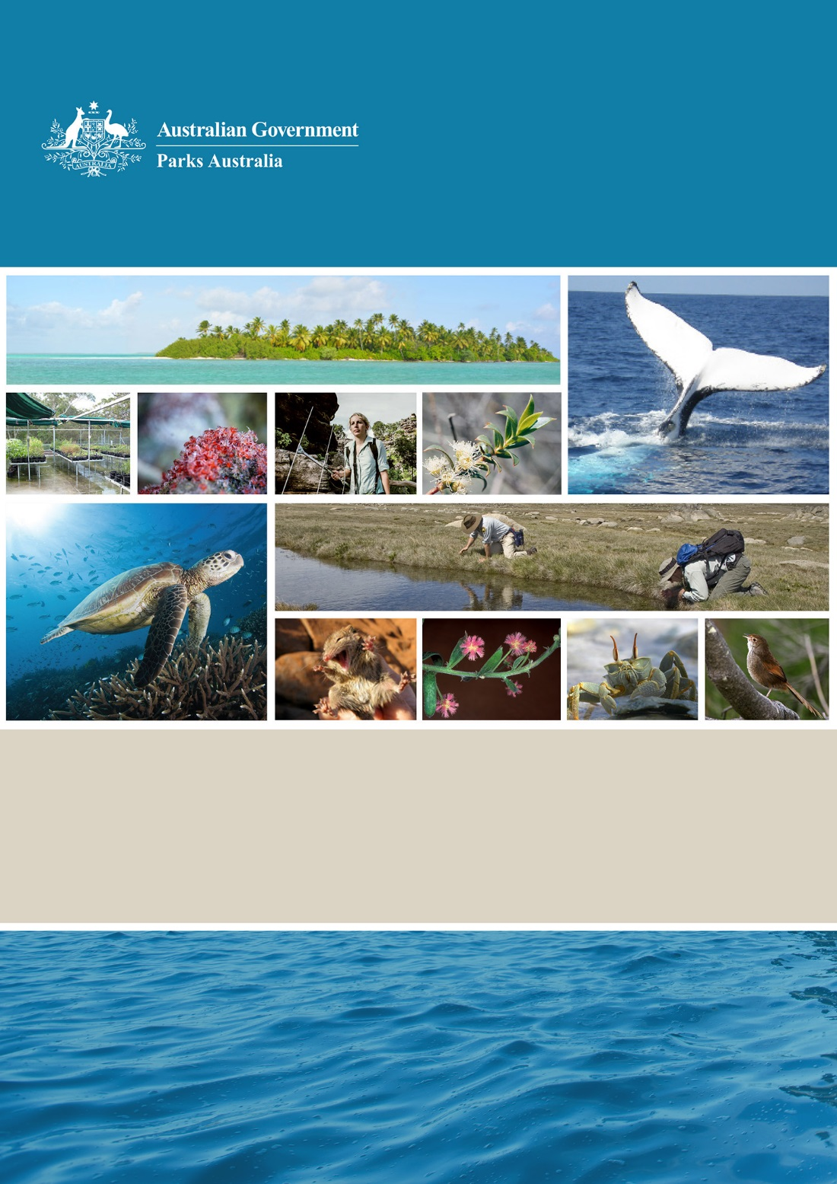

**Parks Australia**

**Science Direction Statement 2018–2022**

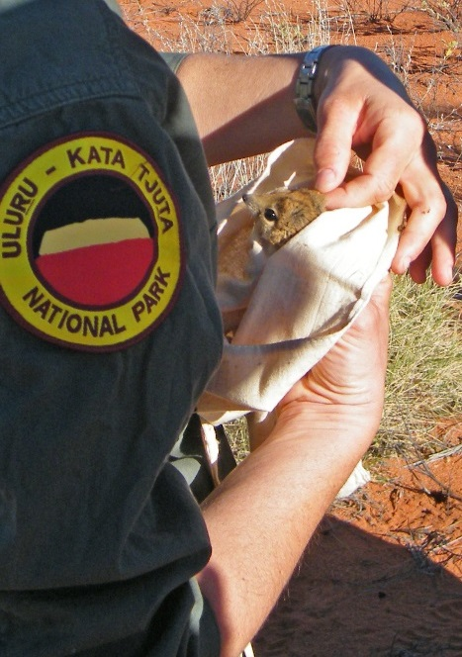

**Message from the Director of National Parks**

*Parks Australia relies on high quality science to make the best decisions we can for biodiversity conservation, towards improving and enriching the values of our Commonwealth parks.*

*The Parks Australia Science Direction Statement 2018-2022, the first we have produced, describes the guiding principles and sets priorities for our science effort. It highlights opportunities for scientific collaboration and brings focus to areas where our knowledge is poor.*

*We are looking to science that can help us better understand the values and vulnerabilities of our parks, and how to apply our understanding in new and more effective ways.*

*The Parks Australia Science Direction Statement 2018–2022 is a guide and an invitation to contribute to improving the informed management of our parks.*

Judy West  
A/g Director of National Parks

February 2018

**Parks Australia – Description**

Parks Australia is a Corporate Commonwealth Entity, operating under the *Environment Protection and Biodiversity Conservation Act 1999* (EPBC Act). The Director of National Parks (DNP) is responsible for the administration of Divisions 4 and 5 of Part 15 of the EPBC Act (Commonwealth parks and conservation zones).

There are seven terrestrial and 59 marine parks, geographically widespread and diverse in nature, managed by Parks Australia. Four of the terrestrial parks are on mainland Australia (Kakadu, Uluru-Kata Tjuta, the Australian National Botanic Gardens and Booderee National Park) and threeare on islands (Norfolk, Christmas and Pulu Keeling). The Australian Marine Parks surround our coastline, comprising an area of approximately 2.8 million km2. Under delegation from the DNP, the Australian Antarctic Division of the Department of the Environment and Energy manages the Heard Island and McDonald Islands Marine Park.

Parks Australia is also engaged in research, documentation, curation and dissemination of scientific data and knowledge on Australia’s biodiversity, in digital and physical form, through the Australian Biological Resources Study, the National Seed Bank, and in partnership with CSIRO in the Centre for Australian National Biodiversity Research and the Australian National Herbarium.

**Figure 1: Location of terrestrial and marine parks**

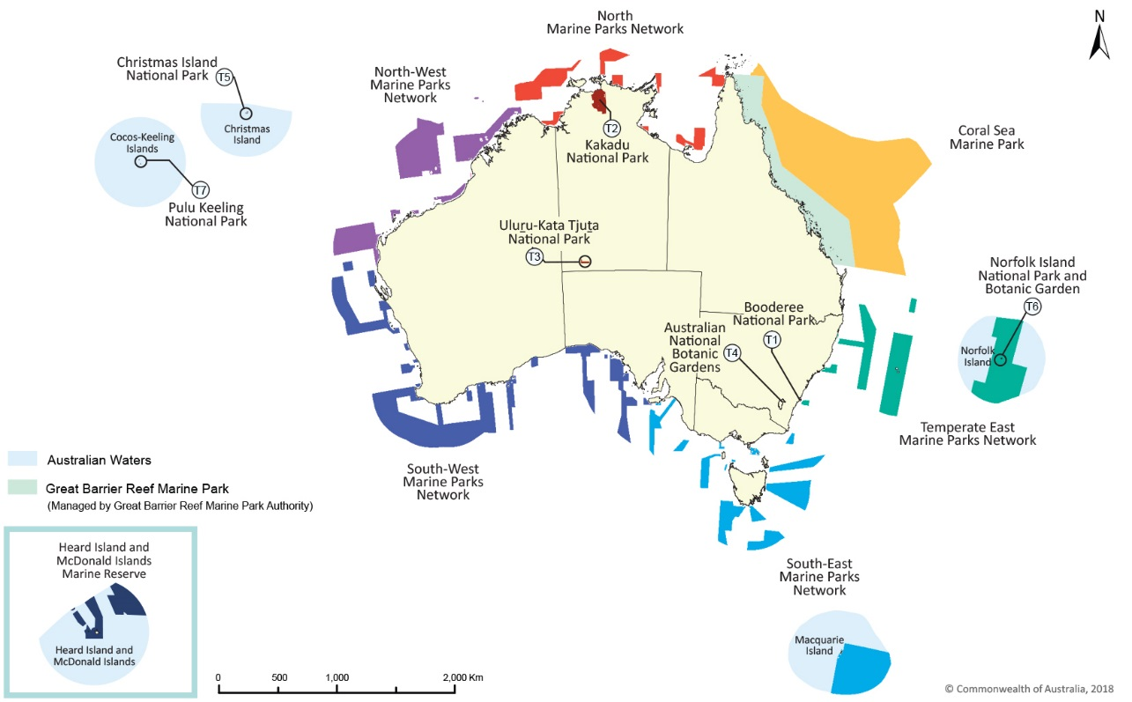

**Parks Australia – Park Values**

The values managed by Parks Australia are:



***Natural***The native species, habitats and ecosystem processes of each park or those species we help to manage outside of specific park responsibilities.



***Cultural***Living and cultural heritage recognising Indigenous beliefs, practices and obligations for country, places of cultural significance and cultural heritage sites.

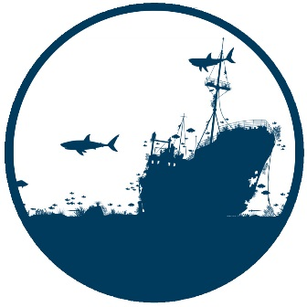

***Heritage***The historical infrastructure and landscape features of the park that reflect traditions and practices handed down by non-Indigenous ancestors.



***Socio-economic***  
The aspects of a park that relate to human use and enjoyment, as well as health and well-being of visitors and local communities.

**Science for Parks Australia – Our Vision**

*Parks Australia will use robust and relevant science to conserve the natural, cultural, heritage and socio-economic values of the parks we manage and the broader Australian environment.*

**Parks Australia Science Direction Statement – Purpose**

This Science Direction Statement will be used to guide science activities undertaken by or on behalf of Parks Australia over the next five years.

Its purpose is to:

* encourage research and innovation aligned with our long-term vision   
  and targeted to address our science priorities
* facilitate effective partnerships with other organisations
* foster science engagement and collaboration with Indigenous Australians
* communicate our science needs to the broader scientific community, and
* increase our use of citizen science as a valued contribution to science programs   
  and build community participation.

**Science for Parks Australia – Our Guiding Principles**

* **Science for conservation and sustainable use**Science in our parks contributes to the conservation of natural, cultural, heritage and socio-economic values of Commonwealth parks while providing for sustainable use and positive visitor experiences.
* **Science for adaptive and effective management**Science in our parks supports evidence-based, adaptive management. Science is important to underpin Parks Australia’s commitment to effective management, including supporting, evaluating and reporting on the health and integrity of natural, cultural, heritage and socio-economic values.
* **Quality science**Science in our parks adheres to best-practice research and monitoring design, assessment and methods, and collections management. Results are reported in a way that best enables evidence-based decision making.
* **Prioritised science investment**Our investment in science is regularly reviewed and prioritised to obtain the information that is most needed for advancing knowledge of Australia’s biodiversity and for effective management of the values of our parks.
* **Collaborative science**Parks Australia values and promotes partnerships with other agencies and the broader science and conservation community. Effective collaboration encourages innovation, efficiency and the sharing of expertise and capability.
* **Open access to science outputs**Data, information and products appropriate to managers, the science community and the Australian public are communicated and wherever possible made openly available.
* **Engagement with Indigenous peoples and Traditional Owners**Parks Australia recognises the role of traditional knowledge in land and sea country management, Indigenous custodianship and ongoing cultural connection, and the importance of respectful science collaborations and engagement with Indigenous people.

**Science for Parks Australia – Adapting to Management Needs**

Scientific knowledge is continually evolving. The information we need to manage our parks and the Australian environment will also evolve as we adapt to new evidence about our values and the pressures on these values. There will always be the potential for obtaining more data, information and knowledge about our parks than there are resources to obtain it.

We therefore prioritise our science needs to best inform management of our parks and natural places. This is an ongoing process and as new information emerges priorities may be revised and altered. Throughout the next five years, the applicability of the Parks Australia Science Direction Statement will be reviewed regularly.

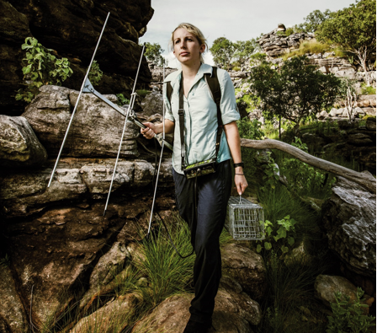

**Science for Parks Australia – Key Themes**

Our science needs are divided into seven key themes.

**THEME 1: Ecosystem structure and function**

Ecosystem health depends on a delicate and intricate mix of processes and biological cycles. We welcome science activities that improve our understanding and management of the natural values of our parks and their key ecosystem characteristics and processes.

More fundamentally, in many cases we are still discovering new species and exploring the diversity within our parks and country. Ongoing species discovery and survey programs help us to understand and plan for effective management of ecosystems.

**Examples include:

* *improving our understanding of the distribution and functioning of biodiversity in parks, especially through habitat mapping and marine flora, fauna and ecosystem studies;*
* *monitoring the health of and threats to vulnerable ecosystems and ecological communities such as coastal mangroves, seagrass meadows, monsoon rainforests and freshwater ecosystems;*
* *mapping the bathymetry of Australian marine parks and adjacent areas to as fine a resolution as possible, particularly focusing on features such as shoals, banks, reefs, canyons and seamounts;*
* *understanding the ecosystem wide effects of reintroductions;*
* *understanding the importance of patchiness within a fire on threatened flora and fauna in our fire prone parks; and*
* *identifying and documenting the species and communities in Australian marine parks, particularly those of greater ecological, cultural, social or economic importance.*

**THEME 2: Conservation of threatened, migratory, culturally significant or other species of special interest**

Understanding the biosystematics, abundance, demographics, population trends and biologically important areas for threatened, migratory or otherwise significant species within our parks is important for assessing our management effectiveness and prioritising future actions.

We encourage science activities on threatened, keystone, migratory, harvested or culturally significant species in our parks.

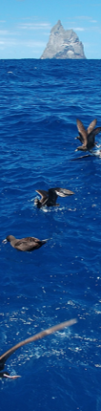Examples include:

* *improving our ability to monitor species through the exploration and application of new technologies (for example, using environmental DNA to detect cryptic species) and new approaches (for example, exploring use of surrogates to enable monitoring of a larger number of species);*
* *improving our understanding of the distribution, usage patterns, population status and trends of priority species (e.g. threatened, migratory, keystone, harvested or culturally significant species);*
* *research to resolve taxonomic boundaries in complex or poorly understood groups of organisms, especially those of conservation concern;*
* *monitoring of sea birds across marine and terrestrial parks;*
* *knowledge discovery through seed science and seed banking, including germination and storage research, to develop conservation methods for rare and threatened island plants including the ferns of Christmas Island and Norfolk Island; and*
* *improving our understanding of seed physiological responses and thresholds to assess the habitat preferences, niche tolerances and resilience of Australia’s threatened plant species and communities to changing environments.*

**THEME 3: Cultural and heritage values**

Aboriginal people have looked after land and sea country for tens of thousands of years. The traditional owners of the land and sea we manage have significant cultural and spiritual responsibilities to care for land and sea country.

Many of our parks also conserve aspects of Australia’s historical heritage ranging from shipwrecks to historical buildings. We encourage science that advances our understanding and the conservation and monitoring of the Indigenous cultural and historic values of parks.

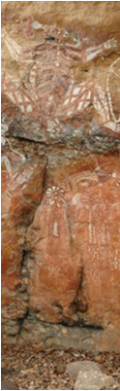Examples include:

* *improving the conservation of rock art;*
* *studies in anthropology or archaeology that facilitate effective management of cultural sites;*
* *mapping the location of any unmapped heritage values (e.g. historic shipwrecks) within parks;*
* *collaborating with local Indigenous communities to map sites within Australian Marine Parks of cultural significance to Indigenous peoples;*
* *researching and monitoring culturally important species (e.g. turtles, dugongs, mutton-birds, magpie geese, woma pythons) to improve our understanding of their feeding areas, breeding areas, migratory routes, and pressures within parks; and*
* *developing food webs and mapping ecological and cultural connectivity using a combination of traditional and scientific knowledge for Australian Marine Parks.*

**THEME 4: Social and economic outcomes**

Our parks provide opportunities for visitor experiences that enhance Australia’s visitor economy. Providing engaging activities for visitors to our parks is an important consideration in achieving this aim, and we need studies that will inform us about visitor needs and expectations and ways to improve their experience in our parks.

Of equal importance is the growing evidence that natural places can provide significant benefits to people’s health and wellbeing. This is something that we are only just beginning to understand, and significant further research is needed.

We would like to understand much more about the current and potential social and economic values of our parks and ways we can maximise this potential to provide benefits both to local communities and to people visiting from elsewhere in the country and from overseas.

Examples include:

* *assessing and documenting the value of our parks to local and regional economies;*
* *better recording visitor satisfaction levels and the effectiveness of our visitor services in providing engaging visitor experiences (including experiencing parks online);*
* *assessing the effectiveness of marketing campaigns in improving visitor numbers;*
* *evaluating options for developing Indigenous employment and business models;*
* *understanding the health value of our places to visitors and local communities (for example, physical activity, stress reduction and mental wellbeing);*
* *identifying options for citizen science initiatives in our terrestrial and marine parks; and*
* *improving our understanding of use by, benefits for, and effects of recreational fishers, commercial tour operators and commercial fishers in Australian Marine Parks.*

**THEME 5: Pressures, threats and change**

The diverse set of places Parks Australia manages is challenged by an equally diverse set of pressures and threatening processes. Some of these are long-standing management challenges, while others are more recent or are potential issues on the horizon.

The effects of a changing climate are already being detected and are likely to become more severe in the future, potentially interacting with and exacerbating existing threats as well as bringing new challenges and changes.

We encourage science activities that help to understand and manage pressures and change.

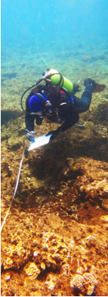Examples include:

* *assessing the impact of feral cats and foxes in parks;*
* *improving our understanding of the impacts of pressures on key marine habitats and priority species within Australian Marine Parks, their resilience to pressures, and effective management initiatives to reduce impacts;*
* *monitoring the health of shallow coral and temperate reefs within, and adjacent to, Australian Marine Parks, particularly with respect to impacts of climate change and fishing;*
* *monitoring the concentration, distribution and sources of marine debris (including microplastics and ghost nets) particularly within the North, Northwest and Southwest Networks, and the Coral Sea Marine Park, and impacts of marine debris on cultural, natural values and economic cost; and;*
* *improving our management options for novel pest species such as tramp ants and wolf snakes.*

**THEME 6: Management effectiveness**

We manage a diverse set of terrestrial and marine parks. To inform adaptive management of our parks, we need to know how well different management approaches work.

Examples include:

* *understanding how the natural, economic, cultural and heritage values of parks are changing in response to different management actions and zones;*
* *assessing the effectiveness of feral animal and weed control programs on terrestrial parks;*
* *assessing the effectiveness of planned burning in fire prone parks;*
* *determining the relative effectiveness of different zones in Australian marine parks;*
* *developing cost effective methods for remotely monitoring a range of key ecological indicators in marine parks; and*
* *measuring the effectiveness of wet season burning for long term fuel reduction in Kakadu National Park.*

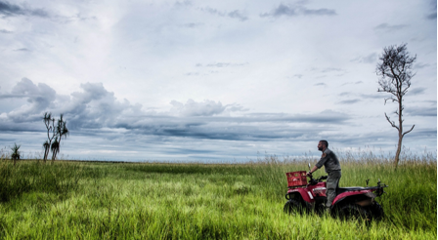

**THEME 7: Information management, science communications and knowledge uptake**

A large body of information exists about Parks Australia’s terrestrial and marine parks. Some of this information is not readily discoverable, or is not in a form which can be easily translated for management use and understanding. Parks Australia will work with and encourage information custodians to make research outputs more discoverable, accessible and reusable to ensure that managers, the research community and the public are able to make better use of research undertaken in our parks.

Examples include:

* *improving our ability to collate and synthesise information relevant to parks;*
* *supporting the development and update of online platforms that synthesise and disseminate scientific information relevant to parks including the Parks Australia website and the ‘Australian Marine Parks Science Atlas’; and*
* *enabling knowledge uptake by supporting and contributing to open access to information, including through the Parks Australia Science Atlas, the Australian Ocean Data Network and the Atlas of Living Australia.*

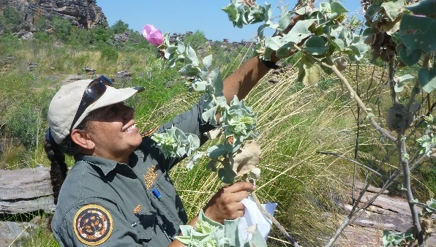

**Science for Parks Australia – Our Scientific Approach**

To address the themes above, a range of scientific work will be needed including:

1. **Discovery or inventory studies**to determine what natural, cultural, heritage, and socio-economic values exist in the areas we manage or are responsible for helping to conserve.
2. **Baseline studies** to establish enough knowledge or a reference point in time to provide a basis for subsequent temporal comparison or systematic monitoring.
3. **Monitoring** (establishment of systematic, time-series data and analysis using standard and repeated methods to detect change) using appropriate indicators for monitoring ecosystem health, pressures and management effectiveness.
4. **Process studies** to understand cause and effect pathways, interactions between pressures and park values, and possible management responses or treatments.
5. **Predictive studies** of the possible or likely change in condition of park values under differing pressure and response treatments or options. Such studies can assist managers to explore what might be the most suitable management responses.
6. **Conservation planning**research to inform strategic decisions about management direction and pathways for adapting to climate change.

The relative importance of these different types of scientific study will vary from place to place and over time, depending on the current state of our knowledge and the management questions that need to be answered.



**Science for Parks Australia – Next Steps and Further Information**

**Next steps**

Parks Australia will continue to work collaboratively with the research community, Indigenous communities and local and regional groups on science that informs management of our parks.

An important next step is to develop a detailed and prioritised list of specific priorities for marine and terrestrial parks to guide future investment in science activities. Within and between our science themes, we will prioritise our effort according to considerations such as:

* *the relative importance of the biodiversity, cultural, heritage or socioeconomic value;*
* *the pressures or threats affecting the value; and*
* *the adequacy of our knowledge for effective management.*

Priorities will also continue to evolve in response to new knowledge and new management issues and will be regularly reviewed—recognising too that many of the questions we address need sustained investment over the long-term.

**Further information**

Further information on the science needs and priorities for Parks Australia can be found in park and network management plans, by contacting Parks Australia or in the Australian Marine Parks and Commonwealth Terrestrial Parks Research and Monitoring Strategies.

Research and science activity within Commonwealth parks require a permit or research agreement. Information on these permits can be found on the Parks Australia online authorisations portal at the Department of Environment and Energy site, https//onlineservices.environment.gov.au. Information on collaborative research agreements can be found by contacting Parks Australia offices.