DEVELOPMENT IN PARRAMATTA CITY AND THE IMPACT ON OLD GOVERNMENT HOUSE AND DOMAIN’S WORLD AND NATIONAL HERITAGE LISTED VALUES
TECHNICAL REPORT
Planisphere would like to thank the following organisations for their contributions to this project:
The Australian Government Department of Sustainability, Environment, Water, Population and Communities
The New South Wales Department of Planning and Infrastructure
The New South Wales Heritage Office
Parramatta City Council
© Planisphere 2012
This Publication is copyright. No part may be reproduced by any process except in accordance with the provisions of the Copyright Act 1968.
CONTENTS
THE CONTEXT 4
THE PROJECT 6
STUDY AREA 6
BACKGROUND 9
PARRAMATTA PLANNING CONTEXT 10
MANAGING VALUES 12
OGHD WORLD AND NATIONAL HERITAGE VALUES 16
VIEWS & SETTINGS 27
INTRODUCTION 28
DETERMINING SIGNIFICANCE 30
SETTINGS 34
VIEWS 44
AREA OF SENSITIVITY 78
FUTURE DEVELOPMENT 83
DESIGN PRINCIPLES 84
FUTURE DEVELOPMENT GUIDELINES 86

APPENDIX A: DOCUMENT REVIEW 105
APPENDIX B: DEVELOPMENT SITES 117
APPENDIX C: EXISTING CONTROLS 123

THE CONTEXT
Parramatta lies at the geographic centre of Sydney’s metropolitan area, it is the largest employer outside of Sydney’s CBD and the gateway to the booming western district which is home to 34% of the Sydney workforce. Parramatta is becoming denser, buildings are getting taller and transport to the city is improving bringing more and more people into the city.
A revised planning framework in 2007 supports a higher concentration of residents, businesses and workers in Parramatta. This alongside its location within the ‘global arc’ has made the social and economic development of Parramatta city a state-significant priority. The city has a changing demographic and rapid population growth. The residents of Parramatta and Western Sydney are younger than the Sydney average, more culturally diverse and increasingly highly skilled and educated. Approximately 50% of those residing in Parramatta’s catchment were born overseas with Chinese, Indian, Arabic, Korean and other Asian ethnicities being the most prevalent cultural groups. Parramatta’s new residents show a strong preference for urban living with demand for apartments close to transport and other city amenities resulting in a surge of residential construction activity and changes in the retail, food and services mix within the CBD.
The city must balance its growth with the retention and enhancement of significant historical sites. Parramatta is one of the most historic places in Australia with a rich tapestry of Aboriginal and non Aboriginal cultural and built heritage. Parramatta has a number of historic sites and buildings including Parramatta Town Hall, Lennox Bridge, St John’s Cathedral and Parramatta Park which houses Old Government House, the subject of this study.
Old Government House is Australia's oldest surviving public building and was the residence and offices of 12 prominent governors of New South Wales, from 1788-1856. Here decisions were made about the control and administration of the colony and management of convicts.
It was also where agricultural production in Australia and town planning commenced, and the site of some of Australia's earliest astronomical and botanical endeavours. Today the Georgian style house remains, with some of the surrounding landscape. The Old Government House and Domain is one of eleven sites that together form the Australian Convict Sites which was inscribed on the UNESCO World Heritage List in 2010.
Parramatta has a number of large developments in the pipeline including the vision for the Westmead Precinct Proposal which lies to the north west of Parramatta Park and Auto Alley to the south east of the Park.
While new development is vital to this rapidly growing City, it must be balanced against the need to protect the integrity of Old Government House and Domain. This project creates a methodology which will allow proposals for any new developments to be assessed against visual impacts on the Old Government House and Domain’s World and National Heritage Values.
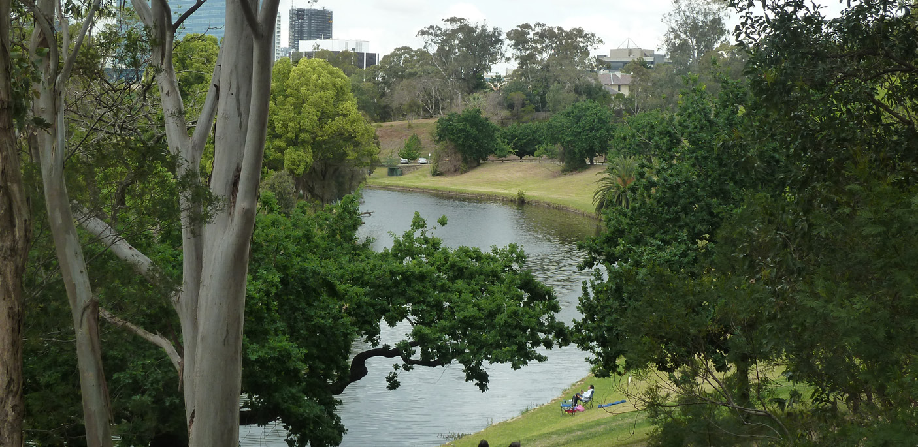
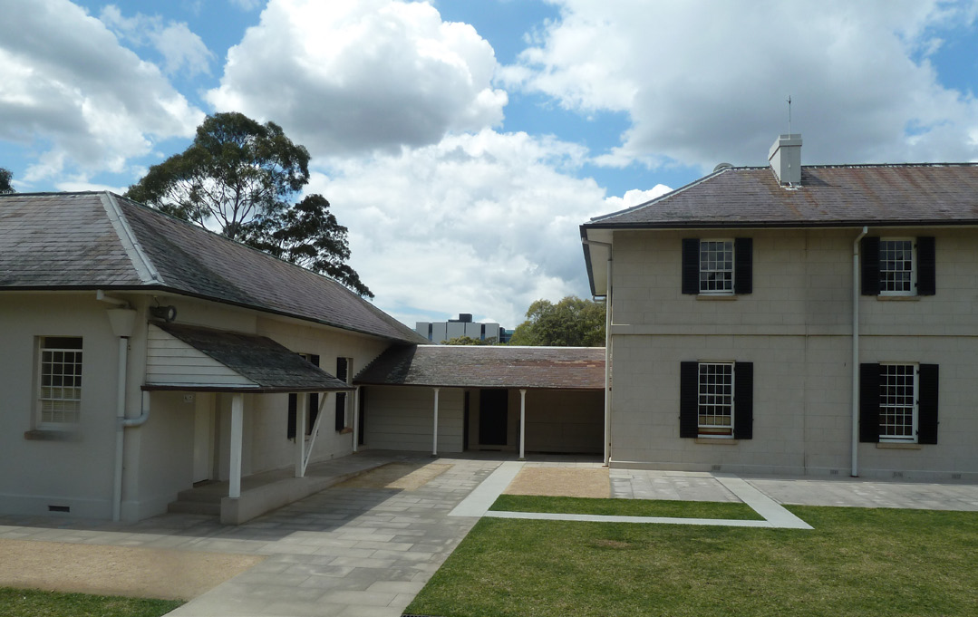
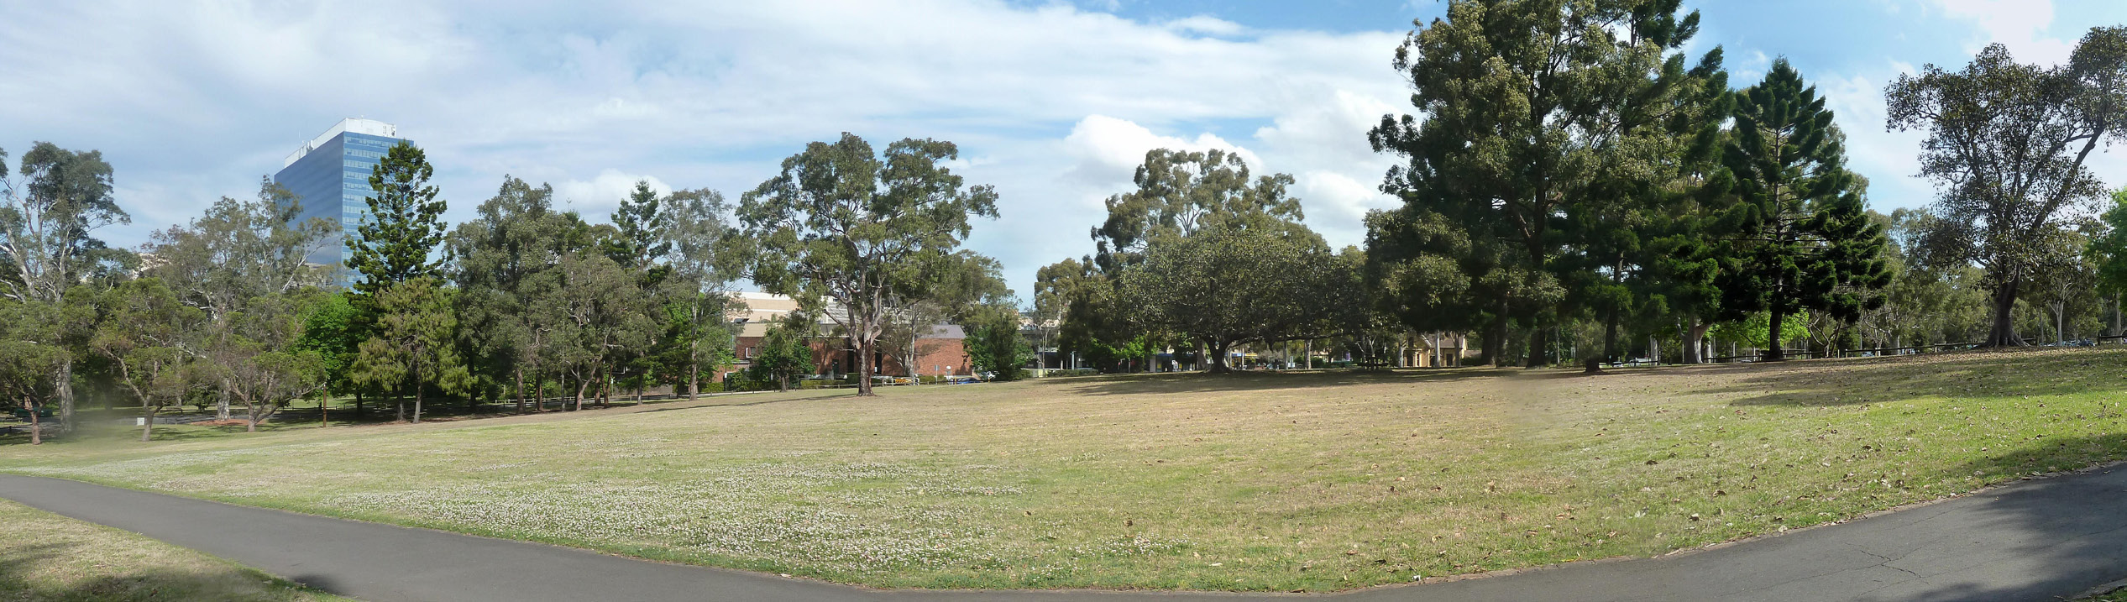
LOOKING TOWARDS THE CITY FROM OGH COURTYARD
PARRAMATTA RIVER WITH OGH VISIBLE ATOP THE HILL
LOOKING SOUTH EAST ACROSS THE BROAD LAWNS OF THE GOVERNMENT DOMAIN
THE PROJECT
The purpose of the project is to undertake a study of the relationship of future development in Parramatta City to the World and National Heritage listed Old Government House and Domain (OGHD), with the key objectives being to:
- Identify, document and describe important views and settings (particularly in relation to areas outside the boundaries of Parramatta Park).
- Create future development guidelines to determine if future development is likely to have an impact on heritage values.
- Review draft planning controls, and potentially development concepts, in light of the identified views and settings, and future development guidelines.

The project is being undertaken within the context of significant growth and development in Parramatta City, together with the recognition by Council of the importance of protecting and managing its heritage assets.
STUDY AREA
While the focus of the study is the World and National Heritage listed OGHD, it is particularly important to identify important views and settings from outside the boundaries of Parramatta Park. As such, consideration of the heritage values of the OGHD precinct has been undertaken from Westmead, the western edge of Parramatta CBD and the wider city environs. Consideration has also be given to potential and known future development sites.
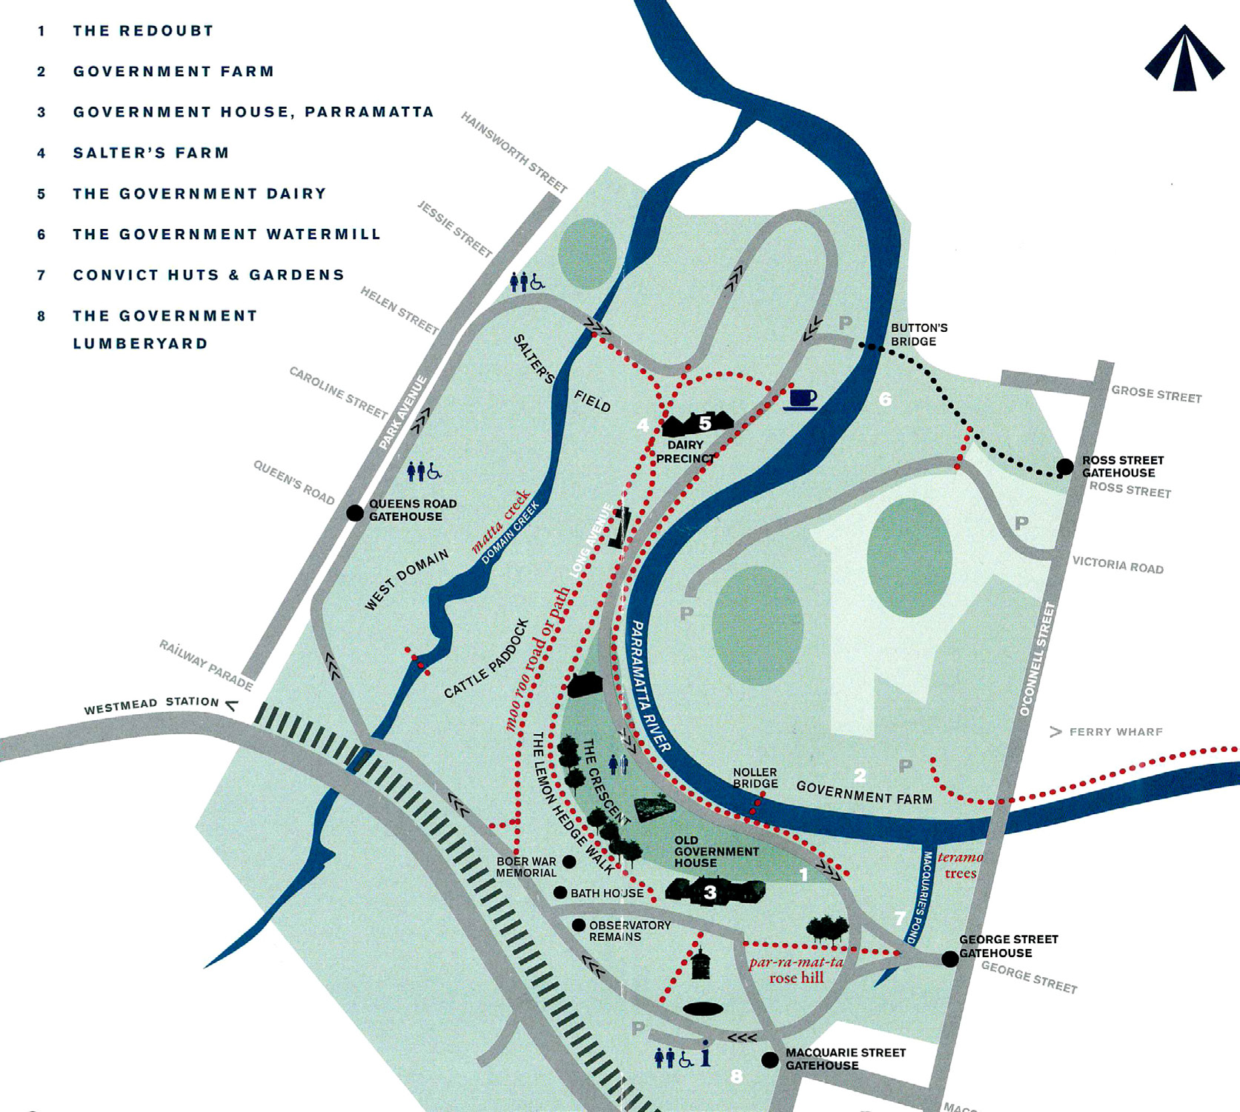
OLD GOVERNMENT HOUSE AND DOMAIN (Map from Parramatta Park Trust)
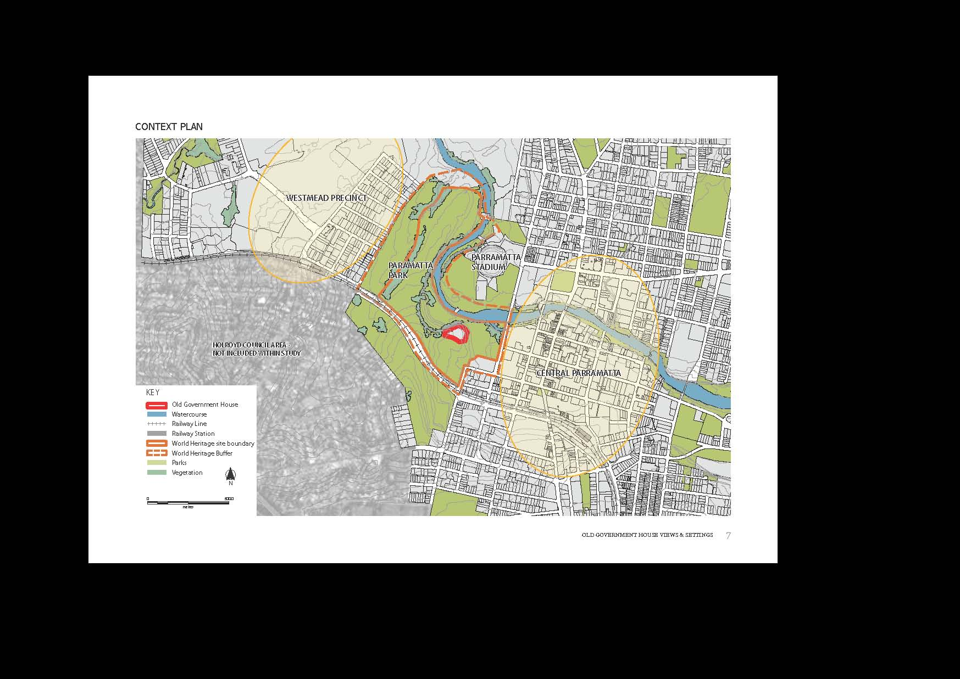
“The natural landform dominated the views and landmarks of early European settlement at Parramatta, and the views from individual buildings and places were a consequence of the landform and landscape and the siting of land uses. Decisions about siting of land uses were not arbitrary”.
(Views Study, 1997, page 9)
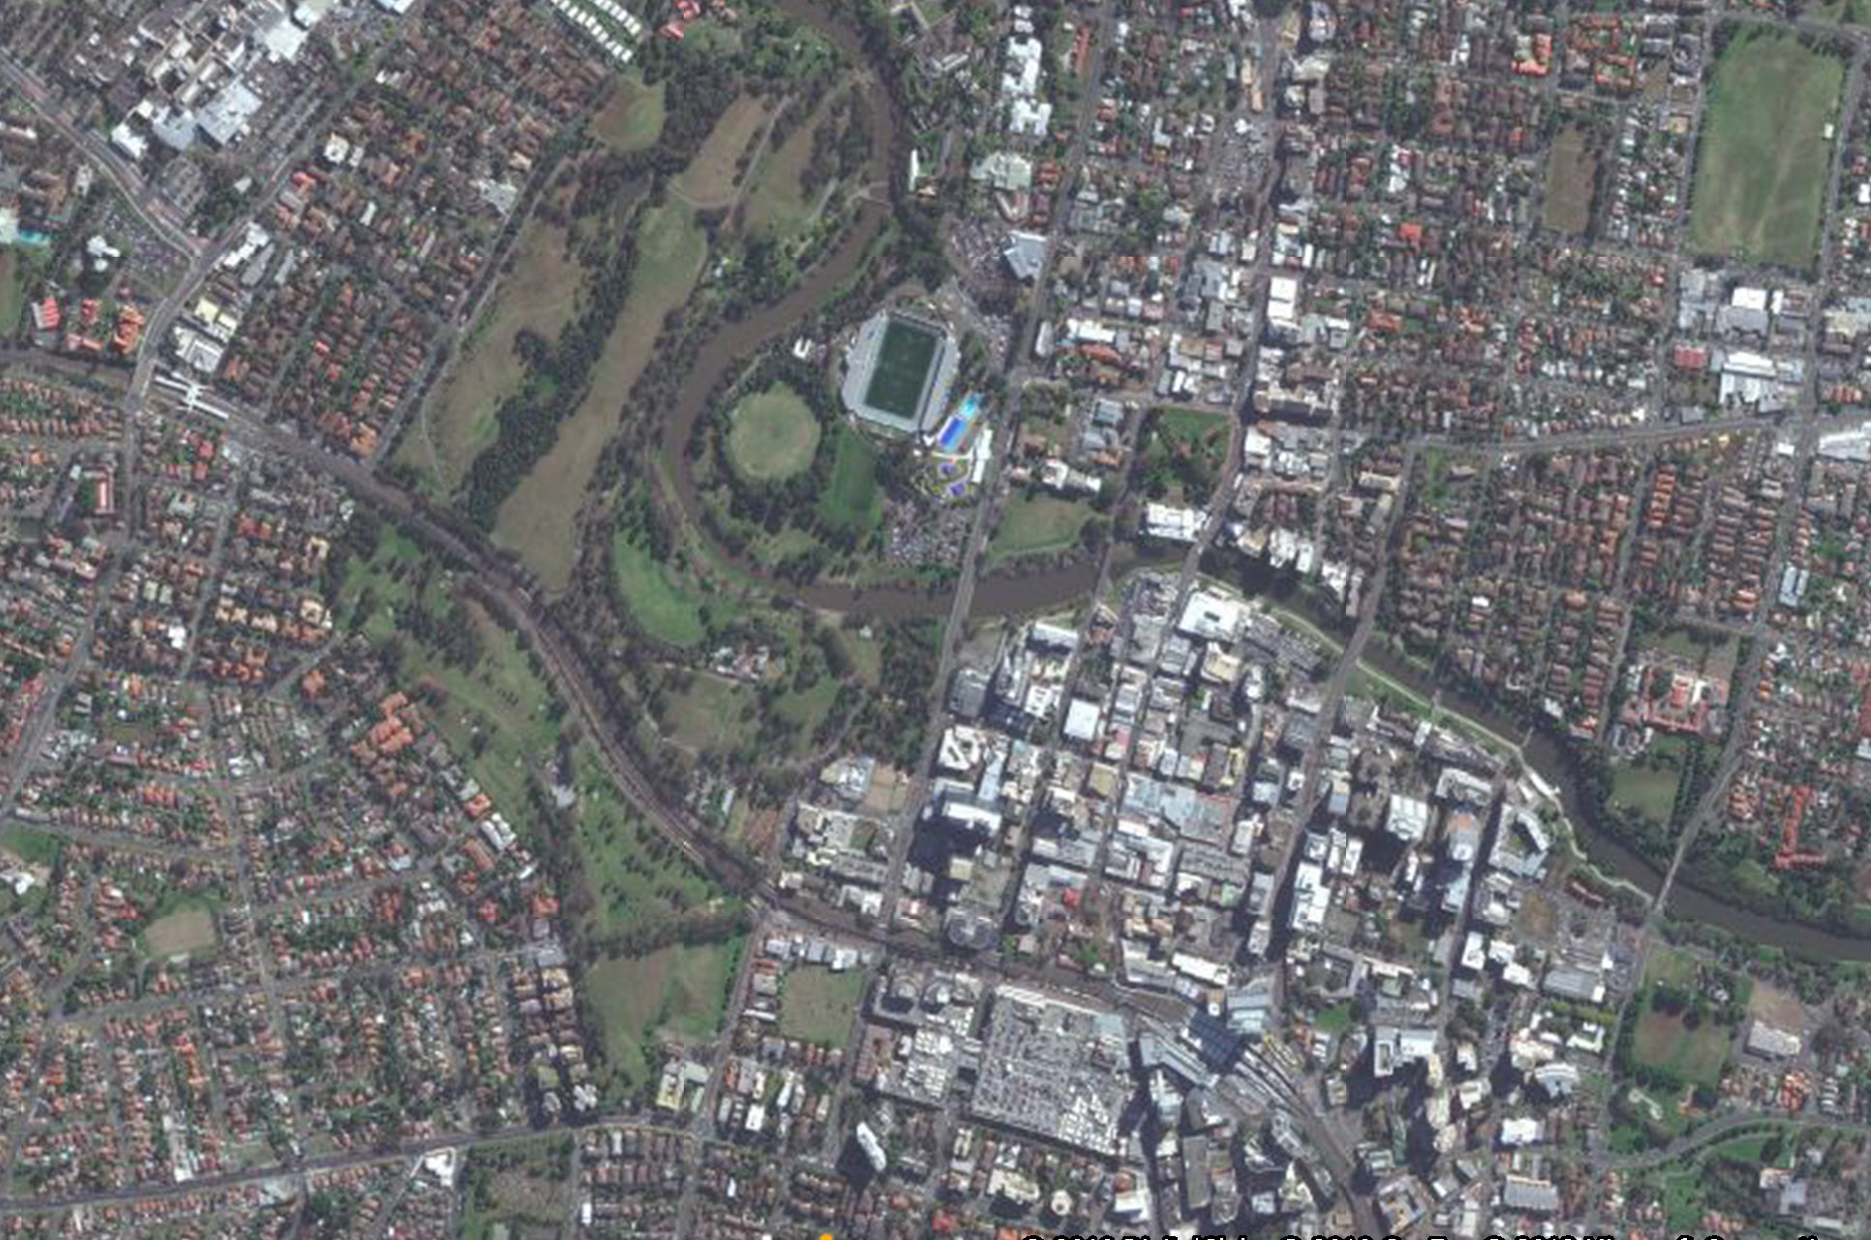
- .

BACKGROUND 1
PARRAMATTA PLANNING CONTEXT

METROPOLITAN PLAN FOR SYDNEY 2036
This plan describes the one of the keys to Sydney’s long–term sustainability being the emergence of Parramatta as the city’s second CBD. The Metropolitan Plan targets employment capacity of 70,000 jobs for Parramatta by 2036. The future directions outlined for Parramatta are to:
strengthen role as Sydney’s premier Regional City and second CBD.
- ensure development is consistent with Parramatta City Centre Plan to enhance heritage profile and facilitate creative industries.
- Better integrate Parramatta River with the centre.
- Enhance attractiveness ...including public domain, streetscape, high quality building design. Protect commercial core from residential development that may preclude employment growth.
- Improve liveability consistent with Civic Improvement Plan.
- Revitalise inner city suburbs on Parramatta’s edge
- Capitalise on investment in public transport infrastructure.
- Deliver Parramatta to Epping Rail Link, additional growth buses
- Develop a Parramatta Regional City Transport Strategy

THE LOCAL ENVIRONMENTAL PLAN 2007 (LEP)
The Local Environmental Plan (LEP) establishes the current planning controls within Parramatta including zoning, heights, ﬂoor space ratios and mentions the need to preserve historic views.
Clause 21: (g) to ensure the preservation of historic views shown in the City Centre Development Control Plan.
PARRAMATTA CITY CENTRE DEVELOPMENT CONTROL PLAN 2011 (DCP)
The DCP outlines more detailed planning provisions including the mapping and description of historic views (refer to Appendix A, page 92).
This document sets out a number of objectives in reference to views:
- To preserve and enhance district and local views which reinforce and protect the City’s urban form and enhance legibility.
- To encourage view sharing through complementary siting of buildings, responsive design and well-positioned landscaping.
- To ensure highly visible sites are designed in scale with the City’s setting and encourage visual integration and connectivity between places.

PARRAMATTA CITY CENTRE VISION 2007
The Parramatta City Centre Vision sits alongside the LEP and the DCP to set out a 25 year plan for the future growth of Parramatta. This document sets the scene in terms of planning for growth, creating a centre vision, shaping the city form and celebrating heritage along with the historical context of Parramatta. These themes are summarised below:
PLANNING FOR GROWTH
There are development pressures on Parramatta City as residential growth is forecast to increase from a current population within the city centre of 6,000 residents to 26,000 residents over the next 25 years. Parramatta is successfully attracting an increasing number of ﬁnance and business service ﬁrms and also has a significant presence in tourism and hospitality. Recent evidence suggests that Parramatta is attaining take-off in relation to sustainable investment and job growth with major public and private projects likely to create new opportunities for employment growth.
THE CITY CENTRE VISION
Parramatta will continue to strengthen its role as a regional city and successful second CBD for Sydney, based on a highly competitive commercial office market, retail, public space, and a range of facilities including cultural, medical, educational, tourism, and recreational.
It will also beneﬁt from a unique inner city residential living environment that values heritage assets and the natural environment. The centre will continue to plan strategically to maintain its position as an accessible primary business services centre for Western Sydney and a significant business location for metropolitan Sydney.

SHAPING THE CITY FORM
Future developments concentrated in the city centre will create an elegant and ﬂowing city skyline. The George Street, Church Street and riverside corridors will play a major part as generators of the new city image and new built forms will celebrate, enhance and reinforce the original Georgian Town Plan.
CELEBRATING THE SPECIAL HERITAGE OF PARRAMATTA
As Australia’s second oldest city and originally home to the Dharug people, Parramatta’s cultural heritage will be recognised and celebrated. Access to heritage buildings and key sites such as Parramatta Park will be facilitated, its significance illuminated, and heritage promoted and managed as a major cultural tourist asset
HISTORICAL CONTEXT
The name Parramatta means “the place where eels lie” and is a reference to the name used by the Burramattagal clan for the area.
The area around Parramatta had been occupied for nearly forty thousand years by the Darug people.
The site of Parramatta, the second oldest European settlement in Australia, was discovered by Governor Arthur Phillip and a small party as early as 23 April 1788. They were searching for suitable land for cultivation and discovered what he called the Crescent, along with thousands of acres of potentially arable land which was visible from the top of the hill.
The township was planned in 1790. The main street (High Street, now George Street) was to be 62 metres wide, spanning on an east west axis from Government House to the public wharf. Another major street planned was Church Street perpendicular to the High Street with the Town Hall on its northern end and St. Johns Church on its southern end. Given the intended agricultural nature of the settlement the town allotments were larger than those in Sydney and were designed to provide gardens which could be worked by convicts and others to supplement the scarce food supplies of the colony.
The second stage of the planning of Parramatta took place in 1811 when extensions to the town were laid out by Governor Macquarie, to accommodate a rapidly growing population. Constrained by the river, the city expanded south and existing streets were re-sized, including the narrowing of High Street from approximately 61 metres to its present 20 metres and the extension of Church Street to connect the colony with the newly constructed Sydney Road(now Parramatta Road) lying just to the south. The construction of Lennox Bridge at around this time, a northern extension of Church Street, and the emergence of new towns in the surrounding hinterland facilitated the colony’s expansion north beyond the river. By 1798, the roof of Phillip’s Government House had fallen and a decision was made to demolish it. The new Government House was a two storey brick building described as large, elegant, spacious and roomy with a cellar and attic storey. The building still stands within Parramatta Park albeit with later alterations and additions.
The Domain surrounding Government House was declared in 1810 and the Parramatta Park was included in 1857.
Today, strong elements of Parramatta’s original urban fabric remain, including the Georgian street layout and key historic buildings, spaces and landscape features. Many of the close up and long distance views of its historic buildings and landscape settings have also been retained.

IMPLICATIONS FOR PROJECT

- Parramatta is growing
- Inner city residential development is likely to expand
- Future developments concentrated in the city centre should create an elegant and flowing city skyline
- Growth should be balanced against heritage values
- The Georgian street layout remains a strong urban element
- George Street, the riverside and Church Street will play a part in generating a new city image. George Street was originally planned by Governor Phillip to be 62m wide. It is now 20m.
IMPLICATIONS FOR PROJECT
- Parramatta is growing
- Inner city residential development is likely to expand
- George Street, the riverside and Church Street will play a part in generating a new city image. George Street was originally planned by Governor Phillip to be 62m wide. It is now 20mMANAGING VALUES

The integrity of the values related to Old Government House and Domain are managed under Commonwealth, State and Local legislation and policy.
COMMONWEALTH (WORLD AND NATIONAL) FRAMEWORK
ENVIRONMENT PROTECTION AND BIODIVERSITY CONSERVATION ACT 1999 AND REGULATIONS 2000.
Through its inclusion on the National and World Heritage List, the Old Government House and Domain site is subject to the EPBC Act and EPBC Regulations.
Central to the control of identified National and World Heritage values under the EPBC Act is the need for Ministerial approval of:
an activity or ‘action that has, will have or is likely to have a significant impact on certain aspects of the environment’—that is, the National or World Heritage values of identified places/properties—and his/her determination as to whether the action ‘should proceed’
EPBC ACT GUIDELINES: SIGNIFICANT IMPACT CRITERIA
The purpose of these guidelines is to assist in determining whether there is a need to submit a referral to the Australian Government Department of the Environment, Water, Population and Communities for a decision by the Australian Government Environment Minister on whether assessment and approval is required under the Environment Protection and Biodiversity Conservation Act 1999 (EPBC Act)

Under the EPBC Act an action will require approval from the minister if the action has, will have, or is likely to have, a significant impact on a matter of national environmental significance.
These guidelines outline a ‘self-assessment’ process to assist in determining whether or not referral may be required.
These criteria are as follows:
An action is likely to have a significant impact on the World Heritage values of a declared World Heritage property if there is a real chance or possibility that it will cause:
one or more of the World Heritage values to be lost
            - one or more of the World Heritage values to be degraded or damaged, or
- one or more of the World Heritage values to be notably altered, modified, obscured or diminished.

These guidelines cover a broad range of World Heritage Properties from The Great Barrier Reef to Old Government House and Domain. The guidelines focussing specifically on World Heritage Properties with cultural heritage values are as follows:
An action is likely to have a significant impact on cultural heritage values of a World Heritage property if there is a real chance or possibility that the action will:
- permanently remove, destroy, damage or substantially alter the fabric of a World Heritage property
- extend, renovate, refurbish or substantially alter a World Heritage property in a manner which is inconsistent with relevant values
- permanently remove, destroy, damage or substantially disturb archaeological deposits or artefacts in a World Heritage property
- involve activities in a World Heritage property with substantial and/or long-term impacts on its values
- involve construction of buildings or other structures within, adjacent to, or within important sight lines of, a World Heritage property which are inconsistent with relevant values, and
- make notable changes to the layout, spaces, form or species composition in a garden, landscape or setting of a World Heritage property which are inconsistent with relevant values restrict or inhibit the existing use of a World Heritage property as a cultural or ceremonial site causing its values to notably diminish over time;
- permanently diminish the cultural value of a World Heritage property for a community or group to which its values relate
- alter the setting of a World Heritage property in a manner which is inconsistent with relevant values
- remove, damage, or substantially disturb cultural artefacts, or ceremonial objects, in a World Heritage property, and
- permanently damage or obscure rock art or other cultural or ceremonial features with World Heritage values.

NEW SOUTH WALES (STATE AND LOCAL) FRAMEWORK
ENVIRONMENTAL PLANNING & ASSESSMENT ACT 1979
The Environmental Planning and Assessment Act 1979 (EP&A Act) establishes the environmental and land use planning system for New South Wales to encourage the proper management, development and conservation of natural resources and the built environment. The EP&A Act requires proposed development to comply with relevant planning controls according to their nature, scale, location and potential impacts on the physical and social environment.
The EP&A Act allows for the creation of environmental planning instruments such as State Environmental Planning Policies (SEPPs) and Local Environmental Plans (LEPs). These planning instruments set out the planning provisions and rules that apply to areas that the Minister for Planning considers are of State or Regional significance.
SYDNEY REGIONAL ENVIRONMENTAL PLAN NO. 28 – PARRAMATTA, 1999 (PARRAMATTA REP, NOW SUPERSEDED BY THE PARRAMATTA CITY CENTRE PLAN)
Within the Parramatta REP Parramatta Park is included in the Government Precinct which also comprises the Parramatta River and the North Parramatta Government site. Parramatta Park is recognised as a nationally significant cultural landscape and key planning strategies for the Old Government House and Domain are to:
1. conserve, restore, interpret and promote the Park’s landscape sites monuments, archaeological resources, buildings, important views and vistas;
2. protect the Park’s boundaries from further excisions, encroachments and inappropriate development;
3. enhance and promote the Park’s passive recreational assets and capitalise on the potential links to the North Parramatta Government site
PARRAMATTA CITY CENTRE LOCAL ENVIRONMENTAL PLAN 2007
Under the Parramatta LEP, Parramatta Park is zoned as primarily for public recreation use and heritage conservation. The Parramatta Regional Park is heritage listed under the LEP.
HERITAGE ACT 1977
Old Government House and Domain site is listed on the New South Wales State Heritage Register (SHR) and is thus subject to the relevant provisions of the Heritage Act relating to SHR items. The Heritage Council is the statutory authority for any development within the curtilage of NSW state, such as (not limited to):
- Parramatta Park & Old Government House;
- Cumberland Hospital;
- Parramatta Jail;
- The Old King’s School/Marsden Rehabilitation Centre;
- Lennox Bridge;
- St.John’s Cathedral;
- the Travellers’ Rest group (NE cnr. Hunter/Marsden St.;
- Perth House, 90 George Street;
PARRAMATTA PARK TRUST ACT 2001
The Parramatta Park Trust Act 2001 controls the current administration and management of Parramatta Park by a statutory trust of seven (7) members, appointed by the Minister. The functions of the Trust are set out under Part 3 section 6 of the Act, being:
a) To maintain and improve the trust lands, and
b) to encourage the use and enjoyment of the trust lands by the public by promoting the creational, historical, scientific, educational and cultural heritage values of those lands, and
c) to ensure the conservation of the natural and cultural heritage values of the trust lands and the protection of the environment within those lands; and,
d) such other objects, consistent with the functions of the Trust in relation to the trust lands, as the Trust considers appropriate.
In the exercise of its functions, the Parramatta Park Trust is subject to the control and direction of the Minister. Conservation and land management operations are undertaken by staff with expertise in administration, conservation and technical services.

PARRAMATTA PARK (OLD GOVERNMENT HOUSE) ACT 1967
The purpose of the Parramatta Park (Old Government House) Act 1967 No. 33 is to provide for the care, control and management of that land and to appoint the National Trust of Australia (New South Wales) as trustee of the land. The National Trust is appointed as a trustee of the land under the Crown Lands Act 989, No. 6 and may use the land for such purposes as the responsible Minister may from time to time approve.
The National Trust of Australia (NSW) elects a board of 12 directors and appoints one exofficio director to administer and direct trust functions in accordance with the National Trust of Australia (NSW) Act 1990. Old Government House is managed by on site staff supported by technical and curatorial staff located at the National Trust Head Office.
NATIONAL TRUST OF AUSTRALIA (NEW SOUTH WALES) ACT 1990
[The] National Trust of Australia (New South Wales) Act 1990, No. 92 establishes the National Trust in New South Wales as a statutory corporation (but not representing the Crown). The National Trust manages the site in accordance with the provisions of the Act. The objectives of that Act are as follows:
(a) to acquire, control, maintain, protect and preserve for the benefit of the public generally land, buildings, works, structures and articles, of beauty or of national, historical, antiquarian, scientific, artistic, architectural or cultural interest (including Aboriginal relics, Aboriginal rock carvings and Aboriginal rock paintings and archaeological sites), and
(b) to protect and preserve the natural features of and to conserve the fauna and flora on, any land referred to in paragraph (a) and acquired by, or under the control of the Trust, and
(c) to encourage and promote, by any means whatsoever, public appreciation, knowledge and enjoyment of, respect for, and interest in, any land, buildings, works, structures or articles referred to in paragraph (a), and
(d) to provide and improve amenities on and access to any land, buildings, works and structures referred to in paragraph (a) and acquired by or under the control of the Trust, and
(e) to co-operate with any corporation, body or society, either within or outside New South Wales, having objects wholly or substantially similar to the objects of the Trust, in promoting the objects of such corporation, body or society or the Trust.

OGHD WORLD AND NATIONAL HERITAGE VALUES

Old Government House and Domain is listed under the National and World Heritage (UNESCO) listings. This project will consider the values associated with these listings and the impact of future development upon them.
UNESCO LISTING
Old Government House is one of eleven penal sites, among the thousands established by the British Empire on Australian soil in the 18th and 19th centuries. These eleven penal sites together make up the Australian Convict Sites UNESCO World Heritage Property.
The property is on the World Heritage List on the basis of cultural criteria (iv) and (vi).
Criterion (iv): The Australian convict sites constitute an outstanding example of the way in which conventional forced labour and national prison systems were transformed, in major European nations in the 18th and 19th centuries, into a system of deportation and forced labour forming part of the British Empire’s vast colonial project. They illustrate the variety of the creation of penal colonies to serve the many material needs created by the development of a new territory. They bear witness to a penitentiary system which had many objectives, ranging from severe punishment used as a deterrent to forced labour for men, women and children, and the rehabilitation of the convicts through labour and discipline.This criterion was supported in the nomination on the grounds that, collectively, the Australian Convict Sites represent an outstanding example of the creation of architectural ensembles that illustrate an important and difficult period of human history, namely, the transportation of prisoners to colonial convict settlements and the use of forced labour.
Criterion (vi): The transportation of criminals, delinquents, and political prisoners to colonial lands by the great nation states between the 18th and 20th centuries is an important aspect of human history, especially with regard to its penal, political and colonial dimensions. The Australian convict settlements provide a particularly complete example of this history and the associated symbolic values derived from discussions in modern and contemporary European society. They illustrate an active phase in the occupation of colonial lands to the detriment of the Aboriginal peoples, and the process of creating a colonial population of European origin through the dialectic of punishment and transportation followed by forced labour and social rehabilitation to the eventual social integration of convicts as settlers.This criterion was supported in the nomination on the grounds that, the group of sites that make up the property is directly associated with the development of the ideas and debates in Enlightenment Europe about the punishment and rehabilitation of criminals and guilty people in human society.

INTEGRITY
Integrity raises the general issue of the completeness of the various nominated sites as convict settlements. The eleven sites have sometimes been affected by subsequent use, leading to modifications or the addition of anachronistic buildings when compared with their testimony as convict sites.
In terms of the landscape, the listing describes the integrity of most sites as generally fairly satisfactory but comments that
Looking at the landscape perspectives and horizon lines, the urban environment significantly alters the property’s integrity at several sites, notably the tall buildings near ...Old Government House.
The tourism development plan for Old Government House and Domain includes several development issues that require better regulation in order to ensure improved respect for the integrity of the site, and;
More broadly, [OGHD] may be threatened by the development of the property’s peripheral area and in its buffer zone, notably in terms of the landscape impact of growing urban environments.Avoiding listing this World Heritage Area on the ‘World Heritage in Danger’ list is a priority for the Australian Government.

RECOMMENDATIONS
The International Council on Monuments and Sites recommends that the State Party give consideration to the following (in relation to OGHD):
- Give consideration to removing the anachronistic structures or constructions at Old Government House; and .... pay attention to managing the landscape values of the sites in or close to urban areas by studying the visual impact of their current environment and any projects liable to affect those values

THE WORLD HERITAGE BUFFER ZONE
It is important to note that the World Heritage Buffer Zone offers protection to the immediate vicinity of OGHD.
“For the purposes of effective protection of the nominated property, a buffer zone is an area surrounding the nominated property which has complementary legal and/or customary restrictions placed on its use and development to give an added layer of protection to the property. This should include the immediate setting of the nominated property, important views and other areas or attributes that are functionally important as a support to the property and its protection. The area constituting the buffer zone should be determined in each case through appropriate mechanisms. Details on the size, characteristics and authorized uses of a buffer zone, as well as a map indicating the precise boundaries of the property and its buffer zone, should be provided in the nomination.” [Paragraph 104, Operational Guidelines for Implementation of the World Heritage Convention].
Although a buffer zone is not part of the inscribed World Heritage property, the buffer zone boundaries are formally registered at the time of inscription of a property, or at the time modifications are approved by the World Heritage Committee. The buffer zone is an integral component of the State Party’s commitment to the protection, conservation and management of the property.
IMPLICATIONS FOR PROJECT
- OGHD is one of eleven penal sites which together make up the UNESCO listing ‘Australian Convict Sites’.
- Criteria (iv) and (vi) are cultural criteria and while they do not relate directly to the significance of particular views or settings, the listing highlights the importance of the building and its landscape setting to Australia’s history, and provides an overall justification for the protection and enhancement of the site, and views to and from the precinct.
- The tall buildings near Old Government House are mentioned as impacting the integrity of the listing.
- It is possible that the listing may be threatened by further development of the surrounding urban landscape

THE NATIONAL HERITAGE LIST
The National Heritage List assessment of OGHD sets out the official values which relate to the National Heritage Listing Criteria which are met by Old Government House and Domain.
These criteria are listed in the following table, including the relevant official values and their relevance to views and settings. The latter information has been ‘sieved’ into three categories against which views are assessed. These categories are described in detail on page 30.

WORLD AND NATIONAL HERITAGE VALUES
WORLD AND NATIONAL HERITAGE VALUES

3 CATEGORIES RELATED TO VIEWS AND SETTINGS

LANDSCAPE SETTING

LAYERING OF CULTURAL AND HERITAGE ELEMENTS

VISUAL PROMINENCE AND SYMBOLISM

CRITERIA | OFFICIAL VALUES | RELEVANT CATEGORIES OF VIEWS/SETTINGS
The National Heritage List Official Values  (a) the place has outstanding heritage value to the nation because of the place’s importance in the course, or pattern, of Australia’s natural or cultural history | Old Government House and the former Government Domain in Parramatta Park provides a most significant tangible link with the earliest days of the foundation of the colonial development of Australia in 1788.  Old Government House at Parramatta is the oldest surviving public building on the Australian mainland, and the only early colonial Government House to have survived relatively intact, particularly illustrated by brick flooring of the Phillip era building of July 1790 on display. The three rooms at the front of the main section of the house date to Governor Hunter in 1799 while the remainder of the Palladian style main house and the two side pavilions date to Governor Macquarie in 1818. It provides a publicly accessible cultural focus and landmark for many Australians, providing physical evidence of the earliest years of colonial development.  The house and domain also represent convict working places as well as primary sites associated with the foundation of British colonial settlement. The house itself and the surrounding historic elements such as the Crescent, the governor’s dairy, the bathhouse, memorials, carriageways and gatehouses, and the remains of Governor Brisbane’s observatory, all reflect the establishment of agricultural production, the administration of the colony, the administration of the convict system in Australia, the commencement of town planning, and the site of some of Australia’s earliest astronomical and botanical endeavours. | Important considerations include:  - LANDSCAPE SETTING Views towards the areas of agricultural endeavour (the Crescent, the site of Old Government Farm, Salter’s Farm around the Dairy Precinct and the West Meadow [Westmead]).  - LAYERING OF CULTURAL HERITAGE ELEMENTS The establishment of the original grid pattern of streets can still be seen in the present City of Parramatta.  - VISUAL PROMINENCE AND SYMBOLISM The original relationship between the broad avenue of George Street, the township itself, and the Governor’s Domain and house on the rise.  - VISUAL PROMINENCE AND SYMBOLISM Master and Commander: Old Government House as a seat of authority, an aristocratic and civilising focus for society.  - LAYERING OF CULTURAL HERITAGE ELEMENTS Views between and towards the various landscape elements - the Crescent, the river, the governor’s dairy, the bathhouse, memorials, carriageways and gatehouses, and the remains of Governor Brisbane’s observatory.

CRITERIA | OFFICIAL VALUES | RELEVANT CATEGORIES OF VIEWS/SETTINGS
(c) The place has outstanding heritage value to the nation because of the place’s potential to yield information that will contribute to an understanding of Australia’s natural or cultural history | The Government Domain is an extensive cultural landscape that has yielded archaeological evidence and has potential to yield more, particularly as a convict work place. Supporting information of historic documents and images are available in public records. | Not directly relevant to this study however it should be noted that The NSW Heritage Council is the statutory authority for excavation permits required on land not on the NSW SHR where known or potential historical archaeological ‘relics’ may be found. This may have a knock on effect on building heights if underground car parks cannot be accommodated due to archaeological relics.
CRITERIA | OFFICIAL VALUES | RELEVANT CATEGORIES OF VIEWS/SETTINGS
(d) the place has outstanding heritage value to the nation because of the place’s importance in demonstrating the principal characteristics of: (i) a class of Australia’s natural or cultural places; or (ii) a class of Australia’s natural or cultural environment  CRITERIA OFFICIAL VALUES RELEVANT CATEGORIES OF VIEWS/SETTINGS  (h) the place has outstanding heritage value to the nation because of the place’s special association with the life or works of a person, or group of persons, of importance in Australia’s natural or cultural history. Old Government House and the Governor’s Domain at Parramatta Park are significant for their association with the life and work in Australia of the early colonial governors. Governors Phillip, Hunter, King, Macquarie and Brisbane all resided and worked at the house, and all have left their mark on the site through their development of the fabric of the respective buildings and the enhancement of the Domain. Old Government House and the Domain provide a remarkable insight into the life and work of these governors. This insight is enhanced by the wealth of information available about the site, both in terms of its documentation and the pictorial representations and photographs of the various stages of its development. Important considerations include: - LAYERING OF CULTURAL HERITAGE ELEMENTS Macquarie had a particularly strong influence in expanding OGH, defining the domain, setting out carriageways and other landscape elements (for example pushing the city back east to absorb Pitt Row into his Domain; building gate houses and fences to keep the city/public out, re landscaping ‘his’ domain). Pitt Row is legible in the park’s landscape levels and mowing heights of grass today. This layering also includes the views towards Old King’s School and views towards OGH pine plantings marking Governor Brisbane’s observatory and its meridian line points on May’s Hill. - VISUAL PROMINENCE AND SYMBOLISM Governor Phillip’s original vision for a 62m wide George Street | Old Government House in its setting of the former Governor’s Domain is significant as a cultural landscape of importance in Australia’s history. Although the Park has been reduced from the original 99.6 hectares to 85 hectares, allocated in 1856, it contains a number of historic elements that have a tangible link with the earliest days of the foundation of British colonial settlement of Australia, and that interlink with the landscape.  These historical elements include the Crescent, the governor’s dairy, the bathhouse, memorials, carriageways and gatehouses, and the remains of Governor Brisbane’s observatory. These historic elements demonstrate strong links with cultural processes of importance in Australia’s development from a penal colony dependant on Great Britain to a self governing colony.  Old Government House provides evidence of the evolution of early colonial and convict administration. The development of the house itself mirrors the growth and complexity of these processes, both as the governor’s home and as the seat of administration, while the Domain and the Crescent mark the commencement of agricultural production in Australia. Other historic elements within the Domain provide evidence of the beginnings of astronomical and botanical science in this country. Uniquely for a site of this age in Australia, the pattern of use and living established by the early governors is still clearly legible in the house and the surviving historic elements in the landscape. | Important considerations include:  - LAYERING OF CULTURAL HERITAGE ELEMENTS The pattern of use and living established by the early governors is still clearly legible in the house and the surviving historic elements in the landscape.  - LANDSCAPE SETTING Historical landscape elements, the interlink with the landscape and the earliest days of colonial administration.  - LAYERING OF CULTURAL HERITAGE ELEMENTS The commencement of early agricultural process can still be discerned in the today’s relationship between the government farm area, including the Crescent, the river, the dairy and the house and its outbuildings.  - VISUAL PROMINENCE AND SYMBOLISM Old Government House and the Governor’s Domain demonstrate an integration of features with the landscape that reflect the development of colonial administration and Australian society The geographical relationship between the Crescent and Old Government House, the relationship between the house, the Domain and the township of Parramatta itself, the remains of the bathhouse, the memorials and the succession of gatehouses. The astronomical work of Governor Brisbane at the site can still be seen in the remains of the observatory and the marker trees.

OTHER POSSIBLE HERITAGE VALUES
Further research revealed other possible relevant heritage values. While not of national heritage value, they could be of state/local value and are included here for completeness.
Criteria (e) Aesthetic characteristics
- THE LOCATION OF OGH IN RELATION TO PARRAMATTA In the English and Scottish country houses with which Elizabeth Macquarie was familiar, the setting of the house was as important as the design of the house itself. The completed composition of Old Government House, a Palladian style country house set in an extensive park, reflected this belief and was consciously recreating Britain. The layout of the early town of Parramatta reinforced this aspect, with the Governor’s house in its park, being a focal point of the town. The vista looking up George Street from the Queens Wharf landing on the river still sweeps the eye along the street to the colonial seat of power on its rise overlooking the town

- THE LANDSCAPE SETTING The English picturesque style in which smooth undulating grass would run straight to the house, scattered with clumps, belts, scattering of trees, and with serpentine lakes and water features was both fashionable in Elizabeth Macquarie’s world, and lent itself to the terrain at Parramatta. Throughout the Domain, undergrowth was thinned with only major native trees remaining. The landscape was opened up to reveal its parklike nature, and selected English trees such as oak and elm were planted to enhance the parklike design. Open expanses of grasslands led the eye upward from George Street to the house. Old Government House and the Governor’s Domain at Parramatta still retain this picturesque plan of the country seat in its landscaped setting.

Source: http://www.google.com.au/url?sa=t&rct=j&q=&esrc=s&source=web&cd=2&ved=0CC0QFjAB&url=http%3A%2F%2Fwww.environment.gov.au%2Fheritage%2Fahc%2Fnational-assessments%2Fold-government-house%2Fpubs%2Fold-government-house.rtf&ei=nMmNUPvxL8qjigfrpICICA&usg=AFQjCNH0g8WeSeF0EdP5XmK8dJIicap04w&sig2=1up4G6VtBS9sWnCBA8FJ0Q (National Heritage Assessors Report)

VALUES IN RELATION TO VIEWS AND SETTINGS
The values of most relevance to the determination of important views and settings (and that have implications for the future development of Parramatta) can be grouped into three different categories.
1LAYERING OF CULTURAL HERITAGE ELEMENTS The multilayered cultural landscape elements which show the place’s importance in the course of Australia’s cultural history.
2VISUAL PROMINENCE AND SYMBOLISM Old Government House as the seat of Colonial power and its relationship with Parramatta. The landscape setting of Old Government House atop a hill.
3LANDSCAPE SETTING The landscape setting and landscape elements of Old Government House and Domain.

These categories are discussed in further detail on page 30.

IMPLICATIONS FOR PROJECT
- These values are used to assess the significance of views.

ARTWORKS
The development of OGHD during the various periods of governance is depicted in a number of artworks from the 1790s through the 1880s, these works show the development of the domain over time.
These artworks help to illustrate the historical dominance of Old Government House in the context of early Parramatta.
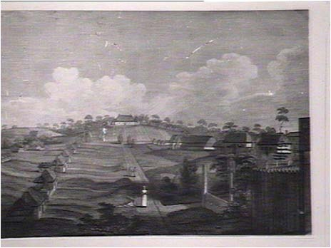
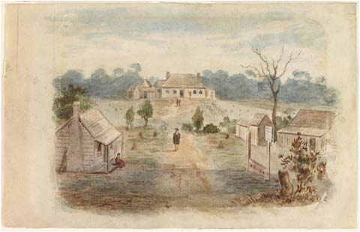
Governor’s House Rosehill [From High/George St] 1790, artist unknown
Government House, 1798, artist unknown
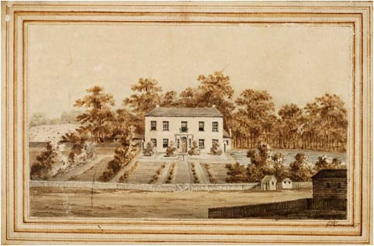
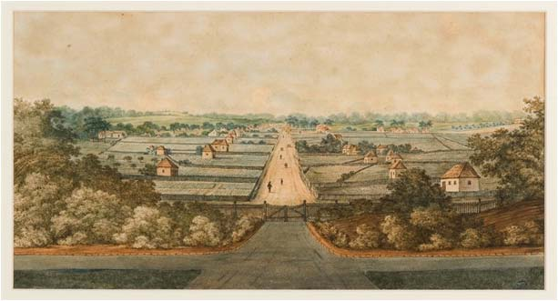
High/ George St from gates of Government House, 1805 , Evans
Government House, 1805, Evans
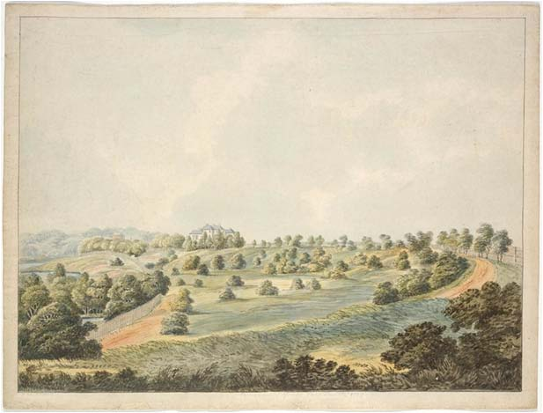
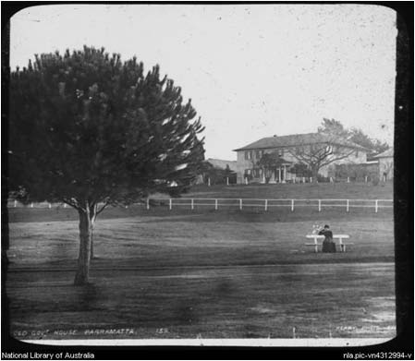
Government House, c.1886, Kerry
Government House from north west, 1819, Lycett
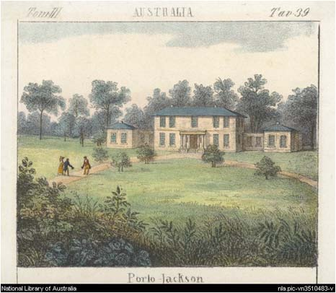
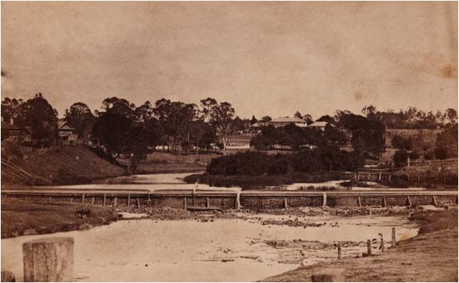
Government House, c.1835, artist unknown
Government House from east, 1870, artist unknown
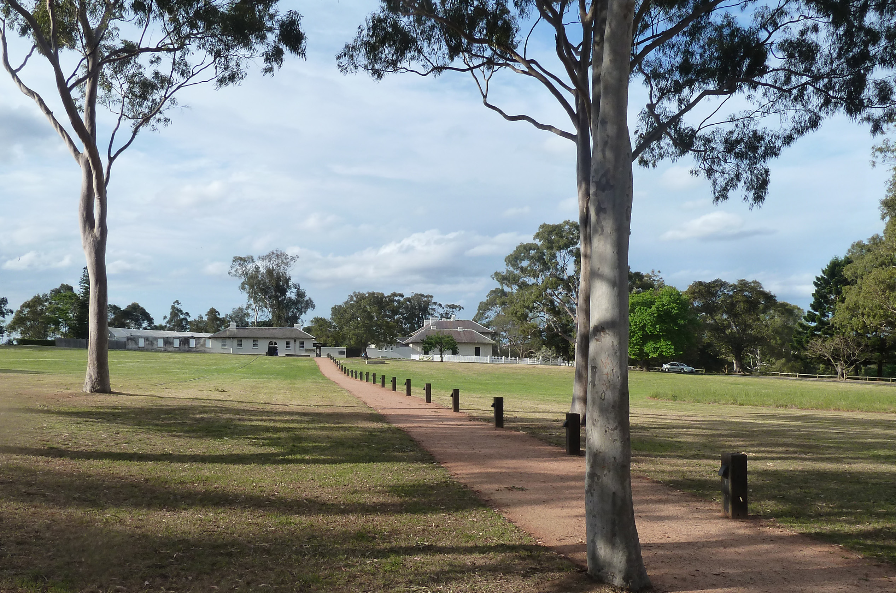
- .

2 VIEWS & SETTINGS
INTRODUCTION

This section of the document describes and assesses the significance of various views and settings of, from and within Old Government House and Domain.

DEFINING ‘VIEW’
A SIGHT OR PROSPECT OF SOME LANDSCAPE OR SCENE.
Views occur over distance, and through ‘view planes’, and comprise a foreground, middle-ground and background. The qualities or components of the foreground, middle-ground and background help to define what is important about a view, and changes within those ‘planes’ will alter the qualities and characteristics of a view.
Views are sensitive to changes within the natural and built environment and are affected by weather variations.
Viewing Location
The point or area from which the view is seen.
Viewing Distance
The generally accepted distance bands (CALM, 1994*) affecting visibility are as follows:
Immediate Foreground: This zone begins at the viewer and extends to about 100 metres.
Foreground: In the case of this project the foreground has been determined as up to 500m.
Middle ground: Up to 1.5 km from the observer
Middle Distance: Up to 7 km, this viewing plane is often not visible in this context due to existing built form/topography.
Background: This zone extends from middle distance to infinity.
* Department of Conservation and Land Management Reading the Remote: Landscape Characters of Western Australia. CALM, Perth, 2004.
VIEW TYPES: DEFINITIONS
The following view ‘types’ occur from within and to the study area.
POINT TO POINT VIEW (OR VISTA)
A directed view from a particular point in the landscape, to another point of interest, such as a landmark or feature.
e.g. The view along George Street towards the gatehouse and Domain
POINT TO AREA VIEW (OR PANORAMA)
A general view from a particular point in the landscape, to a wide area.
e.g. The view from the Crescent north towards the vegetated ridgeline and hills
AREA TO POINT VIEW (OR VISTA)
A directed view from a general area to a point of interest, landmark or feature in the landscape.
e.g. The view from anywhere within the Domain towards Old Government House
AREA TO AREA VIEW (OR PANORAMA)
A view from a general area to a wide area, or a general view from one area to another.
e.g. The view from the bath house area towards the City

DEFINING ‘SETTING’
THE IMMEDIATE AND EXTENDED ENVIRONMENT THAT IS PART OF, OR CONTRIBUTES TO, ITS SIGNIFICANCE AND DISTINCTIVE CHARACTER.
Beyond the physical and visual aspects, the setting includes interaction with the natural environment; past or present social or spiritual practices, customs, traditional knowledge, use or activities and other forms of intangible cultural heritage aspects that created and form the space as well as the current and dynamic cultural, social and economic context
2005, ICOMOS Xi’an Declaration on the Conservation of Settings
For the purposes of this study, five settings have been described, and are integral to the understanding and significance of the views. The concepts of views and settings are intrinsically linked ie. a ‘setting’ is often the termination or focal point (or area) of a view, and a view is often experienced from within a ‘setting’.
While the five important settings have not been individually rated, they form part of the views that are assessed in detail.
The Domain provides a ‘setting’ for Old Government House but is also part of the World and National Heritage listing in its own right, as a landscape.
MAPPING VIEWS
For the purpose of this project views have been mapped using view cones.
The extent of these view cones has been estimated during site surveys and by analysing photographs. Often all buildings contained within the view cone will not be visible to the viewer due to their current building height, however, if new taller buildings are developed within these viewcones it is likely that they will be visible within the assessed views.
VIEWS AND VEGETATION
Vegetation will effect these viewcones both throughout the seasons and after pruning. Vegetation, landscapes, and therefore, views of them, are changing entities. In some cases existing trees are an integral part of a important view (or indeed the terminating element) and while this may change, the study assesses the current day situation and acknowledges the current Parramatta Park Management Plan.

GENERAL TERMS
PANORAMA
An unobstructed view or prospect over a wide area, often in many directions.
VISTA
A view or prospect, especially one seen through a long, narrow avenue or passage.

DETERMINING IMPORTANT VIEWS
WHAT MAKES A VIEW IMPORTANT?
For the purpose of this report ‘important views’ are those views which demonstrate the heritage values as included on the World and National Heritage lists.
An assessment of 16 views has been undertaken against the World and National Heritage values. These 16 important views were chosen by site survey, through a review of previous views studies (refer to appendix A) and on site discussions with the National Trust and Parramatta Park Trust.
It must be noted that numerous other views were considered but do not appear in the table to the right as when assessed, these views did not rate as ‘highly’ or ‘moderately’ important. For a full illustration of views considered refer to appendix A p.115.
CATEGORIES OF VIEWS AND SETTINGS
LAYERING OF CULTURAL HERITAGE ELEMENTS
The view reveals the multi-layers of built and landscape elements that evoke a sense of the past, and highlight the city’s importance in the course of Australia’s cultural history. These ‘layers’ or elements include Old Government House itself, the Domain, the crescent, Old Government Farm, the dairy, the river, the formal layout of the carriageways and other historic buildings and monuments. The view may also evoke a sense of association with important historic figures such as Macquarie, who had a particularly strong influence in expanding Old Government House, defining the Domain, and setting out and designing carriageways and other elements of the landscape.
VISUAL PROMINENCE AND SYMBOLISM
The view highlights the visual prominence of Old Government House as the former seat of colonial power, and its traditional ‘master and commander’ relationship with Parramatta. The view evokes a sense of the former authoritative dominance of the house, atop a hill in its landscape setting, and its relationship to the wider city. The view may also reinforce the relationship between Old Government House and the original Georgian town plan, particularly the axis of George Street.
LANDSCAPE SETTING
The view highlights the landscape setting and landscape elements of Old Government House and Domain.

A site survey was undertaken over 2 days to assess the significance of views by focussing on the World and National values which may be affected by future development. Views have been assessed as seen on the 8th and 9th of October 2012 in fair conditions. 16 views have been assessed.
Each view has been rated according to its heritage values. The rating system is as follows:
Rating 3 (The view has a strong relation to the heritage values)
Rating 2 (The view has a moderate relation to the heritage values)
Rating 1 (The view has a little or no relation to the heritage values)
Each view was then given a total rating and a low/moderate or high significance.
Rating is 7-9 High significance
Rating is 4-6 Moderate significance
Rating is 1-3 Low significance
 | Heritage Values
Views | Multilayered | Prominence | Landscape Setting | Total
1: OGH towards the city | 2 | 3 | 3 | 8
1b: OGH Courtyard towards the city | 3 | 2 | 1 | 6
2: Looking NE towards OGH within domain | 2 | 3 | 3 | 8
3: Looking NE towards former Kings School from OGH | 3 | 2 | 2 | 7
4: Looking N from the crescent | 2 | 1 | 3 | 6
5: Bath house area to city | 3 | 2 | 2 | 7
6: Looking NE from the crescent towards the city | 2 | 1 | 2 | 5
7: Bath house area to Westmead | 1 | 1 | 2 | 4
8: Parramatta River views | 2 | 2 | 3 | 7
9: Looking E from the crescent towards the city | 2 | 1 | 1 | 4
10: Dairy precinct | 3 | 1 | 3 | 7
11: Looking N towards the Female Factory | 1 | 2 | 1 | 4
12: George Street | 2 | 3 | 2 | 7
13: Macquarie Street | 1 | 2 | 2 | 5
14: Hunter Street | 2 | 1 | 1 | 4
15: Looking E towards Old Government Farm | 3 | 2 | 1 | 6
16: Mays Hill | 1 | 1 | 2 | 4

DESCRIBING VIEWS & SETTINGS

SETTINGS
Each setting has been described using a table which outlines the following;
DESCRIPTION OF THE SETTING
A description of what can be seen in the foreground, middle ground/middle distance and distance
PHYSICAL COMPONENTS
A description of the physical components of the setting, for example, landforms, vegetation, water, structures, historic and other features, integrity, enclosure.
EXPERIENTIAL/SENSORY COMPONENTS
A description of how the setting responds to the sense of place, particularly when considering the heritage values.
VIEWS
Each view has been described using a table which outlines the following;
VIEWING LOCATION
A brief description of the viewing location
DIRECTION/TYPE OF VIEW
A description of the direction of the view and type of view, for example a point to point view or area to point view (refer to p.28)
DESCRIPTION OF VIEW
A description of what can be seen in the foreground, middle ground/middle distance and distance
PHYSICAL COMPONENTS
A description of the physical components of the setting, for example, landforms, vegetation, water, structures, historic and other features, integrity, enclosure.
EXPERIENTIAL/SENSORY COMPONENTS
A description of how the view responds to the sense of place, particularly when considering the heritage values.
AESTHETIC CHARACTERISTICS
Aesthetic characteristics have been considered in relation to compositional qualities, visual interest and rarity of the views as follows:
COMPOSITION
The ‘structure’ or compositional qualities of the view. For example, a classic vista or a point to area panorama. Views can be balanced, both horizontally and vertically; a ‘picture postcard’ view. The focal point of the view might be centred, and elements in the foreground, middle ground and background, might be equally weighted. The view may be framed by elements to the viewer’s left and right, and may be an ‘iconic’ view that is instantly recognisable or well known.
VISUAL QUALITY
The view may be compelling or inspiring for its visual qualities, including a built or landscape feature (that may be the focal point of the view), or a collection of built or landscape features; visual variety and contrasts; and other elements such as colour, texture etc.
RARITY
The view may be a ‘one-off’ or rare view and it, or a similar view, is not available nearby. The view itself may also contain a rare element that is not prevalent in other views from within the city.
VALUES SIGNIFICANCE
A consideration of the significance of the view when related to the World and National Heritage values (refer to p.30)
URBAN DESIGN/PARK MANAGEMENT NOTES
Brief commentary on potential considerations around the urban design of the surrounding streetscapes and within Parramatta Park.
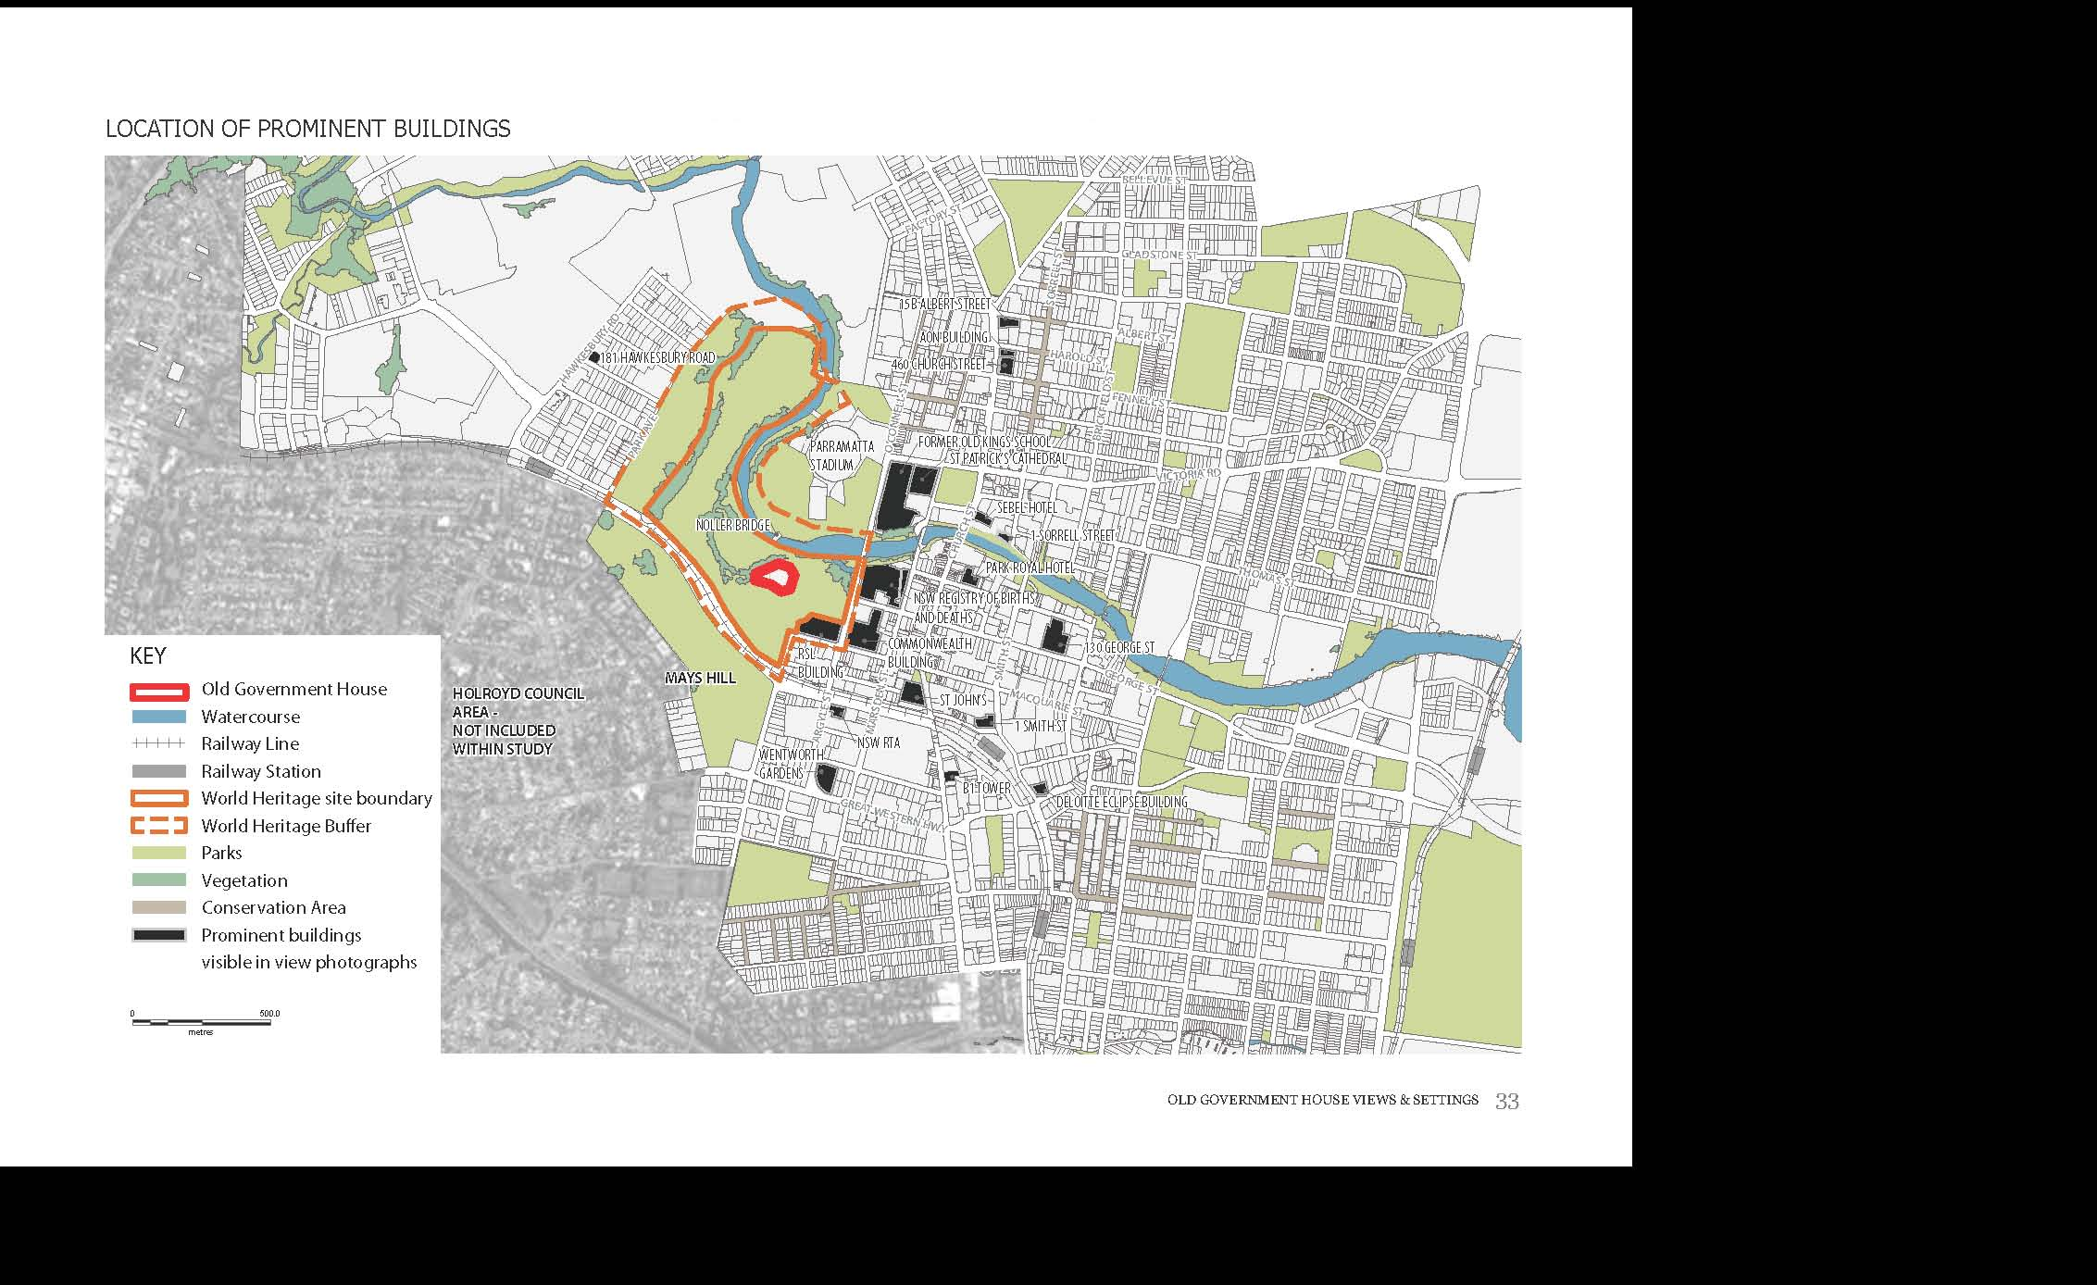
SETTINGS
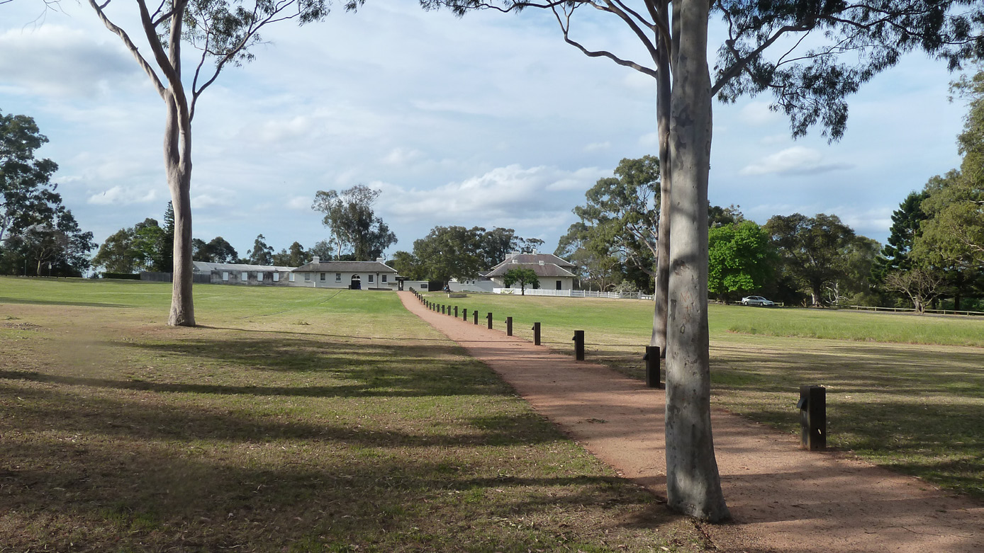

SETTING 1: OLD GOVERNMENT HOUSE AREA

Description of setting | Old Government House is a prominent  Old Government House is a prominent feature siting atop a lawned hill within a parkland. This elevated location creates a sense of the dominance of OGH, particularly when viewed from below.  The house is partially surrounded by mature vegetation which contrasts against the white painted walls of OGH and creates a vegetated backdrop to views.  The carriageways and pathways follow the alignment as created by Macquarie.
Physical Components | Land sloping towards OGH  Vegetation  Pathways  Rural style fencing  OGH a prominent feature
Experiential/sensory components | Strong sense of place reflecting development of OGH and Domain setting, particularly by Macquarie.  There is a rural character to this setting as OGH, the surrounding parkland and vegetated backdrop dominate all views towards OGH.

LOOKING NORTH TOWARDS OLD GOVERNMENT HOUSE
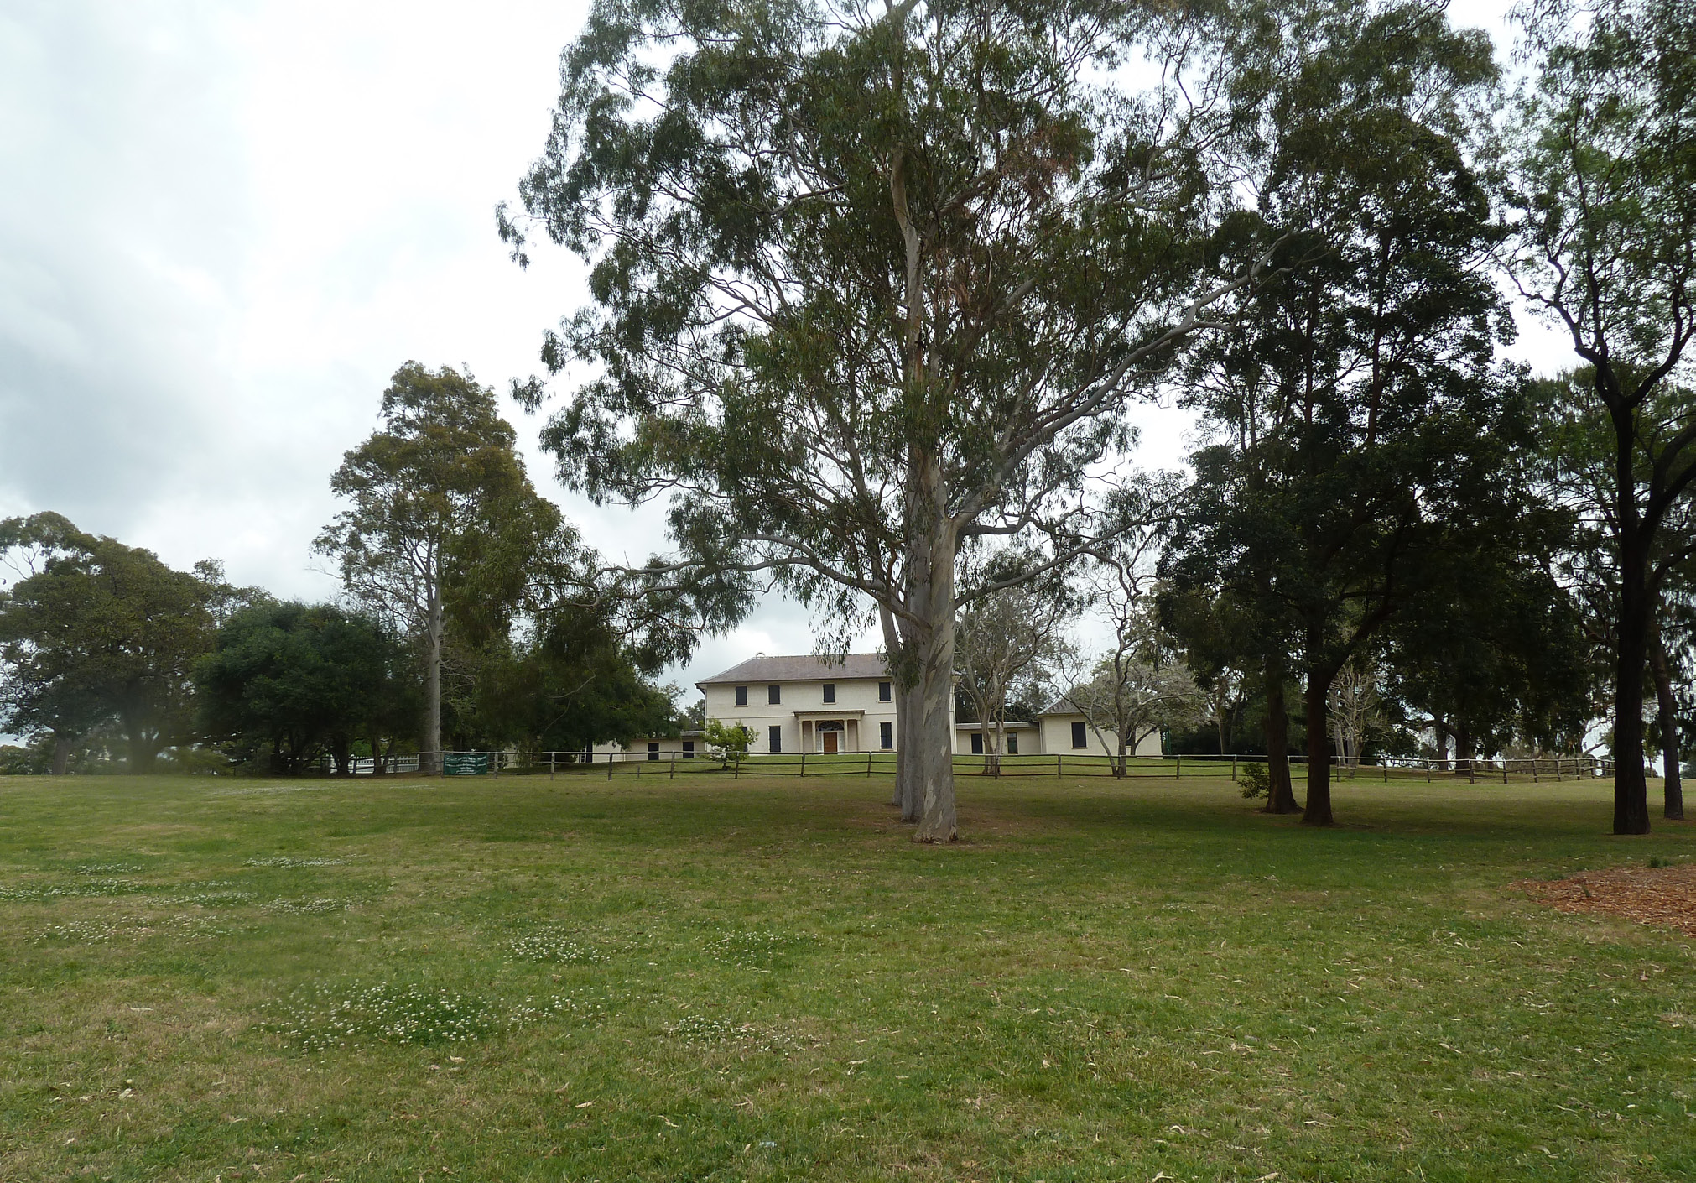
LOOKING WEST TOWARDS OLD GOVERNMENT HOUSE

SETTING 2: DAIRY

Description of setting | The dairy is set within open parkland with a backdrop of mature vegetation.  The rural style fencing and adjacent cottage garden evoke a sense of dislocation from the adjacent city context.  The city skyline is occasionally visible above the treeline.
Physical Components | Broad lawns  Roads and pathways  Rural fencing  Dairy buildings
Experiential/sensory components | Strong sense of place which displays intact examples of the spatial links to the surrounding parkland and Female Factory on the opposite banks of the Parramatta River.

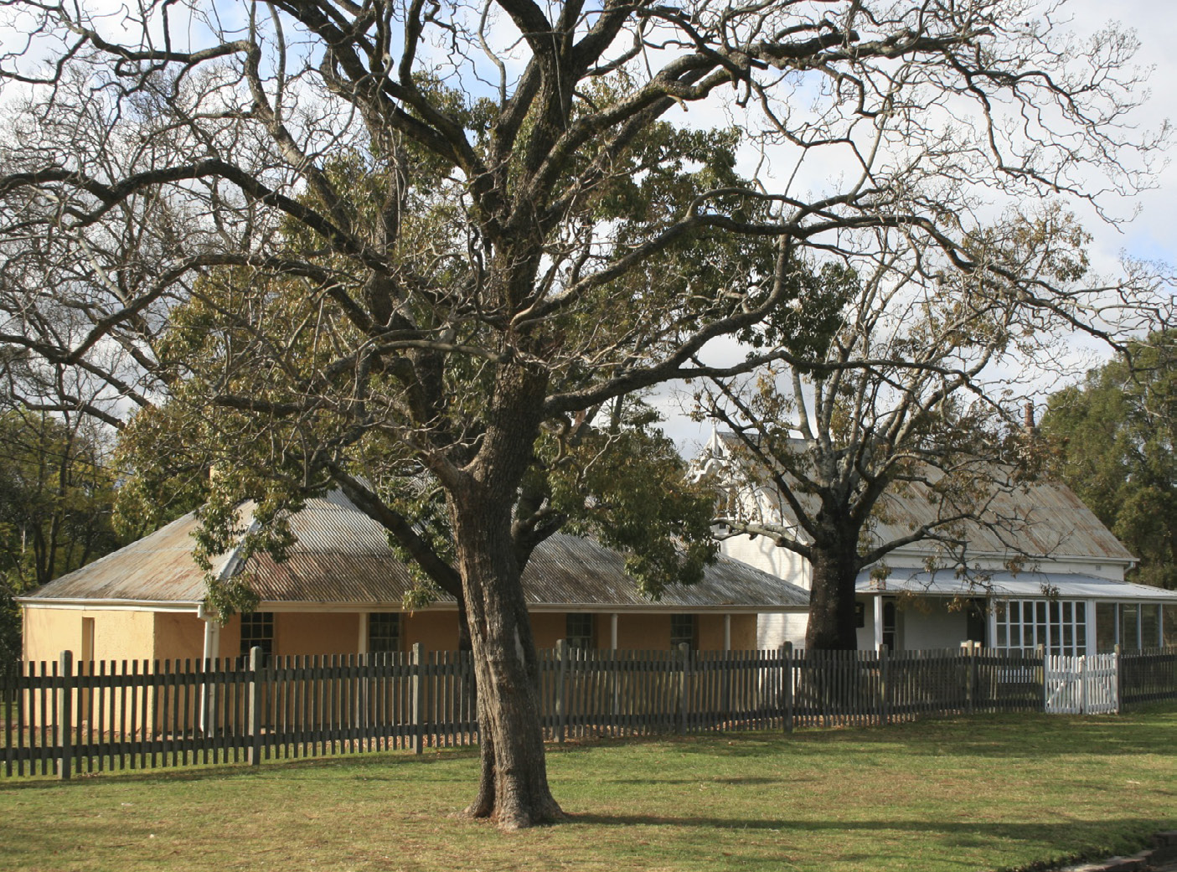
THE DAIRY WITHIN THE LANDSCAPE SETTING
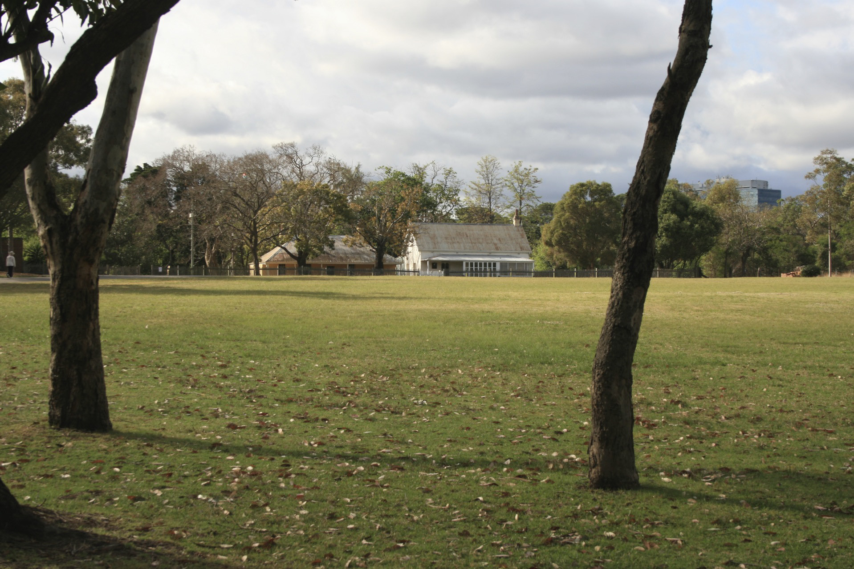
LOOKING NORTH EAST TOWARDS THE DAIRY
SETTING 3: CRESCENT

Description of setting | Old Government House is a prominent feature sitting atop a lawned hill within a parkland. The house is partially surrounded by mature vegetation which helps to create a sense of the rural.
Physical Components | Amphitheatre topography  Vegetated ridge line  Scattered trees  Road  Bend of Parramatta River
Experiential/sensory components | It was here that Governor Phillip came across a natural phenomenon where the river had scoured into the side of a hill, forming an extensive river flat in a semi-circular shape and where the former course of the river had formed a billabong. Its siting relates to the establishment of an agricultural settlement in 1788, vital towards the survival of the early colony.  Sequential views are available from the ridgeline towards church spires, the Parramatta river and Old Kings School giving a sense of the river valley and wider landscape setting.  Strong sense of place with interesting mostly intact topography which was once used as an area of agriculture due to its unique microclimate. The commencement of agriculture at that time can still be seen in the relationship between the government farm area, including the Crescent, the river, and the house and its outbuildings.

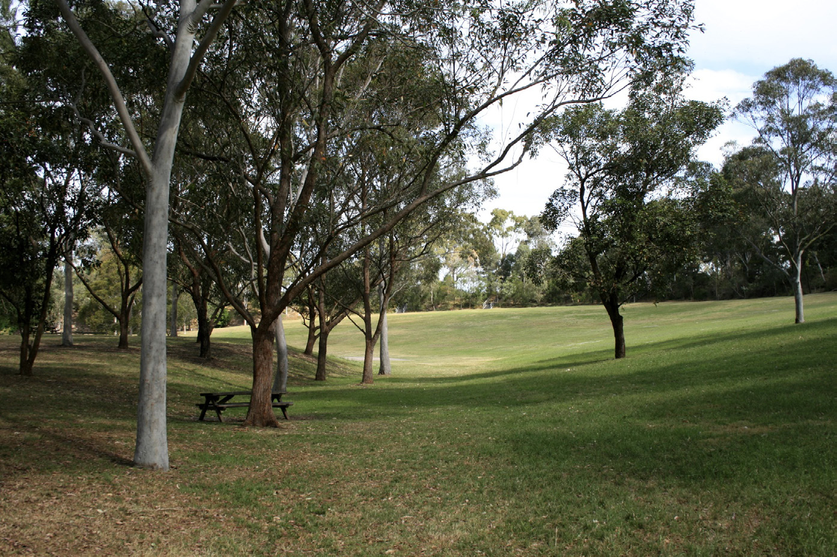
LOOKING SOUTH ACROSS THE CRESCENT
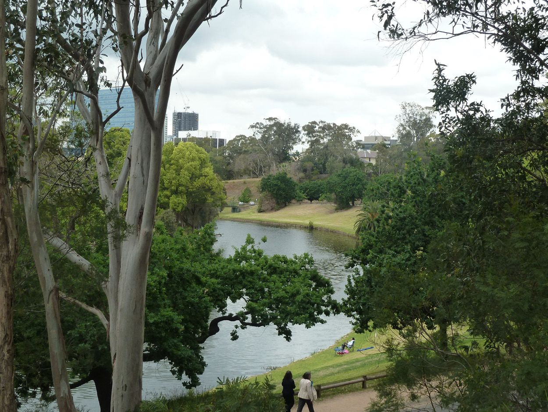
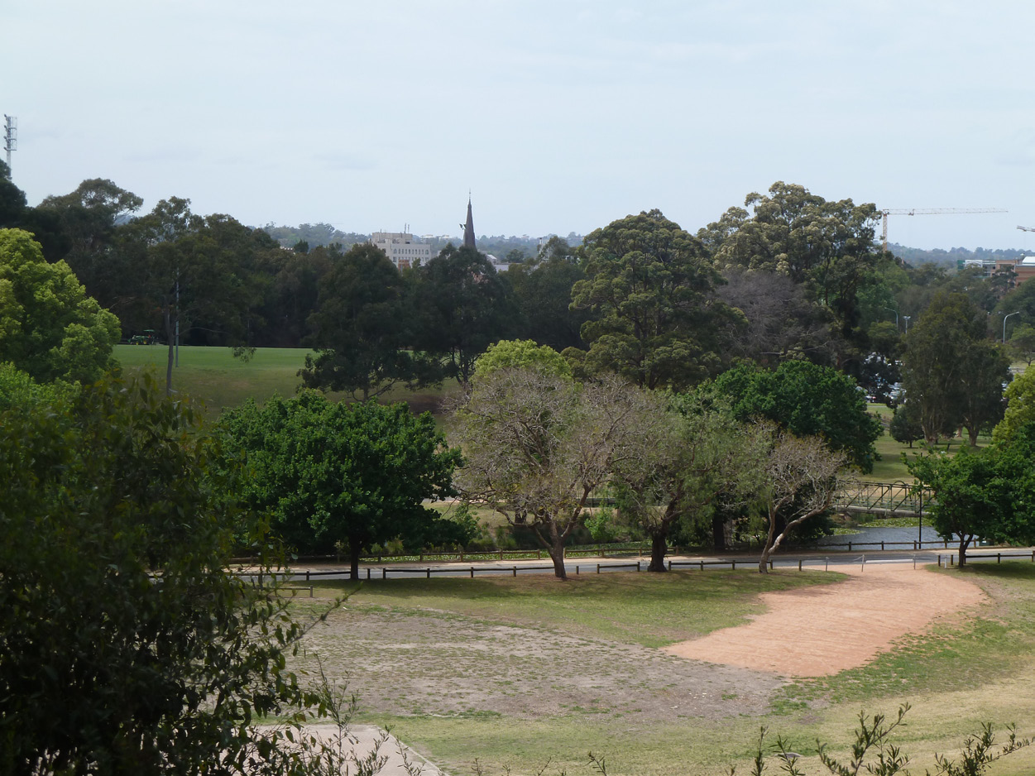

LOOKING EAST FROM THE RIDGE ACROSS THE CRESCENT
LOOKING SOUTH EAST FROM THE RIDGE TO THE PARRAMATTA RIVER
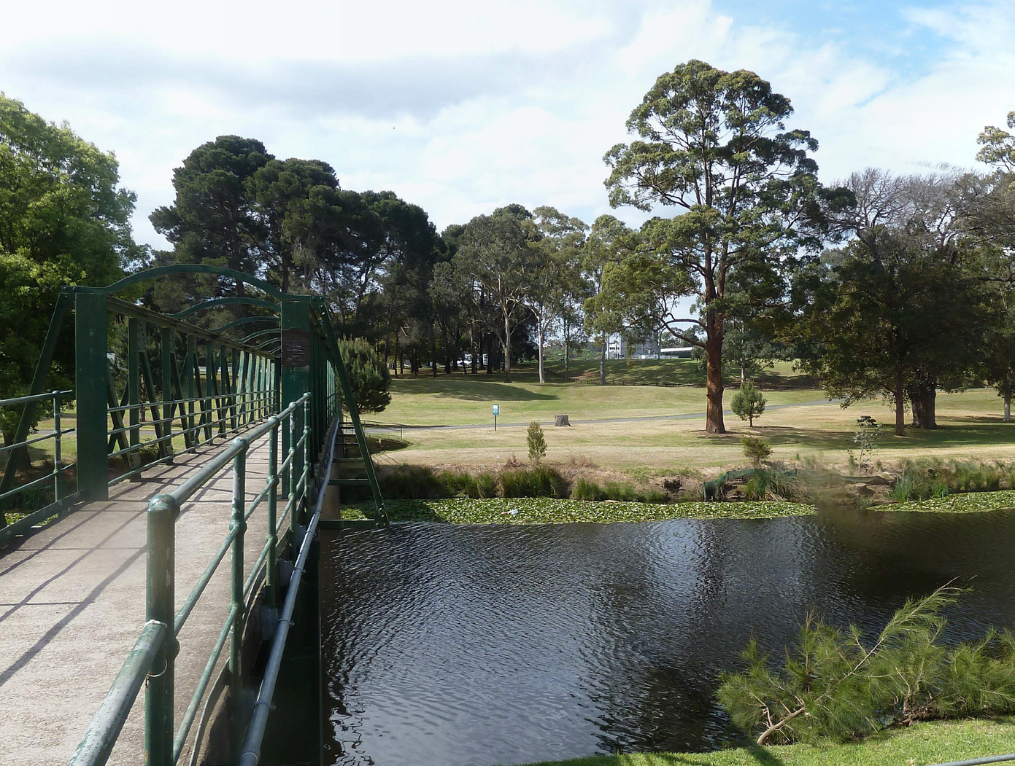

SETTING 4: OLD GOVERNMENT FARM

Description of setting | Site of Old Government Farm on the banks of the Parramatta River.  Backdrop of mature vegetation and car park
Physical Components | Parramatta RIver  Flat river bank  Exotic vegetation  Landscape interventions reflecting agricultural practice
Experiential/sensory components | Fairly strong sense of place depicting where the first successful crops were grown in the colony. Integrity has lost integrity due to the prominent location of the car park.

LOOKING NORTH TOWARDS OLD GOVERNMENT FARM
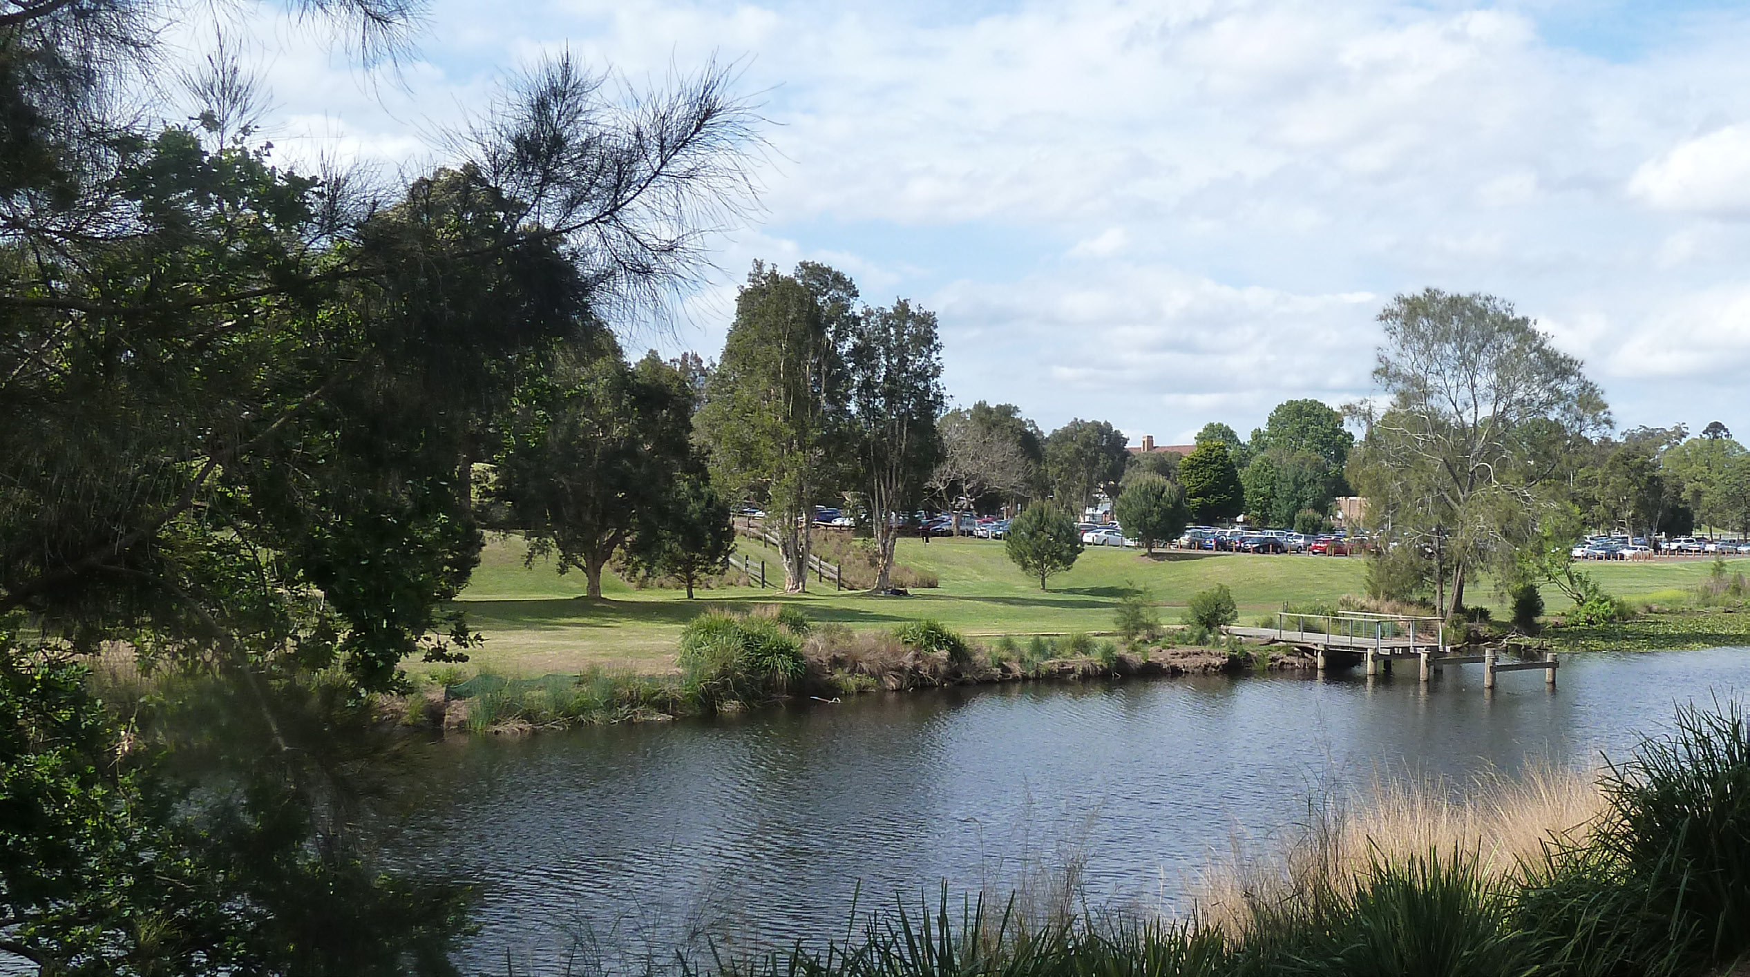
LOOKING NORTH TOWARDS OLD GOVERNMENT FARM
SETTING 5: BATH HOUSE AREA
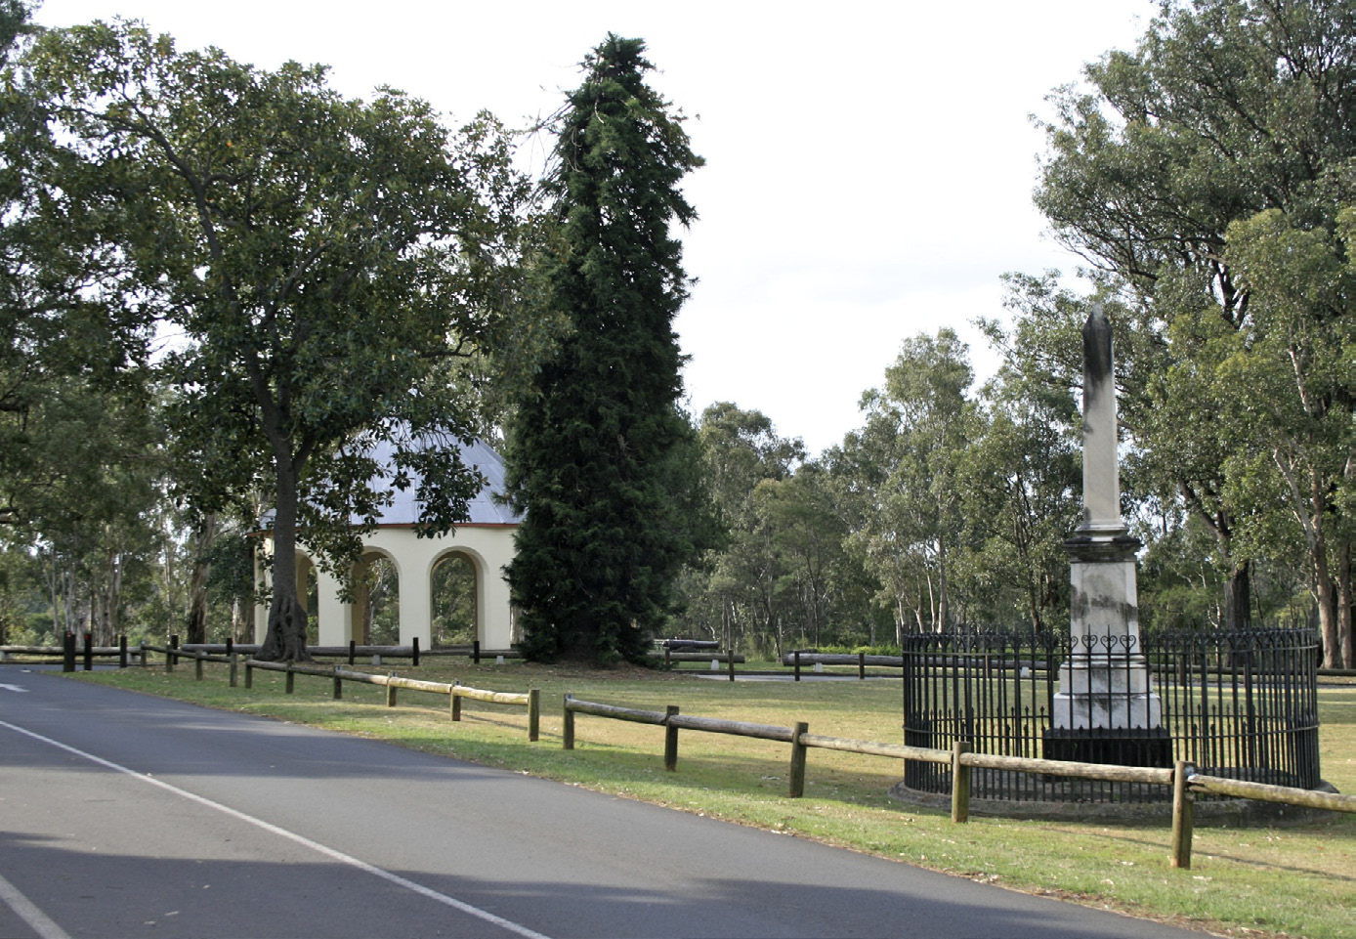

Description of setting | Collection of monuments, landscape features and structures which are sited at the edge of the crescent and adjacent to the roadside. Backdrop of vegetation along the edge of the crescent.  Scattered trees filter views between each element.
Physical Components | Bath house  Boer War Memorial  The Redoubt  The Observatory  Landscape elements (Araucarias, figs, cypresses marking meridien lines)
Experiential/sensory components | Parkland setting featuring a collection of buildings, landscape features and monuments which help to tell the story of the layers of history within the Domain.

LOOKING WEST TOWARDS THE BATH HOUSE
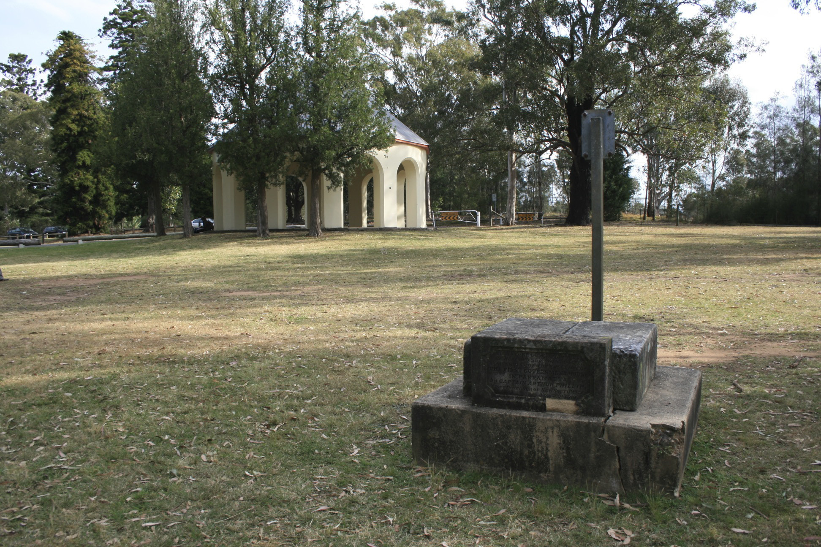
LOOKING SOUTH WITH THE REDOUBT REMAINS IN THE FOREGROUND AND THE BATH HOUSE IN THE BACKGROUND

IMPORTANT VIEWS

Viewing Location | Lawns to the east and south of OGH
Direction / type of view | East and south east / Area to area view
Description of view | Immediate foreground: lawns and pathway. Foreground: expansive lawns sloping down to belt of mixed trees. Middle ground: City buildings which are largely screened by trees, except for Commonwealth building, and to lesser extent RSL building. To the south east a number of buildings are visible over the trees, including Wentworth Gardens
Physical Components | Land slopes gently down towards city. Belt of mixed trees. Mown lawn and pathways. City buildings partly screened by trees, park furniture (railings, bollards etc) Gatehouse just visible through trees. Not enclosed.
Experiential/sensory components | Tree line partially obscured built form, Commonwealth building is prominent.
Aesthetic considerations | Composition: area to area view taking in a broad panorama of the city from a the lawns within the Domain. Visual quality: moderate visual quality of the city of Parramatta against a parkland setting. Rarity: rare within the regional context, similar views are available from other locations.
Values significance | HIGH  Multi- layered elements visible including the layout of pathways. Relationship with the alignment of George Street, Macquarie Street and Hunter Street. Sense of landscape setting in the foreground of views and through the juxtaposition of city and parkland.
Urban Design / Park Management notes | Lack of connection between the city and the domain, George Street looses any sense of formal connection with existing planting and pathway arrangements within the park.

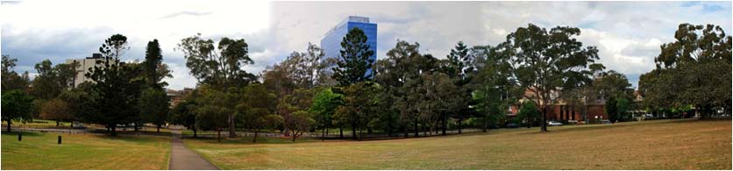

VIEW 1 LOOKING EAST DIRECTLY DOWN GEORGE STREET ALIGNMENT
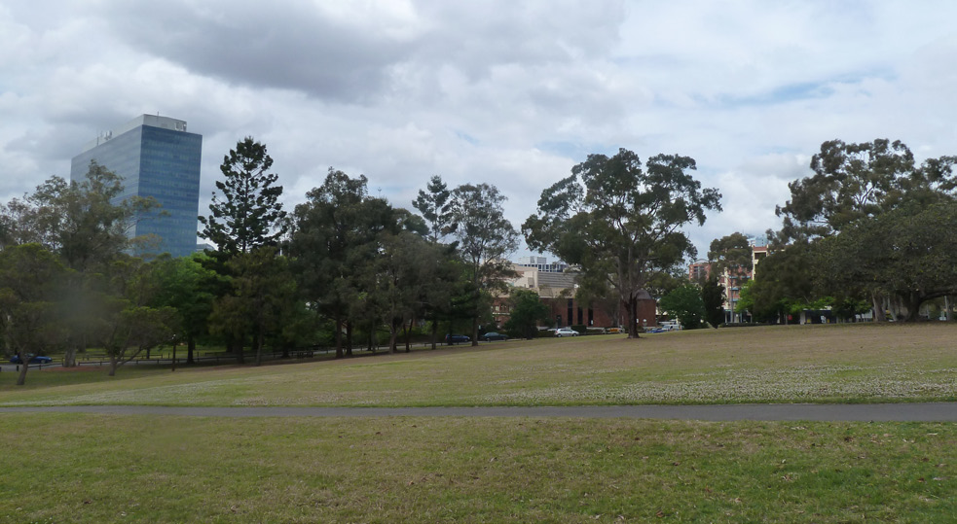

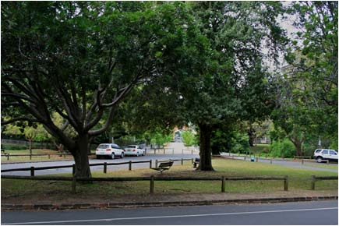
LOOKING SOUTH EAST FROM THE FRONT OF OGH
LOOKING SOUTH EAST TOWARDS THE GATEHOUSE

VIEW 1B: OGH COURTYARD TOWARDS THE CITY

Viewing Location | Within the OGH courtyard
Direction / type of view | East and south east / Point to point view
Description of view | Immediate foreground: Courtyard and OGH buildings  Foreground: Partial tree cover. City buildings – Registry building to NE, Commonwealth building to SE
Physical Components | N/A  OGH dominant feature
Experiential/sensory components | Strong sense of place related to colonial era.  City buildings intrude to some degree.  Height of Commonwealth building increases impact.  Form and colour of Justice building generally complementary with OGH.
Aesthetic considerations | Composition: point to point view framed by the eaves of OGH. Visual quality: moderate visual quality as city buildings impact upon views of OGH. Rarity: one off view.
Values significance | MODERATE  Strong sense of a multilayered landscape through the proximity of OGH and central courtyard. Views towards Parramatta are dominated by OGH giving it an authoritative presence. Low values relating to the landscape setting.
Urban Design / Park Management notes | NA

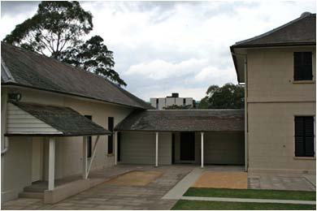
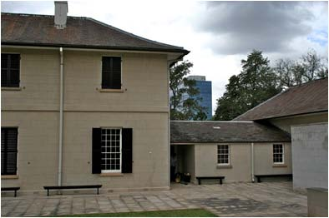
LOOKING TOWARDS THE CITY FROM WITHIN THE OGH COURTYARD

VIEW 2: LOOKING NE TOWARDS OGH

Viewing Location | Looking towards OGH from position as shown
Direction / type of view | North east / Point to point view
Description of view | Immediate foreground: lawn sloping gently towards OGH, scattered trees with high canopy. Pathway  Foreground: Pathway and bollards leads the eye across the treeless lawn to OGH. Views terminate at OGH with eucalyptus forming a background above the roofline.
Physical Components | Lawn, trees, bollards, OGH
Experiential/sensory components | Tranquil parkland setting with OGH acting as a focus for the view
Aesthetic considerations | Composition: point to point view terminating at OGH, well structured view balanced horizontally and vertically. Visual quality: high visual quality showcasing OGH. Rarity: one off view.
Values significance | HIGH  Visible layering of landscape elements including pathways, dovecote and the prominence of OGH itself. Significant, parkland setting evocative of the colonial era (Macquarie and later Governors), no visual intrusion from new buildings.
Urban Design / Park Management notes | While the pathway draws your eye towards OGH it also draws your eye towards the car park to the south west.

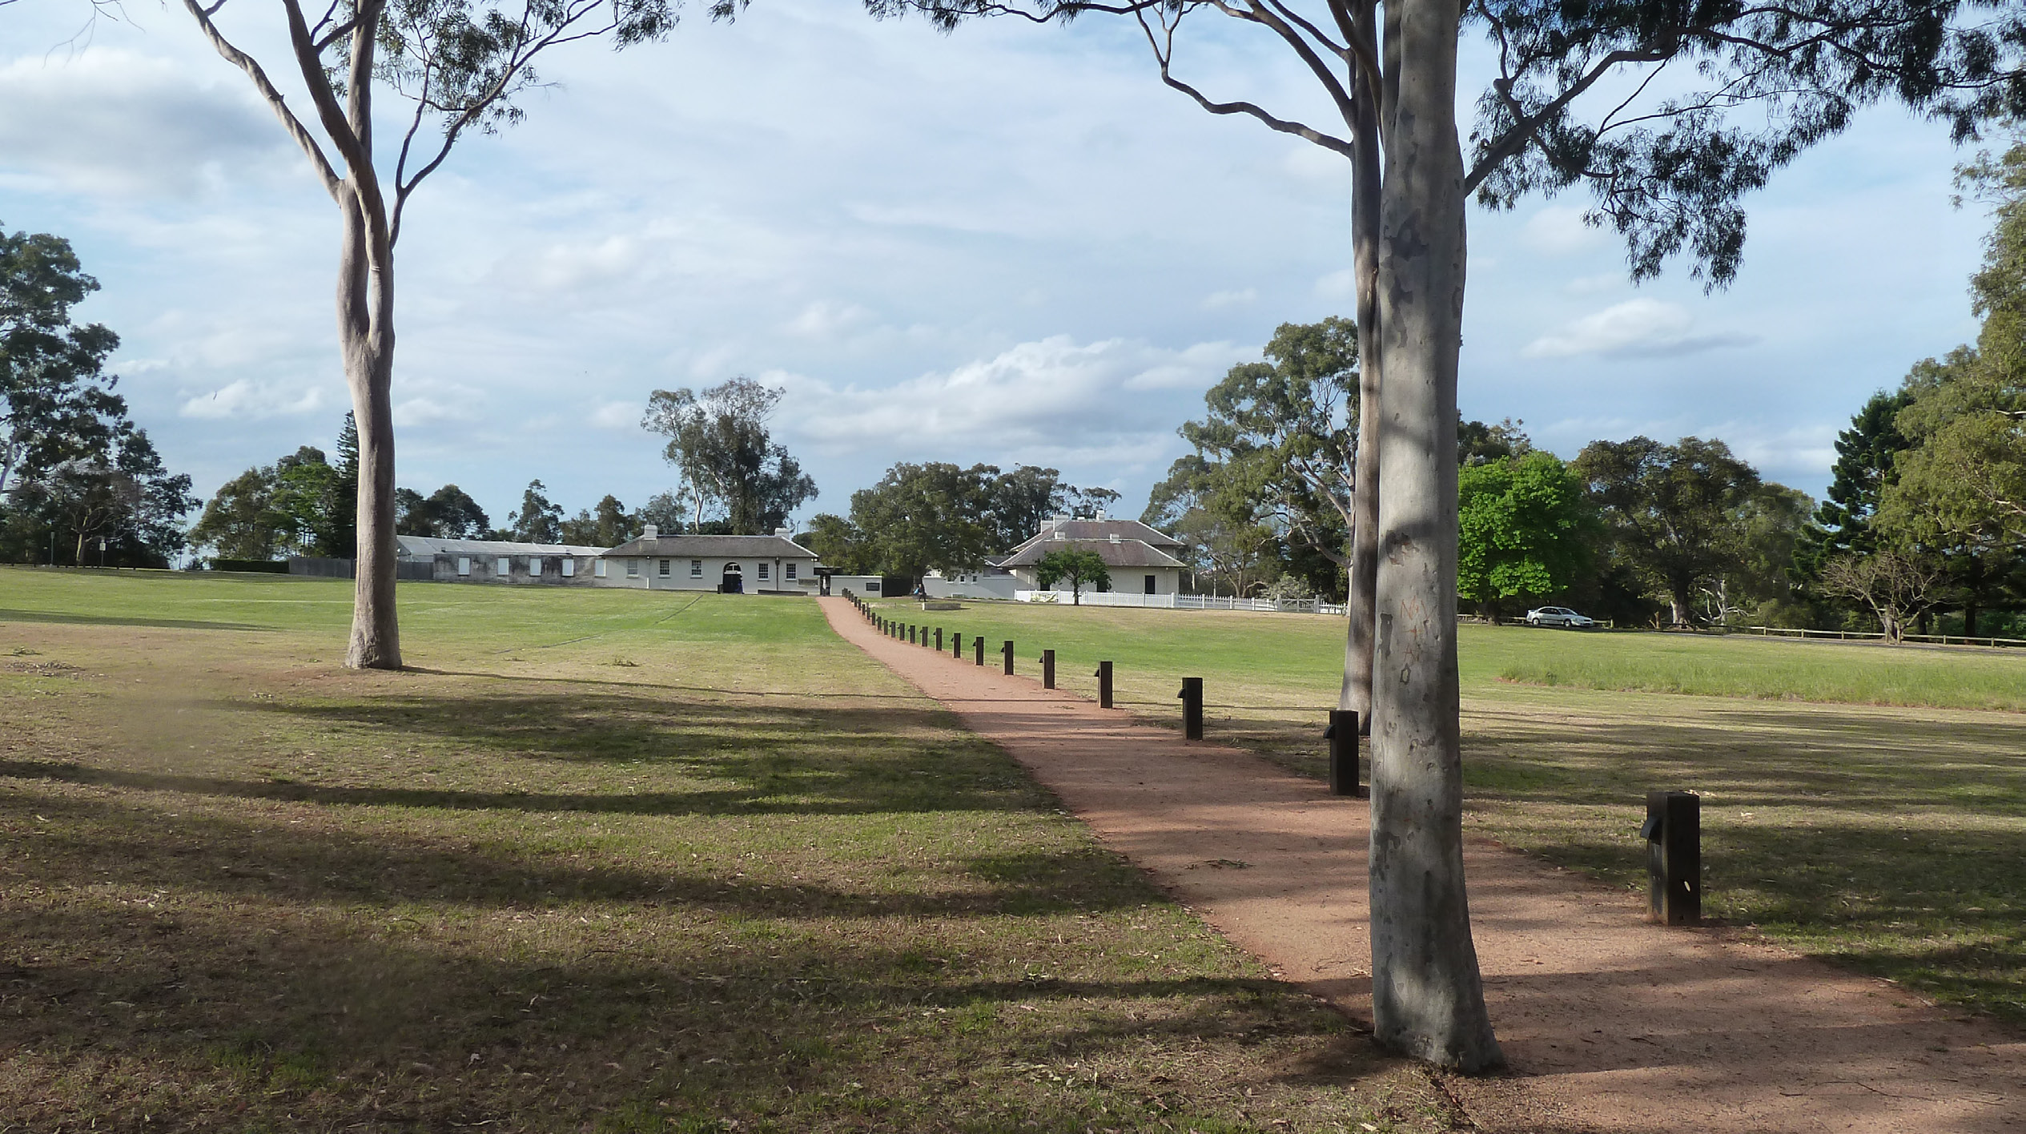
VIEW 2 LOOKING NORTH / NORTH EAST TOWARDS OGH

VIEW 3:OGH TO FORMER KINGS SCHOOL

Viewing Location | NE corner of OGH to former Kings School
Direction / type of view | North east / Point to area view
Description of view | Immediate foreground: Lawns, open fence and mostly deciduous trees (Jacarandas).  Foreground: exotic trees, river and Government farm beyond. Parked cars partly visible.  Middle Ground: Narrow view of former King’s School building (upper floor), St Patrick’s Spire is occasionally visible although mostly obscured by trees.
Physical Components | Fairly steep slope down to river. Undulating beyond. Vegetation: mown lawns and spaced trees (Eucalypts and exotics) River visible through trees. Simple open fence, carpark is fairly dominant and school visible. Part of Government farm site visible. Trees provide sense of enclosure.
Experiential/sensory components | Proximity to OGH, river and farm provide fairly strong sense of place.
Aesthetic considerations | Composition: Point to area view with a fair composition, lack of focal point. Visual quality: while there is no particular focal point there are a number of compelling elements within this view. Rarity: one off rare view
Values significance | HIGH  Very strong layering of landscape elements including the School building, church spires and Government farm which provide historical connection to colonial era. Tree lined ridge on the horizon helps to evoke a sense of the rural.
Urban Design / Park Management notes | Trees obscure views towards Old Kings school and church spires.  Car parking dominates views in the foreground

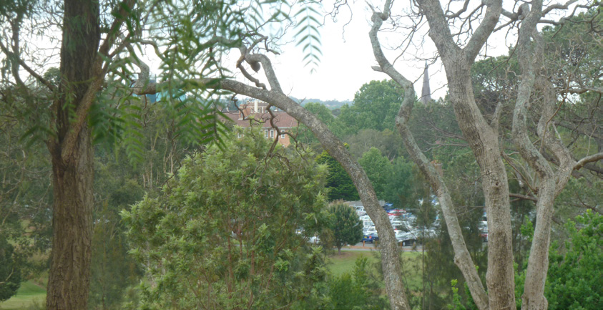

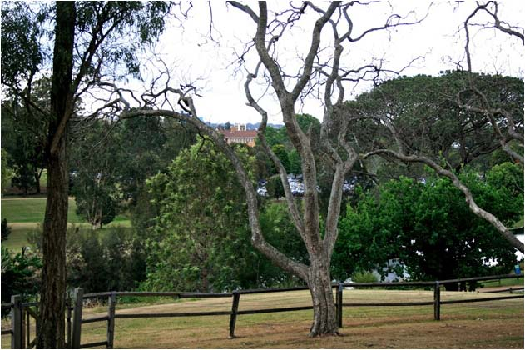

VIEW 4: FROM CRESCENT NORTH

Viewing Location | The rear of OGH
Direction / type of view | North and north east / Point to area view
Description of view | Immediate foreground: Wooden fencing, bush, young trees and shrubby understory  Foreground: Cleared amphitheatre area sloping topography and basin, concrete slab  Middle ground: Bushland with glimpses of the Parramatta Stadium lights  Background: Tree’d horizon line, views terminate at tree’d ridge
Physical Components | Bush and scrub planting, lawned amphitheatre, concrete slab, tree’d horizon line, Parramatta Stadium lighting masts
Experiential/sensory components | Green and tranquil view reminiscent of colonial times but regenerating bush differs from colonial landscape treatment. While the Parramatta Stadium lights are visible they are not dominant.
Aesthetic considerations | Composition: point to area view which is somewhat framed by vegetation in the immediate foreground and terminating at tree lined ridge in the background. Visual quality: High visual quality evoking a rural setting. Rarity: similar views are available along the crescent ridge line.
Values significance | MODERATE  Good views of the Amphitheatre with no visual intrusion from new buildings. Views reflect the natural topography of the area the vegetated hills on the horizon which help to reinforce the rural character of the place.
Urban Design / Park Management notes | Immediate foreground planting obscures views

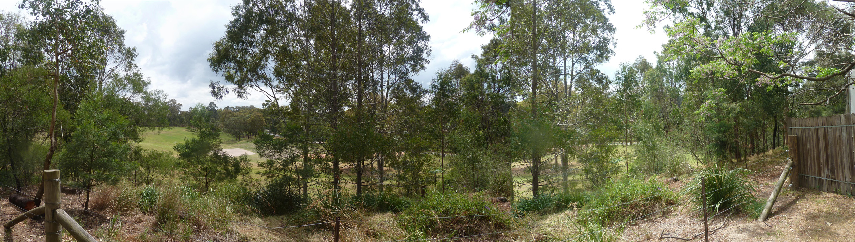
VIEW 4 LOOKING NORTH OVER THE AMPHITHEATRE

VIEW 5: BATH HOUSE AREA TO CITY

Viewing Location | Bath house area
Direction / type of view | East and south east / Area to area view
Description of view | Immediate foreground: The immediate foreground of roads, parking, lawns and spaced trees gives way to mature trees widely spaced in lawns, roadway and parking. OGH features to the to left of views.  Foreground/Middle ground: Views of city buildings are partly screened by mature eucalypts and other tree species Views terminate at city development.
Physical Components | Land falls towards city with a ridge lying to the east which is vegetated in the distance. Tree’d parkland to south and city development to SE. Historic features: OGH and surrounds, bathhouse, Redoubt site, Observatory site, Gov Macquarie Carriageway Drive to OGH Not enclosed
Experiential/sensory components | OGH dwarfed by city views. Relatively unattractive view of OGH.
Aesthetic considerations | Composition: poor composition of scattered elements and visual clutter from street furniture/roadways. Visual quality: collection of landscape features offers interest to the viewer. Rarity: one off view
Values significance | HIGH  Strong layering of landscape elements including the bath house, the Redoubt and Observatory. Strong sense of the relationship between OGH and Parramatta and the general landscape setting.
Urban Design / Park Management notes | Car parking, cluttered signage and furniture dominates views in the foreground. OGH elevational treatment when viewed from the rear is poor. Park edge to south ‘bleeds’ into the city, there is a lack of enclosure and definition between park and beyond.

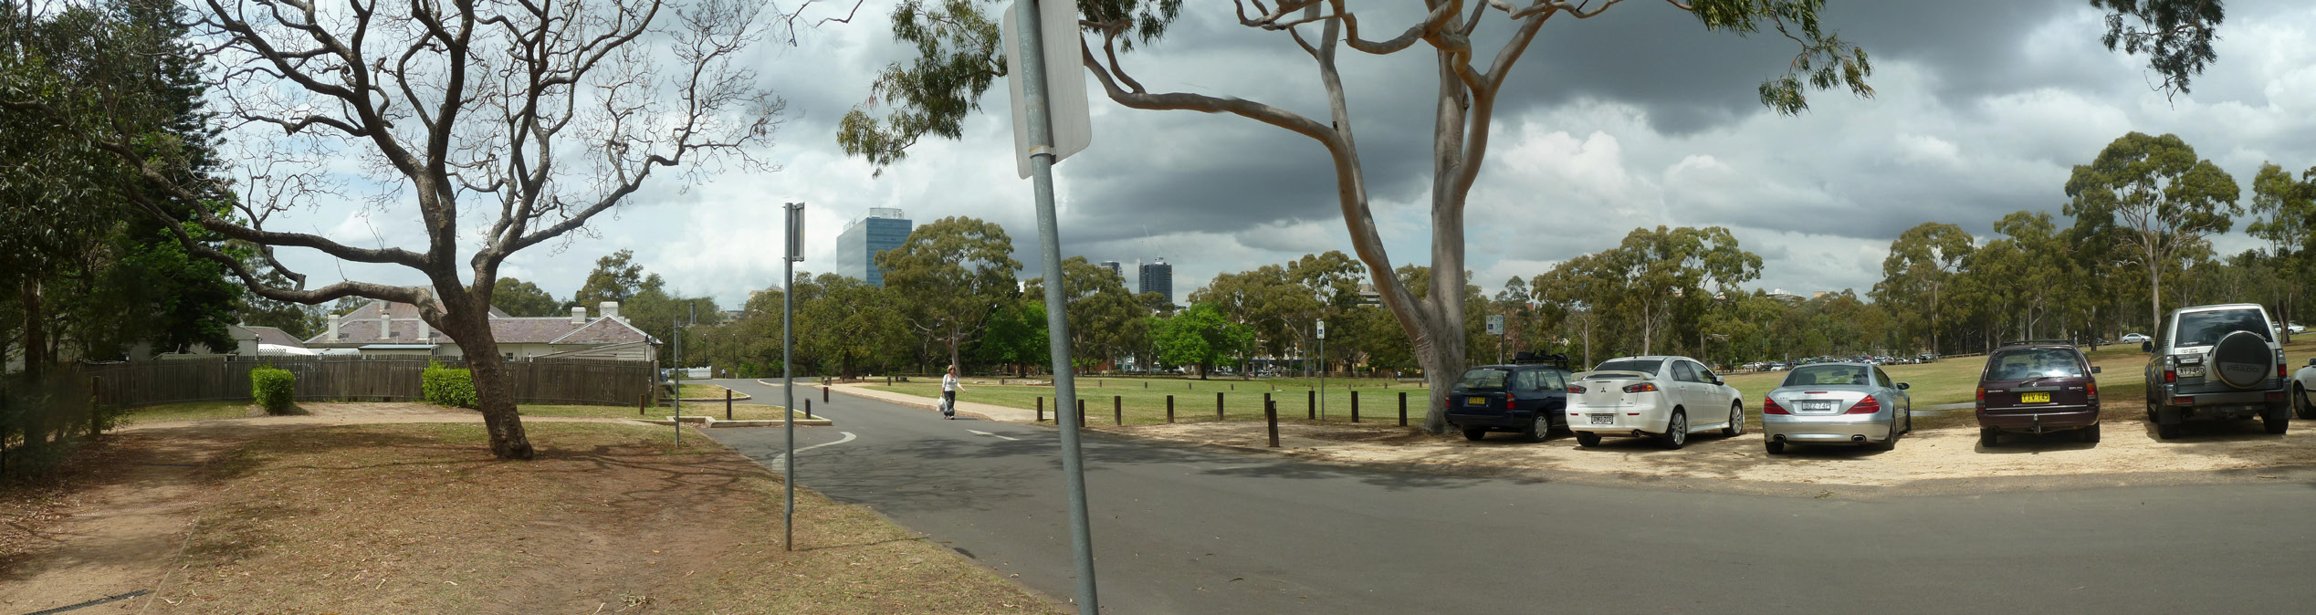

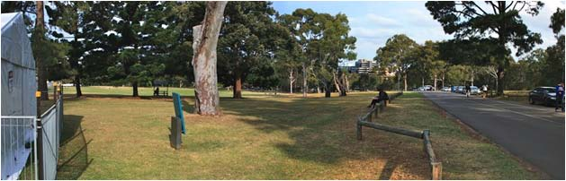

VIEW 6: FROM CRESCENT TO CITY

Viewing Location | View towards City from the Boer War Memorial steps
Direction / type of view | East to north east / Point to area view
Description of view | Immediate foreground: Regenerated woodland with medium size eucalypts and other species. Vegetation is managed to create a grassy understory with views through trees. Foreground: Grassy Crescent amphitheatre with trees and glimpsed views of river. Middle ground: City buildings partially obscured by vegetation. Distance: Long views to are available to the tree’d ridge on the horizon
Physical Components | Steep slopes down to amphitheatre. Undulating with low hills beyond. River partially visible. Two Church spires at St Patrick’s and All Saints are visible in the midground. The Sebol hotel is a prominent feature with its asymmetric roof line and light colours. The amphitheatre (site of Government garden) and Government farm across river are significant heritage features. Moderate integrity. Enclosed view (varies with viewing point).
Experiential/sensory components | Parklike landscape.
Aesthetic considerations | Composition: point to area view taking in a broad panorama of the city against a foreground of vegetation and tree lined ridge in the background. Visual quality: moderate visual quality with some historic features. Rarity: rare view, similar views available from around the crescent.
Values significance | MODERATE  Layering of landscape elements including the crescent and the river. Views north towards the tree’d ridgeline create a sense of openness and rurality against the city.
Urban Design / Park Management notes | Planting partly obscures views

ee

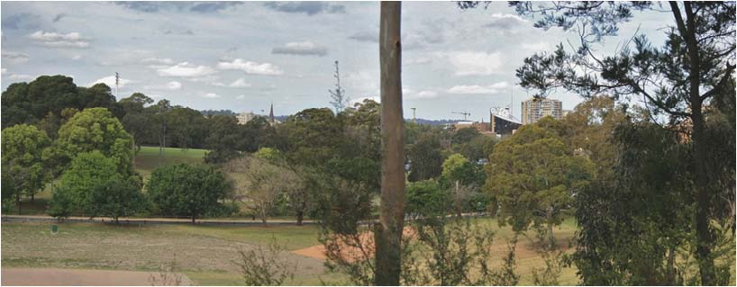
VIEW 6

VIEW 7: BATH HOUSE AREA TO WESTMEAD

Viewing Location | Bath house area (west side)
Direction / type of view | North west / Point to area view
Description of view | Immediate foreground: Cleared lawns falling gently towards the creekline  Middle ground: Views terminate at the vegetated creek line, 181 Hawkesbury Road is visible above the canopy
Physical Components | Bath house and other significant features not visible within this view, sited to the rear.  Lawn and trees are the main physical components making the presence of 181 Hawkesbury Rd fairly prominent
Experiential/sensory components | Parklike landscape.
Aesthetic considerations | Composition: point to area view taking in a panorama of the broad lawns and trees creekline. Visual quality: low visual interest, lawn and trees. Rarity: Similar views available within the domain.
Values significance | MODERATE  Views towards the ‘English’ landscaped setting of broad lawns and mature trees. Rural qualities.
Urban Design / Park Management notes | NA

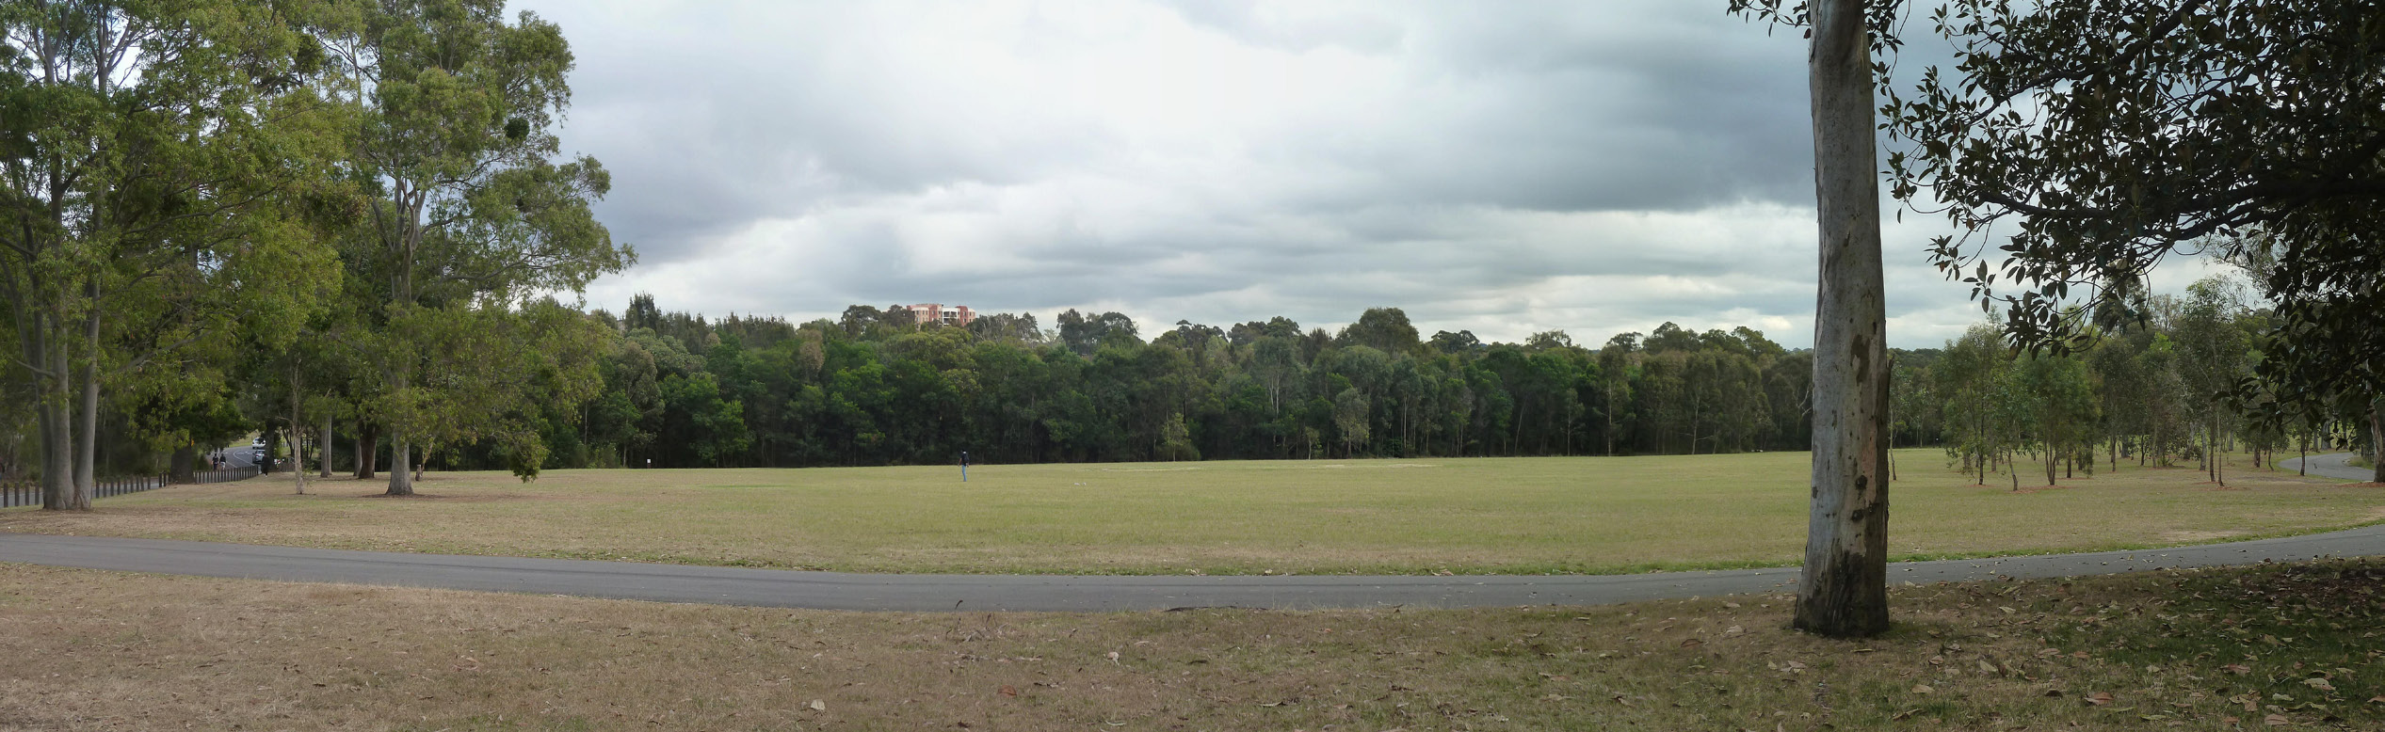
VIEW 7
VIEW 8: PARRAMATTA RIVER VIEWS

Viewing Location | Unfolding views along Parramatta River from road along West side of river (Byrnes Ave).  Starting at point West of Old Kings Oval (a), to point ~75m further south (b), to point near Noller Bridge (c) (below Old Government House)
Direction / type of view | Southeast, then East / Point to area view
Description of view | Point a) Immediate foreground of eucalypts, shrubs and grasses framing the view. Foreground of still, reflective river with lily beds and exotic trees and shrubs in manicured lawns. Middleground view of OGH nestled in tall eucalypts and exotic trees. Wentworth Gardens residential block is visible but not dominant, its colour blending into the sky. Overall, view has high aesthetic characteristics with OGH in mature tree’d river setting.  Point b) Reduced foreground vegetation providing some framing of view. River in foreground with medium size trees and shrubs in manicured lawns. Large city building (Commonwealth building on O’Connell St) prominent above horizon, this building dwarfs OGH. Overall, moderate aesthetic characteristics adversely affected by large city building.  Point (c) Limited framing of view by oaks. Noller Bridge, trimmed laws and medium size exotic trees and shrubs dominate foreground. Two substantial city buildings tend to dominate middle ground view to city. OGH is not visible being hidden behind vegetation. Government Farm is visible across river on the northern bank. Overall this view reads as a landscaped parkland on edge of the city with moderate aesthetic characteristics.
Physical Components | Land sloping to river. Mature native and exotic trees and shrubs, introduced grass lawns. The river is a prominent with its reflective surface. OGH is major heritage feature. Bridge and city buildings prominent from c). Integrity apparent at point a) but less so at b) and c) due particularly to intrusion of modern buildings. Strong sense of enclosure at a) and to limited extent at b).
Experiential/sensory components | Strong sense of place, particularly from a). Highly picturesque setting.
 | Composition: picture postcard views available from point a with OGH as a landmark feature, views are well balanced. Visual quality: high visual quality of context of OGH against the city. Rarity: one off sequence of views
Values significance | HIGH  Strong layering of landscape elements including the river, partial views towards Old Government Farm, exotic plantings and OGH which sits within a dominant location. Evocative of the Macquarie period although tree cover is now greater.
Urban Design / Park Management notes | Trees obscure views at location a), potential to open views towards OGH from location b).

VIEW 9: NORTHERN CRESCENT TO CITY

Viewing Location | View towards City from the steps at location marked
Direction / type of view | East / Point to area view
Description of view | Immediate foreground: Regenerated woodland features in the foreground with medium size eucalypts and other species. Vegetation is managed to create a grassy understory with views through trees. Foreground: Grassy Crescent and amphitheatre with trees and glimpsed views of river. Middle ground: city buildings Distance: Long views to are available to the tree’d ridge on the horizon.
Physical Components | Steep slopes down to amphitheatre. River partially visible. City buildings dominate the middle ground of buildings as they are viewed along the river corridor  The amphitheatre (site of Government garden) is a significant heritage features.  Enclosed view (varies with viewing point).
Experiential/sensory components | Parklike landscape.
Aesthetic characteristics | Composition: point to area view taking in a broad panorama of the city against the parkland and tree lined ridge in the distance. Visual quality: moderate visual quality of the river and city of Parramatta against a parkland setting. Rarity: rare within the regional context, similar views are available from other locations.
Values significance | MODERATE  Views towards the amphitheatre area and river provide some sense of a layering of landscape elements. City buildings are prominent to the east. Tree lined ridge visible to the north.
Urban Design / Park Management notes | Tree canopy blocks views in the foreground

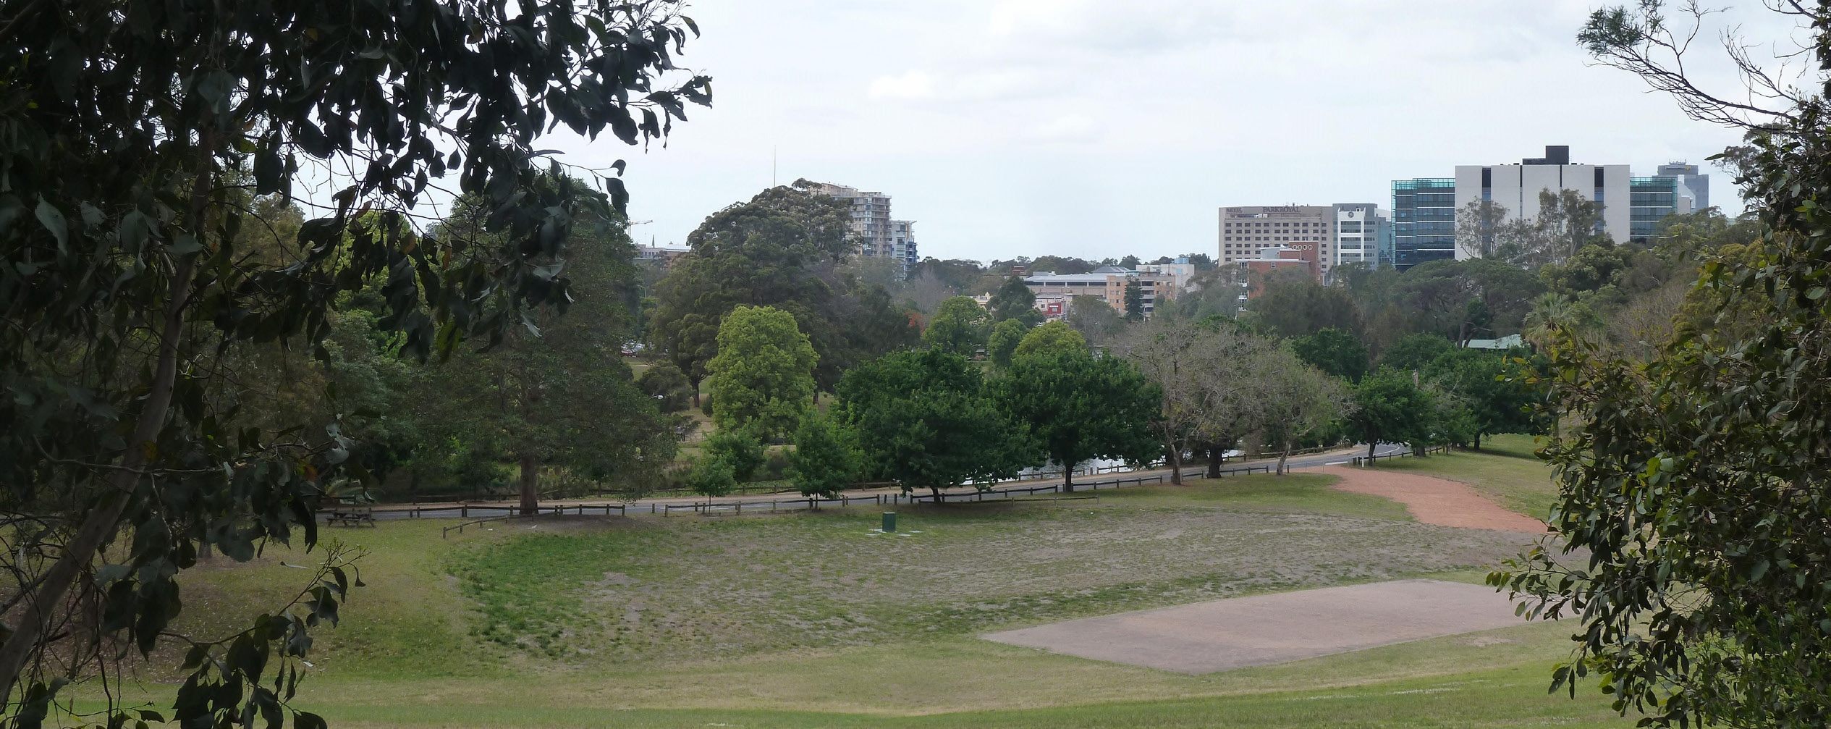

VIEW 9

VIEW 10: DAIRY PRECINCT
N

Viewing Location | Dairy Precinct
Direction / type of view | 1. To North East and South East / Point to area view  2. To West / Point to area view
Description of view | To E (top left photo) Immediate foreground: Lawns, sparse trees, Foreground: Open grass/woodland setting with mature trees and expansive lawns. Middle ground: Densely wooded, development evident in North Parramatta through trees.  To SE (top right photo): Immediate foreground: Lawns, isolated trees. Foreground: Open woodland setting with mature trees and expansive lawns. Middle ground: Densely wooded, city buildings visible from some viewing points (including Deloitte and Commonwealth buildings).  To W: Views across the lawn terminate at the thickly vegetated creek which screens views from development along Park Avenue. 181 Hawkesbury Road is visible above the treeline.
Physical Components | Undulating landform sloping down to river. Vegetation as above. Dairy buildings the main heritage and built element Mature trees provide strong sense of enclosure.
Experiential/sensory components | Strong sense of place related to colonial period – dairy precinct and park-like setting with road following old carriage way.
Aesthetic considerations | Composition: point to area views with the dairy precinct as a landmark feature. Visual quality: tranquil views with historic elements. Rarity: one off views
Values significance | HIGH  Strong layering of landscape elements including dairy buildings, alignment of former carriageway and landscaped parkland. Rural qualities. Tree lined creek terminates views creating closure.
Urban Design / Park Management notes | Tree line is essential in protecting the highly rated values in this location.

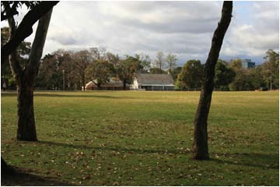
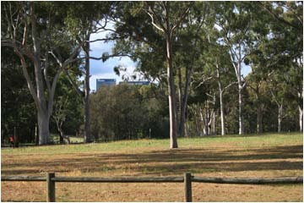
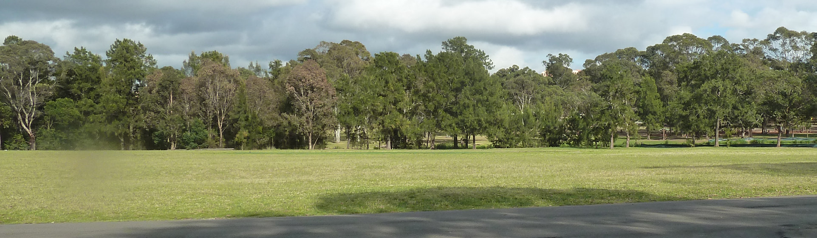
LOOKING EAST (DAIRY IN FOREGROUND)
LOOKING SOUTH EAST (DAIRY TO RIGHT OF IMAGE)
181 Hawkesbury Road, Westmead
LOOKING WEST (DAIRY BEHIND)

VIEW 11: FEMALE FACTORY
Viewing Location | Northern end of park
Direction / angle of view | North / Point to area view
Description of view | Immediate foreground: Views are partially obscured by vegetation and fencing  Foreground: River and opposite river banks  Middle ground: Female Factory can be glimpsed through the trees
Physical Components | Vegetated landform sloping down to river. Heritage fencing in the foreground, Female Factory
Experiential/sensory components | Scenic river setting and views towards heritage property create a strong sense of place. This area is now a haven for bats, many of which are visible in the taller trees.
Aesthetic characteristics | Composition: point to area view terminating at the focal point of the Female Factory which is partially obscured by vegetation. Visual quality: compelling for its visual elements of river and historic features. Rarity: rare, one off view.
Values significance | MODERATE  Strong layering of landscape elements. Visual reminder of the convict era. The female factory was a refuge for unassigned convict women and their children who were sent to the colony of NSW
Urban Design / Park Management notes | Potential to open views and connection towards the The Parramatta Female Factory; Parramatta Girls Home; The Old Roman Catholic Orphanage and other buildings on the Cumberland Hospital site.

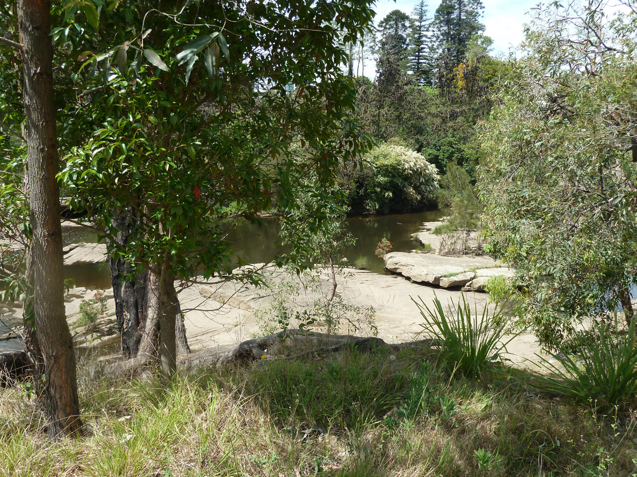
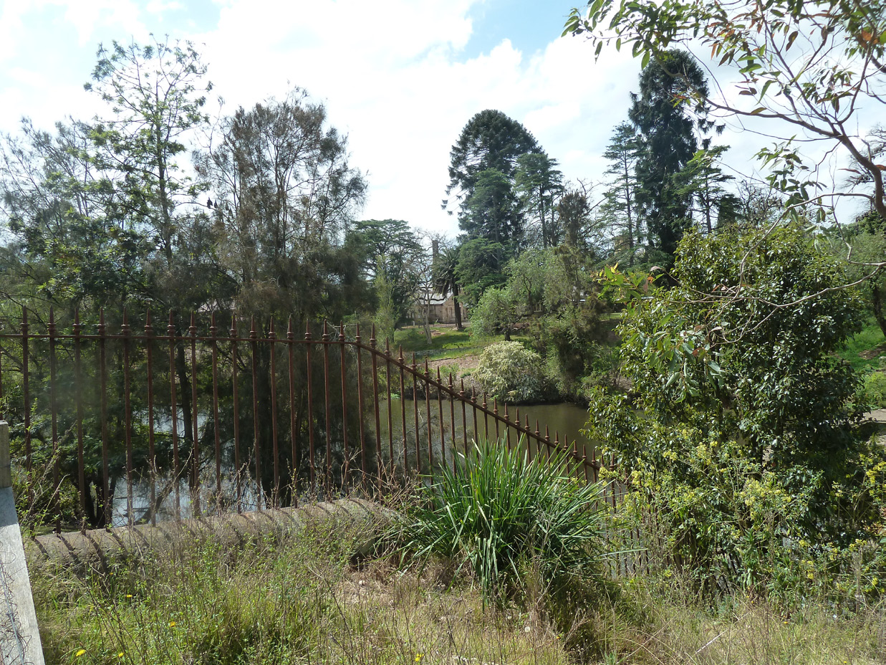

VIEW 11 TOWARDS FEMALE FACTORY
SCENIC RIVER AREA TO THE MIDGROUND OF VIEWS

Viewing Location | George Street
Direction / angle of view | West to north - west / Point to point view
Description of view | Unfolding view.  Immediate foreground and foreground: road and footpaths, traffic, ad hoc collection of medium height buildings. Mature trees on right beyond Marsden St soften the approach to the Gatehouse and park. Middle ground: Gatehouse is a very strong visual element from about Marsden St. Mature trees around the Gatehouse also a strong element. OGH and Parramatta Park are not visible except for the group of large trees near the gatehouse. The view through the gates into the OGHD is limited by the ‘avenue’ of pin oaks and other trees.
Physical Components | Flat ground. Vegetation and structures as above. Tudor-style Gatehouse built in 1885 - regarded as an iconic landmark in Parramatta - is only heritage feature. Enclosure: partly framed by buildings and some trees
Experiential/sensory components | Provides sense of history (Gatehouse) and of park beyond. No sense of colonial period.
Aesthetic considerations | Composition: point to point view framed by buildings/streetscape. Visual quality: Low with potential to improve, gatehouse forms a visual feature. Rarity: rare, one off view.
Values significance | HIGH  No views through the Gatehouse to OGH.
Urban Design / Park Management notes | Consider tree removal within the domain to open up views towards OGH. O’Connell Street creates a strong severance between the park and the City, improve connection through urban design treatment. VIsual clutter along George St dominates views in the foreground.

VIEW 12: GEORGE STREET

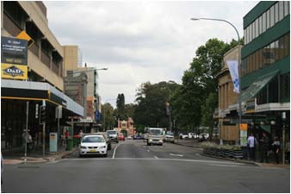
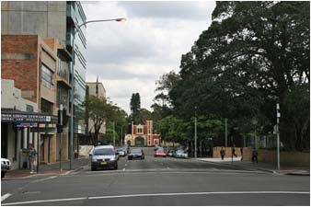
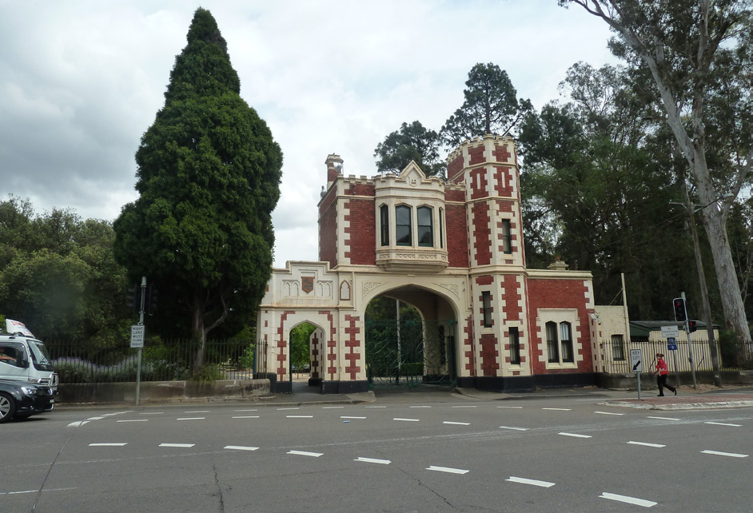
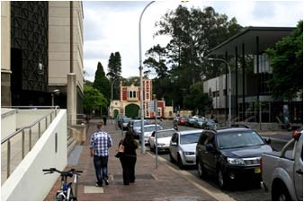
VIEW 12, UNFOLDING VIEW ALONG GEORGE STREET

VIEW 13: MACQUARIE STREET
Viewing Location | Macquarie Street
Direction / angle of view | West to north - west / Point to point view
Description of view | Unfolding view.  Immediate foreground and foreground: road and footpaths, traffic, ad hoc collection of medium height buildings.  Middle ground: Gatehouse is a strong visual element marking the termination of this linear view. Tree canopy within the domain is visible over the gatehouse.  The ‘cottage’ style architecture of the gatehouse is unexpected in this city context
Physical Components | Flat ground, buildings and street clutter.  The gatehouse is only heritage feature. Enclosure: partly framed by buildings
Experiential/sensory components | Provides sense of history (Gatehouse) and of park beyond.  Little sense of colonial period.
Aesthetic considerations | Composition: point to point view framed by buildings/streetscape. Visual quality: Low with potential to improve, gatehouse forms a visual feature. Rarity: rare, one off view
Values significance | MODERATE  Vegetated backdrop provides a visual connection to parkland beyond, relevance to Georgian town plan
Urban Design / Park Management notes | Declutter Macquarie Street to improve views

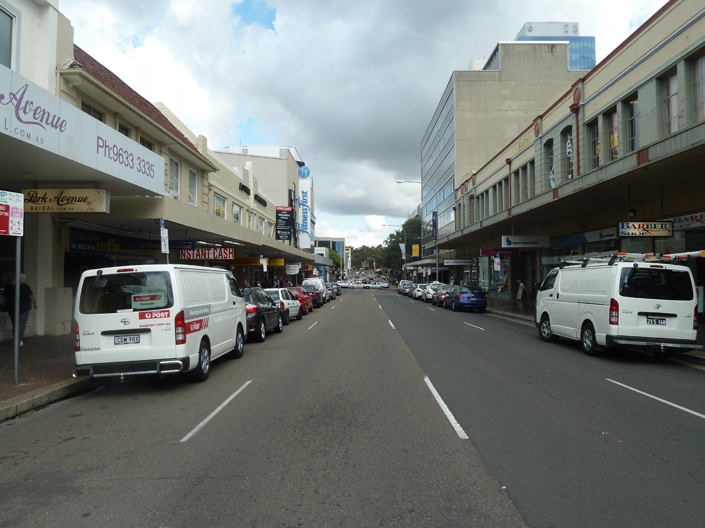
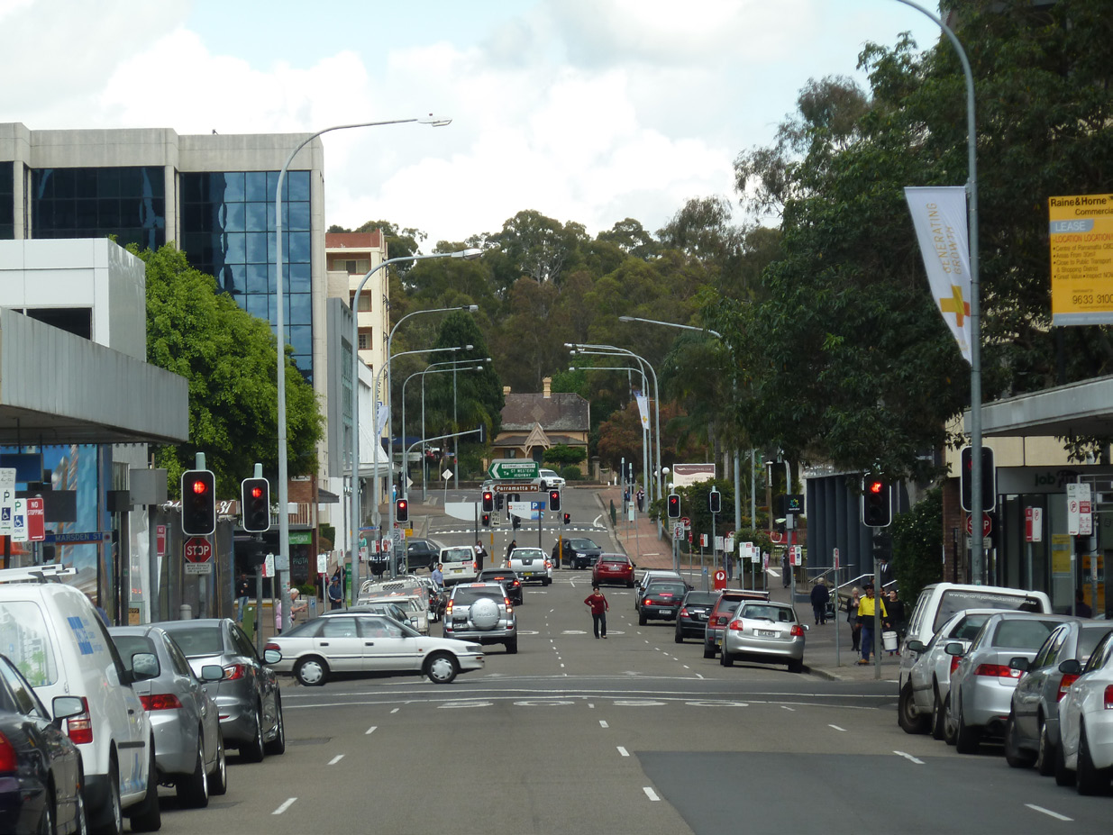
VIEW 13 LOOKING WEST ALONG MACQUARIE STREET

VIEW 14: HUNTER STREET
Viewing Location | George Street
Direction / angle of view | West to north / point to point view
Description of view | This view provides a link between the Domain and St John’s Church.  Immediate foreground and foreground: road and footpaths, traffic, ad hoc collection of medium height buildings.  Tree planting along the Street helps to frame views.  Middle ground: Grassed area, trees beyond and fencing is the only domain feature visible to the west, to the east St John’s creates a focal point.
Physical Components | Flat ground. Vegetation , car parking, buildings of varying heights, St John’s.
Experiential/sensory components | View towards St John’s is pleasant but view towards the Domain is poor, terminating in a grassed area. No sense of colonial period.
Aesthetic considerations | Composition: point to point view framed by buildings/streetscape. Visual quality: St Johns provides a landmark feature towards the east. Rarity: rare, one off view
Values significance | MODERATE  Low connection with identified values but does provide a visual connection between the Domain area and St John’s
Urban Design / Park Management notes | Improve fencing along the grassed area / open views towards Rose Garden

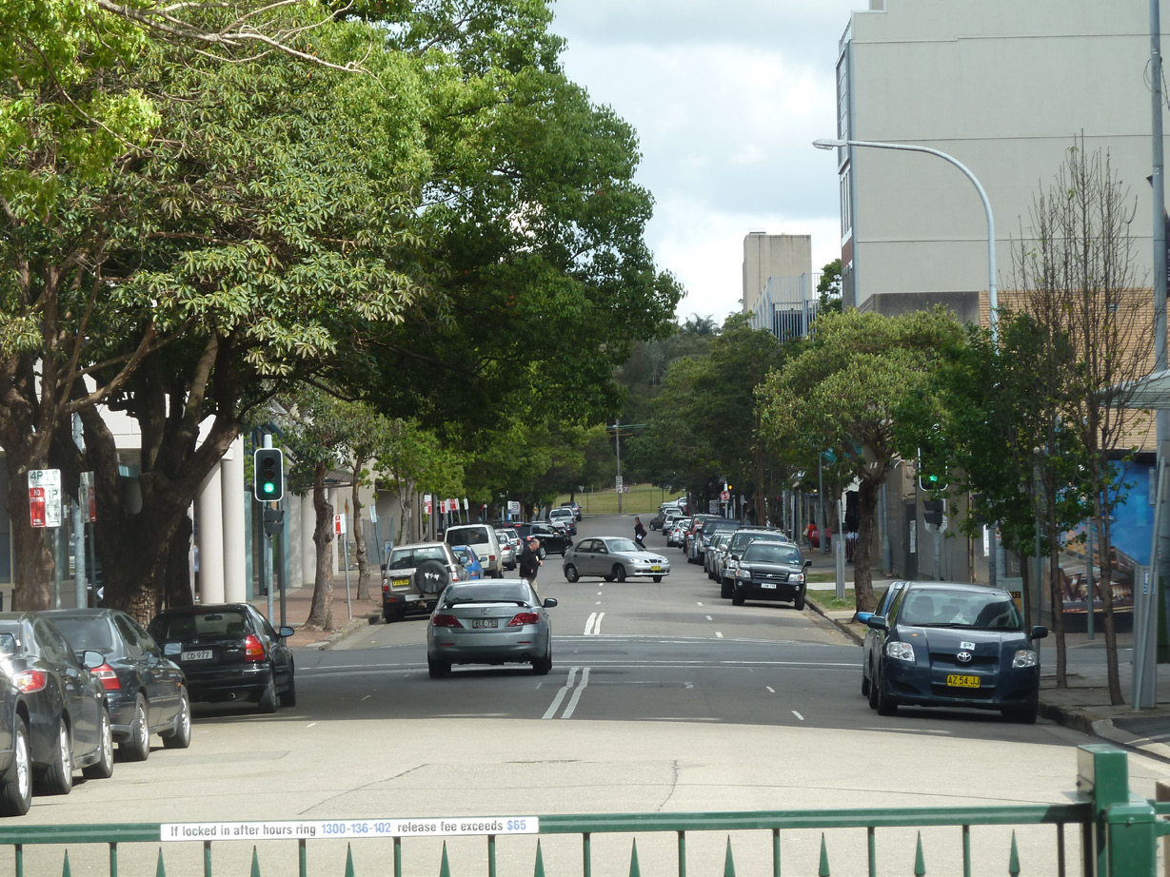
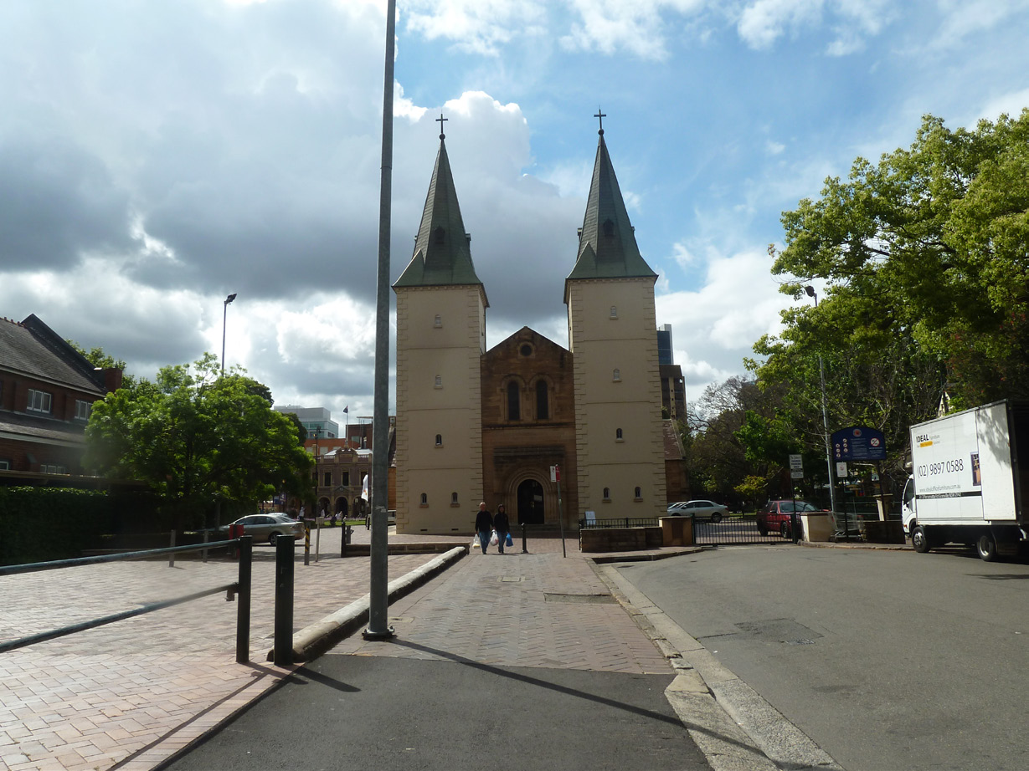

VIEW 14 LOOKING WEST ALONG HUNTER STREET TOWARDS THE DOMAIN
LOOKING EAST ALONG HUNTER STREET TOWARDS ST JOHN’S

VIEW 15: OLD GOVERNMENT FARM
Viewing Location | George Street
Direction / angle of view | North east / Point to area view
Description of view | Immediate foreground: Grassed riverside, low vegetation along bank, sparse tree cover.  Foreground: river, grassed areas with well spaced trees, large carpark, belts of trees to skyline, tops of buildings on skyline.
Physical Components | Land sloping to river  Vegetation as above.  River a strong visual element.  Foot bridge, jetty, signs, carpark. Several city buildings just visible on skyline.  Good views of Government Farm area.
Experiential/sensory components | Fairly strong sense of place - related to agricultural history
Aesthetic considerations | Composition: point to area view with a balanced outlook. Visual quality: Old Government Farm creates a focal point . Rarity: rare, one off view
Values significance | MODERATE  There is a strong layering of landscape elements with Parramatta river and the Old Government Farm visible on the far bank.
Urban Design / Park Management notes | Car park is a dominant feature

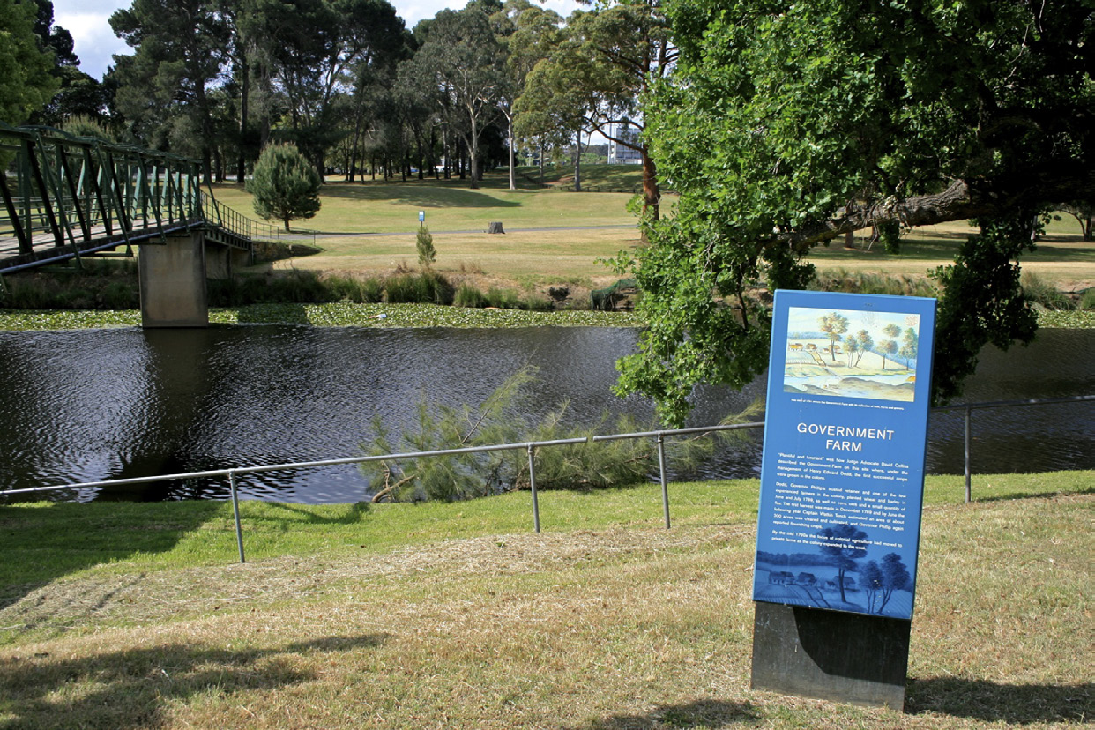
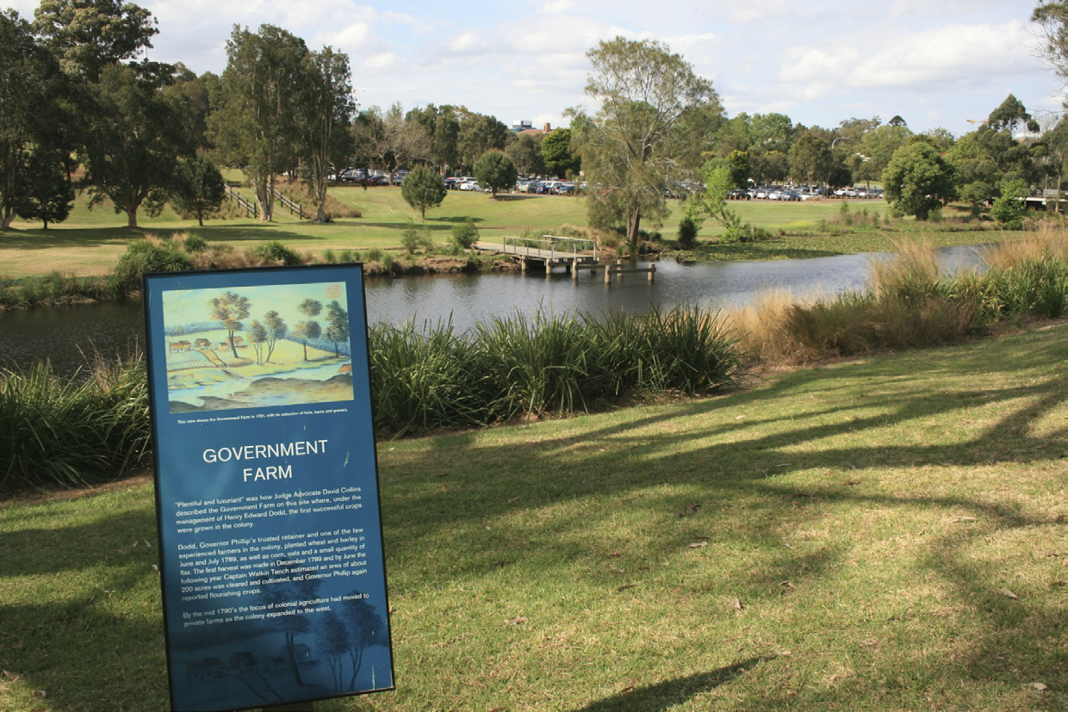

VIEW 15 LOOKING NORTH EAST TOWARDS GOVERNMENT FARM

VIEW 16: MAYS HILL

Viewing Location | Mays Hill
Direction / angle of view | West, North west / area to area view
Description of view | Immediate foreground: Grassed slopes  Foreground: tree canopy, trees, grassed slopes, golf course, single trees. Middleground: panoramic views over the treetops towards Parramatta Park and the City skyline  Middle distance: Paramatta City skyline to the West and a majority green outlook to the North west  Background: long range views towards tree’d horizon
Physical Components | Land sloping west  Vegetation as above.  The city skyline is a strong visual element against the tree canopy
Experiential/sensory components | Fairly strong sense of place - views towards the Domain are not distinctive or differentiated from views in other directions towards vegetation
Aesthetic considerations | Composition: area to area panoramic view.  Visual quality: The city skyline and golf course are the dominant features.  Rarity: rare, one off view
Values significance | MODERATE  There is a strong layering of landscape elements Parramatta Park and the City visible
Urban Design / Park Management notes

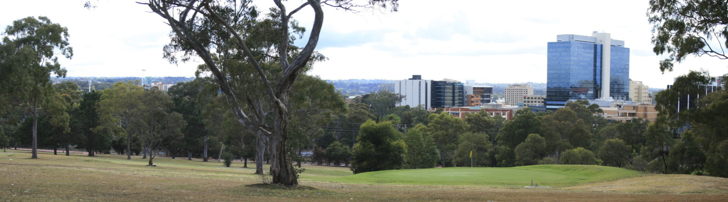
VIEW 15 LOOKING WEST TOWARDS THE CITY
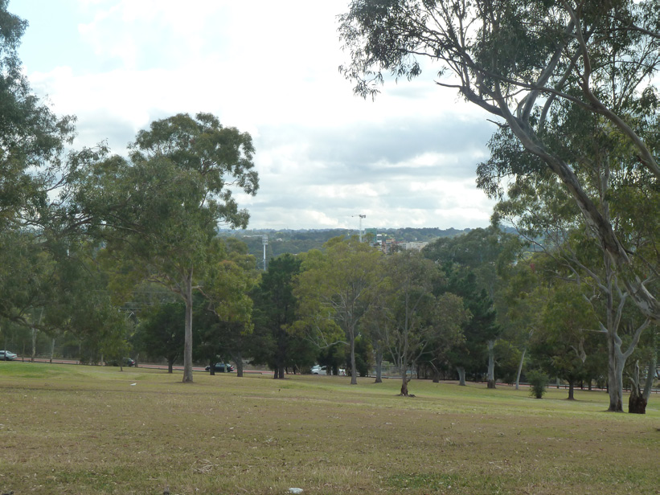
VIEW 15 LOOKING NORTH WEST TOWARDS PARRAMATTA STADIUM OVER THE DOMAIN
DETERMINING THE AREA OF SENSITIVITY

The area of sensitivity proposed is based on detailed analysis of important views from and towards Old Government House and Domain and a layering of viewshed, topography and proximity.
VIEWSHED:
The area which is covered by the highly important view cones
TOPOGRAPHY:
The surrounding topography must be considered as existing buildings located on ridge lines are some of the most visible. The sensitivity mapping covers areas higher than 20m.
PROXIMITY:
Proximity to the Old Government House and Domain dramatically affects the dominance of buildings, this is clear when considering the visual dominance of the Commonwealth building, see below:
VIEWING DISTANCE
Distance away from the subject site is a critical factor in assessing visual impact. The effect of distance on ability to discern detail of built form elements, as well as the contribution of surrounding ‘visual noise’ in the wider vista or view is critical.
The greater the distance and the wider the view/vista or panorama, the less a given visual element will dominate, or be intrusive.
Distance bands are site specific and have been determined through site visits and desk based analysis, distance bands affecting visibility for this study area are as follows:
Immediate Foreground: This zone begins at the viewer and extends to about 100 metres. Individual leaves, flowers, twigs, bark texture, details of colour texture and structures are evident.
Foreground: In the case of this project the foreground has been determined as up to 500m. Detail of landforms and built form are more pronounced when viewed from within the foreground zone and new developments are likely to have a significant impact.
Middle ground: Alterations in the middle ground (up to 1.5 km from the observer) are less distinctive. Some detail can be seen, but where increasingly colour and texture variation is seen as grouped into mass elements. Visible details progressively decline. In the case of Old Government House and Domain, the majority of locations from where new development may impact upon views is within this range
Middle Distance: (up to 7 km): although perception of colour and texture variation is limited, the essential elements are identifiable (i.e. vegetation stands, vegetation texture, dominant colour hues, dramatic features and intrusive elements), new development is less likely to have an impact in this location.
Background: This zone extends from middle distance (minimum of 7 km between the observer and the area being viewed) to infinity. Shape may remain evident beyond 16km, especially if it is inconsistent with other landscape forms. Beyond 16km, alteration in landscape character becomes obscure.
Taking into account the effect of distance bands, any new development proposals would mainly fall into the ‘foreground’ and ‘middle ground’ zones as far as predominant visual accessibility is concerned. The finding is relevant. It means that attention to ‘dominant colours of mass/grouped visual elements’ (i.e collective facades/cladding and walls of structures) will be the most critical element in determining potential visual dominance or intrusiveness in the wider landscape. It also means that bright and contrasting colours will stand out, while muted colours with ‘natural’ tones will not.
FURTHER STUDY
The area to the west of the railway line lies within the jurisdiction of Holroyd Council and has not been included within this study, we recommend that an assessment of this area is undertaken for completeness.
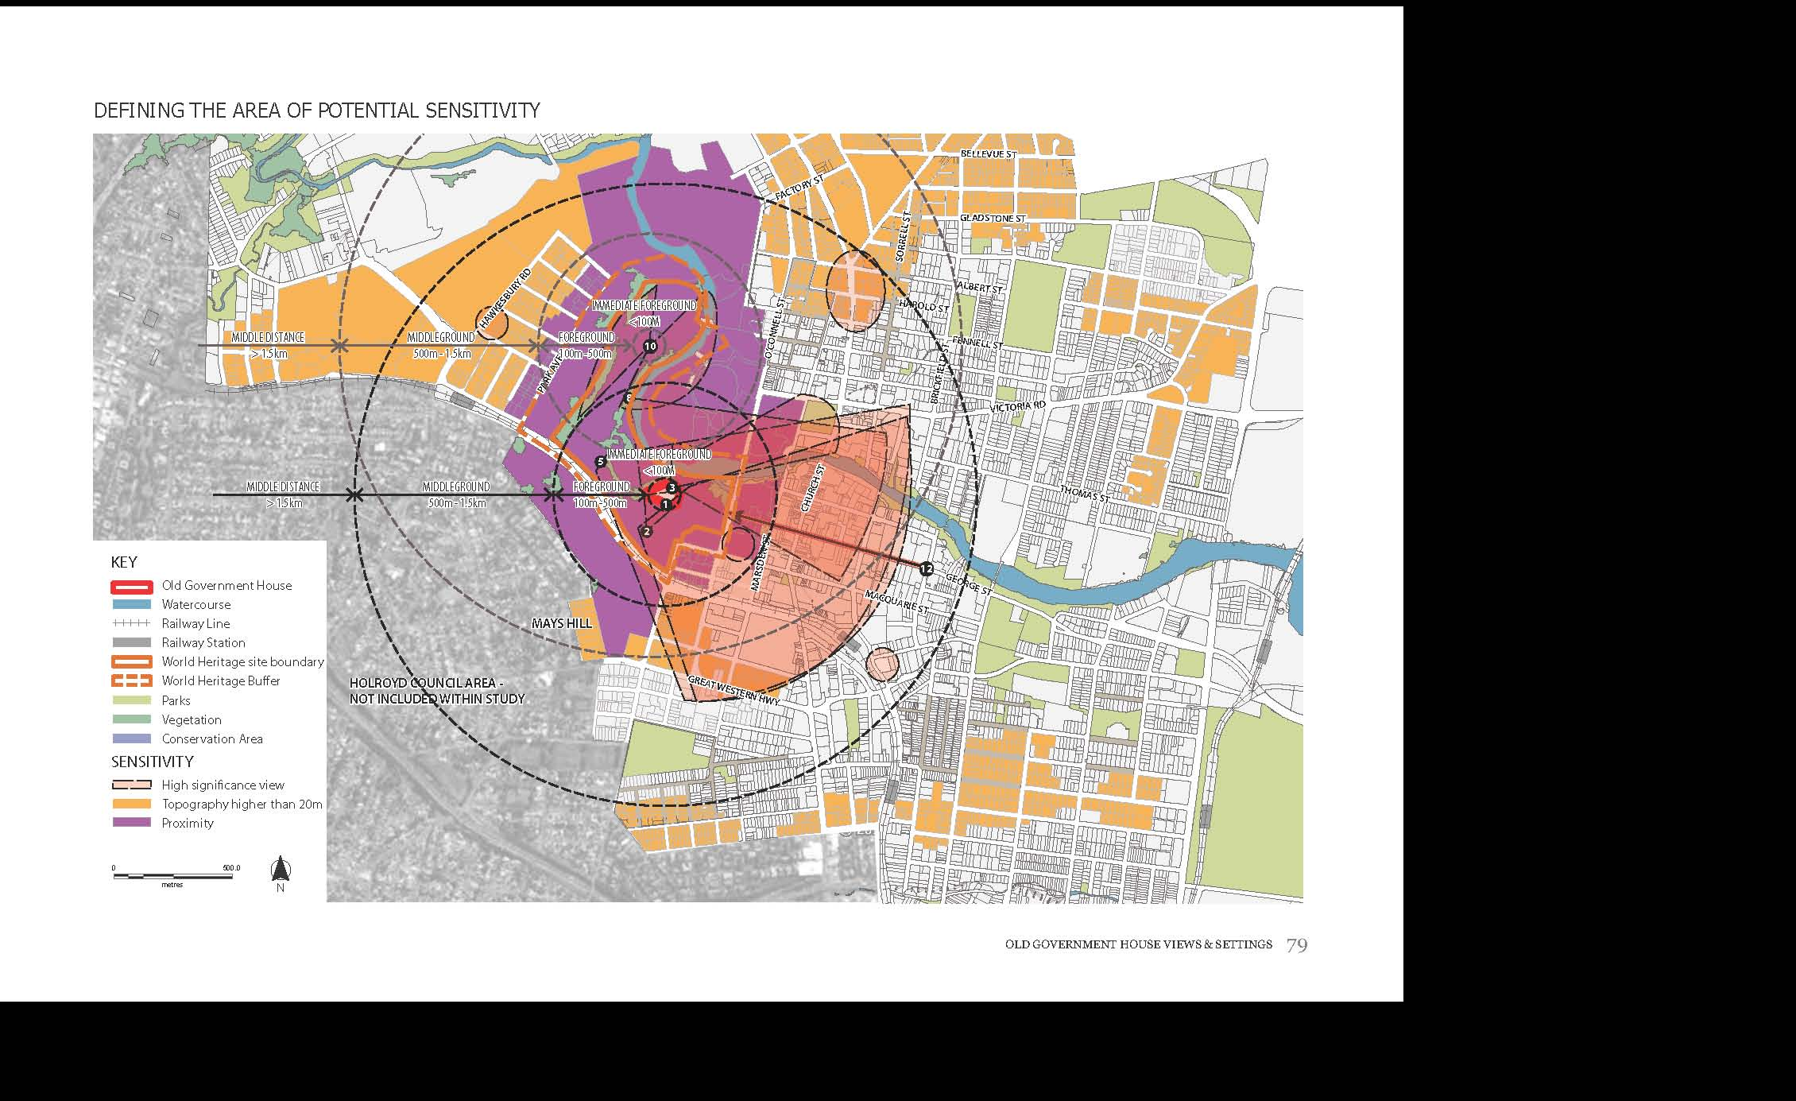
AREAS OF SENSITIVITY

AREAS OF SENSITIVITY
The map to the right shows the areas of Parramatta that have been defined as ‘sensitive’ or ‘highly sensitive’.
These areas have been determined through a process of review of the World and National Heritage values, the analysis and mapping of important views and settings, the proximity to OGHD and the consideration of the underlying topography. It should be noted that while the important view cones cover a larger area than that which has been denoted as ‘highly sensitive’ on page 79, the fact that visual impact reduces with distance has been taken into consideration.
As such, the ‘highly sensitive’ areas of the city are those which are prominent within the ‘foreground’ of a view and are affected by multiple important viewcones. These are the areas where details of built form are more pronounced and have a high risk of resulting in a significant impact upon the World and National Heritage values.
The ‘sensitive’ areas of the city are those areas which appear in the middle ground of a view, or which do not feature within an important viewcone. Development in these areas may have some impact, but there is no risk of resulting in a significant impact upon the World and National Heritage values.

EXCLUSIONS
The map on page 79 shows areas of land above 20m which are located in the middle distance, over 1.5km from Old Government House. Due to their distance from Old Government House (within the middle distance and therefore less prominent) these areas are not deemed to be sensitive.
Westmead Residential Precinct is excluded from the ‘highly sensitive’ area. While development in this area has the potential to impact values, and change the nature of the view, it has been determined that it would not have a significant impact on the World and National Heritage Values.

IMPLICATIONS FOR PROPOSED DEVELOPMENT
Proposed development within the areas of high sensitivity of Parramatta risk having a significant impact on the World and National Heritage values of Old Government House and Domain. This impact may be mitigated below the significant impact threshold by adhering to the essential future development guidelines set out in this document. Impacts that cannot be reduced to below the significant impact level would require assessment by the Commonwealth under the EPBC Act.
To avoid potential for cumulative impacts on the World and National Heritage values, any new development proposal must take into account current or approved developments in relation to spacing between buildings to retain a sense of openness and sky between buildings.
HIGHLY SENSITIVE AREAS
The areas

SENSITIVE AREAS
Development may have some impact, but not a significant impact on the World and National Heritage values of OGHD
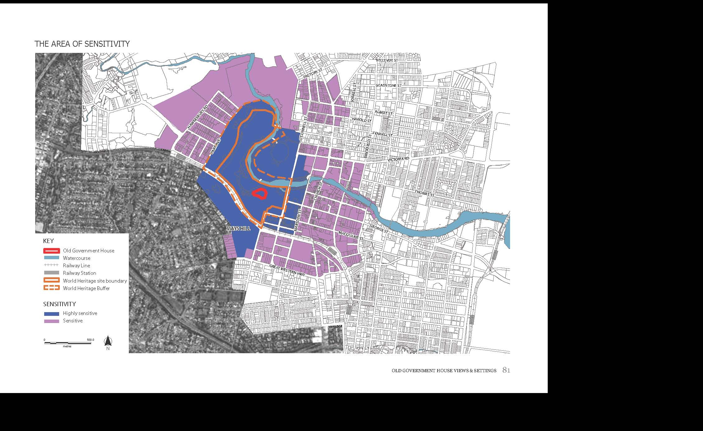
3. FUTURE DEVELOPMENT GUIDELINES
DESIGN PRINCIPLES
Three guiding principles provide the overall vision and direction for the study area.
These principles have been designed to retain and enhance the World and National Heritage Values of Old Government House and Domain.
It should be noted that the World Heritage Buffer Zone and the Domain are integral to the protection of the three design principles. The Domain is highly significant in the protection of the World and National Heritage Values.
PRINCIPLE 1:
VISUAL PROMINENCE AND SYMBOLISM
The backdrop of the buildings in the City of Parramatta should provide a setting for Old Government House compatible with the commanding spirit of the place.
New development should not detract from the setting of Old Government House as the former seat of colonial power, and its traditional ‘master and commander’ relationship with Parramatta. New development should reinforce the relationship between Old Government House and the original Georgian town plan, particularly the axis of George Street.
PRINCIPLE 2:
LANDSCAPE SETTING
New development should not dominate the landscape setting of Old Government House and Domain or detract from the mostly ‘green’ outlook north, allowing the Domain to retain its existing landscape character. New development should not dominate the landscape setting of Old Government House and Domain, including the inter relationship between landscape elements.

PRINCIPLE 3:
LAYERING OF CULTURAL HERITAGE ELEMENTS
New development should retain and enhance views to, from and between the cultural heritage elements that highlight the layered history of the place.
New development should retain views that demonstrate the multi-layers of built and landscape elements, which contribute to the story of the place. These elements evoke a sense of the past, and highlight the city’s importance in the course of Australia’s cultural history. These ‘layers’ or elements include the Georgian Town Plan, Old Government House itself, the Domain, the crescent, Old Government Farm, the dairy, the river, the formal layout of the carriageways, other historic buildings and monuments, the broad lawns, and the picturesque ‘English style’ garden setting.

FUTURE DEVELOPMENT GUIDELINES

Future development guidelines in this section provide guidance for the nature and form of development to reduce impacts on the World and National Heritage values of OGHD. Each precinct has guidelines based on its sensitivity – the significance of the view, proximity and topography. The guidelines in Precinct 1, the ‘highly sensitive’ area, should be considered as required.
Essential future development guidelines: this set of guidelines relates to highly sensitive precinct 1 only. When proposed development meets these guidelines, it will also meet the principles, and is therefore unlikely to have a significant impact on the World and National Heritage values.
Desirable future development guidelines: these guidelines apply to all precincts and it is strongly recommended that new development adhere to them. However, failure to meet the desirable guidelines will not automatically trigger an assessment under the EPBC Act.
The future development guidelines have been developed to also respond to the World Heritage Committee’s recommendations and concerns regarding impacts on the integrity of the site from encroaching development.

NB: The highly sensitive area within the Buffer Zone or open space area (shown hatched on the precinct map) is considered not to be subject to future development and does not have applicable future development guidelines. However, the RSL site may be redeveloped and therefore the future development guidelines for area 1 include guidelines for any redevelopment on this site.
ADDITIONAL MEASURES
It is recommended that the design excellence competition process established under the City Centre LEP should also include as one of the requirements, that the development must address the future development guidelines and the views and settings of OGHD so as to avoid a significant impact on the World and National Heritage values.

IMPLICATIONS FOR PROJECT
The future development guidelines have been drafted such that when development satisfies the essential future development guidelines it will also meet the principles, and will therefore not have a significant impact on world or national heritage values.

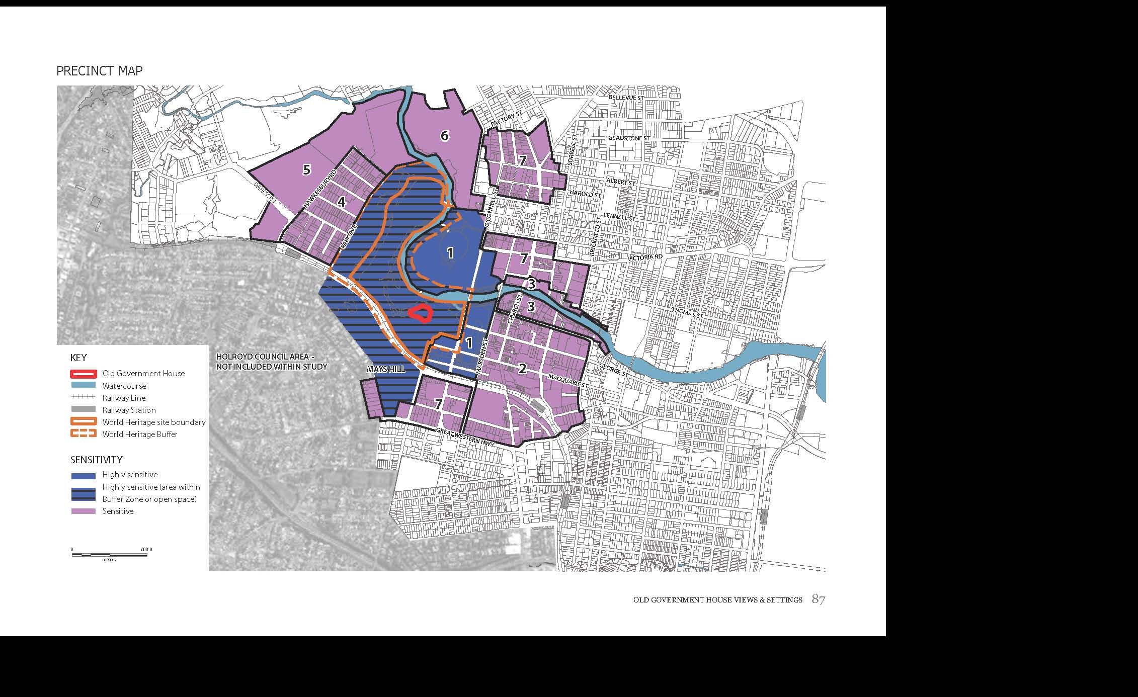
1. PARK EDGE (HIGHLY SENSITIVE)
VISION
The backdrop of buildings to the City of Parramatta (at its western edge) will provide a setting for Old Government House and Domain compatible with the commanding spirit of the place. New development will not visually dominate views out from the Domain, and the visual and physical connection between the OGHD and the city will be strengthened.
FUTURE DEVELOPMENT GUIDELINES
ESSENTIAL FUTURE DEVELOPMENT GUIDELINES
- Apply the design excellence provisions of the Parramatta City Centre LEP 2007 to all new developments in this location.
  - The form, bulk and massing of new buildings must not visually dominate the setting of Old Government House when viewed from within the Domain Parklands. This can be achieved by ensuring that new built form retains a sense of openness and sky between buildings, and does not result in a ‘wall’ of development when viewed from within the domain, by:
  - ensuring that the upper levels of towers that are visible above the established tree canopy of the Domain Parklands, are narrower and /or more slender in form than the lower levels;
  - ensuring that buildings are designed so that the side of towers facing the Domain is no wider than 30m; and,
  - utilising materials and external finishes that reduce distant visibility against the sky (such as light colours, glass and reflective surfaces).

  - Views between Old Government House and the following historic landmarks must be retained: Old Kings School, Old Government Farm , and St Patrick’s Cathedral, by:
  - ensuring that new buildings do not block the sightlines between Old Government House and the historic buildings as depicted in Important View 3 (see p.89).

  - Any new development on the current RSL building site must respect the heritage values of its setting and its inclusion within the World Heritage Buffer Zone, and create a positive interface between the Domain and the city. This can be achieved by ensuring that any building:
  - addresses both its street frontages, as well as the Domain parklands;
  - concentrates development bulk towards O’Connell Street;
  - utilises external colours and finishes that immerse the building within its setting and minimise contrast with the surrounds (such as muted colours and matte finishes); and,
  - is designed to the highest contemporary architectural standards.

DESIRABLE FUTURE DEVELOPMENT GUIDELINES
  - New development between O’Connell and Marsden Streets to the north of George Street should retain and enhance the views of the river bank and environs from the Domain, particularly when viewed from the north west lawn of Old Government House (refer to Important Views 3 and 8) and provide a positive interface with the river. This may be achieved by ensuring that any building:
  - addresses the river as well as any street frontage(s);
  - provides a positive, active interface at pedestrian level, with the public space / promenade adjacent to the river; and,
  - is designed to the highest contemporary architectural standards.

  - New development fronting O’Connell Street should improve the visual and physical connection between the Domain and the city by:
  - creating a pedestrian friendly environment; and,
  - a consistent, ‘human scaled’ and active built form frontage along the street.

  - New development in George Street should strengthen and frame the vista along the street and further reinforce the formal Georgian town plan. This concept is outlined within the City Centre DCP and includes:
  - consistent setbacks (including consistent front setbacks at street level); and
  - no building facade clutter (including signage), particularly below first floor level is also desirable.

  - New development throughout the city centre area should reinforce the formal layout of the Georgian town plan with:
  - consistent setbacks (including continuous front setbacks at street level); and
  - orientation of buildings towards the street grid.

  - The majority ‘green’ aspect when looking north and north east from within the domain parklands should be retained such that the tree lined ridge which forms the background to views remains mostly intact. This may be achieved by :
  - ensuring that the majority of new developments are lower in height than the tree lined ridge when viewed from within the Domain;
  - utilising materials and external finishes that reduce distant visibility and minimise contrast against the green backdrop such as matt finishes and muted tones; and,
  - ensuring that the tops of towers are well designed and do not display advertising materials or banners.

2. CITY CENTRAL
VISION
Intensive development will be contained within this precinct, with distinctive ‘edges’ at the railway line and Phillip Street to improve the legibility of the city centre when viewed from the OGHD, and to ensure that built form, when viewed from the Domain, does not visually dominate the skyline over a broad area.
FUTURE DEVELOPMENT GUIDELINES
DESIRABLE FUTURE DEVELOPMENT GUIDELINES
  - The most intensive development should be contained within the city central precinct to ensure that the city buildings do not visually dominate the skyline over a broad area. This can be achieved by:
  - ensuring that the tallest buildings within Parramatta are located within the City Central precinct; and
  - ensuring that there is a distinctive height edge to the city centre, particularly at Phillip Street.

  - New development should strengthen the visual connection between the OGHD and the city, when viewed from the Domain, including by improving the legibility of the central city and its buildings (refer to Important Views 1 and 5). This may be achieved by:
  - ensuring that towers are well proportioned, with a visually interesting top, and an elevation that enhances the skyline; and
  - introducing upper level setbacks to allow for view sharing from, and between, buildings; and
  - ensuring buildings are designed to the highest contemporary architectural standards.

  - New development in George Street should strengthen and frame the vista along the street and further reinforce the formal Georgian town plan. This concept is outlined within the City Centre DCP and includes:
  - consistent setbacks (including consistent front setbacks at street level); and
  - no building facade clutter (including signage), particularly below first floor level is also desirable.

  - New development throughout the city centre area should reinforce the formal layout of the Georgian town plan with:
  - consistent setbacks (including continuous front setbacks at street level); and
  - orientation of buildings towards the street grid.

3. RIVERSIDE EDGE
VISION
The riverside edge precinct will retain a strong sense of connection to historic built and landscape elements, including the river and its naturalistic environs which are evocative of the Macquarie period. Views along the river, and towards historic landmarks will be protected and enhanced.

FUTURE DEVELOPMENT GUIDELINES
DESIRABLE FUTURE DEVELOPMENT GUIDELINES
  - In order to preserve views along Parramatta River, and improve overall legibility of the river within the context of Parramatta, new development to the west of Church Street and adjacent to the riverside should:
  - create an overall transition in height between the city central (precinct 3) and Parramatta River; and
  - include upper level setbacks of buildings in the blocks immediately adjacent to the river, which step down in height towards the river.

  - New development should enhance the visual connection between landscape and built elements by ensuring that any new building:
  - addresses the river as well as any street frontage(s);
  - provides a positive, active interface at pedestrian level, with the public space / promenade adjacent to the river; and,
  - is designed to the highest contemporary architectural standards.

4. WESTMEAD RESIDENTIAL
VISION
Development within this precinct will not detract from the overall landscape character of the nearby Domain parklands. Intensive development will be concentrated to the south of Queens Road. Building heights will reduce in height towards the north and will be slender in form and spaced to allow a sense of openness between any towers.

FUTURE DEVELOPMENT GUIDELINES
DESIRABLE FUTURE DEVELOPMENT GUIDELINES
  - New towers within the residential area to the south of Hawkesbury Road should retain a sense of openness and sky between buildings, and new built form should not result in a ‘wall’ of development when viewed from the Domain (refer Important Views 10). This may be achieved by:
  - ensuring that the upper levels of towers that are visible above the established tree canopy of the Domain Parklands, are narrower and /or more slender in form than the lower levels;
  - concentrating intensive development to the south of Queens Road;
  - ensuring that buildings are oriented so that the narrowest side of towers faces the Domain Parklands; and,
  - utilising materials and external finishes that reduce distant visibility against the sky (such as light colours, glass and reflective surfaces).

5. WESTMEAD HOSPITAL
VISION
Development within this precinct will not detract from the overall landscape character of the nearby Domain parklands. Any future development on the Westmead Hospital site will be designed to the highest architectural standards.

FUTURE DEVELOPMENT GUIDELINES
DESIRABLE FUTURE DEVELOPMENT GUIDELINES
  - New development should enhance the visual connection between landscape and built elements by ensuring that any new building:
  - addresses the river as well as any street frontage(s);
  - directly adjacent to the Domain Parklands (to the north east of this precinct) is designed so that the upper levels of towers that are visible above the established tree canopy of the Domain Parklands, are narrower and /or more slender in form than the lower levels;
  - directly adjacent to the Domain Parklands (to the north east of this precinct) utilises materials and external finishes that reduce distant visibility against the sky (such as light colours, glass and reflective surfaces).
  - is designed to the highest contemporary architectural standards.

6. HERITAGE CONNECTION
VISION
The visual connection between the Domain and the adjacent heritage elements of the Female Factory Precinct and the Domain will be strengthened. New infill development will frame views to, from and between these historic elements, and views north will retain their majority green background.

FUTURE DEVELOPMENT GUIDELINES
DESIRABLE FUTURE DEVELOPMENT GUIDELINES
  - New development should enhance the visual connection between the Domain and the Female Factory Precinct. This can be achieved by:ensuring new buildings do not block sightlines between the domain parklands, the Female Factory and other heritage elements; and
  - encouraging new buildings to frame views of heritage elements.

7. CITY EDGES
VISION
Development at the edge of the city will be secondary to intensive development within the city central area, including lower development heights. Important Views 3 & 8 will be retained and enhanced, along with distant views north and north east towards the tree lined ridge.

FUTURE DEVELOPMENT GUIDELINES
DESIRABLE FUTURE DEVELOPMENT GUIDELINES
  - The majority ‘green’ aspect when looking north and north east from within the domain parklands should be retained such that the tree lined ridge which forms the background to views remains mostly intact. This may be achieved by :
  - ensuring that the majority of new developments are lower in height than the tree lined ridge when viewed from within the Domain;
  - utilising materials and external finishes that reduce distant visibility and minimise contrast against the green backdrop such as matt finishes and muted tones; and,
  - ensuring that the tops of towers are well designed and do not display advertising materials or banners.

  - In order to create a distinctive ‘edge’ to the city, and to ensure that the city buildings do not visually dominate the skyline over a broad area, development in this location should be secondary to development within the City Central Precinct. This can be achieved by:
  - ensuring that the tallest buildings within Parramatta are located within the City Central precinct; and
  - ensuring that there is a distinctive height edge to the city centre, particularly at Phillip Street.

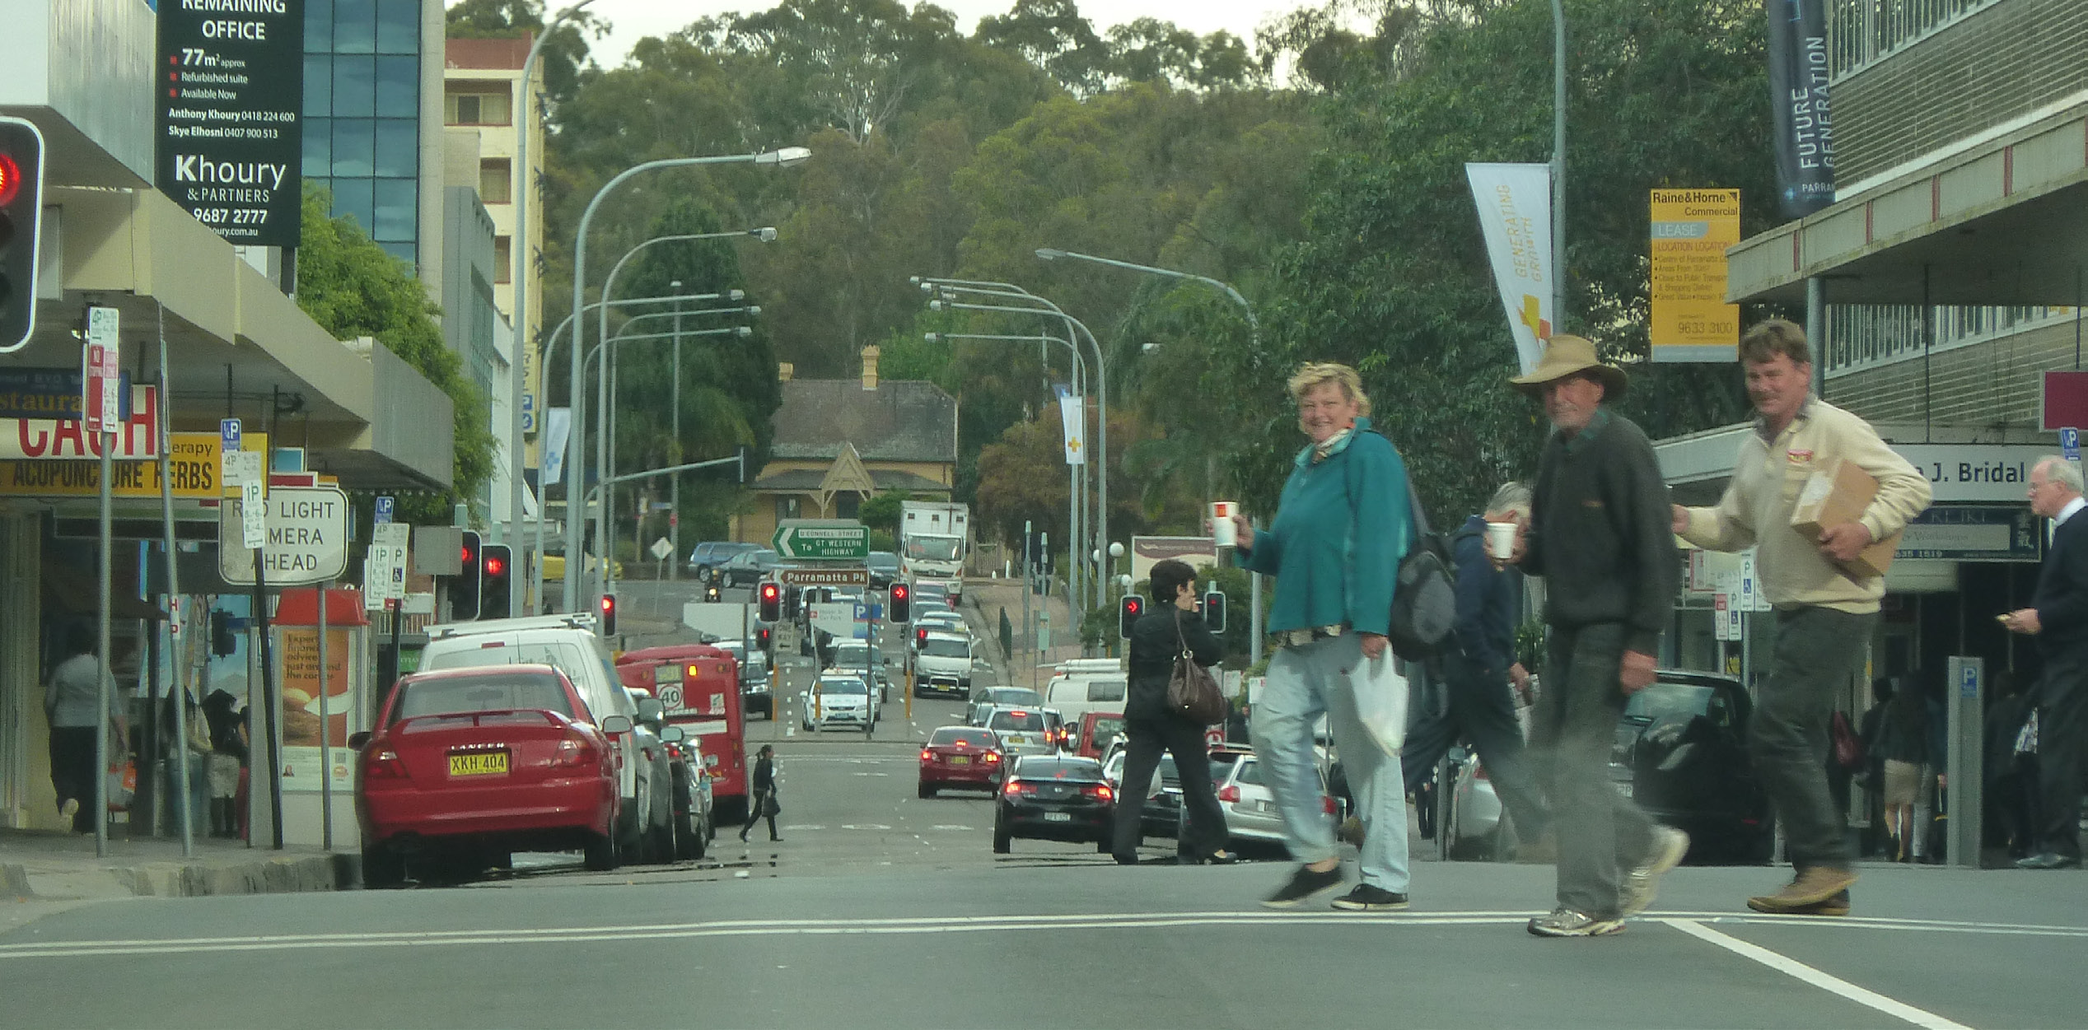
APPENDIX A: DOCUMENT REVIEW
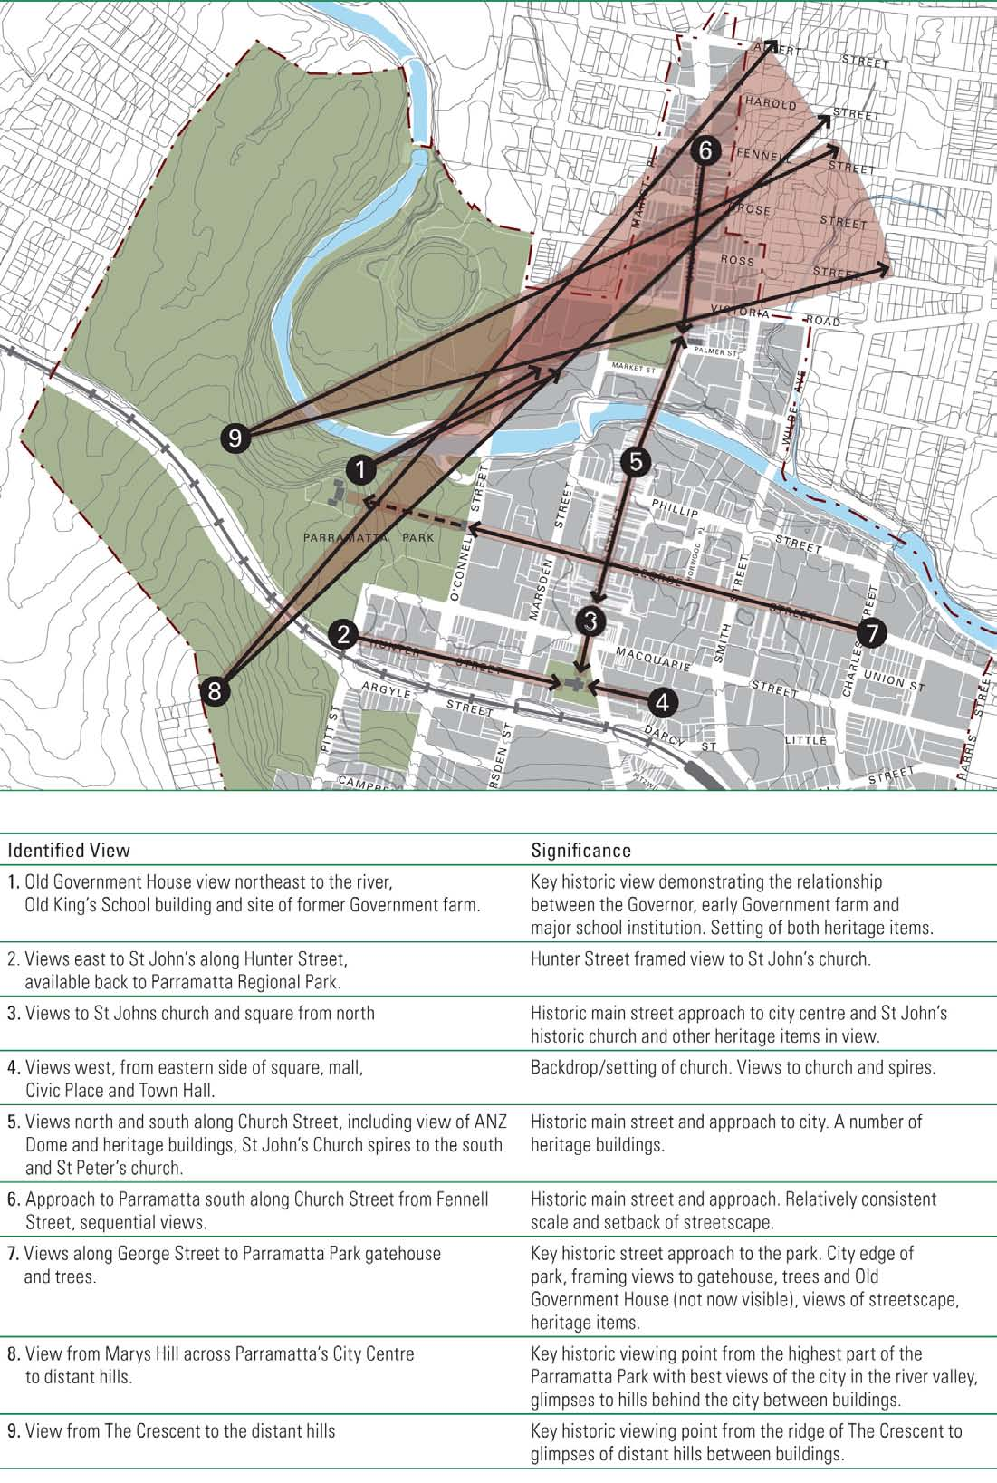
PLANNING POLICY CONTEXT
PARRAMATTA CITY CENTRE LOCAL ENVIRONMENT PLAN (LEP) 2007
Clause 21: The objectives of this Plan for the control of the height of buildings are as follows:
(g) to ensure the preservation of historic views shown in the City Centre Development Control Plan.
PARRAMATTA CITY CENTRE DEVELOPMENT CONTROL PLANS (DCP) 2007
Views contribute to the character and amenity of a city, enhancing the sense of place and identity. The physical setting of the Parramatta city centre between the Parramatta Park and adjacent Parramatta River provides for special views of this natural setting and significant heritage elements. It is important that views within the city and into and out of the city are maintained from as many points as possible. In the redevelopment of some sites consideration should be given to opening up new significant views. Views are regarded as significant when they terminate at places of architectural, landscape, or cultural significance. This may include views of, major parks or publicly significant objects or heritage buildings.
The silhouettes of many buildings are significant and contribute to the identity of the commercial core of the city and its skyline. The massing and arrangement of the skyline and existing building silhouettes should be carefully considered and proposed development should be carefully designed so that its appearance complements the city skyline.
IMPLICATIONS FOR PROJECT
- Views towards distant hills are mentioned as significant
- Views are regarded as significant when they terminate at places of architectural, landscape, or cultural significance. This may include views of, major parks or publicly significant objects or heritage buildings.

PLAN FROM THE DCP (APPENDIX 2) SHOWING HISTORIC VIEWS
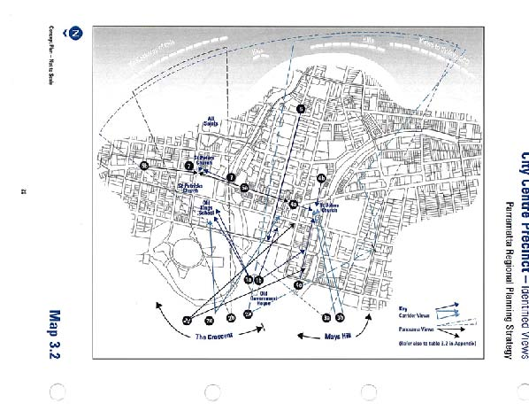
PARRAMATTA REGIONAL PLANNING STRATEGY (RPS) 1999 (SUPERSEDED)
Identified views (related to building heights) included:
- The Crescent (4 views)
- OGH (2 views)
- Mays Hill (2 views)
- Along George St.

View components, significance and management/planning recommendations are documented within appendix 2 (pp. 65-67). Management recommendations include various height controls and the retention, planting, management and selective thinning of trees to manage/enhance views.
PLAN FROM THE RPS (MAP 3.2)
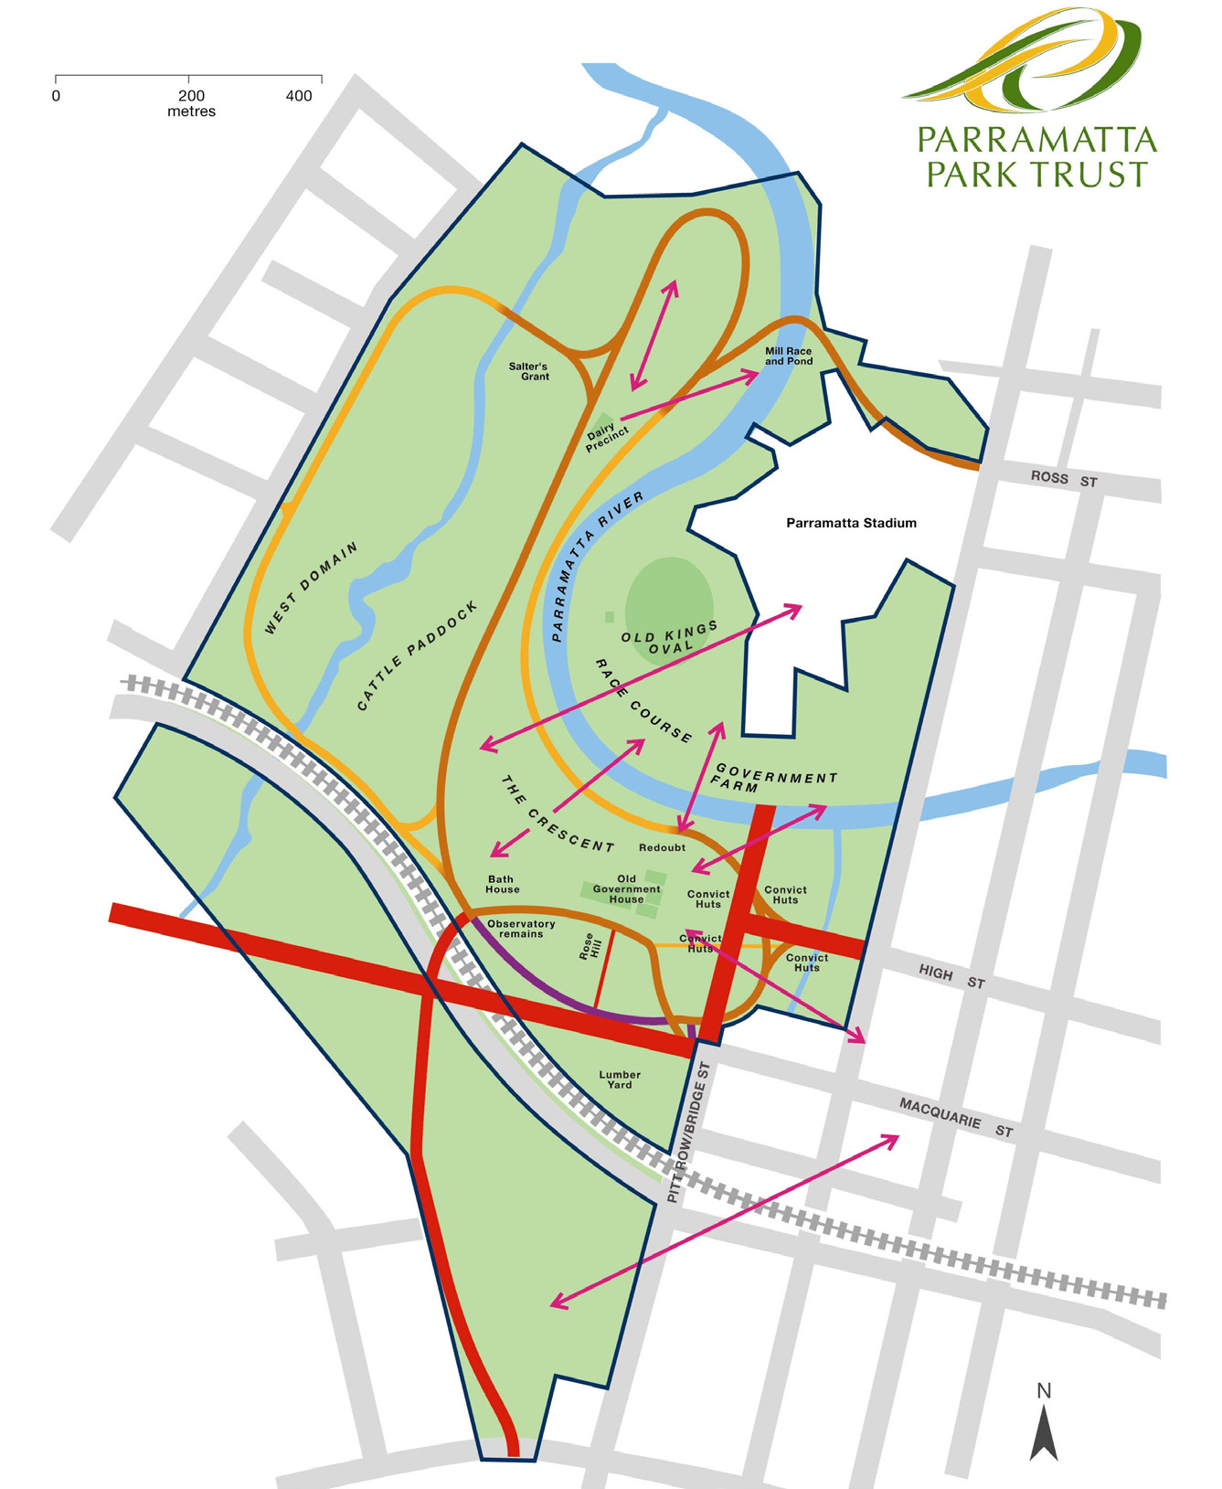
OTHER DOCUMENTS
PARRAMATTA PARK MANAGEMENT PLAN (2008)
There are numerous policies and recommendations within the management plan that relate to views.
The overriding criterion for all future landscape works in the Park is to retain or reinstate the landscape character as recorded in the historic records including restoration and enhancement of natural systems and landforms.
The following critical views and vistas will be actively maintained within the Park:
- Mays Hill to Hunter Street,
- Old Government House and grounds of Parramatta Park- views to east (George Street, O’Connell Street and the river),
- Parramatta River from the west in Parramatta Park,
- Park to Kings School and Lennox Bridge,
- the Ridge of the Crescent to Parramatta,
- the visual relationship between the monuments and their siting on the ridge line,
- from the ridge line to the Macquarie Street gates and the centre of Parramatta
- from the Dairy to Westmead and Wistaria Gardens,
- out of the Park from the Domain to Westmead, the west and north-west.

PLAN FROM THE OGHD MANAGEMENT PLAN SHOWING SIGNIFICANT VIEWS IN PINK
Key National Heritage Values are:
- OGHD’s importance in the course of Australia’s cultural history (colonial development, oldest public building on mainland, earliest agricultural production etc);
- its potential to yield information about Australian history;
- the extensive cultural landscape with numerous elements related to colonial settlement; and
- its special association with important people – Macquarie and other Governors.

OGHD is not of national significance for its aesthetic value.
POLICY OUTCOMES FROM THE OGHD MANAGEMENT PLAN
Vegetation will be managed to ensure the retention of significant views through regular pruning and careful planting programs.
The views from Old Government House to George Street will be opened up through vegetation management and tree removal.
New structures, either permanent or temporary will not be constructed where they will have a detrimental affect on significant views.
Retain vistas of the House from within the Park. Retain vistas from the House to the east and north. Consider the reinstatement of one of the nineteenth-century configurations of the carriage loop and pathways
Continue to reinstate, interpret and /or reconstruct known historical views and vistas that connect Old Government House and its former Domain (Parramatta Park)
Retain a smooth transition that does not interrupt vistas from the grounds of the House into the surrounding parkland and vice versa. Base the design of new fences on the form of fences previously used within the park
Macquarie’s landscape legacy in the Park will be enhanced and reinstated where appropriate and in conjunction with research and detailed landscape design.
Continue to manage the cadastral interface between the Parramatta Park and Old Government House sites in a way that visually minimises the boundaries.
Any new fencing to mark cadastral or other boundaries will reflect known historical fencing forms in the same area and will not obscure views and vistas between the House and the parklands.
Do not permit large scale development adjacent to or within the Park. Retain vistas from the House to the east and north
Appropriate conservation planning recognised by external authorities will underpin the management of cultural and natural heritage
Parramatta Park Trust will work with Parramatta and Holroyd Council’s and other authorities to ensure that developments along the Park boundaries do not detract from significant views from within the Park
IMPLICATIONS FOR PROJECT
- Some views mentioned in the management plan are no longer visible including views of Lennox Bridge
- A number of views and issues mentioned within this document will not be affected by development outside of the buffer zone
- Recommendations include the removal of vegetation to open up views between OGH and George Street
- The plan recommends not allowing large scale development adjacent to or within the Park
- Parramatta Park Trust will work with adjacent Council’s to ensure that new developments to not detract from important views

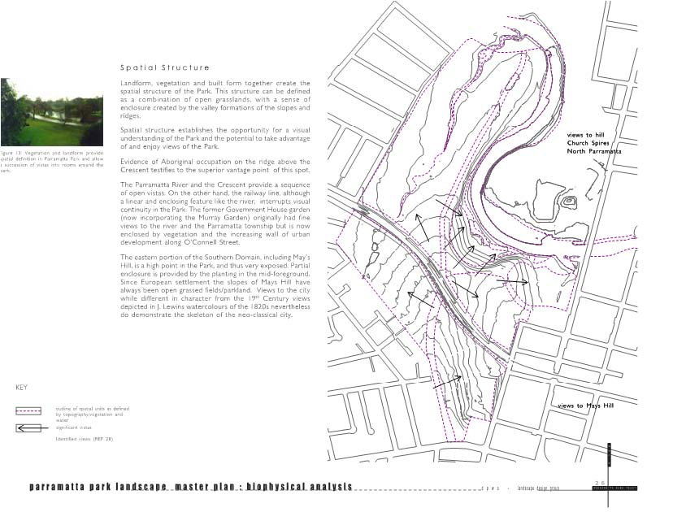
PARRAMATTA PARK MASTER PLAN, LANDSCAPE DESIGN GROUP, 2002
This study provides information on changes to the Old Government House landscape setting over time, including information on the landscape design and the establishment of vantage points to take in views of the water bodes and Parramatta.
Geology and landforms were key factors affecting land use, settlement and access, with elevated edges offering vistas, for example, Redoubt, Mrs. Macquarie’s ‘Hameau’, Lycett’s view of Parramatta.
Landform, vegetation and built form together create the spatial structure of the Park. This structure can be defined as a combination of open grasslands, with a sense of enclosure created by the valley formations of the slopes and ridges.
Spatial structure establishes the opportunity for a visual understanding of the Park and the potential to take advantage of and enjoy views of the Park. The Parramatta River and the Crescent provide a sequence of open vistas. The former Government House garden (now incorporating the Murray Garden) originally had fine views to the river and the Parramatta township but is now enclosed by vegetation and the increasing wall of urban development along O’Connell Street.
Since European settlement the slopes of Mays Hill have always been open grassed fields/parkland. Views to the city while different in character from the 19th Century views depicted in J. Lewins watercolours of the 1820s nevertheless do demonstrate the skeleton of the neo-classical city.
The plan to the right shows significant vistas.

IMPLICATIONS FOR PROJECT
- Views towards the city demonstrate the skeleton of the neo-classical city
- Some views out of the Park are now enclosed by vegetation and urban development

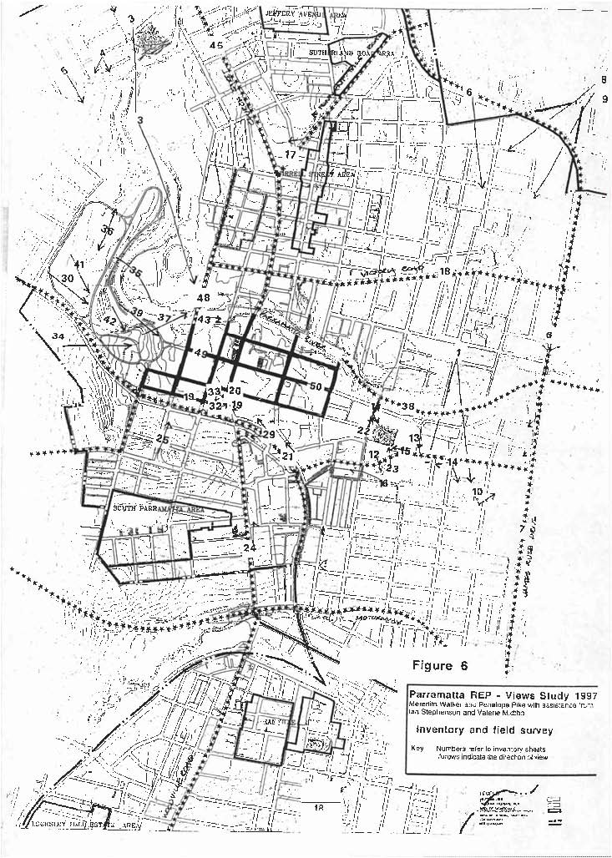
PARRAMATTA REGIONAL ENVIRONMENTAL PLAN: VIEWS STUDY, WALKER, M. AND STEPHENSON, I., 1997
Based on field survey informed by historic images. Approximately 15 views are documented in/near OGHD. The major historical views/viewing points near OGHD are identified as:
- From/to OGH: along George St and to the River and Kings School;
- The Crescent to Parramatta River;
- Parramatta Park to institutions, Kings School and Lennox Bridge; and
- Parramatta River from the west in Parramatta Park.
- From Mays Hill to OGH, City and St John’s

The cultural significance of views is discussed within this document. It is considered that views are significant as the demonstrate the evolution of history, the contribute to individual heritage places and have social value.
Figure 8 to the right is an except from the report and identifies 10 areas where height controls etc needed to retain significant views, including OGH to the river and Kings School, and Mays Hill to St John’s.
There are a number of recommendations regarding the management of views, one of which is related to the consideration of the impact of new development on views. Comment is made on the importance of not only the character of development in the view area, but also the character of development near the view, especially in the foreground or middle ground.
It is recommended that planning instruments include the obligation for the impact of development on views to be taken into account when assessing applications for development, and that DCPs and policies, such as guidelines for developers and architects, include advice about designing to protect and enhance views.
ADDENDUM TO ASSESSMENT OF THE VIEWS AND VISTAS IN PARRAMATTA PARK
The views and vistas of Parramatta Park are significant as, together with the historic images, they document the continuity and evolution of this significant cultural landscape, and the society which shaped it over time.
The views within, to and from Parramatta Park are of cultural significance as:
- a major means by which the geography, early history and development of the Park and the township of Parramatta can be understood and appreciated in a tangible way; [evolution of history]
- a part of the essential, defining character of Parramatta Park; [aesthetic value]
- a key attribute of the heritage of the Park and as evidence of the early history of the Colony of New South Wales; [contribution to individual heritage places] and
- a feature visited and appreciated by the community. [social value]

The views over and from this landscape are highly significant for their ability to reflect the natural topography of the area, including views out to the North and East over the Crescent to the hills on the horizon and along the Parramatta River.
UNDERSTANDING VIEWS WITHIN THE CONTEXT OF CULTURAL LANDSCAPES
Landscapes do not exist in isolation; they are nestled within larger landscapes, which are nested within still larger landscapes and so on. More importantly, as a cultural landscape of significance, Parramatta demands a way of looking which is focused on the key process that have shaped and continue to define the character of the landscape over time; i.e. a cultural landscape approach to management.
Landscapes acquire aesthetic and historic character which, over time, acquires symbolic value for a community. A community assigns values to a landscape that it reads as essential elements of its identity and achieves a sense of belonging to a place for that community.
Views do not always terminate at the feature at the end of a narrow view corridor. Some views are two-way and are experienced within a context from multiple locations. Significant historic views are an important component of the character and heritage value of Parramatta Park and must be respected, guiding future development to avoid structures that are out of character with the surrounding heritage items, street pattern and scale of the historic town centre.
SIGNIFICANT VIEWS AND WORLD HERITAGE VALUES
The important visual aspects and landmark qualities of the World Heritage site include:
1The visual prominence of the Old Government House, including the authoritative and dramatic contrast in scale with the surrounding landscape.
2The visibility of the House and landscape within the context of Parramatta.
3The landscape elements (including the river, the formal layout of carriage ways, buildings and monuments, the broad lawns and water bodies, and the OGHD sites’ relationship to the town plan of Parramatta and the plantings which reflect traditional European principles and elements of nineteenth century international garden style).

Views from within the park historically included the Parramatta river valley and the line of the Hills District, the Old King’s School Building, Lennox Bridge and the town hall, various church spires and distant views to Sydney. Views out of the site help to demonstrate and reinforce an understanding if the original context and contribute to an appreciation of the intactness and authenticity of the setting which is fundamental to the World Heritage Listing.
KEY VIEWS
- OGH to the former King’s School and the hills to the north
- View down George Street
- Views towards May’s Hill
- Views towards the river
- View from northern edge of The Crescent looking south towards OGH

The following are further significant views identified for detailed assessment by Parramatta Park Trust:
1Mays Hill to the north (e.g. Brambilla c.1791, Joseph Lycett, c1822, George Edwards Peacock, c 1840 View of Parramatta from Mays Hill);
2North Government Precinct into Parramatta Park (e.g. Augustus Earle, c1826 View of Female Factory with Domain in the Background);
3From George St to Old Government House (e.g. Collins View of the Governors House, 1798, Evans c. 1805 and Horses Grazing at the Front of Old Government House, September 1844).

IMPLICATIONS FOR PROJECT
- Cultural landscapes demand a way of looking which is focussed on the key processes that have shaped the landscape character over time
- Views out of the site, including views north towards the distant hills are mentioned as helping to demonstrate an understanding of the original context of the landscape

AMALGAMATED VIEWS
The table below and map opposite shows all of the viewpoints as discussed in previous views assessment documents. These 15 views differ from the 16 views assessed within the main document.

No. | VIEW | SOURCE
01 | The Crescent to Old Government House | Regional Planning Strategy (RPS) & Views Study
02 | The Crescent to the river, vacant Council site, Parramatta Hospital, CBD’s northern edge and ridgeline of hills
03 | The Crescent to the backdrop of hills, the Old King’s school, St Peter’s and St Patrick’s church spires, river, Riverside Theatre, Lennox bridge, All Saint’s spire. Sequential views with several viewpoints.
04 | View from the Crescent to the distant hills. | Parramatta City Centre Development Control Plan (DCP)
05 | The Crescent to OGH, CBD and Mays Hill. From access loop road, southern edge of the Crescent and from the lawn at the top of the hill. | RPS & Views Study
06 | OGH view northeast to the river, Old King’s School building and site of former Government farm.
07 | OGH views east to the CBDs western edge.
08 | View from Mays Hill across Parramatta to distant hills. | DCP
09 & 10 | Mays Hill to Parramatta CBD including St John’s spires, south to Campbell Street, Signature Tower and Sydney CBD, northeast to backdrop of hills. Views available from much of Mays Hill, and include a view cone of where view of one or both spires of St Johns is available. | RPS & Views Study
11 | Views along Gorge Street to Parramatta Park gatehouse and trees. | RPS & DCP & Views Study
12 | From the ridge line to the Macquarie Street gates and the centre of Parramatta | Management Plan (MP)
13 | Dairy to Westmead and Wistaria Garden | MP
14 | Parramatta River from the west in Parramatta Park | MP
15 | Mays Hill to Hunter Street | MP
 | These views are noted as being significant within the masterplan document | Parramatta Park Master Plan

IMPLICATIONS FOR PROJECT
- Numerous views are mentioned within the background documents, however, some views are contained within the Park and will not be affected by new development
- Some views are out of date eg. Lennox Bridge and St Peter’s Church spires are no longer visible
- OGH is no longer visible from Mays Hill

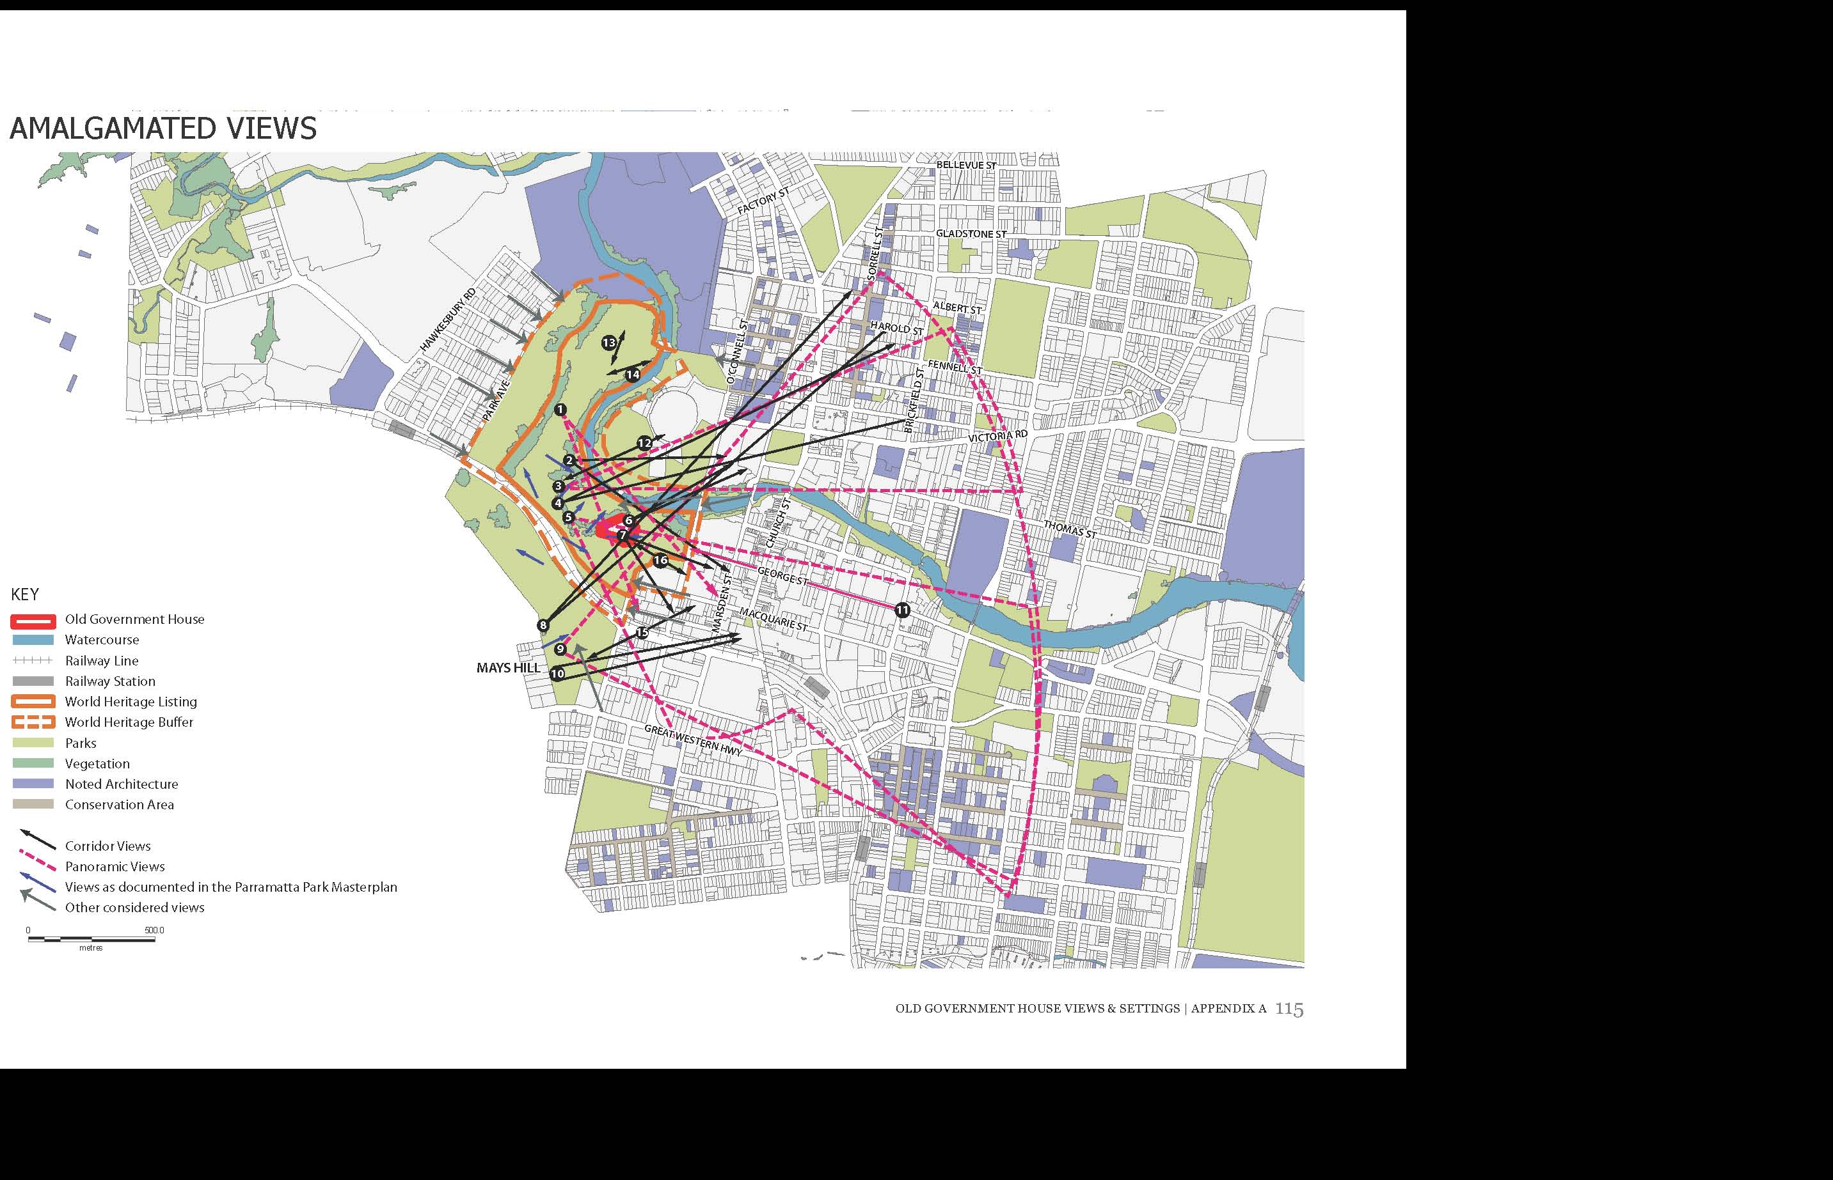
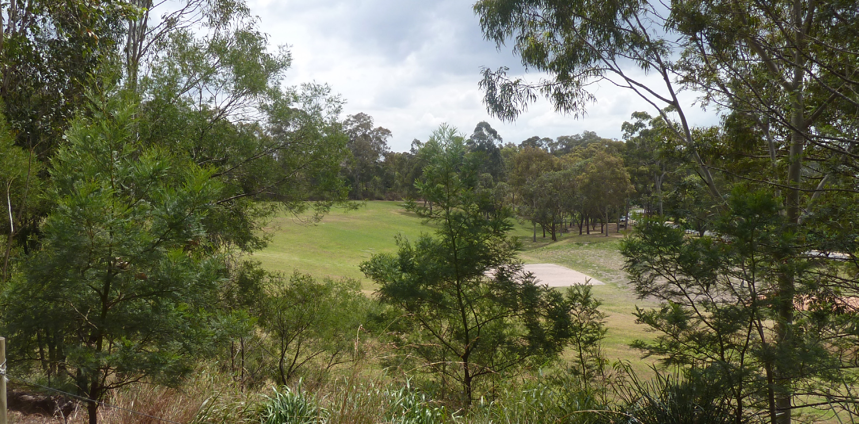
APPENDIX B: DEVELOPMENT SITES
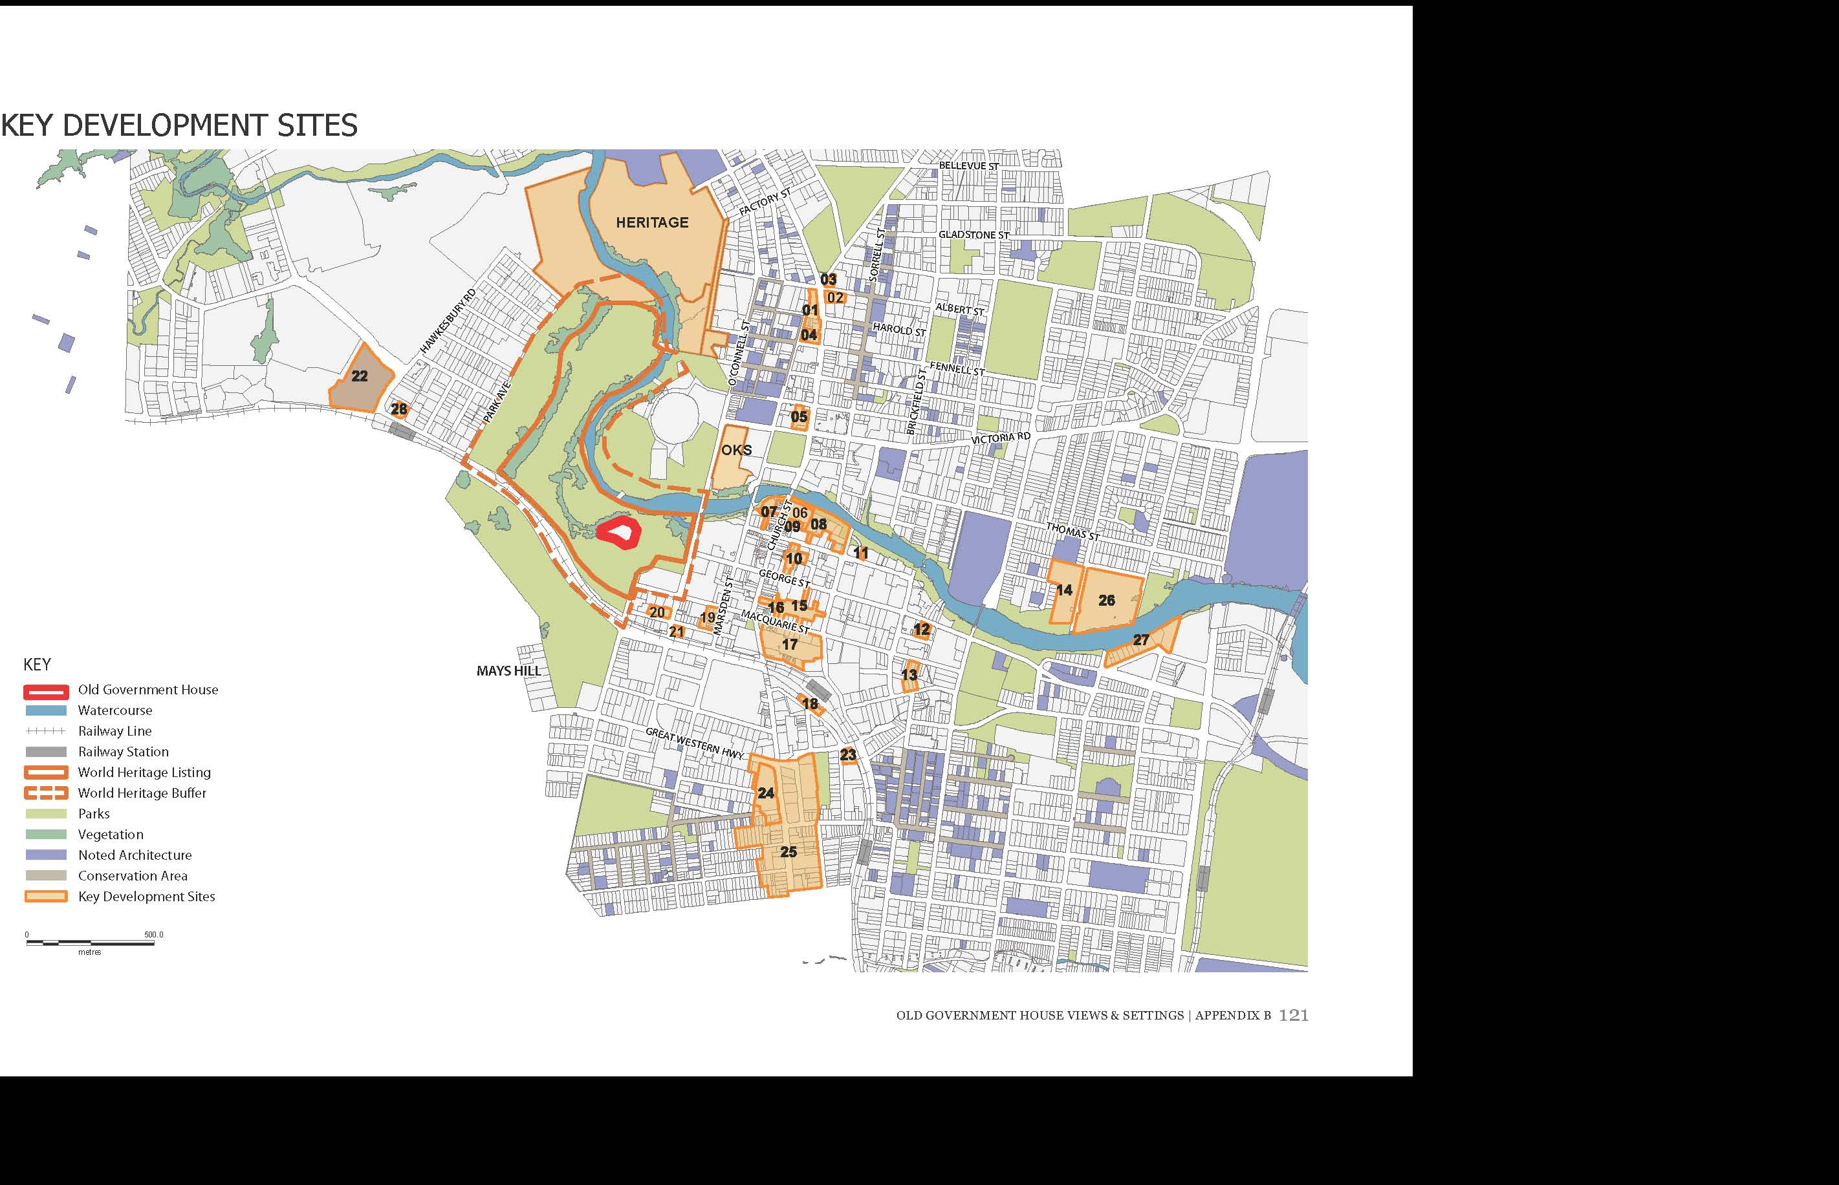
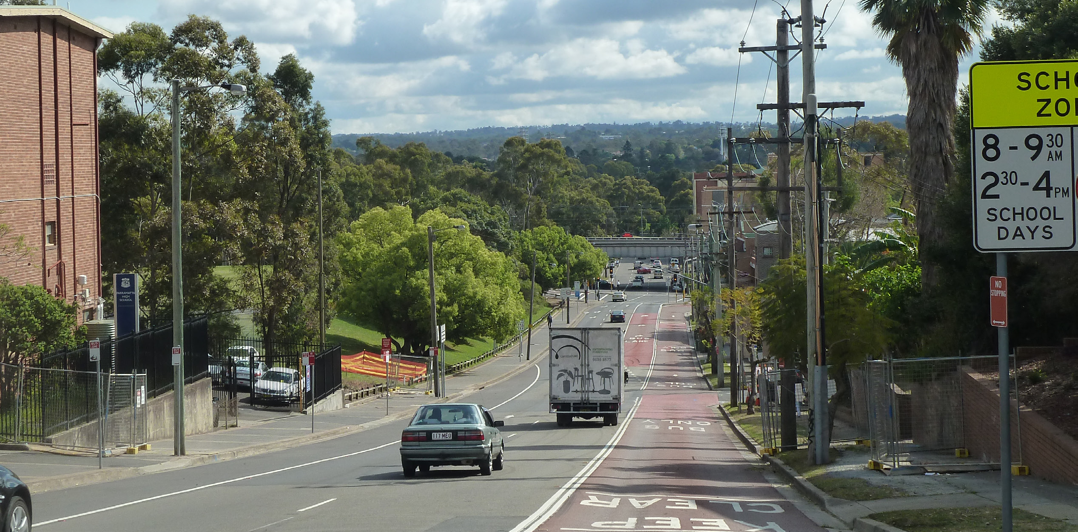
APPENDIX C: EXISTING CONTROLS
EXISTING CONTROLS
BUILDING HEIGHT
There are existing controls on building heights in Parramatta which are shown on the map opposite. The areas outlined in blue are subject to clause 29E, the aim of which is to protect public open space in the vicinity of the Civic Place site, the Lancer Barracks site and Jubilee Park from overshadowing. OGH is shown in red.
Currently building heights fall in height towards the river with the tallest buildings concentrated around the Smith Street / Phillip Street area with the exception of the 200m tower adjacent to the railway station.
Buildings currently do not fall in height towards Old Government House and Domain, creating a fairly continuous wall of development at 54m.
The images to the right show a simple representation of maximum building heights but do not take floor space ratio into consideration.
ARCHITECTURAL ROOF FEATURES
Clause 21A controls architectural roof features and states that consent is required if the roof feature will cause buildings to exceed the height limit.

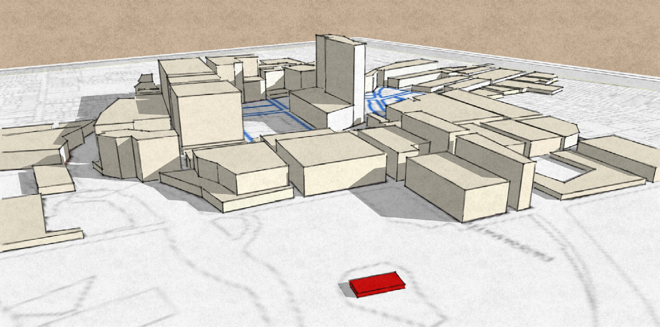
LOOKING SOUTH EAST
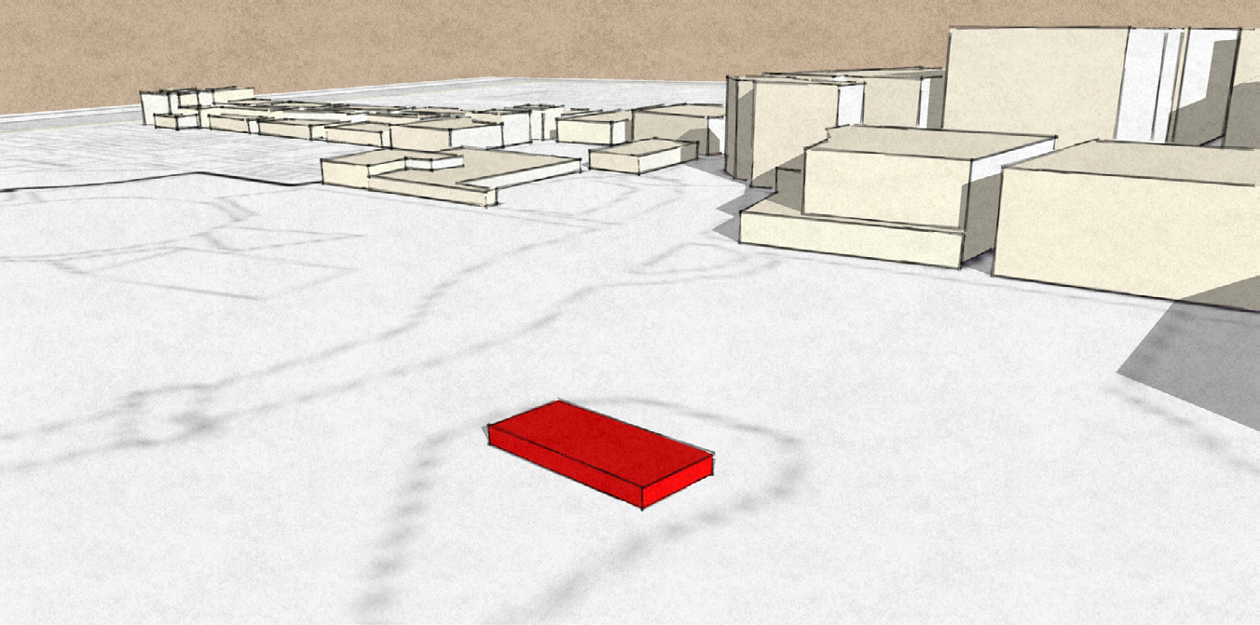
IMPLICATIONS FOR PROJECT
- Currently buildings do not fall in height towards the park, resulting in a ‘wall’ of development along O’Connell Street
- Taller buildings are located further west in the City
- Building heights are lower to the north of the river

LOOKING NORTH EAST
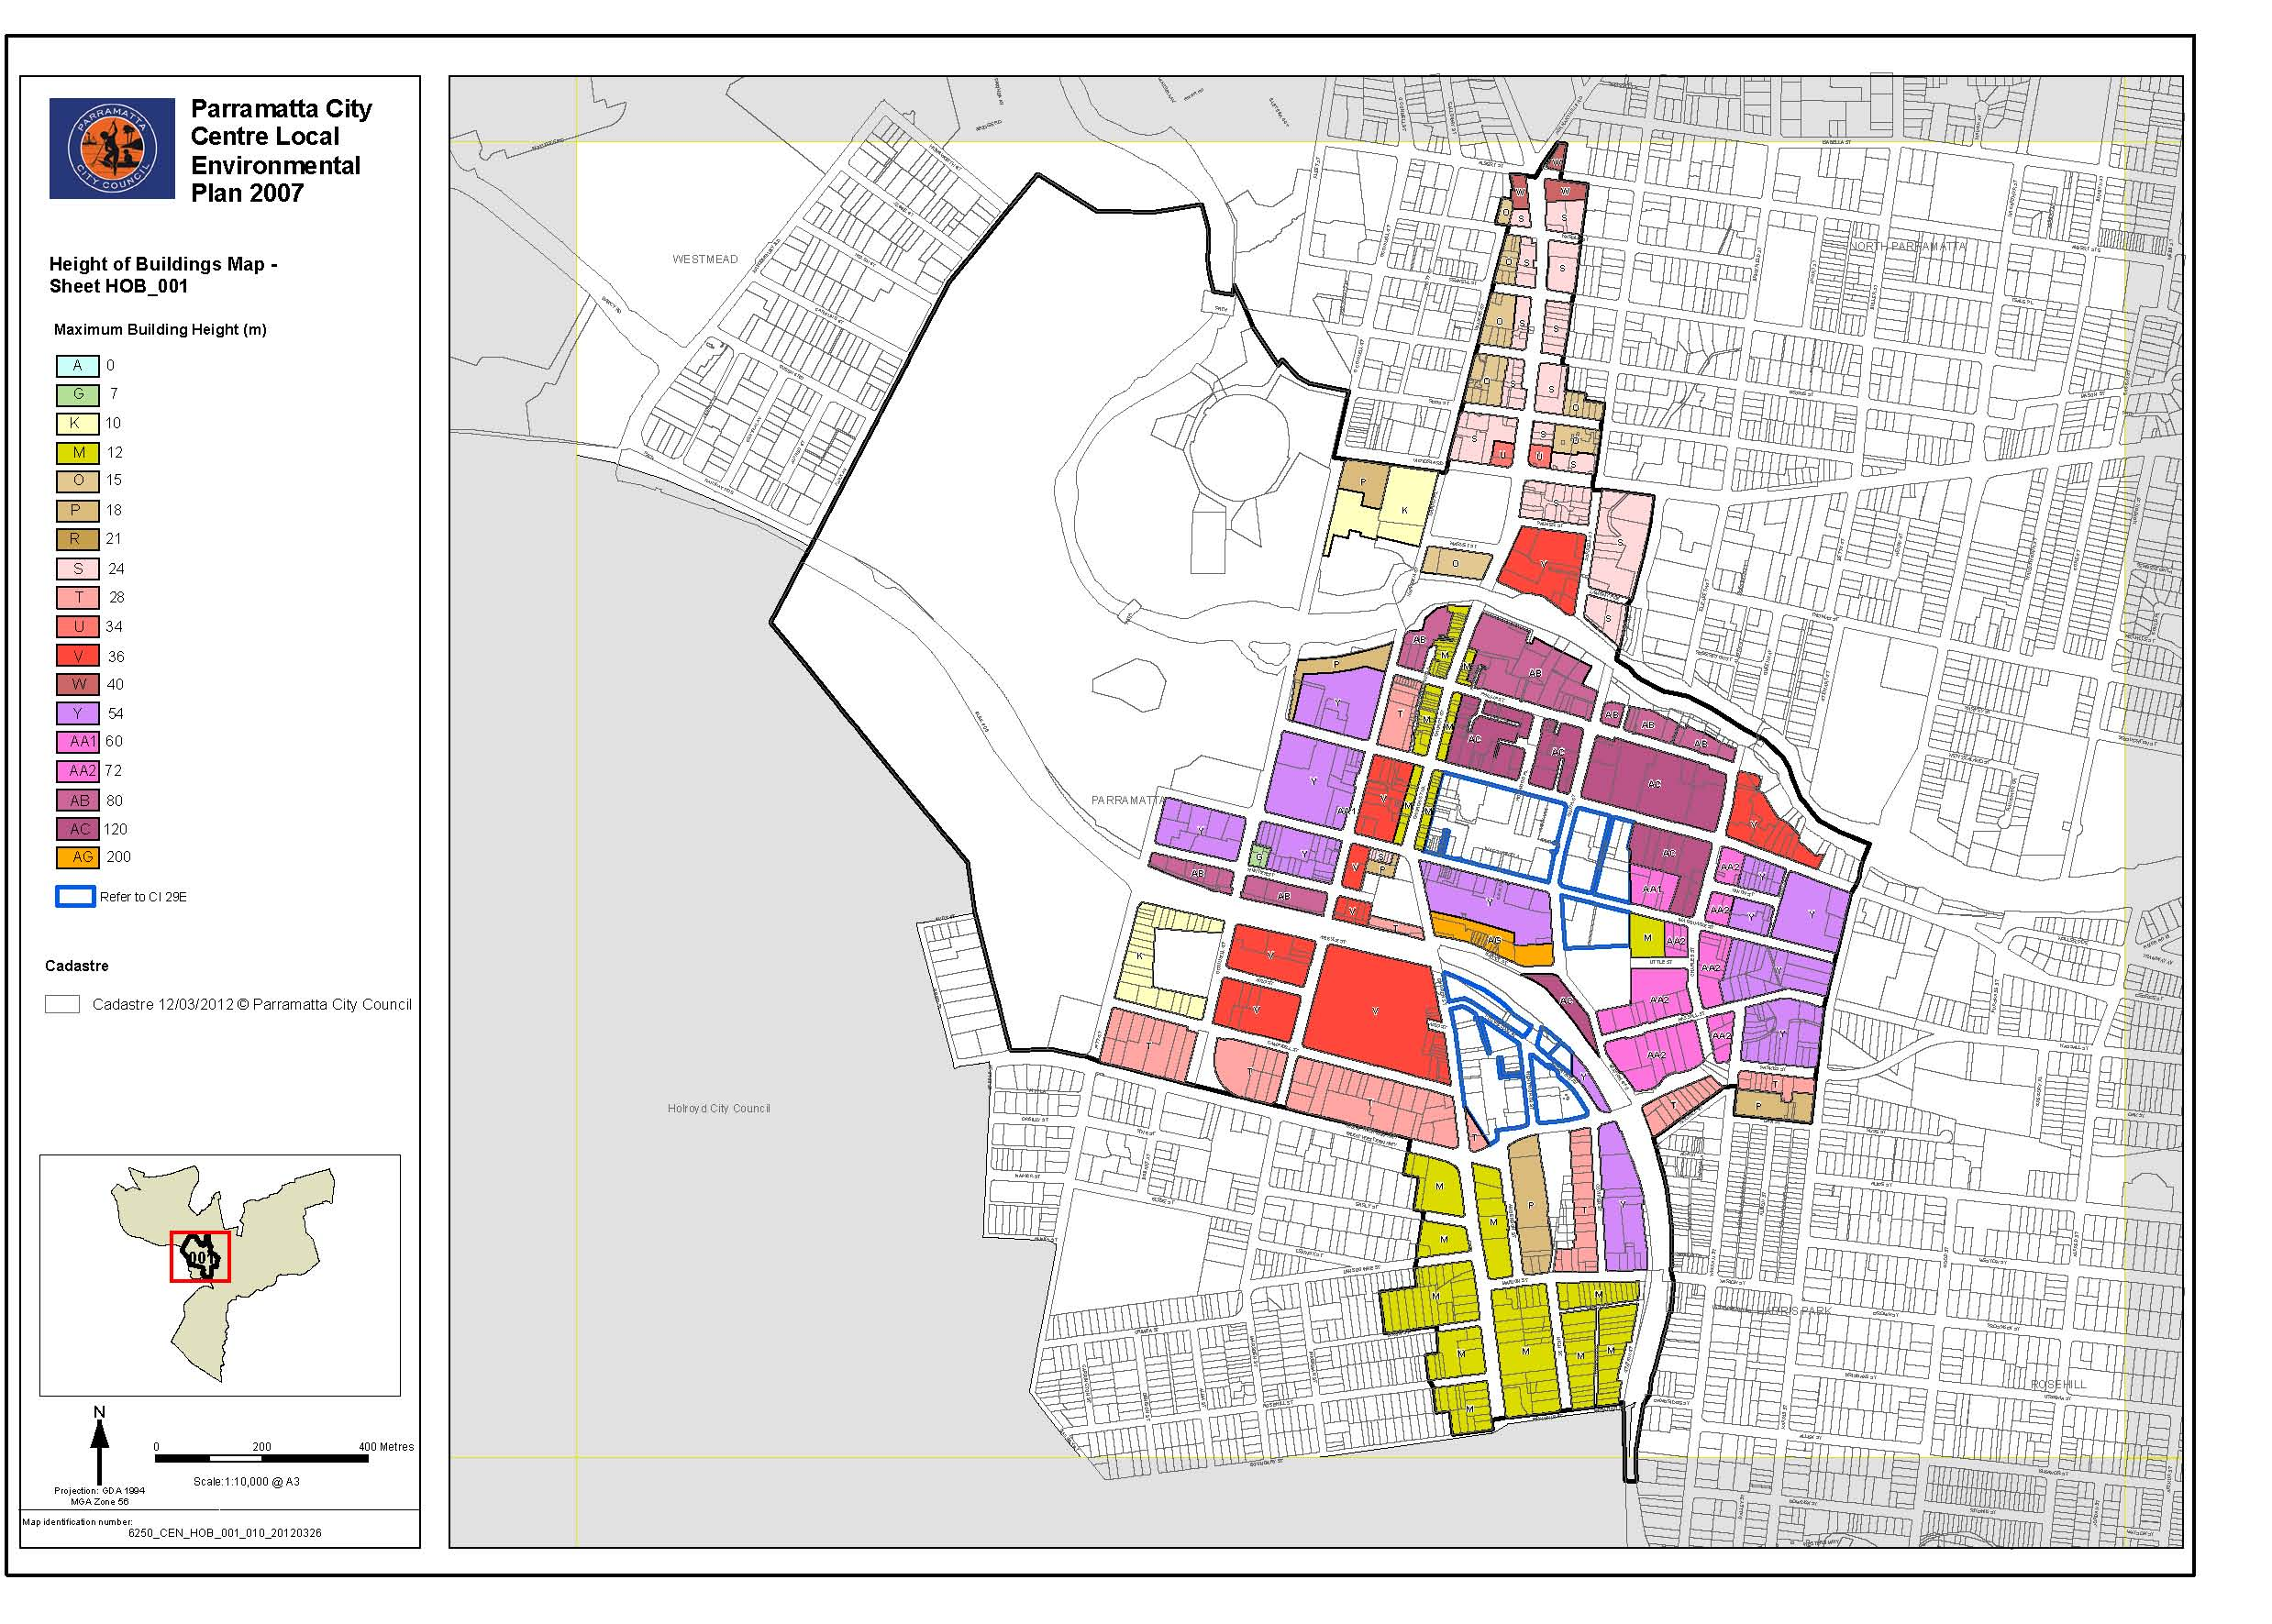
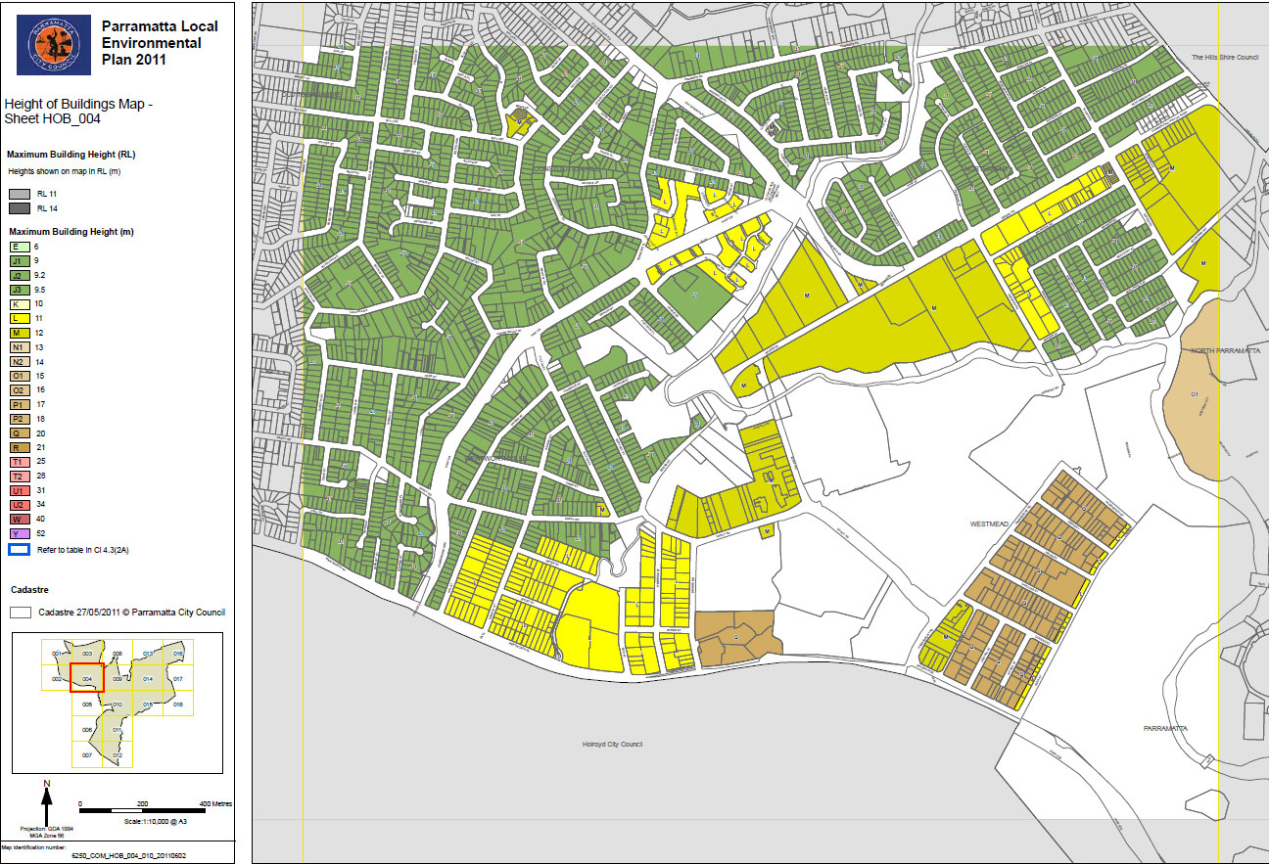
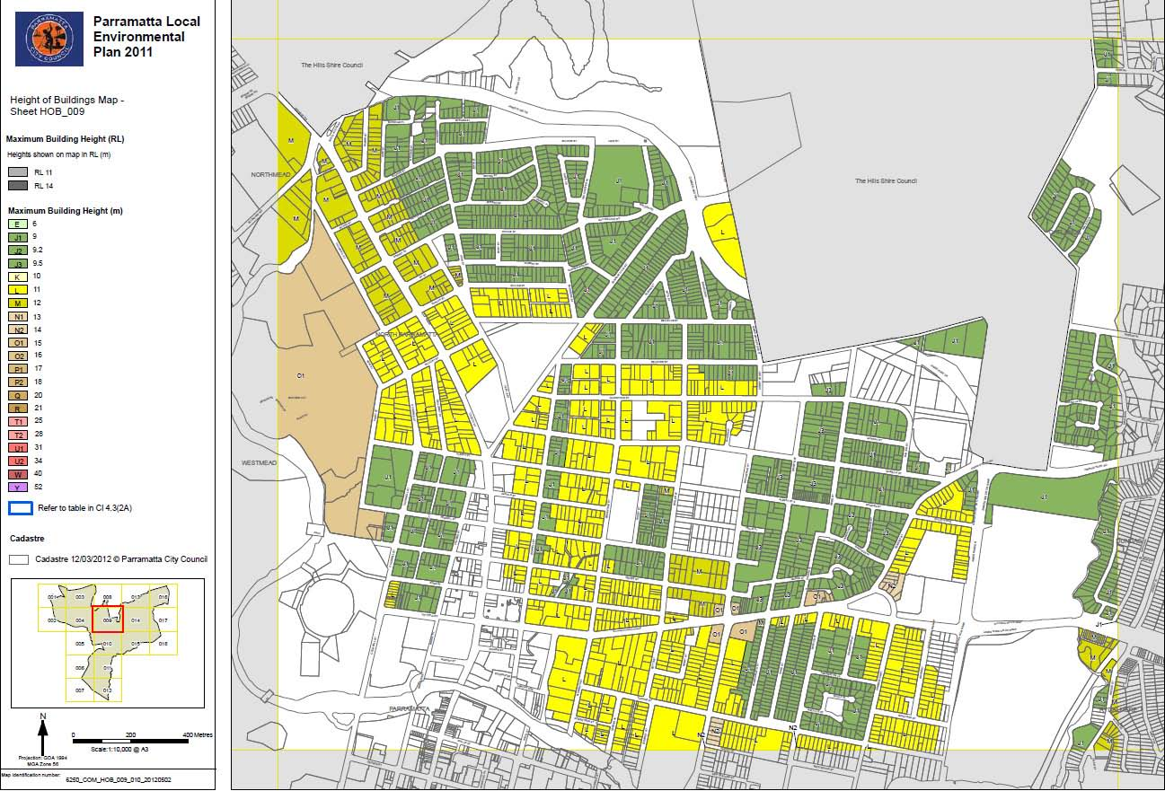
FLOOR SPACE RATIO (FSR)
FSR is the ratio of a building’s floor area to the size of land that the building sits on. The FSR control provides a guide as to how much floor area can be built on a particular parcel of land.
The maximum FSR may not always be reached due to other building controls such as height limits or minimum setback requirements.

IMPLICATIONS FOR PROJECT
- Floor space ratios will determine the bulk of any development and must be considered alongside building heights

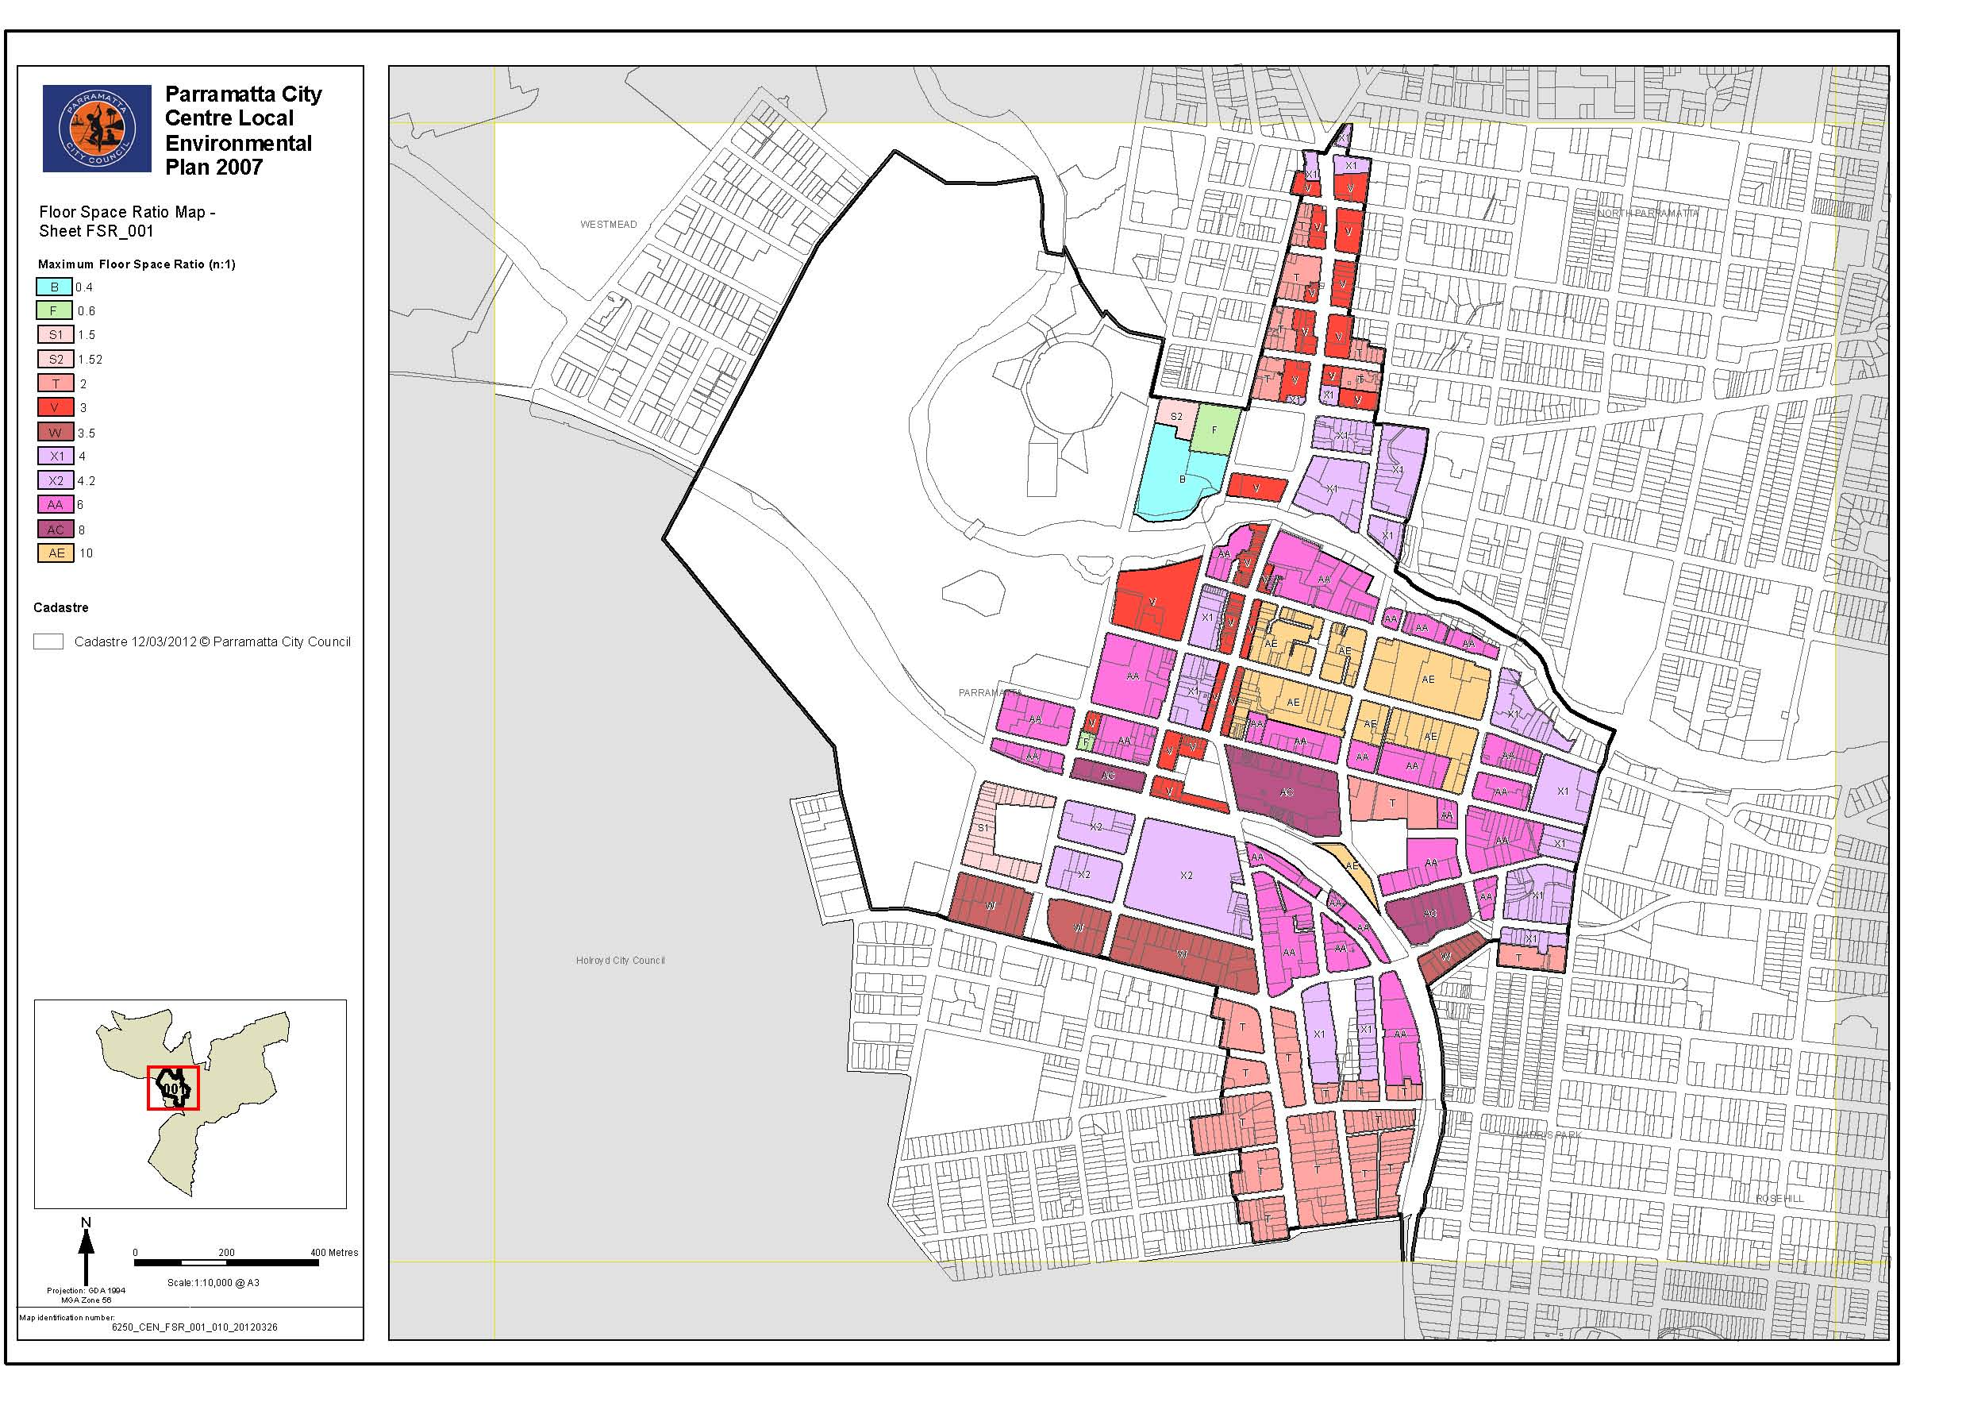
BUILDING FORM
Clause 22B (design excellence) in the Parramatta City Centre LEP 2007 relates to the form of buildings and is triggered by a number of circumstances:
(a) development for which an architectural design competition is required as part of a concept plan approved by the Minister under Division 3 of Part 3A of the Act;
(b) development in respect of a building that is, or will be, greater than 55m or 13 storeys (or both) in height;
(c) development having a capital value of more than $1,000,000 on a key site, being a site shown edged heavy black and distinctively coloured on the Key Sites Map; and
(d) development for which the applicant has chosen to have such a competition.
In these situations buildings must under go a design competition, with designs from 3 architects judged by a panel of experts.
With this process in place it is envisaged that future buildings in the CBD will be of better quality architecture than some of the older style existing buildings. The recently completed Eclipse building at 60 Station St on the corner of Hassall St is the first building completed following a design competition.
COMMERCIAL / RESIDENTIAL
The commercial core of Parramatta is shown in blue on the zoning map opposite. This area will attract a different type of building with a larger floorplate than developments in the mixed use zone, which are more likely to attract residential developments.
This larger type floorplate will have an effect on building form.
IMPLICATIONS FOR PROJECT
- Commercial buildings with a larger floorplate will be located further west, over 2 city blocks from OGHD
- Design competitions are likely to improve the overall appearance of buildings over 55m/13 storeys

