# Assessment of bulk wheat from Canada

Part A: Pathway analysis

**Biosecurity Plant Division** 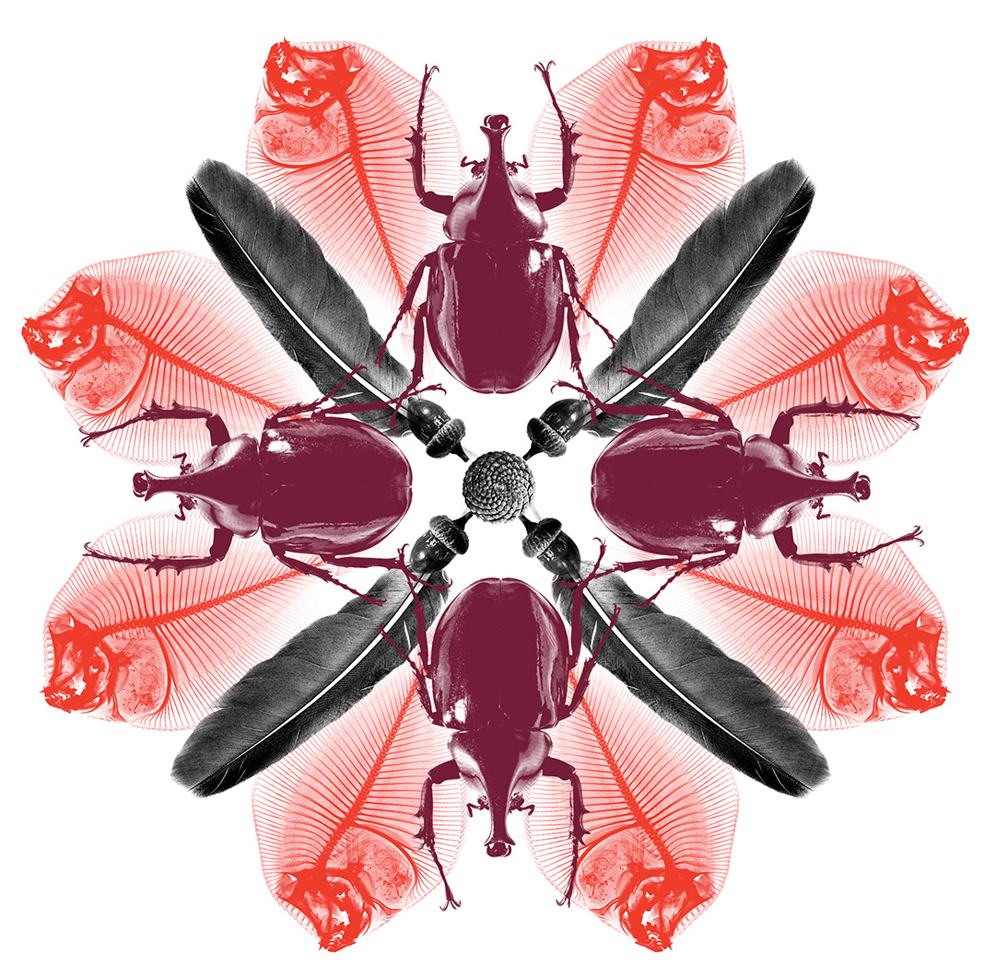

© Commonwealth of Australia 2020

**Ownership of intellectual property rights**

Unless otherwise noted, copyright (and any other intellectual property rights) in this publication is owned by the Commonwealth of Australia (referred to as the Commonwealth).

**Creative Commons licence**

All material in this publication is licensed under a [Creative Commons Attribution 4.0 International Licence](https://creativecommons.org/licenses/by/4.0/legalcode) except content supplied by third parties, logos and the Commonwealth Coat of Arms.

Inquiries about the licence and any use of this document should be emailed to [copyright@awe.gov.au](mailto:copyright@awe.gov.au).

C:\Documents and Settings\west merryn\Local Settings\Temporary Internet Files\Content.Word\by.png

**Cataloguing data**

This publication (and any material sourced from it) should be attributed as: Biosecurity Plant Division 2020 *Assessment of bulk wheat from Canada Part A: Pathway analysis,* Department of Agriculture, Water and the Environment, Canberra, January. CC BY 4.0.

ISBN 978-1-76003-223-4

This publication is available at <http://www.agriculture.gov.au/biosecurity/risk-analysis/plant/>

Department of Agriculture, Water and the Environment

GPO Box 858 Canberra ACT 2601

Telephone 1800 900 090

Web [agriculture.gov.au](http://agriculture.gov.au/)

The Australian Government acting through the Department of Agriculture, Water and the Environment has exercised due care and skill in preparing and compiling the information and data in this publication. Notwithstanding, the Department of Agriculture, Water and the Environment its employees and advisers disclaim all liability, including liability for negligence and for any loss, damage, injury, expense or cost incurred by any person as a result of accessing, using or relying on any of the information or data in this publication to the maximum extent permitted by law.

Contents

Summary 1

Introduction 3

1 Pathway description 4

2 Exclusions 4

3 General requirements for imported bulk grains for processing 4

4 Phytosanitary status of Canadian wheat and production system 5

4.1 Overview of production and handling of wheat 5

4.2 Pests of biosecurity concern to Australia associated with wheat 7

4.3 Pathway analysis 13

4.4 Risk management strategy 16

5 Conclusions and recommendations 20

6 References 21

7 Version history 25

**Tables**

Table 1: Pests of biosecurity concern associated with wheat from all sources and their status in Canada (as confirmed by CFIA in February 2019) 8

Table 2: Stored grain pests of biosecurity concern to Australia (as confirmed by CFIA in February 2019) 10

Table 3: Detection of stored grain pests in bulk wheat shipments 2015-2018 11

Table 4: Weeds and other contaminants of biosecurity concern associated with Canadian wheat 12

Table 5: Cuscuta species reported from Canada and not known to occur in Australia 13

**Figures**

Figure 1: Wheat producing regions of Canada 6

Figure 2: Canadian wheat 6

Figure 3: Canada's grain handling and transportation system 7

**Maps**

Map 1: *Tilletia controversa* regulated area in British Columbia 9

## Summary

In late 2018, the Department of Agriculture, Water and the Environment (department) received an application to import commercially-produced bulk wheat from the Canadian Prairies (Alberta, Manitoba and Saskatchewan) for commercial processing. As part of assessing this application, in February 2019 scientists from the department undertook a pathway risk analysis and visited Canada to verify the pest status of wheat grown in Canada and the integrity of the export pathway to Australia.

*Plant biosecurity risks*

The only identified fungal pathogens of biosecurity concern to Australia that are present in Canada are *Cephalosporium gramineum* and *Tilletia controversa*. *Tilletia controversa* is not present in the Canadian Prairie Provinces (Manitoba, Saskatchewan and Alberta) or the Peace River district in the northern part of the province of British Columbia. *C. gramineum* is primarily a pathogen of winter wheat in Canada and that there is a very low prevalence of this fungus in the Canadian Prairies. The majority of wheat grown in the Canadian Prairies is spring wheat which may explain the low prevalence of *C. gramineum* in this area. Other biosecurity concerns include various stored grain pests and weed seeds. The introduction and spread of these pests and diseases could have significant consequences for Australia’s grain industry and therefore require risk mitigation measures to manage the biosecurity risks.

*Animal biosecurity risks*

The animal diseases of biosecurity concern to Australia that are present in Canada include bovine tuberculosis, brucellosis, chronic wasting disease, avian influenza, infectious bursal disease (IBD), Maedi-visna, Newcastle disease, swine enteric coronavirus diseases and scrapie. It is unlikely that the causal organisms for bovine tuberculosis, brucellosis, IBD and Maedi-visna would contaminate grains produced under broad acre production and mechanical harvesting in Canada. Therefore, these diseases do not require specific risk management measures.

Newcastle Disease, avian influenza, swine enteric coronavirus diseases, chronic wasting disease and scrapie are potential concerns and therefore require risk mitigation measures.

The risk management strategy for bulk wheat from the Canadian Prairies for processing is based on critical control points along the pathway that reduce the risk of introducing these pests and diseases and therefore achieve the appropriate level of protection for Australia. Control points will be applied:

* pre-export, by sourcing spring wheat from low risk areas with low foreign material proportions, using clean transport units and obtaining regulatory assurance (e.g. certification from Canada’s National Plant Protection Organisation (NPPO) – Canada Food Inspection Agency (CFIA) and the Canadian Grain Commission)
* on-arrival, by consignment inspection and verification, and the use of secured handling and transport to manage the risks and impacts of spillage and limitation of diversion.
* at processing stages, by use of department-approved facilities under an Approved Arrangement.

This report, published in two parts: *Assessment of bulk wheat from Canada Part A: Pathway analysis* and [*Assessment of bulk wheat from Canada Part B: Animal biosecurity risk advice*](http://www.agriculture.gov.au/biosecurity/risk-analysis/plant/grains-from-various-countries)presents the findings and recommendations of a pathway analysis by the departmentof the plant and animal biosecurity risks to Australia of commercially produced bulk wheat from Canada; and the systems in place for the production, harvesting, storing, transporting and processing of bulk wheat from the Canadian Prairies destined for export.

## Introduction

The Department of Agriculture, Water and the Environment has a major role in regulating imports of bulk grain through granting import permits, which provide commercial supply options for grain users and suppliers where there are shortfalls in domestic production.

The decision to import grain is a commercial decision by the importer. The department’s responsibility is to ensure that any imports do not compromise Australia’s biosecurity status.

Australia's biosecurity policies aim to protect Australia against the risks that may arise from exotic pests entering, establishing and spreading in Australia, thereby threatening Australia's unique flora and fauna, as well as those agricultural industries that are relatively free from serious pests.

Applications to import grain are considered on a case-by-case basis and require thorough risk assessment and site and desk audits of the proposed import pathway.

For each request we receive to import grain, we undertake a pathway risk analysis for the proposed source country.

A pathway risk analysis involves looking at the scientific and economic evidence for a potential pest, weed or pathogen species of biosecurity concern to Australia, its regulation, and the management actions we would impose to reduce the risk of its entry and spread within Australia.

We also verify the presence or absence of pests of biosecurity concern, pest control practices, and the systems in place for the production, harvesting, storing, transporting and processing of grain destined for export.

If we are not satisfied that the management strategies applied can reduce the biosecurity risks to an acceptable level, we will not allow bulk grains to be imported into Australia.

In late 2018, the department received an application to import commercially-produced bulk wheat from the Canadian Prairies (Alberta, Manitoba and Saskatchewan) for commercial processing. As part of assessing this application, in February 2019 scientists from the department undertook a pathway risk analysis and visited Canada to verify the pest status of wheat grown in Canada and the integrity of the export pathway to Australia.

## Pathway description

This report provides a pathway analysis for import in bulk of commercially produced whole wheat from the Canadian Prairies (Alberta, Manitoba and Saskatchewan) for processing at commercial facilities in Australia.

The intended use of imported Canadian wheat is for processing for human consumption and/or animal feed, which will be sufficient to address the biosecurity risks posed by seed-borne or debris-borne pathogens, such as *Cephalosporium gramineum*,and contamination with other biosecurity risk material, including weed seeds and stored grain pests.

## Exclusions

The bulk imported whole wheat from the Canadian Prairies is not for use as seed for planting, not for direct human consumption, not for direct feeding to livestock as a stockfeed, stockfeed ingredient or supplement, and not for any other unintended use.

## General requirements for imported bulk grains for processing

The department has long-standing arrangements and import protocols for bulk grain imports and recognises that unrestricted imports of whole grains would pose a high biosecurity risk. This is because they are not usually subject to any form of offshore processing (other than harvesting and grading), which means additional levels of assessment, monitoring and controls are required to manage associated biosecurity risks.

Successive Australian Governments have maintained a stringent, but not a zero risk, approach to the management of biosecurity risks. This approach is expressed in terms of the appropriate level of protection (ALOP) for Australia, which is defined in the *Biosecurity Act 2015* as providing a high level of protection aimed at reducing risk to a very low level, but not to zero. The regulation of whole grain imports is governed by the powers and provisions of the *Biosecurity Act 2015* and subordinate legislation.

The following general requirements are applied to the import of whole grains for processing in Australia:

* A permit must be issued for any grain imports prior to arrival. Every permit application is subject to a risk assessment.
* Grain must be sourced from areas of low plant and animal risk, and through export pathways approved by the department.
* Grain must be inspected and certified free from quarantine pests by the National Plant Protection Organisation (NPPO) of the exporting country.
* Vessels carrying bulk grain must be inspected prior to loading and found practically free of residues from previous cargos and free from infestation.
* Grain must be transported in clean conveyances, and conveyances must be secure to control the leakage of grain or dust during transport from the point of discharge through to the point of processing.
* Grain must be transported along approved routes, and traced and tracked from the point of arrival to final release from biosecurity control.
* Imported grain must be stored and processed under biosecurity control and contained to manage spills and any associated biosecurity concerns.
* Processing or treatment of imported grain and associated biosecurity waste must be undertaken in a manner approved by the department before release from biosecurity control.
* Imported grain must not be diverted to any location or for any other use than that stated on the import permit.
* A Process Management System (PMS) must be put in place outlining the processes for movement, storage and processing within Australia.

A range of factors relevant to the management of biosecurity risk, including proximity to agricultural production, potential hosts (animal and plant) and transport routes (especially passage through agricultural areas), are considered during the assessment of the approved arrangement site.

## Phytosanitary status of Canadian wheat and production system

### Overview of production and handling of wheat

Canada is a major global wheat producer and exporter, and is the world’s largest producer of high-protein (milling) wheat. More than 95% of Canada's wheat is produced in the Canadian Prairies [Alberta, Manitoba and Saskatchewan provinces] (Figure 1). Commercial crops are produced using best management practices including, but not limited to, crop rotation, pre-planting tillage, herbicide application and insect and disease control.

Figure 1: Wheat producing regions of Canada

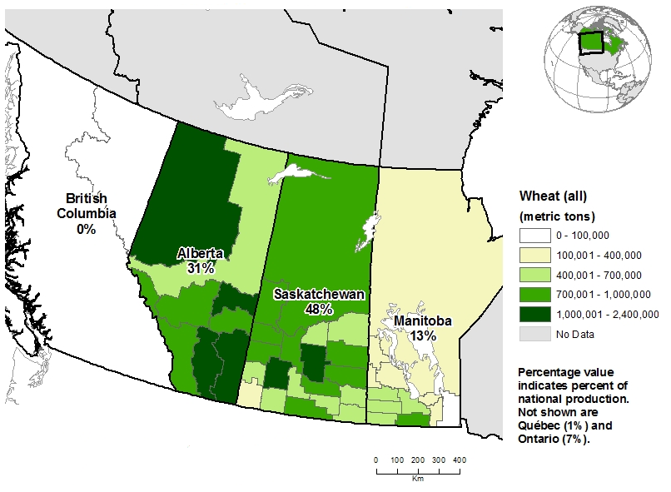

Source: Statistics Canada

The wheat in Canada is classified based on colour (red, yellow, white), planting season (spring wheat - planted in the spring and harvested in the early autumn; and winter wheat - planted in autumn and harvested in the following summer), hardness (hard or soft), and source region (Western or Eastern). For example, Canada Western Red Spring (produced in the Western Division), Canada Prairie Spring, Canada Eastern Soft Red Winter (produced in the Eastern Division). All western/prairie classes of wheat, unless identified as ‘winter’, are spring wheats. The majority of wheat grown in the Canadian Prairies is spring wheat (Figure 2).

Figure 2: Canadian wheat



Source: Statistics Canada

The grain handling process in Canada involves multiple handlers, but is still a relatively simple supply chain. Farmers grow their grain, and in most cases, move their grain to a proximate grain elevator. At the elevator, it is blended, cleaned and stored until it can be loaded onto railcars and moved to port for export (Figure 3). Due to long distances between Canadian port facilities and Prairie elevators, railways are the least expensive means of transporting grains particularly compared to trucking grains (Park & Koo 2001). Grain produced in the west is largely exported through western ports and grain produced in the east is exported through eastern ports.

Figure 3: Canada's grain handling and transportation system

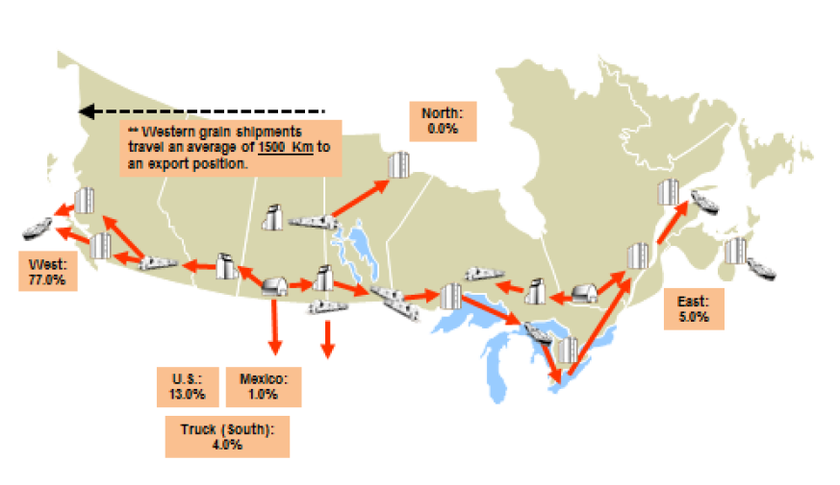

Source: Statistics Canada, 2018; AAFC Calculations; Canadian Grain Commission; Other sources

The government agencies involved with the export of grain from Canada are the Canadian Food Inspection Agency (CFIA), primarily for sanitary and phytosanitary aspects; and the Canadian Grain Commission (CGC), primarily for grain standards and quality aspects.

### Pests of biosecurity concern to Australia associated with wheat

Consistent with the Agreement on the Application of Sanitary and Phytosanitary Measures (the SPS Agreement), and the associated International Standards for Phytosanitary Measures (ISPMs), the department has identified pests of biosecurity concern associated with wheat (Table 1). Phytosanitary measures are in place to mitigate the risk of introduction of these pathogens into Australia.

Australia’s current legislation permits the importation of wheat seed and grain; the department is required to issue import permits that may specify mandatory phytosanitary measures to effectively manage biosecurity risks. Imports of wheat seed include the requirement to grow imported seed in post-entry quarantine facilities for one generation with release of progeny after disease screening. Bulk wheat imports are currently permitted from low risk sources for processing under approved arrangements.

#### Status in Canada of pathogens of biosecurity concern to Australia

The status of quarantinable pathogens associated with wheat in Canada is provided in Table 1. The department has previously approved the Canadian Prairies (Alberta, Manitoba and Saskatchewan provinces) as a low risk source of wheat based on the absence of *Alternaria triticina, Magnaporthe oryzae*-*Triticum* pathotype, *Puccinia graminis* strain Ug 99 and *Tilletia indica* from Canada, and the absence of *Tilletia controversa* from the Canadian Prairies. The Canadian Prairies remain free from the majority of the seed-borne pathogens of biosecurity concern to Australia (Table 1). The CFIA has recently confirmed that the plant health status of Canada has not changed and these status assessments are still correct. An official verification visit and associated discussions with technical experts and representatives from the Canadian NPPO (CFIA) in February 2019 confirmed that *Tilletia controversa* is not present in the Canadian Prairies or the Peace River district in the northern part of the province of British Columbia. The Peace River district is isolated from the affected areas in British Columbia by approximately 400km. The provincial department of agriculture conduct annual surveys for *Tilletia controversa* to maintain area freedom. CFIA conduct annual seed testing of samples representative of bulk vessel wheat exports taken by the CGC for *Tilletia controversa*. Seed testing of 1,486 samples from 2008 to 2018 demonstrated that *Tilletia controversa* is absent from Alberta, Manitoba and Saskatchewan.

Table 1: Pests of biosecurity concern associated with wheat from all sources and their status in Canada (as confirmed by CFIA in February 2019)

| Scientific name | Status in Canada | Status in Canadian Prairies |
| --- | --- | --- |
| *Alternaria triticina Prasada* & Prabhu–Alternaria blight | Absent | Absent |
| *Cephalosporium gramineum* Nisikado & Ikata–Cephalosporium stripe | Present | Present |
| *Magnaporthe oryzae*–*Triticum* pathotype–wheat blast | Absent | Absent |
| *Puccinia graminis*–strain Ug 99–Stem rust | Absent | Absent |
| *Tilletia controversa* J.G. Kühn–dwarf bunt | Present | Absent |
| *Tilletia indica* Mitra–Karnal bunt | Absent | Absent |

The results of a Canadian Plant Disease Survey published by the Canadian Phytopathological Society indicated that *Cephalosporium gramineum* and *Tilletia controversa* were not detected in cereals (wheat, barley, oats) grown in the Canadian Prairies (Elmhist 2018).

The official visit and technical discussions with experts and representatives from the Canadian NPPO also confirmed that *Tilletia controversa* has a restricted distribution in Canada and occurs in only two locations, these being North Okanagan/Shuswap (inter-mountain valleys) in Southern British Columbia (Figure 4) and several counties in southern Ontario.

*Tilletia controversa* is a regulated pest in Canada under the *Canadian* *Plant Protection Act*. Import and domestic movement restrictions to prevent introduction and spread into non-regulated areas are in place.

Map 1: *Tilletia controversa* regulated area in British Columbia

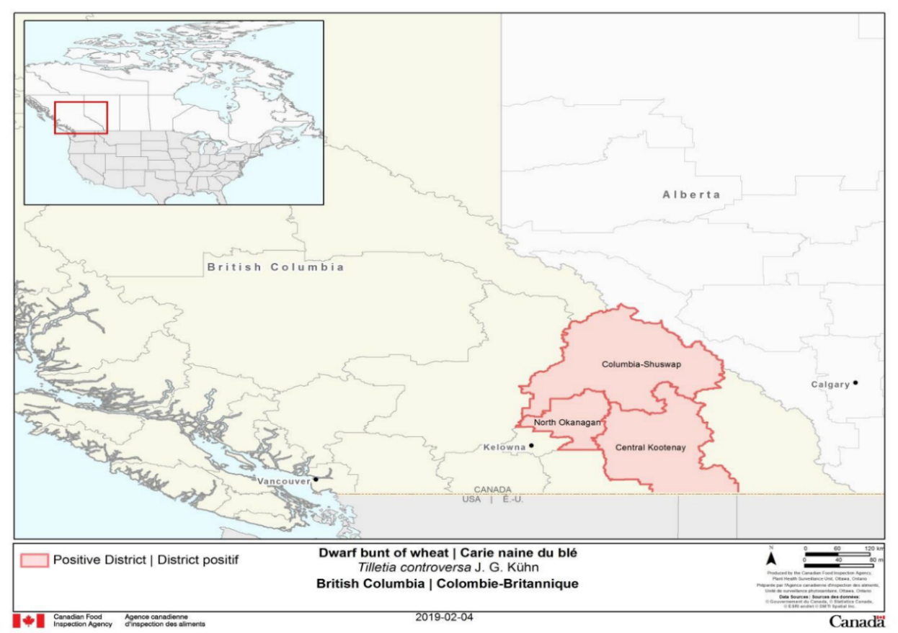

CFIA has confirmed that commercial wheat production does not occur in southern British Colombia. This region is mainly known for forest and horticultural products. Wheat produced in Ontario is used domestically, exported directly south into the USA or exported eastwards via the Great Lakes/St. Lawrence Seaway (e.g. ports in the city of Thunder Bay) and is not exported through the Port of Vancouver. Hence there is minimal risk of cross contamination.

CFIA has confirmed that *Cephalosporium gramineum* is known to occur in the Canadian Prairies. However, its prevalence is low and it has only sporadically been detected during crop surveys undertaken by the provincial agricultural departments. *Cephalosporium gramineum* is primarily a pathogen of winter wheat (Bruehl 1968) but it has also been recorded on other cereals including barley, oats, and rye (Gerdeman & Weibel 1960) and several grasses i.e. *Bromus, Dactylis and Poa* species (Bruehl 1957). Although the pathogen is capable of direct penetration of intact tissues in both the roots and the crown (Douhan & Murray 2001), mechanical damage caused by freezing, frost heaving, root-feeding insects, and other injuries are thought to facilitate the entry of the pathogen into wheat roots (Mathre & Johnston 1975; Morton & Mathre 1980). Spring wheat is not a preferred host of *Cephalosporium gramineum* (Gerdeman & Weibel 1960). Although spring-sown crops are potentially susceptible, they appear to either escape infection or not permit infections to build to a damaging level (Baaj & Kondo 2011). The majority of wheat grown in the Canadian Prairies is spring wheat (Figure 3) and cultivation of winter wheat is very low, which may explain the low prevalence of this fungus in the Prairies.

Infested crop residue is the primary source of inoculum of *Cephalosporium gramineum*, but low rates of seed transmission have also been reported in winter wheat (Murray 2006). CFIA has recently tested randomised seed samples representative of containerised wheat exports from the Canadian Prairies to determine infection levels. During this testing, only two seed lots (contaminated at a rate of 1 seed per lot) of 37 seed lots (a total of 14,800 seeds) have shown infection with the fungus, which supports the assessment of low prevalence of this fungus on seeds of wheat produced in the Canadian Prairies. Additionally, CFIA tested recently spring wheat samples to determine *C. gramineum* infection levels. During this testing of 20 samples (400 seed per sample) *C. gramineum* was not detected.

#### Insect pests of biosecurity concern

##### Stored grain pests

There are several species of stored product pests that could potentially be found in bulk grain, including exotic and cosmopolitan species. Australia is free of several economically important stored grain pests associated with bulk grains that meet the International Plant Protection Convention (IPPC) definition of a quarantine pest and require phytosanitary measures to achieve Australia’s ALOP. Key species of stored grain pests of biosecurity concern to Australia are listed in Table 2.

Table 2: Stored grain pests of biosecurity concern to Australia (as confirmed by CFIA in February 2019)

| Scientific name (s) | Common name(s) |
| --- | --- |
| *Callosobruchus chinensis* (Linnaeus) [Coleoptera: Bruchidae] | Cowpea weevil |
| *Cryptolestes turcicus* (Grouvelle) [Coleoptera: Laemophloeidae] | Flat grain beetle |
| *Cynaeus angustus* (Le Conte) [Coleoptera: Tenebrionidae] | Large black flour beetle |
| *Glischrochilus fasciatus* (Olivier) [Coleoptera: Nitidulidae] | Picnic beetle |
| *Glischrochilus quadrisignatus* (Say) [Coleoptera: Nitidulidae] | Four-spotted sap beetle |
| *Tribolium audax* Halstead [Coleoptera: Tenebrionidae] | American black flour beetle |
| *Tribolium brevicornis* (Le Conte) [Coleoptera: Tenebrionidae] | Flour beetle |
| *Tribolium destructor* Uyttenboogaart [Coleoptera: Tenebrionidae] | Large flour beetle |
| *Tribolium madens* (Charpentier) [Coleoptera: Tenebrionidae] | Black flour beetle |
| *Trogoderma glabrum* (Herbst) [Coleoptera: Dermestidae] | Glabrous cabinet beetle |
| *Trogoderma inclusum* (Le Conte) [Coleoptera: Dermestidae] | Large cabinet beetle |
| *Trogoderma ornatum* (Say) [Coleoptera: Dermestidae] | Ornate cabinet beetle |
| *Trogoderma simplex* (Jayne) [Coleoptera: Dermestidae] | Trogoderma beetle |
| *Trogoderma sternale* (Jayne) [Coleoptera: Dermestidae] | Trogoderma beetle |

CFIA has provided information on the detection of stored grain pests in wheat shipments during pre-export phytosanitary inspection from 2015–2018 (Table 3).

Table 3: Detection of stored grain pests in bulk wheat shipments 2015-2018

| Crop year | No of shipment exported | No of samples tested | No of detected samples |
| --- | --- | --- | --- |
| 2015–16 | 39 | 649 | 1 (*Rhyzopertha dominica*) |
| 2016–17 | 25 | 461 | 3 (*Cryptolestes ferrugineus, Tribolium castaneum, Trogoderma inclusum*) |
| 2017–18 | 41 | 628 | 1 (*Liposcelis paeta)* |

The detection of stored grain pests, including the exotic *Trogoderma inclusum* and cosmopolitan species *Cryptolestes ferrugineus*, *Rhyzopertha dominica* and *Tribolium castaneum*, demonstrates that bulk grain has potential to provide a pathway for the introduction of stored grains pests to Australia.

##### Other pests (Hessian fly)

Hessian fly (*Mayetiola destructor*) is believed to have been introduced into North America with straw wheat bedding (Ratcliffe & Hatchett 1997); it is present in Canada and is identified by the department as a high-priority pest for the Australian grains industry. Hessian fly is one of the most economically damaging pests in the winter wheat systems of North America (Holtzer 2006), and has re-emerged as a significant pest during the past decade (Chen et al. 2009). It is thought that recent severe infestations of Hessian fly in this region have occurred because of the emergence of aggressive fly biotypes, widespread planting of susceptible cultivars, and an increase in no-till wheat systems that provide refuge for pupae (Chen 2009).

Hessian flies damage wheat throughout the growing season and limit grain production by killing or stunting individual tillers, causing plant lodging/ stem breakage, and preventing the grain head from filling (Buntin 1999; Flanders et al. 2013). Hessian flies lay eggs on leaves (Flanders et al. 2013); after hatching, larvae move to the base of the seedling and establish feeding sites (Devika et al. 2018). Larvae are found between the leaves and the stem or culm of the wheat plant throughout their development and during the pupal stage (Gagne & Hatchett 1989; Wellso 1991). Stems infested in the spring may lodge shortly before harvest (Fisher et al. 1981).

Commercially-produced grain does not provide a pathway for Hessian fly as larvae and pupae are found in the stem or crown of the wheat plant (Devika et al. 2018).

#### Weeds of biosecurity concern

The list of weed species of Canada is very extensive (Cavers et al. 2005), but the species composition and abundance varies from field to field and season to season in response to local conditions, farming practices and weather. Crop production practices such as crop rotation, pre-planting tillage and herbicide application can impact the range and abundance of weed species present during cultivation and at harvest (Thomas & Dale 1991; Blackshaw et al. 2006). Grain handling practices in Canada, including cleaning and grading, are expected to reduce the number of weed seeds in harvested grain. Grading can occur at multiple locations, e.g. at farm, inland storage and export terminals. However, in some instances significant levels of weed contamination of Canadian wheat have been reported (Asai et al. 2007; Shimono & Konuma 2008), and blending of grain lots may introduce uncertainty regarding both the species identity and quantity of weed seed contaminants (Wilson et al. 2016).

Some of the weed seeds reported from Canadian wheat would not present a risk of new species introductions, as they are common weeds that are already present in Australia. However, there are also reports of several species restricted by Australia (due to potential for presence of quarantinable seed-borne pathogens), and of exotic weed species that are not present in Australia. Therefore there could be risk of these species being introduced into Australia with bulk wheat imports from Canada. Table 4 lists weeds of biosecurity concern to Australia that have been intercepted in Canadian wheat.

Table 4: Weeds and other contaminants of biosecurity concern associated with Canadian wheat

| Scientific names | Common name(s)/Comments |
| --- | --- |
| Avena sativa L. [Poaceae] | Oats (a restricted seed due to quarantinable seed-borne pathogens) |
| Camelina microcarpa Andrz. Ex DC [Brassicaceae] | Small seeded false flax (prohibited require assessment) |
| Dracocephalum parviflorum L. [Lamiaceae] | Dragonhead |
| Euphorbia serpyllifolia Pers. [Euphorbiaceae] | Themseleaf sandmat (prohibited require assessment) |
| Galeopsis tetrahit L. [Lamiaceae] | Common hemp nettle |
| Galium mollugo L. [Rubiaceae] | smooth bedstraw |
| Glycine max (L.) Merr [Fabaceae] | Soybean (a restricted seed due to quarantinable seed-borne pathogens) |
| Helianthus annuus L. [Asteraceae] | Sunflower (a restricted seed due to quarantinable seed-borne pathogens) |
| Hordeum vulgare L. [Poaceae] | Barley (a restricted seed due to quarantinable seed-borne pathogens) |
| Kochia scoparia (L.) Schrad. [Chenopodiaceae] | Kochia |
| Lens culinaris Medic. [Fabaceae] | Lentil (a restricted seed due to quarantinable seed-borne pathogens) |
| Linum usitatissimum L. [Linaceae] | Flax (a restricted seed due to quarantinable seed-borne pathogens) |
| Lolium persicum Boiss. & Hohen. ex Bois [Poaceae] | Persian ryegrass |
| Medicago sativa L. [Fabaceae] | Lucerne (a restricted seed due to quarantinable seed-borne pathogens) |
| Salsola kali L. [Chenopodiaceae] | Russian thistle |
| Salsola pestifer A. Nelson [Chenopodiaceae] | Russian thistle |
| Secale cereale L. [Poaceae] | Rye (a restricted seed due to quarantinable seed-borne pathogens) |
| Setaria glauca (L.) P. Beauv. [Poaceae] | Yellow foxtail (a restricted seed due to quarantinable seed-borne pathogens) |
| Setaria italica (L.) P. Beauv. [Poaceae] | Foxtail millet (a restricted seed due to quarantinable seed-borne pathogens) |
| Setaria pumila (Poir.) Roem. & Schult [Poaceae] | Yellow foxtail (a restricted seed due to quarantinable seed-borne pathogens) |
| Setaria viridis (L.) P. Beauv. [Poaceae] | Green foxtail (a restricted seed due to quarantinable seed-borne pathogens) |

*Cuscuta* (dodder) species are parasitic plants; many species of dodder are capable of parasitising a wide range of host species from various plant families, while others are more host-specific. While dodder species do not typically attack grasses or sedges (Poaceae, Cyperaceae) (Costea & Tardif 2006), contamination with seeds of legumes poses a risk with respect to potential for presence of dodder propagules (Asai et al. 2007; Shimono & Konuma 2008). Some economically important species of *Cuscuta*, which are especially problematic in legumes (e.g. alfalfa, clovers) and flax, do not occur in Australia (Table 5). Legume seed contaminants in bulk grains therefore provide a potential pathway of importation. Non-dedicated commodity transportation vehicles, temporary storage sites and port terminals could explain the observed carry-over of other crops in wheat seed.

Table 5: Cuscuta species reported from Canada and not known to occur in Australia

| Scientific names | Common name(s)/Comments |
| --- | --- |
| *Cuscuta cephalanthi* Engelmann [Convolvulaceae] | Buttonbush dodder |
| *Cuscuta coryli* Engelmann [Convolvulaceae] | Hazel dodder |
| *Cuscuta gronovii* Willd. [Convolvulaceae] | Common dodder |
| *Cuscuta megalocarpa* Rydb. [Convolvulaceae] | Big fruit dodder |
| *Cuscuta pentagona* Engelmann [Convolvulaceae] | Field dodder |
| *Cuscuta polygonorum* Engelmann [Convolvulaceae] | Knotweed dodder |
| *Cuscuta salina* Engelmann [Convolvulaceae] | Salt marsh dodder |

### Pathway analysis

Pathway analysis is applied as a means to assess the likelihood that one or more species (in this case, identified pests) associated with a particular commodity could enter an importing country, through a defined trading pathway. The pathway in this case is commercially produced wheat sourced from the Canadian Prairies and exported through the port of Vancouver for processing under an approved arrangement.

Processing systems that render seeds non-viable are expected to address much of the risk posed by seed-borne, debris-borne and soil-borne *C. gramineum,* as well as contamination with crop seeds and weed seeds. Spillage of imported bulk wheat and associated admixtures during unloading and storage activities prior to processing could result in plants growing from the spilled seed and provide opportunities for the establishment of pathogens, stored grain pests and weeds, and should therefore be prevented.

The following provides a summary of the **unrestricted risk** posed by the identified pests associated with bulk wheat from Canada.

#### Cephalosporium gramineum

*Cephalosporium gramineum* is primarily a soil-borne pathogen (Shefelbine & Bockus 1990; Stiles & Murray 1996) of winter wheat (Bruehl 1968), but is also known to be seed-borne (Arneson & Stiers 1977; Murray 2006) and trash-borne (Bruehl *et al*. 1964; Lipps 2006). *Cephalosporium gramineum* is found in every winter wheat growing region of the world, with the exception of Oceania (Quincke et al. 2014).

* The entry pathway of *C. gramineum* is via spillage of contaminated seed or exposure of live plant hosts to spilled infected plant debris or dust or soil particles contaminated with fungus during unloading, storage and transportation of imported grain in Australia.
* One route to establishment of this fungus is growth of an infected plant from spilled contaminated seed. The seed-borne nature and seed transmissibility characteristics (Ozaki et al. 1987; Murry 2006) of *C. gramineum* may lead to a scenario where the pathogen could establish following spillage in an isolated area in Australia, assuming appropriate environmental conditions (cool and wet weather conditions) exist.
* The fungus could also establish in Australia by producing conidia on spilled contaminated plant debris under suitable conditions and from there infecting a suitable host. The fungus is known to produce spores on infected plant debris (Wiese & Ravenscroft 1975) during cool and wet weather conditions (Wiese & Ravenscroft 1975). If suitable hosts were not available, the spores could wash into the soil and potentially infect a subsequent crop (Wiese & Ravenscroft 1973; Mathre & Johnston 1975).
* While *C. gramineum* is capable of direct penetration of intact tissues in both the roots and the crown (Douhan & Murray 2001), damage caused by freezing, frost heaving, root-feeding insects, and other mechanical injury facilitates the entry of the pathogen into wheat roots (Mathre & Johnston 1975; Morton & Mathre 1980). Frosts and low temperatures are common in the Australian southern wheat belt, and this could help establishment of this fungus in Australia.
* Spread from an isolated infection to other plant hosts via spores produced on wheat straw or soil-borne inoculum (Wiese & Ravenscroft 1975) would be localised. Spread of *C. gramineum* after establishment in an isolated area to a cereal production area would be most likely to occur through human-mediated activities. It is highly unlikely that infected wheat straw or infested soil would be deliberately moved to cereal production areas in Australia, and relatively unlikely that this would occur unintentionally. Conidia produced by *C. gramineum* on wheat residues are not known to disperse long distances (Wiese & Ravenscroft 1978), but may wash down into the soil root zone and infect the next crop (Wiese & Ravenscroft 1973; Mathre & Johnston 1975).
* The unrestricted introduction and consequent spread of *C. gramineum* into cereal production areas would have potential for significant consequences for Australia. In areas conducive to *Cephalosporium* stripe disease, 50% yield reduction from generalized infections in winter wheat is very common (Mathre et al. 1970; Morton & Mathre 1980). Yield loss of up to 80% can occur in susceptible winter wheat when conditions are favourable (Johnston & Mathre 1972). In the USA, *Cephalosporium* stripe is still a chronic yield-reducing disease that occurs every year in the Pacific Northwest region (Murray 2006). Losses of this magnitude are not expected to eventuate in Australia as the majority of wheat grown in Australia is spring wheat. Additionally, climatic conditions would appear to be relatively non-conducive for this pathogen to cause significant yield losses.

#### Stored grain pests

Many stored grain pests become established in grain consignments containing foreign material including admixtures or trash. Risks of importation of pest species identified as being of biosecurity concern to Australia would be reduced if levels of foreign material are minimised.

* The entry pathway of stored grain pests is through importation of grains that have been infested during or after harvest by pests present in combine harvesters, trucks, bins, or elevators (Hagstrum et al. 2010). Eggs are laid among the grain, and both larvae and adults feed on the grain (Rees 2004). Interception of stored grain pests in imported grains in various countries demonstrates their ability to survive transportation (Dyte & Halliday 1985).
* **Establishment of a stored grain pest requires** maturation of immature stages (i.e. eggs or larvae) into adults in the stored grains, which **provide a sheltered environment** with abundant nutritious food (Nansen et al. 2009).
* The spread of stored grain pests is facilitated through use of infested transport units and by moving of infested grain between storage and processing facilities. Stored grains can provide the means for local spread of these species (Nopsa et al. 2015).
* **The introduction and spread of new stored grain pests** could have significant consequences for Australia’s grains industry. The presence of new stored grain pests could cause direct seed damage through their feeding activities. Further, indirect damage to seed, including heat damage, mould growth and contamination, could occur as a result of the presence of insects (alive or dead) (Hagstrum et al. 1999; Flinn et al. 2003, 2007, 2010). Reported grain loses attributed to stored-grain pests has ranged from 9% in the United States to 20% in developing countries (Pimentel & Gorham 1991).

#### Weeds

Risk of importation of weed species identified as of biosecurity concern to Australia would be reduced if grain with minimal foreign material was imported.

* The potential entry pathway for exotic weed seeds into new areas is through spillage during the handling and storage of imported grains. Internationally-traded grain commodities are recognised as a pathway for the introduction of exotic weeds (Jehlík & Hejný 1974; Hodkinson & Thompson 1997; Kurokawa 2001; Asai et al. 2007; Benvenuti 2007; Jehlík & Dostálek 2008; Darbyshire & Allison 2009; Mekky 2010; Shimono & Konuma 2008; Michael et al. 2010; Salisbury & Frick 2010; Shimono et al. 2015; Wilson et al. 2016).
* Establishment of exotic weed species requires growth of plants from spilled seed. Accidental spills are an unfortunate reality of grain handling systems, as evidenced by weed and volunteer grain flora along railway tracks, roadsides and ports, and around mills and other grain processing facilities (Karnkowski 2001; Dostálek & Jehlík 2004; Jehlík & Dostálek 2008; Hecht et al. 2014; Shimono et al. 2015).
* Spread of exotic weed species from an initial location could be through natural spread (e.g. wind dispersal, livestock or wildlife), or through human-mediated activities (e.g. via transportation routes on shoes, tyres or conveyances). Human-mediated seed dispersal has the potential to spread exotic weed species much further and faster than natural seed dispersal (Shimono et al. 2015). If an exotic weed species was to establish in an Australian grain production area, there would be a likelihood that further spread would occur through the sharing of equipment among farmers, and the use of contaminated commercial seed stocks or feed (Thill & Mallory-Smith, 1997; Barroso et al. 2006; Shimono & Konuma 2008).
* The introduction and spread of exotic weed species could have significant consequences for Australia’s grains industry and environment, as these species can reduce crop yields (Pimentel et al. 2000; Marbuah et al. 2014) and the abundance and richness of native flora and fauna (Gaertner et al. 2009; Powell et al. 2011; Vila et al. 2011). Weeds cause significant ecological damage to the Australian natural environment, and the estimated cost to the Australian economy of weed control costs and lost agricultural production is $4 billion annually (Sinden et al. 2004), excluding the impacts on the environment and community.

### Risk management strategy

The pests of biosecurity concern associated with imports of bulk wheat from the Canadian Prairies include the pathogen *C. gramineum*, various stored grain pests and weed seeds. The **introduction and spread of these pests** could have significant consequences for the Australian grains industry in terms of increased production costs and production losses through reduced yield, and may also impact grain exports. Therefore, risk mitigation measures are both necessary and justified.

The risk management strategy for bulk wheat from the Canadian Prairies for processing is based on critical control points along the pathway that reduce the risk of introduction of pests of biosecurity concern and thus achieve the ALOP for Australia. Control points will be applied at:

* pre-export by sourcing spring wheat from low risk areas with low foreign material proportions, using clean transport units, and obtaining regulatory assurance (i.e. NPPO certification)
* on-arrival by consignment inspection and verification, and use of secured handling and transport to manage the risks and impacts of spillage, and limitation of diversion, and
* at processing stages by use of department-approved facilities under an approved arrangement.

Components of the risk management strategy for bulk whole wheat consignments from the Canadian Prairies are described as follows.

#### Pre-export requirements

##### Wheat must be sourced from low risk areas

The objective of this requirement is to source wheat from areas where pests of biosecurity concern, and pathogens capable of producing aerially dispersed spores, such as smuts and bunts, are not present.

The pathogens of wheat that are known to produce air-borne sporesare either not present in Canada (e.g. *Puccinia graminis* Ug-99 and *Tilletia indica*) or are present in Canada, but absent from theCanadian Prairies, (e.g. *Tilletia controversa*). *Cephalosporium gramineum* ispresent in the Canadian Prairies. This fungus requires high moisture and low temperatures to sporulate; commercially harvested grains generally have less than 14% moisture content, meaning that it is highly unlikely that it would sporulate on stored wheat, weed seeds or plant residues.

CFIA will inform the department through the IPPC contact point if the pest status changes in Canada and/or the Canadian Prairies region (with the exception of *C. gramineum,* Table 1).

##### Spring wheat with low foreign matter must be sourced

The objectives of this requirement are to ensure that imported wheat must only have low levels of foreign material (up to 1%) including other weed seeds, trash and soil.

Only commercially-cleaned, spring wheat certified by the Canadian Grain Commission based on samples drawn during loading of the export vessel, will be allowed entry into Australia.

Importations restricted to spring wheats with low a proportion of foreign material are expected to minimise the risk of accidental introduction of *Cephalosporium gramineum,* the presence of weed seed, storage pests and other contamination.

##### Clean transport units must be used

The objective of this requirement is to minimise cross-contamination by infestible crop residues, contaminants or pests that could affect the integrity of bulk materials, and which could compromise phytosanitary certification by CFIA.

Use of clean transport units will be required to ensure bulk wheat is not contaminated during transportation. The grain-loading path from farm and rural storage facilities to the ship must be clean and free from infestible crop residues, contaminants or pests, as verified by inspection. Transported along the export pathway in conveyances (e.g. railcars, trucks) that have been thoroughly cleaned prior to loading to prevent contamination with imported and/or local whole grain, stock feed or stock feed ingredients, insect pests, and other infestible residues, soil, animal or avian remains, faeces or any other extraneous contamination. Assurance of conveyance cleanliness could be provided through third party inspection certification or recognition of industry quality management systems that manage contamination risks.

During the 2019 official visit, it was confirmed that the Canadian Grain Commission (CGC) or CFIA inspect grain terminal elevators to verify freedom from residues from previous cargos and freedom from pest infestation. CFIA also undertakes inspection of vessels prior to loading to verify freedom from residues from previous cargos and freedom from pest infestation. Under Canada’s legislation (*Plant Protection Regulations*), no person is allowed to load grain onto a vessel for export unless the ship has been inspected and found free from residues and approved for loading by a CFIA Inspector.

##### Exports to be accepted only from specified ports

The objective of this requirement is to ensure consignments are not cross-contaminated with *Tilletia controversa*, which is a pathogen identified as beingof biosecurity concern to Australia.

Canadian Prairies wheat destined for Australia must be exported through the Port of Vancouver. Wheat must not be exported via the Great Lakes/St. Lawrence Seaway (e.g. ports in the city of Thunder Bay) due to the potential for contamination with *Tilletia controversa*.

##### Off-shore export certification must be provided

The objective of this requirement is to ensure that the pre-export requirements stipulated in the import conditions have been met.

CFIA must ensure the pathway to export is effectively managed to meet Australia’s requirements. This may include, but is not limited to, the management of conveyances, storages, discharge and transfer equipment and loading facilities.

The Canadian NPPO (CFIA) must issue a Phytosanitary Certificate for each consignment endorsed with the following additional declarations:

* + 1. ‘*Alternaria triticina, Magnaporthe oryzae-Triticum* pathotype, *Puccinia graminis* strain Ug 99 and Tilletia indica are not present in Canada’
    2. ‘The grain in this consignment originates from <insert name of province(s)> that has/have been surveyed and found free of *Tilletia controversa’*
    3. ‘Representative samples of grain from the consignment for export to Australia have been drawn and visually inspected in accordance with official procedures, and determined to be free from all species of *Trogoderma* and free from infestation by stored product pests of biosecurity concern to Australia’.

The Canadian Grain Commission (CGC) must provide certification of the class of wheat with reference to Canadian grain standards.

#### Entry requirements

##### Import permit required

An import permit issued by the department will be required prior to importation of wheat sourced from the Canadian Prairies. The permit conditions will stipulate the requirements that must be met to manage biosecurity risks along the domestic import pathway.

##### On arrival-inspection and verification

The objective of this requirement is to confirm that the consignment meets Australia’s certification requirements and import conditions.

On arrival in Australia, the department will undertake a documentation assessment to confirm that entry requirements have been met. Each consignment must be accompanied by:

* a Phytosanitary Certificate issued by the CFIA that bears the following required additional declaration(s):
  + 1. *‘Alternaria triticina, Magnaporthe oryzae-Triticum* pathotype, *Puccinia graminis* strain Ug 99 and *Tilletia indica* are not present in Canada’
    2. ‘The grain in this consignment originates from <insert name of province(s)> that has/have been surveyed and found free of *Tilletia controversa’*
    3. ‘Representative samples of grain from the consignment for export to Australia have been drawn and visually inspected in accordance with official procedures and determined to be free from all species of *Trogoderma* and free from infestation by stored product pests of biosecurity concern to Australia’.
* assurance of conveyance cleanliness could be provided through third party inspection certification or recognition of industry quality management systems that manage contamination risks. Transported along the export pathway in conveyances (e.g. railcars, trucks) that have been thoroughly cleaned prior to loading to prevent contamination with imported and/or local whole grain, stock feed or stock feed ingredients, insect pests, and other infestible residues, soil, animal or avian remains, faeces or any other extraneous contamination;
* a Canadian Grain Commission certificate indicating a class of spring wheat that contains less then 1% foreign material, which must comprise only this class based on samples drawn during loading of the export vessel.
* evidence/official documentation to the effect that wheat has been exported through the Port of Vancouver.

After verifying compliance of documentation against entry conditions, the department will inspect a sample of the grain from the consignment using standard procedures to verify freedom from live insects, disease symptoms, soil and extraneous material.

##### Non-compliance

Non-compliance may result in the refusal of permission to discharge, and/or the application of additional biosecurity measures, corrective actions and heightened departmental supervision throughout the onshore component of the import pathway. Significant non-compliance may result in suspension or revocation of import permits and approved arrangement status or enforcement action including civil or criminal prosecution, and may lead to a review of the conditions of entry including audits of the offshore component of the pathway.

#### Grain containment and handling requirements

Imported grain must be secured and handled to manage the risks and impacts of spillage, dust and soil discharge and diversion. This applies to all activities associated with discharge operations, secure transport to and from approved storage and processing facilities, storage, and management of biosecurity waste.

#### Grain processing requirements

##### Processing imported grains under an approved arrangement

The objective of this requirement is to render the wheat non-viable, to address any residual risk posed by seed-borne, debris-borne or soil-borne *Cephalosporium gramineum* and contaminant seeds. Imported wheat from the Canadian Prairies must be processed as stipulated by the permit conditions. Wheat imported from the Canadian Prairies must be processed at the department-approved facilities under an approved arrangement to manage any residual biosecurity risks. Only processed goods may be released from biosecurity control.

## Conclusions and recommendations

The department has identified a number of biosecurity risks associated with the import of bulk grain imports, and some specific pests associated with the import pathway for bulk wheat from Canada.

Critical control points for managing these risks have been identified for consideration in the process of assessment of import permit applications for bulk wheat from Canada.

This review takes into account information provided by the Government of Canada, and obtained during an official visit by the department to North America in early February 2019.

The department considers that plant biosecurity risks associated with bulk wheat sourced from the Canadian Prairies for processing can be effectively managed in accordance with the risk management measures outlined in this document.

## References

Afful, E, Elliott, B, Nayak, MK & Phillips, TW 2018, ‘Phosphine resistance in North American field populations of the lesser gain borer, *Rhyzopertha dominica* (Coleoptera: Bostrichidae)’, *Journal of Economic Entomology* vol. 111, no. 1, pp. 463–469.

Asai, M, Kurokawa, S, Shimizu, N & Enomoto, T 2007, ‘Exotic weed seeds detected from imported small cereal grains into Japan during 1990s', *Journal of Weed Science and Technology* vol. 52, pp. 1–10.

Blackshaw, RE, O’Donovan, JT, Harker, KN, Clayton, GW & Stougaard, RN 2006, ‘Reduced herbicide doses in field crops: A review’, *Weed Biology and Management* vol. 6, no. 1, pp. 10–17.

Bruehl, GW 1957, ‘*Cephalosporium* stripe disease of wheat’, *Phytopathology* vol. 47, pp. 641–649.

Bruehl, GW 1968, ‘Ecology of *Cephalosporium* stripe disease of winter wheat in Washington’, *Plant Disease Reporter*,vol. 52, pp. 590–594.

Cato, A 2015, [Phosphine resistance in North American *Tribolium castaneum* (Herbst) (Coleoptera: Tenebrionidae),](http://krex.k-state.edu/dspace/bitstream/handle/2097/20337/AaronCato2015.pdf;sequence=3) *Master of Sciences Thesis, Kansas University*.

Cavers, PB, Warwick, SI & Clements, DR 2005, ‘The biology of Canadian weeds. Revised instructions and format, updated lists of accounts published and in preparation’ *Canadian Journal of Plant Science* 85: 661–665.

Dostálek, J & Jehlík, V 2004, ‘*Chenopodium probstii* and *Chenopodium missouriense*: two North American plant species in the Czech Republic, Slovak Republic and neighbouring countries’, *Feddes Repertorium* vol. 115, no. 5-6, pp. 483–503.

Douhan, GW & Murray, TD 2001, ‘Infection of winter wheat by a β-glucuronidase transformed isolate of *Cephalosporium gramineum*’, *Phytopathology* vol. 91, pp. 232–239.

Baaj, DW & Kondo, N 2011, ‘Genotyping *Cephalosporium gramineum* and development of a marker for molecular diagnosis’, *Plant Pathology*, vol. 60, pp. 730–738.

Buntin, GD 1999, ‘Hessian fly (Diptera: Cecidomyiidae) injury and loss of winter wheat grain yield and quality’, *Journal of Economic Entomology*, vol. 84, pp. 1913–1919.

Chen, M, Echegaray, E, Whitworth, RJ, Wang, H, Sloderbeck, PE, Knutson, A, Giles, KL & Royer. TA 2009, ‘Virulence analysis of Hessian fly populations from Texas, Oklahoma, and Kansas’, *Journal of Economic Entomology*, vol. 102, pp. 774–780.

Devika, RD, Pedada,S & Singh, R 2018, ‘Hessian fly: new insights to develop a gall nutritive tissue’, Journal of Entomology and Zoology Studies, vol. 6, no. 1, pp. 720–728.

Dyte, CE & Halliday, D 1985, ‘Problems of development of resistance to phosphine by insect pests of stored grains*’, Bulletin EPPO*, vol. 15, pp. 51–57.

Elmhirst, J 2018, [Canadian Plant Disease Survey (pdf 3.96mb),](https://phytopath.ca/wp-content/uploads/2018/04/CPDS_2018_Vol_98.pdf) vol. 98, pp. 1–218’ Canadian Phytopathological Society

Fisher, G, Pike, K, Rickman, R & Maxwell, D 1981, ‘Hessian fly in Oregon’, Extension circular 1093, Oregon State University, Extension Service’

Flanders, KL, Mask, PL & Buntin, GD 2013, ‘Biology and management of Hessian fly’, *Alabama Cooperative Extension System*, 1-8.

Flinn, PW, Hagstrum, DW, Reed, CR & Phillips, TW 2003, ‘United States Department of Agriculture–Agricultural research service stored-grain area wide integrated pest management program’, *Pest Management Science* vol. 59, pp. 614–618

Flinn, PW, Hagstrum, DW, Reed, CR, & Phillips, TW, 2007, ‘Stored Grain Advisor Pro: Decision support system for insect management in commercial grain elevators’, *Journal of Stored Products Research* vol. 43, pp. 375–383.

Flinn, PW, Hagstrum, DW, Reed, CR, & Phillips, TW, 2010, ‘Insect population dynamics in commercial grain elevators’, *Journal of Stored Products Research* vol. 46, pp. 43–47.

Gaertner, M, Breeyen, AD, Hui, C & Richardson, DM 2009, ‘Impacts of alien plant invasions on species richness in Mediterranean-type ecosystems: a meta-analysis’, *Progress in Physical Geography*, vol. 33, pp. 319–338.

Gagne, RJ & atchett, JH 1989, ‘Instars of the Hessian fly (Diptera: Cecidomyiidae)’, *Annals of Entomological Society of America*, vol. 82, pp. 73–79.

Gerdeman, JW & Weibel, RO 1960, ‘Cephalosporium stripe on small grains in Illinois’, Plant Disease Reporter vol. 44, no. 11, pp. 877.

Hagstrum, DW, Flinn, PW, Reed, CR & Phillips, TW 2010, ‘Ecology and IPM of insects at grain elevators and flat storages’, *Biopesticides International* vol. 6, pp. 1–20.

Hagstrum, DW, Reed, C & Kenkel, P 1999, ‘Management of stored wheat insect pests in the USA’, *Integrated Pest Management Reviews* vol. 4, pp. 127–142.

Hecht, M, Oehen, B, Schulze, J, Brodmann, P & Bagutti, C 2014, ‘Detection of feral GT73 transgenic oilseed rape (*Brassica napus*) along railway lines on entry routes to oilseed factories in Switzerland’, *Environmental Science and Pollution Research* vol. 21, no. 2, pp. 1455–1465.

Holtzer, TO 2006, ‘Integrated management of Russian wheat aphid and other cereal arthropod pests. Western Association of Agricultural Experiment Station Colorado State University

Jehlík, V & Dostálek, J 2008, ‘Influence of railway transport in the South-East of Slovakia on formation of adventive flora in Central Europe’, *Biodiversity Research and Conservation* vol. 11–12, pp. 27–32.

Jian, F, Jayas, DS & White, NDG 2013, ‘Can Ozone be a new control strategy for pests of stored grain?’, *Agriculture Research* vol. 2, no. 1, pp. 1–8.

Johnston, RH & Mathre, DE 1972, ‘Effect of infection by *Cephalosporium gramineum* on winter wheat’, *Crop Science* vol. 12, pp. 817–819.

Karnkowski, W 2001, ‘Pest risk analysis and pest risk assessment for the territory of the Repub­lic of Poland (as PRA area) on *Ambrosia* spp. (updated version) 08-14124’, Inspectorate of Plant Protection Central Laboratory, Toruń, 1–50.

Marbuah, G, Green, IM & McKie, B 2014, ‘Economics of harmful invasive species: a review’, *Diversity* vol. 6, pp. 500–523.

Mathre, DE & Johnston, RH 1975, ‘*Cephalosporium* stripe of winter wheat: infection processes and host response’, *Phytopathology* vol. 65, pp. 1244–1249.

Mathre, DE, Johnston, RH & McGuire, CF 1977, ‘*Cephalosporium* stripe of winter wheat: pathogen virulence, sources of resistance, and effect on grain quality’, *Phytopathology* vol. 67, pp. 1142–1148.

Morton, JB & Mathre, DE 1980, ‘Physiological effects of *Cephalosporium gramineum* on growth and yield of winter wheat cultivars’, *Phytopathology* Vol. 70, pp. 807–811.

Murray, TD 2006, ‘Seed transmission of *Cephalosporium gramineum* in winter wheat’, *Plant Disease* vol. 90, pp. 803–806.

Nansen, C, Flinn, P, Hagstrum, D, Toews, MD, Meikle WG 2009, ‘ Interspecific associations among stored-grain beetles’, *Journal of Stored products Research*  vol. 45, pp. 254–260.

Nopsa, JFH, Daglish, GJ, Hagstrum, DW, Leslie, JF, Phillips, TW, Scoglio, C, Sharma, ST, Walter, GH & Garrett, KA 2015, ‘Ecological networks in stored grain: key postharvest nodes for emerging pests, pathogens, and mycotoxins’, *BioScience* vol.65, no. 10, pp. 985–1002.

Park, JJ & Koo, WW 2001, [U.S./Canada Grain Handling and Transportation Systems. Agribusiness & Applied Economics Report](http://ageconsearch.umn.edu/record/23576/files/aer451.pdf?version=1), Department of Agribusiness and Applied Economics, North Dakota State University, Fargo: Northern Plains Trade Research Centre. Accessed February 2019.

Pimentel, D & Gorham, JR 1991, World resources and food losses to pests, ecology and management of food-industry pests’, *Association of Official Analytical Chemists*’, vol. 5, pp. 11.

Pimentel, D, Lach, L, Zuniga, R & Morrison, D 2000, ‘Environmental and economic costs of nonindigenous species in the United States’, *Bioscience* vol. 50, pp. 53–65.

Powell, KI, Chase JM & Knight, TM 2011, ‘A synthesis of plant invasion effects on biodiversity across spatial scales’, *American Journal of Botany*, vol. 98, pp. 539–548.

Ratcliffe, RH & Hatchet, JH 1997, ‘Biology and genetics of the Hessian fly and resistance in wheat: 47-56. Research Signpost, Scientific Information Guild, Trivandum, India.

Rees, D 2004, ‘Insects of stored grain, CSIRO publication.

Rubin, B, Tal, A & Yasuor, H 2004, ‘The significance and impact of herbicide resistant weeds—A global overview’, *Acta herbologica* vol. 13, no. 2, pp. 277–288.

Schemerhorn, BJ, Crane, YM & Crane, CF 2015, ‘The evolution of Hessian fly from the old world to the new world: Evidence from molecular markers’ *Insect Science*, vol. 22, pp. 768–784.

Shimono, Y & Konuma, A 2008, ‘Effects of human-mediated processes on weed species composition in internationally traded grain commodities’, *Weed Research* vol. 48, pp. 10–18.

Shimono, Y, Shimono, A, Oguma, H, Konuma, A & Tominaga, T 2015, ‘Establishment of *Lolium* species resistant to acetolactate synthase inhibiting herbicide in and around grain-importation ports in Japan’, *Weed Research* vol. 55, pp. 101–111.

Sinden, J, Jones, R, Hester, S, Odom, D, Kalisch, C, James, R & Cacho, 0 2004, ‘The economic impact of weeds in Australia'. Technical Series No. 8 CRC for Australian Weed Management, Adelaide.

Thomas, AG & Dale, MRT 1991, ‘Weed community structure in spring-seeded crops in Manitoba’, *Canadian Journal of Plant Science* vol. 71: pp. 1069–1080.

Vila, M, Espinar, JL, Heida, M, Hulme, PE, Jarošik, V & Maron, JL 2011, ‘Ecological impacts of invasive alien plants: a meta-analysis of their effects on species, communities and ecosystems’, *Ecology Letters* vol. 14, pp. 702–708.

Wellso, SG 1991, ‘Aestivation and phenology of the Hessian Fly (Diptera: Cecidomyiidae) in Indiana’, *Environmental Entomology* vol. 20, no. 3, pp. 795–801.

Wiese MV & Ravenscroft, AV 1973, ‘Quantitative detection of propagules of *Cephalosporium gramineum* in soil’, *Phytopathology* vol. 63, pp. 1198–1201.

Wiese, MV & Ravenscroft, AV 1975, ‘*Cephalosporium* gramineum populations in soil under winter wheat cultivation’, *Phytopathology* vol. 65, pp. 1129–1133.

Wiese, MV & Ravenscroft, AV 1978, ‘Cephalosporium stripe decline in a wheat monoculture’, *Plant Disease Reporter* vol. 62, pp. 721–723.

Wilson, CE, Castro, KL, Thurston, GB & Sissons, A 2016, ‘Pathway risk analysis of weed seeds in imported grain: a Canadian perspective’, *NeoBiota* vol. 30, pp. 49–74.

## Version history

The following table details the published date and amendment details for this document.

|  |  |  |
| --- | --- | --- |
| Version | Date | Amendment details |
| 1.0 | 26 August 2019 | First publication of this report |
| 2.0 | 11 February 2020 | * Added Trogoderma simplex and T. sternale as quarantine pests for Australia * Removed reference to specific grade names to allow for the import of any Canadian spring wheat class that has no more than 1% total foreign material. |