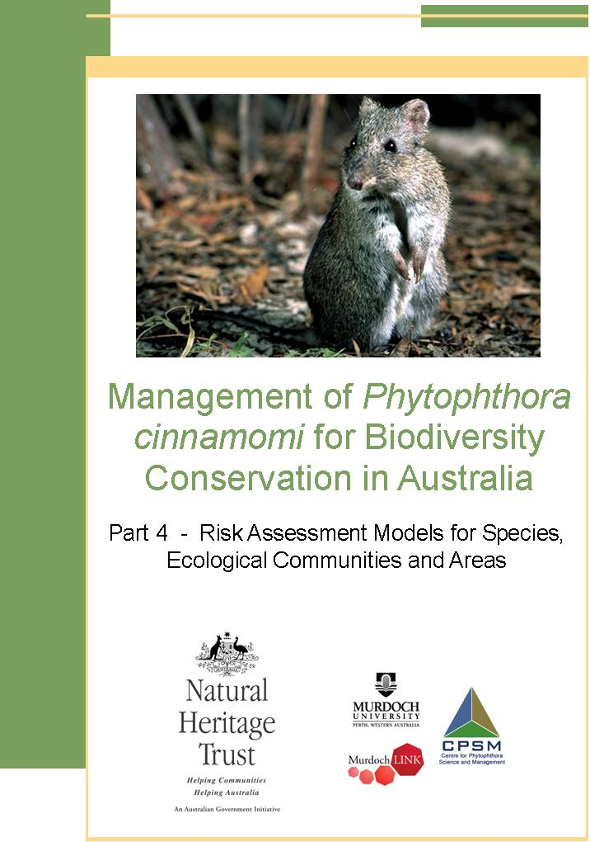

ACKNOWLEDGEMENTS

The Centre for Phytophthora Science and Management would like to thank the Project Reference Group (membership below) for their guidance and extensive input into these models.

Name | Agency | State
Hugh Bramwells | Department of Sustainability & Environment | Victoria
David Cahill | Deakin University | Victoria
Paul Gadek &  Stuart Worboys | James Cook University | Queensland
Keith McDougall | Department of Environment & Conservation | NSW & liaison with the ACT
Ian Smith | Department of Sustainability & Environment | Victoria
Tim Rudman | Department of Primary Industries, Water & Environment | Tasmania
Kevin Vear | Department of Conservation & Land Management | WA
Renate Velzeboer | Department of Environment & Heritage | SA

The Australian Government Department of the Environment and Heritage provided funding for this project, and the Centre for Phytophthora Science and Management would like to thank Ms. Belinda Parkes from the Department for her support throughout the project.

How to cite this document:
CPSM (2005) Management of Phytophthora cinnamomi for Biodiversity Conservation in Australia: Part 4 – Risk Assessment Models for Species, Ecological Communities and Areas. A report funded by the Commonwealth Government Department of the Environment and Heritage by the Centre for Phytophthora Science and Management, Murdoch University, Western Australia.

Cover photo Gilbert’s Potoroo, courtesy Dick Walker/Gilbert’s Potoroo Action Group.

TABLE OF CONTENTS

ACKNOWLEDGEMENTS i
1 INTRODUCTION 1
2 RECOMMENDATIONS FOR THE USE OF THE RISK ASSESSMENT MODELS 2
3 THE MODELS 6
3.1 Risk analysis model for susceptible species of flora 7
3.2 Risk analysis model for susceptible species of fauna 9
3.3 Risk analysis model for susceptible communities 11
3.4 Risk analysis model for management areas 13
3.4.1 Cost of Management Options for Extreme and High Risk Areas 17
4 REFERENCES 19
5 GLOSSARY 19

INTRODUCTION

Disease in natural ecosystems of Australia, caused by the introduced plant pathogen Phytophthora cinnamomi, is listed as a key threatening process under the Environment Protection and Biodiversity Conservation Act 1999 (EPBC Act). The Act requires the Australian Government to prepare and implement a threat abatement plan for nationally coordinated action to mitigate the harm caused by P. cinnamomi to Australian species, particularly threatened flora, fauna and ecological communities. The ‘National Threat Abatement Plan for Dieback Caused by the Root-Rot Fungus Phytophthora cinnamomi’ (NTAP) was released in 2001 (Environment Australia, 2001). The NTAP is designed to promote a common understanding of the national threat P. cinnamomi poses to biodiversity in Australia.
This project, funded by the Australian Government Department of the Environment and Heritage (DEH), is one of the most significant actions to be implemented from the NTAP to date. The project has two major components:
- to review current management approaches and identify benchmarks for best practice
- the development of risk assessment criteria and a system for prioritising management of assets that are or could be threatened by P. cinnamomi.

The project outputs are presented in a four-part document entitled Management of Phytophthora cinnamomi for Biodiversity Conservation in Australia:
Part 1 – A Review of Current Management
Part 2 – National Best Practice Guidelines
Part 3 – Risk Assessment for Threats to Ecosystems, Species and Communities: A Review
Part 4 – Risk Assessment Models for Species, Ecological Communities and Areas (this document).

This document describes the attached models for assessing the risk of P. cinnamomi to biodiversity in Australia. These models were developed after a review of previous and current studies, unpublished information and expert opinion (Part 3). Please refer to the recommendations presented in the next section before using the models.
- RECOMMENDATIONS FOR THE USE OF
THE RISK ASSESSMENT MODELS

The Australian Government Department of the Environment and Heritage (DEH) commissioned this project. The tender specifications for the risk assessment component of the project called for the development of a process and criteria suitable for national adoption, which supports the identification of the highest priority places in Australia for the management of P. cinnamomi by:
- considering the species, ecological communities and habitats under threat from P. cinnamomi
- using the EPBC Act list of threatened species and communities as a basis for making decisions
- considering an estimate of management costs and the potential effectiveness of control measures, and
- considering cost/benefit analysis methods to help compare the relative merits of different management approaches.

This section provides recommendations for the use, application and further testing of the risk assessment models presented in this document, as well as research and monitoring required to fill the significant gaps in knowledge identified during the development of the models.
Significant gaps in knowledge about the extent of the threat
There has been insufficient monitoring in all parts of Australia to determine the long-term ecological impacts of P. cinnamomi. The information available on the impact of ecosystem degradation on native fauna is particularly poor. The extent of the threat that P. cinnamomi poses to biodiversity is largely unknown in some parts of Australia, particularly the disease syndromes associated with the pathogen in the wet tropics of northern Qld and parts of NSW. The susceptibility of listed taxa to P. cinnamomi is simply not known in some States, including SA. Due to this lack of empirical data, many of the criteria in the risk assessment models require semi-quantitative or qualitative assessments.
The need for spatial information on risk factors
The collection and maintenance of data on the distribution of P. cinnamomi in the landscape has been, and continues to be a challenge. Consequently, data on the rate of spread of P. cinnamomi in various landscapes is scant. Mapping the location of infestations is expensive and complicated by cryptic disease expression in some States.
At the strategic level, understanding will be greatly facilitated by mapping parameters such as: the areas suitable for the establishment and persistence of P. cinnamomi; the presence of susceptible vegetation; the distribution of P. cinnamomi; and possibly other factors that can influence management, for example land tenure. The identification of management priorities using the risk assessment models developed in this project is an exercise at an operational scale and should form part of a broader planning framework, in which there is a good understanding of the threat P. cinnamomi poses at a strategic level (Figure 2.1).
To date strategic scale maps have been produced in Tasmania (DPIWE website – GTSpot User Guide, accessed 03/03/05); Victoria (Gibson et al. 2002); for the Wet Tropics World Heritage Area of northern Queensland (Gadek et al. 2001); and for the south coast region of WA by the South Coast Regional Initiative Planning Team (SCRIPT) NRM Region. Each differs in the scale and according to the quantity and quality of the data available to the process.
Gaps in knowledge about the effectiveness of control measures
Management costs are provided in the models for a range of options, and approximate costs of management appropriate for an area can thus be calculated. The benefits, in terms of reducing the spread and impact of the pathogen, cannot be calculated as data on the effectiveness and efficiency of the various management options is unavailable. This gap in knowledge has been identified in numerous reviews in the past, including the National Threat Abatement Plan, and has been identified during this project as an impediment to many aspects of management including the development of a risk assessment process.
As part of the consultation process on Part 1 – National Best Practice Guidelines, stakeholders were asked what impediments existed to the uptake of on-ground management measures. One stakeholder, reflecting the concerns of others, indicated that they ‘would be unlikely to invest in Phytophthora management based on what is known on the effectiveness of management techniques’ and would require a ‘full analysis of the costs and benefits’ to the industry before management measures were adopted.
Appropriate use of the models
A significant issue throughout this process has been the identification of the appropriate audience for these models. Initially, there was an expectation that the models would be used by DEH to facilitate decisions on national funding for the protection of environmental assets/values under threat from P. cinnamomi.
As the project progressed, however, it became apparent that most of the funding necessary for the management of prioritised assets will need to come from Natural Heritage Trust funds, the second round of which is being delivered through the Natural Resource Management Regions in each State (please visit http://www.nrm.gov.au/ for further information on this process).
Concerns have been raised in other pest management programs about setting priorities at a regional level, which have the potential to result in the inconsistent management of threats that are a State-wide problem. Similarly, the NTAP calls for areas to be ranked on a ‘nationally consistent basis’ to ensure the benefits from limited funding are maximised.
Further testing of the models
The risk assessment models have been developed and have undergone preliminary testing with data from all affected States. However, the timeframe of the project did not allow the level of robust testing that will be required to refine the models.
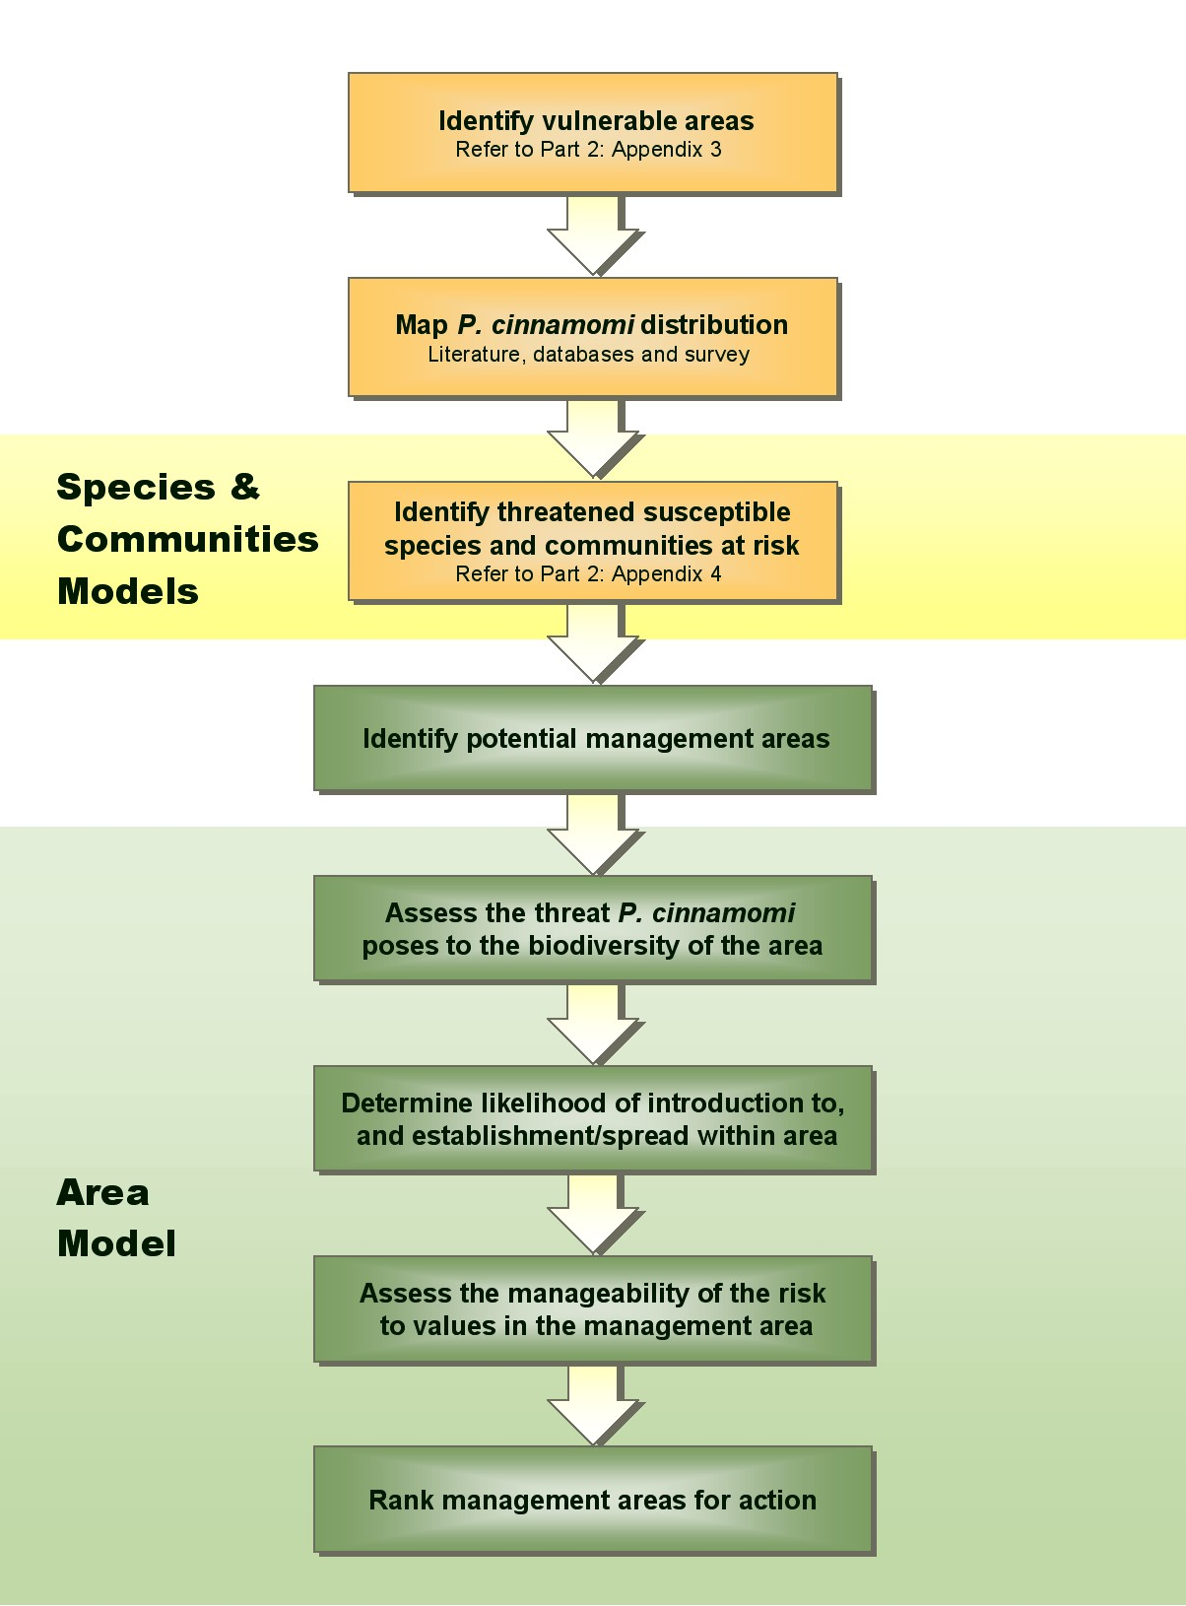

Figure 2.1 The risk assessment models developed in this document, in the context of the broader strategic planning framework in which they should ideally operate.

Recommendations
Recommendation 1: In the next 12 months further testing of the models is undertaken by an appropriately experienced team or individual. Testing should be undertaken initially in Western Australia and Tasmania where datasets are currently the most comprehensive, to ensure that the algorithms work over a range of sites and threatened taxa.
Recommendation 2: National and State funding of research to give highest priority to addressing significant gaps in basic knowledge about the extent of the threat P. cinnamomi poses to flora and fauna in Australia.
Recommendation 3: Each State/Territory affected by P. cinnamomi to compile and develop GIS layers with currently available data such as: the distribution of vulnerable vegetation; the distribution of threatened species; land use and vector intensity; and where possible distribution P. cinnamomi and/or symptoms of disease.
Recommendation 4: The risk assessment models are used to undertake strategic planning to identify a single set of P. cinnamomi management priorities for each affected State.
Recommendation 5: That DEH, the key State Government conservation and land management agencies, and relevant NRM Councils and Regions work together to develop appropriate investment, management and implementation programs for the priorities identified.
Recommendation 6: Establish programs to monitor the effectiveness of current management options to facilitate cost/benefit analysis of management.

3 THE MODELS

Four models (flora species, fauna species, communities and management areas) have been developed to calculate rankings for the risk of P. cinnamomi. The models were developed by the CPSM and the Project Reference Group. Examples are provided for each model. Resources can be prioritised for those species, communities and areas most at risk. Before using the models, the following issues should be considered:
- The models are for use on species and communities that occur in areas that are vulnerable to P. cinnamomi (i.e. where rainfall and temperature are conducive to disease).

If it is unknown if an area is infested with P. cinnamomi then consider it uninfested until proven otherwise and apply the appropriate management prescriptions (Part 2 – National Best Practice Guidelines).

The results from these models should be accompanied by an estimate of how information was obtained to complete the data set. The degree of uncertainty should be explicitly described with relationship to priority listings. Estimate the percentage of scores that were determined from published data, unpublished data, expert opinion or best guess and include in the spreadsheet. This will highlight gaps in knowledge and will allow the models to be used to monitor species and community health over time.
  - Where prospects for the management of values at extreme risk are low ex situ conservation is imperative.
Management options should be assessed on the basis of the extent of risk reduction, and the extent of any additional benefits derived from it. Where large reductions in risk may be obtained with relatively low expenditure, such options should be implemented. Further options for improvement may be uneconomic and judgement needs to be exercised as to whether they are justifiable.

3.1 Risk analysis model for susceptible species of flora
The plant species should be assessed over its whole range.

Column A Flora species
List the species to be ranked.

Column B EPBC status (IUCN category)
Determine the conservation status of the species (EPBC, State legislation or if not currently listed use IUCN criteria [http://www.iucn.org/themes/ssc/iucnredlists/ssc-rl-c.htm]). The status is not used in the calculations but can be used to help prioritise the ranked data.

Column C Risk Ranking
A rank of Extreme, High, Medium or Low is determined automatically from the risk score. Arbitrary boundaries have been set for these categories.
Risk (R) is calculated as: R = ∑ ( [E, F, G] × I + H ) / J

where E = number of populations (score)
F = populations on infested sites or on sites likely to become infested in the next 10 years (%)
G = percentage of plants on infested sites (%)
H = other values (score)
I = susceptibility of species (score)
J = populations in refugia (%)

Calculate the risk Phytophthora cinnamomi poses to the species

Column E Number of populations
Determine the number of existing populations and use the category score.

Column F Populations on infested sites or on sites likely to be infested in the next 10 years
Estimate the percentage of the populations that occur on infested sites and include those that are on sites that are likely to be infested in the next 10 years. When estimating the likelihood of infestation occurring within the next 10 years, consider:
- the proximity to an infested area. Sites are likely to become infested in the next 10 years where the closest infestation is within 1-2km.
- the impact of current land use, in particular the frequency of soil transfer (e.g. large soil transfers are caused by activities like road maintenance, construction, and mining or extractive industries). The frequency of activities such as horse riding and off road vehicle driving should also be considered.

Column G Plants on infested sites
Estimate the total percentage of plants that occur on currently infested sites

Column H Other Values
Take into account other factors that characterise the species being assessed, and determine if disease will result in significant losses. For example, the susceptible species may be considered iconic or culturally significant or may be a common overstorey or keystone species. Loss of a keystone species can result in impacts to other species. The economic impacts of P. cinnamomi can include losses in forestry production, tourism, flower harvesting and apiculture, as well as lost opportunities for pharmaceutical prospecting. Species can have more than one ‘Other Values’, so these scores are additive.

Column I Susceptibility of species
Assess the susceptibility of the species using the known host list provided in Part 2 – National Best Practice Guidelines, Appendix 4. Determine if the impact of P. cinnamomi is significant on this plant species, if so, the species are listed as moderately or highly susceptible. When plants are determined to be variably susceptible, or deaths are commonly observed which may be caused by P. cinnamomi, or the communities are threatened and the extent of susceptibility to P. cinnamomi is unknown classify these as moderately susceptible.
If plants species do not appear in the list are compare to other species of the same genera in Part 2 – National Best Practice Guidelines, Appendix 4. If that genera have not been previously studied and there is no evidence to suspect that P. cinnamomi is causing deaths in populations under consideration then assume low susceptibility.

Column J Populations in refugia
In this column, estimate the percentage of the populations that occur in refugia (i.e. areas where P. cinnamomi is not likely to be active because of environmental constraints). For example, these may be areas of suppressive soils or areas where drainage disfavours the pathogen.

Column K and onwards
These columns are intended for the user’s notes on the species. In the examples provided details on the number of populations and total number of plants, the geographic range of the species and its area of occupancy are included.

3.2 Risk analysis model for susceptible species of fauna
The species should be assessed over its whole range.

Column A Fauna species
List the species to be assessed.

Column B EPBC status (IUCN category)
Determine the conservation status of the species (EPBC, State legislation or if not currently listed use IUCN criteria [http://www.iucn.org/themes/ssc/iucnredlists/ssc-rl-c.htm]). The status is not used in the calculations but can be used to help prioritise the ranked data.

Column C Risk Ranking
A rank of Extreme, High, Medium or Low is determined from the risk score. Arbitrary boundaries have been set for these categories.
Risk (R) is calculated as: R = ( ∑ [E, F, G] × ∑ [K, L, M] + H ) / I

where ∑(K, L, M) ≤10
E = number of populations (score)
F = populations on infested sites or on sites likely to become infested in the next 10 years (%)
G = habitat on infested sites (%)
H = other values (score)
I = populations in refugia (%)
K = decline in vegetation structure due to P. cinnamomi infestation (score)
L = decline in food availability (score)
M = decline in nesting sites (score).

Calculate the risk Phytophthora cinnamomi poses to the fauna species

Column E Number of populations
Determine the number of existing populations and use the category score.

Column F Populations on infested sites or on sites likely to be infested in the next 10 years
Estimate the percentage of the populations on that occur on infested sites and consider:
  - predicted decline of the animal species
  - predicted decline of populations
  - probability of the species becoming extinct.
Estimate the likelihood of infestation occurring within the next 10 years by considering:
- the proximity to an infested area. Sites are likely to become infested in the next 10 years where the closest infestation is within 1-2km.
- the impact of current land use, in particular the frequency of soil transfer (e.g. large soil transfers are caused by activities like road maintenance, construction, and mining or extractive industries). The frequency of activities such as horse riding and off road vehicle driving should also be considered.

Column G Habitat on infested sites
Estimate the percentage of habitat that occurs on currently infested sites.

Column H Other values
Take into account other intrinsic values that define the species being assessed or if infestation will result in significant losses. For example, the susceptible species may be considered iconic or culturally significant, economic loss may be likely, common overstorey or keystone species could be susceptible or there may be a drastic decline in population. Species can have more than one ‘Other Values’, so these scores are additive.

Column I Populations in refugia
Ascertain the percentage of the populations that occur in refugia (i.e. areas where P. cinnamomi is not likely to be active because of environmental constraints). For example, these may be areas of suppressive soils or areas where drainage disfavours the pathogen.

Calculate the risk Phytophthora cinnamomi poses to the habitat

Gauge the effect of P. cinnamomi on the key habitat values – food and protection. In some instances the habitat may be degraded but still habitable, while in extreme circumstances the affected vegetation may be uninhabitable. Consider keystone species of the habitat that may be affected, any increase in bare ground and a decrease in litter cover that may affect foraging, nesting and general habitat quality.

Column K Loss of protective cover
Consider the quality of the habitat in relation to the decline in vegetation structure and canopy cover. Degraded habitat refers to the loss of >50% of cover (at least in the short term) because of P. cinnamomi.

Column L Decline in food availability
Consider the quality of the habitat in relation to the decline in food availability including nectar, pollen, seeds, fungi and invertebrates. Degraded food source refers to a loss of >50% of food availability (at least in the short term) because of P. cinnamomi.

Column M Decline in nesting sites
Consider the quality of the habitat in relation to the decline in tree hollows and other nesting sites. Degraded habitat refers to a loss of >50% of nesting sites (at least in the short term) because of P. cinnamomi.

3.3 Risk analysis model for susceptible communities

Column A Communities
List the communities to be assessed.

Column B EPBC status (IUCN category)
Determine the conservation status of the species (EPBC, State legislation or if not currently listed use IUCN criteria [http://www.iucn.org/themes/ssc/iucnredlists/ssc-rl-c.htm]).

Column C Risk Ranking
This rank of Extreme, High, Medium or Low is determined from the risk score. Arbitrary boundaries have been set for these categories. This is automatically calculated as data are entered.

Risk (R) is calculated as: R = ∑ (E, F, G) × K + I + J
where E = number of patches (score)
F = patches on infested sites or on sites likely to become infested in the next 10 years (%)
G = patches in refugia (%)
I = other values (score)
J = structural change (score)
K = susceptibility of species in community (score)

Calculate the likelihood that Phytophthora cinnamomi poses a risk to the community

Column E Number of Patches
Determine the number of patches that exist in areas vulnerable to P. cinnamomi.

Column F Patches on infested sites or on sites likely to be infested in the next 10 years
Estimate the percentage of patches on that occur on infested sites and consider:
  - predicted decline of the flora/fauna species
  - predicted decline of populations
  - probability of the species becoming extinct.

Estimate the likelihood of infestation occurring within the next 10 years by considering:
- the proximity to an infested area. Sites are likely to become infested in the next 10 years where the closest infestation is within 1-2km.
- the impact of current land use, in particular the frequency of soil transfer (e.g. large soil transfers are caused by activities like road maintenance, construction, and mining or extractive industries). The frequency of activities such as horse riding and off road vehicle driving should also be considered.

Column G Patches in refugia
Ascertain the percentage of the populations that occur in refugia (i.e. areas where P. cinnamomi is not likely to be active because of environmental constraints). For example, these may be areas of suppressive soils or areas where drainage disfavours the pathogen.

Calculate the consequences of Phytophthora cinnamomi infestation to the community

Column I Other Values
Take into account other factors that define the community being assessed or if infestation will result in significant losses. For example, the susceptible species may be considered iconic or culturally significant, economic loss may be likely, common overstorey or keystone species could be susceptible or there may be a drastic decline in population. Communities can have more than one ‘Other Values’, so these scores are additive.

Column J Structural change in community due to P. cinnamomi infestation
Assess the impact that P. cinnamomi has on vegetation structure and canopy cover, considering each of the key structural layers in vegetation communities. Assess the number of vegetation layers and how each is affected, considering keystone species of the habitat that may be affected. Degraded refers to the loss of >50% of community structure (at least in the short term) because of P. cinnamomi.

Column K Susceptibility of species in community (% of species commonly killed by P. cinnamomi)
Assess the susceptibility of the species using known host list (refer to Part 2 – National Best Practice Guidelines, Appendix 4) as:
- greater than 25% of species commonly killed by P. cinnamomi
- between 5 and 25% of species commonly killed by P. cinnamomi
- or less than 5% of species commonly killed by P. cinnamomi.

3.4 Risk analysis model for management areas
To complete the dataset for this model, knowledge of the susceptibility of the species, pathogen distribution, climate and environmental conditions conducive to disease are required. Data deficiencies for this model indicate that surveys or research is required to complete the necessary datasets.

To define management areas, species and communities that have extreme or high rankings in other models are to be mapped with the most important populations or communities highlighted (rather than try to address all sub/populations). Areas of a manageable size need to be identified. The user should realise the highest level of management possible to reduce the probability of an introduction and the spread within an area, and utilise this information to set the boundaries of the management area. The aim is to ‘protect the protectable’. Thus, areas that contain P. cinnamomi within them should only be selected when it is not feasible to locate any P. cinnamomi free areas. The boundaries will be set to most tightly control P. cinnamomi vectoring.

When defining management areas, only the most intact areas and assets should be considered – i.e. areas that have other significant threats such as weed invasion, salinity or severe degradation should not be considered if no other action is being taken to mitigate the other threats. Any large areas of disease free vegetation that are highly susceptible should be included.

Column A Management Areas
Manageability of land areas is important and will be quite different in different landscapes. A management area can be any size, shape, whole or subset of a larger region as long as it is meaningful in a management context.

Column B Values
The rank of High, Medium or Low is determined from the risk score for values. Arbitrary boundaries have been set for these categories. This is automatically calculated as data are entered.
Values is calculated as: Values = ∑ (F, G, H, I, J, K, L)
where F = population of EPBC endangered species that are moderately or highly susceptible in management area (score)
G = populations of EPBC endangered communities that are susceptible to P. cinnamomi (score)
H = EPBC vulnerable species that are moderately or highly susceptible to P. cinnamomi (score)
I = State (ex EPBC) threatened species and communities that are moderately or highly susceptible (score)
J = other non-listed species and communities that are moderately or highly susceptible to P. cinnamomi (score)
K = Other Values (score)
L = the size of the management area (score)

Column C Likelihood
The rank of High, Medium or Low is determined from the risk score for values. Arbitrary boundaries have been set for these categories. This is automatically calculated as data are entered.
Likelihood is calculated as: Likelihood = N × ∑ (O, P, Q, R, S, T, U, V)
where N = vulnerable area infested (%)
O = the distance to closest P. cinnamomi infestation (score)
P = the distribution of P. cinnamomi in the landscape (score)
Q = the presence of natural buffers (score)
R = the landscape relief (score)
S = likelihood of spread due to low risk activities (score)
T = likelihood of spread due to medium risk activities (score)
U = likelihood of spread due to high risk activities (score)
V = likelihood of spread due to access risk (score)

Column D Risk (Values x Likelihood)
The rank of Extreme, High, Medium or Low is determined by multiplying the scores for Values and Likelihood. Arbitrary boundaries have been set for these categories.

Calculate the risk Phytophthora cinnamomi poses to the Values

Column F Populations of EPBC endangered species in management area that are moderately or highly susceptible to P. cinnamomi
Determine the number of populations of EPBC listed endangered species that are moderately or highly susceptible to P. cinnamomi and occur in the management area.

Column G Populations of EPBC endangered communities that are susceptible to P. cinnamomi
Determine the number of populations of EPBC listed endangered communities that are susceptible to P. cinnamomi and occur in the management area.

Column H EPBC vulnerable species that are moderately or highly susceptible to P. cinnamomi
Determine the number of populations of EPBC listed vulnerable species that are moderately or highly susceptible to P. cinnamomi and occur in the management area.

Column I State (ex EPBC) threatened species and communities that are moderately or highly susceptible to P. cinnamomi
Determine the number of populations of state listed (e.g. FFG Act, Victoria) endangered species and communities that are moderately or highly susceptible to P. cinnamomi and occur in the management area that are not already listed under EPBC.

Column J Other species and communities that are moderately or highly susceptible to P. cinnamomi
Determine the remaining number of populations of threatened species and communities that are susceptible to P. cinnamomi and occur in the management area.
Column K Other values
Take into account other factors that define the community being assessed or if infestation will result in significant losses. The susceptible species may be considered iconic or culturally significant, economic loss may be likely (e.g. decline in tourism due to reduced aesthetics and amenity values, or the decline in local industry due to reduced commercial values), or the management area may be within a biosphere, reserve, world heritage area or a dedicated conservation reserve. Areas can have more than one ‘Other Values’, so these scores are additive.

Column L Size of management area
Place the highest value on large disease free areas as there is generally more to lose if the area is large than if it is small.

Calculate the likelihood of spread of Phytophthora cinnamomi in the
management area

To quantify the risk to the area assess the likelihood of the arrival or establishment and/or the spread of P. cinnamomi. What is happening outside the boundary of the management area must also be taken into account.

Column N Vulnerable area infested
Determine the percentage of the area that is vulnerable to infestation by P. cinnamomi. There may be obvious parts of the management area that are not vulnerable, for example, sand dunes and large rock outcrops.

Column O Closest P. cinnamomi to management area
Determine the distance to the nearest P. cinnamomi infestation to the management area.

Column P Position of P. cinnamomi in management area
Within the management area determine if the infestation occurs high or low in the landscape, or in the middle or on the periphery of the area. Both vectored and autonomous spread are accounted for in this column.

Column Q Presence of natural buffers
Are there natural buffers that reduce the likelihood of spread of P. cinnamomi such as rivers, creeks or sharp ridgelines, or where the underlying geology results in soils that are not conducive to the establishment and proliferation of the pathogen, or areas of resistant vegetation that is not traversed by roads or tracks with uncontrolled access?

Column R Landscape relief
Ascertain if the relief of the landscape is greater than 100m.

Column S Likelihood of spread due to low risk activities
Determine the frequency of activities such as bushwalking, orienteering and mountain bike riding. Animal vectors such as feral pigs, foxes, cats, goats and rabbits should also be considered as low risk activities that occur in the management area.

Column T Likelihood of spread due to medium risk activities
Determine the frequency of activities such as vehicles (including trail bikes), horse riding and natural resource harvesting (flowers and apiculture).

Column U Likelihood of spread due to high risk activities
Determine the frequency of high risk activities such as mining or extractive industries, and any activity where movement of large volumes of soil occurs such as in the construction and maintenance of fire breaks, fencing, utilities, paths and roads, and logging.

Column V Access risk
Determine the extent of risk that access poses to the management area. The more tracks and roads (sealed and unsealed) within the habitat of threaten species or the endangered community, the higher the threat of P. cinnamomi spread.

Calculate the ability to reduce the spread (or inhibit the introduction) of Phytophthora cinnamomi within the management area

For each management area you need to determine which management options are applicable (Columns X to AB). Areas ranked as Extreme or High Risk (Column D) need to be evaluated further to determine the level of management that can be achieved. A summary of expected outcomes for each of the following management options should be included in Columns AG to AK.

In addition, for each management area it is important to ascertain if the management plan addresses the threat of P. cinnamomi, if there are co-operative land managers, and there is governance potential. Determine if there are resources already available for management (i.e. staff dedicated to P. cinnamomi control or community group committed to P. cinnamomi management). Where there are no practicable management options for a management area all endangered species should be conserved utilising ex-situ conservation (e.g. germplasm and translocation).

Column X Can you restrict access within habitat of threatened species or endangered communities?
Ascertain if access can be removed or if the risk posed by access can be managed. Access can also be redistricted by reducing the length and number of roads and tracks in the management area. It may be more difficult to restrict access to areas that are readily accessible and popular, as public opposition is likely to lead to breaches in areas of restricted access. Areas of high potential for management are remote areas and/or places where opposition to restricted access is likely to be low.

Column Y Can you modify activities within the area?
Consider the activities listed in columns S to U and determine whether these activities can be reduced or eliminated. Determine the potential for hygiene protocols to prevent spread of the disease. Establish which areas have a high prospect of breaches or failure of hygiene. Management potential would be high in areas; where there is little or no human activity, where activities are low risk, or where activities can be eliminated.

Column Z Can you improve or move roads/tracks?
The risk of spreading the disease can be reduced by improving road surfaces, their drainage and in some cases moving roads to less sensitive parts of the management areas (i.e. not higher in the landscape than the susceptible areas, avoiding wet areas, or away from highest risk areas). The length of roads and tracks may be reduced and alternative pathways could be installed (e.g. boardwalks). Refer to Part 2 – National Best Practice Guidelines, Table 5.4.

Column AA Can you amend the drainage?
Determine if it is possible to make changes in drainage in the landscape to prevent infection spread.

Column AB Do the values (columns F-J) under imminent threat respond to phosphite?
Can the threatened plant species or communities be treated with phosphite?

To rank the data

Sort the data by column D - Risk (Values x Likelihood).

Extreme and High Risk Management Areas

Transfer areas ranked Extreme and High Risk in the Areas model to the 5th spreadsheet and provide a brief narrative on the overall prospects for risk reduction in the management area to identify those areas where the greatest reduction of risk can be achieved.

3.4.1 Cost of Management Options for Extreme and High Risk Areas
Cost may be the final deciding factor when prioritising management and so risk assessment models would ideally include cost benefit analyses. The role of cost benefit analyses is to provide information to the decision maker that compares the relative merits of different management approaches. It is intended to inform the decision making process not to replace it.
A full cost benefit analysis of P. cinnamomi management is not currently possible, as there is a lack of information on the efficacy and financial benefits of the management options available. This is a significant knowledge gap which requires immediate attention as it has the potential to hamper the uptake of P. cinnamomi management.
To assist with management planning, however, the costs of a range of management options are provided in the 5th spreadsheet. These costs will enable approximate costs for management of specific risks to be calculated for each management area and will assist in the decision making process, especially when all other factors are equal.
4 REFERENCES

DPIWE website (Tasmanian Government Department of Primary Industries, Water and Environment) - GTSpot User Guide: http://www.gisparks.tas.gov.au/

Gadek PA, Gillieson D, Edwards W, Landsberg J, Pryce J (2001) Rainforest Dieback Mapping and Assessment in the Wet Tropics World Heritage Area. Schools of Tropical Biology, Tropical Environmental Studies, Geography and the Rainforest CRC. James Cook University, Cairns.

Gibson M, Milne R, Cahill D, Wilson B (2002) Preliminary review of the actual and potential distribution of Phytophthora cinnamomi dieback in parks and reserves across Victoria. Report to Parks Victoria. Centre for Environmental Management, University of Ballarat.

5 GLOSSARY

culturally significant
qualities and attributes possessed by areas that have aesthetic, historic, scientific or social value for past, present and future generations (and may include places and physical features, people’s associations with or feelings for a plant species, community or area, or cultural practices, knowledge, songs and stories).

community
a mappable vegetation unit – i.e. a group of plants and animals living and interacting with one another in a specific region under relatively similar environmental conditions.

consequence
the outcome of an event expressed qualitatively or quantitatively, being a loss, injury, disadvantage or gain (From: AS/NZS ISO 14001, 1996 - Environmental Management Systems – Specifications with guidance for use. Standards Australia, Homebush, NSW and Standards New Zealand, Wellington).

dedicated conservation reserve
areas for which there is a statutory responsibility to protect biodiversity (e.g. national parks, state reserves, and world heritage areas.

iconic
areas which are considered symbolic, or species that are emblems (e.g. world heritage listed areas, biospheres and reserves).

likelihood
a qualitative or quantitative description of probability or frequency.

patches
examples of plant communities that are separated from each other by patches of different plant communities.

population/subpopulation
geographically or genetically distinct groups of the total population.

refugia
an area in which a susceptible plant species occurs but where P. cinnamomi is unlikely to be active.

risk
the chance of something happening that will have an impact upon management objectives. It is measured in terms of consequences and likelihood.

risk analysis
a systematic use of available information to determine how often specified events may occur and the magnitude of their consequences.

risk assessment
the overall process of risk analysis and risk evaluation (the process of determining the risk that disease poses to plant species, communities and areas).

risk management
the culture, processes and structures that are directed towards the effective management of potential opportunities and adverse effects.

