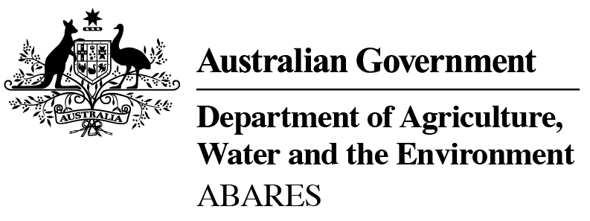

**Pathways to sustainable and productive agriculture: an Australian perspective**

## Dr Steve Hatfield-Dodds

#### Executive Director

**Australian Bureau of Agricultural**

**and Resource Economics and Sciences**

28 October 2020

S Hatfield-Dodds, J Greenville, K Burns and R Downham, 2020, *Pathways to sustainable and productive agriculture – An Australian perspective*, Notes prepared for webinar on EU– Australia Farming: One goal but many paths to sustainability on 28 October 2020, ABARES, Canberra.

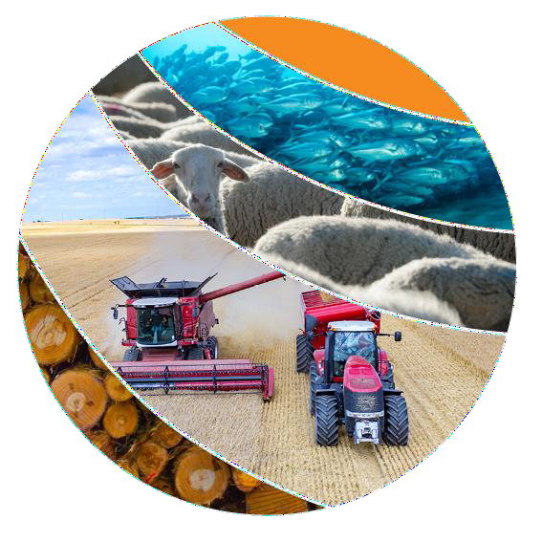Research by the

Australian Bureau of Agricultural and Resource Economics and Sciences

© Commonwealth of Australia 2020 Ownership of intellectual property rights

Unless otherwise noted, copyright (and any other intellectual property rights, if any) in this publication is owned by the Commonwealth of Australia (referred to

as the Commonwealth). Creative Commons licence

All material in this publication is licensed under a Creative Commons Attribution 4.0 International Licence except content supplied by third parties, logos and the Commonwealth Coat of Arms.

Inquiries about the licence and any use of this document should be emailed to [copyright@awe.gov.au](mailto:copyright@awe.gov.au).



##### Cataloguing data

This publication (and any material sourced from it) should be attributed as: Hatfield-Dodds, S Greenville, J, Burns, K & Downham, R 2020, Pathways to sustainable

and productive agriculture: an Australian perspective, ABARES Conference Paper, Canberra, October, DOI: [https://doi.org/10.25814/2twd-0018.](https://doi.org/10.25814/2twd-0018) CC BY 4.0. ISSN 1447-3666

Australian Bureau of Agricultural and Resource Economics and Sciences (ABARES) GPO Box 858 Canberra ACT 2601

Telephone 1800 900 090 Web awe.gov.au

##### Disclaimer

The Australian Government acting through the Department of Agriculture, Water and the Environment, represented by the Australian Bureau of Agricultural and Resource Economics and Sciences, has exercised due care and skill in preparing and compiling the information and data in this publication. Notwithstanding, the Department of Agriculture, Water and the Environment, ABARES, its employees and advisers disclaim all liability, including liability for negligence and for any loss, damage, injury, expense or cost incurred by any person as a result of accessing, using or relying on any of the information or data in this publication to the maximum extent permitted by law.

##### Professional independence

The views and analysis presented in ABARES publications, including this one, reflect ABARES professionally independent findings, based on scientific and economic concepts, principles, information and data. These views, analysis and findings may not reflect or be consistent with the views or positions of the Australian Government, or of organisations or groups who have commissioned ABARES reports or analysis. More information on professional independence is provided on the ABARES website.

2

# Australian biodiversity and ecosystems are unique and globally significant

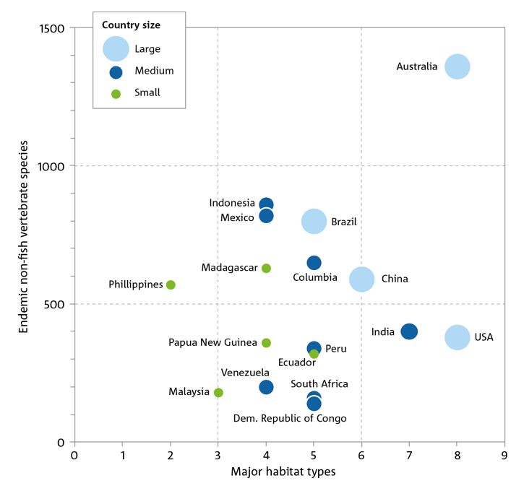***Australia has globally distinctive biodiversity Australia is around three-quarters the size of Europe***

* Australia is renowned for its globally distinct ecosystems, made up of diverse flora and fauna.
* Our biodiversity is highly regarded for its diversity, endemism, and evolutionary adaptations.
* Australia is considered one of the world’s 17 megadiverse countries, which together account for 70% of the world’s biological diversity across less than 10% of the world’s surface.
* Around 150,000 species have been formally described in Australia, but this is only about 25% of the total number present.
* Australia has many different climates zones primarily due to the vast size of the continent—equatorial, tropical, subtropical, desert, grassland, and temperate.
* Australia’s land mass is around three-quarters the size of Europe (Aus: 7,692,024 km2 ; Europe: 10,180,000 km2).

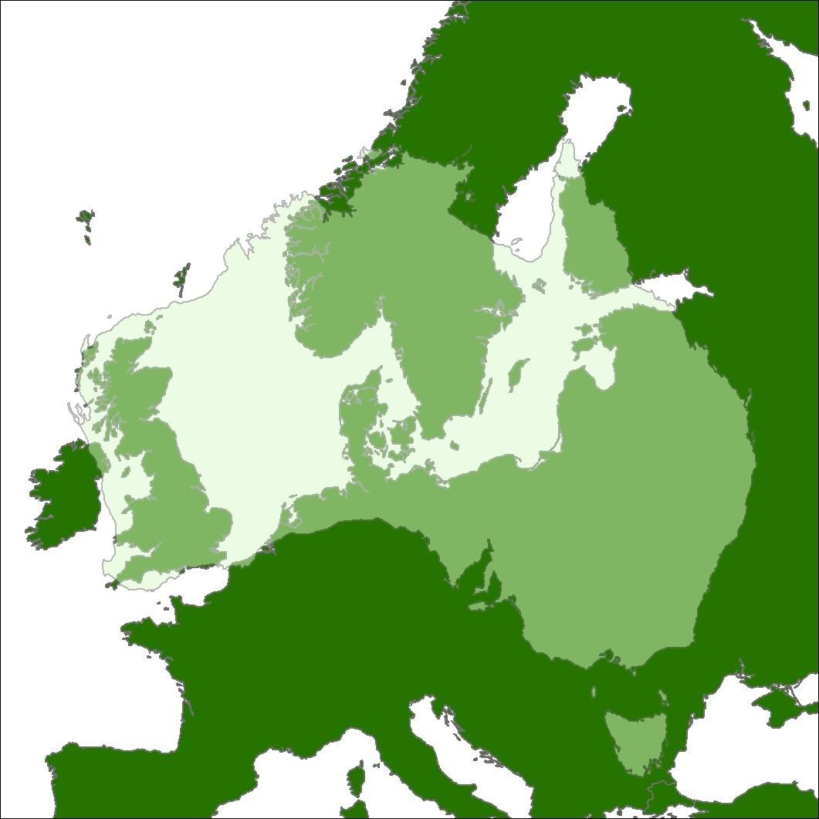

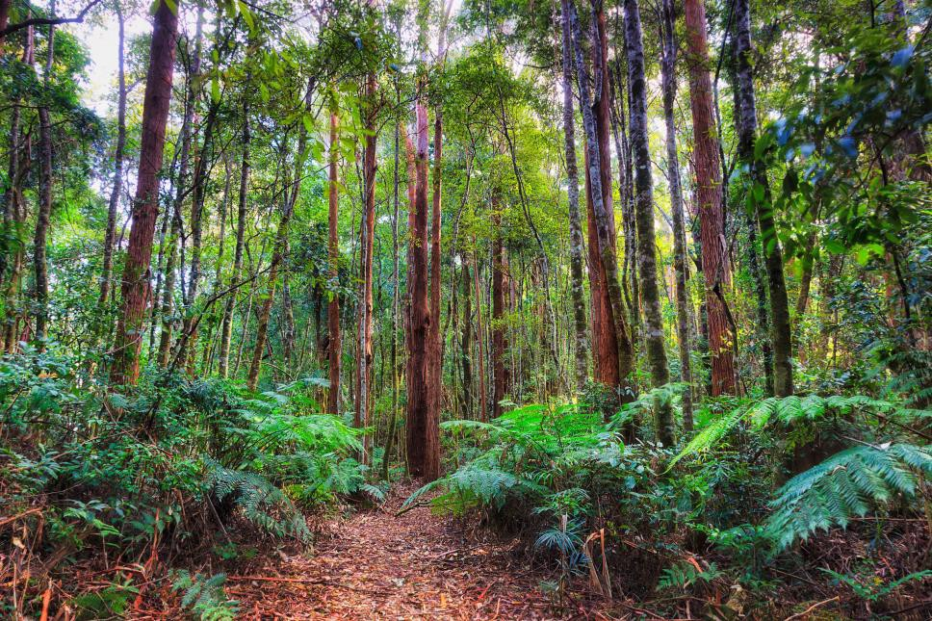

Cresswell, ID & Murphy, HT 2017, [Australia State of the Environment 2016: Biodiversity](https://soe.environment.gov.au/download/reports), Australian Government Department of the Environment and Energy, Canberra.

Hatfield-Dodds et al. 2015, [Australian National Outlook 2015: Economic activity, resource use, environmental performance and living standards, 1970-2050](https://publications.csiro.au/rpr/pub?pid=csiro%3AEP154878), CSIRO, Canberra. 3

# Australian agriculture produces high-quality food and fibre, focusing on minimally processed products

* Agriculture accounts for 11% of Australia’s good and services exports, 2.2% of value added (GDP), and 2.6% of employment in 2018–19.
* Australia exports around 70% of the total value of agriculture, fisheries and forestry production (around $49 billion in 2018–

19) and is the 12th largest global agricultural exporter.

* The mix of Australian agricultural activity is determined by

climate, water availability, soil type and proximity to markets.

* + Livestock grazing is widespread, occurring in most areas of Australia.
  + Cropping and horticulture are generally concentrated in more southern areas relatively close to the coast.
* Agricultural production is growing—the value of agriculture, fisheries and forestry production has increased by 19% in the past 20 years in real terms (adjusted for inflation), from approximately $58 billion in 1999–2000, to around $69 billion in 2018–19.
* Economic performance is driven by the largest and most productive farms.
  + A range of factors has seen large farms (with receipts above

$1 million per year in real terms) grow from around 3% to around 15% of the farm population over the last four decades.

* + Meanwhile, their share of output has increased from 25% to around 58% of the value of output.
* Australian farmers have historically achieved strong productivity growth.
  + Agricultural productivity growth has been comparable to competing farmers in other high-income countries and faster than most other sectors of the Australian economy.
  + This growth has been driven by improvements in technology and structural change.

***Agriculture, fisheries and forestry value of production, by commodity, 2018–19***

***Agriculture, fisheries and forestry exports by destination, 1999–2000 to 2018–19***

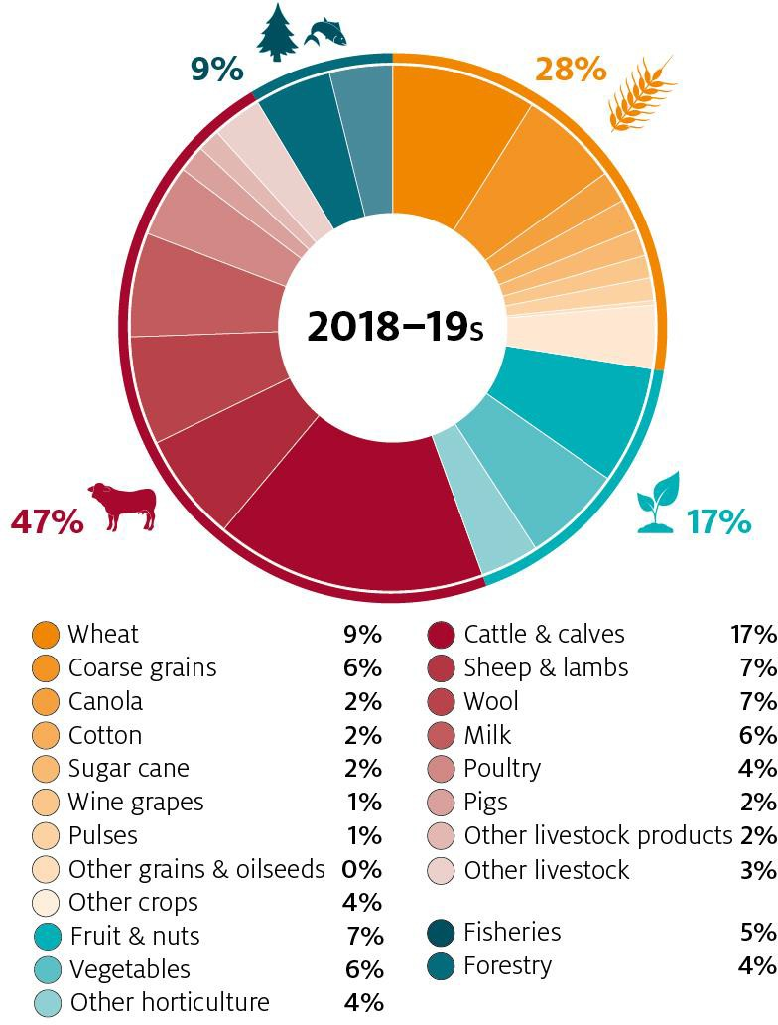 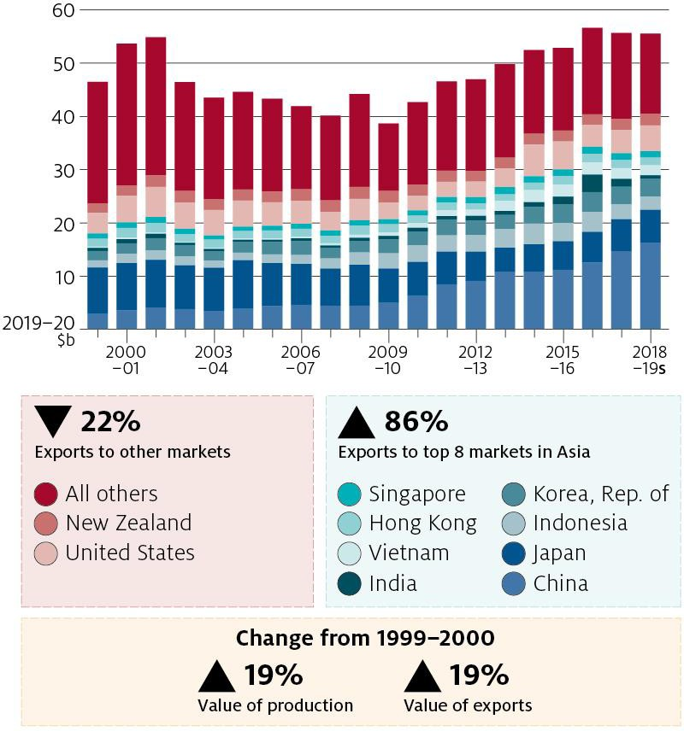

***Agriculture, fisheries and forestry production, 1999–2000 to 2018–19***

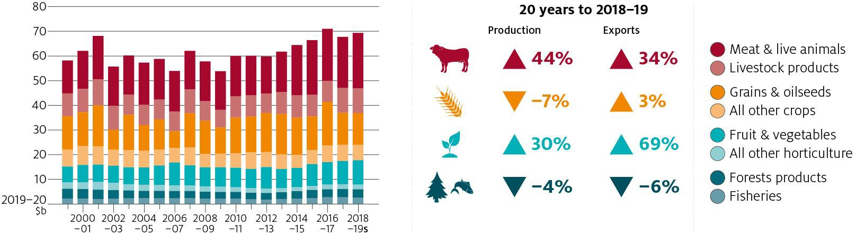

Jackson, T, Zammit, K & Hatfield-Dodds, S 2020, [Snapshot of Australian Agriculture 2020](https://www.agriculture.gov.au/abares/publications/insights/snapshot-of-australian-agriculture-2020), ABARES, Canberra.

Greenville, J 2019, [Australia’s place in global agriculture and food value chains](https://www.agriculture.gov.au/abares/publications/insights/global-agriculture-and-food-value-chains), ABARES, Canberra. 4

# Strengths in sustainability:

**Australian agriculture works with nature, not against it**

***Australia’s climate and agricultural output value is more***

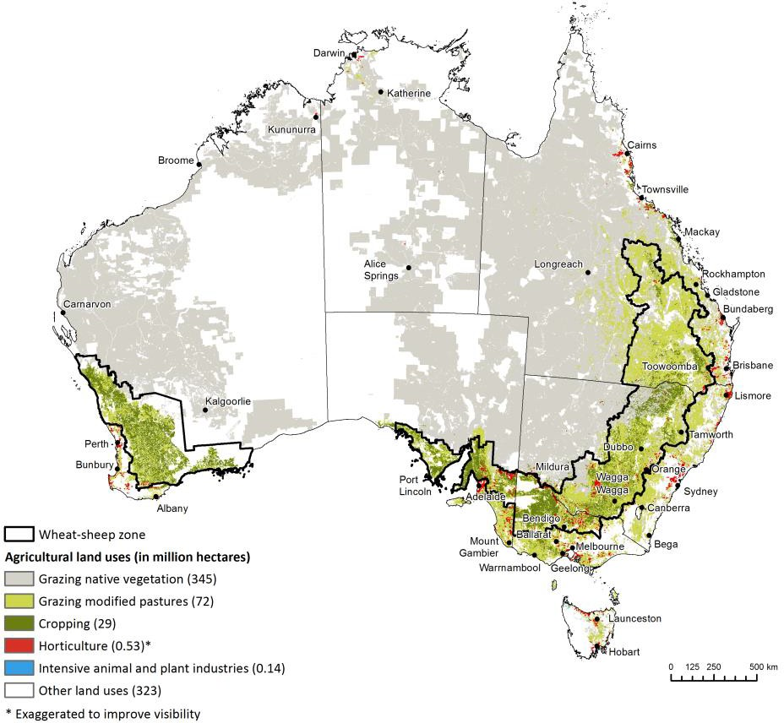

***Agriculture accounts for 58% of Australian land use***

***(446 million hectares)***

* Australian agricultural producers manage very significant variability, particularly a highly variable climate.
* Agriculture is undertaken across diverse conditions, and accounts for 58% of Australian land use.
* These factors generate substantial variation in farm output, greater than that experienced by farmers in most other countries, and greater than that experienced by business owners in other sectors of the Australian economy.
  + Australian agricultural output value and rainfall are more variable than most agricultural producers (see figure top left).
  + Low rainfall years have become more frequent over much of the wheat-sheep zone in recent decades (see impacts bottom right).
* Evidence that crop producers have adapted to changing climate conditions and in doing so have partly restored productivity growth (Hughes, Lawson & Valle 2017).
  + Strong growth in climate-adjusted productivity since 2006–07 has helped the cropping industry to offset the decline in climate conditions.
  + Farm productivity and wheat yields have become less sensitive to climate since 2005–06.

***variable than most other countries***

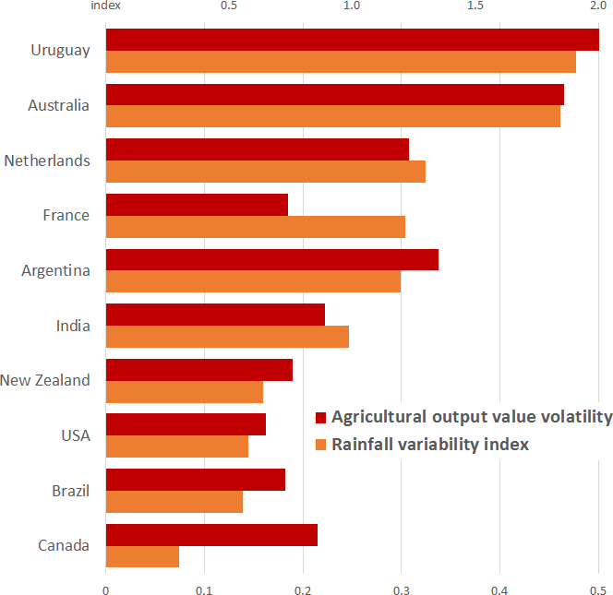

**Australia**

***Climate-adjusted productivity growth, cropping farms, 1978–79 to 2014–15***

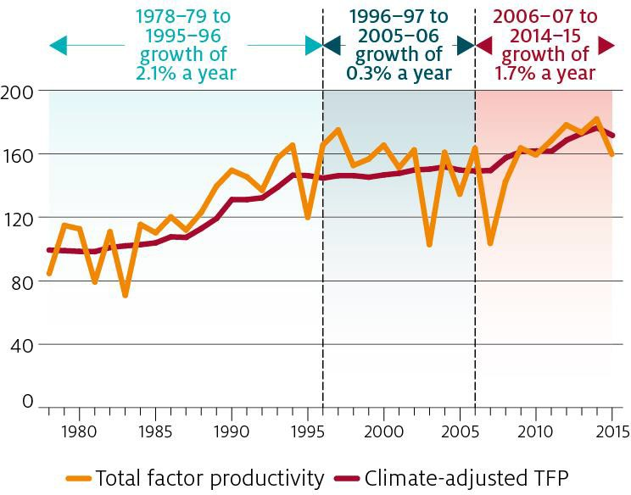

Notes to figure top left: Figure presents agricultural output value volatility (1961– 2009) on top axis as an index where the average volatility across 15 countries = 1 and year-to-year rainfall variability index (1901–2015) on low axis, defined as 90th rainfall percentile minus 10th rainfall percentile divided by 50th rainfall percentile. Source: Value from Keogh (2012) and rainfall from World Bank Group – Climate Change Knowledge Portal

***Shifts in climate and seasonal conditions in the last two decades have impacted farm business profits***

Jackson, T, Zammit, K & Hatfield-Dodds, S 2020, [Snapshot of Australian Agriculture 2020](https://www.agriculture.gov.au/abares/publications/insights/snapshot-of-australian-agriculture-2020), ABARES, Canberra.

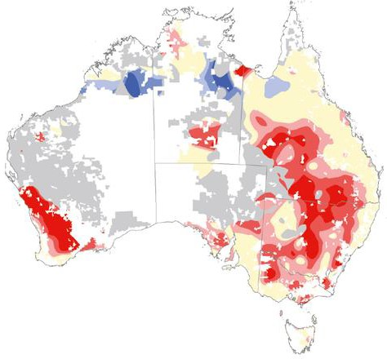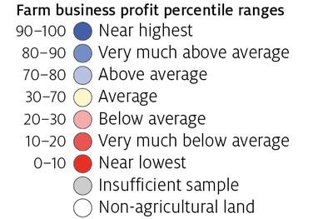

Source: Data from Hughes et al. (2019)

Hughes, N, Lawson, K, & Valle, H 2017, [Farm performance and climate: Climate-adjusted productivity for broadacre cropping farms](https://www.agriculture.gov.au/abares/research-topics/climate/farm-performance-climate), ABARES, Canberra.

Keogh, M 2012, [Including risk in enterprise decisions in Australia’s riskiest businesses](https://ideas.repec.org/p/ags/aare12/124202.html), 2012 Conference (56th), February 7-10, 2012, Fremantle, Australia 124202, Aust. Agricultural and Resource Economics Society.

*ABARES Insights* (2019.06) 5

# Policy settings: Farming practices – lean and sustainable

### *Careful stewardship is central to economically and environmentally sustainable* production

***Australia has one of the lowest levels of support***

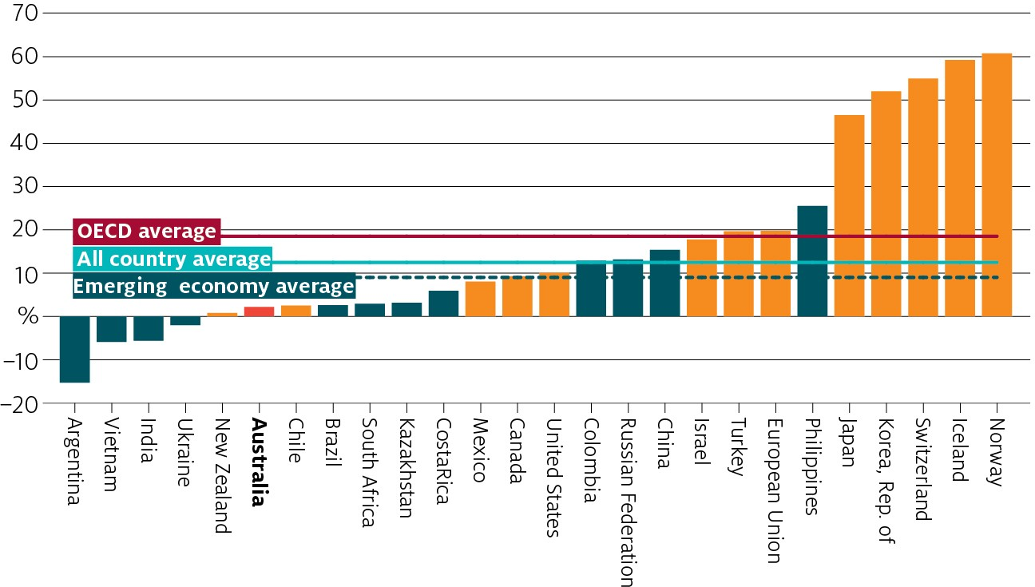

Notes: Support measures as a share of gross farm receipts. The All countries total includes all OECD countries, non- OECD EU Member States, and the 12 Emerging Economies. The OECD total does not include the non-OECD EU Member States. Latvia and Lithuania are included only from 2004. The 12 Emerging Economies include Argentina, Brazil, China, Colombia, Costa Rica, India, Kazakhstan, the Philippines, Russian Federation, South Africa, Ukraine and Vietnam.

Source: Greenville (2020)

***Farmer motivations for native vegetation management***

financial financial + envir

*$*

*$* ****

*$* **** ☺

****

☺

*$* ☺

all three

environment

* Australian agriculture is globally competitive and operates with virtually no direct producer support. Sustainable practices facilitated by policy approach and open markets.
* Policy seeks to ensure competitive pressure helps drive sustainability outcomes, with

the right rules to balance resource use and conservation.

* There have been significant changes in agricultural and environmental policies since European settlement.
  + Early phase pro-development (sometimes farmers had to clear land and demonstrate use). This has shifted over time to promote environmentally sustainable development.
* Over time (since the 1990s), governments in Australia have moved away from directly supporting farmers with payments, to encouraging:
  + increased self-reliance and profitability through improving productivity via R&D; and
  + economies of scale through expansion of export markets.
* Australian farmers cannot afford to maintain unsustainable farming practices, as these erode long term productivity through running down the natural capital stock on farms. Our system of agricultural support reinforces this—virtually no direct farm support.
* Instead, main policies aimed at more environmentally sustainable agricultural development include regulation, suasion, Market Based Instruments (MBIs) and RD&E.
  + Regulation—imposed restrictions on land clearing in 1980s and 1990s.
  + Suasion and capacity building —introduced Landcare in 1989 (still operates today);

objectives include increased environmental awareness and sustainable agriculture.

* + Market Based Instruments since 2000s: competitive tenders to cost effectively

envir + personal

personal personal + financial

**** ☺ allocate funds for biodiversity; currently used to purchase GHG reductions under ERF.

o Government investment in RD&E also used to increase adoption of technologies that have on and off-farm benefits (e.g., minimum till).

* + - This has led to sustainable practices such as crop rotations (an issue that exists in Europe

0% 5% 10% 15% 20% 25% 30% 35%

**$** financial **** environmental ☺ personal

Notes: Bars represent proportion of respondents citing each combination of motivations for vegetation management. Sums to 100%. Source: Kancans et al. (2014)

Greenville, J 2020, [Analysis of government support for Australian agricultural producers](https://www.agriculture.gov.au/abares/research-topics/trade/analysis-of-government-support-agricultural-producers), ABARES, Canberra.

current CAP funding arrangements), limits to pesticide and fertilizer use, and practices such as no-till farming becoming the norm.

* More than half of Australian farmers choose to manage native vegetation based on

environmental motivations.

Kancans, R, Ecker, S, Duncan A, Stenekes, N & Zobel-Zubrzycka, H 2014, [Drivers of practice change in land management in Australian agriculture: Synthesis report—Stages I, II and III](https://daff.ent.sirsidynix.net.au/client/en_AU/search/asset/1027311/0), ABARES, Canberra. 6

# Policy settings: Water markets and reforms deliver for agriculture and the environment

* Water markets are widely accepted in Australia as an efficient way to allocate scarce resources, allowing irrigators to adapt to changing seasonal conditions and water supply.
* Water markets in the Murray–Darling Basin (MDB) are highly developed and well managed relative to other places in the world (Grafton & Horne 2014, Wheeler 2014), and environmental water has been integrated into our largest operating water market the southern MDB.
* A wide range of policy reform has been undertaken since the early 1900s, that has resulted in water becoming a more economic and transferable commodity (Wheeler 2014).

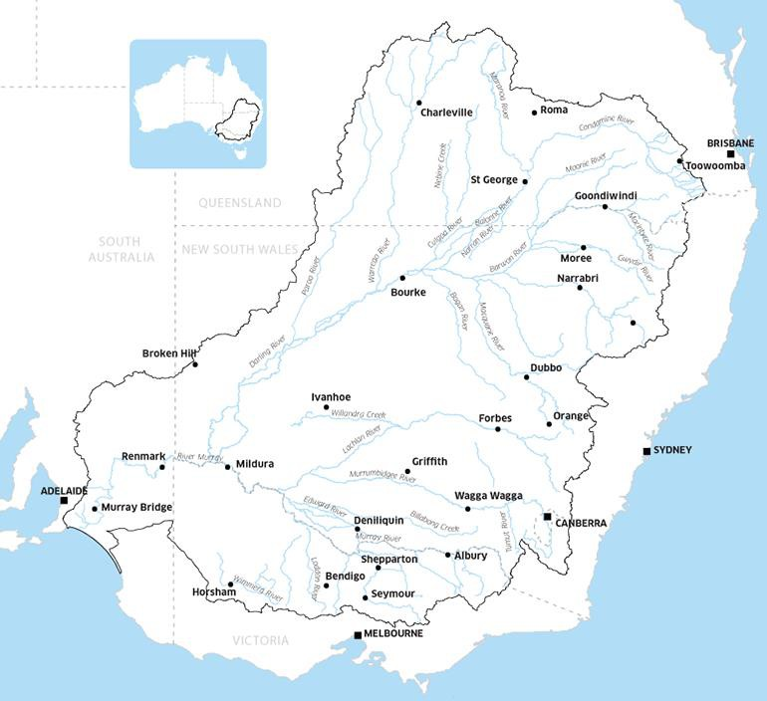***Murray–Darling Basin***

* The Murray–Darling Basin (MDB) is the largest and most complex river system in Australia. The basin is essentially the food bowl of the nation.
* Entitlements are issued by state governments and help regulate water use.
* Water can be bought and sold in markets—prices reflect scarcity and vary very significantly with conditions. Prices in dry years are around three times higher than in typical years.

o ABARES estimate average annual prices in the southern MDB to be around $550/ML under dry seasonal conditions, compared to around $180/ML under typical seasonal conditions (Figure 5 Whittle et al 2020).

* Markets facilitate the movement of water to its highest-value use, including allocation between years, within districts, and between different regions.
* Since 2007 around 20% of surface water rights have been recovered through purchase of entitlements from farmers. This water has been permanently retired from irrigation use, and is managed by government for the environment.

***Water demand and prices are likely to increase***

All irrigation activites

Cotton Almonds Pastures - hay Other cereals

Fruit Other broadacre Other crops Grapevines Vegetables

Dairy Rice

Pastures - grazing

- 150

GL 150 300 450



600

750

Current demand,

existing plantings

Additional demand at full maturity



Grafton, R.Q. & Horne, J, 2014, “Water markets in the Murray-Darling basin”, *Agricultural Water Management*, 145(C), pp.61-71.

Wheeler, S.A., 2014, “Insights, lessons and benefits from improved regional water security and integration in Australia”, *Water Resources and Economics*, 8, pp.57-78.

Westwood, T, Qin, C & Whittle, L 2020, [Water Market Outlook: July 2020](https://www.agriculture.gov.au/abares/research-topics/water/murray-darling-basin-trends-and-drivers), ABARES, Canberra. Whittle et al 2020 [Economic effects of water recovery in the Murray Darling Basin](https://daff.ent.sirsidynix.net.au/client/en_AU/search/asset/1030661/0), ABARES Canberra. Goesch, T, Legg, P & Donoghoe, M 2020, [Murray–Darling Basin water markets: Trends and drivers 2002–03 to 2018–19](https://www.agriculture.gov.au/abares/research-topics/water/murray-darling-basin-trends-and-drivers), ABARES, Canberra.

**Changes in demand for water by sector, from 2006 to 2019 at $200 per ML.** Note: Modelled estimates from ABARES Water Trade Model, including demand associated with existing perennial plantings coming to maturity.

Source: Goesch et al. (2020)

7

# Policy & industry settings: Innovation and industry awareness

### *Agriculture is on the front foot*

* R&D programs helping develop better practices and climate suited varieties.
  + Australia looks to market approaches to drive innovation and sustainability

in land use, complemented with government incentives where appropriate.

* According to the OECD, most (56%) of the current support provided by Australia is general services (e.g., R&D). The remaining 44% of support was assessed to be producer support.
  + Total support provided to Australian farmers contributes very little directly to farmer revenues (around 2% over the period 2016 to 2018).

***Australia’s support is heavily R&D focused***

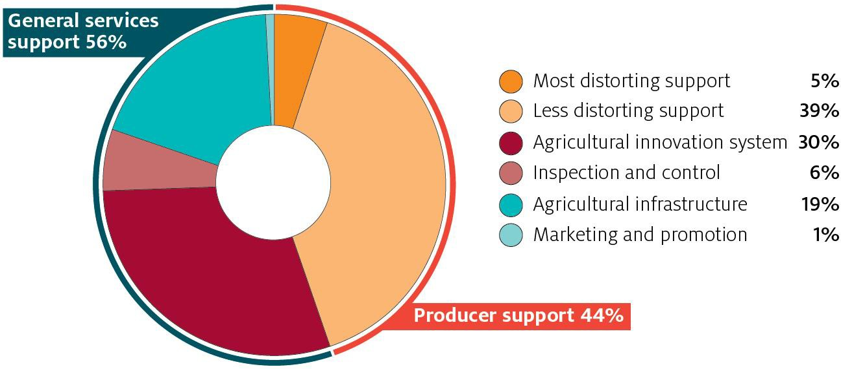

Notes: Most distorting support relates to payments linked to production in some form, such as inputs or where production is required.

Least distorting support is not linked to production. Source: Greenville (2020)

* Some RDCs have highlighted the need for further research into GHG mitigation and productivity growth.
  + MLA research has identified possible areas for further work, including feed

supplements, genetics, vaccination and early life programming of livestock.

* + Some of these are more prospective than others, but those with the highest mitigation and productivity potential also require the highest investment (MLA 2015).
* Australian agriculture has improved emissions intensity over time.
  + Livestock emissions, which form the majority of agricultural emissions, have fallen since 1990, similar to trends in some other countries.
* Australia’s agricultural sector is acting—driven by market opportunities and threats.
  + Most industry associations support GHG mitigation, and R&D is increasingly focused on responding to climate change (both mitigation and adaptation).
* Australian farmers are internationally focused, and looking forward to consumer and investor trends. Driven by these incentives, all farming industry bodies have commitments to sustainability initiatives.
  + The NFF 2030 Roadmap identifies growing sustainably as one of their key pillars to making Australian agriculture a $100b industry by 2030.

Notes for Figure middle right: Data is the average for 2006–2016. Left panel shows emissions per unit of output for ten

largest beef and veal exporters. Right panel shows major exporter’s shares of global beef and veal exports in increasing order of emissions intensity, followed by Rest of world. Source: OECD/FAO (2019) *Agricultural Outlook 2019–2028*

Greenville, J 2020, [Analysis of government support for Australian agricultural producers](https://www.agriculture.gov.au/abares/research-topics/trade/analysis-of-government-support-agricultural-producers), ABARES, Canberra.

***Australia’s beef emissions intensity appears lower than most major exporters,***

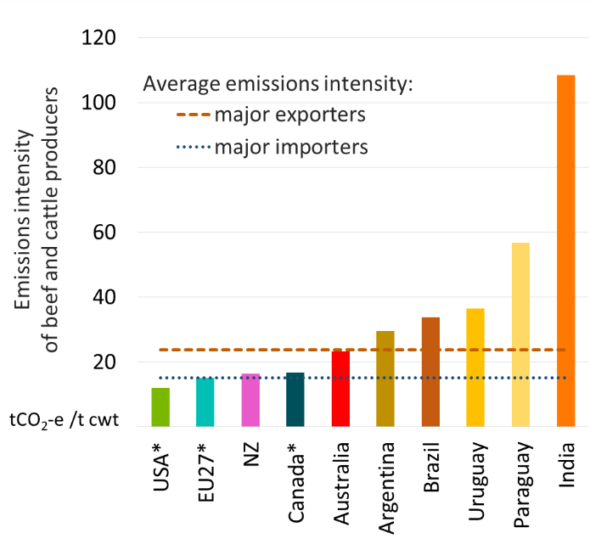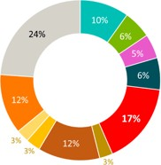***but higher than major importers***

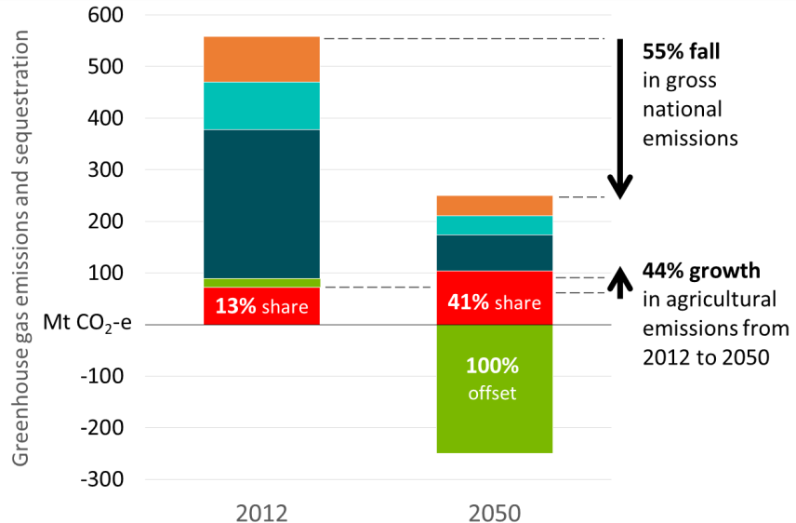* Country or region is both a major importer and a major exporter

***Agriculture’s share of emissions likely to rise as other sectors cut emissions more cost-effectively***

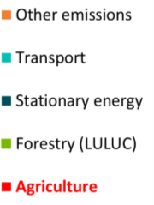Notes: Chart presents modelling results for an illustrative scenario. Agricultural output value and gross emissions are projected to rise, despite reduced emissions intensity and some shift of land into carbon offsets. Carbon forestry projected to offset all gross national emissions in 2050.

Source: Data from ClimateWorks Australia (2014); *Pathways to Deep Decarbonisation*

OECD/FAO, 2019, [OECD-FAO Agricultural Outlook 2019-2028](https://www.oecd-ilibrary.org/agriculture-and-food/oecd-fao-agricultural-outlook-2019-2028_agr_outlook-2019-en), OECD Publishing, Paris.

*in 2050* 8

# Shared challenge:

**Achieving consistent outcomes from different approaches**

### *Achieving more by working together*

* Trade rules should encourage innovation across different approaches to meeting the sustainability challenge and avoid a prescription of one approach over the other.
* Rules on land use and policies that promote farmers to work with the environment, not against it, can deliver as good (if not better) sustainability outcomes compared to direct intervention models.
* Trade rules should not get in the way of market based instruments as a tool to help achieve sustainability outcomes.
* Trade can allow production to shift and occur in the most sustainable location. This will help deliver on global goals of emissions reduction, food security and rural growth.
* Free trade where countries are acting on these issues promotes global action.
* Closer ties will help with sharing lessons and approaches and help both contribute more effectively to solving sustainability challenges.
* Australia and the EU export to a range of countries and regions contributing to global food security and development
* 64% of Australia’s food exports are sent to countries in Asia, while only 5% of our food exports are sent to Europe (EU-27). Around one-third of our food exports are minimally transformed.
* 33% of Australia’s imports are sourced from Asia, and 25% from Europe.

Over 90% of our food imports are substantially or elaborately transformed.

* Australia’s high quality agricultural exports to the EU consist mainly of minimally transformed products such as oilseeds, horticulture and animal products. These become important inputs into Europe’s further processing of food and agricultural products.
* Around 90% of the EU’s agricultural exports to Australia are substantially transformed: processed meats, fruit & vegetables, confectionary and beverages.

***Australia’s agricultural exports to EU in 2019–20***

**3%**



**52%**

2019–20

$1.91 billion

Oilseeds Industrial crops Pulses

Other crops and crop products Fruit & nuts

Vegetables

Other horticulture

***Australia and the EU bring complementary perspectives to global sustainability challenges***

***– including ensuring food security and protecting natural capital***

**33%**

AUD

**12%**

Wool

Meat and live animals Dairy products

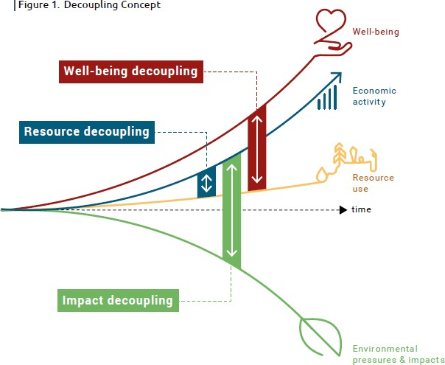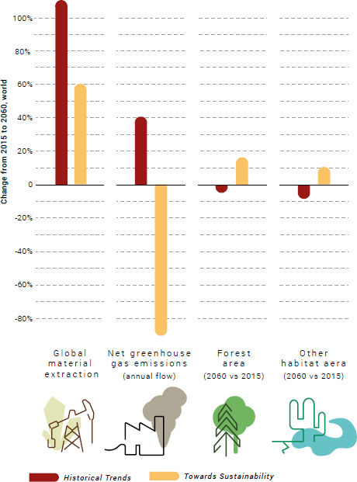

**income up, pressures down**

**decoupling** is required to see

income, resource-based services

and **well-being increase**

while environmental **pressures decrease** or reverse, in stark contrast to **unsustainable historical trends**

Other livestock and livestock products Fisheries

Forestry

Source Figure above: ABARES analysis.

Source Figure on right: IRP (2019) *Global Resources Outlook 2019 – Implications for Business Leaders,*

Figure 1 p.10 and Figure 6 p.25 – see also Figure 4.24 in main GRO2019 report 9



**Dr Steve Hatfield-Dodds**



Executive Director,

**Australian Bureau of Agricultural**

**and Resource Economics and Sciences**

Honorary Professor,

Crawford School of Government,

**Australian National University**

Expert Member,

**International Resource Panel,**

**UN Environment**

**awe.gov.au/abares**

The Australian Bureau of Agricultural and Resource Economics and Sciences is the research arm of the Australian Government Department of Agriculture, Water and the Environment.

Our mission is to provide professionally independent data, research, analysis and advice that informs public and private decisions affecting Australian agriculture, fisheries and forestry.

10