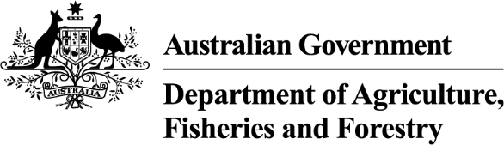

Exports work instruction

Paying the authorised officer annual levy using the Plant Exports Management System
Direction to authorised officers
This is official instructional material of the Department of Agriculture, Fisheries and Forestry (the department). Failure to comply with it may result in a breach of relevant legislation and/or the code of conduct under section 13(5) of the Public Service Act 1999.

Purpose of this document
This document details the procedure to pay the annual levy using the Plant Export Management System (PEMS). _________________________________________________________________________________
Contents
This document contains the following topics.
Purpose of this document 1
Policy statements 1
Roles and responsibilities 2
Pay the annual levy 3
Related material 11
Contact information 11
Document information 11
Version history 12
Appendix A: Definitions 13
Appendix B: Legislation and related policy frameworks 13

Policy statements
- All AOs who hold a valid appointment on 1 July must pay an annual levy. The annual levy covers costs that are incurred by the AO Program in the administration of the AO model.
- The policy related to this work instruction can be found in the Exports Policy: Management of third-party plant exports authorised officers.

Roles and responsibilities
The following table outlines the roles and responsibilities undertaken when paying the annual levy.
Role | Responsibility
Authorised officer | Pay the annual levy.

Pay the annual levy
The following table outlines how to pay the annual levy.
Step | Action | Graphic
1. | Go to https://online.agriculture.gov.au/selfservice  Note: The log in page will display.
2. | - Enter your User Login and Password.  - Check the ‘I accept the terms of use’ box.  - Click ‘Log in’.
3. | Click the ‘PEMS’ button to enter the PEMS home page.
4. | Select your name in the top right corner.  Note: This will take you to your PEMS profile. | 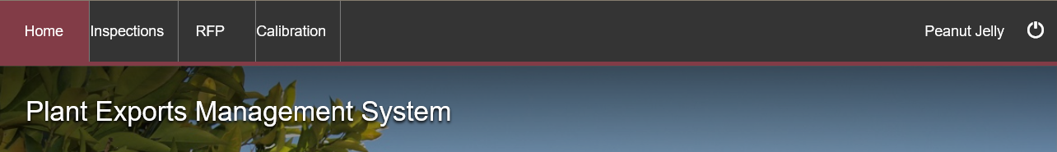
5. | Select ‘My Application’ next to your Personal details section. | 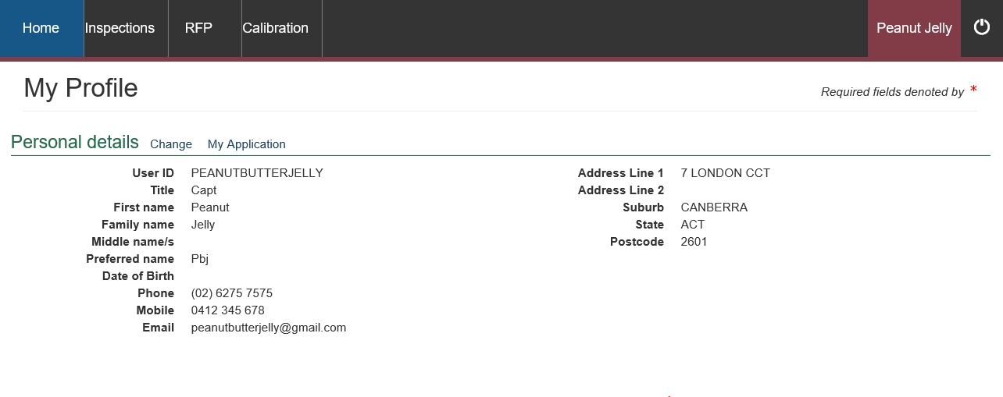
6. | - Select your ‘Appointment’ tab.  - Under the Annual Levy section select ‘Pay Now’. | 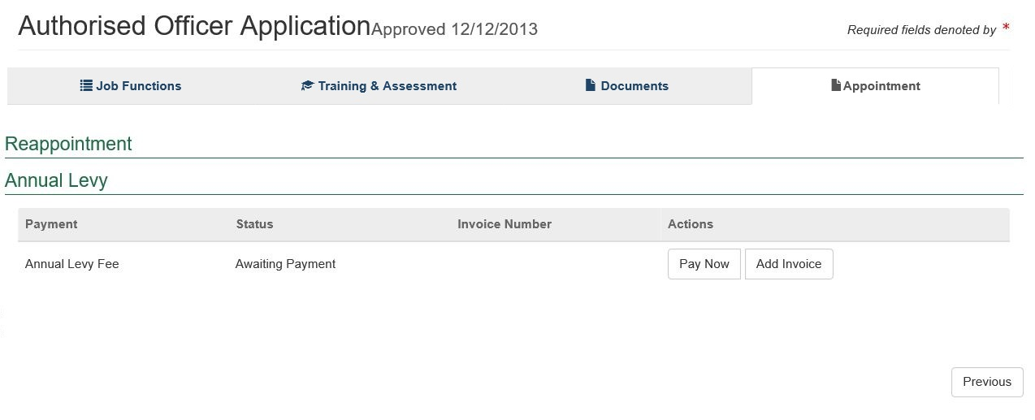
7. | - Review the details of the Service Summary.  - Click ‘Next’. | 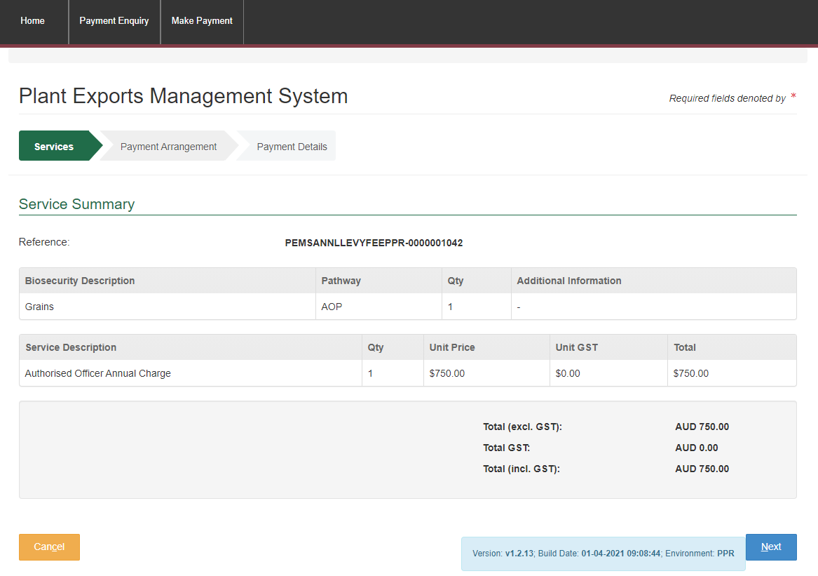
8. | - Select ‘No’ to the question Do you have an Account Number?  - Click ‘Continue to Payment’. | 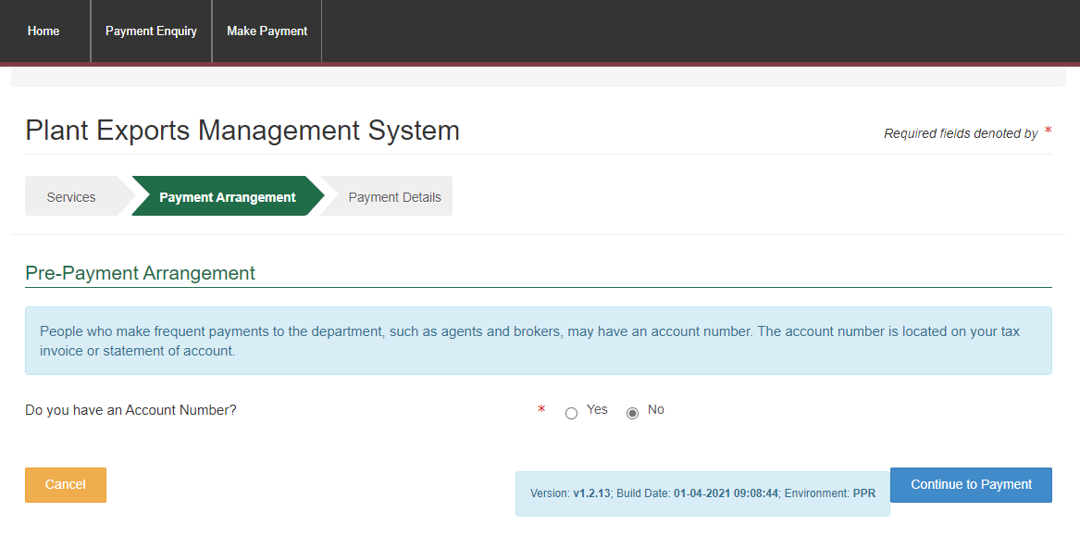
9. | - Enter your credit/debit card details.  - Click ‘Pay Now’. | 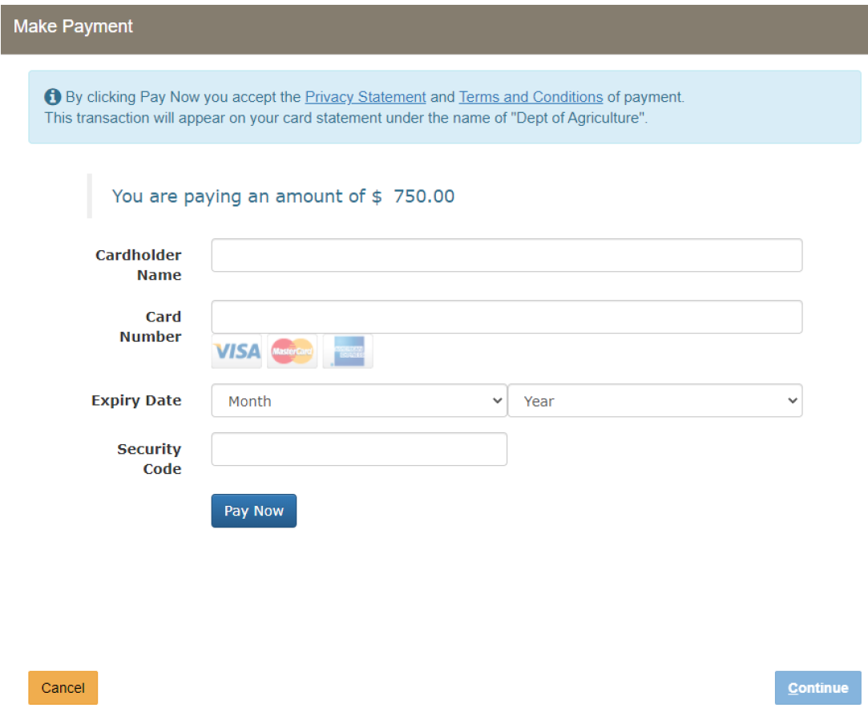
10. | - Note the Payment Confirmation screen.  - Click ‘Continue’.  Notes:  - A receipt will be emailed to you from do-not-reply@aff.gov.au.  - Please check your spam/junk mailbox.  - If you do not receive your receipt within 1 business day, please email the Authorised Officer Program. | 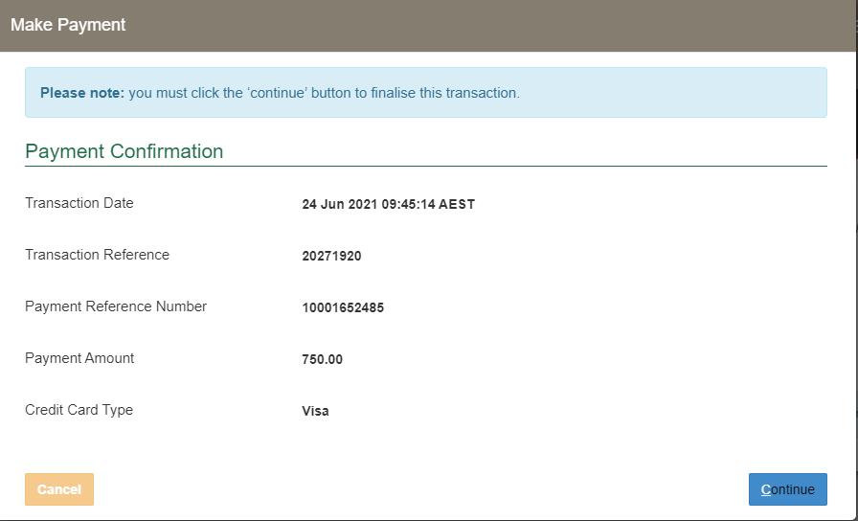

Related material
The following related material is available online:
- Authorised Officer webpage:
- Exports Policy: Management of third-party plant exports authorised officers
- Exports work instruction: Requesting Authorised Officer training using the Plant Exports Management System
- Exports work instruction: Requesting Authorised Officer training using the Plant Exports Management System
- Exports work instruction: Requesting an Authorised Officer Instrument of Appointment using the Plant Exports Management System
- Exports reference: Requesting additional job functions in the Plant Exports Management System
- Plant Exports Management System
- Plant Export Operations Manual:
- Exports reference: Plant Exports Management System Authorised officer user guide
- Exports reference: Table of authorised officer job functions
- Authorised Officer declaration of boarding experience.
- Fees and charges
- Privacy Policy
- Australian Federal Police webpage (police checks)

Contact information
- Authorised Officer Program: PlantExportTraining@aff.gov.au
- Authorised Officer Hotline: 1800 851 305.

Document information
The following table contains administrative metadata.
Instructional Material Library document ID | IMLS-9-7946
Instructional material owner | Director, Authorised Officer Program
Risk rating | [Low]
Review period | Due for review within [four] years of the most recent approved date.

Version history
The following table details the published date and amendment details for this document.
Version | Date published | Date last approved | Review type | Summary of review
1.0 | 03/11/2022 | 03/11/2022 | New Document | First publication of this work instruction.
2 | 28/02/2024 | 28/02/2024 | Major Change | - Updated department branding and contact information.  - Converted to new exports templates.

Appendix A: Definitions
The definitions related to this work instruction can be found in the Exports Policy: Management of third-party plant exports authorised officers.

Appendix B: Legislation and related policy frameworks
The legislation related to this work instruction can be found in the Exports Policy: Management of third-party plant exports authorised officers.

