Knowledge report
Temperate Highland Peat Swamps on Sandstone: evaluation of mitigation and remediation techniques
This report was commissioned by the Department of the Environment on the advice of the Interim Independent Expert Scientific Committee on Coal Seam Gas and Coal Mining and prepared by Water Research Laboratory, School of Civil and Environmental Engineering, University of New South Wales.
August 2014

Copyright
© Copyright Commonwealth of Australia, 2014.

Temperate Highland Peat Swamps on Sandstone: evaluation of mitigation and remediation techniques, Knowledge report is licensed by the Commonwealth of Australia for use under a Creative Commons By Attribution 3.0 Australia licence with the exception of the Coat of Arms of the Commonwealth of Australia, the logo of the agency responsible for publishing the report, content supplied by third parties, and any images depicting people. For licence conditions see: http://creativecommons.org/licenses/by/3.0/au/
This report should be attributed as ‘Commonwealth of Australia 2014, Temperate Highland Peat Swamps on Sandstone: evaluation of mitigation and remediation techniques, Knowledge report, prepared by the Water Research Laboratory, University of New South Wales, for the Department of the Environment, Commonwealth of Australia’.
The Commonwealth of Australia has made all reasonable efforts to identify content supplied by third parties using the following format ‘© Copyright, [name of third party]’.
Enquiries concerning reproduction and rights should be addressed to:
Department of the Environment, Public Affairs
GPO Box 787 Canberra ACT 2601
Or by email to: public.affairs@environment.gov.au
This publication can be accessed at: www.iesc.environment.gov.au
Acknowledgements
This report was commissioned by the Department of the Environment on the advice of the Interim Independent Expert Scientific Committee on Coal Seam Gas and Coal Mining. It was prepared by Erica Davey (Project Engineer), Dr William Glamore (Principal Engineer) and Grantley Smith (Manager and Principal Engineer) at the Water Research Laboratory (University of New South Wales) and peer reviewed by Mr Roger Good (Good Environmental Systems).
Following discussions with the report author, the peer reviewers’ comments have been incorporated into the report, appearing as either changes to the text, footnotes, end of chapter notes or appendices. Additional references have been provided by the reviewers.
New South Wales Government agencies were provided the draft report for comment, through the National Partnership Agreement Reference Group, established between the Commonwealth and signatory state governments under the National Partnership Agreement on Coal Seam Gas and Large Coal Mining Development.
Disclaimer
The views and opinions expressed in this publication are those of the authors and do not necessarily reflect those of the Australian Government or the Minister for the Environment or the Interim Independent Expert Scientific Committee on Coal Seam Gas and Coal Mining or the statutory Independent Expert Scientific Committee on Coal Seam Gas and Large Coal Mining Development (IESC).
While reasonable efforts have been made to ensure that the contents of this publication are factually correct, the Commonwealth and IESC do not accept responsibility for the accuracy or completeness of the contents and shall not be liable for any loss or damage that may be occasioned directly or indirectly through the use of, or reliance on, the contents of this publication.
Contents
Summary 7
Abbreviations 9
Glossary 10
1 Introduction 14
2 Upland peat swamps 16
2.1 Importance of the THPSS community 16
2.2 Other upland peat swamp communities 18
2.3 Formation and characteristics of upland peat swamps 20
2.4 Representative swamp conceptual models 22
2.4.1 Headwater swamps 22
2.4.2 Valley infill swamps 22
2.4.3 Hanging swamps 23
2.5 Chapter synthesis and knowledge gaps 23
Note on EPBC listing 24
3 Impacts of longwall mining and subsidence 25
3.1 Underground coalmining techniques 25
3.2 Longwall mining in the Sydney region 27
3.2.1 Southern Coalfield 28
3.2.2 Western Coalfield 29
3.3 Historical context 30
3.4 Impact mechanisms 32
3.5 Impacts of mining on upland peat swamps and water bodies in the Sydney Basin 41
3.5.1 Observed longwall mining impacts on upland peat swamps 42
3.5.2 Observed longwall mining impacts on water bodies 55
3.6 Internationally reported impacts 61
3.7 Chapter synthesis and knowledge gaps 63
4 Prediction, mitigation, management and monitoring of impacts 64
4.1 Prediction of mining impacts on upland peat swamps 64
4.2 Mitigation of longwall mining impacts 66
4.3 Time lag between mining and observation of impacts 66
4.4 Trigger action response plans 67
4.5 Monitoring 68
4.5.1 Surface subsidence 69
4.5.2 Groundwater monitoring 69
4.5.3 Subsurface monitoring 70
4.5.4 Ecological monitoring 71
4.6 Chapter synthesis and knowledge gaps 71
Peer review comments on Chapter 4 72
5 Remediation techniques 73
5.1 Remediation of fracture networks and vertical seepage 75
5.1.1 Surface sealing techniques 76
5.1.2 Injection grouting 77
5.1.3 Permeation grouting 80
5.1.4 Cross-bore injection of gels 80
5.1.5 Use of grout curtains 81
5.1.6 Self-amelioration 81
5.1.7 Other surface treatments 82
5.2 Remediation of the water regime 82
5.2.1 The ‘Australian approach’ 83
5.2.2 The ‘Canadian approach’ 86
5.2.3 Guidelines for peatland restoration, Northern Ireland 87
5.3 Remediation examples 88
5.3.1 Proposed upland peat swamp remediation techniques 88
5.3.2 Remediation of streams affected by longwall mining 89
5.4 Chapter synthesis and knowledge gaps 91
Peer review comments on Chapter 5 91
6 Conclusions 93
6.1 Impacts on peat swamps 93
6.2 Impact prediction and mitigation 93
6.3 Monitoring 94
6.4 Remediation 94
6.4.1 Knowledge gaps 95
6.5 Summary and key points 95
7 References 97

Tables
Table 3.1 Overview of mining operations in the Southern Coalfield. 28
Table 3.2 Depth of cover and estimated extent of fracture zones in areas impacted by longwall mining. 29
Table 3.3 East Wolgan Swamp: timeline and impact information from available references. 45
Table 3.4 Narrow Swamp: timeline and impact information from available references. 46
Table 3.5 Junction Swamp: timeline and impact information from available references. 47
Table 3.6 Kangaroo Creek and swamps: timeline and impact information from available references. 49
Table 3.7 Long Swamp: timeline and impact information from available references. 49
Table 3.8 Swamp 18: timeline and impact information from available references. 50
Table 3.9 Swamp 19: timeline and impact information from available references. 51
Table 3.10 Flat Rock Swamp: timeline and impact information from available references. 53
Table 3.11 Drillhole Swamp: timeline and impact information from available references. 55
Table 3.12 Cataract River: timeline and impact information from available references. 56
Table 3.13 Upper Georges River: timeline and impact information from available references. 57
Table 3.14 Waratah Rivulet: timeline and impact information from available references. 58
Table 3.15 Wongawilli Creek: timeline and impact information from available references. 59
Table 3.16 Avon Reservoir: timeline and impact information from available references. 59
Table 3.17 Bargo River: timeline and impact information from available references. 60
Table 3.18 Native Dog Creek: timeline and impact information from available references. 60
Table 4.1 Predicted subsidence for upland swamps to be undermined. 65
Table 4.2 Ecological monitoring techniques. 71
Table 5.1 Possible mitigation and remediation strategies or options for groundwater control. 75

Figures
Figure 2.1 Listed THPSS swamps and coal titles in the Blue Mountains region; Newnes Plateau swamps are visible in the north-west. 17
Figure 2.2 Upland peat swamp distribution and coal titles on the Woronora Plateau and Southern Highlands. 19
Figure 3.1 Plan view layout of typical longwall panels. 26
Figure 3.2 Coalfields of New South Wales. 27
Figure 3.3 Surface effects of longwall mining. 32
Figure 3.4 Cracking of riverbeds (indicated by arrow) within the Southern Coalfield. 34
Figure 3.5 Buckling of near surface, Waratah Rivulet (Southern Coalfield), late 2004. 35
Figure 3.6 Conceptual model of the upsidence mechanism (cross-section view). 36
Figure 3.7 Conceptual model for ground deformation above a caved longwall panel. 37
Figure 3.8 Comparison of aperture of a single fracture with equivalent thickness of porous media. 38
Figure 3.9 Piezometer response and modelled hydrograph for Piezometer 12_01, Swamp 12, Dendrobium Mine. 39
Figure 3.10 Location of observed impacts in the Sydney Basin. 42
Figure 3.11 THPSS and mining longwalls at Angus Place Colliery. 43
Figure 3.12 Peat slumping, July 2009 (top) and desiccation, March 2014 (bottom) related to mine water discharge and subsidence at East Wolgan Swamp. 44
Figure 3.13 Changes in vegetation and water levels in Junction Swamp; left: 2001 (before mining); right: 2007 (after mining). 47
Figure 3.14 Dieback of the swamp on Kangaroo Creek above longwall 940, indicating a permanent change in groundwater conditions, 2009. 48
Figure 3.15 Gully erosion through Swamp 18, looking upstream. 50
Figure 3.16 Knickpoint and gully in Flat Rock Swamp. 52
Figure 3.17 Deeply gullied peat in a valley infill swamp, Flat Rock Swamp, Waratah Rivulet, September 2007. 52
Figure 3.18 Extensive gully through Drillhole Swamp, looking downstream. 54
Figure 3.19 Mining-related impacts on Lizard Creek (Southern Coalfield): (a) apparent mining-induced loss of flow in Lizard Creek; (b) iron staining, discolouration and opacity of water downstream of subsided area. 61
Figure 4.1 Estimated timeline for first-, second- and third-order impacts. 67
Figure 4.2 Upland peat swamps, including piezometer locations for monitoring, at Dendrobium Colliery. 70
Figure 5.1 Geofabric installation to prevent water loss in streams with mining-induced tension fractures: a) stream-bed preparation; b) geofabric anchoring system; c) habitat controls; d) covering the geofabric. 76
Figure 5.2 Injection grouting: (a) drilling into the bedrock (Georges River); (b) grout pump station set-up (Georges River); (c) injecting grout into the bedrock via packer system (Georges River); (d) grout injection operations (United States). 77
Figure 5.3 The concrete creek in the Lower Hunter. 79
Figure 5.4 Square coir logs for knickpoint control. 85
Figure 5.5 Trenching and positioning of the first layer of coir logs during construction of a small dam in an entrenched swamp flow line. 85
Figure 5.6 Small coir log dams (with jute wrapping) constructed at intervals along an incised swamp flow line. 86

Summary
Key points
- Longwall mining beneath upland peat swamps may fracture the sandstone substrate and alter the swamp’s water balance. To date, no strategies—other than changes in mine plan layout—have been proven to effectively mitigate longwall mining impacts.
- Remediation strategies in regions affected by longwall mining are primarily designed to restore the hydrological regime. To date, on-ground remediation strategies have focused on sealing fracture networks on cracked stream beds and have not addressed fractures occurring beneath peat sediments. No examples were found of upland peat swamps impacted by longwall mining that have been remediated.
- Direct remediation to combat vertical seepage beneath upland peat swamps has not been attempted. Existing remediation techniques are unproven and appear insufficient without the destruction of the surface environment.

Mining and subsidence
Location of mining leases beneath upland peat swamps has been a subject of debate for more than a century. Impacts on upland peat swamps from mining subsidence have been reported in nearby creek lines, where surface and subsurface rock fracturing has been observed. Where fracture networks form and the water balance is affected (including along upstream, downstream or subsurface boundaries), potential impacts on upland peat swamps include effects on soil structure, water quality and ecology, as well as increased susceptibility to stressors such as fire. Although substantial anecdotal and post-monitoring data are available, and various scientific hypotheses have been proposed to explain the mechanisms for impacts (or mitigation of impacts) on upland peat swamps from longwall mining, no before–after control–impact data are available to allow detailed assessment of the impacts.
Monitoring
Limited onsite monitoring data are available on the effect of longwall mining subsidence on upland peat swamps. In most cases, detailed monitoring is either absent or spatially and temporally insufficient to identify complex hydrogeological processes. Where available, data commonly focus on exposed bedrock creek channels; limited data are available on peat sediments or adjacent catchments. The overall lack of onsite monitoring data limits the direct assessment of mitigation measures and remediation strategies for upland peat swamps.
Numerous upland peat swamps located above longwall mined sections have been affected by changes to the hydrological regime. However, the lack of monitoring data means that the discrete causal mechanism and specific time frames are difficult to quantify. Detailed descriptions of various sites before and after mining activities provide strong qualitative data. Observations from these sites indicate that changes to the hydrological regime can result in declines in groundwater quality, desiccation of organic matter, slumping and void formation, creation of knickpoints, increased erosion, severe impacts on flora and fauna, and increased susceptibility to extreme weather events (drought, floods, fire). Further information is required on the specific time lags between mining and likely impacts, and the role of mine plan layout and proximity in the extent of onsite damage.
Mitigation
Various planning commissions and scientific panels have investigated longwall mining impacts in the Sydney catchment area, and associated mining plans to mitigate impacts on upland peat swamps. Mitigation strategies to minimise the impacts of mine subsidence are documented; the only effective measures rely on changes to mine plan layout. Industry is increasingly recognising that trigger action response plans (TARPs), a commonly used mitigation measure to predict surface impacts from longwall mining, are an ineffective strategy. This is due to the time lag between onsite mining and the measurement of surface impacts. Another mitigation technique—the use of stress relief slots—has been reported to limit the impacts of longwall mining on a rock bar in a stream. This technique has not been trialled to mitigate impacts on upland peat swamps, and significant disturbances to the surface may occur following the construction of stress relief slots, potentially limiting their use for upland peat swamps. Best industry practice would involve development of predictive techniques to recognise risk, and minimising impacts on upland peat swamps before they occur.
Remediation
Remediation strategies in regions affected by longwall mining are primarily designed to restore the hydrological regime. To date, on-ground remediation strategies have focused on sealing fracture networks on cracked stream beds; they have not addressed fractures occurring beneath peat sediments. No examples were found of upland peat swamps impacted by longwall mining that have been remediated.
Remediation techniques have been trialled to restore the hydrological regime of creek beds in the vicinity of upland peat swamps, and upland peat swamps that have been impacted by factors other than longwall mining. Creek-bed techniques have involved filling the fracture network void using naturally available materials, grout and/or gels. These techniques have been subject to limited applied trials, are prohibitively expensive for broadacre trials, have inherent environmental risks or limited lifespans, and may not be implementable in upland peat swamps without significant disturbance of the substrate. Remediation techniques for swamps impacted by factors other than longwall mining, such as in the Blue Mountains, generally focus on reducing water velocities through the system via the use of coir logs and other natural materials. These techniques may be relevant where the hydrological regime of downstream sites has been impacted by longwall mining, or where vertical drainage is not a concern.
There is limited evidence that self-amelioration is a reliable or feasible remediation technique. The self-amelioration method is largely uncontrolled and untested, and there are several knowledge gaps relating to implementation time frames. To date, self-amelioration has not been measured at upland peat swamps, including sites impacted for more than 25 years.

Abbreviations
General abbreviations | Description
BHPB | BHP Billiton
DSEWPaC | Australian Government Department of Sustainability, Environment, Water, Population and Communities
EPBC Act | Environment Protection and Biodiversity Conservation Act 1999
PAC | Planning Assessment Commission
SOS | Save our Swamps
TARP | Trigger action response plan
THPSS | Temperate Highland Peat Swamps on Sandstone

Glossary
A detailed glossary of hydrological terms can be found on the United States Geological Survey website (http://or.water.usgs.gov/projs_dir/willgw/glossary.html). Specific terms of relevance for this project are defined below.
Term | Description
Aggradation | The increase in surface elevation due to the deposition of sediment. Occurs where sediment supply is greater than the material that the system can transport.
Anthropogenic | Relating to, or resulting from, the influence of human beings on nature.
Aperture | Separation distance between two fracture surfaces, used as measure of fracture width.
Aquifer | Rock or sediment in formation, group of formations or part of a formation, that is saturated and sufficiently permeable to transmit quantities of water to wells and springs.
Aquitard | A saturated geological unit that is less permeable than an aquifer and incapable of transmitting useful quantities of water. Aquitards often form a confining layer over an artesian aquifer.
Bore/borehole | A narrow, artificially constructed hole or cavity used to intercept, collect or store water from an aquifer, or to passively observe or collect groundwater information. Also known as a borehole, well or piezometer.
Casing | A tube used as a temporary or permanent lining for a bore.  Surface casing: the pipe initially inserted into the top of the hole to prevent washouts and the erosion of softer materials during subsequent drilling. Surface casing is usually grouted in and composed of either steel, PVC-U, or composite materials.  Production casing: a continuous string of pipe casings that are inserted into or immediately above the chosen aquifer and back up to the surface through which water and/or gas are extracted/injected.
Chain pillars | Pillars between longwall panels that provide an airway and access for people and materials, and a way for the mined coal to be removed.
Coal seam | Sedimentary layers consisting primarily of coal. Coal seams store both groundwater and gas and generally contain saltier groundwater than aquifers that are used for drinking water or agriculture.
Coir | A natural fibre extracted from the husk of coconut and used in products such as floor mats, doormats, brushes and mattresses. Coir logs are used in remediation.
Compaction | The process by which geological strata under pressure reduce in thickness and porosity, and increase in density.
Compression | A system of forces or stresses that tends to decrease the volume or shorten a substance, or the change of volume produced by such a system of forces.
Confined aquifer | An aquifer bounded above and below by confining units of distinctly lower permeability than that of the aquifer itself. Pressure in confined aquifers is generally greater than atmospheric pressure.
Degradation | A general lowering of Earth’s surface by erosion or weathering.
Deposition | The process by which materials such as mud, sand, pebbles and silt are transported by the river and eventually dropped; linked to accumulation.
Desiccation | Dryness resulting from the removal of water.
Fault | A planar fracture or discontinuity in a volume of rock across which there has been significant displacement along the fractures as a result of earth movement.
Goaf | The part of a coalmine from which the coal has been removed, with the resulting space filled with caved material to varying extent. Also the caved material in a mine.
Fracture | Any planar or curviplanar discontinuity or break in a rock mass that has formed as a result of a brittle deformation process. Joints, shear fractures, faults, microcracks, etc. are all examples of fractures.
Fracture network | Two- or three-dimensional arrangement of intersecting fractures. Fractures in a network may be of identical aperture, length or orientation, or may represent a distribution of fractures of varying parameters.
Groundwater | Water occurring naturally below ground level (whether in an aquifer or other low-permeability material), or water occurring at a place below ground that has been pumped, diverted or released to that place for storage. This does not include water held in underground tanks, pipes or other works.
Heterogeneity | Composition from dissimilar parts.
Hydraulic conductivity | The rate at which a fluid passes through a permeable medium.
Hydraulic gradient | The change in hydraulic head between different locations within or between aquifers or other formations, as indicated by bores constructed in those formations.
Hydraulic head | The potential energy contained within groundwater as a result of elevation and pressure. It is indicated by the level to which water will rise within a bore constructed at a particular location and depth. For an unconfined aquifer, it will be largely subject to the elevation of the watertable at that location. For a confined aquifer, it is a reflection of the pressure that the groundwater is subject to and will typically manifest in a bore as a water level above the top of the confined aquifer, and in some cases above ground level.
Hydrology | The study of the movement, distribution and quality of water on Earth and other planets, including the hydrologic cycle, water resources and environmental watershed sustainability.
InSAR | Satellite interferometric synthetic aperture radar: a remote-sensing technique that uses radar signals to interpolate land surface elevation changes.
Knickpoint | A location of in a river or channel where there is a sharp change in channel slope, such as a waterfall.
Lidar | Light detection and ranging: a remote-sensing method used to examine the surface of Earth.
Mitigation | The action of reducing the severity or seriousness of something.
Overburden | Material of any nature, consolidated or unconsolidated, that overlies a deposit of useful materials such as ores or coal, especially those deposits that are mined from the surface by open-cut methods.
Permeability | The measure of the ability of a rock, soil or sediment to yield or transmit a fluid. The magnitude of permeability depends largely on the porosity and the interconnectivity of pores and spaces in the ground.
Radar | Radio detection and ranging: an object-detection system that uses radio waves to determine the range, altitude, direction or speed of objects.
Remediation | The act of providing a remedy for an environmental problem.
Sag subsidence | The downward movement of the surface in the mine zone.
Sediment | A naturally occurring material that is broken down by processes of weathering and erosion, and is subsequently transported by the action of wind, water or ice, and/or by the force of gravity acting on the particle itself.
Self-amelioration | The clogging of voids with natural material, by natural processes (i.e. no human interference).
Shearing | The relative, near-horizontal or low-angle movement between two sections of a rock stratum or a number of strata due to failure of the rock along a shear plane.
Stream competence | A measure of the maximum size of the particles that a stream can transport.
Subsidence | Usually refers to vertical displacement of a point at or below the ground surface. However, the subsidence process actually includes both vertical and horizontal displacements. These horizontal displacements, in cases where subsidence is small, can be greater than the vertical displacement. Subsidence is usually expressed in units of millimetres (mm).
Tension | A system of forces that stretches rocks in two opposite directions. The rocks become longer in a lateral direction and thinner in a vertical direction. One important result of tensile stress is that it creates joints or fractures in the rock. Tensile stress is rare because most subsurface stress is compressive, due to the weight of the overburden.
Tilt | The change in the slope of the ground as a result of differential subsidence. It is calculated as the change in subsidence between two points divided by the distance between those points. Tilt is usually expressed in units of millimetres per metre (mm/m), or as a ratio of rise to run (mm:mm). A tilt of 1 mm/m is equivalent to a change in grade of 0.1 per cent.
Triassic | The period of geologic time, 248 million to 206 million years ago.
Trough subsidence | The combined downward movement of the surface due to pillar failure/compression and sag subsidence.
Unconfined aquifer | An aquifer that has the upper surface connected to the atmosphere.
Upland peat swamp | The term used in this report to collectively describe listed swamp ecological communities on the plateaus surrounding Sydney. This includes Temperate Highland Peat Swamps on Sandstone, Coastal Upland Swamp, Blue Mountains swamps, Newnes Plateau Shrub Swamp and Montane Peatlands and Swamps.
Upsidence | A term commonly used by subsidence engineers to describe different mechanisms of upward vertical movement or uplift.
Viscosity | A measure of a fluid’s resistance to gradual deformation by shear stress or tensile stress. For liquids, it corresponds to the informal notion of ‘thickness’. For example, honey has a higher viscosity than water.
Water quality | The physical, chemical and biological attributes of water that affect its ability to sustain environmental values.
Water quantity | A mass of water and/or discharge. It can also include aspects of the flow regime, such as timing, frequency and duration.
Watertable | The upper surface of a body of groundwater occurring in an unconfined aquifer. At the watertable, pore water pressure equals atmospheric pressure.
Well | A human-made hole in the ground, generally created by drilling, to obtain water. See also bore
Yield | The rate at which water (or other resources) can be extracted from a pumping well, typically measured in litres per second (L/s) or megalitres per day (ML/d).

Introduction
The Temperate Highland Peat Swamps on Sandstone (THPSS) ecological community consists of both temporary and permanent swamps developed in peat overlying Triassic Sandstone formations at high elevations, generally between 600 and 1200 m above sea level (DSEWPaC 2012c). This ecological community is largely located in the Sydney geological basin in New South Wales. The THPSS are listed as a threatened ecological community under the Environment Protection and Biodiversity Conservation Act 1999 (EPBC Act) and as endangered under the New South Wales Threatened Species Conservation Act 1995.
Many similar peat swamps in areas below 600 m elevation, such as the Woronora Plateau, are not included in the THPSS listing. Where relevant, information on these Woronora Plateau swamps is considered in this report.
Collectively, the THPSS and Woronora Plateau swamps are referred to in this report as upland peat swamps. These swamps are potentially impacted by longwall coalmining and associated changes in the water regime, water quality, geology and topography.
This report is the final in a series of three reports on peat swamps and longwall coalmining that were commissioned by the Office of Water Science, on the advice of the interim Independent Expert Scientific Committee on Coal Seam Gas and Coal Mining:
- Report 1: Ecological characteristics, sensitivities to change, and monitoring and reporting techniques (CoA 2014a)
- Report 2: Longwall mining engineering design—subsidence prediction, buffer distances and mine design options (CoA 2014b)
Report 3: Evaluation of mitigation and remediation techniques (this report).
In preparing this report, an extensive literature review was conducted to obtain relevant reference material. This included:
- literature searches (using keywords) by technical staff and database experts at the University of New South Wales Water Reference Library, using various databases accessed through the university’s electronic and hard-copy resources
- contacting relevant industry and international experts—this included workshops and meetings with the other research project teams and experts
- directly contacting collieries and coalmining companies for input
attending the International Peatland Symposium, part of the Society of Wetland Scientists Conference in Duluth, Minnesota, 1 to 6 June 2013 (Dr W Glamore).
The report provides background information on upland peat swamps and longwall mining, as well as details of recorded attempts at remediation. Where possible, the original references have been provided to avoid duplication of citations or excessive cross-citations.
The report is divided into six sections:
- Section 1—introduction
- Section 2—an overview of key information about THPSS and other similar swamp communities
- Section 3—a discussion of underground mining processes, longwall mining in the Sydney Region and the way in which longwall mining affects upland peat swamp communities; and the observed impacts of longwall mining on upland peat swamps and other ecosystems, with a particular focus on the Sydney Basin
- Section 4—a discussion of the existing state of the industry, including techniques used for mitigating impacts
- Section 5—an evaluation of remediation techniques, including information about restoration attempts at streams impacted by longwall mining
Section 6—summary, conclusions and suggestions for further research.

Upland peat swamps
This section summarises background information about THPSS and related upland peat swamp communities. It also provides information about upland peat swamp formation and representative peat swamp types that are regularly discussed in the literature. The information on the mechanisms of formation and characteristics of upland peat swamps will assist in understanding the mechanisms of impact of longwall mining (Section 3.4), observed impacts (Section 3.5), the state of the industry (Section 4) and remediation methods (Section 5).

Importance of the THPSS community
The THPSS ecological community was listed as endangered under the EPBC Act in 2005 (DSEWPaC 2012c). The ecological community is confined to New South Wales, comprising swamps at altitudes between 600 m and 1200 m above sea level in the Blue Mountains, Lithgow, Southern Highlands and Bombala regions (Keith & Benson 1988; Benson & Keith 1990; DSEWPaC 2012c). A variety of native plants and animals reside within THPSS, including the nationally endangered Blue Mountains water skink, the giant burrowing frog and the Wingecarribee leek orchid. The giant dragonfly, which is threatened in New South Wales, also occurs within this ecological community (DSEWPaC 2012c). THPSS play an important hydrological role, acting as water filters and releasing water slowly to downstream watercourses (DSEWPaC 2012c).
THPSS comprise temporary or permanent swamps with a substrate of peat over sandstone. Vegetation is characterised by the presence of sedges, graminoids (grass-like plants) and forbs (herbaceous non-grass or grass-like plants), with or without shrubs (DSEWPaC 2012c). Sphagnum can occupy the wetter sections of the swamps, while sedge and shrubs occur in the drier areas. Figure 2.1 shows the distribution of the THPSS ecological community in the Blue Mountains region, highlighting the overlap between swamps and coal titles in the Newnes Plateau (top left of Figure 2.1).
It is estimated that 3000 hectares (ha) of THPSS remain. Approximately 1300 ha are contained within the Blue Mountains National Park, and the remainder are found on a mixture of freehold land, state forests and Crown land (DSEWPaC 2012c). Specific swamps and regions included in the ecological community listing (DSEWPaC 2012c) are:
- Blue Mountains swamps
- Butlers Swamp
- Jacksons Bog (also known as Mila Swamp)
- Newnes Plateau swamps
- Paddys River swamps (also known as Hanging Rock, Long, Mundego and Stingray swamps)
- Wildes Meadow Swamp
Wingecarribee Swamp.
Some of these swamps—for example, Wingecarribee Swamp—occur in natural depressions or along watercourses. Others—such as the Blue Mountains swamps—regularly present as hanging swamps, prominent on steep valley sides (DSEWPaC 2012c). Section 2.4 provides further information about the different types of swamps and their characteristics.

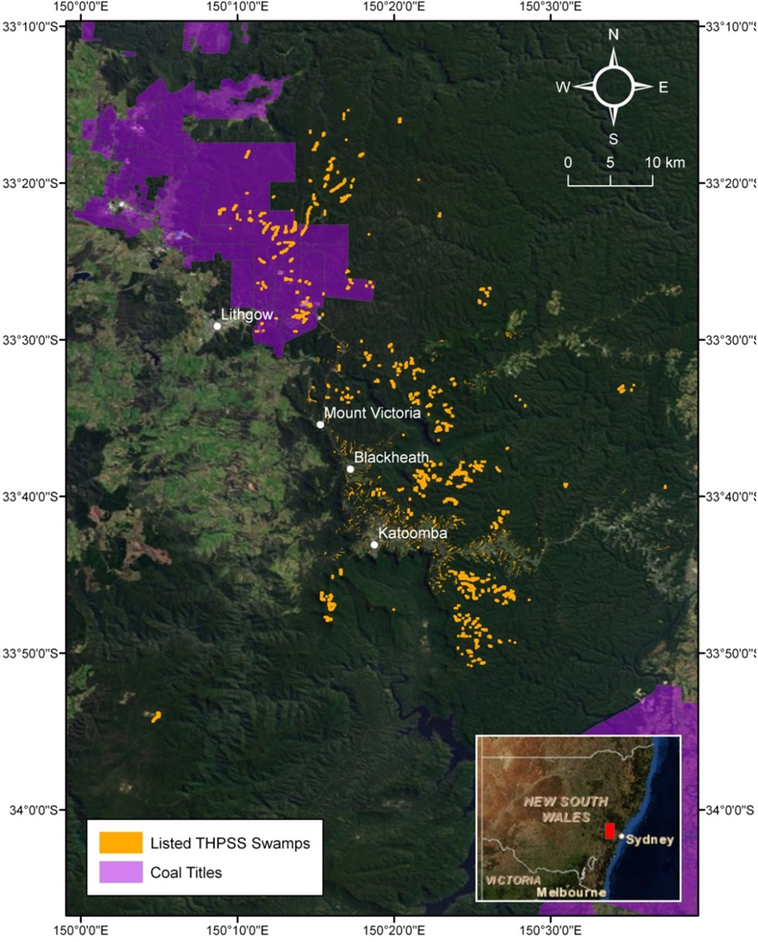
Image created by authors in September 2013 using THPSS data; coal title information from MinView (www.resourcesandenergy.nsw.gov.au/miners-and-explorers/geoscience-information/online-services/minview)
Figure 2.1 Listed THPSS swamps and coal titles in the Blue Mountains region; Newnes Plateau swamps are visible in the north-west.
Threats to THPSS vary between geographic regions; from swamp to swamp within regions; and with the proximity of swamps to urban, forestry or agricultural land. However, the main threats to THPSS are weed invasion; erosion; sedimentation; changed hydrology; fire; recreational activities; and impacts from agriculture, introduced animals, forestry, quarrying and mining (Whinam & Chilcott 2002; NSW Scientific Committee 2005b, 2007; Carey 2007; DSEWPaC 2012c).

Other upland peat swamp communities
In addition to the THPSS ecological community, four swamp ecological communities within the Sydney Basin are listed for protection by the NSW Scientific Committee (2004, 2005b, 2007, 2012):
- montane peatlands and swamps of the New England Tableland, New South Wales North Coast, Sydney Basin, South East Corner, South Eastern Highlands and Australian Alps bioregions (endangered ecological community)
- Newnes Plateau Shrub Swamp in the Sydney Basin bioregion (endangered ecological community)
- Blue Mountains swamps in the Sydney Basin bioregion (vulnerable ecological community)
Coastal Upland Swamp in the Sydney Basin bioregion (endangered ecological community).
Advice to the former Australian Government Department of Sustainability, Environment, Water, Population and Communities (DSEWPaC) on a revised listing of the THPSS ecological community recommends that the existing elevation criteria (>600 m above sea level) be removed (CoA 2014a). A revised listing would facilitate the inclusion of many similar swamps in New South Wales, particularly in lower elevation areas (<600 m above sea level), such as the Woronora Plateau, south of Sydney, above the Southern Coalfield (see note 1 at the end of this section). The four upland peat swamp communities face the same threats as THPSS: changed hydrology; weed invasion; erosion and sedimentation; fire; recreational activities; impacts of residential development and urban infrastructure; and impacts from agriculture, introduced animals, forestry, quarrying and mining (NSW Scientific Committee 2004, 2005b, 2007, 2012). This report therefore includes information about these swamps. For clarity, all five swamp ecological communities are referred to as upland peat swamps, unless specifically noted (although a more appropriate name is upland dells—Young 1982).
Figure 2.2 shows the location of upland peat swamps on the Woronora Plateau and Southern Highlands, including Butlers Swamp, Wingecarribee Swamp and Wildes Meadow Swamp (all listed in the THPSS ecological community). This figure highlights the number of swamps on the Woronora Plateau, as well as the overlap between these swamps and the coal titles of the Southern Coalfield.
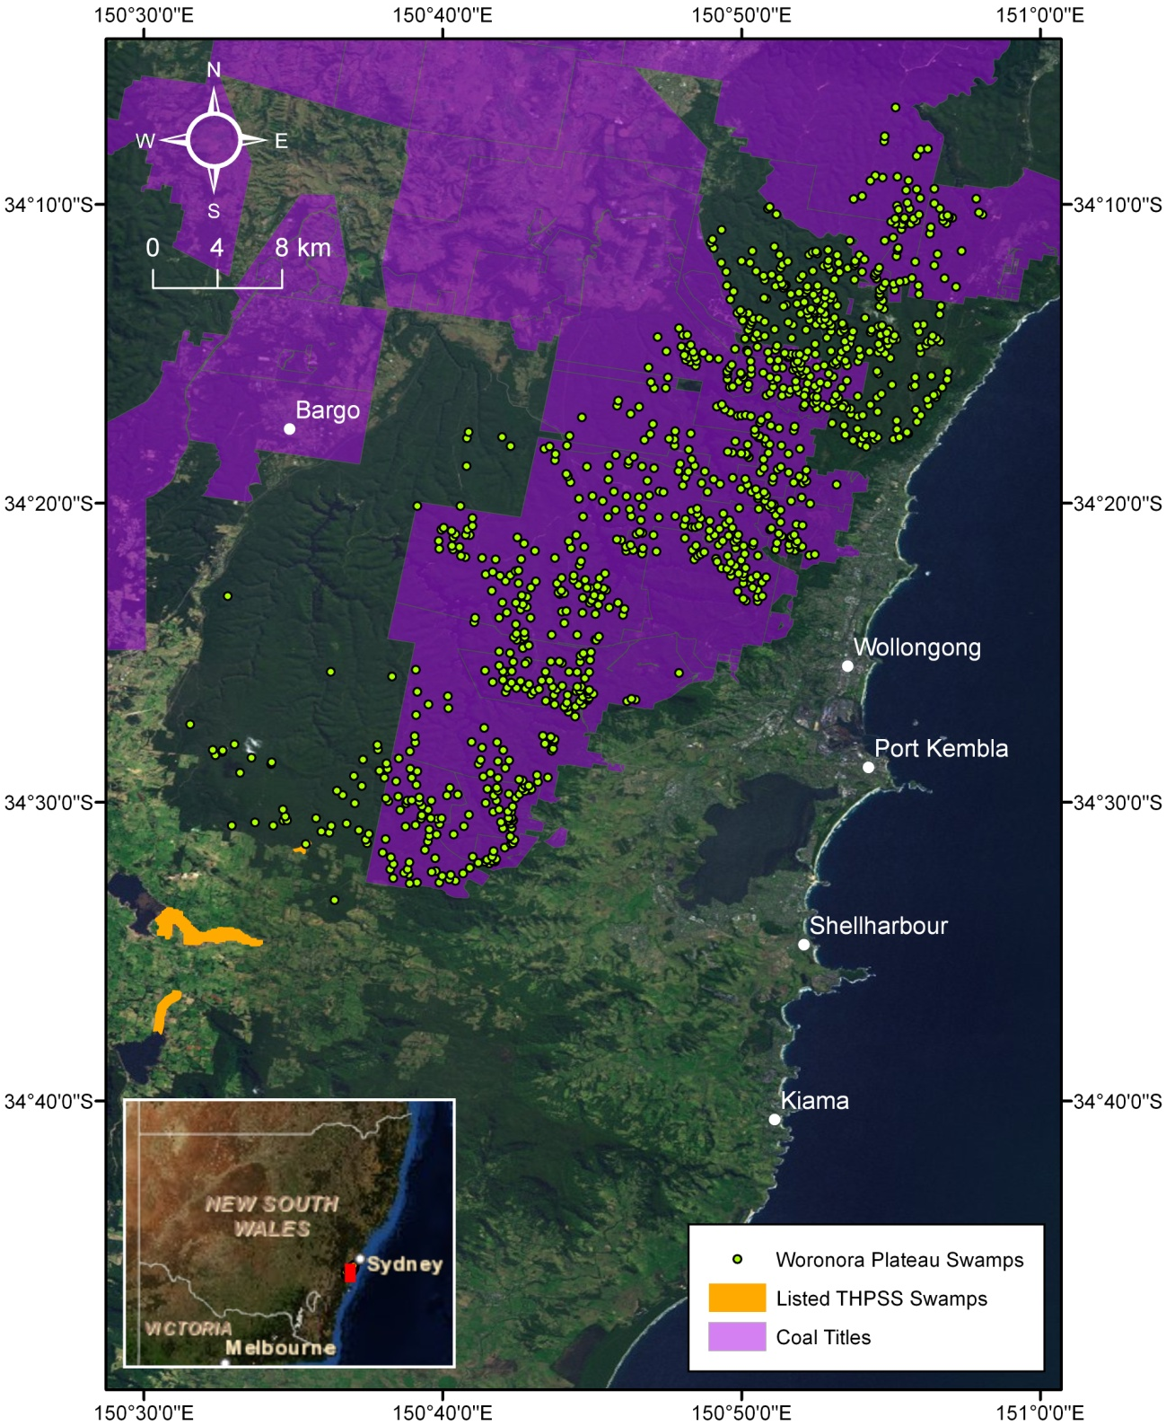
Image created by authors in September 2013, using Woronora Plateau data and THPSS data from DSEWPaC; coal title information from MinView (www.resourcesandenergy.nsw.gov.au/miners-and-explorers/geoscience-information/online-services/minview)
Figure 2.2 Upland peat swamp distribution and coal titles on the Woronora Plateau and Southern Highlands.

Formation and characteristics of upland peat swamps
Young (1982) provides a detailed discussion of upland peat swamps on the Woronora Plateau, including their position in the landscape, geomorphic and ecological interrelationships, fundamental hydrological processes, and vegetation response to altered sedimentary patterns. An overview is provided below, as context to proposed remediation strategies.
Upland peat swamps exist on the sandstone plateaus surrounding Sydney (as outlined in Sections 2.1 and 2.2). Most occur within first- or second-order valleys; however, they are not solely confined to valley floors, and can exist on benches or steep valley sides (Young 1982). In the Blue Mountains and Newnes Plateau regions, the upland peat swamps generally occur:
- in shallow, gently sloping and often narrow headwater valleys (Benson & Keith 1990; Keith & Benson 1988)
- on open drainage lines at the base of the slopes, along low-lying, broad valley floors and alluvial flats (DEC 2006)
at gully heads, along open depressions on ridge tops and steep valley sides associated with semipermanent water seepage (Holland et al. 1992; DEC 2006).
In the central and southern areas of New South Wales, upland peat swamps occur in river headwaters on gently sloping valleys, overlying Hawkesbury Sandstone or Permian sandstones of the lower Berry Formation on the Southern Tablelands (DSEWPaC 2012c). Headwater drainage swamps are common on the Woronora Plateau; valley-filling swamps are confined to the more dissected valleys (e.g. Tomkins & Humphreys 2006; Florasearch & Western Research Institute 2008; Merrick 2008). More information about representative swamp types commonly referred to in the literature is provided in Section 2.4.
Upland peat swamps are formed in locations of relatively high moisture—usually where precipitation substantially exceeds evaporation (Young 1982). They lie on gently sloping plateaus, are well vegetated, lack continuous open channels and have limited discharges. Consequently, they generally have low stream competence, and sediment is deposited. The sediment derived from the medium–coarse quartzose sandstone of the plateau results in the accumulation of sandy inorganic sediment, commonly forming the basal layer of upland peat swamps (Young 1982).
Organic and inorganic sediments typically aggregate in stream-line depressions within upland peat swamps. These waterlogged sediments are poorly aerated, and subsequently partially decayed organic matter accumulates. Anaerobic conditions dominate in the stream-line depressions. Sediment deposition maintains the hydraulic gradient and encourages further deposition, fostering a positive feedback loop. This process, including the development of hydrophilic graminoid vegetation, may increase the water-holding capacity of the sediment and contribute to the slow rate of horizontal seepage (Benson & Baird 2012). With increasing waterlogging, rates of organic decomposition decrease under anaerobic conditions, leading to the accumulation of peat, or at least more organic-rich swamp substrates (Young 1982; Keith et al. 2006; Benson & Baird 2012).
Young (1982) established that there is a close relationship within upland peat swamps between the characteristics of the modern sediments and the localised hydrological conditions. Four groups of sediments were identified within the upland peats swamps of the Woronora Plateau: organic fines, organic sands, grey–brown sands and sandy yellow earths (Young 1982). The first three sediment types are largely depositional, and are distinguished by their different organic contents and resultant colour differences. This highlights that the upland peat swamps studied by Young (1982) are a mix of organic and inorganic sediments. Similar layers, between highly penetrable peat and dense sands or sandy clays were also noted on the Newnes Plateau (Benson & Baird 2012). The organic fines identified by Young (1982) had a very low mineral content and could be described as peat. However, the organic fines are limited in extent, both across the valleys and with depth, being set within wedges of organic sand along permanently wet channels (Young 1982).
Overland flows deposit small plant fragments and organic debris, as well as mineral silt and clay, within seepage zones. The humic materials darkening organic soils are acidic, and accumulate in usually or permanently wet soils, because of the prevailing anaerobic conditions. Young (1982) conducted field measurements of water chemistry within upland peat swamps. She found that the waters of the swamps were acidic, ranging from pH 3.7 to 5.6. The top 10 cm of the organic-rich sediments within the Woronora upland peat swamps were noted to have extremely high concentrations of iron oxides (often 1 to 3 per cent, and up to 20 per cent of dry weight expressed as Fe₂O₃) (Young 1982). Iron is removed in solution from the sediments by the acidic and poorly aerated waters; the leaching of iron is seen in the slimy orange floc that often precipitates from swamp exit streams during low flows (Young 1982). This iron leaching is the most apparent mechanism of weathering of the bedrock underlying the swamps (Young 1982).
Young (1982) investigated the average position and fluctuations of the watertable in swamps on the Woronora Plateau. During wet weather, the watertable in the upland peat swamps was at the ground surface in the valley axes, in tributary seepage zones and on side slopes where the bedrock was shallow. Following prolonged rainfall, the watertable persisted close to the surface for a week or more. Young (1982) observed that the high watertable was localised to the swamp sediments; immediately adjacent forested areas had minimal standing water in holes augered through the soil to bedrock. Hydrological conditions such as these must be considered when designing and implementing remediation projects.
In mapping the swamps of the Newnes Plateau, Benson and Keith (1990) noted that swamps could be differentiated based on their moisture content. They grouped all permanent swamps together as Newnes Plateau Shrub Swamp, but noted that swamps on the western side of the plateau (e.g. West Wolgan, Kangaroo Creek-Upper) tended to be drier and have a greater component of Leptospermum shrubland, perhaps indicating that the watertable is not permanently high—it may be more rainfall dependent than groundwater dependent. Distinctions between ‘dry’ and ‘wet’ swamps have been made in the context of potential impacts of subsidence from underground longwall mining (Aurecon 2009, in Benson & Baird 2012); the implication is that subsidence impacts are less likely to affect ‘dry’ swamps. There is evidence that these swamps may be less susceptible to subsidence impacts than the groundwater-dependent swamps further east, because of the lower level of incision of the drainage lines (Benson & Baird 2012).
Young (1982) noted that upland peat swamps are contemporary features of the landscape, rather than relics of a past climate or a disrupted drainage system. Aggradation rates of 0.1 to 1 mm/year were reported (Young 1982). Similar rates (0.1 to 0.3 mm/year) were calculated for five sites in the Blue Mountains (Stockton & Holland 1974). However, individual upland peat swamps may erode at substantially higher rates than recorded in these geographically restricted studies. Erosion of upland peat swamps takes place by knickpoint retreat between pre-existing scour pools, resulting in a gully cutting through the swamp (Tomkins & Humphreys 2006). Tomkins and Humphreys (2006) investigated erosion in three Woronora Plateau swamps: Drillhole Swamp, Swamp 18 and Flat Rock Swamp (see Section 3.5.1 for detailed information about the observed impacts at these swamps). Although the cyclical nature of upland peat swamp erosion and deposition has been highlighted (Young 1982; Tomkins & Humphreys 2006; Fryirs et al. 2012), Tomkins and Humphreys (2006) noted that gully erosion results in the rapid release of a large volume of sediments into the reservoirs downstream.
Erosion appears to begin through the formation of scour pools in the swamp surface, which can become progressively channelised to form a continuous gully (Tomkins & Humphreys 2006). The formation of scour pools is a critical indicator of likely future gully erosion in the swamps. Tomkins and Humphreys (2006) note that the trigger(s) and controlling factors, including intrinsic thresholds, for the scour pools are unknown, but extreme rainfall events may be a trigger. Previous investigations also suggest that disturbance, either human (e.g. direct physical disturbance or mine subsidence) or natural (e.g. bushfires), can lead to increased erosion in swamps (Tomkins & Humphreys 2006).

Representative swamp conceptual models
Section 2.3 outlined the generalised process of formation of upland peat swamps, alluding to different conceptual models discussed in the literature. Three conceptual models of upland peat swamps—headwater, valley infill and hanging—are commonly presented as being representative of the broad spectrum of individual upland peat swamps (e.g. Tomkins & Humphreys 2006; NSW PAC 2010, 2009). These differ in characteristics relating to their hydrodynamic regime and setting in the landscape. It is important to note that an individual upland peat swamp may have characteristics of more than one conceptual model.
The following sections provide an overview of the different swamp conceptual models. A detailed analysis of the geological, hydrological and ecological characteristics of each swamp models is provided by Jacobs SKM in CoA (2014a).

Headwater swamps
Headwater swamps occur close to catchment divides in the upper catchment. Because of their position high in the landscape and the relatively flat terrain on which they occur, groundwater connection is rare. The swamps’ dominant water source is recharge through rainfall and run-off (both overland flow and from headwater streams) (NSW PAC 2009). Water flows through the swamps either as sheet flow along the surface of the peat, through the peat sediments themselves or through channels, which are normally discontinuous within the peat.
Headwater swamps occur within the Sydney Basin and are the dominant swamp type on the Woronora Plateau (DoP 2008; Bower 2009). There are numerous examples of this swamp type on Newnes Plateau (Tomkins & Humphreys 2006; DoP 2008; Bower 2009; Benson & Baird 2012).

Valley infill swamps
Valley infill swamps occur further down the catchment than headwater swamps and are often located in the steeper terrain of incised valleys, associated with second- or third-order streams. Valley infill swamps are probably initiated by rapid transportation of sediment material downstream and its rapid deposition, possibly as a result of channel profile restriction (i.e. logjams) (DoP 2008). Once initiated, the swamps are likely to be self-enforcing, trapping more sediment, raising the watertable, and fostering the development of organics and the formation of peat (Tomkins & Humphreys 2006).
Valley infill swamps can be further differentiated based on their underlying strata into two categories:
- valley infill swamps on sandstone
valley infill swamps on alluvium.
Valley infill swamps on sandstone are formed where a deposit of peat material has formed directly on a sandstone base, and where the hydraulic gradient of the swamp is controlled by the variation in the valley floor and the slow migration of water through the swamp (CoA 2014b).
Valley infill swamps on alluvium are located on a substantial thickness of alluvial sediment, rather than directly on sandstone rock strata. A key difference between the two conceptual models of valley infill swamps is that the groundwater system of valley infill swamps on alluvium is typically interconnected with the adjacent environment, rather than perched on a sandstone base, which may be largely independent of the surrounding watertable (CoA 2014b).

Hanging swamps
The term hanging swamps covers a broad spectrum of swamps that are located on the often steep, sloping sides of catchments, rather than in valleys. Hanging swamps are typically located where groundwater discharges occur along the top of impermeable claystone layers (Keith & Benson 1988; Holland et al. 1992). These swamps are generally found in the headwaters of catchments, and are not typically associated with stream channels, rarely showing the presence of surface water. They typically do not have substantial peat deposits, and rely on a combination of direct rainfall or run-off and groundwater for recharge. Water volumes are held in the sandstone-derived soil and include plant root matter. Hanging swamps are typically underlined by sandstone with a (sometimes steeply) sloping surface. This type of swamp occurs famously in the Blue Mountains and Newnes Plateau. They have also been identified on the Woronora Plateau (DoP 2008), where they are most common in the Cataract Catchment on short, gentle and benched slopes. Hanging swamps do not extend continuously from the valley floors up steep ridges (Young 1982).

Chapter synthesis and knowledge gaps
The importance and uniqueness of THPSS is reflected in the inclusion of this ecological community as endangered in Commonwealth and New South Wales listings. Upland peat swamps are under threat from a range of processes; Sections 2.1 and 2.2 highlight the proximity of longwall mining operations to upland peat swamps located above the Southern and Western coalfields. Section 2.3 cites references that detail the long-term stability of upland peat swamps, and recognise the unique formation mechanics, soil structure, heterogeneity, ecology and spatial distribution that differentiate upland peat swamps from other ecological communities.
The overview of representative conceptual models for upland peat swamps in Section 2.4 highlights the heterogeneity between swamps. Although similarities exist, any remediation plans for upland peat swamps will have to be developed individually, taking into consideration both the characteristics of the upland swamp in its natural condition and the nature of the impact that has occurred.
Despite the early work of Young (1982), considerable uncertainty remains in understanding upland peat swamp landscapes. This is summarised by Keith et al. (2006, p. 2): ‘Despite recent improvements in knowledge, considerable uncertainties remain in understanding the dynamics of upland swamp landscapes’. A particular knowledge gap is the understanding of peat swamp hydrology. As noted by Jankowski and Spies (2007, p. 9) a thorough understanding of the impact of longwall mining on the surface waterways and groundwater system is necessary ‘before any remediation options to reduce loss of water into subsurface routes and minimise impact on water quality are considered’. Ecoengineers (2007, p. 29) highlight that ‘no… quantitative water balance study [of upland peat swamps] has been published’. Indeed, despite the extensive literature review undertaken for this project, no quantitative water balance of an upland peat swamp has been identified. Consequently, there is limited knowledge of the natural range of variability within upland peat swamps. Understanding of the variability between different upland peat swamps in a similar region is also limited.
Section 2.3 outlines how upland peat swamps in the Sydney region are still developing, although aggradation rates are slow (0.1 to 1 mm/year). Young (1982) noted that vegetational changes in the upland peat swamps mirrored sedimentological changes and, consequently, hydrological changes. Therefore, remediation programmes should focus on restoring the natural hydrological regime of the swamps, allowing sediment deposition, vegetation growth and reinforcement of the peat-forming conditions. However, measured aggradation rates for some swamps are substantially higher than observed for the majority (Young 1982). Further information about aggradation rates will assist the development of remediation plans for upland peat swamps that are impacted by longwall mining.
Tomkins and Humphreys (2006) highlight the lack of knowledge about erosion of upland peat swamps. Although the formation of scour pools is a critical indicator of likely future gully erosion in the swamps, the trigger(s) and controlling factors, including intrinsic thresholds, for the scour pools are unknown. Further research in this field would lead to a better understanding of erosion processes for upland peat swamps. Finally, there is limited understanding of the response of upland peat swamps to anthropogenic stressors—for example, swamp degradation caused by recreational vehicles.

Note on EPBC listing
1. In December 2010, the Threatened Species Scientific Committee requested that the Australian Government Department of the Environment review the listed ecological community ‘Temperate Highland Peat Swamps on Sandstone’ with the view that it could be split into two separate ecological communities, one of which was the ‘Upland Peat Swamps of the Sydney Sandstone Basin’, later renamed ‘Peaty Upland Swamps on Sandstone in the Sydney Basin’. The revision concluded that the proposed changes would be confusing and would not achieve the desired protection outcomes. Subsequently, the decision was made to keep the original ‘Temperate Highland Peat Swamps on Sandstone’ ecological community without change and examine the recently listed New South Wales ‘Coastal Upland Swamps in the Sydney Basin Bioregion’ to assess whether it would be appropriate to list a similar or the same ecological community under the national environmental law (the Environment Protection and Biodiversity Conservation Act 1999—EPBC Act).
The assessment was placed on the 2013 Finalised Priority Assessment List by the federal Minister for the Environment. Guided by expert technical input, an assessment of eligibility for listing by the Threatened Species Scientific Committee has progressed in the form of a draft description of the ecological community.
During early 2014, the Department of the Environment undertook a public consultation on the assessment of the ‘Coastal Upland Swamps in the Sydney Basin Bioregion’ as a potentially threatened ecological community under the EPBC Act. It was proposed to assess the community for listing as ‘endangered’. At the time of writing, the outcome of the proposed listing was unknown.

Impacts of longwall mining and subsidence
This section provides an overview of underground mining techniques (Section 3.1), underground mining operations in the Western and Southern coalfields (Section 3.2), and the historical context for the present investigation (Section 3.3). Section 3.4 discusses subsidence mechanisms and associated likely impacts on upland peat swamps and waterbodies. Sections 3.5 and 3.6 present numerous examples of upland peat swamps and waterbodies that have been affected by longwall mining subsidence within the Sydney Basin and internationally.

Underground coalmining techniques
Underground coalmining methods involve the development of a series of excavations in the rock mass. Different mining methods can be characterised by the absolute size of each excavation and the absolute size of the pillar(s) between each excavation (DoP 2008). Historically, two main extraction methods are used in underground coalmining in Australia: bord and pillar, and longwall. In recent years, there has been a rapid decrease in bord and pillar application; with a few exceptions, this technique is now confined to a number of small mines operating at shallow to moderate depths (DoP 2008).
Longwall mining is the most commonly used and economical underground coalmining method in Australia. Safety, productivity and cost considerations mean that longwall mining is now the only major, viable, high-production mining method in the majority of Australian underground coalmines (DoP 2008). Longwall extraction operations effectively result in the formation of wide and long excavations, separated by a single or double row of relatively narrow chain pillars. Hydraulic roof supports temporarily hold up the roof strata immediately in front of the coalface, providing a working space (Madden et al. 2009). One large coal pillar is extracted within each longwall panel by progressively shaving slices of coal, or webs—about 1 m wide—off one end of the pillar. As the coalface is cut away, the hydraulic roof supports, face conveyor and shearing machinery move forward (Madden et al. 2009). Longwall panels can range from 150 to 400 m in width, and from 1 to 4 km in length (DoP 2008). Chain pillars between longwalls vary in width from 20 to 50 m (Holla & Barclay 2000). Figure 3.1 shows the layout of a typical longwall mine.
Longwall face operations are conducted under the protection of mobile hydraulic supports, providing a safe working environment while minimising operating costs and maximising productivity (Madden et al. 2009). Millions of tonnes of coal can be extracted without the need to install permanent or semipermanent roof supports. The hydraulic supports are advanced as each web of coal is mined, thereby progressively increasing the area of the unsupported excavation, or goaf, behind the supports; a collapse zone is formed above the extracted area. This zone is highly fractured and permeable. It normally extends above the seam to a height of five times the extracted seam thickness (typical extracted seam thickness is approximately 2 to 3.5 m) (NSW Scientific Committee 2005a).
Above the collapsed zone is a fractured zone, where the permeability is increased to a lesser extent than in the collapsed zone. The fractured zone extends to a height above the seam of approximately 20 times the seam thickness; however, in weaker strata, this can be as high as 30 times the seam thickness (NSW Scientific Committee 2005a). Above this level, the surface strata may crack as a result of bending strains. The cracks vary in size according to the level of strain, the thickness of the overlying rock stratum, and the frequency of natural joints or planes of weakness in the strata (Holla & Barclay 2000). Significant subsidence and resulting disturbance of the subsurface and surface may occur, depending on the mining layout (DoP 2008). If these impacts penetrate to the surface watertable, the subsidence and associated impacts, including watertable drainage, can have a substantial impact on ecosystems on the surface, such as swamps. The following sections discuss impact mechanisms and subsidence following longwall mining, and provide an overview of longwall mining in the Sydney region.
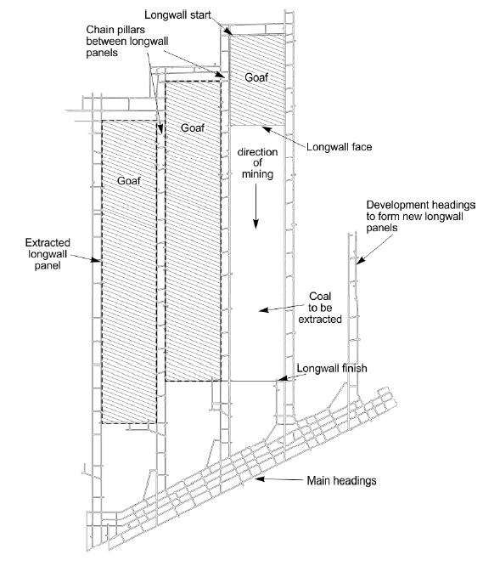
© Copyright, CoA 2014b
Figure 3.1 Plan view layout of typical longwall panels.

Longwall mining in the Sydney region
The major coal resources in New South Wales are located in the 500-km-long, 150-km-wide Sydney–Gunnedah Basin, which extends from south of Wollongong to north of Newcastle and north-westerly towards Queensland. There are five major coalfields within the basin: Hunter, Newcastle, Southern, Western and Gunnedah (Figure 3.2). This report focuses on the Southern and Western coalfields, where virtually all coalmining is underground (NSW Scientific Committee 2005a). Longwall mining in the Southern and Western coalfields is relevant to this study because of the proximity of these coalfields to upland peat swamp ecological communities, including the endangered THPSS ecological community in the Western Coalfield. The following sections provide detailed information about underground mines in these coalfields.
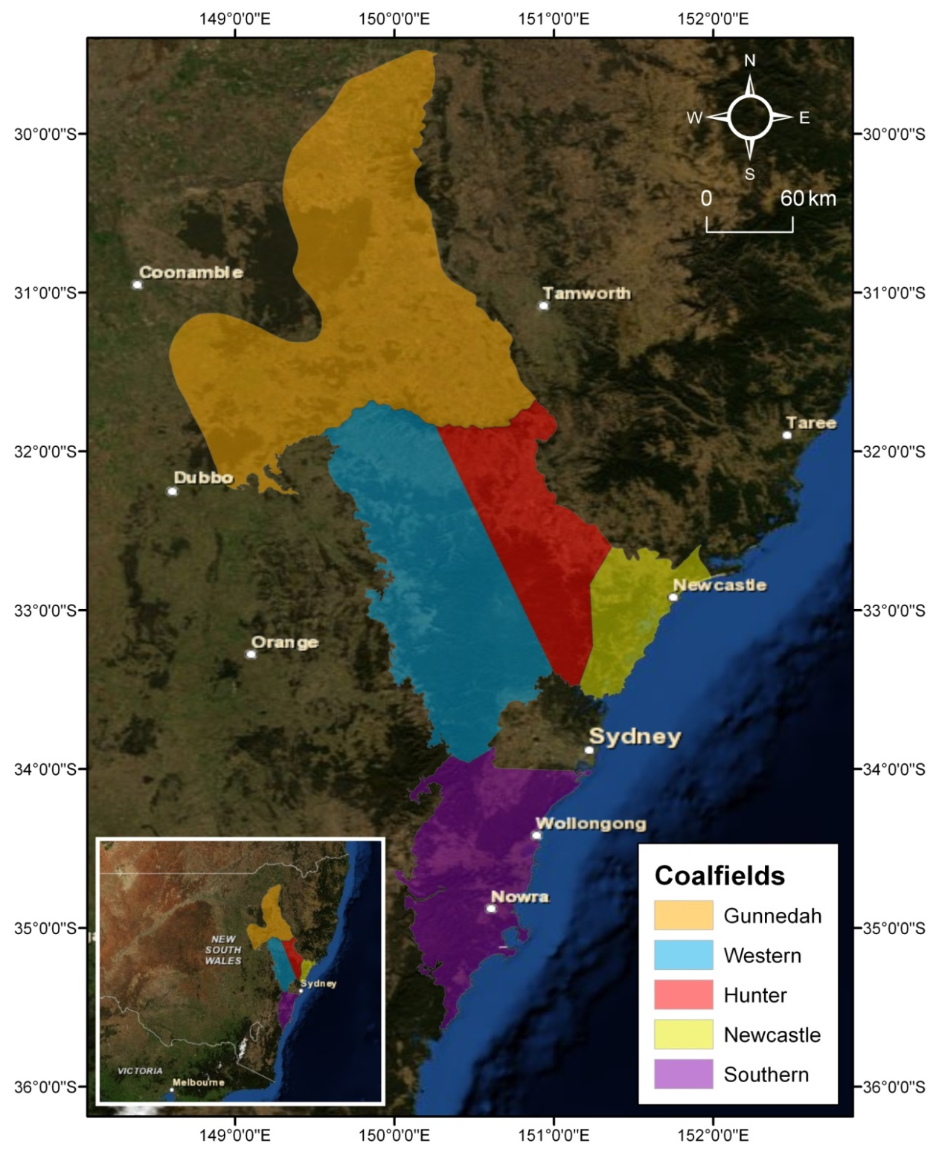
Image created by authors in September 2013, using MinView (www.resourcesandenergy.nsw.gov.au/miners-and-explorers/geoscience-information/online-services/minview)
Figure 3.2 Coalfields of New South Wales.

Southern Coalfield
Coal was first discovered in Australia in the early 1790s at the mouth of the Hunter River, New South Wales. Shortly afterwards, in 1796, it was also found near Wollongong at Coal Cliff (Krogh 2007). Mining commenced in the Wollongong region in 1848 at the Albert Coal Mine at Mt Keira, but it was not until 1857 that the first commercial quantities of coal were produced, at the Kemira Colliery (DoP 2008). By 1870, three collieries were in operation, and the Metropolitan Colliery at Helensburgh opened in 1888 (DoP 2008). There are currently eight operational underground coalmines in the Southern Coalfield.
The overall thickness of the coal measures, as well as the nature and thickness of individual coal beds, varies depending on their location within the basin. Substantial areas of the Southern Coalfield have been extracted by both bord and pillar workings and longwall mines. For example, in a 55 km² area around Appin, the combined footprints of longwall mine extractions occupy 26 km²; much of the remaining area contains bord and pillar first workings (Pells & Pells 2012). Table 3.1 provides an overview of mining operations, and Table 3.2 provides further details for a selection of collieries, documenting the depth of cover, width of longwall panels and estimated height of the fracture zone.
Table 3.1 Overview of mining operations in the Southern Coalfield.
Colliery | Owner/operator | Previous name/owner | Mining method | Coal seam
Metropolitan | Helensburgh Coal Pty Ltd, a subsidiary of Peabody Energy Australia Coal Pty Ltd | Excel Coal Limited | Longwall since 1995 | Bulli
Appin | Illawarra Coal Holdings Pty Ltd, a subsidiary of the BHP Billiton Group | Appin West, formerly known as Tower | Longwall in Appin since 1969; longwall in Tower 1988 to 2002 | Bulli
West Cliff | Illawarra Coal Holdings Pty Ltd, a subsidiary of the BHP Billiton Group | CRA Limited (before 1997) | Longwall since 1982 | Bulli
Dendrobium | Dendrobium Coal Pty Ltd, a subsidiary of the BHP Billiton Group |  | Longwall since 2005 | Wongawilli
NRE No. 1 | Gujarat NRE Australia Pty Ltd (since 2004) | Known as Bellpac Colliery, Bellambi Colliery, Cordeaux and Bulli Colliery | Bord and pillar; longwall since late 1970s | Bulli Balgownie  Wongawilli
NRE Wongawilli | Gujarat NRE Australia Pty Ltd (since December 2007) | Consolidates Elouera (previously Kemira and Nebo—both owned by BHP Billiton), Avondale and part of Huntley | Longwall since 2009; longwall in Elouera 1993 to 2007 | Wongawilli
Tahmoor | Xstrata Coal (NSW) Pty Ltd | Centennial Coal Company Limited | Longwall | Bulli
Berrima | Boral/Delta | na | Longwall | Wongawilli
na = not applicable
© Copyright, SCA 2012
Table 3.2 Depth of cover and estimated extent of fracture zones in areas impacted by longwall mining.
Colliery | Coal seam | Depth of cover (m) | Panel width (m) | Estimated height of fracture zone (m)
Metropolitan | Bulli | 400–560 | 120–158 | ~130
Bulli Seam Operations (Appin, West Cliff) | Bulli  Wongawilli | 300–500 | 310 | Up to the surface
NRE No. 1 | Bulli  Wongawilli | 237–255 (Wonga East A1)  267–320 (Wonga East A2)  457–512 (Wonga West A4) | 105 (Wonga East A1)  150 (Wonga East A2)  155 m (Wonga West A3–A4) | ~150
NRE Wongawilli | Wongawilli  Tongarra | 300–400 | na | na
Dendrobium (Area 1) | Wongawilli | 137–322 | 240 | Up to the surface
Dendrobium (Area 2) | Wongawilli | 145–315 | 245 | 250
Dendrobium (Area 3A) | Wongawilli | 260–400 | 250–300 | 300–370
na = not applicable
© Copyright, SCA 2012

Western Coalfield
More than seven underground coalmines operate in the Western Coalfield on the edge of the Sydney Basin:
- Ulan No. 3 Colliery (existing) and Ulan West Colliery (construction recently commenced)—owned and operated by Ulan Coal Mines Limited, a subsidiary of Xstrata Coal (Xstrata Coal Ulan 2012)
- Clarence, Springvale and Angus Place collieries—all owned in joint ventures by Centennial Coal (Centennial Coal 2012a)
- Airly Colliery—owned by Centennial Coal (Centennial Coal 2012a)
Baal Bone Colliery—owned by Xstrata Coal; operations ceased in 2011 (Xstrata Coal 2012).
Substantial impacts of longwall mining have been reported on the THPSS of the Newnes Plateau (see Section 3.5), and remediation plans have been submitted for two of these sites (DSEWPaC 2012a, b). Detail regarding the proposed remediation is provided in Section 5.3.1.

Historical context
Longwall mining proposals in the Sydney region have generated debate for many years. Of particular concern to the public has been longwall mining beneath Sydney’s drinking water catchments in the Southern Coalfield. For more than a century, water supply authorities and mining companies have discussed the potential loss of surface water and groundwater on the Southern Coalfield (Reynolds 1976; McNally & Evans 2007).
In 1904, following a proposal to mine beneath what would soon become an area of water impounded by Cataract Dam, the Board of Water Supply and Storage objected, contending that no mining should be allowed under stored waters, or within one-quarter of a mile of the dam boundaries (Reynolds 1976). This was followed by periodic objections to mining grants. Consensus was reached about the prohibition of mining in the vicinity of dam structures, but there was no agreement about mining under the water storages themselves or under major tributaries that discharge to the impoundments (Krogh 2007). As a result, mining beneath stored waters and fringe zones occurred under a variety of limiting conditions, using bord and pillar extraction techniques. The extent of mining increased and, in 1959, following three applications to mine under Cataract Reservoir, the Water Board asked for the entire catchment to be exempted from the leasing conditions of the Mining Act (Reynolds 1976). No agreement could be reached on the matter and, in 1973, a commission of inquiry was established, with Justice RG Reynolds of the Supreme Court as Commissioner.
During the Reynolds inquiry, the Water Board stressed the susceptibility of concrete dams to failure due to subsidence movements, as well as the potential for flooding of mines and unrestrained seepage of water into the escarpment area. Other problems considered important by the Water Board were abnormal geological conditions (faults, etc.) and the long-term stability of pillars that could deteriorate as a result of age, fires, submergence or seismic activity. The Water Board presented material on the seepage of water into Huntley Colliery, claimed to be from the Avon Reservoir, on the basis of algae and other tests (see Section 3.5.2.6 for further detail). The Water Board also tabled examples of damage to a number of dams in Wales, the undermining and subsequent failure of the reinforced concrete New Lambton Reservoir at Newcastle, and numerous mining disasters (Reynolds 1976).
In contrast, the mining industry presented many successful experiences of mining under water storages and the ocean, under a range of conditions. However, knowledge within an Australian context was relatively rare, particularly in the Southern Coalfield. The Reynolds inquiry largely found in favour of the mining industry, suggesting that relevant mining should be permitted because of the value of the resource, and that the security of stored waters could be maintained if mining were carried out with the proper safeguards. Reynolds (1976) recommended that mining under stored water be restricted to specified systems of partial extraction. As well, minimum depths of cover were to be maintained, with no mining under stored water or the marginal zones of stored water with a depth of cover of less than 60 m.
The New South Wales Government did not adopt the recommendations of the Reynolds inquiry. However, in November 1977, following general concern about the safety of dams and the need to establish control over coalmining in the vicinity of dams and storages, the New South Wales Cabinet approved the establishment of a Dams Safety Committee (Anderson et al. 1989). The Dams Safety Committee has a major role in providing recommendations regarding the granting and renewal of coal leases, and specifically coalmining adjacent to and under dams and storages (Krogh 2007).
In recent years, the potential impacts of longwall mining in a broader ecological sense have been recognised. In 2005, the NSW Scientific Committee, concerned about longwall mining in the coalfields surrounding Sydney, listed ‘Alteration of habitat following subsidence due to longwall mining’ as a Key Threatening Process under Schedule 3 of the New South Wales Threatened Species Conservation Act 1995 (NSW Scientific Committee 2005a).
The focus of government agencies and nongovernment organisations has been on gathering information about the potential and observed impacts of longwall mining. Three major reviews have been conducted since 2007: the inquiry into the Southern Coalfield (DoP 2008), the Metropolitan Coal Project Review (NSW PAC 2009) and the Bulli Seam Operations PAC Review (NSW PAC 2010). Two of these were Planning Assessment Commission (PAC) reports on specific projects. The other was an independent inquiry into underground coalmining in the Southern Coalfield, which was established by the New South Wales Government in December 2006 as a result of concerns held by the government over past and potential future impacts of mine subsidence (DoP 2008).
Key research outcomes from the independent inquiry are summarised by Hebblewhite (2009, p. 121):
- ‘The coal mining industry and Government should undertake additional research into the impacts of subsidence on both valley infill and headwater swamps. This research should focus on the resilience of swamps as functioning ecosystems, and the relative importance of mining-induced, climatic and other factors which may lead to swamp instability.
- The coal mining industry should undertake additional research into means of remediating stream bed cracking, including:
  - crack network identification and monitoring techniques;
  - all technical aspects of remediation, such as matters relating to environmental impacts of grouting operations and grout injection products, life spans of grouts, grouting beneath surfaces which cannot be accessed or disturbed, techniques for the remote placement of grout, achievement of a leak-proof seal and cosmetic treatments of surface expressions of cracks and grouting boreholes; and
  - administrative aspects of remediation, in particular, procedures for ensuring the maintenance and security of grout seals in the long term.
- The coal mining industry should escalate research into the prediction of non-conventional subsidence effects in the Southern Coalfield and their impacts and consequences for significant natural features, particularly in respect of valley closure, upsidence and other topographic features.’
The inquiry into the Southern Coalfield (DoP 2008) and the Bulli Seam Operations PAC Review report (NSW PAC 2010) specifically mention observed impacts of longwall mining on upland peat swamps.
DoP (2008) mentions four swamps that may have been affected by longwall mining: Flat Rock Swamp, Drillhole Swamp, Swamp 18 and Swamp 19. It states that ‘whilst the Panel cannot be certain that subsidence either initiated or contributed to the overall damage at these swamps, the available evidence suggests a significant possibility that undermining of valley infill swamps could cause drainage, watertable drop and consequent degradation to swamp water quality and associated vegetation’ (DoP 2008, p. 117).
The Bulli Seam Operations PAC Report (NSW PAC 2010) noted that swamps brought to the attention of the Assessment Panel as having been impacted by longwall mining are ‘Dendrobium Swamp 1, East Wolgan Creek Swamp—Newnes Plateau, Kangaroo Creek—Newnes Plateau, Junction Swamp—Springvale Colliery, Swamp 18—Elouera Colliery, and Swamp 32. In addition to these, the Panel observed that multiple swamps either side of an undermined (and severely impacted) reach of Lizard Creek appeared to be dry and undergoing compositional change from invasion by wattles and eucalypts’ (NSW PAC 2010, p. 88). Section 3.5.1 provides observations of swamps impacted by longwall mining.

Impact mechanisms
To understand the potential surface impacts of underground coalmining—in particular, on ecological communities such as upland peat swamps—and how these relate to remediation strategies, it is important to understand subsidence and associated impact mechanisms.
The principal surface impact of underground coalmining is subsidence caused by deformation of the ground mass from longwall mining (DoP 2008; Hebblewhite 2009). The independent inquiry into longwall mining in the Southern Coalfield (DoP 2008) reported subsidence to include all mining-induced ground movements, including both vertical and horizontal displacement, tilt, strain and curvature (Figure 3.3) (DoP 2008; Hebblewhite 2009). Coffey Geotechnics (CoA 2014b) provided a detailed discussion of surface subsidence and the associated factors. Development of comprehensive remediation plans for affected ecosystems must take into account how all components of subsidence and the associated mechanisms affect the environment.
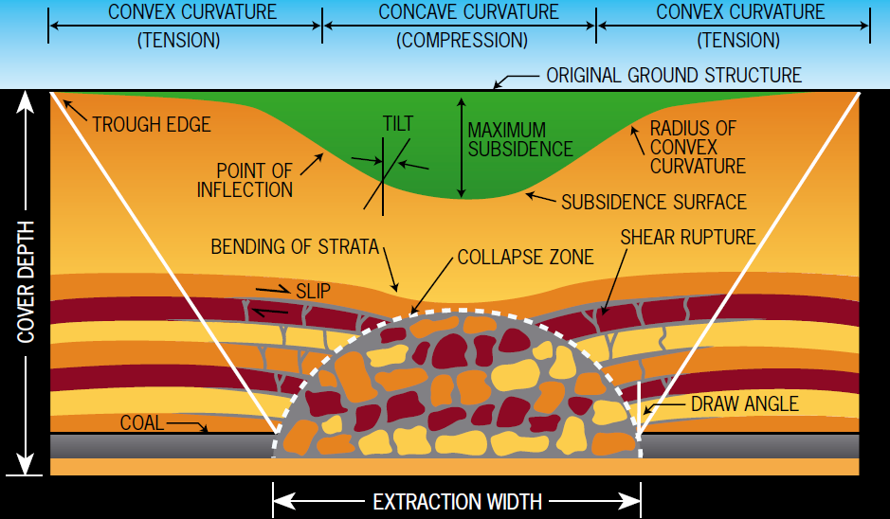
© Copyright, Mine Subsidence Board 2007
Figure 3.3 Surface effects of longwall mining.
Longwall mining causes disturbance to the overburden strata as the strata subside downwards into the void created at the mining horizon. The total subsidence at a surface point consists of two components: active and residual (Krogh 2007). Active subsidence usually occurs immediately, following the advance of the working face. In most cases, it forms 90 to 95 per cent of the total subsidence. Residual subsidence is due to readjustment and compaction within the goaf area and is time dependent (Holla & Barclay 2000; NSW Scientific Committee 2005a).
Subsidence impacts are primarily influenced by panel width and height, pillar width, depth of cover, geological strata (including faults and joints), and surface topography (Holla & Barclay 2000; ACARP 2002, 2001; Booth 2006). Subsidence also depends on topography—it is generally more evident in hilly terrain than in flat or gently undulating areas (Elsworth & Liu 1995; Holla 1997; Holla & Barclay 2000; ACARP 2001). The extent and width of surface cracking will also decrease with an increased depth of mining (Elsworth & Liu 1995).
The degree of subsidence caused by a particular mine depends on a range of site-specific factors. In the Sydney Basin, the maximum subsidence, which may occur only after several parallel panels have been mined over a number of years, is approximately half the thickness of coal extracted (Holla & Barclay 2000). For example, mining 2 m of the Bulli Seam has the potential to generate 1 m of subsidence; the residual is taken up by dilation of the overburden rock mass. For workings 400 m deep, this amounts to about 0.25 per cent overall volume increase in the form of cracking; however, the dilation is substantially greater in the 10 to 20 m above the seam and approximately 1 per cent in the topmost 10 to 20 m (McNally & Evans 2007).
Maximum surface impacts occur above the edges of the extraction area, and impacts may be cumulative where more than one seam is worked towards a common boundary (Krogh 2007). Further, the surface area affected by ground movement is greater than the area worked in the seam (Bell et al. 2000). In the New South Wales Southern Coalfield, horizontal displacements can extend for more than 1 km from mine workings (in extreme cases, more than 3 km) (ACARP 2002, 2003). However, at these distances, the horizontal movements have limited associated tilt or strain. Mining each panel may take up to a year to complete, and the surface strata may continue to experience residual subsidence for several years after completion (Holla & Barclay 2000). This time lag has potentially significant implications for managing mitigation and remediation of upland peat swamps.
The ‘conventional’ model of surface subsidence, accepted internationally, is based on several factors, including the following:
- The surface topography is relatively flat.
- The coal seam is level.
- The surrounding rock mass is relatively uniform, and free from major geological disturbances or dissimilarities.
- The surrounding rock mass does not contain any extremely strong or extremely weak strata.
The mine workings are laid out on a regular pattern (Hebblewhite 2009).
Where these ideal conditions are not met, as reported for the Southern and Western coalfields, surface subsidence can differ from that predicted using conventional modelling, and the subsidence behaviours and resulting effects (far-field horizontal movements, valley closure, upsidence and other topographical effects) are known as ‘nonconventional’. Whereas conventional surface subsidence impacts are well understood and hence readily and reasonably predictable using established methods, nonconventional surface subsidence effects are less well understood (Hebblewhite 2009). The inherent uncertainty in model predictions, due to natural heterogeneity of the overburden, reduces certainty in estimating impacts throughout the strata.
Two of these effects—valley closure and upsidence—which have been observed at many places in the Southern Coalfield, are difficult to predict (Hebblewhite 2009). Figures 3.4 and 3.5 show the cracking of riverbeds within the Southern Coalfield, following overstressing of valley floors, with the near-surface rock strata uplifting under the effects of bending and buckling. These examples are from creek beds and consequently free from sediment, making the cracking visible. Cracking below upland peat swamp sediment is more difficult to locate; however, the same mechanisms are likely to exist.
The mechanism(s) involved when the surface topography contains valleys, gorges or significant slope changes are not fully understood (DoP 2008; Hebblewhite 2009). However, two responses arising from these mining-related stress behaviours are:
- valley closure, where the two sides of a valley move horizontally towards the valley centreline
uplift of the valley floor, as a result of valley bulging and buckling, and shearing of the valley floor and near-surface strata; this behaviour is a direct consequence of valley closure—if valley sides close, the valley floor must be compressed, leading to buckling, which then gives rise to uplift (Hebblewhite 2009).
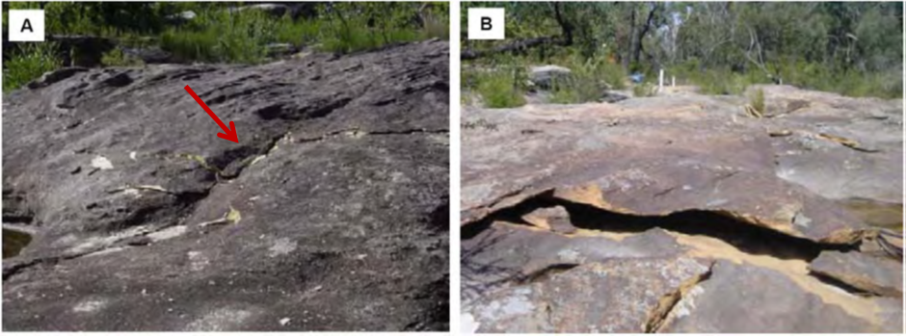
© Copyright, Sainsbury 2008
Figure 3.4 Cracking of riverbeds (indicated by arrow) within the Southern Coalfield.
© Copyright, Hebblewhite 2009
Figure 3.5 Buckling of near surface, Waratah Rivulet (Southern Coalfield), late 2004.
The term ‘upsidence’ is used by subsidence engineers to describe different mechanisms of upward vertical movement or uplift (DoP 2008). In some instances, it describes the absolute upward vertical movement of the surface at the edges of a region of subsidence influence, associated with massive strata cantilevering. However, the more common and widely accepted current use of the term is the valley effect described above, where a component of relative upward movement (uplift) is created by the horizontal compression and buckling behaviour of the rock strata in the vicinity of the valley floor (DoP 2008). Figure 3.6 shows a conceptual model of the upsidence mechanism.
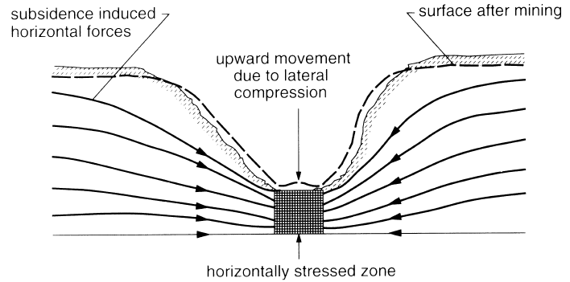
© Copyright, Sainsbury 2008
Figure 3.6 Conceptual model of the upsidence mechanism (cross-section view).
Buckling and shear in the near-surface strata, which lead to upsidence, can also generate an extensive network of fractures and voids in the valley floor. Ground movements due to conventional subsidence can contribute to the formation of this network if the upsidence occurs within the angle of draw of the mine workings. The formation of an upsidence fracture network has been monitored at Waratah Rivulet (overlying longwall panels at Metropolitan Colliery) for a number of years using an array of surface and subsurface instrumentation (Hebblewhite 2009). This has revealed that the network becomes deeper with the passage of each longwall in its vicinity. The main fracture network extends to a depth of about 12 m, and bed separation extends to a depth of about 20 m (Mills 2007).
Mining-induced subsidence is associated with cracking of valley floors and creek lines, and with subsequent effects on surface and groundwater hydrology (e.g. Booth et al. 1998; Holla & Barclay 2000; ACARP 2001, 2002, 2003; Dawkins 2003; Jankowski 2007; Sainsbury 2008; Jankowski & Knights 2010). Tammetta (2013) highlighted that, from a hydrogeological perspective, longwall mining and the associated caving process create two distinct zones above the panel: the unsaturated collapsed zone and the saturated disturbed zone (Figure 3.7).
The extent of the collapsed and disturbed zones (Figure 3.7) depends on several factors, including the depth and width of the longwall panels, and the geology. Subsidence-induced cracks beneath water bodies may result in the loss of water to near-surface groundwater flows. If the water body is located in an area where the coal seam is less than 100 to 120 m below the surface, longwall mining can cause the water body to permanently lose flow (NSW Scientific Committee 2005a). If the coal seam is deeper than approximately 150 m, the water loss may be temporary unless the area is affected by severe geological disturbances, such as strong faulting. In most cases, surface waters lost to the subsurface re-emerge downstream via lateral faults (NSW Scientific Committee 2005a).
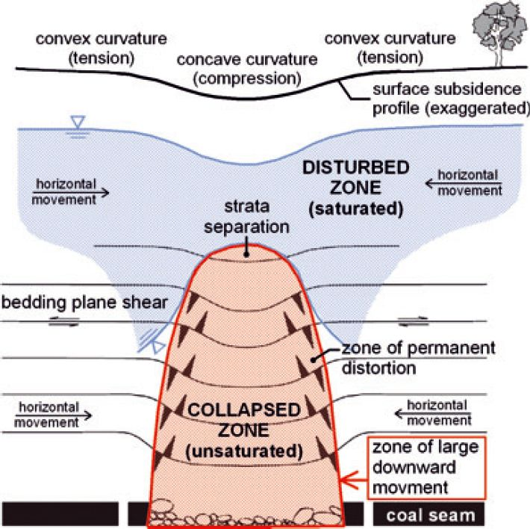
© Copyright, Tammetta 2013
Figure 3.7 Conceptual model for ground deformation above a caved longwall panel.
To understand the changes to subsurface flow, it is important to consider the preferential flow path process. Darcy’s Law cannot be used to describe flow through discrete fractures at local scales. Instead, flow in discrete fractures can be described using the cubic law, with the general assumption that fracture walls are analogous to parallel plates separated by a constant aperture (Witherspoon et al. 1980; Bear 1993; Lapcevic et al. 1999). Consequently, for a given gradient, flow through a fracture is proportional to the cube of the fracture aperture, as expressed in equation 3.1 (Lapcevic et al. 1999).
$Q=C{(2b)}^{3}∆h$
(3.1)

where:
Q = volumetric flow rate
C = constant related to the properties of the fluid and the geometry of the flow domain
b = aperture of the fracture
$∆h$ = change in hydraulic head
Flows through a fracture flow path are often significantly higher than flow through intact media. Figure 3.8 demonstrates this for a range of hydraulic conductivities. Figure 3.7 shows the thickness of a porous medium that would be equivalent to a single fracture of a given aperture. For example, under the same hydraulic gradient, the flow through a single fracture with an aperture of 1 mm is equivalent to the flow through a 10-m-thick layer of intact media with a hydraulic conductivity of 10 m/day (~10^{–4} m/s) (Lapcevic et al. 1999). The influence of fracture surface roughness can be accounted for by the inclusion of an additional factor, f, in equation 3.1. Witherspoon et al. (1980) conducted experimental studies using both radial and straight flow geometries and fractures of various rock types, with apertures ranging from 4 to 250 μm. In these experiments, f was observed to vary from 1.04 to 1.65. Consequently, a more generalised form of the cubic law exists (Witherspoon et al. 1980) (equation 3.2):
$Q=\frac{C}{f}{(2b)}^{3}∆h$
(3.2)

where:
$f=1$ for smooth walls and $f>1$ for rough surfaces
Hence, predictions of groundwater flow based on the cubic law, where f = 1, are generally adequate for most conditions (Lapcevic et al. 1999). Flow velocities through discrete fractures (often measured in m/day) are substantially higher than flow velocities through porous media (typically between 1 and 100 m/year) (Cook 2003). The water velocity in the fracture is proportional to the square of the fracture aperture (Cook 2003).
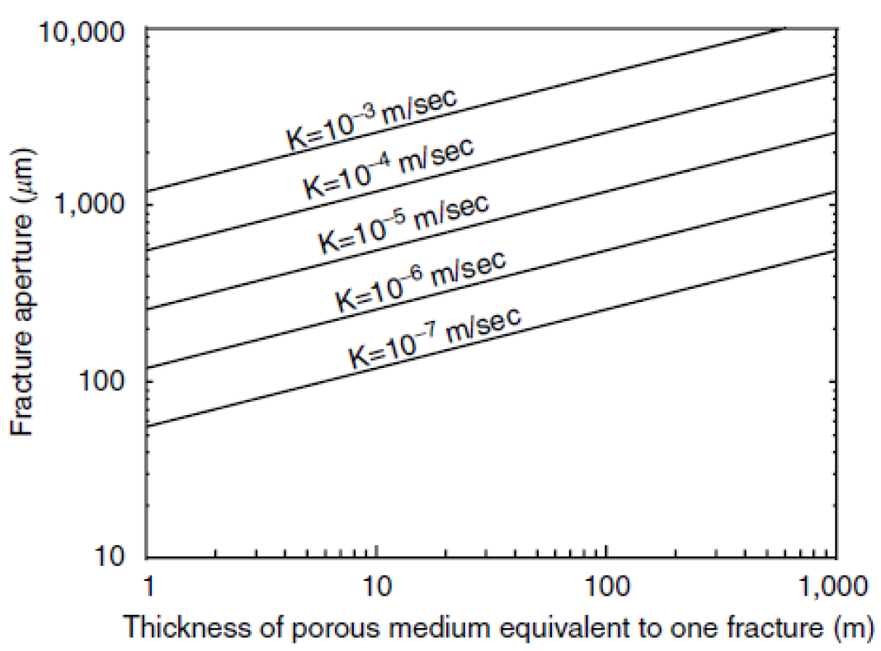
© Copyright, de Marsily 1986
Figure 3.8 Comparison of aperture of a single fracture with equivalent thickness of porous media.
This summary and explanation of the physics of groundwater flow demonstrate that a few small cracks through the swamp substrate can lead to substantial vertical drainage. The cracks can have an aperture of millimetres, making them hard to detect through overlying sediment and vegetation. The increased flow volume and flow velocity through the fractures can have implications for remediation, as discussed in Section 5.1.
The ability of a swamp water body to recover depends on the width of the crack, the surface gradient, the substrate composition and the presence of organic matter (NSW Scientific Committee 2005a). An already-reduced flow rate due to drought conditions, or an upstream dam or weir, will increase the impact of water loss through cracking. The potential for self-closure of surface cracks is greater at sites with a low surface gradient; however, even temporary cracking, leading to loss of flow, may have long-term effects on ecological function in localised areas (NSW Scientific Committee 2005a). In general, the steeper the gradient, the more likely it is that suspended solids will be transported downstream, allowing the void to remain open, and the more likely is potential loss of flows to the subsurface (NSW Scientific Committee 2005a).
Coffey Geotechnics (CoA 2014b) analysed the hydrological impact of longwall mining, calculating the running cumulative residual of water deficit at Dendrobium Swamp 12, and comparing this with the measured water level in a piezometer at the site (Figure 3.9). Following undermining in late June 2011, a notably altered hydrological regime was measured at the swamp, with no recovery to pre-mining levels during the reported period (CoA 2014b). This altered hydrological state may directly affect adjacent organic sediments, and altered inflows may also affect upstream and downstream locations that were not directly affected. A similar assessment was conducted by Coffey Geotechnics (CoA 2014b) for West Wolgan Swamp. Undermining by longwall 940 in late 2008 appeared to have had negligible impact; however, further undermining by longwalls 950 and 960 led to substantial differences between the measured water level and the calculated running cumulative residual.
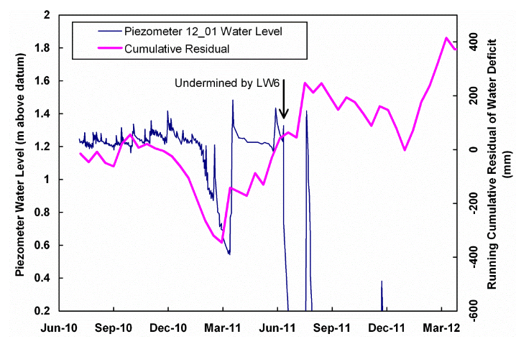
© Copyright, CoA 2014b
Figure 3.9 Piezometer response and modelled hydrograph for Piezometer 12_01, Swamp 12, Dendrobium Mine.
Cracking of stream beds and resultant water loss can lead to permanent changes in the structure and composition of riparian communities. Stream-bed cracking following longwall mining has been observed in the Sydney Basin (see Section 3.5.2). Further, impacts from longwall mining subsidence can cause contamination of groundwater by acid drainage; increased sedimentation; bank instability and loss; creation or alteration of riffle and pool sequences; changes in flood behaviour; increased rates of erosion with associated turbidity impacts; and deterioration of water quality due to a reduction in dissolved oxygen and to increased salinity, iron oxides, manganese and electrical conductivity (e.g. Booth et al. 1998; Booth & Bertsch 1999; Gill 2000; Sidle et al. 2000; Stout 2003; NSW Scientific Committee 2005a; Jankowski 2007).
As a direct result of mining-induced subsidence, many changes to the groundwater system are possible, including the following:
- Water levels in wells (representing conditions in the surrounding watertable) may drop, as water is drawn into the surrounding rock mass to fill newly created fractures.
- Wells may dry up completely, while piezometric head in other wells may decline and then recover over succeeding months or years. In extreme cases, the well casings may be bent, distorted or even sheared.
- Groundwater quality may decline through mixing of fresh water in shallow aquifers with more saline water from deeper aquifers, or by reaction between oxygenated surface water and newly exposed fresh rock in subsidence fractures.
- Shallow surface water bodies such as upland swamps may partially or completely drain; streams may diminish or cease to flow altogether.
- Perched aquifers within the seam overburden may be cracked and drain downwards, or downwards and sideways along bedding planes, sometimes to create new spring lines downstream.
Gas stored in seams and porous rock above the coal measures may be released and flow to the surface (McNally & Evans 2007).
Pells and Pells (2012), who reviewed several bores in the Sydney Basin, stated that when the relationship between groundwater and longwall mining is considered, the question is not if impacts will occur, but when will they occur. In numerous instances, the standing water level in the bores dropped considerably following undermining, and the yield was (and remained) significantly reduced. Pells and Pells (2012) noted these effects both within and outside regions of subsidence and fracturing.
Jacobs SKM investigated the sensitivity of THPSS ecological communities to longwall mining impacts (CoA 2014a). They used Bayesian belief networks to model the implications of longwall mining on THPSS and individual species, with individual Bayesian belief networks developed to model ecosystems as a whole and indicator species. Two different model types were developed: one for processes within hanging and valley infill swamps, and the other for processes within headwater swamps. In both models, change to the ecological community was strongly influenced by the stability of the peat, followed by a lesser effect from inundation and fire (CoA 2014a). These results support other suggestions that erosion of the peat can have catastrophic impacts on the overall health of the peat swamp (Young 1982; Tomkins & Humphreys 2005). Furthermore, the impact of fire is likely to be dependent on the level of inundation, since the wetness of the swamp controls the frequency and intensity of fires that burn through peat swamps. Subsequent changes to the hydrological regime of the swamps, through subsidence, upsidence and associated impacts, are of key concern to upland peat swamp ecosystems.
Various authors (e.g. Krogh 2007; Young 2007) suggest that upland peat swamps depend, often entirely, on the integrity of the underlying bedrock. If the bedrock surface is cracked, there is the potential for the swamp sediments to dry out and desiccate (Young 2007). As the water balance shifts towards a drier environment, the organic matter may oxidise and the sedimentary mass may become highly erodible. Following this process, anything that breaches the root network, or creates a knickpoint at the downstream boundary, is likely to lead to rapid and severe erosion (Young 2007). Although natural erosion and aggradation exist under stable groundwater tables (Young 1982; Tomkins & Humphreys 2006; see Section 2.3), a cracked and dehydrated swamp is unlikely to recover naturally. Because of lower soil moisture levels and increased fuel loading, these areas are also highly vulnerable to fire. Extensive gullying and erosion of swamps following extreme rainfall have been reported at impacted sites on the Woronora Plateau and other locations (Young 1982; Tomkins & Humphreys 2006; Krogh 2007). Examples of swamp degradation due to subsidence-associated impacts following longwall mining are provided in Section 3.5.1.
The impacts discussed above indicate, in general terms, issues that need to be considered when developing remediation options for upland peat swamps.

Impacts of mining on upland peat swamps and water bodies in the Sydney Basin
Subsidence impacts following longwall mining have been observed in the Sydney Basin and further afield. The following sections provide examples of upland peat swamps and water bodies that have been affected by longwall mining. These examples include swamps listed in the THPSS ecological community and others recognised under the New South Wales Threatened Species Conservation Act 1995 (see Section 2.2). Figure 3.10 shows the approximate location of most of the features discussed below.
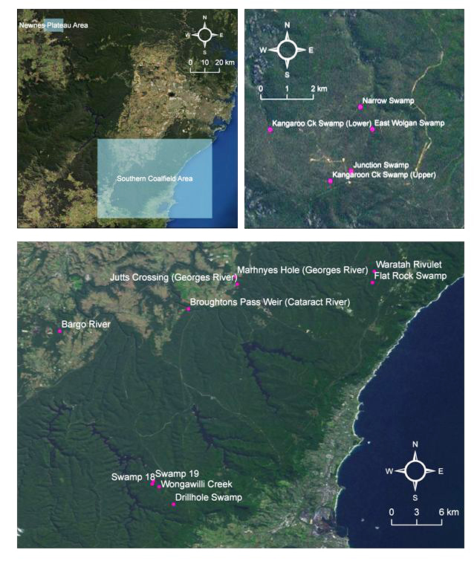
© Copyright, Benson & Baird 2012 (Newnes Plateau information); DECC 2007 (Southern Coalfield information)
Figure 3.10 Location of observed impacts in the Sydney Basin.

Observed longwall mining impacts on upland peat swamps
As discussed in Section 3.3, both the inquiry into the Southern Coalfield (DoP 2008) and the Bulli Seam Operations PAC Review report (NSW PAC 2010) specifically mentioned observed impacts of longwall mining on upland peat swamps. Figure 3.11 highlights the proximity of swamps to longwall mining operations at Angus Place Colliery. At this location, longwall mining occurs directly beneath THPSS, with some sites undermined by multiple longwall panels. Benson and Baird (2012) suggested that some swamps on the Newnes Plateau, including West Wolgan Swamp, are naturally drier than others, possibly making them less vulnerable to changes associated with longwall mining. East Wolgan Swamp, Narrow Swamp and Kangaroo Creek have all experienced adverse impacts, as described in the following sections.
© Copyright, CoA 2014b
Figure 3.11 THPSS and mining longwalls at Angus Place Colliery.

East Wolgan Swamp, Newnes Plateau (Western Coalfield)
East Wolgan Swamp on the Newnes Plateau (Figure 3.10) is a THPSS that has been impacted by longwall mining from Springvale Colliery and requires remediation (DSEWPaC 2012a). Figure 3.12 shows the slump hole that has formed within East Wolgan Swamp. Table 3.3 provides key information and observations regarding the impacts on East Wolgan Swamp.
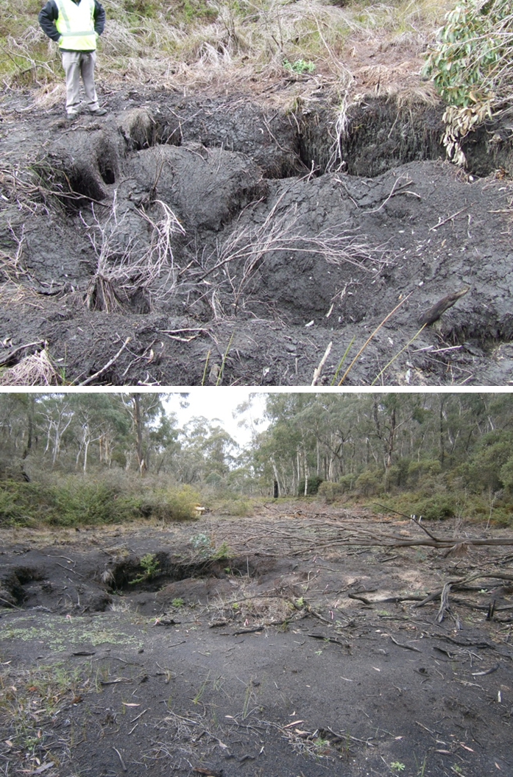
© Copyright, top photo DSEWPaC, bottom photo M Krogh, NSW Office of Environment and Heritage
Figure 3.12 Peat slumping, July 2009 (top) and desiccation, March 2014 (bottom) related to mine water discharge and subsidence at East Wolgan Swamp.
Table 3.3 East Wolgan Swamp: timeline and impact information from available references.
Key information and observed impacts | References
March 2006: Undermined. Swamp is located 330 m above the Lithgow Coal Seam. | Muir 2010
November 2006: Groundwater levels are in rapid decline. | Muir 2010
March 2008: Discharges of up to 14 ML/day of saline mine effluent from licensed discharge point 4 (Springvale Coal 2009; Muir 2010, p. 17). Discharges were released over periods ranging from weeks to months, over almost 3 years. | Muir 2010
November 2009: Springvale Coal reports that it has ‘found that water was entering a cavity and not resurfacing. Several inspections in adjacent drainage lines as well as inspections downstream of where the cavity is located did not locate the water. Monitoring from a nearby piezometer array indicates that the water is travelling to a depth of approximately 60 to 70 m underneath the swamp and most probably travelling laterally and pooling within the bedding partings. The investigation found that the water, however, did not enter the mine workings’. | Muir 2010
November 2009: Since mining of longwalls 411 and 412, there have been no natural flows through East Wolgan Swamp. Before mining, flows from East Wolgan Swamp would have been around 1 ML/day. | Muir 2010
October 2011: ‘Enforceable undertaking’ª is issued following alleged breach of EPBC Act. | DSEWPaC 2011
August 2012: Referral by Centennial Coal to DSEWPaC of proposed action for remediation and restoration works within East Wolgan Swamp. | DSEWPaC 2012a
Death of permanent moisture-dependent species such as Gleichenia and degradation of the peaty swamp soil at East Wolgan Swamp are reported. Also, local disturbance and scouring caused by contaminated mine water discharges have caused erosive channelling, mortality of swamp flora and invasion of exotic weeds, such as the wind- and water-dispersed herbs Cirsium vulgare and Sonchus oleraceus, into pristine creek lines. | Benson & Baird 2012
DSEWPaC = Australian Government Department of Sustainability, Environment, Water, Population and Communities, EPBC Act = Environment Protection and Biodiversity Conservation Act 1999
a Enforceable undertaking is an undertaking made by Springvale Coal Pty Ltd and Centennial Angus Place Pty Ltd to provide funding for peat swamp research in response to an alleged breach of the EPBC Act.

Narrow Swamp, Newnes Plateau (Western Coalfield)
Narrow Swamp on the Newnes Plateau (Figure 3.10) is a THPSS that has been impacted by longwall mining from Angus Place Colliery and requires remediation (DSEWPaC 2011). Key information and a timeline of observed impacts at Narrow Swamp are summarised in Table 3.4.
Table 3.4 Narrow Swamp: timeline and impact information from available references.
Key information and observed impacts | References
Undermined by the 265-m-wide longwall 940 (3 July 2007). | Adhikary & Guo 2009; Muir 2010
Greater than expected subsidence (1.456 m), associated with a fault/fracture zone at the northern end of the swamp (reported February 2008). | Muir 2010
Significant reduction in flow has been observed, from 8 ML/day at Springvale’s discharge point LDP5, above Narrow Swamp, to 4 ML/day at the weir downstream of Narrow Swamp, amounting to 244 ML over the period May to July 2008. | Muir 2010
Once emergency discharges ceased, the near-surface groundwater fell rapidly below the base of monitoring bores (reported December 2009). | Muir 2010
October 2011: ‘Enforceable undertaking’ª is issued following alleged breach of EPBC Act. | DSEWPaC 2011
August 2012: Referral by Centennial Coal to DSEWPaC of proposed action for remediation and restoration works within Narrow Swamp. | DSEWPaC 2012b
DSEWPaC = Australian Government Department of Sustainability, Environment, Water, Population and Communities, EPBC Act = Environment Protection and Biodiversity Conservation Act 1999
a Enforceable undertaking is an undertaking made by Springvale Coal Pty Ltd and Centennial Angus Place Pty Ltd to provide funding for peat swamp research in response to an alleged breach of the EPBC Act.

Junction Swamp, Newnes Plateau (Western Coalfield)
Junction Swamp is a headwater THPSS swamp on the Newnes Plateau (Figure 3.10). At 1155 m, it has the highest elevation of any swamp on the Newnes Plateau. Before it was undermined, it had permanent moisture and areas of sphagnum moss. It is a unique swamp because of its small catchment (30 ha), perched aquifer, relatively steep north-easterly aspect and topographic position at the headwater of the upper Wolgan River, as well as the relatively small area of land at this elevation (Benson & Baird 2012). Table 3.5 details key information and observations at Junction Swamp, and Figure 3.13 shows swamp vegetation before and after mining.

Table 3.5 Junction Swamp: timeline and impact information from available references.
Key information and observed impacts | References
Undermined 2003 to 2004. During 2001, before being undermined, Junction Swamp had permanent flows during dry conditions. | Muir 2010
Discharge from a V-notch weir declines to 0 as longwall mining approaches the second half of Junction Swamp in March 2004, and is associated with a fall in the groundwater level. This was linked to extraction of longwall 940. | Connell Wagner 2005, in Muir 2010
Swamp vegetation species—sphagnum moss, coral fern, and sedge and rush species—that had been healthy in 2001 have declined by 2006 (reported November 2006). | Muir 2010
Emergent eucalypt saplings are reported in March 2007, indicating that the swamp may be evolving into a woodland. | Muir 2010
When near-surface groundwater levels under Junction Swamp recover for a short period to just 1 m below pre-mining levels, flows over the V-notch weir on the stream associated with the headwater swamp still do not return (reported February 2008). | Muir 2010

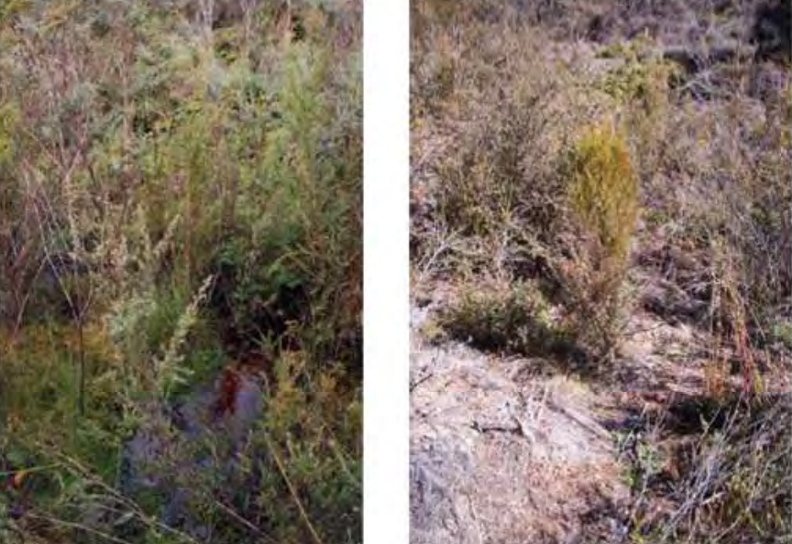
© Copyright, Muir 2010
Figure 3.13 Changes in vegetation and water levels in Junction Swamp; left: 2001 (before mining); right: 2007 (after mining).

Kangaroo Creek and swamps, Newnes Plateau (Western Coalfield)
Kangaroo Creek and its associated swamps (Figure 3.10) on the Newnes Plateau have experienced decreased flow since May 1996 (Muir 2010). Detailed measurements could not be obtained for this study; however, Muir (2010) suggested that these flow declines are due to longwall operations under a swamp in the creek’s headwaters. Benson and Baird (2012) discuss the additional loss of groundwater at Kangaroo Creek lower swamp. Figure 3.14 shows dieback of the vegetation in a swamp on Kangaroo Creek, and Table 3.6 details key information and observed impacts along Kangaroo Creek and the relevant swamps.
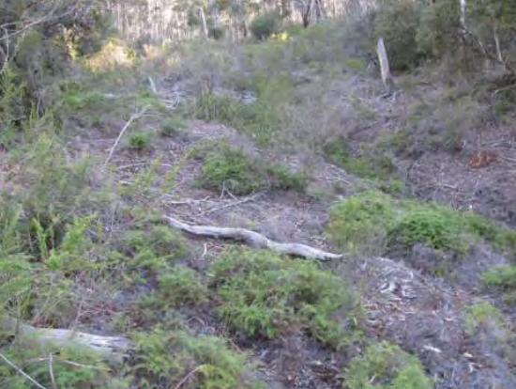
© Copyright, Muir 2010
Figure 3.14 Dieback of the swamp on Kangaroo Creek above longwall 940, indicating a permanent change in groundwater conditions, 2009.

Table 3.6 Kangaroo Creek and swamps: timeline and impact information from available references.
Key information and observed impacts | References
The flow of Kangaroo Creek is reported as reduced since May 1996 when longwall operations commenced under a swamp in the creek’s headwaters. Very low flows from the headwaters of Kangaroo Creek have been maintained. | Muir 2010
Since mining began, upper Kangaroo Creek only flows very rarely after heavy rain, and usually has no flow (reported June 2009). | Muir 2010
An area of Leptospermum dieback is noted (reported December 2009), suggesting a permanent ecological change in downstream riparian conditions. | Muir 2010
Downstream, western ends of longwalls 930 to 980 of Angus Place Colliery pass under Kangaroo Creek, with a depth of cover of 260 m above the coal seam. | Muir 2010
On 16 April 2007, stream-flow monitoring on Kangaroo Creek downstream of longwalls 930 to 980 shows a loss of flow (reported August 2007). | Muir 2010
Groundwater monitoring site on Kangaroo Creek Swamp indicates a sharp fall in groundwater levels on 17 June 2008 with the passage of longwall 940 under the swamp. | Muir 2010
Decline in groundwater is attributed to subsidence cracking; the creek stopped flowing. Creek flows above longwall 940 are reported to occur ‘through fractures in the underlying rock’ (reported August 2008). | Muir 2010
Subsequent monitoring has revealed continued low water flows in the creek (reported December 2009). | Muir 2010

Long Swamp
Loss of surface flows has also been reported with faults associated with Long Swamp on the Coxs River (Muir 2010). Table 3.7 summarises key information and observations associated with the loss of surface water flows.
Table 3.7 Long Swamp: timeline and impact information from available references.
Key information and observed impacts | References
Streamwatch records flows over three years (October 2006 to February 2010). Permanent flow is observed, even during the 2006 drought at Long Swamp, the headwater of the Coxs River. | Muir 2010
Water flows through the upper reaches of the swamp stop in November 2009, following the sudden drop in near-surface groundwater levels reported in observation bores after mining of longwall 29 began in July 2009. | Muir 2010

Swamp 18, Woronora Plateau (Southern Coalfield)
Desiccation, scouring and gullying of Swamp 18, located above the Southern Coalfield (Figure 3.10), have been linked to recent mining in the area (Krogh 2007; Total Environment Centre 2007a). DECC (2007) suggests that subsidence-related impacts have made the swamp more susceptible to burning and erosion. Figure 3.15 shows gully erosion through Swamp 18, and Table 3.8 highlights key information and a timeline of observed impacts on Swamp 18.
© Copyright, Tomkins & Humphreys 2006
Figure 3.15 Gully erosion through Swamp 18, looking upstream.
Table 3.8 Swamp 18: timeline and impact information from available references.
Key information and observed impacts | References
Longwall mining occurs beneath Swamp 18 between 1995 and 1997. Longwalls are roughly perpendicular to the swamp, which has a staged effect on subsidence. Subsidence-related cracks in bedrock are first noticed in the creek downstream of the swamp in late 2001. | Tomkins & Humphreys 2006
‘A survey by Biosis has revealed some holes and cracks in Swamp 18 above the Elouera mine with accompanying desiccation and fallen vegetation. A subsequent inspection by staff of BHP Billiton, SCA, Biosis and MSB was unable to find unequivocal reasons for these features.’ | CSIRO 2002, p. 113
The 2001 bushfires severely burn the swamp to its peat layer, indicating that swamp sediments were dry before burning. | Tomkins & Humphreys 2006
Major erosion gully is discovered in 2002, following a series of storm events. | DECC 2007
Gibbins (2003) determines that subsidence-induced cracking of the impervious Hawkesbury Sandstone beds underlying Swamp 18 was the cause of vertical water movement through the swamp, altering groundwater levels and moisture content. | Tomkins & Humphreys 2006; DECC 2007
Studies recognise that natural erosion was occurring before mining; however, the rate of erosion increased following the bushfires. | Tomkins & Humphreys 2006

Swamp 19, Woronora Plateau (Southern Coalfield)
As for Swamp 18, desiccation, scouring and gullying of Swamp 19 on the Woronora Plateau (Figure 3.10) have been linked to recent mining in the area (Krogh 2007; Total Environment Centre 2007a). Limited investigations have been undertaken on Swamp 19; however, considering its close proximity to Swamp 18 and its similar mining history (above Elouera Colliery longwalls), Swamp 19 is likely to have experienced the same causal processes of subsidence and cracking as Swamp 18 (Krogh 2007). Table 3.9 highlights some of the known information and observed impacts at Swamp 19.
Table 3.9 Swamp 19: timeline and impact information from available references.
Key information and observed impacts | References
Swamp 19 has a similar longwall mining history to nearby Swamp 18. | DECC 2007; Krogh 2007
Longwall mining has locally increased the gradient of Swamp 19, and significant subsidence cracking is noted below the swamp in Native Dog Creek. | DECC 2007
2001 bushfires severely damage the swamp. | DECC 2007
Cracking is visible in exposed rock in the middle of the swamp. | DECC 2007

Flat Rock Swamp, Woronora Plateau (Southern Coalfield)
Flat Rock Swamp is located on Waratah Rivulet in the headwaters of the Woronora Catchment and has experienced extensive gully erosion (Figures 3.16 and 3.17). DECC (2007) suggested that subsidence and tilting of the swamp are likely to have made the swamp more susceptible to natural erosive processes. The swamp is underlain by two collieries: Metropolitan (Helensburgh) at the lower (northern) end of the swamp, and Darkes Forest (Coal Cliff) at the upper (southern) end. Table 3.10 summarises key information and a timeline of observed impacts at Flat Rock Swamp.
© Copyright, Tomkins & Humphreys 2006
Figure 3.16 Knickpoint and gully in Flat Rock Swamp.
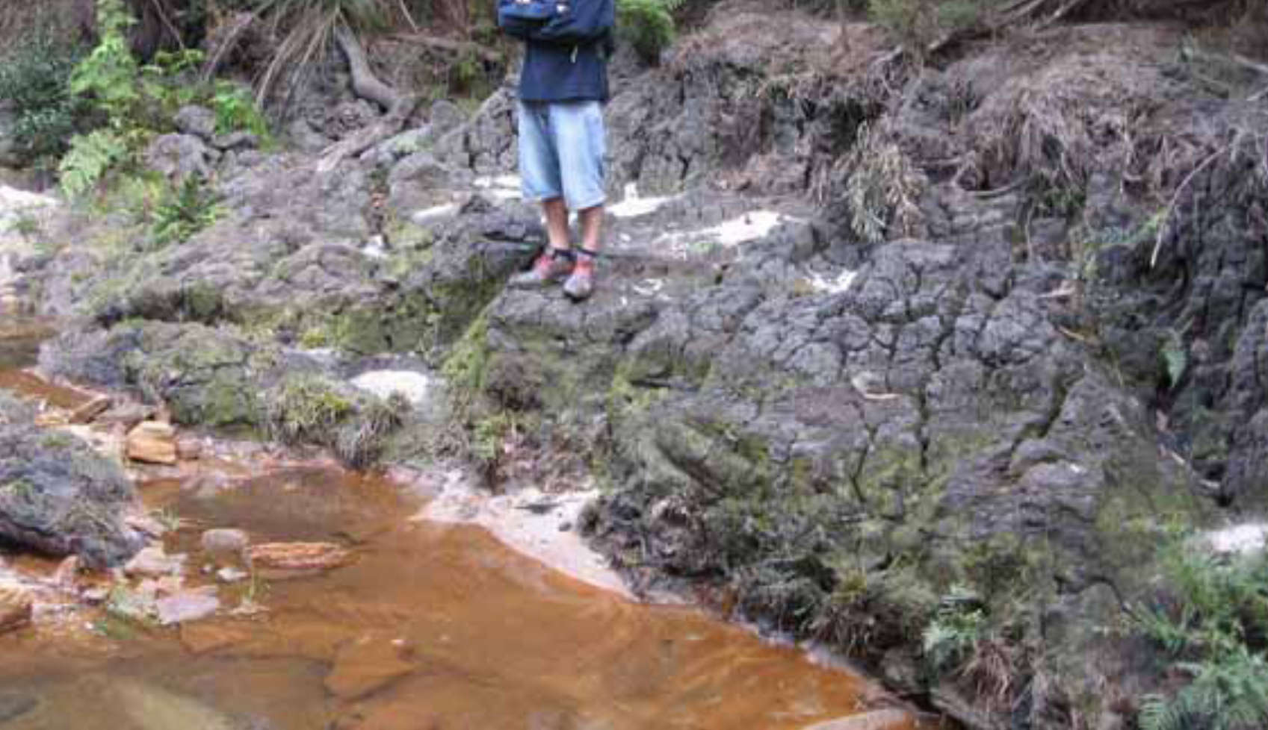
© Copyright, DoP 2008
Figure 3.17 Deeply gullied peat in a valley infill swamp, Flat Rock Swamp, Waratah Rivulet, September 2007.
Table 3.10 Flat Rock Swamp: timeline and impact information from available references.
Key information and observed impacts | References
The two collieries below the swamp have a history of both bord and pillar and longwall mining. | DECC 2007
The 2001 bushfires burn the swamp, but not to the same high intensity as Swamps 18 and 19. | DECC 2007
The first longwall to undermine the northern half of Flat Rock Swamp is in September 2002. This is followed by three longwalls located progressively further to the north and west, beneath Waratah Rivulet; the most recent began in April 2005. | Tomkins & Humphreys 2006
Metropolitan Colliery and Sydney Catchment Authority staff first notice cracks in the bedrock in Waratah Rivulet at the end of 2003. No cracking has been observed in Flat Rock Swamp. | Tomkins & Humphreys 2006
Erosion of the main section of the gully occurs between February 2002 and November 2004. Burnt and desiccated peat in the swamp may have facilitated the formation of knickpoints. Mine-related subsidence may have contributed to the main gully erosion, since longwall mining commenced under the lower part of the swamp in September 2002. | Tomkins & Humphreys 2006
Mining reports indicate a large zone of fracturing extending underneath the lower end of Flat Rock Swamp. | DECC 2007
Inspection identifies severe erosive gullying throughout the entire swamp, with little or no surface water visible in the swamp (October 2004). | Total Environment Centre 2007c
The gully remains in the swamp (2007), but some vegetation has regenerated. | DECC 2007

Drillhole Swamp, Woronora Plateau (Southern Coalfield)
Drillhole Swamp, also known as Swamp 37a, located on Flying Fox Creek No. 1 in the headwaters of the Avon Catchment (Figure 3.10), consists of a number of smaller swamps occurring on three main tributaries, and a larger main swamp formed at the tributary confluence (Tomkins & Humphreys 2006). DECC (2007) noted extensive gully erosion within the swamp (Figure 3.18), and cracking and loss of surface water flow in the creek downstream. It has been suggested (DECC 2007) that surface disturbance from mining investigations created a knickpoint, which eroded the swamp during a subsequent rainfall event. Table 3.11 details key information and a timeline of observations at Drillhole Swamp.
© Copyright, Tomkins & Humphreys 2006
Figure 3.18 Extensive gully through Drillhole Swamp, looking downstream.

Table 3.11 Drillhole Swamp: timeline and impact information from available references.
Key information and observed impacts | References
Drillhole Swamp has an extensive history of mining disturbance from bord and pillar mining (1968 to 1969) and longwall mining (1974 to 1977). | Tomkins & Humphreys 2006; DECC 2007
Cracking in the bedrock downstream of the swamp is first noticed in 1971 and linked to mine subsidence. This subsidence became the subject of an investigation by the Metropolitan Water, Sewerage and Drainage Board as part of the inquiry into mining under stored water. The investigation, however, caused significant disturbance to the swamp surface, including construction of an access track across the centre of the swamp, clearing of a section of the swamp to bedrock, mounding of the spoil along the swamp margins and construction of a small dam on a creek upstream of the swamp, as well as actual drilling (up to 350 m into bedrock). | ACARP 2001; Tomkins & Humphreys 2006
In March 1978, a severe rainfall event occurs in the catchment, reportedly leading to failure of the small dam and triggering erosion of a gully that dissects the swamp. | Tomkins & Humphreys 2006
‘At Drillhole Swamp there was one small A-tent in the bedrock channel, and the water level in boreholes drilled for the Reynolds inquiry was 8 m below the bedrock surface. Once the gully formed, several cracks in the bedrock were noticeable, but leakage to the subsurface through these was not observed. The subsidence of 2.4 m, with associated maximum surface strains of 2 mm/m tension and 1.5 mm/m compression, was at the time the largest recorded in the Southern Coalfield.’ | Young 2007, p. 2
The gully in the swamp remains (2007), but has been prevented from travelling deeper by a natural bedrock control. No natural remediation is evident in the 25 years since impacts occurred. | DECC 2007

Swamp 36, Woronora Plateau (Southern Coalfield)
Following the increasing concern about impacts of longwall mining on swamps, monitoring was installed in Swamp 36 on the Woronora Plateau, above the Elouera Colliery, in an attempt to measure before and after impacts of longwalls 9 and 10 (Paterson 2004, in Krogh 2007). Monitoring of water levels began before mining operations and continued over the extraction period of longwall 9. However, longwall 9 only partially undermined Swamp 36, and longwall 10 was shortened because of geological conditions. As a result, Swamp 36 was not completely undermined as had originally been proposed (Krogh 2007). Substantial differences in the recharge of the swamp were identified (Paterson 2004, in Krogh 2007). However, because of the change in actual longwall mining layout and an extremely dry period during monitoring, the causal factors for the decline in recharge could not be identified unambiguously (Krogh 2007).

Observed longwall mining impacts on water bodies
Many streams and rivulets around the Sydney region have been adversely affected by longwall mining—in particular, the Woronora Plateau above the Southern Coalfield (Krogh 2007). Loss of stream flow has also been observed in Kangaroo Creek and the Wolgan River in the Newnes region following longwall mining (Muir 2010).
The Total Environment Centre (2007a) reported on a range of rivers that have been affected by longwall mining in the Southern, Western and Hunter Valley/Newcastle coalfields. In the Southern Coalfield, the affected areas include Lower Cataract River, Upper Georges River, Stokes Creek, Bargo River, Upper Nepean River, Flying Fox Creek, Wongawilli Creek, Native Dog Creek and Waratah Rivulet (Total Environment Centre 2007a). Affected locations in the Western Coalfield include Goulburn River and Moolarben Creek, Wollangambe River and Farmers Creek, and Coxs River and Kangaroo Creek (Total Environment Centre 2007a).
The Cataract River, the Upper Georges River and Waratah Rivulet are three of the most significantly affected watercourses in the Sydney region. Remediation has been attempted at all three locations. Details of the damage to these watercourses are provided in the following sections; remediation attempts are outlined in Section 5.3.2.

Cataract River (Southern Coalfield)
The cracking of the Cataract River bed, downstream of Broughtons Pass Weir (Figure 3.10), is one of the most widely publicised subsidence-related events in the Southern Coalfield (NSW Scientific Committee 2005a; Krogh 2007). Subsidence related to longwall extraction caused the loss of surface flow, including water loss from permanent pools, as well as reduced water quality, growth of iron-oxidising bacterial mats, gas emissions, vegetation dieback, fish kills and rock falls (DECC 2007). Key information and observed impacts are listed in Table 3.12, and information about attempted remediation is provided in Section 5.3.2.1.
Table 3.12 Cataract River: timeline and impact information from available references.
Key information and observed impacts | References
Mining of the Bulli Seam (430 m below the river) is undertaken by Tower Colliery. | McNally & Evans 2007
Longwall 3 (extracted during 1990) is the first of 10 to pass directly beneath the river. | DECC 2007
Five initial panels (mined between 1988 and 1991) are 110 m wide. Mining subsidence increases with each panel extracted, up to 325 mm with the fifth panel. However, this subsidence represents only about 13% of the seam thickness (2.5 m), a low figure for multiple panels on the Southern Coalfield. An additional five longwall panels, around 1 km downstream (mined between 1991 and 1993) are widened to 155 m. The maximum subsidence increases to 475 mm (19% of seam thickness) by the 10th panel. | ACARP 2001, 2002; DECC 2007; McNally & Evans 2007
By 1994, the river downstream of the longwall mining operations ceases to flow, and adverse impacts on the river are reported by residents. | DECC 2007; McNally & Evans 2007
As there is no inflow to the mine workings, it is assessed that surface cracks are not connected to the mine workings. It is estimated that surface cracking might extend approximately 10 to 20 m below the surface. | Everett et al. 1998
Hundreds of cracks in the riverbed are revealed, and substantial reductions in river flow are noted. Reduction of surface river flow is accompanied by release of gas, fish kills, iron bacteria mats, and deterioration of water quality and instream habitat. Water re-emerging downstream is deoxygenated and heavily contaminated with iron deposits. | Everett et al. 1998; NSW Scientific Committee 2005a; DECC 2007; Krogh 2007; Total Environment Centre 2007a
The dam wall of Broughtons Pass Weir, controlling 20% of Sydney’s water supply, is cracked in four places and leaking across the face; the Nepean Tunnel and the Upper Canal are cracked, and the extent of water loss is unknown. | Total Environment Centre 2007a
In 1998, a Mining Wardens Court Hearing determines that 80% of the drying of the Cataract River is due to impacts following longwall mining operations, with the remainder attributed to reduced flows regulated by Sydney Water. | NSW Scientific Committee 2005a; DECC 2007; Krogh 2007
Periodic drying of the river continues, with cessation of flow recorded on more than 20 occasions between June 1999 and October 2002. At one site (the 'Bubble Pool’) localised water losses up to 4 ML/day are recorded. | DIPNR 2003, in Krogh 2007
Piezometer monitoring of the Cataract River indicates an unusually high permeability in the sandstone, suggesting widespread bedrock fracturing. | DIPNR 2003, in Krogh 2007
Gas emissions within and around areas of dead vegetation on the banks of the river are observed. It is surmised that this dieback is related to the generation of anoxic conditions in the soil as the migrating gas is released. | Everett et al. 1998
From 1996 onwards, large amounts of methane gas begin venting at locations in the riverbed; it is reported that sections of the river appeared to be boiling and that the gas could be set alight. | Total Environment Centre 2007a

Upper Georges River (Southern Coalfield)
Another high-profile example of subsidence-induced cracking has occurred in the Upper Georges River (near Appin) in the vicinity of Marhnyes Hole and Jutts Crossing (Figure 3.10). Subsidence related to longwall extraction has resulted in the loss of surface flow, including loss of water from permanent pools and reduced water quality, as well as gas releases and rock falls (DECC 2007). Table 3.13 lists key information and observed impacts at the Upper Georges River. Details regarding attempted mitigation and remediation techniques are provided in Section 5.3.2.2.
Table 3.13 Upper Georges River: timeline and impact information from available references.
Key information and observed impacts | References
1.5 km of Georges River is undermined by longwalls 5A1–5A3. | DECC 2007
Some surface fracturing is identified at Jutts Crossing in September 2000, and significant draining of pools is noticed in November 2000. | DECC 2007
Fracturing of Marhnyes Hole was first noted during the extraction of longwall 5A4. New fracturing is identified when the longwall face passes the rock bar by 100 m. | DECC 2007
Flow monitoring data suggest that up to 1 ML/day is being diverted (post-mining) via the subsurface fracture network in some sections of the Georges River before remediation initiatives. | NSW PAC 2010
Stress relief slot is installed in 2002 to minimise cracking damage to Marhnyes Hole from longwall 5A4; this is considered successful by geologists. | DECC 2007; Mills et al. 2004, in Krogh 2007
Rock fall collapses force the temporary closure of the swimming hole to the public on safety grounds. | Total Environment Centre 2007a
When flows are very low, the company has been reported to release environmental flows to increase pool levels. | DECC 2007

Waratah Rivulet, Woronora Catchment (Southern Coalfield)
Waratah Rivulet (Figure 3.10) is a major contributor (approximately 29 per cent) to storage at Woronora Reservoir on the Woronora Plateau, providing both the Sutherland Shire and Helensburgh with drinking water (Total Environment Centre 2007a). In 1999, the Healthy Rivers Commission described the condition of the Woronora Catchment upstream of the dam as largely pristine (Total Environment Centre 2007a). However, in subsequent years, it has become a significant focus of environmental protest against longwall mining–induced subsidence on the Southern Coalfield (McNally & Evans 2007). Subsidence-related impacts of longwall mining have resulted in cracking and tilting of bedrock, loss of surface flows, loss of water from permanent pools, reduced water quality, growth of iron-oxidising bacterial mats, loss of habitat and accelerated bank erosion (DECC 2007). Since there was no discharge of mine water at the site, changes in water quality measured at Waratah Rivulet are likely to be due to mining-related subsidence. Table 3.14 lists key information and observed impacts at Waratah Rivulet. Information about remediation attempts at this site is outlined in Section 5.3.2.3.
Table 3.14 Waratah Rivulet: timeline and impact information from available references.
Date | Key information and observed impacts | References
1995 | Longwall mining commences. Longwall widths begin at 125 m and are increased up to 162 m for longwall 11. | Total Environment Centre 2007a
November 2004 | Initial cracks are noticed when longwall 10 undermines the rivulet. This is followed by major cracking, failure of rock bar WRS3 and loss of surface water flows (4 to 4.5 ML/day), associated with the extraction of longwall 11, including upsidence in the order of 60 mm (noticed in November 2004). | Galvin & Associates 2005, in DECC 2007; Krogh 2007
? | Water quality data show changes in chemical composition due to cracking of riverbeds and rock bars, and diversion of surface water into subsurface routes in the Hawkesbury Sandstone aquifer. | Jankowski et al. 2008
? | Anecdotal reports suggest that the rivulet has ceased to flow at locations not previously known to have gone dry. The rivulet tilts to the east as a result of subsidence and upsidence. | Total Environment Centre 2007a
? | In the absence of remediation, it is estimated that an additional water input of 1.7 to 2 ML/day would be required to compensate for leakage caused by the fracturing, to maintain water in the pond immediately upstream of the rock bar. | Galvin & Associates 2005, in Krogh 2007
? | Despite the severe damage to Waratah Rivulet, and preliminary remediation measures being implemented, approval is given to continue mining longwalls 12 and 13 (underneath the rivulet), which may cause further fracturing of the rock bar and riverbed. | Krogh 2007
? | Additional mining in the region is reported, as the Metropolitan Coal Project involves mining beneath the Woronora Reservoir and surrounding area. The longwall panels applied for under Waratah Rivulet (and catchment) are of similar width (165 m) to those that had previously caused damage to Waratah Rivulet. Where the longwall panels are to pass directly under Woronora Reservoir, the proposed panel widths are reduced to 130 m and pillar widths are increased to 70 m to reduce the impacts on Woronora Reservoir. | Helensburgh Coal 2008; DECCW 2010
2007 | The creek ceases to flow under low-flow conditions. | DECC 2007

Upper Waratah Rivulet, Woronora Catchment (Southern Coalfield)
In addition to the problems on Waratah Rivulet described in Section 3.5.2.3, DECC (2007) details additional issues on Waratah Rivulet upstream of Flat Rock Swamp (Figure 3.10). Presumed subsidence from Darkes Forest Colliery (created in 1971) has resulted in the fracturing of bedrock and the loss of surface water flows (with water appearing to return approximately 500 m downstream). Limited information has been published, and no monitoring or remediation is known to have taken place. Surface cracks remain visible, with surface water disappearing into the cracks (DECC 2007). It is suggested that this example shows that natural remediation (self-amelioration) is an ineffective remediation ‘technique’ over timescales of decades or shorter (DECC 2007).

Wongawilli Creek, Avon Catchment (Southern Coalfield)
Subsidence related to longwall extraction has resulted in cracking and the loss of surface flow, including loss of water from permanent pools, as well as reduced water quality in Wongawilli Creek (Figure 3.10) (DECC 2007). Key information and observed impacts are tabulated in Table 3.15.
Table 3.15 Wongawilli Creek: timeline and impact information from available references.
Key information and observed impacts | References
Longwall extraction is reported in the area from 1993. | DECC 2007
Subsidence in the order of 1 m is identified beneath Wongawilli Creek, with fracturing occurring up to 500 m from the mining activity. | BHP Billiton 2003, in DECC 2007
Surface flows are observed to run laterally down cross-bedded sections under the alluvial banks of the creek. | BHP Billiton 2003, in DECC 2007
Water chemistry is altered, including potentially toxic levels of dissolved zinc. | DECC 2007
In 2007, it is reported that the creek ceases to flow during low-flow conditions. | DECC 2007
The endangered Macquarie perch has been observed in Wongawilli Creek. | DECC 2007

Avon Reservoir (Southern Coalfield)
Huntley Colliery undermined the upper reaches of the Avon arm of Avon Reservoir in the 1970s. Subsidence-related issues resulted in the loss of water to mine panels (DECC 2007). Information about the related issues is included in Table 3.16.
Table 3.16 Avon Reservoir: timeline and impact information from available references.
Key information and observed impacts | References
Huntley Colliery undermines the upper reaches of the Avon arm of Avon Reservoir in the 1970s, the shallowest cover under stored water of any mine, according to the Reynolds inquiry. | Reynolds 1976; DECC 2007
There are limited inflows (88 to 270 m³/day) of water into the mine from Avon Reservoir because of a roof zone under a roadway. | Reynolds 1976
At Wongawilli Colliery, bord and pillar mining, with some pillar removal, takes place under Avon storage; the depth of cover varies from 90 m to 140 m. | DECC 2007
Water flows into the mine workings to a maximum flow rate of 100 000 L/hour, gradually declining to 30 000 L/hour. | DECC 2007
The proximity of Avon Reservoir, and the commonality of algal species between the mine water inflow and Avon Reservoir, suggests a surface-to-seam connection. This results in the reduction and eventual curtailment of mining in this area of Wongawilli Colliery. | Whitfield & Anderson 1988
Gas bubbles are still visible (2007) in some areas of the reservoir. | DECC 2007

Bargo River (Southern Coalfield)
Subsidence-related impacts following longwall mining beneath the Bargo River (Figure 3.10) resulted in the cracking of bedrock and the loss of surface flow, including water from permanent pools, as well as declines in groundwater levels (DECC 2007). Table 3.17 outlines the key information and recorded observations at the impacted section of the Bargo River.
Table 3.17 Bargo River: timeline and impact information from available references.
Key information and observed impacts | References
First longwalls to mine directly beneath Bargo River commence in 1991 (longwalls 8 to 13). | DECC 2007
Surface fracturing with cracks up to 50 mm wide are observed near the supporting piers of Rockford Road Bridge following the extraction of longwalls 12 and 13. Fractures are also observed during extraction of longwall 12 downstream of the bridge. | DECC 2007
The second series of longwalls to mine directly beneath Bargo River commence in 1995 (longwalls 14 to 19). Limited monitoring indicates little impact on the river during the extraction of longwalls 14 to 17. Fracturing is not visible on the surface, although many sections are concealed by alluvial and talus deposits. | DECC 2007
In January 2002, pool levels are reported to have dropped, and flow is reduced to a trickle. Fracturing of rock shelves has occurred. The river is drained directly above longwall 18, and the length of drainage extends for some distance beyond longwall 14. | DECC 2007
Water levels in three piezometers over longwall panels 22 to 26 have recorded declines of up to 2 m over 1 month, followed by a gradual decline of a further 2 m observed over 4 months due to extraction of panels 22 and 23A. Impacts on agricultural bores are also documented. | Geoterra 2006, in DECC 2007

Native Dog Creek, Avon Catchment (Southern Coalfield)
Subsidence-related impacts from longwall extraction resulted in adverse impacts on Native Dog Creek in the Avon Catchment (Figure 3.10) (DECC 2007). These impacts included the loss of surface flow, including loss of water from permanent pools. Toxic levels of acidity and heavy metals were identified at one site. Table 3.18 outlines the key information and reported observations at the impacted creek site.
Table 3.18 Native Dog Creek: timeline and impact information from available references.
Key information and observed impacts | References
Longwall extraction in the near vicinity of Native Dog Creek is reported since 1993. | DECC 2007
Subsidence in the order of 1 m is identified beneath Native Dog Creek, with fracturing occurring up to 500 m from the mining activity. | BHP Billiton 2003, in DECC 2007
Altered water chemistry, with toxic levels of aluminium, zinc and nickel, is detected. At one site, pH is lowered. | BHP Billiton 2003, in DECC 2007
The creek ceases to flow during low-flow conditions (2007); no remediation has been undertaken. | DECC 2007

Lizard Creek (Southern Coalfield)
Lizard Creek, located in the Southern Coalfield, is a large tributary of the Cataract River. Lizard Creek has experienced complete loss of flow over stream lengths of more than 100 m following mining-induced subsidence (NSW PAC 2010). Figure 3.19(a) shows a section of Lizard Creek that has been affected by longwall mining and was dry on both occasions (2009 and 2010) that PAC Panel members undertook aerial inspections, despite obvious flow upstream and downstream (DoP 2008). Figure 3.19(b) shows iron staining, discolouration and opacity in Lizard Creek, downstream of longwall mining panels (extracted more than a decade ago). Stream water transported along new subsurface fracture pathways may dissolve iron-bearing minerals such as siderite, hematite and marcasite, which are known to be present in the Hawkesbury Sandstone. When this water emerges back to the surface, iron precipitates in the form of oxyhydroxides, leaving characteristic orange and red staining (NSW PAC 2010).
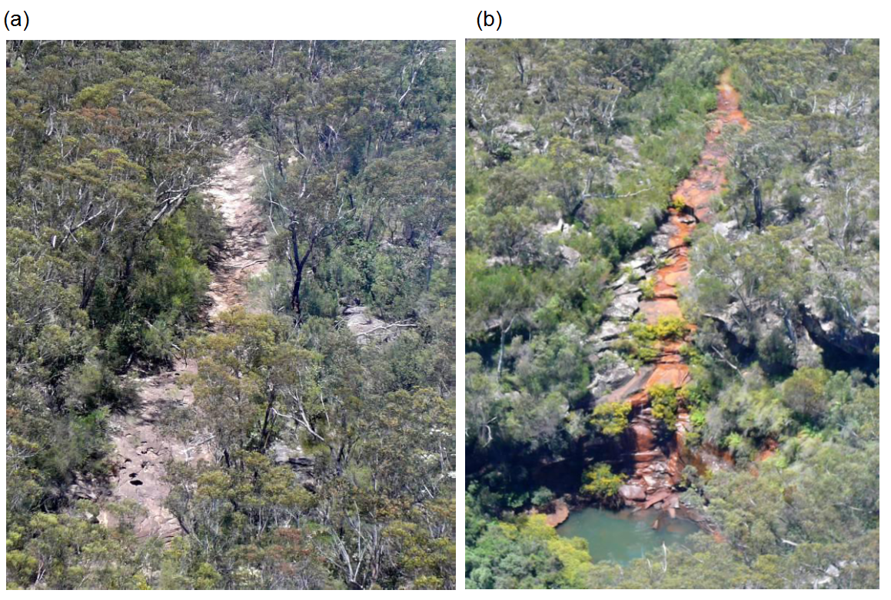
© Copyright, NSW PAC 2010
Figure 3.19 Mining-related impacts on Lizard Creek (Southern Coalfield): (a) apparent mining-induced loss of flow in Lizard Creek; (b) iron staining, discolouration and opacity of water downstream of subsided area.

Internationally reported impacts
No information has been found on observed impacts on similar ecosystems to upland peat swamps in international settings. However, information has been found on subsidence-related impacts of longwall mining on groundwater systems, streams and agricultural regions in the United States.
Professor Colin Booth (Northern Illinois University) has written many articles on the groundwater hydrology of underground coalmining and mine subsidence (e.g. Booth 1986, 1992, 1998, 2003, 2006, 2007; Booth & Spande 1992, 1991; Booth et al. 1998; Booth & Bertsch 1999). Groundwater case studies, following the impacts of longwall mining, have been conducted in two key regions of the United States: the Appalachian and Illinois coalfields (Booth 2003). Increases in permeability of 1 to 2 orders of magnitude due to subsidence-induced fracturing are commonly reported for both these coalfields (Booth 2003). Similar groundwater responses to those in New South Wales have been observed, including declines in piezometric head in near-surface unconfined aquifers.
Booth (2003, 2006) discussed the recovery of water levels after mining. Groundwater levels in the subsidence zone typically recover slightly as a result of post-subsidence compressional stresses. Water levels should also recover as water flows back into the temporary potentiometric depression created by the subsidence fracture effects. However, this recovery depends on connection to sources of recharge and on the ability of the aquifer to transmit water back into the affected area (Booth 2006).
Water levels (or piezometer head levels) in wells that penetrate the lower fractured zone do not usually recover (Booth 2003). Permanent changes in groundwater flow may be caused by the increases in permeability, because of gradient changes or leakage through fractured aquitards, with many sites exhibiting permanent piezometric head losses (Booth 2006). Further, American case studies show that long-term recovery is hard to predict (Booth 2006). It has been suggested that piezometric levels and stream flows may recover, particularly in stream valleys, but are less likely to recover in upland environments (Booth 2003).
Detailed investigations have been conducted into the effects of subsidence resulting from underground coalmining on surface structures, features and water resources in Pennsylvania, United States (e.g. Iannacchione et al. 2011). Of particular interest is the impact of longwall mining–induced subsidence on streams. Tension cracks were a dominant cause of reported land impacts in Pennsylvania between 2005 and 2008 (Iannacchione et al. 2011). As mentioned above (Section 3.4), these tension cracks can encounter surface streams and direct flow to the subsurface. Of the 55 streams investigated by the Pennsylvania Department of Environmental Protection between 2003 and 2008, only two were reportedly not affected by longwall mining (Iannacchione & Tonsor 2011). Thirty-five of these cases remain to be resolved and are under some form of interim solution, such as monitoring flow, measuring biological diversity, grouting open fractures, altering stream gradients, revegetating stream banks, augmenting stream flow, promoting aquatic diversity and health, or repairing obstacles within the streams that impair flow (Iannacchione et al. 2011). More information about remediation techniques used in the United States is included in Section 5.
Darmody (1998) provided insight into the impacts of underground coalmining on the agricultural sector—in particular, as observed in Illinois, United States. Effects are divided into three key categories: impacts on structures, impacts on soils and impacts on crops. Impacts on soils can include soil erosion, disruption of surface and subsurface drainage, wet or ponded areas, and reduction of crop yields. Darmody (1998) notes that subsidence impacts on agriculture are generally more severe in areas of low relief and high watertables, such as southern Illinois. In these landscapes, subsidence associated with longwall mining can create wet or ponded areas that delay and disrupt farming practices, cause low seed germination, and reduce crop growth and yield. A 4.7 per cent average reduction in overall corn yields was found for subsidence-impacted lands in southern Illinois (Darmody 1998). Relatively high-impact remediation techniques are outlined by Darmody (1998), such as cutting drainage ditches, adding fill and recontouring the landscape. These techniques have not been included in Section 5 of this report because they are designed to remove water from an overly saturated agricultural environment.

Chapter synthesis and knowledge gaps
The co-location of upland peat swamps and mining leases across the Sydney Basin provides a potential risk to swamp water balance and ecology. Section 3 has highlighted the widespread potential risk of longwall mining impacts. Subsidence-related impacts from longwall mining are unique, broad ranging and potentially devastating, as indicated by observed impacts. Section 3.5 presents reported impacts of longwall mining in the Sydney Basin, while Section 3.6 discusses longwall mining impacts reported internationally.
Various scientific hypotheses have been proposed to explain the mechanisms of impact (or avoidance of impact) on upland peat swamps from longwall mining (Section 3.4). Although impacts have been observed at several locations following longwall mining beneath the upland peat swamps, limited comprehensive studies have been undertaken using before–after control–impact (BACI) methods, resulting in knowledge gaps linking theory and field observations.
Visual impacts on upland peat swamps are most commonly reported along creek lines, where surface cracking and subsurface fracture networks have been reported. Where fracture networks form and the water balance is impacted (including along upstream, downstream or subsurface boundaries), the impacts on upland peat swamps can be widespread. They include impacts on soil structure, water quality, ecology, and future responses to stressors such as fire. Limited studies have been undertaken on locating fracture networks beneath peat swamp sediments.
Knowledge gaps exist on the ability to predict the severity, extent and timing of any impact, either immediately above the mined longwall or in proximity to the mining lease. This includes an explicit timing of the impact process, including timing of the initial subsidence (and associated impacts) and of impacts that develop over time as a result of residual subsidence and hydrological or ecological changes.

Prediction, mitigation, management and monitoring of impacts
This section discusses the current state of practice within the mining industry for impact prediction and remediation plans for upland peat swamps. It provides a brief overview of current systems for predicting the potential impacts on upland peat swamps, as well as an overview of standard procedures for monitoring impacts, both during and after longwall mining operations.

Prediction of mining impacts on upland peat swamps
Numerous methods can be used to predict the level of subsidence on the surface; however, there are no known direct methods for specifically predicting the impacts of longwall mining on peat swamps (CoA 2014b). Coffey Geotechnics (CoA 2014b) suggests that further reviews are required of mining subsidence on peat swamps, to determine the extent and significance of impacts. This is important because the impacts on creeks and river channels—in particular, cracking and upsidence—are likely to be repeated directly below upland peat swamps, with a similar potential for diversion of flow into the subsurface fracture network. However, the short-term and long-term sensitivity of peat swamps to changes in subsurface flow is unknown.
Recently assessed literature highlights the variety in predicted subsidence at locations within the coalfields. Table 4.1 gives a summary of predicted subsidence for swamps overlying BHP Billiton (BHPB) Illawarra Coal’s Dendrobium Colliery. The reports that provided the data for Table 4.1 also present maximum predicted upsidence, closure and other factors. The data in Table 4.1 highlight the effect that multiple longwall panels can have on a single swamp.
It is important to remember that subsidence is not necessarily the major contributing factor to impacts on swamps. BHP Billiton (2012) states that tensile strains greater than 0.5 mm/m may be of sufficient magnitude to result in fracturing in the topmost bedrock. Further, compressive strains greater than 2 mm/m may be of sufficient magnitude to result in the topmost bedrock fracturing, buckling and dilating. For many swamps in Area 3B (see Table 4.1), BHP Billiton (2012) suggests that cracking in the bedrock may occur as a result of the predicted maximum tensile and compressive strains induced by conventional subsidence.
Further information and discussion on the prediction of mining impacts is presented by Harvey (2003), Seedsman and Dawkins (2006), Tammetta (2013) and Coffey Geotechnics (CoA 2014b).

Table 4.1 Predicted subsidence for upland swamps to be undermined.
Colliery | Swamp | Longwall | Maximum predicted cumulative subsidence (mm)ª | Colliery | Swamp | Maximum predicted cumulative subsidence (mm)ª
Dendrobium Area 3 | 12 | After LW6 | 120 | Dendrobium Area 3B | 1a | 2000
Dendrobium Area 3 | 12 | After LW7 | 1730 | Dendrobium Area 3B | 1a | 2000
Dendrobium Area 3 | 12 | After LW8 | 1885 | Dendrobium Area 3B | 1b | 1500
Dendrobium Area 3 | 12 | After LW9 | 1900 | Dendrobium Area 3B | 1b | 1500
Dendrobium Area 3 | 12 | After LW10 | 1900 | Dendrobium Area 3B | 3 | 2250
Dendrobium Area 3 | 15a | After LW6 | <20 | Dendrobium Area 3B | 3 | 2250
Dendrobium Area 3 | 15a | After LW7 | <20 | Dendrobium Area 3B | 4 | 2150
Dendrobium Area 3 | 15a | After LW8 | <20 | Dendrobium Area 3B | 4 | 2150
Dendrobium Area 3 | 15a | After LW9 | 2020 | Dendrobium Area 3B | 5 | 2050
Dendrobium Area 3 | 15a | After LW10 | 2275 | Dendrobium Area 3B | 5 | 2050
Dendrobium Area 3 | 15b | After LW6 | <20 | Dendrobium Area 3B | 8 | 2250
Dendrobium Area 3 | 15b | After LW7 | 410 | Dendrobium Area 3B | 8 | 2250
Dendrobium Area 3 | 15b | After LW8 | 1920 | Dendrobium Area 3B | 10 | 2450
Dendrobium Area 3 | 15b | After LW9 | 2115 | Dendrobium Area 3B | 10 | 2450
Dendrobium Area 3 | 15b | After LW10 | 2115 | Dendrobium Area 3B | 11 | 2200
Dendrobium Area 3 | 16 | After LW6 | 70 | Dendrobium Area 3B | 11 | 2200
Dendrobium Area 3 | 16 | After LW7 | 70 | Dendrobium Area 3B | 13 | 2200
Dendrobium Area 3 | 16 | After LW8 | 70 | Dendrobium Area 3B | 13 | 2200
Dendrobium Area 3 | 16 | After LW9 | 70 | Dendrobium Area 3B | 14 | 2500
Dendrobium Area 3 | 16 | After LW10 | 70 | Dendrobium Area 3B | 14 | 2500
Dendrobium Area 3 | 34 | After LW6 | <20 | Dendrobium Area 3B | 23 | 2400
Dendrobium Area 3 | 34 | After LW7 | <20 | Dendrobium Area 3B | 23 | 2400
Dendrobium Area 3 | 34 | After LW8 | <20 | Dendrobium Area 3B | 35a | 1000
Dendrobium Area 3 | 34 | After LW9 | <20 | Dendrobium Area 3B | 35a | 1000
Dendrobium Area 3 | 34 | After LW10 | 40 | Dendrobium Area 3B | 35b | <20
LW = longwall
a Within a 20 m radius of the perimeter of each swamp
© Copyright, BHP Billiton 2012 (Dendrobium Area 3B); Cardno Forbes Rigby 2007 (Dendrobium Area 3)

Mitigation of longwall mining impacts
There are several ways to mitigate the impacts of longwall mining. NSW PAC (2009) and Coffey Geotechnics (CoA 2014b) discuss mitigation strategies to reduce the impacts of subsidence on surface features such as upland peat swamps. Four common mitigation approaches are:
- restriction of ground movement—through design of mine layout, or mining practice methods
- isolation of ground movement—isolating a feature from ground strains and shear displacements, primarily through the use of stress relief slots, trenches or slots in the bedrock to lessen predicted stresses
- maintenance responses—measures that aim to maintain the physical state and function of a feature, such as artificially increasing flow volume in affected watercourses
preservation responses—archaeological artefacts that may be at risk from mine subsidence may be removed on a temporary or permanent basis before undermining, or logged and recorded in a visual format for posterity (NSW PAC 2009).
Coffey Geotechnics (CoA 2014b) provided an overview of changes to mine layout, focusing on long-term planning and buffer zones, as well as a discussion about the use of stress relief slots, focusing on the slot that was used at Marhnyes Hole on the Georges River to protect the integrity of the upstream rock bar. The literature does not document the size of the stress relief slot. Although the stress relief slot at this location was deemed to be successful by geologists and BHPB Illawarra Coal (Mills et al. 2004, in Krogh 2007; BHPB Illawarra Coal 2007), it was insufficient to prevent the near-total draining of water from many pools and the significant loss of flow in the Upper Georges River (Krogh 2007).
Coffey Geotechnics (CoA 2014b) suggested that it may be possible to form a slot just outside the edge of a peat swamp to substantially protect the sandstone base of the swamp. However, there may be significant disturbance to the surface following the construction of stress relief slots (Mills 2007), potentially limiting their use for upland peat swamps.
Restriction of ground movement, through changes to the design of mine layout, was used to protect a significant waterfall on Sandy Creek above BHPB Illawarra Coal’s Dendrobium Area 3A longwalls. Mining was stopped 400 m short of the waterfall, sterilising a large amount of coal. However, there was no impact from longwall mining subsidence on the waterfall (DoP 2013).

Time lag between mining and observation of impacts
Recent literature (e.g. Gujarat NRE Coking Coal 2012; SCT Operations 2012; CoA 2014a) has discussed the delay between undermining of upland peat swamps and other systems, such as streams, and the observation of impacts. Two problems are associated with this delay: it is not known immediately if mining has had an impact, and, by the time remediation is necessary, the swamp may be irreversibly damaged.
Petts (1987) divides the mechanisms for impacts into three broad categories: first-, second- and third-order impacts. This idea can be used to reflect the time lag between mining and impacts (CoA 2014a):
- First-order impacts are immediate impacts of subsidence, or subsidence effects, such as cracking, shearing, tilting, and reopening of bedding planes and joints within the sandstone.
- Second-order impacts are impacts resulting from subsidence effects, such as changes to swamp hydrology from altered groundwater or surface water flow paths, and impacts on water quality.
Third-order impacts are impacts resulting from changes to swamp hydrology and water quality, such as peat erosion, and the ecological response of flora and fauna.
It is important to note that third-order impacts can lag significantly behind the first- and second-order impacts—changes to swamp flora are sometimes identified decades after the swamp has been undermined (NSW PAC 2009; CoA 2014a). Figure 4.1 highlights the lag time between first-order impacts (subsidence effects), second-order impacts (hydrological impacts) and third-order impacts (ecological response). The timing of ecological impacts could vary significantly, and limited information is available on this topic.
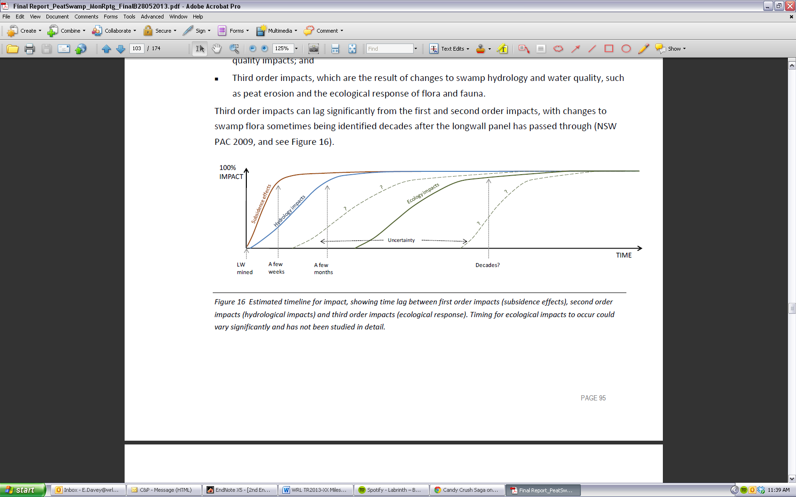
@ Copyright, CoA 2014a
Figure 4.1 Estimated timeline for first-, second- and third-order impacts.

Trigger action response plans
Trigger action response plans (TARPs) are commonly used across the industry as a technique for managing impacts (e.g. BHP Billiton 2012; Centennial Coal 2012b). A TARP can be developed to reduce impacts to tolerable levels for infrastructure and surface features with a capacity to absorb subsidence impacts, where these impacts can be measured as strain deformation, tilt or some other appropriate parameter (CoA 2014b).
TARPs are not well suited to managing impacts that occur from mining beneath upland peat swamps, because the impacts (discussed in Section 3.5.1):
- may be small compared with impacts from other, unrelated causes
- may not become apparent for some time (i.e. prolonged time lag)
may only become apparent after a tipping point has been reached (CoA 2014b).
The Swamp impact, monitoring, management and contingency plan for Dendrobium Area 3B (BHP Billiton 2012) provides an overview of the monitoring and TARP process. In this example, monitoring results are proposed to be reviewed monthly by the Subsidence Management Committee; however, if the findings of monitoring are deemed to warrant an immediate response, the Approvals Manager will initiate the requirements of the TARP. The TARP has three levels of ‘swamp landscape observational monitoring’:
- level 1—fracturing in a swamp, drainage line or rock bar that does not appear to result in visible loss of surface water or erosion, and/or soil surface crack that does not cause erosion
- level 2—fracturing in a swamp, drainage line or rock bar that results in visible loss of surface water in some sections of the swamp, drainage line or rock bar, or causes erosion that is likely to stabilise within the monitoring period, and/or soil surface crack that causes erosion that is likely to stabilise within the monitoring period
level 3—fracturing in a swamp, drainage line or rock bar that results in loss of surface water from all sections of the swamp, and/or major erosion caused by loss of water, and/or impacts on the structural integrity of the controlling rock bar of a swamp (BHP Billiton 2012).
For level 1 impacts, the associated ‘actions’ focus on monitoring and reporting. Response to level 2 impacts requires a review of monitoring frequency, development of corrective management actions and implementation of the approved corrective management actions. No information is available on required timelines for response. Level 3 impacts require immediate notification of the appropriate government agencies and specialists, as well as a photographic record. Corrective management actions for the site must be developed within one month (in consultation with key stakeholders). The TARP developed by BHP Billiton (2012) also includes specific sections for shallow groundwater, and terrestrial flora and fauna. Actions and time frames for the level 1, 2 and 3 impacts for these sections are similar to those for swamp landscape observational monitoring.
As noted above, the TARP management approach is not always appropriate for monitoring impacts on ecological systems such as upland peat swamps. These inadequacies are increasingly being recognised within industry. The mining company Gujarat NRE Coking Coal (2012, p. 38), probably upon advice from SCT Operations (2012, p. 11), noted that ‘that any impacts to swamps are unlikely to become apparent until well after mining is complete which doesn’t allow NRE time to make any significant change to the mining process. Trigger Action Response Plans (TARP) as a method of protecting swamps is not considered overly useful because many of the impacts are likely to be long term and difficult to detect without extended monitoring’. Consequently, it is important that industry develop an appropriate technique to manage potential impacts of upland peat swamps, and similarly affected ecosystems, before potentially irreversible tipping points are reached (see note 1 at the end of this section).

Monitoring
Monitoring is a key component of TARPs and other planning techniques, to identify impacts on upland peat swamps following longwall mining. Coffey Geotechnics (CoA 2014b) provide a summary of monitoring techniques for collecting data on subsidence impacts, divided into three key sections: surface subsidence, groundwater and subsurface monitoring. Jacobs SKM evaluated a range of monitoring techniques, focusing on monitoring swamp ecological condition and ecological response (CoA 2014a). An overview of methods to monitor cracking and tilting of the sandstone surface, and to monitor changes to swamp hydrology, is provided in CoA (2014a). The following sections provide information about each of these monitoring components.

Surface subsidence
An overview of surface subsidence monitoring techniques is presented by Mills (2011) and Coffey Geotechnics (CoA 2014b). Techniques discussed include:
- level and peg-to-peg chaining
- total station surveying
- GPS surveying
- use of lidar (light detection and ranging)
use of InSAR (interferometric synthetic aperture radar).

Groundwater monitoring
As mentioned in section 2.3, the hydrological regime is integral to the formation and health of upland swamp communities. Monitoring of the water within the swamps is a key part of determining impacts on upland peat swamps.
CoA (2014a, 2014b) outline different groundwater observation techniques, including observation wells, standpipe piezometers, vibrating wire piezometers, packer tests, permeability testing and groundwater quality testing.
As an example of the groundwater monitoring that is commonly used by the industry, Coffey Geotechnics (CoA 2014b) performed a detailed analysis of the monitoring of undermined swamps at Angus Place (Western Coalfield) and Dendrobium Collieries (Southern Coalfield). One method of estimating which swamps are impacted is to analyse hydraulic head behaviour, as measured in groundwater monitoring piezometers installed within the swamps. Figures 4.2 and 3.11 show the distribution of monitoring piezometers within swamps at these collieries.
Analysed data for piezometer WW1 in West Wolgan Swamp (Angus Place Colliery) and piezometer 12_01 in Swamp 12 (Dendrobium Colliery) suggested that there were significant drops in swamp water levels due to undermining. From the 13 sites with data analysed by Coffey Geotechnics (CoA 2014b, in Tabe 7.4), three main conclusions were drawn:
- No pre-mining water level data were available (consequently, no conclusions could be drawn) for three sites.
- A clear impact was observed at 10 sites (some after additional longwalls were mined).
Impacts at the final site were not clear because of drought and then mine water discharge affecting the groundwater levels.
Springvale Coal (2012) provides groundwater monitoring information at 17 swamps in the Newnes region: Kangaroo Creek, West Wolgan, Narrow, East Wolgan, Trail Six, Twin Gully, Tristar, Sunnyside, Sunnyside West, Sunnyside East, Carne West, Junction, Gang Gang West, Gang Gang, Carne Central, Bungleboori and Marangaroo swamps. Of these 17 swamps, 10 are reported to have had no observed mining impacts, and no mining nearby. Of the remaining seven, Springvale Coal (2012) reported that none have been affected enough to activate their TARP. In the more detailed monitoring report from April–May 2012, Aurecon (2012) only specified that Kangaroo Creek Swamp has been previously affected by longwall mining. However, if East Wolgan and Narrow swamps were impacted to the point that they required remediation (DSEWPaC 2012a, b), the monitoring and reporting process has the potential to be misleading to some readers.

© Copyright, CoA 2014b
Figure 4.2 Upland peat swamps, including piezometer locations for monitoring, at Dendrobium Colliery.

Subsurface monitoring
Mills (2011) and Coffey Geotechnics (CoA 2014b) provide an overview of subsurface monitoring techniques. They highlight the complexity of monitoring surface subsidence and subsurface features, especially monitoring of natural features such as rock bars in river channels or cliff formations. Detailed techniques include:
- stress change monitoring
- use of borehole extensometers
- use of borehole cameras
- use of borehole inclinometers
- rock core inspections
time domain reflectometry (TDR).

Ecological monitoring
A detailed overview of ecological monitoring techniques is provided by Jacobs SKM (CoA 2014a). This report highlights that a number of swamp attributes, which can be monitored using a variety of methods, can be used to establish baseline ecological condition. Using ecological variables as indicators of subsidence has limitations because changes may also be attributable to factors other than subsidence, such as extreme weather events, fire or other disturbances (CoA 2014a). Further, a detailed baseline of natural variability must be established for ecological indicators if they are to be useful in detecting subsidence impacts. Since ecological responses to subsidence may be delayed by several years, ecological monitoring may not be useful for early indication of impacts, or for setting trigger levels that can be used to implement management actions.
Ecological monitoring techniques are typically divided into two components: vegetation survey methods and fauna monitoring methods. Table 4.2 lists the techniques discussed by Jacobs SKM (CoA 2014a). CoA (2014a) also provides an overview of remote-sensing techniques to monitor ecological response, including passive remote sensing, such as multispectral digital sensors and active remote sensing (the use of lidar and radar).
Table 4.2 Ecological monitoring techniques.
Type | Description
Vegetation survey methods | Flora species census
Vegetation survey methods | Monitoring vegetation community patterns
Vegetation survey methods | Monitoring vegetation condition
Fauna monitoring methods | Wetland frog monitoring
Fauna monitoring methods | Reptile monitoring
Fauna monitoring methods | Wetland bird monitoring
Fauna monitoring methods | Monitoring of aquatic macroinvertebrate diversity monitoring
Fauna monitoring methods | Wetland invertebrate monitoring
© Copyright, CoA 2014a

Chapter synthesis and knowledge gaps
Section 4 has presented an overview of the current state of the industry. This includes the prediction of longwall mining impacts on upland peat swamps (Section 4.1), mitigation of longwall mining impacts (Section 4.2), the time lag between longwall mining and the observed impacts (Section 4.3), the effectiveness of TARPs (Section 4.4), and monitoring techniques (Section 4.5).
It is evident that, for several proposed longwall mines, the planning and prediction process accepts that impacts on upland peat swamps are possible. In many cases, the management of these impacts, primarily through the use of TARPs, is fundamentally flawed because of the time lag between longwall mining and recognised impact at the peat swamp. Further, the monitoring of impacts on upland peat swamps can be insufficient, inappropriate or absent. Since management of impacts under current industry practices is ineffective, effective mitigation is required to limit impacts of longwall mining on upland peat swamps.
Limited information is available to link ecological monitoring and the assessment of impacts, mainly because of the absence of long-term, broadacre monitoring (particularly before mining) at many upland peat swamps. Available reports indicate that monitoring plans have historically been focused on channel hydrology and flow at the downstream boundary; limited ecological monitoring has been conducted. It is recommended that future monitoring be conducted with a broader catchment focus, including hydrological and water balance data for the entire upland peat swamp, rather than just the downstream channel.
A significant knowledge gap exists with regard to mitigation techniques and testing. Only one possible mitigation technique (other than alteration to mine layout) was identified, and this has not been tested in an upland peat swamp environment. Development and testing of additional mitigation techniques will reduce impacts on upland peat swamps, limiting the need for remediation (see note 2 at the end of this section). Further information is also required on the specific time lags between mining and likely impacts, and the role of mine plan layout and proximity in the extent of onsite damage.

Peer review comments on Chapter 4
1. Roger Good comments:
Mining companies do have stated ‘trigger points’ to subsidence and rock fracturing and when these are met during mining operations, the mining processes should be modified. Unfortunately it would appear that it is all but impossible to modify mining operations once commenced such that further rock fracturing will not occur. If the modification of mining operations was implemented it may be beneficial in mitigating further rock fracturing but it is to be recognised that the detrimental impacts on the swamps overlying the mining operations would in most situations already have occurred. The trigger points to mining operations would therefore predictably provide little benefit to mitigating further impacts e.g. peat loss and water-holding capacity, or assist/contribute to restoration of any impacted swamp.
2. Regarding mitigation options Roger Good comments:
The only available and effective ‘amelioration of impact’ techniques to ensure maintenance and sustainability of peat swamps are those that mitigate the impacts in the first instance before detrimental impacts on the swamps occur. These techniques/approaches are encompassed in sound planning of longwall mining operations that potentially include greater support of the rock strata by larger supporting pillar size and location and narrower mining widths.

Remediation techniques
This section outlines theoretical and applied remediation techniques relevant to upland peat swamps impacted by longwall mining. The discussion is based on the current understanding of the science and relevant learnings from previous sections, including the following:
- There are a range of peat swamp types with varying formation mechanisms (Section 2).
- Hydrological impacts caused by longwall mining must be restored before remediation of the peat swamp is addressed (Section 3.4).
Ecological remediation should be attempted after the hydrological regime is restored (Section 3.4).
To date, no information has been found through the literature review or contact with mining companies on on-ground remediation attempts for upland peat swamps that have been impacted by longwall mining. It is therefore not possible to summarise findings regarding the remediation of upland peat swamps impacted by longwall mining. Further, extremely limited information is available in the public domain on the costs of remediation techniques. Where known, information on costs of remediation approaches is included in this section.
BHPB Illawarra Coal regularly provides an overview of remediation and mitigation options for upland peat swamps as they become impacted by longwall mining (e.g. Good et al. 2010; BHPB Illawarra Coal 2007, 2009; BHP Billiton 2012). The proposed remediation techniques differ between documents but include natural remediation, sealing of streams, injection grouting, permeation grouting, use of impermeable linings, joint sealing, surface treatment, stress relief options, compensatory measures, water spreading and use of coir log dams. Similar techniques are outlined by Centennial Coal (2012b, pp. 56–7) for restoration of affected near-surface aquifers, surface water flows and/or swamps: diversion of water into the creek or swamp, bunding to divert water into the swamp, bentonite cut-off trenches to control groundwater flow, use of subsurface drains, grouting of rock bars and grouting of aquifer cracks. Sections 5.1 and 5.2 discuss these options and their relevance as remediation or restoration techniques for impacted upland peat swamps.
However, as of 2007, Illawarra Coal was ‘unaware of any mitigation or rehabilitation requirements or activities that have been carried out on swamps’ (BHPB Illawarra Coal 2007, p. 46). This is also reflected in the 2012 Swamp impact, monitoring, management and contingency plan (BHP Billiton 2012), as outlined in remediation and mitigation options for the swamps.
Several references highlight the differences between and within upland peat swamps (e.g. Keith et al. 2006; Richardson & Ryan 2007; Benson & Baird 2012). Consequently, remediation attempts on swamps are likely to be site specific. Nonetheless, general remediation concepts are relevant to the majority of swamps.
Mills (2007, p. 215) highlights that stream flow can be restored to waterways affected by longwall mining by controlling the hydraulic gradient, by one of three mechanisms:
- ‘Artificially maintaining the river channel flow at a level that is equivalent to flow through the subsurface fracture network so that the flow across the surface can occur;
- Increasing the hydraulic resistance of the subsurface fracture network to a level that restores natural flow in the river channel back to the surface; and/or
- Providing an artificial barrier that forces the hydraulic gradient to the surface or above at the location of the barrier’.
These three mechanisms can be applied using different remediation techniques, with some relevance to upland peat swamps. The first, artificial flow maintenance, is largely inappropriate for upland peat swamps because of the absence of a substantial artificial water supply upstream. However, it may be an option for some waterways lower in the catchments. The second two mechanisms—increasing the hydraulic resistance of the subsurface fracture network and providing an artificial barrier forcing the hydraulic gradient to the surface—raise similar concerns. Information on these techniques is outlined below.
With specific reference to upland peat swamp communities within the Sydney Basin, issues can be divided into two key components: hydrologically based problems and ecologically based problems. Hydrological problems are either:
- vertical seepage issues, such as longwall mining subsidence-associated cracking of the underlying strata, leading to leakage into lower levels and draining of the swamps, or
horizontal flow issues, with two extremes—excess flow from upstream sources following mining discharges (as observed at East Wolgan Swamp—Section 3.5.1.1) or reduced flow from upstream following longwall mining–associated impacts in the area (as hypothesised for Kangaroo Creek and associated swamps—Section 3.5.1.4).
Coffey Geotechnics (CoA 2014b) provides examples of possible mitigation and remediation strategies for different aspects of swamps affected by longwall mining, including rock bars, near-surface facture zones under swamps and the main upsidence zone (Table 5.1). Control (mitigation) options were outlined in Section 4.2), and the other options—focusing on surface and injection grouting—are outlined in Section 5.1. Section 5.1.7 discusses additional options for restoration of the hydrological regime and re-wetting of upland peat swamps, assuming that any problems associated with cracking of the underlying strata have been resolved.
Ecological problems faced by upland peat swamps could include introduction of, or colonisation by, exotic vegetation, and impacts of fire or peat mining. Peat mining, although common in Europe and Canada, is limited in Australia because of the limited thickness of Australian peat. However, approximately 10 ha of Wingecarribee Swamp in the Southern Highlands, with peat thicknesses of up to 10 m, has historically been subjected to peat mining (NSW OEH 2013).
This section outlines potential remediation options for environments impacted by longwall mining. It must be reiterated that none of the proposed techniques have been used for remediation of upland peat swamps following longwall mining. Section 5.3.1 discusses proposed remediation plans for THPSS on the Newnes Plateau, while Section 5.3.2 outlines examples of these remediation techniques for stream beds in the Southern Coalfield.

Table 5.1 Possible mitigation and remediation strategies or options for groundwater control.
Component of swamp | Possible mitigation and remediation strategies or options for groundwater control
Rock bars | Prevent fracturing by mine planning  Reduce fracturing by mine planning  Fill fractures with grout, sand or other materials  Increase the base flow (temporarily or permanently) to mitigate loss of water  - Construct slots to decrease fracturing  - Construct artificial barrier to replace the rock bar
Near-surface fracture zone under swamps | Fill near-surface fractures with grout or other materials to maintain a surface flow path  Drill boreholes into the fracture zone and inject grout. Multistage grouting may be needed as a result of washout of the grout and/or the development of additional fractures. Fill material needs to be cohesive or cemented  Fill all fractures along the entire length of the channel or line the channel  Add compensation flows to the waterway to maintain flow
Main upsidence zone | Fill entire fracture network at key locations  Drill longer boreholes or trench for access to fractures  Use high-volume injection of material into large fractures. This approach lends itself to the use of natural materials such as sand, gravel and clay to fill the fractures  Add compensation flows to the waterway to maintain flow
Adapted from a table © Copyright, CoA 2014b

Remediation of fracture networks and vertical seepage
As outlined in Section 3.4, the key concern regarding the impact of longwall mining subsidence on upland peat swamps and waterways is the formation of fracture networks in the substrate, which can severely alter the hydrological regime of water bodies. A variety of techniques have been proposed by industry for remediation of upland peat swamps; however, no remediation of upland peat swamps following longwall mining impacts has been conducted. The following sections provide an overview of commonly reported options:
- surface sealing techniques
- injection grouting
- permeation grouting
- cross-bore injection of gels
- use of grout curtains
- self-amelioration
other surface treatments.

Surface sealing techniques
Surface sealing techniques are used to remediate the large cracks that appear on the surface. These cracks impact stream flow and can be sealed by hand, using cement-based grout. Generally, surface grouting requires only small quantities of grout, which can be mixed and placed by hand onsite (BHPB Illawarra Coal 2007; BHP Billiton 2012). Hand-placed grouting of large fractures, also known as joint sealing, was implemented at the Marhnyes Hole rock bar on the Georges River near Appin and was deemed successful (BHPB Illawarra Coal 2007; BHP Billiton 2012).
Grout can be either cement based or composed of various plastics or resins (e.g. polyurethane) (NSW PAC 2009). Grouting success depends on the accessibility of the site, the type of grouting materials used and timing. For watercourses, it is not yet feasible to remediate an entire upsidence fracture network, and remediation efforts in the Southern Coalfield have often focused on sealing the fracture network at strategic locations, such as rock bars (NSW PAC 2009).
These techniques have the potential for additional environmental impacts and must be carefully planned to avoid contamination of waterways. Bunds are commonly used to contain local spillages at mixing points and, where required, cofferdams are built downstream of the grouting operation to limit distribution (BHPB Illawarra Coal 2007).
Another technique that uses a surface sealing approach is the use of geofabric to prevent water flow from entering surface cracks (Iannacchione & Tonsor 2011). This technique involves preparing an even surface in the stream channel for the geofabric, constructing a concrete box to hold the liner in place, placing rocks and other material to improve habitat development, and finally redepositing the substrate material into the stream bed and restoring the stream-bank vegetation, as shown in Figure 5.1. This technique has been trialled in the United States—its effectiveness is currently being evaluated by both the mining companies and the Pennsylvania Department of Environmental Protection (Iannacchione & Tonsor 2011). It is likely that the ‘impermeable linings’ restoration technique suggested by BHPB Illawarra Coal (2007) would be similar.
© Copyright, Iannacchione & Tonsor 2011
Figure 5.1 Geofabric installation to prevent water loss in streams with mining-induced tension fractures: a) stream-bed preparation; b) geofabric anchoring system; c) habitat controls;
d) covering the geofabric.
It is important to consider that surface sealing techniques such as grouting or the use of geofabrics are unlikely to be used for remediation of upland peat swamps, as their implementation requires destruction of habitat. The methodology does have potential along exposed surfaces or in locations where the site is severely degraded and surface cracks have been located.

Injection grouting
Injection grouting involves drilling holes into the bedrock, through which grouts and filler materials are injected to fill the voids in the fractured strata. The primary aim is to achieve a low-permeability ‘layer’, approximately 1 to 2 m thick, below the surface over the length of the impacted area (BHPB Illawarra Coal 2007). Injection grouting has been used both locally and internationally. Figure 5.2 shows injection grouting in the Georges River and the United States.
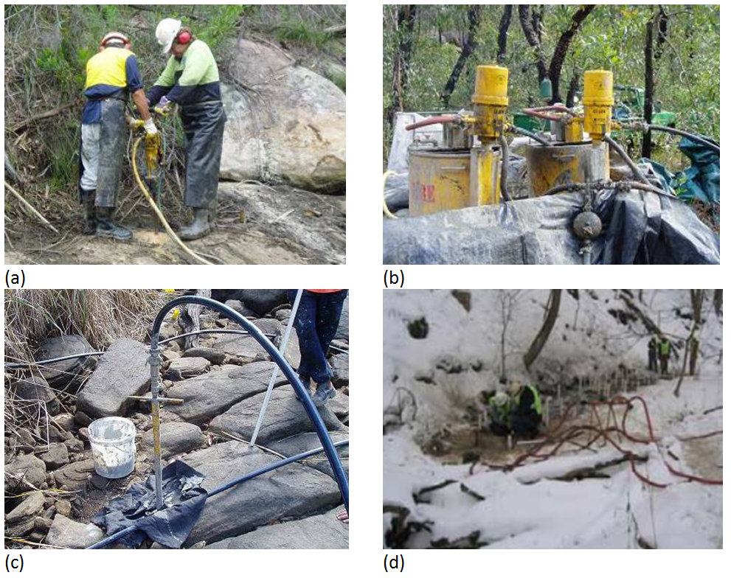
© Copyright, Good et al. 2010; Iannacchione & Tonsor 2011
Figure 5.2 Injection grouting: (a) drilling into the bedrock (Georges River); (b) grout pump station set-up (Georges River); (c) injecting grout into the bedrock via packer system (Georges River); (d) grout injection operations (United States).
When injection grouting is used for stream-bed remediation, grouting holes are drilled in a pattern, usually commencing at a grid spacing of 1 m × 1 m to 2 m × 2 m. The most efficient method to drill the holes, taking into account potential environmental impacts, is to use small handheld drills. The drills are powered by compressed air that is distributed to the work area from a compressor. Once mechanical packers have been installed at the surface, grout is injected into the holes at a low pressure. Grout is pumped into the holes from a small tank that is pulled adjacent to the site behind a 4WD rubber-tyred vehicle (BHPB Illawarra Coal 2007). This process would need to be adapted for swamp applications to take into consideration the sensitive swamp ecosystem and potential impacts on the vegetated surface.
NSW PAC (2009) highlights the complexities associated with fracture networks and the resultant difficulties in remediation. At some sites, the fracture network can extend some distance laterally under the toe of valleys or be covered by boulder beds within watercourses. These settings, as well as the fragility of upland peat swamp environments, potentially restrict access for grout injection equipment (NSW PAC 2009).
Directional drilling for grout injection may need to be investigated for upland peat swamps. Where alluvial sediments overlie sandstone, grouts may be injected through grout rods to seal voids in or under the soil or peat material. BHP Billiton (2012) reports that this technique was successfully used at Pool 16 in the Georges River to rehabilitate surface flow bypass to Pool 17. In this case, 1 to 2 m of loose sediment was grouted using purpose-built grouting pipes. To be successful, however, this technique requires that the fracture network has been identified using nondestructive techniques. To date, limited references are available on determining the location and extent of the fracture network below alluvial sediments (see note 1 at the end of this section).
To optimise remediation outcomes, grout is mixed and pumped according to the preferred grout design. As with surface grouting, bunds are used to contain local spillage at mixing points. A grout of high viscosity can be used if vertical fracturing is present, as it has a shorter setting time. A low-viscosity grout will be used if cross-linking is noted during grouting (BHPB Illawarra Coal 2007).
The content of the grout is important in sensitive environmental regions. Some types of grouting agents used for sealing similar types of fracture networks in other locations have not been permitted in the Southern Coalfield because of concerns about pollution of water supplies (NSW PAC 2009). Limited information is available on the full range of grouting chemicals commonly used in grouting applications.
Once the grout has been installed, packers are removed and the area is cleaned. After sufficient time is allowed for the product to cure, the area may be in-filled with additional grouting holes that target areas of significant grout take from the previous pass (BHPB Illawarra Coal 2007). The grouting process is iterative, relying on detailed monitoring of grout injection quantities, grout back-pressure analysis and measurements of water-holding capacity (BHPB Illawarra Coal 2007). Grouting volumes and locations are recorded, and high-volume areas are identified. For waterways, once the grout take is reduced and the material has cured, the grouted section of the pool is isolated and filled with water (BHPB Illawarra Coal 2007). The rate at which the water drains is measured and compared with pre-grouting results. Again, this process may need to be adapted for swamps because flow measurements may not be compatible. BHP Billiton (2012) suggests that, if flow diversion through a swamp rock bar occurs that lowers the surrounding shallow groundwater table, it may be more appropriate to implement alternative grouting techniques, such as a deep grout curtain (see Section 5.1.5).
It is important to note that injection grouting methods allow only limited control over where the grout is transported. Section 5.1.4 outlines a technique—cross-bore injection of gels—that may result in a more controlled injection of subsurface grout. Injection grouting may penetrate natural subsurface flow networks and may not restore the hydrology to pre-impacted conditions. A recent remediation project in the Lower Hunter highlights the importance of understanding the fracture network and applying due diligence when implementing grouting techniques. At this site, a section of Sugarloaf State Conservation Area was damaged by subsidence from Glencore’s West Wallsend Colliery and required remediation (Page 2013b). Attempts were made in June 2013 to grout a large subsidence crack at the top of a ridge in the reserve. However, the grout passed through the hillside and into a tributary of Cockle Creek at Lake Macquarie (Page 2013b). Figure 5.3 shows the ‘concrete creek’, which was reported as 1 m deep and 5 m wide in places (Page 2013b). More than 180 tonnes of concrete were pumped into the subsidence crack (Page 2013b). The New South Wales Office of Environment and Heritage has issued Glencore with a formal remediation direction for the spill (Page 2013a).
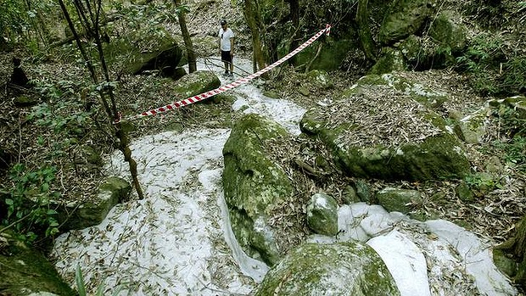
©Copyright, Page 2013b
Figure 5.3 The concrete creek in the Lower Hunter.
The Nebraska Grout Study (Lackey et al. 2009) evaluated the performance of various grouting methods used in domestic well construction, with varying results (Ross 2010). Sixty-three observation wells, located at five sites, were constructed to certain specifications, using a variety of different grout mixtures (Ross 2010). Testing showed that, although grouts performed as expected below the watertable, the grouts (particularly bentonite slurries) performed worse than expected in the unsaturated zone (Ross 2010). Further, the study highlighted that there is no perfect grout—a grout that will work in all applications was not found (Oliver 2012). Substantial desiccation of grouts in the unsaturated zone occurred, resulting in shrinkage and cracking (Ross 2010; Oliver 2012).
The implications from this research are pertinent to restoration of upland peat swamps using injection grouting. Firstly, grouting for restoration of upland peat swamps is likely to be within the unsaturated zone; consequently, shrinkage and cracking of the grouts may occur. If subsurface fracture networks are not completely remediated, as a result of either shrinkage and cracking of the grout or the grout not reaching every small fracture, water will continue to flow through the subsurface fracture networks because of preferential flow pathways (as discussed in Section 3.4).
NSW PAC (2009) highlights that there are no known attempts to remediate fracture networks beneath swamps and suggests that current grouting techniques are not suitable for remediation of fracture networks beneath swamp sediments. The NSW Scientific Committee (2005a) also highlighted concerns about grout-based remediation, particularly in reference to swamps: ‘Mitigation measures themselves may have additional environmental impacts due to disturbance from access tracks, the siting of drilling rigs, removal of riparian vegetation, and unintended release of the grouting material into the water. Furthermore, even measures that are successful in terms of restoring flows involve temporary rerouting of surface flows while mitigation is carried out (generally for 2 to 3 weeks at each grouting site). Planning for remediation measures may also be hampered by the lack of predictability of some impacts, and difficulties gaining access to remote areas where remedial works are needed. The long-term success of mitigation measures such as grouting is not yet known. It is possible that any ongoing subsidence after grouting may reopen cracks or create new ones. Further, it is not yet known whether the clay substance bentonite, which is often added to the cement in the grouting mix, is sufficiently stable to prevent shrinkage. Grouting under upland and hanging swamps that have no definite channel is probably not feasible.’ Section 5.3.2 provides additional information about restoring waterways in the Southern Coalfield and internationally using grouting techniques.

Permeation grouting
Limited information is available about use of permeation grouting as a remediation technique following longwall mining. Information on permeation grouting from other industries (e.g. Keller Ground Engineering 2013; RIX 2013) suggests that it is similar to injection grouting (Section 5.1.2). However, BHPB Illawarra Coal (2007, p. 44) notes the following about permeation grouting: ‘Permeation grouting involves the introduction of grouting and filling materials into an individual pool, or a stream flow, in such a manner that the material is drawn into cracks to seal the voids in the bed of the stream. A section of the stream is isolated by temporary bunding, to allow the impoundment of grouting media of various viscosities, permitting the introduction of the grout via gravity and flow induced movement. The grout mixture would vary for the treatment of wide through to finer fractures. Locations to undertake this type of grouting would need to be carefully selected to ensure environmental values are maintained.’ This method of grouting has not been used in the Southern Coalfield (BHPB Illawarra Coal 2007).

Cross-bore injection of gels
Cross-bore injection of gels is another possible remediation method. Although it has not yet been developed or tested for application in longwall mining impacts, it has been used to control water flow in an open-cut iron ore mine in Western Australia (Beale 2013). The gel is injected into a bore, with simultaneous pumping from another nearby bore to create a preferential flow field. When the technique was applied in Western Australia, a series of borehole ‘pairs’ (spaced 20 to 40 m apart) were used to control the flow through the strata (Beale 2013).
The injected nonviscous polymer can infiltrate narrow fractures in the target area and is set using a gelling agent. A retarding agent can also be used to delay setting the polymer for several days. Information on the safety of the products for use in the Sydney Catchment (including information from the material safety data sheets) would need to be assessed before on-ground trials. Laboratory experiments (of shrinkage and durability), followed by a pilot test to determine the feasibility and optimal process for fractured sandstone, are also required. Because this technique uses paired bores at either side of a valley, it may be more effective than uncontrolled grout barriers with a larger construction footprint.

Use of grout curtains
Grout curtains—grout injected to create a single barrier or curtain—are used in and around underground hydraulic structures that store and transport water; in underground reservoir structures that store natural gas and petroleum products; and in tunnels, shafts, underground pump houses, sewage plants and power houses (RIX 2013). Other examples include the containment of contaminated groundwater and soil (e.g. Evanko & Dzombak 1997), and the installation of grout curtains in combination with the development of leachate ponds (e.g. Zhan et al. 2008).
BHP Billiton (2012) suggests that if flow diversions through a swamp rock bar occur, lowering the surrounding shallow groundwater table, use of grout curtains may be more appropriate than injection grouting (Section 5.1.2). No detailed information was found on the use of grout curtains for remediation following the impacts of longwall mining; however, it is assumed that grout curtains pose the same risks as injection grouting to surface ecosystems if not implemented appropriately.
Peabody Energy (2010) outlines the proposed remediation plan for the Waratah Rivulet, focusing on restoration of surface flow and pool holding capacity, primarily through the injection of polyurethane grouting products into the fracture network. Grouting products proposed for use in the remediation activities include CarboPur (WFA and WF grades), which are products used for consolidation, stabilisation and/or sealing of strata. A grout curtain will be constructed across a rock bar by drilling a line of holes at regular intervals (approximately 2 m) and progressively injecting polyurethane at a range of depths (approximately 20 m to surface). The injection of polyurethane grout reduces the permeability of the overall rock mass by filling voids and thereby reducing subsurface flow pathways.

Self-amelioration
Natural remediation—the clogging of voids with natural material—is commonly referred to as self-amelioration. Self-amelioration has been highlighted as a remediation strategy for subsidence-related impacts in industry literature (e.g. BHPB Illawarra Coal 2007; BHP Billiton 2010). BHPB Illawarra Coal (2007) suggests that cracking in the soil profile as a result of mine-induced subsidence will eventually reseal as the natural processes of erosion and deposition occur, and that the rate of sealing will be determined by the characteristics of the surface materials and the relative position of a specific impact within the landscape.
BHPB Illawarra Coal (2007) suggested that regular monitoring of surface soil cracking in Dendrobium Areas 1 and 2 clearly demonstrates natural amelioration with time. However, the time frames associated with self-amelioration are significantly different from those required to impact upland peat swamps. In 2004, the Senior Environmental Scientist at the Sydney Catchment Authority made the following comment about remediation programmes throughout the catchments, specifically addressing problems within Waratah Rivulet: ‘these systems simply do not “self-heal” in the time frames that are required if sustainable water supply is to be maintained and ecological health protected in these areas’ (Total Environment Centre 2007b, p. 31). No estimates of the time frame required for surface cracks to reseal was found in the literature, and no reported evidence was found suggesting that self-amelioration is a feasible and reliable remediation method.
The concept of self-amelioration was also discussed as part of the strategic review into impacts of underground coalmining on natural features in the Southern Coalfield (DoP 2008). Regarding watercourses, it is suggested that the measure and rate of natural processes of remediation depend on the extent of damage and the type of watercourse (DoP 2008). Examples are provided of the Nepean and Cataract rivers, and Waratah Rivulet: ‘For example, the Nepean River is heavily regulated by weirs and can be considered as a long, shallow, generally low stream-energy impoundment in the area where mining has and will take place. Rate of flow is therefore interrupted and the river contains a substantial and semi-constant water column and a significant bed load of fine sediment and decomposing vegetation. Cracking of the stream bed beneath this sediment load is unlikely to lead to any long-term consequences, and the short-term impact of gas release generally dissipates over a number of months. On the other hand, a high energy stream environment with a low natural sediment load such as the Waratah Rivulet which has been impacted by upsidence, rock bar cracking and pool drainage, may be expected to show a much slower rate of natural remediation. The Cataract River might be considered to fall mid-way between these two cases’ (DoP 2008, p. 93).
Regarding upland peat swamps, the extent of self-healing of fracture networks between swamps and the degree to which the ecological function of deeply scoured swamps can be restored through natural process are unknown (DoP 2008). It is likely, as highlighted for watercourses, that the rate of natural remediation depends on the extent of damage and the ecological system.
The lack of recovery at Drillhole Swamp (see Section 3.5.1.9), without intervention, highlights the time frames that may be required for self-amelioration of ecological systems—at Drillhole Swamp, no natural remediation is evident in the more than 25 years since impacts occurred (DECC 2007). Self-amelioration has also not occurred upstream of Flat Rock Swamp on Waratah Rivulet, where impacts occurred more than 30 years ago. Surface cracks remain visible, with surface water disappearing down the fractures (DECC 2007). DECC (2007) suggests that this location highlights that natural remediation (self-amelioration) is an ineffective remediation ‘technique’ over timescales of decades or shorter (DECC 2007).

Other surface treatments
BHPB Illawarra Coal (2007) suggested additional surface treatments that can be used to treat surface cracks. Where significant cracking develops in the soil profile, there may be a requirement for tilling and compacting areas to preventing subsequent erosion. Larger cracks may require mulch or other protection to prevent the development of erosion channels. Surface protection is provided until vegetation re-establishes to cover a disturbed area. Where the cracks are wide, they are filled to the surface soil level with sand or crushed sandstone and revegetated using local native plants. Filling of cracks and mulching to ensure revegetation with local species has been successfully implemented at sites of tension cracks associated with Dendrobium Area 1 (BHPB Illawarra Coal 2007).
Centennial Coal (2012b) discusses a range of techniques that can be used to redirect flow to areas that have been affected by longwall mining, including diverting water into creeks and swamps, using bentonite cut-off trenches to control groundwater flow and installing subsurface drains. It is important to note that, although these methods may help reduce erosion in surface cracks and provide water to affected swamp systems, they are temporary remediation measures. If there has been significant cracking of the underlying strata, these techniques do not address the inherent hydrological concern.

Remediation of the water regime
Traditional restoration techniques (i.e. for ecosystems that have not been affected by longwall mining) generally involve methods to reduce velocities and increase residence times of water within peat swamp systems. Work undertaken in the Blue Mountains (Hensen & Mahony 2010; Save Our Swamps Program 2010), New South Wales Central Coast (Save Our Swamps Program 2010) and Australian Alps (Snowy Mountains) (Good 2006), and international guidelines (e.g. Quinty & Rochefort 2003; PUBDG 2010) highlight the effectiveness of reducing velocities and increasing residence times for water in the system (assuming that the overall water balance is unchanged).
The following sections outline approaches used in Australia, Canada and Northern Ireland for restoring peat swamp communities. The restoration approaches outlined by Quinty and Rochefort (2003) and PUBDG (2010) include information for the re-establishment of vegetation, whereas the Australian project primarily focuses on restoration of the hydrological regime.

The ‘Australian approach’
Substantial on-ground work has been undertaken to restore upland swamps within the THPSS ecological community in the Blue Mountains and Lithgow areas. This work has been led by the Save our Swamps (SOS) project, an integrated programme to protect and improve the condition and extent of the nationally endangered ecological community. The SOS project is funded by the New South Wales Environmental Trust and the Australian Government’s Caring for Our Country programmes (Hensen & Mahony 2010). It aims to restore swamps in the Blue Mountains and Newnes Plateau that have been degraded by a number of factors.
More than 1000 ha of nationally listed peat swamps in the Blue Mountains are within catchments impacted by urban ridgeline development (Hensen & Mahony 2010). Urban development within the Blue Mountains has resulted in:
- an increase in impervious surfaces, peak flow volume and duration, causing a reduction of recharge to aquifers that support groundwater-dependent ecosystems
- erosion, gullying, piping and channelisation within swamps
delivery of sediment containing nutrients and weed propagules (Hensen & Mahony 2010).
Incised channels or pipes drain subsurface flows, lowering groundwater tables within swamps and desiccating swamp substrates. This desiccation causes a significant reduction in floristic complexity, making affected swamps vulnerable to weed invasion. Weeds are able to exploit the voids created by weakened or dying swamp plants, and thrive on the more aerobic but relatively moist and nutrient-rich soil conditions (Hensen & Mahony 2010). On the less developed Newnes Plateau, a significant driver of degradation is recreational vehicles. These vehicles damage swamp systems directly, and create eroded access trails that deposit significant volumes of sediment into swamps, smothering their vegetation (Hensen & Mahony 2010).
The SOS programme, established in 2005, involves swamp rehabilitation works, supported by soft engineering structures and conventional soil conservation earthworks in the surrounding catchment (Hensen & Mahony 2010). These works encourage the diversion, detention and infiltration of sediment-laden stormwater run-off before it can reach the affected swamp systems, protecting them from ongoing erosion and sedimentation. On the Newnes Plateau, the approach is complemented by additional measures for controlling threats from recreational vehicles (Hensen & Mahony 2010).
The principal strategy behind the soft engineering swamp rehabilitation method adopted by the SOS programme is to slow the movement of water through the degraded swamps and re-establish the water balance (Hensen & Mahony 2010). This is achieved by constructing check dams, water spreaders and chains of infiltration cells to encourage the lateral and vertical rehydration of desiccated swamp substrates. Ongoing drainage and dewatering of swamp substrates is also prevented by packing and infilling drainage points (Hensen & Mahony 2010). The SOS programme predominantly uses organic materials, such as coir logs, sterilised straw bales, jute mesh, jute matting and wooden stakes. Over time, these materials break down and become incorporated into the swamp substrate (Hensen & Mahony 2010).
The SOS approach to swamp rehabilitation has proven successful, demonstrating multiple benefits. The approach directs limited resources to treating the causes rather than the symptoms of degradation (Hensen & Mahony 2010). Once the waterlogged and anaerobic conditions are re-established by the soft engineering rehabilitation techniques, many weeds (particularly weedy grasses) are outcompeted by the spontaneous natural regeneration of native swamp vegetation and no longer require intense weed control (Hensen & Mahony 2010). A detailed practical guide was produced as part of the SOS programme, detailing the remediation methods used and implementation processes (Save Our Swamps Program 2010).
The techniques used by the SOS approach form the basis of restoration techniques outlined by BHP Billiton (2012) and the proposed rehabilitation plans for East Wolgan and Narrow swamps (Section 5.3.1). The approach primarily uses coir logs in a range of different methods. Coir log dams (Figure 5.4) are proposed at knickpoints in the channelised flow paths or at the inception of tunnel/void spaces. The coir log dam reduces the flow velocity in the entrenched drainage line, such that the drainage line will silt up, and inflows to the swamp will flow through the swamp. Square coir logs used to construct these small dams were developed specifically for swamp rehabilitation and have been successfully used during a number of recent swamp rehabilitation programmes in the Blue Mountains and Snowy Mountains (Good et al. 2010). Sediment is deposited behind the coir log dams, and additional logs are added until the pooled water behind the dams is at or above the level of the bank of the eroded channel, or the peat bed of the swamp. The coir logs are held in place by wooden stakes and bound together with wire (Figure 5.4) (Good et al. 2010). A key aspect in the construction of these coir dams is the positioning of the first layer. A trench is cut into the organic soils such that the first layer sits on the underlying substrate and the top of the first coir log is at ground level (Figure 5.5) (Good et al. 2010).
The small coir log dams are constructed at intervals down the eroded or entrenched flow line. The intervals are calculated based on the depth of entrenchment, the slope and predicted peak flows. Where increased filtering of flows is required, the coir logs are wrapped in jute fibre matting (Figure 5.6) (Good et al. 2010). Maintenance of the swamp moisture regime can be assisted by additional water spreading techniques, involving long lengths of coir logs and hessian ‘sausages’, which are linked together across the contour such that water flow accumulates behind them and the water seeps through the water spreaders (Good et al. 2010).
Although this remediation approach has been successfully used on THPSS and similar ecological communities, it may be less applicable to remediation of upland peat swamps directly affected by longwall mining. The technique may be successful on sites indirectly impacted (i.e. above or below in the catchment), but it does not address sites where vertical drainage is a concern.
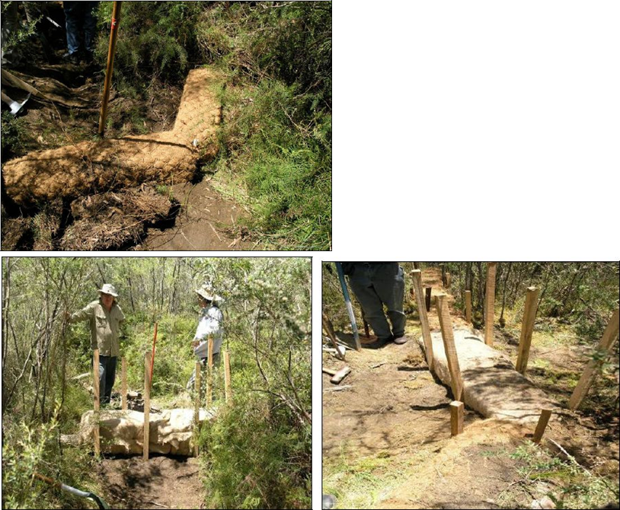
© Copyright, Good et al. 2010
Figure 5.4 Square coir logs for knickpoint control.
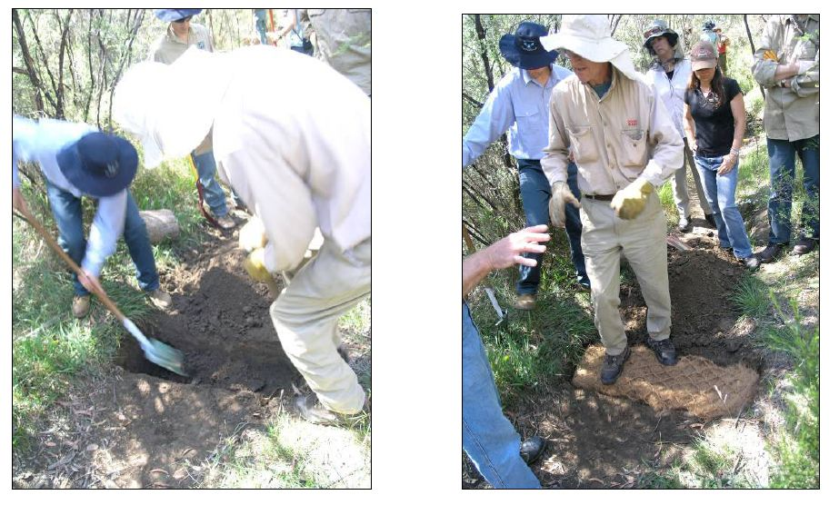
© Copyright, Good et al. 2010
Figure 5.5 Trenching and positioning of the first layer of coir logs during construction of a small dam in an entrenched swamp flow line.
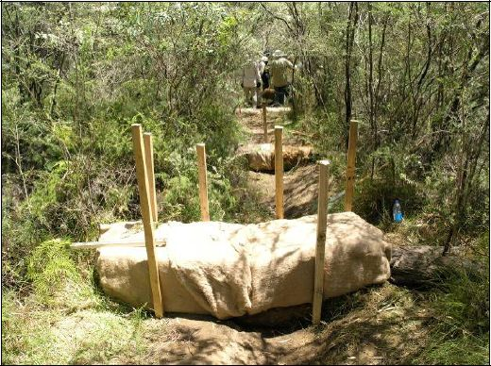
© Copyright, Good et al. 2010
Figure 5.6 Small coir log dams (with jute wrapping) constructed at intervals along an incised swamp flow line.

The ‘Canadian approach’
Extensive peat swamp remediation has been undertaken in Canada following destruction of peatlands by peat and sand mining. Quinty and Rochefort (2003) present, in a practical format, the approach that is proposed for restoring milled peatlands. The approach is based on the research conducted in Canada over 10 years by the Peatland Ecology Research Group, restoring more than 160 ha of the Sainte-Marguerite bog in Québec by Planirest Environment Inc., and on the experience of practitioners from Canadian peat producers who shared their knowledge at annual workshops. The method is known as the ‘Canadian approach’ and focuses on restoration of sphagnum-dominated peatlands.
The Canadian approach has two specific objectives (Quinty & Rochefort 2003, p. 11):
- ‘re-establishing a plant cover dominated by peatland species including sphagnum mosses, and
- re-wetting harvested sites by raising and stabilizing the water table near the surface’.
The Canadian approach, based on active reintroduction of peat bog plant species and hydrological manipulation, consists of the following operations: surface preparation, plant collection, plant spreading, straw spreading, fertilisation and blocking drainage (Quinty & Rochefort 2003).
There are two key components and assumptions regarding the Canadian approach. First, a specific objective of the programme is to restore the water balance within the site. Second, the approach assumes that conditions are still appropriate for the creation and growth of the organic peat layer. The Canadian approach focuses on the development and restoration of sphagnum peatlands, a vegetation type that is only rarely present in the upland peat swamps of the Sydney Basin. It is important to note that the Canadian approach does not consider vertical draining from the site, and thus would not be applicable to longwall mining environments. The Canadian approach also includes extensive agricultural practices, such as tilling, that are not appropriate to the Australian setting.

Guidelines for peatland restoration, Northern Ireland
The main aim of peatland restoration considered in the guidelines developed by the Peatlands and Uplands Biodiversity Delivery Group within the Northern Ireland Environment Agency is to reinstate an ecologically functioning peatland habitat for the benefit of biodiversity (PUBDG 2010).
It is suggested that restoration or re-creation of peatland habitat is likely to be appropriate if:
- there is a reasonably deep peat layer at the site (e.g. >0.5 m)
maintaining or creating a high water level is feasible (PUBDG 2010).
It is important to consider the differences between the Irish peatland ecosystems and the upland peat swamps found in Australia—in particular, the differences in peat depth. Across nine Newnes Plateau upland peat swamps studied by Benson and Baird (2012), the average peat depth was 0.83 m, with a range of 0.33 to 1.30 m, suggesting that some of these swamps would not be suitable for restoration, if impacted, using the Northern Ireland guidelines.
PUBDG (2010) highlight that attempted restoration of a peatland environment is not appropriate when there is no potential at the site for achieving and sustaining high water levels. This emphasises the importance of sustained hydrological conditions for the development of peatland, including the Australian upland peat swamp ecosystems. Also, while a site is being restored, there may be a need to provide an artificial water supply to restoration areas until a self-regulating water level can be guaranteed (PUBDG 2010). At locations where there is limited peat remaining and reduced scope for peatland restoration or re-creation, there is still potential for biodiversity gains through the development of alternative wetland ecosystems (PUBDG 2010).
Restoration guidelines are provided for three different cases:
- restoration of drained peatland sites
- restoration of aggregate extraction/quarrying sites where peat is an overburden
restoration of peat extraction sites (PUBDG 2010).
For all three cases, restoration of the hydrological regime is the first priority. General advice is provided by PUBDG (2010) for encouraging vegetation growth, with two key components: stabilising the substrate and revegetating the substrate, including restoring the plant community. It is important to note that the Northern Ireland approach does not consider vertical draining from the site, and thus would not be applicable to longwall mining environments.

Remediation examples
As noted above (Section 5), this investigation has found no evidence of remediation undertaken on upland peat swamps, or similar ecosystems, impacted by longwall mining. Consequently, no specific remediation examples can be provided. However, the proposed remediation plans for East Wolgan and Narrow swamps on the Newnes Plateau are discussed (Section 5.3.1) and, for further reference, three remediation examples of stream beds affected by longwall mining within the Southern Coalfield are provided (Section 5.3.2).

Proposed upland peat swamp remediation techniques
Two upland peat swamps in the Sydney region—East Wolgan Swamp and Narrow Swamp on the Newnes Plateau—have been considered for remediation following impacts associated with longwall mining—in particular, discharge of mine water. Impacts were first observed in 2009 and 2008 for the two swamps, respectively (see Sections 3.5.1.1 and 3.5.1.2). The then Australian Government Department of Sustainability, Environment, Water, Population and Communities (DSEWPaC) commissioned a study of the impacts to the swamps in 2008. In October 2011, an enforceable undertaking (DSEWPaC 2011) was issued under the EPBC Act on the companies Springvale Coal and Centennial Angus Place Coal because the environment minister considered that the Act had been breached by the impacts caused to the swamps. The enforceable undertaking required the companies to pay a sum of $1.45 million.
In August 2012, Centennial Coal referred proposed remediation works for the two swamps to DSEWPaC (DSEWPaC 2012a, b). The proponents were advised in September 2012 that the proposed remediation works were not controlled actions under the EPBC Act and approval was not required. On-ground remediation works did not commence at the swamp sites until January 2014.
The remediation plan for the swamps was proposed by Grundy (2011), with the following aims: ‘The aim of the East Wolgan Swamp project is to reinstate the natural hydrological processes of the swamp through the replacement of lost soil and organic material. Narrow Swamp will have a rock ramp constructed to prevent the head cutting that is active in the area at present’ (Grundy 2011, p. 2). The proposed restoration project follows the guidelines and approach successfully adopted by the SOS programme (Save Our Swamps Program 2010). Proposed actions focus on using natural materials (predominantly geotextile, coir logs and sand) to reinstate the natural hydrological processes of the swamp (Grundy 2011). No attempt will be made to seal fractures in the swamp substrate.
RPS (2012) undertook an ecological assessment of the swamps in question, including a site survey and field visits, and provided a review of the works proposed by Grundy (2011). Regarding the proposed restoration works, RPS (2012) highlights that hydrological processes are critical to swamp communities, and reinstatement of any hydrological processes that have been modified is required. RPS (2012, p. 23) generally agrees with the proposed plan, as it is ‘based on techniques specifically designed for swamp remediation which have been used successfully in a number of remediation projects. The approach of seeking to repair and reinstate the hydrology of the slump and erosion areas is a first step to the recovery of the swamp ecosystem and re-establishment of natural vegetation and habitat values’. Several points of concern with the proposed plan are raised for further consideration (RPS 2012, p. 24):
1. ‘The risk posed by the use of machinery should be assessed before the works are commenced. Machinery has been used in other remediation projects, however the stability of the peat system may be low adjacent to the slump and erosion areas. If this risk is other than low, then the potential to move materials by helicopter or other means should be considered.
2. Before works commence, in cases of utilising areas that are not already significantly disturbed (or have not already been identified as storage or lay-down areas), any tracks or areas where materials are to be placed should be inspected by an ecologist and appropriately marked to avoid any direct damage to threatened species.
3. Remediated areas should be monitored/inspected to track recovery over time. Centennial has committed that the project areas will be subject to ongoing care and maintenance for several years to ensure the integrity of the structures are maintained.
4. Consideration should be given to establishing experimental trials that demonstrate if recovery of the swamp community can be assisted with the application of shade and cover as these have been found to aid recovery in other highland swamp systems.
5. Weed removal should be considered where monitoring demonstrates that weed species are persisting or spreading in the treated areas or adjacent to these areas.’
The proposed plan for remediation may be beneficial and potentially effective if applied to many of the Blue Mountains and Newnes Plateau swamps that have not been affected by mining. However, at no point do the proposed plan or review address the underlying cause of the damaged swamps—probably undermining and cracking of the underlying strata. In this sense, the project does not explicitly follow the methods proposed by the SOS programme: restoration of the swamp’s hydrological conditions. As discussed in Section 3.5.1.1, there is a large fracture at the northern end of East Wolgan swamp that is capable of removing 14 ML/day of water from the surface (Muir 2010). This volume of water should be addressed to effectively restore the hydrological regime of the swamp.

Remediation of streams affected by longwall mining
This section provides three examples of stream restoration projects in the Southern Coalfield following subsidence-related impacts of longwall mining. Information reported publicly on these restoration projects is limited, and data on the restoration attempts are not always consistently reported.
There have been attempts, both internationally and within the Sydney region, to restore flow to streams and rivers affected by longwall mining. Some of these projects, such as the injection grouting on the Georges River, have been extensive and are considered a success by the mining company involved (BHP Billiton 2012). However, others suggest that ‘mitigation measures to repair cracking creek beds have had only limited success and are still considered experimental’ (NSW Scientific Committee 2005a). Young (2010) disputes the claims of success, suggesting that, although improvements have been made at some locations, such as the Waratah Rivulet, the results were trivial when compared with the extent of damage caused. Young (2010) notes that, at many of the locations where attempts at remediation have been made, there are other cracks and holes in the surrounding area that have received limited attention.

Cataract River
Observed impacts on the Cataract River (Section 3.5.2.1) were extensive. Installation of a grout curtain in the Cataract River was only partially successful. In 2002, following rehabilitation measures, it was concluded that the environmental flows released from Broughtons Pass Weir by the Sydney Catchment Authority were insufficient to keep the Cataract River flowing or to maintain acceptable water quality (DIPNR 2003, in NSW Scientific Committee 2005a). A return to natural flow levels has not occurred, and environmental flows are being used to compensate for surface flow losses (DECC 2007). More recent information about the longer-term success of this project is not available.

Upper Georges River
As outlined in Section 3.5.2.2, extensive impacts have been observed on the Upper Georges River. Mitigation and remediation undertaken on the Upper Georges River, in the vicinity of Appin, has been extensive. A stress relief slot (see Section 4.2) was installed to limit damage to Marhnyes Hole, and subsidence-induced cracks near Marhnyes Hole were remediated at significant cost ($2.2 million in 2002–03) (Ecological Australia 2004, in Krogh 2007). However, Krogh (2007) suggests that the Upper Georges River is yet to experience a return to the natural flows and pool water retentions that existed before mining. Subsidence-induced cracks were remediated using both injection and surface grouting, and environmental flows were used to increase pool water levels (DECC 2007).
Pool bases and controlling rock bars in the Georges River were rehabilitated using injection grouting, with reports indicating success (e.g. International Environmental Consultants 2004; BHP Billiton 2012), in contrast to the comments of Krogh (2007) mentioned above. As discussed in Section 5.1.2, the grouting process is iterative, relying on detailed monitoring of grout injection quantities, grout back-pressure analysis and measurements of water-holding capacity. In the Georges River, the majority of pools were sealed with 2–3 grout passes (BHP Billiton 2012). More recent information about the longer-term success of this project is not available.

Waratah Rivulet
Remediation of Waratah Rivulet was conducted in 2006 using drill holes and injection of sand into the fractured rock bar. Preliminary improvements in water retention behind the rock bar were noted (DECC 2007; Krogh 2007). Despite the severe damage to Waratah Rivulet and implementation of preliminary remediation measures, approval was given to continue with adjacent panels (longwalls 12 and 13), which subsequently caused fracturing of the rock bar and riverbed (DECC 2007; Krogh 2007). This sediment quickly washed from the cracks during high-flow events and now can be found downstream in various pools in the watercourse (NSW PAC 2009). More recent information about the longer-term success of this project is not available.
Remediation trials involving polyurethane injection have also been conducted on Waratah Rivulet, with remediation of the WRS4 rock bar (NSW PAC 2009). NSW PAC (2009) suggests that the technology has a high potential for effectively sealing a fracture network but requires further development. At the time of inspection by NSW PAC, a 100 per cent seal was yet to be achieved, with only one application of the project (NSW PAC 2009). Further, the durability of the product is not proven; shrinkage was observed during NSW PAC inspections (NSW PAC 2009). Additionally, the technique is yet to be evaluated for restoring surface flows to unfractured rock bars that lose surface flow as a result of diversion of water into upsidence networks upstream (NSW PAC 2009). As of October 2010, further remediation work was planned for Waratah Rivulet (Peabody Energy 2010). Information was not able to be found on the progress of this work.

Chapter synthesis and knowledge gaps
Section 5 presents remediation techniques, approaches and examples. Based on the available evidence, there are no proven techniques for remediation of upland peat swamps impacted by longwall mining. Further, the remediation techniques outlined in the literature seem to assume that the site has already been severely impacted, with no opportunity for early intervention (see note 2 at the end of this section).
Approaches required to remediate upland peat swamps impacted by longwall mining differ between swamps as a result of the nature of impact (i.e. directly undermined and impacted or adjacent to undermined and impacted area). It is evident from the literature that overseas approaches are either not applicable to Australian conditions or not significantly different from remediation approaches in Australia.
The available literature highlights the range of techniques to repair subsurface fracture networks; however, these techniques have not been robustly tested or used for remediation of subsurface fracture networks beneath upland peat swamps. A knowledge gap was found regarding the inability to detect subsurface fracture networks beneath peat swamp substrate using nondestructive methods. Conversely, remediation conducted in stream beds is simplified by the absence of organic sediments. No reported information was available on probable time frames for ecological restoration or preferred ecological restoration states for sites undermined by longwall mining.
Other knowledge gaps include the durability of remediation material and the permanency of repairs. There is also an absence of information on the time lag for recovery of a system, assuming that the natural water balance can be restored. This includes considerations of the unique soil chemistry of upland peat swamps and associated ecological indicators. This culminates in the question, ‘Can remediation of upland peat swamps impacted by longwall mining be successfully conducted over a relevant timescale?’

Peer review comments on Chapter 5
1. Peer reviewer Roger Good has worked as a report author and advisor for the Dendrobium swamp area and comments that:
The techniques applied at this site, which potentially could be implemented in other sites, were difficult to implement and very costly. There was a lack of ongoing long-term monitoring at the site that may have been able to indicate whether the techniques applied were justifiable on a cost/benefit basis and from a swamp restoration consideration whether they were appropriate and ecologically beneficial.
The rock fracture sealing project was not particularly successful and has provided little benefit to the restoration of ecosystem function and sustainability, and the eco-services of any swamp in the near vicinity of the works. The works were not undertaken entirely within a swamp where subsidence and rock fracturing had occurred directly below it.
The approaches to rock fracture sealing were implemented, as much as a field trial, as an endeavour to mitigate detrimental impacts, or for any swamp restoration purpose per se. The works were undertaken with a commitment and were well planned and implemented by the company and hence are worth noting as a possible remediation technique in some other swamp sites in the future.
2. Roger Good summarises approaches to swamp remediation:
The restoration of swamps that have been impacted by subsidence and rock fracturing is limited to two approaches, one being structural restoration and one ecological restoration. Structural restoration only addresses water loss and hydrological features of a peat bog and as such only contributes in part to restoration of peat swamp hydrology. If this structural restoration can be achieved, ecological restoration can then commence. The ‘soft engineering’ techniques address the ecological restoration of a peat swamp but can also contribute to mitigating excessive loss of water from a swamp system. The two approaches are complimentary but neither is an appropriate approach if implemented in isolation. They must be implemented together to ensure at least some ecological benefit accrues from the restoration work.
Even where swamp restoration techniques have been applied to swamps impacted by bushfires, domestic stock grazing, recreational activities etc. (and NOT affected by uncontrolled vertical drainage due to subsidence effects) recovery to a fully functional ecological system can take many decades. Experience from peat swamp restoration works in the Snowy Mountains indicates that full recovery of the swamp ecosystems can take more than four decades or more but significantly any loss of peat from any impact can seldom be recovered as peat-forming climatic conditions now don’t exist.
It is to be recognised that much swamp restoration work to date both overseas and to a lesser extent in Australia, has been revegetation, not restoration of swamp functionality and the eco-services a stable peat swamp provides.
No overseas peat swamp restoration techniques are appropriate for use in Australia, particularly swamps of the Sydney sandstone basin where longwall mining has resulted in rock fracturing and subsidence with subsequent impacts on the swamps.
Mitigation and remediation of rock fracturing and swamp drainage is not swamp restoration per se, but only an initial component of effective ecological restoration of upland peat swamps. The well-developed surface soft engineering techniques provide the ecological restoration component, which provides for swamp recovery and long-term sustainability.

Conclusions
This report provides a detailed and critical investigation into mitigation and remediation techniques for the THPSS endangered ecological community. The report findings are based on a detailed literature review of more than 570 references collated within a bibliographic database.
The importance and uniqueness of THPSS are reflected in the inclusion of this ecological community as endangered in Commonwealth and New South Wales listings. Because upland peat swamps in the Sydney Basin have similar characteristics to THPSS, have a broader geographic coverage and are listed in New South Wales as endangered ecological communities, this report incorporates these upland peat swamps with THPSS. Formation mechanics, soil structure, heterogeneity, ecology and spatial distribution are important factors that differentiate upland peat swamps from other ecological communities.
Background information on upland peat swamps supports the need for further conservation; however, there are knowledge gaps associated with fundamental hydrology, soil distribution and chemistry, aggradation rates, erosion mechanics, natural variability within and between swamps, and hydrogeological variances.

Impacts on peat swamps
The co-location of upland peat swamps and mining leases across the Sydney Basin is a potential risk to the swamps’ water balance and ecology. Various scientific hypotheses have been proposed to explain the mechanisms for impacts, or mitigation of impacts, on upland peat swamps from longwall mining. Although observed impacts from longwall mining have been reported at several upland peat swamp locations, limited comprehensive studies employ the before–after control–impact (BACI) monitoring method commonly applied elsewhere.
Impacts on upland peat swamps are most commonly reported along creek lines, where surface cracking and subsurface fracturing networks have been described. Where fracture networks form and the water balance is altered (including along upstream, downstream or subsurface boundaries), the impacts on upland peat swamps can be widespread. They can include effects on soil structure, water quality, ecology, and responses to stressors such as fire.

Impact prediction and mitigation
Limited techniques are available to predict the severity, extent and timing of any impact, either immediately above the mined longwall or in proximity to the mining lease. Few studies have been undertaken on locating fracture networks beneath peat swamp sediments using nondestructive techniques. Methods to locate fracture networks below peat swamp strata are limited.
This report presents the current state of the industry, with a focus on impact prediction, mitigation and proposed remediation strategies. It highlights the delay between longwall mining and observation of the impacts on peat swamp ecology, following hydrological changes. Available literature suggests that, other than alterations to mining layout (and subsequent avoidance of the upland peat swamp system), there are no proven mitigation strategies for reducing impacts on upland peat swamps. Additionally, engineered mitigation strategies, as used on a rock bar in the Georges River, may not be applicable to protection of upland peat swamps. The relevance of commonly used TARPs was assessed; TARPs were shown to be an ineffective technique to minimise impacts on upland peat swamps.
Best industry practice would involve development of predictive techniques to recognise risk and minimise or manage impacts on upland peat swamps.

Monitoring
Limited onsite monitoring data are available to measure the effect of longwall mining subsidence on upland peat swamps. In most cases, detailed monitoring is absent or spatially and temporally insufficient to identify complex hydrogeological processes. Where available, data commonly focus on exposed bedrock creek channels; limited data are available on peat sediments or adjacent catchments. The overall lack of onsite monitoring data limits the direct assessment of mitigation measures and remediation strategies for upland peat swamps.
Although numerous upland peat swamps located above longwall mined sections have been impacted by changes to the hydrological regime, the discrete causal mechanism and specific time frames are difficult to quantify because of the lack of monitoring data. Detailed descriptions of various sites before and after mining activities provide strong qualitative data. Observations from these sites indicate that changes to the hydrological regime can result in declines in groundwater quality, desiccation of organic matter, slumping and void formation, creation of knickpoints and increased erosion, leading to severe impacts on flora and fauna and increased susceptibility to extreme weather events (drought, floods, fire).
Further information is required regarding the specific time lags between mining activities and associated impacts at the surface, as well as the role of mine plan layout and proximity in the extent of onsite damage.

Remediation
Despite numerous observed impacts of longwall mining on upland peat swamps, including on the THPSS ecological community, no examples of conducted remediation were obtained through this study. A remediation plan for East Wolgan and Narrow swamps above the Western Coalfield has been developed, but remediation work has only recently commenced. Further, the proposed remediation plan does not consider the remediation of the fractured underlying strata.
Remediation strategies in regions affected by longwall mining are primarily designed to restore the hydrological regime. To date, on-ground remediation strategies have focused on sealing fracture networks on cracked stream beds and have not addressed fractures occurring beneath peat sediments. No examples were found of upland peat swamps impacted by longwall mining that have been remediated.
Any remediation approach for directly impacted swamps would probably need to be a two-stage process: first ameliorating any artificial leakage through the substrate or rock bars, and then creating the appropriate hydrological regime through proven techniques. However, success in restoring hydrology has yet to be documented under an upland peat swamp impacted by longwall mining.
Remediation techniques have been trialled to restore the hydrological regime of (i) creek beds in the vicinity of upland peat swamps and (ii) upland peat swamps not impacted by longwall mining. Creek-bed techniques primarily focus on filling the fracture network void using either naturally available materials or grout and/or gels. These techniques have had limited applied trials, are prohibitively expensive for broadacre trials, have inherent environmental risks or insufficient lifespans, and may not be relevant to upland peat swamps without significant disturbance of the substrate. Remediation techniques for sites not impacted by longwall mining, such as in the Blue Mountains, may be relevant for swamps where downstream sites have been impacted by longwall mining or where vertical drainage is not a concern.
The available literature suggests that the preferred remediation approach would depend on the severity and nature of the impact. It may be possible to manage minor downstream or upstream impacts to hydrology. However, if vertical seepage is evident, the natural hydrological regime would be difficult to restore because of the limited understanding of natural peat swamp hydrological extremes (i.e. previous long-term monitoring data) and of the impact processes of longwall mining on upland peat swamps.
Changes to hydrology beyond natural variations may result in immediate and irreversible impacts on soil structure, composition and geochemistry. These will have direct impacts on ecology, including responses to stressors such as fire.

Knowledge gaps
Knowledge gaps exist on the ability to predict the severity, extent and timing of any impact, either immediately above the mined longwall or in proximity to the mining lease. Limited studies have been undertaken on locating fracture networks beneath peat swamp sediments using nondestructive techniques, and comprehensive methods to locate fracture networks remain problematic.
No reported information was available on the likely time frames for ecological restoration or preferred ecological restoration states for sites undermined by longwall mining. However, aggradation rates of natural upland peat swamps in the Sydney Basin suggest that complete restoration following significant impacts would require tens to hundreds of years. Additional research is required to determine the recovery time frames of upland peat swamps following remediation. International remediation techniques were shown to be not applicable locally, because no similar overseas environments were impacted by uncontrolled vertical seepage issues.
Major knowledge gaps exist in the current understanding of the complex interactions between upland peat swamps and longwall mining.

Summary and key points
Knowledge gaps have been identified for the various stages of planning, monitoring, mitigating and remediating upland peat swamps. Existing information suggests that longwall mining has impacted several sites, and no effective mitigation techniques are available to reduce impacts once detected (other than altering mine plan layout). Direct remediation of upland peat swamps has not been attempted, and current remediation strategies appear insufficient to effectively combat vertical seepage through fracture networks beneath peat swamp sediments. Once an upland peat swamp has been severely impacted, the restoration time frames are beyond typical planning periods as a result of natural aggradation rates, biogeochemical processes and increased susceptibility to environmental stressors. Knowledge of the natural variability of upland peat swamp hydrology is of primary importance and should be obtained before mitigation or remediation actions are developed.
Key points:
- Numerous swamps have been impacted by longwall mining subsidence, with observed changes to the hydrological regime, as well as declines in water quality, desiccation of organic matter, erosion, slumping and void formation.
- Exact mechanisms and time frames of impact are unknown because of a lack of monitoring; limited comprehensive studies have been undertaken using before–after control–impact (BACI) methods.
- There are no proven mitigation strategies other than alterations to mining layout. The time delay between mining and observation of surface impacts—in particular, ecological impacts—suggests that existing industry mitigation strategies, such as TARPs, are not suitable. Engineering solutions such as the creation of stress relief slots are untrialled for peat swamps, but likely to be ecologically damaging to implement.
- Industry best practice would involve the development of predictive techniques to recognise risk and minimise or manage impacts on upland peat swamps.
- Information on subsidence impacts, and remediation of these impacts, has focused on exposed bedrock channels, with no remediation examples of undermined upland peat swamps.
- Ecological restoration times for peat swamps are likely to be tens to hundreds of years because of slow aggradation rates. No evidence was found to suggest that self-amelioration is reliable or feasible; there have been no signs of self-amelioration in swamps impacted more than 25 years ago.
- Subsidence remediation strategies have focused on sealing fracture networks of exposed bedrock. These attempts have been relatively small scale, often limited to trials that are costly, risky and likely to be of limited lifespan. Their applicability to upland peat swamps is unknown because of the presence of organic peat sediments and associated issues with detection of subsurface fracture networks.
- Remediation of peat swamps not directly impacted by vertical drainage has been trialled in Australia, particularly within the THPSS ecological community. This is potentially relevant at peat swamps downstream of direct subsidence impacts.
- International peat swamp remediation techniques are not applicable because these swamps and peatlands are not impacted by uncontrolled vertical seepage.

References
ACARP 2001, Impacts of mine subsidence on the strata and hydrology of river valleys: management guidelines for undermining cliffs, gorges and river systems, Australian Coal Association Research Program final report C8005 stage 1, Brisbane.
ACARP 2002, Impacts of mine subsidence on the strata and hydrology of river valleys: management guidelines for undermining cliffs, gorges and river systems, Australian Coal Association Research Program final report C9067 stage 2, Brisbane.
ACARP 2003, Review of industry subsidence data in relation to the influence of overburden lithology on subsidence and an initial assessment of a sub-surface fracturing model for groundwater analysis, Australian Coal Association Research Program final report C10023, Australian Coal Association Research Program, Brisbane.
Adhikary DP & Guo H 2009, ‘An efficient approach to numerical simulation of coal-mine related geotechnical issues’, in GS Esterhuizen, C Mark, TM Klemetti & RJ Tuchman (eds), Proceedings of the International Workshop on Numerical Modeling for Underground Mine Excavation Design, information circular 9512, US Department of Health and Human Services, Pittsburgh, pp. 3–17.
Anderson D, Stapleton DHS & Mattes NS 1989, Coal mining beneath reservoirs, New South Wales, Australia 1979–1989, Dams Safety Committee, Sydney.
Aurecon 2009, Newnes Plateau Shrub Swamp management plan: investigation of irregular surface movement within East Wolgan Swamp, report 7049-010-Rev to Centennial Coal, Sydney.
Aurecon 2012, Groundwater monitoring report for April–May 2012: Angus Place and Springvale groundwater monitoring program, report 208362/208354 prepared for Centennial Coal, Sydney.
Beale G 2013, Planning of integrated pit slope depressurization programs, presentation to the ARMA Workshop, SLC, 21 March 2013, accessed 23 September 2013, <www.armarocks.org/documents/free_downloads/Enabling_Technologies_Hard_Rock_Mining_Applications/Beale.pdfs>.
Bear J 1993, ‘Modeling flow and contaminated transport in fractured rocks’, in J Bear, C-F Tsang & G De Marsily (eds), Flow and contaminant transport in fractured rock, Academic Press, San Diego.
Bell FG, Stacey TR & Genske DD 2000, ‘Mining subsidence and its effect on the environment: some differing examples’, Environmental Geology, vol. 40, nos. 1–2, pp. 135–52.
Benson D & Baird IRC 2012, ‘Vegetation, fauna and groundwater interrelations in low nutrient temperate montane peat swamps in the upper Blue Mountains, New South Wales’, Cunninghamia, vol. 12, no. 4, pp. 267–307.
Benson DH & Keith DA 1990, ‘The natural vegetation of the Wallerawang 1:100 000 map sheet’, Cunninghamia, vol. 2, no. 2, pp. 305–35.
BHP Billiton 2003, Wongawilli and Native Dog creeks, geology, surface water flow and quality, BHP Billiton Illawarra Coal Technical and External Services.
BHP Billiton 2010, Environmental management system: West Cliff Area 5, Longwalls 34–36, Georges River Management Plan, BHP Billiton, Melbourne.
BHP Billiton 2012, Swamp impact, monitoring, management and contingency plan: Dendrobium Area 3B, BHP Billiton, Melbourne.
BHPB Illawarra Coal 2009 Bulli Seam Operations project environmental assessment, BHP Billiton, <www.bhpbilliton.com/home/aboutus/regulatory/Pages/default.aspx>.
BHPB Illawarra Coal 2007, Independent inquiry into NSW Southern Coalfield: Illawarra Coal submission, submission to the Southern Coalfield Independent Expert Panel, Southern Coalfield Inquiry, July, BHP Billiton, Melbourne.
Booth CJ 1986, ‘Strata-movement concepts and the hydrogeological impact of underground coal mining’. Ground Water, vol. 24, no. 4, pp. 507–15.
Booth CJ 1992, ‘Hydrogeological impacts of underground (longwall) mining in the Illinois Basin’, in SS Peng (ed.), Proceedings: third Workshop on Surface Subsidence Due to Underground Mining, 1–4 June 1992, Morgantown, West Virginia, pp. 222–27.
Booth CJ 1998, ‘Impacts of mine subsidence on groundwater’, in CL Hooks, KC Vories & D Throgmorton, Proceedings of the Prime Farmland Interactive Forum, University of Southern Indiana, 3–4 March 1998, US Department of Interior, Office of Surface Mining, & Coal Research Center, Southern Illinois University, Illinois, pp. 143–51.
Booth CJ 2003, ‘Groundwater as an environmental constraint of longwall coal mining’, RMZ: Materials and Geoenvironment, vol. 50, no. 1, pp. 49–52.
Booth CJ 2006, ‘Groundwater as an environmental constraint of longwall coal mining’, Environmental Geology, vol. 49, no. 6, pp. 796–803.
Booth CJ 2007, ‘Confined-unconfined changes above longwall coal mining due to increases in fracture porosity’, Environmental & Engineering Geoscience, vol. 13, no. 4, pp. 355–67.
Booth CJ & Bertsch LP 1999, ‘Groundwater geochemistry in shallow aquifers above longwall mines in Illinois, USA’, Hydrogeology Journal, vol. 7, no. 6, pp. 561–575.
Booth CJ & Spande ED 1991, ‘Changes in hydraulic properties of strata over active longwall mining, Illinois, USA’, 4th International Mine Water Congress, Ljubljana, Slovenia, September 1991, International Mine Water Association, pp. 163–74.
Booth CJ & Spande ED 1992, ‘Potentiometric and aquifer property changes above subsiding longwall mine panels, Illinois Basin Coalfield’, Ground Water, vol. 30, no. 3, pp. 362–8.
Booth CJ, Spande ED, Pattee CT, Miller JD & Bertsch LP 1998, ‘Positive and negative impacts of longwall mine subsidence on a sandstone aquifer’, Environmental Geology, vol. 34, no. 2–3, pp. 223–33.
Bower CC 2009, Bulli Seam Operations: Appendix E—terrestrial flora assessment, prepared by CC Bower, FloraSearch, for BHP Billiton, Melbourne.
Cardno Forbes Rigby 2007, Environmental assessment for modification to Dendrobium area 3, prepared for BHP Billiton Illawarra Coal.
Carey A 2007, ‘Protecting swamp communities in the Blue Mountains’, Australian Plant Conservation, vol. 16, no. 2, pp. 14–16.
Centennial Coal 2012a, Operations, Centennial Coal, accessed 28 November 2012, <http://centennialcoal.com.au/Operations/OperationsList.aspx>.
Centennial Coal 2012b, Site water management plan: Angus Place Colliery, February 2012, Centennial Coal, Sydney.
CoA 2014a, Temperate Highland Peat Swamps on Sandstone: ecological characteristics, sensitivities to change, and monitoring and reporting techniques, Knowledge report, prepared by Jacobs SKM for the Department of the Environment, Commonwealth of Australia, Canberra.
CoA 2014b, Temperate Highland Peat Swamps on Sandstone: longwall mining engineering design—subsidence prediction, buffer distances and mine design options, report prepared by Coffey Geotechnics for the Department of the Environment, Commonwealth of Australia, Canberra.
Connell Wagner 2005, ‘Appendix I’, in Springvale Colliery Longwalls 411–418 Subsidence management plan application, Springvale Coal, Lidsdale.
Cook P 2003, A guide to regional groundwater flow in fractured rock aquifers, CSIRO Land and Water: Glen Osmond, South Australia.
CSIRO 2002, Audit of the Sydney drinking eater supply catchments managed by Sydney Catchment Authority, final Report to the Minister for the Environment, NSW State Government, Sydney.
Darmody RJ 1998, ‘Reclamation of agricultural land after planned coal mine subsidence’, in CL Hooks, KC Vories & D Throgmorton, Proceedings of the Prime Farmland Interactive Forum, University of Southern Indiana, 3–4 March 1998, US Department of Interior, Office of Surface Mining, & Coal Research Center, Southern Illinois University, Illinois, pp. 152–72.
Dawkins A 2003, ‘Potential management and rehabilitation requirements of environmental effects from longwall subsidence on streams, lakes and groundwater systems’, Proceedings of the 2003 coal operators’ conference, The Australian Institute of Mining and Metallurgy, Illawarra Branch, University of Wollongong, pp. 117–24.
de Marsily G 1986, Quantitative hydrogeology, Academic Press, Orlando.
DEC 2006, The vegetation of the western Blue Mountains (including the Capertee, Coxs, Jenolan & Gurnang areas), vol. 1, Technical report, project funded by the Hawkesbury–Nepean Catchment Management Authority, NSW Department of Environment and Conservation, Hurstville.
DECC 2007, Submission on the strategic review of the impacts of underground mining in the Southern Coalfield, submission to the Southern Coalfield Independent Expert Panel, Southern Coalfield Inquiry, NSW Department of Environment and Climate Change, Sydney.
DECCW 2010, 2010 audit of the Sydney drinking water catchment, NSW Department of Environment, Climate Change and Water, Sydney.
DIPNR 2003, Hydrological and water quality assessment of the Cataract River; June 1999 to October 2002: implications for the management of longwall coal mining, NSW Department of Infrastructure, Planning and Natural Resources, Wollongong.
DoP 2008, Impacts of underground coal mining on natural features in the Southern Coalfield: strategic review, NSW Department of Planning, Sydney.
DoP 2013, Response to 7:30 NSW re alleged surface impacts from Illawarra Coal’s Dendrobium Mine, NSW Department of Planning, accessed 23 September 2013, <https://www.google.com/url?q=http://www.planning.nsw.gov.au/DesktopModules/MediaCentre/getdocument.aspx%3Fmid%3D1286&sa=U&ei=_XQ_UrPmM-SdiAe1q4D4Dw&ved=0CAkQFjAB&client=internal-uds-cse&usg=AFQjCNGd_pTMSyHfEg2jIOBalq_JWqngnw>.
DSEWPaC 2011, Undertaking to the Minister for Sustainability, Environment, Water, Population and Communities given for the purposes of section 486DA by Springvale Coal Pty Limited and Centennial Angus Place Pty Limited, 12 October 2011.
DSEWPaC 2012a, Referral of proposed action: remediation and restoration works within East Wolgan Swamp, Department of Sustainability, Environment, Water, Population and Communities, Canberra.
DSEWPaC 2012b, Referral of proposed action: remediation and restoration works within Narrow Swamp, Australian Government Department of Sustainability, Environment, Water, Population and Communities, Canberra.
DSEWPaC 2012c, Temperate Highland Peat Swamps on Sandstone, Australian Government Department of Sustainability, Environment, Water, Population and Communities, Canberra, accessed 26 November 2012, <www.environment.gov.au/cgi-bin/sprat/public/publicshowcommunity.pl?id=32>.
Ecoengineers 2007, Dendrobium Mine Area 3 surface water quality and hydrology assessment, prepared for Cardno Forbes Rigby, document 2007/08B.
Ecological Australia 2004, The impacts of longwall mining in the Upper Georges River Catchment: key extracts from report to Total Environment Centre, Ecological Australia, Sydney.
Elsworth D & Liu J 1995, ‘The influence of mining induced subsidence on groundwater resources’, in FBJ Barends, FJJ Brouwer & FH Schröder (eds), Land subsidence, proceedings of the Fifth international symposium on land subsidence, The Hague, 16–20 October 1995, International Association of Hydrological Sciences, Wallingford, pp. 141–8.
Evanko CR & Dzombak DA 1997, Remediation of metals-contaminated soils and groundwater, GWRTAC E Series TE-97-01, prepared for Ground-Water Remediation Technologies Analysis Center, Pittsburgh.
Everett M, Ross T & Hunt G (eds.) 1998, Final report of the Cataract River Taskforce: a report to the Upper Nepean Catchment Management Committee of the studies into the loss of water in the Lower Cataract River during the period 1993 to 1997, Cataract River Taskforce.
Florasearch and Western Research Institute 2008, Metropolitan Coal Project environmental assessment: terrestrial flora and fauna impact assessment, report prepared for Helensburgh Coal Pty Ltd.
Fryirs K, Friedman B & Kohlhagen T 2012, ‘The formation and geomorphic condition of upland swamps in the Blue Mountains: rehabilitation potential of these endangered ecosystems’, in JR Grove & ID Rutherford (eds), Proceedings of the 6th Australian stream management conference: managing for extremes, Canberra, 6–8 February 2012, River Basin Management Authority.
Galvin & Associates 2005, A risk study and assessment of the impacts of longwall mining on Waratah Rivulet and surrounds at Metropolitan Colliery, report no. 0504/17-1c, NSW Department of Primary Industries.
Geoterra 2006, Longwall panels 24 to 26: surface water and groundwater subsidence management plan, report no. TA4-R1B for Centennial Tahmoor, Tahmoor, NSW.
Gibbins LH 2003, ‘Geophysical investigation of two upland swamps, Woronora Plateau, NSW, Australia’, Bachelor of Science (Honours) thesis, Macquarie University, Department of Earth and Planetary Sciences.
Gill DR 2000, ‘Hydrogeologic analysis of streamflow in relation to underground mining in northern West Virginia’, MSc (Geology) thesis, Department of Geology, College of Arts and Sciences at West Virginia University.
Good R 2006, The Australian Alps rehabilitation manual: a guide to ecological rehabilitation in the Australian Alps, prepared for the Australian Alps Liaison Committee.
Good R, Hope G & Blunden B 2010, Dendrobium Area 3A: swamp impact, monitoring, management and contingency plan, report for BHP Billiton, Melbourne.
Grundy S 2011, East Wolgan Swamp, Narrow Swamp, remediation proposal, prepared by The Bush Doctor (NSW) Pty Ltd for Centennial Coal, Sydney.
Gujarat NRE Coking Coal 2012, Longwalls 4 & 5 and Maingates 6, 7 & 8: response to submissions, Gujarat NRE Coking Coal.
Harvey C 2003, ‘The challenge to improve the prediction of subsidence impacts’, in N Aziz (ed.), Coal 2003: coal operators’ conference, University of Wollongong & the Australasian Institute of Mining and Metallurgy, pp. 81–9.
Hebblewhite B 2009, ‘Outcomes of the Independent Inquiry into Impacts of Underground Coal Mining on Natural Features in the Southern Coalfield: An overview’, in N Aziz (ed.), Coal 2009: coal operators’ conference, University of Wollongong & the Australasian Institute of Mining and Metallurgy, pp. 113–24.
Helensburgh Coal 2008, Metropolitan Coal Project: environmental assessment, Helensburgh Coal Pty Ltd, Peabody Pacific.
Hensen M & Mahony E 2010, ‘Reversing drivers of degradation in Blue Mountains and Newnes Plateau Shrub Swamp endangered ecological communities’, Australasian Plant Conservation, vol. 18, no. 4, pp. 5–6.
Holla L 1997, ‘Ground movement due to longwall mining in high relief areas in New South Wales, Australia’, International Journal of Rock Mechanics and Mining Sciences, vol. 4, no. 5, pp. 775–87.
Holla L & Barclay E 2000, Mine subsidence in the Southern Coalfield, NSW, Australia, NSW Department of Mineral Resources, St Leonards.
Holland WN, Benson DH & Mcrae RHD 1992, ‘Spatial and temporal variation in a perched headwater valley in the Blue Mountains: geology, geomorphology, vegetation, soils and hydrology’, Proceedings of the Linnean Society New South Wales, vol. 113, no. 4, pp. 271–95.
Iannacchione AT & Tonsor SJ 2011, ‘Streams and longwall coal mining subsidence: a Pennsylvania perspective’, in 30th international conference on ground control in mining, Morgantown, 26–28 July 2011, pp. 51–7.
Iannacchione AT, Tonsor SJ, Witkowski M, Benner J, Hale A & Shendge M 2011, The effects of subsidence resulting from underground bituminous coal mining on surface structures and features and on water resources, 2003 to 2008, research conducted by the University of Pittsburgh for the Pennsylvania Department of Environmental Protection.
International Environmental Consultants 2004, Pattern grouting remediation activities: review of environmental effects on Georges River pools 5–22.
Jankowski J 2007, ‘Changes of water quality in a stream impacted by longwall mining subsidence’, in G Li & D Kay (eds), Mine subsidence 2007: proceedings of the Seventh Triennial Conference on Mine Subsidence, Wollongong, 26–27 November, Mine Subsidence Technological Society, pp. 241–51.
Jankowski J & Knights P 2010, ‘Surface water-groundwater interaction in the fractured sandstone aquifer impacted by mining-induced subsidence: 1. Hydrology and hydrogeology’, Biuletyn – Panstwowego Instytutu Geologicznego, vol. 441, 33–42.
Jankowski J & Spies B 2007, ‘Impact of longwall mining on surface water—groundwater interaction and changes in chemical composition of creek water’, in L Ribeiro, A Chambel & MT Condesso De Melo (eds), Proceedings of the XXXV IAH Congress: groundwater and ecosystems, Lisbon, 17–21 September 2007, International Association of Hydrogeologists.
Jankowski J, Madden A & McLean W 2008, ‘Surface water-groundwater connectivity in a longwall mining impacted catchment in the Southern Coalfield, NSW, Australia’, in M Lambert, TM Daniell & M eonard (eds), Proceedings of Water Down Under 2008, Modbury SA, Engineers Australia, pp. 2128–39.
Keith DA & Benson DH 1988, ‘The natural vegetation of the Katoomba 1:100 000 map sheet’, Cunninghamia, vol. 2, no. 1, pp. 107–43.
Keith DA, Rodoreda S, Holman L & Lemmon J 2006, Monitoring change in upland swamps in Sydney’s water catchments: the roles of fire and rain, NSW Department of Environment and Conservation, Sydney.
Keller Ground Engineering 2013, Permeation grouting, Keller Ground Engineering, accessed 18 September 2013, <www.kellerge.com.au/technique/permeation-grouting>.
Krogh M 2007, ‘Management of longwall coal mining impacts in Sydney’s southern drinking water catchments’, Australasian Journal of Environmental Management, vol. 4, no. 3, pp. 155–65.
Lackey O, Myers WF, Christopherson TC & Gottula JJ 2009, Nebraska Grout Task Force in-situ study of grout material 2001–2006 and 2007 dye tests, Institute of Agriculture and Natural Resources, Conservation and Survey Division, University of Nebraska, Lincoln.
Lapcevic PA, Novakowski KS & Sudicky EA 1999, ‘Groundwater flow and solute transport in fractured media’, in JW Delleur (ed.), The handbook of groundwater engineering, CRC Press LLC, Boca Raton.
Madden A, Ross JB & Jankowski J 2009, ‘Longwall mining effects on deep groundwater in a Southern Coalfield catchment, Australia’, H2009 32nd hydrology and water resources symposium, Newcastle: adapting to change, 30 November to 3 December 2009, Engineers Australia, Barton, pp. 286–97.
McNally G & Evans R 2007, Impacts of longwall mining on surface water and groundwater, Southern Coalfield NSW, report prepared for NSW Department of Environment and Climate Change, eWater CRC, Canberra.
Merrick NP 2008, A hydrogeological assessment in support of Metropolitan Colliery Longwalls 20 to 44 environmental assessment, report HC2008/5, prepared by Heritage Computing for Helensburgh Coal.
Mills KW 2007, ‘Subsidence impacts on river channels and opportunities for control’, in G Li & D Kay (eds), Mine subsidence 2007: proceedings of the seventh triennial conference on mine subsidence, Wollongong, 26–27 November, Mine Subsidence Technological Society,pp. 207–17.
Mills KW 2011, ‘Developments in understanding subsidence with improved monitoring’, Mine Subsidence 2011: proceedings of the eighth triennial conference on management of subsidence, Pokolbin, NSW, Mine Subsidence Technological Society, pp. 25–41.
Mills K, Brassington G, Poole G, Walsh R, Wood J, Riley P & Fredericks L 2004, ‘Mitigation of subsidence impacts at Marhnyes Hole rockbar’, Proceedings of Mine Subsidence Technological Society 6th triennial conference on subsidence management issues, Maitland, 31 October to 2 November 2004, Mine Subsidence Technological Society, The Junction, pp. 47–63.
Mine Subsidence Board 2007, A guide to designing for mine subsidence, Mine Subsidence Board, accessed 26 August 2013, <http://minesub.nsw.gov.au/SiteFiles/minesubnswgovau/MSB4ppA4Design07.pdf>.
Muir K 2010, The impact of coal mining on the Gardens of Stone, The Colong Foundation for Wilderness Ltd, Sydney.
NSW OEH 2013, Wingecarribee Swamp, NSW Office of Environment and Heritage, accessed 18 September 2013, <www.environment.nsw.gov.au/heritageapp/ViewHeritageItemDetails.aspx?ID=5001277>.
NSW PAC 2009, The Metropolitan Coal Project review report, NSW Planning Assessment Commission, Sydney.
NSW PAC 2010, Bulli Seam Operations PAC report, NSW Planning Assessment Commission, Sydney.
NSW Scientific Committee 2004, Montane peatlands and swamps of the New England Tableland, NSW North Coast, Sydney Basin, South East Corner, South Eastern Highlands and Australian Alps bioregions: endangered ecological community listing—final determination, NSW Department of Environment and Heritage, accessed 28th November 2012, <www.environment.nsw.gov.au/determinations/MontanePeatlandsEndSpListing.htm>
NSW Scientific Committee 2005a, Alteration of habitat following subsidence due to longwall mining: key threatening process listing, NSW Department of Environment and Heritage, accessed 28 November 2012, <www.environment.nsw.gov.au/determinations/LongwallMiningKtp.htm>.
NSW Scientific Committee 2005b, Newnes Plateau Shrub Swamp in the Sydney Basin bioregion: endangered ecological community listing, NSW Department of Environment and Heritage, accessed 28th November 2012, <www.environment.nsw.gov.au/determinations/NewnesPlateauShrubSwampEndSpListing.htm>.
NSW Scientific Committee 2007, Blue Mountains swamps in the Sydney Basin bioregion: vulnerable ecological community listing, NSW Department of Environment and Heritage, accessed 28 November 2012, <www.environment.nsw.gov.au/determinations/BlueMountainsSwampsVulnerableEcologicalCommunity.htm>.
NSW Scientific Committee 2012, Coastal Upland Swamp in the Sydney Basin bioregion: endangered ecological community listing, NSW Office of Environment and Heritage, accessed 5 July 2013, <www.environment.nsw.gov.au/determinations/BlueMountainsSwampsVulnerableEcologicalCommunity.htm>.
Oliver B 2012, ‘The Nebraska study in a nutshell’, National Driller, vol. 33, no. 3, p. 50.
Page D 2013a, ‘Glencore gets clean-up notice’, Newcastle Herald, 28 August, accessed 18 September, 2013, <www.theherald.com.au/story/1737619/glencore-gets-clean-up-notice/?cs=305>.
Page D 2013b, ‘Mine subsidence devastates Sugarloaf conservation area’, Sydney Morning Herald, 28 August, accessed 18 September 2013, <www.smh.com.au/nsw/mine-subsidence-devastates-sugarloaf-conservation-area-20130828-2spuc.html>.
Paterson PW 2004, ‘Upland swamp monitoring and assessment program: Determining the impacts of subsidence in an upland swamp related to Elouera Colliery operations’, MSc (Hydrogeology and Groundwater Management), thesis, National Centre for Groundwater Management, University of Technology, Sydney.
Peabody Energy 2010, Metropolitan Mine rehabilitation management plan, Metropolitan Coal, Peabody Energy Australia.
Pells SE & Pells PJN 2012, ‘Impacts of longwall mining and coal seam gas extraction on groundwater regimes in the Sydney Basin part 2—practical applications’, Australian Geomechanics, vol. 47, no. 3, pp. 53–68.
Petts GE 1987, ‘Time-scales for ecological change in regulated rivers’, in JF Craig & JB Kemper (eds), Regulated streams, Plenum Press, New York, pp. 257–66.
PUBDG 2010, Guidelines for peatland restoration, Peatlands and Uplands Biodiversity Delivery Group, Environment Agency, Northern Ireland, accessed April 2014, <www.doeni.gov.uk/niea/peatlandsrestorationguidlines>.
Quinty F & Rochefort L 2003, Peatland restoration guide, 2nd edn, Canadian Sphagnum Peat Moss Association & New Brunswick Department of Natural Resources and Energy, Canada.
Reynolds RG 1976, Coal mining under stored water: report on an enquiry into coal mining under or in the vicinity of the stored water of the Nepean, Avon, Cordeaux, Cataract and Woronora Reservoirs, New South Wales, Australia, NSW Department of Public Works, Sydney.
Richardson M & Ryan D 2007, ‘The ecology of subsidence–upland swamps in the Southern Coalfield’ in G Li & D Kay (eds), Mine Subsidence 2007: proceedings of the seventh triennial conference on mine subsidence, Wollongong, 26–27 November, Mine Subsidence Technological Society, pp. 219–31.
RIX 2013, Ground engineering: grouting, RIX Group, accessed 18 September 2013, <www.therixgroup.com.au/ground-engineering/grouting>.
Ross J 2010, ‘The Nebraska Grout Study’, Water Well Journal, November, pp. 25–31.
RPS 2012, Ecological assessment of areas requiring remediation and stabilisation within East Wolgan and Narrow Swamps at Angus Place and Springvale coal mines, Newnes Plateau, report prepared by RPS Australia East Pty Ltd for Centennial Springvale Pty Ltd.
Sainsbury DP 2008, ‘Analysis of river bed cracking above longwall extraction panels in the Southern Coalfield of NSW, Australia’, in Y Potvin, J Carter, A Dyskin & R Jeffrey (eds), Proceedings of SHIRMS 2008: 1st Southern Hemisphere international rock mechanics symposium, Perth, Western Australia, 16–19 September 2008, Perth, Western Australia, Australian Centre for Geomechanics, Nedlands, pp.325–38.
Save Our Swamps Program 2010, Soft engineering solutions for swamp remediation: a ‘how-to’ guide, NSW Environmental Trust, Blue Mountains City Council, Wingecarribee Shire Council, Lithgow City Council, Gosford City Council & the Australian Government.
SCA 2012, Literature review: coal seam gas impacts on water resources, December 2012, draft revision 4, Sydney Catchment Authority.
SCT Operations 2012, ‘Response to subsidence related comments on longwalls 4 and 5 and MG6, 8 Pt 3A modification application’, letter from Ken Mills (Senior Geotechnical Engineer, SCT Operations) to David Clarkson (Group Approvals Manager, Gujarat NRE FCGL), 4th October 2012.
Seedsman R & Dawkins A 2006, Techniques to predict and measure subsidence and its impacts on the ground water regime above shallow longwalls, project no. C13009, Australian Coal Association Research Program, Brisbane.
Sidle RC, Kamil I, Sharma A & Yamashita S 2000, ‘Stream response to subsidence from underground coal mining in central Utah’, Environmental Geology, vol. 39, no. 3–4, pp. 279–91.
Springvale Coal 2009, Subsidence management status report: four monthly update, Springvale Colliery, Springvale Coal, Sydney.
Springvale Coal 2012, Subsidence management status report: four monthly update, Springvale Colliery, Springvale Coal, Sydney.
Stockton ED & Holland W 1974, ‘Cultural sites and their environment in the Blue Mountains’, Archaeology & Physical Anthropology in Oceania, vol. 9, no. 1, pp. 36–65.
Stout BM, III 2003, Impact of longwall mining on headwater streams in northern West Virginia, prepared for West Virginia Water Research Institute, Morgantown.
Tammetta P 2013, ‘Estimation of the height of complete groundwater drainage above mined longwall panels’, Ground Water, vol. 51, no. 5, pp. 723–34.
Tomkins KM & Humphreys GS 2005, Technical report 1: review of the hazards, triggers, mechanisms and frequency-magnitude of extreme erosion-sedimentation events in southeastern Australia with emphasis on post-fire erosion, report to the Sydney Catchment, Penrith.
Tomkins KM & Humphreys GS 2006, Technical report 2: upland swamp development and erosion on the Woronora Plateau during the Holocene, report to the Sydney Catchment Authority, Penrith.
Total Environment Centre 2007a, Impacts of longwall coal mining on the environment in New South Wales, Total Environment Centre, Sydney.
Total Environment Centre 2007b, Inquiry into NSW Southern Coalfield: independent expert panel, submission to the Southern Coalfield Independent Expert Panel, accessed May 2014, <www.planning.nsw.gov.au/en-au/developmentproposals/planningreviewsandpanels/archive-planningreviewsandpanels/coalmininginthesoutherncoalfieldinformation.aspxSouthern%20Coalfield%20Inquiry>.
Total Environment Centre 2007c, What happened to the Waratah Rivulet? A case study of the failure to protect streams from longwall mining, Total Environment Centre, Sydney.
Whinam J & Chilcott N 2002, ‘Floristic description and environmental relationships of Sphagnum communities in NSW and the ACT and their conservation management’, Cunninghamia, vol. 7, no. 3, pp. 463–500.
Whitfield LM & Anderson D 1988, ‘The role of algae in the investigation of water inflow into a coal mine’, Proceedings of the Third International Mine Water Congress, October 1988, Melbourne, Australia, International Mine Water Association, pp. 251–60.
Witherspoon PA, Wang JSY, Iwai K & Gale JE 1980, ‘Validity of cubic law for fluid flow in a deformable rock fracture’, Water Resources Research, vol 16, no. 6, pp. 1016–24.
Xstrata Coal 2012, Baal Bone Colliery, Xstrata Coal, Mudgee, accessed 28 November 2012, <www.xstratacoal.com/EN/Operations/Baalbone/Pages/BaalBone.aspx>.
Xstrata Coal Ulan 2012, Xstrata Coal Ulan, Mudgee, accessed 28 November 2012, <www.ulancoal.com.au>.
Young A 2007, Submission to the Inquiry into NSW Southern Coalfield, submission to the Southern Coalfield Independent Expert Panel, accessed May 2014, <www.planning.nsw.gov.au/en-au/developmentproposals/planningreviewsandpanels/archive-planningreviewsandpanels/coalmininginthesoutherncoalfieldinformation.aspxSouthern%20Coalfield%20Inquiry>.
Young A 2010, The Bulli Seam EA - Illawarra Coal - PAC Inquiry, Comments by Dr. Ann Young. February 2010.
Young ARM 1982, ‘Upland swamps (dells) on the Woronora Plateau, NSW’, PhD thesis, Department of Geography, University of Wollongong.
Zhan TLT, Chen YM & Ling WA 2008, ‘Shear strength characterization of municipal solid waste at the Suzhou landfill, China’, Engineering Geology, vol. 97, no. 3–4, pp. 97–111.

