Knowledge report
Temperate Highland Peat Swamps on Sandstone: longwall mining engineering design - subsidence prediction, buffer distances and mine design options
This report was commissioned by the Department of the Environment on the advice of the Interim Independent Expert Scientific Committee on Coal Seam Gas and Coal Mining and prepared by Coffey Geotechnics.
August 2014

Copyright
© Copyright Commonwealth of Australia, 2014.

Temperate Highland Peat Swamps on Sandstone: longwall mining engineering design—subsidence prediction, buffer distances and mine design options, Knowledge report is licensed by the Commonwealth of Australia for use under a Creative Commons By Attribution 3.0 Australia licence with the exception of the Coat of Arms of the Commonwealth of Australia, the logo of the agency responsible for publishing the report, content supplied by third parties, and any images depicting people. For licence conditions see: http://creativecommons.org/licenses/by/3.0/au
This report should be attributed as ‘Commonwealth of Australia 2014, Temperate Highland Peat Swamps on Sandstone: longwall mining engineering design—subsidence prediction, buffer distances and mine design options, Knowledge report, prepared by Coffey Geotechnics for the Department of the Environment, Commonwealth of Australia’.
The Commonwealth of Australia has made all reasonable efforts to identify content supplied by third parties using the following format ‘© Copyright, [name of third party]’.
Enquiries concerning reproduction and rights should be addressed to:
Department of the Environment, Public Affairs
GPO Box 787 Canberra ACT 2601
Or by email to: public.affairs@environment.gov.au
This publication can be accessed at: www.iesc.environment.gov.au
Acknowledgements
This report was commissioned by the Department of the Environment on the advice of the Interim Independent Expert Scientific Committee on Coal Seam Gas and Coal Mining. Itt was prepared by Coffey Geotechnics and peer reviewed by Dr Ross Seedsman (Seedsman Geotechnics) and Dr Tony Iannacchione (Associate Professor and Director, Mining Engineering, University of Pittsburgh).
Following discussions with the report author, the peer reviewer’s comments have been incorporated into the report, appearing as either changes to the text, end of chapter notes or appendices. Additional references have been provided by the reviewers, which the reader may choose to consult.
New South Wales Government agencies were provided the draft report for review, through the National Partnership Agreement Reference Group, established between the Commonwealth and signatory state governments under the National Partnership Agreement on Coal Seam Gas and Large Coal Mining Development.
Disclaimer
The views and opinions expressed in this publication are those of the authors and do not necessarily reflect those of the Australian Government or the Minister for the Environment or the Interim Independent Expert Scientific Committee on Coal Seam Gas and Coal Mining or the statutory Independent Expert Scientific Committee on Coal Seam Gas and Large Coal Mining Development (IESC).
While reasonable efforts have been made to ensure that the contents of this publication are factually correct, the Commonwealth and IESC do not accept responsibility for the accuracy or completeness of the contents and shall not be liable for any loss or damage that may be occasioned directly or indirectly through the use of, or reliance on, the contents of this publication.
Contents
Summary 11
Abbreviations 14
Glossary 15
1 Introduction 21
2 Peat swamps 23
2.1 Valley infill swamps 25
2.1.1 Valley infill swamps on sandstone 25
2.1.2 Valley infill swamps on alluvium 27
2.2 Headwater swamps 28
2.3 Hanging or valley side swamps 29
2.4 Summary of key concepts 31
3 Geology 32
3.1 Southern Coalfield 35
3.2 Western Coalfield 37
3.3 Summary of key concepts 38
4 Longwall mining 40
4.1 Background 40
4.2 Longwall mining process 40
4.3 Summary of key concepts 43
5 Surface subsidence 44
5.1 Introduction 44
5.2 Subsidence parameters 44
5.2.1 Subsidence 46
5.2.2 Tilt 46
5.2.3 Curvature 46
5.2.4 Horizontal movements 47
5.2.5 Horizontal strains 47
5.2.6 Angle of draw 47
5.3 Historical development 48
5.3.1 Overview 48
5.3.2 Monitoring techniques 49
5.4 Components of vertical subsidence 50
5.4.1 Sag subsidence 52
5.4.2 Elastic compression subsidence 54
5.4.3 Subsidence from pillar failure 55
5.4.4 Local subsidence effects due to surface topography 56
5.5 Components of horizontal subsidence movements 56
5.5.1 Systematic horizontal movements 57
5.5.2 Horizontal movement in a downslope direction 58
5.5.3 Horizontal movements associated with horizontal stress relief 72
5.5.4 Combinations of mechanisms causing horizontal movement 73
5.6 Summary of key concepts 75
Peer review comments on Chapter 5 76
6 Overburden caving processes 78
6.1 Introduction 78
6.2 Early understanding of subsurface ground movements 79
6.3 Physical models 86
6.4 Numerical models 88
6.5 Influence of empirical subsidence prediction 89
6.6 Field measurements of subsurface caving behaviour 90
6.7 Significant field studies of subsurface caving behaviour 91
6.7.1 Reynolds inquiry 91
6.7.2 Research by Department of New South Wales Mineral Resources 92
6.7.3 Hydrogeological response of overburden strata at Wyee Colliery 93
6.7.4 Overburden monitoring at Clarence Colliery 93
6.7.5 Overburden monitoring at South Bulli Colliery 93
6.7.6 Other field studies 93
6.8 Caving processes implied by subsidence monitoring 94
6.8.1 Implications of sag subsidence 94
6.8.2 Effect of horizontal stress 96
6.8.3 Elastic compression zone 96
6.8.4 Generalised model of overburden caving 97
6.9 Impacts of subsurface ground movements on groundwater 100
6.10 Summary of key concepts on overburden caving processes 101
Peer review comments on Chapter 6 102
7 Groundwater 103
7.1 Introduction 103
7.2 Hydrological environment for peat swamp growth 103
7.3 Examples of peat swamps and associated groundwater systems 104
7.3.1 Kangaloon 104
7.3.2 Wingecarribee Swamp 105
7.4 Pre-mining aquifer properties 107
7.4.1 Hawkesbury Sandstone 107
7.4.2 General properties of rocks in the Southern Coalfield 109
7.4.3 Banks Wall Sandstone 111
7.5 Impacts of longwall mining on the groundwater system 112
7.5.1 Models of general impacts on the groundwater system 112
7.5.2 Effect of mining on hydraulic conductivity 120
7.6 Observed impacts on peat swamps from longwall mining 123
7.6.1 Key threatening processes to peat swamp survival 123
7.6.2 Reported impacts 124
7.6.3 Analysis 124
7.6.4 Methodology 126
7.6.5 Peat groundwater levels and streamflow 126
7.6.6 Simulation of groundwater hydrographs 127
7.7 Summary of key concepts from the groundwater section 134
Peer review comments on Chapter 7 135
8 Subsidence impacts on peat swamps and valleys 136
8.1 Introduction 136
8.2 Historical background 139
8.3 Horizontal compression in the base of valleys 142
8.3.1 Development of valley floor impacts 143
8.3.2 Comparison with natural weathering processes 149
8.3.3 Effect on surface flow 150
8.3.4 Extent of impact 153
8.3.5 Oxidation of freshly fractured sandstone 154
8.3.6 Gas releases 155
8.3.7 Surface impacts due to conventional subsidence movements 156
8.4 Impacts on peat swamps 157
8.4.1 Impacts on valley infill peat swamps 157
8.4.2 Impacts on headwater swamps 161
8.4.3 Impacts on hanging swamps 164
8.5 Summary of key concepts relating to subsidence impacts to peat swamps and valleys 166
Peer review comments on Chapter 8 166
9 Subsidence models and prediction methods 168
9.1 Introduction 168
9.2 Methods of predicting conventional subsidence movements 169
9.3 Valley closure prediction 170
9.3.1 The ACARP method for predicting valley-related movements 170
9.3.2 Other methods 173
9.4 Prediction of far-field movements 173
9.5 Prediction of mining impacts on peat swamps 174
9.6 Summary of key concepts 175
Peer review comments on Chapter 9 176
10 Monitoring 177
10.1 Introduction 177
10.2 Surface subsidence 177
10.2.1 Level and peg-to-peg chaining 177
10.2.2 Total station surveying 178
10.2.3 Global positioning system 178
10.2.4 LiDAR 178
10.2.5 Interferometric Synthetic Aperature Radar 178
10.3 Groundwater 181
10.3.1 Observation well 181
10.3.2 Standpipe piezometer 182
10.3.3 Vibrating wire piezometer 183
10.3.4 Packer test 184
10.4 Subsurface methods 185
10.4.1 Stress change monitoring 185
10.4.2 Borehole extensometers 185
10.4.3 Borehole camera 186
10.4.4 Borehole inclinometers 187
10.4.5 Rock core 187
10.4.6 Time domain reflectometry 187
10.5 Vegetation 188
10.6 Summary of key concepts 188
11 Management strategies 190
11.1 Introduction 190
11.2 Planning 190
11.3 Subsidence considerations 191
11.4 Setback or buffer distances 191
11.4.1 Preliminary guidelines 193
11.5 Remediation 195
11.6 Summary of management strategies 197
Peer review comments on Chapter 11 198
12 Future work 199
Appendix A-1 200
Appendix A-2 211
Appendix B 217
Appendix C 227
Appendix D 241
References 243

Tables
Table 3.1 Major coal seams of the Southern Coalfield. 36
Table 3.2 Major coal seams of the Western Coalfield. 38
Table 7.1 Hydraulic conductivity results from the Southern Coalfield. 110
Table 7.2 Interpreted deformation zones above a caved panel according to the 1993 model of Kendorski (1993). 115
Table 7.3 Interpreted deformation zones above a caved panel (interpretation of concepts presented in Mills & O’Grady 1998). 117
Table 7.4 Interpretation of monitoring hydrographs for mining under and adjacent to swamps at Angus Place and Dendrobium coalmines. 131
Table 8.1 Summary of subsidence impacts and consequences for significant natural features in the Southern Coalfield. 136
Table 10.1 Appraisal of different subsidence monitoring techniques. 180
Table 11.1 Summary of features and potential remediation options. 196

Figures
Figure 2.1 Identified peat swamps (in green) in the Dendrobium and Elouera Colliery areas. 24
Figure 2.2 Illustration of key characteristics of a valley infill peat swamp. 26
Figure 2.3 A valley infill peat swamp in the Southern Coalfield. 26
Figure 2.4 Key characteristics of a valley infill swamp on alluvium. 27
Figure 2.5 Long Swamp—a valley infill swamp on alluvium—in the Western Coalfield. 27
Figure 2.6 Key characteristics of headwater swamps. 28
Figure 2.7 Headwater swamps in the Southern Coalfield. 29
Figure 2.8 Key characteristics of a hanging or valley side swamp. 30
Figure 2.9 Hanging or valley side swamps in the Western and Southern coalfields. 30
Figure 3.1 Location of the Southern and Western coalfields in the Sydney Basin. 33
Figure 3.2 Schematic structure map of the Sydney Basin. 34
Figure 3.3 Stratigraphy of the Sydney Basin. 35
Figure 4.1 Perspective and close-up view of a longwall mining system. 41
Figure 4.2 Shearer on a longwall face. 42
Figure 4.3 General layout of a typical longwall panel. 43
Figure 5.1 Parameters used to describe subsidence-related ground movement. 45
Figure 5.2 Generalised subsidence behaviour for three different overburden depths (note vertical subsidence scale exaggerated). 52
Figure 5.3 Generalised form of sag subsidence behaviour over a single longwall panel. 53
Figure 5.4 Influence of horizontal stress magnitude on sag subsidence behaviour. 54
Figure 5.5 Mechanics of elastic strata compression. 55
Figure 5.6 Systematic horizontal subsidence movements. 57
Figure 5.7 Dilatancy of rock strata resulting from shear deformation (block-to-block rotation and block-to-block dilation in shear). 59
Figure 5.8 Dilatancy within the overburden strata. 61
Figure 5.9 Formation of basal shear plane coincident with valley floor. 62
Figure 5.10 Displacement vectors for CH Line, Longwall 7, Baal Bone Colliery. 64
Figure 5.11 Example of subsidence movements measured in three dimensions on flat and sloping terrain. 66
Figure 5.12 Summary of subsidence movements above two panels at right angles to each other. Note the reduced level is with respect to the Australian height datum. 69
Figure 5.13 Horizontal movements plotted as a function of elevation and surface gradient. 70
Figure 5.14 Horizontal movements associated with topographic relief after systematic subsidence movements are removed. 71
Figure 5.15 Horizontal movements observed at Ashton Coal in dipping strata. 72
Figure 5.16 Vertical profile of horizontal movements observed in gorge terrain. 74
Figure 6.1 Dome concept of overburden disturbance. 80
Figure 6.2 Zones of deformation conceptualised by Halbaum. 81
Figure 6.3 Conceptual view of conditions at a longwall face. 83
Figure 6.4 Depictions of subsurface ground movement in common use. 84
Figure 6.5 Theoretical stress distribution and hydrogeological model. 84
Figure 6.6 Depictions of subsurface ground movement in common use. 85
Figure 6.7 Example of a physical model. 86
Figure 6.8 Example of a physical model. 87
Figure 6.9 Photograph of roadway roof movement exposed in an abandoned mine opening. 88
Figure 6.10 Downward movement with the overburden strata implied by sag subsidence monitoring. 95
Figure 6.11 Zones of ground movement within the overburden strata inferred from surface subsidence monitoring and borehole observation. 98
Figure 6.12 Forster and Enever conceptualisation of overburden disturbance stretched vertically to coincide with experience measured more commonly. 100
Figure 7.1 A typical pattern of peat swamps in the area of Dendrobium and Elouera collieries; each square represents one square kilometre. 104
Figure 7.2 Conceptual illustration of hydrogeology of highland swamps near Kangaloon. 105
Figure 7.3 Plan view of the outcrop geology for Upper Wingecarribee Swamp. 106
Figure 7.4 Interpreted hydrogeological cross-section through upper Wingecarribee Swamp (see Figure 7.3 for location of section). 107
Figure 7.5 Hydraulic conductivity calculated from packer test results in Mesozoic quartzose sandstones in the Sydney Basin. 108
Figure 7.6 Hydraulic conductivity measurements from packer tests for strata in the Southern Coalfield. 109
Figure 7.7 Log-average core hydraulic conductivity (corrected for overburden pressure and for two alternative correction schemes for gas slippage) compared with log average hydraulic conductivity from packer tests. A 30-point running average was employed for core data and a 10-point running average for packer and pump test data. 111
Figure 7.8 General conceptual model of subsidence and potentiometric response above a longwall mine. 113
Figure 7.9 Overburden caving behaviour inferred from surface extensometer monitoring at Clarence Colliery and experience elsewhere. 116
Figure 7.10 Conceptual model for ground deformation above a caved longwall panel. 119
Figure 7.11 Measured pre and post mining k at a site in Kentucky. 120
Figure 7.12 Measured pre- and post-mining hydraulic conductivity at a site in Illinois, United States. 121
Figure 7.13 Results of numerical simulations undertaken by Ouyang and Elsworth (1993) for a site in Greene County, Pennsylvania (United States). 123
Figure 7.14 Undermined swamps at Dendrobium and Angus Place collieries, analysed in the current study. 125
Figure 7.15 (a) Correlation of average monthly change in peat groundwater levels and average monthly stream flow for nearby drainage channels. (b) Stream flow and peat groundwater levels at profile 6 of Wingecarribee Swamp. 127
Figure 7.16 Modelled hydrograph for piezometer 12_01, Swamp 12, Dendrobium Mine. 128
Figure 7.17 Modelled hydrograph for piezometer WW1, West Wolgan Swamp, Angus Place Mine, 2005 to 2013. 129
Figure 7.18 Longwall and swamp layout at Baal Bone Colliery. 133
Figure 7.19 Water-level monitoring data at Baal Bone swamp piezometers. 134
Figure 8.1 Physical changes observed in river channels from mining-induced horizontal subsidence movements. 143
Figure 8.2 Exposure of Hawkesbury Sandstone in cutting on F6 Freeway south of Sydney. 144
Figure 8.3 Shear stresses developed on bedding planes at various elevations within the overburden strata below topographic high ground. 145
Figure 8.4 Sketch illustrating effect of horizontal compression on sandstone below base of a river channel causing lateral shear failure, upsidence and the creation of a near-surface fracture network. 147
Figure 8.5 Example of shear movements in a vertical borehole drilled in a sandstone rockbar subject to valley closure movements. 148
Figure 8.6 Example of upward buckling of restrained surface strata as a result of valley closure movements concentrated in the floor of the valley. 148
Figure 8.7 Tensile crack and horizontal shear movement (on left) in zone of upsidence in the floor of the valley subject to valley closure movements. 149
Figure 8.8 Natural stress relief impacts to valleys showing development of subsidence movements superimposed in red. 150
Figure 8.9 Example of a creek not affected by subsurface compression fractures (top), and a similar creek drained by subsurface fracturing (bottom). 152
Figure 8.10 Creek flow across surface and through subsurface fracture network, before and after mining subsidence. 153
Figure 8.11 Ferruginous deposits in stream beds immediately downstream of mining area. 155
Figure 8.12 Small-scale gas release in the Cataract River. 156
Figure 8.13 Example of retrogressive nick point erosion and desiccation (top), and slumping of the side of a peat swamp as a result of the formation of a scour gully. 159
Figure 9.1 A comparison of predicted and observed valley closures. 171
Figure 9.2 A comparison of predicted and observed valley upsidence. 172
Figure 9.3 Observed horizontal movements versus distance from longwall. 174
Figure 10.1 How InSARWorks. 179
Figure 10.2 Interferogram showing deformation in the Los Angeles Basin from April 1998 to May 1999. 180
Figure 10.3 Observation well 182
Figure 10.4 Piezometer 183
Figure 10.5 Vibrating wire piezometer 184
Figure 10.6 Typical plots of inclinometer data – (a) ‘change’ plot and (b) ‘cumulative change’ plot (Dunnicliff 1993). 187
Figure 11.1 Potential subsidence impacts to a valley. 195
Figure C1 Site information. 228
Figure C2 Valley closure versus distance from the advancing goaf edge of the longwall relative to the width of the panel plus the width of the pillar. 229
Figure C3 Adjusted valley closure versus distance from the end of the longwall. 230
Figure C4 Adjusted valley closure versus valley depth. 231
Figure C5 Adjusted valley closure versus maximum incremental subsidence 232
Figure C6 Maximum compressive strain versus valley closure. 233
Figure C7 Revised site information. 234
Figure C8 Adjusted valley closure versus distance from the end of the longwall. 235
Figure C9 Maximum compressive strain versus valley closure. 236
Figure C10 Upsidence versus distance from the advancing goaf edge of the longwall relative to the width of the panel plus the width of the pillar. 237
Figure C11 Adjusted upsidence versus distance from the end of the longwall. 238
Figure C12 Adjusted upsidence versus valley depth. 239
Figure C13 Adjusted upsidence versus maximum incremental subsidence. 240

Summary
Key points
- The subsidence-related ground movements most likely to impact peat swamps are associated with fracturing of the rock strata that lie directly beneath swamps and, in some circumstances, drawdown of near-surface groundwater levels.
- Where peat swamps occur in areas of topographic relief, subsidence movements associated with conventional or systematic subsidence behaviour tend to be overshadowed by the effects of horizontal subsidence movements that are collectively called ‘valley closure effects’.
- This report proposes using thresholds of tensile and compressive horizontal strain as the basis for buffer or stand-off distances between longwall mining and peat swamps.
- Trigger action response plans (TARPs) are widely used in the underground coalmining industry; however, the difficulty of quickly finding suitable parameters to indicate impacts on peat swamps makes TARPs ineffective for managing the impacts of longwall mining on peat swamps.
- Provided adequate planning occurs based on knowledge of peat swamps to be protected, mine layouts can be modified by adjusting the length and, in some circumstances, the width of individual longwall panels to change the magnitude and nature of surface movements, and therefore mitigate impacts on peat swamps.
The ground movements most likely to impact on peat swamps are associated with fracturing of the rock strata that lie directly beneath swamps and, in some circumstances, drawdown of near-surface groundwater levels. These movements and changes can affect the balance between natural recharge of swamp systems and natural discharges downstream and into the groundwater system.
Because of the lack of published information relating specifically to the subsidence impacts on peat swamps, this report focuses on relevant information about subsidence-related ground movements, overburden caving mechanics, and groundwater impacts that are known and available in the public domain. In most cases, it is not clear how significant these impacts are over the medium to long term. Further work could address this by determining the significance and longevity of subsidence-related impacts on peat swamps, using the experience gained from previous longwall mining under these swamps.
Peat swamps
For this study, peat swamps were divided into three basic types, with a further subdivision of valley infill swamps:
- headwater swamps
- valley infill swamps
- hanging or valley side swamps.
Subsidence impacts on peat swamps
The main interaction between mine subsidence and peat swamps is fracturing of the underlying rock strata and subsequent changes caused in the hydrology of the peat swamp. The type of interaction that occurs depends on the topographic setting of each swamp. The impacts on peat swamps from subsidence are known to include:
- development of a subsurface fracture network below the swamp, as a result of valley closure movements, that diverts water from the swamp into the subsurface strata
- flattening of the groundwater table through an increase in the hydraulic conductivity due to fracturing of the subsided topographic high ground
- drawdown of the groundwater system below a swamp through downward flow into the mine
- alteration to the chemistry of groundwater flowing into swamps.
Some of these impacts may only become apparent after a tipping point in the health of the swamp has been reached. In addition, it may be difficult to differentiate between subsidence impacts and impacts from environmental changes or other human activities.
Ground movements associated with conventional mine subsidence are due to the materials overlying the mine collapsing into the mined panel. These conventional movements are able to be described by parameters such as vertical subsidence, tilt, curvature and horizontal strain. There are a variety of methods that allow these parameters to be predicted in flat terrain. However, for peat swamps in areas of significant topographic relief, subsidence movements associated with conventional subsidence behaviour tend to be overshadowed by the effects of horizontal subsidence movements that are collectively called ‘valley closure effects’.
It should be emphasised that no direct correlation exists between these physical movements and peat swamp health.
Management strategies
- Long-term planning—Identification of high-value peat swamps in advance of mining is probably one of the more effective techniques for protecting peat swamps and will enormously help mine planners and regulators. Longwall mines are capital intensive and driven by economies of scale. The longwall mining technique is relatively inflexible in its ability to step around sensitive surface features that have been identified once mining has started. However, with appropriate planning based on knowledge of the feature to be protected and analyses of anticipated subsidence impacts, the mine layout can be modified by adjusting the length and, in some circumstances, the width of individual longwall panels to change the magnitude and nature of surface movements, and, therefore, mitigate impacts on peat swamps.
- Buffer zones—The application of a buffer or stand-off distance should not be a general ‘one size fits all’ condition because of variations in potential subsidence impacts with depth, extent of mining, geological conditions and the condition of the swamp itself. The environmental, geological and groundwater conditions must be understood before the impact of mining on the peat swamp can be assessed. The interrelationship of these conditions on peat swamps health is not clearly understood at this time.
- This report proposes buffer or stand-off distances with some site-specific criteria. However, these will need to be updated based on the investigation of peat swamps that have been undermined and data from active mining. This is because it is not clear at what level of deformation significant impacts start and at what level the deformations result in significant long-term changes to the health of peat swamps.
- Trigger action response plans (TARPs)—TARPs are widely used in the underground coalmining industry to manage impacts. However, while they are useful for surface features that have some capacity to accommodate subsidence impacts and these impacts can be measured, the difficulty of finding suitable parameters to indicate impacts on peat swamps in a timely fashion makes TARPs ineffective for managing the impacts of longwall mining on peat swamps. Monitoring is nevertheless useful as a basis to determine the impacts of mining on peat swamps to inform future management strategies.
- Monitoring—Monitoring the impacts of mining on peat swamps would usually form part of a TARP. However, monitoring for specific impact management is unlikely to be effective given the nature of the impacts and the timeframes involved.
Mitigation
Mitigation strategies presented in this report include:
- providing site-specific buffer zones between high conservation value peat swamps and longwall mining
- improving the health of swamps ahead of mining to increase their tolerance to change
- creating vertical ‘stress relief’ slots along peat swamps to provide space in which horizontal compression movements can be accommodated without causing rock fracture below the base of the peat swamp. The physical disturbance associated with such a process is considered likely to be significant, but may be tolerable in some circumstances.
Remediation
Remediation activities presented in this study mainly relate to filling the subsurface fracture network created by mining. The filling process typically involves drilling boreholes into the fracture zone and injecting a cementitious grout and/or other setting fluid to reduce the loss of surface flow into the fracture network. There are no known examples of remediation of peat swamps, but remediation of stream channels has been attempted. Remediation activities may also cause disturbance to peat swamps.

Abbreviations
General abbreviations | Description
ACARP | Australian Coal Association Research Program
cm | Centimetres
CSIRO | Commonwealth Scientific and Industrial Research Organisation
GL | Gigalitres (1,000 million litres)
GPa | Gigapascal
GPS | Global Positioning System
IESC | Independent Expert Scientific Committee on Coal Seam Gas and Large Coal Mining Development
InSAR | Satellite Interferometric Synthetic Aperture Radar
km | Kilometre
Lidar | Light detection and ranging
m | Metre
ML | Megalitres (1 million litres)
mm | Millimetres
MPa | Megapascal
NSW | New South Wales
NWQMS | National Water Quality Management Strategy
OWS | Office of Water Science
RADAR | Radio Detection and Ranging
s | Second
THPSS | Temperate Highland Peat Swamps on Sandstone
US | United States of America

Glossary
Term | Description
Anticline | An upward fold or arch of rock strata or a fold structure in which the strata dip away from each other forming an inverted V.
Bedding | The arrangement of sedimentary rocks in beds or layers of varying thickness and character.
Bore/borehole | A narrow, artificially constructed hole or cavity used to intercept, collect or store water from an aquifer, or to passively observe or collect groundwater information. Also known as a borehole, well or piezometer.
Chain pillars | Several pillars between longwall panels that provide an airway and access for people and materials, and a way for the mined coal to be removed.
Coal seam | Sedimentary layers consisting primarily of coal. Coal seams store both groundwater and gas and generally contain saltier groundwater than aquifers that are used for drinking water or agriculture.
Compressibility | A parameter that determines the potential for compaction. Compressibility is typically high for soft clays, intermediate for sands, low (but variable) for coals, very low for consolidated sedimentary rocks such as sandstones and mudstone, and extremely low for competent rocks such as granites and other intrusions.
Compression | A system of forces or stresses that tends to decrease the volume or shorten a substance, or the change of volume produced by such a system of forces.
Darcy flow equation | The equation that describes the rate and quantity of groundwater flow.
Depressurisation | The lowering of static groundwater levels through the partial extraction of available groundwater, usually by means of pumping from one or several groundwater bores.
Devonian age | A period of geologic time, 419.2 million to 358.9 million years ago.
Dewatering | The lowering of static groundwater levels through complete extraction of all readily available groundwater, usually by means of pumping from one or several groundwater bores.
Disconformity | An unconformity in which the beds above the unconformity are parallel to the beds below the unconformity.
Discretisation | Size of blocks and time segments for which the groundwater flow equations will be solved.
Drawdown | The reduction in groundwater pressure caused by extraction of groundwater from a confined formation, or the lowering of the watertable in an unconfined aquifer.
Dyke | A long and relatively thin sheet-like or tabular-shaped body of igneous rock that, while molten, intruded a fissure in pre-existing rocks, cutting across the sedimentary layering, metamorphic foliation or other pre-existing textures or structural planes of the host rock.
Electromagnetics | Relating to electromagnetism, which is a force described by electromagnetic fields and has innumerable physical instances, including the interaction of electrically charged particles and the interaction of uncharged magnetic force fields with electrical conductors.
Fault | A planar fracture or discontinuity in a volume of rock, across which there has been significant displacement along the fractures as a result of earth movement.
Geological layer | A layer of a given sample. An example is Earth itself. The crust is made up of many different geological layers which are made up of many different minerals/substances. The layers contain important information as to the history of the planet.
Geologic stratum | A layer of sedimentary rock or soil with internally consistent characteristics that distinguish it from other layers. The ‘stratum’ is the fundamental unit in a stratigraphic column and forms the basis of the study of stratigraphy.
Goaf | The part of a coalmine from which the coal has been removed and the resulting space filled with caved material to varying extent. Also the caved material in a mine.
Groundwater | Water occurring naturally below ground level (whether in an aquifer or other low permeability material), or water occurring at a place below ground that has been pumped, diverted or released to that place for storage. This does not include water held in underground tanks, pipes or other works.
Groundwater monitoring/ observation bore | A bore installed to: determine the nature and properties of subsurface groundwater conditions; provide access to groundwater for measuring level, physical and chemical properties; permit the collection of groundwater samples; and/or conduct aquifer tests.
Heading | An access way for personnel and equipment in a mine.
High-angle fault | A fault with a dip greater than 45°.
Hydraulic conductivity | The rate at which a fluid passes through a permeable medium.
Hydraulic fracturing | Also known as ‘fracking’, ‘fraccing’ or ‘fracture simulation’, is the process by which hydrocarbon (oil and gas) bearing geological formations are ‘stimulated’ to enhance the flow of hydrocarbons and other fluids towards the well. The process involves the injection of fluids, gas, proppant and other additives under high pressure into a geological formation to create a network of small fractures radiating outwards from the well through which the gas, and any associated water, can flow.
Hydraulic gradient | The change in hydraulic head between different locations within or between aquifers or other formations, as indicated by bores constructed in those formations.
Hydraulic head | The potential energy contained within groundwater as a result of elevation and pressure. It is indicated by the level to which water will rise within a bore constructed at a particular location and depth. For an unconfined aquifer, it will be largely subject to the elevation of the watertable at that location. For a confined aquifer, it is a reflection of the pressure that the groundwater is subject to and will typically manifest in a bore as a water level above the top of the confined aquifer, and in some cases above ground level.
Hydraulic pressure | The total pressure that water exerts on the materials comprising the aquifer. Also known as pore pressure.
Hydrogeology | The area of geology that deals with the distribution and movement of groundwater in the soil and rocks of Earth’s crust (commonly in aquifers).
Hydrology | The study of the movement, distribution and quality of water on Earth and other planets, including the hydrological cycle, water resources and environmental watershed sustainability.
Inbye | Towards the face where coal is being mined.
InSAR | Satellite interferometric synthetic aperture radar; a remote-sensing technique that uses radar signals to interpolate land surface elevation changes.
Joint | A break in the continuity of a rock mass of geological origin, occurring either singularly or, more frequently, in a set or system with no visible movement at the face of the discontinuity. A joint is not bedding or cleavage.
Jurassic period | A period of geologic time, 201.3 million to 145 million years ago.
Lidar | Light detection and ranging; a remote-sensing method used to examine the surface of Earth.
Lineaments | Linear surface expressions of subsurface fracture zones, faults and geological contacts.
Longwall mining | A method used to extract large rectangular panels of coal. The coal is progressively mined by a shearer that shaves off slices of coal from the face, under the protection of self-advancing hydraulic supports, until all the panel is fully extracted. The hydraulic supports are then removed, allowing the goaf to cave into the mined void.
Longwall mining panel | In longwall mining, a block of solid coal whose minimum dimension (its width, equal to the face length) is typically 200–300 m in present-day Australian mines. The panel length (its maximum dimension) is generally 1–3 km. A series panels is usually laid out side by side in groups of three to five.
Mesozoic era | An era of geologic time, 252.2 million to 66 million years ago.
Microseismic monitoring | The monitoring of very slight tremors or quiverings of Earth's crust that are not related to an earthquake; usually from anthropogenic causes.
Nick point erosion | Erosion resulting in the development of an abrupt change in slope of the stream channel or surface.
Normal fault | A fault that forms due to a tectonic extension, and so is a sign of tectonic extension. The hanging wall moves downwards with respect to the footwall. Also called a gravity or extensional fault. Opposite of thrust fault.
Outbye | Away from the face where coal is being mined.
Overburden | Material of any nature, consolidated or unconsolidated, that overlies a deposit of useful materials such as ores or coal, especially those deposits that are mined from the surface by open-cut methods.
Palaeozoic | An era of geologic time, 541 million to 252.2 million years ago.
Permeability | The measure of the ability of a rock, soil or sediment to yield or transmit a fluid. The magnitude of permeability depends largely on the porosity and the interconnectivity of pores and spaces in the ground.
Pore-fluid pressure/pore pressure | See Hydraulic pressure
Porosity | The proportion of the volume of rock consisting of pores, usually expressed as a percentage of the total rock or soil mass.
Potentiometric surface | An imaginary surface representing the static head of groundwater and defined by the level to which water will rise in a tightly cased well.
Radar | Radio detection and ranging; an object-detection system that uses radio waves to determine the range, altitude, direction or speed of objects.
Reverse fault | A fault on which the hanging wall has moved upward relative to the footwall.
Sag subsidence | The downward movement of the surface in the mine zone.
Screen | The intake portion of a bore, which contains an open area to permit the inflow of groundwater at a particular depth interval, while preventing sediment from entering with the water.
Sediment | A naturally occurring material that is broken down by processes of weathering and erosion, and is subsequently transported by the action of wind, water or ice, and/or by the force of gravity acting on the particle itself.
Settlement | Unless otherwise specified, the vertical displacement of strata in response to compaction or removal of underlying strata.
Shearing | The relative, near-horizontal or low-angle movement between two sections of a rock stratum or a number of strata due to failure of the rock along a shear plane.
Sheet sandstone | A sandstone of great areal extent, probably deposited by a transgressing sea advancing over a wide front and for a considerable distance.
Sills | An intrusive sheet of igneous rock of roughly uniform thickness that has been formed between the bedding planes of existing rock and is, therefore, parallel to bedding.
Slug test | A particular type of aquifer test where water is quickly added (i.e. slug test or falling head) or removed (i.e. bail test or rising head) from a groundwater well and the change in hydraulic head is monitored through time, to determine the near-well aquifer characteristics.
Storativity | A dimensionless ratio that relates to the volume of water that is released per unit decline in pressure head for a defined vertical thickness of the formation.
Stratigraphy | A branch of geology that studies rock layers (strata) and layering (stratification).
Strike slip fault | A fault on which movement is parallel to the strike of the fault.
Subsidence | Usually refers to vertical displacement of a point at or below the ground surface. However, the subsidence process actually includes both vertical and horizontal displacements. These horizontal displacements, in cases where subsidence is small, can be greater than the vertical displacement. Subsidence is usually expressed in units of millimetres (mm).
Syncline | A configuration of folded, stratified rocks in which rocks dip downward from opposite directions towards each other to form a trough. Opposite of anticline.
Tension | A system of forces that stretches rocks in two opposite directions. The rocks become longer in a lateral direction and thinner in a vertical direction. One important result of tensile stress is that it creates joints or fractures in the rock. Tensile stress is rare because most subsurface stress is compressive due to the weight of the overburden.
Tertiary | A geologic period (from 66 million to 2.588 million years ago) that is no longer recognised as a formal unit by the International Commission on Stratigraphy, but is still widely used.
Throw | The vertical component of displacement on fault.
Thrust fault | A fault in which the hanging wall appears to have moved upward relative to the footwall. Also called a reverse fault. Opposite of normal or gravity or normal fault.
Tilt | The change in the slope of the ground as a result of differential subsidence. It is calculated as the change in subsidence between two points divided by the distance between those points. Tilt is usually expressed in units of millimetres per metre (mm/m), or as a ratio of rise to run (mm:mm). A tilt of 1 mm/m is equivalent to a change in grade of 0.1 per cent.
Triassic | The period of geologic time 248 million to 206 million years ago.
Trough subsidence | The combined downward movement of the surface due to pillar failure or compression, and sag subsidence.
Unconfined aquifer | An aquifer that has the upper surface connected to the atmosphere.
Unconformity | Results from contact between rock strata, and is the erosional surface separating two rock masses. The older underlying rocks having been exposed to erosion for a long time before younger material is deposited. If older rocks were deformed and not horizontal at the time of the subsequent deposition, the surface of separation is an angular unconformity. If older rocks remained essentially horizontal during erosion, the surface separating them from younger rocks is a disconformity. An unconformity that develops between massive igneous or metamorphic rocks exposed to erosion and then covered by sedimentary rocks is called a nonconformity.
Water quality | The physical, chemical and biological attributes of water that affects its ability to sustain environmental values.
Watertable | The upper surface of a body of groundwater occurring in an unconfined aquifer. At the watertable, pore water pressure equals atmospheric pressure.
Well | A human-made hole in the ground, generally created by drilling, to obtain water. See also Bore
Yield | The rate at which water (or other resources) can be extracted from a pumping well; typically measured in litres per second (L/s) or megalitres per day (ML/d).

Introduction
The Temperate Highland Peat Swamps on Sandstone (THPSS) ecological community consists of both temporary and permanent swamps developed in peat overlying Triassic Sandstone formations at high elevations, generally between 600 and 1200 m above sea level (DSEWPaC 2012). This ecological community is largely located in the Sydney geological basin in New South Wales. The THPSS ecological community is listed as a threatened ecological community under the Environment Protection and Biodiversity Conservation Act 1998, and is also listed as endangered under the NSW Threatened Species Conservation Act 1995.
Many similar peat swamps that exist in areas below 600 m elevation, such as the Woronora Plateau, are not included in the THPSS listing; however, where relevant, information on these swamps is considered in this report.
Collectively, the THPSS and Woronora Plateau swamps are referred to in this report as upland peat swamps. These swamps are potentially impacted by longwall coal mining, and associated changes in the water regime, water quality, geology and topography.
This report is the second of three reports focused on peat swamps and longwall coal mining, commissioned by the Department of the Environment on the advice of the Interim Independent Expert Scientific Committee on Coal Seam Gas and Coal Mining:
- Report 1: Peat swamp ecological characteristics, sensitivities to change, and recommendations for monitoring and reporting regimes (CoA 2014a)
- Report 2: Longwall mining engineering design—subsidence prediction, buffer distances and mine design options
- Report 3: An evaluation of mitigation and remediation techniques for peat swamps impacted by longwall mining (CoA 2014b).
The report provides scientific advice to the Department of the Environment about subsidence from longwall mining that may impact temperate peat swamps in the Southern and Western coalfields of NSW, based on a review of national and international knowledge relevant to peat swamps. It addresses three priority research areas identified by the Interim Committee:
- predicting subsidence-related impacts on peat swamps from longwall mining
- engineering and mine design, particularly in terms of longwall orientation and dimensions, and the relationships between mine design and potential subsidence risks
- defining appropriate buffer distances and stand-off distance between longwall panels and high conservation value aquatic ecosystems.
The focus of the report is on the physical impacts of longwall mining on the rock strata that underlies peat swamps, the potential for impacts on groundwater systems, and the opportunities for management of the impacts through prediction, engineering intervention (including mine design and provision for suitable buffers), mitigation and remediation. The report reviews published national and international experience and includes a review of the mechanics of the subsidence processes involved.
The first part of the report characterises the three types of peat swamps that are regarded as being representative of the broad spectrum of peat swamps that exist in areas where there is, has been or is planned to be longwall mining. These are:
- headwater swamps
- valley infill swamps
- hanging swamps.
The report then presents an overview of the geology of the Southern and Western coalfields and peat swamp locations, and describes longwall mining techniques and subsidence behaviour as measured around longwall panels. Both vertical subsidence and horizontal movements are discussed, as well as the caving processes that cause disturbance to the overburden strata. A conceptual model of ground behaviour is described, based on a review of the subsidence and subsurface data presented, and the experience of subsidence-related impacts on peat swamps and river channels is discussed in association with the understanding of pre-mining groundwater conditions within and beneath peat swamps.
Finally, techniques to predict vertical subsidence are discussed, along with monitoring techniques to help assess subsidence and its impact on peat swamps, and techniques to manage the impacts of longwall mining on peat swamps. Preliminary guidelines to assess potential subsidence impacts to peat swamps are provided. The report concludes with recommendations for further work.

Peat swamps
This section describes the types of peat swamps that have been observed in areas where coal is, has or is likely to be mined in New South Wales over the next several decades, with a focus on the key characteristics that affect how these swamps are impacted by mine subsidence.
The term peat swamp is used to describe a range of natural features that are found in sandstone terrain in the temperate highlands of eastern Australia, particularly in the bushland areas to the west and south of Sydney. These features are found from near Gosford in the north, west through the Blue Mountains, Wollemi National Park and Newnes Plateau, and south to the Southern Highlands, including the Woronora Plateau and the hinterland behind the Illawarra Escarpment, much of which is part of the Sydney water catchment. The Commonwealth-listed Temperate Highland Peat Swamps on Sandstone (THPSS) are generally located between altitudes of 600 and 1200 m (DSEWPaC 2012).
Figure 2.1 shows a typical pattern of peat swamps in the area of Dendrobium and Elouera collieries. Each square represents one square kilometre and gives a sense of scale for the swamps.
Peat swamps are under pressure from many sources, including inundation from water supply dams, drainage, weed invasion, feral animals, grazing, forestry activity, urban run-off, development of access tracks and various forms of mining, including coalmining, peat mining and sand mining (DSEWPaC 2012). While most peat swamps, particularly the large swamps such as Wingecarribee Swamp and those located in national parks, are unlikely ever to be affected by subsidence caused by longwall mining, the potential for impact from longwall mining subsidence is nevertheless recognised as one of many influences that have impacted or have the potential to impact the health of peat swamps.
© Copyright, BHP 2007
Note: The grid is 1 km and provides an idea of scale for the swamps.
Figure 2.1 Identified peat swamps (in green) in the Dendrobium and Elouera Colliery areas.
This report focuses mainly on those types of peat swamps that have been observed in areas where coal is being mined. No attempt is made to quantify the relative significance or otherwise of subsidence impacts with other impacts that may be occurring from causes unrelated to mining.
Three types of peat swamps are considered in this study as being representative of the broad spectrum of individual peat swamps that exist. These three types are differentiated on the basis of the characteristics that are likely to influence how they respond to the ground movements and other changes caused by mine subsidence. An individual peat swamp may have characteristics of more than one type of peat swamp, and there are many subtypes of peat swamps based on characteristics of the flora and fauna. However, for the purposes of describing subsidence impacts from longwall mining, it is convenient to differentiate three types of swamps that appear to be broadly consistent with characterisations presented by others (Young 1982; Brassington & Horsley 2004).
- Valley infill swamps
- Valley infill swamps on sandstone
Formed where peat material several metres thick has been deposited on a sandstone base and where the hydraulic gradient within the swamp is controlled by the gentle dip of the valley floor and the slow migration of water through the swamp.
- Valley infill swamps on alluvium
Formed where a layer of peat material has been deposited in a broad valley that is not directly on top of sandstone but is instead on sand, talus or other alluvial material so that the watertable in the swamp is integral to the groundwater system in the surrounding terrain rather than perched above it on a sandstone rock base.
- Headwater swamps—formed where a typically thinner layer of peat and other organic material has been deposited in the base of the broad valley upstream of a waterfall or other rock feature that substantially influences the hydraulic gradient through the swamp;
- Hanging swamps or valley side swamps—formed where sandstone rock strata is exposed at or near the surface on the side of a valley and the swamp relies on the integrity of the underlying rock strata and a combination of rainfall and groundwater infiltration for recharge.

Valley infill swamps

Valley infill swamps on sandstone
The key characteristics of a valley infill swamp on sandstone are illustrated in Figure 2.2. Sandstone strata form the base of the swamp, much as it does elsewhere along the stream channel. However, the stream gradient is low enough in the area of the peat swamp for peat to accumulate sufficiently thick to support an ecological community that is distinctly different to elsewhere along the stream channel, thereby defining the extent of the peat swamp. Water flowing in the stream channel upstream and downstream of the swamp typically flows in one or more channels across the surface of the peat so that the watertable within the peat swamp is near the surface and well above the level of the sandstone base. Flat Rock Swamp on the Waratah Rivulet was an example of this type of swamp before the bushfire in 2001.

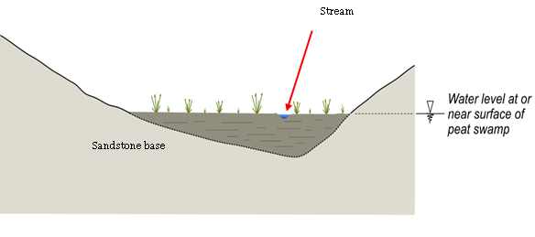
Figure 2.2 Illustration of key characteristics of a valley infill peat swamp.
Figure 2.3 is a photograph of this type of swamp in a tributary of Waratah Rivulet, west of Helensburgh on the Woronora Plateau. The extent of the swamp is evident in the base of the valley by the change in vegetation.
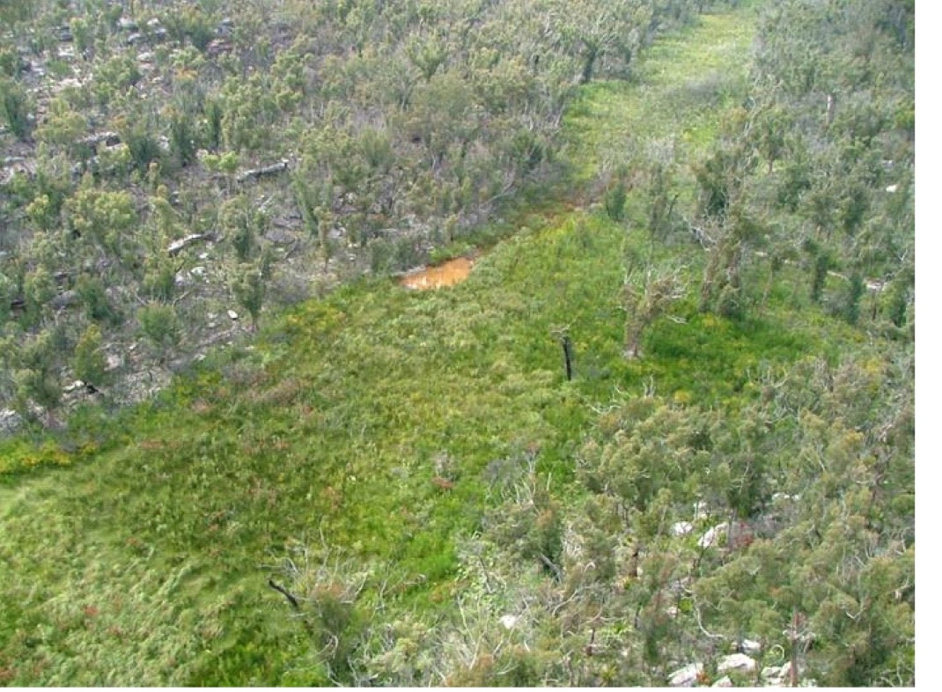
© Copyright, Ken Mills
Figure 2.3 A valley infill peat swamp in the Southern Coalfield.

Valley infill swamps on alluvium
Valley infill swamps on alluvium are similar to other types of valley infill swamp except that they occur on a substantial thickness of alluvial sediment rather than directly on sandstone rock strata (Figure 2.4). This means that the watertable within the swamp is integral with the groundwater system more generally rather than being perched on a sandstone base that may be largely independent of the surrounding watertable.
These swamps tend to be in areas where the talus or other erosion debris has substantially infilled a valley and allowed organic material to build up to form a swamp. Valley infill swamps generally have a low gradient, which means that they are typically saturated for extended periods following heavy rainfall. There may be a channel down the length of the swamp in periods of high flow, but in general flow occurs through the infill material rather than along a narrow, well-defined channel.
Figure 2.4 shows a schematic diagram that illustrates the key characteristics of valley infill swamps on alluvium. Long Swamp at the head of Coxs River is considered typical of this type of swamp (Figure 2.5).
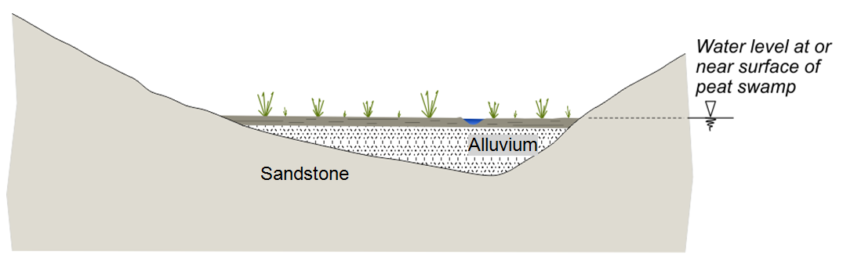
Figure 2.4 Key characteristics of a valley infill swamp on alluvium.

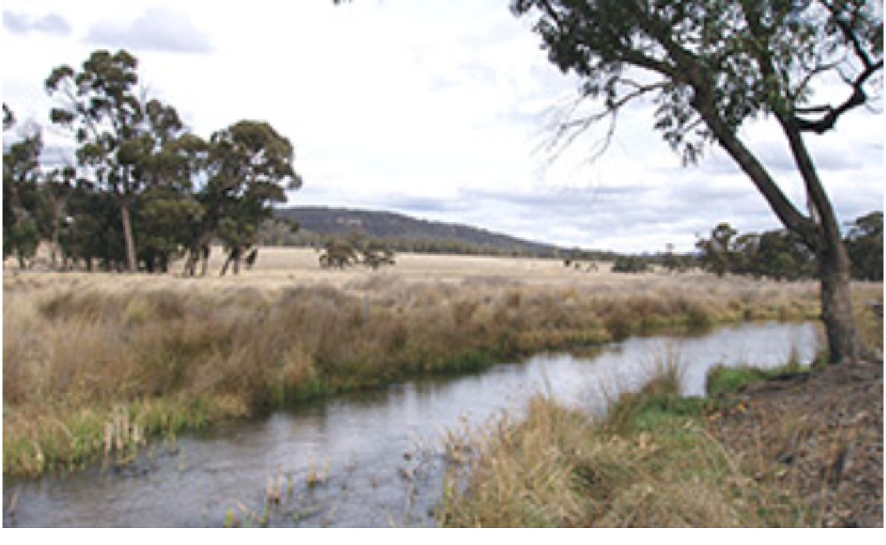
© Copyright, www.hn.cma.nsw.gov.au/topics/2094.html, 2013
Figure 2.5 Long Swamp—a valley infill swamp on alluvium—in the Western Coalfield.

Headwater swamps
Headwater swamps are typically located on a watercourse, similar to valley infill swamps. Because of their position high in the landscape and the relatively flat terrain on which they occur, groundwater connection is rare. The hydraulic gradient along the swamp is often influenced by a downstream barrier such as the lip of a waterfall or other sandstone rock structure. The thickness of peat material is generally less, and, as a result, the stream channel through the swamp typically flows along the sandstone base in a defined channel rather than on top of the peat, particularly at the downstream end of the swamp. The peat material and vegetation on either side of the channel has a high water content but is not typically fully saturated at all times. There are numerous examples of these types of swamps on Newnes Plateau and in the Southern Coalfield.
Figure 2.6 illustrates the key characteristics of headwater swamps and Figure 2.7 is an example of this type of swamp.

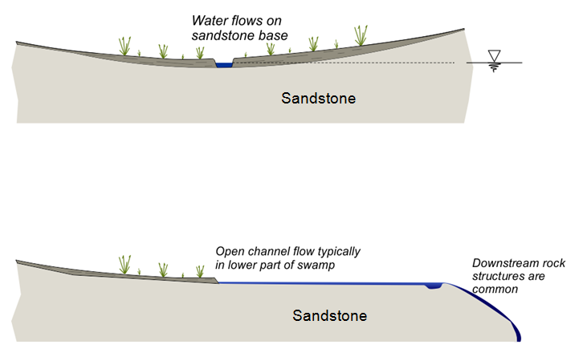
Figure 2.6 Key characteristics of headwater swamps.

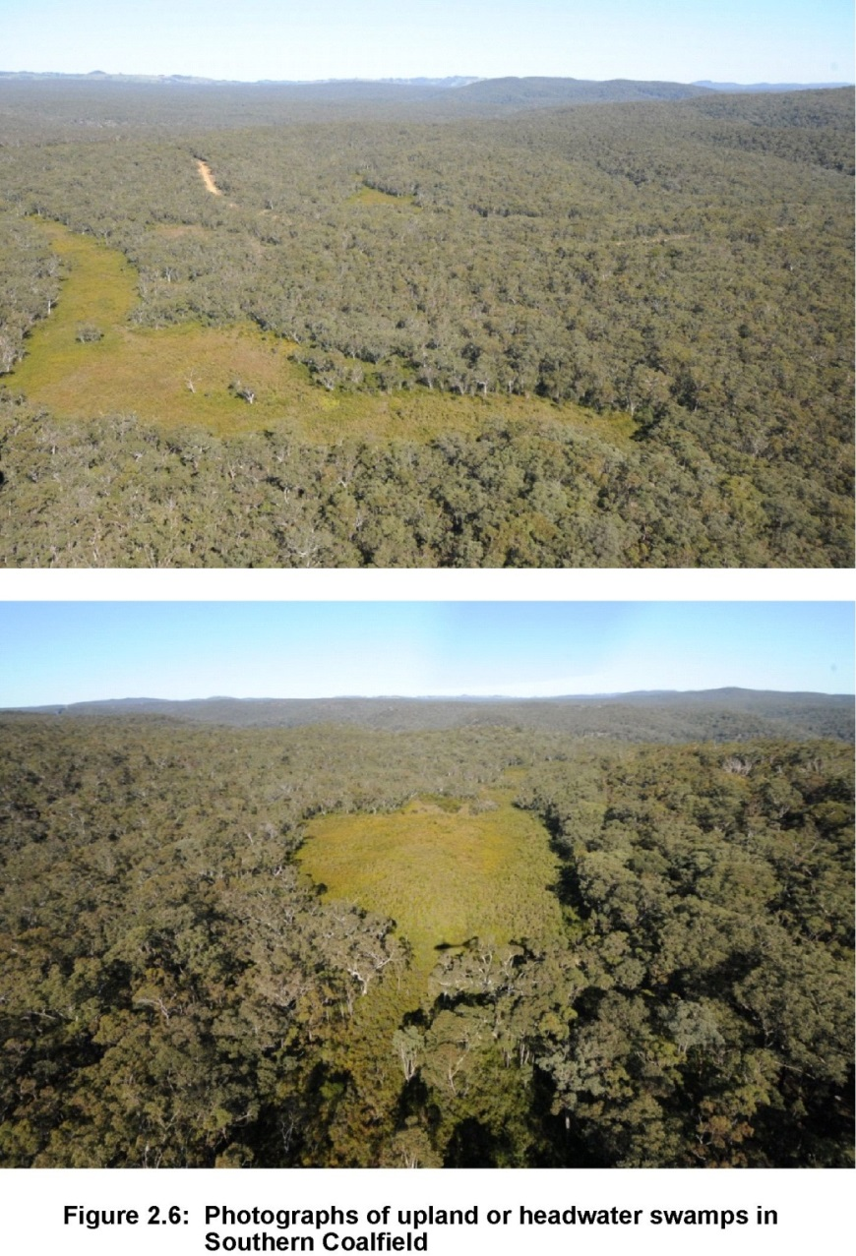
© Copyright, Ken Mills
Figure 2.7 Headwater swamps in the Southern Coalfield.

Hanging or valley side swamps
The term hanging swamp covers a spectrum of swamps that tend to occur on sloping ground rather than in valleys and also occur on steep valley sides as a series of rock tiers. They are not typically associated with specific stream channels and rarely have surface water (HNCMA 2013). Hanging swamps typically are underlain by sandstone with a sloping surface, even though the rock may be flatly dipping. The basal rock surfaces usually do not have substantial peat deposits, but have a relatively thin layer of soil or plant material covering the sandstone. The swamps rely for recharge on rainfall events and groundwater seepage, with large amounts of water held in the sandstone-derived soil and organic root matter of the plants. The soil structure tends to be unstable and loose, and to have low fertility (HNCMA 2013). The loose structure of the soil makes the swamps susceptible to erosion and fire. Plants that tend to dominate these types of swamps include tea-trees, sedges and grasses. In this type of swamp, bare rock may be exposed between isolated clumps of plant material.
Figure 2.8 shows a schematic diagram that illustrates the key characteristics of a hanging swamp and Figure 2.9 shows photographs of several of these types of swamps.

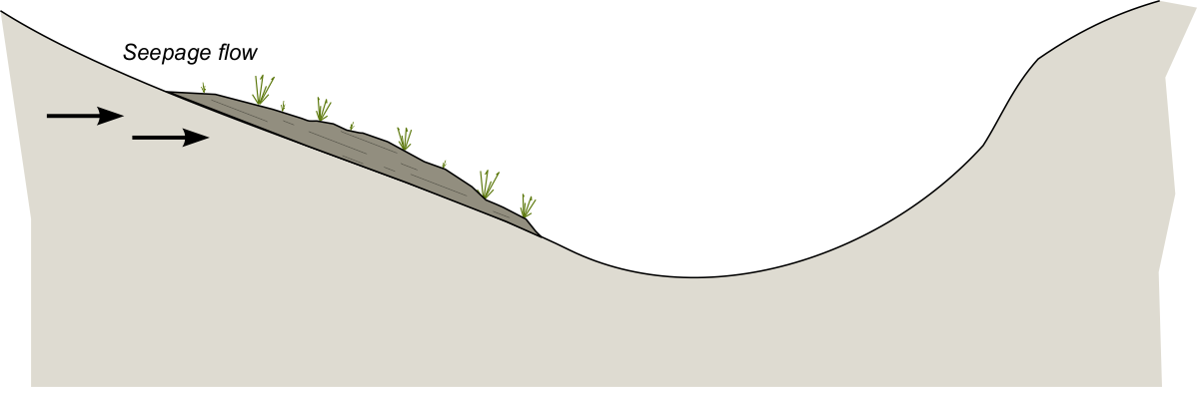
Sandstone
Figure 2.8 Key characteristics of a hanging or valley side swamp.
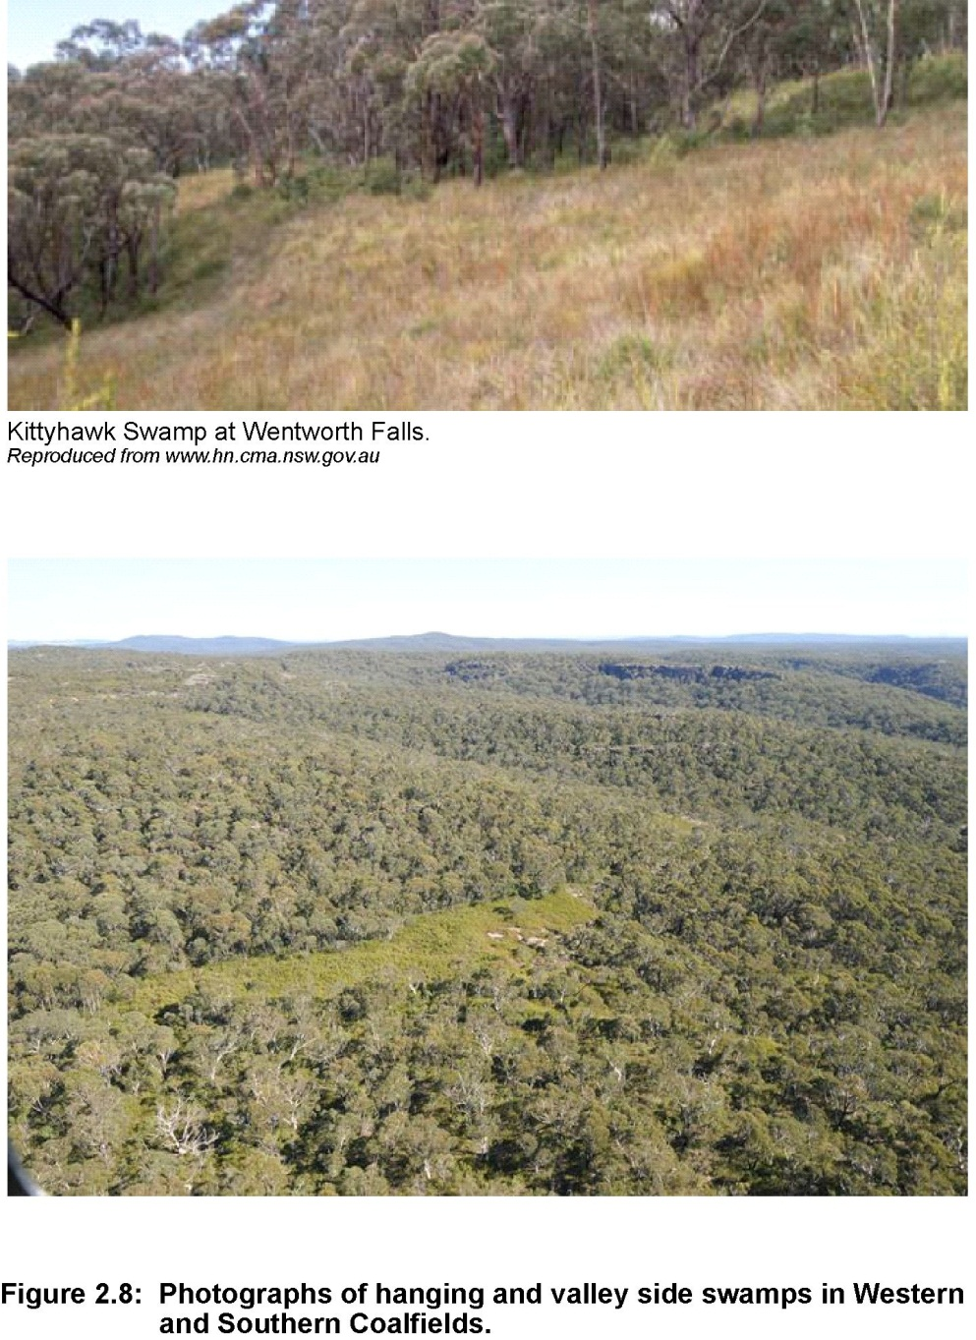
© Copyright, www.hn.cma.nsw.gov.au (top photo) and Ken Mills (bottom photo)
Figure 2.9 Hanging or valley side swamps in the Western and Southern coalfields.

Summary of key concepts
- Although there is a range of swamp types and some swamps have characteristics of more than one type, peat swamps can be categorised into three main types for subsidence impact assessment:
  - Valley infill swamps, which have formed from the accumulation of peat material in the base of valleys and are principally recharged from upstream stream flow. Two subtypes are differentiated based of their interaction with the broader groundwater system and sensitivity to horizontal subsidence movements
- Valley infill swamps on sandstone occur where peat material up to several metres thick has formed on a sandstone base and where the hydraulic gradient within the swamp is controlled by the gentle dip of the valley floor and the slow migration of water through the swamp. The water level in the swamp is not necessarily associated with a deeper groundwater regime.
- Valley infill swamps on alluvium occur where a layer of peat material has formed in a broad valley not directly on top of sandstone, but instead on sand, talus or other alluvial material. The watertable in the swamp is integral to the groundwater system in the surrounding terrain rather than perched above it on a sandstone rock base.
  - Headwater swamps occur where organic material has formed in the base of a broad valley but surface flow occurs in a channel on a sandstone base. These swamps often form upstream of a waterfall or other rock feature but may extend outward from the valley floor for a considerable distance. Their principal sources of recharge are rainfall and overland flow.
  - Hanging swamps or valley side swamps occur where sandstone is exposed at or near the surface and the swamp relies on the integrity of the underlying rock strata and a combination of rainfall and groundwater infiltration for recharge.
- THPSS ecological communities generally occur at altitudes between 600 and 1200 m.
- Peat swamps can be impacted by various factors, including inundation from water supply dams, weeds, feral animals, grazing and mining. Mining impacts can be due to subsidence and mine water discharges.

Geology
This section presents a general overview of the geological setting of the rock strata that forms the Southern and Western coalfields of New South Wales. The geological setting and general stratigraphy provide context to the relationship between the surface sandstone strata where the peat swamps occur and the economically significant coal seams that exist below them. The geological coincidence of significant coal resources directly below sandstone strata that promote the formation of peat swamps means that there is potential for interaction between the subsidence caused by mining and the swamps.
More detail of the geological setting of the region is provided in Moffitt (2000) and Yoo et al. (2001).
The Southern and Western coalfields of New South Wales are part of the Sydney Basin, which in turn forms the southern part of the larger Bowen – Gunnedah – Sydney Basin system, shown in Figure 3.1. The Sydney Basin is a broad sedimentary syncline that extends from Newcastle in the north to Batemans Bay in the south. Additional synclinal and anticlinal structures trending north-west occurred after the main structure formed (see Figure 3.2). In general, the strata dip up to 5 degrees, but dips of less than 2 degrees are typical. The predominant regional structure in the coalfield is the north–south trending Cumberland Basin Lapstone Structural Complex. The Lapstone Structural Complex incorporates the Nepean Fault Zone in the south and the Lapstone Monocline in the north.
Stratigraphically, the basin consists of Early Permian to Middle Triassic non-marine sediments, marine sediments and volcanics (Figure 3.3). These sediments include Permian coal measure strata and several economically significant coal seams that have been mined in the Basin, using a range of mining techniques, since soon after European settlement. Significant Triassic sandstone units, particularly Hawkesbury Sandstone in the Southern Coalfield and Banks Wall Sandstone in the Western Coalfield overlie the coal measure strata. These sandstone units dominate the landscape to the north, west and south of the Cumberland Basin as large sandstone plateaus, cliff formations, deeply incised valleys and gorges. The Triassic sandstone provides an environment where the various types of peat swamps described in Chapter 2 can form.
The coal measure strata, which includes the coal seams that have been mined, extends from an outcrop along the Illawarra Escarpment in the south to an outcrop at Newcastle in the north and to an outcrop near Lithgow in the west. These coal seams lie about 1000 m below central Sydney in the centre of the basin.
The Palaeozoic aged Lachlan Fold Belt bounds the western side of the Sydney Basin and is believed to underlie the basin sequence. The northern side of the basin is bounded by the Devonian to Carboniferous aged New England Fold Belt. These fold belts consist of areas where large deformations driven by tectonic forces resulted in highly folded, faulted and metamorphosed rocks.
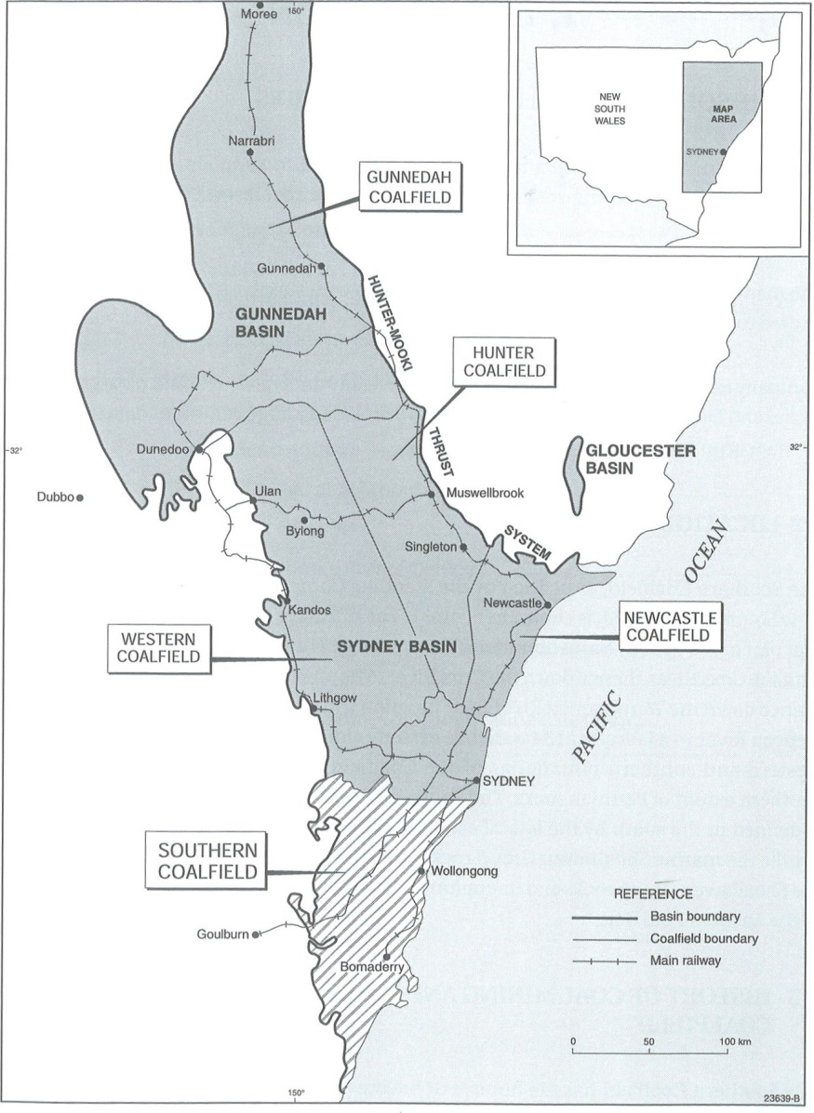
© Copyright, Moffitt 2000
Figure 3.1 Location of the Southern and Western coalfields in the Sydney Basin.

© Copyright, Moffitt 2000 after Scheibner & Basden 1986
Figure 3.2 Schematic structure map of the Sydney Basin.

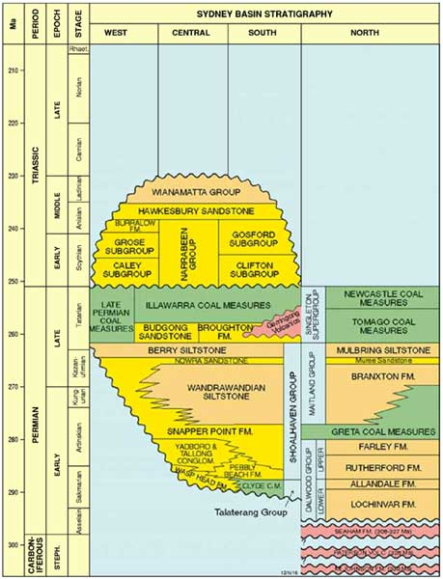
© Copyright, Geoscience Australia 2013: www.ga.gov.au/oceans/ea_ofs_sdny_Strat.jsp
Figure 3.3 Stratigraphy of the Sydney Basin.

Southern Coalfield
The general stratigraphy and depositional environment of the Southern Coalfield above the Shoalhaven Group comprises:
- Wianamatta Group—formed in a shallow marine to alluvial floodplain that is today exposed across much of the Cumberland Basin
- Hawkesbury Sandstone—formed in an alluvial environment, the outcrop of which dominates the sandstone formations around Sydney
- Narrabeen Group—formed in estuarine and alluvial environments, with lithic and quartzose sandstones, shales and mudstones
- Illawarra Coal Measures—formed in an alluvial plain and deltas, with the economic coal seams.
The current economic coal resources of the Southern Coalfield are located within the upper half of the Illawarra Coal Measures. These economic resources consist of four seams, which are shown in Table 3.1.
Table 3.1 Major coal seams of the Southern Coalfield.
Seam | Thickness (m) | Mining | Use | Interburden thickness
Bulli | 2–5 | Room-and-pillar and longwall mining | Thermal and coking | Typically now 350–550 m, but historically 30–500 m  Accessible resource to a depth of about 800 m
Balgownie | 1.5–2 | Limited mining in the past | Thermal and coking | 5–30 m below Bulli Seam
Wongawilli | 6–18 | Room-and-pillar and longwall mining | Thermal and coking | 30–50 m below Bulli Seam
Tongarra | ~3 | Limited mining in the past | Thermal | 70–80 m below Wongawilli Seam

Currently, the Bulli and Wongawilli seams are the most important economic seams. The Tongarra Seam is considered only economic south of Wollongong, where it was mined for power generation. The Balgownie Seam was only mined in small areas.
As shown on Figure 3.3, the coal seams are overlain by a number of sandstones, including Hawkesbury Sandstone. Hawkesbury Sandstone can be up to 250 m thick.
Conaghan (1980) divides Hawkesbury Sandstone into three main components:
- sheet sandstones—occur in boldly outcropping, cross-bedded, lenticular beds ranging in thickness from several centimetres to 5 m thick
- massive sandstones—finer grained, more shaley, more friable, less cemented and hence less conspicuous in outcrop than sheet sandstones. Beds are a maximum of 15–20 m thick
- mudstones (shales or laminites)—make up only about 5% by volume of Hawkesbury Sandstone. These non‐extensive lenses are typically less than 3 m thick and less than 100 m in lateral extent.
In assessing Hawkesbury Sandstone as a base rock for peat swamps, Davey, Glamore and Smith (CoA 2014b) indicate that the following characteristics should be borne in mind:
- Hawkesbury Sandstone is made up of near-horizontal layers, typically 3 to 5 m thick, which differ in their degree of strength and permeability.
- Near‐vertical, horizontally persistent joints exist, which allow rainwater to infiltrate and groundwater to circulate within sandstone rock masses. These joints are typically 3 to 10 m apart (i.e. somewhat further apart than the bedding planes).
- Residual soils on top of Hawkesbury Sandstone tend to be thin, generally 1 m or less, and extensive areas of bare rock occur close to cliff crests and along creek beds.

Western Coalfield
Yoo et al. (2001) present a summary of the geology of the Western Coalfield, which forms the basis of this section.
The Western Coalfield changes in stratigraphy from north to south, with the south being similar to the neighbouring Southern Coalfield. The units generally outcrop on the western side of the coalfield and dip to the east. Seams dip at 1 degree to 2 degrees in an easterly direction, except along the margin of the coalfield where dips can reach 10 degrees. A strong correlation exists between the surface of the basement rocks (palaeotopography) and seam thickness, dip angle and direction, and coal quality. Dominant structures are broadly north-south–trending regional-scale monoclines, and include the Lapstone Structural Complex and the Mount Tomah Monocline.
These monocline structures have associated large subparallel faults with throws of up to 200 m. There are also small-scale faults with throws of 5 m, which trend north-south. These structures generally have a localised effect. The types of faults in the Western Coalfield consist of strike slip, high-angle reverse and normal.
Some Jurassic to mid-Tertiary igneous intrusions are present in the centre and north-east of the coalfield.
The thickness of overburden strata above the coal resources increases to the east, ranging from outcrop up to about 400 m in current mining areas near Lithgow, and increasing up to about 500 m near the boundary with Wollemi National Park. The coal-bearing sequence of the Western Coalfield lies within the Illawarra Coal Measures, overlying the Shoalhaven Group. The Narrabeen Group overlies the coal measures. Because of the large extent of the Western Coalfield, correlation between the north and south parts is difficult because few data are available for these areas.
The general stratigraphy and depositional environment of the Western Coalfield includes:
- Narrabeen Group—formed in an estuarine and alluvial plain that includes Banks Wall Sandstone
- Illawarra Coal Measures—formed in an alluvial plain and deltas, with economic coal seams.
The economic coal reserves of the Western Coalfield are located within the upper half of the Illawarra Coal Measures. These economic reserves consist of several seams, as shown in Table 3.2.
Table 3.2 Major coal seams of the Western Coalfield.
Seam | Thickness  (m) | Mining | Use | Overburden depth (m)
Katoomba | 0–6 | Yes | Thermal | 0–350
Middle River | 15–22 | Not mined | Thermal | NA
Moolarben | 1–3 | Not mined | NA | NA
Irondale | 1–2 | Yes | Coking | NA
Ulan | 14 | Yes | Thermal | 0–350
Lidsdale | 2 | Yes | Thermal | NA
Lithgow | 1–7 | Yes | Thermal | 0–450
NA = not available

Banks Wall Sandstone is one of the major sandstones in the Western Coalfield. Davey, Glamore and Smith (CoA 2014b) provide the following comments on Banks Wall Sandstone, drawing on Goldbery (1969) and Bembrick (1980) as primary references:
- Banks Wall Sandstone is the main cliff‐forming sandstone in the western Blue Mountains. It is up to 115 m thick. In cliff faces its most distinctive feature is the presence of thin but persistent, widely spaced red–brown claystone units, which host colonies of mossy groundwater‐dependent ecosystems.
- In roadside exposures, Banks Wall Sandstone exhibits many discontinuous crust-like ironstone bands, which stand out from the more easily eroded bulk of the sandstone. Nevertheless, many exposures are well cemented and similar to Hawkesbury Sandstone.
- Banks Wall Sandstone is weaker, more friable and much more easily eroded by running water than Hawkesbury Sandstone. In general, it is also likely to be more permeable than Hawkesbury Sandstone, although there are no direct data to support this.
- Banks Wall Sandstone has a tendency to weather by dissolution and surface erosion into silicate karst landforms, known as pagoda weathering. This distinctive landscape is widespread above mining leases north of Lithgow and is a major feature in the Gardens of Stone National Park.

Summary of key concepts
- The Southern and Western coalfields of NSW are part of the Sydney Basin, which extends from south of Batemans Bay to north of Newcastle and north-west to Narrabri.
- The rocks consist of Early Permian to Middle Triassic non-marine sediments, marine sediments and volcanics that dip at generally less than 2 to 10 degrees.
- Several economically significant Permian coal seams are present in the Illawarra Coal Measures in both coalfields. The seams can be up to 22 m thick, but most are 2 to 5 m thick.
- Coal has been mining since soon after European settlement, using a variety of methods.
- Hawkesbury Sandstone overlies the coal seams in the Southern Coalfield and Banks Wall Sandstone overlies the coal seams in the Western Coalfield. These sandstone units dominate the landscape as plateaus, cliff formations, deeply incised valleys and gorges.
- Hawkesbury Sandstone can be up to 250 m thick. It consists of zones of sheet sandstones from several centimetres to 5 m thick, massive sandstones that are less well cemented and up to 15 to 20 m thick, and shale or laminites that are typically less than 3 m thick.
- Banks Wall Sandstone can be up to 115 m thick. In cliff faces its most distinctive feature is the presence of thin but persistent, widely spaced claystone units. Banks Wall Sandstone has a tendency to weather into silicate karst landforms, known as pagoda weathering.
- Temperate peat swamps form predominately on Hawkesbury Sandstone and Banks Wall Sandstone.

Longwall mining
In this section, longwall mining is discussed as a basis for understanding the changes to the overburden strata caused by longwall mining. The similarities between longwall mining and room-and-pillar extraction mining are also discussed. Room-and-pillar extraction has been practiced for over a century in Australia and as some of these room-and-pillar extraction areas are located below peat swamps, they present the opportunity to extend the time over which subsidence impacts on peat swamps can be studied.

Background
Longwall mining started in the United Kingdom in about 1690, using manual methods. Mechanised longwall mining started in Germany during World War II and was introduced into the Unites States in the early 1950s. This method started in Australia in 1963 at Coal Cliff Colliery but was not used for long because of various problems. Extensive use of longwall mining was delayed until the 1970s when longwall shields were introduced (Kininmonth & Baafi 2009).
Modern longwalls in Australia use the retreat method, whereby a longwall panel, typically about 250 m wide, but anywhere between 50 and 400 m wide depending on the equipment used, is formed by developing two sets of underground roadways the full length of a rectangular-shaped panel. Coal is extracted between the two sets of development roadways as the longwall panel retreats back toward the main headings (see Figure 4.3). The development roadway next to the longwall panel on each side of the panel being mined is abandoned behind the retreating longwall face.
An advancing longwall is different in that the headings are mined as the longwall face advances away from main headings toward the far extent of the panel. In an advancing longwall, the headings need to be heavily supported as they pass through caved material. Advancing longwall mining is not used in Australia.
Room-and-pillar extraction is another mining technique that has been used to mine coal in all New South Wales coalfields since at least the beginning of the 20th century. It is a more irregular process that varies to suit particular mining environments, but the overall geometry of the panel is not usually fundamentally different to that of a longwall panel. Initially, a panel of stable pillars is formed by developing a grid or other arrangement of roadways. Subsequently, the coal pillars are mined, usually as the panel is retreated back toward the main headings. There is typically no subsidence during the development phase of the panel, but pillar extraction routinely generates surface subsidence of a magnitude that is similar to, but usually less regular than, longwall operations. The long history of subsidence induced by room-and-pillar mining means that there is potentially an extended time over which to assess the long-term effects of mining subsidence on peat swamps.

Longwall mining process
In a longwall operation, coal is removed from the longwall face by a longwall shearer. The longwall shearer cuts coal from the coal face one shear (cut) at a time as it traverses the width of the longwall face. The roof immediately above the coal face is supported by a series of hydraulic roof supports (shields), which temporarily hold up the roof strata and provide a secure working space at the coal face. The coal is then transported by an armoured face conveyor located behind and beneath the longwall shearer. As the coal is cut and removed after each shear of the coal face, the shields are stepped forward one at a time so that the coal face progresses incrementally across the width of the face and the coal face retreats one shear at a time down the panel. The area where the coal has been mined and the roof strata has collapsed behind the longwall face is called the goaf.
The configuration of a typical longwall face is shown in Figure 4.1, with a close up of the shearer and the roof supports in upper part of the figure.
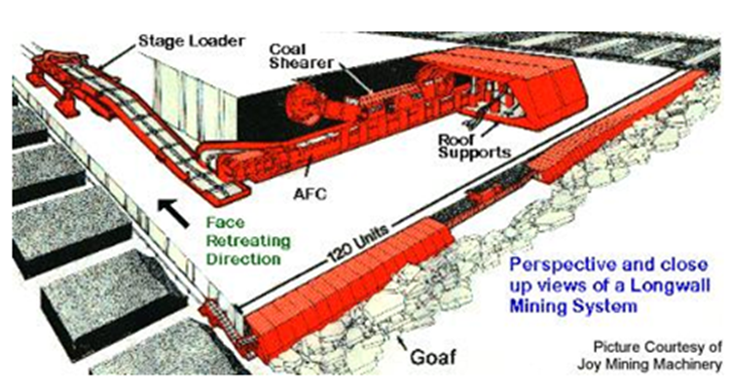
AFC = armoured face conveyor
© Copyright, Joy Mining Machinery
Figure 4.1 Perspective and close-up view of a longwall mining system.
Figure 4.2 shows a photograph of the longwall shearer cutting coal on the face. The longwall supports or shields that temporarily support the roof strata above the face can also be seen. The shields are typically 1.2–2 m wide and 6–8 m from the tip to the back of the shield. The top canopy of the shield is pushed against the roof by large hydraulic rams, typically two per shield, that are capable of generating a canopy load on each shield of about 1000 tonnes. Shields are moved forward individually by depressurising the large hydraulic rams and sliding the shield forward relative to the adjacent shields using separate hydraulic rams located horizontally on the floor. The large rams are then reset and the process repeated for the next adjacent shield.

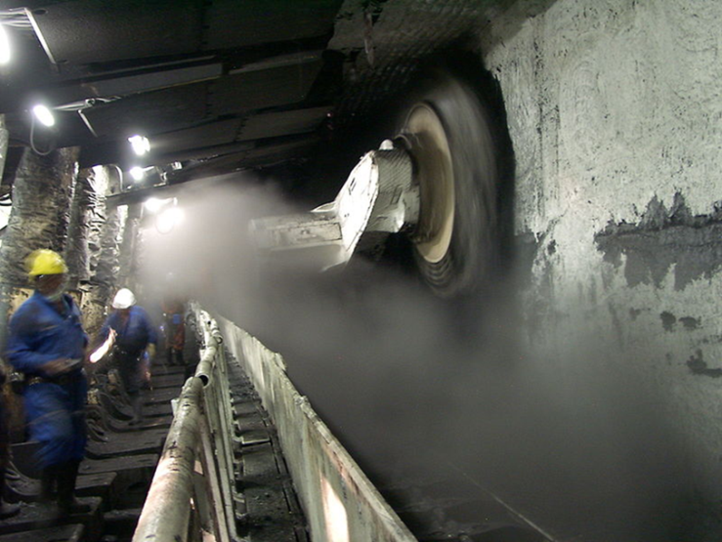
© Copyright, Eickhoff Engine Works and Iron Foundry, Bochum
Figure 4.2 Shearer on a longwall face.
Figure 4.3 shows the general layout of a typical longwall panel. The development headings used to define the block in a retreating longwall are called gateroads. These roads are typically formed as a pair of headings for ventilation and are joined together by cut-throughs about every 100 m, giving them the appearance in plan view of a chain. The pillars that separate the two roadways are thus called chain pillars. During longwall mining, the gateroad that is used to routinely access the longwall face is usually on the unmined side of the panel and is called the maingate. The gateroad on the other side of the panel next to the previously mined panel is called the tailgate.

Figure 4.3 General layout of a typical longwall panel.

Summary of key concepts
- Longwall mining started in about 1690, using manual methods.
- Mechanised longwall mining started in Germany during World War II and became more common in Australia in the 1970s.
- In mechanised longwall mining the coal is cut by a shearer and shields support the roof in the area being mined. This area is known as the ‘face’.
- Modern longwall panels are typically about 250 m wide, but range from less than 100 m up to about 400 m.
- Longwall mining in Australia uses the ‘retreat’ method of mining. The block to be mined is defined by building access roadways on each side of the longwall panel to be mined, for the length of the panel. The panel is extracted by retreating back towards the main headings.
- As the longwall face retreats, the rock in the area where the coal has been mined is allowed to collapse.

Surface subsidence
This section presents an overview of subsidence behaviour as measured around longwall panels. The first part focuses on vertical subsidence and the conventional subsidence parameters of tilt, strain curvature. The second part focuses on horizontal movements and the mechanics of the processes that cause these movements.

Introduction
Longwall mining causes disturbance to the overburden strata as the strata subsides downward into the void created at the mining horizon. Subsidence and caving of the materials above and in the immediate vicinity of the longwall panel can result in disturbance to peat swamps through modification of the ground surface and fracturing of the underlying rock, thereby allowing the peat swamp to drain. The ground movements that occur at the surface as subsidence have been observed for a wide range of overburden depths and panel geometries over the decades that subsidence has been monitored. These observations provide a base from which to study movements—surface movements and ground movements within the overburden strata, using combined measurements from different overburden depths.
The capability and opportunity to measure and observe ground movements and their various impacts has increased significantly in recent years through industry and government support for research and commercial projects.

Subsidence parameters
A range of subsidence parameters have been developed to characterise subsidence–related ground movements (see Figure 5.1). Subsidence parameters are determined by repeated field measurement of lines of survey points located above the area to be mined. The survey points are established before mining starts and are resurveyed as mining continues, to monitor the ground movements that develop.

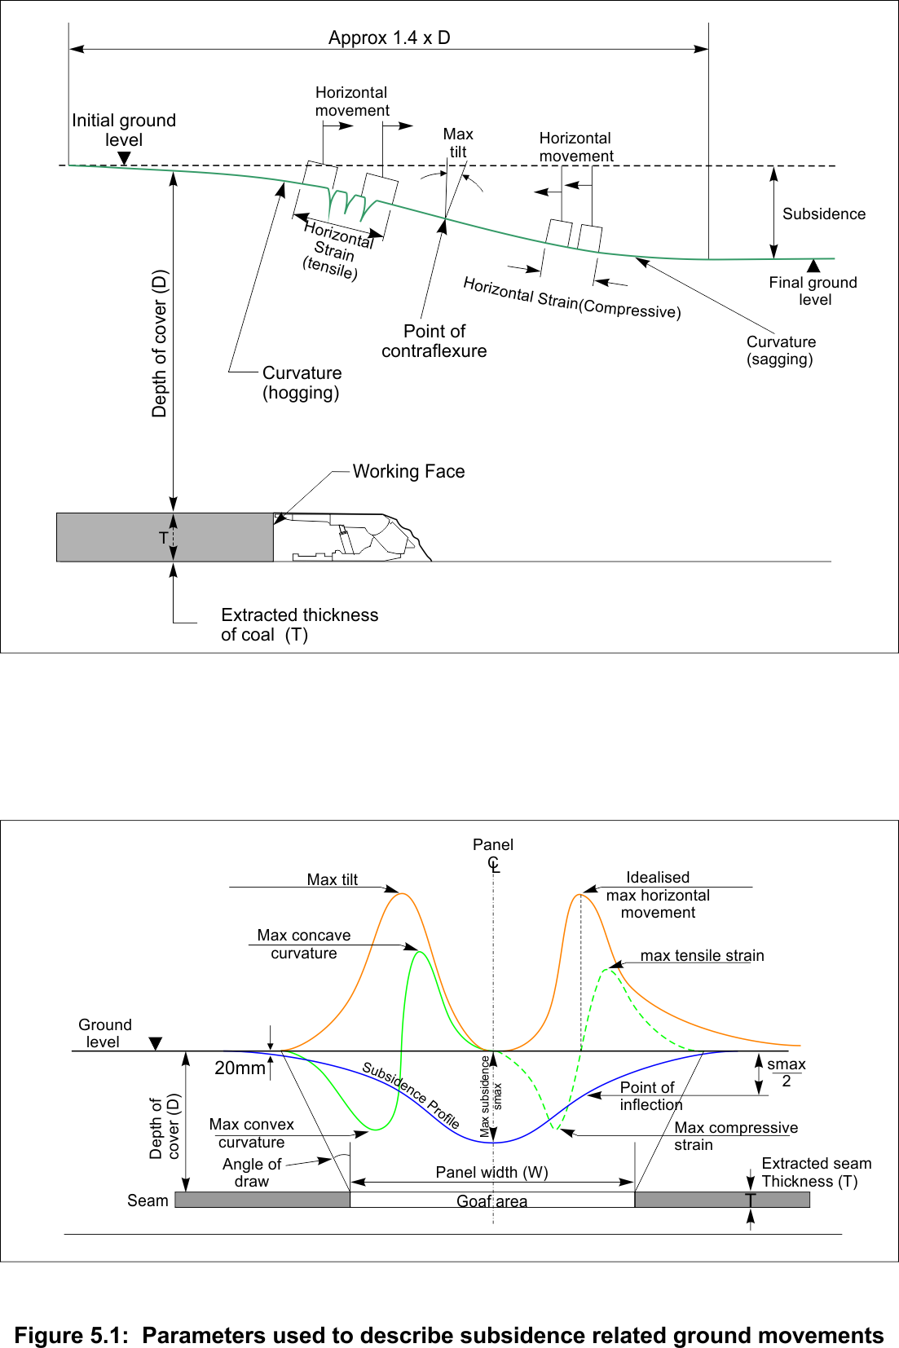
a. Overall subsidence profile
b. Close up of one end of subsidence profile
Modified from MSEC 2007
Figure 5.1 Parameters used to describe subsidence-related ground movement.
Subsidence, tilt, curvature and horizontal strain are the subsidence parameters normally used to describe the magnitude of surface movements. Angle of draw defines the practical limit of vertical subsidence at 20 mm. Goaf edge subsidence is a parameter that helps define the magnitude of subsidence at the limits of extraction. These parameters generally form the basis for the assessment of surface impacts to inform strategies for managing subsidence impacts.
In recent years, the ability to measure subsidence movements in three dimensions has allowed horizontal movements to be measured and resolved into either north and east components or cross-panel and long-panel components, as well as loci of horizontal movement.
Parameters such as valley closure and upsidence have emerged in the quantification of impacts of subsidence on natural features such as river channels and peat swamps. However, the characterisation of horizontal movements and the development of suitable parameters for horizontal movements are not as well developed as for vertical subsidence.

Subsidence
Subsidence usually refers to the vertical component of subsidence movements, but can also be used as a general term to describe both horizontal and vertical movements. Subsidence is determined by subtracting the current elevation of a survey point from the pre-mining elevation of that same point. It is usually expressed in millimetres and as positive downwards (see Figure 5.1a).
Subsidence = original level – new level

Tilt
Tilt is the first derivative of the vertical subsidence profile, or the rate of change of vertical subsidence. It is calculated as the change in vertical subsidence between two points divided by the horizontal distance between those two points. The sign of tilt is not important but, by convention, positive tilt occurs when the subsidence is increasing in the direction of measurement. Tilt is usually expressed in millimetres per metre. It is shown in Figure 5.1.
Tilt = (subsidence of nth peg – subsidence of (n + 1)th peg) / original horizontal distance between the pegs
Since the tilt is determined over a base length, the standard peg spacing of 1/20th the depth means that tilts at shallow depth are determined over a shorter interval than tilts at greater depth.
Maximum tilt or the steepest portion of the subsidence profile occurs at the point of inflection in the subsidence profile, which typically occurs at a point where subsidence is approximately equal to one half of the maximum subsidence.

Curvature
Curvature is the second derivative of subsidence, or the rate of change of tilt. It is calculated as the change in tilt between two adjacent sections of the tilt profile divided by the average length of those sections. Curvature is usually expressed in units of km⁻¹, but can also be expressed in inverse form as the radius of curvature, usually expressed in kilometres.
Radius of curvature = (sum of the lengths of successive bays) / (2 × differential tilt between them).
Curvature is convex or ‘hogging’ over the goaf edges and concave or ‘sagging’ toward the bottom of the subsidence trough. Convex curvature is usually expressed as positive.

Horizontal movements
Horizontal movements are typically determined and reported as two components in a north–south, east–west coordinate system, usually in millimetres. It is often convenient for interpretation purposes to report them as cross-panel and long-panel movements when the orientation of the longwall panels does not align with the cardinal points of the compass.
As well as reporting and plotting horizontal movements purely as magnitudes, there are significant benefits in presenting the development of horizontal movements in plan view as a locus (trace or path) followed by individual points on the surface.
The same style of presentation can be used in combination with vertical subsidence to give cross-sections and long sections of the movement paths. These are particularly helpful for identifying causal mechanisms and locating initiating subsidence events.
Surface topography has been found to have a strong influence on the magnitude and direction of horizontal movements (Mills 2001; Seedsman & Watson 2001).

Horizontal strains
Strain is the first derivative of horizontal movement, or the rate of change of horizontal movement. It is calculated as the change in horizontal length of a section of the subsidence profile divided by the initial horizontal length of that section and is usually expressed in units of millimetres per metre. Figure 5.1.b shows an example of horizontal strain.
Strain = (new horizontal distance – original horizontal distance) / (original horizontal distance between the pegs)
Tensile strains are associated with stretching of the ground surface. By convention, tensile strains are positive. They tend to occur near the edges of a panel in flat terrain and on topographic highs. Compressive or negative strains tend to occur in the centre of a panel in flat terrain or in topographic lows.
The concept of horizontal strain was much simpler to understand when strain was measured by peg-to-peg survey technique because there was no awareness of horizontal movements that occur in a direction other than along the subsidence line. Because out-of-plane horizontal movements may be much larger than the strains measured along the subsidence line, depending on the orientation of the subsidence line relative to surface topography, horizontal strains measured along the subsidence line may not necessarily be a good representation of the actual maximum strain that has occurred.
By convention, horizontal strain is presented as the strain measured along the subsidence line, but there are grounds to present horizontal strains in other directions as well, particularly in the context of determining maximum strain and its direction. The presentation of loci of horizontal movement provides a more intuitive approach for presenting these data but has yet to be widely adopted.

Angle of draw
An angle of draw is used to define the practical limit of vertical subsidence outside a mining area (see Figure 5.1). The angle of draw is defined as the angle between the vertical and an imaginary line joining the goaf edge with a point on the surface where the vertical subsidence becomes less than some value, typically 20 mm. A value of 20 mm is usually adopted as the limit of vertical subsidence (see note 1 at the end of the chapter) because this approaches the practical limit of routine survey accuracy and a point where fluctuations in ground level caused by natural processes such as seasonal moisture variation become larger than the subsidence movements.
Angle of draw is often determined through measurement as a site-specific parameter. However, angles of draw of 26.5 degrees and 35 degrees are usually used by regulatory authorities to define the practical extent of vertical subsidence mining applications. These angles correspond to distances on the surface from the goaf edge of 0.5 and 0.7 times depth, respectively. In general, it is simpler to determine protection offsets based on half-depth (or 0.7 times depth) because these distances can be defined with a higher degree of confidence than angle of draw. Angle of draw is a measured parameter that is sensitive to low-level survey tolerance and for a range of practical reasons is difficult to measure. The concept of half-depth as the practical limit of subsidence is much easier to define and is not subject to change.
Angle of draw is defined in relation to vertical subsidence. Subsidence impacts resulting from horizontal movements may occur beyond the limit of vertical subsidence. Structures and surface features that are sensitive to horizontal subsidence movements may not be protected purely by limiting vertical subsidence to low levels. These features require specific assessment. (See note 2 at the end of the chapter).

Historical development
Understanding of subsidence behaviour has developed hand in hand with the capabilities of systems available to measure subsidence movements and to differentiate the key subsurface caving processes (discussed in Chapters 6 and 7).

Overview
Subsidence monitoring and the development of subsidence engineering began in Europe in the early 1800s (Whittaker & Reddish 1989). Much of the understanding of subsidence developed in Europe up to the 1970s was imported into Australia. In particular, many of the techniques and conventions used in the United Kingdom have found their way to Australia. However, routine monitoring of surface subsidence above longwall panels in Australia has led to the development of a database that has allowed significant differences in subsidence behaviour to be identified and subsidence behaviour to be better understood in the specific geological conditions that exist in Australia.
Research into subsidence engineering in New South Wales (NSW) has been in progress since the late 1960s and was undertaken initially by the then Department of Mineral Resources (DMR), colliery operators and some research organisations on behalf of colliery operators.
Up until 1978, research by the DMR was mainly confined to data collection and was supervised only on a part-time basis by a Special Duties Inspector of Collieries, who also had other inspectorial responsibilities. As a result of recommendations made by Justice Reynolds (Reynolds 1977), a subsidence engineer was appointed by the DMR in 1978. A second subsidence engineer was appointed in 1981 to share the increasing workload.
The subsidence engineering section was further strengthened in 1988 by the appointment of a Principal Subsidence Engineer entrusted with the responsibility of managing subsidence issues in NSW. While the position of Principal Subsidence Engineer has been maintained, the resources available within the DMR to support research activities have fluctuated over the last decade or so.
Since the mid-1990s, a worldwide reduction in funding for government research organisations has driven the trend for subsidence-related research to be undertaken by specialist groups within small research and consulting firms and some universities. This research has been supported by the coal industry and the increased volume of commercial work associated with the need to comply with legislative requirements and address specific issues.
The proceedings of the Mine Subsidence Technological Society (MSTS) triennial conferences provide a record of the developments in subsidence engineering in NSW since the first conference was held in 1988. Issues such as the effects of subsidence on buildings, public utility infrastructure, cliff lines and mining under foreshores are discussed in the early conferences of this series. By about 1997, there was an increasing focus on the impacts of mining on river channels. By 2001, the effects of horizontal movements became widely recognised and, by 2004, there was a stronger focus on managing surface subsidence impacts and revisiting the impacts of mining on subsurface behaviour. The management of subsidence impacts, effects of multiseam mining and risks associated with legacy mining continue to be as relevant today as they were when the MSTS was formed (Kinnimonth & Baafi 2009).

Monitoring techniques
In Australia, early techniques to monitor subsidence involved measuring vertical subsidence on an array of subsidence monitoring points arranged at intervals along a line. By convention, an interval of approximately 1/20th of overburden depth was adopted as a practical standard. These monitoring points allow measurement of vertical subsidence relative to a benchmark located beyond the zone of influence of mining subsidence.
Although vertical subsidence is the source of subsidence-related movements, other subsidence parameters such as tilt, curvature and strain are more useful for predicting and assessing subsidence-related impacts, particularly in relation to man-made infrastructures such as buildings and roads. Tilt is a measure of the rate of change of vertical subsidence. Curvature is a measure of the rate of change of tilt. Both parameters can be derived from measurements of vertical subsidence, provided subsidence monitoring points are arranged at intervals in an approximately straight line in a direction that is likely to yield the maximum values being measured.
The measurement of horizontal strain requires a different approach. The approach that has been historically adopted involves the repeated chaining (measurement using a surveyor’s chain) of distance between adjacent pegs before and after mining, and sometimes as mining proceeds. The changes in distance between adjacent pegs resolved onto the horizontal are expressed as a proportion of the original horizontal distance between the pegs. By installing the subsidence monitoring points a short distance above the ground so that the distance between them can be measured, horizontal strain can be determined relatively easily, particularly in flat terrain.
The practice of measuring horizontal strains by peg-to-peg chaining has had some unintended consequences that have limited the development of understanding of subsidence movements, particularly in relations to horizontal subsidence movements. Two assumptions implicit in the technique are not immediately obvious. The first is that the end peg on the subsidence line remains stationary; the second is that all the horizontal movements of interest occur in the direction of the survey line.
The assumption that the end peg remained stationary appeared reasonable on the basis that vertical subsidence at the end of the line is typically small, by design of the line, and the horizontal strains are also small. It was not until the development of routine three-dimensional subsidence techniques used for monitoring cliff lines (Kay 1990) and the results of precise survey work in the Southern Coalfield reported by Reid (1995, 1998) that it became apparent that horizontal movements routinely occur for significant distances outside the mining area and in directions not related to the geometry of the longwall panels.
Studies in the Western Coalfield, particularly at Baal Bone Colliery (Mills 2001), investigated the characteristics of horizontal movements and some of the causal factors. Three-dimensional surveying allows horizontal movements to be measured in directions other than in the direction of the subsidence line. The significant effects of surface topography on horizontal movements can then be recognised and more directly related to phenomena such as valley closure impacts on river channels and cliff line impacts. Through the gradual adoption of three-dimensional monitoring for routine subsidence in the Southern Coalfield over the last decade, the influence of horizontal stress-related movements has become more apparent and the significant influence of surface topography on horizontal movements recognised.
The availability of the global positioning system (GPS) is improving the ability to detect horizontal movements remote from mining areas without incurring the cumulative survey errors that traditionally affected the ability to maintain remote control points. In the next decade or so, it is likely that techniques such as satellite-based laser interferometry will allow not only better resolution of horizontal movements but measurement of these movements over whole coalfields in one pass.

Components of vertical subsidence
Vertical subsidence is the most easily measured of all the subsidence components and typically the largest. Monitoring surface subsidence has shown that vertical subsidence in single seam longwall operations is comprised of two essentially different components, and that two other components occur in special circumstances (Mills 1998).
The main components are:
- sag subsidence over each individual panel
- elastic strata compression of the chain pillars and the strata above and below.
The less commonly observed components are:
- failure of pillar systems, including failure of the immediate roof or floor strata
- topography-related dilatational effects that cause upsidence and uplift.
Sag subsidence and strata compression subsidence combine in various proportions, depending primarily on panel width and overburden depth but also on overburden composition and in situ stress levels, to give what is observed on the surface as systematic subsidence behaviour.
The essential differences between the main two components have not been widely recognised in the subsidence literature. Although not critical to empirical predictions, the differentiation allows a more cohesive understanding of subsidence behaviour and the processes that cause subsidence. For instance, subsidence results have been interpreted as indicating different subsidence behaviour in different coalfields of NSW. However, it is now recognised that the two components of sag subsidence and pillar compression subsidence are essentially similar in all coalfields. The different proportions of each component and the minor variations that occur with different geological conditions are responsible for the different subsidence behaviour observed in different coalfields.
Other non-systematic or unconventional effects that impact on the final subsidence profile involve the interaction of subsidence movements, with surface topography causing effects such as valley closure and upsidence, and the interaction with subsurface geological features causing various types of anomalous subsidence behaviour. These issues are discussed separately later in this section in the context of horizontal movements.
Figure 5.2 shows the generalised shape of subsidence above a series of longwall panels for three different overburden depths. The longwall panels are otherwise of similar geometry. The magnitude of the vertical subsidence is greatly exaggerated to illustrate the different behaviours observed.
When the width of individual longwall panels is much less than the overburden depth to the mining horizon, as shown in Figure 5.2a, the surface subsidence profile tends to be gentle, develops gradually and extends across multiple panels without any single panel being apparent in the profile. This behaviour is typical of longwall panels that are less than 150 to 200m wide at 500 m overburden depth, such as most pillar extraction panels and many of the early longwall panels mined in the Southern Coalfield.
When the width of individual longwall panels approaches the overburden depth, as shown in Figure 5.2b, the subsidence profile begins to reflect the position of individual longwall panels, but the overall profile is still substantially a function of the combined width of all the panels. This behaviour is typical of sites in the Western Coalfield where the overburden depth is in the range 300–350 m and in areas of the Southern Coalfield where the longwall panel widths are more than one-third the overburden depth.
When the width of individual longwall panels is much greater than overburden depth, as shown in Figure 5.2c, full subsidence develops in the central part of each longwall panel and there are very low levels of subsidence above the chain pillars. This behaviour is typical of many sites in the Hunter and Western coalfields where the overburden depth is less than about 200 m.
The reasons for this widely varied subsidence behaviour becomes apparent when the two main components of subsidence—sag and elastic compression subsidence—are considered separately.

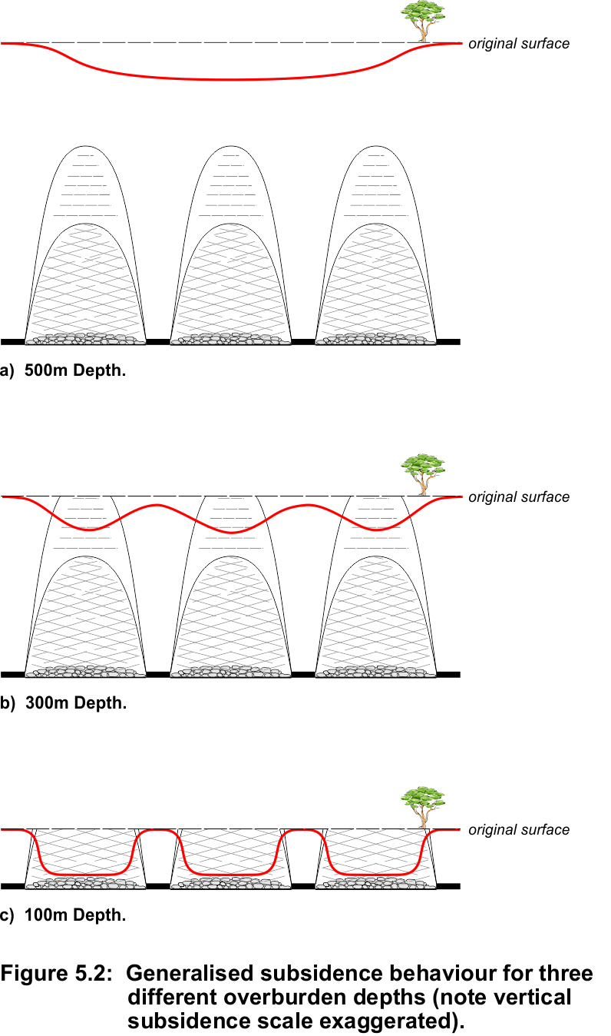
Figure 5.2 Generalised subsidence behaviour for three different overburden depths (note vertical subsidence scale exaggerated).

Sag subsidence
Sag subsidence occurs as downward movement of the overburden strata over the void created by each individual longwall panel when the overburden strata is no longer able to bridge across the panel.
In this report, the term ‘trough subsidence’ refers to the lowering of the ground surface over multiple longwall panels due to the combined effects of pillar compression and sag subsidence, while the term ‘sag subsidence’ refers to downward movements over single panels. The general form of the relationship observed between maximum subsidence divided by seam thickness and panel width divided by overburden depth is shown in Figure 5.3. This presentation was used by the National Coal Board in the United Kingdom and has been used to represent subsidence behaviour in Australia for many years, although it is common for surface subsidence above multiple panels (i.e. trough subsidence) to be plotted against the width to depth ratio for single panels. Unfortunately this presentation tends to obscure the mechanics of ground movements above a single panel.
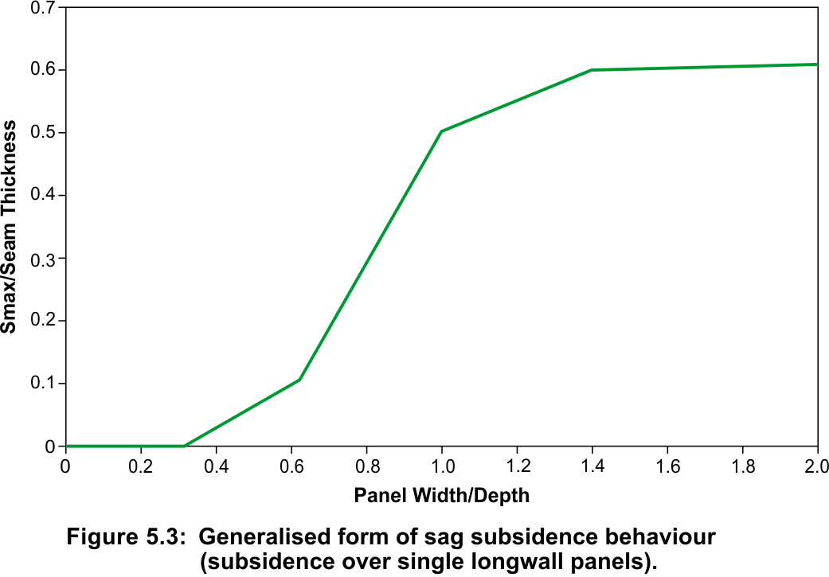
Figure 5.3 Generalised form of sag subsidence behaviour over a single longwall panel.
Figure 5.3 shows that panels that are narrow relative to the depth to the mining horizon give low levels of surface subsidence because there is capacity for the overburden strata to bridge across the panel. This bridging capacity diminishes as the panel width to depth ratio increases, until eventually full subsidence is reached and a further increase in width, or reduction in depth, does not cause additional subsidence.
When the panel width to depth (W:D) ratio is less than about 0.3, bridging is almost total and there are very low levels of vertical subsidence. As the W:D ratio increases between 0.3 and about 0.7, the level of maximum subsidence steadily increases. For W:D ratios between about 0.7 and 1.2, the rate at which maximum subsidence increases is more rapid. When the panel is wider than about 1.2 times the depth, the rate flattens off, and beyond a W:D ratio of about 1.5 maximum, subsidence becomes independent of W:D ratio and remains steady, typically somewhere between 0.5 and 0.65 times the thickness of the coal seam mined. These different stages are characteristic of different zones of disturbance within the overburden strata.
The general form of the sag subsidence behaviour shown in Figure 5.3 is characteristic of a wide range of geological settings. Small shifts in the characteristic curve occur as a result of changes in horizontal stress magnitude within the overburden strata and changes in the nature of the overburden strata, but the general characteristics remain similar.
For instance, subsidence monitoring data presented by Tobin (1998) for longwall subsidence in the Newcastle area in essentially similar geological conditions is reproduced in Figure 5.4. These data show the effects of horizontal stress on caving and subsidence behaviour by contrasting the subsidence observed when longwall panels are oriented in different directions to the major horizontal stress (the largest of the three components of in situ stress in the rock caused predominantly by tectonic forces within Earth’s crust).

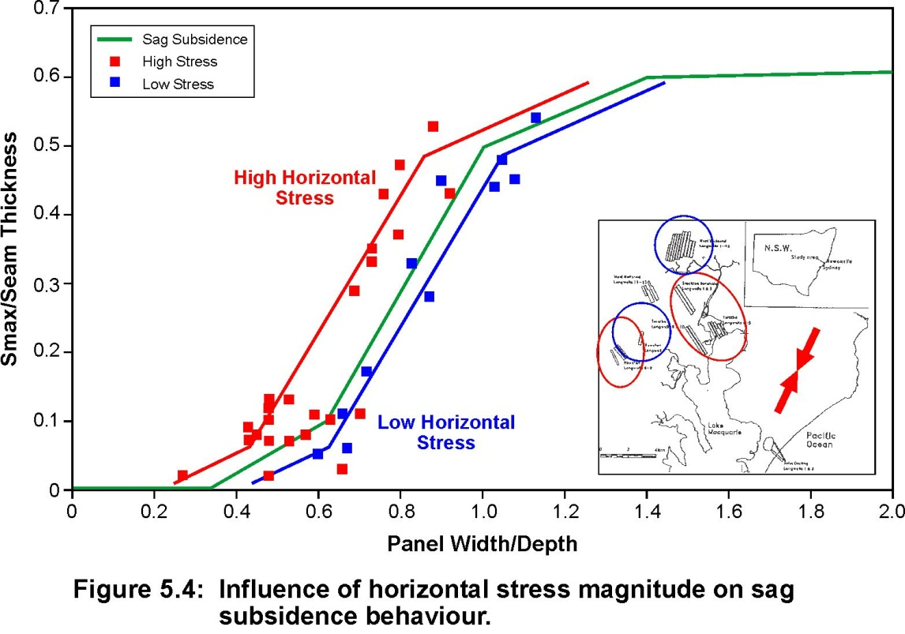
© Copyright, Tobin 1998
Figure 5.4 Influence of horizontal stress magnitude on sag subsidence behaviour.
In Figure 5.4, the characteristic subsidence curve is shifted to the left for panels that are oriented so that the horizontal stress is greatest across the panel (i.e. panels are oriented north-west across the major horizontal stress) and to the right when the horizontal stress is least (i.e. panels are oriented north-north-east parallel to the major horizontal stress and across the minor horizontal stress).

Elastic compression subsidence
Elastic compression subsidence occurs on the surface above the chain pillars when multiple longwall panels are mined next to each other (Holla 1985, 1992, Holla & Barclay 2000). The ground directly above and below each chain pillar is subject to the increased vertical stress concentrated onto the chain pillars by the extraction of the intermediate longwall panels. Figure 5.5 illustrates the mechanics of elastic pillar compression and the pillar loading generated by longwall mining on both sides of a chain pillar.

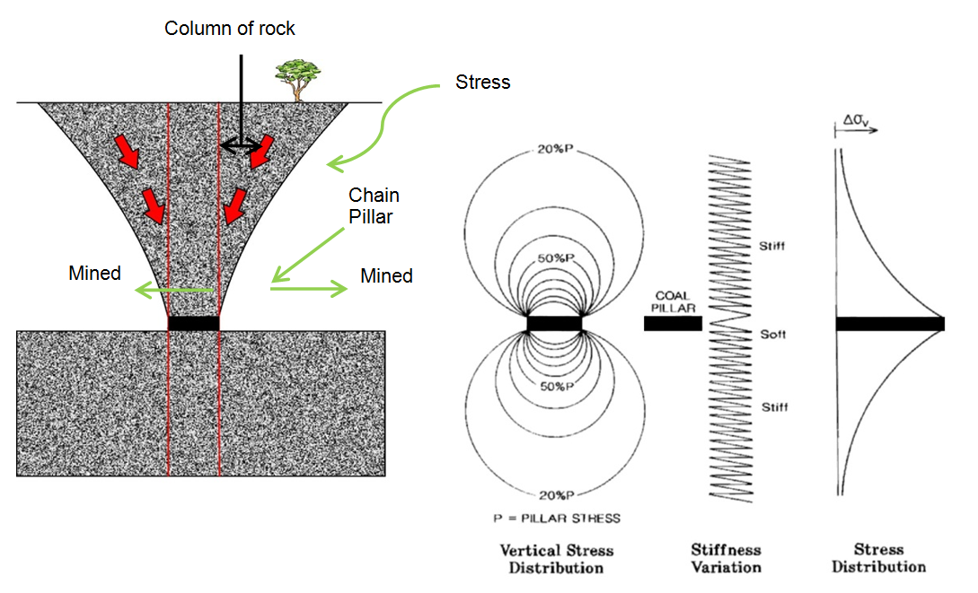
© Copyright, Mills 1998
Figure 5.5 Mechanics of elastic strata compression.
The chain pillars consist of coal, a material with relatively low elastic modulus (typically about 3 GPa). The rock strata above and below the coal seam has a relatively higher elastic modulus (typically 6–20 Gpa). In typical longwall geometries, and for the range of overburden depths of interest, chain pillars press on the roof and floor strata with stresses in the range 10–50 MPa (Gale & Mills 1995). The increased vertical stresses that result from these pressures diminish with distance above and below the chain pillars but typically extend for several hundred metres. Elastic compression of the chain pillar and the column of rock above and below the chain pillar that is subject to increased vertical stress accumulates through the overburden section to produce vertical subsidence at the surface directly above each chain pillar. (See note 3 at the end of the chapter.)
At depths of less than 100 m, the elastic compression subsidence is typically in the range 50–100 mm. At 300 m, accumulated elastic compression is typically 600–800 mm and at 500 m depth is typically in the range 1000–1400 mm, because of the higher loads involved and the greater height of the column of rock that is compressed (Mills 1998).

Subsidence from pillar failure
Subsidence from pillar failure (rather than pillar yield) is less common in longwall operations than it is in pillar extraction operations, because of the large pillars required to maintain acceptable roadway conditions in the tailgate of longwall operations and the confinement provided to pillars by the collapsed rock in the goaf. There are, however, special circumstances where the collapsed strata in the goaf does not provide sufficient confinement to the pillar system to prevent non-linear deformations. These non-linear deformations contribute to additional subsidence at the surface (Gale 2010). However, even in these somewhat unusual circumstances, the strata directly above and below the chain pillar continues to be in compression, and the increased subsidence over the chain pillars is still predominantly a result of elastic compression. (See note 4 at the end of the chapter).

Local subsidence effects due to surface topography
Upsidence and uplift are phenomena that are known to cause changes in the vertical subsidence profile in areas where there is topographic variability. However, these processes are driven by horizontal ground movements and are discussed in the next section.

Components of horizontal subsidence movements
In recent years, horizontal subsidence movements have become more widely recognised as the cause of various subsidence phenomena. These phenomena include horizontal movement in a downslope direction (sometimes referred to as downslope movement), valley closure and upsidence. The impacts of these phenomena are observed as rock falls on sandstone cliff formations, fracturing in river channels and ripples in gently sloping terrain. Although such phenomena have been observed for many years, it is not until relatively recently that the causal mechanisms have been identified. In this section, the components of horizontal movement and the mechanics involved are discussed, mainly in the general context of valleys and river channels. The impacts of these horizontal movements on peat swamps are discussed in more detail in Chapter 7.
The causal links between vertical subsidence above longwall panels and horizontal ground movements have become apparent from numerous investigations conducted for different coal mining companies for a range of specific purposes. Although the detail of many of the individual studies is not available in the public domain, the understanding that has developed from these studies has become more widely known. This understanding and the results of published studies that illustrate the mechanics are described in this section.
Essentially, horizontal movements are driven by a combination of gravitational potential energy as the overburden strata subsides and potential energy stored in the overburden strata as in situ stress is released by subsidence movements. These two sources of energy are the only sources available to drive horizontal movements. Each has its own characteristics that are reflected in the nature and extent of the deformations observed.
Horizontal movements are composed of several components:
- systematic horizontal movements that are initially toward the goaf (area that has been mined) and subsequently in the direction of mining once the longwall face has passed
- horizontal movement in a downslope direction that gives rise to valley closure
- stress relief movement that includes far-field movement and in some circumstances contributes to valley closure and valley bulging (although not necessarily in a downslope direction).
Each of these components is discussed in more detail in the following sections.
The term ‘valley closure’ has become widely used in the subsidence vocabulary as representing all the processes that cause the phenomenon of valley closure without seeking to differentiate the various mechanisms involved in these processes. In most sections of this report, the differentiation of these various mechanisms is relevant to the discussion and the impacts. The term valley closure is therefore used sparingly and mainly to describe the general phenomenon.

Systematic horizontal movements
In flat terrain, the two components of movement evident directly above and adjacent to the longwall panel are commonly referred to as systematic subsidence movements. They are related to the drag that occurs toward the mined zone as the overburden strata subsides and the reversal that occurs as the overburden strata settles. The trajectory of points on the surface at various locations relative to a retreating longwall panel is illustrated in Figure 5.6. The actual pathway followed by any point on the surface is a function of its position relative to the longwall panel.
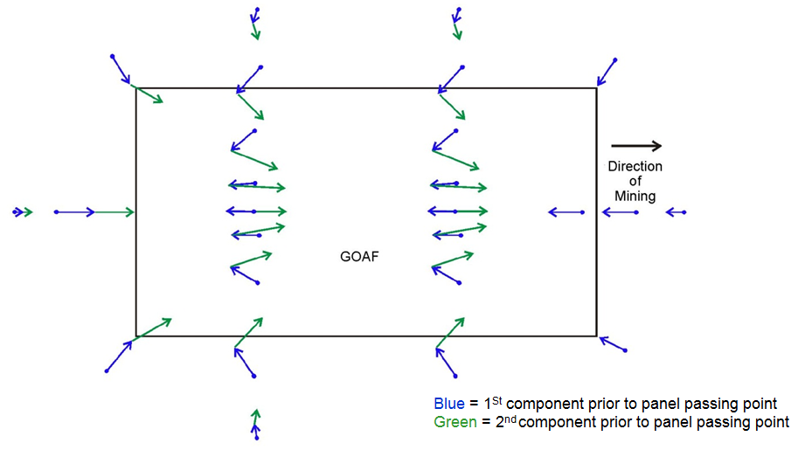
Figure 5.6 Systematic horizontal subsidence movements.
The first movement is toward the approaching longwall face as the ground surface subsides into the newly formed goaf. A second component of movement occurs in the direction of mining. From numerical modelling studies, it appears to be a function of the way the subsiding overburden strata rotates forward during the later stages of vertical subsidence, when the already subsided strata becomes locked in place during the compression stages of ground movement while the still subsiding strata in the stretching stage of subsidence are still free to move. The result is a tendency for a permanent horizontal offset in the direction of mining.
Points on the panel centreline move more or less along the axis of the panel. A point on the centreline over the panel moves initially toward the goaf and, once the longwall face has retreated past, reverses. Movement then continues back through the original position to a point that is permanently offset in the direction of mining.
Points on the panel centreline over the start of the panel move initially toward the goaf and, because this direction is also the direction of mining, the second component continues in the same direction as the first, so both components are additive. As a result, systematic horizontal movement is greatest at the start of the longwall panel.
Points on the panel centreline at the finishing end of the panel move initially toward the goaf but there is no second component because the goaf does not pass the end of the panel. As a result, systematic horizontal movement is least at the finishing end of the longwall panel.
On the sides of the panel, horizontal movements are initially towards the approaching goaf (at a diagonal angle to the panel) and then towards the retreating face, but still inward toward the panel centreline. In these areas, the resulting horizontal movement follows a dogleg pathway.
The magnitude of systematic horizontal movement is typically about 50–150 mm in a direction towards the approaching longwall and then 100–250 mm in the direction of mining so that on the panel centreline in flat terrain there is usually a permanent offset in the direction of mining of about 50–200 mm.
The rate of change in the horizontal movement gives rise to differential movements that are measured as systematic strains. The differential horizontal movements occur over a horizontal distance that is proportional to overburden depth. At shallow depths, systematic strains therefore tend to be larger because, although the horizontal displacements have a similar magnitude, the differential movements occur over a shorter horizontal distance. As the overburden depth increases, the distance over which differential horizontal displacements occur increases, so the systematic strains tend to be less.
The component of these differential horizontal movements that aligns with a subsidence line is measured and reported as horizontal strains. In conventional two-dimensional subsidence monitoring, the differential movements across the subsidence line are not measured.

Horizontal movement in a downslope direction
In sloping terrain, a third, and usually dominant component of horizontal movement is observed in addition to the two components associated with systematic horizontal movements. This third component is associated with horizontal movement in a downslope direction. Horizontal movement in a downslope direction gives rise to the phenomenon of valley closure and, in some circumstances, upsidence and valley bulging. It does not have any vertical component but occurs horizontally. The term ‘downslope’ comes from the direction of movement, which is in the direction of maximum topographic gradient, or downslope.
Horizontal movement in a downslope direction occurs primarily as a function of dilatancy—a property of rock and other granular materials whereby volume increases as the rock material is deformed (see Figure 5.7). Other factors that affect the magnitude of horizontal movement in a downslope direction include the direction of mining relative to the topographic slope, the topographic gradient and the geological profile. The magnitude of in situ stress does not appear to be a factor. Horizontal stress-related movements are observed, but these are considered to be a separate phenomenon and are discussed in the next section.
An extended program of three-dimensional subsidence monitoring at Baal Bone Colliery from 1990 to about 2005 provided the opportunity to study the principal mechanisms driving horizontal movements in steep terrain. Other studies in the Hunter, Western and Southern coalfields have confirmed these mechanisms.
Figure 5.7 illustrates the rock property called dilatancy that causes volumetric change in rock strata as a result of shear deformation. The fracture network is random and different to the fracture network observed in a sedimentary sequence, but it illustrates how a volume increase within the rock mass occurs when the rock mass is sheared. The phenomenon was first recognised as a fundamental characteristic of granular materials in soil mechanics in studies of sand behaviour (Terzaghi & Peck 1967) and later in rock materials (for instance Ladanyi & Achambault 1969). Shear dilatancy and its interaction with pore water lead to many of the characteristics that affect the behaviours of soil and rock materials of interest to geotechnical engineering, slope stability, petroleum engineering and other related disciplines, but its characteristics do not seem to have been widely recognised in the field of subsidence engineering.
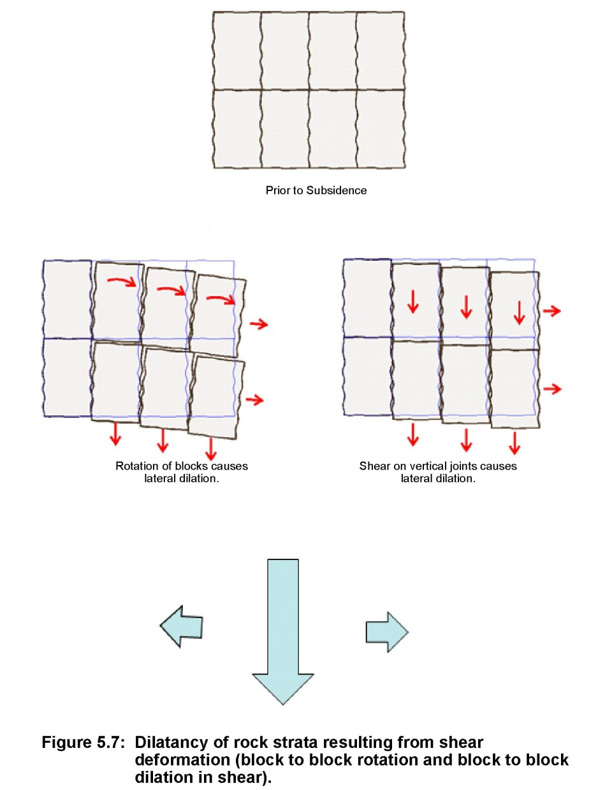
Figure 5.7 Dilatancy of rock strata resulting from shear deformation (block-to-block rotation and block-to-block dilation in shear).
Dilatancy, an inherent property of granular materials and rock strata, is the primary mechanism of horizontal movement in a downslope direction. The overburden strata laid down over geological time, formed an essentially solid rock mass. Over time, discontinuities developed from various causes. Within this rock mass are numerous layers of different materials each with joints, bedding planes and other geological structures, but there is no space within the rock mass for adjacent blocks of rock material to rotate relative to each other or to slide past each other as the rock mass is deformed. For deformation to take place, the rock mass has to either expand in volume to create space for movement to occur or generate large confining stresses that effectively force the volume to be created through volumetric compression of the rock fabric.
The incremental nature of coalmining, particularly longwall mining, has the effect of subsiding the rock mass that forms the overburden strata above the extracted panel, causing it to be incrementally subject to shear deformation. The incremental nature of vertical subsidence means that adjacent blocks of rock strata within the rock mass are forced to subside differentially so that they shear and rotate relative to each other (i.e. dilate) as they move downward at slightly different rates. As the rock mass accommodates these differential ground movements, dilatancy causes the overall volume of the rock mass to increase if there is space available or exerts an outward pressure if there is not.
Figure 5.8 illustrates the space that exists up through the overburden section available for the rock strata to dilate into as subsidence occurs. At seam level there is volume available in the void created by mining. The disturbed rock strata moves downward differentially into the space created, increases in volume and bulks up. Further up through the overburden section the rock strata is more constrained by the presence of intact strata on either side of the panel. The volume increase necessary to accommodate differential subsidence movements occurs horizontally toward the already subsided goaf, contributing to the horizontal movement that occurs toward the approaching goaf and causing low-level, permanent vertical dilation. The vertical dilation decreases with height above the mining horizon and can be detected by surface extensometers, as discussed in Chapter 6. Horizontal dilation is more difficult to detect at depth because of the practical difficulties of getting suitable instruments into the active subsidence zone. Horizontal movements caused by horizontal dilation become apparent as movement at the surface in sloping terrain, or where the strata dips relative to the surface because there is less constraint in these circumstances, allowing ground surface freedom to move laterally.
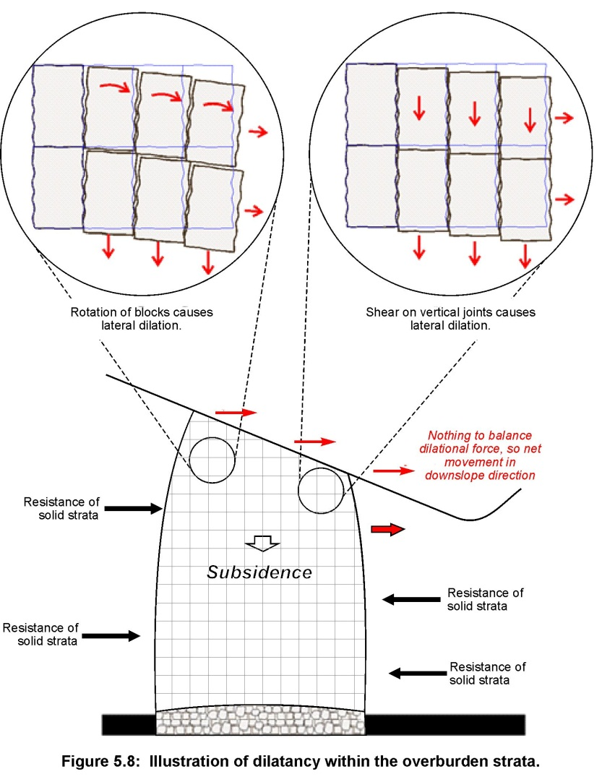
Figure 5.8 Dilatancy within the overburden strata.
In sloping terrain or where the strata dips relative to the surface, the propensity of the subsiding rock strata to dilate horizontally as a result of vertical subsidence and the lower shear strength of bedding planes in sedimentary strata such as Hawkesbury Sandstone causes lateral movement toward the nearest free surface on a path of least resistance. The greatest freedom is in a direction toward the slope, so movement occurs laterally in this direction. The resulting movement is observed at the surface as horizontal movement in a downslope direction.
The interface between the rock strata that is free to move laterally and the deeper rock strata that is constrained and cannot move freely typically occurs on a level at or close to the base of the nearest topographic low point, as illustrated in Figure 5.9.
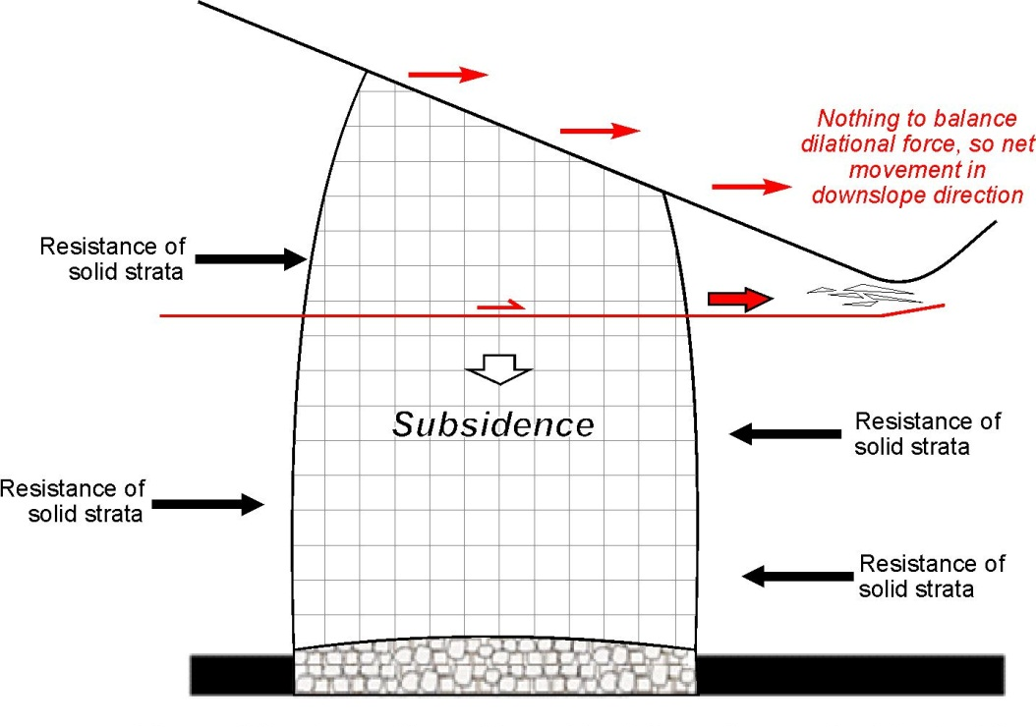
Figure 5.9 Formation of basal shear plane coincident with valley floor.
If lateral movement occurs on a bedding plane horizon that emerges from the ground above the base of the valley, the horizontal movement can occur freely without causing damage to sandstone strata in the base of the valley. However, when the bedding plane that moves is located below the base of the valley, sandstone strata in the base of the valley get caught between rock strata that are dilating laterally due to vertical subsidence below the slope on one side of the valley, and rock strata on the other side of the valley that is either not moving at all or is also moving in the opposite direction toward the valley because it too is subsiding and moving horizontally toward the valley.
The consequence of lateral compression in the floor of a valley depends on the relative magnitude of the horizontal movement in a downslope direction and the deformational characteristics of the rock material in the valley floor. When mining occurs under or near a river channel, there is commonly sufficient horizontal movement in a downslope direction to exceed the compressive strength of the rock material and cause perceptible fracturing.
Downslope movements causing valley closure are commonly measured. When longwall mining occurs below adjacent sloping terrain, downslope movements more than several hundred millimetres have been reported but have been observed to range from low levels remote from mining up to the magnitude of the vertical subsidence (about 1.2 m), depending on a range of factors.
The tolerance of sandstone strata in the base of a river channel is difficult to estimate with confidence without measuring the initial state of stress in the rock and other site-specific rock properties. However, horizontal compression of 100 mm over a 10-m base length or 200 mm over a 20-m base length is equivalent to 1 per cent compressive strain. At this level of compressive strain, intact sandstone strata would be expected to exhibit signs of rock failure and perceptible changes would be likely to become apparent.
Actual field monitoring (Mills et al. 2004; Mills & Huuskes 2004) indicates that the changes in horizontal stress that occur in sandstone rockbars are relatively small and much less than the intact strength of the rock strata. This suggests that the sandstone rock strata in the base of river valleys is already in or close to a residual state—that is, the rock mass in the floor of the valley is no longer able to generate resistance to horizontal movement due to previous stress relief, as shown in Figure 7.8. The deformations that occur are then controlled by processes external to the rockbar.
The sandstone rock strata in the base of the valley is essentially a passive element in the deformational processes—it is not a buttress holding back the sides of the valley. This distinction is significant in the context of some of the models of strata behaviour that have been published based on stress-related phenomenon (see note 5 at the end of the chapter).

Effect of mining direction on downslope movement
Figure 5.10 shows the subsidence movements observed during mining of Longwall 7 at Baal Bone Colliery in January 1991. These observations are among the first three-dimensional measurements of ground movement on a conventional survey line in steep terrain in Australia. The subsidence line was surveyed in three dimensions before and after mining. The displacement vectors shown in Figure 5.10 are exaggerated in magnitude but are drawn at natural scale so that both the vertical and horizontal components are at the same scale. The overburden depth ranges from 100 m in the valley to 175 m on the ridge tops. The longwall panels have a mined width of 211 m. The seam section mined is approximately 2.5 m thick.
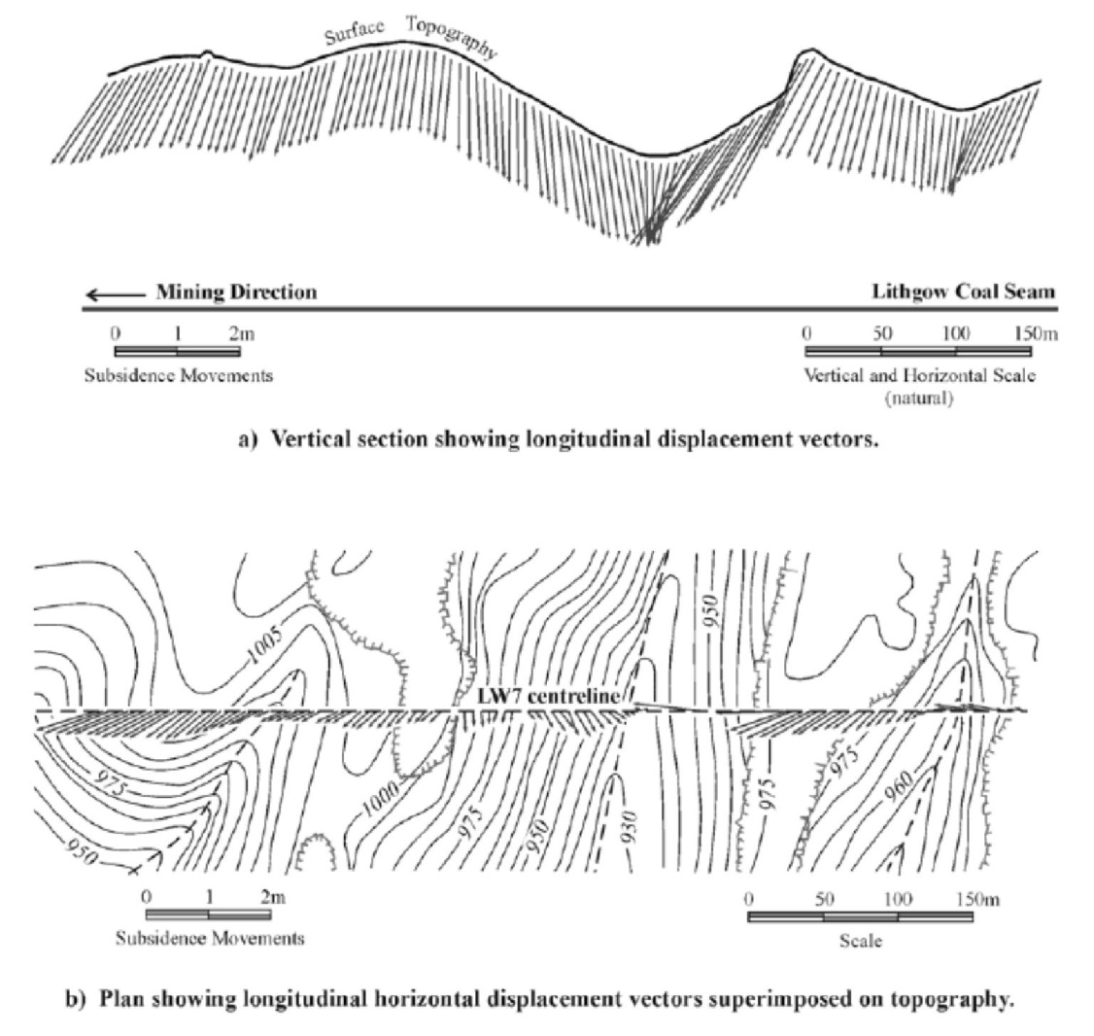
© Copyright, Mills 2001
Figure 5.10 Displacement vectors for CH Line, Longwall 7, Baal Bone Colliery.
These measurements show that the direction of mining relative to the valley axis strongly influences the magnitude of the horizontal movements observed below the sides of a valley.
In the flatter terrain on the left of Figure 5.10a, the general tendency for an offset in the direction of mining is apparent. Superimposed on this background movement is the horizontal movement that occurs in a downslope direction as a consequence of surface topography. This movement is particularly evident around the large valley. Where the direction of mining proceeds in a downslope direction, the two components add together and the result is large horizontal movements that approach the magnitude of the vertical subsidence when the slope is steep. Where mining proceeds in an upslope direction, the two components tend to cancel each other out and the net horizontal movement along the panel is much smaller and may even be in the opposite direction, where the horizontal movement in a downslope direction overwhelms the normal movement in the direction of mining and there is a permanent offset in a direction opposite to mining.
The plan view in Figure 5.10b shows that this process also occurs sideways across the panel. In flat terrain, no cross-panel movements would be expected. In sloping terrain, however, there appears to be a strong tendency for movements to occur downslope even if the downslope direction is across the panel.

Relationship of horizontal movement to vertical subsidence
Mills (2001) describes the results of subsidence monitoring at another site at Baal Bone Colliery that provided a relatively unique opportunity to closely observe subsidence movements in three dimensions. The mining occurred at shallow depth (25–50 m below the surface). The shallow depth meant that the full subsidence cycle (from no subsidence to full subsidence) occurred over a short distance and the time taken for the longwall to retreat was short enough to allow intensive monitoring over a full subsidence cycle.
A grid of pegs was monitored in the shallow cover area at the outbye end of Longwall 17 at four- to six-hour intervals for several days as the longwall passed underneath. The site included a flat, low-lying area to the west and a sloping area in the east, allowing subsidence behaviour and horizontal movements to be directly compared between flat and sloping terrain. The depth of overburden ranged from 30 m at the top of the slope to 23 m at the bottom. Mining occurred obliquely across the slope from the high ground toward the low ground. The area is located in the centre of a 211-m wide longwall panel and is remote from panel edge effects.
Figure 5.11 shows an example of the subsidence movements measured in three dimensions on the flat and on the slope. These are presented as a plan, a side elevation looking to the west and an end elevation looking toward the north.
Vertical subsidence is the largest component of movement at 1100–1300 mm. Horizontal movements along the panel range between 300 and 400 mm, and cross-panel movements are generally less than 100 mm. Horizontal movements are initially towards the approaching goaf and subsequently in the opposite direction towards the retreating longwall face.
In the early stages, horizontal movements are greater than vertical subsidence. As the longwall face (and the longwall face supports) pass under a location, the vertical movements increase more rapidly. The direction of horizontal movement reverses when the longwall face is 15–20 m past a location and when approximately half the vertical subsidence has occurred.
Significantly, most of the horizontal movement in a downslope direction occurs during the early stages of vertical subsidence when the ground is being stretched and horizontal movement is in a direction towards the approaching goaf. Once the direction of horizontal movement reverses so that horizontal movement occurs in the direction of mining, there is no further horizontal movement in a downslope direction. The implication of this is that when the rock strata is being stretched, dilatancy is expressed as volume change, and when the rock strata is being compressed volume change is more constrained and the dilatancy is less apparent.
Horizontal movement continued until the longwall face was about 40–60 m past a location (i.e. a distance equal to approximately twice the depth at this site of approximately 25 m). Thereafter, essentially no further subsidence occurs. In the last stages of subsidence, the increments of vertical and horizontal movement are approximately equal in magnitude.

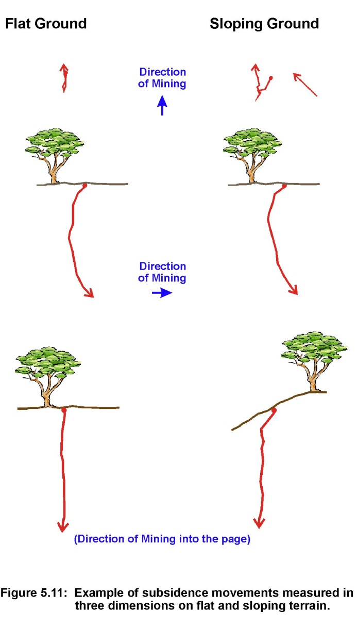
Figure 5.11 Example of subsidence movements measured in three dimensions on flat and sloping terrain.
The location and width of surface cracks were mapped at intervals during the monitoring period. In the flat terrain, tension cracks developed approximately parallel with the longwall face in the interval between the coal face and the back of the longwall supports. The cracks were widest a short distance behind the back of the supports and closed again about 20–25 m behind the face, leaving minor compression overrides and surface humps similar to the surface impacts commonly observed at other sites, particularly at shallow depth.
In the sloping terrain, tension cracks were not parallel to the longwall face but lagged behind where the overburden depth was greater. These cracks also show a downslope shear offset across the crack during the early stage of crack development. The sense of shear is such that the goaf (south) side of the crack displaces in a downslope direction relative to the solid (north) side. When the cracks subsequently closed, this offset is permanently preserved.
On the flat ground above the sloping terrain, there was a different style of cracking behaviour: a series of tension cracks developed. These could be readily identified on the hard-packed surface of a four-wheel drive track and were different to cracks that typically develop behind the longwall face. The cracks were parallel to the top of the slope and remained permanently open once mining was complete. Ten separate cracks up to 10 mm wide were observed as far as of 33 m (approximately the depth of overburden) back from the top of the slope. The total combined width of the cracks is approximately 50 mm. This corresponds with the magnitude of downslope movement observed on survey pegs at the top of the slope.
This stretching behaviour and the cracks that develop at the top of a slope are significant in the context of peat swamps located in plateau terrain at the top of steep slopes. The cracks that form could increase the hydraulic conductivity between the surface and the deeper strata and change the balance of inflow and outflow of water within the peat swamp. This is discussed in more detail in Chapter 9.

Other influences on horizontal movement in downslope direction
Subsidence monitoring above Longwalls 16 and 19 at Baal Bone Colliery provided an opportunity to compare the influence of surface gradient and overburden geology on horizontal subsidence movements for two different orientations relative to the in situ stress.
Both panels share a range of similar characteristics:
- The surface topography slopes in the direction of mining.
- The overburden depth reduces in the direction of mining from 65 to 40 m.
- The seam section mined is approximately 2.5 m thick.
- Three-dimensional subsidence movements are measured along both panel centrelines.
- Although separated by several kilometres, the overburden geology is effectively the same at the two sites.
- In situ stress measurements at the two sites indicate that the major horizontal stress is just east of north at both sites and that the horizontal stress magnitudes are low.
The main difference between the two sites is the direction of mining. Longwall 16 was mined south to north whereas Longwall 19 was mined east to west.
Figure 5.12 shows a summary of subsidence movements and topography at the two sites over the final 300 m of each panel. At both sites:
- vertical subsidence ranges from 1.1 to 1.6 m
- horizontal movements occur in the direction of mining and are essentially zero in the cross-panel direction
- the peak horizontal movement is approximately the same magnitude as the vertical subsidence
- the final vertical subsidence profile is irregular in nature and has a saw-tooth appearance. Close inspection shows that tension cracks are interspersed with compression humps, and the peaks of lesser subsidence coincide with compression humps.
Apart from the magnitude of the horizontal movements, which is somewhat higher than normal, perhaps because of the relatively shallow depths involved, the subsidence behaviour observed on both lines is generally typical of subsidence behaviour observed elsewhere at the mine and elsewhere in NSW.
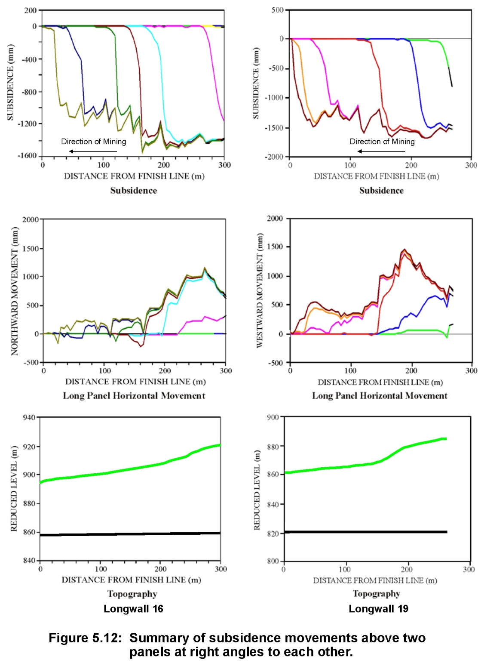
Figure 5.12 Summary of subsidence movements above two panels at right angles to each other. Note the reduced level is with respect to the Australian height datum.
When the profiles of horizontal movement at the two sites are compared, it is apparent that the horizontal movements are not uniform along the subsidence line. Horizontal movements are less than 500 mm for large sections of the lines and consistently much greater and even approach the magnitude of the vertical subsidence in other sections.
To investigate this effect more closely, the magnitude of horizontal movement was plotted against height above the coal seam at which the horizontal movement is measured (Figure 5.13). The ground is sloping at both sites and therefore the height above the coal seam changes, allowing horizontal displacement to be plotted against height above the coal seam. Surface gradient and the geological section from a nearby borehole are also shown.
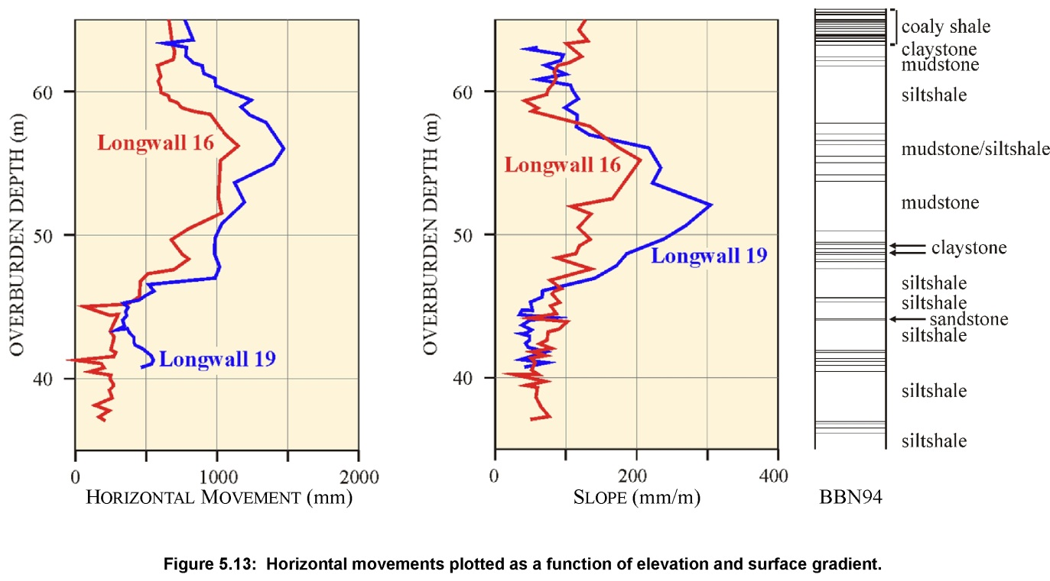
Figure 5.13 Horizontal movements plotted as a function of elevation and surface gradient.
There is a clear correlation between the two sites in terms of the depth profile of horizontal movement. At both sites, the peak horizontal movement occurs at about 57 m above the coal seam. There is also a clear step at 47 m and numerous other minor inflections at corresponding depths. Observation of the ground surface at these horizons shows significant lateral shearing of the ground and associated override compression humps up to 0.5 m high. The strata above the 47 m horizon has moved horizontally in a downslope direction relative to the strata below this horizon, causing a compression hump or ripple at the surface. The geological section in Figure 5.13 indicates that claystone horizons bracket the zone of maximum horizontal displacement, suggesting that geology and low-strength bedding plane horizons influence the size and location of horizontal movements in a downslope direction.
The plot of surface gradient shows that the general form of the surface gradient is the same at both sites, although the maximum grade is much greater over Longwall 19 and the point of maximum gradient occurs at slightly different horizons.
The strong correlation between the horizontal movement profiles at the two sites mined in different directions confirms that the phenomenon of large horizontal movement (when the direction of mining coincides with the downslope direction) is not specific to panel orientation. Horizontal stress measurements taken underground close to the two sites indicate that the principal horizontal stress is just east of north at both sites and of low magnitude at both sites. The observed horizontal movements are therefore not driven by horizontal stress (which is direction specific) but rather by the caving processes in response to the surface topography. These observations suggest that horizontal stresses are not playing a significant role in the processes involved in driving horizontal movements in a downslope direction. Other observations, particularly those made in the Southern Coalfield have characteristics consistent with horizontal stress influencing horizontal movements, but these are regarded as an essentially unrelated mechanism that is discussed in the next section.

Experience of horizontal movement in a downslope direction at other sites
Seedsman and Watson (2001) found that when they removed the systematic horizontal movements from the three-dimensional movements observed around a topographic ridge at Newstan Colliery in the Newcastle Coalfield the remaining horizontal movements correlated strongly with surface topography. Figure 5.14 shows the horizontal movements inferred once the systematic horizontal movements were removed. These movements occurred away from the topographic high towards the valley in all directions.
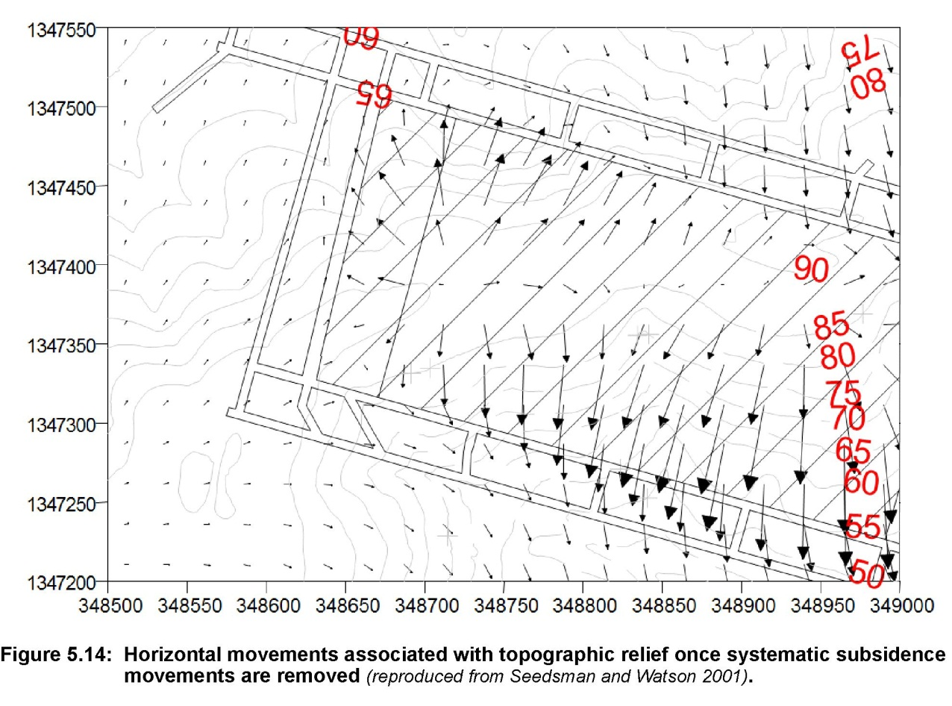
© Copyright, Seedsman & Watson 2001
Figure 5.14 Horizontal movements associated with topographic relief after systematic subsidence movements are removed.
Mills and Huuskes (2004) present the results of three-dimensional subsidence monitoring on D Line at Metropolitan Colliery in the Southern Coalfield. D Line extends approximately perpendicular to a number of valleys. Results from monitoring subsidence at D Line show that horizontal movements occur in a downslope direction. Compression occurs at the bottom of valleys and tension or stretching occurs at the top of ridges. Horizontal strain data on D Line presented in MSEC (2008b) shows compressive strain peaks in the topographic low points and tensile strain peaks at topographic high points, confirming that the entire hillside is expanding laterally, consistent with dilatant behaviour of the rock mass that forms the ridge.
Figure 5.15 shows the mechanics of horizontal movement observed at Ashton Coal Operations in the Hunter Valley. At this site, the strata dips more steeply than the surface topography. Vertical subsidence causes the rock strata to dilate and move toward the nearest free surface. However, instead of the bedding planes being horizontal and the nearest free surface being towards the valley, as is commonly the case (illustrated on the left side of the diagram), the bedding planes are inclined and the nearest free surface is in an up-dip direction. The resulting horizontal movements at Ashton are therefore in an up-dip (and in this case up-slope) direction. The fact that the dilational forces within the overburden strata are sufficient to move the strata up dip against gravity confirms that they are of significant size.

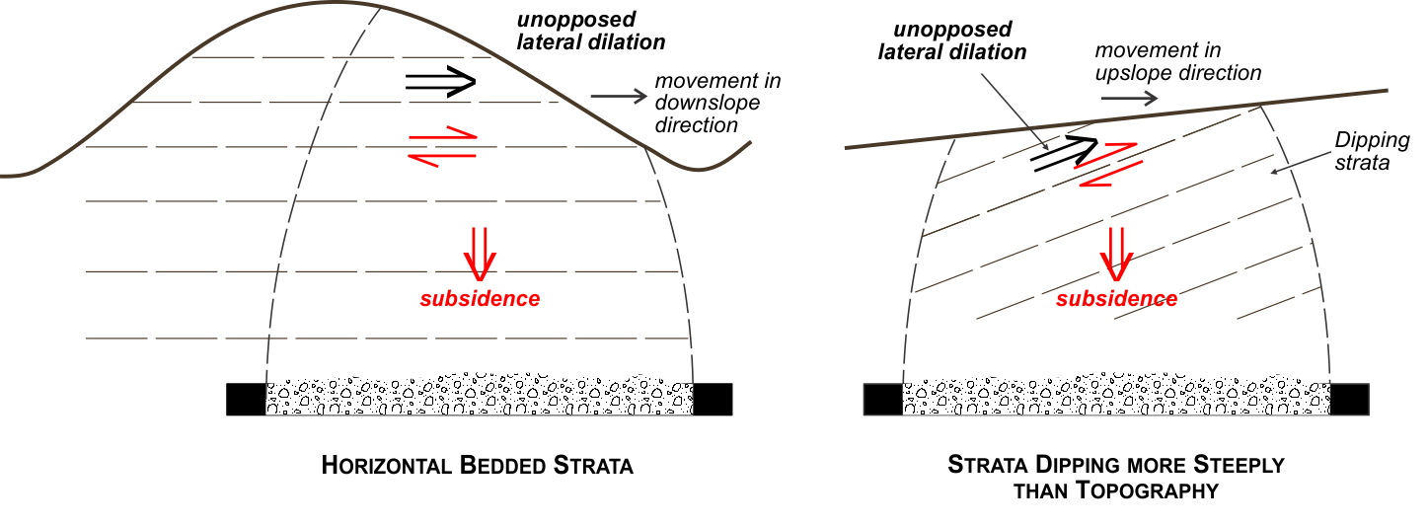
© Copyright, SCT 2009
Figure 5.15 Horizontal movements observed at Ashton Coal in dipping strata.
The more general experience of valley closure impacts on river channels throughout NSW is evidence of the widespread occurrence of horizontal movement in a downslope direction.

Horizontal movements associated with horizontal stress relief
Horizontal stress relief is a second mechanism that contributes to horizontal movements. Tectonic energy is stored in the overburden strata as in situ horizontal stress over geological time. In uneven terrain, these in situ horizontal stresses have to find an equilibrium with the contour of the surface. In horizontally bedded strata, this equilibrium involves the horizontal stresses becoming inclined to the bedding planes as they pass below the base of river channels. As these inclined stresses exceed the shear strength of bedding planes, horizontal movement occurs in a direction that relieves the horizontal stress and brings it back into equilibrium with the shear strength of the bedding planes. In some circumstances the energy is released suddenly to generate a seismic event or the energy is released slowly in an incremental fashion. Vertical stress acts perpendicular to the bedding planes, clamping the bedding planes and allowing them to generate the frictional strength necessary to resist the shear stresses generated by the inclined horizontal stresses.
Mine subsidence has the effect of reducing the vertical stresses above the panel being mined. The reduction in vertical stress reduces the clamping forces acting on bedding planes and thereby the shear capacity of the bedding planes. Where in situ stresses are inclined across bedding planes and in equilibrium with the frictional strength of the bedding planes, a reduction in clamping force means that the shear capacity of the bedding plane is exceeded and horizontal movement can occur where there is space for this movement to occur. Bedding planes that emerge in or just below the base of a valley are located such that the overlying strata is free to move toward the valley, whereas movement on bedding planes deeper in the sequence is buttressed by solid strata at greater depth below the base of the valley.
In this way, mine subsidence causes horizontal movements toward valleys through a stress relief mechanism. The release of energy along the bedding plane that moves can be an unstable and therefore sudden process, when movement involves fracturing of previously intact rock strata, or a gradual process when movement occurs on a horizon that has previously sheared and has residual strength.
Horizontal stress relief movements are characterised by movements that occur:
- primarily in the direction of the in situ horizontal stress that is able to be relieved (i.e. towards the goaf or valleys)
- over a large area outside the goaf
- as a function of distance from the goaf edge, decreasing in magnitude linearly with distance.
Stress relief movements are typically of low magnitude (less than 100–200 mm at the goaf edge). They may occur suddenly as an essentially one-off event if the formation of the basal shear plane involves fracturing of new rock strata, with the unstable release of energy that results. However, field monitoring experience indicates that stress relief movements can occur incrementally in response to changes in mining geometry, possibly as a series of smaller stick-slip movements.
Reid (2001) postulated a relationship between in situ stress orientation and the direction of horizontal movements remote from mining, based on precise surveying of widely distributed monuments in the vicinity of mining activity in the Southern Coalfield. The horizontal movements of the remote points were predominantly aligned with the regional in situ stress direction. Nearer to the mining, the orientation was more typically toward the longwall goaf, suggesting that horizontal movements were occurring as a combination of mechanisms. Reid also noted horizontal movements of low magnitude (less than 100 mm) at the goaf edge and that these movements were decreasing approximately linearly to zero at distances of up to 1.5 km from the goaf edge.
Mills et al. (2011) report horizontal movements, attributed to stress relief at Ulan, extending some 1.8 km from the edge of the longwall panel and decreasing in magnitude approximately linearly with distance from the goaf edge. The magnitude of movement at the goaf edge was approximately 200 mm and horizontal movements occurred in a bi-linear distribution to 20 mm at 1.8 km. The GPS survey control methods used for these measurements provide a higher level of confidence in the accuracy and direction of the horizontal movement than was possible with the survey techniques that were used routinely for subsidence monitoring until recently. It is likely that horizontal stress relief movements occur routinely but have not been able to be measured using conventional subsidence monitoring techniques.

Combinations of mechanisms causing horizontal movement
Horizontal movements are caused by systematic movements close to the longwall goaf edge, strata dilatancy (horizontal movement in a downslope direction) in areas of uneven surface topography or dipping strata, and by horizontal stress relief. In most situations, the actual horizontal movements measured near longwall panels are a combination of all three.
the different components can be differentiated somewhat by their characteristic behaviours. Components that occur in a response to progress of mining are more likely to be systematic horizontal movement and movement in a downslope direction. Components that are of small magnitude and occur in the direction of in situ stress or towards the goaf, remote from mining activity, are more likely to be associated with horizontal stress relief, particularly if they occur suddenly as a one-off event.
In steep terrain, the formation of a bedding plane shear at or close to (generally below) the base of a river channel is characteristic of movement associated with both horizontal movement in a downslope direction and stress relief movements.
Hebblewhite et al. (2000) describe the movement observed up the face of a steep-sided gorge on the Nepean River near Sydney. The movement is illustrated in Figure 5.16 and increases with mining. Closure observed at the base of the valley is reported as being 86 per cent of the closure observed at the top of the cliff. The movements observed indicate that the rock strata above the base of the valley have moved en masse towards the valley. These results imply that there is a bedding plane horizon below the base of the river channel and that the movement has occurred along this horizon.
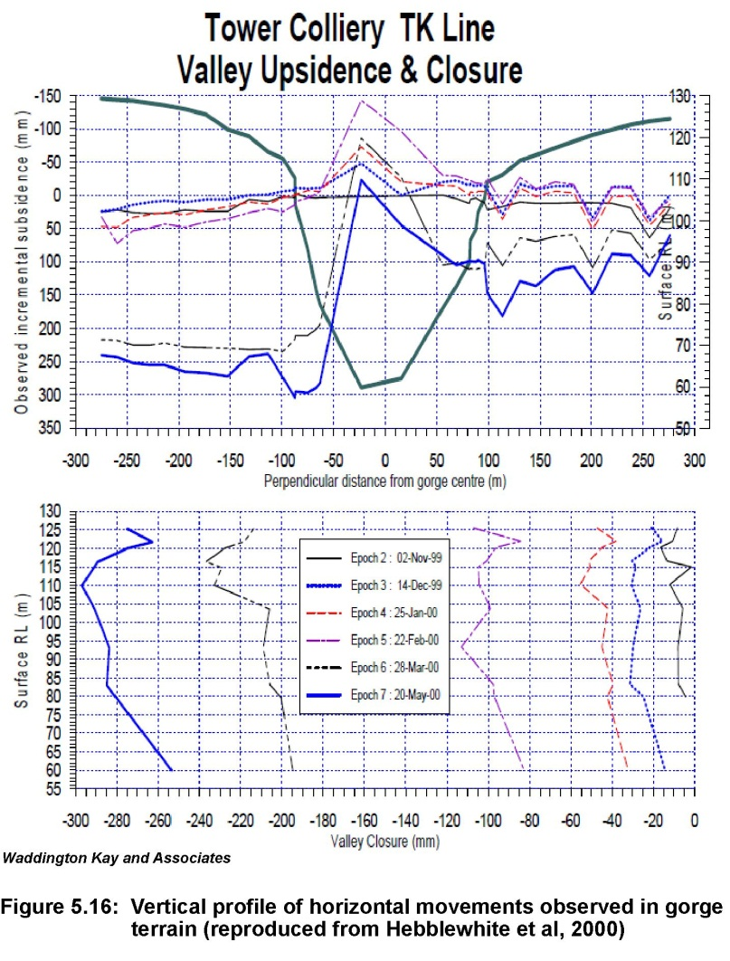
© Copyright, Hebblewhite et al. 2000
Figure 5.16 Vertical profile of horizontal movements observed in gorge terrain.
The same study measured horizontal movements of less than 100 mm well outside the mining area that were directed towards the goaf and the river gorge. Movements directly over the mining area were much larger but still directed towards the valley in an approximately opposite direction. The small, remote movements are characteristic of stress relief movements. The larger movements have characteristics of both stress relief movements and movement caused by strata dilatancy (i.e. horizontal movement in a downslope direction).
Systematic horizontal movements associated with vertical subsidence movements have been recognised for over a century. Since topography-related horizontal movements were recognised in the last few decades, there has been a tendency in the subsidence literature to explain these horizontal movements in terms of stress-related effects, such as stress concentration below river channels.
Horizontal stresses contribute to natural deterioration of river channels and horizontal stress relief effects are apparent at low levels in steep terrain when the in situ horizontal stresses are large. However, in most circumstances, the effects of shear dilatancy and resulting horizontal movement in a downslope direction are much more dominant. Unfortunately, these effects have yet to be widely recognised or the mechanics widely understood. The development of this understanding remains at the forefront of subsidence engineering in Australia.

Summary of key concepts
- Subsidence occurs at the surface as a result of downward movement of the rock strata towards the horizon where coal has been mined. The overall movements are referred to as trough subsidence. Trough subsidence has two components: sag subsidence and pillar compression. Sag subsidence causes stretching of the overburden strata above each longwall panel, leading to an increase in fracturing and therefore increased hydraulic conductivity. Elastic strata compression occurs over the chain pillars between each panel, also contributing to the downward movement of the surface. The compression leads to a decrease in fracture aperture and, therefore, decreased hydraulic conductivity over these pillars.
- Subsidence movements have both vertical and horizontal components.
- The nature and causes of subsidence movements have been studied since the late 1800s and are relatively well understood, particularly since recent improvements in monitoring techniques have become available.
- Monitoring initially used optical survey and chaining (measuring) between survey pegs in a line; therefore, only movements in two directions along the subsided surface were obtained. GPS monitoring allows movements in three planes along the subsided surface to be measured. Satellite technology is expected to allow measurement of movements over large areas in the future, but this technology is still emerging.
- Conventional subsidence deformations shown in Figure 5.1 include:
  - vertical subsidence
  - tilt of the ground surface
  - curvature of the ground surface;
  - horizontal ground movements.
In flat terrain, horizontal ground movements generally occur in a direction towards the centre of the panel and in the direction of mining. These movements result in permanent tensile strains at the edge of the subsided area and compression strains in the interior of the subsided area, with transitory tensile and compression strains during the period of active mining.
- Non-conventional subsidence deformations include the following:
  - In sloping terrain, horizontal movements also occur in a direction towards topographic low ground and away from topographic high ground, causing valley closure and upsidence in the base of valleys. The magnitude of these horizontal movements in a downslope direction tends to be larger in magnitude than conventional subsidence movements.
  - Low-level far-field horizontal movements are caused by relief of horizontal stress within the overburden strata. These effects may extend for some kilometres from the edge of a longwall mining area but are of such low magnitude to be of no practical significance to peat swamps.

Peer review comments on Chapter 5
Ross Seedsman has provided the following comments:
1. In research partly funded by the NSW Mines Subsidence Board, Delaney et al. (2005) reported seasonal movements of up to 58 mm for the Newcastle area. Seasonal vertical movements of in excess of 40 mm in the vicinity of Cataract Creek near Wollongong have recently been reported to NSW Roads and Maritime Services. Using this definition, the angle of draw is an outcome of a monitoring/survey program. Even with the conventional usage of 20 mm vertical, it is apparent that there will be movements (both vertical and horizontal) outside. Holla and Barclay (2000) present data showing that in the Southern Coalfield the angle of draw to 20 mm vertical subsidence varies between 2º and 56º, with an average of 29º with 70% being less than 35º.
2. The goaf angle is likely to vary as a function of the orientation of the longwall panels with respect to the orientation of the joints—lower values if the gate roads are driven parallel to the major structural grain and higher values if the gateroads are oblique to the joints in the overburden. This is consistent with the observations by Creech (1995) and Tobin (1998) that greater sag was noticeable if the longwalls were aligned to the north-west parallel to the regional structure in the Newcastle field (a lower goaf angle, a higher effective span, and greater sag). Neither of these authors referenced orientation to horizontal stress. Seedsman (2010) also inferred lower goaf angles if more than 2 joint sets are present.
3. The distinction between sag subsidence and the subsidence that develops above chain pillars (Mills 1998) does provide the basis for a more analytical engineering approach to subsidence prediction. Seedsman and Kerr (2001) and Seedsman (2004a, 2006, 2007, 2010) have used this approach when predicting vertical surface displacements associated with sag and pillar subsidence at Bellambi West Colliery (Southern Coalfield) and Mandalong Mine (Newcastle Coalfield), respectively. At these mines and at numerous other mines and projects, particularly in Queensland, the predictions of vertical movements are combined with empirically derived shape factors and then input to an influence function method to visualise the subsidence bowls (Byrnes 2003).
4. When Mills (1998) separated sag subsidence from elastic compression and pillar failure, he stated that pillar failure (that is, failure of the coal itself) is uncommon, suggesting that it is often mistaken for elastic compression. Recent research (Seedsman 2004a) and mining practices suggest that it is more appropriate to refer to coal pillar yield rather than coal pillar failure as the source of the non-linear deformations discussed in Section 5.4.3. Yielding of the coal in the chain pillars is in fact very common and is an intrinsic feature of current longwall mine layouts. As discussed in Seedsman (2004a), yielding of chain pillars is the default position for longwall mine design.
5. An alternative mechanism for valley closure and upsidence is presented in Seedsman and Dawkins (2006)—see extract in Appendix D. This mechanism proposes the opening (dilatancy) of joints as the mechanism for valley closure and proposes upsidence in the same way as outlined in this report. It is a dilation model, but advocates dilation of pre-existing joints on a deforming substrate. The model provides a mechanism for closure when a valley is undermined and also for closure (compression) above unmined coal where the horizontal stress changes should be tensile. The model, although yet to be fully developed, is consistent with the empirical observations and the geomechanics of jointed rock masses. A simple heuristic from the model is that maximum valley closure is equal to the valley depth times the maximum tilt. Higher tilts can be associated with trough subsidence and the trough subsidence can be reduced if the pillar width is increased such that pillar yield does not develop. If the Seedsman/Dawkins model is accepted, then the way to reduce valley closure and hence upsidence/subsurface cracking may be to increase the pillar width, so that pillar yielding is not induced, resulting in less subsidence. Initial analyses suggest chain pillars widths may need to be about 45 m. By comparison, there is relatively little to be gained by reducing extraction widths.
Tony Iannacchione comments in relation to Section 5.5: Only recently has the issue of accounting for non-uniform surface topography been addressed and the validity of these techniques is only now being measured.
The authors present the concept of dilation to account for valley closure, excessive and irregular horizontal movement, and damage at the bottoms of stream valleys. While the theory supporting the proposed concept is sound, analytical and numerical treatments are needed. Section 5.5 has only a few citations and relies on confidential company reports and un-named studies conducted in the Hunter, Western, and Southern coalfields to confirm their dilation mechanism.
Observations of damage within unmined valley bottoms are plentiful (Ferguson being the first with many others that followed this early work; Ferguson, H.F., ‘Valley stress-relief in the Allegheny Plateau’, Association of Engineering Geologists Bulletin, 1967, vol. 4, pp. 63–68).
The relationships of vertical and horizontal movements are largely based on empirical and analytical methods and, while useful, are inadequate in determining the precise behaviour of an individual structure or a water supply at the surface. It is difficult to calculate these movements without detailed information of the geologic unit’s physical properties and the associated discontinuities distributed throughout the rock sequence of interest.

Overburden caving processes
This section discusses the processes that cause disturbance to the overburden strata above a longwall panel and reviews the historical development of the various conceptual models of ground behaviour that have been presented in the literature. The measurements that form the basis of current understanding of ground behaviour are presented. A conceptual model of ground behaviour is described based on a review the subsidence and subsurface data presented.
The physical disturbance that occurs immediately below peat swamps is typically a result of horizontal movements and valley closure effects that fracture the rock strata immediately below a peat swamp, in much the same way that river channels are impacted. The mechanics of the processes that cause these horizontal movements are a consequence of vertical caving processes. It is useful to describe the caving processes first and then the mechanics of the horizontal subsidence movements. The mechanics of the horizontal movements and their impact on peat swamps are discussed in Chapter 8.
The caving processes also have potential to impact on the deeper rock strata below peat swamps and to impact on the groundwater and hydrogeological environment more generally. These issues are also discussed in Chapter 8.

Introduction
Disturbance to the rock strata starts at the mining horizon and moves upwards through the overburden strata where it may reach the surface, depending on a range of factors. The nature of this disturbance is best seen at seam level and at the surface. In between seam and surface there has been opportunity for conjecture and unfortunately some of the theories developed have inadvertently tended to confuse the actual mechanics involved. Although the general concepts of subsidence have been studied and described in the literature since the 1800s, it is only relatively recently—with the development of borehole instrumentation systems and surface subsidence monitoring techniques—that it has been possible to confirm the processes involved.
Since coal is mined in a longwall panel or pillar extraction panel, the roof strata immediately above the coal is unsupported. This unsupported strata collapses downward into the void that is left as the coal is mined, a process referred to in this report as caving. The area where the coal has been mined and into which the strata caves is called the goaf. Strictly speaking, the goaf refers only to the mined area at seam level, but the term is also used more broadly, in the absence of any other suitable term, to describe the zone above the extracted coal where the strata has been significantly disturbed by mining.
In the goaf, the process of caving at the mining horizon causes an upward progression of downward movement within the overburden strata. This downward movement may continue through to the surface and appear as surface subsidence, depending on a range of factors such as panel width, overburden depth (i.e. depth between mining horizon and the surface), number of seams mined, thickness of coal seam mined and geology of the strata (i.e. percentage of stiff rocks, number of persistent bedding planes, in-situ fracture network, dip of the formations, horizontal stresses and surface topography).
Underground, the collapsed zone at seam level can be seen by looking behind the longwall supports. The collapsed strata consist of loose blocks of rock, typically containing numerous large voids where the highly disturbed rocks do not pack closely together, and is clearly hydraulically very conductive.
Above the mining horizon, it is increasingly difficult to determine the post-mining state of the rock strata because of the challenges of inspecting the disturbed strata in situ and maintaining systems capable of measuring the ground movements. In Australia, a number of field studies have been aimed specifically at measuring subsurface ground movements and have provided the measurements that have allowed greatly improved understanding of subsurface behaviour in Australia.
It is much easier to characterise the strata disturbance at the surface because the surface is accessible to inspect and routine surveying techniques can be used to quantify the movements observed. Understanding of caving behaviour and subsurface ground movements in general was initially closely linked to an understanding of surface subsidence behaviour. During the last decade or so, development of three-dimensional surveying techniques and the Global Positioning System (GPS) has led to their widespread use for routine subsidence monitoring, particularly in New South Wales. The effectiveness of surface surveying as a technique for understanding subsurface ground movements has improved significantly as a result of these developments (Mills 1998, 2001, 2011). Improvements in numerical modelling have also significantly improved understanding of subsurface ground movements (Gale 2004, 2011).
The caving processes for longwall operations appear to be essentially similar to those in deeper pillar extraction operations. Longwall geometries are more regular, a higher proportion of coal is removed from a longwall panel and the width of the longwall panel is typically much greater than the width of a pillar extraction panel. Therefore, the height of strata disturbance above the coal seam tends to be greater above a longwall panel, but the caving processes are otherwise essentially similar. However, at shallow depth, subsidence around pillar operations may include sudden collapse and sinkhole formation—features that are not typically observed above longwall panels. These differences are not relevant to impacts on peat swamps in New South Wales and are ignored in the following discussions. (See note 1 at the end of the chapter.)

Early understanding of subsurface ground movements
Historical development of the understanding of subsidence and early concepts of subsurface ground movements caused by mining coal are well documented in Whittaker and Reddish (1989). The discussion of early studies presented in this section is summarised from Whittaker and Reddish.
Young and Stoek (1916) indicate that the early concepts of mining subsidence originated in Belgium and France about 1825 and involved relatively large extraction areas in relation to depth below surface. The mode and mechanics of the upward progression of subsidence movements from seam level appears to have been a starting point for the development of early subsidence concepts, including the influence of inclined seams.
Work directed at protecting railways in Austria in the Ostrau-Karwin Coalfield was published by Jicinsky (1884, cited in Whittaker & Reddish 1989) and Rziha (1882, cited in Whittaker & Reddish 1989) and shows the idea of a paraboloidal region overlying the coal extraction and referred to as a ‘zone of falling’ (Young & Stoek 1916, cited in Whittaker & Reddish 1989). The dome concept of Rziha—illustrated in Figure 6.1 (especially plots 1 and 2)—is very close to the mechanics that are now recognised. The third plot introduces the concept of a larger zone of ground movement that is defined by a line extending upwards from the edges of the goaf and outwards to the surface. This concept has remained popular in many depictions of the zones of ground deformation above extraction panels, but unfortunately is slightly misleading in terms of the mechanics involved.
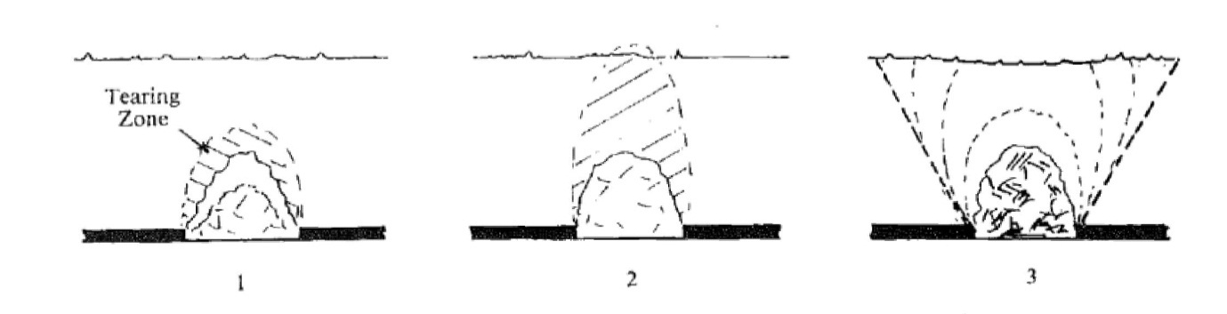
© Copyright, Rziha 1882
Figure 6.1 Dome concept of overburden disturbance.
Mining subsidence studies in Germany appear to have started with Schulz (1867, cited in Whittaker & Reddish 1989), who considered the angles of fracture toward the surface. Hausse (1885, cited in Whittaker & Reddish 1989) put forward the theory of ‘break angles’ of differing significance.
In a remarkably perceptive paper, Fayol (1885, cited in Whittaker & Reddish 1989) identified many significant aspects of mining subsidence that remain entirely consistent with current understanding today, including that:
- movement is transmitted to the surface from all depths of workings
- surface effects become minimal, below a certain depth
- movements become increasingly feeble as they progress upwards from the working level
- subsidence always occurs vertically above mine workings
- subsidence occurs within limits drawn from the edge of workings
- packing (stowing) of mined-out areas reduces the effects of subsidence and affords protection to the surface.
Fayol further concluded, from various experiments and lengthy investigations, that caving around a working face gave rise to an active zone of limited extent that controlled how subsidence developed behind the extraction.
Early British investigators Dixon (1885, cited in Whittaker & Reddish 1989) and Dickinson (1898, cited in Whittaker & Reddish 1989) recognised the existence of a leading and following wave of surface disturbance and the concept of angle of draw that should vary with the strength of the overburden strata. Trompeter (1899, cited in Whittaker & Reddish 1989) drew attention to the horizontal effects of mining subsidence and the role of rock movements in the immediate vicinity of the extraction.
Halbaum (1903, 1905, cited in Whittaker & Reddish 1989) endeavoured to standardise the terminology and bring increased clarity to the understanding of subsidence by considering the subsiding strata to be a cantilever, which continued to promote the concept of a line of break and an angle of draw. Figure 6.2 represents the zones of deformation within the overburden strata as conceptualised by Halbaum.
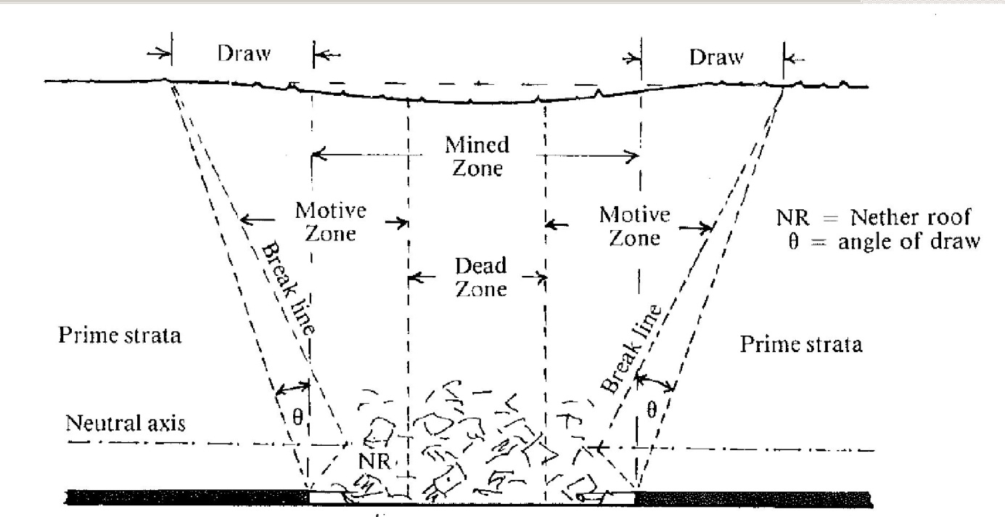
© Copyright, Halbaum 1905
Figure 6.2 Zones of deformation conceptualised by Halbaum.
Hausse (1907, cited in Whittaker & Reddish 1989) published his findings from 20 years of studying mining subsidence in the German coalfields, presenting the concept of a ‘main break’ over the extraction panel and an ‘after break’ over unmined coal being responsible for defining the limits of mining subsidence.
Goldreich (1913, cited in Whittaker & Reddish 1989) published a major work that discusses various theories of the period and the results of observations made in the Ostrau-Karwin Coalfield of Czechoslovakia.
Knox (1913, cited in Whittaker & Reddish 1989) recognised a range of factors influencing subsidence behaviour, including several that had not previously been associated with subsidence movements such as surface contour and the nature of the in situ stress field.
Young and Stoek (1916, cited in Whittaker & Reddish 1989) report on an extensive study aimed at addressing concerns in North America over subsidence at shallow depth above pillar panels. However, they point out that field data in the United States were very sparse and most of the available field data were sourced from Europe.
Briggs (1929, cited in Whittaker & Reddish 1989) and Lane and Roberts (1929, cited in Whittaker & Reddish 1989) give a comprehensive review of the state of the art of mining subsidence at the time. A range of formulae were developed in an attempt to give an approximate assessment of the magnitude of subsidence, including those by O’Donahue (1907, cited in Whittaker & Reddish 1989), Louis (1922, cited in Whittaker & Reddish 1989) and Briggs (1929, cited in Whittaker & Reddish 1989), but, as Grond (1953, cited in Whittaker & Reddish 1989) noted, none take into account the width of extraction and are ‘therefore patently defective’ and not suitable for universal application because they appear to have been developed for a particular set of circumstances and mining layout.
The concept of a straight line from the edge of extraction through to the surface at the limit of subsidence is generally shown to be straight. Groothoff (1922, cited in Whittaker & Reddish 1989) suggested that this line should not necessarily be straight and should reflect the geological setting and, in the Dutch context, the presence of a significant thickness of saturated sands.
Since about 1930, the focus of subsidence research efforts seems to have shifted towards the development of subsidence prediction methods and attempts to match theoretical models of ground behaviour with surface subsidence data. The concepts of a zone of movement defined by an angle of draw and bending of the rock strata (Peng 1992) seem to have become entrenched in the development of various conceptual models of overburden caving behaviour.
The concept that the height of caving (disturbed ground) is entirely limited by bulking of the broken strata and that this height therefore restricts further deformation higher in the overburden strata, unrelated to panel width, also seems to have gained traction during this period. This is despite (or perhaps because of) the complete disconnection between the disturbance underground at the mining horizon and surface subsidence implied by this concept and the earlier observations of Grond (1953, cited in Whittaker & Reddish 1989).
Farmer and Altounynan (1980) report that the zone of fracturing as defined by vertical dilation of 2.5 mm/m extends at least half the face distance above the mining horizon, so there was evidence of quantifiable disturbance beyond a few multiples of seam thickness by this time, consistent with earlier models forwarded by Rhiza (1892, cited in Whittaker & Reddish 1989) and Fayol (1885, cited in Whittaker & Reddish 1989). However, the continued acceptance of the concept of bulking as the basis for restricting subsequent vertical dilation in the overburden strata above the goaf is evidenced by the numerous references in the literature of the time to the height of caving being a function expressed only in terms of seam thickness and not panel width.
The definition of the height of caving is not precise. To some it may represent the height of the pile of clearly disjointed rock debris immediately above the mining horizon and to others the height of intense rock fracturing that may extend through to the surface.
Forster and Enever (1992) cite a list of studies that examined the mechanics of strata deformation both in Australia and overseas, including Bhattacharya and Gurtunca (1984), Galvin (1987a,b), Kapp and Williams (1972), Singh and Kendorski (1981), Whitworth (1982), Wardell (1975), Kesseru (1984, cited in Forster & Enever 1992), Kesseru et al. (1987, cited in Forster & Enever 1992), Morton (1976), Orchard (1969, cited in Forster & Enever 1992) and Kratzsch (1983). (See Appendix B for additional detail on some of these references.)
The model forwarded by Galvin (1987a) is consistent with numerical modelling capability at that time and shows zones of tension and zones of compression around the excavation that would be expected in a continuum of uniform elastic material.
Depictions that show caving are characterised by a caved/collapsed zone that is based on the mined seam thickness ‘T’. The caved zone is thought to extend a distance of between 3T– where T is the seam thickness mined–(Singh & Kendorski 1981) and 5T (Wardell 1975) above the mining horizon, and bedding plane separation occurs up to about 10T (Wardell) to 58T (Singh & Kendorski)–about 150 m above the mining horizon for a 2.5-m thick seam. Somewhat surprisingly, the height of disturbance is not recognised as having a relationship to panel width. This may be because they are intended to represent supercritical subsidence behaviour, where full subsidence has developed independent of panel width, but the representation of the distribution of surface subsidence then becomes less realistic.
Kapp and Williams (1972) show depictions where the shape of the disturbed zone is more extensive and approximately equal to panel width. Orchard (1974) shows an area directly above the extracted panel that shows the zones affected by mining as extending through to the surface.
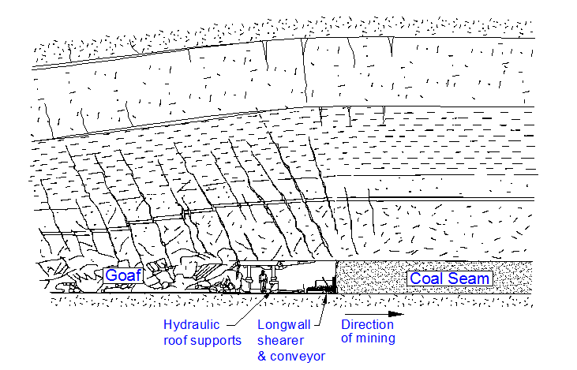
Other depictions that are in common use are shown in Figures 6.3 to 6.6.
© Copyright, MSEC 2007
Figure 6.3 Conceptual view of conditions at a longwall face.

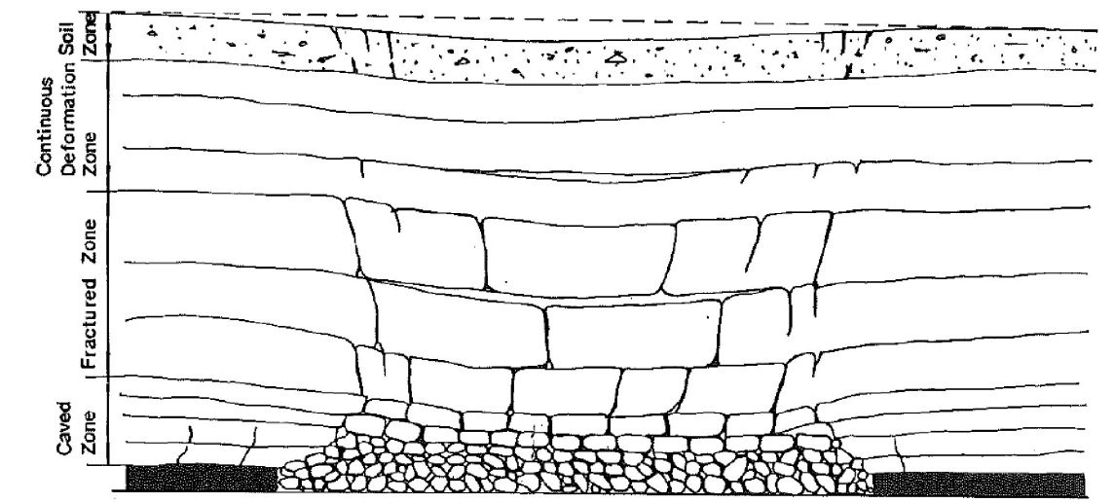
© Copyright, Peng & Chiang 1984
Figure 6.4 Depictions of subsurface ground movement in common use.

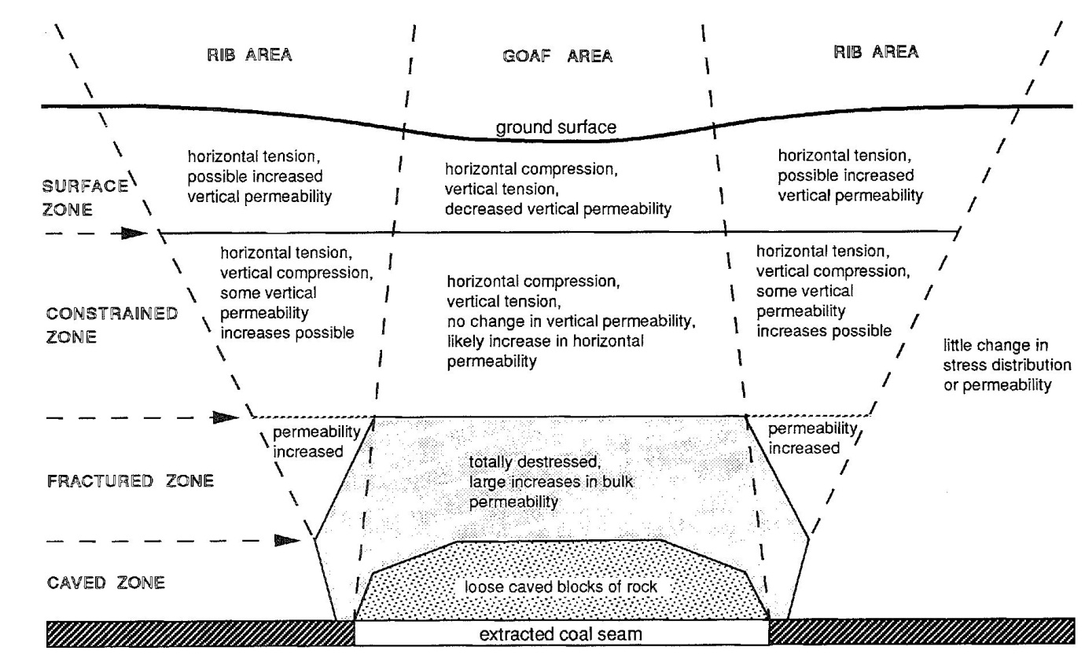
© Copyright, Forster & Enever 1992
Figure 6.5 Theoretical stress distribution and hydrogeological model.
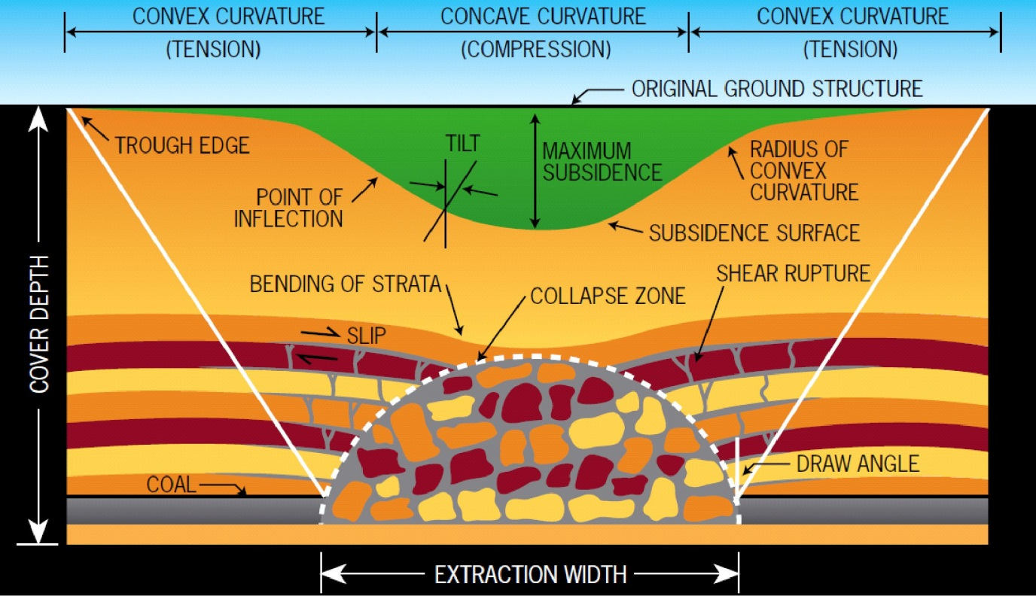
© Copyright, Mine Subsidence Board 2007
Figure 6.6 Depictions of subsurface ground movement in common use.
The common characteristics of these models are the zone of highly disturbed strata immediately above the coal seam, a tendency to understate the zone of vertical disturbance above each panel and a surface subsidence trough that extends well outside the extraction area, giving the impression that a significant part of the ground movements associated with subsidence occurs outside the panel boundaries.
This third characteristic illustrates how the depictions of subsurface movement can unintentionally convey concepts that are not reflective of the reality. In most longwall mining operations in Australia, the vertical subsidence at the goaf edge is typically less than 100 mm, and more generally in the range 50—250 mm depending mainly on overburden depth and geological stratigraphy. For supercritical width panels, maximum subsidence is typically in the range 1.2–2.0 m. Thus subsidence at the solid goaf edge of supercritical width longwall panels is typically less than 0.1 times the maximum subsidence, particularly in the mid-depth to shallow-depth range (such as in the Western Coalfield; Holla 1991). Goaf edge subsidence ranges from 0.1 to 0.25 times the maximum subsidence in the Southern Coalfield (Holla & Barclay 2000), but there are few circumstances where peat swamps are located that the mining depths and panel widths are suitable to create supercritical width subsidence. The differences in the depictions compared with actual subsidence behaviour is significant, because although the depictions indicate a high proportion of vertical subsidence occurs outside the limits of the panel, the actual vertical ground movements outside the limits of the panel are relatively small compared with the ground movements directly above each panel.
This section has focused on the early developments in understanding of caving processes above extraction panels and the evolution of concepts. A large number of more recent studies in the last decade or so have added significantly to the understanding of the mechanics involved. These are discussed further in the following sections.

Physical models
Before computer modelling became powerful enough and routinely available for analysing mining problems, two-dimensional physical models were created to investigate ground movements around longwall panels using various combinations of sand, plaster and water to try to simulate the natural materials (Whittaker et al. 1985; Wold 1984). Other models have used gelatine or plaster materials in a centrifuge Whittaker and Reddish (1989).
Figures 6.7 and 6.8 illustrate two examples of physical models that have several notable characteristics:
- overhanging ground deformations on both sides of the excavation
- highly disturbed ground with open fractures and voids adjacent to, but within, the boundaries of the panel
- low magnitude of ground deformations outside the boundaries of the panel
- complete absence of ‘bending’ as defined by the structural engineering principle that plane sections remain plane–the basis for the development and application of bending formulae and bending-related concepts used in engineering practice.
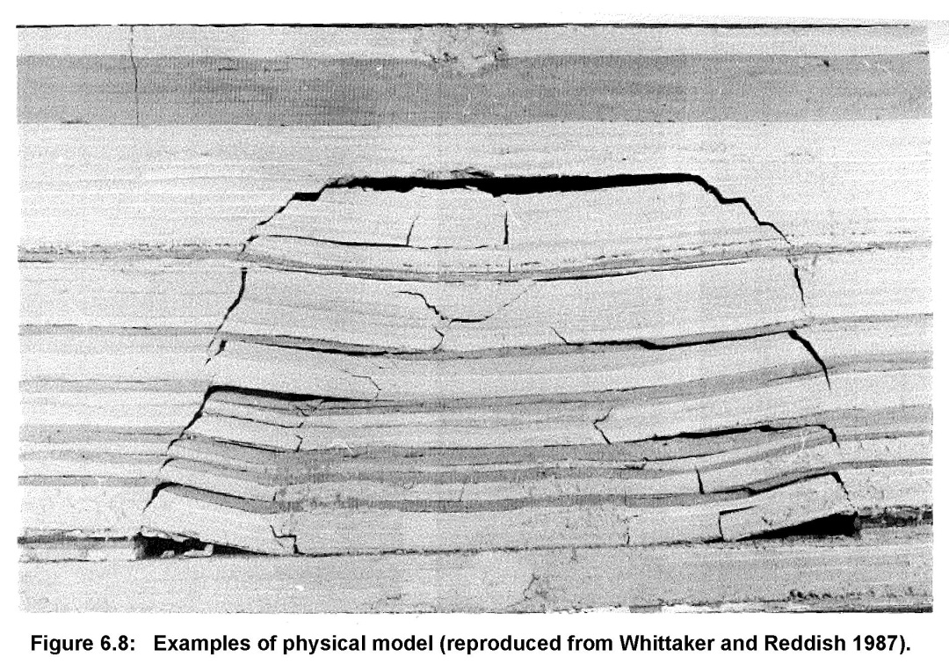
© Copyright, Whittaker & Reddish 1989
Figure 6.7 Example of a physical model.
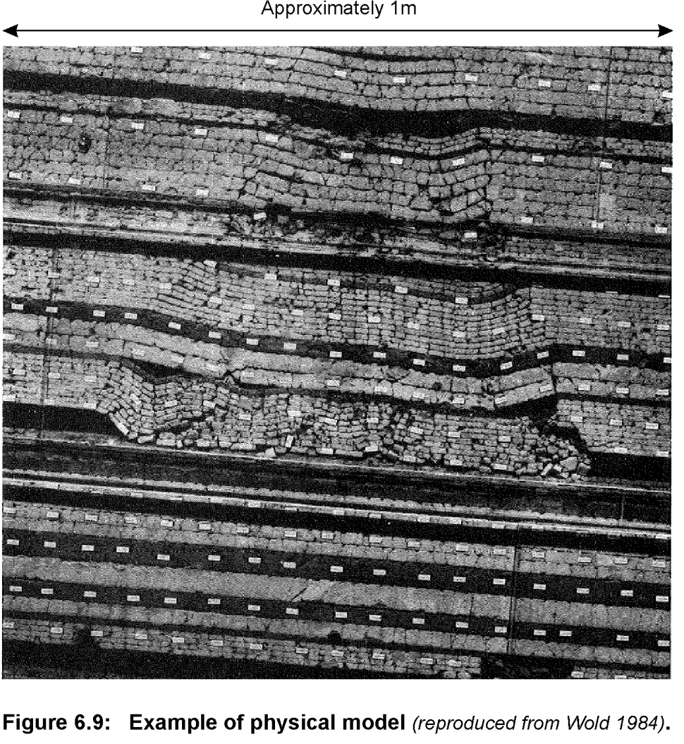
© Copyright, Wold 1984
Figure 6.8 Example of a physical model.
Despite the characteristic behaviours indicated by these physical models and their similarity with real-world observations of ground deformations around roadway entries exposed in open-cut mining highwalls at shallow depth—for example, see Figure 6.9—translation of these characteristics into conceptual models of ground behaviour above extraction panels seems to have been sporadic.
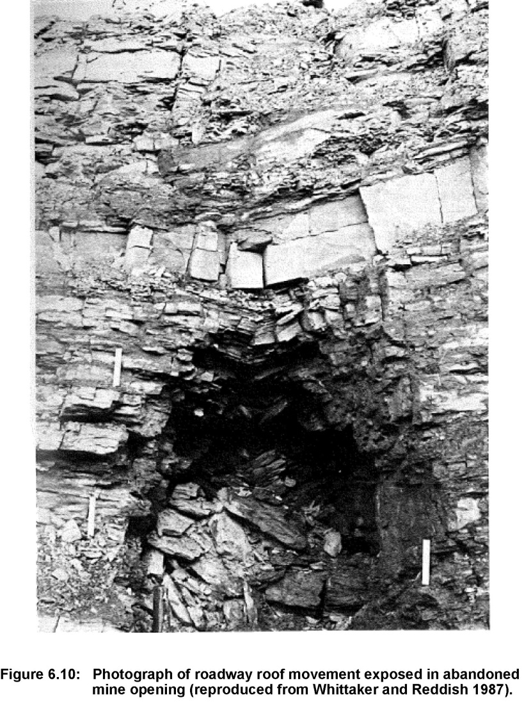
© Copyright, Whittaker & Reddish 1989
Figure 6.9 Photograph of roadway roof movement exposed in an abandoned mine opening.
The overhang of the strata on the sides of the excavation is consistent with Hausse’s (1907, cited in Whittaker & Reddish 1989) ‘main break’, and the central shape of the zone of deformation is consistent with the paraboloid shape proposed during the early stages of subsidence by Rziha (1882), including the zone of tearing around the edges. However, the ‘after break’ or ‘angle of draw’ concepts, although useful in the context of defining the extent of subsidence at the surface, are clearly indicated by these physical models as being relatively insignificant compared with the changes that occur directly over the extracted void.

Numerical models
The development of more and more sophisticated numerical models since the 1960s has made it possible to represent the characteristics of the rock strata in increasing detail. Various theoretical models have been devised based on simplifying assumptions, such as material elasticity and representation of the strata as a series of plates that bend in three dimensions. Although such assumptions are convenient from a numerical modelling perspective, the correlation with actual behaviour can be less than ideal and the mechanics of the numerical models fundamentally different from the reality of caving observed in practice.
As an example, in 1987, the New South Wales Department of Minerals and Energy initiated a study to assess the ability of available mathematical models to predict coalmining-induced surface and subsurface subsidence (Kay 1990). Thirteen organisations participated in the study to predict subsidence over two longwall panels at Angus Place Colliery. A range of site-specific geomechanical data for the overburden and field monitoring were gathered and made available to the participating groups. The task was to predict the surface and subsurface movements before knowing the monitored ground movements and then compare these predictions with actual measurements for first one and then two adjacent longwall panels.
The study highlighted many aspects and complexities of typical longwall subsidence and strata ground movements. Models generally overestimated rib-side subsidence (edge of panel) and underestimated mid-panel subsidence, with predictions generally within 50 per cent of the monitored subsidence. No model predicted horizontal movement or strains well, and the study did not discuss how the models predicted the subsurface ground behaviour.
Since that study, there have been ongoing developments in modelling capability, with most models continuing to use numerically convenient assumptions of ground behaviour to try to match actual subsidence behaviour. Relatively few models endeavour to replicate the actual mechanical processes of caving. Gale (2004, 2011) reports on successes using finite difference models that aim to capture actual rock behaviour through the complex interactions associated with caving processes and eventual subsidence (see note 2 at the end of the chapter).
Most of the numerical modelling effort seems to be directed towards approximating the overburden behaviour in a way that simplifies the numerical computation rather than capturing the essence of the caving processes. The representation of the overburden strata as essentially elastic media—as a series of beams subject to bending in two dimensions or as a vertical stack of plates subject to three-dimensional bending—is relatively common. Finite element and finite difference models offer the potential to more effectively model behaviour of the material, but only a limited selection of constitutive models have characteristics that closely approximate the complex nature of the multiple modes of failure that occur in real subsidence processes. Issues such as the significant shear softening caused by bedding planes and natural jointing that is commonly observed in the overburden strata are usually difficult to model successfully using readily available constitutive models.

Influence of empirical subsidence prediction
Empirical methods for predicting subsidence have found wide acceptance; they are very suitable for predicting subsidence behaviour, particularly as the database of examples expands. Notable examples of empirical methods include:
- the National Coal Board subsidence engineers’ handbook ( 1975) in the United Kingdom
- the guidelines published by Holla (1985, 1987, 1991) for three coalfields in New South Wales
- the incremental profile method developed and applied by Waddington and Kay in Australia since 1994 (Waddington & Kay 1995, 1998).
These empirical methods are based on using existing experience of subsidence monitoring to predict future subsidence in similar circumstances. The regulatory requirements to routinely gather and analyse subsidence data above longwall panels in Australia and elsewhere adds greatly to the information available to support an approach based on empirical predictions. The use of empirical methods is discussed in a number of sections in this report in the context of determining the key characteristics of surface subsidence behaviour.
A general drawback of empirical approaches is that they tend to be weak in developing understanding of the mechanics of the processes that cause subsidence movements, relying for their success on identifying patterns of behaviour from as broad a base as possible. As a result, there can be a tendency for unintentionally inaccurate representations of the subsurface caving behaviour to become part of the established understanding. Empirical modelling of surface subsidence tends to be a practical method of predicting subsidence in similar circumstances to the information used, because predictions are routinely matched against real data. The same rigour is not usually possible for confirming subsurface behaviour. For this confirmation, a broad range of field measurements are required.
Notwithstanding some of the limitations of inferring subsurface behaviour from observations of surface subsidence, the subsidence behaviour observed on the surface must be consistent with and reflective of the caving behaviour. Observations of surface subsidence provide very useful insights into subsurface caving behaviour.

Field measurements of subsurface caving behaviour
Field measurements of subsurface caving behaviour include a wide range of different techniques, each of which provides insight into the nature of the caving processes and how the ground moves and stabilises following subsidence (Mills 2011). Field measurements of subsurface caving behaviour rely heavily on techniques that can be deployed from surface boreholes. These techniques are discussed in more detail in Chapter 10 and include:
- surface extensometer monitoring using multiple anchors at different elevations within the overburden strata to monitor downward movement as mining progresses
- shear monitoring systems to detect the locations of shear horizons that are mobilised by subsidence-related ground movements. These systems include inclinometers and time domain reflectometry (TDR) systems
- comparative fracture intensity logging in boreholes drilled over longwall goafs and nearby boreholes in undisturbed strata; core logging and borehole geophysical logging are both useful
- direct inspection of the borehole wall to detect fractures and fracture aperture using borehole cameras or acoustic scanners
- comparative hydraulic conductivity testing (packer testing) in boreholes drilled over longwall goafs and nearby boreholes in undisturbed ground
- monitoring changes in piezometric pressure through the overburden sequence using strings of piezometers fully grouted into the borehole.
Other more remote techniques include:
- interpreting surface subsidence monitoring which, while sensitive to the assumed model of ground movement, is nevertheless very helpful in investigating subsurface caving behaviour
- microseismic monitoring of caving activity within the overburden strata, which has proved effective where compressive rock failure occurs, tending to be less sensitive to low-energy release tensile failures (Gale 2001)
- three-dimensional seismic surveying of goaf development, which is emerging as a useful technique for defining the extent of caving processes.
Better understanding typically requires a significant effort and a range of different field measurements. Galvin (1987b) notes that ‘In many areas of subsidence engineering, Australia is at the forefront. However, it lags behind many of its overseas competitors as far as the quantification of subsurface behaviour is concerned. This is primarily due to a lack of borehole extensometer data.’ Fortunately, the Australian underground coal industry appears to have responded to Galvin’s observations. Since the mid-1980s, there has been a strong focus on obtaining field measurements of subsurface caving behaviour to match the experience reported by, for example, Schumann (1993) in South Africa and Peng (1992) in the United States.
With improvements in the capability of borehole systems in recent decades, the capacity to observe and measure subsurface ground movements associated with longwall mining has increased significantly, resulting in a clearer understanding of the caving processes involved.

Significant field studies of subsurface caving behaviour
In recent decades, the Australian coal industry has undertaken a number of studies to better understand the interaction of underground coalmining and caving behaviour within the overburden strata. Many of these studies are available in the public domain and form the basis for the discussions in this section. Numerous other studies have been undertaken for operational purposes such as mine design, protection of specific infrastructure or protection of specific natural features. Although not all of these studies are available in the public domain, they nevertheless increase the understanding of subsurface caving behaviour and have helped guide the development of conceptual models of ground behaviour and instrumentation systems useful for measuring this behaviour.

Reynolds inquiry
Reynolds (1977) reports on an extensive study of the factors influencing hydraulic interactions above underground coalmining operations during an inquiry for the Supreme Court of New South Wales into coalmining under stored waters in the Southern Coalfield. As well as providing a summary of worldwide experience of mining under stored waters, the inquiry undertook some field experiments and tests that compared the condition of the overburden strata at two nearby locations: one directly over a 117 m wide pillar extraction goaf at Kemira Colliery and the other in an unmined area nearby. As a result of these experiments and other observations, Reynolds made some significant observations on the nature of caving processes above coal extraction operations in Australia and the steps necessary to prevent hydraulic connection with the surface.
One key observation was that a high level of fracturing in core recovered from a borehole drilled over a pillar extraction goaf was evident below about 110 m above the mining horizon (i.e. just less than one panel width above the mining horizon). Reynolds recorded ‘…there was heavy fracturing which must be attributed to mining’, ‘Below this … to the base of the hole … appeared the most intensely fractured section of the hole’, and ‘if water had access in the lower section of the hole [96 m above the mining horizon] vertical drainage would exist to the workings’.
On the basis of these and other observations, Reynolds recognised that ‘… the problems related to partial extraction and permeability cannot be dealt with or solved by the application of a simple proposition that three zones will be created in the overburden of which the central is tightly constrained and impervious’. However, he also recognised that there is a point above the mining horizon where, for practical purposes, the effects of mining do not significantly change the vertical permeability of the rock strata.
Reynolds recommended that at depths of cover not less than 120 m, partial extraction of coal by the panel and pillar method, an analogue of later longwall mining techniques, may be carried out provided that panel sizes do not exceed one-third of the depth of cover and pillar sizes are of a length co-extensive with that of the panel extracted and of a width not less than one-fifth of the depth of cover or fifteen times the height of extraction, whichever is the greater. Although these recommendations were not directly integrated into a legislative framework by the New South Wales Government, they did lead to the appointment of a Principal Subsidence Engineer and of the Dams Safety Committee, both of which have been closely involved in regulating mining activity and surface impacts (in the case of the latter, around stored waters) ever since.

Research by Department of New South Wales Mineral Resources
In the role of Principal Subsidence Engineer for the NSW Government during the 1980s and 1990s, Holla undertook a series of field investigations and compiled a significant body of work relating to subsidence and subsurface caving behaviour in the state. Three subsidence guidelines were produced: the Southern Coalfield (Holla 1985), the Newcastle Coalfield (Holla 1987) and the Western Coalfield (Holla 1991). They provide a summary of experience of surface subsidence and remain a benchmark for subsidence predictions in New South Wales.
A comprehensive investigation into aspects of subsurface subsidence in strata undermined by longwall mining was initiated in 1984 by the then Department of Mineral Resources. Field studies were conducted in three major coalfields, in different geological environments and at a range of mining depths. Subsurface investigations were conducted at Ellalong Colliery (Holla & Armstrong 1986), Tahmoor Colliery (Holla & Buizen 1991), and Wyee and Invincible collieries (Holla 1989).
As an example relevant to the Southern Coalfield, Holla and Buizen (1991) monitored a surface extensometer above a retreating longwall panel at Tahmoor Colliery, and measured fracture frequency from core and hydraulic conductivity using packer tests before and after mining. The longwall panel was 192 m wide, including the gateroads, and the mining horizon was 424 m below the surface. The extensometer extended to about 260 m above the mining horizon (1.4 times panel width). Holla and Buizen reported fractured rock (as defined by vertical strains of greater than 2.5 mm/m) to about 300 m above the mining horizon (about 1.6 times panel width). They noted an increase in fracture frequency, particularly in the zone of nominally fractured rock, and a significant increase in permeability, although not uniformly and not necessarily vertically continuous. They also noted that the upper part of the overburden strata panel width appeared to move down en masse as the adjacent panel was mined. Holla and Barclay (2000) provide a further analysis of the monitoring at Tahmoor.
Similar investigations at the other sites produced results that were essentially similar to those observed at Tahmoor. A highly disturbed zone was evident immediately above the mining horizon to a height of about 10 times the seam thickness, with disturbance throughout the overburden strata at shallow depths, and a zone of substantially undisturbed strata was near the surface at greater depth. At Wyee Colliery (Holla & Buizen 1990) the hydraulic conductivity of the overburden strata measured in a packer test increased from a background pre-mining level of 1 × 10^{–8}m/s to more than 1 × 10^{–5}m/s (the effective upper limit of the packer gear).
The results of the Reynolds inquiry and studies by the then Department of Mineral Resources are among the first to quantifiably underpin the understanding of ground deformation above longwall panels. These results have been supported by numerous studies since, and form the basis of current knowledge of ground deformation above longwall panels, which is discussed in Section 6.8.

Hydrogeological response of overburden strata at Wyee Colliery
Forster and Enever (1992) report on a significant field project aimed at measuring changes to the pore-pressure distribution above a longwall panel at Wyee Colliery (Central Coast, New South Wales) as it was mined. The fieldwork component of the project appears to have been limited by the complexity of the site, which had previously been mined in an upper seam using pillar extraction, loss of a critical borehole during the fieldwork and limitations of the then state-of-the-art pore-pressure monitoring system. Despite these limitations, the diagram depicting a theoretical stress and hydrogeological model of the various zones within the overburden strata (Figure 6.5) has become widely adopted as representing the nature of subsurface ground movements near longwall panels.
Forster and Enever (1992) warn that their proposed geological model is based on limited data and caution should be exercised in applying the results to specific sites. Nevertheless, the model is a significant advance in defining the characteristics of the different zones in the overburden strata. The model does not have any scale in relationship to height above the mining horizon or recognise any relationship between the height of the various zones above the mining height and panel width. However, by adjusting the vertical scale to match the zone of total destressing with panel width, the zones identified in the model correlate well with the zones identified from field monitoring at a broad range of sites and from subsidence monitoring.

Overburden monitoring at Clarence Colliery
Mills and O’Grady (1998) report on a field study conducted at Clarence Colliery over two longwall panels of different widths to measure the height and shape of the zone of disturbance. The study showed that a zone of large downward movement (<0.5 m)—developed at a height above the mining horizon approximately equal to the panel width and the shape of the zone of large downward movement—was approximately a paraboloid, similar to the shape observed in physical model studies. The study also showed that there must be large, open voids created within the overburden strata around the sides of the zone of large downward movement and potentially also at the top of it (in the sandstone strata at this site).

Overburden monitoring at South Bulli Colliery
Byrnes (1999) describes the results of a study at the then South Bulli Colliery above a series of 110–120-m wide longwall panels. The study included installation of multiple piezometers directly above the longwall panels. These piezometers provide one of the first vertical profiles of pore pressure directly above a longwall goaf. They indicated that the maximum height of interconnected fractures, as indicated by complete drawdown in the piezometric profile, was approximately 120 m and therefore approximately equal to the width of the longwall panels.

Other field studies
Numerous other studies in the last decade or so have been aimed at better understanding longwall caving processes in specific conditions, such as at shallow depth (Seedsman 2006), and particularly in relation to water inflows (Klenowski 2000; Gale 2008). These studies are discussed in more detail in Chapter 8 in the context of groundwater interactions.

Caving processes implied by subsidence monitoring
Vertical subsidence monitoring provides an insight into the nature of caving processes by combining subsidence observations at a range of overburden depths and longwall panel widths. In this section, the implications of vertical subsidence monitoring are presented as a basis for more generally characterising overburden behaviour near longwall panels. As discussed in Chapter 5, vertical subsidence in single seam longwall operations can be divided into two essentially different components (Mills 1998):
- sag subsidence over each individual panel
- elastic strata compression of the chain pillars and the strata above and below.
The division of subsidence components into these two categories is helpful in the context of the behaviour of the overburden strata that each implies.
Sag subsidence occurs as downward movement of the materials over the void created by each individual longwall panel as the overburden is unable to bridge the panel. Sag subsidence represents the zone where rock strata is stretched vertically as a result of the underlying support being removed. Elastic compression subsidence, on the other hand, is associated with compressive vertical loading of the unmined coal that remains around the extracted void. The overburden strata above the unmined coal and in the overhang zone above the edge of each panel is vertically compressed. The difference in hydrogeological response of the rock strata in these two different zones, one stretched vertically and the other compressed vertically, is significant.

Implications of sag subsidence
The general form of the sag subsidence behaviour is shown in Figure 5.3. This characteristic form is observed in a wide range of geological settings—for example, Holla and Barclay (2000) for Southern Coalfield, Misich et al. (1992) for Collie Basin and Kapp (1985) for Newcastle Coalfield. The similarity across multiple sites implies a fundamental characteristic that is common to the subsidence process. Small shifts in the characteristic curve occur as a result of changes in horizontal stress magnitude within the overburden strata and changes in the nature of the overburden strata. The nature of these small shifts, associated with increasing horizontal stress and changes in overburden geology, provide further confirmation of the caving processes involved.
Figure 6.10 shows a more intuitive way of presenting the same data shown in Figure 5.3. Depth is plotted on the vertical axis as depth over panel width. Subsidence is plotted on the horizontal axis as the ratio of maximum subsidence to seam thickness mined, in the same format as vertical deformations measured by a surface extensometer would be plotted. The different stages of ground behaviour are apparent as a function of height above the mining horizon divided by panel width. The data presented by Tobin (1998) are also plotted to show the effect that changes in horizontal stress have on the height of caving.

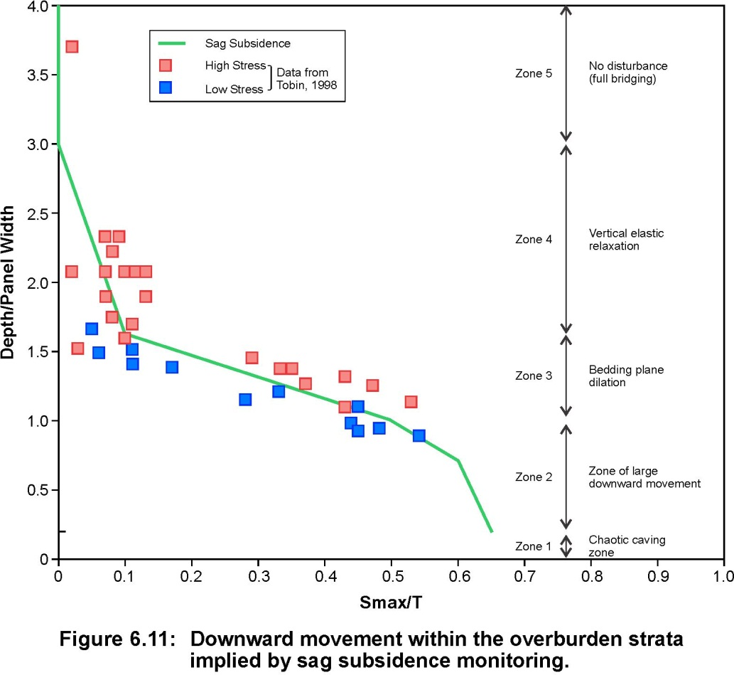
Figure 6.10 Downward movement with the overburden strata implied by sag subsidence monitoring.
Synthesising the subsidence data from different sites with a variety of different overburden depth to panel width ratios, as shown in Figure 6.10, provides a plot of ground movement in a composite overburden section. This composite shows that the ground movements above each panel can be divided into five zones starting:
- a zone above 3.0 times panel width where there is no significant vertical subsidence (zone 5)
- a zone of minor ground movements from 1.6 to 3.0 times panel width above the mining horizon (zone 4)
- a zone of transitional ground movement from about 1.0 to 1.6 times panel width above the mining horizon (zone 3) that correlates with bedding plane separation
- a zone of large downward movement from seam level to a height above the mining horizon approximately equal to or slightly less than the panel width (zone 2), where there is high-intensity shear fracturing
- a zone immediately adjacent to the mining horizon that represents the chaotic disturbance evident immediately behind the longwall supports and is often referred to as the height of caving in the subsidence literature (zone 1). This zone is not represented in subsidence data because longwall mining does not occur at overburden depths less than 10–20 m.
A sixth zone overlies the chain pillars in the area where there are compressive deformations associated with elastic compression of the chain pillars.
A strong correlation exists between the heights of caving above longwall panels indicated by surface subsidence data and the observations for field measurements observed in the field. Reynolds (1977) observed significant fracturing to a height above the mining horizon of slightly less than the panel width. Mills and O’Grady (1998) found that the zone of large downward movement extended to a distance above the mining horizon, approximately equal to panel width in two panels of different width.
Byrnes (1999) reported interconnected fracturing to a height approximately equal to panel width. These reported zones correlate closely with zone 2.
At Tahmoor Colliery, Holla and Buizen (1991) reported vertical dilation of greater than 2.5 mm/m to a height above the mining horizon equal to 1.6 times panel width. Above this horizon, the ground appeared to move down en masse. The zone of dilation observed at Tahmoor correlates closely with zone 3, the zone of transitional ground movement associated with bedding plane separation.

Effect of horizontal stress
Subsidence data from Tobin (1998) reflecting horizontal stress are also plotted in Figure 6.10. These data relate to two groups of longwall panels located in essentially the same geological setting that are oriented at significantly different angles to the direction of major horizontal stress. The only difference is that the overburden strata above one set of panels is subject to much higher horizontal stress (red squares) than the overburden strata above the other panels (blue squares) where the horizontal stress across the panel is less. These data imply that the height of the zone of large downward movement is higher when the horizontal stresses acting across the panel are higher. This characteristic is similar to the experience of increased height of softening above underground roadways subject to increased horizontal stress reported by Gale (1986).
These results imply that surface subsidence is sensitive to the magnitude of horizontal stresses in the overburden strata above the longwall face. This sensitivity of subsidence to stress magnitude has been used to determine the direction of horizontal stress from bias in the subsidence profile in subcritical width panel geometries in much the same way as roadway deformations underground are sensitive to horizontal stress magnitude (Mills et al. 2011).
Greater subsidence is routinely observed at the start of longwall panels where the maximum subsidence is typically higher than further along the panel. This is because the full horizontal stress acts through the overburden strata at the start of the panel but is partially relieved by the goaf that has formed further along the panel.

Elastic compression zone
In addition to the five zones identified above each longwall panel, there is a sixth zone (zone 6) above each of the chain pillars that has distinctly different characteristics to the five zones directly above each longwall panel. Whereas the sag subsidence directly over each panel causes the ground to be fractured in horizontal shear and to be stretched vertically so that there is an increase in fracture volume within the overburden, the elastic strata compression over the chain pillars and around the solid edges of the longwall area cause the strata there to be vertically compressed so that fracture volume is reduced.
The interface between the zone of large downward movement and the less disturbed strata above and to the sides of this zone accommodates some relatively large differential movements for rock strata within a short distance. This interface zone is characterised by open shear fractures and fractures between rotated blocks of intact material.

Generalised model of overburden caving
Subsidence monitoring provides an indication of the height of the various deformation zones above each longwall panel. Extensometer monitoring presented by Mills and O’Grady (1998) indicates that the stretching zones over each longwall goaf are paraboloid or arch shaped—similar in profile to the doming-type roadway failures observed in an underground roof fall once all the fall material has been removed.
Based on this information, Figure 6.11 shows a visualisation of ground movement zones above a series of longwall panels. The vertical extent and general shape of the zones are shown; the edges of these various zones may be transitional. The chaotic zone (zone 1) extends to a height generally indicated in the literature as being about 10–15 times the seam thickness, although the boundaries of this zone with zone 2 are likely to be transitional. The zone of large downward movement (zone 2) is characterised by downward movement of more than about 0.5 m. The edges of this zone with the undisturbed strata in zone 6 are also transitional, although extensometer monitoring indicates the transition may occur over a relatively narrow zone of perhaps a few metres to tens of metres along the ‘main break’.

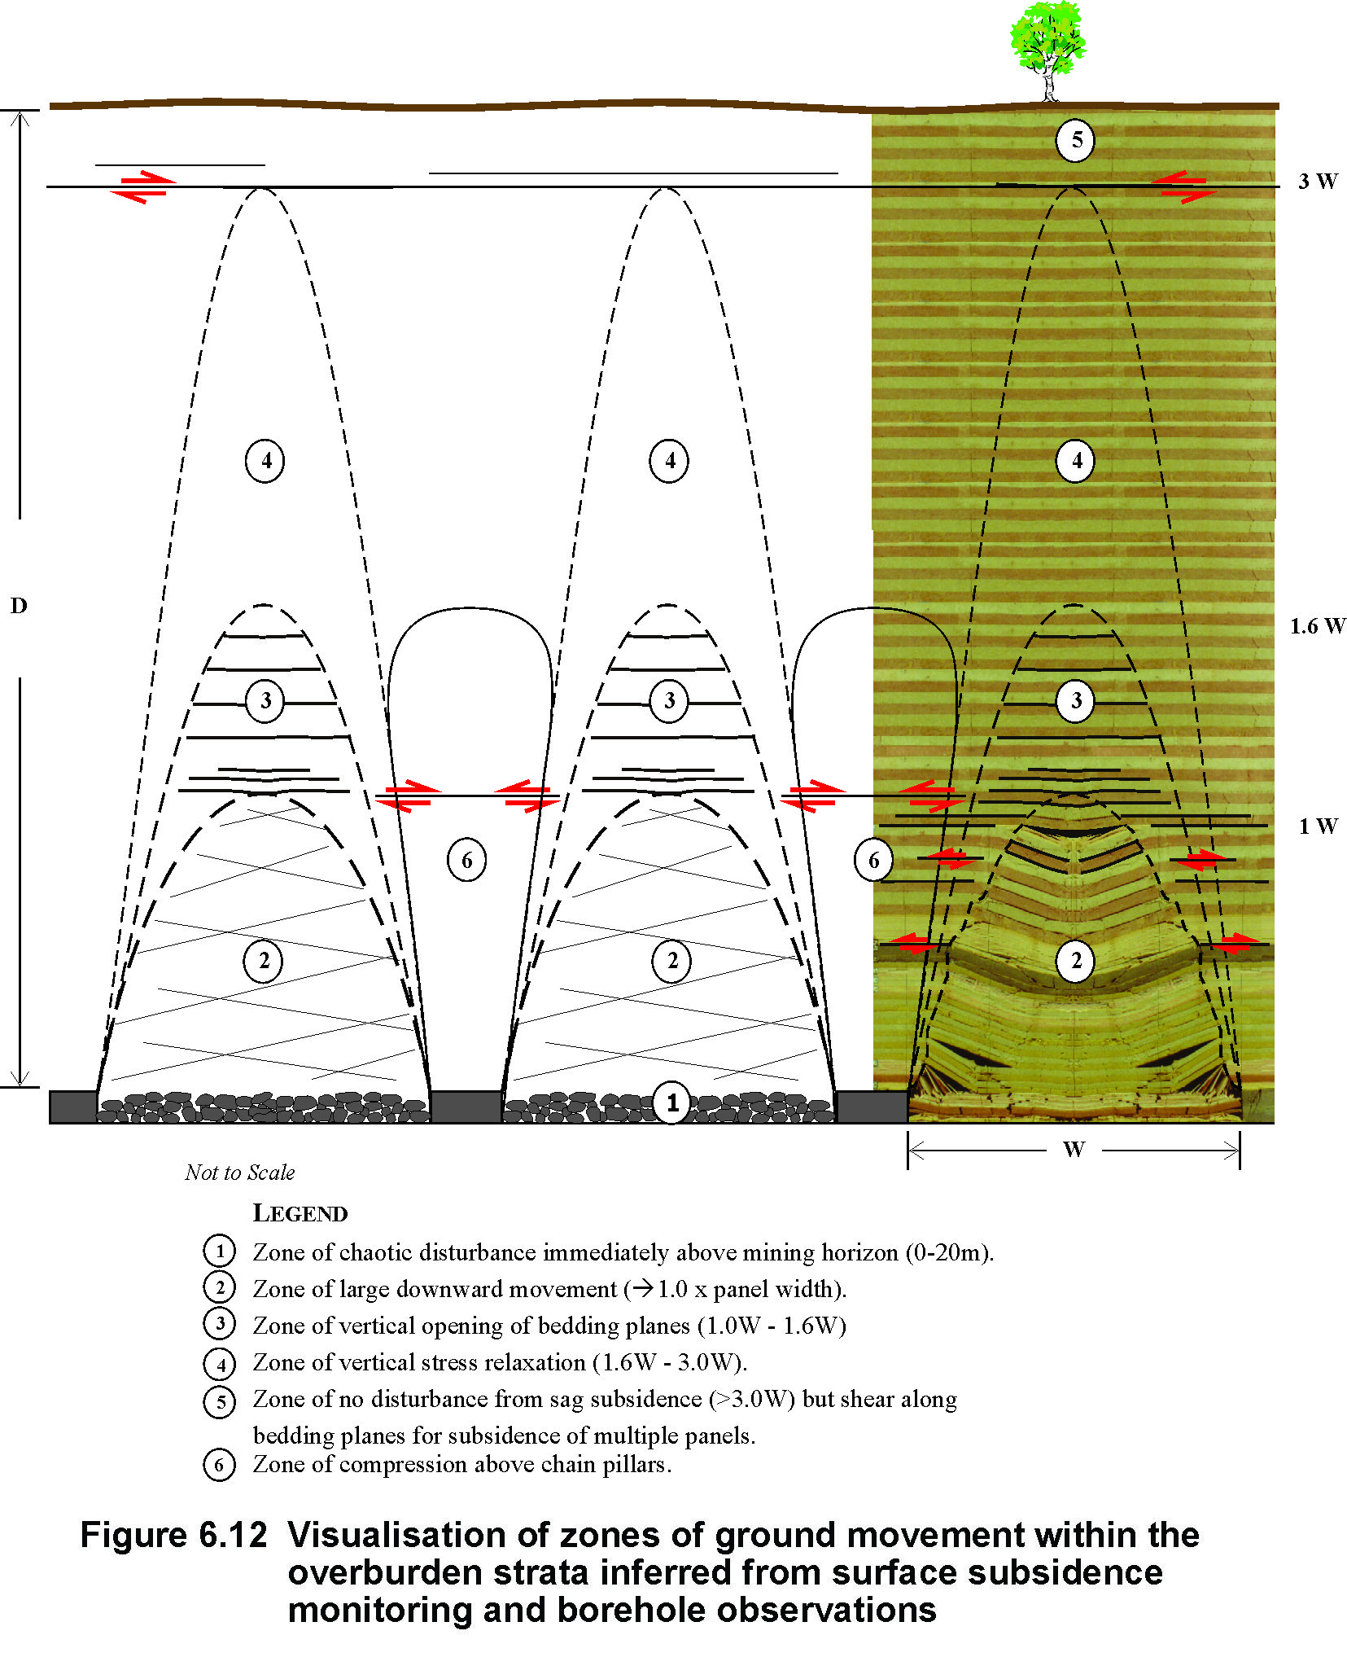

Figure 6.11 Zones of ground movement within the overburden strata inferred from surface subsidence monitoring and borehole observation.
The transition between zone 2 and the overlying zone of bedding plane separation (zone 3) appears to be quite sharp in some geological settings. This transition can be an open void where a bridging unit in the overburden strata coincides with the top of zone 2.
Zone 4 is characterised by elastic relaxation of the rock strata in a vertical direction. The rock strata that were supporting the zone 4 strata before mining have moved downwards and released the vertical stress in zone 4. The magnitude of elastic relaxation strains implied by the vertical subsidence data in zone 4 is consistent with the changes that would be required to reduce the pre-existing vertical stress to low levels.
Zone 5 is above the caving processes that are occurring above individual longwall panels. However, when trough subsidence is associated with the interaction of multiple panels, there is potential for lateral shear movements to occur on bedding planes as the overburden subsides. These shear movements have potential to dilate bedding planes and increase the horizontal conductivity of the overburden strata in zone 5. This increase is particularly significant when the surface topography is uneven because there is a tendency for the groundwater table to be flattened relative to the adjacent creek lines.
As discussed in the previous section, there is also a zone of elastic strata compression (zone 6) located above each of the chain pillars and above the solid abutments outside the footprint of the longwall panels. The increase in vertical compression in zone 6 is expected to reduce the hydraulic conductivity of the rock strata in this zone.
In Figure 6.11, a physical model of overburden behaviour superimposed onto zone 2 above one of the longwall panels shows that there is a reasonable correlation between the type of disturbance indicated in the physical model and the conceptual model.
Figure 6.12 shows the diagram presented by Forster and Enever (1992) for the Central Coast, stretched vertically until the top of the zone described as totally destressed is stretched vertically to correspond to the top of zone 2. A strong correlation then exists between the zones described by Forster and Enever and the various zones inferred from generalised subsidence monitoring and other information.
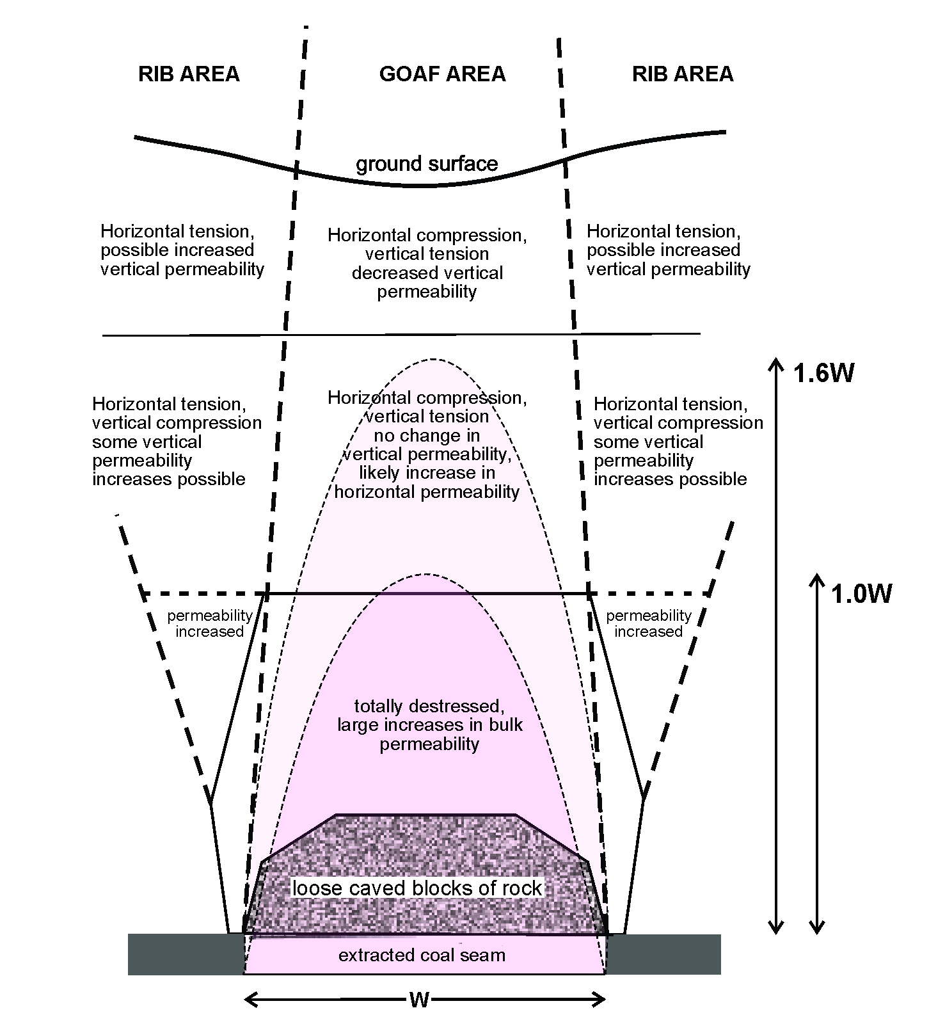
© Copyright, Forster and Enever 1992
Figure 6.12 Forster and Enever conceptualisation of overburden disturbance stretched vertically to coincide with experience measured more commonly.
Although there may be geological circumstances where the conceptual model presented in Figure 6.11 needs to modified, perhaps as a result of increased horizontal stress or bridging strata, the model nevertheless is considered to represent a state-of-the-art visualisation of the zones of ground movement near extracted longwall panels. It provides a starting point for refinement based on site-specific information, but in the absence of other information appears to be consistent with subsidence and other experience from a broad range of different geological settings. (See note 3 at the end of the chapter.)
From a hydrogeological perspective, superimposing a vertically stretched Forster and Enever model, as shown in Figure 6.12, appears to overcome the shortcomings of the model as originally presented, which was insensitive to panel width.

Impacts of subsurface ground movements on groundwater
Groundwater impacts are discussed in more detail in Chapter 7, but it is useful to discuss the main mechanisms whereby groundwater is impacted by mining subsidence in the context of subsurface ground movements.
At the level of individual river channels, horizontal subsidence movements can cause fracturing of the sandstone strata in the base of the river channel so as to greatly increase its hydraulic conductivity and redirect flow from above-surface in river channels or near-surface, in the case of peat swamps, into the fractured strata within the top 6 m or so of the basal sandstone where it can flow laterally downstream to re-emerge on the surface again in areas where the strata is not fractured. The fracture network generated by this mechanism is typically limited to a corridor 20–40 m wide below the topographic low point and extends along the section of river channel subject to valley closure movements.
In the slopes above river channels, vertical subsidence movements cause the intact rock strata to expand laterally as a result of dilatancy. This expansion is expressed as horizontal movement in a downslope direction or valley closure, but the dilatancy that causes the expansion also causes an increase in the hydraulic conductivity of the rock strata that moves, particularly the rock strata subject to vertical subsidence directly above each panel. The dilatant horizontal movement is mainly concentrated in the strata above the basal shear plane that emerges in the valley, so increases in hydraulic conductivity are greatest above this horizon. In circumstances where the groundwater table is elevated above the adjacent river systems (i.e. in a gaining river system), the effect of an increase in hydraulic conductivity of the strata below the topographic high ground is to cause the elevated watertable in this area to be lowered and flattened. The fracture network generated by this mechanism is essentially limited to the rock strata above the level of adjacent topographic low points that have been mined under to cause vertical and horizontal ground movements.
In circumstances where subsurface ground movements induced by mining subsidence cause a significant increase in the hydraulic connection between the surface and the underground mining horizon, there is potential for more widespread drawdown of the near-surface groundwater table through increased downward flow into the mine. The rate of flow is sensitive to a broad range of factors and the potential for drawdown of the near-surface groundwater table through flow into the mine needs to be assessed on a site-by-site basis. However, a characteristic of this mechanism is that a large area extending well beyond the physical extent of the longwall panels has potential to be drawn down, with the greatest impact being directly above the longwall panels.

Summary of key concepts on overburden caving processes
- Longwall mining causes disturbance to the rock strata starting at the mining horizon and moves upwards through the overburden strata where it may reach the surface, depending on a range of factors such as longwall panel width, overburden depth, number of mined coal seams and thickness of mined coal seams.
- Six zones of disturbance from mine level to the surface are recognised in the conceptual model of overburden behaviour during subsidence. These zones are shown in Figure 6.11 and are:
  - zone 1–chaotic disturbance immediately above the mining horizon (0–20 m) where the rock caves into the mined area
  - zone 2–large downward movement of the rock mass extending to a height of up to 1 times the panel width
  - zone 3–vertical opening between bedding planes extending to a height of about 1 to 1.6 times the panel width
  - zone 4–vertical stress relaxation without fracturing, extending to a height of about 1.6 to 3 times the panel width
  - zone 5–no disturbance from sag subsidence over an individual panel but, with shearing along bedding planes, disturbance is associated with multipanel trough subsidence
  - zone 6–compression above and below the chain pillars that extends upwards and gradually outwards over each longwall panel through to the surface.
Measurements with instruments indicate that the caving in zones 1–4 is paraboloidal or arch shaped over the mined panel.
- The caving processes for longwall operations are essentially similar to those in deeper pillar extraction operations, providing the opportunity to study the recovery of peat swamps from longwall mining back to the 1970s and pillar extraction operations back to the 1920s.
- The caving process has been studied in detail at numerous sites in Australia using combinations of underground observations, physical models, numerical models and monitoring with instruments.

Peer review comments on Chapter 6
1. Tony Iannacchione comments: The authors affirm that the caving processes for longwall operations are essentially similar to those in deeper pillar extraction operations. This statement could be misleading. Most modern pillar recovery operations leave some portion of the coal pillar behind, often called a stump. There are also supports that are placed within the pillar recovery area that slightly change the behaviour of the caving strata.
2. Tony Iannacchione comments that he believes: Dr Winton Gale’s numerical models are among the most sophisticated and accurate modelling techniques for this problem. Future research would benefit greatly from one of Dr Gale’s simulations, especially to further explore the merits of the dilation concept discussed earlier and, more importantly, to fully understand the degree and nature of mining-induced fracture development near peat swamps. Dr Gale’s techniques rely on extensive analysis of rock core properties from a ‘typical’ geology in the area of interest.
3. Ross Seedsman suggests that the application of Voussoir beam concepts can be used to understand overburden caving processes. Voussoir beam analyses are used to assess the deflection of the beam, which is equivalent to the sag subsidence that is being considered. Input parameters include the span, the density and strength and deformation modulus of the intact rock, the thickness of the beam, and the weight of any material carried by the beam. Analyses based on this theory show a non-linear convex relationship between deflection and span that is similar to the trends seen in subcritical to critical maximum subsidence. As an insight to beam behaviour, at the limit of its stability a voussoir beam in typical sandstones/conglomerates may have a thickness that is approximately 10% of the span, and a deflection that is in the order of 1% to 2% of the span. Some key implications that follow from the application of voussoir beam concepts are:
- Vertical strains measured in boreholes may not be a good indicator of the fracturing of rock beams, and
- The thresholds for downward movement of 200 mm (Mills & O’Grady1998) or the 500 mm (Section 5.5.2.3) are arbitrary and do not reflect the onset of beam collapse.

Groundwater

Introduction
An understanding of pre-mining groundwater conditions within and beneath Temperate Highland Peat Swamps on Sandstone (the peat swamps) is essential for assessing impacts associated with longwall mining. Figure 7.1 provides an example of a longwall panel overlain by several peat swamps.
The peat swamps occur mostly over Mesozoic sandstones at high elevations to the south, west and north of the Sydney metropolitan area. In the Southern Coalfield the main swamp base stratum is Hawkesbury Sandstone; in the Western Coalfield it is Banks Wall Sandstone. Both strata are quartzose sandstones with similar hydraulic properties, although much more is known about Hawkesbury Sandstone.

Hydrological environment for peat swamp growth
Essential conditions for formation and survival of peat swamps are:
- impeded drainage at the floor of the substrate (a floor of low permeability clay or localised low-permeability rock). Vertical drainage of water from the peat must be minimal
- waterlogged conditions (limiting the amount of oxygen) and low temperatures, both of which reduce the rate of decomposition of vegetation in the substrate
- accumulation of organic matter faster than the rate of decomposition. Acidic conditions are an advantage.
To maintain waterlogged conditions, a swamp requires a location with high soil water credit (rainfall minus evaporation). The peat requires a quasi-continual, uninterrupted supply of water to avoid drying out. Much of the water supply comes from run-off or springflow. Groundwater accession (inflow) may also occur as a secondary recharge process. For a continual water supply to be available, the run-off behaviour must be advantageous for peat swamp development. Run-off patterns are dependent on regional topography and sedimentation. Sediment chokes can trap low-flow run-off. The swamps tend to occur at elevations of 600–700 m in the Southern Highlands.
The hydraulic properties of peat are:
- hydraulic conductivity
  - Quinton et al. (2008): horizontal conductivity (Kh) of 10 to 1000 m/day above 0.1 m depth, decreasing to 0.5 to 5 m/day below 0.2 m (more decomposed)
  - Wong et al. (2009): vertical conductivity (Kv) between 1 and 0.001 m/day (lower in amorphous peat, higher in fibrous peat)
  - Nichols (2008): 4.5 m/day from a two month peat bed test
- variable storativity; peat expands and contracts with increases and decreases in water content.

© Copyright, BHP 2007
Figure 7.1 A typical pattern of peat swamps in the area of Dendrobium and Elouera collieries; each square represents one square kilometre.

Examples of peat swamps and associated groundwater systems

Kangaloon
Ross (2009) reports on studies of the hydrogeology of 17 upland swamps in a localised area of the Southern Highlands at Kangaloon, in the Upper Nepean River catchment. Rainfall in the area is mostly above 1000 mm/year. With the exception of Stockyard Swamp, the swamps seldom have permanent standing water. Layers of clayey or silty sediment are present over Hawkesbury Sandstone bedrock in the floor of some of the swamps. Groundwater shows a strong response to rainfall and plant transpiration. The water supply is derived from direct rainfall recharge and local run-on. Some leakage to the regional groundwater system occurs.
A detailed programme of groundwater and surface water monitoring provide a large database of measurements from which it was interpreted that water levels in the peat were above the watertable in rock (Ross 2009). It was considered that the groundwater systems within the swamps were hydraulically disconnected from the water levels in the underlying Hawkesbury Sandstone, as illustrated in Figure 7.2 (Ross 2009). Although these swamps were considered typical of swamps in the Woronora and Illawarra plateaus south of Sydney, it is not certain that this potential hydraulic isolation is characteristic of other peat swamps in the Sydney Basin.
© Copyright, Ross 2009
Figure 7.2 Conceptual illustration of hydrogeology of highland swamps near Kangaloon.
The perched nature of the groundwater within the swamps was studied using shallow monitoring bores installed in some of the swamps and monitoring bores installed into the underlying Hawkesbury Sandstone. This monitoring allowed the watertable in the Hawkesbury Sandstone to be identified. Drawdown monitoring (in peat and sandstone) during pump tests undertaken adjacent to Stockyard Swamp and Butlers Swamp revealed significant drawdown in the sandstone and no apparent drawdown (due to pumping) in the swamps (Ross 2009). It was concluded that these swamps (considered typical of those in the regional area on the plateau) are not dependent on the Hawkesbury Sandstone aquifer system for water, but instead depend upon rainfall recharge to maintain saturation.

Wingecarribee Swamp
Wingecarribee Swamp in the Southern Highlands is by far the largest of the peat swamps in the Sydney Basin and was studied in detail by Coffey (2007). A plan view of the swamp is shown in Figure 7.3. Its size is due to the unique presence of a large and steady surface water source from springs present in an extensive basalt sequence surrounding the swamp. Its water supply comes from surrounding alluvium (kept saturated by basalt springs and subsurface recharge) or directly from basalt springs. It straddles Hawkesbury Sandstone and a rock outcrop of the Wianamatta Group, but unsaturated conditions are believed to exist underneath parts of the basalt in the regional area.
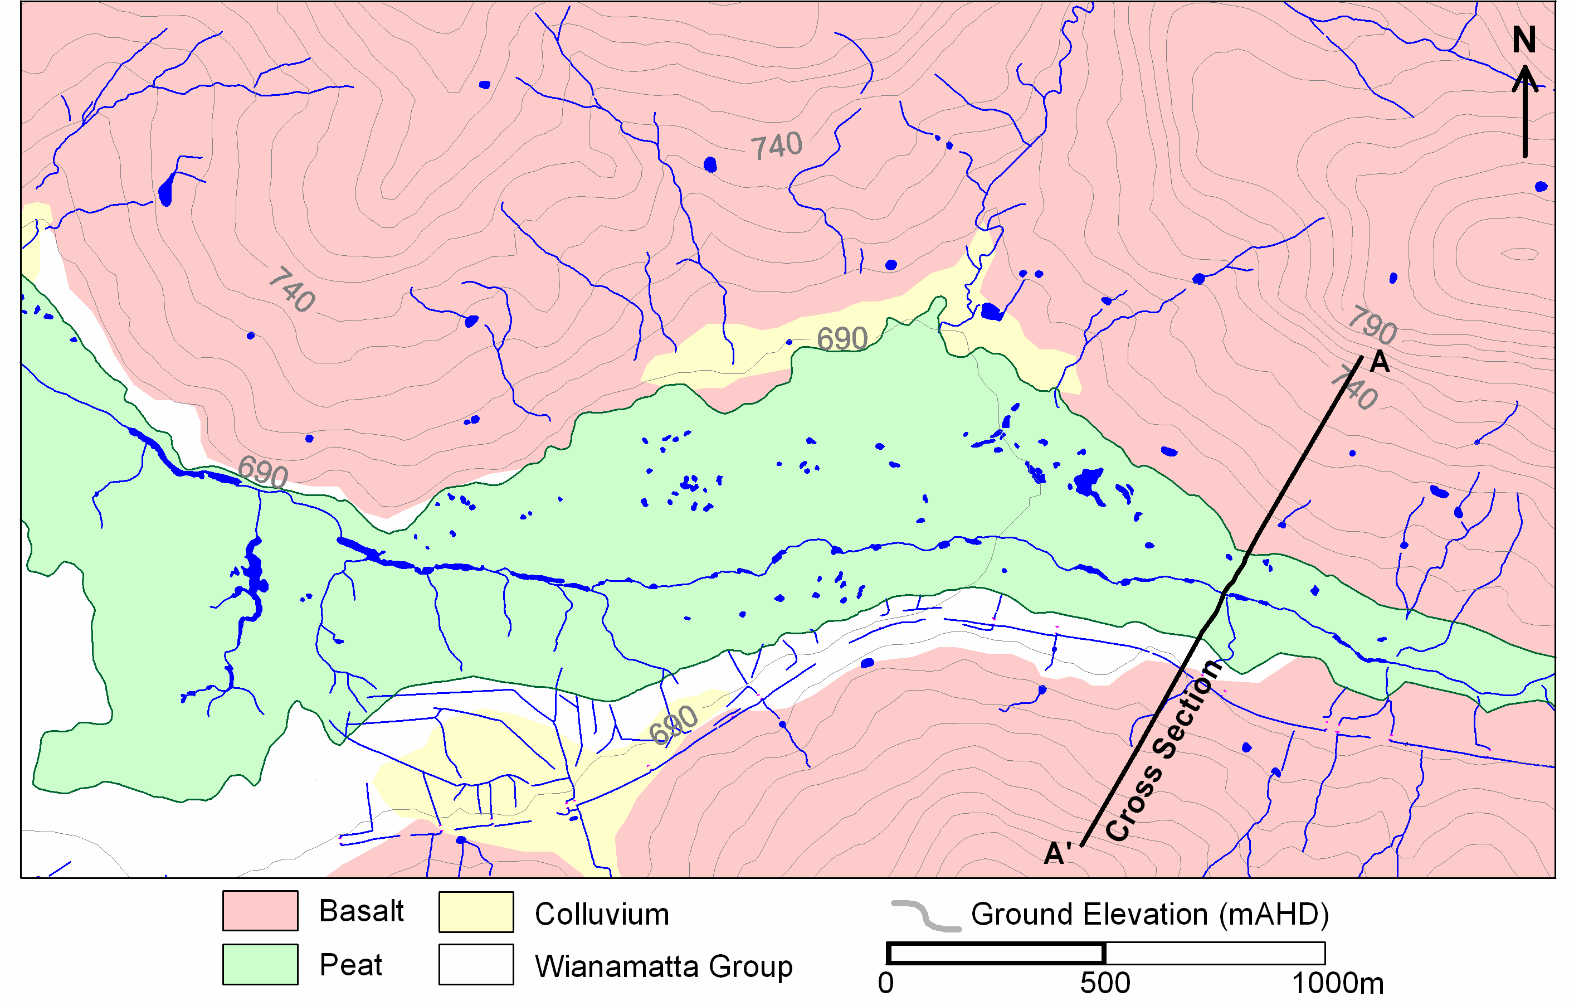
Figure 7.3 Plan view of the outcrop geology for Upper Wingecarribee Swamp.
Hydraulic head measurements made at the swamp indicate an average vertical hydraulic gradient of about 0.6 in the basalt (some lateral discharge at springs) and about 0.8 in the underlying shale and sandstone (lower lateral discharge). The swamp takes advantage of the concentrated springflow and underlying clay. Springflow from the basalt can be viewed as delayed run-off. This interpretation is shown in Figure 7.4. The interpreted watertable and desaturated zones are based in part on the trend in pressure heads along the depth profile; however, alternative interpretations are possible.

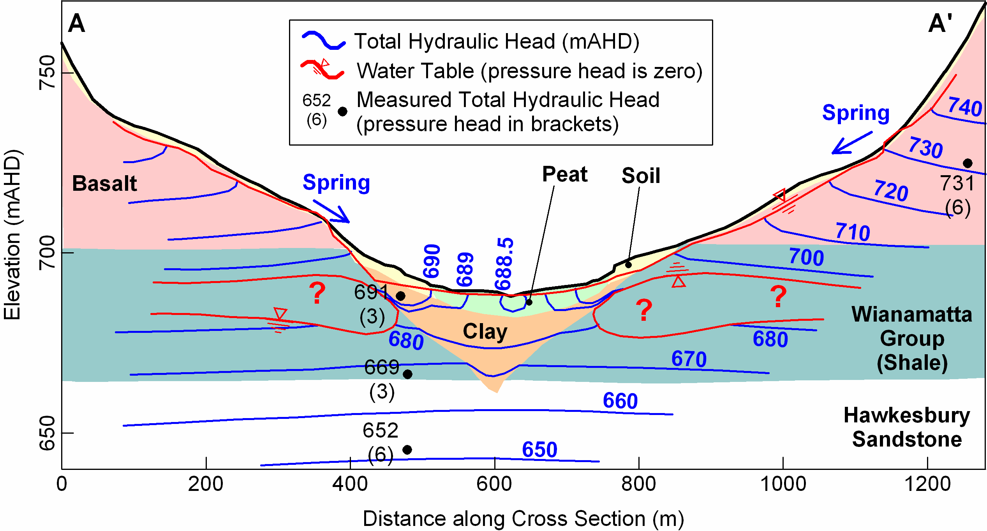
Data © Copyright, Coffey 2007
Figure 7.4 Interpreted hydrogeological cross-section through upper Wingecarribee Swamp (see Figure 7.3 for location of section).

Pre-mining aquifer properties
Field testing of hydraulic conductivity in rock is often carried out using packer tests (sometimes described as Lugeon tests). These tests involve injecting water into an isolated section of a borehole while measuring the pressure applied and the rate of water ingress. The results of this testing are interpreted to provide an assessment of hydraulic conductivity.

Hawkesbury Sandstone
Hawkesbury Sandstone shows a decreasing hydraulic conductivity (k) with depth, in areas free of major structural deformities in the northern Sydney metropolitan area. This is primarily related to increasing overburden pressure and increasing horizontal stress with depth. Figure 7.5 shows the calculated k from numerous packer test results for the Hawkesbury Sandstone and Narrabeen Group in the Sydney metropolitan area and wider Sydney Basin. The log-average typical hydraulic conductivity for the Mesozoic Sandstones in Figure 7.5 ranges from about 0.1 m/day at the surface to about 0.0001 m/day at 400 m depth.

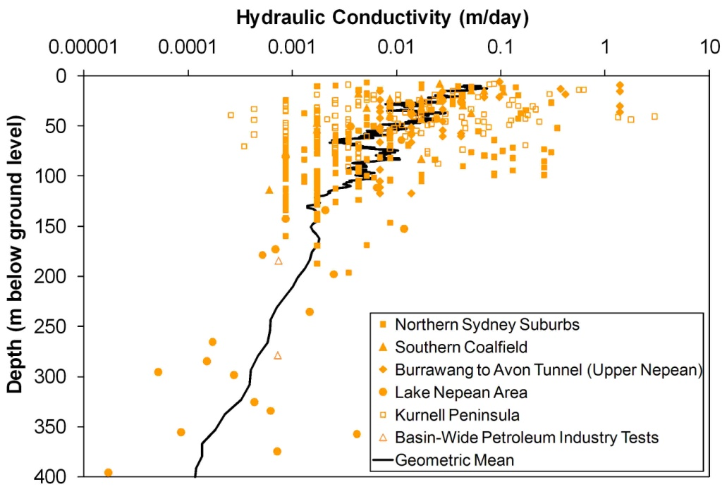
© Copyright, Tammetta & Hawkes 2009
Figure 7.5 Hydraulic conductivity calculated from packer test results in Mesozoic quartzose sandstones in the Sydney Basin.
The measured k represents the total magnitude of hydraulic conductivity, which for undisturbed sandstone is dominated by the lateral component. The vertical k is between about 0.1 and 0.01 times less than the horizontal k, imparting a vertical anisotropy to the stratum. This is seen as partially confined conditions when drawdown of shallow hydraulic heads is measured during pumping at depth. The typical thickness of an individual sandstone horizon is small compared with the typical total stratum thickness in the swamp areas. These characteristics lead to an overall downward hydraulic head gradient that, near ground surface, may manifest as zones of saturation interspersed with zones of pressure head less than zero (dry conditions). The downward gradient is also sometimes observed during bore drilling, when the standing water levels fall as the hole deepens due to the higher hydraulic heads draining down the hole until the deeper zones of lower hydraulic head are encountered, at which point the water level equilibrates.
The hydraulic conductivity data show a standard deviation of about 1 log cycle at a fixed depth. A surface outcrop layer, therefore, may show a random layout of zones ranging from very low permeability to very high permeability. This, together with advantageous surface run-off conditions, creates the pattern of swamps seen on maps.
Hydraulic conductivity measurements from packer tests for other strata in the Southern Coalfield are shown in Figure 7.6. Decreasing permeability with depth is a conspicuous feature of the strata, and the results are characteristic of sedimentary rock sequences in other parts of the Sydney Basin. Structural features such as dykes or faults may reduce or enhance the normal hydraulic characteristics of the strata.

Figure 7.6 Hydraulic conductivity measurements from packer tests for strata in the Southern Coalfield.

General properties of rocks in the Southern Coalfield
Numerous studies of aquifer hydraulic conductivity have been undertaken in the Southern Coalfield of New South Wales for coal and petroleum exploration, creating an extensive database of measurements that can be used to characterise the hydraulic conductivity of host aquifers.
The hydraulic conductivity of rock is a function of hydraulic conductivities of the matrix (the rock material itself) and defects (open joints and bedding plane partings). Packer tests measure the total (matrix and defect) hydraulic conductivity, while the matrix permeability can be measured using rock cores. Laboratory permeability tests on solid rock cores do not measure the defect permeability. Table 7.1 presents a summary of the laboratory test results and packer test results from Reid (1996).
The matrix permeability of the Bald Hill Claystone shows significantly lower hydraulic conductivity than other strata. However, field (packer) test results for the Bald Hill Claystone are similar to those for other strata, suggesting that flow in defects is the dominant flow process in the Claystone in the area tested by Reid (1996).
The matrix hydraulic conductivity of rock strata in the Southern Coalfield was assessed by analysing a database of 1634 laboratory permeability tests on rock cores. The tests had been conducted by the New South Wales Government and coal companies on sandstones and claystones from the southern half of the Sydney Basin (Stuntz 1974; Bembrick et al. 1982; Galloway & Hamilton 1988). Of these, 551 tests were on plugs drilled in the cores at a right angle to the rock bedding, and the rest were on plugs drilled in the cores parallel to the rock bedding. The majority of samples were of sandstone.
Table 7.1 Hydraulic conductivity results from the Southern Coalfield.
Unit | Results from packer tests |  |  | Results from laboratory tests on rock coresª |  |  | Vertical joint spacing (m)^{b}
Unit | Lugeons | Approx. (m/s) | Number of tests | Range (m/s) | Mean (m/s) | Number of tests | Range | Mean
Hawkesbury Sandstone | 0.1–21 | 10^{–8}–10^{–6} | 68 | 0–10^{–5} | 10^{–6} | 31 | 3–40 | 7–15
Bald Hill Claystone | 0.1–23 | 10^{–8}–10^{–6} | 35 | 0–10^{–9} | 10^{–10} | 12 | 0.3–3 | 1
Bulgo Sandstone | 0–24 | 0–10^{–6} | 108 | 10^{–9}–10^{–6} | 10^{–7} | 53 | 0.5–10 | 1–3
 |  |  |  |  |  |  |  | 0.2 (shale)
Scarborough Sandstone | 0.1–10 | 10^{–8}–10^{–6} | 11 | 10^{–9}–10^{–7} | 10^{–8} | 60 | 1–35 | 20
a Combined from Stuntz 1974 and Jensen 1975
b From McElroy & Probert 1976 and Regan 1980
© Copyright, Reid 1996
Figure 7.7 shows a running log-average of the core permeability tests corrected for gas slippage and confining pressure, and a running log-average of the packer test data presented previously, for comparison. The break in slope of the packer test curves at around 100 m depth indicates that the mode of hydraulic conductivity (matrix or defect) control begins changing at that depth. Bulk hydraulic conductivities and matrix hydraulic conductivities converge at about 200 m depth. Above this depth, matrix conductivities are lower than bulk conductivities; this suggests that in the top 200 m of an unmined rock profile, the bulk hydraulic conductivity of a large rock volume is controlled mostly by defect aperture and fracture flow. Below 200 m, the hydraulic conductivity is controlled mainly by the rock matrix. This is not to say that defect aperture will all be closed below 200 m depth. In fact, it will be highly likely that some defects will be open below 200 m depth, but not in the same numbers nor aperture widths as at shallower depths, unless significant structures exist such as large igneous intrusions. Where the matrix conductivity prevails, the vertical anisotropy might be small.
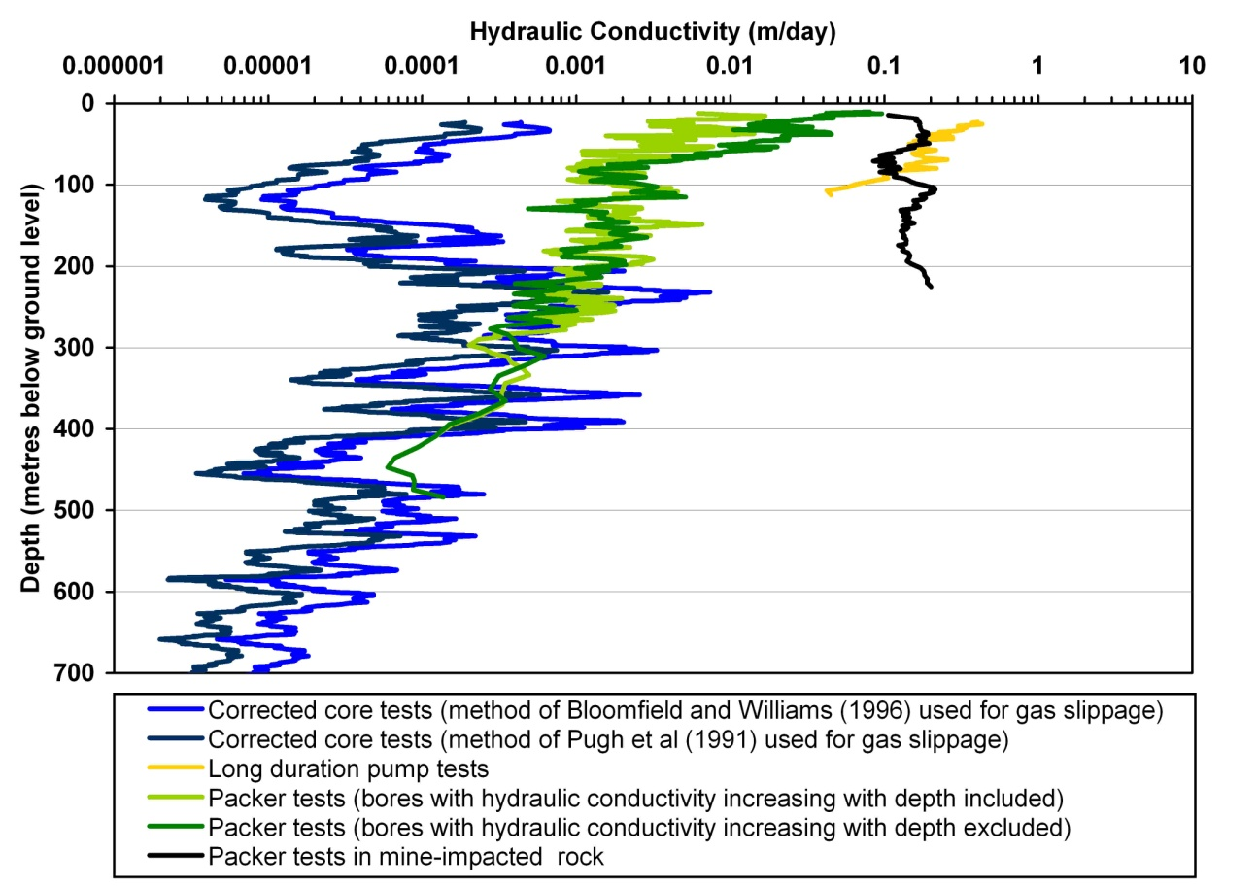
Figure 7.7 Log-average core hydraulic conductivity (corrected for overburden pressure and for two alternative correction schemes for gas slippage) compared with log average hydraulic conductivity from packer tests. A 30-point running average was employed for core data and a 10-point running average for packer and pump test data.
Most of the core permeability values from the upper 150 m of the profile are from the Hawkesbury Sandstone (with many of these tests being recorded as nil flow or too small to measure). Geophysical (gamma) logs for the boreholes where cores were obtained would suggest that of the main sandstones in the profile, the Hawkesbury Sandstone has the highest clay content. The convergence of the core and packer test curves at around 200 m depth in Figure 7.7 is remarkable, given the independence of the two datasets. The scale effect for a rock matrix appears to be less severe than for a fracture system, as would be expected given the similar relative sizes between a core and a rock pore and, say, a block and a rock pore.

Banks Wall Sandstone
Banks Wall Sandstone has a higher incidence of continuous claystone beds than Hawkesbury Sandstone. The effect of these claystones can be seen in cliff faces in the Blue Mountains, where vegetation receives lateral groundwater seepage along the claystone horizons. Hydraulic conductivity data for the sandstone were unavailable at the time of reporting.

Impacts of longwall mining on the groundwater system

Models of general impacts on the groundwater system
The three main impacts of longwall mining on the groundwater system are:
- drainage of groundwater into the mined interval
- changes to aquifer properties (Booth 1986)
- changes to groundwater quality.
Other potential threatening processes may exist. The severity of impacts to the groundwater flow system from longwall mining is related to the height of the collapsed zone.
Following is a literature review on field observations regarding the impacts from longwall mining.

Booth et al. (2000)
Studies by Booth et al. (2000) indicated that following longwall mining, fracturing and bedding separation alters aquifer properties and causes major changes to hydraulic heads. However, they also discuss other studies (Hill & Price 1983; Walker 1988; Matetic & Trevits 1992; Booth & Spande 1992) that report a typical pattern of rapid decline in hydraulic head (caused by sudden increases in fracture porosity) and alteration of hydraulic gradients, caused by increased permeabilities.
Booth et al. (2000) present a model of ground deformation above a subsided longwall panel. The model is based on a site in Jefferson County, Illinois (United States), where longwall mining of a 3 m thick coal seam at a depth of 220 m occurred (Booth & Spande 1992; Mehnert et al. 1994; Trent et al. 1996; Booth et al. 1997, 1998). Mining produced about 2 m of subsidence at the surface, with significant fracturing of the overburden strata. The pre-mining and post-mining hydraulic conductivity (k) of a sandstone stratum was examined. The stratum was about 24 m thick and overlain by about 23 m of shale and glacial sediments. Aquifer tests indicated that the sandstone k increased by one to two orders of magnitude, and the storativity by one order, due to increased fracturing and increase in void ratio. Well yields over the panel increased, but the quality of the groundwater deteriorated (with increased salinity and sulfate concentrations) due to altered flow patterns. The hydraulic head in the sandstone fell gradually before undermining, then fell rapidly during the initial tensional phase of subsidence, then partially recovered during the compressional phase, then fully recovered over several years (see note 1 at the end of the chapter).
A conceptual model based on previous studies and the Jefferson County site was presented, and is reproduced in Figure 7.8. The diagram illustrates a cutaway view of the longwall mine face and shows:
- intense fracturing and strata collapse immediately above the mined-out area, overlain by subsidence of more coherent strata
- subsidence and hydraulic head in the sandstone
- the subsidence trough at the ground surface
- a representation of a tension–compression subsidence wave. (The terms ‘tension’ and ‘compression’ refer in the first place to the observed horizontal ground movements, but also generally indicate the overall volumetric dilational and compressional regimes of subsidence).
The numbered stages along the piezometric level in the diagram can be viewed either as spatially separate points at a single instant of time, or as the development of the water level through time as a piezometer is approached and undermined by the longwall face.
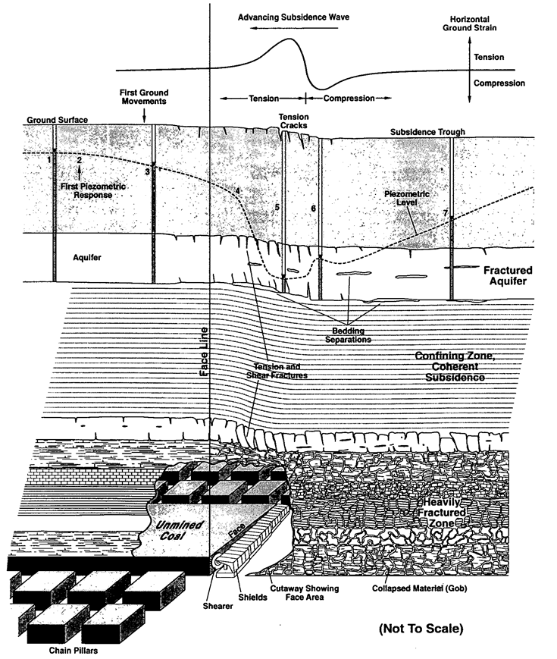
© Copyright, Booth et al. 2000
Figure 7.8 General conceptual model of subsidence and potentiometric response above a longwall mine.
Booth et al. (2000) discuss seven stages of changes in hydraulic head (as interpreted from piezometer water levels). These are shown in Figure 7.8 and are listed below.
- Initial static water level beyond (before) the influence of mining.
- First groundwater-level response, indicating the onset (edge) of a drawdown effect spreading out from the potentiometric low in the active subsidence area. This drawdown effect spreads farther in more transmissive units and is closer to the face line for less transmissive units, which exhibit a more delayed and abrupt response than transmissive units. Studies in the Appalachian coalfield have indicated that the lateral limit of response is within ±70 m of the face line and depends on the position in the subsurface in three dimensions (Cifelli & Rauch; 1986; Johnson & Owili-Eger 1987; Johnson 1992; Matetic & Trevits 1990, 1992l; Werner & Hempel 1992). Walker (1988) suggested that impacts did not occur until the distance from the well to the face position was approximately equal to the depth of the overburden.
- Gradual, accelerating decline in water level as the subsidence front approaches.
- Change from the initial drawdown phase transmitted through the aquifer, to a phase in which the hydraulic head drop is directly due to the physical changes in the aquifer. The change approximately coincides with the onset of significant tensional fracturing soon after undermining. It is abrupt because it indicates a sudden discontinuity in the hydraulic properties of the aquifer, both spatially and temporarily. (An anomalous increase in piezometric levels has been observed in some low permeability units which cannot drain freely; this is discussed in another paper by Booth et al. 1999).
- The potentiometric low, or maximum head drop, occurs at the time and place of maximum tensional (dilational) strain. Subsidence opens joints and bedding planes and creates fractures, suddenly creating a larger volume of secondary porosity in which the water level drops accordingly. The effect is dramatic in bedrock, which has dominant fracture porosity, but slight in unconsolidated units. The head drop may be amplified by drainage to deeper zones through fracturing of underlying aquitards, especially in perched aquifers (Werner & Hempel 1992).
- Rapid partial rise in head during the compressional phase of subsidence in which discontinuities partially re-close, reversing the above process.
- Gradual recovery of water levels, taking a few months to a few years, as water flows back into the affected area. Long-term recovery is very hard to predict. In a study by Cifelli and Rauch (1986), only one of 19 water supplies directly over total extraction mining had any significant recovery, whereas Johnson and Owili-Eger (1987) reported several case studies in which recovery typically occurred within a few months. Johnson (1992) and Leavitt and Gibbens (1992) considered that recovery was likely in wells below the regional watertable but not in perched aquifers below which the aquitard had been fractured. At the Jefferson site, potentiometric recovery to the levels first measured before the mining of the study panel took about two years and to a stable higher head (presumably the natural pre-mining level), approximately four years. Hydraulic and geochemical results indicated that the aquifer was recharged both by leakage through an overlying fractured shale and by lateral flow from areas of the aquifer outside the subsidence trough (Booth et al. 1998).

Kendorski (2006)
Kendorski (2006) presented a literature review for assessment of the height of groundwater desaturation and aquifer property change above longwall panels. The current state of knowledge was considered to be the conceptual model known as the ‘1993’ model (Kendorski 1993). Other interpretations of the desaturated zone are also discussed (e.g. Palchik 2003). The 1993 model comprises five zones above the mined seam, as listed in Table 7.2

Table 7.2 Interpreted deformation zones above a caved panel according to the 1993 model of Kendorski (1993).
Zone | Extent | Characteristics
Caved | To between 6 and 10 t above the mined seam | Complete disruption of the pre-mining rock structure. Complete drainage of groundwater.
Fractured | To between 24 and 30 t above the mined seam | Continuous open fractures. Complete drainage of groundwater.
Dilated | To 60 t above the mined seam | Dilated strata. The dilation increases the strata storativity and impacts groundwater levels. There is no direct or effective hydraulic connection to lower strata.
Constrained and unaffected | From 60 t above the mined seam to 15 m below the surface | Strata are unaffected by mining and subsidence deformations and undergo no change in permeability.
Surface fracture | From 15 m below the surface to the surface | Temporary open fractures.
t = mined height

Mills and O’Grady (1998)
Mills and O’Grady (1998) combined subsidence data from different sites (having a variety of different overburden depth to panel width ratios) to develop a model of longwall overburden deformation (Figure 7.9). The zones of ground displacement above multiple longwall panels are differentiated by subsidence monitoring and characterised using borehole camera observations, packer testing, piezometer data and extensometer monitoring. The model comprises six zones, as listed in Table 7.3. The upper zones, shown in Figure 7.9, are not to scale.
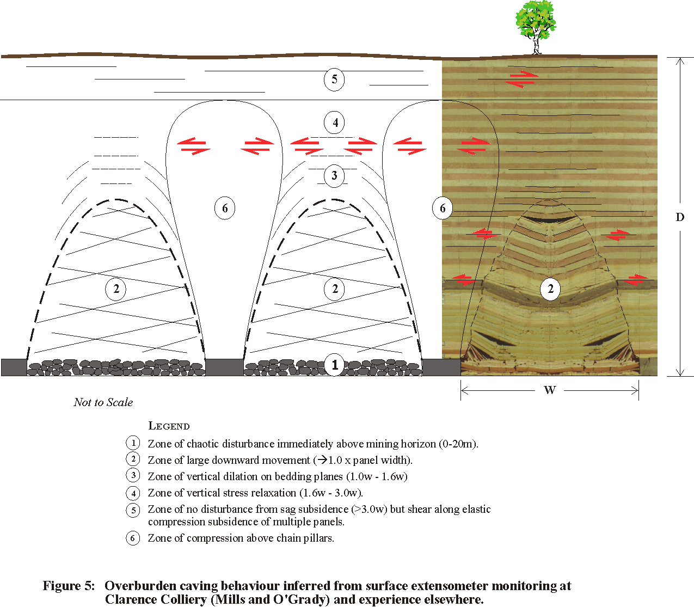
© Copyright, Mills & O’Grady 1998
Figure 7.9 Overburden caving behaviour inferred from surface extensometer monitoring at Clarence Colliery and experience elsewhere.

Table 7.3 Interpreted deformation zones above a caved panel (interpretation of concepts presented in Mills & O’Grady 1998).
Zone | Extent | Characteristics
1 | From the mined seam to about 10–20 m above the mined seam | Chaotic disturbance immediately above the mined seam. Complete drainage of groundwater.
2 | From the mined seam to about 1w above the mined seam | Large downward movement. Characterised by extensive conjugate shear fracturing with numerous open fractures, particularly around the margins of the zone, and numerous inclined fractures throughout. Complete drainage of groundwater. The interface between this zone and the less disturbed strata above and to the sides of this zone accommodates some relatively large differential movements for rock strata within a short distance. This interface zone is characterised by open shear fractures and fractures between rotated blocks of intact material.
3 | From 1 to 1.6w above the mined seam | Transitional ground movement. Vertical opening of horizontal bedding planes with horizontal fractures being dominant in borehole fracture logs.
4 | From 1.6 to 3w above the mined seam | Minor ground movement. Vertical displacements are consistent in magnitude with elastic relaxation of the pre-mining vertical stresses without the need for physical opening of bedding planes.
5 | Higher than 3w above the mined seam | No significant vertical subsidence. Essentially undisturbed above single panels. Typically, significant elastic strata compression subsidence occurs when multiple adjacent longwall panels are mined at depth.  When elastic strata compression occurs, it results in differential shearing on bedding planes. Movement along these bedding planes contributes to stress relief movements (controlled by topography) that tend to be the dominant type of ground movement whenever mining is deep enough for zone 5 to be present.
6 | Over the chain pillars | Elastic compression of the chain pillars. Whereas the sag subsidence directly over each panel (zones 1 to 5) causes the ground to be fractured in horizontal shear and stretched vertically so that there is an increase in fracture volume within the overburden, the elastic strata compression over the chain pillars and around the solid edges of the longwall area cause the strata there to be vertically compressed so that the fracture volume is reduced.
w = panel width
© Copyright, Mills & O’Grady 1998
Extensometer monitoring reported in Mills and O’Grady (1998) indicates that these zones are arch shaped above each panel, similar to the doming-type mine heading failures observed in underground roof falls once all the material has been removed.
The Newcastle data presented by Tobin (1998) indicates that the height of the zone of large downward movement is higher when the horizontal stresses acting across the panel are higher. This is similar to the experience of increased height of softening above underground mine headings subject to increased horizontal stress reported by Gale (1986).
These data suggest that surface subsidence is sensitive to the magnitude of horizontal stresses in the overburden strata above the longwall face in much the same way as mine heading deformations underground are sensitive to horizontal stress magnitude. This sensitivity of subsidence to stress magnitude can be used to determine the direction of horizontal stress from bias in the subsidence profile in subcritical width panel geometries (Mills et al. 2011).
Greater subsidence is routinely observed at the start of longwall panels, where the maximum subsidence is typically higher than further along the panel, because the full horizontal stress acts through the overburden strata at the start of the panel but is partially relieved by the goaf that has formed further along the panel.

Tammetta (2012)
Tammetta (2012) estimated the height of complete groundwater drainage above subsided longwall panels (referred to as H) using a database of hydraulic head measurements made with multiple devices down the depth profile at a number of sites worldwide. H was shown to be relatively independent of most parameters except the geometry of the mined width and the overburden thickness. An empirical equation linking H (in metres) over a centre panel to these parameters was developed and is given by:
H = 1438 ln(4.315 × 10^{–5} u + 0.9818) + 26
where w is the mined width (equal to the panel width plus the adjacent heading widths), d is the overburden thickness, t is the mined height, and u = w t1.4 d0.2. All dimensions are in metres.
In the equation, H depends only on the geometry of the mine opening and the overburden thickness. The equation applies to a variety of strata types and is considered a reliable tool for making predictive estimates of H. Host geology appears to play a minor role.
Tammetta also presents a ground deformation conceptual model from a groundwater perspective, shown in Figure 7.10.
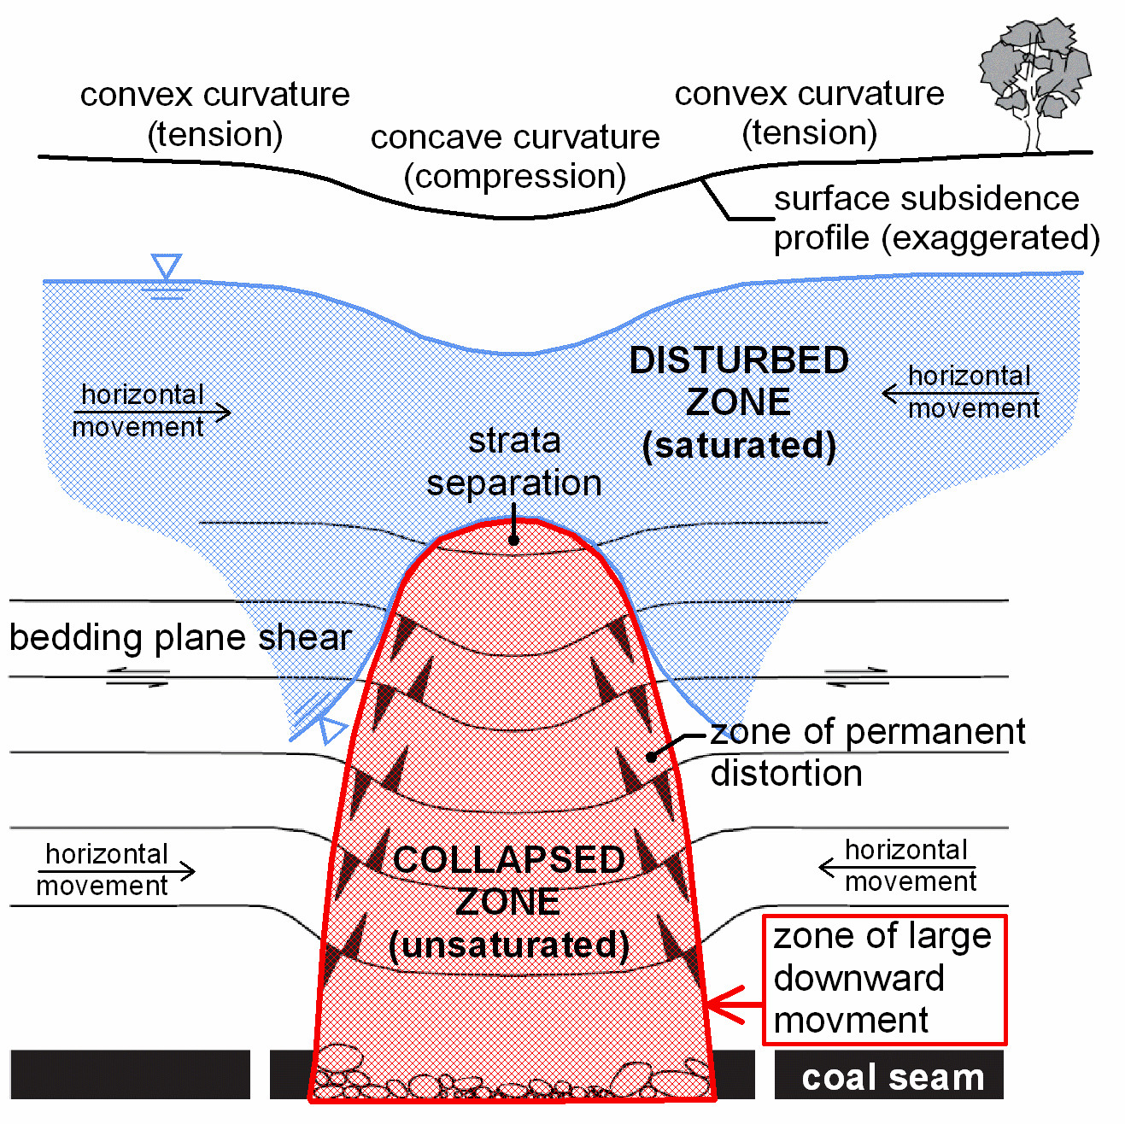
© Copyright, Tammetta 2012
Figure 7.10 Conceptual model for ground deformation above a caved longwall panel.
From a groundwater perspective, longwall caving creates two distinct zones above a continuously sheared panel (Tammetta 2012):
- the collapsed zone
- the disturbed zone.
These zones are illustrated in Figure 7.10. The collapsed zone is parabolic in cross-section, and reaches from the mined seam to a maximum height equal to H over the centre panel. This zone is severely disturbed and is completely drained of groundwater during caving. It is subsequently unable to maintain a positive pressure head. It will behave as a drain while the mine is kept dewatered. Within this zone, the matrix of rock blocks may continue draining for extended periods; however, the defects will immediately transport this water downward to the mine. Groundwater flow will not be laminar, and Darcy’s equation is unlikely to be obeyed.
The disturbed zone overlies the collapsed zone. Positive groundwater pressure heads are maintained over most of the zone. Limited data for long-term groundwater behaviour in this zone suggest that hydraulic heads remain relatively stable, except for immediate lowering associated with drainage of lower strata and minor increases in void space after caving. Groundwater flow will be laminar, and Darcy’s equation is likely to be obeyed. Desaturation in the disturbed zone occurs above the chain pillars. Here, H is smaller than over the centre panel, and may reduce to zero if the pillar is flanked by only one panel. H above the pillars is likely to be more strongly dependent on d than for the centre panel, and will probably also be dependent on the pillar width (see note 2 at the end of the chapter).

Effect of mining on hydraulic conductivity

Field observations
Results in Reid (1996) for strata impacted by mining are shown in Figure 7.6. They are from packer tests undertaken in strata directly overlying the mined seam, where caving has occurred from full extraction (from boreholes adjacent to Avon Reservoir and at Wongawilli Colliery). Mining occurred in either the Bulli or Wongawilli seams, and the Bulli Seam would be at an average depth of about 320 m (with respect to the impacted strata packer test results) on Figure 7.6. Panel widths are thought to have been about 250 m or less. The effect of mining on overburden hydraulic conductivity is seen as a trend centred around 0.15 m/day at the surface, with conductivity increasing slightly with depth, and probably indicates a significant loss of confining pressure in the tested strata.
At a mine site in Kentucky (United States), changes in hydraulic conductivity were measured in detail (Hutcheson et al. 2000). Overburden strata comprise about 250 m of interbedded coal seams, shale, limestone and massive sandstone of Middle Carboniferous age. The panel width was 213 m at a depth of about 250 m, with a mined seam thickness of 2.3 m. Two major sandstone sequences, each about 30 m thick, occur within overlying strata. Hutcheson et al. (2000) report measured pre-mining and post-mining hydraulic conductivities over a single longwall (LW7). Results are shown in Figure 7.11. These results are similar to those of Reid (1996), also indicating that the normal relationship of decreasing permeability with depth for undisturbed strata is significantly affected by longwall mining.
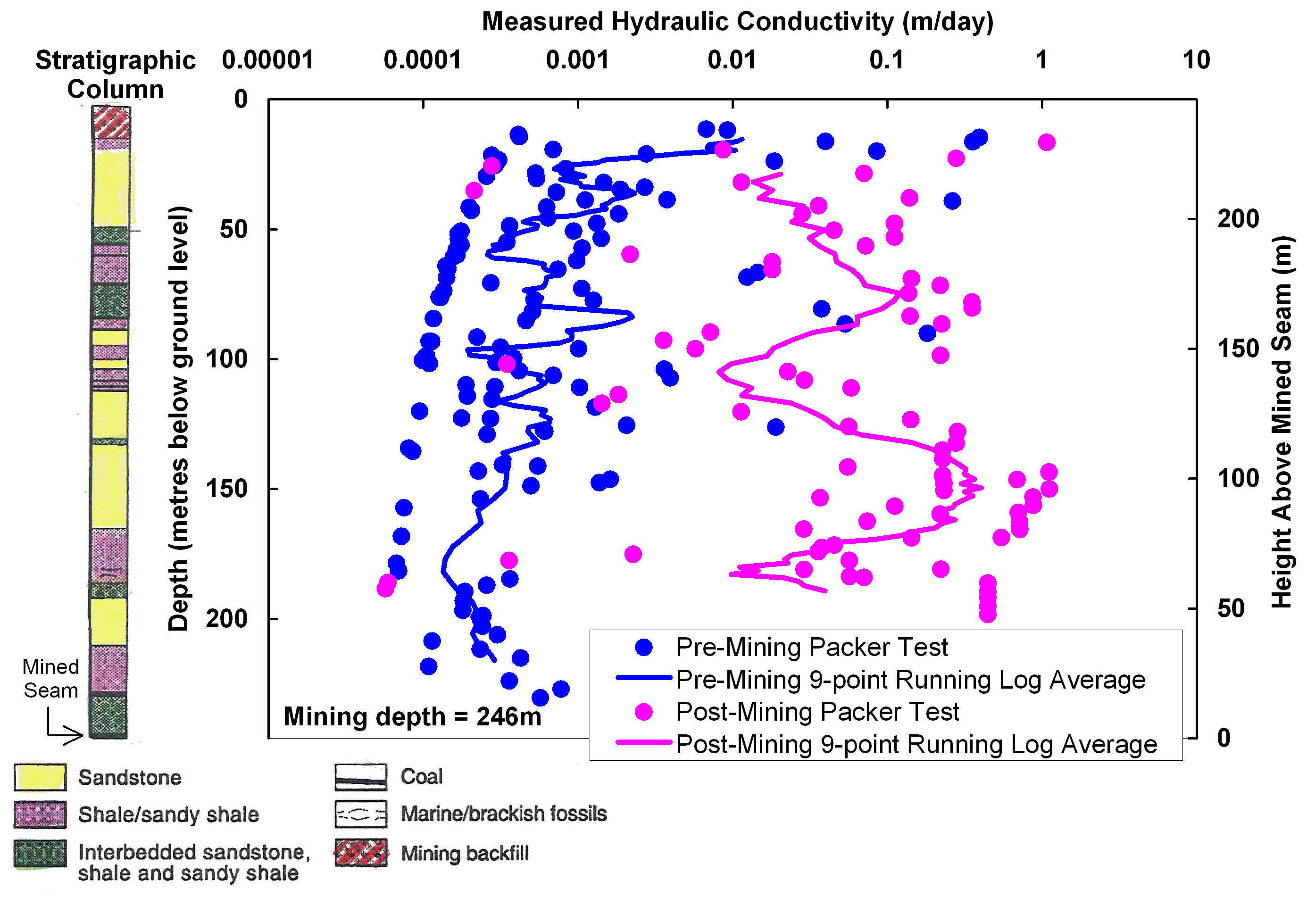
Data © Copyright, Hutcheson et al. 2000
Figure 7.11 Measured pre and post mining k at a site in Kentucky.
At a coalmine in Illinois (Booth & Spande 1992), hydraulic conductivity was measured from packer tests for pre- and post-mining scenarios over the centre of a longwall at a depth of 221 m (panel width 183 m and mined seam thickness 2.7 m). Rock strata comprise mostly Permian coal measures. Changes in hydraulic conductivity are shown in Figure 7.12. Below the Mount Carmel Sandstone Member, post-mining hydraulic conductivities are about 100 times greater than pre-mining.
Booth et al. (1998) recorded an average increase of one to two orders of magnitude in hydraulic conductivity from pre-mining to post-mining conditions, assessed from packer tests in a sandstone layer approximately 170 m above a longwall in the United States. Confined storativities assessed from long-term pump tests increased by a factor of around 10 (from around 10^{–4} to 10^{–3}), as a result of the increased compressibility available from increased void volume caused by separation of bedding planes and dilation of fractures and joints in the aquitard zone.
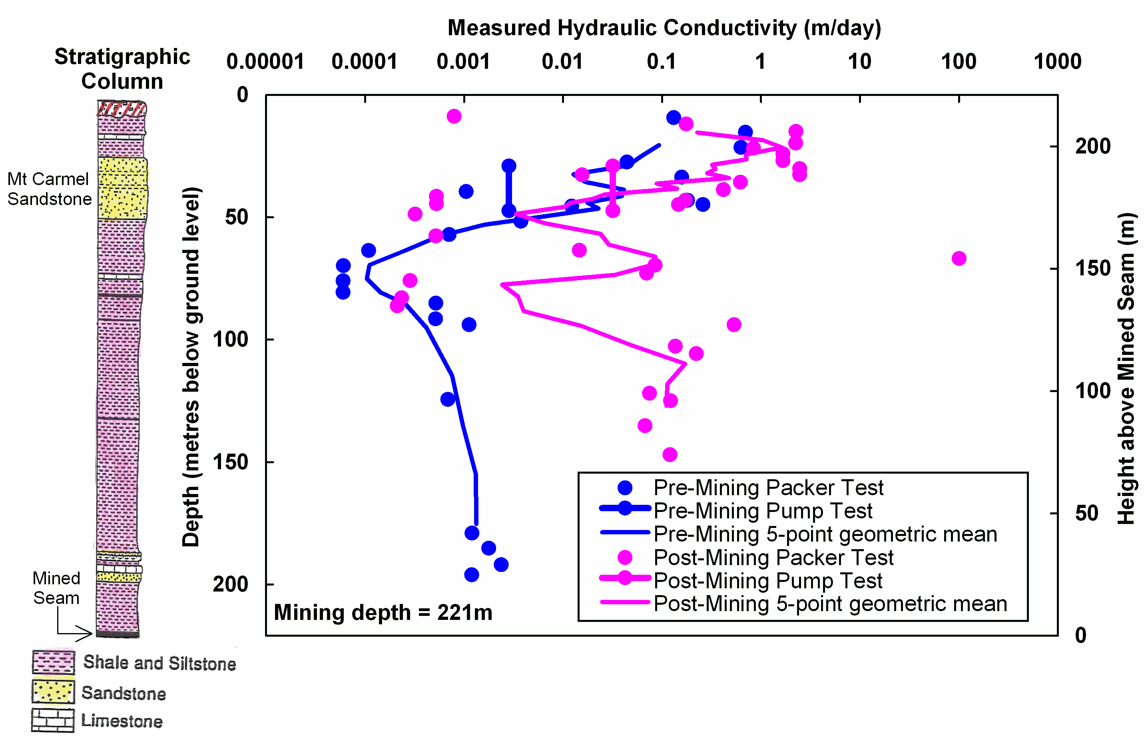
Data © Copyright, Booth & Spande 1992
Figure 7.12 Measured pre- and post-mining hydraulic conductivity at a site in Illinois, United States.

Theoretical assessment
Changes to hydraulic conductivity induced by longwall mining may be calculated empirically (by applying best-fit methods to observations) using resultant in situ stresses around the workings (Esterhuizen & Karacan 2005; Whittles et al. 2006) or by theoretical relationships derived from first principles that relate the change in hydraulic conductivity to the induced strain field in and around the workings (Matetic et al. 1995; Liu et al. 1997). Whittaker et al. (1979) were among the first workers to derive relationships between pre-mining and post-mining hydraulic conductivity.
One approach in estimating changes in hydraulic conductivity in the absence of direct field measurements of hydraulic conductivity is the use of theoretical expressions combined with rock-testing data. The following equations provide expressions for the change in vertical and horizontal hydraulic conductivity according to induced strains (Liu et al. 1997):

$$K_{x}=K_{xo}[1+\frac{b+S\left(1-R_{m}\right)}{b} ∆∈_{y}]^{3}$$

$$K_{y}=K_{yo}[1+\frac{b+S\left(1-R_{m}\right)}{b} ∆∈_{x}]^{3}$$

where:
K_{x} and K_{y} are post-mining hydraulic conductivities in the x and y directions, respectively
K_{xo} and K_{yo} are the pre-mining hydraulic conductivities in the x and y directions, respectively
R_{m} is the rock modulus reduction factor (defined as E/Er where E is the deformation modulus of the rock mass and Er is the deformation modulus of a rock specimen)
b is the fracture aperture; S is the fracture spacing
∆Є_{x} and ∆Є_{y} are the induced strains in the x and y directions, respectively
When R_{m} = 1, the rock mass modulus and intact material modulus are identical and the strain is uniformly distributed between fractures and matrix, resulting in the smallest possible calculated change in conductivity. When R_{m} = 0, the extensional strain is applied entirely to the fracture system, resulting in the largest possible calculated change in conductivity. These values bound the possible ranges in the behaviour of the system in a natural and mechanistically defensible manner. For the upper 200 m of the Sydney Basin in undisturbed strata, groundwater flow is expected to occur primarily in defects and the changes in hydraulic conductivity would probably lie near the upper end of the possible range.
Calculations made with the equations above are considered reasonable when strains are moderate but questionable when appreciable strains are developed (Liu et al. 1997). For this reason they are potentially not applicable to zones of significant trauma where unsaturated flow conditions are developed, but they are nevertheless a useful tool for assessment of conductivity changes in higher zones.
Figure 7.13 shows the post-mining k divided by pre-mining k (denoted Rt) simulated by Ouyang and Elsworth (1993) for a longwall layout in Greene County, Pennsylvania (United States). The work used the same method as Liu et al. (1997). The values of Rt in Figure 7.13 are much smaller than those typically measured in the field around the collapsed zone (see above) because of the high strains that are developed in this zone in the field. However, the results of Ouyang and Elsworth (1993) may be appropriate for the scenario that was simulated, and they are nonetheless of significant use in assessing the pattern of deformation. Rt was calculated from Rx and Rz, the post- to pre-mining k ratios in the lateral (x) and vertical (z) directions, respectively. Results indicate that permeability at the surface increases either side of the panel.
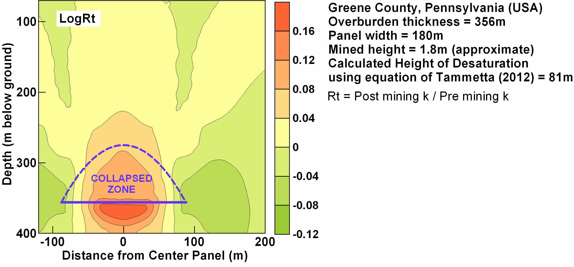
© Copyright, Ouyang & Elsworth 1993
Figure 7.13 Results of numerical simulations undertaken by Ouyang and Elsworth (1993) for a site in Greene County, Pennsylvania (United States).

Observed impacts on peat swamps from longwall mining
Peat swamps have been undermined at several mines in New South Wales. Groundwater monitoring data are available for piezometers within undermined swamps at the following mines:
- Southern Coalfield mine
  - Dendrobium
  - Elouera
  - Metropolitan
- Western Coalfield mines
  - Springvale
  - Angus Place
  - Baal Bone
Except for the Elouera mine, groundwater-level monitoring data from swamp monitoring piezometers at these mines are available from documents in the public domain. Elouera ceased operations several years ago and monitoring data could not be found on the internet. Data from several surface water flow monitoring gauges are also available.

Key threatening processes to peat swamp survival
Three key threatening processes to peat swamps from longwall mining are:
- breach of the sealing layer under the peat or swamp substrate (e.g. if intersected by the collapsed zone). If this happens, peat can easily drain vertically
- reduction or elimination of the peat water supply (e.g. if run-off is diverted by distant subsidence troughs or drained to the subsurface by distant surface cracking, or the topography of the area is changed due to subsidence so that the area is higher with respect to the subsided area). If this happens, waterlogging may be unsustainable
- fouling of the peat water supply (e.g. where surface discharge of low pH or high SO₄ goaf water flows to the swamp). If this happens, vegetation may be stressed and die, or may generate toxins within its tissue.
A much rarer form of impact could be underground mine fires, which may heat the ground and kill vegetation. Goaf fires are particularly rare in modern times, and the probability of a mine fire occurring underneath a peat swamp is extremely low.
Where the hydraulic head in an underlying groundwater system is above the base of a swamp substrate, drawdown in the underlying groundwater system (in the absence of mechanical change) may induce seepage from the swamp substrate.

Reported impacts
A groundwater monitoring program was undertaken for Swamp 36 at Elouera Colliery to assess mining impacts from Longwalls 9 and 10 on the swamp (Paterson 2004). Monitoring was conducted; however, a change in mine plan resulted in Longwall 9 only partially undermining Swamp 36. Longwall 10 was shortened due to geological conditions. Large differences in recharge to the swamp were identified (Paterson 2004).
Swamp 18 at Elouera Colliery is situated on Native Dog Creek, also in the headwaters of the Avon catchment. Mining at Elouera passed under Swamp 18 on Native Dog Creek between 1995 and 1997 (TEC 2007). TEC (2007) reports that the ensuing subsidence cracked Native Dog Creek, and a study commissioned by BHP Billiton in 2001 recorded a fracture along the left margin of the swamp. It is now known if the swamp had been dewatered by 2001, after longwall mining had taken place and before the bushfires of 2001–02. A major erosion gully appeared in the swamp in 2002. Geophysical studies in 2003 found that a complex series of fractures along the main drainage line of the swamp led to the dewatering and that another swamp that was similarly burnt, but not subject to longwall mining and fracturing, remained uneroded.
Slumping in East Wolgan Swamp (straddling the Springvale and Angus Place mine leases) was investigated by RPS (2012) to assess the ecological condition of the Narrow Swamp and East Wolgan Swamp impacted sites and the potential for remediation of the impacts. Slumping occurred at two locations, causing significant settlement of surface soils. The slump areas coincide with the location of chain pillars (tensile zones near the panel edges) of the longwalls.
The 2011 Clarence mine annual environmental management report states that Happy Valley Upper Swamp was undermined by partial extraction in March 2010. In September 2011, partial extraction occurred in panel 706 immediately west of HVU2. HV1 was undermined by partial pillar extraction in October 2010. The site was further undermined by partial extraction in panel 712 in June/July 2011, with subsequent pillar extraction under the swamp in September 2011.

Analysis
In this study, undermining of swamps at Angus Place Colliery and Dendrobium Colliery has been analysed. Figure 7.14 shows the swamp and longwall layouts for both collieries. The analysis estimates the framework within which swamps are impacted, by analysing hydraulic head behaviour as measured in groundwater monitoring piezometers installed within swamps.
Figure 7.14 Undermined swamps at Dendrobium and Angus Place collieries, analysed in the current study.

Methodology
The analytical methodology:
- assessed the relation between swamp monitoring piezometer hydrographs and the flow rates of associated nearby drainage channels of the swamp
- formulated a relationship that equates groundwater levels to rainfall and evaporation
- assessed impacts on swamp groundwater levels as a function of mine void geometry and panel location.

Peat groundwater levels and streamflow
Figure 7.15a shows the average monthly change in groundwater level plotted against the average monthly streamflow from a nearby stream gauge for a number of groundwater hydrograph – streamflow dataset pairs at Wingecarribee Swamp (Southern Highlands) and Narrow Swamp (Angus Place Colliery). The data show a strong (linear) relationship, which suggests swamp monitoring piezometers are adequate samplers of the groundwater system within the peat. The linear relationship suggests that the groundwater level is an approximate representation of streamflow, without higher-order terms. The linear trend is probably a result of the very high hydraulic conductivity of the peat, the monthly time window, and the relatively tabular shape of the peat (relatively flat floor of the peat body compared with its areal extent).
Figure 7.15b shows the stream flow and piezometer hydrographs for the Wingecarribee Swamp –Caalang Creek flow gauge (piezometer profile 6).

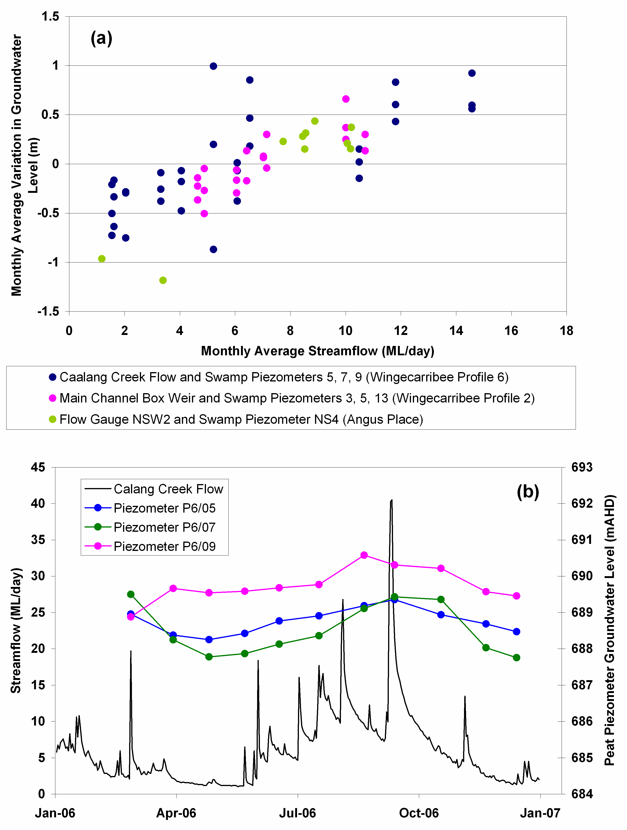

Figure 7.15 (a) Correlation of average monthly change in peat groundwater levels and average monthly stream flow for nearby drainage channels. (b) Stream flow and peat groundwater levels at profile 6 of Wingecarribee Swamp.

Simulation of groundwater hydrographs
The hydrographs for swamp monitoring piezometer 12_01 at Swamp 12 at Dendrobium Mine (Figure 7.16 and Appendix A-2) and swamp monitoring piezometer WW1 at West Wolgan Swamp at Angus Place Colliery (Figure 7.17) were selected for an analysis of replication using rainfall and evaporation.
Piezometer 12_01 was undermined in late June 2011. Fortnightly rainfall at Darkes Forest and fortnightly average pan evaporation from the Australian Bureau of Meteorology gridded dataset were used to construct a running cumulative residual (R) of the difference between fortnightly rainfall and evaporation (the water deficit). R is calculated by first finding the time series of fortnightly rainfall minus fortnightly pan evaporation, referred to as the fortnightly water deficit. The average of the time series of the fortnightly water deficit is then found. A second time series is then created, comprising the fortnightly deficit minus the average, creating a time series of deficit residuals. These deficit residuals are then cumulatively added to create R. This simple yet powerful formulation tracks the groundwater levels reasonably well. The data show that the water level drop in June 2011 was due to undermining, because climate response would have maintained higher water levels. The formulation is of added value because groundwater levels appear to be underestimated, requiring that mine impacts be stronger to be definitively identified.
Figure 7.16 Modelled hydrograph for piezometer 12_01, Swamp 12, Dendrobium Mine.
The impact at piezometer WW1 (and WW2 close by) is interpreted from comparing the deficit cumulative residual (R) to measured WW1 water level, as shown in Figure 7.17. Undermining by LW940 in late 2008 appears to have had negligible impact. However, passage of LW950 nearby, in mid-July 2009, caused WW1 water levels to fall further than would have been expected from natural processes (using R). Water levels following passage of LW950 display a more erratic behaviour than previously, which do not match the rainfall deficit. Water level falls in mid-2011 occur a few months after passage of LW960, and do not appear to have been caused by natural processes.
Figure 7.17 Modelled hydrograph for piezometer WW1, West Wolgan Swamp, Angus Place Mine, 2005 to 2013.
A list of impacted swamps and mining geometry can be compiled from plotting the running cumulative residual (R) of the water deficit. Table 7.4 shows a list of studied sites, and the interpretation at each site. The data are interpreted to indicate the following:
- Clear impacts on a swamp groundwater system occurred for ground surfaces as high as 86 m above the top of the collapsed zone (see the model of Tammetta 2012). It is likely that intersection of the collapsed zone with a swamp would almost certainly significantly impact the survival of the swamp; however, the results listed in Table 7.4 show that even when the surface is above the top of the collapsed zone, surface cracking (particularly in the tensional zone on the panel fringes) will also significantly impact swamp groundwater systems.
- The responses at WE1 and WE2 (East Wolgan Swamp), and at WW1 and WW2 (West Wolgan Swamp), suggest that the most severe impact occurs at the edge of the panel, to a minimum distance of half the panel width (0.5w) past the edge of the panel (i.e. a distance of 1 panel width from the centre of the panel). This correlates with the off-panel surface zone of conductivity increase simulated by Ouyang and Elsworth (1993).
- LW930 passed alongside WW1 and WW2 in late June 2006. The groundwater-level response appears to be due to drought conditions and suggests no impact from mining at distances of 1.6w (WW1) and 1.5w (WW2) from LW930.
From the database, the angle of influence for impacts (defined as the angle whose tangent is the lateral distance to an impact at the surface, divided by the overburden thickness) is a maximum of approximately 45° (WE1 and LW411 Springvale). These impacts are characterised by deformation of the rock underneath the swamp. Impacts were not interpreted to occur at two locations where the angle was approximately 50° (WW1 and LW930) and 45° (WW2 and LW930). The database is too small to draw definite conclusions about the generic extent of off-panel impact; however, the results agree closely with field observation discussed in Ouyang and Elsworth (1993) where a probable angle of influence of 42° was interpreted from a large database of dewatering information for water supply wells.
Table 7.4 Interpretation of monitoring hydrographs for mining under and adjacent to swamps at Angus Place and Dendrobium coalmines.
Site | Date undermined (and longwall panel) | Positionª (panel widths from centre) | Panel width (m) | Mined height (m)^{b} | Overburden thickness (m) | Angle of influence (degrees) | Height of collapsed zone (m above seam)^{c} | Top of collapsed zone (mbgl) | Interpretation
KC1 | Late May 2008 (LW940) | 0.4 | 260 | 3.7 | 295 | Over panel | 289 | 6 | Clear impact
WW1 | Late June 2006 (LW930) | 1.6 | 255 | 3.7 | 365 | 50 | 295 | 70 | No mining impact
WW1 | Early Nov 2007 (LW940) | 0.5 | 260 | 3.7 | 365 | Over panel | 300 | 65 | No clear impact until passage of LW950 (next panel south)
WW1 | Mid-July 2009 (LW950) | 0.8 | 270 | 3.7 | 375 | 30 | 312 | 63 | Impact
WW2 | Late June 2006 (LW930) | 1.5 | 255 | 3.7 | 365 | 45 | 295 | 70 | No mining impact
WW2 | Late Oct 2007 (LW940) | 0.3 | 260 | 3.7 | 361 | Over panel | 299 | 62 | No clear impact until passage of LW950 (next panel south)
WW2 | Mid-July 2009 (LW950) | 0.9 | 270 | 3.7 | 375 | 35 | 312 | 63 | Impact
WW3 | Mid-Jun 2006 (LW930) | 0.6 | 260 | 3.7 | 355 | 25 | 298 | 57 | No pre-impact water-level data available
WW3 | Late Oct 2007 (LW940 | 0.5 | 260 | 3.7 | 355 | Over panel | 298 | 57 | No pre-impact water-level data available
WW4 | Early May 2006 (LW930) | 0 | 260 | 3.7 | 352 | Over panel | 298 | 54 | No pre-impact water-level data available
WE1 | Late Jul 2006 (LW411 Springvale) | 1 | 310 | 3.2 | 347 | 45 | 290 | 57 | Impact masked by drought effect
WE1 | Early Apr 2010 (LW960) | 0.5 | 295 | 3.7 | 350 | Over panel | 333 | 17 | Reduced number of spikes after LW960, despite LDP04 discharges affecting groundwater levels
WE2 | Early Aug 2006 (LW411 Springvale) | 0.9 | 310 | 3.2 | 342 | 40 | 289 | 53 | Clear impact (water periodically above ground pre-impact)
WE2 | Early Apr 2010 (LW960) | 0.6 | 295 | 3.7 | 345 | 30 | 333 | 12 | Reduced number of spikes after LW960, despite LDP04 discharges affecting groundwater levels
12–01 | Mid-Jun 2011 (LW7) | 0 | 240 | 3.6 | 330 | Over panel | 264 | 66 | Clear impact
15b–H2 | Mid-Oct 2011 (LW7) | 0.6 | 240 | 3.6 | 322 | 30 | 263 | 59 | Clear impact
LC3–02 | Mid-Aug 2010 (LW6) | 0.7 | 240 | 3.4 | 332 | 25 | 246 | 86 | Clear impact
NS1 | Early Feb 2009 (LW950) | 0.3 | 260 | 3.7 | 346 | Over panel | 297 | 49 | Impact masked by last discharges at LDP06. Following water levels show impact
NS2 | Early Feb 2009 (LW950) | 0 | 280 | 3.7 | 346 | Over panel | 317 | 29 | Impact masked by last discharges at LDP06. Following water levels show impact
NS4 | Early March 2004 (LW27) | 0.5 | 280 | 3.7 | 307 | Over panel | 311 | –4 | No pre-impact water-level data available
a In units of panel width, from panel centre. Distance of 0.5 is at panel edge. Distance >0.5 is off-Panel.
b Estimate only
c Calculated using the equation in Tammetta (2012)
The impacts database is insufficient to allow an assessment of the relationship of the offset distances (interpreted above) to the mined geometry (w, t and d). It is most likely that this distance will depend strongly on panel width, mined height and overburden thickness, as does the height of the collapsed zone (H) (Tammetta 2012). As H and/or d increase, the distance from the panel centre to impacts at the surface will also increase.
Table 7.4 forms the rudiments of a database that is intended to be used to explore the relationships between impacts and mining geometries. It is hoped that further measurements of impact distance and angle of influence will be added to the database as time progresses.

Baal Bone Colliery
At Baal Bone Colliery, Longwall 29 passed to within 400 m of Coxs River Swamp (see Figure 7.18). Water levels monitored in six piezometers measured an impact from the mining. Monitoring data are shown in Figure 7.19 (Baal Bone 2012). LW29 began in July 2009. A clear impact at BBP1 (15 m deep and screened in siltstone) is seen in August 2009, probably at about the time of the first longwall collapse. This impact on groundwater, at around this depth, is commonly seen at longwall mines at this distance from the panel. Piezometer BBP2 is about 280 m away from LW29 but occurs on the same structural lineament, BBP1. BBP2 shows a lesser impact, at the same time as at BBP1, characteristic of more moderate drainage, with small amounts of deformation. For Baal Bone the impact at these piezometers may have been exacerbated by transmission of ground deformation along zones identified as ‘structural stress zones’ in Baal Bone (2012), which follow drainage lineaments.
Figure 7.18 Longwall and swamp layout at Baal Bone Colliery.
Figure 7.19 Water-level monitoring data at Baal Bone swamp piezometers.
Piezometers BBP5 and BBP6 are shallow and screened in peat and sediments. A secondary impact of the extended shallow rock deformation is the slow drainage from the peat seen at BBP6, with the piezometer going dry in about November 2009. However, the peat resaturates, with the piezometer registering free water again in late 2010. This suggests that deformation in the sealing layer underneath BBP6 did not occur from LW29.

Numerical simulation
Simulation of impacts to swamps from longwall mining must include detailed simulation of:
- rainfall recharge
- surface run-off
- evapotranspiration
- realistic change in hydraulic conductivity from deformation of the sealing layer.
Groundwater modelling packages can simulate the first three processes; however, the crucial process is the deformation of the sealing layer below the peat. Even when this can be simulated in detail, the change in hydraulic conductivity (i.e. the drainage potential) of the sealing layer is significantly uncertain.

Summary of key concepts from the groundwater section
- Conductivity has two components:
  - flow in discontinuities
  - flow in the rock matrix.
- The three main impacts of subsidence on groundwater are:
  - changes in aquifer properties
  - drainage of groundwater to the mine
  - changes of groundwater chemistry.
- There can be separate groundwater regimes in the peat swamp and underlying rock.
- Lateral hydraulic conductivity in rock generally decreases with depth.
- Lateral hydraulic conductivity of the Bald Hill Claystone appears to follow the same trend as other stratigraphic units.
- In the Southern Coalfield, hydraulic conductivity for undisturbed rocks from the surface to a depth of about 200 m appears to be mainly controlled by flow in discontinuities and, below that depth, mainly by the rock matrix.
- The groundwater response in a well varies according to its screened depth and monitoring time relative to the mining or subsidence cycle. In general, the groundwater level may fall gradually as the mining approaches a well, then drop rapidly or go dry in close proximity to the working face due to subsidence processes. Following passage of the working face, the well may recover due to closure of fractures and discontinuities over a period of a few years, or may remain dry.
- The height of caving and characteristics of each zone above a longwall panel have been estimated in various ways. Table 7.3 summarises one approach.
- The height of complete groundwater drainage above subsided longwall panels can be estimated using the approach in Section 7.5.1.4.
- Subsidence impacts to the peat swamp groundwater can include:
  - cracking of the material in the base of the swamp, allowing the peat to drain
  - reduction or elimination of the peat swamp water supply
  - fouling of water quality.

Peer review comments on Chapter 7
1. Tony Iannacchione comments in relation to the Illinois example that: in time, some percentage of subsidence fractures will fill with clay, organic material and sand particles. The in-filling of fractures greatly reduces near-surface strata hydraulic conductivity. Time effects are an important consideration and should be evaluated in future analysis.
2. Ross Seedsman believes that some of the larger figures for complete height of groundwater drainage (CHGD) provided in Tammetta (2012) should be considered in relation to a paper by Guo et al. (2007), which provides a different interpretation. Ross suggests that the representation of the collapsed zone in Figure 7.10 is questionable and also that there is a fundamental difficulty in using complete groundwater drainage as a measure of impact as it is difficult to allow for the time factor. The dilated zones in the current models allow for a temporary drop in piezometric level, which may take an extended period of time to recover if the pre-mining hydraulic conductivities are low.

Subsidence impacts on peat swamps and valleys
In this section, subsidence-related impacts on peat swamps, and river channels more generally, is discussed and then considered in the context of the vertical and horizontal subsidence mechanisms presented in Chapter 5 and the subsurface caving mechanisms presented in Chapter 6. The specific effects of mining-induced changes in groundwater are also discussed in this section, with more detail in Chapter 7.

Introduction
A strategic review by the New South Wales Department of Planning (2008) recognised a number of impacts on peat swamps, which are summarised in Table 8.1, with additional information in Appendix A-1. These include physical impacts such as cracking, localised uplift and tilting that result in:
- redirection of surface flow from valley swamps and river channels, with loss of standing water in pools
- drop in perched watertables in upland swamps
- increased potential for erosion, and vulnerability to fire damage
- adverse water quality impacts, including deoxygenation and iron staining
- release of methane gases
- ultimately, changes in swamp vegetation communities.

Table 8.1 Summary of subsidence impacts and consequences for significant natural features in the Southern Coalfield.
Natural feature | Physical subsidence impacts | Primary consequences for natural features | Secondary consequences
Watercourses | - Tensile cracking of stream rock bars; tensile/shear movement of joint and bedding planes in the stream bed | - Loss of surface water flow into subsurface flow path  - Loss of standing pools/connectivity  - Additional groundwater inflows, commonly carrying ferrous iron from freshly broken rock  - Adverse water quality impacts (e.g. iron bacterial mats)  - Localised adverse visual impacts | - Aquatic ecology loss (connectivity)  - Loss of recreational amenity  - No evidence of regional loss of water supply
Watercourses | - Localised uplift and buckling of strata in the stream bed (e.g. lifting or mobilising of stream-bed rock plates) | - Loss of surface water flow into subsurface flow path  - Loss of standing pools/connectivity  - Additional groundwater inflows, commonly carry ferrous iron from freshly broken rock  - Adverse water quality impacts (e.g. iron bacterial mats)  - Localised adverse visual impact
Watercourses | - Tilting of stream beds (both dynamic/incremental and final outcome) | - Stream-bank and stream-bed erosion  - Changes in flow rates  - Migration of flow channels
Watercourses | - Gas releases from near surface strata | - Temporary gas releases to the water column, with water quality impacts  - (Rarely) riparian vegetation dieback | - Appears to have no significant long-term impact
Cliffs | - Tensile surface cracking—close behind and (sub)parallel to cliffs, or within cliff faces | - Cliff falls  - Instability of cliffs and overhangs, etc. | - Adverse visual impact  - Public safety implications  - Loss of recreational amenity and public access  - Potential damage or destruction of Aboriginal heritage sites  - Loss of habitat for cliff-dependent species and damage to GDEs or riparian vegetation
Swamps | - Valley infill swamps: tensile cracking, tensile or shear movement of joint and bedding planes, and buckling and localised upsidence in the stream bed below the swamp | - Draining of swamps, leading to:  - drying and potential erosion and scouring of dry swamps  - loss of standing pools within swamps  - vulnerability to fire damage of dry swamps  - change to swamp vegetation communities  - adverse water quality impacts (e.g. iron bacterial matting)  - Loss of stream base flow | - Loss of swamp ecology (terrestrial and aquatic)  - Loss of flow leads to the full range of downstream consequences
Swamps | - Headwater swamps: tensile cracking and tensile or shear movement of joint and bedding planes in the rocks below the swamp | - Potential drop in perched watertables, leading to draining of swamps  - Impacts are likely to be similar in character but less extensive and significant than for valley infill swamps
Groundwater reservoirs | - Tensile cracking and tensile or shear movement of strata  - Bending of strata and horizontal separation of bedding planes  - Depressurisation of groundwater from the coal seam | - Re-direction of subsurface flows  - Mixing of aquifers or groundwater with surface water  - Change in aquifer storage characteristics  - Depressurisation of strata overlying extracted coal seam | - Failure of GDEs  - Cross-aquifer contamination  - Mine water inflows and consequent water management issues  - Loss of available aquifer resource
GDE = groundwater-dependent ecosystem
© Copyright, NSW Department of Planning 2008
As discussed in Chapter 2, three categories of peat swamps are considered representative of the broad spectrum of peat swamps of interest to this review. These three types are differentiated on the basis of the characteristics that are likely to influence how they respond to the ground movements and other changes caused by mining subsidence. The three types are:
- valley infill swamps
  - valley infill swamps on rock where a deposit of peat material up to several metres thick has formed on a sandstone base in the bottom of a valley
  - valley infill swamps on talus or other alluvial material so that the watertable in the swamp is integral to the groundwater system in the surrounding terrain rather than perched above it on a sandstone rock base
- headwater swamps—where a typically thinner layer of peat and other organic material has formed across a broad valley, sometimes upstream of a waterfall or other rock feature that substantially influences the hydraulic gradient through the swamp. The watercourse typically flows directly on sandstone rock strata
- hanging swamps—formed where sandstone rock strata are exposed at or near the surface and the swamp relies on the integrity of the underlying rock strata and a combination of rainfall and groundwater infiltration for recharge.
The types of peat swamps located directly on sandstone strata all have the potential to be affected by physical changes to the sandstone material that forms the base of these swamps, so that surface water and groundwater is redirected away from the swamp, thereby changing the hydrological equilibrium in which the swamp has developed. The valley infill swamp on alluvium has an additional sensitivity in that more general changes in groundwater level within the overburden strata also have potential to impact the integrity of the swamp.
Although river channels are not specifically the subject of this report, the observations of subsidence impacts to river channels are directly applicable to peat swamps located in valleys. For all practical purposes, sandstone strata below a river channel behave the same whether they are exposed in a river channel or covered by peat. Physical impacts can be seen more clearly in river channels where the peat is not obscuring the sandstone, and monitoring of subsidence and other changes is much easier without the peat covering. Observations of the behaviour of river channels in response to subsidence movements are therefore helpful in understanding the processes that are also occurring below peat swamps.
The impacts of longwall mining on peat swamps can be divided into four main categories:
- physical impacts associated with horizontal compression in the base of valleys
- physical impacts associated with surface cracking and overburden dilatancy away from valleys
- groundwater changes and increased hydraulic conductivity associated with dilatancy of the overburden strata below topographic high ground
- more general groundwater changes caused by drawdown into the mine.
This section provides a discussion of each of these impacts, but first it is useful to discuss the historical development in Australia of the understanding of horizontal compression movements in valleys.

Historical background
Jensen (1973) and Kapp (1973) appear to have been among the first in Australia to recognise and publish experience of large compressive strains being measured in the bottom of valleys with consequential impacts on stream flows. In their literature review, Waddington Kay & Associates (2002) relate that Jensen reported, in an internal report, to the Sydney Metropolitan Water, Sewerage and Drainage Board on an area of pillar extraction mining in two seams that resulted in 2.4 m of subsidence below tributaries of Flying Fox Creek, and caused cracking and loss of water through cracks up to 100 mm wide. Marshy areas were found to be dry whereas upstream, where cracks were not evident, was wetter. It was noted that some ‘water holes’ that had previously held water for extended periods were now rapidly drained, a section of creek showed no flow over several hundred metres, and rock strata were observed to be arched upward suggesting compressive forces were at work.
Kapp (1973) reports the observation of high compressive strains in topographic low points above extraction areas at Kemira Colliery.
In December 1985, Span 6 of the Stanwell Park Viaduct, a brick structure on the South Coast Rail Line approximately 50 km south of Sydney, was damaged when pillars were being mined nearby at Coalcliff Colliery (Hilleard 1988).
This event represents one of the earliest published examples of horizontal movements in a downslope direction impacting a valley outside the mining area. No measurements of subsidence were made over the panel because mining was outside the area where subsidence was thought likely to impact on the viaduct, suggesting there was little recognition of valley closure effects in the mid-1980s.
Hilleard provides a summary of the mechanisms involved, which is illuminating in terms of the general level of understanding at the time.
Although it is clear that a cause and effect relationship exists between the coal extraction in Panel 283 and the deformation and subsequent cracking of the viaduct, a consensus view has yet to be reached on the exact mechanisms which have applied and the role played by additional factors such as the in situ stress field and the steep topography … It has been proposed that the notch effect, created by the valley of the Stanwell Creek, has concentrated the north-south horizontal compressive stress field in the rock mass below the viaduct. The subsidence over Panel 283 is expected to have opened up horizontal planes in the rock above the coal seam, or reduced the normal stress across the planes, inhibiting the transfer of shear stress below the seam and hence causing further concentration of stress in the rock interval between the coal seam and the valley floor.
It is also considered likely that subsidence would have induced east-west tensile stress in the valley floor, hence encouraging north south compression, and also to have acted directly in drawing the south valley side towards the north. These effects would have been exaggerated by the topography in this case, since the valley sides are relatively free to converge due to the lack of buttressing at the open east end of the valley. It is expected that the net effect on the viaduct would be abnormally high values of horizontal compression in the north-south direction across the valley floor, producing severe shortening of the structure. The physical evidence at the site, including the magnitude and timing of compression of the viaduct, recent and continuing crushing failure in the bedrock below the stream, and the measured subsidence and uplift in the vicinity of the mined area support this.
© Copyright, Hilleard (1988)
This explanation distinguishes the components of horizontal stress relief and systematic horizontal movement, although the mechanics are slightly confused. The explanation also hints at the concepts of horizontal movement in a downslope direction, given the freedom to converge and lack of buttressing in the direction of the valley, but does not recognise the influence of strata dilatancy. Notwithstanding these limitations, the explanation provides evidence of how the concepts surrounding the mechanics of valley closure had developed by 1988.
During the late 1980s, several major cliff falls led to a study program using three-dimensional survey techniques (Kay 1990) that provided some insight into horizontal ground movements outside the area directly undermined. This study was mainly in relation to cliffs and steep slopes, but the results indicated the effects of lateral movement in a downslope direction.
Studies undertaken specifically for collieries in the Western Coalfield, especially at Baal Bone Colliery, contributed significantly to the understanding of horizontal movements that was developed during this period (Mills 2001). Some of these studies have been described more fully in Chapter 5. The influence of horizontal movement in a downslope direction independent of in situ stress and direction of mining was recognised during these studies.
During the 1990s the impact of mining operations on rivers came under public scrutiny. In 1994, some of the local residents, who owned properties along the Cataract River Gorge, complained that water had been lost from some of the more permanent ponds within the bottom of the gorge. This led to a class action lawsuit against BHP for loss of amenity and raised public awareness of the potential for underground mining activity to have an adverse impact on rivers.
As Longwalls 8 and 10 were mined at Tower Colliery, the surface movements had been measured along a series of survey lines across and within the bottom of Cataract River Gorge. The measured movements indicated that upsidence had occurred in the bottom of the gorge and that the sides of the gorge had closed. In some areas, the upsidence exceeded the subsidence and the bottom of the gorge was approximately 250 mm higher after mining than it was before mining (i.e. it experienced a net uplift). The closure and upsidence movements were accompanied by high levels of compressive strain, up to 15 mm/m, which had resulted from cracking and buckling of the rock strata in the bottom of the gorge. These movements were also described by Reid (1994), in an internal report to the New South Wales Dams Safety Committee.
Holla (1997) reports on observations of horizontal movement in high relief areas in New South Wales caused by longwall mining and noted that horizontal movements as large as 40 per cent of the vertical subsidence were being concentrated in the base of valleys. Holla reports that while horizontal ground movements above longwall panels in flat terrain conformed with the theoretical patterns, the pattern in high relief areas was found to be different, with asymmetrical movement toward the creek beds.
This horizontal movement caused a high compressive strain and a hump in the base of the valley. The horizontal movements outside the goaf are larger than vertical subsidence in both flat terrain and high relief terrain, but extend further in high relief terrain and extend beyond the angle of draw determined on the basis of vertical subsidence. However, the horizontal movements outside the goaf tend to be of a general body nature, with insignificant consequences for the surface.
Waddington Kay & Associates (2002) report on the results of two Australian Coal Association Research Program (ACARP) research projects, one that studied the impacts of mine subsidence on the strata and hydrology of river valleys, and the other that developed a handbook of management guidelines for undermining cliffs, gorges and river systems. The handbook presents a comprehensive review of the literature relating to horizontal stress relief around mined areas, impacts observed in creeks, remediation of creek beds and, most significantly, an empirical method for estimating valley closure and upsidence. The method for estimating valley closure represents a significant advance as it is the first and still the only method for estimating valley closure and upsidence.
The method considers the vertical incremental subsidence, proximity to the longwall both transversely and longitudinally, and valley depth. Although the authors have subsequently indicated that the method tends to overestimate valley closure and upsidence, the method nevertheless presents a useful guide for estimating the upper limit of valley closure movements that can be expected based on previous experience.
Explanations of the mechanics of subsidence processes presented in the handbook are significantly different than those presented in this report. The handbook explanations are inclined towards presenting horizontal stress as the primary driver for valley closure movements and do not recognise the influence of strata dilatancy causing horizontal movement in a downslope direction. The handbook also views the height of fracturing above longwall panels as extending only to approximately 21 times the seam thickness in strong ground (about 50 m for typical extraction heights) and 33 times the seam thickness (about 8 0m) in weaker strata. It does not recognise the height of fracturing as being related to panel width, as indicated by other studies.
The handbook was intended as a live document and it is anticipated that these differences will be reconciled in later editions. A considerable quantity of data has been collected by the collieries in New South Wales since the Management Information Handbook was published in 2002 (Waddington Kay & Associates 2002). An extensive database of valley-related movements has been also been developed during the last 10 years. It is anticipated that together with the results of a more recent ACARP project investigating site detail at many of the sites for which data is available, the handbook will be updated in the near future.
At the time of Brassington and Horsley’s (2004) study into the impacts of mining on peat swamps, the exact impacts or influences of subsidence on upland swamps on the Woronora Plateau were inconclusive. They describe a long-term monitoring study involving 13 piezometers in four swamps, including two swamps that had been mined under and two that would be mined under over the next decade. The results of this monitoring are discussed in Section 8.4.1.1.2.
Since the mid-1990s, numerous studies have measured the height of caving (Mills & O’Grady 1998; Byrnes 1999; Gale 2004) and investigated the mechanisms that cause horizontal movement in river valleys (Mills 2001; Mills et al. 2004; Mills & Huuskes 2004). These and subsequent studies provide the basis for the information of the mechanisms that cause horizontal movement in river valleys presented in this report, and are discussed in detail in the following sections.

Horizontal compression in the base of valleys
The mechanics of the processes that cause subsidence movements are discussed in Chapter 5. Horizontal subsidence movements are recognised as being the primary cause of the near surface subsidence impacts on river channels and peat swamps. These horizontal movements are primarily associated with the response of surface topography to vertical subsidence.
Figure 8.1 shows a cross-section and the key physical changes that are observed in the base of river channels as a result of mining subsidence. This cross-section is based on detailed studies conducted at several sites in the Southern Coalfield (Mills 2007).
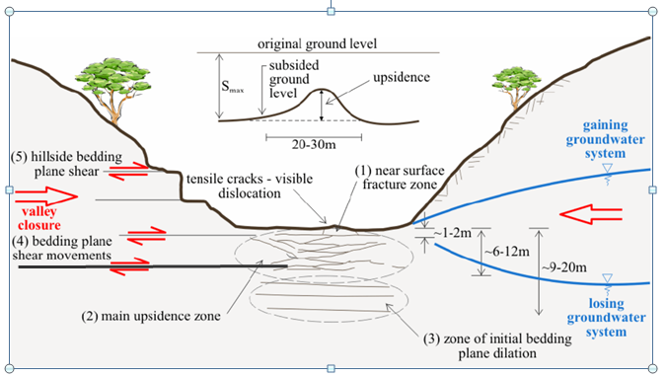
Figure 8.1 Physical changes observed in river channels from mining-induced horizontal subsidence movements.

Development of valley floor impacts
As discussed in Chapter 5, lateral compression occurs whenever there is vertical subsidence within the valley—that is, vertical subsidence occurs below the valley slopes. The primary driver for the horizontal compression in river channels is horizontal movement in a downslope direction caused by strata dilatancy as overburden strata below the topographic high ground on either side of the valley moves downward as a result of vertical subsidence. A secondary effect associated with horizontal stress relief is also evident in some places, notably in the vicinity of gorges in the Southern Coalfield. The magnitude of stress relief movements are generally lower, typically with an orientation of the major horizontal stress direction and generally toward the goaf, and are most evident well beyond the goaf edge in areas where horizontal movement in a downslope direction is not present.
Lateral compression is typically too small to have any practical significance while mining is remote from the river channel. At this stage, the compression is only detectable using high-precision stress change monitoring systems such as the ANZI strain cell (described in Mills et al. 2012) or the stress change monitoring system used at South Bulli (Byrnes 1999). These initial stress changes are small enough to be within the elastic range of the rock strata in the base of valleys and less than the stress required to mobilise low-strength bedding planes or cause perceptible changes in the sandstone strata below the base of valleys.
As further mining occurs below the valley sides closer to the river channel, vertical subsidence increases, the lateral compression associated with strata dilatancy increases and the length of bedding plane available to resist lateral shear movement decreases. The potential for stress relief movements also increases.
From a structural point of view, the effective valley floor is usually somewhat lower than the surface of the rock strata exposed in the base of the valley. The difference depends on the degree of weathering and the location of naturally occurring bedding planes relative to the base of the valley. Figure 8.2 shows an example of Hawkesbury Sandstone exposed in a cutting on the side of the F6 Freeway south of Sydney. The major bedding planes are apparent at a vertical spacing of 2–4 m and have a fine grained, muddy infill typically a few millimetres to a few centimetres thick. Any one of these bedding planes can be mobilised, but the bedding plane that is located at or just below the base of the river channel is the one most likely to be mobilised. This bedding plane, referred to as the basal shear plane once lateral movement has started, is the most likely to become overloaded and allow displacement to occur. Of all the shear planes available to be mobilised, shear on this surface presents the path of least resistance for horizontal movements in a downslope direction.
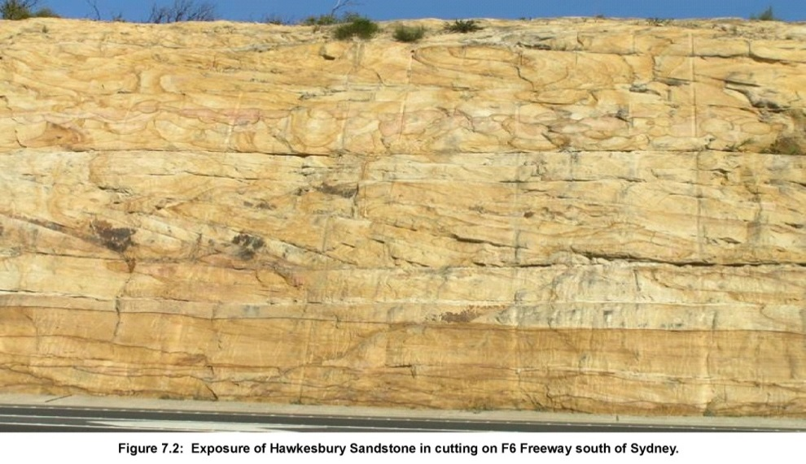
© Copyright, Ken Mills
Figure 8.2 Exposure of Hawkesbury Sandstone in cutting on F6 Freeway south of Sydney.
As shown in Figure 8.3, bedding planes higher up the stratigraphic sequence are subject to lower levels of shear stress because there is less volume of overburden strata dilating higher in the sequence. Although shear movements do occur on these higher bedding planes, such shear movements tend to be localised and do not become systematic until large-scale vertical subsidence occurs. Once vertical subsidence occurs, more generalised shear movement on all bedding planes is required to accommodate the differential vertical subsidence movements that occur above the goaf. These differential movements and shear displacements generate the dilatancy that ultimately cause valley closure and impacts in the base of the river channel.
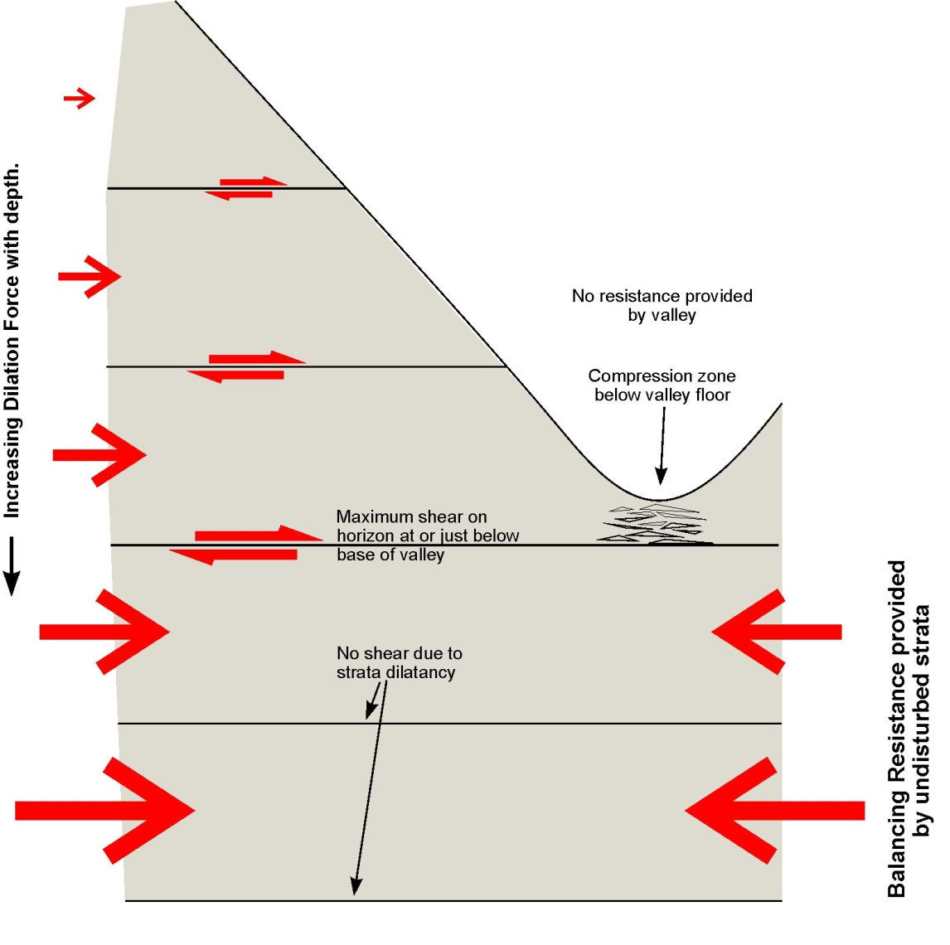
Figure 8.3 Shear stresses developed on bedding planes at various elevations within the overburden strata below topographic high ground.
Bedding planes lower in the stratigraphic section (i.e. below the basal shear plane) are not so prone to shear movement because of the buttressing effect of intact strata deeper below the river channel. Strata on the opposite side of the valley resist shear movements and reduce the shear resistance required to be mobilised on these deeper bedding planes. The lateral compression from below the valley slope on one side is transferred through the buttress and shear movement on the deeper bedding planes are prevented. Once the river channel is directly mined under, these bedding planes tend to become mobilised in shear as the subsiding strata seek to accommodate the differential vertical subsidence movements, but this is a later stage process common to all subsiding rock strata and is not specific to the horizontal compression that occurs below the base of the valley.
Once the shear strength of the basal shear plane has been exceeded, shear movement on this plane causes horizontal compression of sandstone strata in the base of the valley above the level of the basal shear plane. These strata have been observed to fail suddenly, with limited release of seismic energy—particularly during the initial stages of mining—but, in general, shear and horizontal closure movements tend to occur incrementally with the progress of nearby mining below the adjacent slope. This mining causes vertical subsidence, the vertical subsidence causes dilatancy of the subsiding strata, horizontal movement occurs in a downslope direction toward the base of the valley, and the rock strata in the base of the valley is compressed. If mining stops, vertical subsidence stops, dilatancy stops, and the horizontal movements in a downslope direction also stop, typically with only a short delay.
The basal bedding plane that provides the path of least resistance for lateral shear below the sides of the valley is predisposed to develop below the base of the valley when the naturally weathered strata below the base of the valley offer little in the way of buttressing resistance, and thereby allows the basal shear plane to still be the path of least resistance.
If the rock strata in the base of the river channel are sufficiently strong to provide significant buttressing and there is a natural bedding plane present above the base of the river channel, the bedding plane can become the basal shear plane so that horizontal movement occurs on a horizon above the base of the floor of the valley without impacting the sandstone strata in the base of the river channel. This behaviour is observed in river channels where mining-induced subsidence movements appear to leapfrog sections of river channel. Horizontal bedding planes that are mobilised by mining subsidence upstream below the floor of the valley can gradually rise above the base of the valley as the river channel cuts down into the stratigraphy moving downstream. Over the section of the river channel where the basal bedding plane is above the floor of the valley mining-induced horizontal movement in a downslope direction does not cause perceptible impacts on the river channel. It is not until further downstream when another deeper bedding plane becomes the path of least resistance for lateral shear that the sandstone strata above this deeper bedding plane is again subject to lateral compression and impacts become perceptible.
As shown in Figure 8.1, a zone of chaotic low-angle shear fracturing develops in the zone below the base of the valley as the valley side that is being mined under collides with the other side that is stationary (or may be moving toward the goaf as part of a larger-scale horizontal stress relief). The low angle shear fractures that develop are typical of the shear fractures that develop when horizontally bedded strata becomes overloaded in horizontal compression. These low-angle shears override each other, as shown in Figure 8.4, like a series of wedges. As they move together, they force the overlying strata upward (in another example of dilatant rock behaviour), causing a relative upward movement of the surface called upsidence.
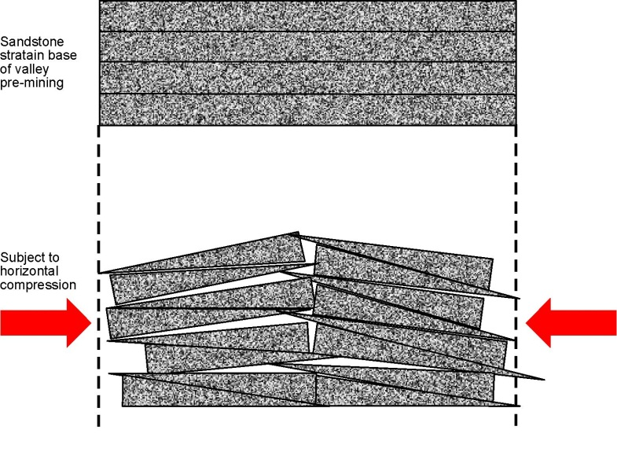
Figure 8.4 Sketch illustrating effect of horizontal compression on sandstone below base of a river channel causing lateral shear failure, upsidence and the creation of a near-surface fracture network.
The zone of upsidence can be detected using surface subsidence monitoring. The zone of upsidence coincides with the zone of chaotic low-angle shear fracturing that is occurring within the rock strata below the surface. Figure 8.5 shows an example of this shear interfingering, looking into a borehole that was drilled before the onset of the shear movement. The zone of upsidence typically extends for 20–40 m from edge to edge, with a peak in the middle, and is generally, although not always, located near the base of the valley.
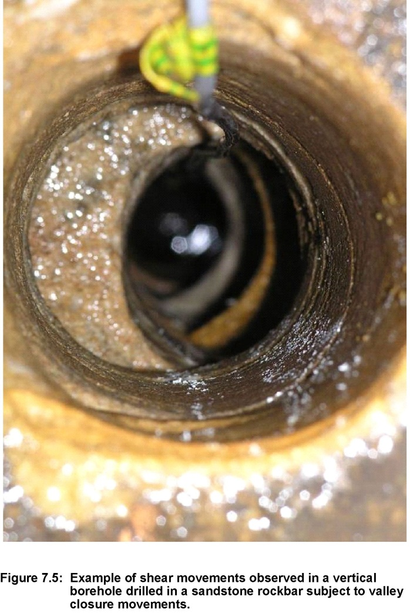
Figure 8.5 Example of shear movements in a vertical borehole drilled in a sandstone rockbar subject to valley closure movements.
At the surface, the strata sometimes buckle upwards, as shown in Figure 8.6, but this behaviour is localised and deeper down and occurs as low-angle shear.
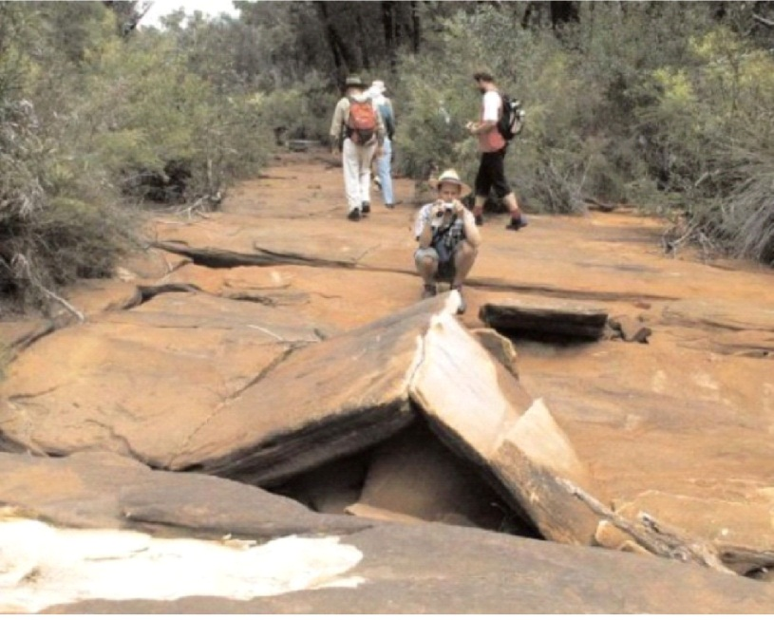
© Copyright, habitatadvocate.com.au
Figure 8.6 Example of upward buckling of restrained surface strata as a result of valley closure movements concentrated in the floor of the valley.
A characteristic of compressive shear fracturing is that overlying strata in the bed of the river channel frequently show tensile cracking, often in a direction along the axis of the river channel and perpendicular to the direction of the lateral compression, as shown in Figure 8.7. This tensile cracking is a result of overall compressive shortening and near-surface buckling that is common in rock strata overloaded with compression. Unfortunately, this tensile cracking has led some observers to conclude that the valley is being stretched or bent open, whereas, in reality, subsidence monitoring shows quite clearly that there is overall compression. The tensile cracking is simply a consequence of the horizontal compression process.
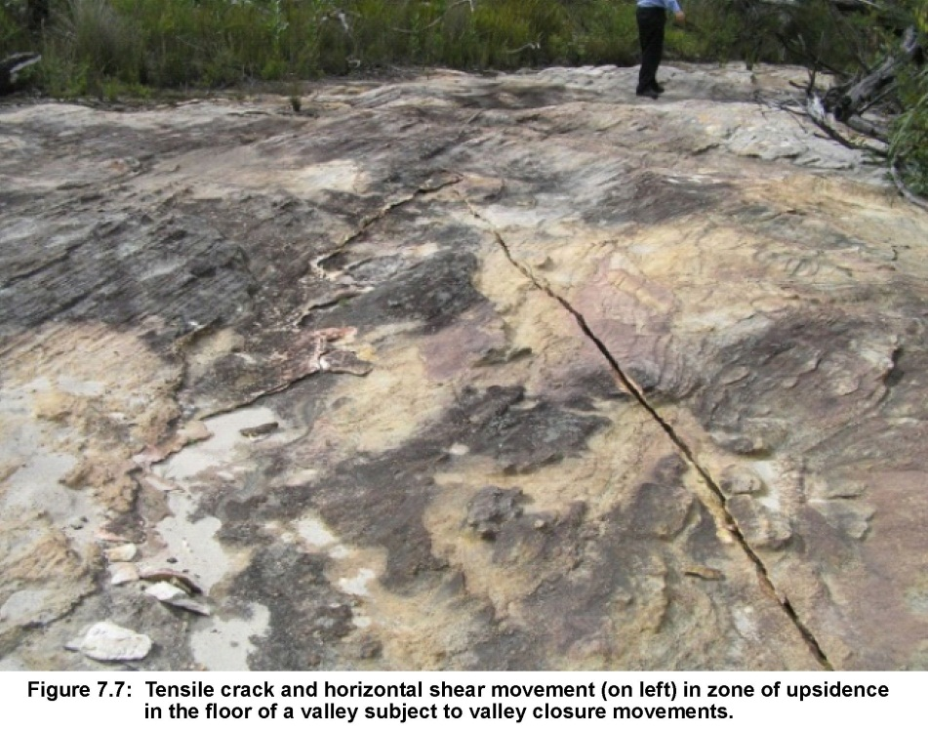
© Copyright, Ken Mills
Figure 8.7 Tensile crack and horizontal shear movement (on left) in zone of upsidence in the floor of the valley subject to valley closure movements.

Comparison with natural weathering processes
The mechanics of the mining-induced subsidence processes that cause valley closure and upsidence in the floor of the valley are driven by a different mechanism to the mechanism that causes natural weathering.
Patton and Hendren (1974) show the type of deformations that occur naturally around the floor of a valley over geological time in response to natural weathering processes. Their figure is reproduced from Fell et al. (2004) in Figure 8.8, with a mining-induced basal shear plane added in red.
Natural weathering processes involve stress relief that occurs through weathering of the sandstone material in the base of the river channel. The limitation on further movement is controlled by the residual strength of the material in the base of the river channel, a process essentially internal to the river channel itself.
In contrast, mining-induced lateral compression is imposed on the sandstone strata in the base of the valley from outside and the rock strata in the base of the valley are entirely passive in this process. This lateral compression is only loosely related to in situ horizontal stresses and is instead driven by horizontal movement in a downslope direction that may involve the entire overburden section above the basal shear plane. The mining-induced lateral compression can far exceed the strength of the sandstone rock strata in the base of the valley and continue without regard for the residual strength of these rock strata. Compression movements cease only when the vertical subsidence below the valley sides and the consequential strata dilatancy have ceased. Mining-induced lateral compression in river channels can also be related to the release of far-field horizontal stresses. Although this process is much closer to the natural processes, it is still a process that is initiated outside the river channel, unrelated to the residual strength of material in the base of the river channel. The magnitude of far-field stress relief movements tends to be smaller (less than 100–200 mm) compared with horizontal movements in a downslope direction generated by the dilatancy of subsiding strata (typical 200–1000 mm).
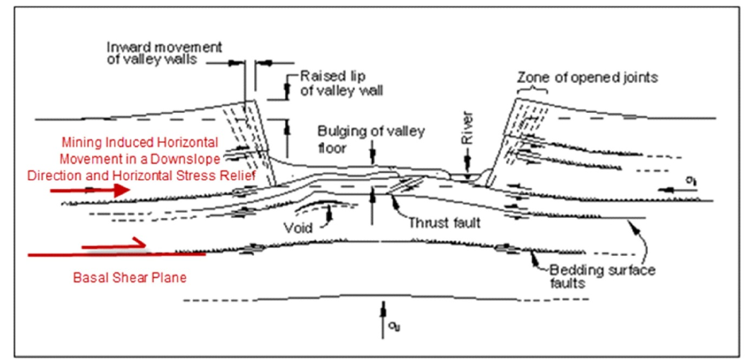
Adapted from © Copyright, Fell et al. 2005, based on Patton and Hendren 1974
Figure 8.8 Natural stress relief impacts to valleys showing development of subsidence movements superimposed in red.

Effect on surface flow
As evident from Figure 8.3, the zone of chaotic shear fracturing associated with upsidence is characterised by large, open fractures, typically through fresh sandstone but in some cases from reactivation of natural shear zones. At several sites, this zone of intense fracturing has been measured to be 5–10 m, nominally 6 m, deep (Iannicchione & Tonsor 2011; Mills 2007) below the top of the previously intact rock strata. However, depth is sensitive to a range of factors, particularly the elevation of the basal shear plane relative to the elevation of the river channel. This relative difference is site specific and is likely to vary significantly, depending on the vertical spacing of natural bedding planes and the natural state of weathering.
Some evidence suggests that there is a downward progression as the level of compression increases, but further field study is required to confirm this behaviour. The basal shear plane may even occur above the level of the base of the river channel in some circumstances, so that no chaotic fracturing occurs, but, more generally, the basal shear plane is observed to be 5–10 m below the surface of the river channel.
The creation of open fractures within the sandstone in the base of the river channel changes the hydraulic conductivity of this strata significantly. In an undisturbed state, the hydraulic conductivity of intact sandstone is about 1 × 10^{–8}m/s at depth and about 1 × 10^{–6} m/s near the surface (Hewitt 2005). Where there are open fractures, the hydraulic conductivity through the fracture network is likely to be in the range 0.1 to 1 m/s, an increase of five or six orders of magnitude.
Before mining impacts, the hydraulic conductivity of the rock strata is typically sufficiently low that flow through the sandstone is small enough to be insignificant for all practical purposes. There are locations where the structure of the weathered sandstone is such that some flow occurs naturally below the surface for short distances. In the headwaters of streams, total flow can be low enough that even low-level subsurface flow becomes a significant proportion of the overall flow. This subsurface flow is part of the natural interaction between surface flow and the groundwater system.
When open fractures are created within the sandstone base of the river channel by mining subsidence, surface water can be redirected into the subsurface fracture network so that the river channel appears to dry up. The fracture network may only extend 6 m below the surface and be 20 to 30 m wide, but experience indicates that such a network is capable of accommodating subsurface flows of greater than 4 ML/day, which is more than the total flow of most tributary upland river systems and peat swamps. The result is that stream channels and peat swamps appear to dry up over the section of the river channel that is impacted by mining subsidence. Figure 8.9 shows an example of the type of change typical of mining-induced impacts on stream channels.
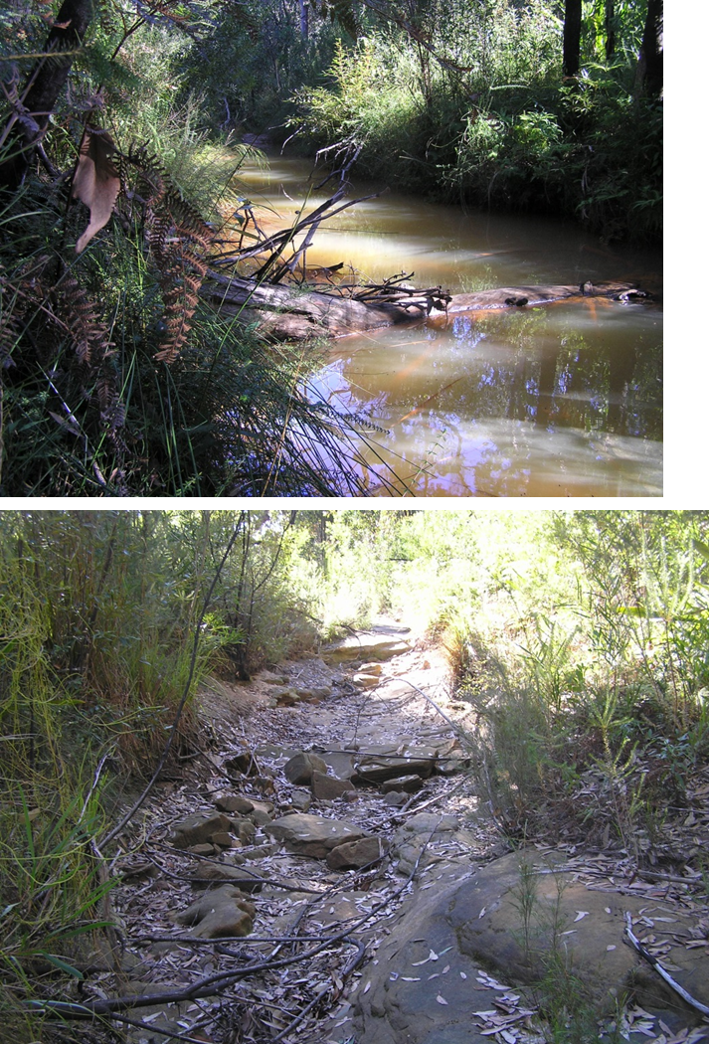
© Copyright, Ken Mills
Figure 8.9 Example of a creek not affected by subsurface compression fractures (top), and a similar creek drained by subsurface fracturing (bottom).
During flood flow, when there is sufficient surface flow to exceed the capacity of the subsurface fracture network, the subsurface flow network flows full and any remaining flow is apparent as surface flow. Thus, river systems impacted by mining subsidence flow again after heavy rain, but once the total flow becomes less than the capacity of the subsurface fracture network, flow occurs entirely within the fracture network and stream channels appear to dry out again.
Mining Subsidence Engineering Consultants Pty Ltd compiled a database of valley-related subsidence movements and concluded that there has been no loss of water from pools within drainage lines or creek alignments when the valley closure has been less than 200 mm (Don Kay, pers. comm., March 2012). This conclusion applies to relatively major creek systems where there is a perennial base flow of some megalitres per day. Water loss from pools occurs naturally in the upper reaches of most water catchments during periods of low flow, even when there is no mining impact. There is self-evidently a relationship between flow and the magnitude of valley closure that is required to cause loss of water from pools. In considering flow loss in upland peat swamps, the magnitude of base flow needs to be considered in the context of the level of valley closure required to cause loss of water from rock pools in drainage lines and creek alignments.

Extent of impact
Water that flows below the surface in the mining-induced fracture network can still remain within the river channel system and return to the surface further downstream in areas that are not impacted by mining subsidence, provided the river system is a gaining system (i.e. the groundwater levels adjacent to the river channel are higher than the river channel) and there is no downwards flow into the mine as a result of more generalised subsidence impacts within the overburden strata.
Initial impact conditions and potential subsidence for rock bars are shown in Figure 8.10.
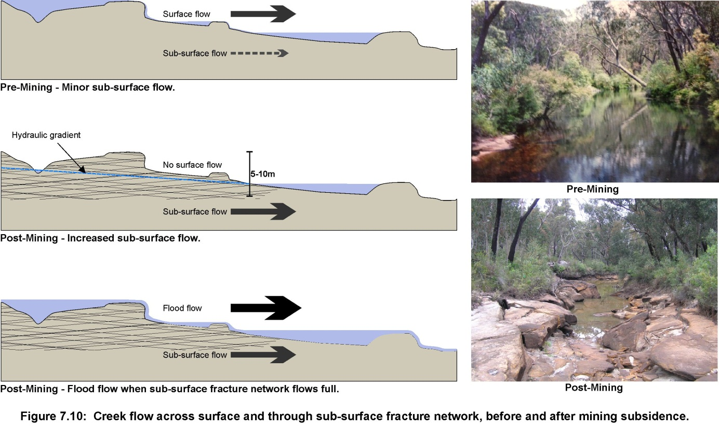
Figure 8.10 Creek flow across surface and through subsurface fracture network, before and after mining subsidence.
When the groundwater system is a gaining system, there can be no net loss of subsurface flow from a mining-induced fracture network below the base of the river channel. Downstream, the subsurface flow returns to the surface as the mining fracture network reduces in size and significance and is eventually no longer present. The return of flow to the surface depends on a number of site-specific characteristics that include:
- stream flow
- stream gradient
- characteristics of the mining-induced fracture network
- how quickly the significance of the mining-induced fracture network reduces with distance from mining
- the significance of stress relief movements in causing the fracture network (because stress relief movements tend to extend much further beyond the longwall edge than horizontal movements in a downslope direction).
In general, in a gaining system, surface flow can be expected to return to the surface within a few hundred metres of the outside goaf edge of longwall mining, either upstream or downstream of the goaf edge, depending on flow conditions.
If the groundwater system is a losing system—either naturally or as a result of mining impacts—some or all of the flow that enters the subsurface fracture network can bleed away into the groundwater system and not return to the surface until the river system becomes a gaining system further downstream. Although this process can occur naturally in a naturally losing groundwater system, the presence of a mining-induced fracture network capable of diverting surface water into subsurface flow increases the potential for loss of surface water into the groundwater system.
Losing groundwater systems occur naturally in the upper reaches of catchments and on slopes elevated above the main river channels. Mining-induced fracture networks in these upper reaches that redirect flow away from the surface impact these areas by reducing the amount of time that there is surface flow in the stream channel to only during and immediately after rainfall events. Peat swamps that occur as headwater swamps and hanging swamps tend to be located in areas where the groundwater system is a likely to be a naturally losing system, making these features more susceptible to mining subsidence impacts.
If the longwall panel is sufficiently wide for zone 2, and sometimes zone 3, described in Chapter 6 to interact with the surface below or adjacent to the valley, the increased hydraulic conductivity in these zones has potential to cause a general drawdown in the watertable through increased downward flow into the mine. Such downward flow can have the effect of changing a gaining river system into a losing river system. The extent of this effect and its significance is site specific and depends on a range of factors, most particularly the height of vertically interconnected fracturing above individual longwall panels.

Oxidation of freshly fractured sandstone
The mining-induced fracture network that develops in the base of river channels, but also more generally throughout the overburden strata, creates fresh fractures in the sandstone strata. Surface water that flows into the subsurface fracture network oxidises the freshly exposed sandstone. The oxidation depletes the water of oxygen and generates weathering products such as iron oxide. These oxidation products cause the water to become red with a ferruginous deposit for some distance downstream of where water returns to the surface. Figure 8.11 shows some examples of the ferruginous deposits due to subsidence impacts.
Oxidation and the generation of ferruginous deposits occur naturally, but there is typically a significant increase in the concentration of these deposits downstream of areas affected by mine subsidence because fracturing allows weathering of the surfaces of the new fractures. Although the impact is noted, the water chemistry of these oxidation processes, the impacts of any changes on ecological communities, and the distance downstream of mining-affected areas have not been studied in detail in this report.
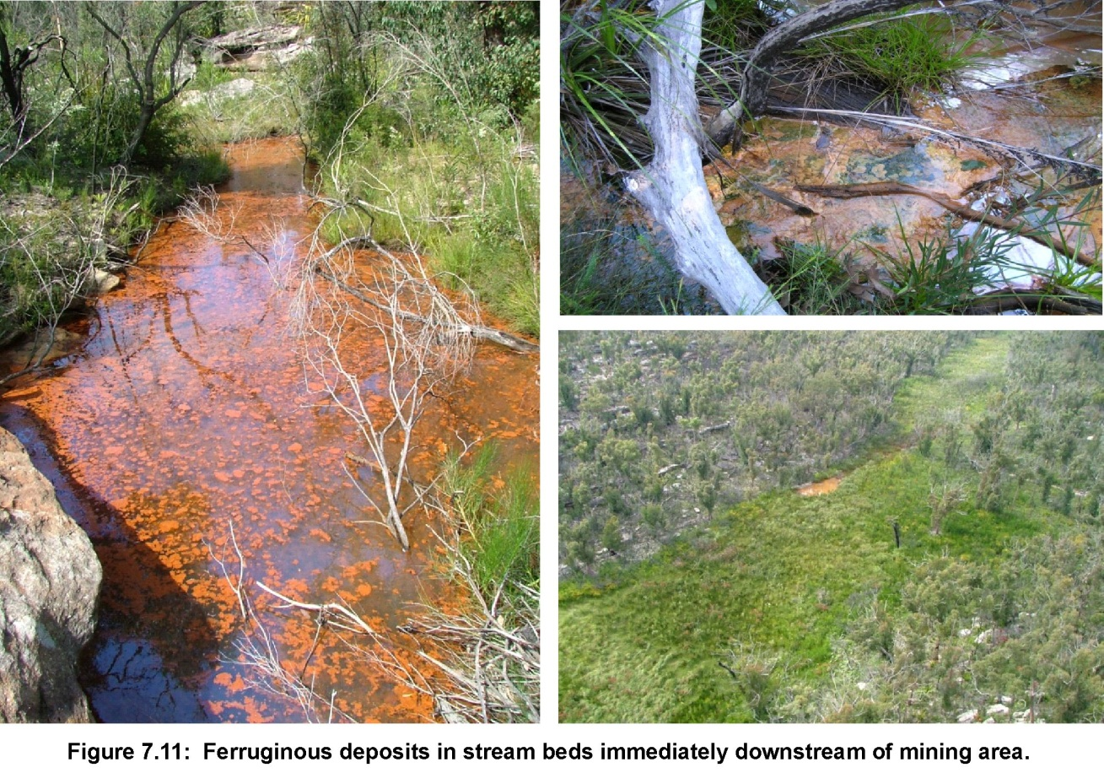
© Copyright, Ken Mills
Figure 8.11 Ferruginous deposits in stream beds immediately downstream of mining area.

Gas releases
Methane gas releases have been observed to bubble up through pools of water in areas impacted by mining subsidence (Figure 8.12). The gas appears to be stored in the sandstone strata and liberated when the sandstone and more impermeable layers that trap the gas are fractured by mining subsidence.
It is likely that such releases occur more widely than in the base of river channels but go undetected because of the small volumes involved and the fact that methane is odourless and colourless and therefore largely undetectable. Methane gas releases are not known to have had any significant impact on peat swamps. Apart from some reports of vegetation die back in the Cataract Gorge immediately adjacent to the release points, the potential for significant impacts associated with methane gas releases appears minor.
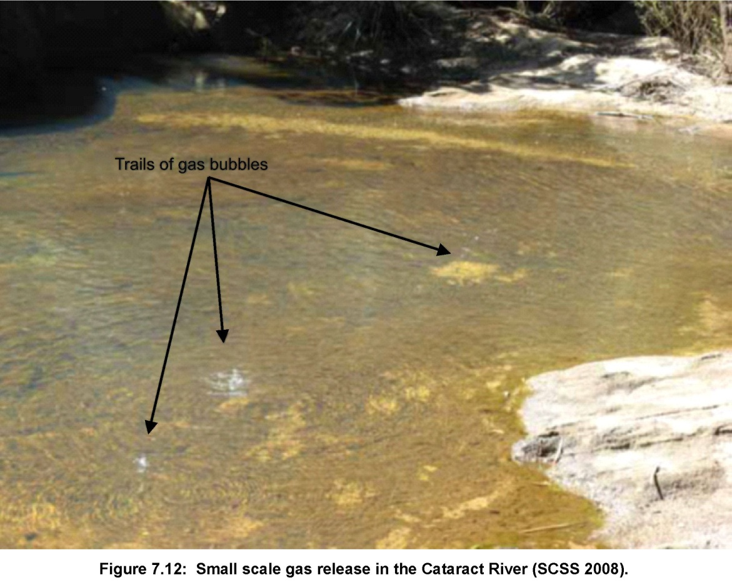
© Copyright, Julie Sheppard, NSW Department of Planning 2008
Figure 8.12 Small-scale gas release in the Cataract River.

Surface impacts due to conventional subsidence movements
Conventional or systematic subsidence behaviour can be quantified using subsidence parameters such as tilt, curvature and systematic strain. The maximum values of these parameters can be predicted for flat terrain conditions with relative confidence, based on the depth of mining, the seam thickness mined and previous experience from using a variety of different prediction techniques. However, in steep terrain, these systematic parameters significantly underestimate the magnitude of the subsidence parameters routinely observed in the base of river valleys because the horizontal movements associated with valley closure typically cause local tilts, curvature and strains that are of much greater magnitude than the systematic equivalents.
Tilting occurs as a result of differential subsidence either from overall vertical subsidence above the mining area or locally around the areas of upsidence that develop in the base of valleys as a result of horizontal compression. Mining-induced tilts alter the gradient of the surface and can result in ponding of surface water or redirection of surface flows, causing scouring and erosion of surface soils. Local tilting as a result of mining subsidence is reported to have caused realignment and increased bank erosion at some sites. Upsidence usually occurs over a much shorter distance (10 to 20 m) and may have a magnitude of 0.5 m, generating tilts of about 50 mm/m. By comparison, tilts associated with general subsidence are typically less than 10 mm/m at 400 m deep.
Upsidence-related local tilts are more likely to be responsible for local redirection of flow paths within a stream channel, with potential for increased bank erosion, because they are larger and occur close to the base of the valley and hence to the watercourse. There is also potential for nick point erosion to be initiated by both local tilting and more general tilting, but the mechanisms involved appear more complicated and seem likely to have a range of other contributing causes, such as fire, intense rain, and flow into mining-induced fracture networks, that also need to be considered. Further work is required to define the mechanism and the influence of these various factors.
Mining-induced curvatures and systematic strains can result in cracking of rock beneath the swamps and buckling of surface soils, with potential to alter the flow of surface water into the underlying strata. The levels of systematic strain are dictated by the mining geometry, the extracted seam thickness and the depth of mining. Where the depth of mining is relatively high (i.e. more than 400 m), the conventional strains rarely exceed 1 mm/m tensile, and 2 mm/m compressive. At these strain levels, changes in the rock strata are unlikely to be readily perceptible. However, locally in the base of river channels, horizontal compressive strains reflect the concentration of horizontal movements of 0.5 m over a 20 to 40-m-wide zone of compression and upsidence. The local strains in this circumstance are about 10 to 20 mm/m and well above the threshold for rock failure.

Impacts on peat swamps
In this section, subsidence impacts on three types of peat swamps are discussed. These three categories (described in Section 8.1) are considered representative of the broad spectrum of peat swamps that occur in areas where mining subsidence occurs.

Impacts on valley infill peat swamps
In this section, valley infill swamps are considered to be swamps that form in flatter sections of relatively major creeks. They comprise several metres of peat material on top of soil and/or rock strata and typically support one or more surface flow channels. The mechanisms that are recognised to impact on these types of swamp are:
- compression fracturing in the sandstone base creating alternative pathways for surface flow
- nick point erosion initiated by differential subsidence
- general lowering of the groundwater table.
The impacts of these mechanisms on peat swamps are discussed in this section. The impacts discussed are more significant directly over longwall panels where the subsidence is greatest, but also occur outside the mining area.

Valley infill peat swamps on rock

Fracturing of underlying sandstone strata
The shear fracture network that develops below a valley infill peat swamp is not usually evident at the surface because it is covered by peat material and masked from view. Upsidence is also not commonly measured in peat swamps because subsidence monitoring lines are difficult to establish without themselves having a significant impact on the peat swamp. However, the mechanics of the shear fracturing and buckling that occur in sandstone strata below creek channels are not significantly affected by the presence of the peat material, so their presence below peat swamps can be expected.
There are not known to be any direct measurements of the physical disturbance in the base of a valley infill peat swamp, but it is surmised that water that keeps the peat swamp saturated when the sandstone rock strata acted as an impermeable base can be diverted into the fracture network in the rock below the base of the swamp, with the result that the swamp tends to become dry over time.
Impacts include loss of surface water into the subsurface fracture network, physical damage to the rock surface where it is exposed, and red staining associated with oxidation of freshly fractured sandstone in areas where water emerges from the subsurface fracture network.
Systematic strains and curvature are not expected to be significant in the bottom of a valley compared with valley closure movements, which tend to be much greater.
Strata compression in the base of a valley associated with horizontal movement in a downslope direction is greatest when mining occurs directly below a valley and the valley floor, but has also been observed outside the mining area at distances up to several hundred metres, depending on the site conditions. Subsurface fracturing is therefore possible at these distances outside the mining area.
Far-field horizontal movements can extend for distances of 1.5 km or more from the edge of the nearest longwall panels (Reid 1998). However, the magnitude of the horizontal strains generated is very small (about 100 mm over 1 km, or 0.1 mm/m) compared with systematic strains directly over the longwall panels. Impacts from far-field horizontal movements on valley infill peat swamps are not known and are unlikely.

Nick point erosion
Nick point erosion has been observed at several sites in close proximity to longwall mining activity, but it is also a natural process that occurs at intervals of several thousand years (Prosser 1994).
A change of gradient could produce accelerated flow at the point in the peat swamp where the gradient increases, initiating nick point erosion. However, the causal relationships that initiate erosion are not well understood and may relate of one of several factors or a combination thereof (Brassington & Horsley 2004).
Surface tilting either locally due to upsidence effects or more broadly with general subsidence has potential to increase surface gradient. Other factors such as desiccation caused by the creation of a mining-induced subsurface fracture network, fire damage, natural processes (e.g. droughts and high rainfall storm events) or a combination of all of these may be equally important triggers.
Creation of a subsurface fracture network is seen in river channels, and similar processes are expected below a peat swamp. The creation of such a fracture network causes surface flow to be diverted deeper in the underlying strata. In a peat swamp, this redirection of flow is likely to accelerate desiccation of the peat swamp, with potential to cause vertical shrinkage and associated changes in the surface level of the swamp. No measurements of change in vertical level of the surface of a peat swamp due to desiccation are known to exist, but, in a 3 m thick peat swamp, it is considered likely that the change would be about the same as the level of mining-induced tilt.
Nick point erosion may also be initiated by fire damage followed by high rainfall events, but it unclear to what extent these factors alone would be sufficient to create a nick point.
Flow over a nick point produces a high-energy flow that causes accelerated erosion retrogressively back along the peat swamp, potentially well beyond the area where the nick point initiated. If the channel that forms is deep enough, the peat on the sides of the channel become vulnerable to slumping sideways into the channel, causing further erosion and significantly changing the character of the swamp, as shown in Figure 8.12. This process may also occur naturally but there are several examples where it appears likely to have been associated with mining subsidence.
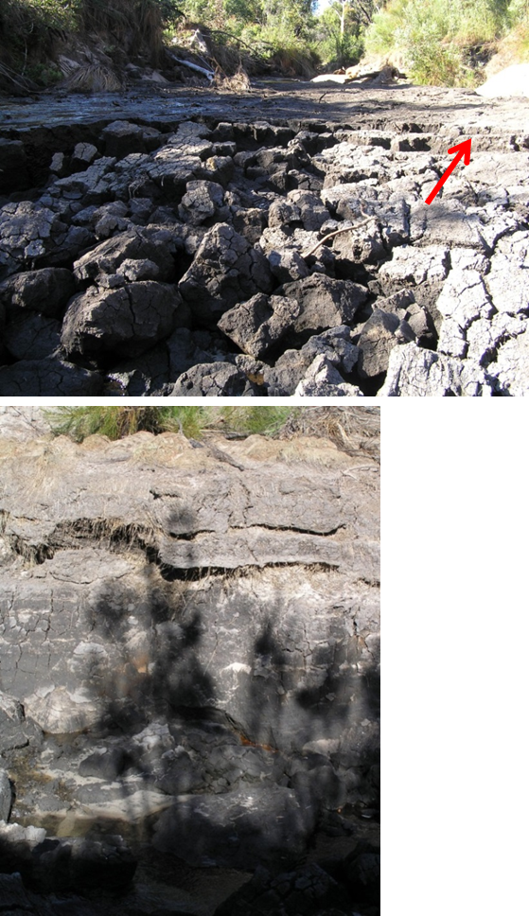
© Copyright, Ken Mills
Figure 8.13 Example of retrogressive nick point erosion and desiccation (top), and slumping of the side of a peat swamp as a result of the formation of a scour gully.
Differential subsidence associated with general subsidence decreases rapidly outside the mining area and is small enough at the goaf edge to be insignificant for most practical purposes. Strata compression in the base of a valley associated with horizontal movement in a downslope direction is greatest when mining occurs directly below a valley and the valley floor, but can also occur outside the mining area at distances up to several hundred metres, depending on the site conditions. Local tilting due to upsidence and subsurface fracturing are therefore possible at these distances.
Far-field horizontal movements are small and are not expected to initiate nick point erosion.

General lowering of groundwater table
General lowering of the groundwater table below valleys occurs as a result of mining subsidence, when there is hydraulic interaction between the surface and underground. Such interaction is considered most likely to occur when the depth of mining is less than about the width of individual longwall panels (Mills & O’Grady 1998; Mills 2012). However, this interaction is likely to be site specific and sensitive to a range of other factors such as magnitude of subsidence, stratigraphy and the hydraulic characteristics of the overburden strata (Forster et al. 2004; Gale 2008; Tammetta 2012).
The impacts on valley infill swamps are likely to depend on how much change in groundwater level there is compared with surface flows and rainfall recharge, and whether or not the groundwater system is changed from a gaining system to a losing system as a result of mining impacts. The effects of longwall mining on valley infill swamps are greatest when the longwall panels are directly under the peat swamp because differential subsidence, compression fracturing and general groundwater drawdown are all likely to be greatest directly above longwall panels.
The extent of drawdown of the groundwater table at any particular site depends on a range of factors, including panel width, overburden depth, geological setting and magnitude of subsidence. The complex interaction of these factors justifies a site-specific investigation at each site.
Groundwater drawdown can extend much further outside the mining area than subsidence impacts. Peat swamps that are sensitive to groundwater drawdown are likely to require special consideration.

Valley infill peat swamps on alluvium

Fracturing of underlying sandstone strata
Valley closure movements can fracture the underlying sandstone in much the same way as described in Section 8.4.1.1 for valley infill swamps on sandstone strata, with the differences being that there is soil material between the fracture network and the surface and these types of swamps tend to be located in flat areas where alluvial material has been deposited.
Where valley closure causes a fracture network to develop within the sandstone strata below this type of swamp, the formation of a fracture network may be of less consequence, as when an alluvial river channel is undermined. The fracture network causes a local increase in hydraulic conductivity, but this increase is of little significance. The fracture network remains fully saturated and because there is no significant gradient along the network for flow—as is possible on steeper gradients in river channels with a sandstone base—there is less potential for any longitudinal flow. Furthermore, any redirection of flow from the surface into the fracture network is significantly limited by the presence of the overlying alluvial materials. As a result, mining-induced fracturing of the underlying sandstone has limited impact when the longitudinal gradient of the swamp is low and there is a significant thickness of soil material.
Systematic and far-field subsidence movements are likely to be insignificant in terms of impacts on the sandstone base when the overburden depth to the mining horizon is greater than about 400 m, even when mining occurs close by.

Nick point erosion
The factors that may initiate nick point erosion are likely to be similar to those discussed in Section 8.4.1.1.
The potential for desiccation and associated shrinkage as a result of surface flow being redirected into the subsurface fracture network is likely to be less if soils are present and there is no downstream outlet from the mining-induced fracture network because of a flatter stream gradient and full saturation within the fracture network.
However, surface tilting—either locally due to upsidence effects or more broadly with general subsidence—can locally increase surface gradient and therefore initiate nick point erosion. Fire damage and natural processes such as droughts and high rainfall storm events, or a combination of all of these may be equally important triggers. In a long, flat swamp, initiation of a nick point may retreat well upstream of the initiation point and therefore be much more significant.
Differential subsidence associated with general subsidence decreases rapidly outside the mining area and is small enough at the goaf edge to be insignificant for most practical purposes.
Far-field horizontal movements are small and are not expected to initiate nick point erosion.

General lowering of groundwater table
General lowering of the groundwater table could impact the swamp and result in drying out of the peat.

Impacts on headwater swamps
In this section, headwater swamps are those where peat and other organic material has formed upstream of a waterfall or other rock feature that substantially influences the hydraulic gradient through the swamp. Typically, the watercourse is directly on sandstone strata. These swamps are frequently located in upland areas in the headwaters of creek systems.
The mechanisms that impact on these types of swamp are:
- compression fracturing in the sandstone base creating alternative pathways for surface flow
- compression fracturing in the hydraulic gradient control structure causing localised groundwater drawdown
- overburden fracturing due to strata dilatancy
- general lowering of the groundwater table.
The impacts of these mechanisms on headwater peat swamps are discussed in this section. The impacts discussed are more significant directly over longwall panels where the subsidence is greatest, but also occur outside the mining area.

Fracturing of underlying sandstone strata
The shear fracture network that develops below a headwater peat swamp is typically evident in the exposed watercourse but may be obscured outside this channel by the cover of peat material and vegetation. The mechanics of the shear fracturing and buckling that occur in sandstone strata below creek channels are not significantly affected by the peat material. The development of a fracture network below headwater peat swamps is expected to be essentially similar to the fracture network developed below a stream channel. The impacts are also similar and include loss of surface water into the subsurface fracture network, physical damage to the rock surface and red staining associated with oxidation of freshly fractured sandstone.
Systematic strains and curvature observed around headwater peat swamps are not expected to be significant by comparison with the valley closure movements that tend to be of much greater magnitude and cause the impacts that are significant.
Strata compression in the base of a valley associated with horizontal movement in a downslope direction is greatest when mining occurs directly below a valley and the valley floor, but has also been observed outside the mining area at distances up to several hundred metres, depending on the site conditions, particularly the nature of the surface topography. Subsurface shear fracturing associated with upsidence and loss of surface water is therefore possible outside the mining area, depending on site conditions.
Far-field horizontal movements are small and generate only low-level horizontal strains (less than 0.1 mm/m). These types of movement are not recognised to or expected to have any impact on headwater peat swamps.

Fracturing of hydraulic control and local groundwater drawdown
Headwater swamps are often located upstream of a waterfall or similar rock structure so that there is a significant change in elevation between the strata that forms the base of the swamp and the river channel downstream of the swamp. The waterfall or rock structure that forms the bottom of the swamp effectively controls the hydraulic gradient within the swamp. If mining subsidence causes a shear fracture network to develop in this structure, particularly one connected to fracture network below the base of the swamp, there is potential for significant local drawdown in groundwater level. The hydraulic gradient through the swamp is no longer controlled by the lip of the waterfall, but is controlled instead by a point of much lower elevation downstream of the waterfall or rock structure.
The potential for loss of surface water occurs because of the presence of the subsurface fracture network that develops below the swamp. The magnitude of the local groundwater drawdown is much greater when there is a fracture network created through the waterfall or other rock structure than when the rock structure remains intact. However, the magnitude of the drawdown may not be significant because the loss of water from the surface causes the major impact rather than the hydraulic gradient within the subsurface fracture network.
Strata compression in the base of a valley associated with horizontal movement in a downslope direction is greatest when mining occurs directly below a valley and the valley floor, but has also been observed outside the mining area at distances up to several hundred metres from the nearest longwall panel depending, on the site conditions. Waterfall and similar rock structures are likely to be more sensitive to horizontal compression movements because of their location at the head of an incised valley and are therefore likely to be impacted by smaller mining-induced ground movements at greater distances from the nearest longwall panels. Impacts are not expected to be generally perceptible beyond a few hundred metres from the goaf edge, depending on site condition.
Far-field horizontal movements are not expected to impact waterfall rock structures downstream of headwater swamps except possibly in special cases where these structures are particularly sensitive in their own right.

Local groundwater drawdown due to strata dilatancy
The presence of a waterfall or similar rock structure at the downstream end of a headwater swamp and the associated change in elevation of the ground surface also means that there is greater potential for horizontal movements in a downslope direction to occur in a downstream direction along a basal shear plane that emerges downstream of the waterfall. The horizontal movement in a downslope direction is driven by dilatancy of the subsiding overburden strata immediately upstream of the waterfall. A secondary effect of this dilatancy is to open up natural joints, bedding planes and mining-induced fractures throughout the upper overburden strata, to be more hydraulically conductive.
The increase in hydraulic conductivity is not likely to be as high as the increase observed in the valley floor compression zone, but a more general increase in overall hydraulic conductivity is nevertheless likely. There are no known field measurements of changes in hydraulic conductivity caused by subsidence-related dilatancy. However, observations of impacts of mine subsidence on headwater peat swamps are consistent with impacts associated with horizontal compression across the valley and a general increase in hydraulic conductivity of the immediate overburden strata. The base flows in headwater swamps are lower than further downstream and so the sensitivity of impact on changes in hydraulic conductivity is also likely to be significant.
This more general increase in hydraulic conductivity is not expected to extend vertically below the basal shear plane when longwall panels are narrow enough relative to depth to the mining horizon, and there is no interaction between the surface fracture network and the fracture network generated in the goaf by caving processes. However, the more general increase in hydraulic conductivity is expected to increase the potential for the groundwater system upstream of the waterfall rock structure to become a losing system, with a consequent reduction in water available to the swamp vegetation.

General lowering of groundwater table
General lowering of the groundwater table occurs as a result of mine subsidence, when there is hydraulic interaction between the surface and underground. Such interaction is considered most likely to occur when the depth of mining is less than about the width of individual longwall panels (Mills & O’Grady 1998; Mills 2012). However, this interaction is likely to be site specific and sensitive to a range of other factors such as magnitude of subsidence, stratigraphy and the hydraulic characteristics of the overburden strata (Forster et al. 2004; Gale 2009; Tammetta 2012).
The impacts on headwater swamps are likely to depend on how much change in groundwater level there is compared with surface flows and rainfall recharge, and whether or not the groundwater system is changed from a gaining system to a losing system as a result of mining impacts. The effects of longwall mining on headwater swamps are expected to be greatest when the longwall panels are directly under the peat swamp because differential subsidence, compression fracturing and general groundwater drawdown are all likely to be greatest directly above longwall panels.
The extent of drawdown of the groundwater table at any particular site is likely to be site specific and require a site-specific assessment. Groundwater drawdown could extend much further outside the mining area than subsidence impacts. Peat swamps that are sensitive to groundwater drawdown are likely to require special consideration.

Impacts on hanging swamps
Hanging swamps considered in this section are those that have formed on valley sides where sandstone rock strata are exposed at or near the surface and the swamp relies on the integrity of the underlying rock strata and a combination of rainfall and groundwater infiltration for recharge. These types of swamps are not typically located on stream channels and do not have standing water.
The mechanisms that are recognised to impact on these types of swamp are:
- fracturing in the sandstone base creating alternative pathways for surface flow
- overburden fracturing due to strata dilatancy causing general groundwater drawdown below topographic high points
- general lowering of the groundwater table.
The impacts of these mechanisms on hanging swamps are discussed in this section. The impacts discussed are more significant directly over longwall panels where the subsidence is greatest. In some circumstances, impacts may also occur outside the mining area.

Fracturing of underlying sandstone base
The shear fracturing observed in valleys is not expected to occur below hanging swamps located on the sides of valleys. However, such swamps are still subject to systematic tilts, curvature and horizontal strains associated with subsidence, as well as tensile strains that are associated with horizontal movement in a downslope direction caused by dilatancy as rock strata subsides.
In general, when the overburden depth to the mining horizon is greater than about 400 m, maximum systematic tilts are expected to be less than 5 mm/m and systematic strains are expected to be less than 1 to 2 mm/m. At these levels, surface cracking and changes in gradient are likely to be imperceptible and impacts associated with mine subsidence are expected to be slight.
However, at 200 m overburden depth to the mining horizon, maximum systematic tilts of 10 to 15 mm/m and maximum systematic strains of 4 to 5 mm/m are expected. These levels of strain would be expected to cause perceptible cracking of sandstone strata. The formation of cracks in the underlying sandstone strata is likely to reduce the water-holding capacity of swamp systems that rely on the integrity of the sandstone base. Even at 200 m depth of overburden to the mining horizon, tilting is not expected to cause significant impacts in hanging swamps because 10 to 15 mm/m change in grade is relatively small compared with the natural grade typical of these types of swamp.
Tensile cracking and elevated tensile strains are generated at the top of slopes by horizontal movements in a downslope direction. The compression that occurs in the bottom of valleys is offset by stretching that occurs at topographic high points. This stretching can cause much larger cracks—from a few tens of millimetres through to a few tens of centimetres wide—along the topographic high ground than those associated with systematic subsidence behaviour. Hanging swamps that are on or immediately adjacent to the top of slopes where mining occurs below the valley sides may experience the large tensile cracks associated with this mechanism. The formation of such large tensile cracks is expected to significantly impact on overland recharge and the storage of water within the soils that form these peat swamps.
Far-field horizontal movements are of low magnitude and cause very low horizontal strains. Far-field horizontal movements are not expected to cause cracking of the underlying sandstone base.

Local drawdown caused by strata dilation
The mechanics of horizontal movement in a downslope direction are discussed in Chapter 5. Strata dilatancy occurs when topographic high ground is subsided and this dilatancy drives horizontal movement in a downslope direction. Strata dilation occurs primarily above the basal shear horizon that emerges in the base of the valley. Dilatancy causes voids to be created within the overburden strata as it subsides. The creation of these voids increases the overall hydraulic conductivity of the strata, particularly in a vertical direction but also laterally. Where the groundwater level is elevated above the river channel—that is, in a gaining river system—an increase in the horizontal hydraulic conductivity of the rock strata below the valley sides causes a flattening of the groundwater table below the valley sides because subsurface flow can occur more easily towards the topographic low points.
Through this mechanism, mining subsidence below the sides of a valley sides causes a general increase in hydraulic conductivity and a general lowering of the groundwater level below the topographic high ground. These processes are expected to reduce the flow available from seeps and springs. Swamps that rely on groundwater recharge from seeps and springs are likely to be impacted as a result (see note 1 at the end of the chapter).
A local drawdown in groundwater level below valley slopes and an increase in vertical hydraulic conductivity are also expected to reduce the capacity of swamps to retain water during dry periods.

General lowering of groundwater table
General lowering of the groundwater table occurs as a result of mining subsidence, when there is hydraulic interaction between the surface and underground. Such interaction is considered most likely to occur when the depth of mining is less than about the width of individual longwall panels (Mills & O’Grady 1998, Mills 2012). However, this interaction is likely to be site specific and sensitive to a range of other factors such as magnitude of subsidence, stratigraphy and the hydraulic characteristics of the overburden strata (Forster et al. 2004; Gale 2009; Tammetta 2012).
The impacts on hanging swamps are likely to depend on how much change in groundwater level there is compared with rainfall and overland recharge and how much the groundwater system is changed. The effects of longwall mining on hanging swamps are expected to be greatest when the longwall panels are mined directly under the peat swamp because differential subsidence, compression fracturing and general groundwater drawdown are all likely to be greatest directly above longwall panels.
The extent of drawdown of the groundwater table at any particular site is likely to be site specific and require a site-specific assessment. Groundwater drawdown could extend much further outside the mining area than subsidence impacts. Peat swamps that are sensitive to groundwater drawdown are likely to require special consideration.

Summary of key concepts relating to subsidence impacts to peat swamps and valleys
- Physical disturbance of the overburden rock strata above longwall mining areas is largely over the longwall panels. Impacts to the groundwater depend on a range of geometric factors such as panel width, overburden depth and stratigraphy but typically extend beyond the zone of physical subsidence impacts.
- Potential subsidence impacts on peat swamps and valleys may include:
  - redirection of surface and subsurface flow from valley swamps and river channels into the immediate subsurface strata (typically less than 6–10 m below the surface), with loss of standing water in pools from the surface
  - near-surface fracturing of rock strata with potential for a drop in perched watertables
  - increased potential for erosion, particularly nick point erosion, and vulnerability to fire damage
  - adverse water quality impacts, including deoxygenation and iron staining
  - release of methane gases
  - potential for changes in swamp vegetation communities.
- Subsidence deformations in valleys result from horizontal movements in a downslope direction on one or both sides of the valley causing:
  - development of a near-surface fracture zone typically to about 6 m below the surface
  - upsidence
  - dilation along bedding planes
  - shear movements along bedding planes below the valley
  - shear movements on bedding planes on the sides of the valley.
- Water lost into the fractured zone that forms in the bottom of the valley allows water to drain from the stream into the subsurface strata. This subsurface flow typically reappears downstream in areas unaffected by mining but, in some circumstances, a proportion may drain downwards into the mine.

Peer review comments on Chapter 8
1. Tony Iannacchione suggests further information could be presented on subsidence impacts on springs that feed peat swamps and also on stream channel pooling. In the US, springs in the headwater areas of watersheds are impacted the most. Springs further away from the headwater areas, when impacted, can reappear further down the hillsides, closer to the valley bottoms. The groundwater aquifers of most concern for the peat swamps are those above drainage. In the northern Appalachian Coal Fields of the US, spring formation (creation) offset some percentage of the spring’s impacts (i.e. total amount of water produced by a watershed). In general, perched aquifers are impacted less by mining-induced subsidence as depth of mining increases.
In some areas pooling in the stream is responsible for changes in the ecosystem and has been observed to cause wetland formation. Stream pooling and flooding occurs when the natural drainage gradient is altered, creating stream segments with both higher and lower slopes, depending on the location within the subsidence basin. The lower sloped stream segments have a higher concentration of pooling problems.

Subsidence models and prediction methods

Introduction
A number of methods are available for predicting both the magnitude of subsidence movements and the various subsidence parameters. These methods generally allow vertical subsidence, tilt, curvature and strain to be predicted. Some methods also allow the shape of the subsidence profile to be determined. However, these parameters alone are not necessarily suited for predicting the impacts of mine subsidence on peat swamps, because impacts on peat swamps are likely to be related to a range of other factors to do with the particular characteristics of the peat swamp itself.
The mechanics of the processes that impact peat swamps have been discussed in Chapter 8. These mechanics vary with the nature and location of swamps relative to the topographic landscape:
- Valley infill peat swamps on sandstone located in the base of valleys can be impacted by horizontal compression that occurs in the valley floor when the sides of the valley are undermined.
- Valley infill peat swamps located on alluvium or otherwise connected with the general groundwater system can be impacted by drawdown in groundwater level.
- Headwater swamps and hanging swamps can be impacted by cracking of the rock strata that form the immediate base of the swamp, dilation of the overburden strata more generally and a general increase in the hydraulic conductivity of the overburden strata below topographic high ground, causing an increase in lateral groundwater flow and a corresponding reduction in groundwater level.
To predict these various impacts requires a range of methodologies that are currently only in the early stages of development.
The phenomenon of valley closure has been recognised for several decades, but only one empirical method is available to predict it. This method is regarded as capable of providing an upper bound of the valley closure movements, but at this stage is not particularly suited to predicting the level of horizontal compression that has potential to impact on peat swamps.
Groundwater modelling systems are available to estimate the drawdown in groundwater level in the vicinity of mining operations. However, the detail of the interaction between mining-induced ground movements and groundwater remains an area of research where more work is required. Tammetta (2012) reviews the experience of mining depressurisation near longwall panels that provides a strong basis for estimating the height of depressurisation above individual longwall panels. Note that there is always likely to be a significant site-specific component to the interaction that will require resolution through field measurements.
The phenomenon of ground dilation and the interaction of this dilation with groundwater below topographic high points and more generally within the overburden strata are areas of research where further work is required. Some work has been undertaken at specific sites, but the industry understanding of the phenomenon and its interaction with groundwater is still developing.
In this section, methods for predicting conventional subsidence are reviewed briefly. However, because these methods are not directly applicable for predicting impacts on peat swamps, the review is an overview for completeness rather than an in-depth appraisal of each approach. An empirical method that is available to predict valley closure movements is reviewed as a basis for estimating the compression movements likely to be experienced by valley infill swamps. Areas of further work are identified and discussed.

Methods of predicting conventional subsidence movements
A number of methods are used for predicting conventional subsidence movements, most of which are based on or calibrated against empirical observations. Due to the variation in geological conditions from country to country and site to site, all prediction methods need to be calibrated to locally measured subsidence data and regularly compared with field observations. This allows the methods to be refined as further data become available. In Australia, most of the subsidence prediction work is undertaken by a small number of specialist consulting companies each using their own methods, most of them using a proprietary database developed over time, proprietary software or both. A few methods for estimating subsidence parameters are publicly available, but these tend to be of a general nature. Empirical methods include localised characterisation of subsidence behaviour (e.g. Holla 1987, 1988, 1991), which is a publicly available methodology; the Incremental Profile Method (Waddington & Kay 1995), which is based on a proprietary database; profile function methods; and various graphical methods.
A range of numerical and analytical models have also been used to predict subsidence movements. These methods involve characterising the overburden strata into discrete units that are assumed to behave according to a set of constitutive models that govern material behaviour. The complexity of these models depends on the level of discretisation and the assumptions that are made about the behaviour of the material.
Simple models assume the overburden strata is a continuous, isotropic, elastic, homogeneous medium that is disturbed only by the removal of coal at the mining horizon. The influence function method (Ren et a. 1987) and boundary element models (Crouch & Starfield 1983) are examples of this type of model.
Simple conceptual models based on the mechanics of subsidence behaviour allow estimation of sag subsidence over single panels and elastic compression subsidence over multiple panels. When added together, the total subsidence can be estimated and subsidence parameters such as strain and tilt can then be derived empirically.
The next level of complexity that is common in subsidence models involve the assumption that the overburden strata behaves according to the relationships that have been developed for slender beams or, in three dimensions, plates. There are numerous variations of this approach that range from treating significant stratigraphic units as single beams through to the multiple stacked plates that attempt to match the general overburden behaviour on the assumption that individual stratigraphic units deform as beams. As discussed in previous sections, the actual subsurface ground movements are strongly influenced by failure of the rock strata in horizontal compression and, unfortunately, this behaviour is not well represented in beam theory. Nevertheless, these models are widely used and can be calibrated to give parameters that are close enough to actual behaviour to be useful.
A higher level of complexity involves discretisation of the overburden section into small enough elements to simulate actual material behaviour, including the range of actual failure processes. The elements are typically less than 1 m in size, and the constitutive equations that govern material behaviour reflect the brittle nature of rock failure, the influence of confining pressure, and the influence of natural and mining-induced fractures in the rock strata. The mechanics of the subsidence processes can be investigated using this approach. However, the approach requires a high level of investigative effort to determine the material properties for each of the elements and, at this stage, essentially remains a two-dimensional process because of the heavy computational effort required.

Valley closure prediction
The prediction of valley closure movements provides an indication of the magnitude of mining-induced movements likely to impact on sandstone strata that form the base of peat swamps. This magnitude is only an indication of likely impacts because the sensitivity of particular peat swamps to any given level of movement cannot yet be predicted with a high level of confidence, particularly at low flow rates such as those that are commonly observed in peat swamps.
The is an empirical method for the prediction of valley-related mining-induced movements, based on an extensive database of observed valley-related movements over coalmining operations in New South Wales (Waddington Kay & Associates 2002). This method provides an upper bound measure of valley closure movements, and is described in this section.

The ACARP method for predicting valley-related movements
The Australian Coal Association Research Program (ACARP) method for predicting valley-related movements enables the prediction of closure and upsidence in gorges, river valleys, creek alignments and other watercourses. The prediction, at a particular point in a valley, usually includes closure of the valley sides, uplift due to bulging and buckling of the strata in the base of the valley, and the potential compressive strain across the valley.
The method uses four parameters to make the predictions, using four graphs for closure and four graphs for upsidence. The four parameters are the maximum incremental subsidence of the longwall being mined, the depth of the valley at the point under consideration, the transverse distance from the side of the longwall and the longitudinal distance from the end of the longwall.
The transverse distance is used to obtain an initial closure or upsidence value from the first of the graphs, and the other three graphs are used to obtain adjustment factors (F1, F2 and F3), based on the other three parameters. The final value of closure or upsidence is obtained by multiplying the initial value by the three adjustment factors. The compressive strain is obtained from the closure value using a graph that plots the relationship between maximum compressive strain and closure.
The predicted effects are used to assess the likely levels of impact on the watercourses and the potential for the diversion of surface water flows into the dilated strata caused by upsidence in the base of the valley.
The ACARP method is an empirical method based on an extensive database of observed upsidence and closure movements in valleys based on about 10 000 data points (Kay et al. 2011b). The method has been used on many occasions and has been found to be conservative (i.e. to overpredict in most cases), as illustrated in Figure 9.1, which is not surprising, since the method was based upon a series of upper-bound curves over the available data. Subsets of the empirical data relevant to specific cases can be used to refine the upsidence and closure predictions, if more realistic rather than conservative predictions are required.

© Copyright, Kay et al. 2011
Figure 9.1 A comparison of predicted and observed valley closures.
A further ACARP study is aiming to include the effects of geological data.
The method is based on observed data that was collected predominantly from the Southern Coalfield of New South Wales and is therefore better suited for use in that coalfield. The method could be extended for use in other coalfields, although at shallower overburden depth much larger horizontal movements have been observed than would be predicted (Mills 2001), so the method would need to be modified somewhat in this circumstance. The method has also been used at a coalmine in Pennsylvania where the predicted movements compared well with the observed movements.
The method allows upsidence to be predicted. However, there are a number of practical limitations that make the prediction of upsidence less consistent than the prediction of valley closure. The localised nature of sliding, shearing, crushing and buckling of strata in the base of valleys means that there can be great variability in upsidence. The majority of the subsidence movements are measured on survey lines where the survey marks are 20 m apart. It is, therefore, possible that any local buckling of the strata may not be apparent from the survey data.
The method can be used to predict the upsidence along a river or creek alignment, to indicate the likely changes in gradient and the potential for ponding or scouring to occur, but the upsidence value does not readily lend itself to the assessment of the physical impacts.
In contrast, valley closure is more of an en masse movement of the valley sides towards each other in a downslope direction and is less affected by the mode of failure of the strata in the base of the valley. The closure of the valley has, therefore, been chosen as the primary parameter to use for estimating the magnitude of potential physical impacts.
As an empirical method that is based on a large database of observed data, the ACARP method would appear to be more reliable than other possible numerical modelling methods that would need to make significant assumptions regarding the state of stress in the valley sides, the potential changes in stress as mining occurs and the failure mechanisms that are likely to occur. One of the major problems in making such assumptions is that the underlying mechanisms are not fully understood and there are a number of conflicting theories.
The ACARP method is not a proprietary method and can be used by others; it is expected to be revised by the end of 2013.
The prediction of valley-related subsidence effects is not an exact science. However, the ACARP method, being based on upper-bound curves, has given reasonable and conservative results in most cases, as shown in Figures 9.1 and 9.2, and has been used as the basis for management plans to protect major creeks and river systems above longwall mining operations at collieries in the Southern Coalfield. Its application to predicting impacts on peat swamps is likely to be less reliable because the levels of flow diversion are likely to be much less.

© Copyright, Kay et al. 2011
Figure 9.2 A comparison of predicted and observed valley upsidence.
Observed movements have been compared with predicted movements and have generally been found to be lower than predicted, though in approximately 5 per cent of cases the predicted values have been exceeded. Typically, observed closures have been approximately 50 per cent of the predicted values, while observed upsidence values have been approximately 30 per cent of the predicted values.

Other methods
CSIRO researchers Mike Wold and Xavier Choi used numerical UDEC and FLOMEC models to investigate valley-related subsidence movements as part of the work carried out by MSEC under ACARP research projects C8005 (2001) and C9067 (2002).
Chugh et al. (1994) report on three-dimensional modelling of subsidence, strain, tilt and curvature due to the proposed longwall extraction at BHP’s Appin and Tower collieries. They used a three-dimensional numerical model, the longwall ground mechanics model, which was developed at Southern Illinois University. The finite element analysis of mining-induced effects in a gorge area was made using the ANSYS finite element computer program.
An assessment of valley-related subsidence impacts on the Upper Cordeaux No. 2 Dam, due to mining at Dendrobium mine, was carried out by the New South Wales Department of Commerce in 2006, using a linear elastic finite element (FE) model (NSW Department of Commerce 2006). (See the note at the end of the chapter.)

Prediction of far-field movements
Far-field movements are small movements observed for considerable distances outside the mining area. In general, these movements are of little significance except in particular circumstances where large structures that are vulnerable to differential movements are constructed in circumstances where differential far-field movements can impact them. Far-field movements are not generally associated with high levels of strain and are unlikely to have any potential to impact peat swamps.
Far-field movements were first noticed during surveys around the Cataract Dam in the early 1990s as mining occurred at South Bulli Colliery (Reid 1995). Similar movements were recorded during 1997 and 1998 as Longwalls 15 and 16 were mined at Tower Colliery, to ascertain whether the mining would adversely affect the twin bridges that carry the Hume Highway across the Nepean River at Douglas Park and the overbridge that carries Moreton Park Road across the Hume Highway (Hebblewhite et al. 2000). Far-field movements that had occurred in the Western Coalfield and at the Cataract Dam were referred to by Mills (2001) and Reid (2001), respectively.
Waddington Kay & Associates (2002) show recorded far-field horizontal movements at Bellambi and Tower collieries plotted against the distances from the edges of the longwall goaf areas. This graph could be used to give an approximate value of the regional horizontal movement, based on the upper-bound values for each colliery. Figure 9.3 shows an update of this data and estimates of confidence that can be placed in the results. While this graph can be used to predict values of far-field movements, the results will be conservative (i.e. the graph will tend to overpredict). The majority of the data was collected in the Southern Coalfield and may be less representative of movements in other coalfields. However, Mills et al. (2011) report far-field horizontal movements measured at Ulan Coal Mine in the Western Coalfield extending to about 1.6 km from the goaf edge.

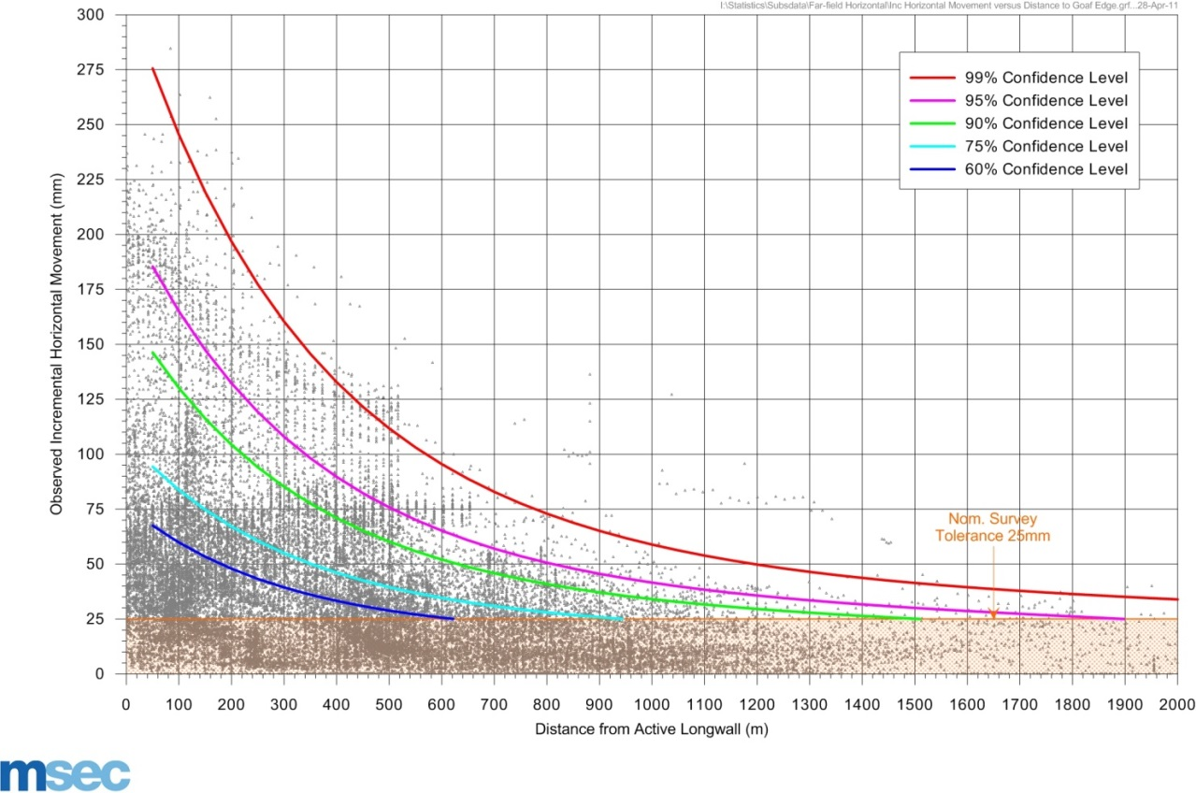
Figure 9.3 Observed horizontal movements versus distance from longwall.
The main cause of far-field horizontal movements is thought to be relief of horizontal stresses either toward the goaf of one or more longwall panels or toward a significant topographic feature, such as a gorge or large valley. Pells (2011) reports on a simple method for estimating horizontal stress relief, based on an elastic model.
While predicting far-field horizontal movements is helpful to estimate the small changes that are commonly observed to extend to 1.5 km or so outside longwall mining areas, there is no clear association between these movements and potential impacts on peat swamps. The horizontal strains generated are typically less than 0.2 mm/m to 500 m and less than 0.1 mm/m at 500 to 1500 m from the goaf edge. These strains are much less than the 2 mm/m or greater that are typically required to cause perceptible levels of change to rock strata. Far-field horizontal movements are not critical to peat swamps.

Prediction of mining impacts on peat swamps
No direct methods for predicting the impacts of longwall mining on peat swamps are known. As noted in Chapter 8, peat swamps are likely to be sensitive to a range of factors that include changes in water level, including changes associated with redirection of surface flows into a mining-induced subsurface fracture network.
Further work is required to review the experience of mining subsidence on peat swamps, to determine the extent and significance of impacts. During the last century, pillar extraction and longwall mining methods have been used to undermine a large number of peat swamps in the Southern and Western coalfields of New South Wales. A review of the rate of recovery, the nature of the changes and the significance of any changes is recommended.
Experience of impacts on creeks and river channels are likely to be repeated directly below peat swamps with similar potential for flow diversion into the subsurface fracture network. However, whereas the impacts on creeks are usually only considered for third- and fourth-order creeks, where the flows are typically more than 1 ML/day, most peat swamps are located on first- and second-order watercourses, where surface flow rates are typically ephemeral and range from nothing to less than 0.5 ML/day. The long- and short-term sensitivity of peat swamps to small changes in the subsurface flow is not known.
Most of the significant impacts noted for peat swamps relate to high flow events that are associated with mine discharges or natural rainfall events following bush fires. Others relate to physical disturbance such as the formation of access tracks. Some of these impacts are mining related but many are not necessarily subsidence related. Others are essentially a combination of natural events, with the possibility that there has been some contribution from mining subsidence. The prediction of these types of combination impacts is challenging, even though the impacts may be more immediate and more significant.

Summary of key concepts
- Prediction of subsidence impacts
  - The sensitivity of particular peat swamps to any given level of movement cannot yet be predicted with a high level of confidence, particularly at low flow rates such as those that are commonly observed in peat swamps.
  - Conventional subsidence prediction methods are limited for peat swamps since they do not predict valley closure, a process that has potential to modify flow regimes within swamps.
  - An empirical method has been developed for predicting ground movements associated with valley closure.
- Conventional subsidence prediction methods
  - Empirical methods include localised characterisation of subsidence behaviour (e.g. Holla 1987, 1988, 1991), a publicly available methodology; the Incremental Profile Method (Waddington & Kay 1996), based on a proprietary database; profile function methods; and various graphical methods.
  - Numerical and analytical models have been used to predict subsidence movements. These methods involve characterising the overburden strata into discrete units that are assumed to behave according to a set of constitutive models that govern material behaviour. The complexity of these models depends on the level of discretisation and the assumptions that are made about the behaviour of the material.
- Non-conventional prediction methods—valley closure
  - The ACARP method is an empirical approach to predict valley closure and upsidence from a database of upsidence and valley closure movements, predominantly from the Southern Coalfield. It has been found to give reasonable and conservative results. Further research will include the effects of geological data on the movements.
- Non-conventional prediction methods—far-field effects
  - Far-field horizontal movements are due to stress relief and are not recognised to have any potential to impact on peat swamps, due to the low levels of horizontal strain and tilt involved.
  - A plot of distance versus horizontal movement, based on a number of data points and an elastic model, provides estimates of these movements that confirms their low magnitude.

Peer review comments on Chapter 9
Tony Iannacchione notes: A new version of the Surface Deformation Prediction System (SDPS) now accounts for sloping terrain and can also predict valley closure (“Addressing the Effect of Sloping Terrain on Ground Movement Due to Underground Mining,” by Agioutantis and Karmis, 2013, in Environmental Considerations in Energy Production).

Monitoring

Introduction
Data collection to assess the condition of peat swamps before, during, and after mining is important for understanding the impact of mining on peat swamps. It is not a management tool since by the time the impacts are picked up by the monitoring equipment, the feature of interest has been impacted to same extent. This section provides a summary of some techniques that can be used to collect data so that subsidence impacts to the peat swamps can be better assessed in the future by regulators and researchers.

Surface subsidence
Mills (2011) provides a summary of subsidence monitoring methods, which are discussed in the remainder of this section.

Level and peg-to-peg chaining
Level and peg-to-peg chaining has been used for a number of years. Mills (2011) indicates that survey pegs are installed along a line at a spacing ºf 1/20th the overburden depth perpendicular, parallel or at an angle to the longwall panel. The line extends beyond the limits of where subsidence is anticipated. The limit of subsidence is typically taken as 20 mm due to survey tolerance and movements that may be due to ground swell or shrinkage, rather than subsidence.
Mills also indicates that two assumptions were implicit in this technique:
- the pegs at the ends of the line do not move horizontally (i.e. beyond the limit of subsidence)
- all horizontal movements and strains occur in the direction of the subsidence line. However, because the distance between pegs was measured by chaining, since horizontal movements can extend well beyond the extent of no vertical subsidence and movements are typically three dimensional, care must be taken in using this method, therefore, three-dimensional surveying of pegs is a better approach.
Levelling is the most familiar form of ground survey, and comprises taking measurements of ground elevation and position, with respect to known locations, using an accurate surveying instrument called a theodolite. Differential levelling refers to any method of measuring the difference in elevation between two or more points directly with a graduated staff.
Precise levelling is a particularly accurate method of differential levelling that uses highly accurate equipment and reference levels, with a more rigorous observing procedure. It has an accuracy of approximately 1 mm per 1 km traverse. This method is regarded as the most accurate, but also the most time-consuming.
Elevations are measured with respect to precisely surveyed reference locations called benchmarks. The measurement of subsidence relies on stable benchmarks.
Geoscience Australia and Habermehl (2010) indicate that geodetic topographic monitoring should be carried out. Geodetic monitoring simply means that a survey should be georeferenced, and should account for the curvature of Earth. In Australia, this typically means that the national standard geographic coordinate system, GDA 1994 MGA (and relevant zone) is used for spatially locating the study area. Reference points can be set and the movement of these points monitored over time, using either ground-based surveying or remote satellite-based monitoring.

Total station surveying
Mills (2011) indicates that three-dimensional surveying became more common in the late 1990s due to the availability of total station survey instruments.
Garlinge and Barbato (2011) present the use of an automated total station approach for monitoring longwall subsidence deformations.

Global positioning system
The global positioning system (GPS) refers to defining a location using a number of satellites from the group of GPS satellites that orbit Earth. Each GPS satellite continually transmits messages that include the time of transmittal and satellite position. A receiver on Earth’s surface uses these messages to determine the transit time of each message and computes the distance to each satellite using the speed of light. These distances, along with the locations of the satellites, are used to calculate the position of the receiver. Exceptional time accuracy is required; therefore, a receiver uses four or more satellites to solve for four variables (the ’receiver's location and the exact time).
For subsidence assessment, differential GPS (DGPS) measurements are used to calculate horizontal positions and an ellipsoid height (Sneed et al. 2001). Ellipsoid height is the vertical difference relative to a geodetic reference system. The ellipsoid that closely approximates Earth’s shape in Australia is the Australian Geodetic Datum of 1994 (AGD94). Subsidence is measured by determining changes to ellipsoid heights. To determine changes in ellipsoid heights, heights from successive GPS surveys are compared, and the differences in the ellipsoid heights are used to determine the existence, location, and magnitude of vertical land-surface changes (Sneed et al. 2001).

LiDAR
LiDAR (Light Detection and Ranging) and ALS (Airborne Laser Survey) are different names for the same technique. In Australia, ALS is the most commonly used term. ALS uses pulsed light emitted in a swathe, generally from an aerial laser system mounted beneath an aircraft or helicopter, or mounted on a tripod. The laser pulses are reflected by the ground surface back to a receiver, enabling topographic data to be calculated by measuring the time taken for the pulses to return. Typically, the data is at a resolution of between 0.5 and 10 points per square metre, depending on the monitoring medium (with helicopter surveys generally giving the greatest density of points).

Interferometric Synthetic Aperature Radar
Interferometric Synthetic Aperture Radar (InSAR) is a method that uses radar signals emitted from satellites orbiting Earth. The phase component of reflected radar signals is used to measure apparent changes in the distance to the land surface. Ordinary radar on a typical Earth-orbiting satellite has poor ground resolution (about 5–6 km) because of the restricted size of the antenna on the satellite. Synthetic Aperture Radar (SAR) takes advantage of the motion of the spacecraft along its orbital track to mathematically reconstruct (synthesise) an operationally larger antenna to produce a high-resolution scan or image.
Radar waves are reflected from Earth’s surface and returned to the satellite, as shown in Figure 10.1. Interferometric processing of the phase (wavelength) information received by the satellite provides topographic information, as the SAR images taken at the same location but acquired at different times yield information on topographic change. Differential interferograms are created by subtracting one set of data from another. Topographic change is represented by phase changes, which appear as interference fringes. These fringes are usually allocated the full colour spectrum on interferograms, to better differentiate the phase cycles and topographic change (i.e. the colour of the fringe at the point in question indicates the magnitude of ground deformation). A sample interferogram is shown in Figure 10.2.
For landscapes with more or less stable radar reflectors (such as buildings, structures, undisturbed rocks and ground surfaces), high-precision measurements of the change in the position of the reflectors can be made by subtracting two radar scans made of the same area at different times (USGS 2000). Under ideal conditions, it is possible to resolve changes in elevation of about 5–10 mm (USGS 2000).
There are a number of different SAR techniques, each adopting a different image analysis approach. Further, different satellites use different wavelength radar. ALOS PALSAR L-Band data is currently the most widely used, with a wavelength of 236 mm and data extending back to 2006. Before this, ERS-2 C-band data was used, with a wavelength of 58 mm. The fringes representing each phase cycle in a Differential SAR (DifSAR) interferogram represent ground displacement equal to half the wavelength (i.e. 118 mm for ALOS and 28 mm for ERS-2).
Industry representatives and coal seam gas experts attending Coffey Geotechnics workshop on 24 August 2012 considered InSAR one of the most effective and practical subsidence monitoring methods for coal seam gas production projects. The technique has been successfully used in Australia to detect small ground deformation over large areas (e.g. Ge et al. 2003).
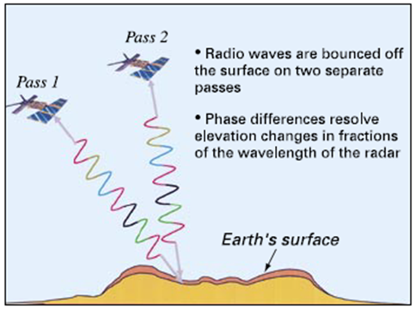
© Copyright, USGS 2005
Figure 10.1 How InSARWorks.
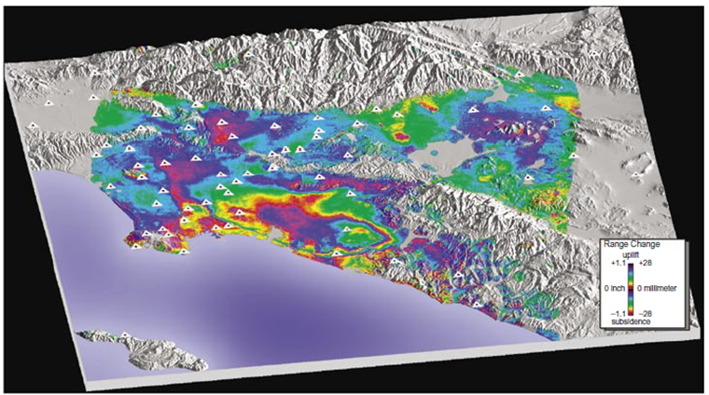
© Copyright, USGS 2005
Figure 10.2 Interferogram showing deformation in the Los Angeles Basin from April 1998 to May 1999.
Table 10.1 Appraisal of different subsidence monitoring techniques.
Monitoring technique | Advantages | Disadvantages
Conventional levelling | Inexpensive if used for small study areas.  Provides 0.1 –1 mm accuracy (USGS 2000b). | Not practical or cost-effective over large study areas.  May be restricted by access issues.
Differential Global Positioning System (DGPS) | Inexpensive over small study areas.  Accurate to 20 mm in the vertical direction and 5 mm in the horizontal direction (USGS 2000b). | Restricted resolution and accuracy.  Error increases with distance from reference station.  Accuracy reduced due to tree cover.
Airborne Laser Survey (ALS)  Measures the return time of pulsed light to provide high-resolution topographic data | High-resolution data over a defined area.  Can be supplied with corresponding high-resolution aerial photographs.  Over flights can be commissioned whenever the client requires (subject to weather conditions). | Requires independent survey over flights.  Expensive  Prone to localised distortion if effective algorithms to remove vegetation are not applied.
Synthetic Aperture Radar (SAR)  Uses differences in radar wave phase and amplitude to assess changes in topography | Data can date back to the early 1990s.  Data covers large area: some satellites can capture areas of up to 100 km by 100 km: ALOS has a swathe width of 70 km and overpasses areas every 46 days.  Accurate to 5–10 mm (USGS 2000b).  Reflective markers can be placed within the study area to reduce positioning error. | Results can be somewhat subjective, depending on the accuracy to which the start of phase changes are measured.  SAR is sensitive to variations in moisture (e.g. seasonal variations in groundwater levels and vegetation growth/removal). Long wavelength signals (i.e. ALOS data) are less prone to moisture-related scatter.  Atmospheric variability (temperature, pressure and water vapour) can cause radar wave scatter, resulting in image artefacts and localised phase variations of up to 0.5 phase cycles. This can often be visually identified as they appear different to variations associated with ground displacement.  The differential interferogram is produced in conjunction with a digital elevation model (DEM) to remove topographic effects from the output image. Magnitude of topographic phase errors is a function of the DEM quality.  Positioning errors can occur, causing large-scale orbital phase trends across the interferograms.  It is advantageous to analyse as many DifSAR pairs as possible (tens of pairs, particularly where precise, millimetric ground movement change is required). If just a few are assessed, it is difficult to assess which phase changes represent ground movement, or which are artefacts.  Ground shrink-swell behaviour (e.g. where clay layers expand and contract in accordance with seasonal water availability) can confound results.  Cost may be an issue.

Groundwater

Observation well
An observation well is a device that has no subsurface seals and creates a vertical connection between strata. A well typically consists of PVC pipe with a slotted section. The pipe is installed in a sand-filled borehole with a cement seal around the pipe at surface level to stop run-off entering the borehole, as shown in Figure 10.3. Water levels are measured using a water-level indicator, which consists of a probe, a graduated tape and a cable reel with built-in electronics. The probe is lowered down the standpipe until it makes contact with water, signalled by a buzzer and light. The water-level depth is read from the tape.
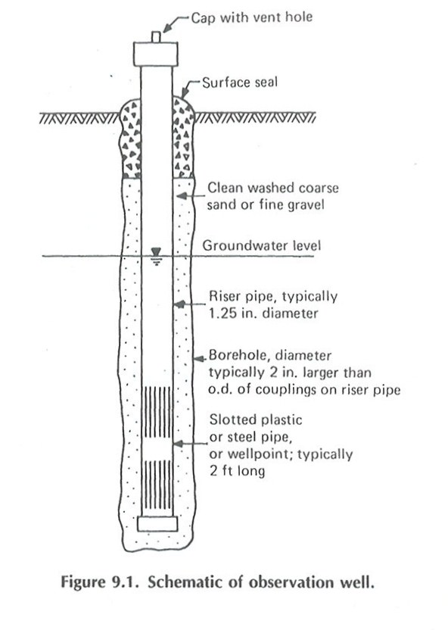
© Copyright, Dunnicliff 1993
Figure 10.3 Observation well

Standpipe piezometer
The standpipe piezometer only monitors a specific zone in the borehole, as shown in Figure 10.4. A porous tip or a section of slotted pipe is installed in the zone of interest. This zone is sealed off so that groundwater pressures at other elevations do not impact the water in the zone of interest. After the pipe is installed, a sand filter zone is tremied into place around the filter tip or slotted section of pipe. The top of the filter zone is sealed with bentonite to isolate the pore water below. The space between the pipe and the borehole is sealed to the surface with a bentonite grout to prevent vertical migration of water. Water levels are measured in the same way as an observation well.
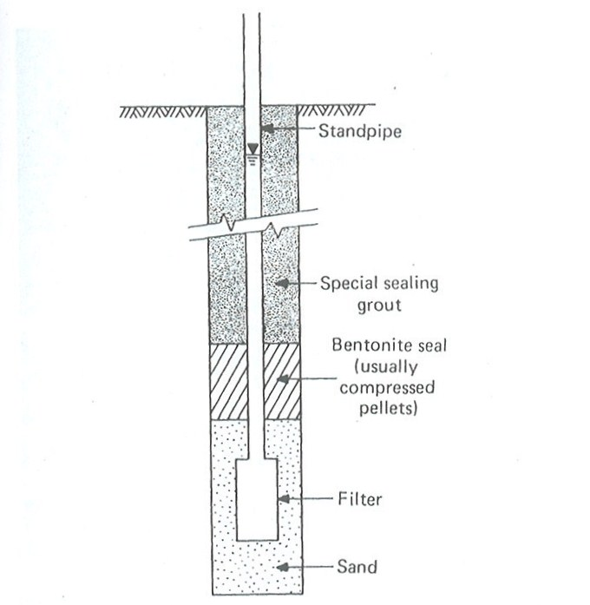
© Copyright, Dunnicliff 1993
Figure 10.4 Piezometer

Vibrating wire piezometer
The vibrating wire piezometer converts water pressure to a frequency signal via a diaphragm, a tensioned steel wire and an electromagnetic coil (Figure 10.5). The piezometer is designed so that a change in pressure on the diaphragm causes a change in tension of the wire. An electromagnetic coil is used to excite the wire, which then vibrates at its natural frequency. The vibration of the wire in the proximity of the coil generates a frequency signal that is transmitted to the readout device. Data loggers record the frequency and convert this to pressure using calibration data.
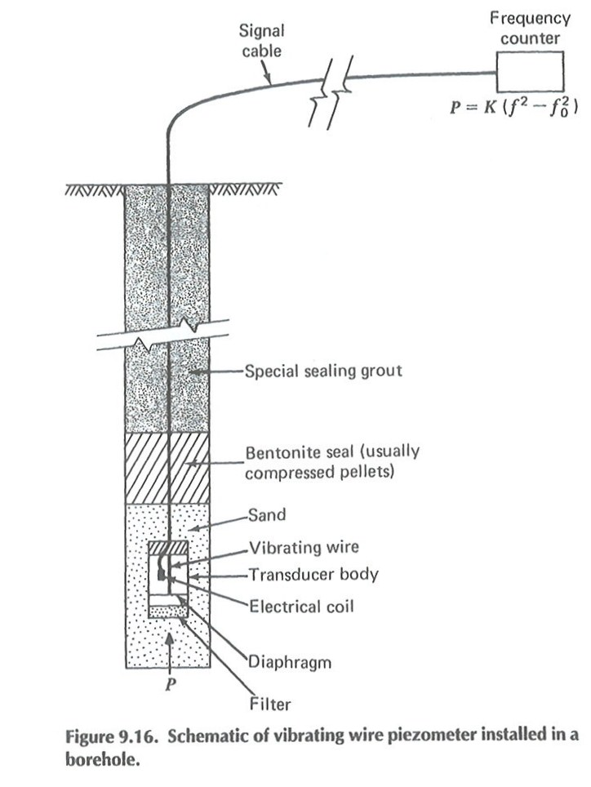
© Copyright, Dunnicliff 1993
Figure 10.5 Vibrating wire piezometer

Packer test
Packer testing involves pressurising a closed section of borehole with water and measuring the flow of water into this section of borehole, and by implication the ground, at several different pressures. More fractured ground takes more water. The section of borehole to be tested may be at the completion of a run hole or between two packers once the hole is complete.
Reynolds (1977) describes a program of packer testing and core inspection conducted in two holes, one located above a goaf and one in adjacent ground. Reynolds reports that the height of strata disturbance was clearly evident from this approach. These results correlate closely with more recent measurements over wider panels.
Holla and Buizen (1991) describe an extensometer monitoring program at Tahmoor Colliery where packer testing was conducted to examine the impact of ground movements on the hydraulic conductivity of the overburden strata.
Similar programs have been run at other sites. The key challenges with this approach relate to the practical limitations of the packer testing equipment for characterising the hydraulic conductivity of highly fractured ground typically observed above longwall panels. The limit on maximum flow measurement of the equipment is generally not sufficient to allow accurate measurement of the hydraulic conductivity of open fractures, but it is nevertheless sufficient to show where mining-induced fractures have developed.

Subsurface methods

Stress change monitoring
Stress change monitoring essentially involves point measurements of small deformations that occur in response to ground movements in the rock strata around boreholes. There are several types of stress change monitoring instruments. Most of these instruments are suitable for deployment at depths up to a few tens of metres from the collar of the borehole or have the capability to measure the stress change in one direction only. This means their application for subsidence monitoring is relatively limited.
The development of the ANZI stresscell (Mills 1997) to the stage where it can be deployed in boreholes to depths ranging from a few metres to in excess of 150 m now provides the capability to monitor three-dimensional stress changes in the overburden strata.
The concurrent development of logging systems have allowed these instruments to monitor stress changes at intervals ranging from once every few seconds to twice a day, depending on the application, with resolutions ranging, in strain terms, from about 0.00 5mm/m to 0.05 mm/m, depending on rock and other environmental conditions.
Stress change monitoring is particularly useful when the ground movements are in the elastic range. Once failure occurs, the stresses no longer continue to increase with deformation and may even decrease in magnitude, depending on the circumstances. However, by this time the magnitudes of ground movement are typically detectable by other means.
For many natural features that require protection, monitoring in the elastic range is what is relevent.

Borehole extensometers
Borehole extensometers have been deployed for monitoring mining-induced ground movements for several decades. Extensometer systems comprise a number of anchor points installed at various depths in an open borehole. These anchor points are connected to the surface by wires. Relative displacements between the anchors and the borehole collar are monitored at the surface.
The challenges with these systems relate to maintaining stable borehole conditions, avoiding the wires becoming intertwined during installation, and compensating for shear movements in the borehole. Nevertheless, the results have been very useful for characterising the nature and extent of subsurface ground movements.
Initial attempts by Gurtunca (1984) at South Bulli and West Cliff collieries and Schaller and Hebblewhite (1981) at Angus Place Colliery were unsuccessful because of borehole instability, but Holla and Armstrong (1986) made successful measurements at Ellalong Colliery using a system of hanging weights that was later deployed at Tahmoor, Invincible and Angus Place collieries in the 1980s.
Much shorter versions of these instruments have been used to characterise ground movements in rockbars subject to valley closure and upsidence (Mills & Huuskes 2004).
Mills and O’Grady (1998) describe the results of monitoring ground movements above two longwall panels of different widths at Clarence Colliery in the Western Coalfield of New South Wales with rotary spring extensometers. The extensometers were installed in one hole over a narrow panel and three holes across a wider panel immediately alongside. The longwall panels below the extensometers were mined and the ground movements were measured.
The extensometer monitoring shows that a zone of large downward movement (greater than about 0.5 m) can be clearly observed in the monitoring results. This zone extends upwards through the overburden strata to a height above the mining horizon approximately equal to the width of the panel. Three extensometers located across the width of the panel indicate that the shape of this zone of large downward movement is arch shaped, with the top of the arch near the centre of the panel.
The results of subsidence monitoring indicate that the top of the arch is probably biased to the side of the panel where horizontal stresses are concentrated most by the retreating panel; this is effectively biased guttering, similar to that observed underground by Gale (1986).
Weighting cycles and other caving phenomena were detected by plotting the displacement of extensometer anchors relative to the longwall face.
The key elements of interest to characterising the ground disturbance above a longwall panel from these results are as follows:
- The height of the zone of large downward displacement above the mining horizon is approximately equal to the panel width.
- The zone of large downward displacement is arch shaped above the mining horizon and develops gradually behind the longwall face in a similar arch-shaped geometry.
- The edges of the zone of large downward movement are incrementally sheared and stretched well beyond the elastic limits of the rock strata so that mining induced-fractures are formed throughout the zone of large downward movement.
- The behaviour observed within the zone of large downward movement is consistent with surface subsidence behaviour once the longwall panel becomes supercritical in width.
Other extensometer monitoring results show similar behaviour, although it is common, particularly where the overburden depth is much greater than the panel width, for a second zone of disturbance to become evident to a height above the mining horizon equal to about 1.6 to 1.7 times panel width. The displacements within this second zone are typically less than in the zone of large downward movement.
Extensometer monitoring indicates that although there are general trends in subsurface ground movements that are common across most sites, there are also differences in behaviour that are associated with particular geological settings. Stratigraphic units that can bridge panels are prone to modifying caving behaviour.

Borehole camera
Borehole cameras, televiewers and other borehole imaging devices have been very useful for characterising zones of ground movement observed above longwall panels. To measure the nature and extent of subsurface ground movements using these devices, it is necessary to drill a borehole into a caved area above a longwall panel, typically in the centre of the panel to a depth about 20 m above the mining horizon. It is good practice to drill a second hole nearby in undisturbed ground as a control and to run a similar survey in this hole as well, so that the difference in the fracture patterns observed in the two holes is immediately apparent.
The various zones of ground movement are clearly apparent and can be correlated with zones of displacement evident from observations of surface subsidence.

Borehole inclinometers
Borehole inclinometers measure the lateral movement of the ground with depth. Figure 10.6 provides an example of the output. They must be socketted into stable materal that is below the zone of movement, to obtain good data to help define the zone of movement. The inclinometers are tremie grouted into place.
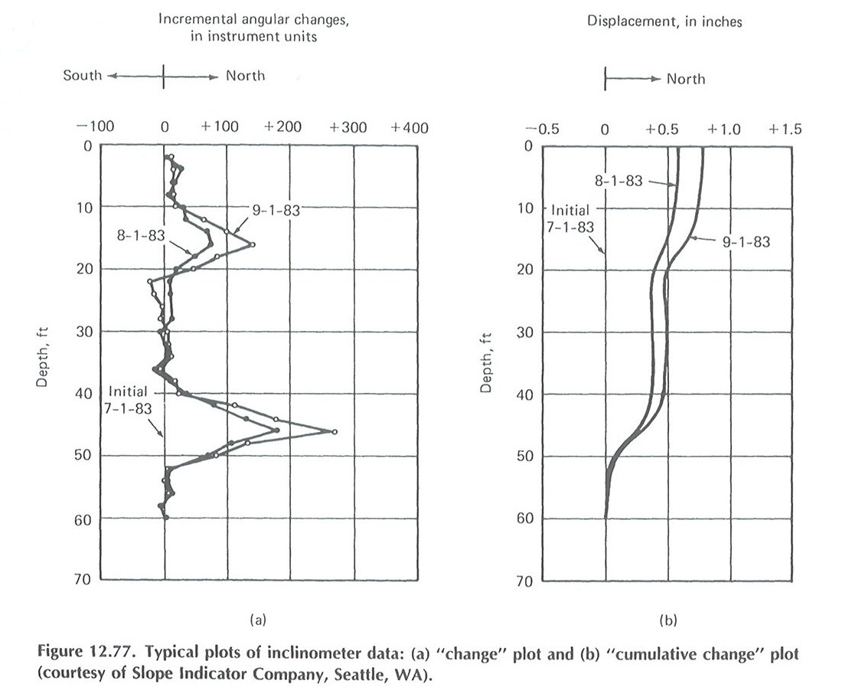

© Copyright, Slope Indicator Company, Seattle
Figure 10.6 Typical plots of inclinometer data – (a) ‘change’ plot and (b) ‘cumulative change’ plot (Dunnicliff 1993).

Rock core
Inspecting core recovered from boreholes drilled through the overburden strata above an extracted longwall panel and comparing it with core recovered from a nearby borehole from an unmined area is a useful technique for detecting the influence of mine subsidence on the overburden strata.

Time domain reflectometry
Time domain reflectometry was orginally developed to locate breaks in power cables. It consists of a coaxial electrical cable that can be placed in a trench or grounded in a borehole. An eletrical pulse is sent though the cable and its return is monitored. Breaks or crimps impact the signal and their position can be located. This approach has been used in boreholes to assess caving and along roads to monitor subsidence movements.

Vegetation
Monitoring vegetation health from the air or satellites can be used to reduce impacts on the swamp from ground-based monitoring activity. New South Wales uses Landsat satellite images to monitor changes to woody vegetation (NSW DEH 2012). Viño et al. (2004) discuss the use of satellite monitoring to assess changes in vegetation, and Ozesmi and Bauer (2002) discuss satellite monitoring of wetlands.

Summary of key concepts
- Monitoring surface movements
  - Level surveying with an optical instrument and peg-to-peg chaining has been extensively used in the past to assess subsidence deformations. The pegs are typically in a line spaced at 1/20th the overburden thickness and extend beyond the expected limits of subsidence. The vertical accuracy of this approach is about 20 mm. The approach provides data in two dimensions, since the pegs are assumed to stay in line with each other, which typically does not occur. The vertical data is also reliant on the benchmark not moving.
  - Total station surveying allows three-dimensional assessment of movement of each monitoring location.
  - Global Positioning System (GPS) uses a number of satellites to determine the position of a monitoring location. The more satellites used, the more accurate the position. However, this takes time. Accuracy of about 20 mm vertically and 5 mm horizontally can be achieved. Tree cover reduces the effectiveness of this method.
  - LiDAR (ALS) uses light pulses from a laser mounted in an aircraft to develop topographic data. The laser pulses are reflected back to a receiver and the topographic data calculated by measuring the time for the pulses to return. Data is typically provided at a resolution of 0.5 to 10 points per square metre.
  - Interferomotic Synthetic Aperture Radar (InSAR) uses radar signals emitted from satellites to provide topographic data. Under ideal conditions, a vertical accuracy of 5 to 10 mm can be obtained.
- Monitoring groundwater
  - Observation wells can be installed in boreholes to assess conditions in several units, since they provide a vertical connection between strata. Typically, water-level indicator is lowered down the well. A data logger can also be installed to provide water-level readings at specified intervals.
  - Standpipe piezometers provide water-level information on a specific zone. A low permeability material, such as bentonite, may be placed in the borehole above and below the zone of interest to isolate that zone from the intrusion of water from other zones.
  - Vibrating wire piezometers convert water pressure to a frequency signal via a diaphragm, a tensioned steel wire and an electromagnetic coil. They are typically installed similar to a standpipe piezometer. Readings can be taken as needed or a data logger can be installed.
  - Packer tests can be used to assess hydraulic conductivity of a given section in a borehole. A section of the borehole is isolated with packers, above and below the zone of interest, and the pressure and amount of water injected into the zone are monitored. In highly fractured ground, it may not be possible to inject enough water to obtain an accurate measurement of the hydraulic conductivity.
- Monitoring subsurface movements
  - Stress change monitoring essentially uses stress cells to take point measurements of small deformations that occur in response to ground movements in the rock strata around boreholes. Stress change monitoring is most useful in the elastic stress range of the rock.
  - Borehole extensometers consist of a number of wires anchored to the rock at various depths. The relative displacements between the anchors and the borehole collar are monitored at the surface. They are useful to help assess the height of caving.
  - Borehole cameras can be used to view conditions in a borehole, such as fracturing, groundwater inflows and outflows, rock types and weathering;
  - Borehole inclinometers measure the lateral movement of the ground with depth. It is important that the bottom of the inclinometer is below the zone of movement to define where the movement is occurring. Inclinometer readings can be taken as needed using a probe lowered down the casing or an automated device.
  - Rock core can be obtained to assess the condition of the rock. The borehole can also be used for packer testing to assess hydraulic conductivity.
  - A time domain reflectometry cable can be installed in a borehole or trench. Changes in its length impact a signal sent through the cable, indicating that movement is occurring.
- Vegetation
  - Changes in vegetation can be assessed using satellites.

Management strategies

Introduction
Potential impacts to peat swamps from longwall mine subsidence may be managed before mining by planning. Intrusive remediation activities after mining has occurred may work, but have not been proven and the work may also cause damage to the peat swamp. Features that are to be protected need to be identified at the planning stage, so that the mining operation can work around them. Waiting until a feature starts to show impacts from mining before taking action is not an effective approach for either the mining operation or the peat swamps, because:
- it is difficult to modify the mining operation after it has commenced
- damage may have already occurred to a swamp.

Planning
It is important to understand that a significant amount of time is needed to develop a longwall mine and that the layout of the longwall panels is very difficult to change once mining is under way. Because of the length of time required for mine planning, the impact of mining on peat swamps and other environmentally important features must be considered during life of mine (LOM) planning. Kininmonth and Baafi (2009) indicate that LOM planning and feasibility studies typically extend 20 to 30 years into the future.
Kininmonth and Baafi (2009) expand on consideration of environmental impacts during the LOM planning as follows:
- ‘Define the critical environmental impacts of the LOM plan with particular attention to where these affect or modify existing approvals, ensure all proposals fully align with the corporations Environment Management System (EMS) or Environmental Management Plan (EMP)
- discuss the environment constraints that impact directly on mining designs and schedules
- discuss the mine closure plan, including final landform and after mining land use.’
Because of the years of planning required for a new mine, the relative inflexibility of the longwall system to accommodate changes and the indication of damage in a peat swamp possibly being too advanced to save the peat swamp, regulators and mine planning staff must define peat swamps and other environmentally important features early in the LOM process, so that they can be dealt with appropriately.
Planning needs to assess potential physical and groundwater impacts to peat swamps on an individual basis.

Subsidence considerations
Impacts on peat swamps that are recognised to be associated with longwall mining subsidence fall into four broad categories:
- compression fracturing of the rock strata below a peat swamp. Such fracturing results in shear fractures, buckling and combinations thereof that produce open fractures and alternative flow paths for water out of the swamp, in and through previously intact rock strata. In addition, flow through these fractures can impact water quality
- tensile fracturing of rock strata, typically sympathetic with but not always along natural joints. Such fracturing provides alternative flow paths for water out of the swamp through previously intact rock strata
- differential lowering or tilting of the ground surface. Tilting causes redirection of natural stream channels through the swamp and may allow nick points to develop that cause channel erosion and associated sidewall slumping of the peat
- general lowering of the groundwater table through drawdown towards the workings that decreases the flow available to support swamp vegetation.
The majority of both vertical and horizontal subsidence movements occur directly above the combined goaf of longwall panels and, in general, decrease with distance from the nearest goaf edge. Thus, peat swamps that are located directly over longwall panels are more susceptible to mining impacts and the magnitude of impacts on peat swamps tends to decrease with distance from the longwall panel.
Effects that occur outside the immediate area of mining and may impact on peat swamps include:
- groundwater drawdown, which tend to be greatest in permeable strata but may be perceptible, although not necessarily significant, for a kilometre or more from the goaf edge
- topographic effects typically expressed as valley closure that can extend to the nearest topographic low point outside the goaf edge but are usually only significant up to about 400 m from the goaf edge, depending on the nature of the terrain
- lowering of the groundwater table below topographic high ground caused by shear on bedding planes and increased hydraulic conductivity towards topographic low points. These effects are likely in sloping terrain and extend from over the longwall panels to the nearest topographic low point outside the goaf edge, typically within about 400 m
- horizontal stress relief that increases the volumetric storage within the rock strata causing transient groundwater drawdown and changes in stress and hydraulic conductivity that are perceptible with high-resolution instruments but are likely to be second-order effects in the context of impact on peat swamps.

Setback or buffer distances
The use of setback or buffer distances seems an easy way to protect peat swamps. However, due to the variety of factors involved in the function of peat swamps and the occurrence of subsidence, such as the quality of the swamp, existing terrain, precipitation, subsidence impacts to surface and groundwater, the influence of geology, mining depth and panel width, such an approach is too general to be of practical use.
Hebblewhite (2009) in his review of the impacts of subsidence on peat swamps agrees:
‘One of the key findings of the Panel was the fact that there was no scientific evidence or argument to support the view that an absolute “one size fits all” protective buffer region should be applied for protection of significant natural features from adverse subsidence impacts from underground mining. A number of community groups argued that a 1 km wide buffer, below which no mining was permitted, should be applied to all rivers in the Southern Coalfield. However the basis for either the 1 km figure, or the universal application of a single measure was not substantiated. For example, simple variations in depth, not to mention mining widths, seam thicknesses, and structural geology features all contribute to some degree of variability in the surface extent of any adverse subsidence impacts. Furthermore, there was a clear misconception in the minds of some, in relation to the widely reported far-field horizontal displacement effects associated with the monitoring of the Lower Cataract and Nepean Gorges above Tower Colliery. The fact that horizontal displacements occurred at least 1 km away from the edge of mining (a subsidence effect) did not equate to an adverse subsidence impact (of which there was no evidence of any). In fact the greatest distance away from the edge of mining where any adverse impacts had been observed and reported across the Southern Coalfield was less than 400 m.’
Each swamp needs to be considered individually. For instance, some data appear to indicate that groundwater at a projection of greater than 45 degrees from the extent of mining should not be impacted by mining, but it is not clear how this relates to two groundwater regimes—shallow and deep—and, in particular, to peat swamps, since they may be more reliant on precipitation and surface flow than deeper groundwater flow (see note 1 at end of the chapter).
The ecological, geological, surface water and groundwater conditions at each peat swamp and how they relate to the functioning of the peat swamp must each be clearly understood as a system before the impact of potential subsidence deformations on the system can be assessed.
Assessment of subsidence impacts on existing peat swamps, and to peat swamps currently subjected to subsidence impacts, is needed to develop a database on which to provide guidance on this issue.
The Panel for the Southern Coalfield study for the New South Wales Government dealt with the uncertainties by defining risk management zones (RMZs) in an attempt to provide guidance for mining near specific features, while offering protection to the feature. Mining within the RMZ of a feature could be performed only with an increased level of prediction confidence and level of proof of such confidence (e.g. through previous case history back-analysis) such that mining impacts, if any, should be tolerated by the feature. The RMZ definition included a 40 degree angle from vertical component, to recognise the role of depth, as well as a default minimum figure of 400 m, with the RMZ being the greater of the two values. They also recognised that ‘It is expected that the definition and application of the RMZ will be the subject of ongoing review as the relevant databases and prediction techniques improve’ (NSW Department of Planning 2008). Further comment from the panel is provided below.
‘Due to the extent of current knowledge gaps, the Panel considers that a precautionary approach should be applied to mining which might unacceptably impact highly-significant natural features. The Panel considers that the approvals process should require a ‘reverse onus of proof’ from the mining company before any mining is permitted which might unacceptably impact highly-significant natural features. In other words, the mining company must demonstrate, on the balance of probabilities, that identified highly-significant natural features would not be unacceptably impacted. If insufficient assurance can be provided, then mining which might cause severe impacts should not be permitted to proceed. Any proposed mining that might unacceptably impact those features should require that subsidence effects and impacts are predicted and assessed with a high degree of confidence. Evidence should be provided of both the validity and accuracy of the prediction techniques used. The predicted impacts would have to be ‘acceptable’ to Government. Alternatively, mitigation and/or remediation strategies (offering sufficient certainty of outcome and effectiveness), could be proposed. The Panel also considers that mining approved to proceed within an RMZ associated with such highly-significant features should be subject to preparation and approval of a contingency plan to deal with the chance that predicted impacts are exceeded. This plan might include any one or a combination of measures, including a cessation of mining within the subject longwall panel, a pullback of subsequent longwall panels from the feature, undertaking foreshadowed remedial works with predictable and acceptable outcomes, or provision of an environmental offset’ .
© Copyright NSW Department of Planning (2008)

Preliminary guidelines
The following guidelines are predicated on the need to confirm which types of peat swamps are at risk of being impacted by mine subsidence over the long term. The guidelines are based on unpublished observations and will need to be updated as additional information becomes available.
In the absence of more detailed studies and published findings, the following basic guidelines are provided to progress the management of mine subsidence in relation to peat swamps. These are draft preliminary guidelines and further discussion and consultation is warranted to explore these recommendations and their effectiveness and consequences.

General guidelines
Peat swamps that are potentially affected by cracking of the underlying sandstone may be protected by mine design using the following guidelines (see note 2 at the end of the chapter):
- Maintain tensile horizontal strains at the surface at less than 1 to 2 mm/m and compressive strains at less than 2 to 3 mm/m over a 20-m-wide zone. At these compressive strain levels, there is unlikely to be any significant impact on peat swamps because these strain levels are not usually sufficiently high to cause cracking of the near surface rock strata. The calculation of these strains is site specific, but can be calculated using the Australian Coal Association Research Program (ACARP) method.
- Position the panels so that they do not directly underlie the peat swamp. Higher levels of strain are typically experienced directly over the mined panels, so not directly mining under a peat swamp is likely to limit the potential for higher strains to develop.
- If a high level of protection against rock fracturing is required, position the mine layout so that mining does not occur within a distance of half the overburden depth of the peat swamp to be protected.
An example illustrating the use of the guidelines using the ACARP method is provided in Appendix C (see note 3 at the end of the chapter).

Additional considerations for valley infill swamps and hanging swamps
Valley infill swamps and hanging swamps that rely significantly on groundwater recharge are expected to be sensitive to changes in hydraulic conductivity of the overburden strata, potential for drawdown of the groundwater in topographic high ground, and potential for drawdown into the mine. These effects are strongly site dependent and less well understood than the physical impacts. If there is groundwater drawdown associated with mining, such drawdown is likely to be greatest directly over the longwall panel mined. Drawdown may extend laterally outside the mining area for some distance, depending on site conditions, but may also only be temporary.

Monitoring
Peat swamp function, surface deformations and groundwater impacts should be monitored before, during and after mining, to generate a database to assess mining impacts on other peat swamps and provide information for future revisions to the guidelines.

Trigger action response plans
Trigger, action, response plans (TARPs) can be used to manage impacts at tolerable levels. This is especially the case for infrastructure and surface features that have some capacity to absorb subsidence impacts, however small, and where these impacts can be measured as strain deformation, tilt or some other appropriate parameter. TARPs are widely used in the underground coalmining industry to manage impacts.
It is possible to develop a TARP to adjust the length of a panel to limit subsidence impacts on a sensitive feature, particularly at the finishing end of a longwall panel. Changing the width of a panel is more difficult and needs to be planned in advance. Although TARPs are very suitable for managing impacts, they are not well suited to managing situations in which:
- impacts are small by comparison with impacts that are occurring for a range of other unrelated reasons
- impacts may not become apparent for some time
- impacts may only become apparent after a tipping point has been reached
- the relationships between short-term and long-term impacts are poorly understood.
Many of the impacts on peat swamps fall into these categories, and include:
- the development of a subsurface fracture network below swamps as a result of valley closure movements that divert water from the swamp into the subsurface strata
- nick point erosion caused by a combination of desiccation, tilting, fire, drought and heavy rainfall events
- flattening of the groundwater table through increase in the hydraulic conductivity of subsided topographic high ground
- drawdown of the groundwater system below a swamp through downward flow into the mine.
None of these impacts, with the possible exception of the first one, are particularly suited to being part of a TARP.
Monitoring the impacts of mining on peat swamps to develop an understanding of the effects of mining is recommended, but monitoring for specific impact management is unlikely to be effective, given the nature of the impacts and the timeframes involved.

Remediation
Remediation activities are generally undertaken to fix something that is broken. This section provides some comments on remediation of subsidence impacts from experience in the Southern Coalfield and possible approaches, some of which are untried. Iannacchione and Tonsor (2011) provide some examples of stream remediation in Pennsylvania. Figure 11.1 repeats a figure from Chapter 7 for the convenience of the reader. It illustrates potential subsidence impacts to a valley. Table 11.1 provides a summary of features and potential remediation options.
Figure 11.1 Potential subsidence impacts to a valley.
It is assumed in the remainder of this section that planning to mitigate subsidence has already been considered. It should also be noted that mitigation activities may also result in damage to the peat swamp.
Table 11.1 Summary of features and potential remediation options.
Feature | Mitigation of options | Comments
Rock bars | - Fill fractures with grout, sand or other materials from the surface  - Increase the base flow (temporarily/permanently) to mitigate loss of water  - Construct slots to decrease fracturing before mining  - Construct on artificial barrier to replace the rock bar
Near-surface fracture zone under swamps | - Fill near-surface fractures with grout or other materials to maintain a surface flow path  - Drill boreholes into the fracture zone along the length of the fracture zone and inject grout to fill the fractures  - Line the channel to reduce loss of water into the subsurface fractures  - Add compensation flows to the waterway to maintain flow | Multi-stage grouting may be needed due to washout of the grout and/or the development of additional fractures. Fill material needs to be cohesive or contain cement. The flowability of the mix should also be assessed, based on the width of the fractures so that the mix can flow into the fractures.
Main upsidence zone | - Fill entire fracture network at key locations using grout injected through boreholes and/or excavate trenches backfilled with concrete or low-permeability materials  - Adding compensation flows to the waterway are beneficial to maintain flow | It may be possible to use natural materials such as sand, gravel and clay to fill the fractures, instead of a cementitious grout
Bedding plan dilation | - Drill boreholes into the impacted zone for injection of grout or other material. Injection should be performed using low pressure to lessen the potential for increasing the size of the fractures. The injection material should have low flowability to lessen its potential for flowing into deeper fractures and/or into the stream | Bedding plane dilations typically have limited flow capacity and interconnectivity, so remediation may not be needed
Bedding plane shear zone | - Drill boreholes into the impacted zone for injection of grout or other material. Injection should be performed using low pressure to lessen the potential for increasing the size of the fractures. The injection material should have low flowability to lessen its potential for flowing into deeper fractures and/or into the stream | Bedding plane shear zones typically have limited flow capacity and interconnectivity, so remediation may not be needed
Hillside bedding plane shear | See comments | No need for remediation unless slope stability is an issue
Compression ridges | - Remove some of the rock on the sides of the fracture to allow the rock to fit back into place and not tilt upwards  - Excavate material from the ridge and adjacent area, as needed, to allow flow to return to its natural flow path
Note: In relation to peat swamps, these potential remediation options have not been proven and their implementation is likely to cause significant damage to the swamp.

Summary of management strategies
- A list of high-quality peat swamps that are to be protected needs to be developed to assist regulators and mine planners.
- The ecological, geological, surface water and groundwater conditions and how they relate to the functioning of particular peat swamps needs to be better understood before any potential for mining impacts can be assessed.
- Longwall mining is a relatively inflexible mining system in the short term but with sufficient lead time, adjustments to the layout can be accommodated. The early identification by government of high conservation value peat swamps would assist regulators and mine planners to develop suitable mine layouts to mitigate the potential for impacts.
- A review of long-term impacts on the peat swamps that have been previously undermined would assist to better understand those types of peat swamps that are sensitive to mining impacts over the long term.
- Each swamp needs to be assessed separately. Developing a one-size-fits-all setback or buffer distance is not suitable to optimise resource recovery or protect peat swamps from a range of site-specific factors that may affect them.
- The use of monitoring strategies such as trigger, action, response plans as a control measure to protect peat swamps from longwall mining is not expected to be effective because impacts are likely to occur over a longer timeframe than is useful to control mining. Nevertheless, monitoring provides a guide to the type of impacts that affect swamps and is a basis for refining setback criteria if such protection is found to be necessary to the long-term health of each type of swamp.
- Although various mitigation and remediation strategies for peat swamps have been suggested, the techniques available are untried. In addition, mitigation activities may also cause damage to the swamp. Therefore, planning is a better way to deal with this issue. Mitigation activities include cutting slots in the ground to absorb lateral ground movements and lessen impacts to features, and drilling boreholes into fractured zones and filling the fractures with grout after mining has been completed.
- Preliminary guidelines for setback criteria are provide in Section 11.4.1.

Peer review comments on Chapter 11
1. Tony Iannacchione comments The setback/buffer distance concept to mitigate damages to peat swamps is a reasonable administrative tool to control water supply damages on the surface. In the state of Pennsylvania (US), any water supply (wells, springs, ponds, etc.) within a 35-degree angle of the edge of mining and the surface (this is known as the Rebuttable Presumption Zone (RPZ)), if impacted, must be repaired, replaced or substituted by the mining company. The buffer zone associated with the RPZ expands with increasing depth. See: www.elibrary.dep.state.pa.us/dsweb/Get/Document-89950/5600-BO-DEP4054.pdf
In a recent study (“Application of Subsidence Prediction Methodologies for Sizing Barrier Pillars for Stream Protection in Appalachia,” Agioutantis, Karmis and Kirby, 2013, in Environmental Considerations in Energy Production) a technique to size barrier pillars, designed to protect overlying streams, was proposed. In general, the rule of thumb for sizing these protective barrier pillars is related to a 28-degree angle between the edge of the stream channel and underlying coal. This design is meant to lessen subsidence related fracture development at the surface.
2. Ross Seedsman believes management recommendations should recognise the importance of pillar design in modifying trough subsidence,—as mentioned in his comments on Chapter 5, Ross suggests (see Seedsman references in the additional reference list after Chapter 12) the way to reduce valley closure and hence upsidence/subsurface cracking may be to reduce pillar subsidence, and to do that the pillar widths need to be increased so that pillar yielding is not induced.
Ross also suggests increasing pillar width (along with orienting the longwall panels so as not to be parallel to regional joints, and forming narrow panels) are key strategies to reduce tilt—the key subsidence parameter that drives valley closure and upsidence. More research is necessary, but initial indications are that tilts of about 3–5 mm/m within about 300 m of a peat swamp may reduce the hazard significantly. More work is required before this can be used as a planning guideline.
3. Tony Iannacchione comments Using compressive strain to determine a setback distance is reasoned, science-based approach. That being said, in the worked example in Appendix C there are six steps, each introducing some assumptions. Typically, empirical techniques become more conservative as more assumptions are made.
Areas of high-predicted horizontal strains are not always associated with observed damage. The particulars of the individual panels (e.g. geology, dip, existing fracture patterns, stress field, surface topography, panel dimensions, overburden) all interact in ways that make a single empirical approach ineffective for all conditions. Perhaps my biggest concern is that groundwater aquifers that are important to peat swamps may be impacted by other subsidence features not related to compressive strain.

Future work
The following suggestions are provided to improve the understanding and management of potential impacts on peat swamps from longwall coalmining:
- Determine how peat swamps fail due to being undermined, based on field measurements of ground deformations, groundwater levels, and changes in flora and fauna in the undermined swamp and using a control swamp.
- Study damaged swamps. It has been more than 40 years since mining has occurred near some swamps. Information obtained from studies could be put into a database and used to help predict future impacts on peat swamps. This would include drilling boreholes to assess the extent of the fracture zone, digging test pits to assess near-surface conditions, mapping subsidence features, determining changes in flora and fauna, assessing the current groundwater conditions and assessing the values for the various subsidence deformation parameters.
- Perform trial remediation projects on damaged swamps and monitor the swamp to assess if improvement of the swamp occurs over time.
- Improve predictive capability to assess impacts on peat swamps based on a revised understanding of deformation and peat swamp function.
- Develop an approach to assess subsidence impacts from multiseam mining, as impacts from multiseam mining are likely in the future.
- Monitor, simultaneously, groundwater levels in a peat swamp and the sealing layer beneath a swamp before, during and after mining. Monitoring ground movement (strain) must also be conducted simultaneously with the water-level monitoring, so that any relationship between hydraulic head behaviour and ground deformation can be investigated.
- Monitor the long-term hydraulic head behaviour in the peat following mining (this can be conducted at some of the swamps analysed in this report).
- Monitor long-term changes in groundwater levels and chemistry to develop a database for the coalfields for comparison with predictive models.
- Modify the preliminary guidelines for setback criteria, based on the information gained from the above activities.

Appendix A-1
In 2007, the NSW Government established an independent panel to undertake a strategic review of the impacts of underground mining in the Southern Coalfield on significant natural features and report on the social and economic significance to the region and the state of the coalfield resources.
The following table is modified from a submission made by the NSW Department of Environment and Climate Change on subsidence impacts on natural features in the Southern Coalfield (NSW DECC 2007).

Streams
What was impacted? | What were the impacts? | What are the potential causes or contributing factors? | History/Description | Monitoring | Remediation | Current situation
Upper Waratah Rivulet, Woronora Catchment (upstream of Flat Rock Swamp) | Cracking of bedrock  Loss of surface water flows (appears to return approximately 500 m downstream) | Presumed subsidence from Darkes Forest Colliery | The Darkes Forest Mine was created in 1971; very few details available | No monitoring details found | No known remediation | Cracks still visible and surface water can be seen to disappear down cracks.  Given the passage of time this is indicative of an area that has not naturally remediated.
Waratah Rivulet, Woronora Catchment | Cracking and tilting of bedrock.  Loss of surface flows and loss of water from permanent pools.  Reduced water quality and growth of iron oxidising bacterial mats.  Loss of habitat.  Accelerated bank erosion. | Subsidence related to longwall mine extraction directly beneath Waratah Rivulet. Tilting to the east resulting in alteration of flow paths. | Longwall mining commenced in 1995. Longwall widths began 125 m wide and were increased up to 162 m wide for Longwall 11.  Initial cracks were noticed when Longwall 10 was undermined. This was followed by major cracking, failure of rockbar WRS3 and loss of surface water flows (4-4.5 Ml/d) associated with the extraction of Longwall 11 (Galvin & Associates 2005).  Rehabilitation was attempted in 2006 using drill holes and sand curtains in the fractured rockbar and some preliminary improvements in water retention behind the rockbar have been noted.  Risk assessment for Longwall 12 suggested further impacts were likely.  Despite the damage to the Rivulet, approval was given to continue with adjacent panels, which subsequently caused further fracturing of the rockbar and riverbed (Krogh, pers. comm., 2007). | Monitoring by mining company including subsidence, hydrology, riparian vegetation, macroinvertebrate and fish surveys  Monitoring instrumentation was installed at rockbar WRS1 prior to commencement of Longwall 9.  Subsidence movements that occurred as Longwall 10 approached caused instrument failure (Mills & Huuskes 2004).  Monitoring at rockbar WRS3 commenced in October 2003.  Recent roundwater monitoring by SCA Monitoring of remediation impacts including macroinvertebrate and macrophyte surveys. | Remediation attempted using drill holes and sand curtains. These have since been damaged by further mining and fracturing. Still assessing latest attempt at remediation with sand and colloidal silica binding agent. | Creek still ceases to flow during low flow conditions.
Cataract River below Broughtons Pass Weir | Loss of surface flow including water loss from permanent pools.  Reduced water quality.  Growth of iron oxidising bacterial mats.  Gas emissions and vegetation dieback.  Fisk kills.  Rock falls. | Subsidence related to longwall extraction. | Longwall mining began at Tower Colliery in the vicinity of the Cataract River in 1988.  Longwall 3 was extracted during 1990 and was the first of 10 to pass directly beneath the river.  Panels started 110 m wide, and were increased in width to 155 m in 1992.  The first adverse impacts on the river were reported in 1994, when residents reported the loss of surface water from some of the more permanent pools. There was also a decrease in water quality, release of gas, vegetation dieback, fish kills and iron-manganese bacterial mats.  In 1998, a Mining Wardens Court Hearing concluded that 80% of the drying of the Cataract River was due to longwall mining operations, with the balance attributed to reduced flows regulated by Sydney Water. During 1999 grouting was carried out to prevent surface water losses. Despite BHP claims of success, AWT claimed that this was only 50% successful (in DIPNR 2003).  Longwall mining at Appin Colliery commenced near the Lower Cataract River in 1998 with Longwall 401. None of these longwalls passed directly beneath the river. The closest longwall to the river is Longwall 405, which is approximately 80 m from the centre of the river. | Study by DIPNR (2003) found it difficult to determine loss of flow and effectiveness of remediation due to lack of sufficient pre-mining data.  Mining-induced fractures were first observed and mapped in the Cataract River in 1996 (Coffey 1996 cited by MSEC 2006), prior to the commencement of Tower Longwall 14.  Additional fractures were observed between Weirs 4 and 5 during and after the extraction of Tower Longwall 14, and these were mapped in 1997 (Coffey 1997 cited by MSEC 2006).  BHPB have also mapped minor fractures near the end of Longwall 405 (MSEC 2006). | Grouting to prevent surface water losses. Use of environmental flows to compensate for surface flow losses. | A return to natural flow levels has not occurred.  Environmental flow releases were not considered by DIPNR (2003) adequate to keep the river flowing or to maintain water quality.
Jutts Crossing and Marhnyes Hole, Georges River | Loss of surface flow including loss of water from permanent pools.  Reduced water quality.  Some minor gas release and rock falls. | Subsidence related to longwall extraction. | 1.5 km of Georges River undermined by longwalls 5A1-5A3.  Some surface fracturing identified at Jutts Crossing in September 2000, with significant draining of pools noticed in November 2000.  Piezometers installed in 2001, with increased flow discharges leading to increased water levels.  Fracturing of Marhnyes Hole was first noted during the extraction of Longwall 5A4. New fracturing was identified when the longwall face had passed the rockbar by 100 m (MSEC 2006, BHP Billiton 2002).  Stress relief slot installed in 2002 to minimise cracking damage to Marhnyes Hole from Longwall 5A4. This was considered successful by geologists.  Despite this, there was significant loss of flow from Upper Georges River and many pools were drained (Krogh, submitted).  Subsidence cracks being remediated using grouting and mortaring.  Mortaring has been observed to crack and flake due to further mining (TEC 2007). | Monitoring conducted by mining companies and DLWC.  Inadequate monitoring prior to undermining.  BHPB claim that flows have been restored; however, limited before-impact monitoring means that it is difficult to determine whether a return to natural flows has truly occurred. | Stress relief slot installed to limit damage to Marhnyes Hole.  Cracks being filled and mortared.  Environmental flows used to increase pool levels. | When flows are very low the company has been known to release environmental flows to increase pool levels.
Wongawilli Creek, Avon Catchment | Cracking and loss of surface flow including loss of water from permanent pools.  Reduced water quality. | Subsidence related to longwall extraction. | History of longwall extraction from 1993.  Subsidence in the order of 1 m identified beneath Wongawilli Creek, with fracturing occurring up to 500 m from the mining activity (BHP Billiton 2003).  Surface flow was clearly observed to run laterally down cross-bedded sections under the alluvial banks of the creek (BHP Billiton 2003).  Impacts include: loss of flow from creek and altered water chemistry including potentially toxic levels of dissolved zinc.  The endangered Macquarie perch have been photographed and caught within Wongawilli Creek (Krogh, personal communication). | No baseline monitoring prior to longwall extractions.  Some geological and geomorphological mapping prior to undermining Longwall 6.  Environmental Monitoring Program by mining company for extractions of Longwalls 7 and 8. | No remediation undertaken. | Creek still ceases to flow during low flow conditions.  BHPB have reportedly onsold Elouera mine and remediation of impacts uncertain.
Native Dog Creek, Avon Catchment | Loss of surface flow including loss of water from permanent pools.  Toxic levels of pH and heavy metals identified at one site. | Subsidence related to longwall extraction. | History of longwall extraction from 1993.  Subsidence in the order of 1 m identified beneath Native Dog Creek with fracturing occurring up to 500 m from the mining activity (BHP Billiton 2003).  Impacts include: loss of flow from creek and altered water chemistry with toxic levels of aluminium, zinc and nickel detected along with lowered pH at one site (BHP Billiton 2003). | No baseline monitoring prior to longwall extractions.  Mapping and water flow and quality monitoring conducted prior to extraction of Longwall 7.  Environmental Monitoring Program by mining company implemented for extractions of Longwalls 7 and beyond. | No remediation undertaken. | Creek still ceases to flow during low flow conditions.  BHPB have reportedly onsold Elouera mine and remediation of impacts uncertain.
Bargo River | Cracking of bedrock and loss of surface flow including loss of water from permanent pools.  Declines in groundwater levels. | Subsidence related to longwall extraction. | The first longwalls to mine directly beneath the Bargo River commenced in 1991 (Longwalls 8 to 13).  Surface fracturing with cracks up to 50 mm wide were observed near the supporting piers of Rockford Rd Bridge following the extraction of Longwalls 12 and 13 (MSEC 2006 and Geoterra 2006).  Fractures were also observed during extraction of Longwall 12 downstream of the bridge (MSEC 2006; Holla & Barclay 2000).  The second series of longwalls to mine directly beneath the Bargo River commenced in 1995 (Longwalls 14 to 19).  Limited monitoring indicated little impact on the River during the extraction of Longwalls 14 to 17. Fracturing was not visible on the surface, although many sections were concealed by alluvial and talus deposits.  In January 2002, pool levels were noticed to have dropped and flow was reduced to a trickle. Fracturing of rock shelves had occurred and the river was drained directly above Longwall 18 and the length of drainage extended for some distance beyond Longwall 14 (MSEC 2006).  Water levels in 3 piezometers over longwall panels 22 to 26 have recorded declines of up to 2 m over 1 month, followed by a gradual decline of a further 2 m observed over 4 months due to extraction of Panel 22 and 23A (Geoterra 2006).  Impacts on agricultural bores were also documented (Geoterra 2006). | Little baseline data collected.  Some monitoring at various stages by mining company - see MSEC (2006) and Geoterra (2006).  Further fracturing of bedrock in Bargo River that might occur as a result of the extraction of the proposed longwalls is assessed as very minor since Longwalls 24 to 26 do not mine directly beneath the river. | No known remediation of Bargo River.  Two agricultural bores replaced while one had a temporary water supply from a truck as required. | The most recent longwall proposal for Tahmoor Colliery appear to have deliberately avoided impacts on the Bargo River by not mining underneath the river and by staying a distance of at least 225 m (MSEC 2006).  Nevertheless it is predicted that the Bargo River may crack at the main arm bend of the river due to uplift of up to 142 mm in the centre of the gorge (MSEC 2006; Geoterra 2006).  There may be some subsidence impacts from this proposal on Myrtle and Redbank creeks.
Avon Reservoir | Loss of water to mine panels. | Subsidence related to longwall extraction. | Huntley Colliery undermined upper reaches of the Avon arm of Avon Reservoir. This represented the shallowest cover under stored water of any mine when considered by the Reynolds enquiry (Reynolds 1977).  There were some inflows (estimates of 88-270 m³/day) of water into the mine from the Avon Reservoir due to a bad roof zone under a roadway (Reynolds 1977).  At Wongawilli Colliery, bord and pillar development took place under Avon storage with some pillar removal with the depth of cover varying from 90 to 140 m.  Water flowed into the mine workings to a maximum flow rate of 100 000 L/hr. This gradually declined to 30 000 L/h.  The proximity of Avon Reservoir and the commonality of algal species between the mine water inflow and the Avon Reservoir suggested a surface to seam connection (Whitfield & Anderson 1988).  This inflow resulted in the reduction and eventual curtailment of mining in this area of Wongawilli Colliery (Whitfield & Anderson 1988). | Monitoring of water flows in mine.  No surface monitoring because under reservoir. |  | Gas bubbles still visible in some areas.
Drillhole Swamp (Flying Fox Creek, Avon Catchment) | Extensive gully erosion within swamp.  Cracking and loss of surface water flow in creek downstream. | Surface disturbance due to mining investigations created a knick-point, which eroded the swamp during a subsequent rainfall event. | Evidence that periodic erosion of Drillhole Swamp is a naturally occurring process that predates mining (Tompkins & Humphreys 2006).  History of bord and pillar mining (1968 to 1969) and longwall mining (1974 to 1977).  Subsidence related cracking and loss of flow from creek reported in 1971 (ACARP 2001).  Mining investigations during 1976 including track construction, building of a small dam, removal of vegetation to bedrock and drilling operations, caused surface disturbance of the swamp creating a knickpoint.  Subsequent heavy rainfall during 1978 led to gully erosion.  The bursting of the small dam and dry swamp sediments (as a result of subsidence) are thought to have enhanced this erosion (Young 1982). | No baseline monitoring of swamp prior to mining.  Investigations into cause following erosion by Young (1982), EarthTech (2003), and Tompkins & Humphreys (2006). | No known remediation. | Gully still exists, but has been prevented from travelling deeper by a natural bedrock control.  Cracking and lack of surface flow is still evident in Flying Fox Creek downstream from the swamp.  No natural remediation is evident in the 25 years since impacts occurred.
Swamp 18  (Native Dog Creek, Avon Catchment) | Extensive gullying and erosion.  Severely burnt in 2001 bushfires. | Subsidence related impacts are likely to have made the swamp more susceptible to burning and erosion. | Longwall mining beneath swamp between 1995 and 1997.  Consultant Biosis noticed cracking of swamp sediment, desiccated vegetation and loss of water from pools in 2001 (Harrington 2001).  The 2001 bushfires severely burnt the swamp to its peat layer indicating swamp sediments were dry prior to burning (Tompkins & Humphreys 2006).  Major erosion gully discovered in 2002 following a series of storm events.  Evidence found that bedrock beneath the swamp had cracked and water had drained to within the bedrock layer (Gibbins 2003). | No baseline monitoring data prior to mining  Subsequent studies and monitoring following impacts. Most studies recognise that natural erosion was occurring prior to mining (EarthTech 2003 and Tompkins & Humphreys 2006).  However, the rate of erosion was enhanced following the bushfires (Tompkins & Humphreys 2006). | No known remediation. | Gully still exists. Some vegetation has regenerated.  Native Dog Creek still ceases to flow during low flow conditions.
Swamp 19  (Native Dog Creek, Avon Catchment) | Cracking of exposed bedrock in centre of swamp.  Dry and scoured pools.  Severely burnt during 2001 bushfires. | Subsidence has increased the gradient of the swamp. It is likely to have caused the cracking observed and contributed to drying of the swamp making it more susceptible to | Longwall mining history similar to Swamp 18.  The 2001 bushfires severely burnt the swamp.  Longwall mining has locally increased the gradient of Swamp 19 (EarthTech 2003).  Significant subsidence cracking noted below the swamp in Native Dog Creek (EarthTech 2003).  Cracking visible in exposed rock in middle of swamp. | No baseline monitoring data prior to mining.  Assessment of swamp by mining consultants (EarthTech 2003) did not prove or disprove the relative contribution of subsidence compared to drought and natural erosive processes. | No known remediation. | Gully still exists. Some vegetation has regenerated; however, moisture levels in the swamp are still affected.
Flat Rock Swamp  (Waratah Rivulet, Woronora Catchment) | Extensive gullying erosion. | Subsidence and tilting of swamp are likely to have made the swamp more susceptible to natural erosive processes. | History of bord and pillar and longwall mining.  The 2001 bushfires burnt the swamp, but not to the same high intensity as Swamps 18 and 19.  Mining of Longwall 8 commenced during October 2001.  Erosion gullying was first noticed in February 2002.  In 2003 subsidence cracks were noticed downstream in Waratah Rivulet.  Mining reports suggest fracturing below lower end of Flatrock Swamp and possible changes to swamp bed gradients and flow paths (Mills & Huuskes 2004).  Evidence of natural erosive processes acting in swamp prior to mining (Tompkins & Humphreys 2006). | Insufficient baseline monitoring data prior to mining (swamp vegetation survey 2001 to 2003).  Monitoring and assessment of causes of collapse by mining companies and others following erosion Difficulties proving/disproving relative contributions of natural erosion, drought, flood, fire and subsidence due to lack of baseline data (EarthTech 2003; Krogh 2004, Krogh, submitted; Tompkins & Humphreys 2006). | No known remediation. | Gully still exists. Some vegetation has regenerated.
Aboriginal rock art site, Metropolitan Special Areas | Tension cracking.  Water seepage due to increased permeability.  Roof collapse. | Subsidence related to longwall extraction. | Longwall extraction took place near the site in 1980.  Some roof collapse was observed in September 1981.  Further roof collapse was recorded in January 1982.  In February 1984, 26 post supports were installed to support the roof which was in danger of total collapse. | Not known | In February 1984, 26 post supports were installed to support the roof which was in danger of total collapse. | Cave roof supports remain in place.

Appendix A-2
Hydrographs for swamp monitoring piezometers at Swamp 12 at Dendrobium Mine (relevant to Section 7.6.6 of this report) are presented in this appendix.
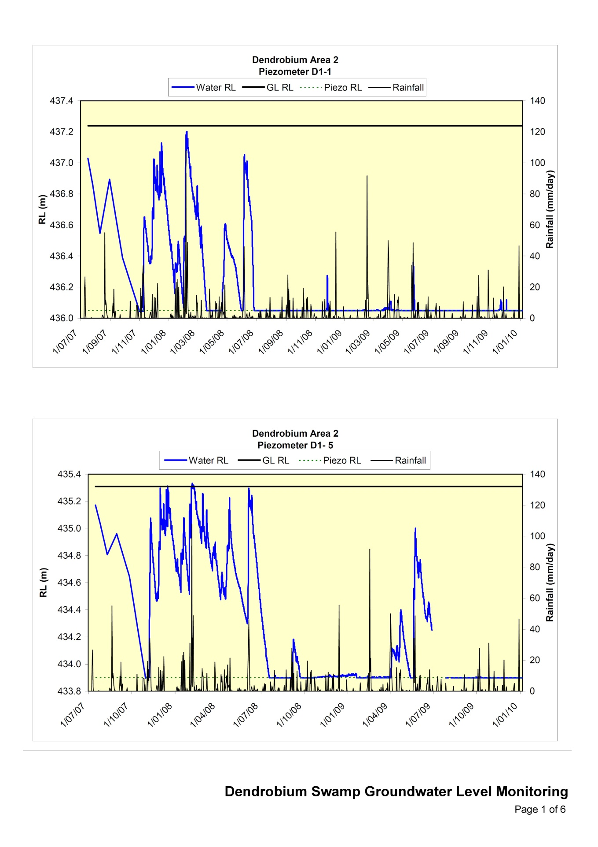
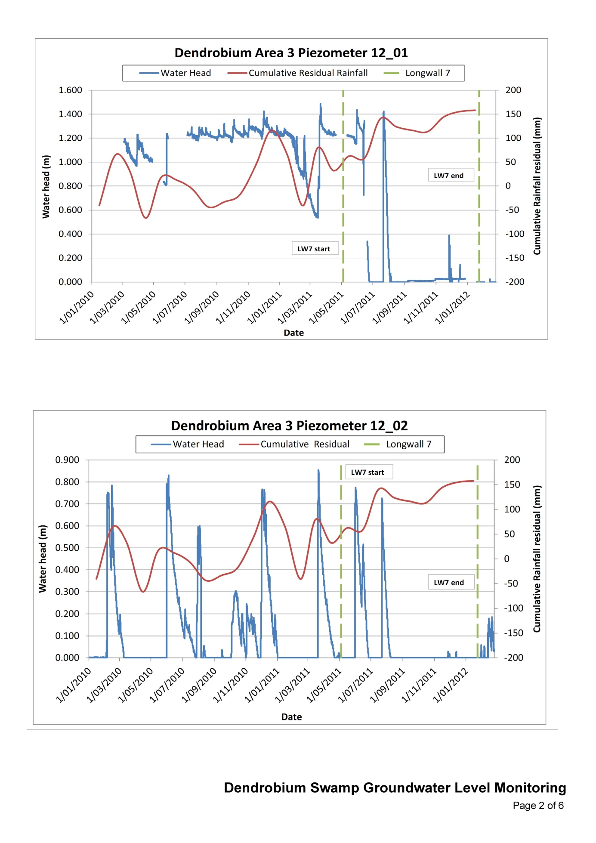
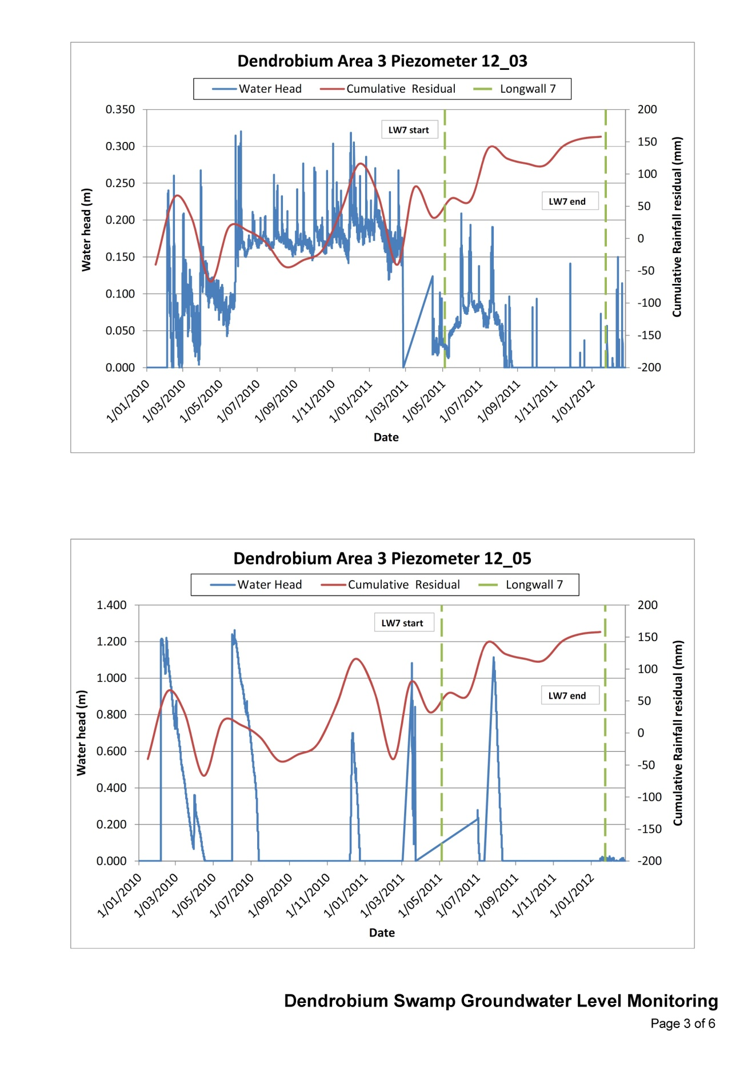
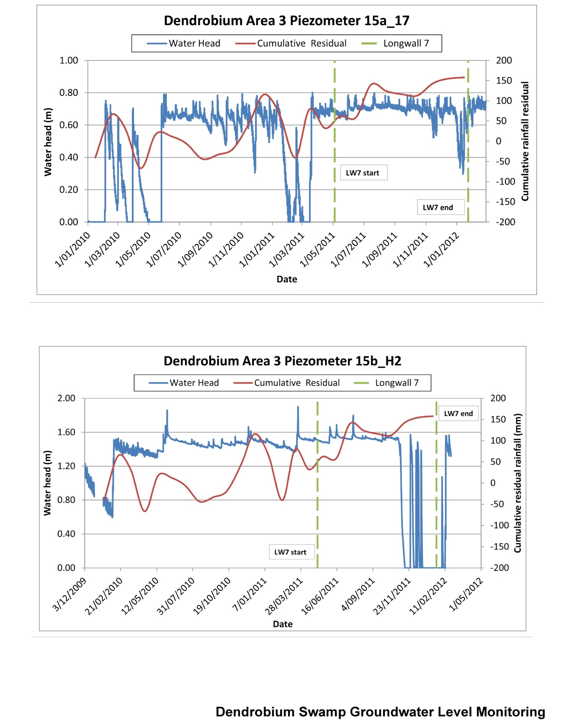
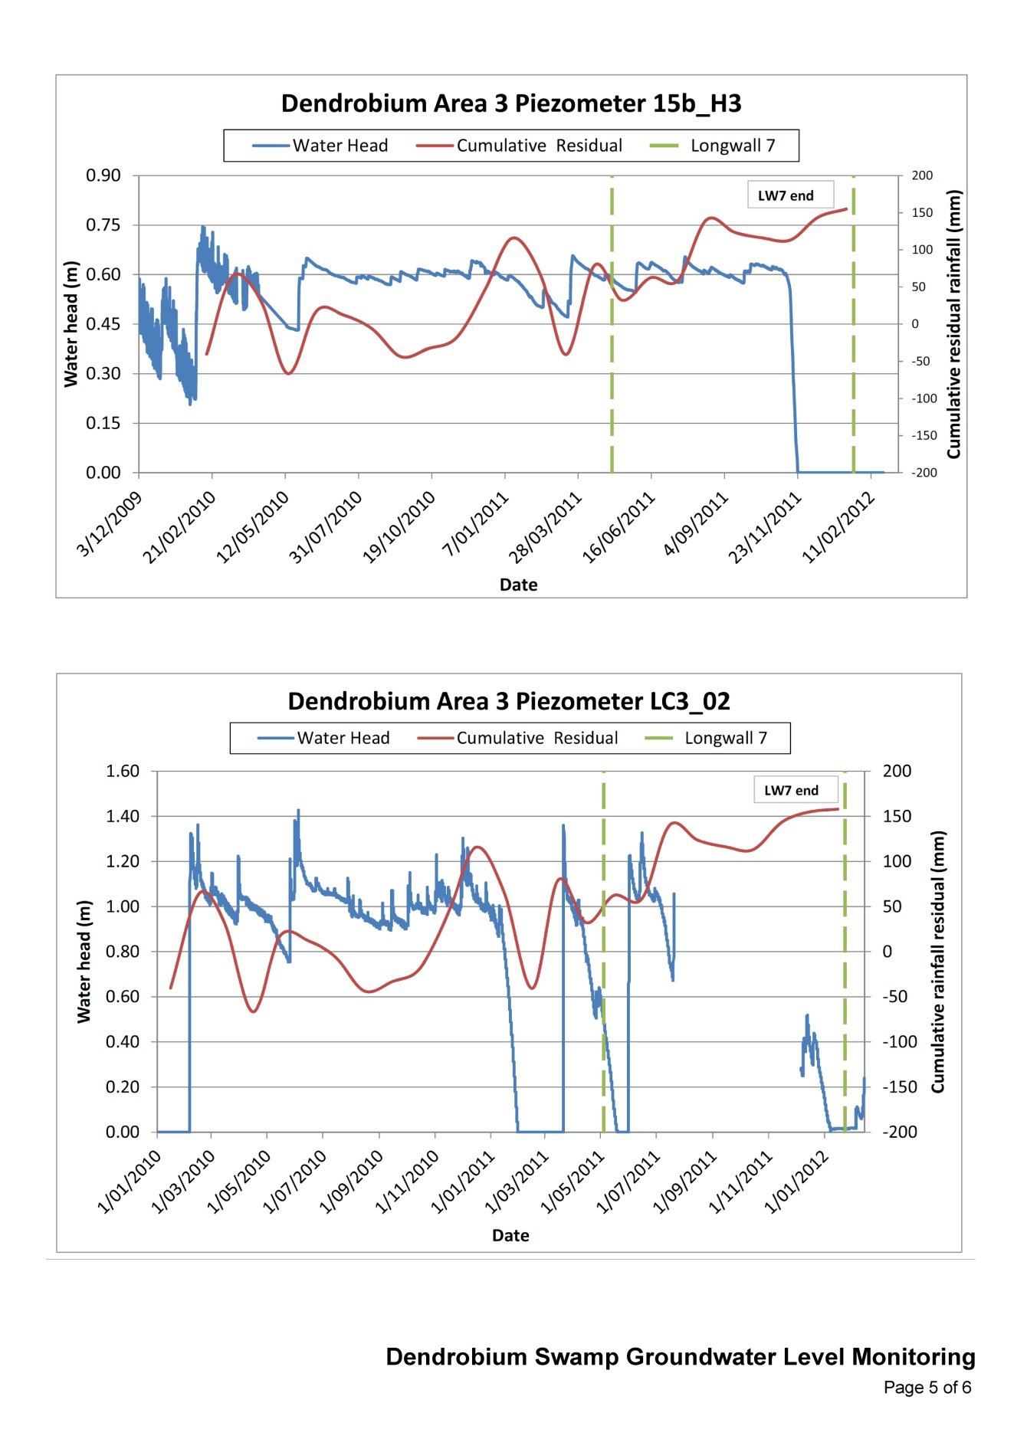
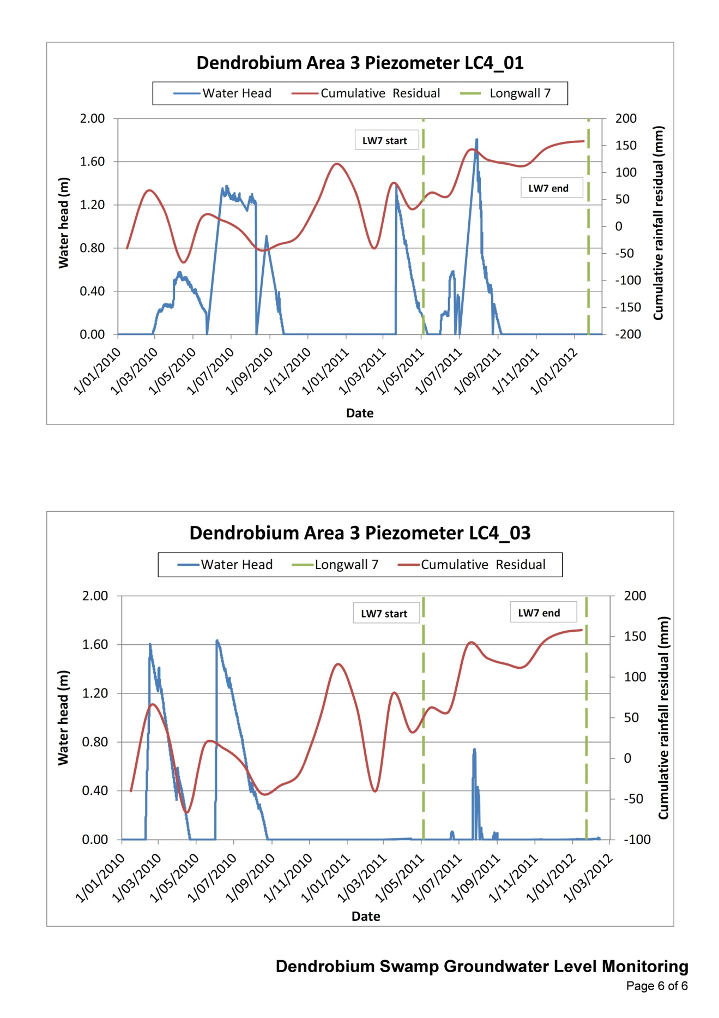

Appendix B
Hydrological response to longwall mining—ACARP project C14033
The tables in this appendix relate to section 6.2 of this report and are from Guo et al. (2007).

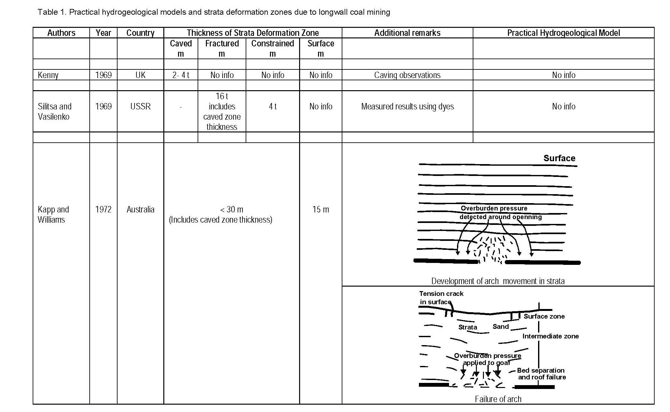
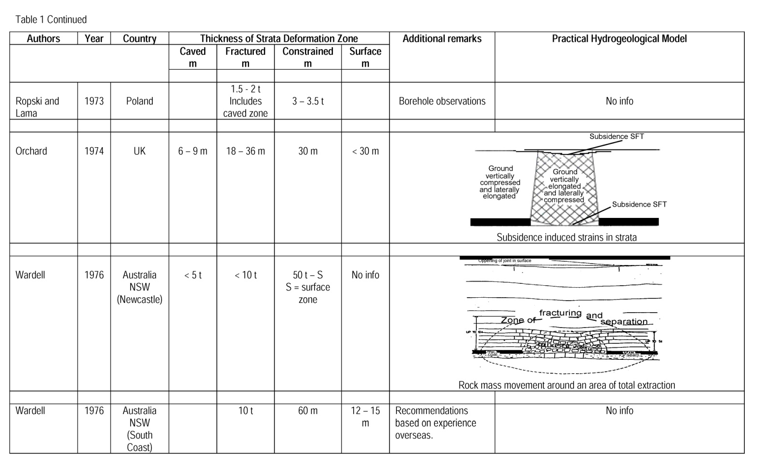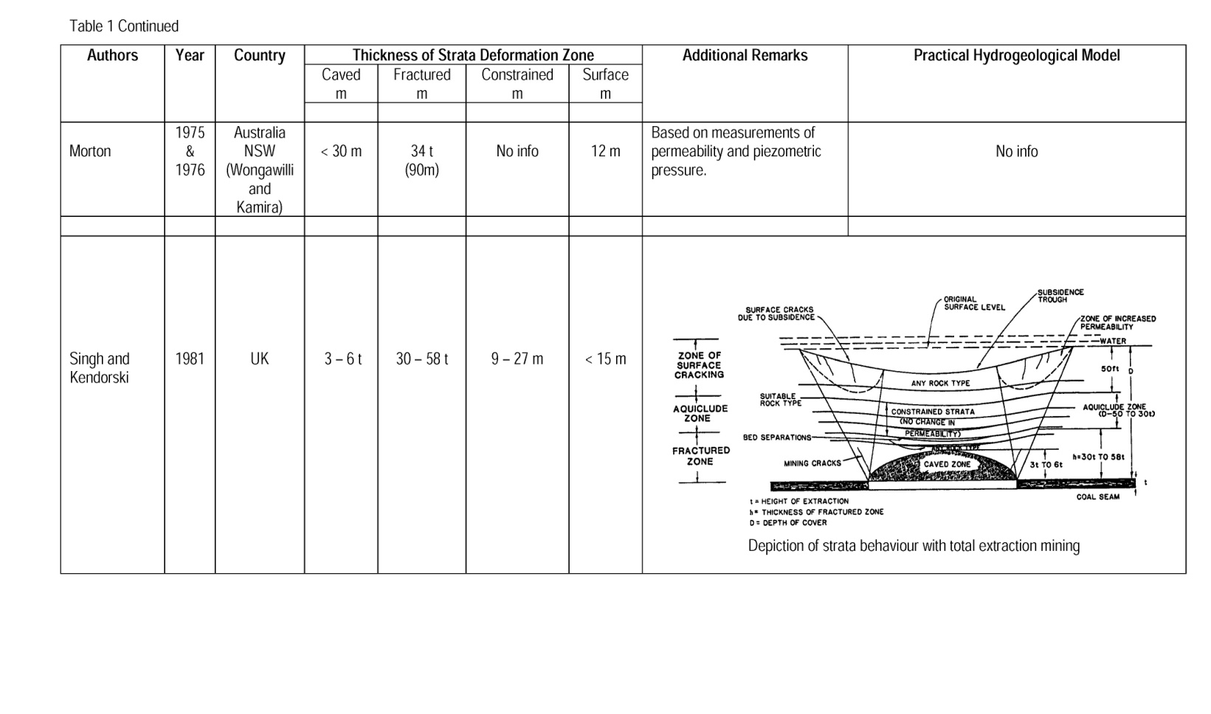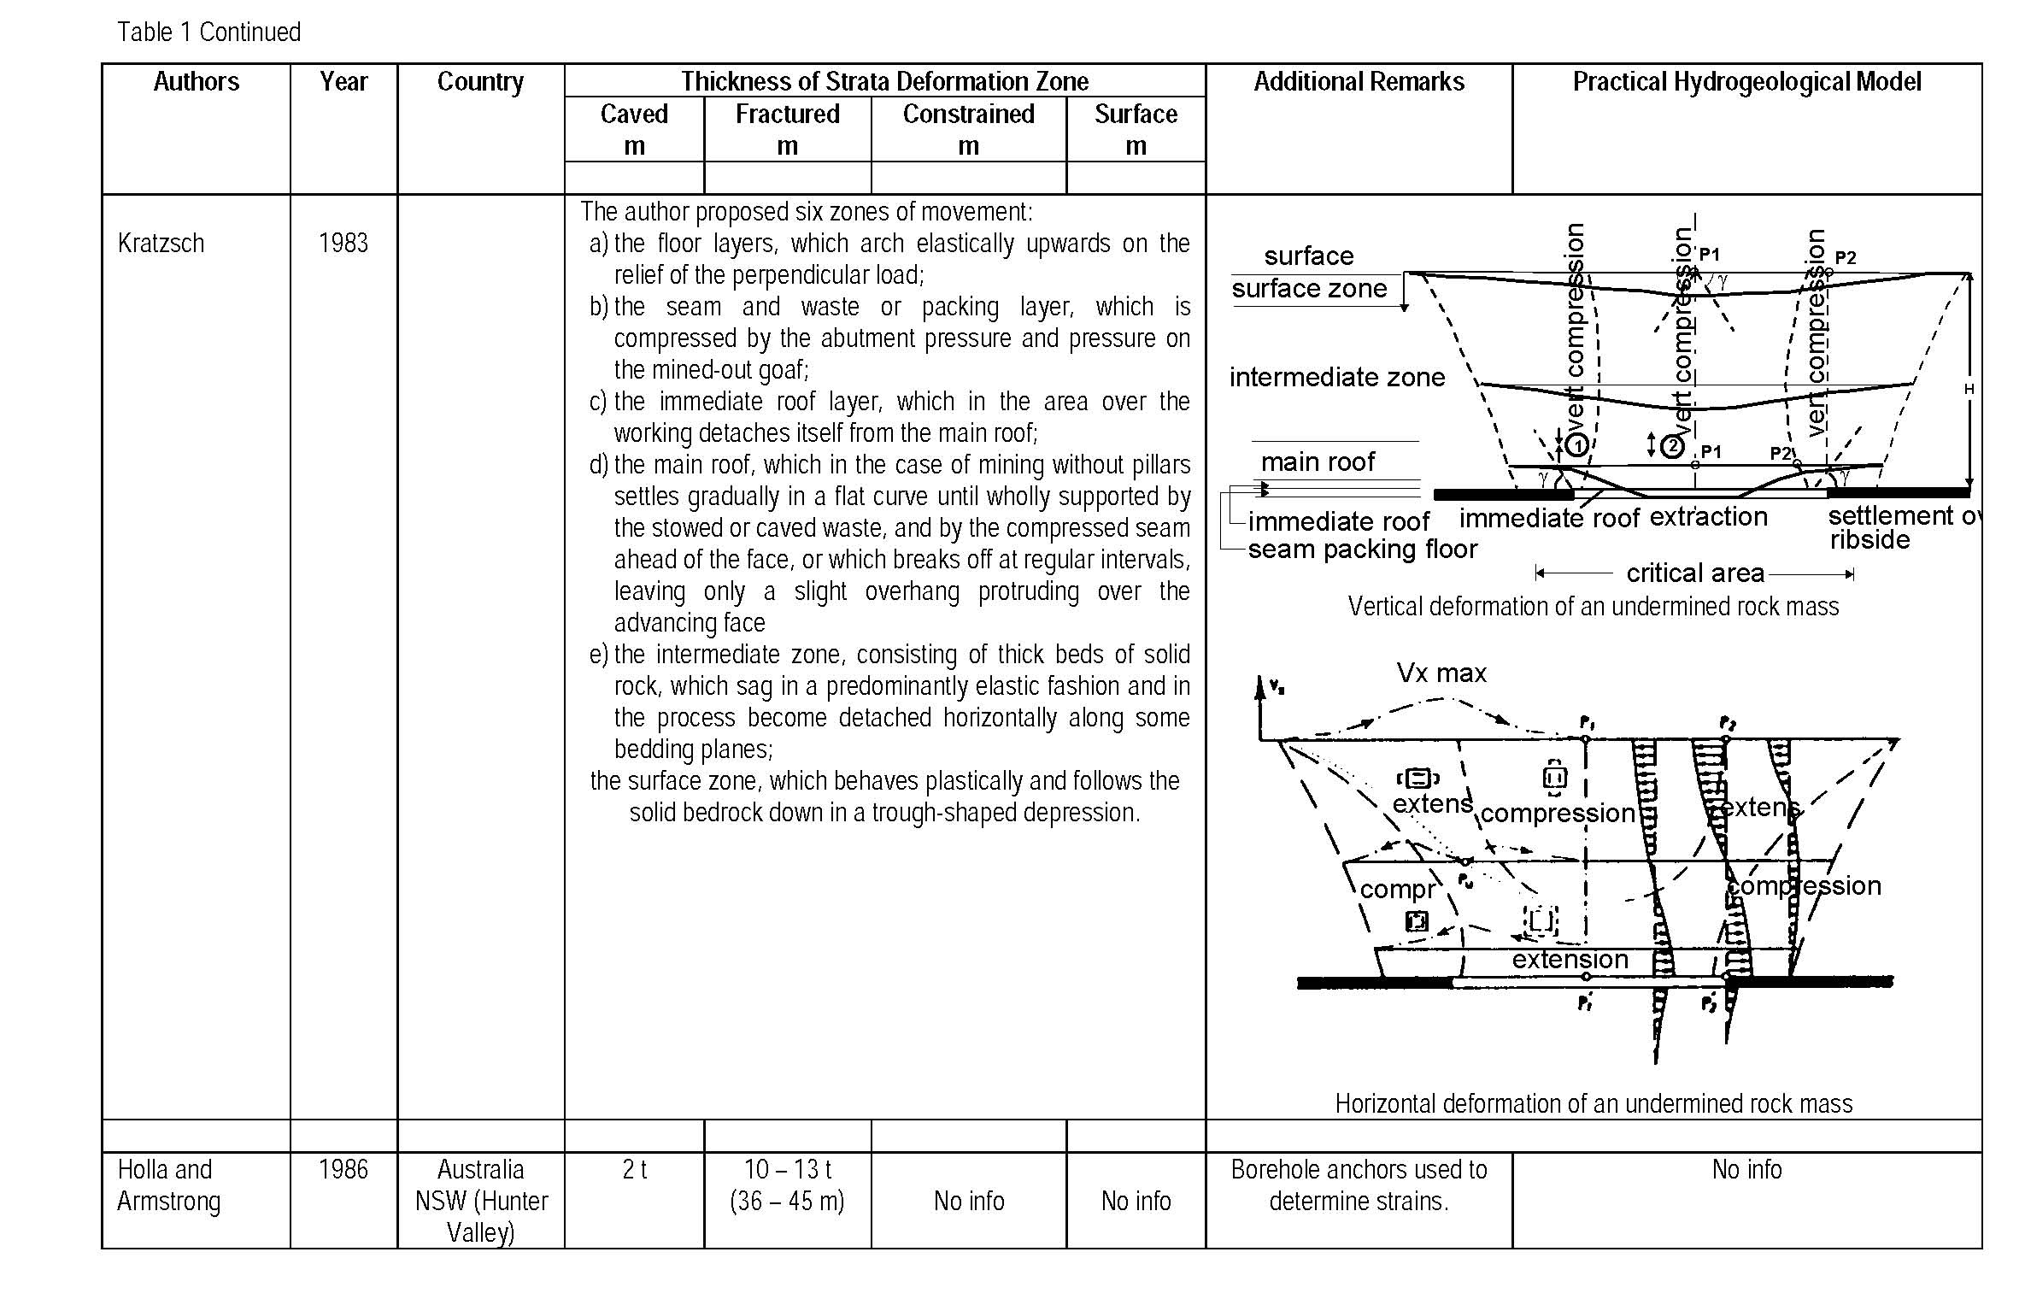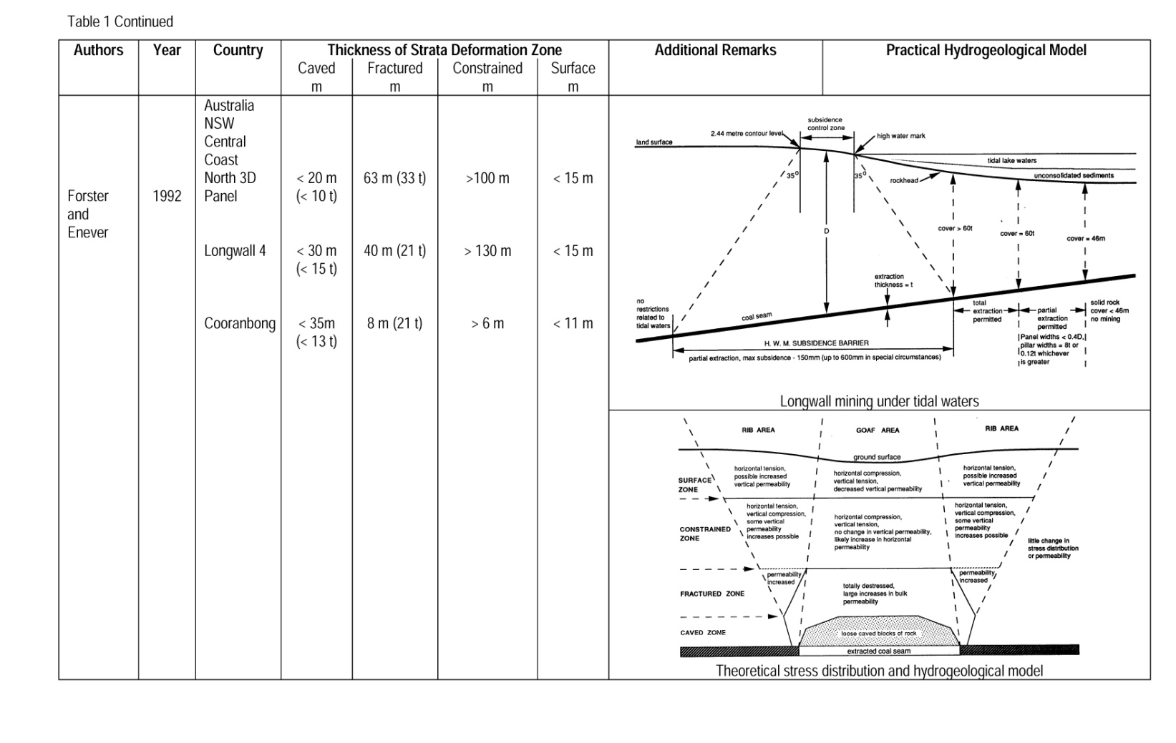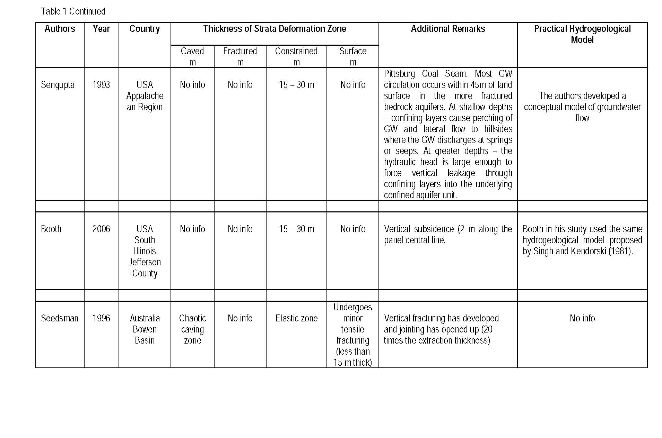
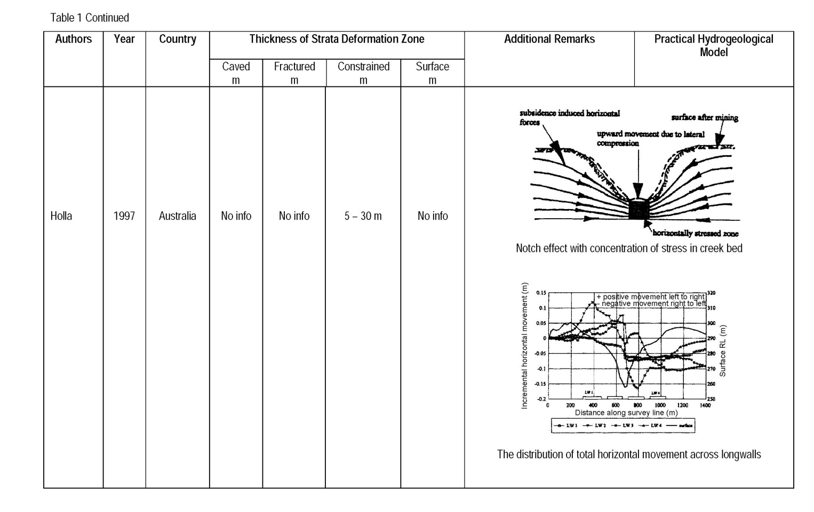
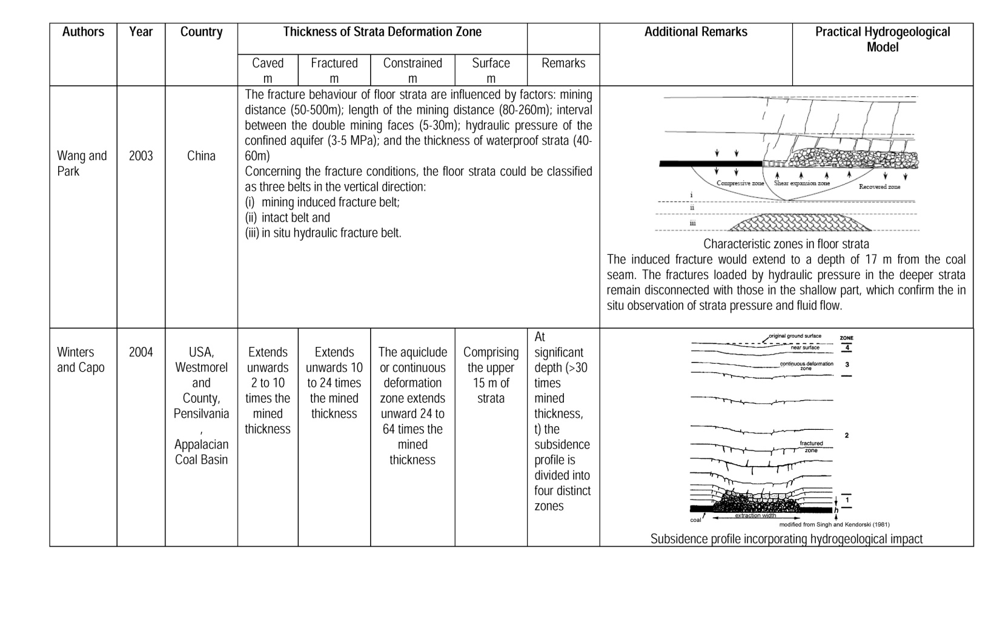
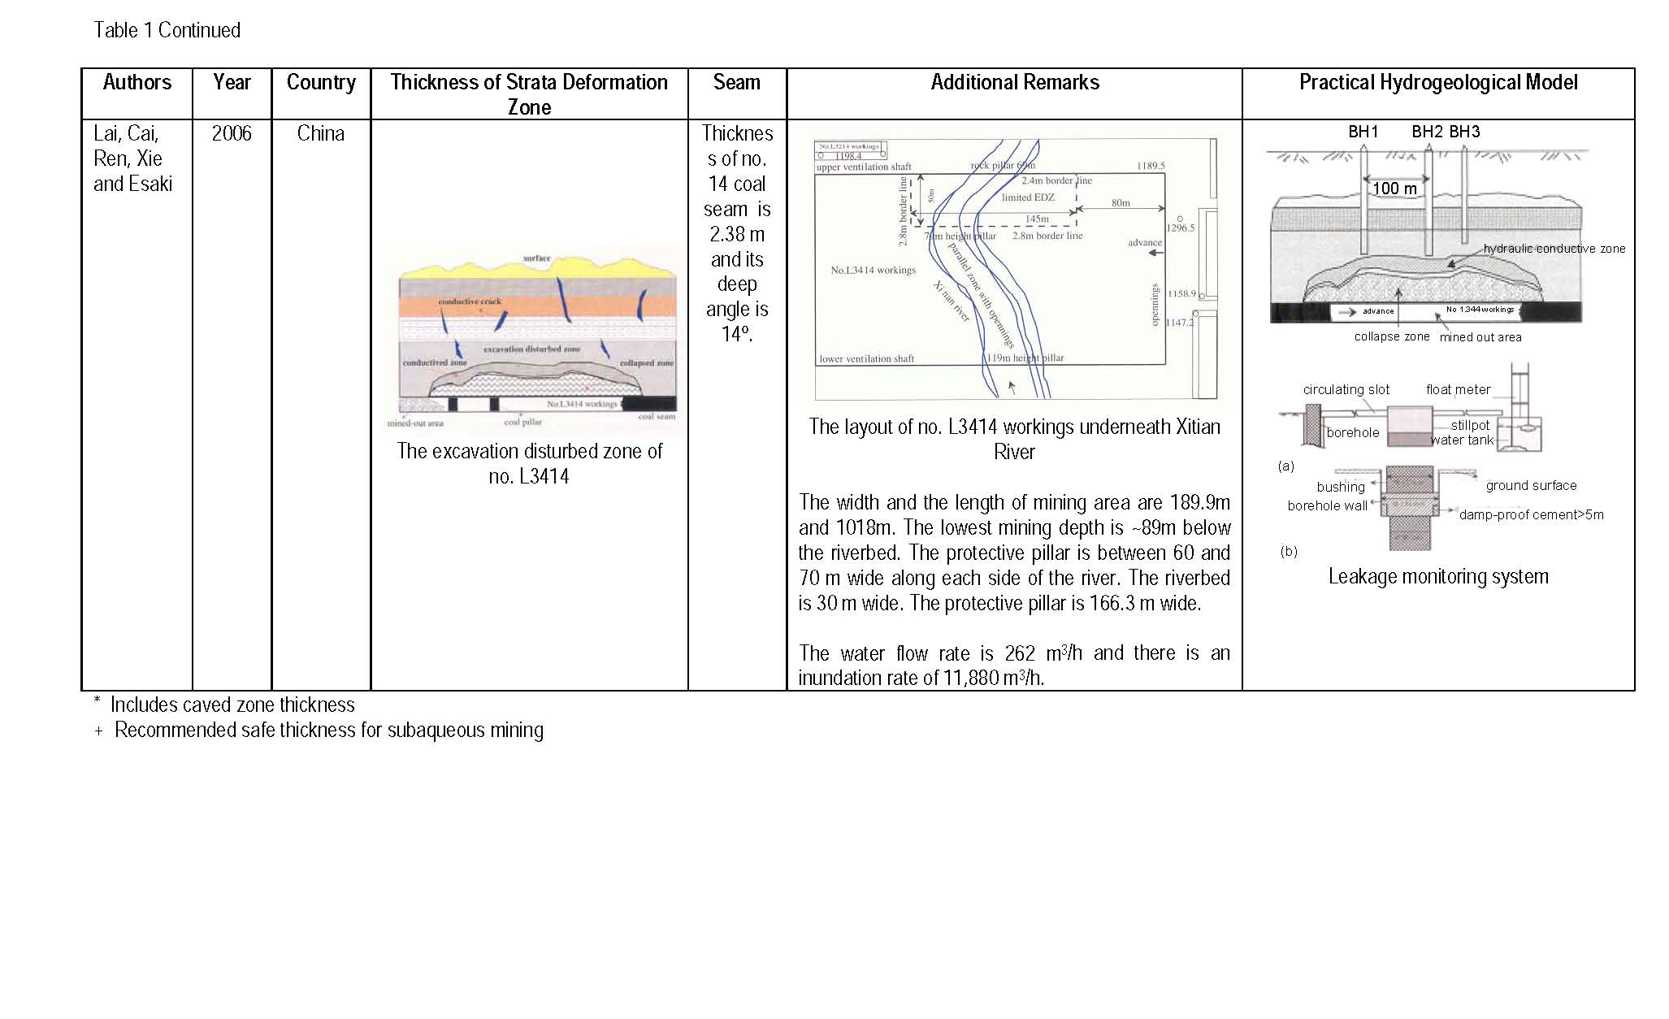

Appendix C
Example of application of general guidelines using the ACARP method
Background
General guidelines
Peat swamps that are potentially affected by cracking of the underlying sandstone may be protected by mine design using the following guidelines:
- Maintain tensile horizontal strains at the surface at less than 1 to 2 mm/m and compressive strains at less than 2 to 3 mm/m over a 20-m-wide zone. At these compressive strain levels, there is unlikely to be any significant impact on peat swamps because these strain levels are not usually sufficiently high to cause cracking of the near surface rock strata. The calculation of these strains is site specific, but can be calculated using the ACARP method.
- Position the panels so that they do not directly underlie the peat swamp. Higher levels of strain are typically experienced directly over the mined panels so not directly mining under a peat swamp is likely to limit the potential for higher strains to develop.
- If a high level of protection against rock fracturing is required, position the mine layout so that mining does not occur within a distance of half the overburden depth of the peat swamp to be protected.
Example
This example shows the application of point 1 from the general guidelines on protecting peat swamps. It has been modified from the one in Waddington 2002. Figure C1 shows the initial layout for Longwall 2. Compressive strain predictions are required for point A, a peat swamp, shown on Figure C1, due to potential impacts from mining Longwall 2. The figure also shows the distance measurement convention used to define the location of the point in the creek. To achieve a layout satisfying the general guidelines, several iterations may be required. Upsidence is also calculated for point A for the final layout, as a check and to help understand the conditions in the valley.
The transverse distances plotted in Figure C2 are the distances measured at right angles to the advancing goaf edge of the longwall, expressed as a proportion of the width of the panel plus the width of the chain pillar between the panels. The transverse distances for points A, B, C and D in Figure C1 are –270 m, 115 m, 460 m and 680 m, respectively, distances outside the goaf being negative.
The longitudinal distances plotted in Figure C3 are the distances from the nearest end of the longwall, measured parallel to the longitudinal centreline of the longwall. These distances for points A, B, C and D in Figure C1 are 450 m, 350 m, 160 m and –130 m, respectively, distances outside the goaf again being negative.
The valley depth and width are 35 m each.
The maximum subsidence is calculated by other methods. For this example, it is 500 mm.

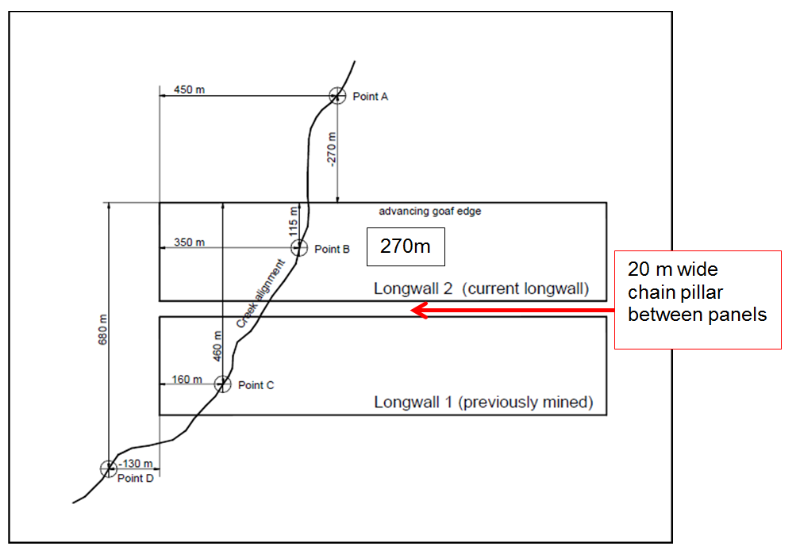
Figure C1 Site information.

Calculate the compressive strain at point A
There are 6 steps in the process to calculate compressive strain
Step 1: Calculate valley closure due to mining Longwall 2
First, we need to establish the transverse and longitudinal distances, the width of the panel and chain pillar, the valley depth at the point and the maximum incremental subsidence over the longwall. From Figure C1, the width of the panel plus the width of the chain pillar is 290 m. Calculate the transverse distance from the goaf edge to point A as a proportion of the width of the panel plus pillar, which in this case would be –270 m/290 m or –0.93. Then we look up the closure from the upper-bound curve in Figure C2 for a transverse distance on width of –0.93, which gives a closure of 190 mm.

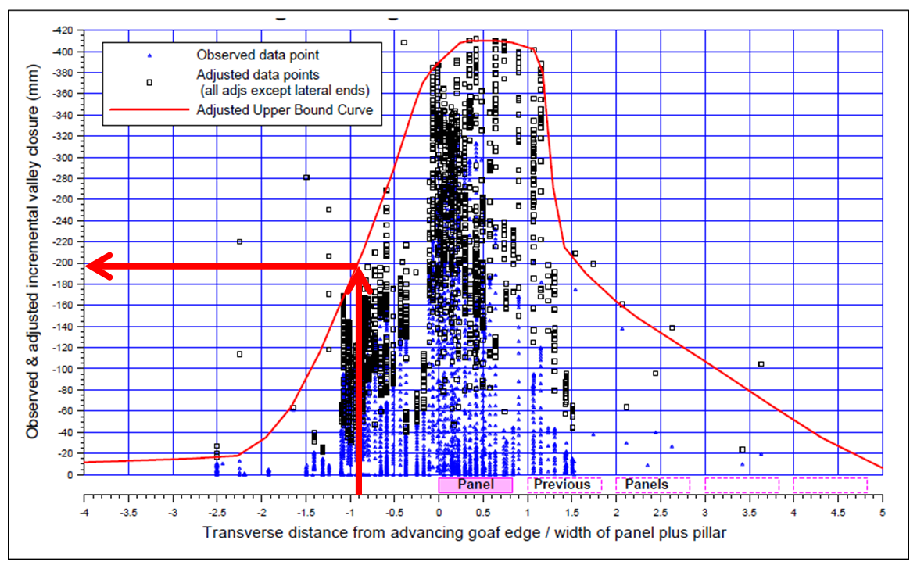
© Copyright, Waddington 2002 (Figure 9.1)
Figure C2 Valley closure versus distance from the advancing goaf edge of the longwall relative to the width of the panel plus the width of the pillar.

Step 2: Make a correction for the longitudinal location of the creek with respect to the longwall
The correction is found by looking up the closure value in Figure C3 for a longitudinal distance of 450 m, which in this case would be approximately 390 mm, compared with a maximum value in the graph of 410 mm. The correction factor for the longitudinal location of the creek, in this case, would therefore be 390 mm/410 mm (95 per cent).

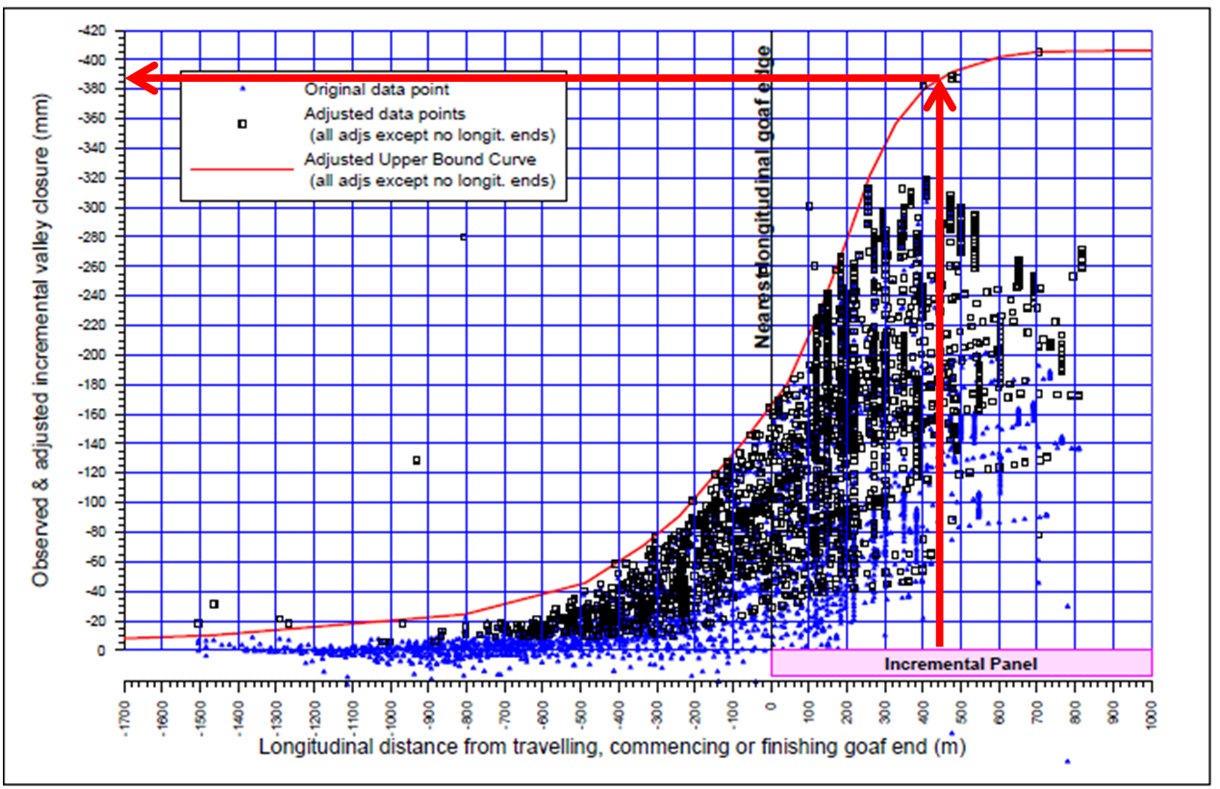
© Copyright, Waddington 2002 (Figure 9.2)
Figure C3 Adjusted valley closure versus distance from the end of the longwall.

Step 3: Make a correction for the depth of the valley
This correction is obtained with reference to the graph in Figure C4. For a valley depth of 35 m, the closure value is 280 mm, compared with the maximum value in the measured data of 410 mm at a depth of 68 m. The correction factor for valley depth would thus be 280 mm/410 mm (i.e. 68 per cent).

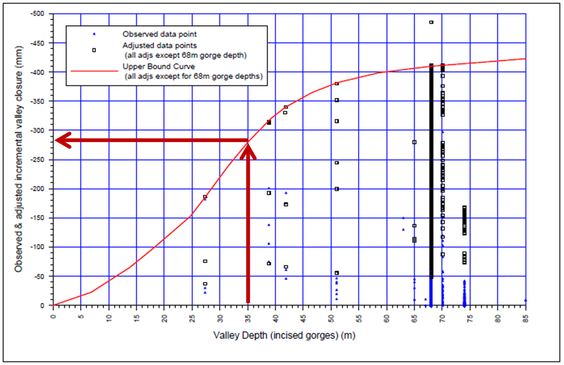
© Copyright, Waddington 2002 (Figure 9.3)
Figure C4 Adjusted valley closure versus valley depth.

Step 4: Make a correction for the maximum incremental subsidence of the longwall
This correction is made with reference to the graph in Figure C5. For a maximum incremental subsidence of 500 mm, the closure value is 440 mm, compared with a maximum closure value of 410 mm at a subsidence of 400 mm. The correction factor for incremental subsidence would therefore be 440 mm/410 mm (1.07).

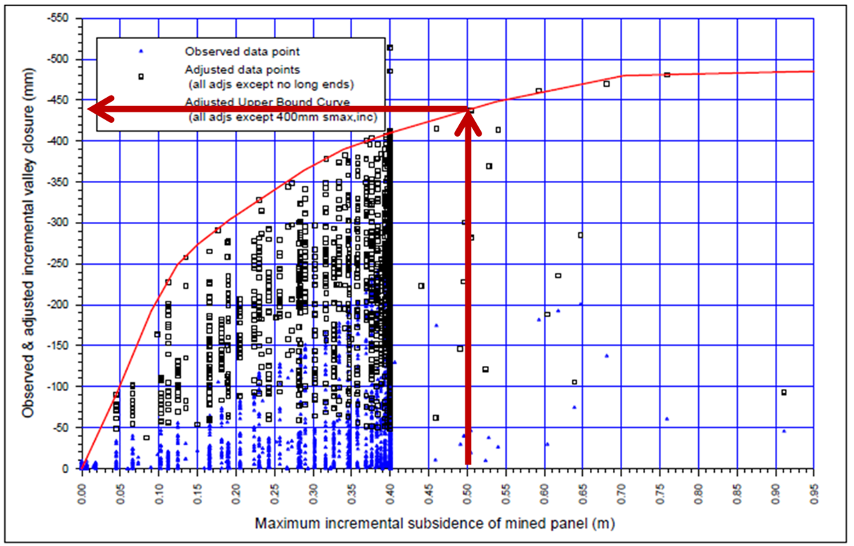
© Copyright, Waddington 2002 (Figure 9.4)
Figure C5 Adjusted valley closure versus maximum incremental subsidence

Step 5: Prediction of valley closure
The predicted closure is the overall closure across the steepest part of the valley. Multiply the value of closure from step 1, 190 mm, by each of the correction factors to arrive at a final value. In this case, the value would be 190 mm × 0.95 × 0.68 × 1.07, which equals 131 mm.
Predicted closure at point A = 131mm.
Step 6: Calculate compressive strain at point A
The predicted maximum compressive strain can be obtained for a given closure using the upper-bound curve in Figure C6.
The predicted strain is the average strain over a bay length of 20 m, and is assumed to occur within the lowest part of the valley. The closure of this bay can, therefore, be determined from the predicted strain.
As explained in Section 9.6 of Waddington (2002), the closure over this bay length can be greater than the overall closure of the valley, due to expansion in the valley sides as the horizontal stresses are relieved.
The closure and strain are assumed to be both driven by the in situ horizontal stress, and it is reasonable to assume that the compressive strains will reduce as the in situ stress reduces. Since the graph in Figure C6 has been based on data from Tower Colliery, where the in situ stress is particularly high, it is expected that the graph will generally be conservative and could overpredict strains by 100 per cent in some cases, particularly where the predicted levels of strain are low. The data spread in the graph shows the variations that have occurred in practice, and provides a guide to the potential range of strains that might occur in a particular case.
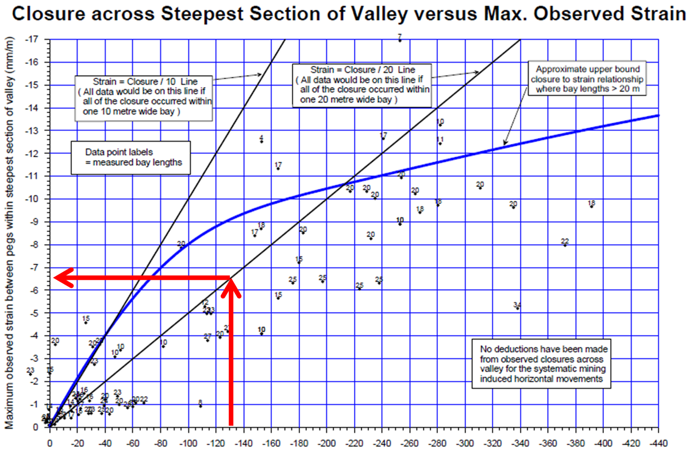
Note: Observed closure across steepest section of valley (i.e. cumulative bay length differences within steepest section of valley [mm])
© Copyright, Waddington 2002 (Figure 12.3)
Figure C6 Maximum compressive strain versus valley closure.

From step 5, the closure is 131 mm.
From Figure C6, the compressive strain for a 20-m-wide section is 6.4 mm/m.
Therefore, the predicted compressive strain at point A in Figure C1 is 6.4 mm/m.
Checking this value with the suggested threshold for compressive strain of 2–3 mm/m, the calculated value is greater than the threshold value; therefore, a swamp at point A would likely be damaged. The longwall panel configuration needs to be reassessed to lower the compressive strain.
Reassessment of longwall panel configuration
The data are as before, except that the longwall has been shortened so that the end of the longwall is now 450 m to the east of point A, as shown in Figure C7. Other configurations may also be applicable. The original longwall position is dashed.
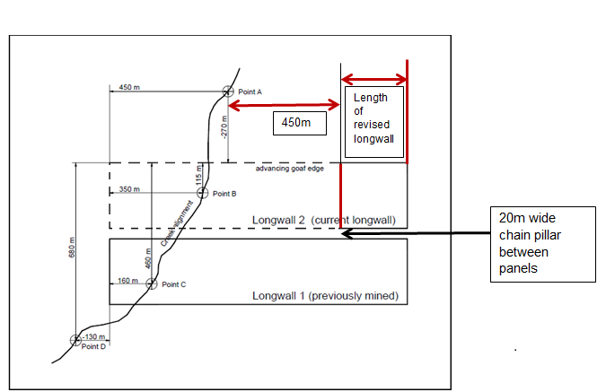
Figure C7 Revised site information.

In this case, the information for step 1 and steps 3–4 are the same and the graphs have not been reproduced. However, this always needs to be checked.

Step 1: Calculate valley closure due to mining Longwall 2
The closure is the same as for the original longwall layout at step 1 above—190 mm.

Step 2: Make a correction for the longitudinal location of the creek with respect to the longwall
Look up the closure value in Figure C8 for a longitudinal distance of –450 m, which in this case would be approximately 50 mm, compared with a maximum value in the graph of 410 mm. The correction factor for the longitudinal location of the creek, in this case, would therefore be 50 mm/410 mm (i.e. 12 per cent, compared with 95 per cent for the original longwall layout).

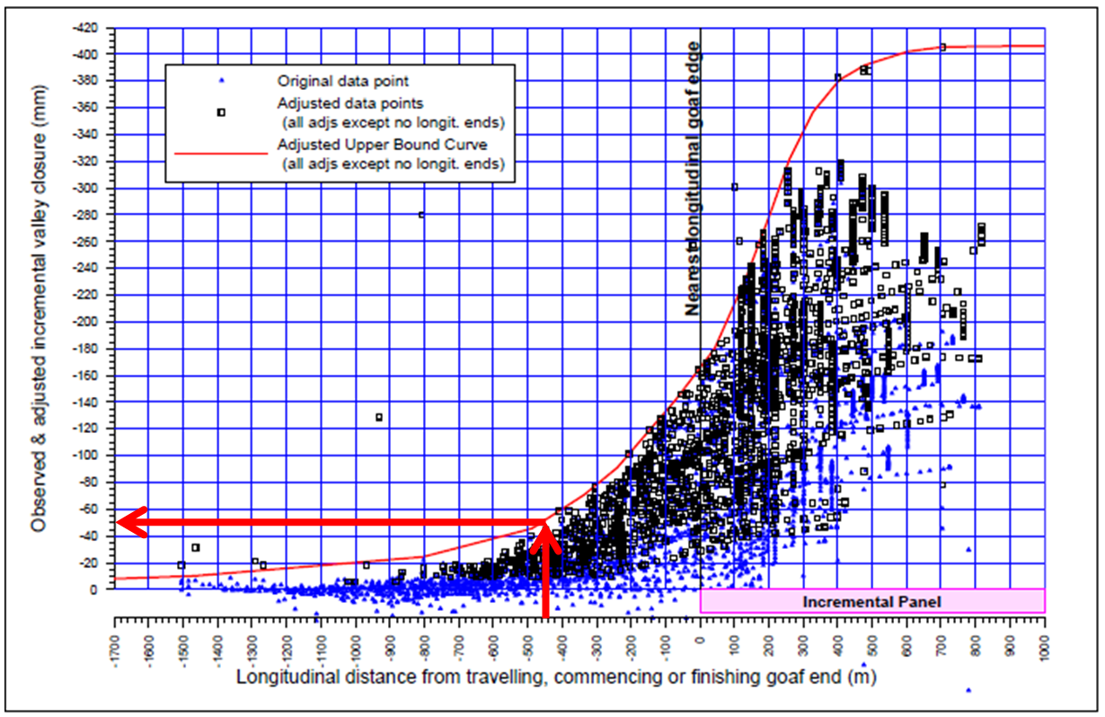
© Copyright, Waddington 2002 (Figure 9.2)
Figure C8 Adjusted valley closure versus distance from the end of the longwall.

Step 3: Make a correction for the depth of the valley
The depth correction is the same as for the original longwall layout in step 3 above—68 per cent.
Step 4: Make a correction for the maximum incremental subsidence of the longwall
The incremental subsidence correction is the same as for the original longwall layout in step 4 above—1.07.
Step 5: Prediction of valley closure
Multiply the initial value of closure, 190 mm, by each of the correction factors to arrive at a final value. In this case, the value would be 190 mm × 0.12 × 0.68 × 1.07, which equals 16.6 mm.
Step 6: Calculate compressive strain at point A
From Figure C9, with a closure of 16.6 mm, the strain is 0.8 mm/m.
Therefore, the predicted compressive strain at point A for the revised longwall configuration is 0.8 mm/m.
Checking this value with the suggested maximum threshold for a compressive strain of 2 to 3 mm/m, the calculated value is now less than the threshold; therefore, a swamp at point A should not be damaged. The revised longwall panel configuration has reduced the compressive strain below the threshold.

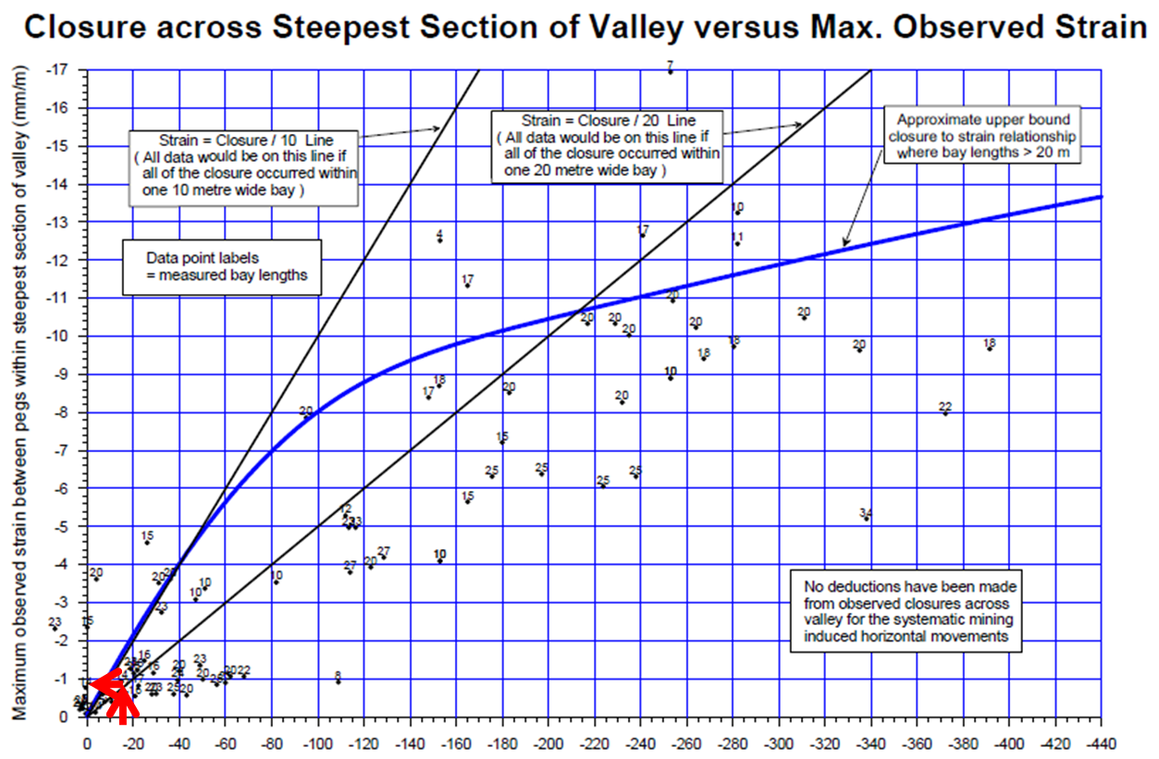
Note: Observed closure across steepest section of valley (i.e. cumulative bay length differences within steepest section of valley [mm])
© Copyright, Waddington 2002 (Figure 12.3)
Figure C9 Maximum compressive strain versus valley closure.

Calculate upsidence at point A
Step 1: Calculate incremental upsidence
Calculate the transverse distance as a proportion of the width of the panel chain plus pillar, which in this case would be –270 m/290 m or –0.93. Then we would look up the upsidence from the upper-bound curve in Figure C10 for a transverse distance on width of –0.93, which would give an incremental upsidence of 85 mm.

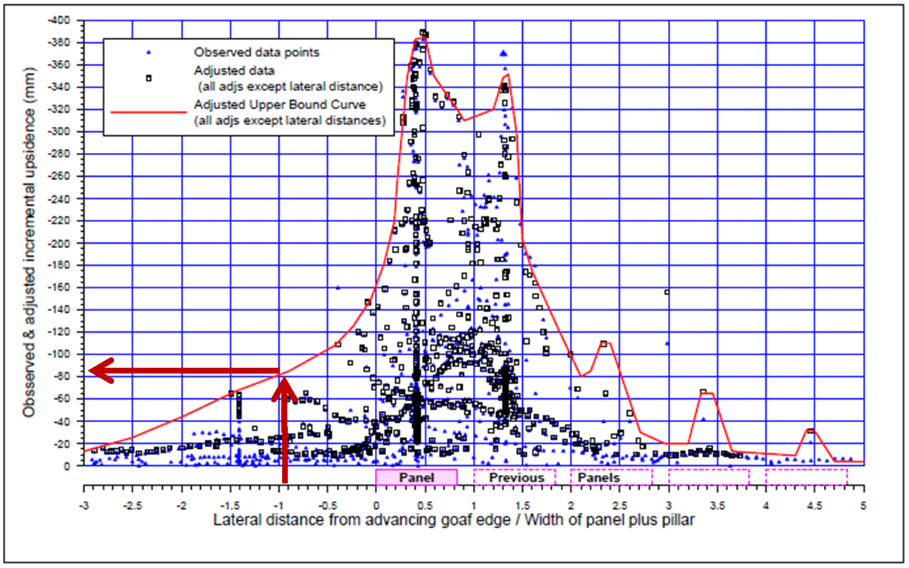
© Copyright, Waddington 2002 (Figure 9.5)
Figure C10 Upsidence versus distance from the advancing goaf edge of the longwall relative to the width of the panel plus the width of the pillar.

Step 2: Make a correction for the longitudinal location of the creek with respect to the longwall position
Look up the upsidence value in Figure C11 for a longitudinal distance of –450 m, which in this case would be approximately 50 mm, compared with a maximum value in the graph of approximately 390 mm. The correction factor for the longitudinal location of the creek, in this case, would therefore be 50 mm/390 mm (i.e. 0.13).

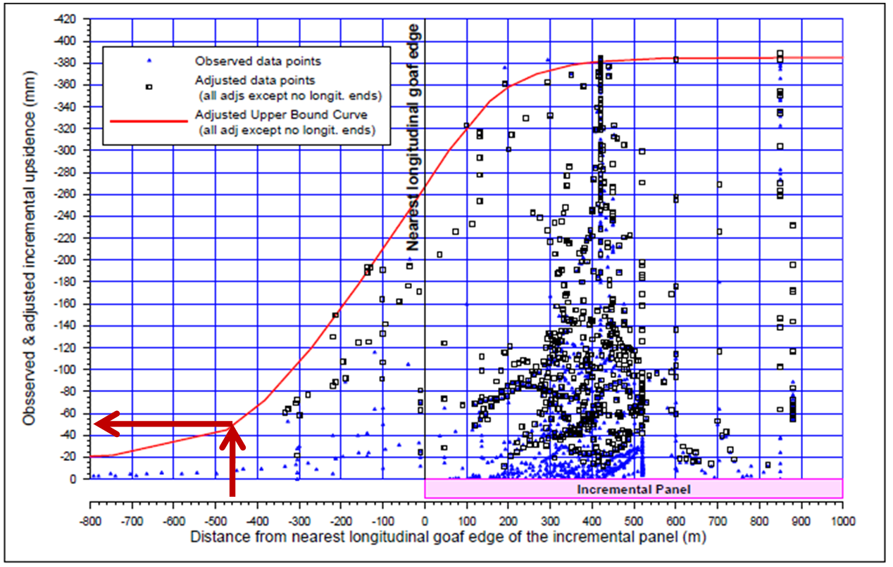
© Copyright, Waddington 2002 (Figure 9.6)
Figure C11 Adjusted upsidence versus distance from the end of the longwall.

Step 3: Make a correction for the depth of the valley
Using Figure C12, the upsidence value for a valley depth of 35 m is 250 mm, compared with a maximum value of 390 mm at a depth of 70 m. The correction factor for valley depth would thus be 250 mm/390 mm (i.e. 0.64).

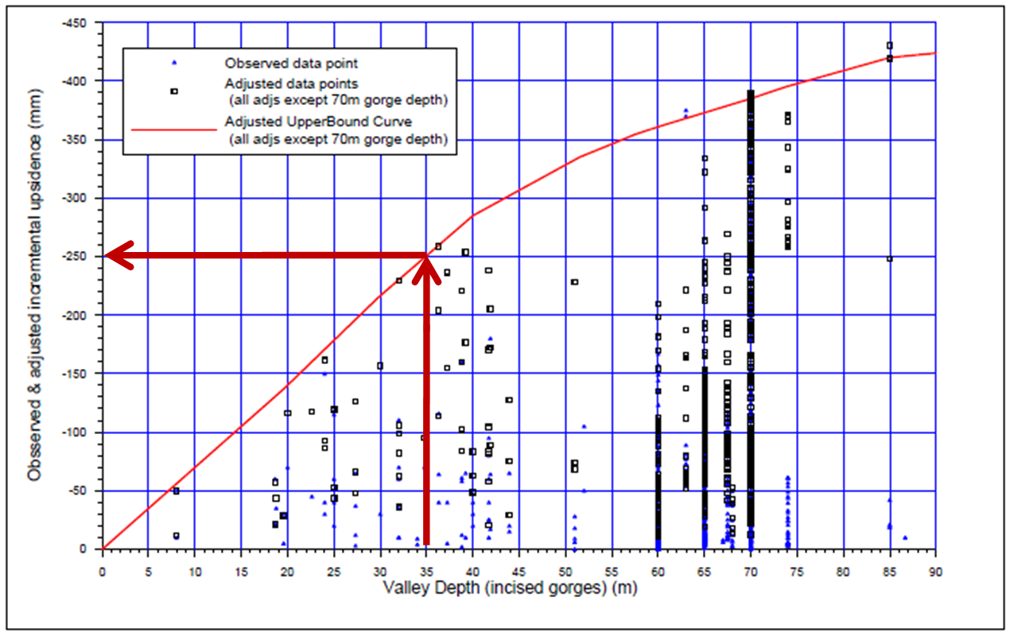
© Copyright, Waddington 2002 (Figure 9.7)
Figure C12 Adjusted upsidence versus valley depth.

Step 4: Make a correction for the maximum incremental subsidence
Make a correction for the maximum incremental subsidence of the longwall with reference to the graph in Figure C13. For a maximum incremental subsidence of 500 mm, the upsidence value is 445 mm, compared with a maximum upsidence value of 390 mm for a subsidence of 350 mm. The correction factor for incremental subsidence would therefore be 445 mm/390 mm (i.e. 1.14).

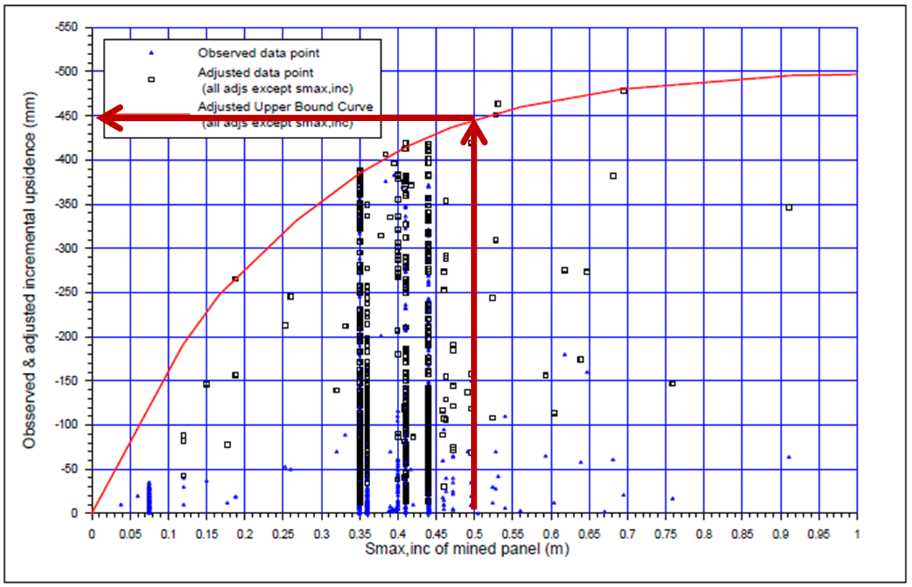
© Copyright, Waddington 2002 (Figure 9.8)
Figure C13 Adjusted upsidence versus maximum incremental subsidence.
Step 5: Calculate upsidence
Multiply the initial value of upsidence, 85 mm, by each of the correction factors to arrive at a final value. In this case, the value would be 85 mm × 0.13 × 0.64 × 1.14, which equals 8.1 mm.

Appendix D
Extract from: RW Seedsman and A Dawkins 2006, Techniques to predict and measure subsidence and its impacts on the groundwater regime above shallow longwalls, ACARP report C23020

In addition, if the lateral continuity of the upper layers of jointed rock blocks is interrupted by gaps (valleys) that provide free faces, the blocks will not interact by generating compressive stresses but simply translate sideways. This model of blocks being deflected during the sagging phase of a subsidence wave provides the explanation for valley closure and the associated phenomenon of down slope movements. Consider the case of an assemblage of blocks with a free face at one end (Figure 13). By tilting blocks relative to each other, the sagging wave will normally induce lateral forces on each block that are resisted by other blocks – this is in fact the basis of voussoir beam behaviour. In the presence of a valley, the geometry is such that that there may be no immediately adjacent block (Block B in Figure 13).
In the absence of a reaction, the interaction of block A and B results in an unrecoverable translation of Block B into the valley. A similar translation towards the valley occurs on the other side.
In a situation where there is no valley at the point of sagging, there is still the possibility that there is translation further a-field, such that there is valley closure in an area of no curvature or in an area of hogging curvature. In fact horizontal movements away from the longwall panel could be observed.

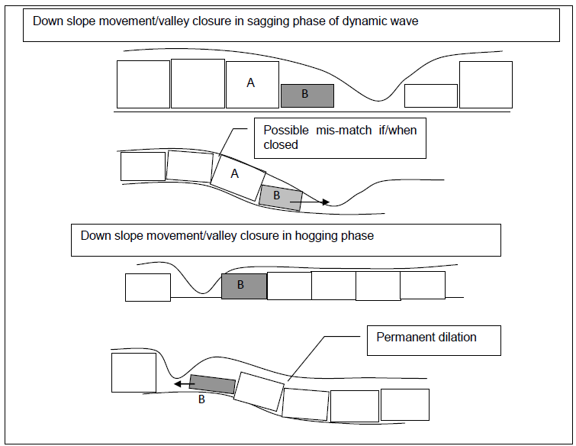

A model for down slope movements in a valley, based on lateral movement induced by sagging curvature.
It will be readily appreciated that the extension of this model to 3 dimensions requires consideration of the orientation of the joints and the valleys relative to the subsidence deformations.
It is also noted that any of these translations are not automatically recoverable and this means that there will be permanent joints opening as a sagging wave passes (Figure 13). Even the passage of a hogging phase may leave an increase in localized joint dilation as it is unlikely that the joints will return to exactly the same position. Dilation may also occur along the translational surface. All of these dilational movements have the potential to increase the transmissivity of the joints and hence the overall rock mass.
Finally this model for the translation of blocks provides a possible driver for upsidence. If the translational surface is above the floor of a valley, there will be simple valley closure; if the surface is well below the floor of the valley, it is possible that there will be no closure at all. If the translational surface is located just under the valley floor, the thin layer of rock may not be able to resist the translation and it will buckle/heave. This buckling will result in the fracture pathways that will transfer water flow to the level of the translation surface and then back to the pre-existing thalweg.

References
Bhattacharya AK & Gurtunca RG 1984, Investigation of subsurface subsidence, NERRDP end of grant report no. 278.
Bembrick CS, Casamassima E & Baines E 1980, Petroleum exploration in PEL 255 and 260, Central Sydney Basin, report 1005, prepared for the Australian Gas Light Company.
Bembrick CS, Casamassima E & Baines E 1982, Petroleum exploration in PEL 255 and 260, central Sydney Basin, report 2005, prepared for the Australian Gas Light Company.
BHP Billiton 2007, The prediction of subsidence parameters and the assessment of mine subsidence impacts of natural features and surface infrastructure resulting from the extraction of proposed longwalls 6 to 10 in Area 3A and future longwalls in Areas 3B and 3C at Dendrobium Mine, report MSEC311, prepared by Mine Subsidence Engineering Consultants for BHP Billiton Illawarra Coal.
Bloomfield JP & Williams AT 1995, ‘An empirical liquid permeability-gas permeability correlation for use in aquifer properties studies’, Quarterly Journal of Engineering Geology and Hydrogeology, vol. 28, pp. S143–S150.
Booth CJ 1986, ‘Strata-movement concepts and the hydrogeological impact of underground coal mining’, Ground Water, vol. 24, no. 4, pp. 507–15.
Booth CJ & Spande ED 1992, ‘Potentiometric and aquifer property changes above subsiding longwall mine panels, Illinois Basin Coalfield’, Ground Water, vol. 18, no. 3, pp. 362–8.
Booth CJ, Carpenter PJ & Bauer RA 1997, Aquifer response to longwall mining, Illinois, US Department of the Interior, Office of Surface Mining, Library report no. 637, Grant/Coop, Agreement GR196171, Washington, DC.
Booth CJ, Curtis AM, DeMaris PJ & Bauer RA 2000, ‘Site-specific variation in the potentiometric response to subsidence above active longwall mining’, Environmental & Engineering Geoscience, vol. VI, no.4, pp. 383–94.
Booth CJ, Curtiss AM, DeMaris PJ & Van Roosendaal DJ 1999, ‘Anomalous increases in piezometric levels in advance of longwall mining subsidence’, Environmental and Engineering Geoscience, vol. 4, no.4, pp. 407–18.
Booth CJ, Spande ED, Pattee CT, Miller JD & Bertsch LP 1998, ‘Positive and negative impacts of longwall mine subsidence on a sandstone aquifer’, Environmental Geology, vol. 34, no. 2–3, pp. 223–33.
Brassington G & Horsley C 2004, ‘Understanding upland swamps in the Illawarra—the relationship of swamps and subsidence’, in Proceedings of the 6th triennial conference on subsidence management issues, Maitland, 31 October – 2 November 2004, Mine Subsidence Technological Society.
Briggs H 1929, Mining subsidence, Edward Arnold & Co.
Byrnes RP 1999, ‘Longwall extraction beneath Cataract Reservoir’, Masters of Engineering Science thesis, University of New South Wales.
Chugh YP, Yang G & Mehta K 1994, Three dimensional modelling of subsidence, strain, tilt and curvature due to the proposed longwall extraction at BHP’s Appin and Tower collieries with special emphasis on the Water Board’s Broughtons Pass Weir and associated pumping stations, Cataract and Nepean tunnels upper canal, as well as the Natural Gas Company’s pipeline and its crossing at Cataract Gorge, final report, vol. I, Summary report, prepared for Australian Water Technologies, BHP Collieries Pty Ltd & the Natural Gas Company, Southern Illinois University, Carbondale, Illinois.
Cifelli RC & Rauch HW 1986, ‘Dewatering effects from selected underground coal mines in north-central West Virginia’, in SS Peng (ed.), Proceedings, 2nd workshop on surface subsidence due to underground mining, Morgantown, August, pp. 249–63.
CoA 2014a, Temperate Highland Peat Swamps on Sandstone: ecological characteristics, sensitivities to change, and monitoring and reporting techniques, Knowledge report, prepared by Jacobs SKM for the Department of the Environment, Commonwealth of Australia, Canberra.
CoA 2014b, Temperate Highland Peat Swamps on Sandstone: evaluation of mitigation and remediation techniques, Knowledge report, prepared by the Water Research Laboratory, University of New South Wales, for the Department of the Environment, Commonwealth of Australia, Canberra.
Coffey Geosciences Pty Ltd 1982, Assessment of water inflows to shaft, Wilton, NSW, report S6955/1-AB, prepared for Crooks Mitchell Peacock Stewart Pty Ltd and Methane Drainage Pty Ltd.
Coffey Geosciences Pty Ltd 2007, Wingecarribee Swamp hydrogeological investigation—stage 2 final report, report S22369/01-AB, prepared for the Sydney Catchment Authority, Robertson, New South Wales.
Crouch, SL and Starfield AM, 1983, Boundary element methods in Solid Mechanics. George Allen & Unwin, London.
Conaghan PJ 1980, ‘The Hawkesbury Sandstone: gross characteristics and depositional environment’, in C Herbert & R Helby (eds), A guide to the Sydney Basin, Geological Survey of New South Wales, Bulletin 26, Department of Mineral Resources.
Dickinson J 1898, ‘Subsidence due to colliery workings’, Proceedings of Manchester Geological Society, vol. 25, p. 600.
Dixon JS 1885, ‘Some notes on subsidence and draw’, Transactions of Mining Institute Scotland, vol. 7, p. 224.
DSEWPaC 2012, Temperate Highland Peat Swamps on Sandstone, Species Profile and Threats Database, Australian Government Department of Sustainability, Environment, Water, Population and Communities, Canberra, viewed 08 August 2012, <www.environment.gov.au/cgi-bin/sprat/public/publicshowcommunity.pl?id=32&status=Endangered>.
Dunnicliff J 1993, Geotechnical instrumentation for monitoring field performance, John Wiley & Sons.
Esterhuizen G & Karacan CÖ 2005, ‘Development of numerical models to investigate permeability changes and gas emission around longwall mining panels’, in Proceedings of. Alaska Rocks 2005, 40th US symposium on rock mechanics, Anchorage, Alaska, 25–26 June.
Farmer IW & Altounyan PFR 1980, ‘The mechanics of ground deformation above a caving longwall face’, in JD Geddes (ed.), Proceedings of the second international conference on ground movement and structures, University of Wales, Cardiff, pp 75–91.
Fell R, MacGregor P & Stapleton D 2004, Geotechnical engineering of embankment dams, Balkema, Leiden.
Forster I & Enever J 1992, Hydrogeological response of overburden strata to underground mining—Central Coast of New South Wales, Office of Energy, Sydney.
Forster I, Beikoff S & Amidy P, ‘Hydrogeological impact of shallow longwall mining at West Wallsend Colliery’, in Proceedings of the 6th triennial conference on mine subsidence on subsidence management issues, Maitland 31 October – 2 November 2004, pp. 9–22.
Gale WJ 1986, ‘The application of stress measurements to the optimization coal mine roadway driveage in the Illawarra coal measures’, in Rock Stress and Rock Stress Measurements: proceedings of the international symposium on rock stress and rock stress measurements, Stockholm, 1–3 September 1986, pp. 551–60.
Gale WJ 2001, ‘Advances in the understanding of complex mining problems’, keynote address a^{t} the 38th US rock mechanics symposium—DC rocks 2001, Washington, DC, 7–10 July 2001.
Gale WJ 2004, ‘Application of computer modelling in the understanding of caving and induced hydraulic connectivity about longwall panels’, in Proceedings of the 6th triennial conference on subsidence management issues, Maitland, 31 October – 2 November 2004, Mine Subsidence Technological Society.
Gale WJ 2008, Aquifer inflow prediction above longwall panels, final report on ACARP research project C13013.
Gale WJ 2010, ‘Stress conditions and failure mechanics related to coal pillar strength’, in Proceedings ^{of} the 3rd international workshop on coal pillar mechanics and design, Morgantown, West Virginia, 26 July 2010.
Gale WJ 2011, ‘Investigation into abnormal increased subsidence above longwall panels at Tahmoor Colliery, NSW’, in Proceedings of the 8th triennial conference on management of subsidence: state of the art, Hunter Valley, 15–17 May 2011, Mine Subsidence Technological Society.
Gale WJ & Mills KW 1995, Coal pillar design guidelines, project P351, final report for Australian Mineral Industries Research Association.
Galloway WE & Hamilton DS 1988, Sydney Basin reservoir study, AGL Sydney Ltd & Earth Resources Foundation.
Galvin JM 1987a, ‘Surface subsidence mechanisms—theory and practice’, part 1, ‘Theory’, The Coal Journal, no. 16, pp. 31–41.
Galvin JM 1987b, ‘Surface subsidence mechanisms—theory and practice’, part 2, ‘Practice’, The Coal Journal, no. 17, pp. 11–25.
Garlinge S & Barbato J 2011, ‘Continuous monitoring of longwall undermining — Blakefield South LW1’, in Proceedings of the 8th triennial conference of the Mine Subsidence Technological Society, Hunter Valley, 15–17 May 2011, pp. 131–36.
Ge L, Chang HC, Janssen V & Rizos C 2003, ‘The integration of GPS, radar interferometry and GIS for ground deformation monitoring’, in 2003 international symposium on GPS/GNSS, Tokyo, Japan, 15–18 November, pp. 465–72.
Geoscience Australia and Habermehl MA 2010, Summary of advice in relation to the potential impacts of coal seam gas extraction in the Surat and Bowen Basins, Queensland—phase one report summary for Australian Government, Department of Sustainability, Environment, Water, Population and Communities, Canberra.
Goldbery R 1969, ‘Geology of the western Blue Mountains’, Geological Survey of New South Wales. Bulletin, 20.
Guo H, Adhikary D P & Gabeva D, 2007, Hydrogeological response to longwall mining, CSIRO Exploration and Mining report P2007/692, ACARP project C14033.
Hebblewhite B 2009, ‘Outcomes of the Independent Inquiry into Impacts of Underground Coal Mining on Natural Features in the Southern Coalfield—an overview’, in Proceedings of the 2009 coal operators’ conference, Wollongong, 12–13 February 2009, University of Wollongong & Australasian Institute of Mining and Metallurgy, pp. 113–24.
Hebblewhite B, Waddington AA & Wood JH 2000, ‘Regional horizontal surface displacements due to mining beneath severe surface topography’, in Proceedings of the 19th international conference on ground control in mining, Morgantown, West Virginia, 8–10 August 2000.
Hewitt P 2005, ‘Groundwater control for Sydney rock tunnels’, Mine-symposium: geotechnical aspects of tunnelling for infrastructure projects, Australian Geomechanics Society – Australian Underground Construction and Tunnelling Association, October 2005, pp. 1–12.
Hill JG & Price DR 1983, ‘The impact of deep mining on an overlying aquifer in western Pennsylvania’, Ground Water Monitoring Review, vol. 3, no.1, pp. 138–43.
Hilleard PR 1988, ‘Damage to Stanwell Park railway viaduct’, in Proceedings of the Mine Subsidence Technological Society conference on buildings and structures subject to mine subsidence, Maitland, 28–30 August 1988, pp. 122–139.
HNCMA 2013, Hanging swamps, fact sheet, Hawkesbury Nepean Wetland Series, Hawkesbury–Nepean Catchment Management Authority, Goulburn New South Wales, viewed June 2014, <http://admin.hn.cma.nsw.gov.au/multiversions/3979/FileName/HANGING%20SWAMPS%20FACT%20SHEET_Web.pdf>.
Holla L 1985, Mining subsidence in New South Wales. 1. Surface subsidence prediction in the Southern Coalfield, New South Wales Department of Mineral Resources, Sydney.
Holla L 1987, Mining subsidence in New South Wales. 2. Surface subsidence prediction in the Newcastle Coalfield, New South Wales Department of Mineral Resources, Sydney.
Holla L 1988, ‘Effects of underground mining on domestic structures—prediction versus performance’, in Proceedings of the fifth Australia–New Zealand conference on geomechanics: prediction versus performance, Sydney, 22–26 August 1988.
Holla L 1989, Investigation into sub-surface subsidence, end-of-grant report 689, Commonwealth Department of Primary Industries, Canberra.
Holla L 1991, Mining subsidence in New South Wales. 3. Surface subsidence prediction in the Western Coalfield, New South Wales Department of Mineral Resources, Sydney.
Holla L 1992, ‘The effectiveness of interpanel pillars in the control of surface subsidence’, in Proceedings of the 11th International conference on ground control in mining, Wollongong, 7–10 July 1992, pp. 491–98.
Holla L 1997, ‘Ground movements due to longwall mining in high relief areas in New South Wales, Australia’, International Journal of Rock Mechanics and Mining Sciences, vol. 34, no. 5, pp. 775–87.
Holla L & Armstrong M 1986, ‘Measurement of subsurface strata movement by multi-wire borehole instrumentation’, Bulletin of Proceedings of Australasian Institute of Mining and Metallurgy, vol. 291, no. 7, pp. 65–72.
Holla L & Barclay E, 2000, Mine subsidence in the Southern Coalfield, NSW, Australia, New South Wales Department of Mineral Resources, Sydney.
Holla L & Buizen M 1991, ‘The ground movement, strata fracturing, and changes in permeability due to deep longwall mining’, International Journal of Rock Mechanics and Mining Sciences & Geomechanics Abstracts, vol. 28, no. 2/3, pp. 207–17.
Hutcheson SM, Kipp JA, Dinger JS, Carey DI, Sendlein LVA & Secrist GI 2000, Effects of longwall mining on hydrogeology, Leslie County, Kentucky, part 3, Post-mining conditions, report of investigations 6, series XI, Kentucky Geological Survey.
Iannacchione AT & Tonsor SJ 2011, ‘Streams and longwall coal mining subsidence: a Pennsylvania perspective’, in Proceedings of the 30th international conference on ground control in mining, Morgantown, West Virginia, 26–28 July 2011.
Jensen NV 1973, ‘Mining subsidence, Wongawilli subsidence grid’, unpublished report, Metropolitan Water, Sewerage, and Drainage Board, Sydney.
Jensen NV 1975, ‘Cordeux Dam, results of drilling and regional mapping’, Metropolitan Water Sewerage and Drainage Board, unpublished report.
Johnson KL, 1992, Influence of topography on the effects of longwall mining on shallow aquifers in the Appalachian coal field, in Peng SS Ed – Proceedings of the Third Workshop on Surface Subsidence due to Underground Mining, Morgantown, WVA June, West Virginia University, Morgantown, WVA 197 – 203.
Johnson KL & Owili-Eger ASC 1987, ‘Hydrogeological environment of full extraction mining’, in Proceedings, longwall USA conference, June, Pittsburgh, pp. 147–58.
Kapp WA 1973, ‘Subsidence at Kemira Colliery, New South Wales’, in AJ Hargraves (ed.), Subsidence in mines, Australian Institute of Mining and Metallurgy, Wollongong, pp. 7.1–7.9.
Kapp WA 1985, ‘Mine subsidence in the Newcastle district, New South Wales’, Transactions of the Institution of Engineers, Australia, vol. CE27, no. 4 October, pp. 331–40.
Kapp WA & William RC 1972, Extraction of coal in the Sydney Basin from beneath large bodies of water, Australian Institute of Mining and Metallurgy, Newcastle, pp, 77–87.
Kay DR 1990, Report of the Angus Place Subsidence Modelling Joint Case Study, New South Wales Department of Minerals and Energy.
Kay DJ, Buys HG, Donald GS, Howard MD & Pells PJN 2011a, ‘Management of the Hume Highway pavement for subsidence impacts from longwall mining’, in Proceedings of the 8th triennial conference on management of subsidence: state of the art, Hunter Valley, 15–17 May 2011, Mine Subsidence Technological Society.
Kay DR, DeBono P & Waddington AA 2011b, ‘Effects of geology on valley upsidence and closure’, in Proceedings of the 8th triennial conference on management of subsidence: state of the art, Hunter Valley, 15–17 May 2011, Mine Subsidence Technological Society.
Kendorski FS 1993, ‘Effect of full-extraction mining on ground and surface waters’, in Proceedings of the 12th international conference on ground control in mining, Morgantown, West Virginia, pp. 412–25.
Kendorski FS 2006, ‘Effect of full-extraction underground mining on ground and surface waters: a 25-year retrospective’, in Proceedings of the 25th international conference on ground control in mining, Morgantown, West Virginia.
Kesseru Zs 1984, ‘Empirical and theoretical methods for designing soft semi-permeable protective barriers’, International Journal of Mine Water, vol. 3, no. 2, pp.1–13.
Kesseru Zs, Szilagyi G, Szentai Gy, Havasy I & Toth I 1987, ‘Exploration and evaluation of the hydrogeological conditions of coal deposits where the water danger strongly depends on mining methods’, unpublished report.
Kininmonth RJ & Baafi EY (eds) 2009, Australian coal mining practice, monograph series 12, Australasian Institute of Mining & Metallurgy.
Klenowski G 2000, The influence of subsidence cracking on longwall extraction, ACARP report C5016.
Kratzsch H 1983, Mine subsidence engineering, Springer Verlag, Berlin.
Ladanyi B & Archambault G 1969, ‘Simulation of shear behaviour of a fractured rock mass’, in Rock mechanics—theory and practice, proceedings of 11th US symposium of rock mechanics, Berkeley, June 1969, pp. 105–25.
Leavitt BR & Gibbens JE 1992, ‘Effects of longwall coal mining on rural water supplies and stress relief fracture flow systems’, in SS Peng (ed.), Proceedings, 3rd workshop on surface subsidence due to underground mining, Morgantown, June 1992, pp. 228–36.
Liu J, Elsworth D & Matetic RJ 1997, ‘Evaluation of the post-mining groundwater regime following longwall mining’, Hydrological Processes, vol. 11, no. 15, pp. 1945–61.
Matetic RJ & Trevits MA 1990, ‘Case study of longwall mining effects on water wells’, SME annual meeting, Salt Lake City, February 26 – March 1, preprint no. 90-141.
Matetic RJ & Trevitts MA 1992, ‘Longwall mining and its effect on ground water quantity and quality at a mine site in the northern Appalachian coal field’, in NGWA ground water management book 13, proceedings of the focus conference on eastern regional ground water issues, Boston, 13–15 October, pp. 563–87.
Matetic RJ, Liu J & Elsworth D 1995, ‘Modelling the effects of longwall mining on the groundwater system’, US Bureau of Mines Report of Investigations RI 9561.
McElroy CT & Probert DH 1976, ‘Jointing in rocks in relation to the Southern Catchment Areas, NSW’, unpublished report prepared for the Department of Mines by Clifford McElroy and Associates.
Mehnert BB, Van Roosendaal DJ, Bauer RA, DeMaris PJ & Kawamura N 1994, Final report of subsidence investigations at the Rend Lake Site, Jefferson County, Illinois, ISGS Open-File Report OFS 1997-7, Illinois State Geological Survey, Champaign.
Mills KW 1997, ‘In situ stress measurements using the ANZI stress cell’, in Proceedings of the 2nd international symposium on rock stress and rock stress measurements, Kumamoto, Japan, 7–10 October 1997, pp. 149–54.
Mills KW 2001, ‘Observations of horizontal subsidence movements at Baal Bone Colliery’, in Proceedings of the 5th triennial conference on coal mine subsidence: current practice and issues, Maitland, 26–28 August 2001, Mine Subsidence Technological Society, pp. 99–112.
Mills KW 2007, ‘Subsidence impacts on river channels and opportunities for control’, in Proceedings of the 7th triennial conference on mine subsidence: a community issue, Wollongong, 26–27 November 2007, Mine Subsidence Technological Society.
Mills KW 1998, ‘Subsidence mechanisms about longwall panels’, in Proceedings of international conference on geomechanics/ground control in mining and underground construction, Wollongong, 14–17 July 1998, vol. 2, pp. 745–56.
Mills KW 2011, ‘Developments in understanding subsidence with improved monitoring’, in Proceedings of the 8th triennial conference on management of subsidence: state of the art, Hunter Valley, 15–17 May 2011, Mine Subsidence Technological Society.
Mills KW 2012, ‘Observations of ground movements within the overburden strata above longwall panels and implications for groundwater impacts’, in Proceedings of the 38th symposium on the geology of the Sydney Basin, Hunter Valley, 10–11 May 2012.
Mills KW & Huuskes W 2004, 'The effects of mining subsidence on rockbars in the Waratah Rivulet at Metropolitan Colliery', in Proceedings of the 6th triennial conference on subsidence management issues, Maitland, 31 October – 2 November 2004, Mine Subsidence Technological Society, pp. 47–63.
Mills KW & O’Grady P 1998, ‘Impact of longwall width on overburden behaviour’, in Coal 98: proceedings of the 1st Australasian coal operators’ conference, Wollongong, 18– Mills KW, Brassington G, Poole G, Walsh R, Wood J, Riley P & Fredericks L 2004, ‘Mitigation of subsidence impacts at Marhnyes Hole rockbar’, in Proceedings of the 6th triennial conference on subsidence management issues, Maitland, 31 October – 2 November 2004, Mine Subsidence Technological Society, pp. 41–6. 20 February 1998.
Mills KW, Morphew RH & Crooks RJ 2011, ‘Experience of monitoring subsidence at Ulan Coal Mine’, in Proceedings of the 8th triennial conference on management of subsidence: state of the art, Hunter Valley, 15–17 May 2011, Mine Subsidence Technological Society, pp. 89–100.
Mills KW, Selmo D, Todd, JB, Puller JW, Nemcik, JA & Simonovski Z 2012, ‘Three decades of measuring in situ stresses and monitoring stress changes with the ANZI strain cell’, Australian Centre for Geomechanics Deep Mining 2012 workshop on stress measurement , Perth, 31 March 2012.
Mine Subsidence Board 2007, A guide to designing for mine subsidence, Mine Subsidence Board, Newcastle, <http://minesub.nsw.gov.au/SiteFiles/minesubnswgovau/MSB4ppA4Design07.pdf>.
Misich I, Evans A & Jones O 1992, ‘Subsidence prediction from the beginning – Collie Coal Basin (Western Australia)’, in Proceedings of the 11th international conference on ground control in mining, Wollongong, 7–10 July 1992, pp. 443–51.
Moffit RS 2000, A compilation of the geology of the Southern Coalfield, Geological Survey of NSW report S19981277.
Morton WH ‘1976, Groundwater studies related to mining under surface reservoirs in the Southern Coalfield, part 2, Final report, report to the Reynolds inquiry.
MSEC 2008a, The predictions of subsidence parameters and the assessment of mine subsidence impacts on natural features and surface infrastructure resulting from the proposed extraction of longwalls 20-44 at Metropolitan Colliery in support of a Part 3A application, report MSEC285 (rev C) prepared by Mine Subsidence Engineering Consultants for Helensburgh Coal Pty Ltd, Metropolitan Colliery longwalls 20 to 44 subsidence assessment.
MSEC 2007, Introduction to longwall mining and subsidence, revision A, August 2007 <www.minesubsidence.com>.
MSEC 2008b, Environmental assessment for Metropolitan Coal Project, Appendix A, Mine Subsidence Engineering Consultants.
<www.peabodyenergy.com/mm/files/operations/australia/metrop/metrop-project/App%20A.pdf

MSEC 2009, The prediction of subsidence parameters and the assessment of mine subsidence impacts on natural features and surface infrastructure resulting from the Bulli Seam Operations in support of the Part 3A Application, report MSEC404 (rev D) prepared by Mine Subsidence Engineering Consultants, to BHP Billiton Illawarra Coal, p. 47.
National Coal Board 1975, Subsidence engineers handbook, NCB Mining Department, United Kingdom.
NSW DECC 2007, ‘Subsidence impacts on natural features in the Southern Coalfields’ attachment 2, in Submission on the strategic review of the impacts of underground mining in the Southern Coalfield, NSW Department of Environment and Climate Change.
NSW DEH 2012, Native vegetation monitoring, NSW Department of Environment and Heritage, <www.environment.nsw.gov.au/projects/NativeVegetationMapping.htm>.
NSW Department of Commerce 2006, Upper Cordeaux No. 2 Dam: report on effects of Area 2 mining on dam, report no. DC06011, NSW Department of Commerce, Sydney.
NSW Department of Planning 2008, Impacts of underground coal mining on natural features in the Southern Coalfield—strategic review, findings of the independent inquiry, NSW Department of Planning, Sydney.
Orchard RJ 1969, ‘The control of ground movements in undersea workings’, The Mining Engineer, no. 101, pp. 259–73.
Orchard RJ, 1974, Statement to Inquiry into Coal Mining Under Stored Waters on Behalf of Department of Mines N.S.W - copy held by Electricity Commission of NSW (referenced in Forster and Enever 1992).
Ouyang Z & Elsworth D 1993, ‘Evaluation of groundwater flow into mined panels’, International Journal of Rock Mechanics and Mining Sciences & Geomechanics Abstracts, vol. 30, no. 2, pp. 71–80.
Ozesmi SL & Bauer ME 2002, ‘Satellite remote sensing of wetlands’, Wetlands Ecology and Management, vol. 10, pp. 381–402.
Palchik V 2003, ‘Formation of fractured zones in overburden due to longwall mining’, Environmental Geology, vol. 44, pp. 28–38.
Patton FD & Hendron AJ 1974, ‘Geotechnical report on mass movements’, in Proceedings of the 2nd international congress of the International Association of Engineering Geology, São Paolo, 18–24 August 1974.
Pells PJ 2011, ‘A simple method of estimating far field movements associated with longwall mining’, Australian Geomechanics, vol. 46, no. 3, pp. 1–8.
Peng SS 1992, ‘Surface subsidence engineering’, Society for Mining, Metallurgy, and Exploration, Littleton, Colo.
Peng SS & Chiang HS 1984, Longwall mining, Wiley, New York.
Prosser P 1994, ‘Gully formations and the role of valley-floor vegetation, south-eastern Australia’, Geology Journal, vol. 22, pp. 1127–30.
Pugh VJ, Thomas DC & Gupta SP 1991, ‘Correlations of liquid and air permeabilities for use in reservoir engineering studies’, The Log Analyst, September–October.
Quinton WL, Hayashi M & Carey SK 2008, ‘Peat hydraulic conductivity in cold regions and its relation to pore size and geometry’, Hydrological Processes, vol. 22, pp. 2829–37.
Regan W 1980, ‘Report on the nature of the defects in Narrabeen Group rocks in the Southern Coalfield’, unpublished report by Coffey Partners to NSW Dams Safety Committee.
Ren G, Reddish DJ, and Whittaker BN, 1987, “Mining subsidence and displacement prediction using influence function methods”, Mining Science and Technology, 5 pp. 89-104.
Reid P 1994, Subsidence investigation Tower Colliery, unpublished report to Dams Safety Committee.
Reid P 1995, ‘Controlled mining under Cataract Reservoir’, in Proceedings of the 3rd triennial conference on buildings and structures subject to ground movement, Newcastle, 5–7 February 1995, Mine Subsidence Technological Society, pp. 179–88.
Reid P 1996, ‘Effect of mining on permeability of rock strata in the Southern Coalfield’, in GH McNally & CR Ward (eds), Geology in longwall mining: proceedings of symposium, Sydney, 12–13 November 1996.
Reid P 1998, ‘Horizontal movements around Cataract Dam, Southern Coalfield’, in Proceedings of the 4th triennial conference on buildings and structures subject to ground movement, Newcastle, 11–13 July 1998, Mine Subsidence Technological Society, pp.157–70.
Reid P 2001, ‘Further analysis of horizontal movements around Cataract Dam, 1980 to 1997’, in Proceedings of the 5th triennial conference on coal mine subsidence: current practice and issues, Maitland, 26–28 August 2001, Mine Subsidence Technological Society.
Reynolds RG 1977, Coal mining under stored waters, report to the Minister for Public Works on an inquiry into coal mining under or in vicinity of the stored waters of the Nepean, Avon, Cordeaux, Cataract and Woronora Reservoirs, New South Wales.
RPS 2012, East Wolgan and Narrow Swamp stabilisation and remediation at Angus Place and Springvale Coal ecological studies—S91 & EPBC referrals study, summary report, RPS Australia, Newcastle.
Schaller H & Hebblewhite BK 1981, Rock mechanics design criteria for longwall mining at Angus Place Colliery, ACIRL report 81-3, p. 46.
Schumann HER 1993, ‘Investigations into the development of subsidence at South African coal mines’, PhD thesis, Technical University of Clauthal, Johannesburg.
SCT 2009, Longwall 4—end of panel subsidence report, report prepared by Strata Control Technology for Ashton Coal Operations Ltd, SCT, Wollongong, viewed June 2014, <www.ashtoncoal.com.au/Resources/Reports--Publications/Mining/End-of-Panel-Reports/Appendix-1A---EoP-LW4-Report-Subsidence-ash3602_Final-2.pdf>.
Seedsman R & Dawkins A 2006, Techniques to predict and measure subsidence and its impacts on the groundwater regime above shallow longwalls—final report, Australian Coal Association research program report C13009.
Seedsman RW & Watson G 2001, ‘Sensitive infrastructure and horizontal ground movement at Newstan Colliery’, in Proceedings of the 5th triennial conference on coal mine subsidence: current practice and issues, Maitland, 26–28 August 2001, Mine Subsidence Technological Society, pp. 171–80.
Singh MM & Kendorski FS 1981, ‘Strata disturbance prediction for mining beneath surface water and waste impoundments’, in Proceedings of the 1st international conference on ground control in mining, West Virginia, pp. 76–89.
Sneed M, Ikehara ME, Galloway DL & Amelung F 2001, Detection and measurement of land subsidence using global positioning system and interferometric synthetic aperture radar, Coachella Valley, California, 1996–98, USGS WRI report 01-4193, Sacramento, California.
Stuntz J 1974, Southern Sydney Basin intergranular porosity and permeability determinations, NSW Geological Survey Report GS1974/514.
Tammetta P 2012, ‘Estimation of the height of complete groundwater drainage above mined longwall panels’, Ground Water, doi 10.1111/gwat.12003.
Tammetta P & Hawkes G 2009. ‘Pump testing of Mesozoic sandstones’, in Groundwater in the Sydney Basin symposium: proceedings, Sydney, 4–5 August 2009, International Association of Hydrogeologists.
TEC 2007, ‘Submission to the Independent Expert Panel’. Inquiry into the NSW Southern Coalfield, 30 July 2007, Total Environment Centre.
Terzaghi K & Peck RB, 1967, Soil mechanics in engineering practice, John Wiley and Sons.
Tobin C 1998, ‘A review of the Newcastle subsidence prediction curve’, in Proceedings of AusIMM, no. 1, pp. 59–63.
Trent BA, Bauer RA, DeMaris PJ & Kawamura N 1996, Findings and practical applications from the Illinois Mine Subsidence Research Program, 1985–1993, Illinois Mine Subsidence Research Program, IMSRP-XII, Illinois State Geological Survey, Champaign.
USGS 2000, Measuring Land Subsidence from Space, USGS Fact Sheet-051-00, April 2000, by Galloway, DL, Jones, DR, and Ingebritsen SE
USGS 2005, Monitoring ground deformation from space, USGS fact sheet 2005–3025, US Department of the Interior & US Geological Survey.
Viño A, Henebry G & Gitelson AA 2004, ‘Satellite monitoring of vegetation dynamics; sensitivity enhanced by the wide dynamic range vegetation Index’, Geophysical Research Letters, vol. 37, L04503.
Waddington AA 1998, ‘Experience with the incremental profile subsidence prediction method’, presentation at the ‘Subsidence prediction issues’ workshop, Mine Subsidence Technological Society, Newcastle, December 1998.
Waddington AA 2002, Impacts of mine subsidence on the strata and hydrology of river valleys: management guidelines for undermining cliffs, gorges and river systems, ACARP project C9067, Australian Coal Association Research Program, Brisbane.
Waddington AA & Kay DR 1995, ‘The incremental profile method for prediction of subsidence, tilt, curvature and strain over a series of panels’, in Proceedings of the 3rd triennial conference on buildings and structures subject to ground movement, Newcastle, 5–7 February 1995, Mine Subsidence Technological Society.
Waddington AA & Kay DR 1998, ‘Development of the incremental profile method of predicting subsidence and its application in the Newcastle Coalfield’ in Proceedings of the 4th triennial conference on buildings and structures subject to ground movement, Newcastle, 11–13 July 1998, Mine Subsidence Technological Society.
Waddington Kay & Associates 2002, Management information handbook on the undermining of cliffs, gorges, and river systems, ACARP research projects C8005 and C9067.
Walker JS 1988, Case study of the effects of longwall mining induced subsidence on shallow ground water sources in the Northern Appalachian Coalfield, US Bureau of Mines, report of investigations 9198, Washington, DC.
Wardell K 1975, Mining under tidal waters, report to the New South Wales Ministry for Mines and Power.
Werner E & Hempell JC 1992, ‘Effects of coal mine subsidence on shallow ridge-top aquifers in northern West Virginia’, in SS Peng (ed.), Proceedings, 3rd workshop on surface subsidence due to underground mining, Morgantown, June, pp. 237–43.
Whittaker BN & Reddish DJ 1989, Subsidence occurrence, prediction and control, vol. 56, Elsevier Science Publishing Company.
Whittaker BN, Reddish DJ & Fitzpatrick DJ 1985, ‘Calculation by computer program of mining subsidence ground strain patterns due to multiple longwall extractions’, Mining Science and Technology, vol. 3, pp. 21–33.
Whittaker BN, Singh RN & Neate CJ 1979. ‘Effect of longwall mining on ground permeability and sub-surface drainage’, in Proceedings of the 1st international mine drainage symposium, Denver, May 1979.
Whittles DN, Lowndes IS, Kingman SW, Yates C & Jobling S 2006, ‘Influence of geotechnical factors on gas flow experienced in a UK longwall coal mine panel’, International Journal of Rock Mechanics and Mining Sciences, vol. 43, pp. 369–87.
Whitworth KR 1982, ‘Induced changes in permeability of coal measure strata as an indication of rock deformation above a longwall coal face’, in IW Farmer (ed.), Strata mechanics, developments in geotechnical engineering, vol. 32, Elsevier, Amsterdam, pp. 18–24.
Wold MB 1984, Physical model study of caving under massive sandstone roof conditions at Moura, Queensland, CSIRO Division of Geomechanics of Coal Mining report no 57.
Wong LS, Hashim R & Ali FH 2009, ‘A review on hydraulic conductivity and compressibility of peat’, Journal of Applied Sciences, vol. 9, pp. 3207–18.
Yoo EK, Tadros NZ & Bayly KW 2001, A completion of the geology of the Western Coalfield, notes to accompany 1:100 000 Western Coalfield Geological Maps, Geological Survey of NSW report GS2001/204.
Young ARM 1982, ‘Upland swamps (dells) on the Woronora Plateau, NSW’, PhD thesis, University of Wollongong.

Additional references provided by peer reviewers
AGE 2012, Report on Mandlaong Longwall Mine—groundwater monitoring review for AEMR 2011, project G1455/G, prepared by Australian Groundwater and Environmental Consultants Pty Ltd for Centennial Mandalong Pty Ltd, <www.centennialcoal.com.au/Operations/OperationsList/Mandalong.aspx>.
Bai M & Kendorski FS 1995, ‘Chinese and North American high-extraction underground coal mining strata behaviour and water protection experience and guidelines’, in Proceedings of the 14th international conference on ground control in mining, pp. 209–17.
Byrnes R 2003, ‘Case studies in the application of influence functions to visualising surface subsidence’, in Coal 2003, proceedings of the 4th Australasian coal operators’ conference, Wollongong, 12–14 February 2003.
Colwell M 1998, Chain pillar design (calibration of ALPS), report to ACARP, project C6036.
Creech M 1995, ‘A review of subsidence data from the Newcastle Coalfield and a new subsidence prediction method’, in Proceedings of the 3rd triennial conference on buildings and structures subject to ground movement, Newcastle, 5–7 February 1995, Mine Subsidence Technological Society, pp. 199–208.
Delaney M, Li J & Fityus S 2005, ‘Field monitoring of expansive soil behaviour in the Newcastle-Hunter region’, Australian Geomechanics, vol. 40, no. 2, pp. 3–14.
Enever JR 1999, ‘Near surface in-situ stress and its counterpart at depth in the Sydney metropolitan area’, in Proceedings of the 8th Australia New Zealand conference on geomechanics, Hobart, pp. 591–7.
Guo H, Adhikary DP & Gaveva D 2007, Hydrogeology response to longwall mining, report to ACARP, project C14033.
Holla L & Barclay E 2000, Mine subsidence in the Southern Coalfield, NSW, Australia, New South Wales Department of Mineral Resources, Sydney.
Keilich W 2009, ‘Numerical modelling of mining subsidence, upsidence and valley closure using UDEC’, PhD thesis, University of Wollongong.
McNally GH 1995, ‘Engineering geology of the Narrabeen Group in the Gosford-Newcastle region’, in Proceedings of the conference on engineering geology of the Newcastle–Gosford region, Newcastle, 5–7 February 1995.
Mills KW 1998, ‘Subsidence mechanism about longwall panels’, in Proceedings of international conference on geomechanics/ground control in mining and underground construction, Wollongong, 14–17 July 1998, vol. 2, pp. 745–56.
Mills KW & O’Grady P 1998, ‘Impact of longwall width on overburden behaviour’, in Proceedings of the 1st Australasian coal operators’ conference, AusIMM Illawarra Branch, February 1998, pp. 147–55.
MSEC (Mine Subsidence Engineering Consultants) 2007, General discussion on systematic and non systematic mine subsidence ground movements, accessed 12 December 2013, <www.minesubsidence.com/index_files/files/General_Disc_Mine_Subs_Ground_Mvmnts.%20pdf>.
MSEC 2008, Subsidence predictions and impact assessment for natural features and surface infrastructure due to proposed extraction of mining longwalls 20 to 44, report MSEC285 by Mine Subsidence Engineering Consultants to Metropolitan Colliery.
MSEC 2009, The prediction of subsidence parameters and the assessment of mine subsidence impacts on natural features and surface infrastructure resulting from the Bulli Seam operations in support of the part 3A application, report MSEC404 by Mine Subsidence Engineering Consultants to BHP Billiton Illawarra Coal.
Pells PJ 2011, ‘A simple method of estimating far-field movements associated with longwall mining’, Australian Geomechanics, vol. 46, no. 3, pp. 1–8.
Poulos HG & Davis EH 1974, Elastic solutions for soil and rock mechanics, Wiley, New York.
Reynolds RG 1974, Coal mining under stored waters, a report on inquiry into coal mining under or in the vicinity of stored water of the Nepean, Avon, Cordeaux, and Woronora reservoirs, New South Wales, Australia, NSW Government Printer, Sydney.
Ross JB 2009, ‘Hydrogeology of upland swamps in the Nepean River catchment, Southern Highlands of New South Wales’, in in WA Milne-Holm (ed.), Proceedings of groundwater in the Sydney Basin symposium, Sydney, 4–5 August 2009, International Association of Hydrogeologists.
Seedsman RW & Kerr G 2001, ‘Coal extraction beneath Cataract Reservoir: mining at Bellambi West from 1998 to 2001’, in Proceedings of the 5th triennial conference on coal mine subsidence: current practice and issues, Maitland, 26–28 August 2001, Mine Subsidence Technological Society.
Seedsman RW 2004a, ‘A review of methods to determine panel and pillar dimensions to limit subsidence to a specified impact’, in Coal 2004: proceedings of the 5th Australasian coal operators’ conference, Wollongong,
Seedsman RW 2004b, ‘Back analysis of sub-critical subsidence events in the Newcastle Coalfield using voussoir beam concepts’, in Proceedings of the 6th triennial conference on subsidence management issues, Maitland, 31 October – 2 November 2004, Mine Subsidence Technological Society.
Seedsman RW 2006, ‘An analytical subsidence prediction method to maximise underground coal extraction under tight environmental constraints’, in Proceedings of the 2nd international conference on advances in mineral resources management and environmental geotechnology, Hania, Greece, 25–27 September 2006.
Seedsman RW 2007, ‘Designing a longwall layout in the face of stringent subsidence constraints—the Mandalong experience’, in Proceedings of the 7th triennial conference on mine subsidence: a community issue, Wollongong, 26–27 November 2007, Mine Subsidence Technological Society.
Seedsman RW 2010, ‘Calibrated parameters for the prediction of subsidence at Mandalong Mine’, in Coal 2010: proceedings of the 10th Australasian coal operators’ conference, Wollongong.
Seedsman RW 2012, ‘The strength of the pillar-floor system’, in Coal 2012: proceedings of the 12th Australasian coal operators’ conference, Wollongong.
Seedsman RW & Dawkins A 2006, Techniques to predict and measure subsidence and its impacts on the groundwater regime above shallow longwalls, ACARP report C23020.
Shen B, Alehossien H, Poulsen B & Waddington A 2010, Subsidence control using coal washery waste, report to ACARP, project C16023.
Sofianos AI & Kapensis AP 1998, ‘Numerical evaluation of the response in bending of an underground hard rock voussoir beam roof’, International Journal of Rock Mechanics and Mining Sciences, vol. 35, no. 8, pp. 1071–86.
Strata Engineering (Australia) Pty Ltd 2003, Review of industry subsidence data in relation to the influence of overburden lithology on subsidence and an initial assessment of sub-surface fracturing model for groundwater analysis, report to ACARP, project C10023.
Tammetta P 2012, ‘Estimation of the height of complete groundwater drainage above mined longwall panels’, Ground Water, vol. 51, no. 5, pp. 723–34.
Tobin C 1998, ‘A review of the Newcastle Coalfield subsidence prediction curve’, AusIMM Proceedings, vol. 303, no. 1, pp. 59–63.
Nichols R 2008, Hydraulic conductivity of essentially saturated peat, report WSRC-STI-2008-00113, contract DE-AC09-96SR18500 with the US Department of Energy.

Papers of interest
Baal Bone Colliery 2012, LW29-31 SMP Area: subsidence management status report no. 13 for the period 8th December 2011 to 7th April 2012, Baal Bone Colliery, New South Wales.
Brassington G 2005, Illawarra Coal—natural features management, unpublished report to the NSW Scientific Committee
Coffey Geotechnics Pty Ltd 2008, Transient groundwater modelling study Upper Nepean (Kangaloon) Borefield, report GEOTLCOV23386AB-AA, prepared for the Sydney Catchment Authority.
DECC Scientific Services Section 2008, Ecological impacts of longwall mining in the Southern Coalfields of NSW—a review, report to the Southern Coalfields Inquiry.
Ditton SG 2011, ‘A new empirical subsidence prediction and geological influence assessment model for the Newcastle Coalfield’, in Proceedings of the 8th triennial conference on management of subsidence: state of the art, Hunter Valley, 15–17 May 2011, Mine Subsidence Technological Society.
Ditton SG & Frith RC 2003, Review of industry subsidence data in relation to the impact of significant variations in overburden lithology and initial assessment of subsurface fracturing on groundwater, ACARP project C10023, Strata Engineering Report 00-181-ACR/1.
Dowdell RS 1968, Response to Wardell & Eynon, in Wardell & Eynon (1968).
Earth Tech Engineering Pty Ltd 2003, Swamps of the Woronora Plateau, Program 1—understanding swamp conditions, unpublished report to BHP Billiton.
Frazier P & Jenkins R 2009, ‘The effect of longwall mining on vegetation’, presentation on ACARP Research Project C15013, Novotel, Wollongong, 16 November 2009.
Gale WJ 2001, ‘Advances in the understanding of complex mining problems’, keynote address at the 38th US rock mechanics symposium—DC rocks 2001, Washington, DC, 7–10 July 2001.
Gale WJ 2001, ‘Application of computer modelling in the understanding of subsidence movements’, in Proceedings of the 5th triennial conference on coal mine subsidence: current practice and issues, Maitland, 26–28 August 2001, Mine Subsidence Technological Society.
Guo H, Adhikary DP & Gavea D 2007, Hydrogeological response to longwall mining, ACARP report C14033.
Holla L, Sutherland G & Hughson RA 1993, ‘Subsidence: legislation, engineering and management’, in AJ Hargraves & CH Martin (eds), Australasian coal mining practice, monograph 12, Australasian Institute of Mining and Metallurgy.
Horsley C 2002, Literature review—subsidence impacts on natural features, unpublished report to BHP Billiton Illawarra Coal.
Jenkins R 2009, ‘Upland swamps mapping—revision and update’, presentation to ACARP Technology Transfer Workshop, Wollongong, November 2009.
Kay DJ 2012, ‘Managing mine subsidence along railways and highway pavements in the Southern Coalfield’, Journal and News of the Australian Geomechanics Society, vol. 47, no. 1, pp. 33–52.
Kay DR, Barbato JP & Mills KW 2007, ‘Review of mechanisms resulting in observed upsidence and closure movements’, in Proceedings of the 7th triennial conference on mine subsidence: a community issue, Wollongong, 26–27 November 2007, Mine Subsidence Technological Society.
Kay DJ, Whelan B, Donald G & Pinkster H 2007, ‘Monitoring mining induced strain in a road pavement using optical fibres’, in Proceedings of the 7th triennial conference on mine subsidence: a community issue, Wollongong, 26–27 November 2007, Mine Subsidence Technological Society.
Kelly M, Gale WJ, Luo X, Hatherly P, Balusu R & Le Blanc G 1998, ‘Longwall caving process in different geological environments—better understanding through the combination of modern assessment methods’, in Proceedings of the international conference on geomechanics/ground control in mining and underground construction, Wollongong, 14–17 July 1998, vol. 2, pp. 573–89.
McKenna GT 1995, ‘Grouted-in installation of piezometers in boreholes’, Canadian Geotechnical Journal, vol. 32, pp. 355–63.
Merrick N 2009, ‘Comparative modelling of longwall mining effects using standard MODFLOW and MODFLOW-SURFACT in the Southern Coalfield, New South Wales, Australia’, in WA Milne-Holm (ed.), Proceedings of groundwater in the Sydney Basin symposium, Sydney, 4–5 August 2009, International Association of Hydrogeologists.
Mills KW, Poole G & Fredericks L 2003, 'Mitigation of subsidence impacts on Marhynes Hole rock bar’, in Proceedings of the 35th Sydney Basin symposium on advances in the study of the Sydney Basin, Wollongong, 29–30 September 2003, pp. 271–9.
MSEC (Mine Subsidence Engineering Consultants) 2010, Report on the prediction of subsidence parameters and the assessment of mine subsidence impacts on natural features resulting from the proposed action referred to as the Bulli Seam Operations in support of the environmental impact statement, report MSEC456, revision B.
Newman D, Agioutantis Z & Karmis M 2001, ‘SDPS for Windows: an integrated approach to ground deformation prediction’, in Proceedings of the 20th international conference on ground control in mining, Morgantown, West Virginia, August 2001.
Nolan R 2010, ‘Wingecarribee swamp—its rise and fall in geological terms’, in Proceedings of the 37th symposium on advances in the study of the Sydney Basin, 6–7 May 2010, Pokolbin, NSW.
NSW Department of Environment and Heritage, Nature vegetation monitoring, accessed 15 December 2012, <www.environment.nsw.gov.au/projects/NativeVegetationMapping.htm%20>.
NSW Department of Mineral Resources 1992, Guidance notes for the preparation of applications to the minister for approval to extract coal pursuant to the provisions of section 138 of the Coal Mines Regulation Act 1982, Coal Mining Inspectorate and Engineering Branch, NSW Department of Mineral Resources, Sydney.
NSW Department of Mineral Resources 2003, Guideline for applications for subsidence management approvals, December 2003
<www.resourcesandenergy.nsw.gov.au/__data/assets/pdf_file/0008/427049/edg17-Applications-for-Subsidence-Management-Approvals.pdf>
NSW Planning Assessment Commission 2009, The Metropolitan Coal Project—review report, PAC report.
NSW Planning Assessment Commission 2010, Bulli Seam operations, PAC report.
Paterson PW 2004, ‘Upland swamp monitoring and assessment program’, MSc thesis, National Centre for Groundwater Management, University of Technology, Sydney.
Pells PJN 2011, ‘A simple method of estimating far field movements associated with longwall mining’, Australian Geomechanics Journal, vol. 46, no. 3, pp. 1–8.
Pells SE & Pells PJN 2012, ‘Impacts of longwall mining and coal seam gas extraction on groundwater regimes in the Sydney Basin. Part 1—theory’, Australian Geomechanics Journal, vol. 47, no. 3, pp. 35–52 (corrected version downloaded from author’s website).
Pells SE & Pells PJN 2012, ‘Impacts of longwall mining and coal seam gas extraction on groundwater regimes in the Sydney Basin. Part 2—practical applications’, Australian Geomechanics Journal, vol. 47, no. 3, pp. 53–68 (corrected version downloaded from author’s website).
Pidgeon AR, Barber RE, Christie D, Kay DJ, Robinson GK, Sheppard IC & Sweeting RD 2011, ‘Management of the main southern railway for subsidence impacts from longwall mining’, in Proceedings of the 8th triennial conference on management of subsidence: state of the art, Hunter Valley, 15–17 May 2011, Mine Subsidence Technological Society.
Save Our Swamps Program 2010, Soft engineering solutions for swamp remediation: a ‘how-to’ guide, NSW Environmental Trust, Blue Mountains City Council, Wingecarribee Shire Council, Lithgow City Council, Gosford City Council & the Australian Government.
Seedsman RW 2004, ‘A review of methods to determine panel and pillar dimensions that limit subsidence to a specified impact’, in Proceedings of the 2004 coal operators’ conference, Wollongong, pp. 101–10.
Seedsman RW 2007, ‘Designing a longwall layout in the face of stringent subsidence constraints—the Mandalong experience’, in Proceedings of the 7th triennial conference on mine subsidence: a community issue, Wollongong, 26–27 November 2007, Mine Subsidence Technological Society.
Seedsman RW 2010, ‘Calibrated parameters for the prediction of subsidence at Mandalong Mine’, in Proceedings of the 2010 underground coal operators’ conference, Australian Institute of Mining and Metallurgy, Illawarra Branch, February 2010.
Swarbrick G & Pinkster H 2011, ‘Mitigation of subsidence impacts on the Upper Canal’, in Mine subsidence 2011: proceedings of the eighth triennial conference on management of subsidence, Pokolbin, NSW, Mine Subsidence Technological Society, pp. 167–73.
Total Environment Centre 2007, ‘Submission to the Independent Expert Panel’. Inquiry into the NSW Southern Coalfield, 30 July 2007.
Tomkins KM & Humphreys GS 2006, Technical report 2: upland swamp development and erosion on the Woronora Plateau during the Holocene, Sydney Catchment Authority – Macquarie University Collaborative Research Project.
Vergara M, Landon-Jones I, Pinkster H & McGill M 2011, ‘Protection of Upper Canal against impact of underground mining—the LW409 experience’, in Proceedings of the 8th triennial conference on management of subsidence: state of the art, Hunter Valley, 15–17 May 2011, Mine Subsidence Technological Society.
Vickers H, McKenna P & Erskine P 2012, Annual 2011 flora monitoring report for Centennial Coal Operations, Newnes Plateau, Centre for Mined Land Rehabilitation, University of Queensland, St Lucia.
Viña A, Henebry G & Gitelson AA 2004, ‘Satellite monitoring of vegetation dynamics; sensitivity enhanced by the wide dynamic range vegetation index’, Geophysical Research Letters, vol. 37, L04503.
Waddington AA 2006, ‘The impacts of coal mine subsidence on streams, river valleys and gorges’, invited paper by the Dutch Association for Engineering Geology, for publication in the Ingeokring Newsletter on Subsidence, vol. 13, no. 1, pp. 33–37.
Waddington AA & Barbato JP, ‘The undermining of railways’, in Proceedings of the 6th triennial conference on subsidence management issues, Maitland, 31 October – 2 November 2004, Mine Subsidence Technological Society.
Waddington AA & Kay DR 2001, ‘Closure and uplift in creeks, valleys and gorges due to mine subsidence’, in Proceedings of the 5th triennial conference on coal mine subsidence: current practice and issues, Maitland, 26–28 August 2001, Mine Subsidence Technological Society.
Waddington AA & Kay DR 2001, ‘Comparisons of predicted and observed mine subsidence profiles’, in Proceedings of the 5th triennial conference on coal mine subsidence: current practice and issues, Maitland, 26–28 August 2001, Mine Subsidence Technological Society.
Waddington AA & Kay DR 2001, Research into the impacts of mine subsidence on the strata and hydrology of river valleys and development of management guidelines for undermining cliffs, gorges and river systems, final report on ACARP research project C8005.
Waddington AA & Kay DR 2002, Research into the impacts of mine subsidence on the strata and hydrology of river valleys and development of management guidelines for undermining cliffs, gorges and river systems, final report on ACARP research project C9067.
Waddington AA & Kay DR 2003, ‘The impacts of subsidence on creeks, river valleys and gorges’, in Proceedings of the 4th underground coal operators’ conference—the longwall environment, Wollongong, February 2003.
Waddington AA & Kay DR 2003, ‘The impacts of subsidence on creeks, river valleys and gorges’, in Proceedings of the 4th underground coal operators’ conference—the longwall environment, Wollongong, February 2003.
Ward CR 1980, Notes on the Bulgo Sandstone and the Bald Hill Claystone’, in C Herbert & R Helby (eds), A guide to the Sydney Basin, Geological Survey of NSW, Bulletin 26.
Wardell K & Eynon P 1968, ‘Structural concept of strata control and mine design’, Transactions of the Institution of Mining and Metallurgy, vol. 77, section A, Mining Industry, A125–A150.
Yoo EK, McDonald I & Norman KR 1987, Geology and coal resources of the southern part of the Western Coalfield, report CGB1987/011, GS1987/332, Coal Geology Branch, NSW Department of Mineral Resources, Sydney.

Waddington AA 2002, Impacts of mine subsidence on the strata and hydrology of river valleys: management guidelines for undermining cliffs, gorges and river systems, ACARP project C9067, Australian Coal Association Research Program, Brisbane.

