

REFERENCE

# Plant Exports Management System (PEMS) Authorised officer user guide – Horticulture Inspections

**In this document**

This document contains the following topics

Purpose of this document 2

Initiating the horticulture inspection 2

Horticulture Inspection page 3

Opening the Request for Permit (RFP) details 4

Returning to the inspection page 5

Recording Place of Origin and Additional declaration 6

Edit Exporter name (*if applicable*) 8

Recording reinspection of a consignment 9

Verifying import permit details 9

Verifying treatment details 11

Recording flow path inspection results 13

Recording trade description result 16

Selecting sampling rate 17

Compliance Labelling 19

Splitting lines on the inspection record 21

Recording inspection results for horticulture 22

New Zealand Inspector details (if applicable) 27

Fumigation required (for Citrus only) 28

10% calyces lift (for Citrus protocol markets only) 28

Pest Concern 30

Setting the line ID for the inspection results 31

Navigating between line inspection windows 33

Expiration date for horticulture inspection 35

Related material 36

Contact information 36

Document information 37

Version history 37

## Purpose of this document

This reference outlines how to use PEMS to record Horticulture Inspections.

**Note:** An overview of PEMS and general functions can be found in the Reference: *Plant Exports Management System (PEMS) Authorised Officer User Guide – Overview and general functions*.

### Initiating the horticulture inspection

To initiate a horticulture inspection, click on the **Home1** PEMS menu tab, and then click the **Horticulture2** button.

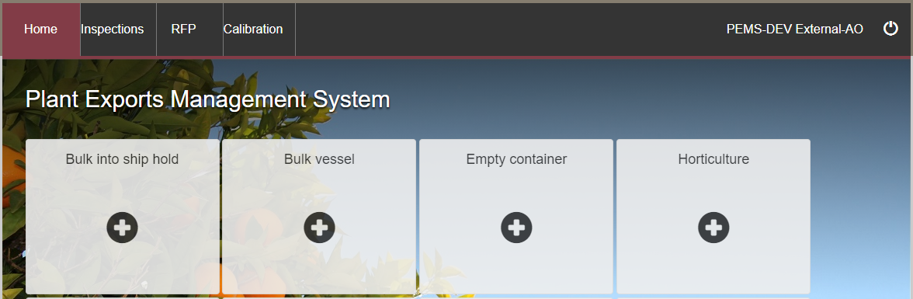

**1**

**2**

The *Create Horticulture Inspection* window will display.

Enter the **RFP number1**. The RFP number will be 7 digits long.

Enter the **Establishment number2** (only mandatory for third party AOs). The establishment number should be 3 to 4 digits long.

****Click **Create3**.

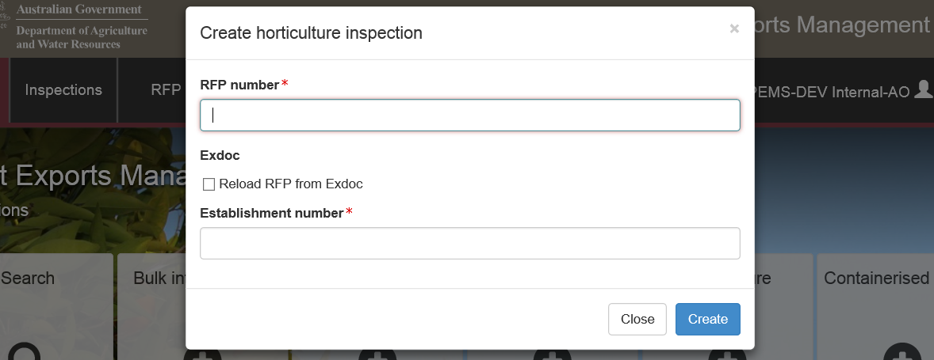

**1**

**2**

**4**

**3**

Where a change is made to the RFP in EXDOC, you can select the **Reload RFP from EXDOC4** checkbox to update the relevant RFP and inspection record in PEMS. For more information see Section 4.1 Reload RFP from EXDOC of the Reference: PEMS AO user guide – Overview and General Functions.

PEMS extracts RFP information from EXDOC to populate the *Horticulture Inspection* page. The inspection page will display by default.

****The inspection record will remain **Active1** until the record is withdrawn, submitted, or cancelled.

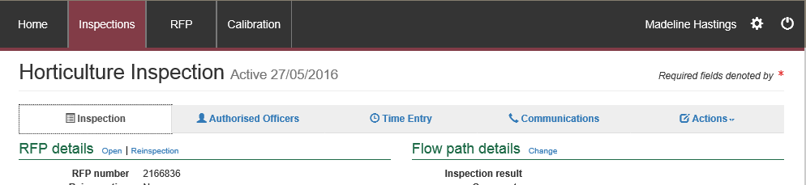

**1**

While the record is active, the date provided at the top of the horticulture inspection record is the date the inspection record was initiated.

### Horticulture Inspection page

The *Horticulture Inspection* page will display the following key sections:

* **RFP details1** **–** populated based on RFP information extracted from EXDOC.
* **Flow path details2** **–** allows you to record or change the flow path inspection result.
* **Outcome details3** **–** allows you to select the inspection sampling rate and trade description results and provides a summary of the inspection outcomes.
* **Results4** **–** where you record the inspection results.
* **Comments5** **–** where general comments, such as additional requirements for protocol markets, can be recorded, see Section 3.8 Adding comments to a record of the Reference: PEMS AO user guide – Overview and General Functions.

Step-by-step instructions on how to record or change data on this page is provided below.

**1**

**3**

**2**

**4**

**5**

### Opening the Request for Permit (RFP) details

To open the RFP details, click the **Inspection1** tab and then click **Open2** under the RFP details section.

**1**

**2**

The *Request For Permit* page will display.

The *Request For Permit* (RFP) page will display a **Summary1** of the RFP from EXDOC, as well as the **Request for permit lines2** that make up the inspection record (for more information on the **RFP tabs3** see Section 4: RFP functions in PEMS (commodity inspections) of the Reference: PEMS AO user guide – Overview and General Functions.

Click **Open4** beside any RFP line to view the details of that line.

The **Import Permits5** details will be displayed.

For departmental AOs only, click **Change6** beside *Comments* to record comments at the RFP level.

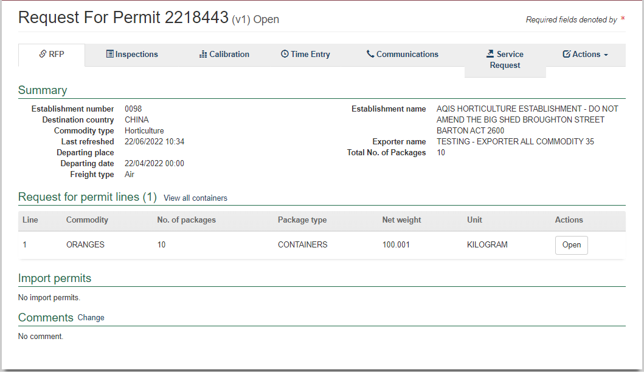

**3**

**5**

**2**

**6**

**4**

**1**

The RFP line window will display the details of the commodity line as provided on the RFP in EXDOC.

Click **Previous** and **Next1** to navigate between the RFP line windows.

Click **Close2** to exit the RFP line window at any time and return to the *Request For Permit* page.

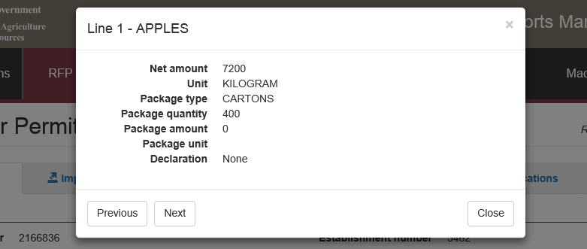

**1**

**2**

### Returning to the inspection page

To return to the *Horticulture Inspection* page, click the **Inspections1** tab. The full list of inspections relating to the RFP will display. For more information see Section 4.3: Navigating to related inspections/calibrations from the RFP of the Reference: PEMS AO user guide – Overview and General Functions.

Click **Open2** beside the ‘Active’inspection record.

**1**

**2**

The *Horticulture Inspection* page will display.

### Recording Place of Origin and Additional declaration

Place of Origin and Additional declaration (if applicable) information is to be recorded for the consignment.

To record the Place of Origin and Additional declaration for the consignment, click the **Inspection1** tab and then click **Change2** under the RFP details section.

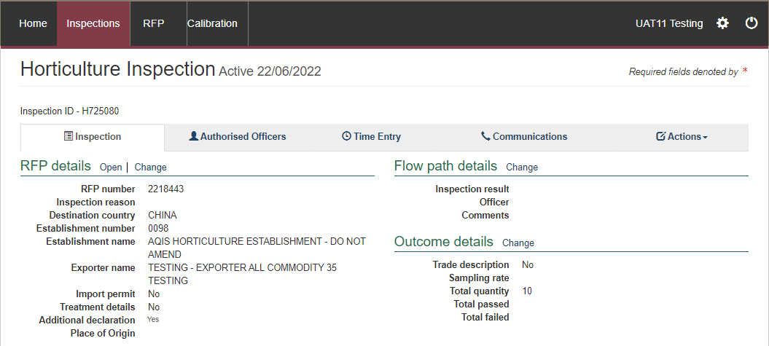

**2**

**1**

The *Change Details* window will display.

Where applicable, you must **View1** the *Link to Micor.* This will open another window and link you to the Micor case for the commodity and country. Then select the **Additional declaration Verified2** checkbox in the *Change Details* window. You will not be able to click the checkbox if you have not viewed and verified the Micor case.

Enter the **Place of Origin3** information and click **Save4.**

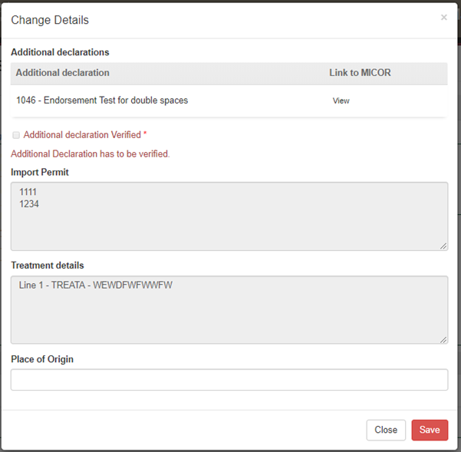

**4**

**3**

**2**

**1**

The *Horticulture Inspection* page will display the updated **Place of Origin** informationand **Additional declaration1** information.

****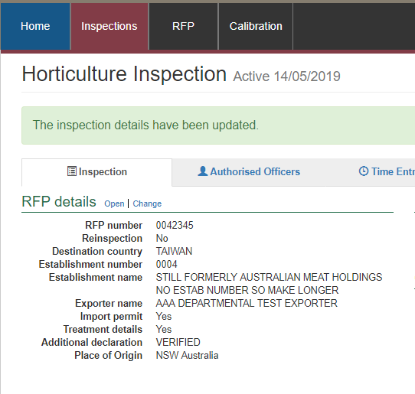

**1**

Inspection results grid will be enabled only when the additional declaration is set either to   
‘No’ or ‘Verified’ and Place of Origin information recorded.

### Edit Exporter name (*if applicable*)

There is a field length limitation of 35 characters when the exporter name is extracted into PEMS from EXDOC (system constraint). This means that in some instances the entire exporter name will not appear in PEMS. This change can no longer be made by the AO.

You must check that the exporter name that appears in the inspection record in PEMS matches the exporter name on the RFP.

If the exporter nameis not correct, you need to contact [PEMS@agriculture.gov.au](mailto:PEMS@agriculture.gov.au) to have the name corrected in the PEMS reference table. Once this is corrected you will not need to request the change again for future inspections/calibrations, as PEMS will save the corrected version of the exporter name for all future records.

If the exporter name is different due to another reason (e.g. legal change of entity name) then these changes must be made in EXDOC through the appropriate process.

### Recording reinspection of a consignment

For more information see Section 4.4 Creating inspection records where a record already exists for an RFPofReference: *Plant Exports Management System (PEMS) Authorised officer user guide – Overview and General Functions*.

### Verifying import permit details

Import permit details must be verified for the consignment. To verify the import permit details, click the **Inspection1** tab and then click **Change2** under the RFP details section.  
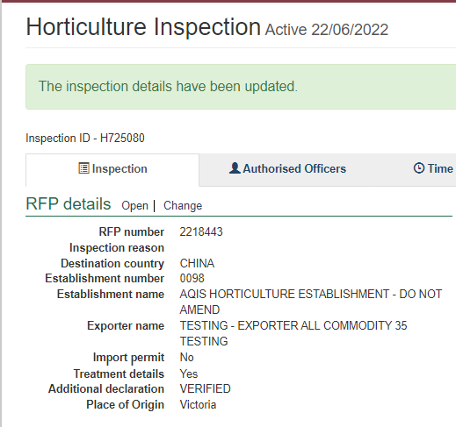

**2**

**1**

The *Change Details* window will display.

You must verify the **Import Permit1** details relevant to the consignment.

Click **Save2**.

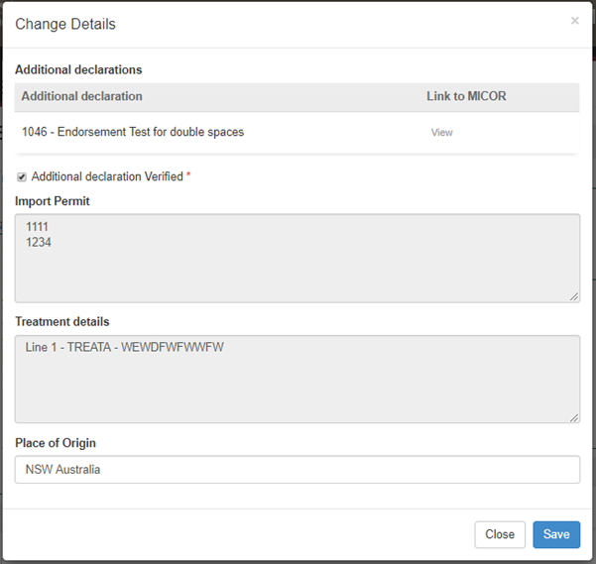

**2**

**1**

### Verifying treatment details

Treatment details must be verified for the consignment. To verify the treatment details, select the **Inspection1** tab and click **Change2** under the RFP details section.

**2**

**1**

The *Change Details* window will display.

You must verify **Treatment details1** relevant to the consignment.

Click **Save2.**

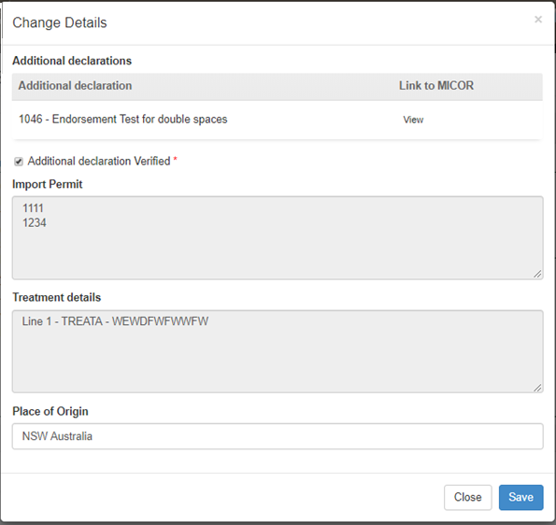

**2**

**1**

### Recording flow path inspection results

Flow path inspection results must be recorded before entering the commodity inspection results and can be changed at any time until the record is submitted, cancelled, or withdrawn.

To record flow path inspection results, click the **Inspection1** tab and then click **Change2** under the flow path details section.

**2**

**1**

The *Flow Path Details* window will display (next screenshot).

****Select a flow path **Inspection result1** of ’Passed’ or ‘Failed’. The flow path details window will expand and you must enter the **Authorised Officer2**, **Result date3** and **Result time4**.

All AOs assigned to the inspection will be available to be selected against a flow path result.

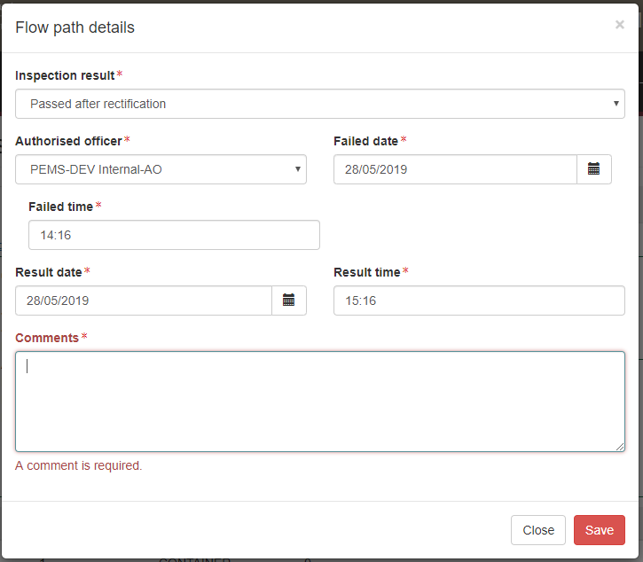

**3**

**4**

**1**

**2**

If the flow path is failed, you then have the option to change the flow path inspection result to **Passed after rectification1**, if applicable. If the flow path fails, you should not submit the inspection record. The flow path must be passed after rectification (see Section 3.3: Recording a passed after rectification flow path result of the Reference: PEMS AO User Guide – Overview and General Functions) before submitting the inspection.

If ‘Passed after rectification’ is selected, the *Flow Path Details* window will expand and you can select the **Authorised Officer2** and will show the **Failed date3** and **Failed time4** from when it was failed. You must enter a **Result date5** and **Result time6**.

If applicable, provide **Comments7** on the flow path inspection (mandatory when the flow path fails or is passed after rectification).

****Click **Save8**.

The whole consignment presented for inspection will fail if the flow path receives a ’Failed’ result. Do not continue with the commodity inspection as you will not be able to add results against RFP line.

You must enter an appropriate time entry record (see Section 3.4: Time Entry of the Reference: PEMS AO user guide – Overview and General Functions) before the inspection record is submitted on PEMS.

The flow path date/time must not be in future and must be equal to or greater than the start time/date and equal to or less than the end time/date of the inspection.

If you fail the flow path initially and then provide a ‘Passed after rectification’ result, rectification date/time must be after the flow path failed date/time.



**8**

**7**

**5**

**6**

**3**

**4**

**1**

**2**

The *Horticulture Inspection* page will display the updated flow path **Inspection result1** and PEMS will populate the name of the **Authorised Officer2** who recorded the flow path inspection results in PEMS.

**1**

**2**

### Recording trade description result

You can enter the trade description results for the inspected consignment by clicking the **Inspection1** tab and then click **Change2** under the Outcome details section.

**1**

**2**

The *Outcome Details* window will display.

The trade description result field is mandatory. Select the **Trade description matched1** checkbox and then click **Save2** (the trade description and sampling rate must be entered before saving the *Outcome Details* window).

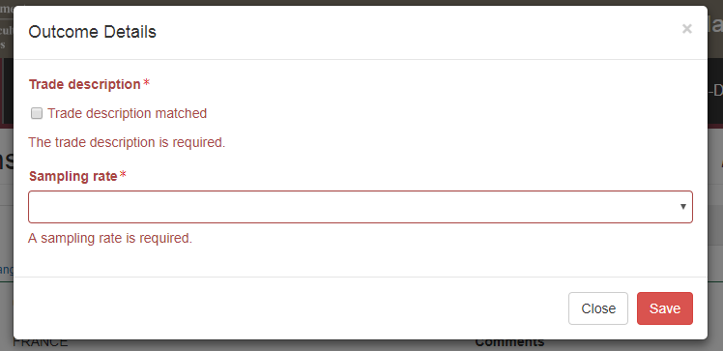

**2**

**1**

The *Horticulture Inspection* page will display the **Trade description1** result.

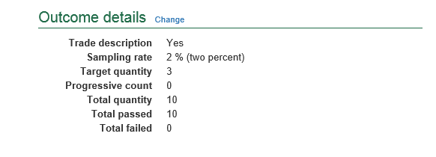

**1**

### Selecting sampling rate

To select a sampling rate for the consignment, click the **Inspection1** tab and then click **Change2** under the Outcome details section.

The *Outcome Details* window will display.

**1**

**2**

Select an appropriate **Sampling rate1** of 2% per line, 2%, 600 units, 600 units per line, or Other (for more information see below).

Click **Save2**.

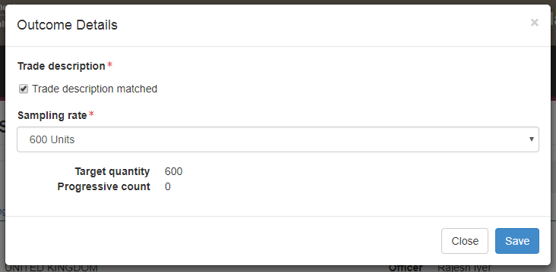

**2**

**1**

If the **Sampling rate1** is set to *Other* the *Outcome Details* window will expand.

You must specify the sampling rate used in **Sampling Description2**.

**1**

Click **Save3.**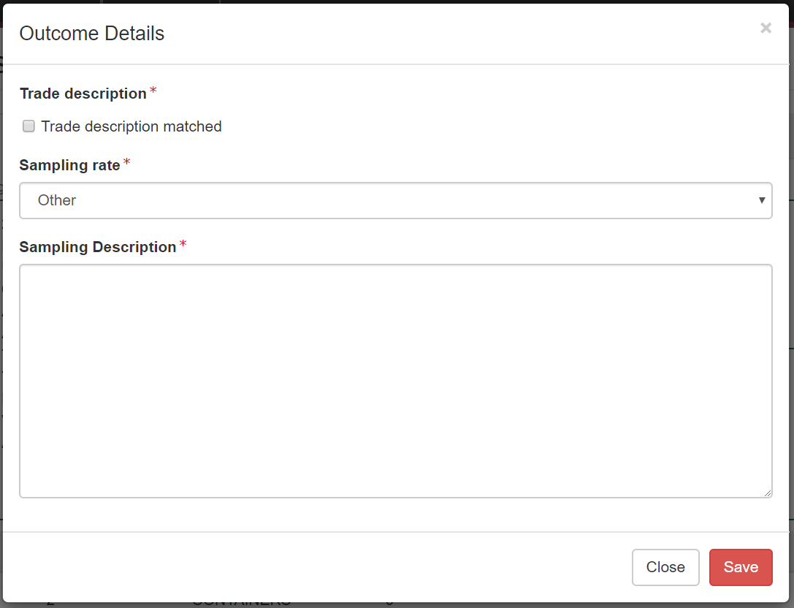

**3**

**2**

### Compliance Labelling

If there is at least one commodity on the RFP for a protocol market the **Compliance labelling verified1** checkbox will be displayed. You will have to verify compliance labelling in the *Outcome Details* window before proceeding with inspecting the consignment.

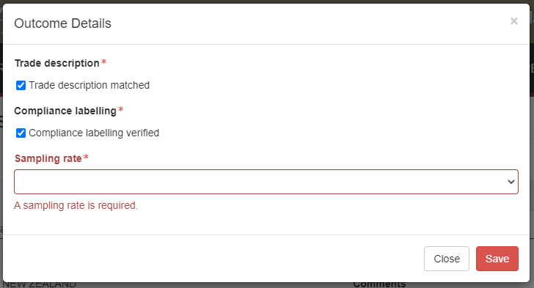

**1**

After you click save, the *Horticulture Inspection* page will display the chosen **Sampling rate1**.

Based on the sampling rate, PEMS will populate the **Target quantity2** to be inspected. As inspection results are entered, PEMS will automatically keep a **Progressive count3** of the numbers of units sampled and record the **Total** **passed** and **Total failed4** for the consignment. If **Compliance labelling5** is applicable to the record it will be indicated in this field.

****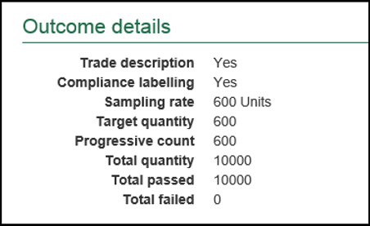

**1**

Inspection results grid will be enabled only when a sampling rate is chosen for the inspection.

**3**

**2**

**5**

**4**

****The inspection record can be submitted in PEMS when the progressive count does not meet the target quantity. However, PEMS will display a warning message and confirm that you wish to proceed with the submission where the target quantity is not met.

If the ‘Other’ sampling rate is selected you must manually enter the ‘Total passed’ and ‘Total failed’ into the inspection record, as shown in the screen shot above. ‘Total passed’ and ‘Total failed’ must be equal to the ‘Total quantity’.

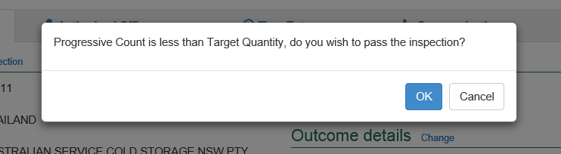**Warning message1** for 600 units or 2% sampling rates**.**

**1**

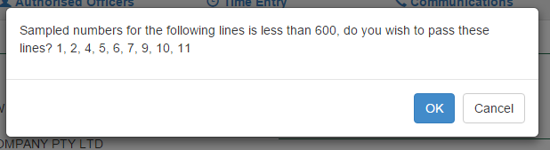**Warning message1** for per line sampling rates.

**1**

### Splitting lines on the inspection record

For *Horticulture Inspection* records, you can split the parent RFP lines of the record where key information regarding the inspected consignment is not provided on the RFP in EXDOC, or does not extract into PEMS, but is important for the traceability of goods.

RFP lines should be split where it is possible to differentiate between a unique and identifiable source of the goods for the RFP line, such as:

* grower
* lot
* packhouse.

To split lines in the inspection record, click **Split line1** beside the appropriate parent RFP line. Any parent RFP line presented for inspection can be split any number of times.

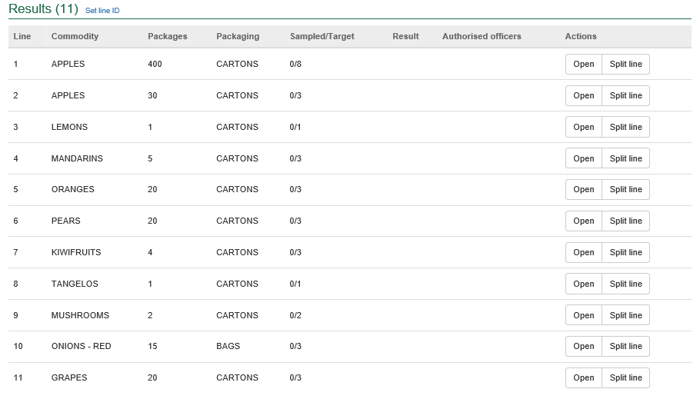

**1**

The inspection *Results* window for the new line will display (see second screenshot in the **Recording inspection results for horticulture** section below and continue to record the results for each line).

### Recording inspection results for horticulture

PEMS will provide different **sample guide columns1** to assist you with tracking the number of units sampled from each RFP line during inspection (next 3 screen shots). The sample guide provided will depend on the sampling rate you originally selected.

PEMS requires that certain inspection data is entered before an inspection record can be successfully submitted:

* CartonsCartonsFor ‘600 units per line’ and ‘2% per line’ sampling rates, an inspection result must be entered against every RFP line
* For ‘600 units’ and ‘2%’ sampling rates, an inspection result does not have to be entered against every RFP line
* For ‘Other’ sampling rates a result does not have to be entered against every RFP line.

**!** Flow path inspection results must be entered before the total passed and failed will display under the outcome details section.

To enter or change inspection results on PEMS click **Open2** beside the appropriate RFP line.

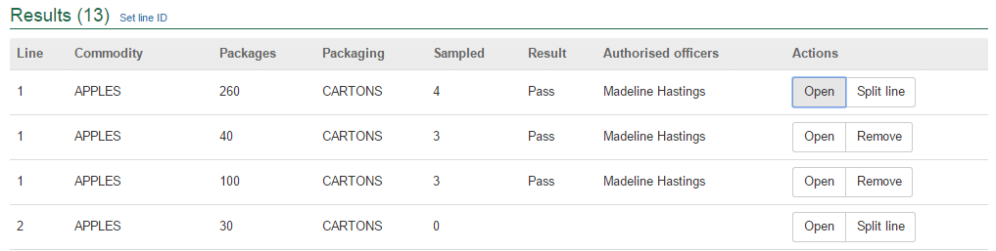

**1**

**2**



Sampling rates for 600 units per line or 2% per line:

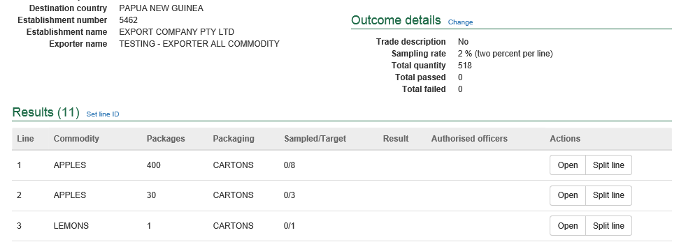

**2**

**1**

Sampling rates for 600 units or 2%:

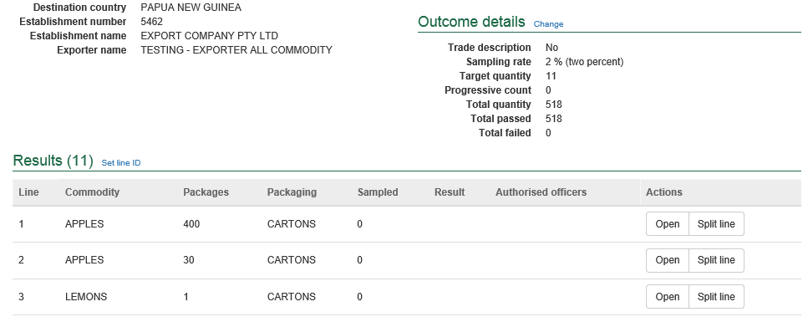

**2**

**1**

The *Inspection Result Line* window will display.

For each line inspected, the system will display the mandatory fields for the inspection:

* If applicable, enter the **Accredited Farm Block Number1** and click **Add2**. This will validate the Farm Block Number. For each new number, multiple block numbers can be added by clicking the Add button again. Enter ‘N/A’ if not applicable; for example, where the block does not require accreditation for the intended pathway. (**Refer to** any relevant protocol or workplan).
* If applicable, enter the **Accredited Packhouse Number3** and click **Add4**. This will validate the packhouse number. For each new number, multiple packhouses can be added by clicking the **Add** button again. Enter ‘N/A’ if not applicable; for example, if the commodity was not packed in a packhouse. (**Refer to** any relevant protocol or workplan).
* If applicable, enter the source of the product into the **Line ID5,**such as grower line and/or lot number.
* Enter the **Number of packages6** presented for inspection if the information is not prepopulated (where split line is used, you will need to amend the number of packages specified in the parent RFP line).
* Enter the **Sampled number7** of units during the inspection (sampled number must be entered before a result can be selected).
* Select a **Result8** of either ‘Pass’ or ‘Fail’ for the line.
* If applicable, select one or more **Remarks9** checkboxes (mandatory if the line fails the inspection).
* Select the checkbox(es) of all **Authorised officers10** who inspected the line.   
  (See Section 3.1: Assigning authorised officers (inspection records only) of the Reference: PEMS AO user guide – Overview and General Functions for more information).
* Click **Save11** to save the inspection record and exit the Inspection Result Linewindow.



Additional remarks for protocol markets must be entered into general comments.   
(See Section 3.8: Adding comments to a record of the Reference: PEMS AO user guide – Overview and General Functions).

When accredited property validation is available you must enter details in the relevant fields so the system can perform the validation. If you discover an error, you **MUST NOT** add or correct details in the comments field – this will not pass at authorisation. You must create a new inspection record to perform the validation.

Accredited property validation is not yet available for all horticulture to protocol markets – for these commodities without validation functionality you will need to record accredited property information in the Comments field.

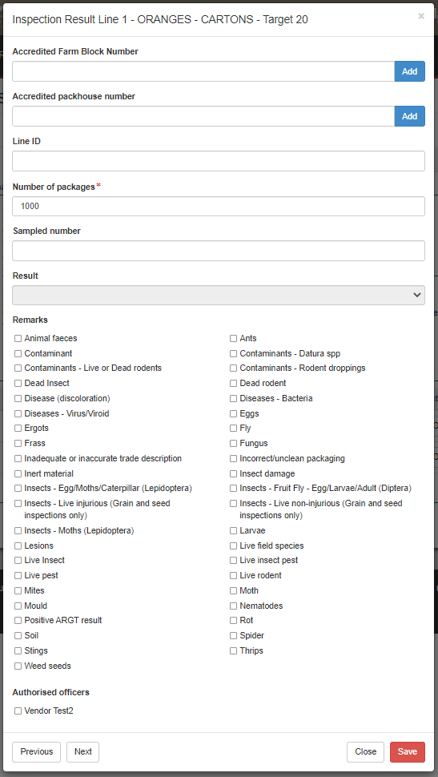

**11**

**9**

**8**

**7**

**6**

**10**

**4**

**5**

**3**

**2**

**1**

An error will appear if the incorrect accredited farm block number or accredited packhouse number is being added to the inspection record. This will not allow the inspection result to save.

To resolve this, contact the exporter to confirm the accredited farm block or packhouse numbers are correct. If errors continue with the correct information, contact the PEMS Administrator.

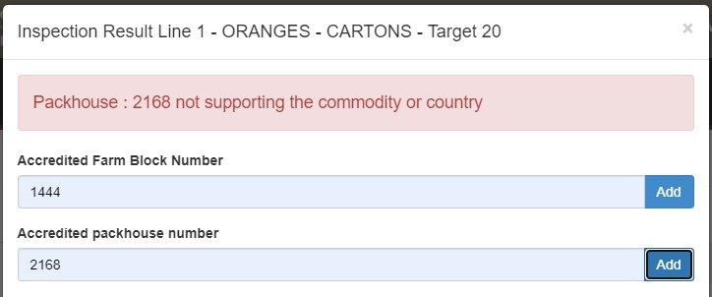

Once the inspection result is saved, the *Horticulture Inspection* page will display the **new split lines1**. You can **Remove2** the split line(s) up until the inspection is submitted, withdrawn, or cancelled.

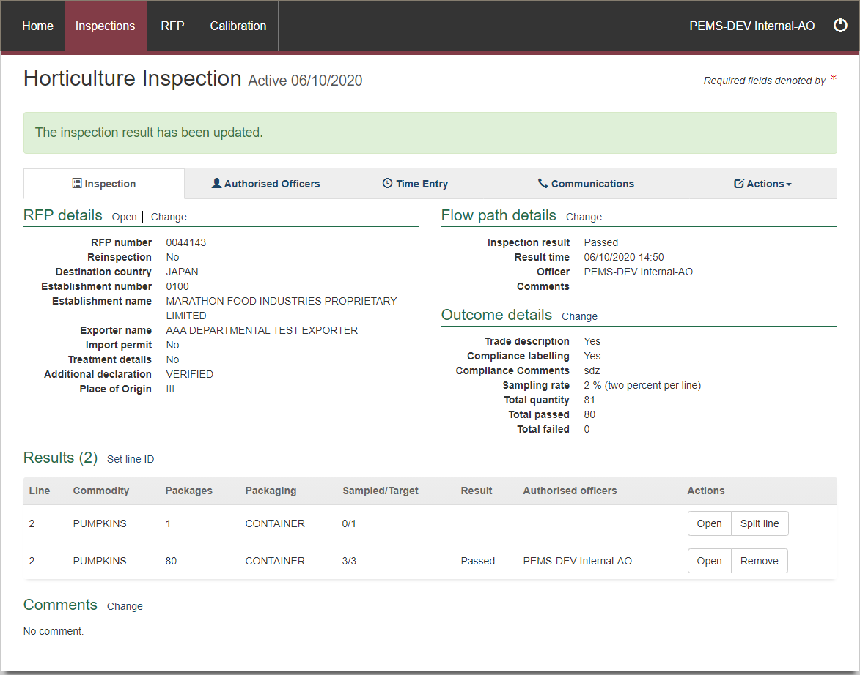

**1**

**2**

### New Zealand Inspector details (if applicable)

When the destination country is New Zealand, the Inspection Result will ask for the **Inspector Details1**. Enter the name of the inspector in this section.

****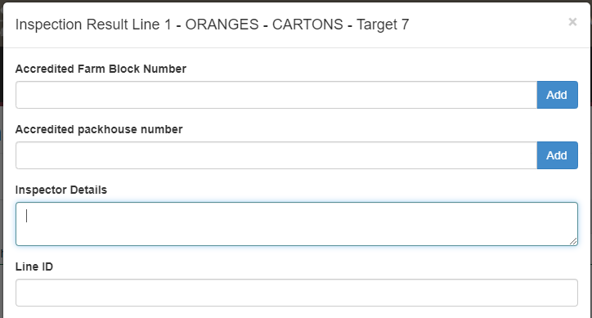

**1**

The **Inspector Details** is a free text box and the information entered in this section will appear on the Horticulture Inspection report under Compliance Comments.

### Fumigation required (for Citrus only)

When entering an Accredited Farm Block Number, it may trigger a warning that states **Fumigation Required**1.

If fumigation is required, you will not be able to submit the inspection until a treatment certificate has been attached to the inpection record. For more information on how to add this certificate see Section 3.5: Communications – attaching files to a record of the Reference: PEMS AO user guide – Overview and General Functions.

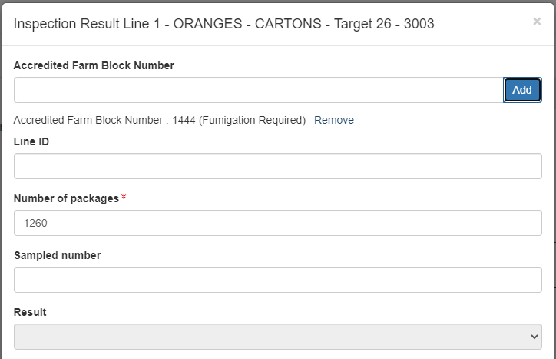

**1**

### 10% calyces lift (for Citrus protocol markets only)

When it is a citrus protocol market this will trigger the **10% calyces lifted1** tick box to appear.

This is a mandatory tick box, and the record cannot be completed without this declaration.

**1**

### Pest Concern

When applicable, the remark/s selected in the *Inspection Result* section, may trigger a pest concern for potential fruit fly contamination. The **Pest Concern** section will appear.

You must select **Change1** to update the information.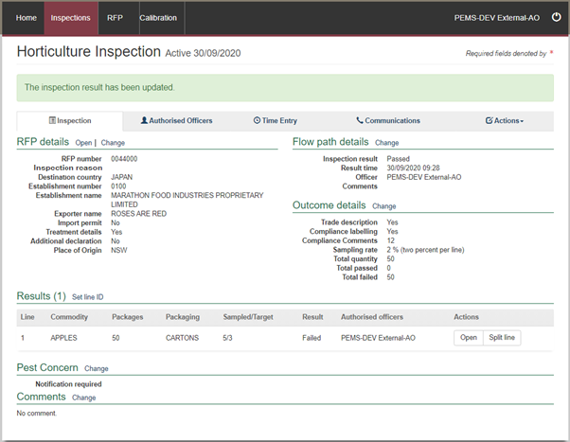

**1**

Depending on the remark and/or market, one of the *Pest Notification Details* windows will appear.

Select the **relevant answer 1** within the window, then click **Save2**.

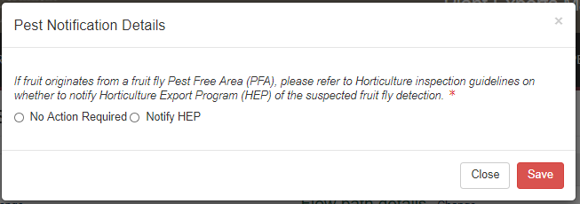

**2**

**1**

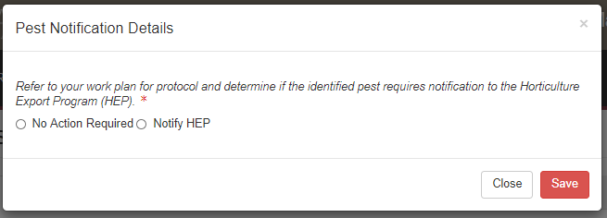

**2**

**1**

When **Notify HEP** is selected, the system will automatically generate an email to advise the program of the pest concern.

### Setting the line ID for the inspection results

Where the line ID for all RFP lines for the consignment will be same, you can set the line ID across all the RFP lines. Click **Set line ID1.**

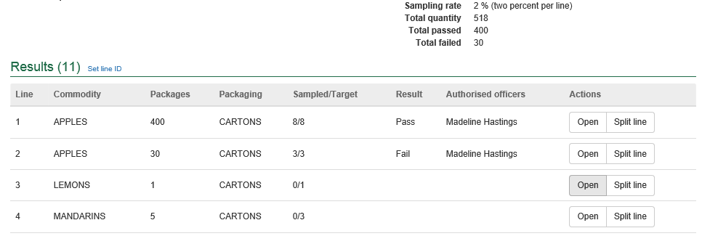

**1**

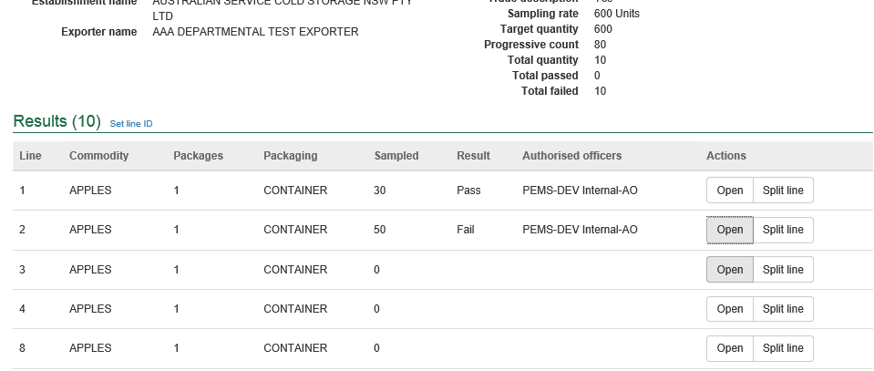

The *Line ID* window will display.

Enter the appropriate **Line ID1**. Click **Save2.**

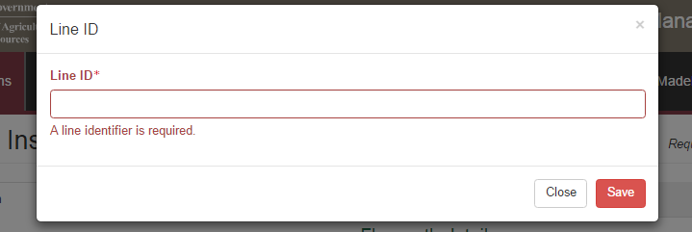

**1**

**2**

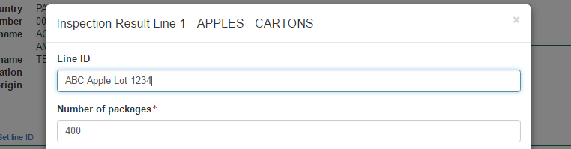The *Line ID* will display in the *Inspection Result Line* window for each RFP line.

### Navigating between line inspection windows

You can navigate between the line inspection windows by clicking **Previous** or **Next1** at the bottom of the window. The inspection result for each line will automatically save when you navigate between windows in this manner.

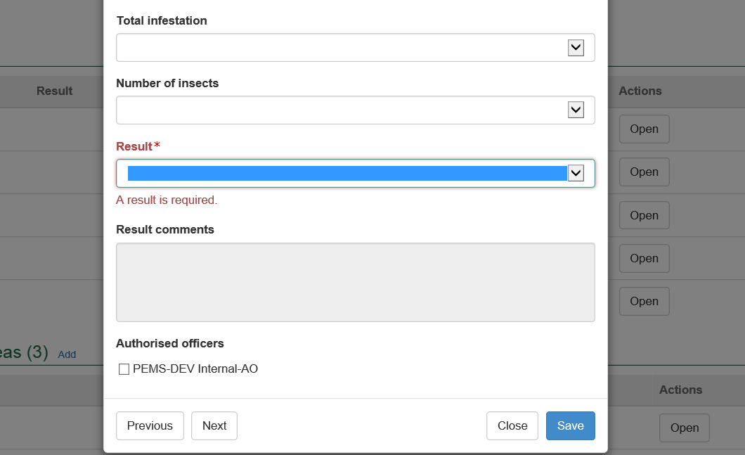

**1**

**Completing and submitting the inspection record**

The inspection record can only be submitted in PEMS after:

* all inspection results and data are recorded appropriately, unless the flow path failed inspection
* a **Time Entry1** is provided for all AOs who recorded inspection results
* if applicable, attachments and correspondence relating to the inspection are added under the **Communications2** tab.

Details on the Time Entry and Communications tabs can be found in Section 3: General PEMS functions of the Reference: PEMS AO user guide – Overview and General Functions.

When you are ready to submit the inspection record, click the **Actions3**tab and then click **Submit4**.

****For more information on **Downloading**, **Cancelling** or **Withdrawing5** the inspection, see Section 3.6: Actions tab of the Reference: PEMS AO user guide – Overview and General Functions.

Once the inspection record is submitted, the record will become read-only, and you will be unable to make changes to the data provided. If you need to make changes to the record, see Section 3.6: Actions tab – Reactivating a completed record of the Reference: PEMS AO user guide – Overview and General Functions.

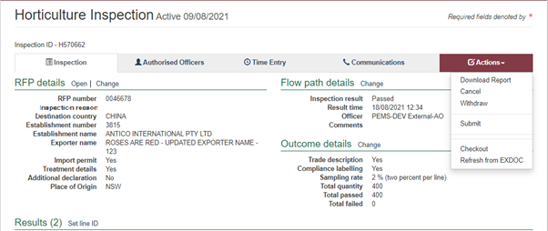

**3**

**5**

**4**

**2**

**1**

A pop-up window will ask you to confirm that you want to **submit the inspection1**.

It will also ask if you want to **email the exporter/EDI user on the submission of the inspection2.** When selecting this option, the Inspection submit confirmation box will expand.

Enter the **email address3**, this can be multiple email addresses each separated by a comma.

Enter in any **Comments4** that are to be included in the email.

Click **Save5**.

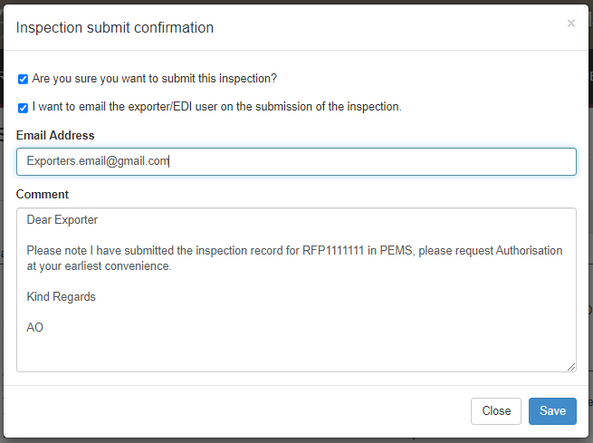

**5**

**4**

**3**

**2**

**1**

The *Horticulture Inspection* record status will display as **Completed1**.

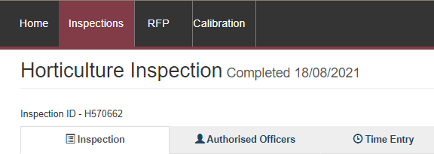

**1**

### Expiration date for horticulture inspection

Following the submission of the *Horticulture Inspection* record, an expiry date will be allocated to the goods which have passed assessment. The expiry date is automatically calculated as 28 days from the first date of the first-time entry.

To view the expiration date, click the **Inspection1** tab and the **Expiry date2** will display under the Inspection validity section.

If the horticulture consignment expiry date is extended, you can view the reason for the expiry date extension by clicking **History3** under the Inspection validity section.

**1**

**3**

**2**

The *Expiry History* window will display.

****Click **Close1** to exit the window.

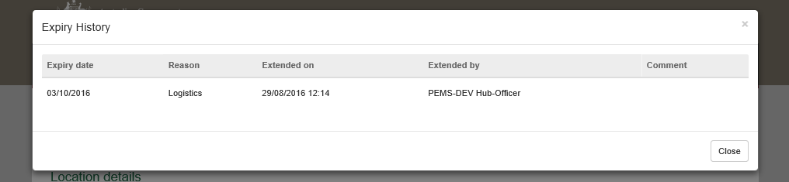

**1**

The date(s) specified on the completed inspection record will be the start date and end date for the inspection. The inspection record date corresponds with the earliest and latest time entry across all AOs for the inspection.

## Related material

The following related material is available on the [website](http://iml.agdaff.gov.au/Draft/General/agriculture.gov.au):

* Manual of Importing Country Requirements ([Micor)](http://micor.agriculture.gov.au/Plants/Pages/Documents.aspx)
* Protocols and Work Plans
* [Plant Export Operations Manual](http://www.agriculture.gov.au/export/controlled-goods/plants-plant-products/plantexportsmanual)
* Reference: PEMS AO user guide – Overview and General Functions
  + *Empty container inspections*
  + *Grain and Plant Product inspections*
  + *Bulk vessel inspections*
  + *Bulk into ship hold inspections*
  + *Quality systems recognition inspection*
  + *In-transit cold treatment calibration records*
* The following related material is available on [Learnhub](https://learnhub.ssc.gov.au/login/):
* Plant Export Management System (PEMS) video tutorials

## Contact information

* Authorised Officer Hotline: 1800 851 305
* Authorised Officer Program: PlantExportTraining@agriculture.gov.au
* PEMS Administration: [PEMS@agriculture.gov.au](mailto:PEMS@awe.gov.au)

## Document information

The following table contains administrative metadata.

| Instructional Material Library document ID | Instructional material owner |
| --- | --- |
| IMLS-9-7599 | Director, Change Management, Digital Clearance Service, Digital Trade Initiative |

## Version history

The following table details the published date and amendment details for this document.

| Version | Date | Amendment details |
| --- | --- | --- |
| 1.0 | 08/07/2016 | New user guide. |
| 1.1 | 12/07/2016 | Minor variations for accuracy and clarity. |
| 2.0 | 30/09/2016 | * Complete document restructure. * Addition of sections on: * Logging into PEMS * Calibration records * Calibration search. |
| 2.1 | 16/12/2016 | * Minor variations for accuracy and clarity * Removal of Appendix F – Calibrations and loading * Removal of Section 2.3 – Calibration search |
| 3.0 | 09/10/2018 | AO user guide updated with PEMS v2.1 enhancements. |
| 4.0 | 23/05/2019 | AO user guide updated with PEMS v3.1 and v3.2 enhancements. |
| 5.0 | 4/11/2019 | Updated with PEMS v.3.3 and 3.4 enhancements. |
| 6.0 | 3/06/2020 | Updated with PEMS 3.5 enhancements. |
| 7.0 | 28/08/2020 | Removal of appendices from Plant Exports Management System (PEMS) Authorised Officer user guide to make each its own user guide. |
| 8.0 | 30/10/2020 | Update with PEMS v3.8 enhancements |
| 9.0 | 28/03/2021 | Updated for commencement of the *Export Control Act 2020* and associated Plant Rules. |
| 10 | 5/07/2021 | Updated ‘edit exporter name’ section of the user guide and removed CGI references in line with the July 2021 release of PEMS |
| 12 | 13/09/2021 | PEMS September 2021 update   * Accredited properties joined the guide * Email notification on submission. |
| 13 | 16/03/2022 | Updated to provide clarity around when accredited property information is required. |
| 14 | 04/04/2022 | Updated with PEMS April 2022 release |
| 15 | 25/07/2022 | Updated with PEMS June 2022 release |