What’s New, What’s Different: Quick Reference Guide

Updates to PEMS on 11 October 2025
As part of the 11 October 2025 release there were 2 critical enhancements to PEMS to improve compliance, data integrity and privacy protection.
Feature 1: Empty container validity check
PEMS has been updated to allow users to verify container history and ensure that valid empty container inspections are recorded before submitting goods inspection records. Third party authorised officers (AOs) and Establishment/Exporters/EDI users will now be able to search for a valid empty container inspection. This enhancement addresses recurring compliance issues and reduces the risk of costly export returns caused by missing inspection data. Additionally, it introduces safeguards to prevent manipulation of inspection details across duplicate Request for Permits (RFPs), thereby strengthening data integrity and supporting regulatory compliance.
Feature 2: Privacy of treatment records
PEMS has been enhanced to restrict visibility of all treatment types, calibration records for third party AOs. The updated functionality ensures:
- Access Control: Each AO can now only view calibration batches associated with their own establishment profile.
- Privacy Compliance: This change aligns with privacy regulations, safeguarding sensitive data from unauthorised access.
- Controlled Collaboration: The ability to ‘Join’ another AO’s calibration record remains available but is now governed by permission-based parameters that validate the AO’s authorisation to access the record.
This update strengthens data confidentiality, mitigates commercial risk, and ensures compliance with the Privacy Act 1988, while still supporting collaborative workflows under controlled conditions.
Below is the current state and future state view for the 2 features went live on the 11 October 2025.
Current | Changes
Feature 1: Empty container inspection validity check
Third party AOs could submit goods inspection records without verifying whether valid empty container inspections were recorded, leading to compliance issues and costly export returns.  Third party AOs were able to search an ‘Empty Container inspection’ using the Inspection tab within PEMS. However, the process was not straightforward for the AOs to determine whether an empty container had a valid inspection.  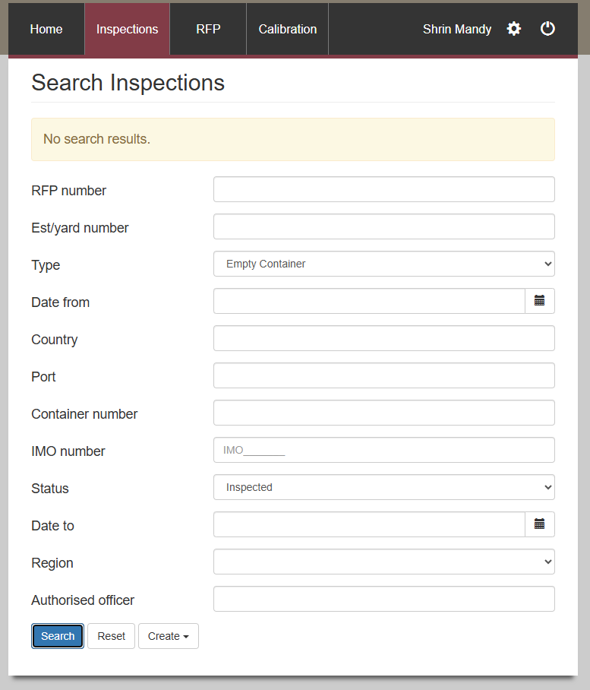  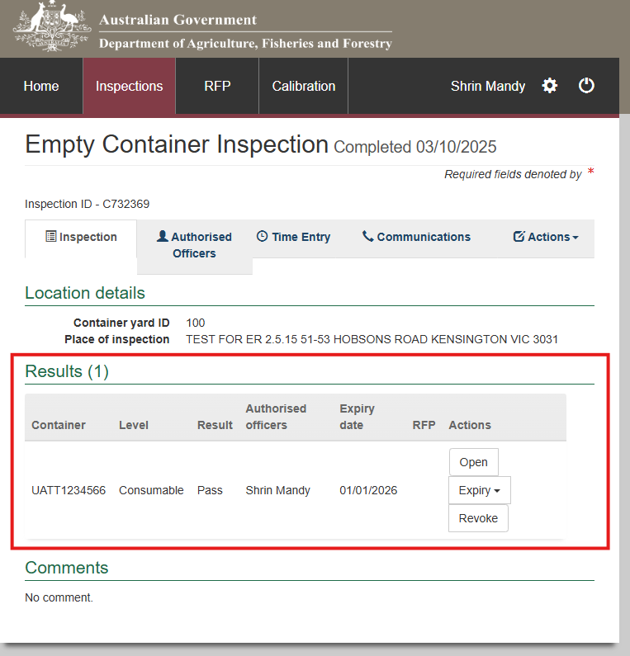 | Appointed AOs with at least one 'Grain' job function, as well as Establishment, EDI, and Exporter Executives with PEMS access, can now perform a search to verify container history and confirm valid empty container inspections before submitting goods inspection records.  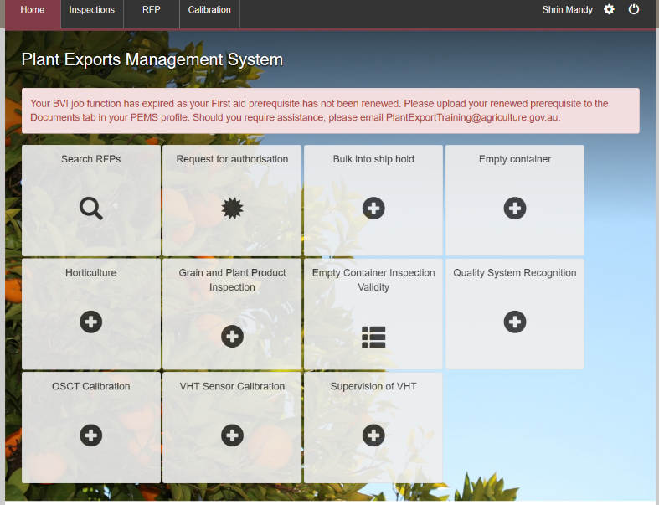  There is a separate tile on the PEMS home screen that allows the above listed user roles to easily access the Empty Container Validity Check tile where PEMS requests the user to enter a valid container number in the search field.  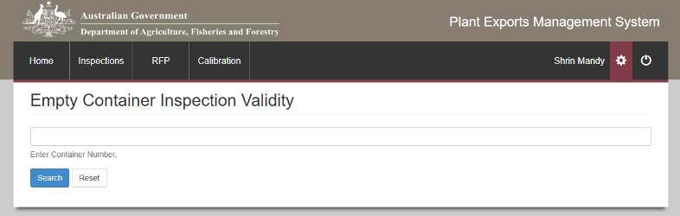  We have defined the criteria for a valid Empty Container Inspection as  - The inspection result is marked as 'Pass'.  - The expiry date is in the future.  - There are NO failed inspections with a start date later than any other previous passed inspection.  The result will extract the below data from the inspection record and display in the search result.  - Container (container number)  - Seal number  - Level (Consumable or Non-Consumable)  - Result (Pass)  - Inspection Date  - Expiry date  It will ONLY display one result that matches the validation rules that define the criteria for a ‘valid’ Empty Container Inspection.  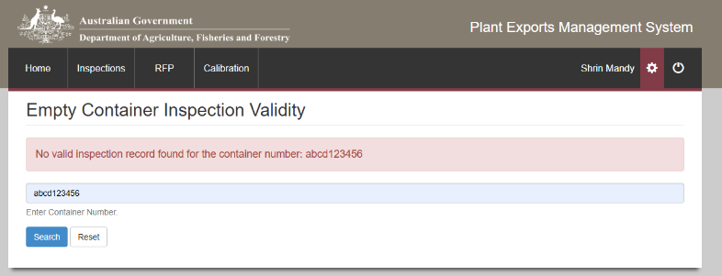  If an incorrect container number is entered, PEMS will display an error message or “No valid inspection record found for the container number: container#”.  This ensures inspection data is complete and prevents manipulation across duplicate RFPs.

Feature 2: Privacy of treatment records
Third party AOs can view and join calibration records from other establishments via the calibration tab in PEMS, creating a risk of commercial misuse and potential breaches of the Privacy Act 1988.  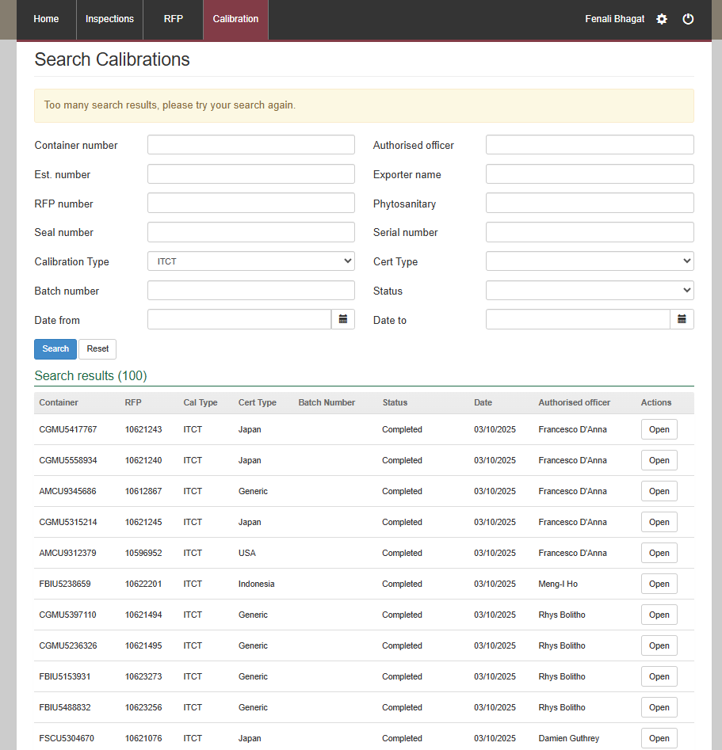  The ‘Join’ button is currently linked to the calibration record in the search results list.  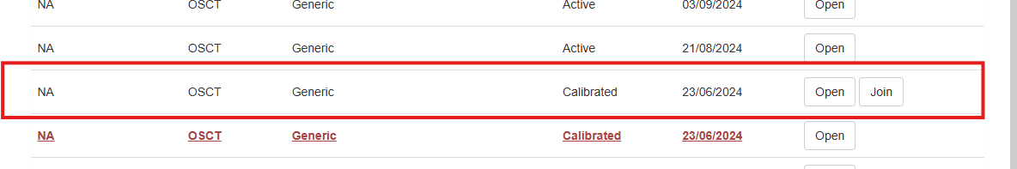 | Third party AOs are now restricted to viewing only calibration batches (within the Calibration tab) associated with their own user profile. The system enforces access controls to ensure sensitive treatment data remains confidential. The search function remains the same however, the search result list will only display calibration records initiated by the logged-in third party AO.  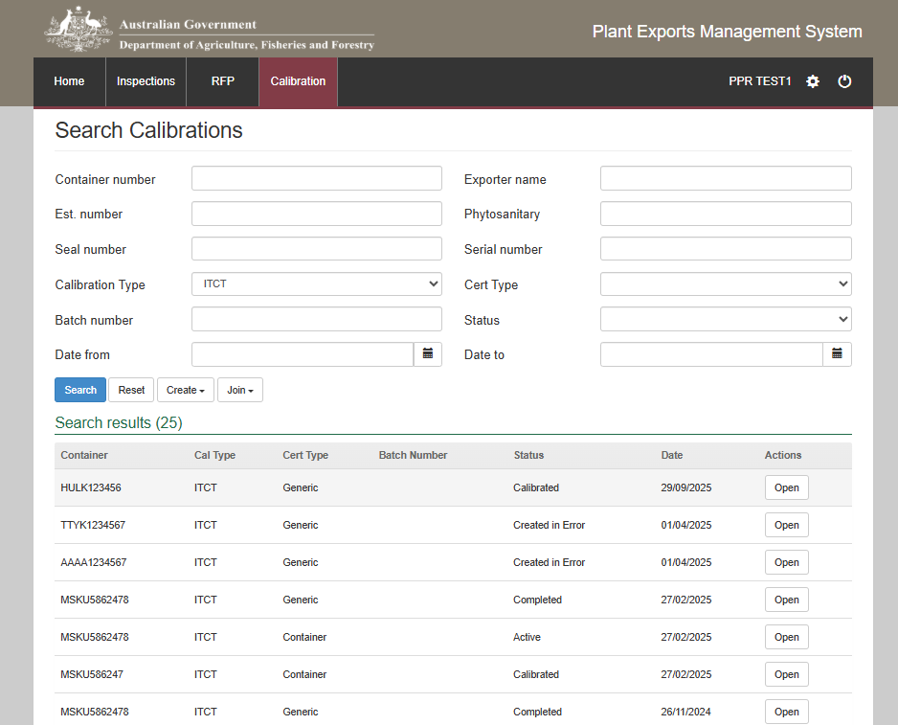  The ‘Join’ functionality for calibration records remains available to support collaborative workflows; to allow AOs to join other AOs records however, it is now governed by permission-based validation to confirm the AO’s authorisation to access the record with a new ‘Join’ button dropdown introduced to allow third party AOs to join other third party AO’s treatment records.  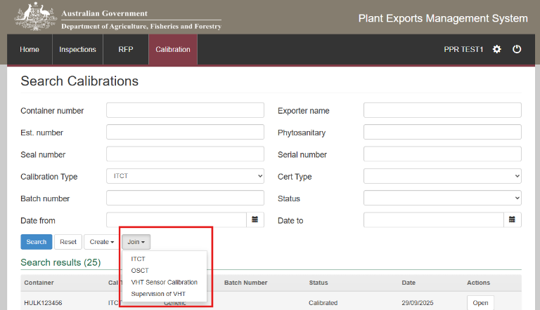  The ‘Join’ button dropdown will follow the same logic/rules as the ‘Create’ button dropdown to display the treatment types that the third party AO is competent for.  PEMS will ensure that third party AOs can only join the treatment type they initially select when clicking 'Join'. For example, if an AO selects ITCT, only ITCT-specific record details should be permitted. Any attempt to enter details for a different treatment type must trigger an error message upload clicking 'Join'.  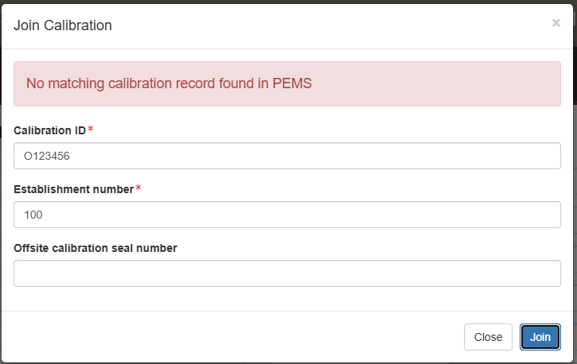  We have introduced a new field, ‘Calibration ID’, which will be used for all treatment types to locate the appropriate calibration record to allow the third party AO to join.  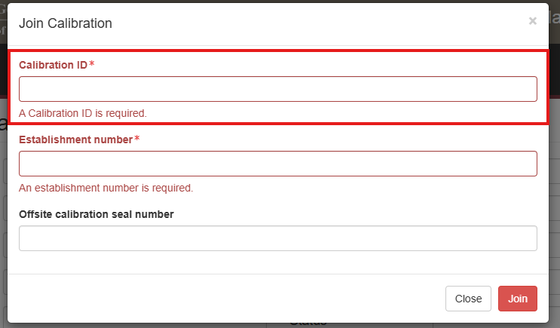  The third party AO wanting to join another AO’s calibration record must have the Calibration ID and other relevant information to ‘Join’ another AOs calibration record. This needs to happen through a manual comms channel.  ITCT:  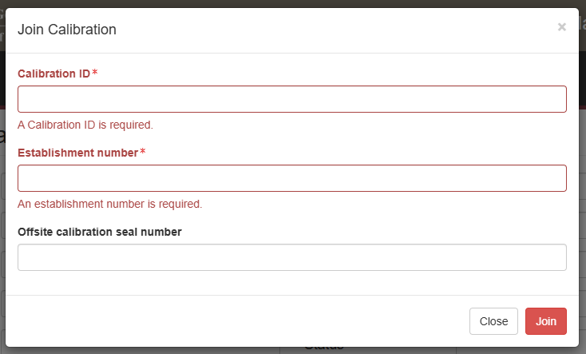  OSCT:  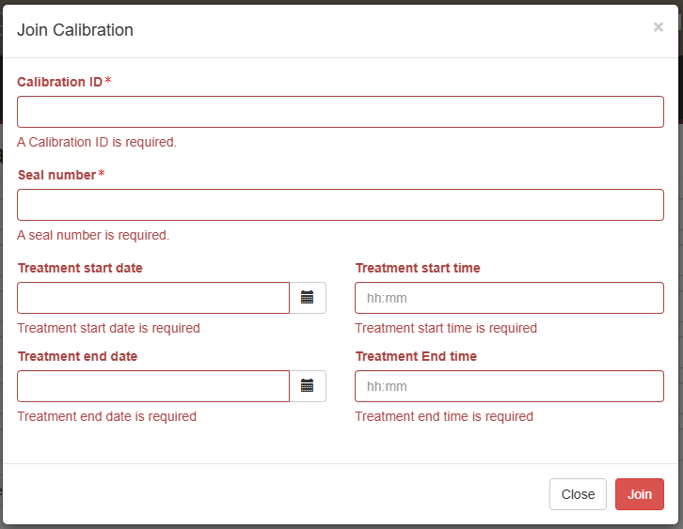  VHT Sensor Calibration:  Supervision of VHT:  For ITCT Records, where seal number is required, PEMS will throw an error message to request the third party AO to enter the seal number, upon clicking ‘Join’.  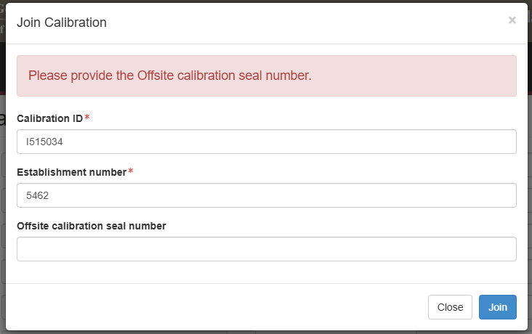  All other user roles, for example, AO Admin, Internal AO, Establishment Executive will remain the same. The functionality is ONLY introduced for third party AOs.

