# Australian Government Department of the Environment and Energy logo

# PEOPLE STRATEGY 2018-22

We support a healthy environment, strong economy and thriving community for all Australians by fostering productive relationships and collaborating on policy, program and regulation. Our workforce is rapidly changing and so is the Australian Public Service. How we add public value and how we deliver positive outcomes continues to evolve. How we do our work, how we interact with technology and data, and how we collaborate with government, communities, business and the public will be our greatest challenge and our greatest opportunity.

To support our workforce for the future, we will deliver a range of initiatives under the following four pillars.

|  |  |  |  |
| --- | --- | --- | --- |
| Small icon of a tree Nurture and Grow our Skills | Small icon of a group of people Cultivate Leadership | Small icon of different coloured triangles Embrace the benefits of diversity | Small icon of an apple Facilitate safe and healthy workplaces |
| We will invest in our people. Our core competencies, critical and specialist skills will be understood, recognised and developed.  We will identify, attract and build the skills we need now and into the future. We will provide opportunities to develop the knowledge and experiences our people need to successfully contribute to the evolving responsibilities of the Department. | We expect our leaders to be influential, inclusive, respectful, accountable, innovative and collaborative. They will communicate our purpose and provide regular feedback on progress toward our goals.  While leadership should occur across all levels in the Department, we will build the capability and empower our Executive Level staff to balance support for our people while delivering our outcomes.  Our leaders will actively manage risk, recognise and reward innovation and engage in conversations that drive high performance and support self-reflection for improvement and development. | We are committed to attracting and celebrating people from all backgrounds and we will continue to strengthen our inclusive and supportive environment.  We recognise the importance of diversity and openly value the different skills, knowledge and perspectives our people bring with them.  We understand and appreciate our unique work locations and their respective cultures. We will work collaboratively to find ways to better connect our cultures across our regional and central offices. | We are committed to ensuring the health and safety of our people and the people who our work directly affects. Our work spans contrasting locations and environments and we will take a risk-based approach when conducting our business.  We will have a strong focus on psychological health to increase overall resilience, health and wellbeing in our workforce. We will support our people by promoting healthy workplaces, behaviours and attitudes. |

THE INVOLVEMENT AND ENGAGEMENT OF ABORIGINAL AND TORRES STRAIT ISLANDER PEOPLES IS DEEPLY IMPORTANT TO OUR DEPARTMENT. WE ACKNOWLEDGE THE IMPORTANT PERSPECTIVE ABORIGINAL AND TORRES STRAIT ISLANDER PEOPLES BRING TO OUR WORK AND CELEBRATE THE ROLE THEY PLAY AS KEY PARTNERS IN ACHIEVING OUR OUTCOMES.

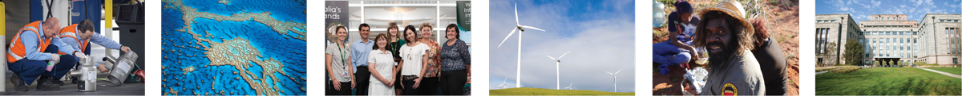

## Our Future Workforce Will Be

* Influential and collaborative across all levels of leadership
* Productive, innovative, engaged and willing to embrace change
* Supported to work in flexible ways both individually and structurally
* Inclusive of diversity in skills, knowledge and perspectives
* Built on individual and team capability through career and talent management
* Supportive of safe and healthy workplaces, practices and behaviours

# Australian Government Department of the Environment and Energy logo

# PEOPLE STRATEGY 2018-22

To prepare you for the future workforce requirements we will leverage the unique expertise you bring to the organisation and provide you with the skills and experiences you need to fulfil your career with the Department.

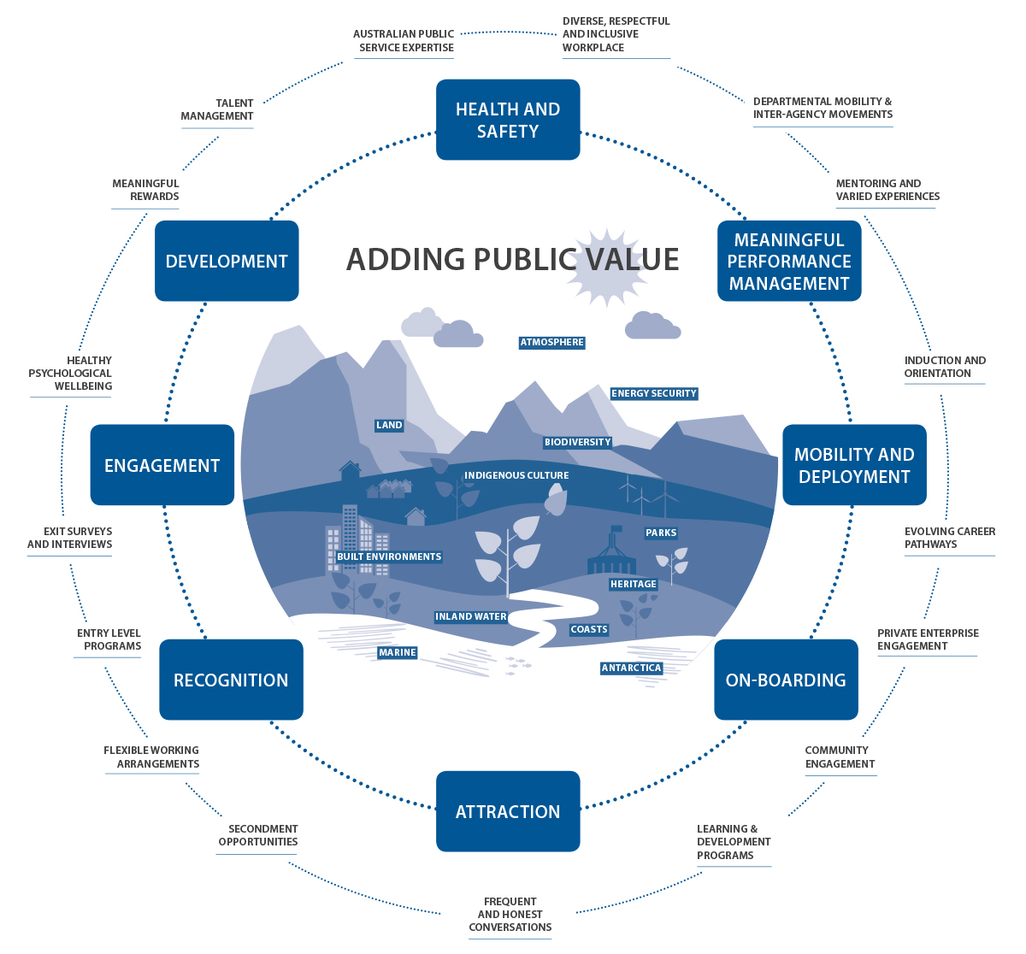

|  |  |
| --- | --- |
| AS AN EMPLOYER WE WILL | AS AN EMPLOYEE YOU WILL |
| Promote and encourage flexible working opportunities that balance operational and individual needs | Uphold the APS values and promote integrity through personal example |
| Ensure we have the capabilities for the Department’s future priorities by providing a Strategic Workforce Plan to implement people and workforce development strategies | Treat your colleagues respectfully and courteously |
| Value the balance between your expertise and breadth of experience and provide mobility opportunities | Be empowered to make decisions whilst actively engaging with risk |
| Provide a safe and healthy workplace with a strong focus on wellbeing | Be able to broaden your skills through mobility opportunities across the Department and wider industries |
| Support a diverse workforce across all our locations who feel respected, encouraged and included | Have opportunities to develop your capabilities to meet future departmental needs |
| Ensure you understand what is expected of you and know when you are performing well by having productive and frequent conversations | Have regular opportunities to discuss your performance and know what your role expectations are |
| Provide meaningful rewards and recognition for high performance | Have the opportunity to build your leadership skills regardless of your level or role |
| Ensure our leaders can anticipate and prepare for changes and are able to respond quickly | Be supported to look for appropriate opportunities to do things differently and be willing to embrace innovation and change |
| Provide targeted learning and development opportunities and invest in growing the skills we need now and into the future | Be respected and valued and promote an inclusive and supportive workplace |
| Reward collaboration across the Department and provide opportunities to enhance skills and experiences | Have access to a safe workplace and take responsibility for healthy attitudes and behaviours |
| Ensure there are systems and frameworks in place to support our leaders to make decisions and engage with risks | Have the opportunity to interact with digital transformation |
| Quickly form response teams by drawing on the diversity of skills and expertise to meet emerging priorities | Be involved in knowledge sharing and collaboration and be committed to continuous improvement in the way we work |
|  | Be willing to engage with workforce initiatives and be committed to self development |