Performance framework 2019–20


Introduction
This framework describes the department’s arrangements to comply with the Public Governance, Performance and Accountability (PGPA) Act 2013, which requires all Commonwealth entities to measure and assess their performance in achieving their purposes and objectives. This includes implementing the requirements of the enhanced Commonwealth performance framework relating to corporate plans, annual reports and annual performance statements.

Corporate planning
The corporate planning and reporting framework begins with the documents that set the department’s strategic direction—the corporate plan and the Portfolio Budget Statements. It continues through the use of high-level business and enabling strategies—for example, the People Strategy, Finance Strategy and ICT Strategy—that support business as usual, and specific major programs and projects, such as the Agricultural Competitiveness White Paper.
These inform each division’s business plans, which provide a line-of-sight through branch and section operations to link to individual work plans (Figure 1).
The corporate plan and the portfolio budget statements provide the basis for the department’s external performance reporting, through the annual report and the annual performance statements. The division business plans are the basis for internal reporting through twice-yearly performance reviews by the Executive Management Committee.
Figure 1 Corporate planning and reporting framework
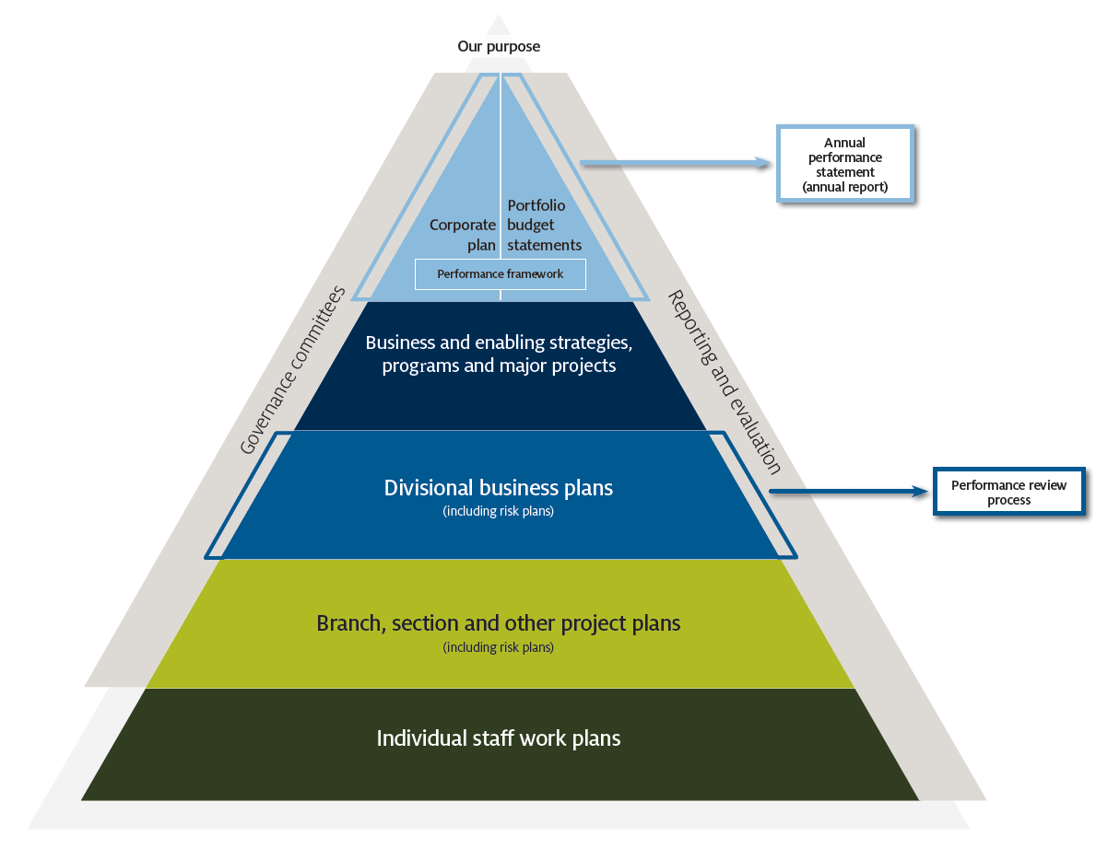
Enhanced Commonwealth performance framework
The department’s obligations under the enhanced Commonwealth performance framework (Figure 2) include:
- publishing a corporate plan each year, setting out its purpose, operating environment and how the department will measure its performance over four years (section 16E, PGPA Rule)
- including high-level performance information in the portfolio budget statements (Finance Secretary: ‘Direction on requirements for performance information in Portfolio Budget Statements’)
- preparing an annual report each year, incorporating the annual performance statements (sections 39 and 46, PGPA Rule).
Figure 2 Enhanced Commonwealth performance framework
Source: Resource Management Guide 130: Overview of the enhanced Commonwealth performance framework, Department of Finance, 2019

Governance
The Secretary is the accountable authority, responsible for meeting our obligations under the PGPA Act.
The First Assistant Secretary Corporate Strategy and Governance is responsible for this performance framework. The Assistant Secretary Planning and Governance oversees arrangements for managing the framework and preparing the corporate plan, the annual report and annual performance statements.
The Chief Finance Officer is responsible for the portfolio budget statements, the other key document in the performance framework.
The Audit Committee reviews and provides independent advice to the Secretary about the appropriateness of the department’s performance reporting arrangements.

Performance measurement
Our strategic framework (Figure 3) states our purpose and three broad-based objectives, with a focus on managing risks. It also sets out the functions we carry out to achieve our purpose.
Figure 3 Department of Agriculture strategic framework
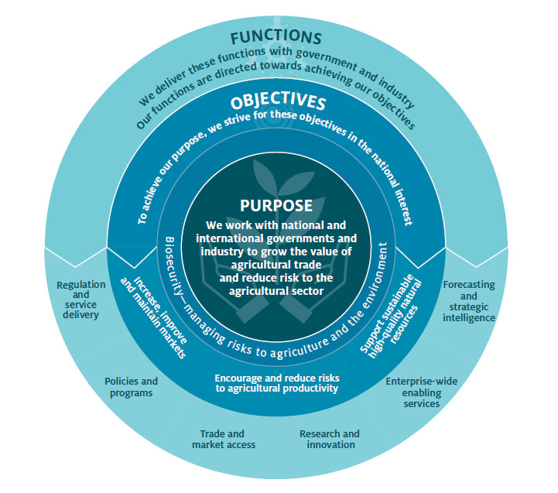
Our strategic objectives are measured by high-level performance criteria that assess the state of the agriculture sector in relation to markets, productivity and resources. These criteria are published in the Corporate Plan 2019–20 and the Portfolio Budget Statements 2019–20.
Most of our performance criteria are aligned to our functions, to measure the way in which we work. These criteria are published in the corporate plan. The results against all criteria are reported in the annual performance statements.

Performance criteria 2018–19

Our objectives

Objective 1: Increase, improve and maintain markets
Criterion Ob1 | The trend in value of agricultural exports increases in real terms over time
Measure | The real value of agricultural commodity exports (adjusted for inflation) exceeds the average real value of the previous 10 years
Method | Ten-year average is based on ABARES and Australian Bureau of Statistics data and is reported in real (2018–19 constant dollar) terms. Matters outside the control of the department, which affect production and currency movements, also influence export volumes and value.  Agricultural commodity exports broadly cover farm-based agricultural commodities (such as crops, livestock, wool and horticulture) and processed agricultural products (such as meat, dairy products, beverages—including wine and spirits—and processed fruit and vegetables). Fisheries products include fish, crustaceans and molluscs and non-edible manufactured fisheries products. Forest products include wood and wood-based products, paper and paperboard, paper manufactures, pulp and woodchips.
Context | The department works to provide opportunities for primary producers to export their commodities. We are involved in negotiations with other countries to establish trade agreements, and we work with trading partners to establish and amend protocols to ensure that Australian agricultural exports meet importing country requirements.  With these arrangements in place, the value of agricultural commodity exports is subject to factors that are outside the department’s control. These include the effect of the climate on production conditions, changes in the global economy affecting currency movements, consumer demand and commodity prices, and the business decisions of primary producers and exporters.  Arrangements to increase, improve and maintain markets are also implemented over the medium to long term. As a result, there is a lag between the department’s activities to open or improve market access, the commencement of trade in those markets and the results in terms of increased export values.

Objective 2: Encourage agricultural productivity
Criterion Ob2 | Portfolio industries record an increase in productivity.
Measure | Average annual productivity growth for the past 10 years is equal to or exceeds average annual market sector productivity growth over the same period.
Method | Based on Australian Bureau of Statistics data from the years 2009–10 to 2017–18, and a forecast for 2018–19. Productivity is measured on a value-added basis. Estimates of productivity growth are sensitive to the choice of start year in the context of significant year to year variability. Therefore, the calculation uses an average estimate for productivity in 2009–10, rather than the actual productivity estimate. Exceptionally favourable seasonal conditions helped lift agricultural output in 2016–17, so assessing productivity growth over the 10-year period to 2018–19 avoids overstating growth due to these seasonal conditions.
Context | The department works to provide a policy and regulatory environment in which primary producers can build their productivity. We also support research, development and extension to promote innovation in agriculture and in agribusiness management.  Within this environment, agricultural productivity is subject to factors that are outside the department’s control. These include the effect of the climate on production conditions and changes in the global and domestic economy affecting currency movements and consumer demand. Factors that are partly within the department’s control are business decisions by primary producers, which can be influenced by policies and programs.  The outcomes from research and development and from business decisions are delivered over the medium to long term. As a result, there is a lag between the department’s activities and the results in terms of increased export values.

Objective 3: Support sustainable, high-quality natural resources
Criterion Ob3.1 | The quality of the resource base is maintained or improved.
Measure | The status and productivity of agricultural land, water resources and Commonwealth fisheries is at least maintained in trend terms, accounting for variation in seasonal conditions.
Context | This is a composite measure drawing from indicators relating to the natural resources upon which the agriculture, fisheries and forestry sectors depend.  The department is responsible for a range of policy and regulatory activities to ensure the sustainable management of agricultural land, forests, water and fisheries.  These resources are subject to factors outside the department’s control, including climate change. Factors that are partly within the department’s control are policy decisions by other agencies and governments, and business decisions by primary producers, which can be influenced by the department’s advice.

Indicator Ob3.1.1 | The groundcover on agricultural land compared to the average for the past 10 years (relative to rainfall)
Method | The online reporting tool RaPP Map—Australia will be used to report fractional groundcover. Regional targets for the amount of groundcover will be established against baseline groundcover, so changes can be monitored and used as an indicator of the level of adoption of improved land management practices.
Indicator Ob3.1.2 | Sufficient water is registered to the Commonwealth Environmental Water Holder to Bridge the gap including 62 GL of efficiency measures to allow the full supply contribution of 605 GL to be utilised.
Method | All water recovery figures are expressed in gigalitres in long term average annual yield (GL LTAAY) terms. The Sustainable Diversion Limit Adjustment Mechanism limits the amount the Basin wide Sustainable Diversion Limit (SDL) can be adjusted up or down by a maximum of 5 per cent (approximately 543 GL). The adjustment mechanism works in two parts: supply projects and efficiency projects. At least 62 GL of efficiency measures must be recovered and for the full 605 GL supply contribution. Water recovered by the Commonwealth is held as a registered water holdings with the Commonwealth Environment Water Holder. Efficiency contributions are also maintained on the register of measures by the Murray-Darling Basin Authority.
Indicator Ob3.1.3 | The percentage of fish stocks solely managed by the Commonwealth that are not overfished.
Method | Based on Fishery Status reporting series, sourced externally and subject to independent reporting. The status is assessed retrospectively for the previous year.

Our functions

Function 1: Regulation and delivery
Criterion | Effective intervention on compliance pathways
Measure Fn1.1 | Rates of compliance with regulations administered by the department are maintained or improved
Context | This is a composite measure, using indicators for a range of areas where the department is responsible for regulatory compliance.  The department works to advise and raise awareness of the requirements of regulations. It conducts activities including inspections, application checks and audits to ensure requirements are being complied with. The department has a range of enforcement options for dealing with non-compliance.  Compliance with regulation is subject to factors partly within the department’s control, including individuals or businesses being unaware or not understanding their obligations, or taking actions that are not compliant with those obligations. The department can influence these actions through advice, assurance and deterrence.  Compliance rates may also vary depending on changes in the focus of, or the allocation of resources to, compliance strategies.

Indicator Fn1.2.1 | Post-intervention compliance with biosecurity requirements for international air travellers and international mail articles.
Method | Estimated post-intervention compliance (PIC) rate for border screenings reported by the method developed with Centre for Excellence in Biosecurity Risk Analysis. Compared with previous three reporting periods.  The PIC rate is calculated using the formula 1 – (u / v) where:  - v is the volume of units  - u is the estimated number of non-compliant units after the department’s intervention is completed  The department uses endpoint surveys to develop ‘leakage rates’, which are applied to a pathway’s volume to estimate the number of non-compliant units after intervention.  The PIC is sensitive to sampling bias in the endpoint surveys, which effects the accuracy of leakage rates, hence the use of an estimated PIC rate to report on this performance indicator.
Indicator Fn1.2.2 | The compliance rate for imported food inspections.
Method | Reported compliance rate from departmental inspections.  Food Standards Australia New Zealand provides advice on foods that pose a medium to high risk to public health.  The department classifies these as ‘risk food’ under the inspection scheme, and classifies all other food as ‘surveillance food’. Risk food is subject to an initial inspection rate of 100 per cent and surveillance food is subject to an inspection rate of 5 per cent.  Summary data is obtained from imported food inspections conducted during the period 1 January to 31 December 2019.
Indicator Fn1.2.3 | The rate of compliance by importers of timber and wood products with requirements for due diligence under the Illegal Logging Prohibition Regulation.
Method | Reported rate of compliance based on departmental audits.  Full compliance activities commenced in 2018. Compliance with rates will be compared with previous reporting periods over time.
Indicator Fn1.2.4 | The rate of compliance by suppliers and manufacturers with the requirements of the Water Efficiency Labelling and Standards (WELS) scheme before and after interventions.
Method | Reported rate of compliance with WELS standards based on departmental audits before and after interventions in specific industry sectors.

Criterion Fn1.3 | Continuous improvement in regulatory practices
Measure | The department implements its Regulatory Practice Framework
Method | Reporting on deliverables to implement the Regulatory Practice Framework
Business/data owner | Compliance Division
Context | We are responsible for a range of regulations to manage risks to agriculture, animal, plant and human health and the environment. Our key regulatory systems include:  - managing biosecurity risk and risks related to ballast water  - certifying goods for export, including importing country requirements, trade descriptions and sanitary or phytosanitary status and animal welfare, and providing a licensing system for meat exporters and livestock exporters  - prohibiting the importation of illegally logged timber and the processing of illegally (domestic) logged raw logs  - ensuring food imported into Australia complies with Australian food standards and the requirements of public health and safety  - rationalising levy and charge collection and ensuring the efficient and effective collection of primary industry levies and charges  - conserving potable water resources by implementing the Water Efficiency Labelling and Standards scheme.  We have begun a two-year program of work to implement a Regulatory Practice Framework to mature our regulatory practice and assurance.

Criterion | Business processes and services are improved through the better use of modern technology and improved work practices
Measure Fn1.4 | Agreed service standards are met
Method | Reporting against service standards as set out in our service charters
Context | This is a composite measure reporting our performance against service level standards.  The department’s service standards have been developed to ensure we are delivering our services within agreed timeframes. The standards describe how individuals and businesses can expect requests for information or services to be progressed by the department. These include:  - requests for general information  - import services, including inspections, treatments of cargo, and the assessment of applications  - export services, including inspections and assessment of applications  - live animal export services, including inspections, assessment of applications, registrations and audits.  The service standards outline obligations of individuals and businesses to help us provide information and services in a timely way. Performance results may be affected by the ability of individuals and businesses to provide necessary information or meet other requirements.

Function 2: Policy and programs
Criterion | Policy advice is evidence-based and influential
Measure Fn2.1 | Qualitative assessment using a case study of policy development
Context | The department is responsible for providing advice to the Minister and Assistant Minister, to enable them to make decisions on policy matters. Policy advice might be provided at the request of the ministers, as a result of the announcement of government commitments, or on the department’s initiative in response to identified policy issues. Ministers decide whether to implement policy advice.

Criterion | Effective programs are developed and delivered to achieve policy objectives
Measure Fn2.2 | Intended program outcomes are being achieved and the department implements improvements from lessons learned
Method | Drawing from program evaluations to report findings on how we set up our program delivery.  The department’s evaluation policy requires any new ‘significant activities’ to plan and conduct evaluation. Significant activities are defined as:  - a new policy/strategy or program with a budget of greater than $ 5million over its life  - a new/change in regulation with a Regulatory Burden Measure greater than $4 million  - an internal policy impacting a significant number of departmental employees.  - The evaluation policy is being implemented in 2018–19, and the department is still building its evaluation capability. This may affect the availability of data in the first reporting period.
Context | The department’s evaluation policy is aimed at ensuring that the department monitors its deliverables so that action can be taken to correct deficiencies, to continuously improve what we do and to understand the impact of our activities.  Depending on the timing of the evaluation, a positive finding can be defined as:  - an assessment that the program is on track to meet its outcomes (with or without adjustment)  - confirmation that benefits or effects of the program are being delivered  - confirmation that the program can or should cease  - an assessment that lessons learned will improve future policy, program and regulatory design.

Function 3: Trade and market access
Criterion | Increased access to overseas markets generates more export opportunities for Australian primary producers
Measure Fn3.1 | The number of export markets that are gained, maintained, improved or restored.
Method | Based on published market access achievements from 1 July 2018 to 30 June 2019 (gained, maintained, improved or restored)
Measure Fn3.2 | New or improved markets show an overall increase in export values in trend terms.
Method | Analysis of exports of a commodity to a selected market where new, improved or maintained access has been achieved to show what changes have occurred in terms of export value over a period of five years since the implementation of the market access change.
Context | The department works to provide opportunities for primary producers to export their commodities. The Australian Government is involved in negotiations with other countries to establish trade agreements, and we work with trading partners to establish and amend protocols to ensure that Australia agricultural exports meet importing country requirements.  The department’s objective is to gain, improve, maintain and restore access to international markets for primary producers. The value of these markets is subject to factors outside the department’s control. These include the establishment of commercial arrangements, climatic effects on production, changes in the global economy, consumer demand, commodity prices, and the business decisions of primary producers and exporters.  There can be a lag between the opening of a new market and utilisation of that market. As a result, there is often a delay between the department’s activities and the commencement of trade in those markets and the results in terms of increased export value.

Function 4: Research and innovation
Criterion | Investment in rural research and development programs demonstrates positive results
Measure Fn4.1 | Qualitative assessment using case studies of benefits from rural research and development and innovation programs
Method | Reporting on the progress of randomly selected projects, to show examples of outcomes from the Rural Research and Development for Profit program and other innovation-focused programs.
Context | We carry out a range of research and innovation work to help achieve our objectives.  The department administers the Rural Research and Development for Profit program, which provides funding for partnerships between rural research and development corporations and other research agencies, funding bodies and businesses. The program is funded until the end of 2021–22, when an end-of-program evaluation will be carried out.  The Rural R&D for Profit program aims to realise productivity and profitability improvements for primary producers through:  - generating knowledge, technologies, products or processes that benefit primary producers  - strengthening pathways to extend the results of rural R&D, including understanding the barriers to adoption  - establishing and fostering industry and research collaborations that form the basis for ongoing innovation and growth of Australian agriculture.  The outcomes of the Rural Research and Development for Profit program are subject to factors partly within the department’s control. The department assesses project applications with the help of external experts. Grant agreements establish requirements for milestone and final reporting of project progress, achievements, findings and conclusions; and for annual and final financial reporting. The progress of projects is the responsibility of the funded party and project partners.
Criterion | The efficient collection and distribution of levies to fund rural research and development
Measure Fn4.2 | Levy collection processes cost no more than 1.2% of levies disbursed
Method | Divide cost-recovery revenue by levy disbursements for the year
Measure Fn4.3 | Inspections of levy agent records cover at least 20% of levy revenue over a three-year rolling average
Method | Divide the value of the last 12 months of levy agent returns by the total levy disbursements for the year
Context | The department is responsible for collecting industry levies and providing them to rural research and development corporations to fund their work. There are currently 113 levies on 77 commodities and we disburse levies to 18 recipient bodies.  The department supports the integrity of the levies system through a risk-based compliance program. We publish semi-annual reports for stakeholders, to provide an overview of the administration of the levies scheme, including collection costs and charges, and the disbursement of levies.

Function 5: Enterprise-wide services
Criterion | The department maintains a positive, professional and engaged workforce
Measure Fn5.1 | The department’s employee engagement measures in the APS employee census are maintained or improved
Method | Employee engagement score for the department, based on independent data provided by the Australian Public Service Commission
Context | The department carries out activities under its People Strategy to support productive and high-performing staff. This includes activities relating to:  - staff attendance  - workplace diversity  - performance management.  The department uses the APS employee census to measure the effectiveness of actions under the strategy. The Australian Public Service Commission conducts the census annually, and invites all APS employees to take part.  The census identifies improvement opportunities and benchmarks APS achievement levels. Its employee engagement scores provide a headline measure of the way staff view their job, their team, their supervisor and their connection to the department, benchmarked against the APS average.

Criterion | The department maintains safe and healthy workplaces
Measure Fn5.2 | The notifiable workplace incident rate is maintained or reduced
Method | Incidents reported to Comcare in accordance with the Work Health Safety Act 2011. A notifiable incident is defined in the Act and includes: death of a worker; or serious injury or illness requiring immediate treatment as an inpatient at a hospital or treatment within 48 hours of exposure to a substance or dangerous incident prescribed by the Work Health and Safety Regulations.

Criterion | The department delivers a balanced and financially sustainable budget
Measure Fn5.3 | The end-of-year financial position is consistent with the budget at the start of the year
Method | Comparison of budget estimates as published in the 2018–19 Portfolio Budget Statements with actual outcomes as presented in the audited 2018–19 financial statements

Criterion | Information and communication technology meets business needs
Measure Fn5.4 | The department’s satisfaction with the delivery of ICT services is improved
Method | The rate of high-severity ICT incidents is maintained or reduced
Context | Our ICT systems underpin our work and support our staff to achieve their objectives. The department also provides online systems to enable individuals and businesses to obtain information, submit applications or make payments. The availability of systems may be affected by failures of infrastructure or equipment hosted by external vendors or on public networks that are outside the department’s control.

Function 6: Forecasting and strategic intelligence
Criterion | Fit-for-purpose economic and scientific modelling
Measure Fn6.1 | Outcomes are consistent with forecasts and predictions, allowing for unforeseeable events
Method | A comparison of the accuracy of the department’s forecasts for the agriculture sector and biosecurity predictions against actual results.
Context | The department’s forecasting and strategic intelligence activities provide data and advice to inform primary producers and industries, and to support our policy work, program development and regulatory activities.  This function will be measured by comparing the department’s economic and scientific forecasts and predictions to actual results over time.  Results in commodities forecasting may be affected by factors including significant weather events, pest and disease incursions, and the business decisions of primary producers.

