# Guide to Australian certification under the Product Emissions Standards Act 2017



© Commonwealth of Australia 2020

Ownership of intellectual property rights

Unless otherwise noted, copyright (and any other intellectual property rights) in this publication is owned by the Commonwealth of Australia (referred to as the Commonwealth).

Creative Commons licence

All material in this publication is licensed under a Creative Commons Attribution 4.0 International Licence except content supplied by third parties, logos and the Commonwealth Coat of Arms.



Inquiries about the licence and any use of this document should be emailed to [copyright@awe.gov.au.](mailto:copyright@awe.gov.au)

Cataloguing data

This publication (and any material sourced from it) should be attributed as: Department of Agriculture, Water and the Environment 2020*, Guide to Australian certification under the Product Emissions Standards Act 2017*, Canberra, March. CC BY 4.0.

ISBN 978-1-76003-287-6

This publication is available at environment.gov.au/protection/emissions-standards

Department of Agriculture, Water and the Environment GPO Box 858 Canberra ACT 2601

Telephone 1800 803 772 Web awe.gov.au

The Australian Government acting through the Department of Agriculture, Water and the Environment has exercised due care and skill in preparing and compiling the information and data in this publication. Notwithstanding, the Department of Agriculture, Water and the Environment, its employees and advisers disclaim all liability, including liability for negligence and for any loss, damage, injury, expense or cost incurred by any person as a result of accessing, using or relying on any of the information or data in this publication to the maximum extent permitted by law.

Contents

1 Introduction 4

Requirements for Australian certification 4

Process 5

2 Making an application 6

Information required from the applicant 7

Application fees 7

Refunds 7

Request to waive the application fee 7

Submitting applications 7

Time period for assessing an application 8

3 If certification is granted 9

Varying, suspending or revoking an Australian certificate of conformity 9

4 If certification is not granted 10

Appeal a decision 10

5 Role of the department 11

6 Need to know more? 12

## Introduction

Since 1 July 2018, all new spark-ignition non-road engines of 19 kilowatts or less in power and new spark-ignition propulsion marine engines imported into Australia—or domestically manufactured and supplied in Australia—must comply with the product emissions standards specified under the Product Emissions Standards Act 2017. Domestic manufacture does not include the assembly of imported engines into products.

From 1 July 2020, all products supplied to the Australian market must comply with the Act. From this date, European-certified non-road products that are imported into Australia must also meet Euro Stage V emissions standards.

Non-road products certified to Euro Stage II emissions standards can continue to be supplied in Australia up until 30 June 2021, after which only products certified to Euro Stage V emissions standards can be supplied.

This guide provides information to support anyone considering making an application to the Department of Agriculture, Water and the Environment for Australian certification. In certain circumstances, products may be eligible for exemptions from the standards under Part 5 of Product Emissions Standards Rules 2017. Refer to the separate guide on exemptions under the Act.

### Requirements for Australian certification

New spark-ignition non-road engines and propulsion marine engines imported or manufactured and supplied to the Australian market need to be certified unless they are exempted under the Act and the Rules.

Products that have been certified as meeting emissions standards in their relevant jurisdictions by the United States Environmental Protection Agency, California Air Resources Board, Environment and

Climate Change Canada, or an EU approval authority are recognised as meeting the Australian standards.

Where a spark-ignition non-road engine or propulsion marine engine is not already certified in a recognised jurisdiction then an application may be made to the department for Australian certification.

Applications for Australian certification will have to submit laboratory emissions testing results to the department for assessment.

Products which are certified, and correctly marked, can be imported or supplied without contravening the offence or civil penalty provisions outlined in Part 3 (Enforcing product emissions standards) of the Act. Products that are not certified are banned from being imported, or manufactured and supplied.

Products with Australian certification or certification from one of the recognised foreign regulatory authorities have an identifying certification number which will need to be provided when the products are imported.

### Process

Applications for Australian certification will be assessed through one of two streams. There is one stream for certification applications where testing has been conducted in a laboratory accredited by the International Laboratory Accreditation Cooperation (ILAC) and another stream where testing is conducted in a non-ILAC accredited laboratory.

Where a non-ILAC accredited laboratory is used for emissions testing the application must be able to demonstrate the testing complies with the engine testing procedures specified in the Australian emissions standards. These are equivalent to the testing procedures specified in the United States

Environmental Protection Agency Code of Federal Regulations Part 1065. Further information on ILAC accreditation is available at: ilac.org

Once the results of testing are assessed and verified by the department as meeting the Australian standard, the engine and any other engines within its designated engine family, are allocated an Australian certificate of conformity. The use of the engine family approach enables a manufacturer to test a specific engine for certification purposes, and have that certification apply to other similar engines without additional testing. This process is subject to strict rules around the selection of the test engine.

## Making an application

Section 18 of the Rules sets out the process for applying for Australian certification. Applications are made through the department’s Online Services platform

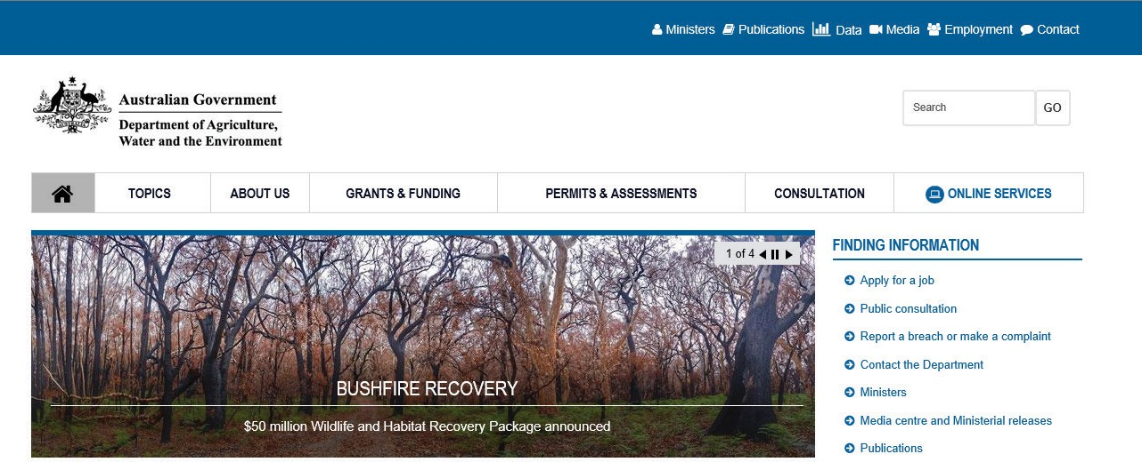

All applicants will need to register to use Online Services. Existing users will be able to login using their registered email address and password. Once logged in, click on ‘Apply for an Emissions Controlled Product certification or exemption’.

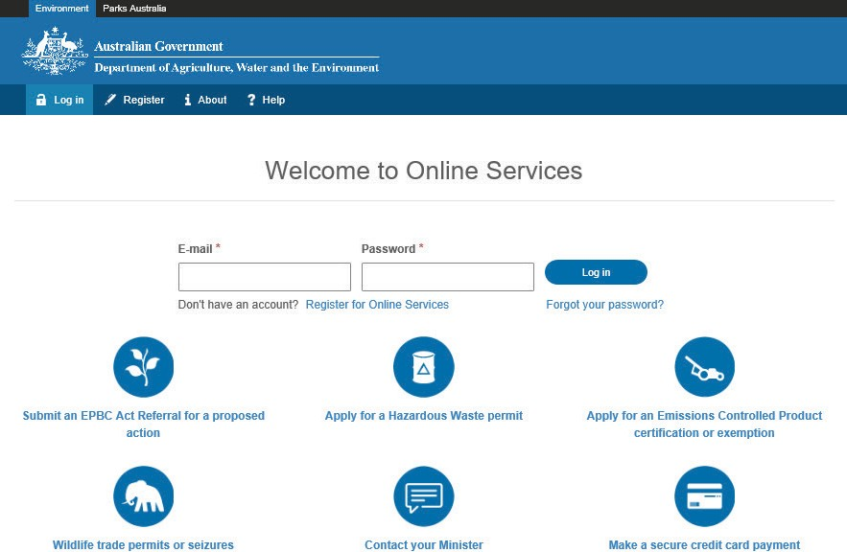

### Information required from the applicant

An application for Australian certification must be in writing and must include the following information as specified in the Rules:

* name and contact details of the applicant
* the results of emissions testing as required under the Rules
* supporting documentation including evidence that the testing was conducted in accordance with the Act
* a declaration that the information provided is correct.

The department may request further information from the contact person if the application does not include the information required.

### Application fees

The fees payable for an application for Australian certification are specified in the Rules and set out in the table below.

The department will only begin work assessing an application when the correct application fee has been paid.

|  |  |
| --- | --- |
| **Certification category** | **Fee per application\*** |
| Certification application (ILAC lab testing) | $1,330.00 |
| Certification application (non-ILAC lab testing) | $2,850.00 |

*GST does not apply to applications fees.

### Refunds

Applicants will only be eligible to receive a refund on the application fee if the application is withdrawn within 14 days of paying the fee and the department has not begun to assess the application. If the department considers an application but does not grant an Australian certificate of conformity the fee will not be refunded.

Requests for refunds must be made in writing to the department at [productemissions@awe.gov.au](mailto:productemissions@awe.gov.au)

### Request to waive the application fee

Under section 44 of the Rules, where the department is satisfied that there are exceptional circumstances the department may waive an application fee if requested by the applicant. Requests for fee waivers are to be submitted by email to: [productemissions@awe.gov.au](mailto:productemissions@awe.gov.au) . The department will consider all requests and advise the applicant about the decision in writing.

### Submitting applications

Once an application is submitted, a confirmation will be sent to the contact person’s email. Applicants will be able to check on the status of their application at any time by logging onto Online Services.

Submitted applications cannot be edited. Where an applicant identifies that they have incorrectly entered information, or details associated with the application have changed or are missing, they can provide the department with written notice of the information to be changed. Notices should be sent to [productemissions@awe.gov.au.](mailto:productemissions@awe.gov.au) The department will update the application and seek formal acknowledgement of changes from the applicant before they take effect.

Applications can be withdrawn at any time during the assessment process by notifying the department in writing at [productemissions@awe.gov.au.](mailto:productemissions@awe.gov.au) As noted above, the application fee will only be refunded if the application is withdrawn within 14 days of paying the fee and the department has not begun to assess the application.

### Time period for assessing an application

Section 21 of the Rules provides that if products have not been certified or refused within 60 days of the department receiving all required information, including confirmation of fee payment or approval of

a fee waiver, then the application is deemed to have been refused. It is anticipated that most applications will be finalised much sooner than 60 days.

## If certification is granted

Where the department is satisfied that an application has met the conditions for certification, an Australian certificate of conformity will be issued. The department will notify the applicant of the outcome in writing and a notice will be published on the department’s website. An Australian certificate of conformity comes into force on the day specified in the certificate.

### Varying, suspending or revoking an Australian certificate of conformity

In certain circumstances the department may vary, suspend or revoke an Australian certificate of conformity.

Section 22 of the Rules allows the department to vary an Australian certificate of conformity. Variations are made by publishing a notice on the department’s website. The contact person for the Australian certificate of conformity will be notified in writing. A variation will take effect on the day specified in the notice. Variations are designed to correct errors and are not intended to allow additional products to be added to an engine family covered by the certificate. In this instance, a new application for Australian certification would be required.

Section 23 of the Rules allows the department to suspend an Australian certificate of conformity by publishing a notice on the website. The contact person for the certificate of conformity will be notified in writing. Suspensions of an Australian certificate of conformity may occur where the department reasonably suspects that any existing certified products do not comply with the relevant Australian emissions standard. For example, this may occur where there is a mismatch between the information provided on the engine label and the types of engines covered by a particular Australian certificate of conformity. Suspending an Australian certificate of conformity allows the department time to investigate whether the conditions of certification are being complied with.

A suspension takes effect on the day specified in the notice. A suspension is ended by publishing a second notice on the department’s website and takes effect from the day specified in the second notice. While a suspension is in force, import and supply of products covered by the Australian certificate of conformity must stop. Continuing to import (or manufacture and supply) or supply (after 1 July 2020) these products will be an offence under Part 3 (Enforcing product emission standards) or Part 4 (Record keeping) of the Act.

The suspension will only end if the department is satisfied that the products included in the suspension comply with the Australian emissions standard.

Section 24 of the Rules allows the department to revoke an Australian certificate of conformity by publishing a notice on the website. To revoke an Australian certificate of conformity, the department must be reasonably satisfied that any of the products covered by the Australian certificate of conformity do not meet the Australia emissions standards.

## If certification is not granted

Where the department is not satisfied that an application has met the conditions for Australian certification, the application will be refused. The department will notify the applicant in writing.

### Appeal a decision

Persons who do not agree with a decision made by the department can seek review by the Administrative Appeals Tribunal. The following decisions related to Australian certification applications can be reviewed by the Administrative Appeals Tribunal:

* a decision to refuse a fee waiver request
* a decision to refuse an application for Australian certification
* a decision to vary, suspend, not end a suspension or revoke an Australian certificate of conformity.

Further information is available at [www.aat.gov.au](http://www.aat.gov.au/)

## Role of the department

The department administers the Act and any product emissions standards made under the Act. Section 10 of the Act allows the Minister to make Rules that provide for Australian certification. Part 4 of the Rules sets out the circumstances in which the department can grant Australian certification for products and/or persons under the Act.

The department is responsible for:

* responding to inquiries from applicants or potential applicants
* ensuring the correct fee has been paid by the applicant
* checking whether each application includes all the required information
* assessing and deciding whether an application should be granted an Australian certificate of conformity
* keeping the applicant informed about the progress of their application
* where an application is approved, issuing a certificate of conformity
* where the certification is refused, notifying the applicant and providing reasons
* ensuring compliance with the Act.

## Need to know more?

If you have any questions about the product emissions standards, or applying for Australian certification, contact the department:

* Email [productemissions@awe.gov.au](mailto:productemissions@awe.gov.au)
* Phone 1800 803 772